A DEMOGRAPHIC ANALYSIS OF CONSUMERS PURCHASE INTENTION TOWARDS ORGANIC FOOD PRODUCTS IN JAMMU REGION
Dr. Neetu Kumari (Assistant Professor, Commerce, School of Social Sciences, Cluster University of Jammu),
Ms. Anushka Singh (Assistant Professor, Commerce, School of Social Sciences, Cluster University of Jammu),
Ms. Riya Gupta (Assistant Professor, Commerce, School of Social Sciences, Cluster University of Jammu)
Abstract
The market for Organic food has been increasing in the recent decade. Customers are becoming more aware about what products they are purchasing and consuming. This depends on various factors like quality of climate condition, increasing pollution, excessive use of chemicals etc. Therefore, Consumers now-a-days are very particular about the products they are consuming. Thus the concept of organic food product come into picture. This concept is gaining impetus in society especially after increase in health problems in individuals. It refers to using such food product which are eco-friendly and safe. Though the concept is not new, but still consumers are not much aware about it. The paper is an attempt to understand the demographic level of awareness about organic food products in Jammu. Statistical tools like Chi-square tests and different charts are used to analyse the data obtained from a primary survey conducted in Jammu. On the basis of demographic analysis done in the paper, it is concluded that the consumption has increased lately although more awareness should be created to make the consumption more popular among consumers.
Keywords: Demographic; Consumers; Organic Farming; Organic Food Products; Pesticides.
Introduction
Organic foods are produced by the methods that comply with the standards of organic farming. Standards vary worldwide, however, organic farming in general, features practices that strive to foster cycling of resources and conserve biodiversity. Organizations regulating organic products may choose to restrict the use of certain pesticides & fertilizers in farming. In general, organic foods are usually not processed using the industrial solvents or synthetic food additives.
Organic cultivation is particularly suitable for a country like India with a huge population of small farmers who still use traditional methods of farming with few agricultural inputs. It is estimated that 65% of the country’s cropped area is organic by default as the small farmers have no choice but to farm without chemical fertilizers and pesticides as they cannot afford. NGOs that promote organic farming and other organizations support farmers in these aspects. An organic movement is now emerging in India on different levels (producer groups, certification bodies and processors and traders). So, dissemination of information about the opportunities and challenges for Indian organic products on the domestic & international market is of fundamental concern in order to allow to be continued.
Organic food production is a self-regulated industry with government oversight in some countries., distinct from private gardening. Currently, the European Union, the US, Canada, Japan & many other countries require producers to obtain special certification based on the government defined standards in order to market food as organic within their borders. In the context of these regulations, foods marketed as organic are produced in a way that complies with organic standards set by national governments and international organic industry trade organization.
Literature Review and Theoretical Framework
The theory of the consumers’ knowledge, perception and attitude justifies that customers are found of organic food, Singh (2022) found that advancement of research in the field of food consumption by providing a fresh perspective on public attitude towards organic food products. Mythili & Dharshini (2020) observed that Consumers play a major role in studying the perception towards Organic food products segment. Tanishka & Sundari T (2021) observed that as with large number of organic food products campaigns, most of the consumers are aware of such products & prefer such products more than non-organic products. The reviewed literature also highlights the Rust & willingness to pay for organic food products. Kennedy (2020) observed that organic market is the one of the fastest growing agricultural markets due to consumers’ increased concern about their own health, the environment, and emergencies worldwide on food safety, and more probably, their trust towards these products. Ramalingam & Anuradha (2021) observed that consumers are becoming more health conscious due to the increasing health hazards. Selvam & Naseeba (2020) found that the perception and trust towards organic food products depict the strongest relationship with buyers’ intention to buy organic food products followed by the buyers’ belief that consuming organic food product is contributing to preserve the environment. The reviewed study also highlight health consciousness & other factors Chandrashekhar (2021) conducted a study and in this study it has been observed that Consumer behavior and health consciousness plays a major role in Organic food products segment. Waqas, Aslam, Chenhong (2019) seen that as with the advancement in economic activities, customer enthusiasm for organic products has expanded. Health awareness requires monitoring of health-related developments and proactive responsibility. Ghani, Adli, Saleeh (2021) observed that Organic food has become more common and in greater demand among consumers due to improved awareness of eating healthily. This study aims to identify the determinants that may influence customers’ purchase intention of organic food, such as knowledge, safety, health consciousness, environment, price, and availability of the organic food.
Research Methodology
The research is conceptual in nature as it examines the reasons why some consumers prefer organic food products and others do not. In this research, we can explore the relationship between consumers buying behavior and organic food products. Further, the present study also reveals the success of organic market as a corporate social responsibility.
To collect the requisite information, both primary and secondary sources of information have been used. Primary data has been collected using Questionnaire which is being sent to the 85 respondents from whom the responses of only 42 respondents have been gathered and Secondary sources viz. internet, articles and printed journals etc. have been used for reviewing the pertinent literature. The main purpose was to know the awareness, willingness and trust of consumers for the organic food products. Primary data has been collected from different locations of Jammu means of structured questionnaire.
Analysis And Findings
Demographic Factors like age, gender, occupation and education are considered for demographic analysis.

Analysis of demographic information
Table 1: Demographic Information of Respondents
Groups | Percentage
Age
Between 15 – 25 years | 69%
Between 26 – 50 years | 31%
Between 50 – 70 years | -
Above 70 years | -
Gender
Male | 23.8%
Female | 76.2%
Occupation
Salaried | 33.3%
Self – employed | 7.2%
Business | 2.4%
Student and Others | 57.1%
Education
Below 12th | 30 %
Graduation | 20.6%
Post Graduation | 20.4%
Uneducated | 29 %

The first demographic factor is age. From the above data, it is seen that 69% of the respondents are under the age group of 15 – 25 years and 31% of the respondents are under the age group of 26 – 50 years.
The second demographic factor is gender. From the above data, it is seen that 23.8% of the respondents are males and 76.2% of the respondents are females.
The third demographic factor is Occupation. From the above data, it is seen that 33.3% respondents come under Salaried category, 57.1% respondents come under Student & others category, whereas 2.4% of the respondents come under the Business category & 7.2% respondents come under Self-employed category.
The fourth demographic factor is Education. From the above data, it is observed that 20.4% of the respondents come under the category of Post Graduate, 20.6% of the respondents come under the category of Graduates, 30% of the respondents fall under the category of 12th pass and 29% of the respondents come under the category of Uneducated.

Table 2: Chi-square test for different demographic factors
Demographic Factors | Chi-square value | D.F. | P-value | Comparison | Decision
Age | 2.607 | 6 | 0.8448 | >0.05 | Accept
Gender | 5.9 X 10⁻³¹ | 1 | 0.9 | >0.05 | Accept
Occupation | 2.538 | 3 | 0.4177 | >0.05 | Accept
Education | 1.7 X 10⁻³¹ | 1 | 0.9 | >0.05 | Accept

It is found that awareness about Organic food is independent of all the demographic factors. Chi-square test of independence is conducted for all the demographic factors to test whether the awareness of organic food is independent of the demographic factors. Hence the following hypotheses are stated-
H₁: Awareness about organic food is independent of age – groups, H₁₁: It is not independent
H₂: Awareness about organic food is independent of Gender, H₁₂: It is not independent
H₃: Awareness about organic food is independent of Education, H₁₃: It is not independent
H₄: Awareness about organic food is independent of Marital Status, H₁₄: It is not independent

Information About Organic Food Products
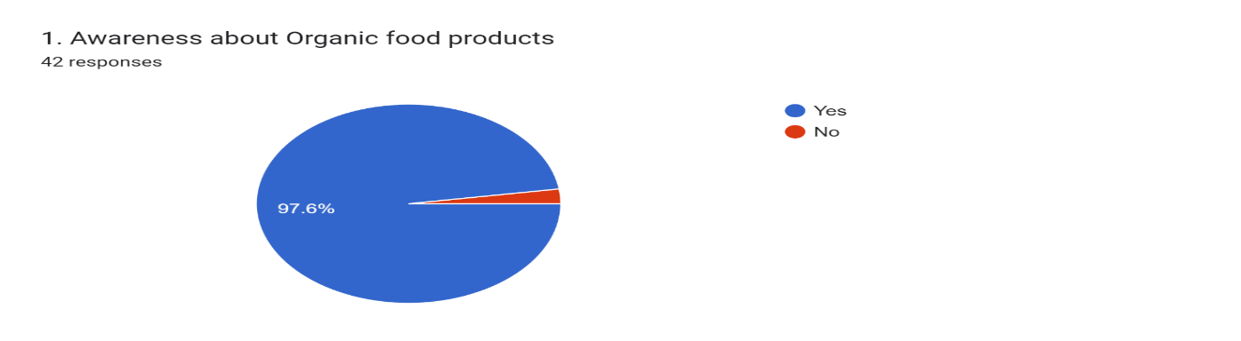
Consumer awareness towards organic food products
From all the responses collected, it can be seen that 97.6% of the respondents have awareness about organic food products whereas 2.4% of the respondents have not heard about such products. Maximum people said that organic food are way towards healthy lifestyle. Such food are less harmful and have no pesticides used.
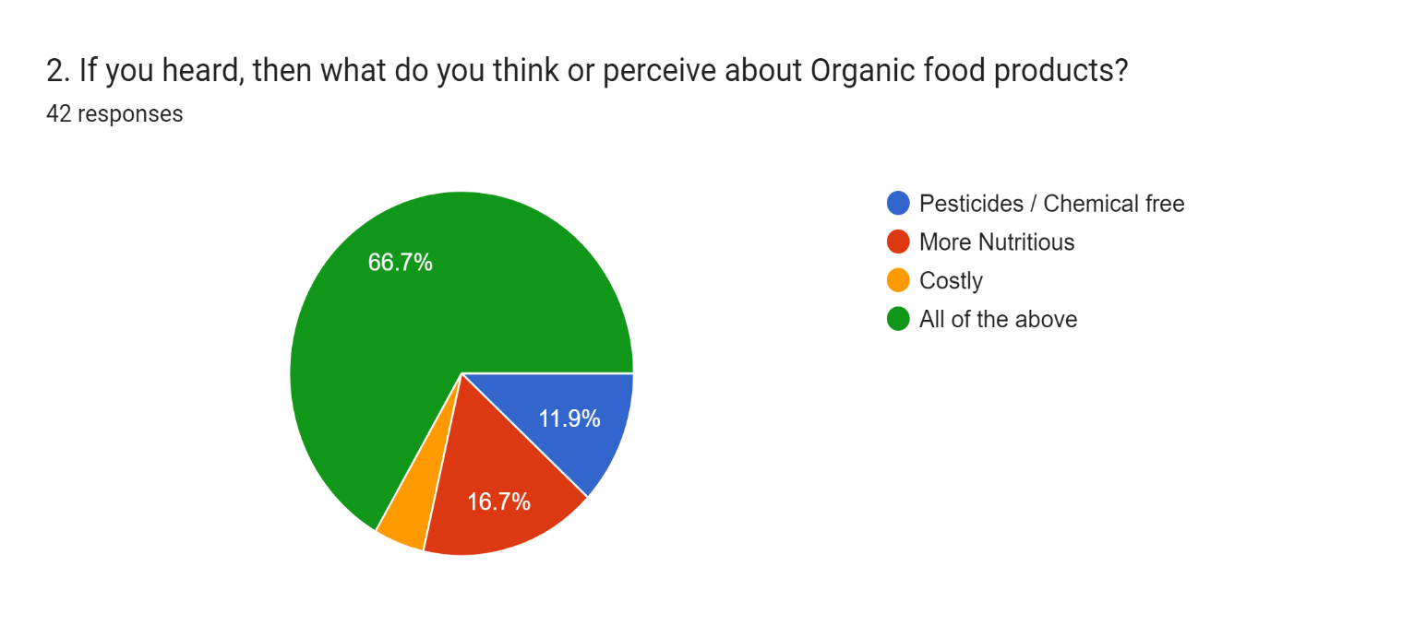
Consumer thinking or perception about Organic food products
The results indicate that 11.9% respondents think organic food products are pesticides / chemical free, 16.7% respondents have a perception that these products are more nutritious, 4.8% of the respondents think these products are costly and 66.7% of the respondents think these products are chemical free, more nutritious and costly as well. People are aware that pesticides are not used in such kind of food so it is less harmful and toxic.
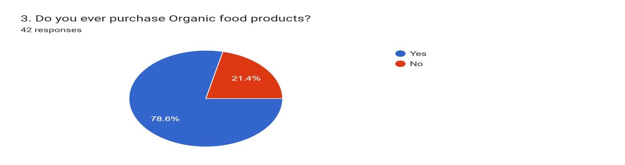
Purchasing behaviour of consumer towards organic food products
From the data, it is seen that 78.6% respondents have purchased organic food products whereas 21.4% of the respondents’ despite of knowing about organic food products have not purchased. It can be assumed that those who have awareness about organic food will prefer organic food over the people who do not have knowledge about it.
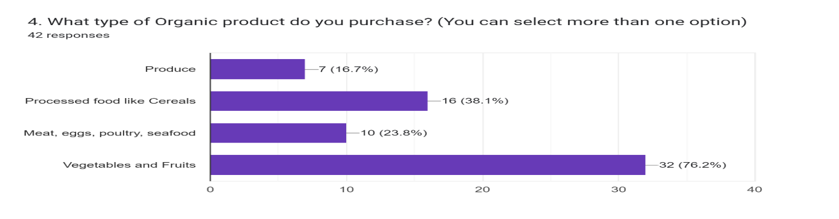
Consumer perception about purchasing Organic product

From the above data, it is observed that 38.1% respondents have purchased processed foods like cereals category organic products, 23.8% respondents have purchased meat, eggs, poultry etc. like organic food products, 76.2% respondents have purchased organically produced vegetables and fruits whereas 16.7% respondents have purchased organically produced goods.
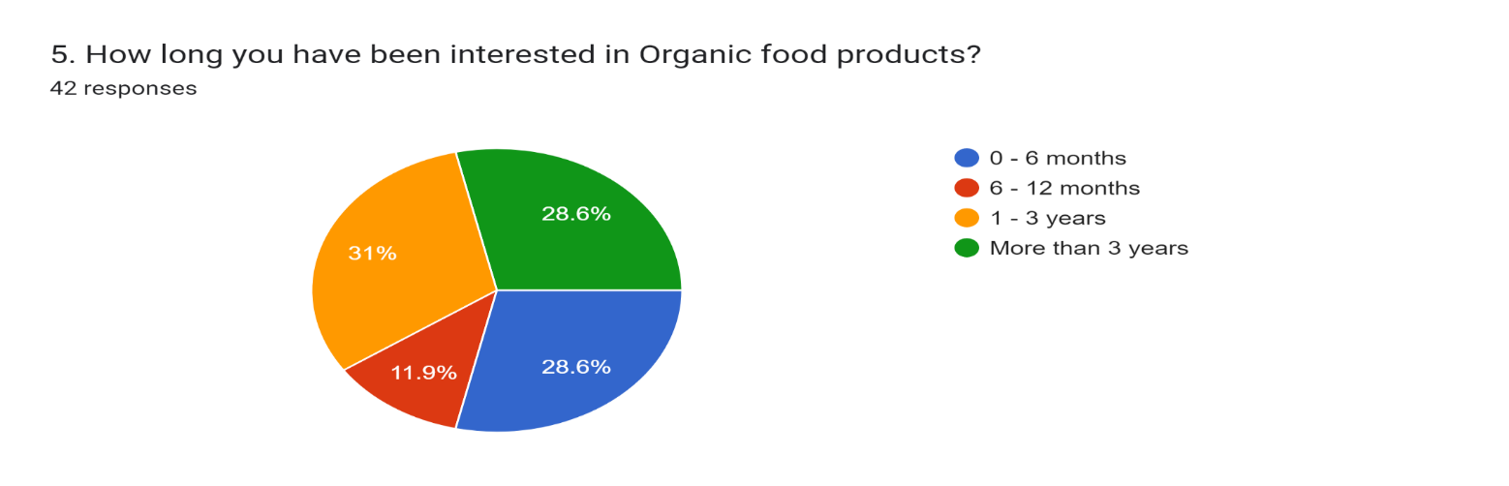
Consumers interest in Organic food products

From the above data, it is observed that 28.6% respondents have been interested in Organic products from 0-6 months, 11.9% respondents have been interested from 6-12 months, 31% respondents have been interested from 01-03 years, 28.6% respondents have been interested for more than 03 years.
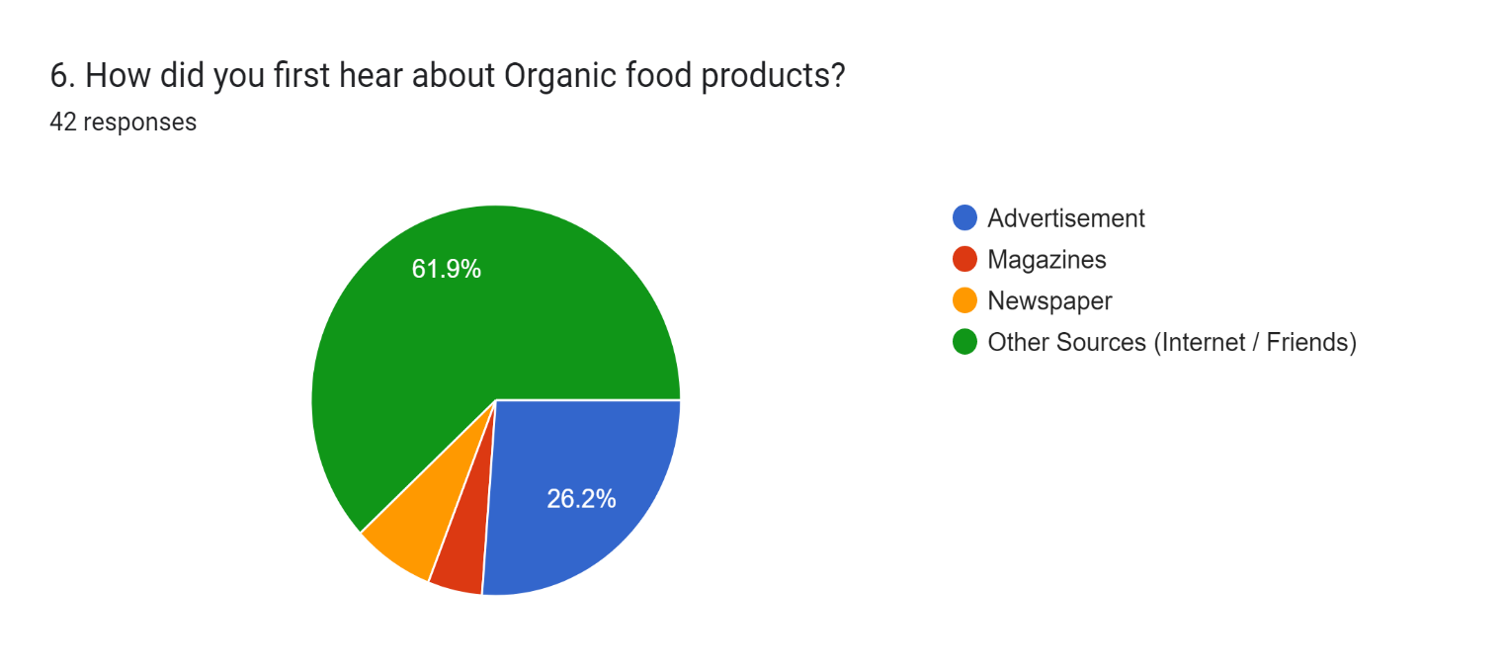
From where Consumer first heard about Organic food products

From the above data, it is seen that 26.2% respondents got to know for the very first time about organic food products from advertisements, 4.8% respondents heard about them through magazines, 7.1% respondents heard about these products from newspapers and 61.9% respondents have heard about such products from their friends or via internet.
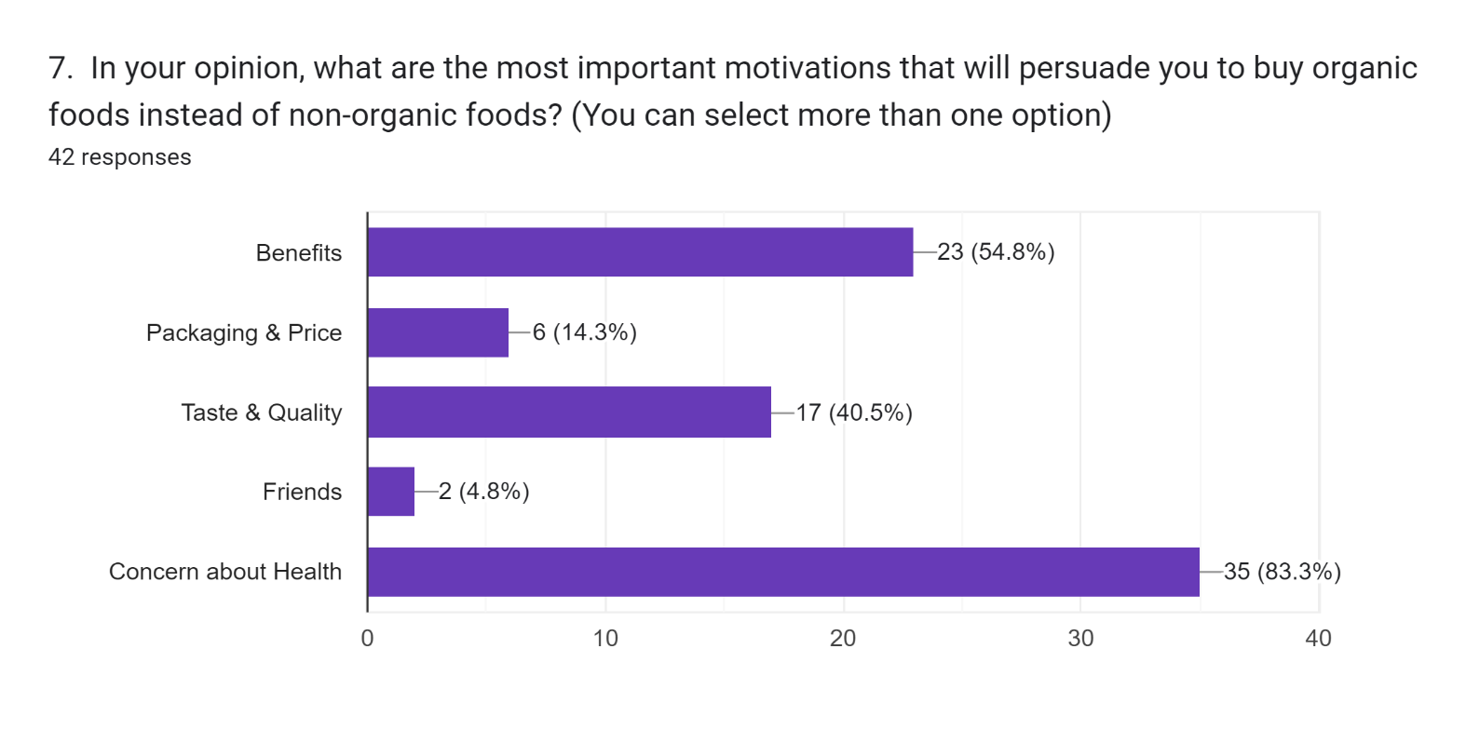
According to Consumer, the most important factors that will persuade them to buy organic foods instead of non-organic foods

From the above data, it is observed that 54.8% respondents consider Benefits of organic food products as important motivation that will persuade them to buy such products, 14.3% respondents consider Packaging & Price as important motivating factor for the purchase of organic food products, 40.5% respondents consider Taste and Quality as their main reason for the attraction towards organic food products, 4.8% respondents consider their Friends as important motivational factor that will encourage / persuade them to buy these products without any doubt or hesitancy and 83.3% respondents are very conscious about their health and in order to remain fit and healthy, they will prefer organic products in comparison to non-organic food products which are not good for their health.

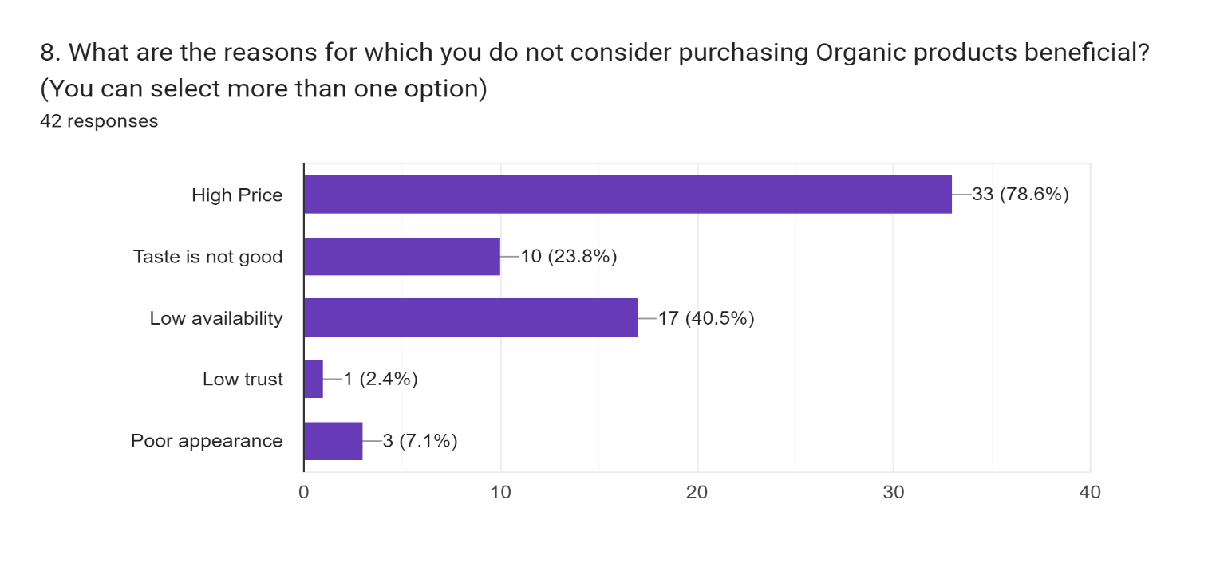
Various reasons for which Consumer do not consider purchasing Organic products beneficial

From the above data, it has been extracted that 78.6% respondents mentioned High price as their primary reason for not purchasing organic food products, 23.8% respondents mentioned Bad taste as one of the important reasons for not purchasing these products, 40.5% respondents indicate Lesser availability of these products at the time of need as their main reason for not purchasing these products, 2.4% respondents indicate lack of trust as the reason for not purchasing organic products and 7.1% respondents indicate poor appearance of these products because of which they do not consider purchasing such products.

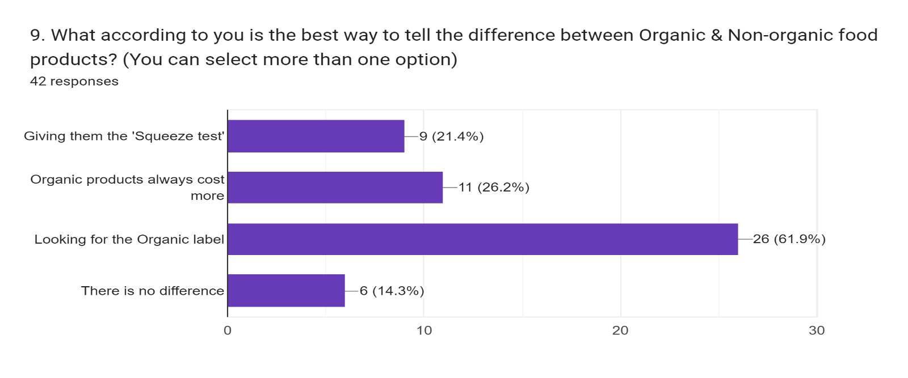
According to Consumer, the best way to tell the difference between Organic & Non-organic food products

From the above data, it is observed that as per 21.4% respondents, by the use of ‘Squeeze test’, one can easily distinguish between the organic and non – organic food products. As per 26.2% respondents, purchasing organic products often cost more as compared to other non – organic food products. As per 61.9% respondents, in order to understand the difference between organic and non- organic food products, simply look for the organic label on the products. If there is an organic label on the product, then it is organic otherwise it is non – organic product. Finally, as per 14.3% respondents, there is no difference between organic and non – organic food products.

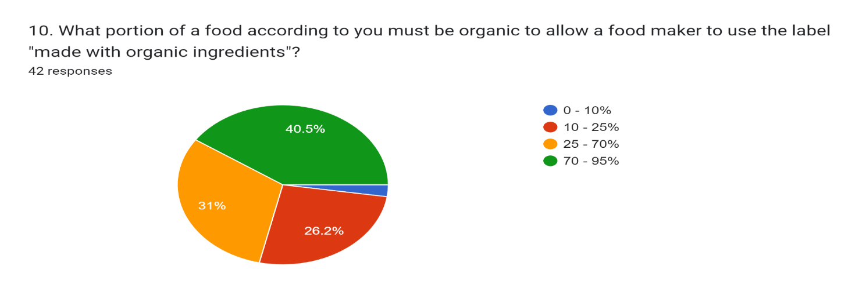
From Consumer perspective what portion of a food must be organic to allow a food maker to use the label "made with organic ingredients"

From the above data, it has been extracted that in order to allow a food maker to use the label ‘made with organic ingredients’ 2.4% respondents think up to 10% portion of food must be organic, 26.2% respondents think 10 – 25% portion of food must be organic, 31% respondents think 25 – 70% portion of food must be organic and 40.5% respondents think 70-95% portion of food must be organic.
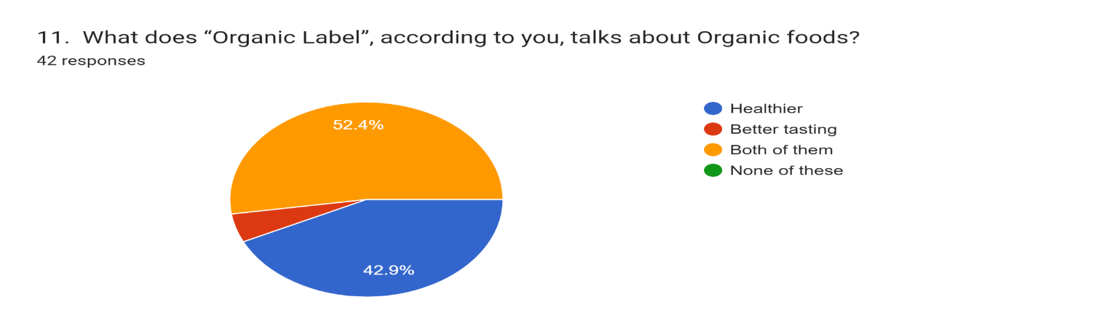
“Organic Label” according to Consumer, talks about Organic foods

From the above data, it can be observed that 42.9% respondents perceive Organic label on organic food products as Healthier, 4.8% respondents perceive Organic label as indicating better taste of these products whereas 52.4% respondents perceive Organic label not only as Healthier but also of good taste on the organic food products.
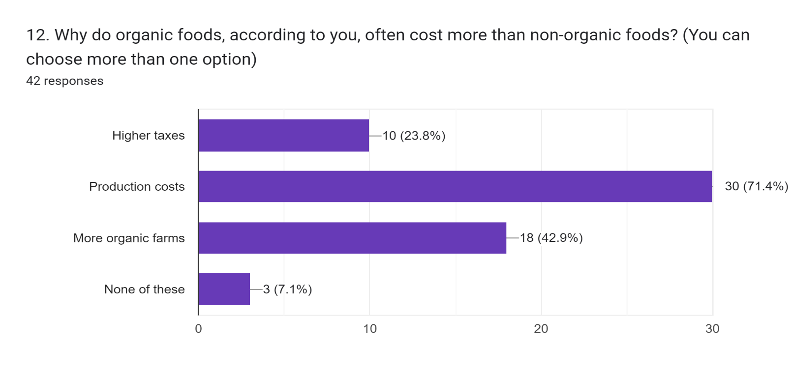
Organic foods, according to Consumer, often cost more than non-organic foods
The results indicate that 23.8% respondents think organic food products are costlier as compared to non – organic food products because of Higher taxes on such products, 71.4% respondents think these products are costlier because of the costs involved in producing them, 42.9% respondents think organic products are costlier because of more organic farms that are engaged in producing such products and 7.1% respondents think none of the mentioned factors is responsible behind the increasing costs of Organic food products.

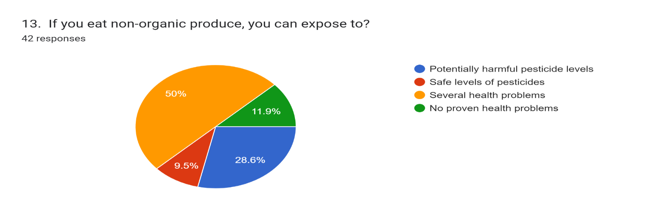
If Consumer eats non-organic produce, they can be exposed to
From the above data, it can be seen that different respondents have different perceptions regarding the consumption of non – organic food products such as 28.6% respondents feel that if they consume non - organic products, they can expose to potentially harmful pesticide levels, 9.5% respondents feel that if they consume non – organic produce, they can expose to safe levels of pesticides, 50% respondents feel that if they consume non – organic products, they can expose to several health problems which may become dangerous as well and finally, 11.9% respondents feel that if they consume non – organic products, they shall have no proven health problems.

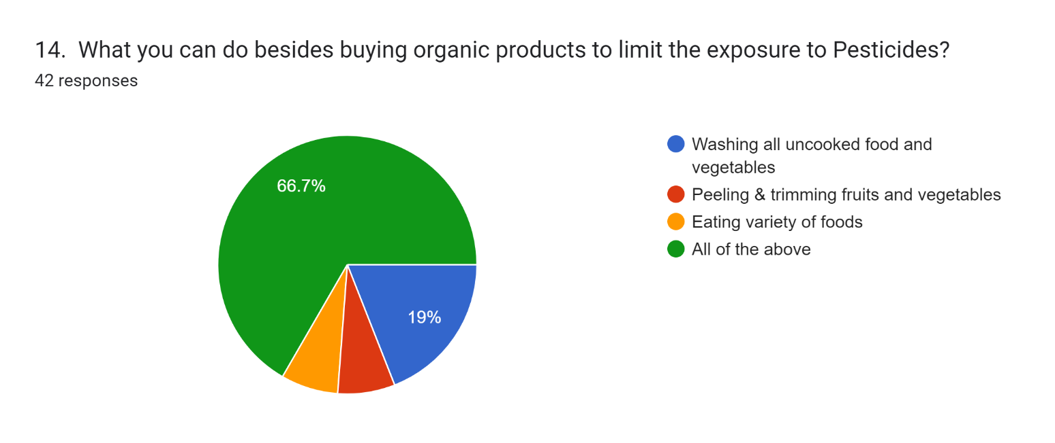
Other options available to Consumer, besides buying organic products to limit the exposure to Pesticides

From the above data, it can be observed that 19% respondents think besides buying organic food products, we can wash all uncooked food and vegetables in order to limit our exposure towards pesticides, 7.1% respondents think we can peel and trim fruits and vegetables before their usage, 7.1% respondents think we can eat healthy and nutritious food cooked at home rather than junk food served at food outlets outside the homes and finally, 66.7% respondents think that by doing all of the mentioned steps, we can limit our exposure towards harmful pesticides.

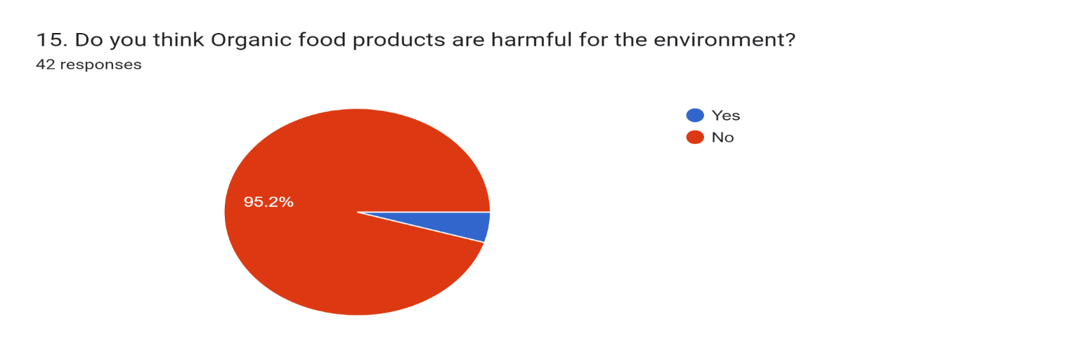
According to Consumer, Organic food products are harmful for the environment

From the above data, it can be concluded that 4.8% respondents think organic products are somehow harmful for the environment whereas 95.2% respondents think that these products are not harmful. They are in fact, good to the environment and to be used by everyone.
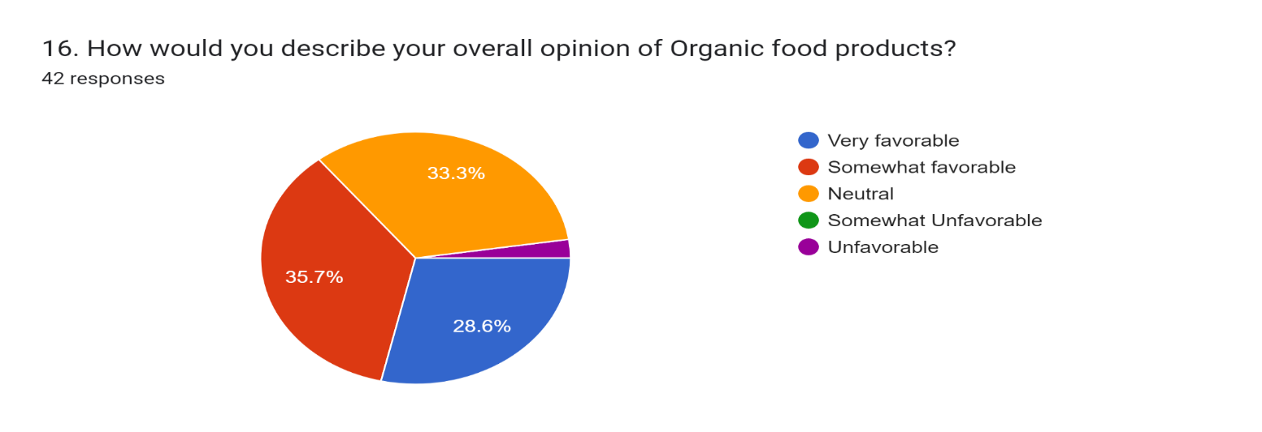
Overall opinion of Organic food products, according to Consumer
From the above data, we can observe the overall opinion of respondents regarding Organic food products, 28.6% respondents have an opinion regarding such products as very favorable, 35.7% respondents have an opinion of somewhat favorable for these products, 33.3% respondents have an opinion towards these products as neutral and 2.4% respondents have an opinion regarding such products as unfavorable.
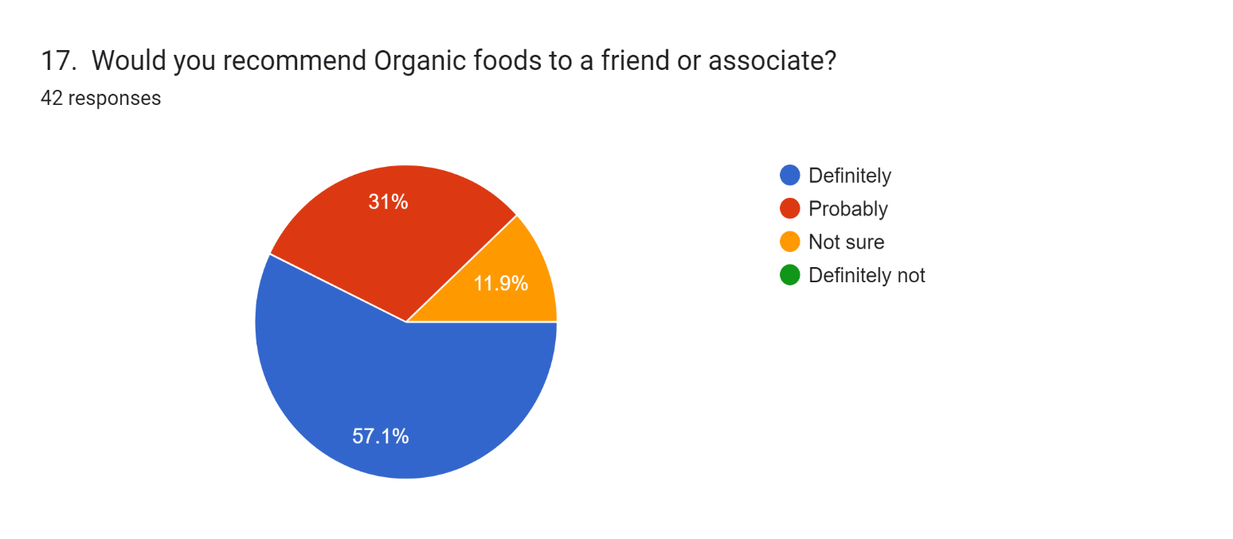
Consumer would recommend Organic foods to a friend or associate

From the above data, it is observed that different respondents have their different viewpoints regarding their recommendations of the organic food products 57.1% respondents have a definite opinion to recommend organic food products to their friends or associates, 31% respondents have a probable opinion regarding the recommendation of such organic products to their friends or associates, And finally, 11.9% respondents are not sure whether they recommend these organic products to their friends or associates depending upon whether the respondents themselves are using the products or not.
Limitations of the Study :
The limitations of the study are as follows:
- Marketing and distribution channels are not efficient because organic food is produced in smaller amounts.
- Organic products have to go through tough certification processes.
- Some consumers though having knowledge of organic food products still resort to non-organic food products which may have some harmful effects on their health.
- There is lack of awareness among the consumers regarding the availability of organic food products in the market.
- As these products are produced in smaller quantities, they are very costlier because of which it is not possible for every consumer to opt for the same.
- Data on all age-group are not uniformly distributed.
- Data on all occupation are not uniformly distributed.
- Data on all marital status are not uniformly distributed.
- Data on all educational qualification are not uniformly distributed.
- Data on all sex are not uniformly distributed.
- The sample size is small.
Conclusion
To conclude, we can say that in today’s market, organic products must be available in excessive quantity so that more and more consumers can make use of such products. It is evident that the consumption of organic food has raised in last five years, but it should have raised more than what has actually happened. People are well aware of organic food and the benefits driven from it. Consumption of such products will reduce health hazards giving a blissful life. In fact, consumers, irrespective of all age-groups, income and educational qualification have enough knowledge regarding this. Most of the consumers are shifting towards non-organic products citing this reason that these are not available in the market. Consumption also depends on the availability of such products in nearby places. Since life in Jammu is very busy, many people do not get ample time to look for organic products if they are not easily available, although there is already a solution to this. Such products can easily be found in the online grocery apps. There are also many people who have included organic food in their diet but have not given up non-organic products either. They prefer both kind of food. According to the survey, such people spend 27% of their budget on food on an average for organic food and rest on non-organic. Only 17% of all consumers were found to depend on organic food products totally. In fact, very few people are found to be dependent on such products for more than 10 years. It can also be concluded from the study that awareness of organic food products should be made on a larger scale so that most of the people can have an idea regarding what these products are, what are their uses, how these products are going to benefit them in living a healthy life and what are the costs of these products. Today, almost everyone is exposed to non-organic food which can no doubt, tastes good as compared to organic food products but also, it can have several bad impacts on the health of human beings. So, consumption of home-made food is always advisable as it will not only contains several carbohydrates and other ingredients like proteins but also prevents us from several problems which can arise by the consumption of outside food like the junk food.

References

- Aarthi M. & Balusamy S. (2020). Consumers Satisfaction towards Organic Food Products in Coimbatore. International Journal of Recent Technology and Engineering (IJRTE), 9(1), 388-390.

- Chandrashekhar H.M (2021). Market Opportunities and Supply Chain Management of Organic Products in Mysore District – A Consumer Perspectives. International Journal of Trend in Scientific Research and Development (IJTSRD), 5(2), 77-85.

- Ghani Abd Fatimah, Adli Aimi Nur Farah, Salleh Salmalina (2021). Determinants Affecting Purchase Intention of Organic Food among Medical Employees. International Journal of Academic Research in Business and Social Sciences, 11(16), 79-90.

- Hong Chen, Aslam, Waqas (2019). Study on Consumer Behaviour and Food Safety of Organic Products in Pakistan. https://doi.org/10.1051/e3sconf/20197802021, 01-07.

- Madhavaiah C. & Shashikiran L. (2016). Review of Consumer Behaviour towards Organic food products in Bangalore city. Adarsh Journal of Management Research, 9(1), 29-35.

- Mythili D. & Dharshini Priya S. (2020). A study on Consumer perception towards organic products with reference to Coimbatore city. Journal of Emerging Technologies and Innovative Research (JETIR), 7(3), 70-78.

- Padmaja V & Parashar Nikhil (2018). A Study on Consumer buying behavior towards Organic food products. International Journal of Applied Engineering Research ISSN, 13(1), 10-12.

- Ramalingam S. & Anuradha R. (2021). Consumers’ willingness to pay more for organic food products-A study with reference to the Chennai city. Turkish Journal of Computer and Mathematics Education, 12(11), 5796-5800.

- Savithri N. & Lavanya B. (2019). Organic food products: A study on perception of Indian consumers. International Journal of Research and Analytical Reviews (IJRAR), 6(1), 212-215.

- Selvam V & Naseeba A. (2020). Customer Satisfaction on Organic Food Products in Namakkal (DT). International Journal of Engineering Research & Technology (IJERT), 8(3), 01-03.

- Sharma Nayana & Singhvi Ritu (2018). Consumers perception and Behaviour towards organic food: A systematic review of literature. Journal of Pharmacognosy and Phytochemistry, 7(2), 2152-2155.

- Sharma Nidhi Ms. & Bhatia Shweta (2019). Consumers’ Buying Behaviour towards Organic Food Products: A Review of the literature. Journal of the Gujarat Research Society, 21(14), 01-13.

- Shrestha Kumar Sajeeb (2020). Consumer Purchase Intention towards Organic Foods. Doi: https://doi.org/10.3126/md.v23i1.35542, 23(1), 37-54.

- Singh Anupam (2022). Modelling the public attitude towards organic foods: a big data and text mining approach. Journal of Big Data, 9(2), 01-21.

- Singh Kumar Nitish & Alagawadi M.V. Prof. (2020). Customer’s awareness towards Organic food products: An Empirical study. https://www.iimk.ac.in/research/markconf20/. ISBN: 978-93-5419-748-2, 01- 05.

- Sulaiman Yaty, Salimon Maruf (2020). Purchase Intention towards Organic Food among Undergraduate Students. Wseas Transactions on Environment and Development DOI: 10.37394/232015.2020.16.76, 734-743.

- Tanishka Sai & T. Mohanasundari (2021). Awareness and Preference towards Organic food products during Covid-19 pandemic in Andhra Pradesh. Journal of Research in Agriculture and Animal Science, 8(10), 01-09.

- Thamaraiselvi G., Rani S., Ramkumar M., Samundeeswari S. & Pradeepa D. (2020). Consumers’ Preference towards the usage of Organic and Non - Organic food products. International Journal of Psychosocial Rehabilitation, 24(5), 2362-2366.

- Ueasangkomsate Pittawat & Santiteerakul Salinee (2016). A study of consumers’ attitudes and intention to buy organic foods for sustainability. Procedia Environmental Sciences, 34(16), 423-430.

- Vijayalakshmi R. & Kennedy Hanuman S. (2020). A Study on Consumer’s choice of Organic products in Bangalore city. International Journal for Research in Engineering Application & Management (IJREAM), 5(11), 174-185.

