A review on Pomegranate biology and ethno-medicinal application

Sutapa Mandal, Tuhin Ghosh*

Department of Chemistry (UG & PG), Durgapur Government College, Paschim Bardhaman-713214, West Bengal India

*Corresponding author: tuhinghoshbuchem@gmail.com

ABSTRACT
The Pomegranate (Punica granatum L.) is an old edible fruit that is available in the market almost throughout the year and has remained the same with time. About 10,000 years ago with the discovery of agriculture, the first report of the cultivation of the fruit was from Egypt. It was also grown in the Indus Valley so early that pomegranate has a Sanskrit nomenclature. Now, pomegranate is cultivated in subtropical and tropical areas in much-changing weather throughout the world. The pomegranate has charming biochemistry, and different classes of compounds found in it have been discussed in this study. Its importance lies mostly in its medicinal, nutritional and ornamental properties and its high applications in food and industrial sector. In addition to the basic biology of the plant, the phytochemicals extracted from the different parts of it and their bioactivity has been briefly described in this study.

Keywords: Punica granatum L., Phytochemicals, Biotechnology, Antibacterial Effect, Ethnomedicinal use

INTRODUCTION
The pomegranate, Punica granatum L., contains a variety of bioactive substances. Due to the presence of numerous phytochemical substances with various biological qualities, it has been utilised in ethnomedicine. When ingested as raw fruit or juice, pomegranates are very nutritious. Pomegranate juice is drunk by people all around the world in addition to being eaten fresh. According to Grove and Grove (2008), 100 g of arils provide 72 kcal of energy, 1.0 g of protein, 16.6 g of carbohydrates, 1 mg of sodium, 379 mg of potassium, 13 mg of calcium, 12 mg of magnesium, 0.7 mg of iron, 0.17 mg of copper, 0.3 mg of niacin, and 7 mg of vitamin C. It has earned the moniker "super-food" due to its excellent nutritional value. Studies on the antibacterial effects of various plant components and plant extracts are currently of significant interest. Due to the pomegranate's excellent nutritional qualities and potential medical applications, research into it is growing. Pomegranate extracts have been discovered to have a wide range of possible effects in investigations, including antibacterial, antifungal, antiviral, and other properties. The pharmacological and therapeutic biological actions of substances from various components of the the fruit, such as flavonoids, tannins, alkaloids, triterpenes, organic acids and steroids, exhibit antioxidant, hypolipidemic, antiviral, anticancer, anti-neoplastic, antihelminthic, anti-diabetic, antibacterial, vascular and digestive protection, and immunomodulation effects. Pomegranate extracts and plant components are frequently used in cosmetic products. Aslam et al. (2006), for instance, described various pomegranate extract fractions that facilitate skin regeneration in a polar manner.

BIOLOGICAL GROWTH
The plants are tiny trees, some as short as 1-2 metres, with straight stems and dark grey bark; occasionally, the branches are spiky. Simple, 2–8 cm long, glossy, and brilliant green leaves are opposite or subopposite to one other, and terminal flowers are present. The flower comes into this tree on the new branches of that year after one month of the bud breaking, on spurs or short branches in general. Flowers can come single, or in a cluster form. Three types of flowers can appear in a single tree at the same time. It is a very common one, long-styled perfect flower having larger ovaries set more fruit than short style types, short styles are either intermediate or male in nature. The ratio of these two flower types changes from cultivar to cultivar. Fruits are generally globose in shape or somewhat flattened, 5–12 cm in diameter, the pericarp is smooth and juicy arils surround the seeds, that are consumed by all.

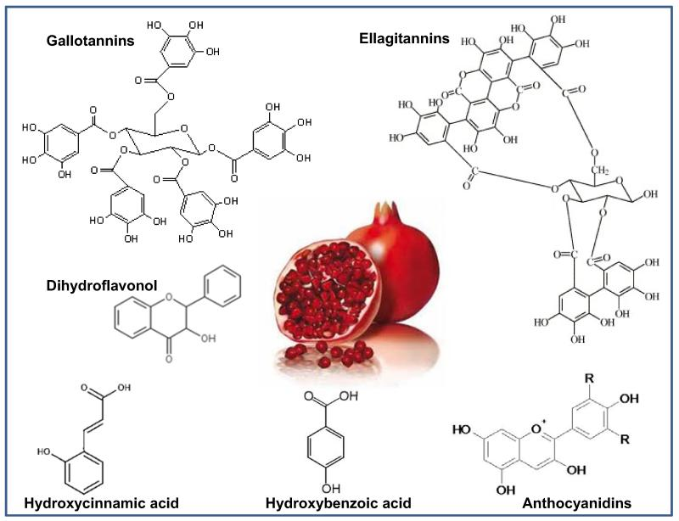

Figure 1: Chemical structures of some phytochemicals obtained from Punica granatum (Ref: Deeba N. Syed, Jean-Christopher Chamcheu, Vaqar M. Adhami, and Hasan Mukhtar, Pomegranate Extracts and Cancer Prevention: Molecular and Cellular Activities, Anticancer Agents Med Chem. 2013 Oct; 13(8): 1149–1161.)

PHOTOCHEMICAL AND CHEMICAL STRUCTURES OF Punica granatum
It contains chemical components such as tannins, ellagitannins, phenols, punicic acid, flavonoids, estrogenic flavonoids, anthocyanins and flavones, according to a variety of research reports (Fig. 1). Some of these have antimicrobial properties. The seeds, bark, and leaves contain a variety of potentially active phytochemicals, including sterols, lignins, and terpenoids; the bark and leaves contain alkaloids; and the seed oil contains fatty acids and triglycerides. Ellagic acid glycosides, anthocyanins, free ellagic acid, gallotannins and ellagitannins, are all present in the juice made from these arils. Punicalagin is a ellagitannin that is water soluble, and the husk and fruit membrane contain trace levels of procyanidins (prodelphinidins and gallocatechin) and anthocyanins (Table-1). Delphinidin compounds are rarely seen, while cyanidin and pelargonidin derivatives can be found in juice and membranes. In terms of the biological activity of the antioxidant phenolic chemicals, pomegranates and pomegranate juice exhibit diverse biological responses. Several bioactive compounds were recovered from the pomegranate peels by Mayasankaravalli et al. using water, acetone, ethanol, petroleum ether and chloroform. Ethanol and aqueous peel extracts have more active components than other extracts. Carbohydrates, saponin, flavonoids, tannins, quinones, alkaloids, cardiac glycosides, phenols, terpenoids, coumarins, and steroids were present in the aqueous peel extract. Chemical concentrations were higher in ethanol peel extract. In addition to calcium, iron, phosphorus, vitamins C and A, retinol, riboflavin, and ferulic acid, the plant contains 17 different types of amino acids. Extracts from the bark and roots of pomegranates are also antihelminthic, vermifuge, and antiparasitic. To comprehend their function in health promotion and medical usage, the biology, bioactivity, and metabolism of pomegranate polyphenols are being studied (Fig. 2).

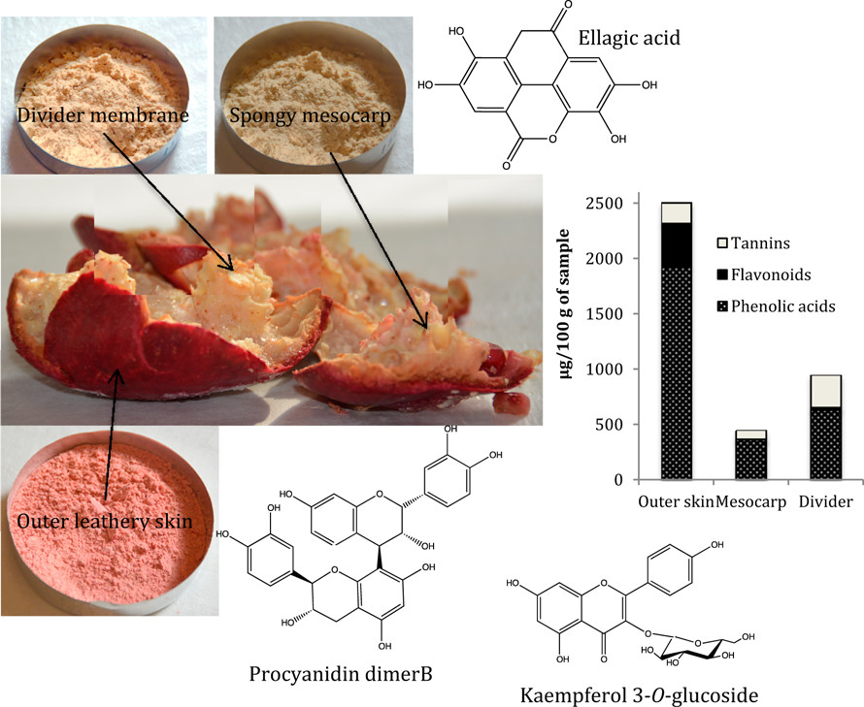

Figure 2: Phytochemicals from the peels of Punica granatum (Ref: Priyatharini Ambigaipalan et al, Phenolic Compounds of Pomegranate Byproducts (Outer Skin, Mesocarp, Divider Membrane) and Their Antioxidant Activities, . Agric. Food Chem. 2016, 64, 34, 6584–6604)
Table 1: Some phytochemicals extracted from pomegranate:

Sl No | Name | Chemical Formula | Plant Part
1. | (-)-Catechin | C₁₅H₁₄O₆ | Fruit Juice
2. | Ellagic acid | C₁₄H₆O₈ | Fruit, pericarp, bark
3. | Linolenic acid | C₁₈H₃₀O₂ | Seed oil
4. | Punicic acid | C₁₈H₃₀O₂ | Seed oil
5. | Testosterone | C₁₉H₂₈O₂ | Seed oil
6. | Sedridine | C₈H₁₇NO | Bark
7. | Chlorogenic acid | C₁₆H₁₈O₉ | Fruit Juice

APPLICATION
The fact that therapeutic plants have few side effects and contain significant quantities of phytochemicals as natural products attracts the interest of pharmaceutical makers. Therefore, clinical trials especially on naturally available compounds, like medicinal potential plants, are important to evaluate the safety and efficacy of plants and to pave the way for the creation of pertinent treatments. According to a review by Eghbali et al., P. granatum is a reliable source of bioactive compounds which may be used in the development of novel pharmaceuticals.

A. Antibacterial activity: This fruit contains a number of chemical components that exhibit antioxidant action, according to numerous literature publications (Fig. 3). Pomegranate's tannin containing ellagitannins and phenolic acid may have antimicrobial properties. According to reports, gallic acid and other phenolic chemicals, which make up the majority of the chemical compounds in pomegranates, are the most significant and effective against germs. The fruit has high tannin content (25%) and secondary metabolites are what give it its antibacterial properties. It also contains thymol, a molecule that possesses antibacterial properties, which is a component of carvacrol methyl ether. This effect could be explained by secondary metabolites. It has also been reported that the antibiotic activity of some substances (gentamicin, chloramphenicol, tetracycline and oxacillin.) is increased in presence of pomegranate extract. The extract from pomegranate peel has greater antibacterial effect compared to the seed.
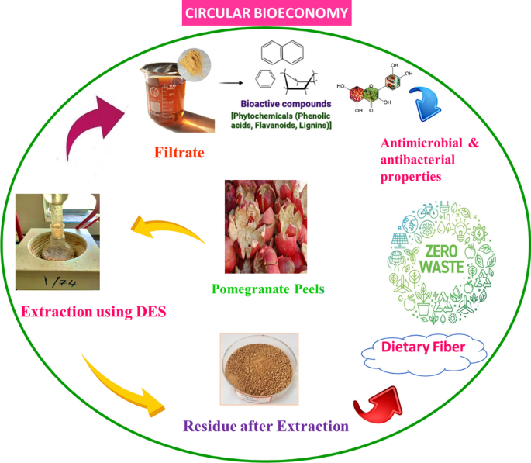

Figure 3: Circular bioeconomy (Ref: Anupama Kumar et al, Valorization of Punica granatum (pomegranate) peels: a case study of circular bioeconomy, Biomass Conversion and Biorefinery 2022)

B. Anti-carcinogenic effects:
It has been reported that the seed oil from Pomegranate (PGO) can inhibit stomach cancer in rats. In western countries, colon cancer is mostly found but dietary intake of conjugated linolenic acid (CLN) inhibits the development of cancer of the intestines. There is a considerable amount of punicic acid, c9, t11, and c13-conjugated linolenic acid (CLN) in pomegranate seed oil. In a report, Kohno et al. explained that dietary administration of PGO rich in c9,t11, and c13-CLN, even at the low dose of 0.1% CLN, inhibits the development of azoxymethane-induced colonic adenocarcinoma in rats significantly but does not cause any adverse effects. When combined, the polyphenol-rich fractions from anatomically distinct pomegranate fruit sections reduced secretory phospholipase expression and lowered proliferation and invasion in prostate cancer cells. The juice and oil from pomegranates reduced proliferation and promoted apoptosis in androgen dependent and independent prostate cancer cell lines, according to early research by Albrecht et al. Interestingly, pomegranate did not harm healthy prostate epithelial cells in any way. Additionally, in naked mice, pomegranate derivatives prevented the formation of prostate cancer xenografts. There is strong evidence that the pomegranate's copious ellagitannins play a substantial role in the fruit's purported biological benefits. The pomegranate fruit's compounds ellagic acid, caffeic acid, luteolin, and punicic acid have all been studied for their individual and combined effects on the invasiveness of prostate cancer cells.

C. Wound healing activity:
Pomegranate peel extract exhibited good healing activity, with a very faster rate. It has been described that the healing power is due to the presence of polyphenol in the methanolic extract. The polyphenols can interact with the proteins and are able to precipitate them, and thus the wound healing process occurs through pomegranate peel extract. The ellagic and gallic acids, as well as other phenolic chemicals, are primarily responsible for the pomegranate's wound-healing abilities in both the peel and seeds. Anthocyanins such as Myrtillin (3-glucoside of Delphinidin), Delphinidin 3-O-β-D-glucoside-5-O-β-D-glucoside, Chrysanthemin (3-glucoside of cyaniding), cyanidin-3,5-di-O-glucoside, pelargonidin-3,5-di-O-glucoside, and pelargonidin-3-O-β-D-glucoside are other compounds that are abundant in pomegranate seeds. Coagulation and hemostasis, inflammation, proliferation, and wound re-modelling are the four stages of the healing process for wounds. Collagen molecules play a critical function in the tensile strength, wound contraction, and structural integrity of the tissue matrix. As a result, it is regarded as a key extracellular protein in the healing of wounds. Collagen synthesis is stimulated by pomegranate consumption. This outcome is most likely a result of increased macrophage growth factor production, which stimulates the development of fibroblastic cells, the main cell type in the body that generates collagen. Neutrophils are the first inflammatory cells to reach the site of the lesion and are essential for chemotaxis and bactericidal actions. The microbes and other heterogeneous lymphoid cells arrive to the wound site about 24 hours after the damage. Chemotactic proteins generated by platelets, fibroblasts, and leukocytes trigger this cascade reaction. Pomegranate's anti-inflammatory properties help wounds heal more quickly. The proliferation stage of wound healing is very crucial. In this stage, fibroblastic cells are essential. Collagen fibres, the primary extracellular matrix proteins, are produced by these cells. The generation of fibroblasts is enhanced by pomegranate extract. Pomegranate seeds and peel have the ability to boost epithelial cell proliferation, according to reports.

D. Anti-obesity property: Genetic make-up, eating habits, environmental circumstances, and way of life are some of the elements that contribute to obesity, a metabolic condition. Studies have looked into the molecular effects of pomegranates on obesity. anthelmintic qualities. According to a study by González-Ortiz et al., pomegranate extract ingestion has also been linked to decreased food intake and decreased body weight in animals. It also demonstrated that giving adults 120 mL of pomegranate juice daily for a month dramatically reduced their fat mass. According to certain theories, one way the pomegranate can help with the treatment of obesity is by controlling appetite.

E. Anti-diabetic properties: Pomegranate flower extracts had been demonstrated in one study by Ge et al. to be effective in reducing the onset of type II diabetes by decreasing blood sugar levels and, in turn, blocking the α-glucosidase enzyme by raising post-prandial blood sugar levels in type II diabetics. Renal failure can result from diabetes nephropathy when type II diabetes progresses severely. For the treatment with diabetic renal disease, the benefits of Punica granatum extracts from leaves in ethanol have been studied. These extracts improved lipid metabolism, standardised blood levels of albumin, and reduced hyperglycemia. Gastrointestinal motility could be inhibited by a methanolic extract from pomegranate seeds. It has been reported that the tannins present in the extract are phytochemicals which are responsible for this activity. Tannins react with the proteins present and form tannates, which cause denaturation of the original protein. In this way, the secretions from the intestinal mucosa are being reduced.

CONCLUSION
One of the most useful plants for medicinal, industrial and economic usage is the pomegranate, commonly known as Punica granatum L. In addition, it is a tree that may be eaten, producing a range of goods like drinks, juices, meals (such as edible jams and salad-based dishes), food colouring, shampoo, and other cosmetics. Different regions of the world use and handle P. granatum in different ways. One of the oldest tree plants, it is still employed today for pharmacological, therapeutic, and medical uses. The Mediterranean region is where it is indigenous. It has been used to treat cardiovascular illnesses, dandruff, ulcers, intestinal disorders, cough, and colds. P. granatum and its active components have been discovered to be more effective in the treatment, prevention, and amelioration of cancer, virus, inflammation, diabetes, being overweight, malarial infections, fibrosis of the liver, infections caused by fungi and bacteria. It includes several chemical components that have been utilised as medicines since the dawn of time. In addition to a brief explanation of the phytochemicals found in the various pomegranate parts (peels, seeds, barks, etc.), this study contains biological growth and attempts to examine the functions of various pomegranate extracts.

REFERENCES
1. Alessandro Lavoro, Luca Falzone, Giuseppe Gattuso, Rossella Salemi, Giovanni Cultrera, Gian Marco Leone, Giuseppa Scandurra, Saverio Candido, Massimo Libra Pomegranate: A promising avenue against the most common chronic diseases and their associated risk factors (Review) International Journal of Functional Nutrition , April 28, 2021 , https://doi.org/10.3892/ijfn.2021.16
2. Pomegranate Ancient root to modern medicine Edited by Navindra P.Seeram, Risa N Schulman and David Haber
3.Yaser Nozohour1, Reza Golmohammadi1*, Reza Mirnejad1, Majid Fartashvand2 Antibacterial Activity of Pomegranate (Punica granatum L.) Seed and Peel Alcoholic Extracts on Staphylococcus aureus and Pseudomonas aeruginosa Isolated From Health Centers J Appl Biotechnol Rep. 2018 Mar;5(1):32-36
4. H., Rezaei, K., Rashidi, L., Extraction of essential oils from the seeds of pomegranate using organic solvents and supercritical CO2. J. Am. Oil Chem. Soc.85, 83–89 2008..
5. Abd-Rabou, S., Simmons, A.M., Augmentation and evaluation of a parasitoid, Encarsiainaron, and a predator, Clitostethus arcuatus, for biological control of the pomegranate whitefly, Siphoninus phillyreae. Arch. Phytopathol. Plant Prot. 43,1318–1334 2010.
6. Jaime A. Teixeira da Silva a,b,∗,1, Tikam Singh Ranac,1, Diganta Narzaryd,1, Nidhi Vermae,1, Deodas Tarachand Meshramf,1, Shirish A. Ranadeg,1 Pomegranate biology, and biotechnology: A review, Elsevier, 2013.
7. Halvorsen, B.L. et al., A systematic screening of total antioxidants in dietary plants, J. Nutr., 132, 461, 2002.
8. Kelawala, N.S. and Ananthanrayan, L., Antioxidant activity of selected foodstuffs,
Inter. J. Food and Nut., 55, 511, 2004.
9. Chu, Y.F., and Liu, R.H., Novel low-density lipoprotein (LDL) oxidation model: antioxidant capacity for the inhibition of LDL oxidation, J. Agric. Food. Chem., 52, 6818, 2004.
10. Priyatharini Ambigaipalan et al, Phenolic Compounds of Pomegranate Byproducts (Outer Skin, Mesocarp, Divider Membrane) and Their Antioxidant Activities, . Agric. Food Chem. 2016, 64, 34, 6584–6604
11. Klouche, K. et al., Mechanism of in-vitro heme-induced LDL oxidation: effects of antioxidants, Eur. J. Clin. Invest., 34, 619, 2004.
12. Maor, I. et al., Plasma LDL oxidation leads to its aggregation in atherosclerotic apolipoprotein E-deficient mice, Arterioscler. Thromb. Vasc. Biol., 17, 2995, 1997.
13. Fadavi A, Barzegar M, Azizi MH, Determination of fatty acids and total lipid content in oilseed of 25 pomegranate varieties grown in Iran. J Food Compost Anal 19:676–680, 2006.
14.Anupama Kumar et al, Valorization of Punica granatum (pomegranate) peels: a case study of circular bioeconomy, Biomass Conversion and Biorefinery (2022)
15.Burton, G.W., Joyce, A., and Ingold, K.U., Is vitamin E the only lipid-soluble, chain breaking antioxidant in human blood plasma and erythrocyte membranes?, Arch. Biochem. Biophys., 221, 281, 1983.

