IoT for Data Collection: Revolutionizing Information Gathering
Kulkarni Archana Sanjeev Dr. Jagdish H Godihal
PG student Professor - CIV and Deputy Dean -Academic Research
School of CS and IS School of Engineering
Presidency University Presidency University
Bengaluru, India Bengaluru, India
Abstract:
The Internet of Things (IoT) has emerged as a groundbreaking technology that has revolutionized the way data is collected across various industries and domains. In this chapter, we delve into the extensive utilization of IoT for data collection, examining its numerous benefits, challenges, and the significant impact it has had on different sectors. By exploring the capabilities of IoT-enabled devices and sensors, we witness the creation of an extensive network of interconnected systems that facilitate seamless data gathering and analysis. Furthermore, we address the critical concerns regarding the security and privacy of IoT data collection, proposing potential solutions to establish a sustainable and secure IoT ecosystem. To showcase the true potential of IoT for data collection, we provide real-world use cases that demonstrate its profound implications for future advancements in numerous fields. The Internet of Things has transformed the way data is collected, allowing for a highly interconnected ecosystem of devices and sensors. These IoT-enabled devices are capable of collecting and transmitting data seamlessly, enabling organizations to gather valuable insights and make informed decisions. One of the significant benefits of IoT-based data collection is the ability to collect data in real-time. This real-time data enables businesses to gain immediate visibility into their operations, leading to improved efficiency, proactive maintenance, and enhanced decision-making processes. By exploring real-world use cases, this chapter aims to demonstrate the potential of IoT for data collection, highlighting its profound implications for future advancements in various fields.
1. Introduction:
The Internet of Things (IoT) is a consequence of the rapid development of technology and the proliferation of linked gadgets. IoT refers to a broad network of intelligent machines, sensors, and actuators that converse with one another to gather and share data. This article focuses on how IoT may transform data-gathering procedures and produce insightful data for diverse sectors.
The primary objectives of this paper are to:
- Examine the role of IoT in enhancing data collection techniques.
- Identify the potential applications of IoT data collection in various domains.
- Analyse the benefits and challenges of using IoT for data collection.
- Propose strategies to address security and privacy concerns associated with IoT data.
- IoT for Data Collection: Applications and Benefits
2. Role of IOT in Data Collection
The Internet of Things (IoT) enables seamless data collection from physical devices and sensors.
- IoT devices gather data in real time, offering valuable insights for decision-making.
- Sensors embedded in IoT devices capture environmental data like temperature, humidity, and motion.
- Remote monitoring of assets and infrastructure is facilitated by IoT, enhancing efficiency and productivity.
- Industrial IoT optimizes processes by collecting and analysing data on machine performance and energy usage.
- Smart cities leverage IoT for monitoring traffic, energy consumption, and environmental conditions.
- Consumer IoT devices like wearables and smart home appliances collect user behaviour and health data.
- Real-time analytics enables immediate decision-making through IoT data analysis.
- Data aggregation and integration platforms handle the vast amounts of data generated by IoT devices.
- Ensuring data security and privacy is crucial in IoT data collection.
2.1Environmental Monitoring
IoT-enabled sensors allow real-time monitoring of environmental parameters like air quality, water levels, and temperature. This data helps cutting-edge examining climate change, recognizing pollution sources, and predicting natural disasters. Environmental supervising using IoT is been implemented in various projects, such as the Smart Citizen project, which deploys sensors in cities to measure air quality and provide real-time data to citizens [1]. Another example is the FloodNet system, which utilizes IoT sensors to monitor water levels and provide early flood warnings [2]. Fig. 1 is the block diagram of the FloodNet System that monitors water level, temperature. The values recorded are stored in the cloud so that it is accessible for analysis.
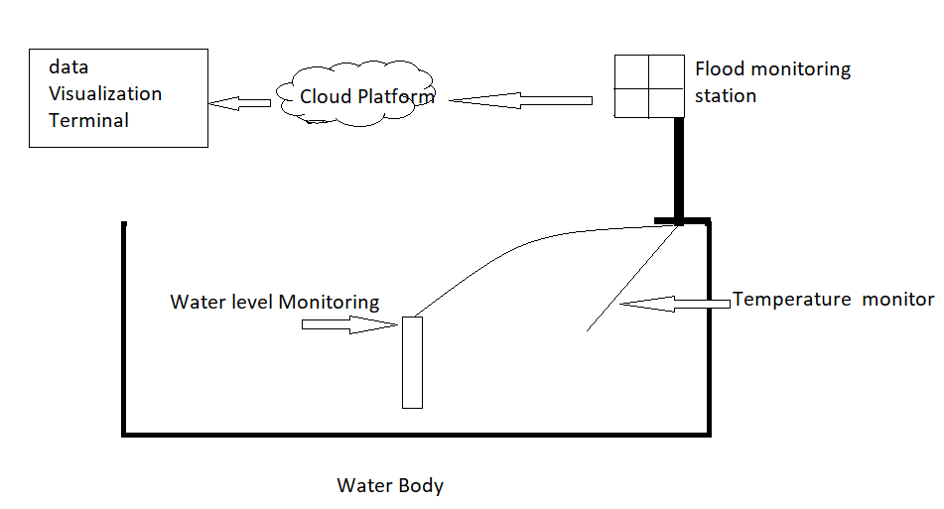
Fig. 1 Flood Monitoring System using IOT
- The system consists of a data acquisition system, a solar power supply system, an all-weather protective box, a weather observation bracket, a video monitoring system, and an environmental monitoring platform.
- The system uses sensors to collect data on water level, rainfall, and other environmental factors.
- This data is then uploaded to the environmental monitoring platform, where it is analysed and used to generate warning information.
- The flood monitoring system provides a comprehensive and reliable way to monitor flood risk and issue timely warnings.
2.2 Healthcare
IoT devices in the healthcare sector enable remote patient monitoring, facilitating continuous data collection for chronic conditions, ensuring better patient outcomes, and reducing hospital visits. Remote patient monitoring through IoT devices has shown significant benefits in healthcare. For instance, a study conducted by Torous et al. (2018) demonstrated the effectiveness of using IoT wearables to monitor and manage mental health conditions [3]. Similarly, IoT-enabled pacemakers allow for real-time cardiac patient monitoring, leading to better diagnosis and timely interventions [4]. Fig. 2, lists a few more IOT-supported medical things [14]

Fig.2 Examples of IoT in Healthcare
The types of sensors used in each case for data collection:
Remote Patient Monitoring: In remote patient monitoring, sensors such as heart rate monitors, blood pressure cuffs, glucose meters, and pulse oximeters are employed to collect vital sign data. These sensors are connected to IoT devices or wearables that transmit the data to healthcare providers for real-time monitoring.
Smart Medical Devices: Smart medical devices utilize specific sensors based on their purpose. For example, smart infusion pumps may incorporate flow sensors to ensure accurate medication delivery. Wearable health trackers often include accelerometers, gyroscopes, and optical sensors to measure activity levels, sleep patterns, and heart rate. Insulin pens may integrate glucose sensors to monitor blood sugar levels.
Asset and Inventory Management: IoT sensors, such as radio-frequency identification (RFID) tags or Bluetooth beacons, are used to track the location and status of medical equipment, supplies, and medications. These sensors communicate with a centralized system, allowing healthcare facilities to monitor inventory levels and automate restocking processes.
Ambient Assisted Living: Ambient assisted living devices may utilize various sensors depending on their intended functionality. For instance, fall detection sensors can employ accelerometers and gyroscopes to detect sudden movements indicative of a fall. Smart pill dispensers may incorporate sensors to monitor medication adherence and send alerts when doses are missed.
Asset and Inventory Management: IoT sensors, such as radio-frequency identification (RFID) tags or Bluetooth beacons, are used to track the location and status of medical equipment, supplies, and medications. These sensors communicate with a centralized system, allowing healthcare facilities to monitor inventory levels and automate restocking processes.
Ambient Assisted Living: Ambient assisted living devices may utilize various sensors depending on their intended functionality. For instance, fall detection sensors can employ accelerometers and gyroscopes to detect sudden movements indicative of a fall. Smart pill dispensers may incorporate sensors to monitor medication adherence and send alerts when doses are missed.
Preventive and Predictive Healthcare: Data for preventive and predictive healthcare is collected from various sources using sensors. IoT devices may incorporate sensors to track daily routines, sleep patterns, exercise levels, and environmental factors. These sensors can include accelerometers, ambient light sensors, temperature sensors, or humidity sensors. Data from wearable devices or smart home sensors is collected and analysed to provide insights and personalized health recommendations.
Medication Adherence: IoT devices for medication adherence often use sensors to monitor medication intake. Smart pill dispensers may employ weight sensors to detect when a pill is dispensed. Medication-tracking systems may utilize RFID tags or barcode scanners to track medication usage, and sensors may be employed to detect pill bottle opening or closing.
Figure 3 illustrates the pathway of data transmission from sensors embedded in wearable devices to the end user, specifically doctors. These doctors can access the data stored in the cloud, analyse it, and derive valuable insights about the patient's condition.

Fig. 3 Flow of data from patients to Doctors using IoT

Thus, by employing a range of sensors, IoT devices can collect precise and relevant data in healthcare use cases. These sensors enable real-time monitoring, accurate tracking, and data-driven insights, leading to improved patient care and operational efficiency.
2.3 Industrial Automation
IoT-powered sensors enhance industrial processes by collecting data on equipment performance, optimizing maintenance schedules, and ensuring smooth operations. Industrial IoT (IIoT) has been widely adopted in the manufacturing and industrial sectors. For example, General Electric implemented an IIoT solution that utilized sensors to collect data on machine performance, resulting in predictive maintenance and reduced downtime [5]. Similarly, IoT-enabled asset tracking and monitoring systems have been employed to optimize supply chain operations [6].

Data Transmission TraTransmissionTraTrans
Fig. 4 Block diagram of IIoT solutions for collecting data on machine performance.
Fig. 4 illustrates a general block diagram of IIoT solutions for collecting data on machine performance.
Industrial Equipment: This component represents the machinery and equipment used in manufacturing or industrial processes. It can include various types of equipment such as turbines, generators, pumps, motors, or any other machines relevant to the specific industry.
IoT Sensors: These sensors are integrated with industrial equipment to capture real-time data on various parameters such as temperature, pressure, vibration, power consumption, or any other relevant metrics. They continuously monitor the equipment's performance and provide data for further analysis.
Data Acquisition: This component refers to the system or mechanism responsible for acquiring the data from the IoT sensors. It interfaces with the sensors, collects the data they generate, and prepares it for processing and transmission.
Data Processing: Once the data is acquired, it undergoes processing. This involves applying edge computing techniques to perform real-time analytics and filtering on the acquired data. The purpose is to extract valuable insights, identify patterns, detect anomalies, or perform any other necessary data transformations.
Data Transmission: After the data processing, the processed data is transmitted securely and efficiently to a centralized data storage or cloud platform. It can be transmitted wirelessly or through a wired connection, depending on the specific implementation.
Data Storage: The transmitted data is stored in a centralized database or cloud storage system. This component allows long-term storage and retrieval of historical equipment performance data. The data can be organized and structured for easy access and analysis.
Analytics and Machine Learning: This component refers to the application of advanced analytics techniques and machine learning algorithms on the stored data. It involves analysing the data to uncover trends, patterns, correlations, and insights regarding the equipment's performance. Machine learning algorithms can be employed to create predictive models or anomaly detection systems.
Predictive Maintenance and Optimization: Based on the insights gained from the analytics component, this component focuses on creating predictive maintenance schedules. It aims to proactively identify potential failures or maintenance needs and optimize the equipment's performance. By predicting maintenance requirements, it helps minimize unplanned downtime and maximize the efficiency of the industrial equipment.
Visualization and Reporting: The insights derived from the analytics component are presented through visual dashboards, reports, or other visualization tools. This component allows operators, engineers, and management to monitor the equipment's performance, track key metrics, and make informed decisions based on the data and insights presented.
2.4 Smart Agriculture
IoT devices assist farmers in precision agriculture by monitoring soil moisture, crop health, and weather conditions, enabling efficient resource utilization and increased crop yields. IoT-based solutions in agriculture have been proven effective in multiple studies.
Here are a few types of agriculture sensors used:
Physical sensors are normally used to check the flow, light, pressure, temperature acoustic, etc. The other type is Chemical sensors used to check the emission of certain gases whereas mechanical sensors are used to monitor wind speed, direction or motion, water level, position or proximity, etc. [15]
Commonly used sensors in Agriculture [16]:
Electromagnetic sensors measure the change in magnetic resistance when a metal object gets closer. They are often used to detect the presence of pests or diseases in crops.
Ultrasonic sensors measure the time it takes for an ultrasonic wave to travel from an object and back. They are often used to measure the distance between objects or the height of objects. Ultrasonic sensors are used in precision harvesting to measure distances and detect objects in agriculture. They provide accurate information about crop location, density, maturity, and potential defects. By integrating these sensors into harvesting machinery, farmers can automate and optimize the process, reducing waste and increasing efficiency. Ultrasonic sensors contribute to sustainable agriculture practices by minimizing crop damage and conserving resources.
Photoelectric sensors measure the amount of light that is reflected from an object. They are often used to measure the health of crops or the amount of soil moisture.
Thermoelectric sensors measure the difference in temperature between two objects. They are often used to measure the temperature of soil or the air.
Capacitive sensors measure the change in capacitance when two objects get closer. They are often used to measure the distance between objects or the moisture content of the soil.
The health of crops, the state of the soil, and the environment are all elements that may be studied with agriculture sensors. Utilizing this information will increase yields, lower costs, and safeguard crops from pests and diseases.
The following are a few of the most popular types of agricultural sensors:
Crop health sensors: These devices monitor elements including temperature, chlorophyll content, and leaf wetness. Farmers can take appropriate action by using this data to spot early symptoms of sickness or stress.
Soil sensors: These sensors monitor the moisture, pH, and nutrient contents of the soil. This information may be utilized to increase crop yields and optimize fertilizer and irrigation inputs. For instance, an experiment conducted by Gogoi et al. (2019) utilized IoT sensors to monitor soil moisture levels, resulting in optimized irrigation and improved crop yield [7]. Another study by Kumar et al. (2020) employed IoT devices to monitor crop health and provide timely interventions, leading to disease prevention and increased productivity [8].
Fig. 5 shows the use of IOT for Soil moisture detection [15], sensors to monitor temperature, chlorophyll content, the wetness of leaves, humidity, temperature, etc. Soil moisture sensors collect the reading and forward the information to the monitoring devices connected in wireless mode, which helps the farmer to take the required action.
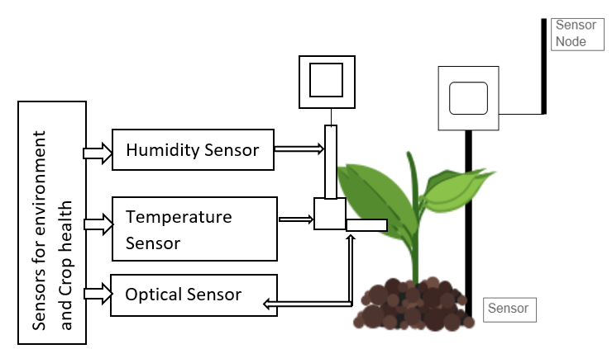
Fig.5 Soil Moisture Detection with wireless sensors
Sensors for the environment: These are the sensors that monitor the environment including those that gauge temperature, humidity, and rainfall. Decisions about irrigation, planting, and harvesting may be made using this data.
Farmers are starting to understand the advantages of having access to real-time data on their crops and the environment, which is why agricultural sensors are being used more and more frequently. We may anticipate even more cutting-edge use of sensors in agriculture as technology progresses.
5 Transportation and Logistics
Incorporating IoT sensors in vehicles and cargo containers enables real-time tracking and monitoring of goods, improving supply chain efficiency and reducing delivery times. IoT-based tracking and monitoring systems have become integral to the transportation and logistics industry. Companies like FedEx and UPS have implemented IoT solutions to track packages, optimize delivery routes, and improve overall operational efficiency [9].
The IoT market is anticipated to exceed US$1 trillion in 2022, with the majority of companies, around 80%, implementing IoT technologies within the next five years. The transportation sector is also integrating IoT technologies, with an estimated expenditure of US$71 billion in 2019, and North America leading the way in adoption. Other significant markets are following suit, with telematics penetration expected to reach 95% for new trucks by 2026. As implementation barriers decrease and deployment becomes more widespread, the competitive advantage provided by IoT-enabled operations in transportation may no longer exist. [17]
Let us consider the IoT ecosystem that Deloitte designed [17].
Connected vehicles are a prime example of the potential of a fully integrated IoT ecosystem. As shown in Fig. 6, modern connected trucks not only transport goods but also generate a wealth of data. This includes information on location, engine performance (such as speed, idle time, and fuel levels), environmental conditions (like temperature, humidity, and light exposure), vehicle data (such as shocks and movement), driver behaviour (including fatigue and erratic driving patterns), and security (including theft, tampering, and alarm activations).
Temperature and Humidity sensors
Vehicle shock and movement
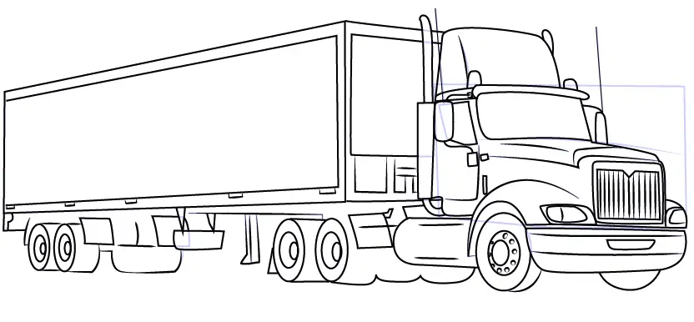
GPS system
Rear Camera
Front Camera

Fig 6. IoT enabled Truck [Ryan Ernst et.al (2019)]
By transferring data from a smart fleet to a cloud-based system and integrating it with other technologies and transportation processes, it is possible to enhance routing, shipment tracking, quality compliance, fleet management, driver performance management, and safety. In a fully IoT-enabled transportation ecosystem, information would circulate smoothly throughout the network, forming an information value loop (refer to Fig. 7). [17]
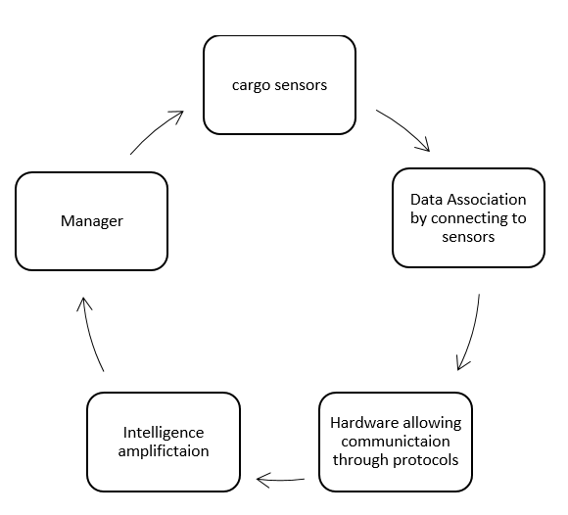
3
2
4
1
Fig 7. The flow of Information in the transportation system supported by IoT [Ryan Ernst et.al (2019)]
1. First we start with collecting the data, for instance, the current location of the vehicle, the current status of fuel, temperature, and humidity from the respective sensors connected to the vehicle. [17]
2. The collected information is raw and so it will be formatted, structured, and organized in a systematic manner. [17]
3. Once the required information is available in a format that can be analysed to get useful insights, and monitor the events or functioning, may be problems in delivery or maintenance required can be identified easily. [17]
4. Depending on the outcome of the analysis the necessary actions will be taken by the manager for instance performing scheduled maintenance, finding the shortest and fastest route, quickly responding to the demand, and quality assurance and management system. [17]
3. Challenges and Limitations:
Let us understand the Challenges and limitations of IoT.
3.1 Data Security and Privacy
IoT data collection raises concerns regarding data security and privacy. Unauthorized access to sensitive information can lead to severe consequences. Robust encryption and authentication mechanisms are essential to mitigate these risks.
3.2 Interoperability and Standardization
The lack of standardized protocols can hinder the seamless integration of different IoT devices and platforms. Establishing universal communication standards is crucial to ensuring interoperability.
3.3 Power Consumption
IoT devices are often constrained by limited power sources. Optimizing energy efficiency is necessary to prolong the lifespan of these devices and reduce environmental impact.
4. Ensuring Security and Privacy in IoT Data Collection
There are various ways in which security and privacy in IoT during data gathering.
4.1 Authentication and Authorization
Robust authentication and authorization mechanisms should be implemented to validate the identity of IoT devices before granting access to data. This can be achieved through secure protocols, cryptographic keys, or certificates to ensure that only authorized devices and users can interact with the IoT network and access IoT data.
4.2 Data Encryption
To safeguard data privacy and confidentiality, encryption techniques should be applied during data transmission and storage. By encrypting data, even if it is intercepted, it remains unreadable to unauthorized entities. Secure protocols like Transport Layer Security (TLS) or Datagram Transport Layer Security (DTLS) can be utilized for secure communication.
4.3 Access Control
Implementing effective access control mechanisms helps prevent unauthorized access to IoT devices and the data they generate. Role-based access control (RBAC) or attribute-based access control (ABAC) models can be utilized to manage and enforce access policies.
4.4 Data Minimization
Collecting and storing only necessary data helps reduce the risks associated with data breaches. Minimizing personally identifiable information (PII) and sensitive data stored on IoT devices or transmitted over networks can mitigate the potential impact of a data breach.
4.5 Secure Software and Firmware
IoT devices often run on embedded software or firmware, making them potential targets for cyberattacks. Implementing secure coding practices, regularly assessing vulnerabilities, and promptly applying security patches and updates are vital to protect against software vulnerabilities and exploits.
4.6 Network Segmentation
Segregating IoT networks into separate zones or subnets with appropriate firewalls and access controls can limit the lateral movement of attackers within the network. This prevents unauthorized access to critical systems even if one part of the network is compromised.
4.7 Regular Updates and Patches
Keeping IoT devices updated with the latest security patches helps mitigate potential vulnerabilities.
4.8 Privacy by Design Integrating privacy principles into the design and development of IoT solutions can help mitigate privacy risks. Conducting privacy impact assessments, employing data anonymization techniques, and implementing user consent mechanisms ensure privacy protection throughout the IoT ecosystem.
4.9 Data Lifecycle Management
Implementing robust data lifecycle management practices ensures data is protected from collection to disposal. This includes secure data storage, adherence to data retention policies, and secure data destruction techniques.
4.10 Regular Monitoring and Auditing
Continuous monitoring of IoT devices, networks, and data transmissions enables the detection of anomalies and potential security breaches. Auditing and logging events facilitate investigating security incidents and ensuring compliance with privacy regulations.
4.11 User Awareness and Consent
Educating users about the privacy and security risks associated with IoT devices is crucial. Providing clear and transparent information about data collection practices and obtaining informed consent from users before collecting their data fosters trust and empowers individuals to make informed decisions.
5. Real-World Use Cases
5.1 Smart City Initiatives
Many cities worldwide are implementing IoT-based solutions to optimize urban services, including traffic management, waste management, and energy consumption. For example, Barcelona, Spain, has implemented an extensive smart city project called "Barcelona Smart City" that utilizes IoT sensors to monitor and optimize various city services [10]. Additionally, Songdo, South Korea, is a smart city project that employs IoT to monitor energy usage, traffic, and waste management [11].
5.2 Energy Monitoring
IoT-based energy monitoring systems have gained traction in recent years as valuable tools for businesses and households to track and optimize their energy consumption. By leveraging IoT sensors, these smart energy monitoring systems provide real-time insights that enable more efficient energy usage. Italy's PowerWatcher project serves as a prime example of how IoT sensors were utilized to monitor energy consumption in households, resulting in reduced wastage and significant cost savings [12].
In Italy, the PowerWatcher project successfully implemented IoT technology to enable the monitoring of energy usage in residential buildings. This involved deploying a network of strategically positioned sensors within households to collect detailed data on electricity consumption. These sensors captured information such as power consumption levels, peak usage times, and specific energy-consuming devices.
Once collected, the data was wirelessly transmitted to a centralized control system for analysis. Advanced algorithms and machine learning techniques were employed to derive meaningful insights from the data, revealing energy consumption patterns and trends. By studying the data over time, the system could identify inefficient energy usage practices, pinpoint energy-intensive appliances, and highlight areas where improvements could be made.
5.3 Smart Shelves in Retail:
An excellent illustration of IoT implementation in the retail industry is the use of smart shelves. These shelves are equipped with sensors and connectivity features that enable real-time monitoring of inventory levels and provide valuable data on product availability. Let's explore some key aspects of their functionality:
Efficient Inventory Management: Smart shelves utilize weight sensors or RFID tags to detect the presence or absence of products. When a customer picks up or places an item on the shelf, the sensors detect the change in weight or read the RFID tag, automatically updating the inventory system. This real-time data allows retailers to closely track stock levels and reduce instances of out-of-stock situations.
Data-Driven Insights: By collecting data on product movement and customer interactions, smart shelves offer valuable insights into customer behaviour and preferences. Retailers can analyse which products are frequently handled but not purchased, enabling them to optimize product placement and pricing strategies accordingly.
Streamlined Replenishment: Connected to the inventory system, smart shelves can trigger automatic replenishment orders when inventory levels reach a predefined threshold. This automation streamlines the restocking process, ensuring shelves are consistently well-stocked, minimizing missed sales opportunities, and reducing the need for manual inventory checks.
Personalized Promotions: Integrated with digital displays or screens, smart shelves can deliver targeted promotions and product information based on the items on the shelf or customer profiles. For example, if a customer selects a particular brand of coffee, the digital display can showcase relevant offers or suggest complementary products.
Enhanced Customer Experience: IoT-enabled shelves provide an interactive and engaging shopping experience. Customers can receive personalized product recommendations or access additional information, reviews, or nutritional facts by scanning items with their smartphones.
Theft Prevention: Smart shelves equipped with IoT sensors help prevent theft and unauthorized removal of products. If an item is taken from the shelf without being scanned or purchased, the system can generate an alert, deterring theft and minimizing losses.
One real-world example of smart shelves in action is the collaboration between Kroger, a major US supermarket chain, and Microsoft. Kroger implemented smart shelves in two pilot stores using Microsoft's Azure IoT platform. These smart shelves are known as "Kroger Edge" shelves.
Thus we can say that the implementation of IoT in retail, particularly through smart shelves, significantly improves inventory management, enhances the customer experience, optimizes promotional strategies, and reduces operational inefficiencies. Retailers can leverage real-time data, make informed decisions, and streamline their supply chain processes to increase sales and overall efficiency.
5.4 Smart Home IoT devices:
IoT devices have revolutionized the concept of smart homes, offering a range of innovative solutions. One popular example is the smart thermostat, which includes devices like the Nest Learning Thermostat and Ecobee Smart Thermostat. These thermostats can intelligently learn your schedule and preferences, automatically adjusting the temperature in your home for optimal comfort and energy efficiency. They provide remote control functionality through smartphone apps and can integrate with other smart devices within your home ecosystem.
Smart lighting is a noteworthy IoT component for smart homes. With the use of a smartphone app or voice commands, owners of the well-known Philips Hue brand may schedule, change the colour, and adjust the brightness of their lights. Users may create the ideal atmosphere for any event with programmable lighting sequences and automation options. A further convenience and energy-saving feature of certain systems is the ability to turn lights on or off when you enter or leave a room.
Smart locks have grown in popularity in the IoT sector for improving home security. The August Smart Lock and the Yale Assure Lock are two examples. These gadgets take the place of conventional locks and provide cutting-edge capabilities like voice control or smartphone apps for locking and unlocking doors. In order to increase convenience and security overall, some versions even offer temporary access credentials for visitors or connectivity with other smart home equipment.
6. Conclusion
The advent of IoT technology has brought about a paradigm shift in data collection methodologies. By harnessing the power of interconnected devices and sensors, IoT has enabled the collection of vast amounts of data, fostering innovation across various industries. While challenges like data security and interoperability persist, the benefits of IoT for data collection far outweigh the risks. To fully realize the potential of IoT, it is imperative to prioritize security, privacy, and standardization efforts. As IoT continues to evolve, it holds the promise of transforming the way we gather, analyses, and utilize data, driving us toward a more connected and data-driven future. By embracing these opportunities and addressing the challenges, we can harness the full power of IoT and create a world where data drives innovation and connectivity, leading to unprecedented advancements across sectors.

References:
[1]SmartCitizen. (n.d.). SmartCitizen - Crowdsourced environmental monitoring. Retrieved from https://smartcitizen.me/
[2]Shen, W., Nguyen, H., & Thai, T. (2015). FloodNet: A Low-Cost Flood Monitoring System using Wireless Sensor Networks. In Proceedings of the 2015 IEEE 13th International Conference on Industrial Informatics (INDIN) (pp. 954-958). IEEE.
[3]Torous, J., Jän Myrick, K., Rauseo-Ricupero, N., & Firth, J. (2018). Digital mental health and the Internet of Things (IoT). Harvard Review of Psychiatry, 26(6), 340-348.
[4]Kusumoto, F., Goldschlager, N., & Hare, J. (2019). Cardiac Devices and the Internet of Things. Circulation: Arrhythmia and Electrophysiology, 12(4), e007495.
[5]Proctor, C., & Jones, D. (2016). The Future of the Internet of Things in Industrial Markets. https://www.ge.com/reports/wp-content/uploads/2016/05/IIoT_MarketBrief.pdf
[6]Xia, W., Mao, Z., Wang, X., Martinez, L., & Xie, L. (2012). Internet of Things. International Journal of Communication Systems, 25(9), 1101-1102.
[7]Gogoi, A., Bora, B., Bhattacharyya, D., & Bhattacharyya, N. (2019). IoT-based real-time smart irrigation system for agriculture. In 2019 International Conference on Smart Electronics and Communication (ICOSEC) (pp. 31-34). IEEE.
[8]Kumar, N., Pandey, M., & Singh, S. (2020). Smart Farming using the Internet of Things (IoT). In 2020 International Conference on Emerging Trends in Communication, Control, and Computing (ICONC3) (pp. 1-4). IEEE.
[9]Veracity. (n.d.). The IoT in logistics – smartening up along the supply chain. Retrieved from https://www.veracity.com/insights/iot-logistics-smartening-up-along-supply-chain
[10]Barcelona Smart City. (n.d.). https://www.barcelona.cat/en/smart-city
[11]Smart Cities Dive. (2018). Songdo: the world's most "smart" city. Retrieved from https://www.smartcitiesdive.com/ex/sustainablecitiescollective/songdo-worlds-most-smart-city/229856/
[12]Iacopo, C., Elia, P., & Pisasale, P. (2019). PowerWatcher: An IoT-based home energy monitoring system. In 2019 IEEE International Workshop on Metrology for Industry 4.0 & IoT (MetroInd4.0&IoT) (pp. 269-274). IEEE.
[13]Ambarish G. Mohapatra, Pradyumna Kumar Tripathy, Maitri Mohanty, Ashish Khanna (2021) IoT enabled distributed cardiac monitoring using Fiber Bragg Grating (FBG) sensing technology Proceedings of the International Conference on Innovative Computing & Communication (ICICC) 2021 (https://papers.ssrn.com/sol3/papers.cfm?abstract_id=3842806)
[14] Fazli Subhan ,ORCID,Alina Mirza ,Mazliham Bin Mohd Su’ud ,Muhammad Mansoor Alam ,Shibli Nisar ,Usman Habib ORCID andMuhammad Zubair Iqbal (2023) AI-Enabled Wearable Medical Internet of Things in Healthcare System: A Survey Applied Sciences Volume13 , Issue 3 https://www.mdpi.com/2076-3417/13/3/1394
[15] Eleni Symeonaki, Konstantinos Arvanitis, Dimitrios Piromalis(2020) A Context-Aware Middleware Cloud Approach for Integrating Precision Farming Facilities into the IoT toward Agriculture 4.0, Applied Sciences 10(3):813
https://www.researchgate.net/publication/338770474_A_Context-Aware_Middleware_Cloud_Approach_for_Integrating_Precision_Farming_Facilities_into_the_IoT_toward_Agriculture_40
[16] Mladen Jurišić*, Ivan Plaščak, Željko Barač, Dorijan Radočaj, Domagoj Zimmer(2021) Sensors and Their Application in Precision Agriculture, Tehnički Glasnik 15(4):529-533 https://researchgate.net/publication/355845598_Sensors_and_Their_Application_in_Precision_Agriculture
[17] Ryan Ernst, Alan Taliaferro, Usman Ahmed, Anupama Harolikar, Shiladitya Ray (2019), Creating IoT ecosystems in transportation https://www2.deloitte.com/xe/en/insights/focus/internet-of-things/transportation-iot-internet-of-things-ecosystem.html

