EVIDENCE-BASED PRACTICE
A.L. MAHALAKSHMI
Professor Cum Vice Principal, Shri Sathya Sai College of Nursing, Sri Balaji Vidyapeeth (Deemed to be University), Puducherry. mahaprabhupm@gmail.com, 9884421981, Orchid id: 0000-0002-5902-8572
ABSTRACT: -
The importance of evidence-based practice in healthcare for improving patient outcomes is widely recognized. While nursing research primarily generates new knowledge, evidence-based nursing practice focuses on applying the best available evidence to guide care. There's a growing trend in research to effectively translate evidence into practice. It's clear that having research-based evidence alone isn't enough; it must also be successfully integrated into a supportive environment to yield meaningful results.In nursing, evidence-based practice means delivering comprehensive, high-quality care based on the latest research and knowledge rather than relying solely on traditional methods, advice from peers, or personal beliefs. Implementing evidence-based practice in nursing bridges the gap between theory and actual patient care, leading to innovative healthcare that incorporates the latest discoveries. Evidence-based practice remains a central theme throughout a nursing career, with its origins dating back to Florence Nightingale, the pioneer of modern nursing. Nightingale collected data and established a connection between unhygienic conditions and declining health, a concept that remains relevant today. Over the past century, advancements in technology and human ingenuity have led to solutions that were unimaginable just 50 years ago. Many diseases have been conquered, countless lives saved, and the pursuit of improved healthcare solutions continues. Evidence-based practice in nursing underscores the notion that medical practices should evolve continually based on an ongoing cycle of evidence, theory, and research. Changes in practice stimulate further research, and the theories arising from that research serve as evidence to drive additional improvements in practice.
I) INTRODUCTION:
Evidence-based practice in nursing requires the ongoing examination and evaluation of the most current research findings. In the nursing context, this knowledge gained from evidence-based research may indicate the need to adapt established nursing care protocols in your clinical practice. It is advisable to engage in collaborative discussions about your findings with your nurse manager and team before implementing any changes. Once you have their support and ensure alignment with your facility's policies and procedures, you can integrate these evidence-based nursing interventions with your patients' values to provide the most effective care. Dr. David Sackett's classic definition of Evidence-Based Practice (EBP) characterizes it as the thoughtful and deliberate use of the latest and most reliable evidence when making decisions about an individual patient's care. This approach involves combining the clinician's expertise, the best available external clinical evidence from systematic research, and the unique values and circumstances of the patient, as well as the specific characteristics of the healthcare setting. In simpler terms, evidence-based practice employs a data-driven, scientific approach to decision-making in patient care. It requires healthcare professionals to critically evaluate evidence and systematically gather information about relevant events. Evidence-based practice formalizes the most effective clinical practices, policies, and procedures.

II) IMPORTANCE OF EVIDENCE-BASED PRACTICE :
The importance of Evidence-Based Practice (EBP) lies in its dedication to providing the most effective healthcare, with the primary objective of improving patient outcomes. Patients rightly expect to receive care based on the latest and most dependable evidence. EBP encourages healthcare professionals to cultivate a sense of curiosity, prompting them to question the rationale behind their practices: Why am I approaching this in this particular way? Is there evidence available to guide me towards a more effective approach? As healthcare providers, a fundamental aspect of delivering a professional service is ensuring that our actions are guided by the most reliable evidence. Furthermore, EBP contributes to the responsible allocation of limited healthcare resources and ensures that relevant evidence informs decisions related to the allocation of funding for healthcare services. It establishes a framework for evidence-based nursing interventions that serve as valuable guidelines for making decisions regarding patient care.
This process involves integrating the best external evidence, the clinician's clinical expertise, and the patient's values and expectations.
- Formulate a Clear and Specific Question: Begin by creating a well-defined and specific question related to the patient's condition, with the ultimate goal of improving a specific procedure tailored to their needs.
- Gather Reliable Evidence: Collect the most trustworthy evidence by conducting a thorough search for clinical articles from reputable and credible sources.
- Evaluate Resources: Assess the gathered resources to determine their validity, quality compared to established evidence standards, and relevance to the patient's situation.
- Apply Evidence to Practice: Make informed decisions that draw upon both your nursing expertise and the newly acquired information, incorporating the evidence into clinical practice.
- Continuously Assess Outcomes: Continually evaluate the outcomes to measure the effectiveness of the treatment and consider its applicability to other patients.
In summary, EBP is a cornerstone of quality healthcare, driving professionals to continually seek and integrate the best available evidence into their practice, ultimately benefiting patient care and resource allocation.

III) PURPOSE OF EVIDENCE-BASED PRACTICE:
The purpose of Evidence-Based Practice (EBP) can be succinctly summarized as follows:
- Staying Informed: EBP serves as a structured guide to help practitioners stay up-to-date with the latest trends in medical treatment, even in the face of an overwhelming amount of research.
- Guiding Practice:It equips practitioners with the most reliable evidence available to inform and guide their clinical practice, enhancing the quality of patient care.
- Encouraging Inquiry: EBP promotes a mindset of inquiry among healthcare professionals, encouraging them to question established practices.
- Validating Decision-Making: EBP supports clinical decision-making by combining clinical experience with evidence, lending credibility to the choices made.
- Incorporating Patient Values: It ensures that patient values and individual circumstances are integrated into the decision-making process, emphasizing patient-centered care.
In essence, EBP is driven by the aim of enhancing healthcare by integrating the latest research findings with clinical expertise and patient preferences, ultimately leading to improved patient outcomes and the provision of high-quality care. Nursing research serves as the cornerstone of Evidence-Based Nursing (EBN) practice. While definitions of Evidence-Based Practice (EBP) may vary, it encompasses a broad spectrum of evidence sources, including research findings, knowledge from fundamental science, clinical expertise, and expert opinions. However, practices grounded in research findings are more likely to yield favorable patient outcomes across diverse healthcare settings and geographical locations. Staff nurses assume a pivotal role in translating research-based changes into clinical practice. The availability of resources can fluctuate depending on the healthcare environment, affecting the capacity to critically evaluate and apply research findings directly at the point of care. They are ideally situated to support new nurses in transitioning to evidence-based practice.In the EBP approach, healthcare professionals leverage the best available evidence to make clinical decisions tailored to individual patients. This process entails meticulous and thoughtful decision-making that not only considers the existing evidence but also accounts for patient characteristics and preferences, emphasizing the integration of theory-guided practice at the core of nursing. This fusion combine outcome-driven practice with the art and science of caring and healing. Although EBP necessitates nurses to base treatment on scientific research, its origins can be traced back to the nursing pioneer Florence Nightingale, even though it gained prominence in the field of medicine during the late 1980s. EBP is rooted in the principle that healthcare professionals should ground their practice in sound information derived from research findings and scientific advancements. There is a perpetual emphasis on advancing nursing knowledge through research and theory development to enrich the foundation of nursing practice. Nursing encompasses various forms of knowledge due to its multidisciplinary nature, encompassing social, behavioral, and biological sciences. Implementing treatment plans following a comprehensive analysis of research reviews is a pivotal step in evidence-based nursing practice. All individuals involved in patient care employ research information to formulate treatment plans. EBP signifies a shift toward a more scientifically informed approach to patient care, while simultaneously recognizing the significance of personal experience, wisdom, and patient relationships in delivering effective nursing care. The examples provided underscore the significant role that research evidence plays in healthcare practices, emphasizing that different individuals and populations may respond differently to interventions.

IV) BENEFITS OF EVIDENCE-BASED PRACTICE IN NURSING
Evidence-based nursing practice brings numerous benefits that extend beyond merely keeping healthcare practices current and relevant, benefiting both nurses and patients significantly:
- Enhances Patient Outcomes: It promotes favorable patient results by guiding care based on the most reliable evidence.
- Reduces Healthcare Costs: By preventing complications, it helps in lowering healthcare expenses.
- Advances Nursing Science: It contributes to the growth of the nursing field by fostering scientific exploration.
- Facilitates Technology Integration: EBP allows for the seamless incorporation of new technologies into healthcare practices.
- Empowers Nurses: It boosts nurse autonomy and decision-making confidence.
- Maintains Relevance: EBP ensures the ongoing relevance of nursing practice through the integration of new interventions and care protocols.
- Offers Informed Decision-Making: It provides scientifically backed research to support well-informed decision-making.
- Promotes Shared Decision-Making EBP promotes collaborative patient involvement in the planning of care decisions.
- Improves Critical Thinking: It enhances critical thinking skills among healthcare professionals.
- Encourages Lifelong Learning: EBP fosters a culture of continuous learning and professional development.
V) FOUR PRIMARY TIERS OF EVIDENCE-BASED PRACTICE, EACH EXERTING VARYING DEGREES OF INFLUENCE ON CLINICAL DECISIONS:
PRIMARY TIERS 1: primarily relies on randomized, controlled trials, regarded as the most reliable source of evidence.
PRIMARY TIERS 2 : is founded on well-structured controlled trials that lack randomization.
PRIMARY TIERS 3: is utilized when there's limited information about a condition and depends on consensus viewpoints or expert opinions.
PRIMARY TIERS - ML (multi-level) is typically employed in intricate cases, combining evidence from various sources across the other levels.
VI) THE EVIDENCE-BASED PRACTICE (EBP) PROCESS ENCOMPASSES FIVE KEY STEPS:The "5A's Cycle" in EBP consists of evaluating the patient's condition, giving priority to care-related inquiries, crafting precise clinical questions, collecting relevant evidence, meticulously assessing research discoveries, integrating evidence-based approaches into patient care, and periodically reviewing one's performance. This cycle then recommences with a reevaluation of the patient and their care.
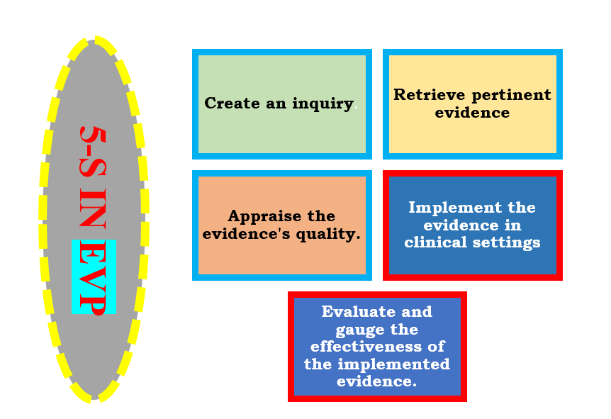Fig:3 -5A's Cycle" in EBP
VII) THE EBP PROCESS
The process has evolved to encompass several components, including the most reliable available research evidence, clinical expertise, the unique values and circumstances of the patient, and the specific attributes of the healthcare setting where the healthcare professional operates. Therefore, EBP goes beyond the mere application of research evidence; it also involves drawing upon one's experience, competencies, and professional training in healthcare while taking into consideration the individual situation and values of the patient (e.g., social support, financial status), as well as the context of the practice (e.g., budget constraints). This comprehensive integration of information is referred to as clinical reasoning. Engaging in EBP means making patient care decisions that encompass all four of these components. With the healthcare system facing increasing pressures and challenges, especially healthcare professionals like nurses dealing with reduced staffing and budget constraints, EBP has become indispensable. This is further compounded by heightened public awareness and legal issues related to healthcare, including concerns such as antibiotic-resistant bacteria, medical errors, suboptimal patient outcomes, and patient dissatisfaction, which are frequently highlighted in the media. Consequently, EBP has become a widely recognized concept and an essential aspect of healthcare practice.
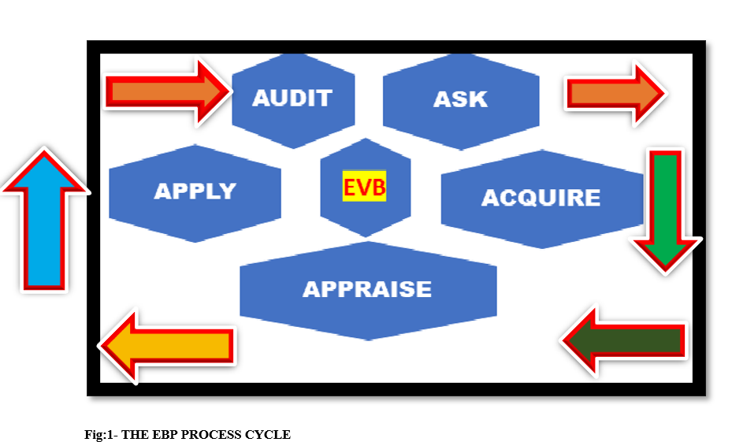
a) Clarifying the Notion and Bridging the skills gap The idea and the fundamental competencies essential for the practice of evidence-based healthcare often prove to be deficient among healthcare professionals. Evidence-based practice (EBP) entails a systematic approach in the healthcare realm, emphasizing the utilization of the most reliable available evidence alongside a practitioner's experience and patient preferences and values to make informed decisions regarding care and treatment. In essence, EBP equips healthcare practitioners with a structured framework for critically assessing their daily routines, making necessary informed adjustments, and simultaneously advancing the knowledge base within their field. Melnyk and Fineout-Overholt have delineated key steps supporting this process.
b) Nurturing the Research Inquiry The initial step carries exceptional significance, necessitating the precise delineation of the specific area of focus right from the outset. This involves the formulation of precise clinical inquiries related to the particular issue at hand. While such inquiries frequently arise in everyday healthcare practice, spanning from fundamental care concerns to more intricate matters, they are occasionally overlooked or left unaddressed amidst the chaos of clinical work. Nonetheless, tools and frameworks exist to aid practitioners in posing and addressing these critical clinical questions, ensuring they receive the attention they deserve. Although this phase may seem time-intensive, it ultimately culminates in the development of focused and efficient inquiries, resulting in a targeted and effective exploration of the literature.
c) The Decision-Making Process Armed with a well-defined and concentrated question, the ensuing step involves conducting a literature search that is less extensive and labor-intensive than conventionally perceived. Instead of generating an excessive number of search results, potentially numbering in the hundreds and often irrelevant, practitioners can now acquire a small, curated collection of highly pertinent research papers for consideration. A range of tools, often referred to as hierarchies of evidence, are accessible to aid individuals, including those new to the field, in assessing the quality of the amassed evidence. However, research findings cannot exist in isolation; they must be placed within the context of care, patient preferences, clinical proficiency, and clinical judgment. The mere implementation of research findings, devoid of due consideration for the care environment, patient involvement, and clinician expertise, carries limited value and may not result in enhanced care or outcomes.
d) Supervision and Assessment The EBP process surpasses the implementation of specific care practices dictated by the best available evidence. It is pivotal to assess the executed care or practice to gauge its true impact. This evaluation is indispensable for generating evidence derived from practical applications. Examples of assessable outcomes encompass infection rates, hospital stays' duration, responses to psychosocial interventions, enhancements in the quality of life, and surveys gauging patient or service-user satisfaction. These outcomes collectively contribute to the enhancement of healthcare services and the overall patient experience.

VIII) STEPS OF EVIDENCE-BASED PRACTICE
A) Crafting a Question and Developing a Hypothesis In the initial stage, a healthcare professional formulates a specific inquiry related to clinical practice. This inquiry often revolves around topics like the potential impact of exercise on reducing blood sugar levels. This inquiry then evolves into the creation of a hypothesis, such as the idea that engaging in 30 minutes of exercise three times a week will result in decreased blood sugar levels, regardless of diet or medication.
B) Collecting and Assessing Supporting Information The subsequent phase entails the collection and scrutiny of available information to evaluate the formulated hypothesis. The healthcare provider gathers data, analyzes it, and draws conclusions based on this evidence. Typically, the evidence is structured using the PICO framework, which encompasses the identification of the patient population, the intervention, comparison, and the desired outcomes.
C) Documenting and Assessing Discoveries Modern information systems efficiently capture and integrate various types of data, enabling healthcare professionals to effectively correlate and evaluate information. This procedure involves reviewing patient histories, objective observations, and test results to make well-informed conclusions.
D) Engaging in the Evidence-Based Practice (EBP) Procedure Engaging in the EBP procedure encompasses six distinct steps, which have been adapted here for the application of social work across various levels of intervention:
- Formulating a precise practice-related question.
- Identifying the most pertinent evidence to address the question.
- Critically evaluate the quality and relevance of the identified evidence.
- Incorporating the findings of the critical evaluation with professional expertise and the unique circumstances of the individual or client system.
- Taking appropriate actions based on the critical assessment of the evidence.
- Continuously monitoring and assessing outcomes related to both the practice decision or intervention and the overall effectiveness and efficiency of the EBP process. EBP is a fundamental component of enhancing patient outcomes and should be seamlessly integrated into daily practice, rather than being seen as an additional task. Overcoming obstacles and perceiving them as adaptable challenges can facilitate the broader adoption of EBP in healthcare

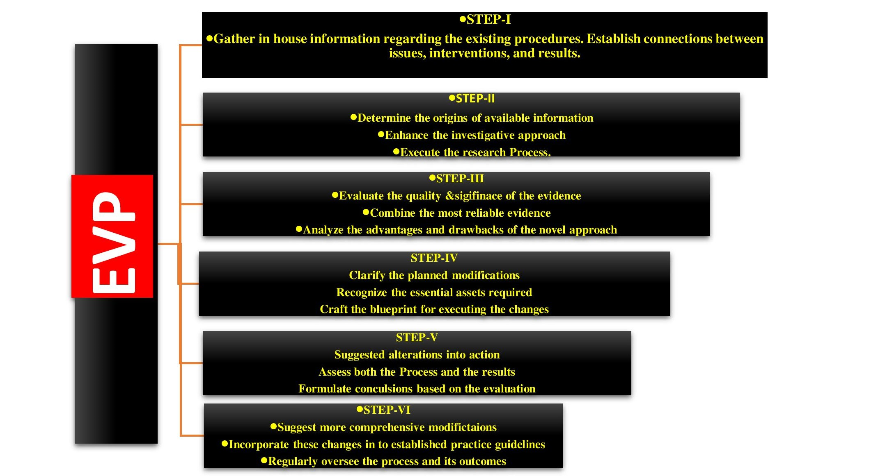
Fig;2: Steps in EVP
Nurses face significant challenges when attempting to translate the best available evidence into clinical practice. For example, research-based databases may have limitations in various areas, and the continuous influx of information further complicates the process. Some of the barriers to EBP encompass:
X) COMMON MISUNDERSTANDINGS ABOUT EVIDENCE-BASED PRACTICE
Misunderstandings surrounding evidence-based practice present a substantial obstacle to its acceptance and implementation. It is crucial to address and correct these misconceptions, as they often arise from a limited or narrow understanding of evidence-based practice principles.
A) Misconception 1: Evidence-based practice dismisses the professional expertise of practitioners. This misconception runs counter to the core of evidence-based practice, which emphasizes decision-making through the careful and judicious utilization of evidence from diverse sources, including practitioners' experiences. Evidence-based practice does not favor one source of evidence over another. Even the professional experience and judgment of practitioners can be a valuable source if considered reliable and pertinent. Insights from practitioners play a vital role in appropriately interpreting and applying evidence from various sources. For instance, when determining effective communication methods among colleagues, organizational evidence may provide insights, but professional experience and judgment are essential in evaluating which practices are practical, especially when working with colleagues of varying skill levels. Likewise, scientific literature can assist in assessing the credibility of personal experiences and judgment. Research indicates that extensive experience in a specific field can lead to substantial expertise and implicit knowledge. In contrast, an individual with numerous unrelated jobs over the same period may possess less reliable expertise. Evidence-based practice centers on utilizing evidence from multiple sources rather than relying solely on one.

B) Misconception 2: Evidence-based practice is exclusively concerned with numbers and statistics. Evidence-based practice involves the search for and utilization of the best available evidence from various sources. It does not exclusively revolve around numbers and quantitative data, although many decisions may have numerical aspects. Becoming a statistician is not a prerequisite for engaging in evidence-based practice, but having a basic understanding of statistical concepts can be beneficial for critically evaluating specific types of evidence. Grasping principles such as sample size, the distinction between statistical and practical significance, confidence intervals, and effect sizes can be achieved without delving into advanced mathematics. Evidence-based practice is not about conducting statistical analyses but rather encompasses adopting statistical thinking as a critical component.
C) Misconception 3: Managers face time constraints and must make quick decisions, making evidence-based practice impractical. However, the approach shifts towards working with the limited available evidence and supplementing it through experiential learning. This involves conducting pilot tests and treating actions as prototypes, systematically evaluating outcomes through experimentation, and engaging in critical reflection .

D) Misconception 5: High-quality evidence doesn't offer definitive solutions to problems. Evidence cannot stand alone; it requires a contextual understanding and critical assessment. Evidence cannot convey its meaning independently. It demands an understanding of the context and a discerning mindset. Evidence-based practitioners don't base decisions on conclusive, unquestionable information but rely on probabilities, indicators, and provisional conclusions. Evidence doesn't dictate decisions; instead, it aids in making more informed choices.

XI) ADVANTAGES OF EVIDENCE-BASED PRACTICE
There are several benefits to embracing evidence-based practice in healthcare, benefiting both providers and patients. Some examples include: • Keeping providers up-to-date: Evidence-based practice helps healthcare providers stay current with evolving treatment methods, ensuring they are informed about emerging practices. • Enhancing clinical decision-making: Evidence-based practice assists providers in evaluating and weighing different types of information, enabling them to make informed decisions for their patients. • Promoting patient recovery: Evidence-based care expedites the diagnosis, treatment, and recovery processes, resulting in improved patient outcomes. • Reducing risks: An evidence-based approach encourages providers to thoroughly assess the risks associated with different treatment options, leading to safer and more effective care.

XII) APPLICATION OF EVIDENCE-BASED PRACTICE IN HEALTHCARE ENVIRONMENTS Implementing evidence-based practice in healthcare follows a six-step process:
- Assess the need for change: Identify areas where current practices require enhancement based on the deficiencies of existing methods.
- Locate the best evidence: Identify sources of evidence and evaluate their credibility and relevance to the research question.
- Synthesize evidence: Analyze and compare available sources to identify commonalities and disparities in various approaches.
- Design the change: Apply synthesized evidence to create a new practice aligned with the updated understanding.
- Implement and evaluate: Put the necessary changes into action and assess their impact to gather new evidence.
- Integrate and sustain changes: Continuously reassess and update practices based on new evidence to maintain ongoing improvement.

XIII) CONCLUSION
Nursing research has always been aimed at enhancing patient care. Nurses should actively contribute to advancing evidence-based practice by addressing barriers, correcting misconceptions, and challenging current clinical practices. Healthcare administrators should foster a culture of intellectual curiosity and provide support for research endeavors. Nurses are dedicated to providing holistic care, focusing on treating and collaborating with patients rather than merely working on them. The effectiveness of treatment is just one aspect of clinical decision-making; factors like patient acceptability and cost-effectiveness are also considered. Several obstacles to implementing evidence-based practice have been identified, and nurse administrators play a pivotal role in fostering an EBP culture within healthcare facilities.

XIV) REFERENCE:
- Chien L. Y. (2019). Evidence-Based Practice and Nursing Research. The journal of nursing research : JNR, 27(4), e29. https://doi.org/10.1097/jnr.0000000000000346
- Turner, M. (2014). "Evidence-Based Practice in Health.” Retrieved from University of Canberra website: https://canberra.libguides.com/evidence
- Guyatt, G.H., Haynes, R.B., Jaeschke, R.Z., & Cook, D.J. (2000). Users' guides to the medical literature: XXV. evidence-based medicine: principles for applying the users' guides to patient care. JAMA, 284, 1290-1296. doi: http://dx.doi.org/10.1001/jama.284.10.1290
- Sackett, D., Rosenberg, W., Gray, J., et al. (1996). Evidence based medicine: what it is and what it isn't: it's about integrating individual clinical expertise and the best external evidence. BMJ, 312, 71-72. doi: http://dx.doi.org/10.1136/bmj.312.7023.71
- Mayer, D. (2010). Essential evidence-based medicine (2nd ed.). Cambridge: Cambridge University Press.
- Hoffman, T., Bennett, S., & Del Mar, C. (2013). Evidence-based practice: across the health professions (2nd ed.). Chatswood, NSW: Elsevier.
- Straus, S., Glasziou, P., Richardson, W., & Haynes, R. (2011). Evidence-based medicine: how to practice and teach it (4th ed.). Edinburgh: Churchill Livingstone Elsevier
- Bushell, M. (2019). Supporting your practice: Evidence-based medicine. Australian Pharmacist, 38, 3, 46-55.
- Cleary-Holdforth J and Leufer T. Evidence-based practice: sowing the seeds for success. Guest Editorial (Invited). Nurse Educ Pract; 2009. 9, p285-287
- An Bord Altranais. Code of Professional Conduct for each Nurse and Midwife. Dublin: An Bord Altranais; 2000
- Larrabee, J. H. (2009). Nurse to nurse: Evidence-based practice. New York: McGraw-Hill.
- Fawcett, J., & Garity, J. (2009). Evaluating research for evidence-based nursing practice. Philadelphia: F.A. Davis.
- Straus, S. E., Glasziou, P., Richardson, W. S., & Haynes, R. B. (2018). Evidence-based medicine: How to practice and teach EBM. Retrieved from https://ebookcentral.proquest.com/

