**DESIGN AND CONSTRUCTION OF A HYBRID (SOLAR-ELECTRIC) FLEXIBLE GRASS CUTTER USING LOCALLY AVAILABLE MATERIALS**

M.A. ISLAM1 and M.H. ALI2

1Scientific Officer, 2Chief Scientific Officer

Agricultural Engineering Division, Bangladesh Institute of Nuclear Agriculture

**Abstract**

Solar energy is the renewable source of energy which can meet the demands of agricultural activities. An initiative was taken to develop a low-cost solar power operated lawn mower from locally available materials which can use solar energy for mowing grass of lawn. The developed mower consists of solar panel (80W), D.C. motor (24V, 14A and 900 rpm), rechargeable battery (24 volt), charge controller, frame, cutting blades and transport wheel. The fabrication and assembling of the mechanical parts of the machine was done by welding machine. The electronics parts of the mower like battery, solar panel and wires were fitted manually. The battery of the machine can also be charged by AC plug-in as a secondary power source at unfavorable weather condition. We tested the machine in the playground of BINA residential area. According to the field test, the theoretical field capacity and effective field were found as 0.0307 ha/hr and 0.0257 ha/hr, respectively. The field efficiency of the machine was found as 83.7%. The local manufacturing cost is around BDT 25000 (USD 250$) which is much lower than the price of other available mower in the market. The performance of the developed lawn mower was satisfactory during field operation for cutting lawn grasses. Hence, the developed mower can effectively be used for cutting grass of lawns and other areas.

**Keywords:** Renewable energy, grass cutter, solar operated mower, and photovoltaic effect

**1 INTRODUCTION**

* 1. **Lawnmower and Photovoltaic**

Grass is a slender leaf that spreads out from the base and covers the ground in a lawn and other places. It is an herbaceous and monocotyledon plant. There are numerous varieties of grasses in nature, on lawns, in the area around houses, and in agricultural fields. Although most members of the grass family are small, some can get quite tall. If not kept up with, these grasses can seriously hinder other beneficial plants and cause environmental problems. Grass maintenance essentially entails trimming and maintaining the grass at a manageable height. For cutting grass in the past, people used scythes, hand shears, and cutlasses. Modern techniques for cutting grass, however, have emerged as a result of expanding technical breakthroughs. Use of a lawnmower or grass-cutter is one of these strategies.

Mowers are widely employed in gardening, agriculture, sports, and public use. Mowers with revolving cutters that are powered by an electric source first became popular in the early 1990s. In 1830, the first type of lawn was created by Edwin Beard Budding which was based on a neighborhood textile mill that was used for trimming fabric. The cast iron cutting wheel mounted to the shaft was used to trim the grass in the same way. By 1832, Ransoms of Ipswich, the world's largest manufacturer of lawn mowers, had begun producing the Budding's lawn mower. Thomas Green created a novel type of lawn that used a chain drive and was known as a "silensmessor" due to its low noise output. By the turn of the 20th century, heavy powered mowers dominated the market. By using gasoline, Colonel Edwin George created the first motor in 1919. The latest technologies are now utilized, and the mower is lifted to different locations using the hover concept and catalytic converters to lessen air pollution. The RC-SOLAR type of mower is utilized to address all issues.

Using a typical motor-powered lawn mower to trim the grass or mow the lawn is inconvenient. Grass cutting is not a task that the old, young, or crippled can readily perform. Push type lawn mowers and riding type lawn mowers with motors produce noise pollution from their loud engines as well as local air pollution from engine combustion. Regular maintenance, such as oil changes, is also required for motorized vehicles. Electric lawn mowers may often be a hassle, despite the fact that they are ecologically beneficial. Electric lawn mowers as well as motor-powered lawn mowers are dangerous and are difficult for everyone to use. Additionally, it may be challenging and unsafe to mow with an electric lawn mower that is corded.

Lawnmower as defined by Ogiemudia (2015) is a device that evenly trims grass using a rotating blade. According to Manpreet et al. (2016), a lawnmower is a device with a rotor, a motor, and blades that is used to cut grass up to a preset height that can be changed based on the mower blades' design characteristics. Lawn mowers come in a variety of designs, including hand-held, riding, walk-behind, automatic, tow-behind, and solar-powered types, each of which has specific features in operational, performance, maintenance, cost, etc. features.

The source of the machine's power supply is a crucial design consideration for any equipment, especially in developing nations like Bangladesh. The sun emits approximately 5.68×1026 calories per minute, yet the earth only absorbs 2.55× 1018 of those calories.(NRF, 2010). Only one millionth of all solar energy transmitted into space is represented by this. The idea of solar energy is not new, but its applications are, and this is because they are less well-liked than the earlier energy sources, such as wood fuels and fossil fuels (Tanimola et al., 2015). Utilizing the plentiful solar energy provided by the sun as a source of power is growing as a result of the continual growth in fuel costs (and also availability uncertainties) and the impact of gases released into the environment as a result of burning fuel.

According to an estimates (Mgbemu, 2005), the solar energy is 30,000 times more powerful than the world's yearly energy output. The solar-powered lawnmower operates on the same fundamental concept as other early lawnmower technologies. Only the manner in which the energy source is employed differs. The photovoltaic panel is used to produce the electricity required to run the mower. In comparison to conventional lawn mowers powered by internal combustion engines and electric motors, it is predicted that a solar-powered lawn mower will address a number of issues. A solar-powered lawnmower will be easier to use, minimize downtime from frequent visits at gas stations for refills, and lower the danger of fuel leaks. By using a solar-powered lawnmower, one may lessen the noise and air pollution that are both caused by conventional lawnmowers.

Direct light-to-electricity conversion at the atomic level is known as photovoltaic. Free electrons can be caught to create an electric current that can be used to generate power (Knier, 2010). The electrical configurations used in series and parallel to provide any needed voltage. Direct-current (DC) power and current combinations are generated by photovoltaic modules and arrays. In essence, solar photovoltaic cells are semi-conductors, which have insulating qualities similar to rubber and electrical transmission capabilities similar to metal or salt water. Doped silicon, the main component of beach sand, is combined with impurities like phosphorus to create panels that allow electrons to flow. An electron flow that can be pulled off by two wires to produce direct current begins when the protons from solar energy strike a photovoltaic cell. A number of solar cells that are electrically connected to one another and mounted in a frame or support structure make up a photovoltaic module. Modules are able to deliver power at a specific voltage. The current generated directly depends on how much light enters the module.

A lawn or field is mowed using a solar-powered lawn mower, in which a blade is moved by an electric motor that is powered by solar energy. Designs have been created in a variety of ways, each to meet a certain requirement or convenience. Over the years, a lot of people have contributed modifications to the speed, efficiency, and power of a mowing machine, making the task of cutting grass easier. The cordless electric lawn mower has been improved by the solar-powered model.

There are several different types of lawn mowers in use around the world, including rotary, riding, hover, and reel mowers. The majority of these are powered by an engine or batteries. Mowers powered by diesel, gasoline, and petrol engines are quite expensive, challenging to use and maintain, and may prove to be very problematic as they age. The cost of an engine-powered mower is likewise extremely high. Compared to gasoline lawn mowers, which are louder and produce 95 decibels, electric lawn mowers are comparatively quiet at 75 decibels. (Hessayon 2007).

**1.2 Environmental issues of gasoline machine**

In the modern world, pollution is a serious problem. As with ordinary internal combustion engine lawn mowers, which emit greenhouse gases from their engine exhaust, man-made pollution may be seen in the environment and is mostly caused by the burning of fossil fuels. Global warming results from this. The fuel cost is also increasing, making it less economical to utilize as a source of energy. The battery can be charged using sustainable energy sources like solar energy from solar panels.

The advantages of direct current electric lawn mowers over gasoline-powered ones are discovered through research. Health risks, noise pollution, and vibration are all produced by gasoline-powered machinery. Furthermore, it has an irreversible impact on human health. Because a typical lawn mower operates for 8 to 9 hours, it is a major worry for the general population. Authorities take care of workplaces and work sites, but for the general public, it is a worrying issue because the mower's annoying noise level is higher than 85 decibels.

A solar-powered lawn mower is one that uses solar energy to propel an electric motor that then moves a blade. Solar energy is an excellent source of renewable energy. A renewable resource is one that can be replenished or replaced by either human activity or the natural processes of the earth. Nearly every place on earth has access to solar energy in some form. Unlike energy sources based on fossil fuels, it cannot be depleted. A "clean" energy source is solar energy. The emission of greenhouse gases, which are regarded to be the main factor contributing to Earth's growing global warming, is not involved.

The development of the solar lawn mower aims to solve a variety of problems with traditional mowers powered by internal combustion engines. It will stop an internal combustion mower's emissions of greenhouse gases, which are mostly to blame for environmental pollution and the effect of green house gases (GHG). Designs have been created in a variety of ways, each to meet a certain requirement or convenience. A lead screw is used in the solar-powered lawnmower's design to regulate the height of the cut grass.

Any agricultural machine that runs successfully on solar power has the potential to save gasoline. The main goal of the project was to turn a hand-held gas disk mower into an electric mower that runs on solar power by swapping out the gas engine for an electric DC motor that runs on a 12-volt battery, which will be charged by a photovoltaic solar panel or electricity. The reduction of greenhouse gases and their damaging effects on the environment was another goal of this change.

**Purpose of the study**

A hybrid grass-cutter/lawn-mower that is driven by both solar energy and DC batteries was conceived, built, and its performance was assessed in this study.

**1.3 Literature review**

Basir (2013) designed a straightforward, portable, and user-friendly self-powered lawn mower. In order to replenish the D. C. battery that powers the electric motor, he added an alternator to his design. A number of pulleys connected to the motor move the blades of the system. Overall, it is a cordless electric power mower with an 89.55% cutting efficiency.

Okokpuje et al. (2017) created and built a cylindrical lawn mower. Torque is transferred to the blade by the mower using an internal gear system. On a sporting field, the machine's performance was evaluated. The cutting efficiency was found to be 91% with 0.244KN of human effort.

Talimola et al. (2014) developed a solar mower. The mower's blades are driven by a direct current (D.C.) motor that is connected to the battery, and the energy needed to drive it is produced by a photovoltaic panel. A field capacity of 1.1110-4 ha/hr nm was used to evaluate the design's performance, and an efficiency of 93% was found. Vivek et al. (2016) designed and examined a rotational lawn mower. A new, reasonably priced product with a straightforward design was proposed. Utilizing ANSYS Workbench, the frame and adjustable module were analyzed. The frame was confirmed to be safe and reliable under loading conditions, according to the results.

Ogiemudia (2015) created a simulation of a better solar lawn mower.. In Nigeria, emphasis was placed on enhancing solar-powered lawnmowers utilizing resources that were readily available. According to one theory, the lawn mowers effectiveness depends on the software's capacity to foresee the conditions that will most likely lead to failure. The finite element approach was used to simulate the target model and SOLIDWORKS 2014 version.

Manpreet et al. (2016) researched and assessed three distinct types of lawnmowers (solar, electric, and gasoline) and came to the conclusion that type of mowers have a cutting efficiency of over 90% and cause no noise or air pollution in comparison to lawnmowers powered by internal combustion engines. Additionally, they came to the conclusion that how the system is charged can vary depending on the sunlight hitting angle in the solar panel.

In the study of McCoy (1988), In order to draw the desired amount of current and voltage, the solar cell combination was combined in an array and set up in parallel or series connection. It was asserted that connecting the group of cells in parallel would allow for the generation of the greatest possible current without increasing the voltage across the terminal. There were groupings of three to four cells each in the array. Due to the electrical separation established by the diode, which stopped the battery to solar cells current flow, this arrangement was utilized to charge the batteries quickly. There is a diode for each group of solar panels. This diode separated each group of solar panels from the other groupings.

According to Paytas' (1991) study, an electric motor-powered lawnmower was constructed. The lawnmower batteries were placed in direct sunlight and either an electric power source or solar energy was employed to replenish them. The design raised the solar panel pairs over the electric motor and connected them with a ridge. Numerous solar cells made up the solar panels, which produced the necessary current and voltage. To regulate the quantity of current passing through each battery, a voltage regulator was connected to the charging outlet. Due to the possibility of the solar cell producing more voltage or current than needed, a voltage regulator was needed to maintain the safe charging. Due to the possibility of the solar cell producing more voltage or current than needed, a voltage regulator was needed to maintain the safe charging.

According to Lucas et al. (2010), a hybrid lawnmower was introduced that could operate on either alternating current (AC) or direct current (DC) power. A hybrid AC/DC controller that served as a step down controller or power inverter supplied the motor with a 60 volt DC feed from the battery pack. The current was converted from AC to DC using the complete bridge rectifier. There are two operating modes for the lawnmower, including conserve and turbo. The hybrid AC/DC controller received an additional 6 volt battery, which, when activated in boost mode, doubled the speed of the blade motor. Additionally, the battery life was increased when the mower was in the conserve mode.

In the study of Thomas et al. (1982), a lawnmower with AC and DC engines was developed. The gear and clutch arrangement that connected the two motors allowed them to be used either jointly or independently. The clutch assembly mechanism allowed DC to the free wheel when the AC motor was energized. The AC and DC motors were both running while the grass was thick. The gear was moved by both AC and DC motors thanks to their connection to the clutch assembly. Three gears were employed in the design, and they were positioned so that they were constantly in touch with one another and moving relative to the driven clutch plates. The AC and DC motors were positioned side by side.

**2 MATERIALS AND METHODS**

Electric motor, battery, frame, deck, charge controller, solar panel, cutter, and wheels are the parts of a functional solar-powered lawn mower. To efficiently cut grass, these parts all function together as a single unit. The machine can cut grass at different heights depending on the user's preferences due to the addition of an adjustable wheel system to the design. Both solar and AC plug-in power are used to charge the battery.

**2.1 Design concept**

A functioning solar lawn mower has an electric motor, battery, frame, deck, charge controller, solar panel, cutter, and wheels in order to cut grass efficiently. The solar lawnmower is depicted in **Fig. 1** in its many perspectives (top, front, and side views). The machine will be able to cut grass at different heights depending on the user's preference. Two charging sources (solar and AC plug-in) will power the machine batteries.

Either an electric power source or solar energy from exposure to sunshine was used to recharge the lawnmower batteries. The solar panel pairs that were united by the panel ridge were elevated above the electric motor in the design. The solar panels were made up of several solar cells that generated the necessary current and voltage. To manage current flow with each battery, a voltage regulator was connected to the charging outlet. As more voltage or current could be extracted from the solar cell, a voltage regulator was needed to maintain the safe charging. When the safety bar was released, the electric clutch served as an electronic brake and delivered the opposite polarity.

The hybrid lawnmower, which could be powered by either direct current (DC) or alternating current (AC) power supplies, was introduced in the study. A hybrid AC/DC controller that served as a step down controller or power inverter supplied the motor with a 60 volt DC feed from the battery pack.

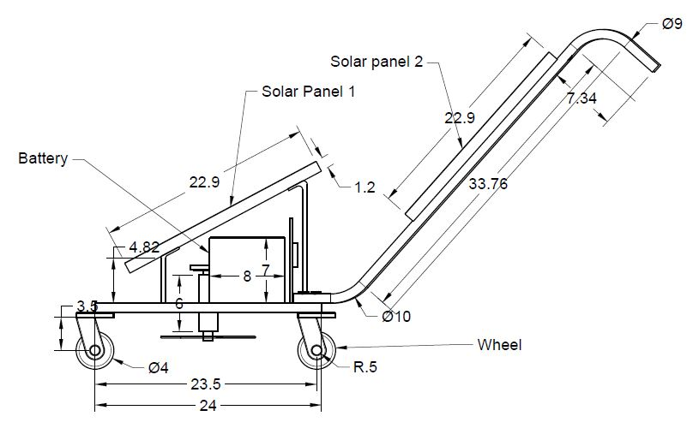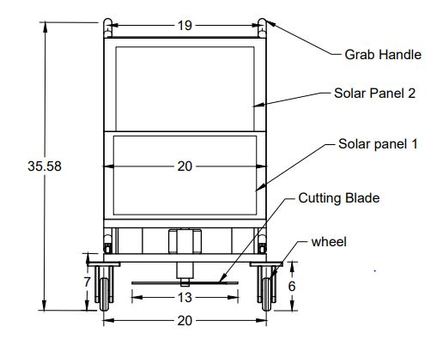

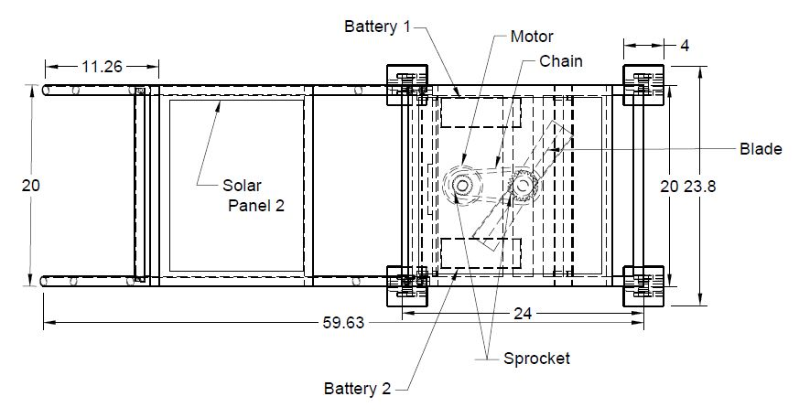

**Fig.1. Design elements of solar mower**

* 1. **Different components**

Different parts/components of prepared solar mower are shown in **Fig.2.**

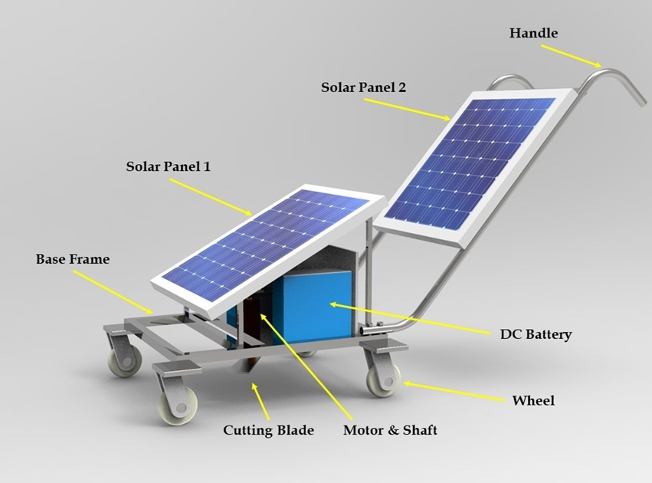

**Fig.2. Components of prepared solar mower**

* 1. **Materials used**

An effective solar-powered lawn mower is made up of an electric motor, battery, frame, deck, charge controller, solar panel, cutter, and wheels that all perform as a single unit to cut grass effectively. The machine can cut grass at different heights depending on the user's preferences due to the addition of an adjustable wheel system to the design. Both solar and AC plug-in power are used to charge the battery. Dimension of different components are summarized in **Table 1**.

Table.1. Dimension of different components

|  |  |  |
| --- | --- | --- |
| Component/Element | Side | Dimension (cm) |
| Whole dimension | L | 150 |
| B | 60 |
| h | 92 |
| Solar | L | 58 |
| B | 52 |
| ht | 1 |
| Battery | L | 19 |
| B | 8 |
| h | 18 |
| Blade | L | 33 |
| B | 4 |
| h | 3 |
| Frame | L | 62 |
| B | 52 |
| h | 4 |
| Total machine wt. | W | 50 Kg |

**i. Solar Panel**

A solar panel is a base-mounted array of electrically connected solar photovoltaic modules. A bundled, connected assembly of solar cells is known as a photovoltaic module. A solar panel is a base-mounted array of electrically connected solar photovoltaic modules. A photovoltaic module is a collection of solar cells that are linked and packed together. As a component of a larger photovoltaic system, the solar panel can generate and supply electricity for use in domestic and commercial applications. The rating of each module is based on its DC output power under standard test conditions (STC), which typically ranges from 20 to 320 watts.

The efficiency of a module determines its size for a specific rated output. Most setups use numerous modules because a single solar module can only provide a certain amount of electricity. A photovoltaic system is made up of a panel or array of solar modules, an inverter, and possibly a battery, sun tracker, and connecting wires. In this instance, two of the 40W solar panels utilized in the mower were utilized.

**ii. The Battery:**

The only time solar cell modules can produce power is when the sun is shining. They are unable to store energy, thus it is necessary to store some of the energy produced in order to maintain the flow of electricity when the sun isn't out. The simplest technique is to use batteries, which chemically store electric energy. Batteries are groups of electrochemical cells that are connected in series and act as "devices that convert chemical energy into electrical energy." Battery cells are made up of two electrodes submerged in an electrolyte solution, and when a circuit is formed between them, they produce an electric current. The current is produced by reversible chemical processes occurring between the electrodes and the electrolyte inside the cell.

Secondary or accumulator batteries are another name for rechargeable batteries. When a battery is being charged, electrical energy is transformed into chemical energy in the battery's cells. When a battery is discharged, the chemical energy that had been stored there is removed and converted into electrical energy. Here, we used two 12V batteries to store power for the lawn mower.

**iii. DC Motors**

A type of electric motor that is mechanically commutated is a direct current (DC) motor. The stator and its current are, by definition, stationary in space. The rotor's current is altered by the commentator such that it becomes stationary in space as well. This keeps the maximum torque at a nearly 90-degree angle between the magnetic fluxes of the stator and rotor. In addition to a revolving armature winding (winding in which a voltage is induced), DC motors also feature a permanent magnet, a static field winding (winding that creates the main magnetic flux), and a non-spinning armature magnetic field.

A variety of inherent speed/torque regulation features are offered by various field and armature winding connections. By changing the voltage applied to the armature or the field current, a DC motor's speed can be altered. By including variable resistance in the field or armature circuit, speed control was made possible. DC motors are typically managed by power electronics devices known as DC drives.

**iv. Blades**

The part of a tool, weapon, or machine with an edge that is intended to penetrate, cut, slice, shove, or scrape surfaces or materials is called the blade. The blade is rarely sharp enough to enable precision cutting. The grass is simply torn by the blade, leaving brown tips. However, it is easy to remove, sharpen, or replace the horizontal blades. Current engine trimmers have a number of disadvantages, including expensive beginning costs, loud engines, excessive fuel use, and operator fatigue over time. Mower blades are the cutting elements of lawn mowers.

They are often made of sturdy metals because they must withstand high-speed contact with a variety of objects in addition to grass. Manufacturers employ different materials, and blade dimensions, thicknesses, and designs differ as well. To make a blade, one can use a flaking stone like flint, metal (typically steel), ceramic, or another material. In this situation, we made use of two metal blades.

**2.4 Power transmission system of the machine**

The schematic of power transmission system is presented in **Fig.3**. The batteries can be charged from the solar panel which can convert solar energy into electrical energy by photovoltaic effect. The batteries can also be charged through the AC current by through a converter which convert AC to DC current. Then batteries transmit the power to the D.C. motor. Through a coupler, the cutting blade is attached to the D.C.'s output shaft.

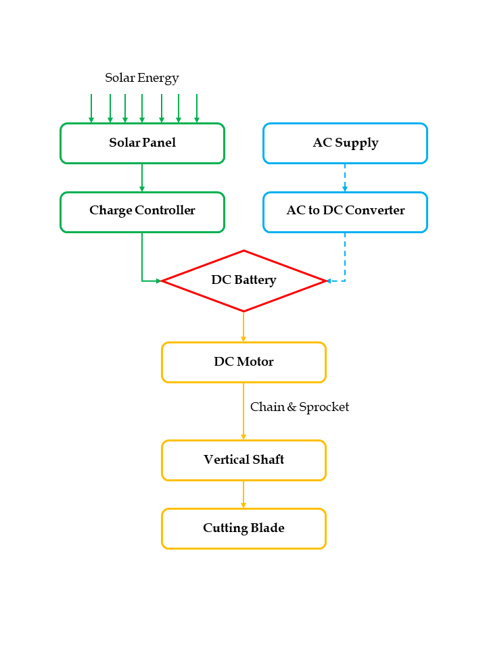

|  |
| --- |
| Fig. 3. Mechanical power transmission system |

**2.5 Design calculation**

Useful mechanical engineering design texts were examined while calculating and choosing the right materials for the manufacturing and selection of various parts needed for the design of the machine. In this study, the selection of the different materials and components needed for the design were considered based on price, availability, strength, weight, etc.

**Power Selection**

* Mass of the blade 0.32 kg
* Angular velocity of 104.7 rad/s
* Radius of gyration 0.0825 m
* Centrifugal force at blade = 0.32 × (104.7)2 × 0.0825= 289.4 N
* Torque of the blade 0.264 Nm
* Power at blade = 0.264 × 104.7 = 27.64 W ≈ 28 W

**Charging Capacity:**

Voltage of solar panel 24V

Capacity of solar panel 80W

Power input 80W/24V=3.33A

Capacity of battery= 60Ah

Charging time= 60/3.33= 18 hrs

1. Time taken for the battery to reach full charge = 18 hours
2. Time taken for the battery to discharge = 4.2 hours

**2.6 Construction process**

The machine is made up of electrical and mechanical components. By joining the various machine components with the help of a welding machine, the manufacturing of the mechanical portion was completed (**Fig. 4**). The machine's chassis, handle, battery compartment, and motor mechanism are only a few of its different compartments. The machine's frame was constructed using square pipes, and its exterior was covered with sheet metal. A lead screw that is attached to the top of the motor as part of the motor mechanism allows for adjustment of the height of the motor while it is running. The battery, charge controller, and solar panel are all housed in the battery compartment, which is linked to the top of the frame.

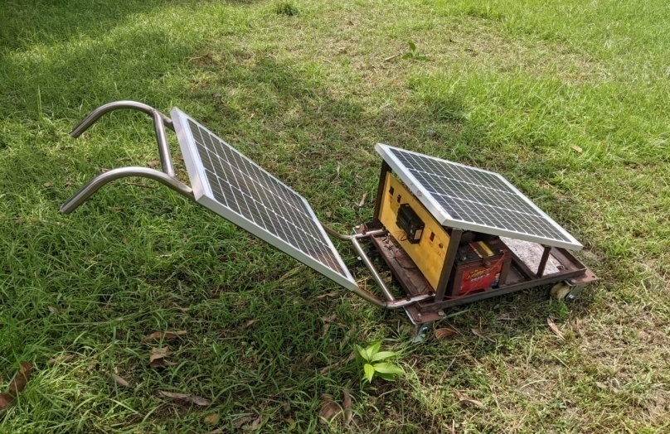

Fig.4. The developed machine

**2.7 Working principal of the machine**

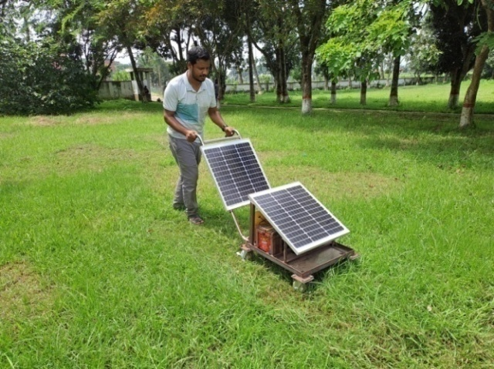The solar panel uses the photovoltaic effect to convert solar energy into electrical energy, which is then stored in a battery. A set of blades created for cutting operations will transform the electric energy of the battery into mechanical energy. Power transfer from the battery to the D.C. motor is ensured by the electric circuit. A coupler is used to link the cutting blade to the D.C. motor's output shaft. Through connecting cables, the motor is connected to the battery. In this connection, an on/off switch is given to start and stop the motor, and a toggle switch is also supplied to adjust the blade's direction (clockwise or anticlockwise). Mower is moved ahead by the operator while the whirling blade continuously cuts the grass (**Fig. 5**).



Fig.5. Field activity of Solar operated garden mower

**2.8 Cost comparison**

Solar operated mower is made from the locally available material, as a result the cost is very low, and the cost varies from 200-250 USD. On the other side, the purchase price of engine operated lawn mower is comparatively high. The price of hand-push type engine-operated mower is more than double to that of present developed mower.

**3 RESULTS AND DISCUSSION**

**3.1. Performance Evaluation**

In order to assess the performance of the created mower, it was tested on a grass with various blades and cut heights. Table 2 displays the findings of the performance review. In conclusion, the lawnmower's field performance was functionally satisfactory. Forage crops and lawn grasses can both be cut using a lawnmower. Because of its narrower working breadth, the lawn mower takes a little longer to cover ground. Cutting height is fairly uniform while using a lawn mower. From an economic standpoint, the lawn mower's performance was likewise acceptable. The design of the lawnmower driven by solar energy was completed, and its performance was assessed. Field efficiency and battery charging time are two of the characteristics that were determined. The result of the field tests is presented in following table (Table 2, Table 3):

Table 2. Performance of lawn mower

| **Sl.**  **No.** | **Sample plot** | **Coverage area**  **(m2)** | **Grass Type** | **Average height before mowing (mm)** | **Expected grass height**  **(mm)** | **Average height after mowing (mm)** |
| --- | --- | --- | --- | --- | --- | --- |
| 1 | BINA residential park | 47.2 | Spare grass | 120 | 60 | 58 |
| 2 | BINA residential park | 48.4 | Stubborn grass | 200 | 60 | 58 |
| 3 | BINA residential playground | 49.6 | Carpet grass | 70 | 50 | 53 |

Forward distance traveled = 6.5 m

Theoretical width of cutting blade = 0.33 m

𝑻𝒉𝒆𝒐𝒓𝒆𝒕𝒊𝒄𝒂𝒍 𝑭𝒊𝒆𝒍𝒅 𝑪𝒂𝒑𝒂𝒄𝒊𝒕𝒚 (𝑻𝑭𝑪) = 𝐹𝑜𝑟𝑤𝑎𝑟𝑑 𝑆𝑝𝑒𝑒𝑑 × 𝑇ℎ𝑒𝑜𝑟𝑒𝑡𝑖𝑐𝑎𝑙 𝑤𝑖𝑑𝑡ℎ 𝑜𝑓 𝑏𝑙𝑎𝑑𝑒

To calculate theoretical field capacity, following data table was prepared (**Table 3**):

Table 3. Theoretical field capacity of lawn mower

| **Sl.**  **No.** | **Forward distance traveled (m)** | **Time**  **taken**  **(s)** | **Forward speed**  **(m/s)** | **Forward speed**  **(km/hr)** | **Theoretical width**  **(m)** | **Theoretical field capacity**  **(ha/hr)** | **Average**  **T.F.C.**  **(ha/hr)** |
| --- | --- | --- | --- | --- | --- | --- | --- |
| 1 | 6.5 | 24.5 | .265 | 0.954 | 0.33 | 0.0315 | 0.0307 |
| 2 | 6.5 | 25 | .26 | 0.936 | 0.33 | 0.0309 |
| 3 | 6.5 | 26 | .25 | 0.9 | 0.33 | 0.0297 |

Average theoretical field capacity was found approximately 0.0307 ha/hr.

𝑬𝒇𝒇𝒆𝒄𝒕𝒊𝒗𝒆 𝑭𝒊𝒆𝒍𝒅 𝑪𝒂𝒑𝒂𝒄𝒊𝒕𝒚 (𝑬𝑭𝑪) = 𝑇𝑜𝑡𝑎𝑙 𝐴𝑟𝑒𝑎 𝐶𝑜𝑣𝑒𝑟𝑒𝑑 / 𝑇𝑜𝑡𝑎𝑙 𝑇𝑖𝑚𝑒

To calculate effective field capacity, following data table was prepared (**Table 4**):

Table 4. Effective field capacity of lawn mower

| **Sl.**  **No.** | **Area**  **covered**  **(m2)** | **Time**  **taken**  **(s)** | **Effective**  **field**  **capacity**  **(m2/s)** | **Effective**  **field**  **capacity**  **(ha/hr)** | **Average**  **E.F.C**  **(ha/hr)** |
| --- | --- | --- | --- | --- | --- |
| 1 | 47.2 | 682 | 0.0692 | 0.0249 | 0.0257 |
| 2 | 48.4 | 663 | 0.073 | 0.0263 |
| 3 | 49.6 | 687 | 0.0722 | 0.026 |

Average effective field capacity was found approximately 0.0257 ha/hr.

Average T.F.C. = 0.0307 ha/hr

Average E.F.C. = 0.0257 ha/hr

So, field efficiency = (E.F.C./T.F.C.) x 100%

= (0.0257/0.0307) x 100%

= 83.7%

The field efficiency of the solar powered lawn mower is calculated as 83.7% which is very efficient, as it is able to perform the operation for which it was designed excellently.

**4. Advantages**

* Compact size and portable
* Easy to move from one place to another place
* Operating principle is simple.
* Non-skilled personnel can also operate this machine

**5. Limitations**

* Manually operated
* Large time required to remove the grass
* Difficult to operate in rainy seasons

**6 CONCLUSION**

In the recent years, machines have been created with the intention of reducing or even eliminating greenhouse gas (GHG) emissions, which are the main cause of the climate change brought on by global warming. Because there are no fuel expenditures, the enhanced solar-powered lawn mower will address the problem of environmental pollution and offer low operating costs, which is what this project seeks to do. The solar-powered lawnmower was developed for use in residences and companies with lawns where tractor-driven mowers couldn't be used. The machine has enough capacity to serve this need. The machine's field efficiency was 83.7%, which is a comparatively high figure. It was also tested on various grass samples. To achieve the anticipated height of grass after mowing, the average height of cut for each grass sample was modified. The features of the grass, such as its roughness and density, affected how long it took to cut each sample of grass. The functional performance of the solar-powered lawn mower was quite satisfactory in well prepared fields and lawns, according to the findings of field operations carried out by the device. The machine's handle may be adjusted, making it simple for both men and women of different heights to use. Its field efficiency was excellent, and its field capacity is good. The cost of machine was reasonably low as compared to engine operated lawn mower. Thus, the machine will open a window for ‘low carbon’ emission machine in a GHG threatened world.

**REFERENCES**

Basil, O. (2013). Simple Design of Self-Powered Lawn Mower. International Journal of Engineering and Technology, 3(10): 933-938.

Hessayon, D.G. (2007). The lawn expert. Transworld publishers, London. <http://en.wikipedia.org/history_of_the_lawn_mower>. Accessed on 25-02-2020.

Knier, G (2010). How do Photovoltaics Work? <https://science.nasa.gov/science-news/science-at-nasa/2002/solarcells>**.** Accessed on 25-02-2020.

Lucas, D.R., Justin Lucas, and Lucas, R. J. (2010). “Hybrid electric lawn mower”, US Patent, Patent no. US20080120955A1.

Manpreet, S., Ashutosh, P., Suman, S., Kurman, P., Maushan, R., & and Tekelllapati, N. (2016). A Review and Comparative Analysis of Solar, Electric and Gasoline Lawn.

Mgbemu, E.N. (2005). Modern Physics, First Edition. Spectrum Limited, Ibadan. pp.72

Akinyemi, A.O., Ayobami D.O.H.R. and Damilare A.S. (2020). Design and Fabrication of a Solar Operated Lawnmower. International Journal of Innovative Science and Research Technology, 5(10): 1161-1197

Manpreet, S., Ashutosh, P., Suman, S., Kurman, P., Maushan, R., & and Tekelllapati, N. (2016). A Review and Comparative Analysis of Solar, Electric and Gasoline Lawnmowers: An Extensive Study. Internetional Journal of Innovative Science, Engineering and Technology.

National Research Foundation (NRF) (2010). Communication Astronomy101 in School. Astronomy Activities/Demostrations, Cape Town, South Africa.

Ogiemudia, O. (2015). Design and improvement of a solar powered lawn mower from locally sourced material. Asia pacific journal of mechanical engineering research.

Okokpujie, I., and Olaseyi, O. K. (2017). Design, Construction of a Cylinder Lawn Mower. Journal of Engineering and Applied Science.

Paytas, A. R.,(1991). “Solar powered mower”, US Patent, Patent No. US4987729A.

Tanimola, O. A., Diabana, P. D., and and Bankole, Y. O. (2014). Design and Development of a Solar Powered Lawn Mower. International Journal of Scientific & Engineering Research, 5(6): 215-228

Thomas R. McCoy (4988). “Solar powered golf kart”, US Patent, Patent No., US4744430A, 1988.

Thomas, R., and Donald H. Smith, (1982). “Combined A.C./D.C. electric lawn mower”, US Patent, Patent No.US4333302A, 1982.

Vivek, P. R., Vishnu, N. V., Akhil, K. A., Kevin, R., and P, A. R. (2016). Design and Analysis of Rotary Lawn Mower. Vol. 5 (04).DOI : <http://dx.doi.org/10.17577/IJERTV5IS040152>