Title: Protease Inhibitors: Implications as key potential therapeutics for COVID19 pandemic

Prathamesh Kale
Protein Biochemistry Laboratory,
Dr. D. Y. Patil Biotechnology and
Bioinformatics Institute
Pune, India
Sujit Pawar
Protein Biochemistry Laboratory,
Dr. D. Y. Patil Biotechnology and Bioinformatics Institute
Pune, India

Divanshi Gupta
Inscribe Company
Pune, India

Ashwini Puntambekar
Protein Biochemistry Laboratory,
Dr. D. Y. Patil Biotechnology and Bioinformatics Institute
Pune, India

Vaibhavi Mohire
Dr. D. Y. Patil Biotechnology and
Bioinformatics Institute
Pune, India

Manjusha Dake*
Protein Biochemistry Laboratory,
Dr. D. Y. Patil Biotechnology and
Bioinformatics Institute
Pune, India
manjusha.dake@dpu.edu.in

Abstract
A new illness with symptoms similar to pneumonia called novel coronavirus disease, or COVID-19, caused by the virus SARS-CoV-2, was sweeping Wuhan in December 2019. This disease spread at a rapid pace and was declared a pandemic by the World Health Organisation (WHO) on March 11, 2020. As of July 5, 2020, the epidemic infected more than 1.5 crore people globally, including 6.9 lakhs in India. The coronavirus's quick global outbreak caused thousands of deaths and a surge in hospital admissions in numerous nations. Thus, the SARS-CoV-2 virus is often regarded as the biggest medical emergency of the 20th century. Health inequities within and between nations have been brought to light by COVID-19, which will have a long-lasting effect on world civilization. Nevertheless, during the past few decades, significant research and funding in biosciences have enabled a quick scientific response with advancements in viral characterization, testing, and sequencing. But even though there have been numerous global initiatives to address this problem effectively to date, COVID-19 still remains untreated and is not yet subject to any effective and targeted therapeutic treatment. Based on gathered knowledge since the COVID-19 pandemic started and a comprehensive list of clinical and preclinical inhibitors with anti-coronavirus activity, we have presented a summary of the progress made in the development of COVID-19 drugs and preventive measures along with the basic knowledge about the structure of the coronavirus, its genomic orientation, spreading mechanism, clinical approaches etc.
Keywords: COVID-19, SARS-CoV-2, Coronavirus, Therapeutics, Virology, Pandemic

I. Disease Introduction
Chinese health officials detected an epidemic of a new coronavirus-2 (CoV-2) in January 2020, As a result, A severe acute respiratory illness manifested itself (SARS). The virus that caused Coronavirus Sickness 2019 (COVID-19) belongs to the coronavirus family (SARS-CoV-2) and was labelled a pandemic by the World Health Organization (WHO). At the whole-genome level, SARS-CoV-2 full-length genome sequences showed 79.6% sequence similarity to SARS-CoV and 96 per cent sequence identity to a bat coronavirus. As of April 30, 2021, COVID-19 has claimed the lives of over 3155168 persons, with over 149910744 million validated instances. Current therapeutic techniques are being studied due to a lack of understanding of COVID-19 sickness. Antiviral medicines, which either inhibit virus entrance or interfere with viral multiplication and maturation, are one potential strategy for slowing illness development. Antiviral drugs including hydroxychloroquine, remdesivir, and lopinavir etc. have been shown to be effective against SARS-CoV-2 in vitro. Many individuals are experiencing serious adverse effects from the above-mentioned medicines due to the high dose required and the tight therapeutic window. As a result, in order to improve COVID-19 therapeutic safety and efficacy, these drugs must be repurposed with an acceptable formulation [1].
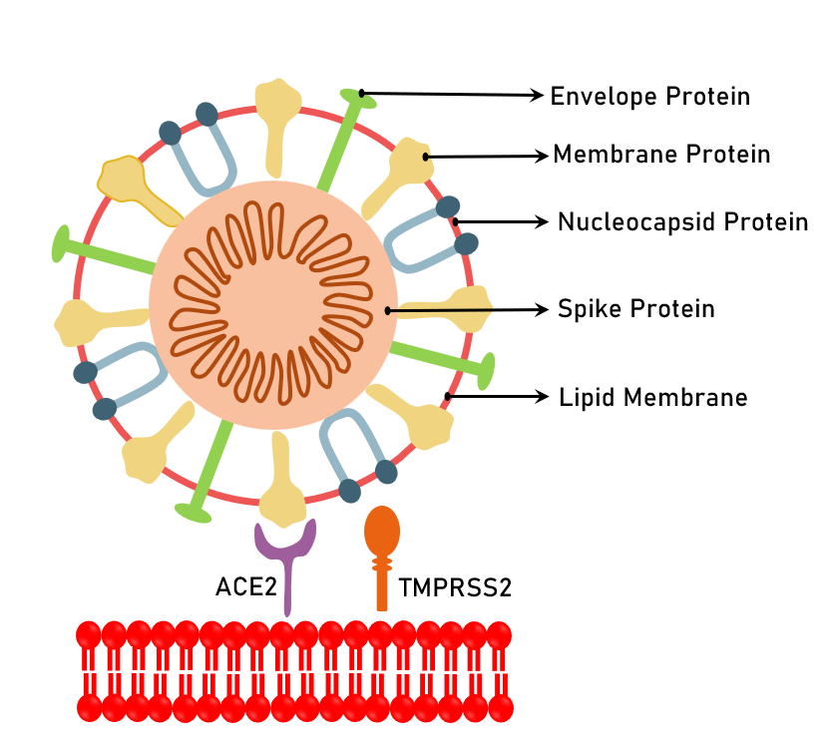
Fever, cough, sore throat, shortness of breath, tiredness, and malaise are some of the symptoms.

Figure 1. Viral Proteins
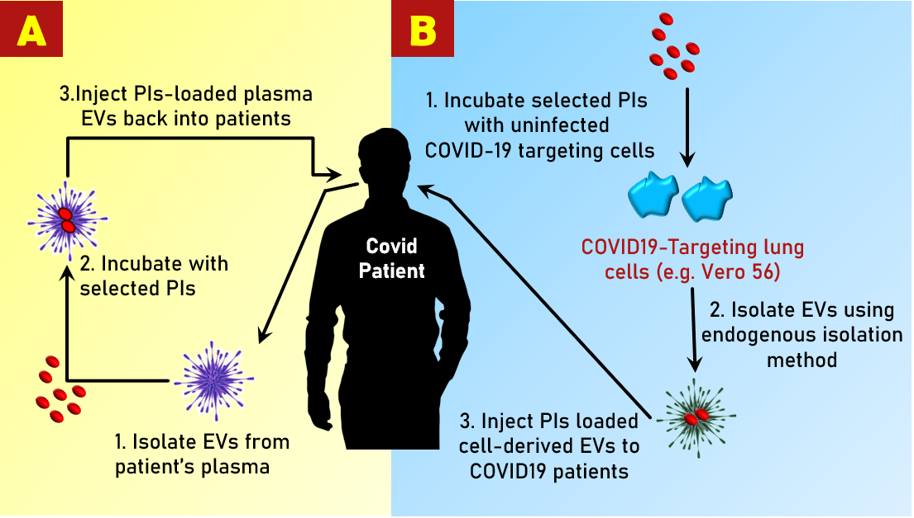

Figure 2. Personalised treatment technique: (A) EVs are extracted from a patient's plasma, loaded with specific PIs, and given to the same patient through IV. EVs are extracted from cell culture media in the endogenous loading mass production technique (B). Uninfected SARS-CoV-2 targeting cells treated with PIs. To prepare for future treatment, isolate EVs that have been encapsulated with PIs.
SARS-CoV-2 is a new human coronavirus with an odd strand and positive sense RNA linked to SARS and MERS (multiple sclerosis) (Middle East respiratory syndrome). It was discovered in late December 2019 in the Chinese city of Wuhan. This 2019-nCoV causes severe respiratory tract infections in humans, as well as other complications such as lung damage. The 2019-nCoV is thought to be transferred from a certain species of bat in China and other regions such as the Middle East and Europe to humans, similar to SARS-CoV and MERS-CoV, which have zoonotic origin and transmitted from bat and camel, respectively. Another research has suggested that the nCoV may have originated from the scaly Pangolin, which is abundant in China [2]. The novel SARS-CoV-2 virus declared as a pandemic by the WHO, implying that the 2019 nCoV is a global emergency. This is because the virus has spread to over a hundred countries [3].
The European Union's open borders allowed the virus to spread across Europe. The illness developed a pandemic due to the open borders between neighbouring countries. Countries with inadequate health systems and diagnostic ability were more vulnerable to huge epidemics that met the criteria of a pandemic, while others were able to control viral spread by maintaining social distance and following a regular sanitization routine. By February 25th, 2020, China has reported around 80,000 cases. Despite the fact that only 10% of cases were detected in China, the real patient number was estimated to be about 8 million. This suggested a lower rate of viral infection transmission when compared to China's population of almost 1.4 billion people, where most Chinese are uninfected and had reduced virus susceptibility. However, due to the asymptomatic nature of the viral infection, the undiscovered transmission of the 2019 nCoV throughout the country began a new pandemic chain of transmission [4].
The spread of COVID-19 slowed economic activity significantly. The world economy fell by around 4.9 per cent in June 2020, according to an early prediction from the International Monetary Fund (2020a) (2020b). This contraction was of far greater magnitude as compared to the 2008-2009 Global Financial Crisis. The reasons behind the lowering of the economy include slowing down social distancing activities causing lowering the activities during lockdowns, and a steeper decline in productivity in the industrial and business sector. The lockdown also adversely affected the labour markets resulting overall effect on the production of supply chains, financial markets, and the World economy. Restrictions such as social distancing measures (e.g., lockdowns and associated rules), as well as the duration of the lockdown, were used to try to mitigate the negative economic impacts. Other impacted areas experienced mental health problems as a result of the pandemic scenario and government involvement, resulting in economic inequalities and affecting various socio-demographic groups [5].
From the beginning, WHO played a key role in the worldwide fight against COVID-19, monitoring the spread of illness, organising global information sharing, and providing technical assistance to all nations. Till January end in 2020, over 20 countries had reported positive instances of COVID-19, with the number quickly climbing to 54 by the end of February and 202 by the end of March. By April 30, 2020, COVID-19 will have extended to 212 nations. According to the WHO, there were 3,059,642 illnesses and 211,028 deaths. COVID-19 was spread to all continents except Antarctica, where fewer regions mostly the Pacific islands reported no COVID-19 cases.
COVID-19.3 was blamed for more than 2 million fatalities in February 2021. This epidemic has presented a serious threat to human physical and mental health, and it has had a significant influence on daily life on a worldwide scale, with psychological consequences. COVID-19's progress may be tracked using a variety of metrics, including epidemiology, virology, pathogenesis, illness diagnostics, and the application of artificial intelligence to aid diagnosis, treatment, and vaccine development [6]. There have been a total of 286,835 COVID-19–related fatalities recorded globally as of May 12, 2020, but no thorough study of this group has been provided [7].
II. Spread and infection
The cause of a widespread outbreak of acute respiratory sickness (COVID-19) has been identified as a new coronavirus strain (SARS-CoV-2). Fast therapeutic responses to SARS-CoV-2 have evolved as a result of the lack of a specific antiviral medication or immunisation. Higher amounts of plasma cytokines, as well as an unregulated influx of inflammatory cells, lead to unbalanced host immunity and increase the severity of the infection. Clinical evidence demonstrated that SARS-CoV-2 infects the human immune system and uses the Angiotensin-Converting Enzyme 2 (ACE2) receptor to infect the host, when tracing back information from *SIRS and MERS (Middle East Respiratory Syndrome) infections. Proteases (TMPRSS2, cathepsins, plasmin, and others) are important in viral entrance and immune system function, according to further study. The goal of this study is to give a quick summary of current research findings in order to assess the potential function of proteases in SARS-CoV-2 viral transmission and infection. Gathering current knowledge on the participation of different proteases in giving an immune response can be used to identify the participation of proteases in giving an immune response. It also recommends a multimodal therapy strategy including a mixture of protease inhibitors to selectively target proteases [8].
COVID-19 (Corona virus disease) formerly, this known as "2019 novel coronavirus" or "2019-nCoV" was the first reported instance of the coronavirus sickness in 2019. On November 17th, 2019, the disease was detected in Wuhan, China's Hubei provincial capital. A few weeks later, in December 2019, Chinese officials revealed the presence of this new coronavirus (Berger and colleagues, 2020). Viral infection can be asymptomatic or develop into fu-like Fever, cough, and shortness of breath are some of the symptoms. In certain people, the illness might progress to pneumonia, multi-organ failure, and death [9]. The virus is transferred most commonly through coughs and sneezes. RT- PCR is the gold standard for detecting COVID-19 infection. Respiratory samples acquired by nasopharyngeal swabs are used in RT-PCR analysis, which can take anywhere from a few hours to two days to complete. Following the emergence of the disease in China, the COVID-19 infection quickly spread to neighbouring nations such as South Korea, Singapore, and others. The virus has now expanded internationally due to its high infectivity rate, resulting in the 2019–2020 coronavirus pandemic [10].
Droplets and contact with contaminated surfaces, fomites, and aerosol formation are the most common ways for the virus to spread. Urine, faeces, and saliva all contain the virus. Asymptomatic shedding, especially in youngsters, appears to be widespread and can transmit illness [11]. The incubation time is commonly 5 to 7 days from infection to first symptom, with a range of 4-14 days. To diagnose a present infection, Virus detection assays in various bodily fluids are used. Antibody blood tests are used to confirm prior infection and infection resistance [12].
COVID-19 transmission has been seen prior to illness onset in recent studies, increasing worries that persons who look healthy might be key contributors to the COVID-19 pandemic. A recent modelling revealed that roughly 44 per cent of secondary cases were infected during presymptomatic phases of illness, based on the fraction of transmission events that occur prior to symptom emergence [13]. The amount of infectious virus required to make COVID-19 transmissible is unclear, however, case investigations have identified numerous instances of transmission before symptoms appear. Epidemiological studies to evaluate the proportion of presymptomatic vs post-symptomatic dissemination are the best technique to estimate transmission potential. The proportion of pre- and post-symptom onset transmission is difficult to determine due to a lack of data on the number of asymptomatic/presymptomatic COVID-19 patients. Epidemiological data may be interpreted via modelling research. COVID-19 models, on the other hand, are extremely reliant on the assumptions that are put into them and can be misconstrued [14].
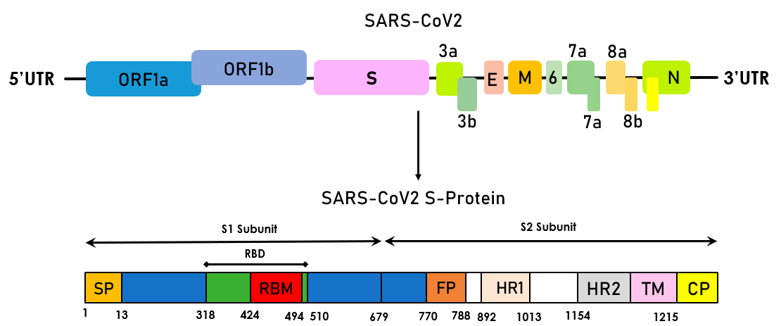

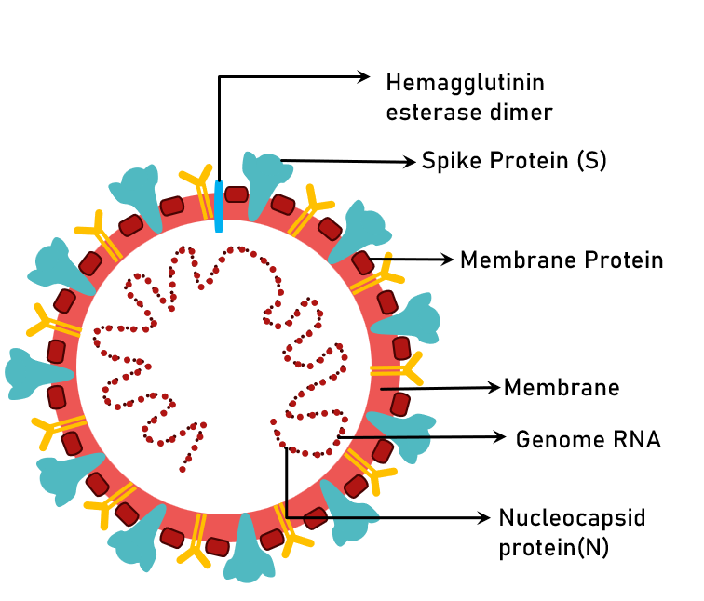

Figure 3. A schematic illustration of COVID-19 genomic structure and functional domains of the S protein.

III. Structure of virus
The ORF1a and ORF1b genes are encoded by the COVID-19 virus's single-stranded RNA genome. These two genes (nsp1–nsp16) code for 16 non-structural proteins. The structural genes encode the spike protein (S), envelope (E), membrane (M), and nucleocapsid (N).
The structure of S protein:
The S protein is made up of two subunits: S1 and S2. Cleavage sites shown with dotted lines make up the S1/S2 cleavage sites. The S-protein is made up of the cytoplasm domain (CP), the fusion peptide (FP), the heptad repeat (HR), the receptor-binding domain (RBD), the signal peptide (SP), and the transmembrane domain (TMD) (TM). A lipid bilayer surrounds the viral surface proteins spike, envelope, and membrane. The nucleocapsid protein is linked to the single-stranded positive-sense viral RNA.

IV. Disease mechanism
Figure 4 depicts the viral entrance, replication, and RNA packing mechanisms in a human cell. The spike (S) protein binds to ACE2 receptors on the surface of a variety of human cells, like the lungs, allowing the virus to enter. Proteases from the host, such as trypsin and furin, break the coronavirus S protein in two spots (the S1/S2 site). The S2 domain (S20 site) is cleaved in the second step to release the fusion peptide. The membrane fusion mechanism with virus will be activated as a result of this occurrence. The binding area of the ACE2 receptor's structural information (aa sequence) might be a potential target for finding antiviral antibodies. Endocytosis is the mechanism through which a human cell ingests the virus. After entering the cytoplasm, COVID-19 adopts a three-step process: i) Conformational changes in the Spike (S) glycoprotein; ii) cathepsin L proteolysis iii) activation of the membrane fusion mechanism. The virus is subsequently released into the cytoplasm when the endosome opens. Endogenous proteasomes degrading foreign proteins, such as the SARS nucleocapsid protein causes viral nucleocapsid (N) to be developed as a two-step process in which the virion's S1 component binds to cell surface receptor followed by breaking of Spike by host proteases [15]. The S2 component aids the fusion of viral and host target membranes at low pH. The viral RNA is totally released into the cytoplasm, where the replication/ transcription complex is in charge of replication and transcription (RTC). Nonstructural proteins make up the RTC complex encoded in the viral genome (nsp). The positive RNA genome's open reading frame 1a/b (ORF 1a/b) is translated to make replicase proteins (see Figure 4). Replicase proteins synthesize full-length negative sense RNAs using a template genome. The viral proteins M, S, and E are produced in cytoplasm16]. Nucleocapsids are made in the cytoplasm by encapsidating replicated genomes with N protein, which then fuse within the membrane to form new virions. Finally, infected cells create fresh virions that infect neighbouring cells by exocytosis. The endoplasmic reticulum may be stressed by viral production, resulting in cell death [17].
In terms of laboratory testing, the majority of patients' lymphocyte absolute levels have decreased showing that 2019-nCoV, like SARS-CoV, may predominantly attack lymphocytes, particularly T cells. Virus particles assault other cells and spread throughout the respiratory mucosa, triggering changes in white blood cells and lymphocytes, creating a cytokine storm in the body, a cascade of immunological reactions. Septic shock, followed by multiple organ failure, is seen in a small percentage of patients with progressive acute respiratory distress treatment (ARDS). As a result, early detection and treatment of significant cases are critical.
For patients with ARDS, intravenous immunoglobulin (methylprednisolone 1–2 mg/kg per day) boosts immune power for anti-infection and steroids treat severely sick individuals. According to a few studies, the coronavirus, which eats numerous immune cells and impairs the body's cellular immunological activity, caused a significant decline in the overall number of lymphocytes. T lymphocyte damage might be a contributing factor in patient 25's exacerbations. In the clinic, lymphocytes with a low absolute value might be used as a reference index for identifying new coronavirus infections [18].
Most COVID-19 patients had a ground glass appearance on chest computed tomographic (CT) images, comparable to SARS and MERS patients. According to biopsy samples from the lung, liver, and heart, a patient with COVID-19 has pathological features that are comparable to SARS-CoV and MERS-CoV infections have both been observed to have similar symptoms. Apart from ARDS, other adverse effects of COVID-19 infection include acute cardiac damage and severe renal damage. The aetiology and pathology of COVID-19 are unknown because it is a new SARS pandemic. There is presently no viable vaccination or antiviral treatment [19].
A. Entry of virus:
Coronaviruses are cytoplasmic positive-stranded RNA viruses that fuse with the host cell membrane using envelope to insert nucleocapsid. The spike glycoprotein (S), which aids viral entry, is a key factor to determine cell pathogenicity. It's a class I fusion protein that goes through a lot of conformational changes for connecting to the receptor on the host cell and for host and viral membranes fusion. The entrance mechanisms of coronavirus are the subject of this topic. Coronavirus causes the S protein to alter shape by a number of mechanisms, including receptor contact, low pH exposure, and proteolytic activation [20].
- Role of proteases in the entry of virus:
Coronaviren (Coronaviridae) enters the host cell via the enzymes trypsin, furin, and other proprotein-convertasen, cathepsin, transmembrane proteases (TMPRSS), and elastases. The proteases TMPRSS2 and TMPRSS11a, which are abundant in the respiratory tract and become expressed on cell surfaces, aid in SARSCoV-1 viral entrance. For the TMPRSS-protease, TMPRSS11d is a protease similar to trypsin, that causes proteolytic activation of the spike protein. TMPRSS2 engages in a complicated interaction with the ACE2 receptor, allowing the virus to penetrate the cell surface efficiently. TMPRSS2 and TMPRSS11D activate the spike protein and divide it into the S1 and S2 subunits, allowing viral entrance into the cell membrane without the use of endosomes [21].

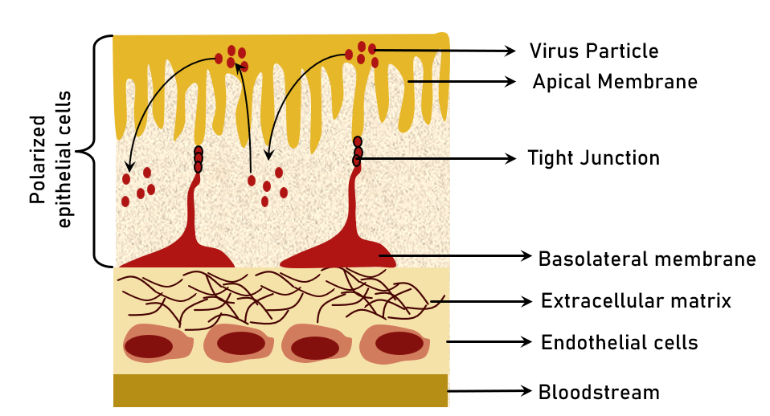

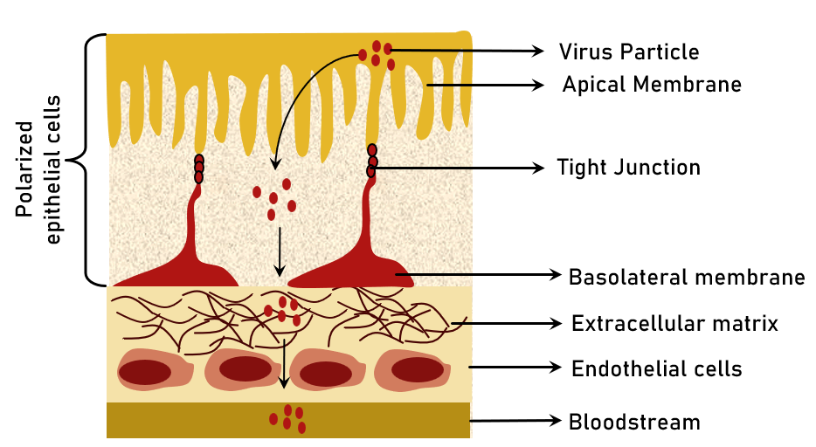

Figure 4. Entry and exit of Coronavirus from polarised epithelium cells via two different routes (A) The apical membrane facilitates lateral spread by allowing entrance and release. (B) Vertical transmission is facilitated by The apical membrane is the point of entry, while the basolateral membrane is the point of exit.
Preventive methods to control the infection require knowledge of the pathogen's genesis and propagation. In the instance of SARS-CoV, researchers concentrated on identifying a crucial reservoir of infection, with civet palms serving as secondary hosts, suggesting positive viral RNA detection results. According to molecular analysis, persons from Hong Kong had a 2.5 percent frequency rate of antibodies against SARS-coronavirus in 2001. As a result, circulating SARS-coronavirus in human bodies was found prior to the epidemic in 2003. Antibodies to SARS-CoV were discovered in Rhinolophus, indicating that they are a source of viral replication [22]. Camels have been identified as a key host for MERS-coronavirus, detected in Saudi Arabia in 2012 and linked to beta-coronavirus, as well as Pipistrellus and Perimyotis bats. As a result, bats have been identified as the primary host for viral transmission, rather than humans [23]. A SARS-CoV-derived receptor binding spike glycoprotein of a new coronavirus has been produced (CoVZXC21 or CoVZC45). It is critical to identify intermediate zoonotic sources that cause viral transmission to humans in order to eradicate the virus [24].
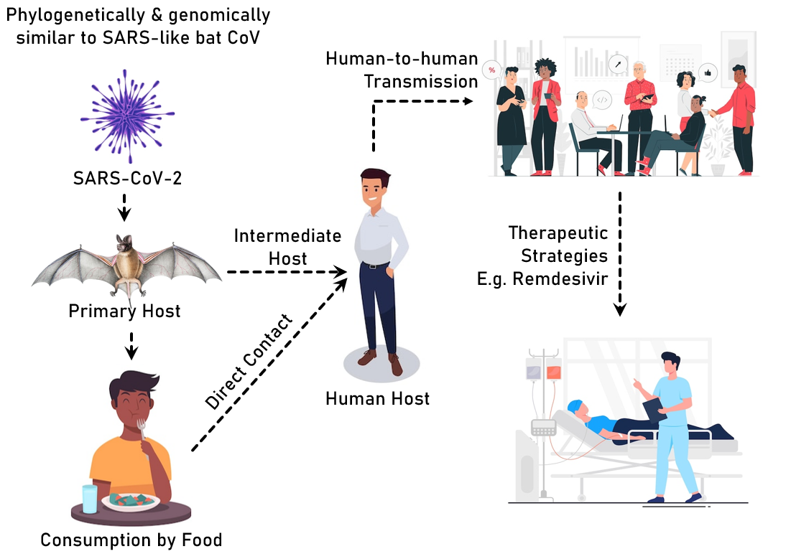

Figure 5. Transmission of COVID-19 virus
Proteins for viral replication, nucleocapsid formation, and spike generation are encoded by genes in the ORF1 downstream areas of coronavirus. The spikes glycoprotein found on coronaviruses' outer surface is crucial for the virus's attachment to and entry into host cells. It is possible for the virus to infect several hosts because the receptor-binding domain (RBD) is loosely connected among viruses. Other coronaviruses have receptors that identify aminopeptidases or carbohydrates, whereas SARS-CoV and MERS-CoV have receptors that recognise exopeptidases. Cellular proteases such as human airway trypsin-like protease (HAT), cathepsins, and transmembrane protease serine 2 (TMPRSS2) divide the spike protein and generate additional penetration alterations, which are required for coronavirus entrance. MERS-coronavirus uses dipeptidyl peptidase 4 as a major receptor, ACE2 is used by HCoV-NL63 and SARS-coronavirus.
SARS-CoV-2 coronavirus has the ability to express polyproteins, nucleoproteins, and membrane proteins including spike protein, RNA polymerase, 3-chymotrypsin-like protease, papain-like protease, helicase, glycoprotein, and auxiliary proteins. The spike protein maintains van der Waals forces in the RBD area. The crucial lysine 31 residue of the ACE2 receptor recognises the 394-glutamine residue in the RBD region of the virus.
S protein binds to the cellular receptor ACE2 and changes its conformation to facilitate the fusion of the viral envelope with the cell membrane via the endosomal pathway. The SARS-CoV-2 virus releases RNA into the host cell, where it is translated to viral replicase polyproteins pp1a and 1ab. Polymerase uses discontinuous transcription to generate a series of subgenomic mRNAs, that are translated into viral proteins. In the ER and Golgi, viral proteins and genomic RNA are produced into virions, which are then transported by vesicles and expelled from the cell.
Alphacoronavirus, Betacoronavirus, Gammacoronavirus, and Deltacoronavirus are members of the Coronavirinae subfamily (Figure 1A). A single-stranded positive-sense RNA (+ssRNA) genome with a 5′ cap structure and a 3′ poly-A tail is seen in CoVs (about 30 kb) [24]
- The replication transcription complex (RTC) is formed in a double membrane vesicle by translating the genomic RNA template into polyprotein 1a/1ab (pp1a/pp1ab), encoding nonstructural proteins (nsps) (DMVs).
- Following that, RTC synthesis a nested collection of subgenomic RNAs with similar′leader and 3′terminal sequences
- At transcription regulatory sequences, which are positioned between open reading frames, transcription, termination, and subsequent acquisition of a leader RNA take place (ORFs).
- These minus-strand sgRNAs serve as templates for the production of subgenomic mRNA.

The two lengthy polypeptides, pp1a and pp1b, are converted into 16 nonstructural proteins.
S, E, M, and N stand for spike, envelope, membrane, and nucleocapsid, which are four structural proteins. nCoV, nCoV, nCoV, nCoV,
Human coronavirus is abbreviated as HCoV, infectious bronchitis virus is abbreviated as IBV, murine hepatitis virus is abbreviated as MHV and transmissible gastroenteritis virus is abbreviated as TGEV.
The nucleocapsid (N) protein of Coronaviruses binds with viral genomic RNA to form a ribonucleoprotein complex. The generation of infectious virus particles is thus dependent on N protein-RNA interactions. Coronavirus infectious bronchitis virus (IBV) has 45 kDa recombinant nucleocapsid N protein is extremely proteolytically sensitive. We were able to get a 14.7 kDa stable fragment containing residues 29–160 at the N-terminus (IBV-N29-160), A five-stranded antiparallel sheet with a hairpin extension and a hydrophobic platform important in RNA binding makes up the protein core. Dimerization of the IBV-C-terminal N's domain leads to oligomerization of the IBV-nucleocapsid protein and viral RNA condensation, according to a model for coronavirus shell formation. [25]
The researchers used in situ cryo-electron tomography and subtomogram averaging to depict the viral replication compartment, offering crucial insights into the virus's budding mechanism as well as the shape of extracellular virions. Assembly of S trimers in lumenal cisternae causes membrane bending and reorganisation on the envelope during virion formation. Different cylindrical assemblies of viral ribonucleoprotein complexes (vRNPs) assemble at the curved membrane. [26]
V. Clinical approach
A new global health catastrophe has emerged, frightening with the rise of COVID-19, the general public has become more aware of the disease designated a public health emergency when it first appeared at a seafood market in China, in December 2019. The World Health Organization has declared an international health emergency (WHO). Several studies have identified current clinical features data to assist possible COVID-19 sufferers with COVID-19 diagnosis, treatment, and prevention. It's critical to keep track of fresh data on clinical features, diagnoses, treatment options, and COVID-19 results at all times. Various degrees of sickness have been reported all around the world as a result of the illness. The illness is treated with general or symptomatic treatment, antiviral medicines, oxygen therapy, and the immune system. To prevent infection from spreading to other patients and healthcare workers, it's vital to identify possible cases as soon as possible and separate suspects from confirmed COVID-19 infections. (Hafeez and colleagues, 2020).
The main protease (Mpro) of the coronavirus that is a feasible therapeutic target in the processing and maturation of the viral polyprotein. GC376, a dipeptide-based protease inhibitor that has been utilised in the treatment of feline infectious peritonitis virus in the past. It is presently in the pre-clinical stage of development (FIPV). Both GC373 and GC376 have been shown to be effective in treating coronavirus infections in animals, making them promising COVID-19 treatment options in people. GC376 is an antiviral that inhibits Mpro in a variety of viruses, including feline coronavirus. However, more research on the effectiveness and safety of these broad-spectrum Mpro inhibitors in COVID-19 patients is essential. Lessons learnt from the effective use of medication candidates to treat coronavirus infections in animals will help build a framework for their application in human trials (Sharun and colleagues, 2021).
The clinical management of COVID 19 includes screening and triage, i.e., early detection of patients, implementation of appropriate IPC measures, collection of samples for investigation, symptomatic treatment, oxygen therapy and monitoring, prevention of complications, adjunctive therapy. These medications' safety and effectiveness in COVID-19 patients have yet to be determined. Patients using Hydroxychloroquine, Chloroquine, and Azithromycin for FDA-approved applications have had trouble filling their prescriptions, apparently because the pills are used to treat COVID-19 [27].
The COVID-19 outbreak has now escalated into a worldwide health emergency. With a positive swab test, the patient might be completely asymptomatic, have a mild influenza-like sickness, or have severe symptoms requiring hospitalisation. HRCT scans of the chest have been demonstrated to be exceedingly sensitive and specific, despite the fact that there is no reliable antibody test for fast diagnosis at this time. In the absence of an effective vaccine, patients are treated with oxygen treatment, antivirals, steroids, HCQS, and antibiotics. Immunomodulatory medications and plasma exchange treatment using recovered patients' convalescent sera may be required in complicated situations and those that are resistant to normal therapy. Advances in viral genome sequencing and technology have paved the way for the development of a COVID-19 vaccine, with human trials now underway at a number of pharmaceutical firms (Parasher and colleagues, 2020).
Classic culture-based approaches, genetic materials-based detection and diagnostics are appropriate for high-throughput testing. They can also reveal therapeutically important information in a matter of hours, such as drug resistance, virulence factors, or strain sub-types, although at a higher cost are important in both routine clinical diagnosis and the discovery of novel bacteria, viruses, and other illnesses. The current state of nucleic acid-based technologies for COVID-19 diagnostics is discussed, as well as future improvements and the advantages and disadvantages of using these technologies [1]
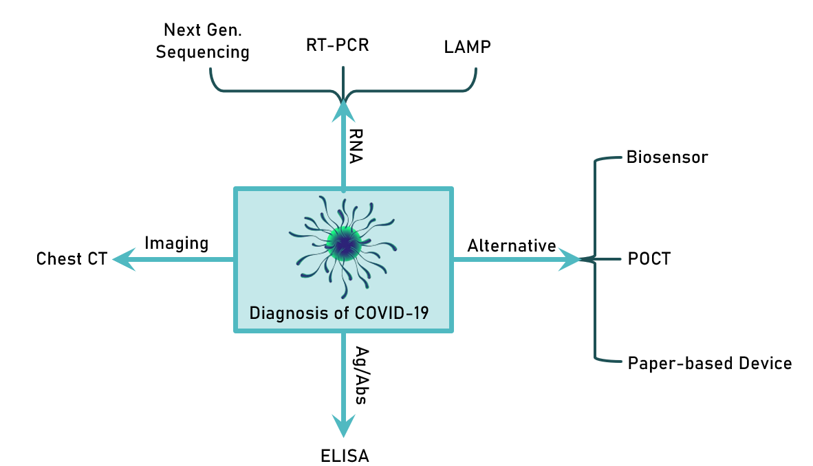

Figure 6. Diagnostic approaches for COVID-19

VI.Treatment
A. Existing drug
In December 2019, a coronavirus pneumonia pandemic in Wuhan, Hubei Province, China, was reported to the World Health Organization (WHO). The sudden outbreak and skyrocketing mortality rate made it urgent to use experimental medications and drug repurposing to lessen the severity of this novel viral infection. Since then, significant advancements have been made to curb the urgent need for some therapeutic intervention to prevent or treat SARS-CoV-2 as the infection rapidly spread worldwide. As a result of the tireless efforts of clinical researchers around the world, many successful approaches and drugs were discovered.
Over 80 clinical trials investigating coronavirus therapy have started, with some pharmacological repurposing or repositioning for COVID-19 being one of them. As a result, in March 2020, we searched the clinicaltrials.gov database. Researchers uncovered 24 clinical studies including over 20 drugs, including human immunoglobulin, interferons, hydroxychloroquine, arbidol, remdesivir, favipiravir, lopinavir, ritonavir, oseltamivir, methylprednisolone, bevacizumab, and traditional Chinese remedies (TCM). Although there are certain restrictions to medication repurposing. However, repositioning clinical trials facilitates the discovery of new classes of drugs, and their reduced costs and shorter time to market make them an appealing option. In this scenario, pharmaceutical supply chains for formulation and distribution are also engaged [28].
Antimicrobials that could work against the coronavirus are as follows:
- Remdesivir – An antiviral approved by the US (FDA) has approved it for the treatment of COVID-19 in adults and children with severe disease. It is also available under an FDA Emergency Use Authorization (EUA). During the course of therapeutic interventions, the possibility of treating COVID-19 using nucleoside analogues was actively explored. The candidates for this intervention included medications like ribavirin, remdesivir, geldesivir, and favipiravir. All of these have gotten significant attention, but Remdesivir has received the most. Remdesivir, a prodrug to adenosine [29], was created initially for the treatment of hemorrhagic fever viruses such as the Ebola (EBOV) and Marburg viruses, however, it performed poorly when compared to antibody treatments for EBOV [30,31].

Early on in the SARS-CoV2 outbreak, Remdesivir was tested in vitro at the Wuhan Virus Research Institute [9] and was found to be a strong inhibitor of viral infection in cell cultures. In a COVID-19 patient, it was successfully employed for the first time in January 2020. Remdesivir has provided an efficient and practical therapy alternative for the future, with an effective decrease of pulmonary viral load in animal models, and an acceptable safety profile in groups of COVID-19 patients. However, there are many restrictions on its use in antiviral therapy combinations during the total course of treatment.

- Hydroxychloroquine & Chloroquine, During the very initial phase of the COVID pandemic, hydroxychloroquine and chloroquine were suggested to be highly effective antiviral agents. In vitro, testing revealed that chloroquine derivatives have antiviral efficacy against SARS-CoV2 [32]. Based on this observation, the medication was quickly put into clinical usage, and early findings indicated that COVID-19 patients who had a 10-day course of Hydroxychloroquine had improved viral clearance and clinical outcomes [33]. According to a French pilot trial [34] that was randomly conducted on 36 COVID-19 patients, those who were treated with hydroxychloroquine plus azithromycin had a quicker time clearing the virus.

Others, however, have disputed the findings and discovered no advantage in either illness outcome or viral clearance [35]. Disappointingly, the largest (also retrospective) trial to date evaluating the effects of hydroxychloroquine alone or in combination with azithromycin indicated no benefit but rather a higher mortality risk among individuals receiving the drug [36]. Later they were revoked by the FDA EUA owing to a lack of effectiveness data.

- Lopinavir; Ritonavir – Lopinavir/ritonavir is an FDA-approved HIV combo drug that was recommended as an antiviral agent against COVID-19 during the pandemic's early stages. A randomised controlled trial found no advantage with lopinavir-ritonavir treatment compared to standard care in individuals hospitalised with severe COVID-19. Thus, due to controversial opinions, Lopinavir/Ritonavir is currently not approved for the treatment of COVID-19 due to a lack of recent preclinical data.
- Ivermectin –Limited clinical data and potential doses exceed those approved in humans.
- Azithromycin- Azithromycin and hydroxychloroquine have been shown to have synergistic effects against SARS-CoV2 in vitro, as was already mentioned, and these effects seem to have carried over into clinical practice. Fascinatingly, azithromycin has an alkalinizing action at least equal to that of hydroxychloroquine and is likewise a weak base that accumulates in endosomes. Azithromycin is sometimes utilised for its immunomodulatory effects in addition to its antibacterial ones, particularly in individuals with chronic pulmonary diseases.
- Paxloid- Paxloid is an oral protease inhibitor composed of two antiviral agents, ritonavir in combination with nirmatrelvir. It is observed to be highly effective against MPRO which is needed for viral replication [37]. Many studies as well as clinical trials proposed that Paxloid demonstrates antiviral activity against most of the forms of coronavirus [38].

“There is no particular anti-COVID-19 medication for COVID-19 patients to recommend,” according to a WHO clinical care recommendation paper (as of March 13, 2020). WHO suggested guidelines of treatment based upon symptomatic therapy for moderate disease to ventilatory management for severe condition COVID 19, ARDS and only licenced, randomised, controlled trials for the treatment of viral pneumonia should employ systemic corticosteroids as experimental anti-COVID-19 therapies. In this regard, the WHO recently launched a global “mega trial” (SOLIDARITY) with a pragmatic trial design to confirm positive cases. Based on local medication availability, remdesivir, chloroquine or hydroxychloroquine, and lopinavir/ritonavir, were the active therapy arms chosen [39].
In nucleic acid vaccines, antigen-encoding plasmid DNA or RNA, mRNA, or viral replicons are utilised. A humoral and cell-mediated immune response arises in response to the nucleic acid that is taken up by a cell to begin protein synthesis. Similar vaccines have been studied for veterinary infectious diseases to demonstrate immunogenicity. In phase, I research, nucleic acid vaccines against Ebola, influenza, and the Zika virus are presently being evaluated in people.
The vaccine made on a nucleic acid platform enables for antigen alteration with increased production speed, and the method can be completely cell-free, eliminating the requirement for BSL2 labs. The main problem is that nucleic acids, because RNA, especially mRNA, is fragile, it must be transported and stored in a cold-chain environment.
SARS-CoV and MERS-CoV DNA vaccines in phase I clinical investigations, coding for the SARS-CoV N protein genome developed by the NIAID was tried in ten people. The number of people who have enrolled in Phase 2 clinical trial for a MERS-CoV DNA vaccine (GLS-5300) that codes for the whole S protein genome. created by GeneOne Life Science/Inovio was greater (n = 75). Both clinical studies produced positive humoral and cellular responses and had acceptable safety profiles. Sinovac Biotech's inactivated vaccine (ISCV) is another SARS vaccine that has reached Phase I testing. Human investigations in which vaccinated patients were challenged with the wild virus were not reported.

B. Protease inhibitors:
Millions of people have been infected throughout the world as a result of coronavirus 2's severe acute respiratory syndrome (SARS-CoV-2). Experimental therapeutics based on repurposing current antivirals are being tried as part of the continuous hunt for an effective antiviral. This includes HIV protease inhibitors (PIs), which have received a lot of press recently. While few trials have shown lopinavir and ritonavir effectiveness in the context of SARS-CoV-2, where it is crucial to validate the drugs' mechanisms of action, more study is needed. Mahdi and colleagues [40].
SARS-CoV-2, causing coronavirus disease 2019 (COVID-19), represents a major threat to global public health. Based on their structure, a number of inhibitors of the coronavirus 3C-like protease (3CLpro), an enzyme required for viral replication, have been found. In both enzyme and cell-based testing using Huh-7 and Vero E6 cell lines, the optimised inhibitory compounds were found to be effective against a variety of human coronaviruses, including MERS-CoV, SARS-CoV, and SARS-CoV-2. In cultivated primary human airway epithelial cells, a variety of medications exhibited antiviral activity against SARS-CoV-2. Administration of a lead compound 1 day after virus infection enhanced survival from 0 to 100% in a mouse model of MERS-CoV infection and reduced lung viral titers and histology. As a result, a series of lead compounds might be used as antiviral medicines against human coronaviruses. (Rathnayake and colleagues, 2020)
SARS-CoV-2 has few antivirals and no vaccines currently available. As a result, identifying pharmacological targets that might lead to effective antivirals is critical. Several viral proteins have been focused on as SARS-CoV-2 antiviral drug targets: the spike protein, the RdRp, Mpro, and PLpro are RNA-dependent RNA polymerase, main protease, and papain-like protease, respectively. Liu and colleagues [41]. On May 1, 2020, the US Food and Drug Administration awarded remdesivir, a SARS-CoV-2 RdRp inhibitor, emergency use authorisation. In cell culture, Remdesivir displays antiviral efficacy against SARS-CoV, SARS-CoV-2, and MERS-CoV. MERS-CoV-infected mice and rhesus macaque models were used to confirm the antiviral activity. Other RdRp inhibitors being researched for SARS-CoV-2 include EIDD-2801, favipiravir (T-705), ribavirin, and galidesivir. [42]
COVID-19 is a sickness caused by the coronavirus SARS2, which has spread to become a pandemic. Many ways are being considered in the development of medicine to combat it. In this study, researchers have studied the replication of COVID-19 and its structural and functional similarities with HIV. The studies conducted before had suggested that the anti-retroviral drugs used in HIV have good affinity towards COVID-19 and hence help in curing it, for example: Lopinavir, ritonavir, etc. Similarly in this study, researchers have come across natural protease inhibitors namely BBI (Bowman-Birk Inhibitor) a serine protease inhibitor, from soybean that has inhibitory effects on HIV. Because the two have structural similarities, this may also be useful in treating COVID-19. The binding affinity of this inhibitor is evaluated using Hex 8.0.0 to support this notion, and the findings are interpreted accordingly. As a result, pharmacological targets for treating it can be found in structural elements of it [43].
SARS-CoV-2, a new coronavirus, has caused a global health and economic disaster. As of April 30, 2020, the sickness, known as coronavirus disease (COVID-19), had infected 3090445 persons globally and killed around 217769 individuals. SARS-CoV-2 is currently without a specific effective medication or vaccination. Several existing and authorised medications are undergoing clinical trials to see if they may be repurposed. However, given the urgency of the issue and the necessity to save the time required for de novo drug development, medication repurposing remains the greatest option for finding effective antiviral therapy. Using a molecular docking method, the goal of this study was to see how effective 82 compounds/drugs were at blocking SARS-main CoV-2's protease (3CLPro). This protease is a key enzyme in viral replication, making it a promising therapeutic target. Among the compounds evaluated are 16 known protease inhibitors, two newly discovered -ketoamides, 24 novel potential inhibitors, and 40 phytochemicals were found. Ritonavir, Indinavir, Montelukast, Nelnavir, Candoxatril, Tigecycline, and Lopinavir are some of the most effective protease inhibitors. Several additional medications and substances, including phytochemicals, have been found as effective enzyme inhibitors or are projected to be so. Several drugs' respective efficacies in inhibiting 3CLPro are also mentioned. As a result, this study is critical for COVID-19 clinical intervention. Choudhury and his associates.
Coronavirus illness 2019, a severe respiratory disease that is quickly spreading, is caused by SARS-CoV-2, a single-stranded RNA beta corona virus. As a result of the absence of a successful therapeutic approach, Chinese health officials began to examine the usage of lopinavir and ritonavir, which have previously been optimised for HIV/AIDS viral infection therapy and prevention. Despite the fact that these two drugs have been used in clinical trials, nothing is known about their possible molecular mechanisms of action. SARS-CoV-2 is a virus that causes SARS. SARS-CoV-2 major protease (Mpro), also known as C30 Endopeptidase, has just been crystallised and published. We used supervised molecular dynamics, an emerging computational tool, to investigate the recognition process of a ligand from its unbound to its ultimate bound state at an atomic level, starting with this important structural information. They revealed the molecular mechanism of Lopinavir, Ritonavir, and Nelfnavir, three possible C30 Endopeptidase inhibitors, with the latter being tested because of promising in-vitro action against the structurally similar SARS-CoV protease.
C. Antiviral drugs:
Repurposing licenced medications is emerging as an essential treatment option during the global outbreak of coronavirus illness 2019 (COVID-19). Ganovo is a very effective hepatitis C virus (HCV) protease (NS3/4A) inhibitor that has been licenced and distributed in China since 2018 for the treatment of chronic hepatitis C patients [18].
Valentina L. 2020 used the crystal structure of COVID-19 protease as a template to create a pharmacophore representation of the protease inhibitor-binding pocket's functional centres.
Researchers analysed the conformational database of 64 FDA-approved drugs for putative COVID-19 protease inhibitors using this pharmacore model. Putative conformers of these drugs were docked to the protease's binding pocket. Three of the identified pharmaceutical molecules are being studied for COVID-19 therapy: carfilzomib, cyclosporine A, and azithromycin. It was suggested that the identified drugs be tested for COVID-19 therapy (Kouznetsova and colleagues, 2020).
Because there is no particular antiviral therapy for COVID-19, numerous therapy techniques have been proposed. The use of convalescent plasma and interferon (IFN), as well as interleukin 6 receptor inhibitors, can help to reduce the cytokine storm. COVID-19 was treated with chloroquine and hydroxychloroquine, which impede nuclear transport of viral proteins19,20 and diminish endocytosis-mediated viral entry and modify glycosylation of ACE2, respectively. Antivirals that block protease inhibitors and nucleotide or nucleoside analogues that impede viral RNA synthesis have also been repurposed to treat SARS-CoV-2 infection. Remdesivir is one of the most efficient antiviral drugs for fighting the SARS-CoV-2 virus. Nucleoside analogues are a kind of antiviral drug that inhibits reverse transcription and are one of the most effective treatments for SARS-CoV-2 infection. The goal of this study was to compile evidence from in vitro investigations, in vivo investigations, COVID-19 inpatients treated under emergency procedures, and clinical trials to present a comprehensive picture of remdesivir's potential in the treatment of COVID-1 patients [44].
Testing whether current antiviral medications are successful in treating similar viral infections is an efficient strategy to drug development. Five FAD-approved drugs were examined in vitro against a clinical strain of 2019- nCoV, includes ribavirin, penciclovir, nitazoxanide, nafamostat, chloroquine, and remdesivir (GS5734) and favipiravir (T-705), two well-known broad-spectrum antiviral medicines (2020).
At this moment, there is no effective antiviral medication for COVID-19. 5%–10% of COVID-19 patients can have severe, potentially life-threatening symptoms, necessitating the discovery of effective treatments. The core of treatment is still optimal supportive care. More than 300 clinical trials are now underway, with numerous antivirals and immunomodulating medicines at various levels of assessment for COVID-19 in those studies, with some of them expected to be published in the next months. Despite the urgent need for randomised controlled research to establish an effective antiviral therapy for COVID-19, various medicines are being utilised all around the globe based on in vitro or extrapolated data or observational research. Chloroquine, hydroxychloroquine, lopinavir/ritonavir, favipiravir, and remdesivir as the most commonly used antimalarial drugs, Nitazoxanide and ivermectin, found to be effective against the SARS-CoV-2 virus [45].
COVID-19 infection needs the development of innovative antiviral drugs very now. There is currently no specific medicine that can be used to treat this illness. Because developing a new medication takes time, repurposing broad spectrum antiviral medications might be a good way to act quickly. This study looked at a class of broad-spectrum antivirals that target the virus spike protein (S protein), RNA-dependent RNA polymerase (RdRp), 3-chymotrypsin-like protease (3CLpro), and papain-like protease (PLpro), which are all important in coronavirus pathogenesis and life cycle [46].
D. Immunomodulatory drugs
Several clinical and experimental research has demonstrated that alterations in the immune response and, in certain individuals, the abnormal release of pro-inflammatory cytokines like interleukin-6 (IL-6), interferon-gamma, and tumour necrosis factor-alpha are significantly related to the damage caused by the virus.
Anti-inflammatory medications especially monoclonal antibodies, which have been used in rheumatology for some time to decrease the immune system reaction, are therefore employed in the COVID-19 emergency alongside being based on prior experience proven in patients with SARS. There are potential roles of anti-IL6, anti-IL-1, JAK inhibitors, corticosteroids, antimalarials, heparins, and immunoglobulins in the management of moderate to severe COVID-19.

.
VII. Prevention of infection
The easiest strategy to avoid contracting COVID-19 is to avoid coming into contact with the virus.
• The virus spreads from person to person owing to close contact with a distance of less than one metre (around 6 feet).
The virus is conveyed by respiratory droplets produced by an infected person coughing. sneezing, or talking. Such droplets penetrate surrounding people's lips or nostrils and are breathed into the lungs. People who are asymptomatic can potentially spread the disease. COVID-19. Limiting close contact with strangers, avoiding close contact with ill individuals, and maintaining a social space between ourselves and others can help prevent viral infection by maintain a space of 6 feet distance. Wearing a mask in public settings where social distance is effective is another protective technique. It is best to avoid young children under the age of two and other people who have respiratory issues. A mask can help limit viral transmission from a sick person to others. (https://www.cdc.gov/coronavirus/2019-ncov/prevent-getting-sick/prevention/prevention.html)
The competent authorities have imposed organisational measures connected to the containment and management of the COVID-19 epidemiological emergency for the management of the evolving pandemic crisis. The following strategies can be used to restrict the disease's spread at the district, state, and national levels.
- Dividing the areas into Red, Orange, and Green zones depending on the total number of patients infected with the COVID-19 virus. Putting travel restrictions in Red Zones by prohibiting people's admission and leave, especially in "red" zones where the frequency of COVID-19 infections is higher.
- Maintaining the 14-day home quarantine requirement for persons living/working in confinement zones or returning from them. Thermal scanning is used to keep track of external collaborators and visitors, and admission is restricted to prevent viral diseases from spreading.
- Setting priorities for the firm and office work by allowing employees to work from home.
- To preserve social distance standards, segregate the whole working workforce in the company/office into two or more autonomous working groups.
- People working in the health industry, such as physicians and nurses, must comply to strict PPE clothing requirements.
- Sanitation of contaminated ambient surfaces, infected items, and equipment to reduce the Contact with infected organisms poses a danger of SARS-CoV-2 infection spreading to people. Reduce direct physical contact (for example, shaking hands);
- Maintaining social distance by keeping a distance of more than 2m with time restrictions of more than 15 minutes by minimising contact with infected people to avoid spreading infections via coughing and breathing, as well as the constant use of hand washing and alcohol-based disinfectants with 62 percent–71 percent alcohol to prevent the transmission
- Avoid contact with individuals for more than 15 minutes and at a distance of less than 2 metres in a closed setting (e.g., classrooms, conference rooms, hospital waiting rooms, and similar places).
- Personal protection equipment, such as hand gloves, masks, and a face shield, is worn.
- Decontamination of all used accessories with hypochlorite after coming into contact with potentially hazardous items (gloves, garments, masks, used tissues, garbage)
Recommending the use of N95 masks, which filter particles 8-12 times larger than surgical masks, which have different filtering capacities based on the particle size in an aerosol (1.3 to 6.5 m) and the model. N95 masks are N95 respirators with an exhalation valve that protects against the inhalation of airborne particles with a size comparable to germs and viruses. With no valve problem, penetration levels ranged from 0.03 per cent to 0.04 per cent [47]. Alternatively, the use of disposable Surgical Facemasks was also promoted among the people. The surgical mask reduces virus exposure by 1.1 to 55 times [48].
Proper disposal of used face masks, gloves, paper tissues and other infected material by following the medical assistance procedure offered by the healthcare personnel [49].
Changes in Government policies including the closure of international borders and putting restrictions on the movement of people ultimately confined to their homes with reduced transport have altered patterns of energy demand /consumption pattern around the world. In comparison to the mean 2019 levels, this has decreased CO2 emissions by –17 per cent and the resulting pollution in early April 2020. As a result of the lockdown effect, CO2 emissions in individual countries were decreased by an average of –26%. Annual emissions in 2020 recorded a low estimate of –4% and a high estimate of –7% by mid-June under pre pandemic conditions, which will continue if worldwide constraints are maintained until the end of 2020.
- Vaccination to prevent COVID-19 infection
Vaccination is a crucial tool in controlling the spread of COVID-19 and protecting individuals from severe illness and hospitalization. The ultimate goal behind vaccination is to trigger the immune mechanism which will in turn generate and keep memory of neutralizing antibodies against the virus. Throughout the world, tremendous efforts and hard work of scientists resulted in the formulation of effective novel vaccines for COVID-19 or SARS-COV2.
- BNT162b2 vaccine (mRNA-based, BioNTech/Pfizer): Based on the efficacy trials, it was reported that the patients of age 16 or above getting two dosages of BNT162b2 presented 95% protection against COVID after the definite period of 21 days. In August 2021, US FDA authorized the clinical practice of this against COVID-19.
- mRNA-1273(mRNA-based, Moderna): Trials proposed that the patient receiving two doses of mRNA-1273 showed 94.1% immunity after the period of 28 days. This was approved to be used against COVID-19 after January 2022.
- Ad26.COV2.S vaccine: It received a green flag for the COVID prevention in February 2021. Based on the randomized trials and studies, it was observed to provide 73.1% efficacy in a single dose.
- ChAdOx1 nCoV-19 vaccine: The interim analysis of randomized control trials demonstrated that ChAdOx1 nCoV-19 offers 64% efficacy in just a single dose while 70.4% clinical efficacy after two doses. Some countries have given it the approval to be used as a vaccine candidate however others are still leading research work.
In early 2021, some patients suffered from the symptoms of a new clinical syndrome characterised by thrombosis and thrombocytopenia after vaccination with the ChAdOx1 nCoV-19 and Ad26.COV2. This novel syndrome was very similar to heparin-induced thrombocytopenia (HIT). However, it was referred to as vaccine-induced immune thrombotic thrombocytopenia (VITT) in the absence of prior heparin exposure.
Furthermore, many other vaccines which are protein-based or inactivated form were also developed and used preferably. Indigenous development of Covaxin by India, Sputnik V by Russia, and Corona Vac by China are some examples among them. These are approved or granted emergency authorization against the battle of COVID-19.
With the help of the National Institute of Virology (NIV), the Indian company Bharat Biotech produced COVAXIN (BBV152), an indigenous COVID-19 vaccine. It was approved for immediate use on November 3, 2021, by the Technical Advisory Group for Emergency Use Listing. It got approval from the Drug Controller General of India (DCGI) after Human clinical trial phase III. It comprises the Vero cell platform, which is well known for its safety and effectiveness both domestically and outside. Covaxin had a 78% effectiveness against COVID-19 of any severity 14 days or more after dose 2. A 93% vaccination success rate against serious illness. Effectiveness ranged from 79% for people under the age of 60 to 68% for those over 60.

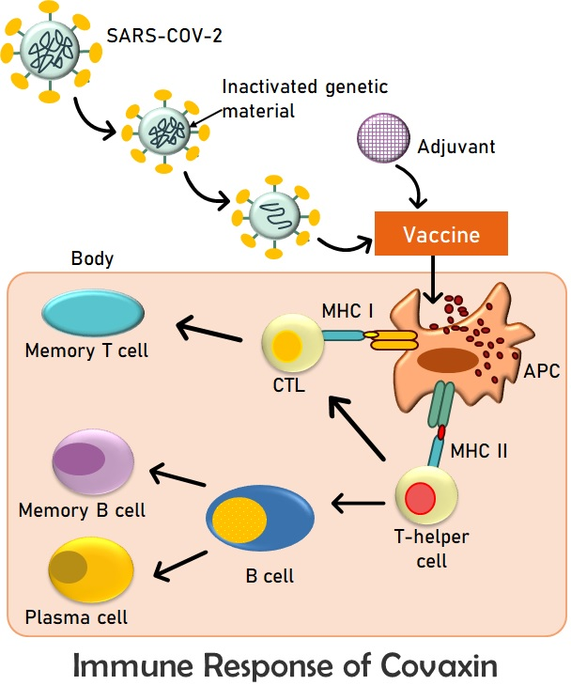

Figure 7. Diagrammatic representation of the mechanism of action of Covaxin

The next most preferred vaccine in India is Covishield. The SARS-CoV-2 Spike (S) glycoprotein is encoded by a chimpanzee adenovirus that is recombinant and replication-deficient. The third phase of the trials found that Covishield had an efficacy rating of around 90%. Since studies have shown that immunity begins to wane after two doses and that a third dose provides higher levels of security, a third dose (also known as a booster dose) has been added to the immunisation schedule of several nations [50,51].

- Preexposure Prophylaxis (PrEP) to prevent SARS-CoV-2 infection
Even though vaccination is the most effective treatment for COVID-19 prophylaxis, some individuals may not produce the necessary immune response. In a small number of patients, the vaccine may manifest contrary expressions because of ancestral medical history. In such a scenario, US FDA has proposed an EUA suggesting the immediate use of Tixagevimab along with Cilgavimab for preexposure prophylaxis of COVID-19 in adults. This also validates for individuals who are taking immunosuppressive medication and because of which are unable to produce appropriate immune responses.

VIII. Will COVID-19 end?
The risk remains that COVID-19 still prevails in our society and poses problems to many people. Innate immunity protects most individuals and also reduces the risk of severity of symptoms along with their further transmission. Even vaccinated individuals have a chance of risk of COVID-19. The rate at which it spreads is very high because the virus undergoes continuous mutation in its structure. This is the key factor why there has not been much subsidy in the rate of spread of COVID-19. The different known variants of COVID-19 are Omicron and Delta variants. Omicron is more infectious than any previous variant and reduces the immunity provided by both prior infection and incomplete vaccination. Certain factors like age, demographics and public behaviour count in the spread of this virus. The new variants of Omicron still remain unknown. Evidence suggests that both natural and vaccine-induced immunity diminishes over time, particularly against infection. Individuals with booster doses of vaccination may benefit from protection against omicron. While those who have only one or two doses may prevail and pass on the infection. The Alpha and Delta variant still reversed the shift towards end of the pandemic and immunity. Many cases of the Delta variant still have a short-term burden of disease. This is also increasing the number of hospitalizations. Delta variant is highly transmittable and thus it is difficult to achieve herd immunity. The effectiveness of vaccines in preventing the disease still raises questions. The beta and gamma variants are also recognized but these are comparatively less pathogenic. These uncertainties pose many problems although the pandemic has now become endemic. SARS-CoV-2 continues to mutate but most mutations do not lead to stable new forms and also pose less risk of severity.

A shift from pandemic to endemicity of the disease does not ever mean that there would be no risk of infection. An “always-on” response towards immunity may quickly increase protection. Protection against the new variant forms of the virus may require herd immunity as well. These factors, combined with limited behaviour change from pandemic-weary populations—and the twin accelerants of transmission, holiday travel and gatherings—meant that Omicron moved through the population with remarkable speed. Even without herd immunity, a transition toward normalcy is possible. Vaccines need to be taken by people to achieve herd immunity. In any case, the future of the COVID-19 pandemic depends likely on the ways in which communities and individuals respond. Discovery of new oral therapeutics which could reduce the chance of progression of the disease needs to be done. Booster doses are to be taken to roll out the pathogenicity and infection. Another step towards reaching the endpoint could be changing the focusing on public health.
COVID-19 risk is not yet completely gone. The symptoms that the mutant strains pose resemble those caused by influenza. Today, the burden of this COVID-19 disease in vaccinated people is almost the same as or slightly less than that of influenza, while the risks in unvaccinated people are higher. The variants of the virus are still a concern for the threatening of the disease progression.

There are also certain risks for herd immunity: The efficacy of the vaccine in reducing transmission may not be as high as expected and could be a problem in reducing herd immunity. Hesitancy in younger populations may also be the reason. The duration of vaccine-mediated immunity may be shorter than anticipated, thus reducing the reach for threshold immunity. Thus, the variants that reduce the effectiveness of vaccines in achieving natural immunity may spread widely. Also, the age of people counts for their vaccination. The short duration of immunity may delay the path towards the end.

Thus, the end towards COVID-19 may look like attaining normalcy and developing herd immunity. This transition will include steps that will gradually normalize aspects of social and economic life. Resuming the pre pandemic activities may rather not be as easy as expected. The next few years are likely to see a combination of some or all of these options around the world. Herd immunity does not seem the same as eradication. SARS-CoV-2 will continue to exist. Even when herd immunity is reached potential other measures like self-awareness may be required to be taken.

IX. Conclusion:
Due to the COVID-19 pandemic all over the world, vulnerable population, such as older persons and those predisposed to cardiovascular/respiratory/renal disorders or diabetes, requires extra protection. Therefore, we conclude using clinically validated protease inhibitors, such as chloroquine, as a preventative measure. Until vaccinations and/or medications that are effective in the prevention and treatment of COVID-19 are widely available, by preventing the entry of the virus via ACE2. Transmembrane serine protease inhibitors can serve as a profound remedy to avoid the expression and advancement of COVID-19. We concluded that using clinically established PIs could treat and significantly reduce COVID-19 infection. Such measures are especially crucial in nations where positive cases are increasing and medical resources are constrained. Although there are no viable therapy options for COVID-19, the protease inhibitors mentioned in this letter can be used as prophylactics to prevent clinical symptoms and complications.

References
- Kumar, S., Zhi, K., Mukherji, A., &Gerth, K. Repurposing antiviral protease inhibitors using extracellular vesicles for potential therapy of COVID-19. Viruses, 12(5), 486. (2020).
- Zhang, W., Zhao, Y., Zhang, F., Wang, Q., Li, T., Liu, Z., ...& Zhang, S. The use of anti-inflammatory drugs in the treatment of people with severe coronavirus disease 2019 (COVID-19): The Perspectives of clinical immunologists from China. Clinical Immunology, 214, 108393. (2020).
- Salih, M. A. H. An Overview on The Pandemic Coronavirus Disease 2019 (COVID-19) Outbreak. Kurdistan Journal of Applied Research, 31-36. (2020).
- MacIntyre, C. R. Global spread of COVID-19 and pandemic potential. Global Biosecurity, 1(3). (2020).
- Brodeur, A., Gray, D. M., Islam, A., &Bhuiyan, S. A Literature Review of the Economics of COVID-19. (2020).
- Wang, C., Wang, Z., Wang, G., Lau, J. Y. N., Zhang, K., & Li, W. COVID-19 in early 2021: current status and looking forward. Signal Transduction and Targeted Therapy, 6(1), 1-14. (2021).
- Du, Y., Tu, L., Zhu, P., Mu, M., Wang, R., Yang, P., ...&Xu, G. Clinical features of 85 fatal cases of COVID-19 from Wuhan. A retrospective observational study. American journal of respiratory and critical care medicine, 201(11), 1372-1379. (2020).
- Seth, S., Batra, J., & Srinivasan, S. COVID-19: Targeting Proteases in Viral Invasion and Host Immune Response. Frontiers in molecular biosciences, 7. (2020).
- Hui DS, Hazar E, Madam DA, et.al.-nCoV epidemic threat of novel coronavirus to global health-the latest 2019 novel coronavirus outbreak in Wuhan. China J Infect Dis. 2020;91:264-6 2019
- Romagnani, P., Gnone, G., Guzzi, F., Negrini, S., Guastalla, A., Annunziato, F., ...& De Palma, R. The COVID-19 infection: lessons from the Italian experience. Journal of public health policy, 41, 238-244. (2020).
- Mizumoto K, Kagaya K, Zarebski A, Chowell G. Estimating the asymptomatic proportion of coronavirus disease 2019 (COVID-19) cases on board the Diamond Princess cruise ship, Yokohama, Japan, Euro Surveill 2020;25:2000180. 10.2807/1560-7917.ES.2020.25.10.2000180 32183930. (2020).
- Beeching, N. J., Fletcher, T. E., & Beadsworth, M. B. Covid-19: testing times. (2020).
- He, X. et al. Temporal dynamics in viral shedding and transmissibility of COVID-19. Nat. Med. 26, 672–675 (2020)
- Slifka, M. K., &Gao, L. Is presymptomatic spread a major contributor to COVID-19 transmission?. Nature Medicine, 26(10), 1531-1533. (2020).
- Hasan, A., Paray, B. A., Hussain, A., Qadir, F. A., Attar, F., Aziz, F. M., …Falahati, M. A review on the cleavage priming of the spike protein on coronavirus by angiotensin-converting enzyme-2 and furin. Journal of Biomolecular Structure and Dynamics, 1–13. (2020).
- Song, H. C., Seo, M.-Y., Stadler, K., Yoo, B. J., Choo, Q.-L., Coates, S. R., Uematsu, Y., Harada, T., Greer, C. E., Polo, J. M., Pileri, P., Eickmann, M., Rappuoli, R., Abrignani, S., Houghton, M., & Han, J. H. Synthesis and characterization of a native, oligomeric form of recombinant severe acute respiratory syndrome coronavirus spike glycoprotein. Journal of Virology, 78(19), 10328–10335. (2004).
- Boopathi, S., Poma, A. B., & Kolandaivel, P. Novel 2019 coronavirus structure, mechanism of action, antiviral drug promises and rule out against its treatment. Journal of Biomolecular Structure and Dynamics, 39(9), 3409-3418. (2021).
- Chen, N., Zhou, M., Dong, X., Qu, J., Gong, F., Han, Y., ...& Zhang, L. Epidemiological and clinical characteristics of 99 cases of 2019 novel coronavirus pneumonia in Wuhan, China: a descriptive study. The Lancet, 395(10223), 507-513. (2020).
- Wu, F., Zhao, S., Yu, B. et al. A new coronavirus associated with human respiratory disease in China. Nature 579, 265–269 (2020).
- Belouzard, S., Millet, J. K., Licitra, B. N., & Whittaker, G. R. Mechanisms of coronavirus cell entry mediated by the viral spike protein. Viruses, 4(6), 1011-1033. (2012).
- Bittmann, S., Luchter, E., Weissenstein, A., Villalon, G., & Moschuring-Alieva, E. TMPRSS2-inhibitors play a role in cell entry mechanism of COVID-19: an insight into camostat and nafamostat. J RegenBiol Med, 2(2), 1-3. (2020).
- Shi Y, Yi Y, Li P, Kuang T, Li L, Dong M, et al. Diagnosis of severe acute respiratory syndrome (SARS) by detection of SARS coronavirus nucleocapsid antibodies in an antigen-capturing enzyme-linked immunosorbent assay. J ClinMicrobiol;41(12):5781–2. (2003).
- Lau SK, Li KS, Tsang AK, Lam CS, Ahmed S, Chen H, et al. Genetic characterization of Betacoronavirus lineage C viruses in bats reveals marked sequence divergence in the spike protein of pipistrellus bat coronavirus HKU5 in Japanese pipistrelle: implications for the origin of the novel Middle East respiratory syndrome coronavirus. J Virol;87(15):8638–50. (2013).
- Shereen, M. A., Khan, S., Kazmi, A., Bashir, N., &Siddique, R. COVID-19 infection: Origin, transmission, and characteristics of human coronaviruses. Journal of advanced research, 24, 91-98. (2020).
- Fan, H., Ooi, A., Tan, Y. W., Wang, S., Fang, S., Liu, D. X., & Lescar, J. The nucleocapsid protein of coronavirus infectious bronchitis virus: crystal structure of its N-terminal domain and multimerization properties. Structure, 13(12), 1859-1868. (2005).
- Klein, S., Cortese, M., Winter, S. L., Wachsmuth-Melm, M., Neufeldt, C. J., Cerikan, B., ...& Chlanda, P. SARS-CoV-2 structure and replication characterized by in situ cryo-electron tomography. Nature communications, 11(1), 1-10. (2020).
- Jaiswal, A., Borage, S., & Shelotkar, P. A clinical approach to COVID-19. International Journal of Research in Pharmaceutical Sciences, 11(Special Issue 1). (2020).
- Rosa, S. G. V., & Santos, W. C. Clinical trials on drug repositioning for COVID-19 treatment. RevistaPanamericana de SaludPública, 44, e40. (2020).
- D. Siegel, H.C. Hui, E. Doerffler, M.O. Clarke, K. Chun, L. Zhang, et al., Discovery and Synthesis of a Phosphoramidate Prodrug of a Pyrrolo[2,1-f][triazin-4-amino] Adenine C-Nucleoside (GS-5734) for the Treatment of Ebola and Emerging Viruses, J. Med. Chem. 60 (5) 1648–1661(2017).
- M.L. Agostini, E.L. Andres, A.C. Sims, R.L. Graham, T.P. Sheahan, X. Lu, et al., Coronavirus susceptibility to the antiviral remdesivir (GS-5734) Is mediated by the viral polymerase and the proofreading exoribonuclease, mBio 9 (2) (2018).
- T.P. Sheahan, A.C. Sims, S.R. Leist, A. Schafer, J. Won, A.J. Brown, et al., Comparative therapeutic efficacy of remdesivir and combination lopinavir, ritonavir, and interferon beta against MERS-CoV, Nat. Commun. 11 (1) 222 (2020).
- M. Wang, R. Cao, L. Zhang, X. Yang, J. Liu, M. Xu, et al., Remdesivir and chloroquine effectively inhibit the recently emerged novel coronavirus (2019-nCoV) in vitro, Cell Res. 30 (3) 269–271, (2020).
- J. Gao, Z. Tian, X. Yang, Breakthrough: Chloroquine phosphate has shown apparent efficacy in the treatment of COVID-19 associated pneumonia in clinical studies, Biosci Trends. 14 (1) 72–73(2020).
- P. Gautret, J.C. Lagier, P. Parola, V.T. Hoang, L. Meddeb, M. Mailhe, et al., Hydroxychloroquine and azithromycin as a treatment of COVID-19: results of an open-label non-randomized clinical trial, Int. J. Antimicrob. Agents 105949 (2020).
- J.M. Molina, C. Delaugerre, J. Le Goff, B. Mela-Lima, D. Ponscarme, L. Goldwirt, et al., No evidence of rapid antiviral clearance or clinical benefit with the combination of hydroxychloroquine and azithromycin in patients with severe COVID19 infection, Med. Mal. Infect. (2020).
- J.N. Magagnoli, F. Pereira, T. Cummings, J.W. Hardin, S.S. Sutton, J. Ambati, Outcomes of Hydroxychloroquine usage in United States veterans hospitalized with COVID-19, medRciv Server, https://doi.org/10.1101/2020.04.16. 20065920 (2020).
- Pillaiyar T, Manickam M, Namasivayam V, Hayashi Y, Jung SH. An overview of severe acute respiratory syndrome-coronavirus (SARS-CoV) 3CL protease inhibitors: peptidomimetics and small molecule chemotherapy. J Med Chem. (2016).
- Owen DR, Allerton CMN, Anderson AS, et al. An oral SARS-CoV-2 MPRO inhibitor clinical candidate for the treatment of COVID-19. Pubmed/34726479. (2021).
- Sanders, J. M., Monogue, M. L., Jodlowski, T. Z., &Cutrell, J. B. Pharmacologic treatments for coronavirus disease 2019 (COVID-19): a review. Jama, 323(18), 1824-1836. (2020).
- Mahdi, M., Mótyán, J. A., Szojka, Z. I., Golda, M., Miczi, M., &Tőzsér, J. Analysis of the efficacy of HIV protease inhibitors against SARS-CoV-2′ s main protease. Virology journal, 17(1), 1-8. (2020).
- Liu, S. Luo, P. Libby, G.-P. Shi, Cathepsin L-selective inhibitors: A potentially promising treatment for COVID-19 patients. Pharmacol. Ther. 213, 107587 (2020).
- Michael Dominic Sacco1, Chunlong Ma2 , PanagiotisLagarias Structure and inhibition of the SARS-CoV-2 main protease reveal strategy for developing dual inhibitors against Mpro and cathepsin L. 020; 6: eabe075 (2020).
- Rane, T. Analyzing the Effect of Natural Protease Inhibitor (BBI) on Replication of COVID-19 in Comparison to HIV, using Protein Interaction Studies. (2002)
- Frediansyah, A., Nainu, F., Dhama, K., Mudatsir, M., &Harapan, H. Remdesivir and its antiviral activity against COVID-19: A systematic review. Clinical epidemiology and global health. (2020).
- YAVUZ, S., & Ünal, S. Antiviral treatment of COVID-19. Turkish journal of medical sciences, 50(SI-1), 611-619. (2020).
- Ghanbari, R., Teimoori, A., Sadeghi, A., Mohamadkhani, A., Rezasoltani, S., Asadi, E., ...& Sumner, S. C. Existing antiviral options against SARS-CoV-2 replication in COVID-19 patients. Future microbiology. (2020).
- Chellamani, K.P.; Veerasubramanian, D.; VigneshBalaji, R.S. Surgical Face Masks: Manufacturing Methods and Classification. J. Acad. Ind. Res., 2, 6. 2013.
- Booth, C.M.; Clayton, M.; Crook, B.; Gawn, J. Effectiveness of surgical masks against influenza bioaerosols. J. Hosp. Infect., 84, 22–26. (2013).
- Cirrincione, L., Plescia, F., Ledda, C., Rapisarda, V., Martorana, D., Moldovan, R. E., ...&Cannizzaro, E. COVID-19 pandemic: prevention and protection measures to be adopted at the workplace. Sustainability, 12(9), 3603. (2020).
- Goldberg Y, Mandel M, Bar-On YM, Bodenheimer O, Freedman L, Haas EJ, Milo R, Alroy-Preis S, Ash N, Huppert A. Waning Immunity after the BNT162b2 Vaccine in Israel. N Engl J Med. Dec 09, 2021.
- Saiag E, Goldshmidt H, Sprecher E, Ben-Ami R, Bomze D. Immunogenicity of a BNT162b2 vaccine booster in health-care workers. Lancet Microbe. Dec 2, 2021.

