Current Progress Achieved in Porous Nanostructured Electrode Materials in Electrochemical Supercapacitor
Abstract
Electrochemical supercapacitors have multi-endowed solutions to meet the demand for various emerging energy storage applications because of their excellent reversibility, long life-span and higher power densities. Generally, choice of electrode materials are one of the essential factors that improve the electrochemical performance in supercapacitors. In this regard, the search for highly suitable electrodes for potential energy storage devices is incalculable. Nanostructure-based electrodes shows promising responses for efficient charge storage capacity in energy applications. The high charge storage performance of supercapacitors are typically enhanced by various dimensional nanostructured electrode material properties such as compositions, porosity, morphology, distributions, etc. Among them, porosity plays a crucial role in the capacity of charge storage in electrode material. Nanoporous electrodes are nanosized porous structure materials with special properties such as large surface areas for more kinetics of charge transfer reactions, thus accumulative the electrical conductivity of the electrode, that enhancing the energy storage capacity. The esteemed researchers have investigated a few outstanding porous electrode materials with excellent electrochemical performance for energy storage applications. In the last few decades, porous nanostructured electrodes have attracted major attention in various research areas because of their specified structural behaviours and easy interaction with suitable electrolytes to achieve advanced electrochemical performances. Hence, in this book chapter, recent developments on porous electrode materials for energy storage applications that includes their synthesis methodology, nanostructures, and their electrochemical performances are compactly discussed.

1. Introduction
The growth and development of human cultural society are explicitly connected with science and technology. From infancy, electrical energy plays a virtual role in human life. Energy storage devices are used to store electrical energy generated by renewable or non-renewable energy sources [1-3]. But conventional energy sources are inadequate for long-term durability and in-time consumption. Thus, energy storage devices are essential to hold the energy for a longer time and to be used when there is an unavailability of energy resources. In the area of research, these energy storage devices are focused on the present decades, which can be professional in worldwide energy applications [4, 5]. The electrical energy sources are the success of advanced technology has made daily life more comfortable and easier by providing modern electronic portable devices such as smart phones, laptops, and electric vehicles. Continuously, the more usage of electronic gadgets the energy demand occurring in the present days. So it is important to develop the energy storage materials. In this scenario, the electrochemical energy storage devices are developed with high consequence effects, such as high energy density and power density, emphasise powerful electronic tools. Dielectric capacitors, lithium-ion batteries and electrochemical supercapacitors [6–9] are unconventional electrochemical energy storage devices (EES) which hold an important position in terms of parameters such as specific power density and energy density. A ragone plot (Fig.1) illustrates the classification of abundant electrochemical energy storage devices on the basis of their outcome in power and energy density. The charge stored in a conventional capacitor is electrostatic and whereas the batteries store charge by a faradaic process. The batteries carry high energy density and capacitors deliver high power density. Typically, supercapacitors fill the power gap between capacitors and batteries.
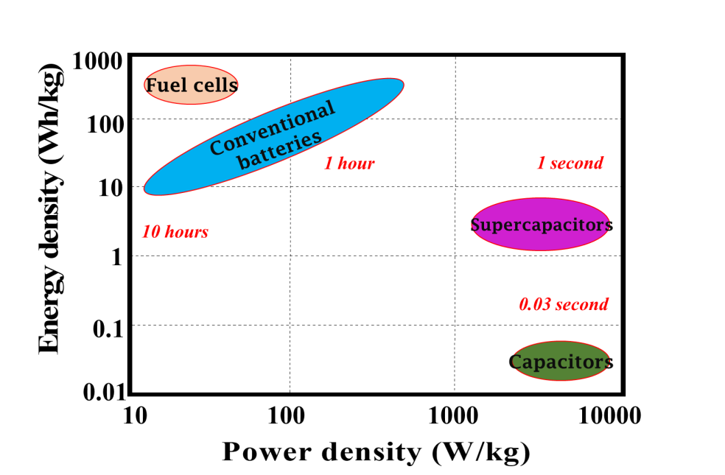
Fig.1 Categorization of energy storage systems - Ragone plot.
A supercapacitor is a type of capacitor to store electrochemical energy. This energy can be converted into electrical energy. Nowadays, electrochemical supercapacitors are highly utilised for numerous applications [10-13] like transportation, electronics, power backup production, military, and aerospace, etc. The employment of rechargeable energy storage devices could deliver more power to scores of applications such as electric vehicles (EVs) and hybrid electric vehicles (HEVs) for collecting and storing energy. The advantages of using rechargeable supercapacitors in vehicles are boosting power as well as a rapid charge and discharge process with a long life-term. Besides that, the low cost of manufacturing supercapacitors can make EVs more affordable. Even supercapacitors can be a major energy storage device in the malleable consumer electronics that assist wearable or bio-medical devices (sensors and implants). Subsequently, supercapacitors could fulfil all the needs of future-generation electronic devices in a simple and effectual manner.
2. Energy storage mechanism of Electrochemical Supercapacitors
Charge stored in electrochemical supercapacitor materialises within the active electrode materials, which are coated on acquit substrates with an electrolyte. On the basis of charge storage mechanisms, supercapacitors can be designated into three categories: electric double-layer capacitors (EDLCs), pseudocapacitors and hybrid supercapacitors. In EDLCs, the electrostatic charge is stored to form the electrical double layer between the electrolyte and the electrode, which in a pseudocapacitor energy storage mechanism is elicited by the efficient and reversible faradic reactions at electroactive sites. In hybrid supercapacitors, charge storage is typically done both electrostatically and electrochemically inside the two electrodes.
2. (a) Energy storage mechanism of EDLCs
The charge storage model for EDLCs was first proposed by Hermann von Helmholtz in 1853. Fig. 2 shows the model of the EDLC charge storage mechanism, the electrostatic charge inflation on the surface of the electrode and electrolyte ligament. In the ideal EDLs, oppositely charged ionic layers mobilise the electrode-electrolyte interfaces for surface charge transfer reactions, i.e., ions move towards the electrodes. The two unique superficial layers formed in an EDLC, i.e., the inner Helmholtz layer and the outer Helmholtz layer. At non-solvated ions or solvated ions with higher ionic conductivity, the innermost Helmholtz layer is thinner. Secondly, a thicker outer layer of the Helmholtz layer is obtained by the chemical ingredient of the electrolyte ions due to strong electrostatic interaction. Further, Gouy and Chapman extended the Helmholtz model by stating that due to the electrostatic interaction and ascendancy of thermal motion on the diffusion layer, the electrolytes are precisely distributed as cations and anions. This model contradicts itself due to an exaggeration in the EDL capacitance. Zeta potential denotes the small potential difference between the Gouy-Chapman diffuse layer and the Helmholtz layer, and it represents ion storage at the diffuse layer. Next, Stern proposed that an electrochemically active region is detached into two layers, one being a Stern-compact layer, which is mostly hydrated ions adsorbed on the electrode surface, and the other being a diffused layer as defined by Gouy and Chapman.
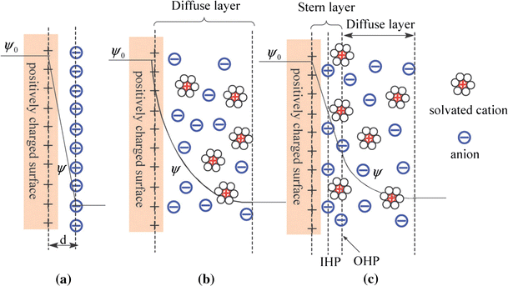
Fig. 2 Models of the EDLC at a positively charged surface. [14]
2. (b) Energy storage mechanism of pseudocapacitors
Inherently, the faradic reaction takes place between the electroactive electrode surface and electrolyte during the charge storage mechanism of pseudocapacitive electrochemical supercapacitors. The specific energy storage capacity of pseudocapacitive material is higher than EDL material in capacitors except for their lower electrical conductivity, which is accompanied by the inadequacy of cycling strength of the device. The amount of redox reaction in a pseudocapacitor is determined by the chemical interaction between the electrode and electrolyte interface, the reversibility of reaction and the stretch of electrolyte reciprocity in the electroactive material. The important parameter for pseudocapacitor performance, i.e., relatedness of electrode and electrolyte interaction, mainly depends on pore size distribution, pore size layout of pores, electric conductivity surface functions, and the chemical performance of nanoporous electrodes.
Furthermore, the electrochemical nature of the faradic charge storage mechanism is divided into three categories. Types of pseudocapacitive charge storage mechanisms are (a) Underpotential deposition events when metal ions form an adsorbed monolayer at a different metal's surface well above their redox potential. i.e., expressly, the applied voltage ought to be below the cation redox potential. (b) Redox pseudocapacitance occurs when ions at a material's surface are electrochemically espoused in a faradic charge kinetics transfer, i.e., electron transfer between redox species, and (c) intercalation pseudocapacitance occurs when ions appear into tunnels of a layer of a reduction-oxidation electroactive material accompanied by a faradic charge-transfer with no crystallographic phase aspect change. In other words, the insertion is accompanied by the neutral from the transition of metal valance to electroactive materials.
3. Electrode materials in electrochemical supercapacitors
Various kinds of electrode materials have been publicly employed in supercapacitors and each electrode has an explicitly specific electrochemical etiquette in a certain electrolyte. Owing to different nano-dimensions, fabrication of various nanostructured electrodes has found its applications in multiple fields like nano-sensors, nano-electrocatalysts, and nano-electronics etc. The electrochemical properties of nanostructured electrode materials can be tuned to achieve high sensitivities, smaller volume, larger surface area, higher sequential resolution, and so on.
A nanostructured electrode is accredited to recite high energy storage capacity, high specific conductivity, high power density, longer flexibility, better crystallinity and thermodynamic stability. The high surface areas of nanostructured electrodes provide a platform for more electrode/electrolyte interactions. In computation, a nanostructured electrode with higher porosity gives more electroactive sites which allows higher ion flux between the electrode and electrolyte as compared to the bulk/non-porous electrode material.
Thus, nanostructured electrodes are appropriate for energy storage device fabrication and cell performance for supercapacitors. The nanostructured electrode materials include carbon, metal oxides and hydroxides, conducting polymers etc.
In this book chapter, we describe the recent study progress on nanoporous electrode materials in the field of electrochemical supercapacitors. Curiously, nanoporous electrode materials have delivered outstanding electrochemical behaviour varied under hardly any parameters such as porosity, conductivity, and transparency. The impact of porous nanostructures in energy storage applications depends on features like, ion-transport resistance and the in-depth of hookup interplay of electroactive sites with electrolytes. The reduction in ion-transport resistance facilitates electrochemical performance of the device by improving the charge kinetics. In this article we have predominantly reviewed the preparation of nanoporous electrodes, morphology, as well as penetrability of nanostructures and their performance in the field of energy storage applications.
4. Nanoporous electrodes and their electrochemical performances
Nanoporous electrodes have nanometer pore sizes in the form of three-dimensional networks that act as ion adsorbents from the electrolyte. The nanoporous electrodes play a critical role in the capacitive deionization process of energy storage capability and cost efficiency. Larger pore volume, uniform pore distributions, and higher surface area are specified in the design of nanoporous materials, which can reduce impedance and result in higher electrochemical performances, such as specific capacitance, power density, and device stability. The nanoporous structure allows ions to move easily on the whole surface of electrodes to felicitate the electrode/electrolyte interactions over electroactive sites. IUPAC classified pores and ligaments into three groups: micro (2 nm), meso (2-50 nm), and macro (> 50 nm), which are referred to as nanoporous foams, particularly monolithic foams. If the pore size of the electrode material is closer to the size of solvated ions, then it provides a channel of ions transport through the electroactive sites in the electrolyte. This improves the diffusion-controlled charge transfer through electrode-electrolyte interfaces [16, 17]. It is found that the porous electrodes of higher surface-to-volume ratios are assimilated with the conductive network to persuade electrical conductivity and also contribute to patronising mechanical properties.
The presence of inter-twined mesoporous and microporous in a porous electrode helps in-fast charge diffusion between micro and mesoporous electrodes, resulting in higher conductivity. But analogously, microporous electrodes deliver a higher specific capacity than mesoporous electrodes. However, the hierarchical porous electrodes have been synthesised by various techniques like paradigm, laser ablation, chemical vapour decomposition, chemical/physical activation, electrical arc method, etc. According to organisation of synthesis methodology, the preparation of this porous nanostructure should focus on small particle size, larger surface area and access of porosity for chemical reaction at electrode/ electrolyte interfaces. Mostly, it is discerned that the size of porous nanostructured (pore size or ligament size of nanoporous) electrodes could be controlled by different parameters during their synthesis process viz., variation of precursor compositions, concentration of precursors, variation of pH, pressure or temperature, ageing of precursors, or addition of surfactants etc. Knox and co-workers [19, 20] have designed porous carbon nanostructures with uniform pore size via a well-controlled template method. Such materials are found with superior compact active sites. The energy storing phenomenon of porous electrodes for charging and discharging processes depends on the pore size to pore volume synergistic effect. Thus, when in nanoporous electrodes the pore volume is stackable with pore size it boosts the active surface area for chemical reactions. The most interesting implementation of the interaction of solvated ions on the order of 2-50 nm for the electrochemical performance of electrodes, depends on the pore size distribution.
The porous structures are able to deliver higher electrochemical behaviour, especially for carbon-based materials. Numerous aspects, like high surface area, pore size distribution, pore volume, improve the electrical conductivity of the carbon materials. The pore size is a requisite parameter to improve the specific capacitance in aqueous and organic electrolytes, while the ideal pore size is in-between 7 and 0.8 nm [21].
Carbide derived carbons are usually auxiliary with a pore size equivalent to the ion size, which entitles them to deliver the maximum double-layer capacitance. This substantial study based on pore size equivalent to ions in a solvent system was investigated by Largeot et al. [20]. It has been reported that the bigger pores accomplished higher charge of storage in an electric double layer for the solvated ions as compared to less pore size due to the ion griddle effect. In porous nanostructured electrodes, the micropores contribute to the higher accumulation of charges on the surface of electrodes, which results in higher frequency ion transportation in the electrolyte, ultimately delivering higher specific capacitance [21-24].
4(a). EDLC-based nanoporous electrodes.
In the past decades, there has been a sustained effort to increase the capacitance of EDL electrodes in capacitors on the basis of the specific surface area (SSA) of carbon-based materials in energy storage applications. Carbon-based materials have a higher surface-to-volume ratio, which leads to higher electroactive sites.
As EDLC stores charge electrostatically between the two electrodes, the pore size in EDLCs, which is generally twice the ion size, allows for higher revelation of charges in and around the pores. The electroactive EDLC materials are basically carbon-based materials like activated carbons (ACs) [25], carbon xerogels, carbon nanotubes (CNTs) [33,34], mesoporous carbons [40], template carbons, carbide-derived carbons, graphene [41-43] and porous carbon spheres [44].
The fluctuating parameter of porous morphology depends on the variation of pore size and pore volume in the EDL-based capacitor. Carbon derivative materials are specified for energy storage applications due to some superintending parameters like pore size, morphology distribution of pores over the whole material, and architecture of pores.
The majority of nanoporous carbon-based electrodes were derived from natural sources, such as corn grains, coffee shells, banana fibers, rice husks, and potato starch. These are abundant, inexpensive carbon sources that can be engendered in larger quantities for industrial benefits. Accessory intensification of nanoporous electrodes can be easily done via carbonization or chemical activation processes of biomass materials. Such an adaptation in the size of pores can boost the electrochemical properties as well as increase the ionic and electronic movements. Thus, this process goal enhances the specific capacitance and rate capability of nanoporous electrode materials in EDL-based capacitors. Recently, activation process-based electrodes Barczak et al., [55] accomplish a micropore distribution of nanoporous carbon electrodes through the carbonization process. The pore structure of carbon is smaller than 1 nm size of their pore size distribution at 0.5 nm of smaller volume and larger pore size. The electrode was performed with an aqueous electrolyte (1 M and 0.5 M Na₂SO₄, 6 M KOH) in various ratios to achieve output performance of 34, 90, and 129 F/g of specific capacitance at a scan rate of 50 mV/s.
Furthermore, various porous carbon materials are extracted from the bio-wastes, and they are utilised as electrodes in energy storage applications. The preparation of the electrodes is based on the activation process of carbon sources with various activation agents. This way of producing carbon nanoporous electrodes supports recycling of bio-waste as well as cheap energy storage applications. Recently, Qian et al. [56] reported the fabrication of high surface area porous carbons from bio-wastes like coffee grounds via pyrolysis followed by a KOH activation process. The electrochemical comportment of the supercapacitor electrode consists of a high surface area of 1856 m²/g and a pore volume of 0.80 cm³/g along with a high specific capacitance of 180.3 F/g at the scan rate of 5 mV/s in 1 M NaCl electrolyte. In the way of the preparation of nanoporous electrodes via the carbonization process performed by Shrestha et al. [57] they prepared a nano-architectonics of nanoporous carbon materials through the carbonization method from the natural resource (Areca Catechu Nut). The porous electrode diversified in pore size depending on the activating agents NaOH, ZnCl₂ and H₃PO₄ as shown in Fig. 3. The preparation of this nanoporous supercapacitor electrode having a surface area and pore volume is in the range of 25–1985 m²/g and 0.12–3.42 cm³/g sequentially. Then the surface area and pore volume mixed depending on the performance with an activating emissary. The nanoporous electrode showed high specific capacitance of 342 F/g at 5 mV/s of scan rate with a high capacity retention of 97% of 5000 cycles, respectively.
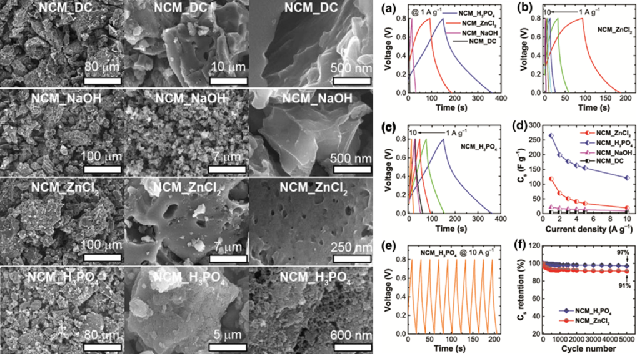
Fig. 3. Represent the different activation agents and their electrochemical performance.
Recently, Kesavan et al. [58] fabricated a hierarchical nanoporous activated carbon (NAC) electrode derived from bio-derived food waste such as Indian cake rusk. The following supercapacitor electrode delivers a higher specific capacitance of 381 F/g at a current density of 1.7 A/g with 95% capacity retention after 6000 cycles in 1 M H₂SO₄ electrolyte because of a higher surface area of 1413 m²/g and pore volume of 0.737 cm³/g of NAC electrode. The fabrication of a symmetric device displayed an energy and power density of 47.1 Wh/kg and 22644 W/kg in 1 M LiPF₆ electrolyte and better cycling stability, respectively. In the subsequent work, Fang et al., [59] synthesized hierarchical porous carbon nanorods through a carbonization process of interrelation with metal-organic frameworks for hydrothermal processes. Then the product was annealed at different temperatures in a nitrogen atmosphere to act as a supercapacitor. The micropore size distribution on the scale of 0.5-2 nm is less than the mesopore distribution and high surface area of 1227.4 m²/g. On applying the electrodes to electrochemical activities in 6 M KOH electrolyte, they displayed a high specific capacitance of 274 F/g at 0.5 A/g of current density. In addition, the modelling of symmetrical devices delivers an energy and power density of 6.77 Wh/kg and 100 W/kg, respectively. Continuously, Tian et al., [60] reported a bio-inspired bee hive-like hierarchical nanoporous carbon extracted from a biomass source (bamboo waste) via the carbonization method. This electrode has a high surface area 1472 m²/g and the total pore volume is 0.61 cm3/g, where 79% of the pore volume is attributed to the micropores. This BHNC based ultracapacitor electrode performed at a higher specific capacitance of 301 F/g at a current density of 0.1 A/g in 6 M KOH electrolyte. Furthermore, the symmetrical device achieves a 100% capacity retention of 20,000 cycles in 6 M KOH. Comparably, Gao et al., [61] reported the fabrication of hierarchical nanoporous carbons via the carbonization process by using zinc ions at the immunisation molecular level. The hierarchical porous electrode shows high surface area and pore volume as 2170 m²/g and 1.445 cm³/g, respectively. Its electrochemical performance as a supercapacitor in an ionic electrolyte (EMIMBF₄) displayed a higher output, such as, a counterfeit symmetrical device shows a higher specific capacitance of 324.36 F/g at 0.5 A/g current density and an energy density of 180.2 Wh/kg with 92.1% capacity retention stability for 10,000 cycles. The hierarchical porous electrode with the electrochemical performance as shown in Fig. 4.
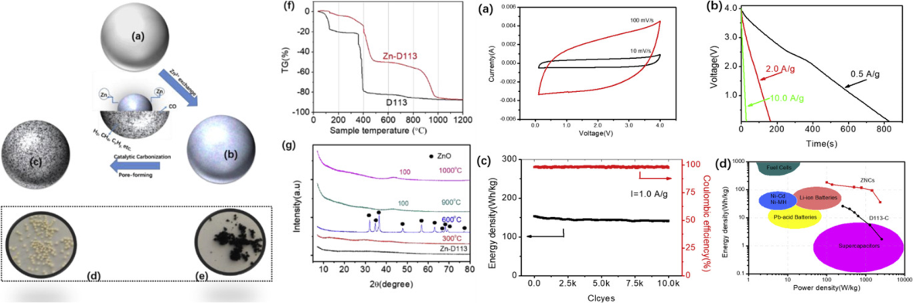
Fig. 4. Represents the preparation of hierarchical nanoporous carbons with their electrochemical device performance [61].
Ganasekaran et al. [62] recently prepared a partially graphitic nanoporous activated carbon from a biomass source (bamboo bagasse) using an activating agent of K₃ [Fe(CN)₆] followed by KOH treated in annealing for carbonization, with a greater specific surface area of the nanoporous electrode of 1360 m²/g. Moreover, a symmetric device with a 0.18 μm thick nanofiber of glass filter paper of coin cells was fabricated, where the device delivered 173.22 F/g specific capacity and capacity retention of 95% for 10,000 cycles in 6 M KOH. The device delivered an energy density value of 12.8 Wh/kg. In terms of the KOH activation process, Nanaji et al. [63] synthesised a nanoporous graphene sheet extracted from bio-waste sources using the same material. The nanoporous electrode performance depends on its surface area intensifying with pore volume, reported as 2393 m²/g and 1.62 cm³/g, respectively. The electrode shows a high specific capacitance of 282 F/g and 70% capacity retention as performed with 6 M KOH electrolyte, where the symmetric device dispatches an energy and power density of 4.2 Wh/kg and 12420 W/kg, respectively. Recently, Senthilkumar et al., [64] have reported a nanoporous graphene concept using reducing agents Mg/Zn strip through a wet chemical method. The electrode was found with a higher active electrochemical locality, i.e., a high surface area of 12974.6 m²/g and a pore size distribution in the range of 0.8–10 nm. The electrode manifests a very high specific capacitance of 204 F/g even at a high current density of 10 A/g. It also showed better capacitance retention with 95% even after 20000 cycles in 6 M KOH electrolyte. Further, the fabricated symmetric device displays have energy and power densities of 14.3 Wh/kg and 933 W/kg, respectively. The nanoporous graphene performance is shown in Fig. 5.
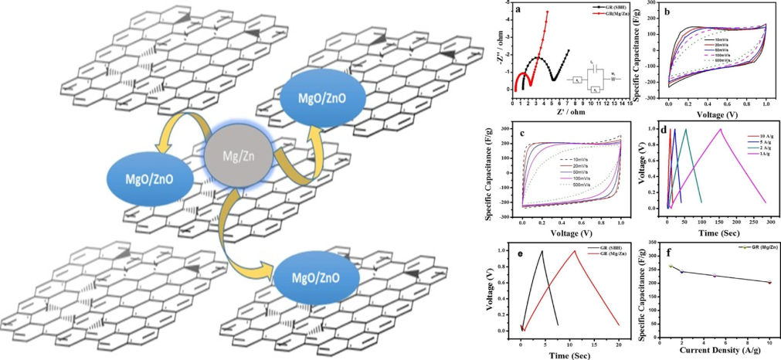
Fig. 5. Represent the schematic diagram of the preparation for nanoporous graphene, their electrochemical behaviours.
The most interesting way to extract nanoporous electrode is to use a popcorn source to dispense an eminent surface area of electroactive sites. Recently, Hou et al., [65] reported on popcorn-derived interconnected honeycomb-like porous carbon flakes extracted from a biomass maize source. The porous electrode having a larger specific surface area of 3301 m²/g and 0.69 nm size of micropores displayed a superior specific capacitance of 286 F/g at a current density of 90 A/g in 6 M KOH electrolyte. This may be due to the easy and attainable sub-nanoporous transition from the electrolyte to the nanoporous electrode.
In addition, Li et al. [66] reported a 3D graphene-alike porous carbon nanosheet extracted from a molecular precursor via a KOH activation process, in addition to improving the electrochemical performance of 3D electrode materials. The graphene acquired has been found with a specific surface area of 2017.3 m²/g, which may be the reason for the high electrochemical performance of the electrode, i.e., a specific capacity of 316.8 F/g at 1 A/g current density as well as 92.5 % capacity maintenance after 2000 cycles in 1 M KOH electrolyte. [67] created a mesoporous carbon extracted from a carbonous source such as soft drink using a 3D mesoporous silica electrode terminated hard templating method. The electrochemical active sites of this electrode have a surface area and pore volumes in the range of 1400-1810 m²/g and 1.45-2.81 cm³/g at a micropore size of 3.5-5.2 nm, respectively. Fig. 6 authorized Surface Morphological and Electrochemical Performance of 3D Mesoporous Carbon Electrodes The nanoporous electrode produced 284 F/g at 1 A/g for excellent cyclic stability over 1000 cycles in 2 M KOH.
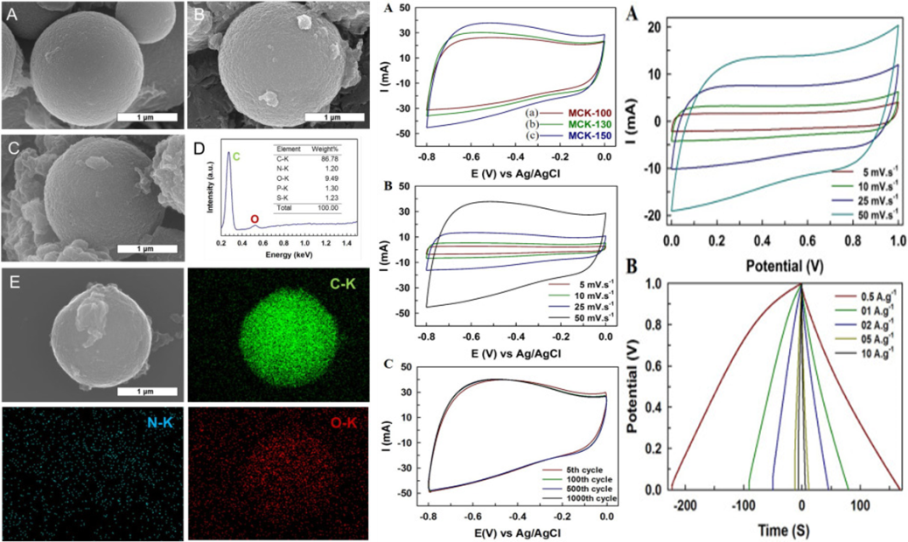
Fig. 6. Represent the SEM images of 3D mesoporous carbon and their electrochemical behaviours.
In addition, by Kruner et al., [68] a carbide-derived nanoporous electrode of polysilsesquioxanes sphere for different organotrialkoxysilane sources using polymer beads was investigated. The nanoporous electrode has a total pore volume and specific surface area as varied at 1.3-2.1 cm³/g and 2014–2114 m²/g, respectively. The enhanced properties of the electrode have higher pore volume and surface area, which appreciable the excellent electrochemical performance in 1 M TEA-BF₄/ACN electrolyte with a specific capacitance of 112 F/g. Similarly, Wang et al., [69] fabricated nanoporous carbon sphere electrodes of high surface area (2221 m²/g) from zinc-phenthe coordination polymer using tannic acid. The nanoporous electrode was reported with a uniform diameter and micro and mesopore range of 120 nm and 4-6 nm, as well as a pore volume of 0.41-1.64 cm³/g. These electrodes were investigated as supercapacitor electrodes in 6 M KOH electrolyte and showed a higher specific capacitance of 271 F/g with 98% capacity retention after 5000 cycles as detailed in Fig. 7
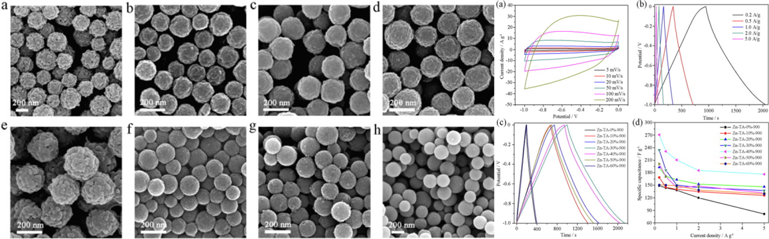
Fig. 7. Represents SEM images of nanoporous carbon spheres and their electrochemical performances.
According to Lu et al. [70], N-doped porous carbon polyhedra derived from ZIF-8 are made of flexible nanopapers aided with rGO via carbonization, calcination, and acid etching. A detailed of these binder-free electrodes in a supercapacitor displayed a high specific capacitance of 280 F/g at 1 A/g current density. Efforts have been made to pursue new structural strategies to accomplish higher performance with 3D nanoporous carbon-based materials in electrochemical supercapacitors. It began by highlighting the fundamentals of EDL formation from the standpoint of ion–electrode correlations at planar, 2D electrodes. However, this model falls short of accurately describing the charge mechanism in nanoporous carbons based materials, which requires excellent view of the porous structure. The improvement of ion absorption techniques proved critical in furthering our fundamental understanding of the charge storage mechanism in porous carbon-based EDLCs. Even though elevated SSA specific surface area and porous nanostrucutured phenomena is always advantageous for increasing capacitance and higher electrochemical stability.

5. Summary and outlook
Supercapacitors are precious energy storage device on the account of their huge power density, excellent specific capacitance and remarkable cyclic stability. The various charge storage mechanism possible in supercapacitors (i.e, EDLC, in which the ions are stored electrostatically, Pseudocapacitors, where the ions are stored electrochemically and hybrid capacitors that have both electrostatical and electrochemical scharge storage mechanism) and improving their electrochemical performance have been discussed in this review. In supercapacitor application, the electroactive materials play an important role. Moreover, the selection of materials also boosts hugely the charge storage performance in order to show the higher electrochemical behaviour.
This review article completely addressed on the porous nanostructured electrode materials for supercapacitor application in recent eras. Generally, other electrode materials were compared to the porous materials in terms of their unique pore surface area, pore volume and size in this crucial phenomenon to increase the electrochemical performance. The porous materials are classified, based on their size, into micro porous, meso porous and macro porous. The various pore size that interacts with electrolyte ions to evaluate the charge storage performance of porous nanostructured materials.
In EDLC mechanism, the porous materials are obtained from activation of biomass products through pyrolysis/carbonization process. This has also been discussed in this review. The derived activated carbons provide high amount of electroactive sites due to the influence of their huge surface area (> 1500 m²/g) that achieved the great energy and power densities. Moreover, the bio source activated carbons are highly effective and low cost-effectiveness. In pseudocapacitor charge storage mechanism, the porous metal oxides/sulphides and porous polymers are provides the better capacitance, vast life-spam and superior rate capability. The metal porous nanostructured materials were obtained via chemical synthesis process. Moreover, pseudocapacitive based porous materials are boosting the charge storage performance due to the impact of higher electroactive sites an electrochemical supercapacitor has been discussed in this review.
In hybrid capacitor charge storage mechanism, the porous materials are grownup to enhance the greatest specific capacitance, longer operation process, higher energy and power density. The porous based battery materials are accumulating the charges in electroactive sites has achieved the better electrochemical performance. The battery-type porous nanostructured materials are attained through chemical synthesis process for high performance supercapacitor applications as detailed discussed in this review.
Besides, those porous electrode materials have been explored the high-performance supercapacitor applications and demanding to point the gap between conventional batteries and supercapacitors. Conversely, the assembling of extremely innovative and efficient electrode materials for the commercialization of these supercapacitors is quiet in the crucial stage and energy storage mechanism of these materials is still indistinct. Henceforward, necessity of advance study to recognise the interfacial reactions between porous electrode materials and electrolytes is needed. Granting porous electrode materials have shown talented results for electrochemical supercapacitors but promoting experts, educational and industrialised research is mandatory for their size miniaturization and commercialization in upcoming years.

Reference
- Larcher, D., and Tarascon, J.M., 2015. Towards greener and more sustainable batteries for electrical energy storage. Nature chemistry, 7(1), pp.19.
- Zhang, K., Han, X., Hu, Z., Zhang, X., Tao, Z. and Chen, J., 2015. Nanostructured Mn-based oxides for electrochemical energy storage and conversion. Chemical Society Reviews, 44(3), pp.699-728.
- Jiang, H., Hu, Y., Guo, S., Yan, C., Lee, P.S. and Li, C., 2014. Rational design of MnO/carbon nanopeapods with internal void space for high-rate and long-life Li-ion batteries. ACS nano, 8(6), pp.6038-6046.
- Chen, G.Z., 2013. Understanding supercapacitors based on nano-hybrid materials with interfacial conjugation. Progress in Natural Science: Materials International, 23(3), pp.245-255.
- Vatamanu, J., Hu, Z., Bedrov, D., Perez, C. and Gogotsi, Y., 2013. Increasing energy storage in electrochemical capacitors with ionic liquid electrolytes and nanostructured carbon electrodes. The Journal of Physical Chemistry Letters, 4(17), pp.2829-2837.
- Akinwolemiwa, B., Peng, C. and Chen, G.Z., 2015. Redox electrolytes in supercapacitors. Journal of the electrochemical society, 162(5), pp.A5054-A5059.
- Hu, D., Peng, C. and Chen, G.Z., 2010. Electrodeposition of nonconducting polymers: roles of carbon nanotubes in the process and products. ACS nano, 4(7), pp.4274-4282.
- Makino, S., Shinohara, Y., Ban, T., Shimizu, W., Takahashi, K., Imanishi, N. and Sugimoto, W., 2012. 4 V class aqueous hybrid electrochemical capacitor with battery-like capacity. Rsc Advances, 2(32), pp.12144-12147.
- Shimizu, W., Makino, S., Takahashi, K., Imanishi, N. and Sugimoto, W., 2013. Development of a 4.2 V aqueous hybrid electrochemical capacitor based on MnO₂ positive and protected Li negative electrodes. Journal of Power Sources, 241, pp.572-577.
- Zhang, S.W., Yin, B.S., Liu, C., Wang, Z.B. and Gu, D.M., 2018. A lightweight, compressible and portable sponge-based supercapacitor for future power supply. Chemical Engineering Journal, 349, pp.509-521.
- Burke, A., Liu, Z. and Zhao, H., 2014, December. Present and future applications of supercapacitors in electric and hybrid vehicles. In 2014 IEEE International Electric Vehicle Conference (IEVC) (pp. 1-8). IEEE.
- Zhang, L., Hu, X., Wang, Z., Sun, F. and Dorrell, D.G., 2018. A review of supercapacitor modeling, estimation, and applications: A control/management perspective. Renewable and Sustainable Energy Reviews, 81, pp.1868-1878.
- Dubal, D.P., Chodankar, N.R., Kim, D.H. and Gomez-Romero, P., 2018. Towards flexible solid-state supercapacitors for smart and wearable electronics. Chemical Society Reviews, 47(6), pp.2065-2129.
- Shao, Y., El-Kady, M.F., Sun, J., Li, Y., Zhang, Q., Zhu, M., Wang, H., Dunn, B. and Kaner, R.B., 2018. Design and mechanisms of asymmetric supercapacitors. Chemical reviews, 118(18), pp.9233-9280.
- Shown, I., Ganguly, A., Chen, L.C. and Chen, K.H., 2015. Conducting polymer‐based flexible supercapacitor. Energy Science & Engineering, 3(1), pp.2-26.
- Zhang, H., Cao, G., Yang, Y. and Gu, Z., 2008. Comparison between electrochemical properties of aligned carbon nanotube array and entangled carbon nanotube electrodes. Journal of the Electrochemical Society, 155(2), pp.K19-K22.
- Zhao, X.S., Su, F., Yan, Q., Guo, W., Bao, X.Y., Lv, L. and Zhou, Z., 2006. Templating methods for preparation of porous structures. Journal of Materials Chemistry, 16(7), pp.637-648.
- Ji, J., Zhang, L.L., Ji, H., Li, Y., Zhao, X., Bai, X., Fan, X., Zhang, F. and Ruoff, R.S., 2013. Nanoporous Ni(OH)₂ thin film on 3D ultrathin-graphite foam for asymmetric supercapacitor. ACS nano, 7(7), pp.6237-6243.
- Chmiola, J., Yushin, G., Gogotsi, Y., Portet, C., Simon, P. and Taberna, P.L., 2006. Anomalous increase in carbon capacitance at pore sizes less than 1 nanometer. Science, 313(5794), pp.1760-1763.
- Largeot, C., Portet, C., Chmiola, J., Taberna, P.L., Gogotsi, Y. and Simon, P., 2008. Relation between the ion size and pore size for an electric double-layer capacitor. Journal of the American Chemical Society, 130(9), pp.2730-2731.
- Liao, Y., Wang, H., Zhu, M. and Thomas, A., 2018. Efficient supercapacitor energy storage using conjugated microporous polymer networks synthesized from Buchwald–Hartwig coupling. Advanced Materials, 30(12), p.1705710.
- Rezma, S., Assaker, I.B., Chtourou, R., Hafiane, A. and Deleuze, H., 2019. Microporous activated carbon electrode derived from date stone without use of binder for capacitive deionization application. Materials Research Bulletin, 111, pp.222-229.
- Park, H., Kim, J.W., Hong, S.Y., Lee, G., Kim, D.S., Oh, J.H., Jin, S.W., Jeong, Y.R., Oh, S.Y., Yun, J.Y. and Ha, J.S., 2018. Microporous polypyrrole‐coated graphene foam for high‐performance multifunctional sensors and flexible supercapacitors. Advanced Functional Materials, 28(33), p.1707013.
- Méndez-Morales, T., Ganfoud, N., Li, Z., Haefele, M., Rotenberg, B. and Salanne, M., 2019. Performance of microporous carbon electrodes for supercapacitors: Comparing graphene with disordered materials. Energy Storage Materials, 17, pp.88-92.
- Hwang, J.Y., Li, M., El‐Kady, M.F. and Kaner, R.B., 2017. Next‐Generation Activated Carbon Supercapacitors: A Simple Step in Electrode Processing Leads to Remarkable Gains in Energy Density. Advanced Functional Materials, 27(15), p.1605745.
- Zhu, X., Yu, S., Xu, K., Zhang, Y., Zhang, L., Lou, G., Wu, Y., Zhu, E., Chen, H., Shen, Z. and Bao, B., 2018. Sustainable activated carbons from dead ginkgo leaves for supercapacitor electrode active materials. Chemical Engineering Science, 181, pp.36-45.
- Wu, P., Cheng, S., Yao, M., Yang, L., Zhu, Y., Liu, P., Xing, O., Zhou, J., Wang, M., Luo, H. and Liu, M., 2017. A low‐cost, self‐standing NiCo₂O₄@ CNT/CNT multilayer electrode for flexible asymmetric solid‐state supercapacitors. Advanced Functional Materials, 27(34), p.1702160.
- Zheng, Y., Lin, Z., Chen, W., Liang, B., Du, H., Yang, R., He, X., Tang, Z. and Gui, X., 2017. Flexible, sandwich-like CNTs/NiCo₂O₄ hybrid paper electrodes for all-solid state supercapacitors. Journal of Materials Chemistry A, 5(12), pp.5886-5894.
- Liu, Y., Li, G., Guo, Y., Ying, Y. and Peng, X., 2017. Flexible and binder-free hierarchical porous carbon film for supercapacitor electrodes derived from MOFs/CNT. ACS applied materials & interfaces, 9(16), pp.14043-14050.
- Mohammadi, A., Arsalani, N., Tabrizi, A.G., Moosavifard, S.E., Naqshbandi, Z. and Ghadimi, L.S., 2018. Engineering rGO-CNT wrapped Co₃S₄ nanocomposites for high-performance asymmetric supercapacitors. Chemical Engineering Journal, 334, pp.66-80.
- Liu, Y., Li, G., Chen, Z. and Peng, X., 2017. CNT-threaded N-doped porous carbon film as binder-free electrode for high-capacity supercapacitor and Li–S battery. Journal of Materials Chemistry A, 5(20), pp.9775-9784.
- Liu, F., Luo, S., Liu, D., Chen, W., Huang, Y., Dong, L. and Wang, L., 2017. Facile processing of free-standing polyaniline/SWCNT film as an integrated electrode for flexible supercapacitor application. ACS applied materials & interfaces, 9(39), pp.33791-33801.
- Lee, T.H., Pham, D.T., Sahoo, R., Seok, J., Luu, T.H.T. and Lee, Y.H., 2018. High energy density and enhanced stability of asymmetric supercapacitors with mesoporous MnO₂@CNT and nanodot MoO₃@CNT free-standing films. Energy Storage Materials, 12, pp.223-231.
- Liu, M., Wang, X., Zhu, D., Li, L., Duan, H., Xu, Z., Wang, Z. and Gan, L., 2017. Encapsulation of NiO nanoparticles in mesoporous carbon nanospheres for advanced energy storage. Chemical Engineering Journal, 308, pp.240-247.
- Song, B., Wu, F., Zhu, Y., Hou, Z., Moon, K.S. and Wong, C.P., 2018. Effect of polymer binders on graphene-based free-standing electrodes for supercapacitors. Electrochimica Acta, 267, pp.213-221.
- Chen, K., Wang, Q., Niu, Z. and Chen, J., 2018. Graphene-based materials for flexible energy storage devices. Journal of energy chemistry, 27(1), pp.12-24.
- Zhang, Z., Song, M., Hao, J., Wu, K., Li, C. and Hu, C., 2018. Visible light laser-induced graphene from phenolic resin: a new approach for directly writing graphene-based electrochemical devices on various substrates. Carbon, 127, pp.287-296.
- Deng, Y., Xu, A., Lu, W., Yu, Y., Fu, C. and Shu, T., 2018. Graphene-based ordered mesoporous carbon hybrids with large surface areas for supercapacitors. New Journal of Chemistry, 42(9), pp.7043-7048.
- da Silva, D.A., Neto, A.J.P., Pascon, A.M., Fileti, E.E., Fonseca, L.R. and Zanin, H.G., 2020. Exploring doped or vacancy-modified graphene-based electrodes for applications in asymmetric supercapacitors. Physical Chemistry Chemical Physics.
- Gunasekaran, Sivagaami Sundari, Senthil Kumar Elumalali, Thileep Kumar Kumaresan, Ramya Meganathan, Ashwini Ashok, Varsha Pawar, Kumaran Vediappan et al. "Partially graphitic nanoporous activated carbon prepared from biomass for supercapacitor application." Materials Letters 218 (2018): 165-168.
- Shrestha, Lok Kumar, Rekha Goswami Shrestha, Sahira Joshi, Rinita Rajbhandari, Nishanta Shrestha, Mandira Pradhananga Adhikari, Raja Ram Pradhananga, and Katsuhiko Ariga. "Nanoarchitectonics of nanoporous carbon materials from natural resource for supercapacitor application." Journal of Inorganic and Organometallic Polymers and Materials 27, no. 1 (2017): 48-56.
- Hou, Jianhua, Kun Jiang, Rui Wei, Muhammad Tahir, Xiaoge Wu, Ming Shen, Xiaozhi Wang, and Chuanbao Cao. "Popcorn-derived porous carbon flakes with an ultrahigh specific surface area for superior performance supercapacitors." ACS applied materials & interfaces 9, no. 36 (2017): 30626-30634.
- Barczak, Mariusz, Yehya Elsayed, Jacek Jagiello, and Teresa J. Bandosz. "Exploring the effect of ultramicropore distribution on gravimetric capacitance of nanoporous carbons." Electrochimica Acta 275 (2018): 236-247.
- Qian, M., Xuan, X.Y., Pan, L.K. and Gong, S.Q., 2019. Porous carbon electrodes from activated wasted coffee grounds for capacitive deionization. Ionics, 25(7), pp.3443-3452.
- Joseph, Stalin, Devaraju M. Kempaiah, Mercy R. Benzigar, Hamid Ilbeygi, Gurwinder Singh, Siddulu Naidu Talapaneni, Dae-Hwan Park, and Ajayan Vinu. "Highly ordered mesoporous carbons with high specific surface area from carbonated soft drink for supercapacitor application." Microporous and Mesoporous Materials 280 (2019): 337-346.
- Krüner, Benjamin, Christina Odenwald, Aura Tolosa, Anna Schreiber, Mesut Aslan, Guido Kickelbick, and Volker Presser. "Carbide-derived carbon beads with tunable nanopores from continuously produced polysilsesquioxanes for supercapacitor electrodes." Sustainable Energy & Fuels 1, no. 7 (2017): 1588-1600.
- Wang, Gen, Jing Qin, Yongxi Zhao, and Jing Wei. "Nanoporous carbon spheres derived from metal-phenolic coordination polymers for supercapacitor and biosensor." Journal of colloid and interface science 544 (2019): 241-248.
- Lu, H., Liu, S., Zhang, Y., Huang, Y., Zhang, C. and Liu, T., 2019. Nitrogen-Doped Carbon Polyhedra Nanopapers: An advanced binder-free electrode for high-performance supercapacitors. ACS Sustainable Chemistry & Engineering, 7(5), pp.5240-5248.

