Chapter
WASTE MANAGEMENT IN FOOD AND AGRICULTURAL INDUSTRIES

Introduction:
In the 21st century, due to the processes of industrialization and urbanization, agriculture and farming are steadily declining. This trend is contributing to a reduction in global food production, exacerbating issues related to global warming and environmental problems. These challenges have both direct and indirect impacts on human life, particularly through the generation of food and agricultural waste.
To address these pressing concerns, it is essential to adopt a comprehensive strategy that leverages multi-layered technological solutions for food and agricultural waste management. While many countries have initiated actions to mitigate food and agricultural waste, the obstacles ahead are substantial, necessitating intensified efforts. By making concerted progress in reducing food and agricultural waste, we can significantly enhance our ability to manage food costs, combat environmental issues, and mitigate greenhouse gas emissions.
The management of food and agricultural waste has emerged as a critical issue in the contemporary context. The levels of food and agricultural waste have already reached critical levels, posing a severe threat to our environment and the planet at large. Consequently, effective food and agricultural waste management practices must be implemented through a framework that prioritizes the principles of refuse, reduce, recycle, repurpose, and reuse.
What is waste?
Waste, referred to as wastes in plural form, represents materials that are unwanted or rendered unusable. Waste encompasses any substance that is discarded following its initial use, or materials that are considered worthless, flawed, and lacking in utility. Conversely, a by-product can be understood as a secondary product with relatively limited economic worth. It's worth noting that a waste product has the potential to transform into a by-product, a co-product, or even a resource through the introduction of an innovation or process that elevates its value above zero.

Need for Waste Management:

The primary objective of waste management is to mitigate the harmful impacts of waste on both human health and the environment. Unfortunately, our environment is deteriorating rapidly, and it may not be long before our planet becomes unable to cope with the immense volume of waste produced and its detrimental consequences.
Given this situation, the significance of waste management cannot be overemphasized. Nations worldwide are increasingly recognizing the perils associated with inadequate waste handling practices.
What is waste management?
Waste management, also known as waste disposal, encompasses the procedures and measures necessary to handle waste from its origin to its ultimate elimination. This comprehensive process includes waste collection, transportation, treatment, and disposal, all while monitoring and regulating the waste management procedure. It also involves the development of waste-related laws, technologies, and economic mechanisms.
Waste Management Hierarchy:
The waste management hierarchy is an approach that prioritizes various waste management practices to achieve sustainable waste management. It establishes a sequence of waste management options, ranging from the most preferred to the least preferred:
* Prevention: According to the waste hierarchy, the top priority for sustainable waste management is waste prevention. Waste prevention primarily focuses on averting substances from becoming waste, rather than managing them as waste.
* Minimization: Waste minimization encompasses a series of processes and practices designed to reduce the volume of waste generated. By decreasing or eliminating the creation of harmful and long-lasting waste, waste minimization contributes to the promotion of a more sustainable society. This approach involves the redesign of products and processes and/or modifications in societal patterns of consumption and production.
* Reuse: Reuse refers to the act or practice of using an item, either for its original purpose (conventional reuse) or for a different function (creative reuse or repurposing). It should be distinguished from recycling, which involves breaking down used items to create raw materials for manufacturing new products. Reuse, by utilizing previously used items without reprocessing them, aids in saving time, money, energy, and resources.
* Recycling: Recycling is the process of converting waste materials into new materials and objects. This concept often includes the recovery of energy from waste materials.
* Disposal: Waste disposal encompasses the procedures and actions necessary to manage waste from its inception to its final disposal. This includes waste collection, transportation, treatment, and disposal, along with the monitoring and regulation of the waste management process and waste-related laws, technologies, and economic mechanisms.
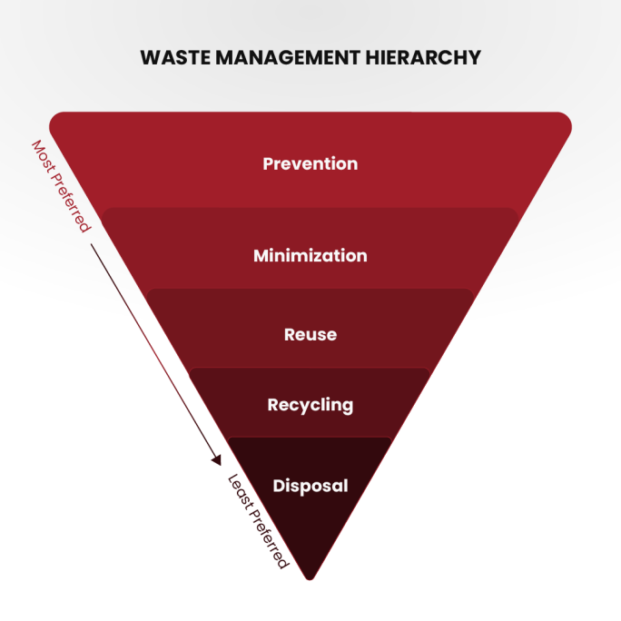
Food and agricultural waste management:-
The food and agricultural waste management system is a meticulously planned system comprising all essential components designed to control and utilize the by-products of food and agricultural production. Its aim is to ensure that these by-products are managed in a manner that either sustains or improves the quality of our air, water, soil, plants, animals, and energy resources.
Technology for Sustainable Agriculture in Food and Agricultural Waste Management:
The comprehensive process of collecting, transporting, disposing of, recycling, and monitoring agricultural waste is termed food and agricultural waste management. This vital process aims to recycle food and agricultural waste to mitigate the adverse impacts of waste on the environment, health, and aesthetics. A variety of techniques are employed for waste management, including landfilling, incineration, anaerobic digestion, pyrolysis, plasma gasification, recycling, and composting. Anaerobic digestion yields biofuel in the form of biogas, while plasma gasification generates electricity from waste. Recycling food and agricultural waste involves collecting, sorting, and reprocessing waste into new products. Notably, vermicomposting is the preferred method of composting due to its production of vermicompost, often referred to as "black gold" due to its rich nutrient content and growth-promoting properties.
The Rise in Waste Accumulation:
The accumulation of waste has surged due to industrialization, urbanization, and the increase in population density. This waste includes a range of materials, such as radioactive substances, agricultural waste, food waste, industrial waste, and municipal waste, including garbage and paper waste. The availability of open land and space for waste disposal has diminished significantly due to the intensive conversion of agricultural land for residential, industrial, and commercial purposes. To alleviate the burden of food and agricultural waste on our planet, there is a pressing need to enhance the collection, transport, recycling, and disposal of these wastes.
The Importance of Sustainable Management:
Managing food and agricultural waste can be financially burdensome, underscoring the significance of understanding effective, sustainable, and safe waste management methods. The principles of "Reduce, Reuse, and Recycle" have become fundamental in food and agricultural waste management due to increased waste generation, rising processing costs, and dwindling landfill space. Flexibility is key in food and agricultural waste management systems to adapt to evolving environmental, social, and economic conditions. Gathering information and feedback through system analysis is valuable for optimizing, evaluating, adapting, and defining food and agricultural waste management systems.
Waste Reduction and Reuse:
At the forefront of waste management hierarchies is the reduction of food and agricultural waste, as the most effective waste management approach is to prevent waste creation in the first place. Reduction of waste can also be achieved through product reuse. These strategies conserve natural resources, curtail waste generation, and reduce the costs associated with food and agricultural waste disposal.
Diverse Management Approaches:
Food and agricultural waste management encompasses a wide range of waste types, including solid, liquid, and gaseous forms. Management methods vary for rural and urban areas, municipal and industrial waste, and developed and developing nations. While local governments typically oversee municipal waste management, farmers are responsible for managing agricultural waste. Developed nations employ innovative technologies and effective management practices to minimize the negative impacts of waste and harness its potential.
Agricultural Waste Management Categories: -

There are various types of raw and solid waste generated within the food and agricultural sector. These wastes, originating from food and agriculture, are released into the air, water, or land. Solid wastes refer to materials discarded at the location of their production.
The primary objective of most food and agricultural sectors is to produce marketable goods. Effective management must strike a balance among multiple complex and interdependent systems, which include:
* Cropping systems
* Livestock systems
* Irrigation and drainage systems
* Pest control systems
* Soil conservation systems
Different methods and equipment are required for managing food and agricultural waste of varying consistencies. Such waste can exist in liquid, slurry, semisolid, or solid forms. For example, manure's consistency can change throughout the year. The key characteristic indicating how this material can be handled is its total solid concentration.
Several factors influence the total solid concentration within a system, including climate, animal type, water consumption, and feed type. In most cases, the waste's consistency can be predicted or determined.
Food and Agricultural Waste Management Factors: -

* Production: This involves assessing the amount and nature of food and agricultural waste generated by an agricultural enterprise. Waste management becomes necessary if the quantity produced is substantial enough to raise concerns. A comprehensive production analysis considers the type, consistency, volume, location, and timing of waste production. The waste management system may need to accommodate seasonal variations in production rates.

* Collection: Collection refers to the initial capture and gathering of waste from its point of origin or deposition to a designated collection point. It entails scheduling collections, estimating labor requirements, procuring necessary equipment, setting up structural facilities, and managing installation costs.

* Transfer: Transfer pertains to moving and transporting waste within the system. This phase includes transporting waste from the collection point to storage and then to treatment facilities.

* Storage: Storage involves temporarily containing the waste. Storage facilities within the waste management system provide the manager with control over the timing and scheduling of system functions.

* Treatment: Treatment encompasses all processes designed to reduce pollution potential or alter the waste's physical characteristics, such as moisture content, to enable more efficient and effective handling.
* Utilization: Utilization includes reusing and recycling waste products. Food and agricultural waste can serve as sources of energy, bedding, mulch, organic matter, and plant nutrients, which can be commercially viable.

Food and Agricultural Waste Management Design involves outlining the management, operation, and maintenance of waste from production to utilization. It includes a list of practices to be implemented, the location of major components, and an installation schedule.
Typical Food and Agricultural Waste Management Systems encompass dairy waste management, beef waste management, swine waste management, poultry waste management, and waste management for other animals such as sheep and goats. It also covers food processing waste and agricultural chemical waste management.
Food Processing Waste Management: -
Food processing facilities generate substantial quantities of waste, which can take the form of solid, slurry, or liquid materials. It is imperative to assess the chemical properties of this waste before devising a waste management system. When the waste is biologically derived, it can be managed in a manner akin to how livestock waste is handled.
Certain food processing waste can be treated using waste treatment facilities. To determine the appropriate volumetric or real loading rates, the waste material must undergo an analysis to measure its volatile solids content or biochemical oxygen demand (BOD) concentration. Since some canneries operate seasonally, it might be necessary to design facilities with extra capacity to accommodate expected periodic heavy organic loads.
Combining food waste with animal manure in an anaerobic digester can substantially enhance methane production. However, acceptable ratios of animal manure to food waste mixtures are regulated at the state level.
Obtaining the requisite permits and adhering to state and local regulations is crucial before land application. Many permits mandate continuous monitoring of groundwater, and potentially, soil and plant matter. Hydraulic loading is frequently overlooked in this process. If the site possesses a high water table or low permeability, the amount of water that can be applied is typically reduced. Additionally, in certain instances, food processing waste may contain excessive salt levels that make land application unfeasible. Hence, it is advisable for most land application sites for food processing waste to be designed by experienced professionals knowledgeable in these types of systems.
Agricultural Chemical Waste Management: -
Many agricultural enterprises employ substantial amounts of agricultural chemicals, which can lead to increased costs as labor expenses rise. This increased chemical use also raises the potential for surface and groundwater contamination due to improper storage of chemical residues, rinse water, unused chemicals, and the incorrect disposal of empty containers. The planning of chemical handling systems should consider state and local regulations.

Conclusion:-
In conclusion, governments, civil societies, and private companies worldwide have taken significant steps to address food and agricultural waste problems through legal measures, innovative technologies, and alternative solutions. The practice of waste reduction and reuse by individuals is crucial to protect our planet from environmental disasters. Developed countries should share their knowledge on effective food and agricultural waste management with developing nations, fostering international cooperation to preserve our shared Earth for future generations.

References:-
- https://pecb.com/article/waste-management-in-food-industry
- https://myethicalchoice.com/en/journal/waste-management/the-importance-of-waste-management/
- https://www.earthreminder.com/waste-management-and-its-importance/
- https://www.researchgate.net/publication/345687135_Modern_Waste_Management_Techniques_-_A_Critical_Review
- Food and Agricultural Waste Management; SanjayMehrotra,Professor in Management Hosei University, Tokyo, Japan, AdvAgriHorti and Ento: AAHE-149,May 02, 2021.

