Rural Solid Waste: Constraints and Management Approaches
Hardeep Rai Sharma¹, Dipti Grover¹, Sandeep Kumar^{1*}
¹Institute of Environmental Studies, Kurukshetra University Kurukshetra,
Haryana, India
sandeep.hird@gmail.com
Abstract
Solid waste management in rural areasis a big challenge and affects the public health, cleanliness and environmental perspective. Domestic waste generated in rural areas of developing countries has become an issue of serious concern. It was estimated that half of the world's population resides in rural areas (World Bank, 2021), While much attention has been given to waste management in urban areas, the challenges faced by rural communities often go unnoticed. Solid waste generated in rural areas is predominantly organic and biodegradable. The organic fraction varies from country to country; it is usually above 50%, even reaching 90% in very isolated communities. The lower values i.e. around 40%, are due to factors such as the use of food as animal feed. Plastic and paper is usually the second and third representative of waste fraction, values of plastic ranging from 4% to 20% while, paper waste represents around 10% in some cases. Key challenges in rural areas include low awareness and education levels among rural residents, inadequate waste management infrastructure, funds, unavailability of sustainable technology at household or community level, adequate operation and maintenance, resource constraints, unorganized waste streams, open dumping and burning practices, and a lack of regulatory enforcement. These challenges collectively contribute to environmental degradation, health risks, and the degradation of local ecosystems. To address these challenges, a multifaceted approach is required including raising awareness, developing essential waste management infrastructure, engaging the local community, promoting waste segregation and recycling, encouraging composting and biogas generation, exploring innovative technologies suitable for rural settings, enacting supportive government policies, and investing in capacity building.The implementation of these strategies will not only alleviate the waste management problems faced by rural areas but also lead to enhanced environmental health, economic opportunities, and improved living conditions. This chapter will provide a roadmap for sustainable waste management practices that contribute to the overall well-being of rural communities in developing countries.

Introduction
Solid waste management is a critical concern that transcends geographical boundaries and socioeconomic contexts, impacting both urban and rural areas. It can be defined as any waste other than human excreta, urine and wastewater. It can also be defined as waste material produced by households, commercial or industrial establishment which have no value for the owner (Shah et. al., 2015). The MSW production was 2.01 billion tonnes in 2016, reported by World bank and projected generation of 3.40 billion tonnes in 2050 (World Bank Group, 2018). According to the 2011 census, 68.84% of the total population of India lives in a rural area, and total waste generated is about 0.3–0.4 million metric tons per day in the rural area (CRINIRDPR, 2016).Typically one to two-thirds of the generated solid waste are not collected (World Resources Foundation, 1996). As a result, the uncollected waste causes environmental pollution and endangers human lives. The waste collection coverage has major gaps between larger cities and rural areas across developing and transition countries. Approximately 1.9 billion people devoid of waste collection facilities in rural region and coverage rate of rural population is below 50% in 105 countries (Mihai, 2015).
Solid waste management (SWM) can be defined as technique for orderly execution of various activities of collection, transport, processing, treatment and disposal of solid waste (Robinson, 1986). The study of sources and rate of waste generation is very important for efficient management of solid waste in rural areas. The management of solid waste involves a series of activities aimed at minimizing waste generation, promoting efficient collection and transportation, implementing appropriate treatment and disposal methods, and fostering recycling and resource recovery. Rural communities, often characterized by dispersed populations, agricultural activities, and limited infrastructure. While the complexities of solid waste management have been extensively studied in urban environments, rural areas present a unique set of challenges that demand distinct considerations and solutions.

Solid waste classification:
Depending upon land holding and house type solid waste in rural areas generally includes kitchen waste, garden waste, plastic, paper, broken glass, cloths, metal, rubber, house sweeping, cattle dung and waste from cattle sheds, agro waste, waste from markets and shopping areas, hotels, etc. (Mohrana, 2012). The sources of waste in rural areas may be agricultural waste ( e.g. straw, husks, stalks, sawdust and wood) which are often disposed by burning in open fields and causes air pollution. This practice also affects soil quality and microbial population (Grover & Chaudhry, 2019). Instead agricultural waste can be collected and managed properly and can be used for conservation agriculture (Grover et al., 2015). Other type of waste generated is rural households (bio-waste, plastics, textiles, etc.) is also prone to open burning practices. Mixed wastes may contain hazardous items (batteries, paints, e-waste, solvents, oils, pesticide bottles, contaminated wood, residues and pharmaceutical products) which can contaminate air, water and soil upon release in the environment (Chanderappa, 2012).
Broadly solid waste can be divided into two categories:-
Biodegradable waste
The waste which can be decomposed and recycled by biological processes, for example, food, farm waste, vegetable peel etc. is known as biodegradable/ organic waste. The rural organic waste i.e. domestic and rural industrial wastes, agricultural waste. The agricultural waste is mainly originated from animals (excreta and by products of dead animals) and plants ( stalks, stubbles, leaves, and shells) (Varshney, 1987). Most of this degradable waste is either thrown on dumping sites mostly on common lands and used as manure in farms after decomposition about a year or more (Yadav et al., 2015).
Non-biodegradable
Non-biodegradable waste is the type of waste which cannot be decomposed by biological processes e.g. glass, metal papers etc. The waste can further categorized into recyclable and non-recyclable. Recyclable waste has economic value and can be recovered for example metal, glass, plastic bottles, paper etc. The metal, glass and plastic waste were reported to be sold to the vendors. Non-recyclable waste e.g. thermocol, tetrapack, multilayer plastic etc which does not have economic value of recovery and most of this waste is burnt by women either for igniting the fire in the hearth instead of disposing (Yadav et al., 2015).
Waste generation scenario in rural areas
The waste composition plays significant role in waste management practices. High-income groups uses more packaged products consequently generate more volume of plastic, paper, glass, textiles and metal in comparison of low income group (Sridevi et al., 2012). The rate of waste generation also depends on factors such as economic status, population density, level of commercial activity, culture and city/region (Sunil et al., 2017). Municipal solid Waste have also fraction of hazardous waste such as pesticides, used medicines, paints, batteries and E-waste. The per capita waste generation in rural areas of Low Middle Income Countries is comparatively lower than elsewhere (Sanabria et al, 2022). This is mainly due to lower income, resource consumption, attitude towards waste generation socio-economic statusand also lifestyle (Han et al., 2018, Patwa et al., 2020, Grover et al., 2023). People become more environmentally sustainable due to poverty and lack of materials; indeed, they give decisive importance to product reuse (Murad and Hasim, 2010 and Gutberlet, 2021). The communities have a more sustainable approach in rural areas than others. The waste generation rate in rural communities of developing countries is shown in figure-1. It can be observed that values vary largely from 0.18 to 0.57 kg/(inhabitant × day). Additionally, local legislation like ban on plastic bags in some African countries has proven effective in reduction of some waste flow (Behuria, 2021). Other factors like, use food waste to feed animal feed or cooking of green waste can contribute in reduction of waste generation in rural communities (Viljoen et al., 2021).

Fig-1 Waste generation rate per capita in rural communities of developing countries (Vinti and Voccari, 2022)
Waste characterization and composition in rural areas:
Waste composition is influenced by a variety of elements, including dietary habits, cultural customs, climate, and socioeconomic status (Gupta et al., 2013: Shrivastva et al., 2014). Waste composition and characterization determine the waste management criteria. Solid waste generated in the rural areas have different characteristics and composition from waste generates in the urban areas. The waste generated in rural areas is mainly organic and biodegradable and also becoming a major problem as the waste generated is not segregated at source (Ministry of Drinking Water and Sanitation), Government of India. Since waste generated is mostly biodegradable, which can be easily converted into compost. Other recyclable material sold to the government authorized recycler and toxic waste to the nearby municipal corporation (Lima and Paulo, 2018; Kale and Attar, 2016). As per survey carried in a Devan village of Hisar district showed that the different type of waste generated from households or residential areas were mainly biodegradable(Yadav et al., 2015). The household waste also mainly comprises of biodegradable waste consisting of kitchen waste mixed with ash, paper, stationary and books, clothes, urine and animal dung, and reminder of fodder by animals and usually not considered hazardous by the villagers. The non-biodegradable waste items like leftover pesticides and their empty containers, paint, batteries and medicines perceived as hazardous waste by villagers. Quantum of waste generated was reported in the form of head load (metal or plastic container). For animal waste, the head load contained dung about 12-15 kg. On average, a family with 4-5 animals produced 2- 3 number of such head loads and another head load of 5-7 kg consisted of household and agro waste. The quantity of waste generated in rural areas is increasing due to increased population, commercial activities and consumerism.
Table-1: Type and quantum of waste at Household level (Yadav et al., 2015)
Sr. No. | Type | Details | Quantum
Biodegradable waste

1. | Kitchen waste and ash | Leftover food, peels and ash | 1.0 kg/day
2. | Paper | Cardboard, paper bags, newspaper, stationary and books | 3-5 kg/annum
3. | Miscellaneous organic materials | Leaves, grass, remainder of agro- waste, clothes | Varied according to family size, land, herd size
4. | Manure | Remainder of fodder by animals, urine and dung of animals | 5-7 kg/day
Non-biodegradable waste

5. | Plastic | Broken mugs, buckets, bottles | 1-2 kg/ annum
6. | Poly bags | Multi coloured poly bags | 0.5 kg/ annum
7. | Glass and Bone- china | Tumbler, Glass bottles, crockery | 3-5 kg/annum
8. | Metal | Tin, containers | 1-2 kg/ annum
9. | Hazardous- waste | Batteries, paints, pesticides, insecticide, left over medicines | Varied according to landholding and means of transportation and type of house
Waste composition is very important to identifying the challenges of waste management as well as the best strategies to manage this waste. It can vary significantly depending on local conditions. Table- 2 shows waste composition in rural communities of developing countries. Organic waste always represents the prevalent fraction.

Table–2:Waste Composition in rural communities of different countries(Vinti and Voccari, 2022).
Waste Fraction [%]
country | Organic fraction | Plastic | Paper and Cardboard | Metals | Glass | Textile | Woods | Hazardous | Others
Mexico | 42.55 | 14.95 | 9.50 | 2.60 | 3.75 | 7.40 | 0.40 | 0.45 | 18.60
India | 74.00 | 4.00 | 7.00 | 1.00 | 0.40 | 2.00 | 6.00 | NA | 5.60
Iran | 50.98 | 13.58 | 6.07 | 0.47 | 2.09 | 12.53 | 0.44 | NA | 13.84
Togo | 38.00 | 11.00 | 7.00 | ≈1.00 | 1.00 | ≈1.00 | NA | <1.00 | 41.00
Brazil | 90.00 | 5.00 | 1.00 | 3.00 | NA | NA | NA | 1.00 | NA
Thailand | 43.29 | 20.62 | 11.43 | 0.34 | 4.55 | 4.55 | 1.55 | 0.29 | 16.53
*NA stands for Not Available information.
As shown in Table 2, the organic fraction vary in different country, it is usually above 50%, and reaching up to 90% in highly isolated communities. The lower values i.e. around 40%, are due to factors such as the use of leftover food to feed animal. Plastic and paper is usually the second and third representative of waste fraction, values of plastic ranging from 4% to 20% while, paper waste contribute around 10% in some cases. Metals and glass also shows substantial variation, between 0.34% and 6.32% for metals and 0.40% to 4.42% for glass. The informal waste pickers or local markets may also affect the percentage of metals and glass waste due to potentially valuable recyclables. Hazardous waste is also worth mentioning along with other waste categories as its waste fraction (including e-waste) was found in many studies in rural areas of developing countries. The rural areas were assumed to be free of toxic waste (Patwa et al., 2020). A study carried out in rural communities in Konkan region to access the quantity and quality of solid waste generated in households showed that the average daily per capita of household waste generation was 0.0314 kg/cap-day. Approximately 54.89% of the total waste generated was organic and food waste in studied villages while rest of waste comprised of paper, cardboard, plastics, metals/glass, textiles and ash/dirt. The detail of each type of waste is shown in table-3

Table 3: Average waste composition in different seasons in the 7 studied villages (Naware et al., 2022)
Sr. No. | Component | Season |  |  | Avg (%)
 |  | Summer (%) | Rainy (%) | Winter (%)
1. | Organic and food waste | 50.64±13.65 | 58.39±20.25 | 55.65±14.35 | 54.89
2. | Paper | 10.96±2.05 | 11.24±2.89 | 5.65 | 9.28
3. | Cardboard | 8.45±1.52 | 6.91±1.50 | 8.78 | 8.05
4 | Plastics | 13.58±2.00 | 14.32±4.51 | 21.3±5.85 | 16.40
5. | Metals/glass | 1.85±0.50 | 0.25 | 1.92 | 1.34
6. | Textiles | 11.68±2.02 | 7.63 | 6.55±2.50 | 8.62
7 | Ash/dirt | 2.84±0.65 | 1.26 | 0.15 | 1.42

Out of the total waste generated one-third of total waste is generated in Asia with significant contributions from China (0–0.49) kg/capita/day and India (0.50–0.9) kg/capita/day (Kaza et al., 2018; Modak, 2011). World Bank has also indicated the average per capita/day waste generated in 2016 ranging from (0.09–0.60)kg for lower-income region, (0.16–0.79) kg for lower-middle income group and (0.1–1.2)kg for Upper-middle income group respectivey. This indicates the average per capita/day waste generation in 2016, (“Waste Generation_world Bank Org.,”, 2015). Figure-2 shows the composition of waste in typical Indian cities compared to developed countries.
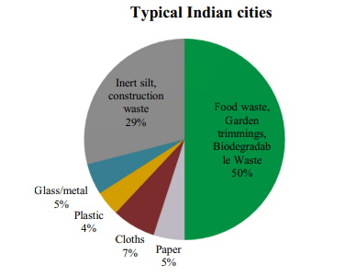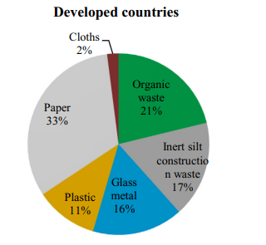
Composition of Indian waste Composition of Developed countries waste
Fig-2 Showing comparison of composition of Indian waste with Developed countries (Ahluwali and Patel 2018, Kaja and Yao, 2018)
Key solid waste management legislation in India
The Union Ministry of Environment, Forests and Climate Change (MoEF&CC) notified the new Solid Waste Management Rules (SWM), 2016.The new rules are now applicable beyond municipal areas and have included every urban local body (Mega city to Panchayat level), outgrowths in urban agglomerations, census towns, notified industrial townships, areas under the control of Indian Railways, airports, special economic zones, places of pilgrimage, religious and historical importance, and State and Central Government organizations in their ambit. In order to channelize the waste to wealth the the source segregation of waste has been made mandatory to recover, reuse and recycle the waste under new rules. Waste generators would now have to now segregate waste into three streams- Biodegradables, Dry (Plastic, Paper, metal, Wood, etc.) and Domestic Hazardous waste (diapers, napkins, mosquito repellents, cleaning agents etc.) before handing it over to the collector.
It has been advised to process, treat and dispose that the bio-degradable waste through composting or bio-methanation within the premises wherever possible and to provide the residual waste collectors or agency as directed by the local authority. All local bodies having a population of 1 million or more will set up waste processing facilities within two years of notification of these SWM rules. The common, or stand-alone sanitary landfills will have to be set for census towns with a population below 1 million or for all local bodies having a population of 0.5 million or more in three years time. Also, common, or regional sanitary landfills to be set up by all local bodies and census towns with a population under 0.5 million will have to be completed in three years. Also, the rules have mandated bio-remediation or capping of old and abandoned dump sites within five years (DTE, 2016).
Need of solid waste Management in rural areas
Solid waste depicts a growing challenge globally, poses a threat to the environment and human health , when not adequately managed(Vinti et al., 2021). It is a serious problem especially in economically developing countries due to their increasing populations, , rising community living standards, life style changes and increasing waste generation (Hassan et al., 2016). Poor domestic waste managed services including the lack of sanitation facilities in developing countries has resulted in serious environmental degradation, damage to landscape and even had a negative impact on local people’s health (Apostol and Mihai, 2012; Balasubramanian and Birundha, 2011).
Now the modern products like plastic and e-waste can be found in rural areas (Salhofer et al., 2021). Unfortunately, people in rural areas often lack the proper awareness and tools to manage solid waste appropriately which turn to dangerous practices as waste dumping and open burning (Cook et al., 2020, Gomez-Sanabria et al, 2022). Although in many cases some rural communities have been trying to make resources from waste, recover precious flows and increase their revenues, by using polluting practices (Salhofer et al., 2021). The uncollected fraction accounts about 80% of waste burning in rural areas (Gomez-Sanabria et al, 2022). In addition, it was also reported that livestock feeding and waste recycling can be illegally carried out in dumpsites (Taghipour et al., 2016). All such practices causes significant environmental and health risks, such as soil, air and water contamination, bioaccumulation of contaminants through the food chain and infectious diseases (Krystsik et al., 2020). In some circumstances, informal waste pickers are involved in collecting precious waste flows, i.e., recyclables usually do not use personal protective equipment and are unaware of the risks of such an informal job (Gutberlet and Udddin, 2017).
Principles and Methods of solid waste management suitable for rural areas
Solid waste management seems a most neglected aspect of environmental sanitation in rural areas. However, it is much easier to maintain solid wastes in rural areas as compared to urban areas. A number of waste prevention techniques are available popularly known as 4Rs: reduction, reuse, recycling and recovery. Principles that can be followed during planning and implementation of biodegradable waste management should be need based and preferences of rural population. These should be technologically easy to use and low operation and maintenance cost.
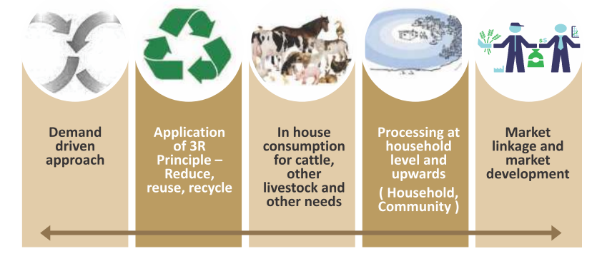
Figure-3 Principles for solid waste management: (Swachh Bharat Mission (Gramin) Phase II Operational Guidelines, 2020.
Management of solid waste which generally involves proper segregation and scientific recycling of all the components is in fact the ideal way of dealing with solid waste.
Basic principles of Solid Waste Management
4Rs: Refuse, Reduce, Reuse & Recycle
- Refuse: Do not purchase anything which we do not really need.
- Reduce - Alter our lifestyle to reduce the amount of garbage generated.
- Reuse - Make secondary use of different articles to its maximum utility.
- Recycle – Keep recyclable things and give it to rag pickers or waste pickers (Kabadiwallahs). Convert organic waste into manures or other useful products.
Segregation at source: keep biodegradable & non-biodegradable solid waste into separate bins to recycle the components with minimum cost and labor.
Suitable treatment of different type of solid wastes: suitable technique must be applied for given type of garbage. For example the technique suitable for general market waste cannot be applicable for slaughter house waste.
Treatment at nearest possible point: The solid waste should be treated in as decentralized manner as possible. The garbage generated should be treated preferably at the site of generation i.e. every house. Based on the above principles, an ideal Solid Waste Management for a village could be as under.
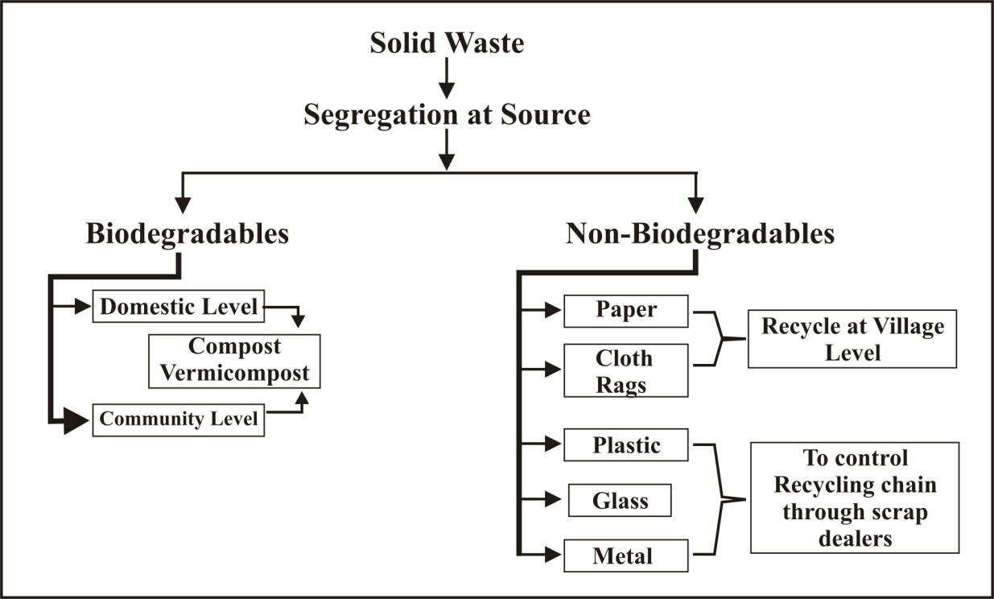
Figure 4- An ideal Solid Waste Management at a glance
Source- Shrikant M. Navrekar, 2008, “Sustainable Solid waste Management: Need of the hour
Household In rural areas generate mainly organic wastes, with little quantity of inorganic wastes and which is completely free from toxic wastes. The non-biodegradable waste like paper, cloth, metal and glass can be recycled and plastics, if collected, segregated and shredded as per norms can be used in road construction. Composting is the most suitable, sustainable, environment friendly and old age practice for recycling and reuse of organic waste in rural areas. It is a process of recycling of organic waste into compost through microorganisms present in soil naturally. Initial mechanical breakdown of organic material in small particle completes by earthworms, and soil insects such as sow bugs, springtails, ants, mites, beetles. After the physical breakdown, microorganism activity starts and organic material decomposes in the form of manure (Cooperband, 2002). There are various types of the composting method suitable for rural areas as vermi-composting, windrow composting, aerobic composting (named Indore method) and anaerobic composting (named Bangalore method), and anaerobic bio-digester (biogas plant) as suggested by (SBM-G, 2015). Factors which may affect composting are moisture content, aeration, turning frequency, temperature, C/N ratio and particle size of compost material.
- Vermi-composting
It is a process to degrade and digest the organic waste using earthworm. The organic material is converted into granular form rich in nitrogen (SBMG, 2015). It is suitable for treatment of organic waste (Shah et al., 2012) it takes 3-4 months but compost can be removed in stages.
- Windrow composting
It is the process to compost organic material by placing the material in long narrow piles of triangular or trapezoidal shape. In this method composting is enhanced through turning of piles to increase passive aeration. (CEEPO, 2016).
- NADEP composting
This method was developed by Narayana deotao Pandharipande of Maharashtra (Edward and Arya, 2011). Composting takes place in rectangular tank of brick material with opening of walls for aeration.
- Indore method
This method was invented by Howard and Wad in 1931 in Indore, Madhya Pradesh (Fitzpatric et al., 2005). Waste material such as animal waste, plant residues, weeds, street refuse and other organic wasteare piled up in layers in a trench or above ground to form a mound called windrow. It takes less time as compared to Banglore method.
- Banglore Method
This method was invented by Acharya in 1939 and used to composting of town refuse and night soil. Waste material used for composting are animal dung, urine, garbage, plant leaf etc. The waste material is crushed under vehicle for reduction of size. It is anaerobic method of composting and does not involve any turning or handling of waste.
- Biogas Technology
Bio gas is created by the decomposition of organic waste in anaerobic conditions. The resulting gas can be let off into the atmosphere or it can be tapped for burning as a fuel. As well as the biogas, the process also produces a slurry which can be used as a nutrient rich fertilizer. Gas accumulation rates are slower than rates of use but for areas reliant on wood as a fuel for cooking biogas provides an excellent alternative. The biogas plant can be linked to the family or community toilet or it can be a standalone system to which wastes are added. There are many different designs available. The choice of design will be influenced primarily by the desired capacity, the space available to install the plant, the type of feed material (cattle dung has higher gas producing capacities than human waste) and the finances available for construction. Waste should be added daily to ensure continuous gas production. Stoves, cookers or lamps must be converted to accept biogas but the gas itself burns without odour ( Pawta et al., 2020).
Biogas technology is a proven and established technology in many parts of the world such as Germany, the UK, Switzerland, France, Austria, the Netherlands, Sweden, Denmark, Norway, Republic of Korea, Finland, Republic of Ireland, Brazil, China, and India (Akinbomi et al., 2014). There are 30 million household digesters in China, India there are 3.8 million, followed by Vietnam with more than 0.5, and Nepal 0.2 million and Bangladesh with 60,000 digesters, while farm-scale digesters are expanding in Europe, the USA, and Canada (Kabir et al., 2016).

It constituted/continued under SBM (G) for specific periods to approve or revise the Perspective Plan called the Project Implementation Plan (PIP) for the States/districts, and the Annual Implementation Plan (AIP) as and when received the State/UT Governments duly approved by the State Level Scheme Sanctioning Committee (SLSCC) and finalized by the Appraisal Committee.

National Scheme sanctioning Committee

Each State has a State Water and Sanitation Mission to ensure that it has representation of state departments dealing with Rural Sanitation, Rural Drinking Water Supply, School Education, Health, Women and Child Development, Water Resources, Agriculture, Publicity etc.

State water and Sanitation committee

District water and sanitation committee should plan and advice on implementation of district Solid waste management plan with appropriate IEC strategies and convergence mechanism with all line department
District water and Sanitation committee

Block water and Sanitation committee is to provide guidance, support and monitor implementation of block Solid waste management plan in Rural Local bodies.

Block water and Sanitation committee

Village water and Sanitation committee is to provide support in terms of motivation, preparation of village action plan, mobilization, implementation and supervision of the programme
Village Water and sanitation committee

Swachh Bharat Mission (Grameen) PhaseII Operational Guidelines, 2020
Figure-5 Institutional framework and its role in Solid Waste Management in rural area

Issues and challenges in solid waste management in rural areas
The lack of governmental policy and finance, and long-term planning in waste management, associated with resistance to behavior change i.e. separation of wastes at source and poor waste management infrastructure, are the factors contribute to the existence of open dumps nowadays (Taherzadeh and Rajendran , 2015). The wild dumps are encountered in the peri-urban and rural areas due to the lack of waste and sanitation facilities. Frequently, such uncontrolled disposal sites are located in the proximity of households and water bodies. The dumps are a source of complex pollution (air, water, soil, and biodiversity) which threatens the public health. Mixed waste fractions (municipal, agricultural, construction and demolition, Waste from Electrical and Electronic Equipments, bulk items), including hazardous streams, are disposed in such sites causing serious public health issues.

Segregation of solid waste
Waste segregation at the source, especially organic and recyclable portions have great environmental and economic advantages (Taghipour et al., 2016). A study of villages in Konkan region of India’s villages shows that the villages lacks an organized, methodological and efficient source separation program has for solid wastes (including food waste, plastics, paper and board, metal, and glass) at the studied villages (Naware et al., 2022). Generally, the people do not have enough cognizance about undesirable environmental and health risks of solid waste disposal at the studied villages. A similar study carried out on Comparison of Rural Solid Waste Management in Two Central Provinces of Iran also shows that waste separation was not implemented in villages and agricultural, medical and domestic wastes were collected in one place. The result of average calculation showed that only 4 percent of the wastes were separated by workers in the two provinces and the other 96 percent were left untouched(Hossein et al., 2017). Rural local bodies lacks appropriate number of sanitary workers in rural areas for door to door collection of waste (Kumar and Sharma, 2017). Agricultural wastes (e.g., straws, stalks, husks, wood, and sawdust) are often disposed by burning in open fields with exposure to fire hazard. Household waste (bio-waste, plastics, textiles, etc.) are also prone to open burning practices. Mixed wastes may contain hazardous items (e-waste, batteries, oils, solvents, paints, contaminated wood, and pharmaceutical products) which are released into the atmosphere, soil, and groundwater. The common hazardous substance used in the rural area includes insecticide, pesticide, fungicide, herbicide, chemical fertilizers, chemicals used for fumigation, cleaning agents used in animal husbandry, and medical waste. Such hazardous fraction must be separated, collected, and managed from common household waste (Chandrappa and Das, 2012). It was observed and reported during discussion with elected representative of Panchayati Raj Institutions in Haryana (India) that most of the time solid waste was handover to sanitary worker in an un-segregated form and only animal dung is separated. Also in majority of cases households retains plastic bottles, metals containers and other saleable item for the vendors. Improper segregation at source level requires additional manpower to segregate and needs more time. (Kumar and Sharma, 2019) .
Open dumping of waste
In rural areas, there is often a lack of awareness about proper waste management practices. Residents may not understand the environmental and health hazards associated with improper disposal methods, leading to open dumping or burning of waste. Constraints associated with bad road connections to urban areas make waste collection and management exceptionally challenging in rural areas. In many cases, big waste trucks can encounter difficulties travelling for long stretches of unpaved roads, and communities or isolated households (Vinti, 2021). while in urban areas of low- and lower-middle-income countries, estimated a waste collection rate of 48% and 71%, respectively, the same authors estimated that in rural areas, the waste collection was much lower, i.e., 26% and 33%, respectively (Kaza et. al., 2018). As a consequence, typical waste management practices at the community level consist of uncontrolled burning of waste, waste dumping, waste burying and reuse of unsorted waste as fertilizer (Ferronato et al., 2019, Cook and Velis, 2020). Infrastructures for management of rural solid waste which include collection, transport, treatment and disposal facilities like trash cans, vehicles, transfer stations, etc. is not enough in rural areas of china. Poor infrastructures significantly contributed the fact of irresponsible dumping of waste. As a result, the phenomenon of garbage besieging in villages is often reported (Chao et al., 2015).

Lack of funds and infrastructure
The rural households may have no access to basic utilities (improved drinking water source, sanitation, waste management services), and pollute nearby water bodies by waste dumping and open defecation. In developing countries, especially in rural areas of Africa, India, and China, human waste disposal is a major concern besides household and agricultural waste (Epstein, 2015).Rural areas typically lack proper waste collection, segregation, and disposal infrastructure. Limited access to collection vehicles, waste treatment plants, and recycling facilities makes it difficult to manage waste effectively less amount of wages are paid to Sanitary workers deployed for solid waste management in villages. It was reported by elected members of various Panchayati Raj Institutions (PRIs) that many of rural local bodies do not have any source of income (village fund) except grant from center and state government. Further many Gram Panchayats has no land availability or the land has been encroached by villagers thereby the shed cannot be constructed. These are alsothe factors responsible for lacking of solid waste processing facilities in rural areas (Kumar and Sharma 2017).Alternate use of SWM sheds and encroachment in the sheds are also hurdle in solid waste management in rural areas.
Lack of proper planning during project preparation
solid waste management services are provided by Municipal Corporations/Municipalities/Rural Local bodies lacks proper planning such as properly designed community waste collection bins as per requirements of quantity solid waste, neither they are nor they are placed at proper places, lack of training to handle the waste by sanitary workers and Lack of coordination among various departments of civic bodies also lead to poor management of solid waste management (Vij, 2012)Preparation of solid waste management project requires detail survey, focus group discussion and Participatory Rural Appraisal (PRA) exercise but many rural local bodies start the project without proper planning and survey. The project can never be successful without proper estimation of solid waste generation, manpower requirement, and vehicles needed for transportation. PRA exercise must be exercised seriously for people participation and to know their willingness to pay for the services provided (Kumar et. al. 2018). The site selections for shed were also found inappropriate in many villages. Either the sheds were constructed at distant location from the residential areas or very close vicinity to village ponds, which inundated during rainy season (Kumar and Sharma 2017).A study on quantification and characterization of rural solid waste in Konkan region also reveal that collection transportation and disposal of villages waste was not taken seriously and disposing it at open dumping sites (Naware et al., 2022). Lack of priority by Gram Panchayats for rural sanitation though many Gram Panchayats are not taking it seriously. They are still interested in traditional practice of construction of streets and drains. There is a need to change the mindset of elected representative of PRI’s to focus on this issue.
Sale of compost and recyclable
After door to door collection the waste is transported to shed where segregation of biodegradable and non-biodegradable waste is carried out. The biodegradable fraction was converted into compost or vermi-compost whereas non-biodegradable is stored for sale to the local vendor. The non-biodegradable dry waste i.e. polythene, rubber, plastic PVC, paper, glass etc. has very low economic value and therefore not purchased by any local purchaser and remained as storage in the shed for long period. Further, in many Gram Panchayat the compost has no local buyer and hence no income generation which also affects the sustainability of the project (Kumar et al., 2019).
Reluctant behavior of households to pay service fees and insanitary behaviour
Large fraction of people in rural areas are reluctant to pay service fees if rural local bodies makes any arrangement of door to door collection and transportation of waste. Insanitary behavior of people is also big hurdle as households dispose un-segregated waste many times and generally kept all their waste to polythene bags and a tie up a knot before disposal. Segregation of waste into dry and wet is prerequisite in SWM. It requires lot of time in with additional manpower and expenditure in segregation of solid wastes after collection. A study of 21 villages located in province of Bushehr, southern area of Iran and north of Persian Gulfalso shows that In 78.6 percent of chosen villages, the villagers pay for the collection, and disposal of waste while in 21.4 percent of villages, the villagers don’t pay any direct expenses (Abduli et al., 2008).
Lack of technical skill
Solid waste management require technical skills. It was found that the sanitary workers lack technically skill (Kumar and Sharma, 2019). The dry waste collected from households composed of variety of mixed electronic and hazardous waste and must be stored separately, but it is was kept in mixed form in dry pits. For vermi-composting, organic wastes and animal dung, moisture and earthworm are required in proportionate manner and needs turning after regular interval of time. As reported the lack of scientific skills causes death of earthworms and thus compost so produced is also of inferior quality. Recycling of only some types of materials like plastics, paper and metals is not enough. Many types of new materials mainly used for packaging are not, or indeed cannot be, recycled in the low-end technology being employed. Technical training at all levels (General public to state) forms the backbone of a successful waste management programme. Adequate training must be given to all those concerned prior to actual launching of the programme in the field (Agarwal et al., 2015)
Possible Solutions and way forward:
Grass root level planning
To make Solid Waste Management a success in true sense, the planning as well as implementation should start from general public level planning followed by block level planning, district level planning and state level planning (Agarwal et al., 2015). Whenever any plan is passed by civic authorities/ rural local bodies for any new residential colony/apartments/flats, or market areas it must check that there should be proper provision of waste disposal and treatment in it so that its waste should be treated at its source level itself and it should not scatter here and there and money spent by civic bodies on its collection, transportation and treatment can be reduced (Vij, 2012).Appropriate number of sanitary worker should be deployed based upon number of HHs. 01 sanitary worker @150-200 HHs should be kept (Kumar and Sharma, 2019). The age of sanitary worker should not be more than 58 years. The sanitary workers should be paid equal wages as per Govt. instructions. The Gram Panchayats should prepare a work schedule/ area allocation to each sanitary worker with clear instruction of work i.e. door to door collection, street sweeping, drains cleaning etc. so that all habitation should be covered. Rural local bodies should pass a resolution to restrict the people using public as well as private land for dump sites. Individual/ community Compost pits should be constructed to remove the dump sites. The funds under SBM-G/ MGNREGA should be utilized for this purpose. Sanitary supervisor-cum-Motivator should be engaged at a cluster level for monitoring, motivation and collection of user charges with the help of sanitary workers.
SWM shed should be not be constructed in waterlogged areas. Local bodies lacking availability of land, either sheds should be constructed in sharing with nearby villages or people should be motivated for home composting. SWM shed must have water facilities for composting/ vermin-composting. Repair and maintenance of SWM sheds should be done if required. Funds under MGNREGA can be used for the purpose. The recurring expenditure includes remuneration of workers, operation and maintenance cost while the income includes service fees, sale of recyclables and compost, fine and penalties etc (Kumar and Sharma, 2019).
Awareness generation
No waste management programme can be successful without the help of the people because ultimately they are the producers of waste. Proper help should be taken from the effective people of the society like Gram Pradhan, RWAs, NGOs etc. to sensitize and educate the people regarding waste management (Vij, 2012). Organizing training and capacity-building programs for local authorities, waste management workers, and community members. Encouraging recycling and composting can significantly reduce the amount of waste that needs to be disposed of. Local initiatives, such as promoting the use of biodegradable products and supporting community composting, can be effective. Intensive IEC activities should done to aware/motivate people especially women to promote HHs level segregation of waste. Elected PRIs , SHGs members, Asha Workers, anganwari workers should be utilized for IEC/BCC for SWM. Notification of SWM rules/Bye laws should be done at prominent location in the village for community awareness. Separate meeting with community Based Organization e.g. Mandir committee, Gurudwara Prabandhak committee, Ramlila Committee, market union etc. should be done to restrict the use of single use plastic during bhandara or any other religious/cultural events.
Waste prevention and rural sustainability approach
Waste management strategy in rural areas must be systematically designed involving financial, technical, environmental, social, and cultural with governance approach. Smart traditional ways must be promoted to recycle, reuse and compost the organic waste remote rural areas to curb faulty waste disposal practices like open burning and wild dumping. The rural communities can achieve sustainable waste management through two main routes as shown in Figure-2. Both the routes can be applicable at regional level in consideration with specific geographical conditions (natural and socioeconomic) at different scales (village, municipality, county, region, and country).
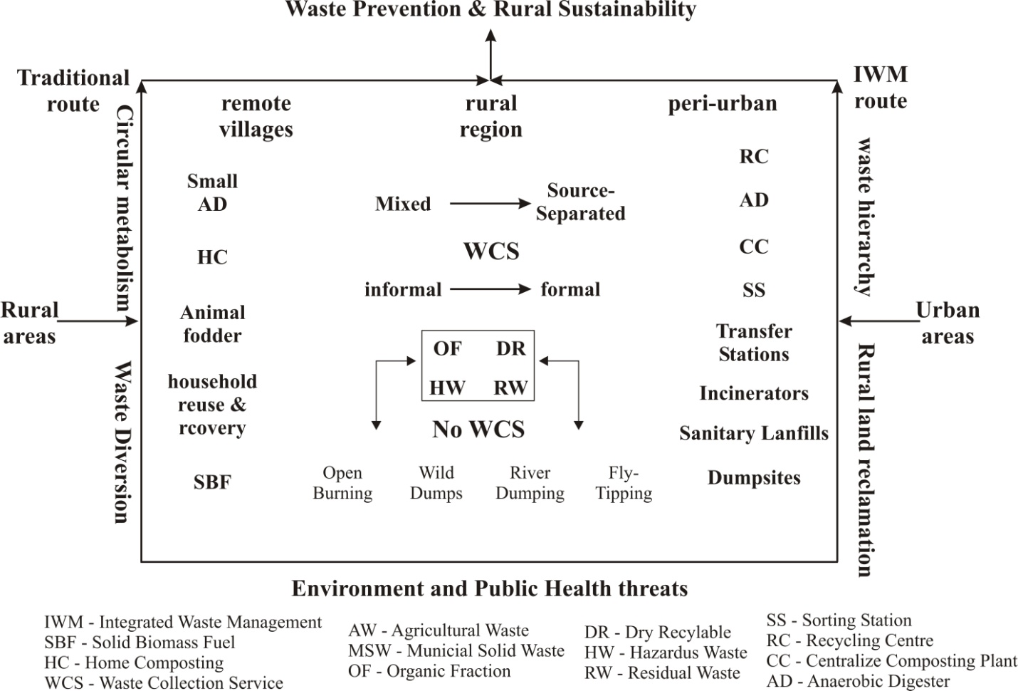
Figure-6 Routes toward waste prevention and rural sustainability (Mihai et al., 2017)
Installation of suitable mechanism for preventing entry of solid waste to water bodies
Suitable mechanism such as mess/grill must be installed in drains to prevent the entry of debris into the water bodies or covered drains should be constructed with silt chamber at each outlet of the HHs to prevent the entry of debris into the drains. If the entry of plastic/ non biodegradable waste is not restricted to enter in village ponds/water bodies, it will not create a heap of legacy waste in coming years but also affect the ponds ecosystem and aquatic biodiversity.
Incineration, Pulverization and land filling
Incineration is highly effective technology for reduction of bulk waste typically reducing waste. It reduces the volume by 90% and mass by around 70% (Ogundele, 2005). It is an excellent method of refuse disposal from the sanitary waste. There are two type of incineration process i.e. central and onsite incineration. Central incineration serve municipality while on-site incineration is used in hospitals, stores, houses, etc. The waste is burnt at high temperate usually between 45°c to 1100°c (APWA, 1970). The high temperature is needed to kill the odour. The solids remaining after incineration are used to fill land.
Pulverization is quick and and relatively simple treatment that a dense homogenous and less offensive waste. In this treatment process heterogeneous waste can be made homogenous through shredding. There are two broad types of pulverization treatment methods, the hammer mill and Rotary. In hammer mill power consumption is increases sharply with the decrease in the particle size of the product while rotary pulverization is done inside the rotary drum by attrition and abrasion.
Land Filling is an improvement on open dumping and involves the use of an existing pit such as quarry or open mining. In some cases a pit of about 12mitres deep. Refuse are then dumped into it by Spreading and compacting of layer up to 12 miters thick to prevent fly ash and pest infestation.
Conclusions
The rural areas have tremendous wealth in terms of underutilized animal excretion, domestic refuses and crop residues. A systematic management and utilization approach with recent innovation will not only help in maintaining rural areas clean but will also provide sufficient energy, manure and raw material for different users. The sustainable waste management technologies will bring about a positive change in sanitation and hygiene behavior in rural people. The governments dealing with rural local bodies should focus on special awareness drive and training on solid and liquid waste management for elected members of village council with special emphasis on sustainable technologies with strong scientific consideration.
It is also recommended that the rural local bodies should place the system of door to door collection of household waste in segregated form and this waste should be utilized for composting /vermin-composting at a reasonable distance from the residential areas. These bodies should pass a resolution to restrict the people using public as well as private land for dump sites. Individual/ community Compost pits should be constructed to remove the dump sites. The funds under different schemes like SBM-G/MGNREGS and other state and center finance commission should converged for this purpose. Intensive IEC activities should done to aware/motivate people especially women to promote HHs level segregation of waste. Elected PRIs, community based organization, Asha Workers, anganwari workers can play a vital role for awareness generation and behavior change campaigning for solid waste management. Notification of SWM rules/Bye laws should be done at prominent location in the village for community awareness.
Solid waste management in rural areas presents unique challenges that require tailored solutions. By raising awareness, building infrastructure, promoting sustainable practices, and fostering collaboration, it is possible to address these challenges and create a cleaner, healthier environment for rural communities. As we move forward, a combination of community participation, technology, and policy support will be key to achieving effective solid waste management in rural areas.

References
Abduli, M. A., Samieifard, R. and Jalili Ghazi Zade, M (2008). Rural Solid Waste Management. Int. J. Environ. Res., 2(4): 425-430, Autumn 2008 ISSN: 1735-686
Agarwal R, Chaudhary M, Singh J (2015). Waste Management Initiative In India For Human Well Being. European Scientific Journal June 2015 /SPECIAL/ edition ISSN: 1857 – 7881 (Print) e - ISSN 1857- 743
Akinbomi J, Brandberg T, Sanni SA, Taherzadeh MJ. Development and dissemination strategies for accelerating biogas production in Nigeria. BioResources. 2014;9(3):5707-5737
American Public Work Association (APWA) Institute for Solid Waste (1970). Municipal refuse disposal public administration serves Chicago. 11-20
Behuria, P. Ban the (plastic) bag? Explaining variation in the implementation of plastic bag bans in Rwanda, Kenya and Uganda. Environ. Plan. C Politics Space 2021, 39, 1791–1808
Centre for Rural Infrastructure National Institute of Rural Development and Panchayati Raj (CRINIRDPR), 2016. Solid Waste Management in Rural Areas a Step-By-Step Guide for Gram Panchayats. Union Ministry of Rural Development, Government of India, http://nirdpr.org.in/nird_docs/sb/doc5.pdf
Chandrappa R, Das DB. Solid Waste Management. Principles and Practice. Springer; (Springer Berlin Heidelberg), Germany, 2012. DOI: 10.1007/978-3-642-28681-0
Cook, E.; Velis, C. Global Review on Safer End of Engineered Life; Royal Academy of Engineering: London, UK, 2020
De Morais Lima, P., Paulo, P.L., 2018. Solid-waste management in the rural area of Brazil: A case study in Quilombola communities. J. Mater. Cycles Waste Manage. 20 (3), 1583–1593.
El-Haggar S. Sustainable Industrial Design and Waste Management. Cradle to Cradle for Sustainable Development. Academic Press; USA, 2007
Epstein E. Disposal and Management of Solid Waste. Pathogens and Diseases. CRC Press; USA, 2015
Ferronato, N.; Torretta, V. Waste Mismanagement in Developing Countries: A Review of Global Issues. Int. J. Environ. Res. Public Health 2019, 16, 1060.
Gómez-Sanabria, A.; Kiesewetter, G.; Klimont, Z.; Haberl, H. Potential for future reductions of global GHG and air pollutants from circular waste management systems. Nat. Commun. 2022, 13, 106
Grover D, Kaur P, Sharma HR (2015) Possible reasons and farmers awareness towards crop residue burning: An overview and a case study from Mirzapur Village of Kurukshetra District, India. Environment & We: An International Journal of Science & Technology 10:75-85.
Grover D& Chaudhry S (2019) Ambient air quality changes after stubble burning in rice–wheat system in an agricultural state of India. Environ. Sci. Pollut. Res. 1-10.
Grover D, Dahiya B, Sharma HR(2023b) Assessment of Municipal Solid Waste Management System in Kaithal City, Haryana. Adv. Biol. Res.
GroverD&Chaudhry S (2023a). Impact of crop residue burning and tillage practices on soil biological parameters of rice–wheat agroecosystems. Trop. Ecol.https://doi.org/10.1007/s42965-022-00287-1
Gupta, S.K., Pandey, S.K., Singh, N.B., Singh, A., Singh, V.K., & Verma, T., 2013. Municipal solid waste characterizations and management strategies for the Lucknow city, India. Int. J. Eng. Res. 8 (17), 2031–2036.
Gutberlet, J. Informal and Cooperative Recycling as a Poverty Eradication Strategy. Geogr. Compass 2012, 6, 19–34.
Gutberlet, J.; Uddin, S. Household waste and health risks affecting waste pickers and the environment in low- and middle-income countries. Int. J. Occup. Environ. Health 2017
Han, Z.Y., Liu, D., Lei, Y.H., et al., 2015. Characteristics and management of domestic waste in the rural area of Southwest China. Waste Manage. Res. 33 (1), 39–47.
Kabir MM, Forgács G, Taherzadeh MJ, Horváth IS. Biogas from wastes: Processes and applications. In: Taherzadeh MJ, Richards T, editors. Resource Recovery to Approach Zero Municipal Waste. CRC Press; USA, 2016. pp.107-140
Kale, M.T.S., Attar, A.C., 2016. Socio-economic Survey of Gotkhindi Village. Int. J. Inventory Res. 2 (9), 148–151, Dubai.
Kaza, S.; Yao, L.C.; Bhada-Tata, P.; Van Woerden, F. What a Waste 2.0: A Global Snapshot of Solid Waste Management to 2050; World Bank Publications: Washington, DC, USA, 2018
Krystosik, A.; Njoroge, G.; Odhiambo, L.; Forsyth, J.E.; Mutuku, F.; LaBeaud, A.D. Solid Wastes Provide Breeding Sites, Burrows, and Food for Biological Disease Vectors, and Urban Zoonotic Reservoirs: A Call to Action for Solutions-Based Research. Front. Public Health 2020, 7, 405.
Kumar S, and Sharma HR, 2019 Wealth from Waste an Initiative for Solid Waste Management in Rural Areas of Haryana: Issues, Challenges and Way Forward. Indian Journal of Waste Management Volume 3
Kumar S, Mal G, Sharma HR (2018) Waste stabilization ponds: a technical option for liquid waste management in rural areas in Haryana under Swachh Bharat Mission-Gramin. Environ We An Int J Sci Tech 13:177–187
Kumar S, Sharma HR (2017) Issues and challenges in rural sanitation in Haryana and role of gram panchayat in its management. In: Kaushik et al (eds) Climate change, resource conservation and sustainability strategies. DBH Publishers and Distributors, New Delhi
Kumar S, Sharma HR (2019) Wealth from waste an initiative for solid waste management in rural areas of Haryana: issues, challenges and way forward. Indian J Waste Management 3(2):61–67
Mihai FC. One global map but different worlds: Worldwide survey of human access to basic utilities. Human Ecology. 2017;45(3):425-429. DOI: 10.1007/s10745-017-9904-7
Moharana P C, Rural Solid waste Management : Issues and Action, Kurukshetra, May 2012 (30-34)
Murad, W.; Hashim, N.M.N. Does poverty cause environmental degradation? Evidence from waste management practices of the squatter and low-cost flat housholds in Kuala Lumpur. World J. Sci. Technol. Sustain. Dev. 2010,
Naware RA, Mohod AG, Khandetod YP, Dhande KG and Dharaskar RM. Quantification and characterization of rural household waste in Konkan region. The Pharma Innovation Journal 2022; SP-11(10): 163-168
Patwa, A.; Parde, D.; Dohare, D.; Vijay, R.; Kumar, R. Solid waste characterization and treatment technologies in rural areas: An Indian and international review. Environ. Technol. Innov. 2020, 20, 101066.
Robinson, W.D. (1986). The Solid Waste Handbook: A Practical Guide, John Wiley and Sons, Chichester
Rural Waste Management Issues at Global Level. Available from: https://www.researchgate.net/publication/319505503_Rural_Waste_Management_Issues_at_Global_Level [accessed Aug 18 2023].
Rural Waste Management Issues at Global Level. Available from: https://www.researchgate.net/publication/319505503_Rural_Waste_Management_Issues_at_Global_Level [accessed Aug 18 2023].
Salhofer, S.; Jandric, A.; Soudachanh, S.; Le Xuan, T.; Tran, T.D. Plastic Recycling Practices in Vietnam and Related Hazards for Health and the Environment. Int. J. Environ. Res. Public Health 2021, 18, 4203.
Salient Features of Solid Waste Management Rules, 2016. Available from : https://cpcb.nic.in/uploads/MSW/Salient_features_SWM_Rules.pdf . [accessed Aug 18 2023].
Shah P, Patel VM, Dhrumit P, et al. Solid and liquid waste management in rural areas. Int J Innov Res Sci Tech. 2015;1(12):509–12.
Shrikant M.Navrekar (2008), “Sustainable Solid waste Management: Need of the hour”, Nirmal Gram Nirman Kendra, Govardhan (Gangapur) Nashik
Sridevi, V., Musalaiah, M., Ch, M.V.V., Lakshmi, A., Kesavarao, L., 2012. A review on integrated solid waste management. Int. J. Eng. Sci. & Advance Technology. 2(5):1491-1499.
Srivastava, R., Krishna, V., Sonkar, I., 2014. Characterization and management of municipal solid waste: a case study of Varanasi city, India. Int. J. Curr. Res. Acad. Rev. 2 (8), 10–16.
Swachh Bharat Mission Gramin (SBMG), Ministry of Drinking Water and Sanitation, Government of India, 2015. https://www.susana.org/en/ knowledge-hub/resources-and-publications/library/details/2322.
Taghipour H, Amjad Z, Aslani H, Armanfar F, Dehgnanzadeh R. Characterizing and quantifying solid waste of rural communities. J Mater. Cycles of waste management. 2016;18(4):790-797.
Taherzadeh MJ, Rajendran K. Factors affecting the development of waste management. Experiences from different cultures. In: Ekström KM, editor. Waste Management and Sustainable Consumption: Reflections on Consumer Waste. Routledge: Earthscan; 2015. pp. 67-88
Vahidia H, H Nematollahib H, Adashb A, Sadeghic B & Nejadb MR, (2017). Comparison of Rural Solid Waste Management in Two Central Provinces of Iran. Environmental Energy and Economic Research (2017) 1(2):195-206 DOI 10.22097/eeer.2017.47246
Varshney A C. Rural Waste Management. Central Inst. Agril. Engg. Bhopal. Associate Publishing Company. Karol Bagh. New Delhi, India. 1987.
Vij, D, (2012). Urbanization and solid waste management in India: Present practices and future challenges. International Conference on Emerging Economies – Prospects and Challenges (ICEE- 2012). Procedia - Social and Behavioral Sciences 37 ( 2012 ) 437 – 447
Viljoen, J.M.; Schenck, C.J.; Volschenk, L.; Blaauw, P.F.; Grobler, L. Household Waste Management Practices and Challenges in a Rural Remote Town in the Hantam Municipality in the Northern Cape, South Africa. Sustainability 2021, 13, 5903.
Vinti, G. Municipal Solid Waste Management and Health Risks: Is it Time for a Solid Waste Safety Plan? Analysis of Case Studies from Serbia and Ghana. Ph.D. Thesis, University of Brescia, Brescia, Italy, 2021
Waste generation_world bank Org, 2015. In Urban Development Series – Knowledge Papers Waste. , pp. 8–12. https://doi.org/10.1787/9789264227385-graph32-en
WHO. Compendium of WHO and Other UN Guidance on Health and Environment; World Health Organisation: Geneva, Switzerland, 2021.
World Bank. World Development Indicators: Rural Environment and Land Use. 2017. Available online: http://wdi.worldbank. org/table/3.1 (accessed on 19 October 2021)
World Resource Foundation (1996), “So what is integrated waste management? Warmer Bulleting: Journal of the World Resource Foundation, No. 49.
World Resources Institute (1996). World Resources 1996-97. The Urban Environment. Oxford University Press. Oxford. UK.
Yadav L, Gandhi S, Mehta M. Existing pattern of household waste generation and its disposal pattern in rural areas. International Journal Applied Home Sci. 2015;2(3&4):143–47
Zeng, C., Niu, D., & Zhao, Y. (2015). A comprehensive overview of rural solid waste management in China. Frontiers of Environmental Science & Engineering, 9(6), 949–961.

