Synthesis and Characterization of Hydrophobic Surface using Metal
Oxides thin films

Shahussen Makandarª, Shivaraj B W^{a*}, Nataraj JRª, Sham Aan^{b}
ª Department of Mechanical Engineering, R V College of Engineering, Bengaluru, 560059, India.
^{b} Department of Chemistry, R V College of Engineering, Bengaluru, 560059, India.

*Corresponding author: shivrajwali@rvce.edu.in
ABSTRACT
Hydrophobic surfaces play vital role in the solving the technological problems such as marine fouling, anticorrosion and drag reduction. For the synthesis of Nanoparticles such as Zinc Oxide (ZnO), Copper Oxide (CuO) and Ferrous Oxide (Fe₂O₃) Solution Combustion Method was used. Spin coating method was used to prepare hydrophobic surfaces. ZnO, CuO and Fe2O3 was mixed separately with Polystyrene (PS) and THF solution then magnetically stirred to get uniform dispersion of particles and heated to form gel. This gel was further spin coated on to the glass substrate to form ZnO/PS, CuO/PS and Fe₂O₃/PS thin films. Synthesized films were measured for Water Contact Angle (WCA) and Sliding Angle (SA) and further characterized for Energy Dispersive X-Ray Spectroscopy (EDX) and Scanning Electron Microscope (SEM). P-XRD of nanoparticles showed the hexagonal wurtzite ZnO structure, monoclinic CuO structure and cubic Fe₂O₃ structure with crystallite size of 12.5, 14.59 and 12.88 nm. Water Contact Angle for ZnO/PS, CuO/PS and Fe₂O₃/PS films was found to be 101.77°, 96.48°and 93.97° and Sliding Angle was found to be 24.23°, 25.24°and 27.53°. EDX analysis showed that presence of 0.18 wt % Zinc, 0.07 wt% Copper, 0.13 wt% Iron, 1.22 wt % Oxygen, 98.43 wt% carbon and 0.24 wt% Silica contents on the surfaces. SEM micrograph of ZnO/PS, CuO/PS and Fe₂O₃ /PS films showed the nanoparticles have been uniformly dispersed in the PS matrix and particle size was found to be 24, 27 and 28 nm.
Keywords: ZnO, CuO, Fe₂O₃, Solution Combustion Method, Water Contact Angle.

1. Introduction
Hydrophobic surface is the one which repels the water the naturally occurring hydrophobic surface is the lotus leafs. To make surface as hydrophobic surface chemistry plays a very important role in the wettability, which gives interrelationship between solid, liquid and gas [1]. Investigation of the surface wettability properties has been one of the most attractive research areas in the past decades because of the numerous industrial applications such as self-cleaning, anti-corrosion, anti-fouling anti icing and oil/water separation [2]. The two main parameters which have significant impacts on the wettability properties are chemical composition and topographical features of the surface [3]. The common method fabrication the hydrophobic surface includes first creating a rough hierarchical structure and then modifying the surface with a low surface energy material [4]. On the basis of this principle, various elegant approaches have been proposed for the preparation of hydrophobic surfaces such as chemical deposition, chemical etching, layer-by-layer deposition, sol–gel, anodic oxidation, electro-spinning and lithography etc [5, 6].
Zinc Oxide (ZnO) has attracted great interest for many unique physical & chemical properties in the optical, electrical, magnetic, piezoelectric, & ferroelectric field. In addition, ZnO nanomaterials have become a hot topic of research & exploration because of its excellent stability & photocatalytic activity used in the field of biomimetic super hydrophobicity [5-7]. Copper (Cu) and Copper oxide has attracted great research interest due to its good mechanical workability, excellent electrical & thermal conductivity, which has a wide range of applications in human life & industry across many fields of electrical, construction, machinery manufacturing and transportation [8-10]. Iron oxide nanoparticles usually are deposited or dispersed in other materials such as polymer, textile, sponge, even bamboo. This strategy is beneficial to remain stability, dispensability, magnetism and other functions [11-13]. Polystyrene is preferred as the host matrix because of its unique properties for studying the optical properties of the nano composite. With Introduction of filler such as nano powders into polymeric matrices can change the optical, electrical & mechanical properties of the polymers [14-16].
2. Experimental Details
2.1Synthesis of Nano Materials
Zinc nitrate (Zn (NO₃)₂, 99%), Citric Acid (C₆H₈O₇, 99%), Cupric Nitrate (Cu (NO₃)₂, 99%), Ferric Nitrate (Fe (NO₃)₂, 99%), Glass substrate, Tetrahydrofuran (CH₂)₄O & Polystyrene were used. Distilled water was used throughout the experiments. Zinc Nitrate, Cupric Nitrate and Ferric Nitrate are taken beakers and mixed with calculated amount of citric acid then it mixed with distilled water to form the solution and stirred until the particles get dissolved then it is placed in the muffle furnace for 15-20 mins at 500°C. A redox reaction takes place in furnace giving out the Zinc Oxide, Copper oxide and Ferrous Oxide Nanopowders.
2.2 Preparation of Thin films
Glass substrates was cleaned with soap, alcohol & acetone for 15 minutes & with distilled water & then dried in a stream of air. 1 gm polystyrene was dissolved in 10 ml of THF solution then heated & stirred for 30 minutes to get homogenous solution[17] Metal oxides like ZnO, CuO and Fe₂O₃ nano crystalline powder were added then stirred for 15 minutes to get metal oxides dispersed in the solution then gel is formed. Before coating spin coater is calibrated to get uniform coating all over substrate then with speed controller knob 2000 rpm & 90 seconds time was set. Then glass substrate is placed on stand. The gel prepared was poured on the glass substrate then allowed spun for required set conditions [18-21]. Gel gets spread on the glass substrate centrifugally to form ZnO/PS, CuO/PS and Fe₂O₃/PS thin films.

2.4 CHARACTERIZATION
2.4.1 Powder X-Ray Diffraction (P-XRD)
P-XRD is a method in which the crystal structure of the synthesized nanoparticles is analyzed to check they are in the nano form. For the analyzation cu k α source was used and the scanning range was 2𝜃 from 20° to 80°.
2.4.2. Water Contact Angle
Water contact angle measuring was carried out on using sessile drop test method for the prepared thin films to test for the hydrophobicity [22].

2.4.3. Energy Dispersive X-Ray Spectroscopy (EDX)
The Energy Dispersive X-ray (EDX) technique is being utilized to analyze the elemental composition of a specimen. EDX suggests quick & efficient characterization technique that attains elemental information at high resolutions.

2.4.4. Scanning Electron Microscope (SEM)
Scanning electron microscope gives the surface morphology of the nano particles or thin films by scanning surface with high energy beam electrons.

3. Results and discussions
3.1 Powder X-Ray Diffraction
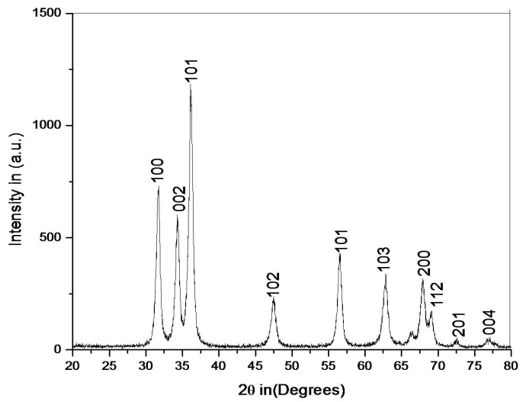
XRD pattern of ZnO nano Nanoparticles is shown in Fig 1(a). XRD peaks of corresponds to the hexagonal wurtzite ZnO structure according to the JCPDS card No 36-1451 with 2θ peaks at 32° (100), 34° (002), 36.10° (101), 47.52° (102), 56.59° (11 0), 62.96° (103), 68.70° (112) & 73.12° (201) was observed. XRD pattern of CuO Nanoparticles is shown in Fig 1(b). XRD peaks of CuO Nanoparticles corresponds to the monoclinic CuO structure according to the JCPDS card No 05-0661 with 2θ peaks at 32.98° (110), 35.2° (111), 38.62° (111), 47.52° (202), 56.59° (202), 62.96° (202), 66.70° (113) & 67.12° (022) was observed and XRD pattern of Fe₂O₃ Nanoparticles is shown in Fig 1(c). The XRD peaks [23-26] of Fe₂O₃ Nanoparticles corresponds to the cubic Fe₂O₃ structure according to the JCPDS card No 84-0311 with 2θ peaks at 31°(102), 33.93°(104), 35.44°(110), 43.21°(113), 49.97°(024), 54.10°(116), 56.98°(018) & 63.12°(214) was observed [27-29].

Figure 1(a): P-XRD pattern of ZnO Nanoparticles.
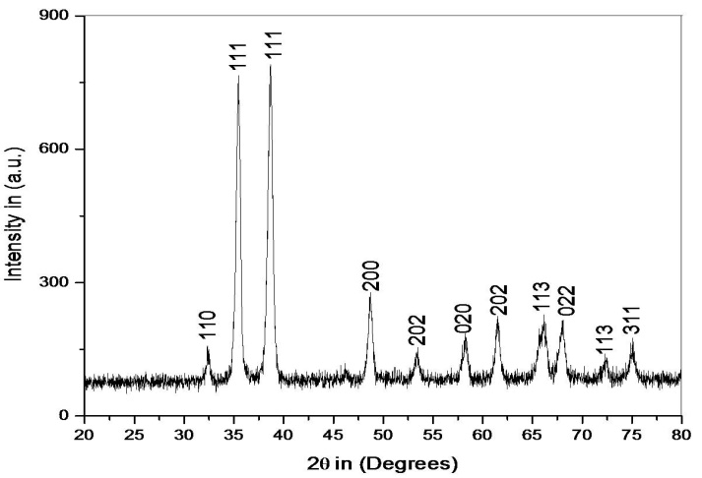

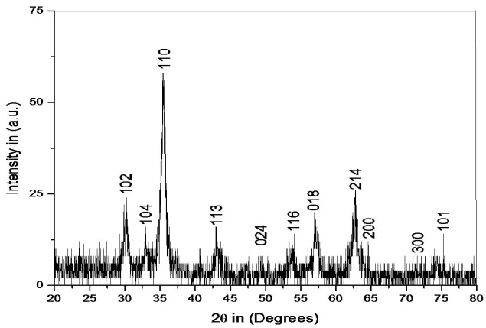
Figure 1(b): P-XRD pattern of CuO Nanoparticles.

Figure 1(c): P-XRD pattern of Fe₂O₃ Nanoparticles.

The crystallite size was calculated from Scherrer Equation (1) given by
$D=\frac{0.9 λ}{β\cos{θ}}$ ………………. (1)
Where D = Crystallite size, λ = wavelength of X-ray = 1.5 A° = 1.5×${10}^{-10}$ m, $β$= full width at half maximum (FWHM) and $θ$= angle of diffraction
The crystallite size for ZnO, CuO and Fe₂O₃ Nanoparticles was 12.5 nm, 14.59 nm and 12.88 nm and it was calculated by using Eqn. 1.
3.2 Water Contact Angle Measurement
In this test substrates were placed on the stand and DI water was used with approximately 2-7µL water droplet is placed on the substrate through syringe and left for few seconds and then with help of camera an images are captured and then contact angle was measured[30-33]. The water contact angle for ZnO/PS, CuO/PS and Fe₂O₃/PS film was 101.77°, 96.48°, and 93.97° respectively. Contact angle for ZnO/PS film is shown in Fig 2(a), contact angle for CuO/PS film is shown in Fig 2(b) and contact angle for Fe₂O₃/PS film is shown in Fig 2(c) and similarly sliding angle was calculated by tilting the glass slide. Sliding for ZnO/PS, CuO/PS and Fe₂O₃/PS film was 24.23°, 27.53°and 29.36° respectively [34-36].
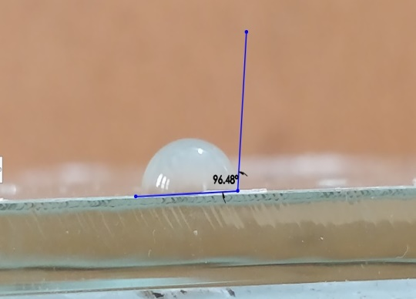
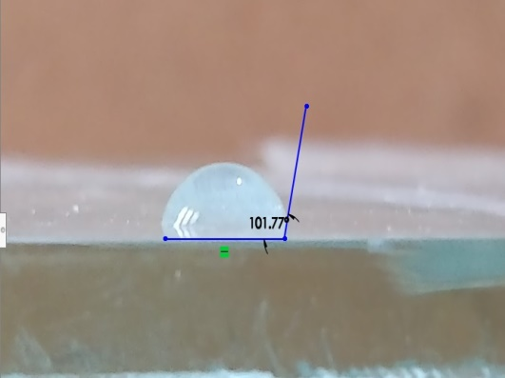

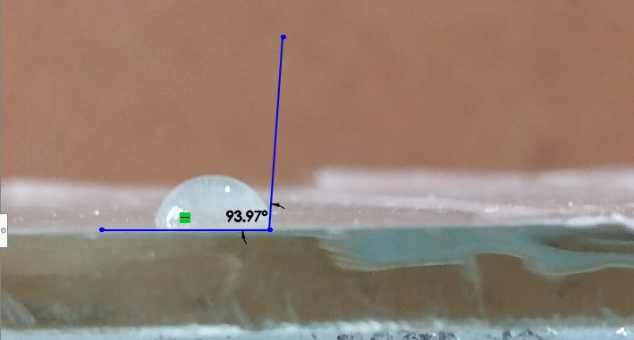
Figure 2(a) ZnO/PS film. Figure 2(b) CuO/PS film

Figure 2(c) Fe₂O₃/PS film
3.3Energy Dispersive X-Ray (EDX) Analysis of Films
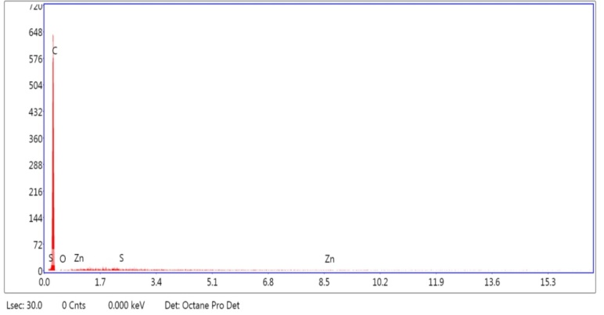
EDX of ZnO/PS is shown in Fig 3(a). which shows that the Zinc, Oxygen, Carbon & Silica content in the film which contains 1.22 wt % oxygen, 0.18 wt % zinc, 98.43 wt% carbon & 0.17% of silica. Some small peaks of silicon are also observed which is obvious as the film is deposited in Si/SiO2 substrate. EDX of CuO/PS is shown in Fig 3(b) which shows that the copper, oxygen, carbon & silica content in the film which contains 19.90 wt% oxygen, 0.07 wt% copper, 79.80 wt% carbon & 0.24% of silica [37-39]. Some small peaks of silicon are also observed which is obvious as the film is deposited in Si/SiO2 substrate. EDX of Fe₂O₃/PS is shown in Fig 3(c). Which shows that the main elements of the ferrous oxide & polystyrene film were iron, oxygen & carbon & the film contained 3.66 wt% oxygen, 0.13 wt% iron & 96.21 wt% carbon.

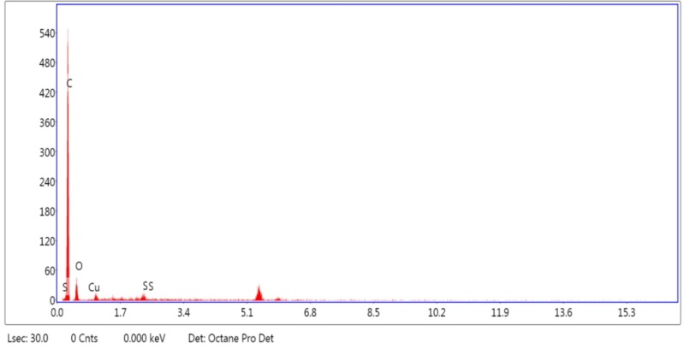
Figure 3(a): EDX image of ZnO/PS film.

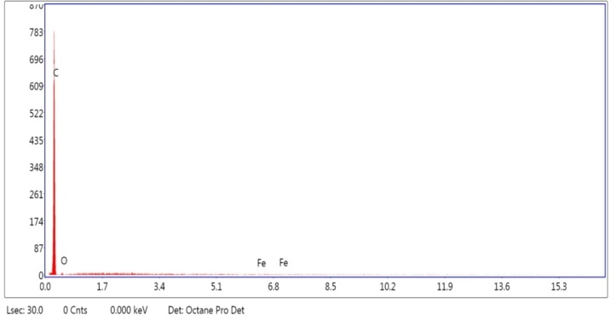
Figure 3(b): EDX image of CuO/PS film

Figure 3(c): EDX image of Fe₂O₃/PS film.

3.4 Scanning Electron Microscopy
Fig 4.1(a) shows the SEM image of ZnO/PS film Surface with magnification of 500 µm. There are voids on the surface because of non-uniform distribution of nano crystalline powder. Small particles on the surface give the presence of the ZnO. The particle size was found to be 24 nm. Fig 4.1(b) shows the SEM image at 50µm. it was smooth surface because of high focused beams melts the polymer surface. Most of the nanoparticles were buried in the coating layer by evaporating the solvent & particle size was found to be same [40].
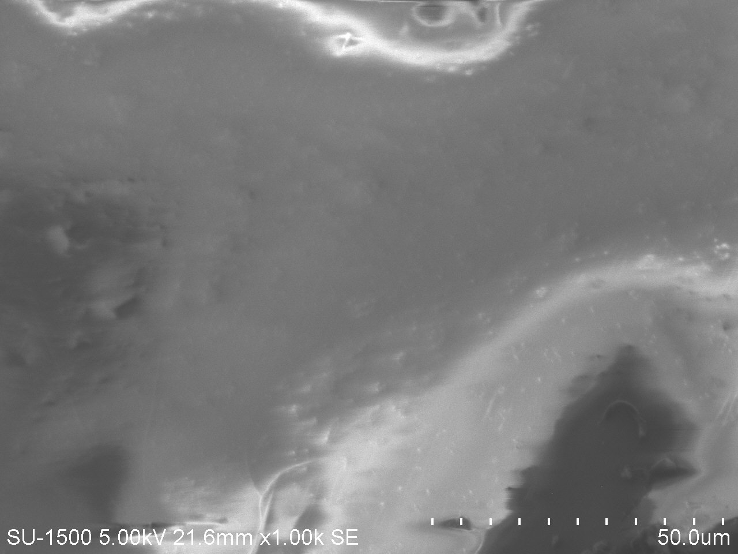
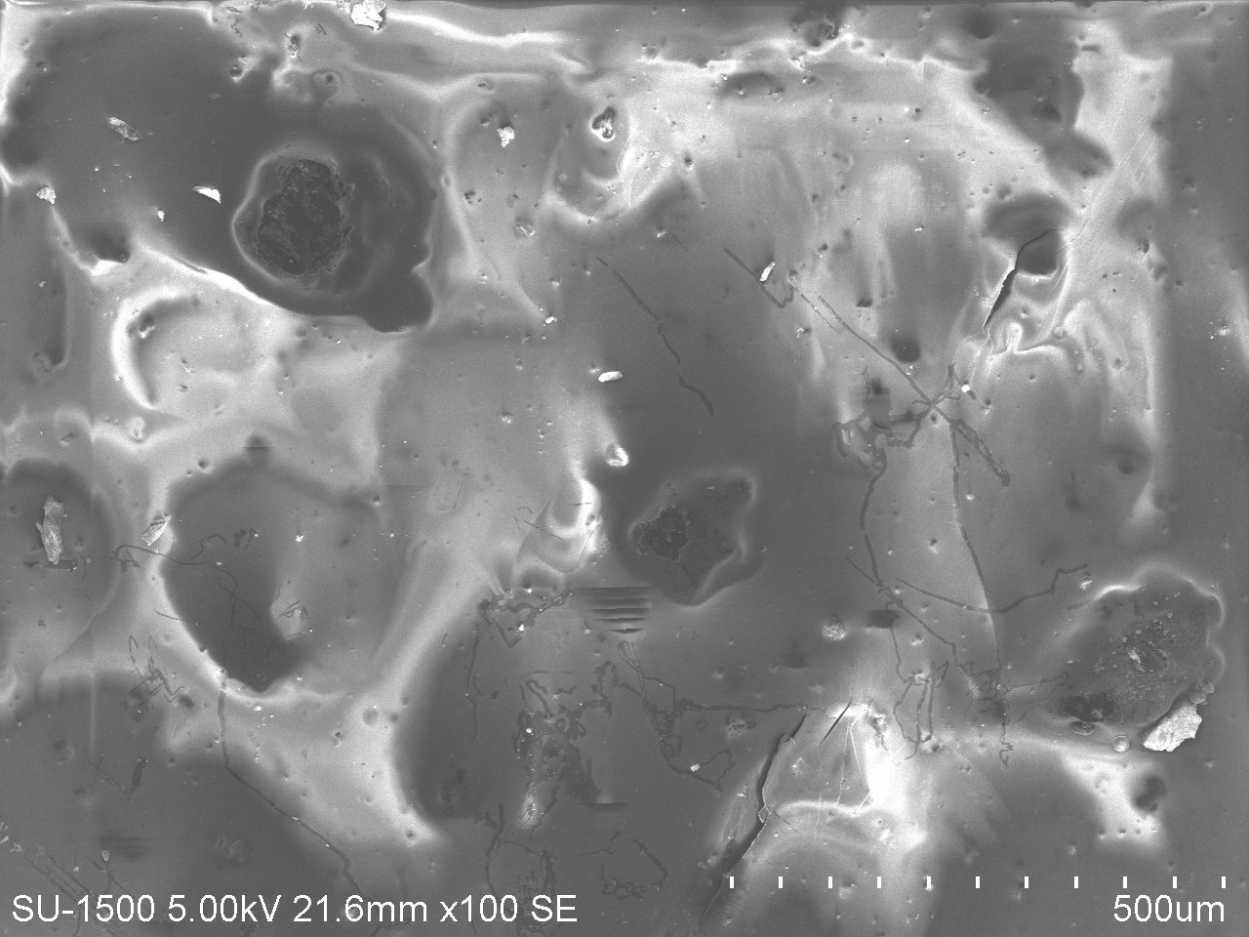
(a)

Fig 4.1(a) SEM image of ZnO/PS at 500 µm Fig 4.1(b) SEM image of ZnO/PS at 50 µm.
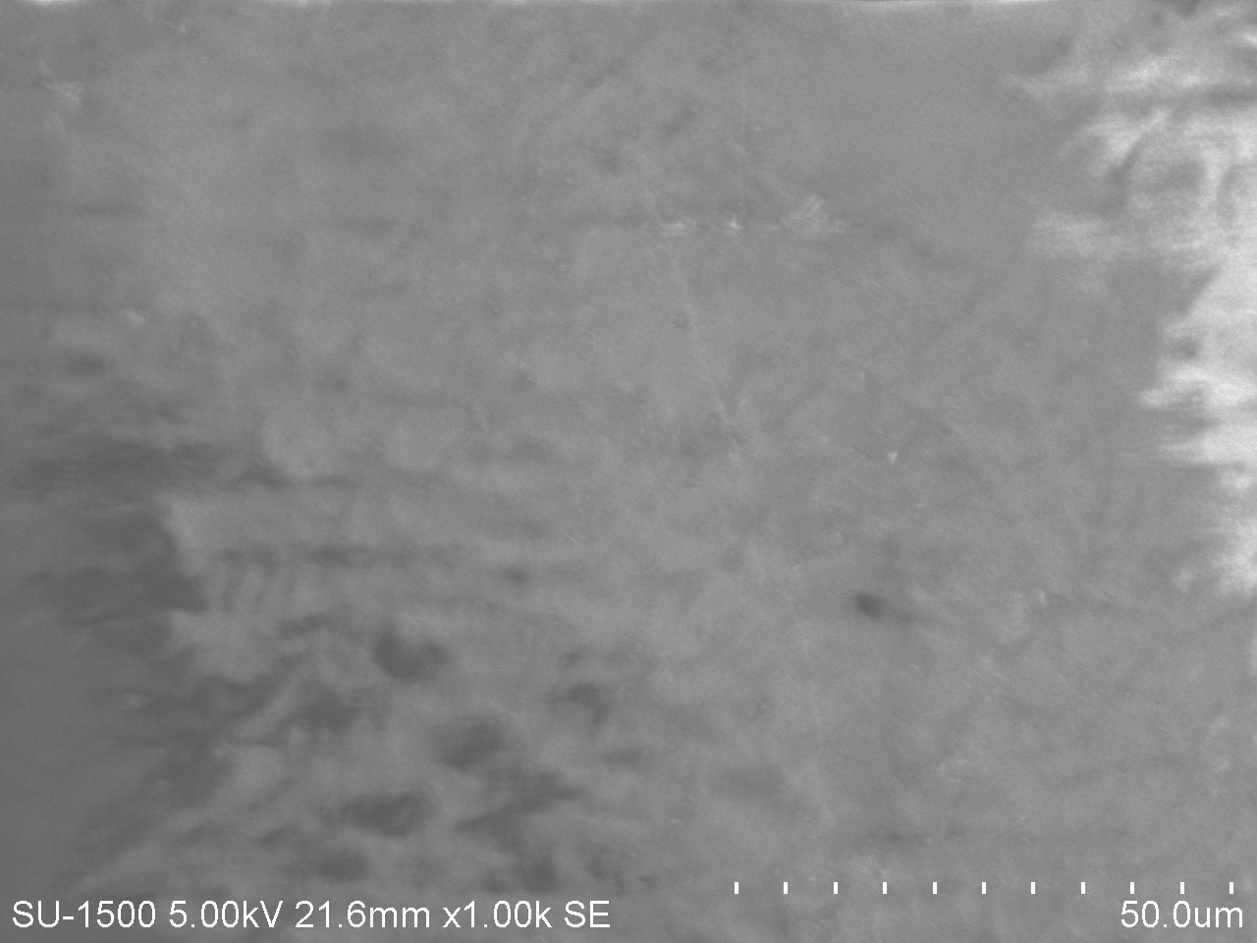
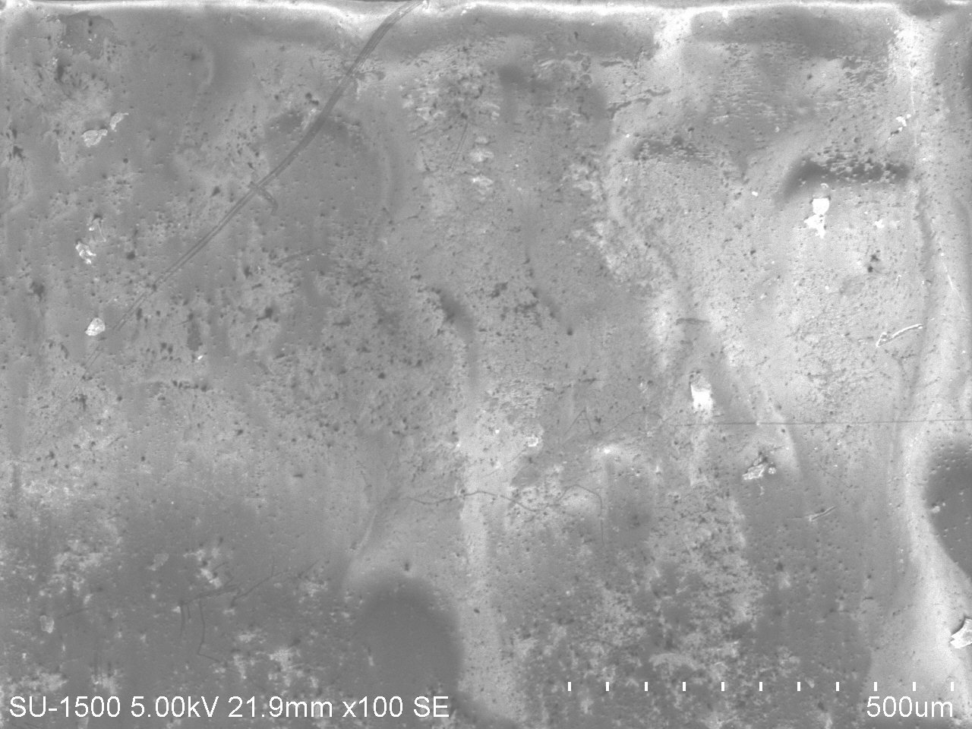
SEM images of CuO/PS film surface is shown in Fig 4.2(a) at magnification 500 µm. It was found that the surface has irregular patterns & there are void on the surface because of improper distribution. Small particles on the surface give the presence of the CuO & rough surface because of presence of the nanoparticles present on the surface which results in the droplet formation on the surface. The particle size was found to be 27 nm. Fig 4.2(b) SEM images at magnification 50 µm. it was found smooth because of high focused beams melts the polymer surface & particle size was found to be same [41].

Fig 4.2(a)) SEM image of CuO/PS at 500µm Fig 4.2(b) SEM image of CuO/PS at 50 µm

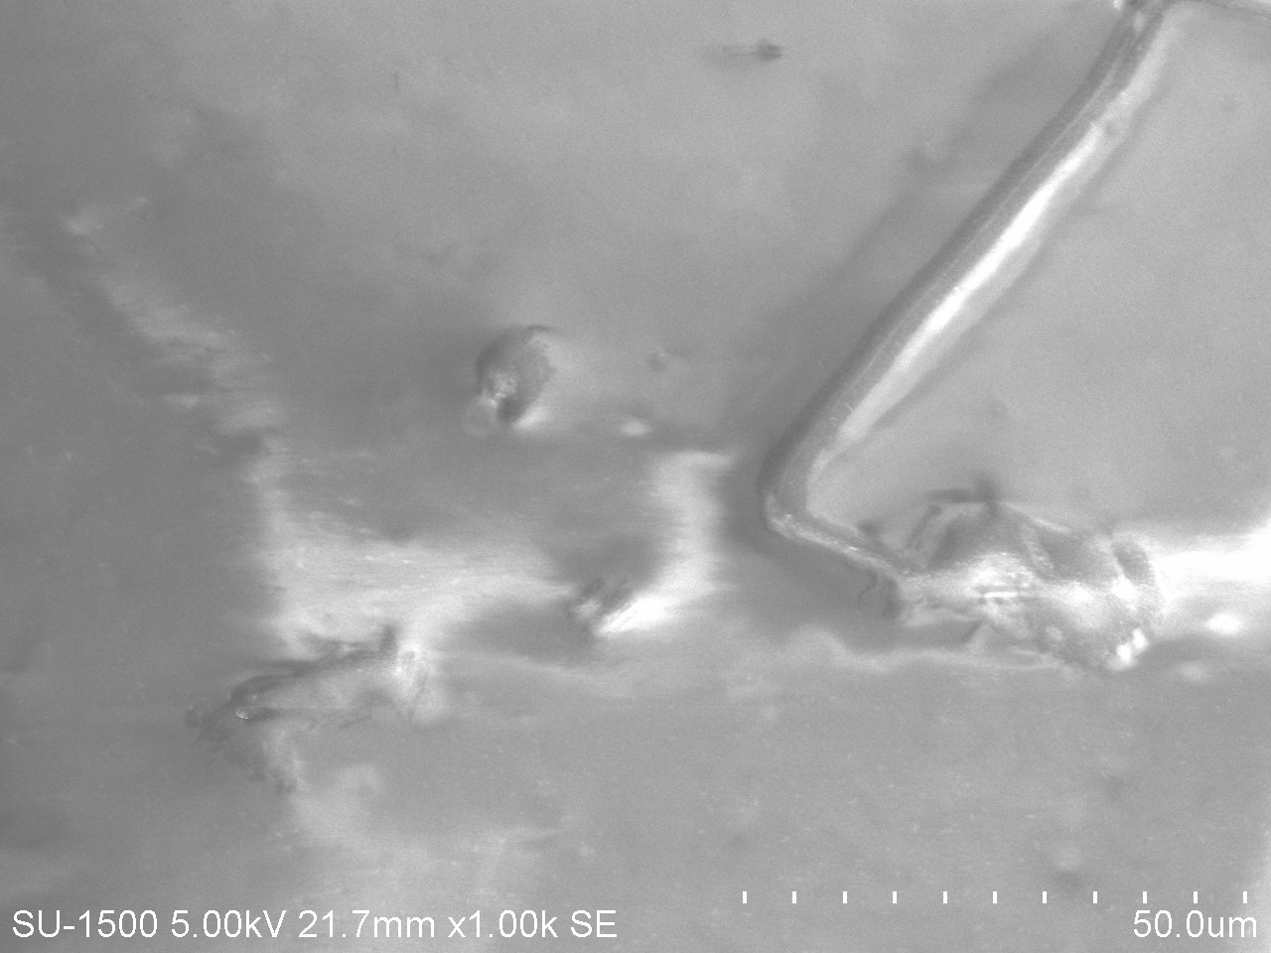
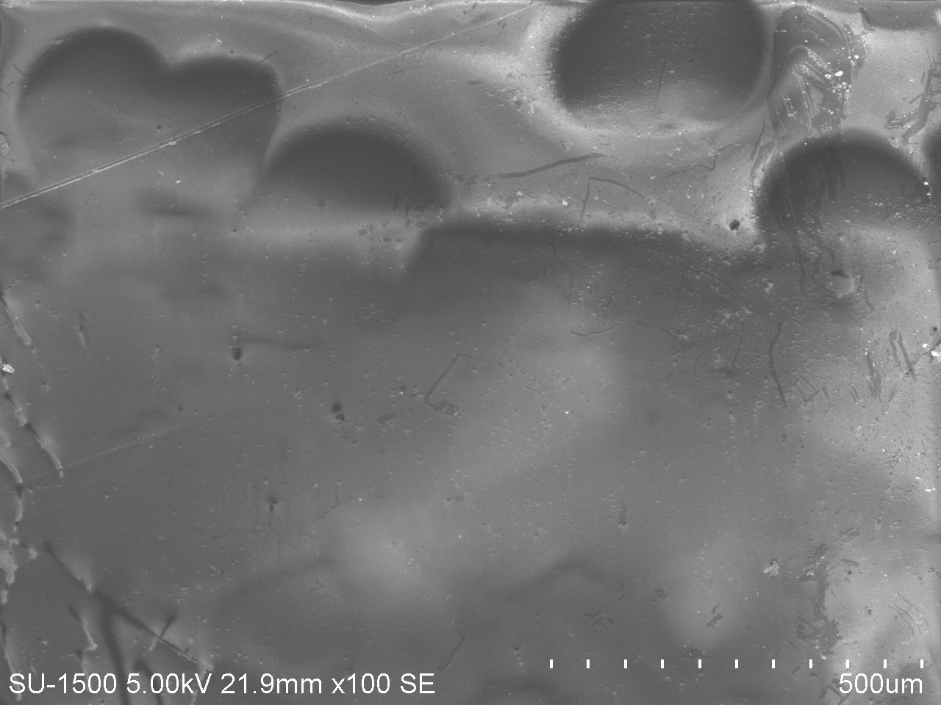
SEM image of Fe₂O₃/PS film surface is shown in Fig 4.3(a) at magnification 500 µm. It was found that the surface has voids on the surface due to the Small particles on the surface gives the presence of the Fe₂O₃ & roughened surface may be cause for the hydrophobicity. The particle size was found to be 28 nm. In Fig 4.3(b) shows SEM image at magnification 50 µm. it was found nearly smooth surface due to high focused electrons melts the polymer surface. In fact, there can be seen very few nanoparticles on the surface showing a very disperse morphology which shows that the most of nanoparticles was buried in the coating layer upon evaporating the solvent [42].

Fig 4.3(a) SEM images of Fe₂O₃/PS at 500 µm Fig 4.3(b) SEM images of Fe₂O₃/PS at 50 µm

4. Conclusions
Three different Metal Oxides Nanoparticles ZnO, CuO & Fe₂O₃ are synthesized through a simple solution combustion method. Hydrophobic surfaces are made by ZnO/PS, CuO/PS & Fe₂O₃/PS has been made through spin coating method on the glass substrate. Water contact angle of 101.77°, 96.48°, & 93.97° have been obtained. Sliding angle of 24.23°, 25.24°, & 27.53° have been obtained. XRD results of ZnO, CuO & Fe₂O₃ powder confirmed nano crystalline powder, crystalline size of 12.5 nm, 14.59 nm & 12.88 nm respectively has been obtained. EDX results of hydrophobic surface gave presence of various elements on the surface like Zn, Cu, Fe, O, C & Si with weight 0.18%, 0.07%, 0.13%, 1.22%, 98.43% & 0.24% respectively on the ZnO/PS, CuO/PS & Fe₂O₃/PS surfaces. SEM results gave the surface morphology of the prepared samples. It was found that presence of ZnO, CuO & Fe₂O₃ particles on the surface & particle size was found to be 24 nm, 27 nm & 28 nm.

References

- Yuanyuan Cheng, Shixiang Lua, Wenguo Xua, , Rabah Boukherroubb, Sabine Szunerits, Wei Liang, “Controlled fabrication of NiO/ZnO superhydrophobic surface on zinc substrate with corrosion and abrasion resistance”, Journal of Alloys and Compounds, 723, 2017, 225-236.
- Elmira Velayi, Reza Norouzbeigi, “Robust superhydrophobic needle-like nanostructured ZnO surfaces prepared without post chemical-treatment”, Applied Surface Science, 426, 2017, 674-687.
- Mohd Faraz, Mohd Zubair Ansari & Neeraj Khare, “Synthesis of nanostructure manganese doped zinc oxide/polystyrene thin films with excellent stability, transparency and super-hydrophobicity”, Materials Chemistry and Physics, 211, 2018, 137-143.
- Bharat Bhushan, Yong Chae Jung, “Natural and biomimetic artificial surfaces for superhydrophobicity, self-cleaning, low adhesion, and drag reduction”, Progress in Materials Science, 56, 2011, 1-108.
- Sanjay S. Latthe, Chiaki Terashima, Kazuya Nakata & Akira Fujishima, “Photocatalytic, superhydrophilic, self-cleaning TiO2 coating on cheap, light-weight, flexible polycarbonate substrates”, Applied Surface Science, 458, 2018, 917-923.
- Farshad Beshkar, Hossein Khojasteh & Masoud Salavati-Niasari, “Recyclable magnetic superhydrophobic straw soot sponge for highly efficient oil/water separation”, Journal of Colloid and Interface Science, 497, 2017, 57-65.
- L.D. Zhang, W.L. Liu, W.H. Xu, J.S. Yao, L. Zhao, X.Q. Wang, Y.Z. Wu, “Synthesis and characterization of superhydrophobic and superparamagnetic film based on maghemite–polystyrene composite nanoparticles”, Applied Surface Science, 259, 2012, 719-725.
- Elbruz Murat Baba, C. Elif Cansoy, Esra Ozkan Zayim, “Investigation of wettability and optical properties of superhydrophobic polystyrene-SiO2 composite surfaces”, Progress in Organic Coatings, 99, 2016, 378– 385.
- Amrita Hooda, M.S. Goyat, Rajeev Gupta, Manish Prateek, Megha Agrawal, Abhijit Biswas, “Synthesis of nano-textured polystyrene/ZnO coatings with excellent transparency and superhydrophobicity”, Materials Chemistry & Physics, 193, 2017, 447-452.
- Jan genzer & Kirill efimenko, “Thermally driven directional free-radical polymerization in confined channels”, Biofouling, 22, 2006.
- Jian Li, Hongqi Wan , Xiaohong Liu, Yinping Ye, Huidi Zhou, Jianmin Chen, “Facile fabrication of superhydrophobic ZnO nanoparticle surfaces with erasable and rewritable wettability”, Applied Surface Science, 258, 2012, 8585–8589.
- Umer Mehmood, Fahad A. Al-Sulaiman, B.S. Yilbas, B. Salhi, S.H.A. Ahmed, Mohammad K. Hossain, “Superhydrophobic surfaces with antireflection properties for solar applications: A critical review”, Solar Energy Materials & Solar Cells, 157, 2016, 604–623.
- Beleta Bolvardi, Javad Seyfi, Iman Hejazi, Maryam Otadi, Hossein Ali Khonakdar, Astrid Drechsler, Matthias Holzschuh, “Assessment of morphology, topography and chemical composition of water-repellent films based on polystyrene/titanium dioxide nanocomposites”, Applied Surface Science, 6, 2016, 1-9.
- E. Vazirinasab, R. Jafari, G. Momen, “Application of superhydrophobic coatings as a corrosion barrier: A review”, Surface & Coatings Technology, 20, 2017, 373-379.
- N Mufti, D Arista, M Diantoro, A Fuad, A Taufiq & Sunaryono, “The Effect of Thickness of ZnO Thin Films on Hydrophobic Self-Cleaning Properties”, Materials Science & Engineering, 2017.
- H. Li, S. Yu, X. Han, “Fabrication of CuO hierarchical flower-like structures with biomimetic superamphiphobic, self-cleaning and corrosion resistance properties”, Chemical Engineering Journal, 283, 2016, 1443-1454.
- R. Fürstner, W. Barthlott, C. Neinhuis, P. Walzel, “Wetting and self-cleaning properties of artificial superhydrophobic surfaces”, Langmuir, 21, 2005, 956–961.
- Adel M.A. Mohamed, Reza Jafari, Masoud Farzaneh, “An optimization of superhydrophobic polyvinylidene fluoride/zinc oxide materials using Taguchi method”, Applied Surface Science, 288, 2014, 229-237.
- Rupsha Bhattacharyya, “Solid state storage of hydrogen and its isotopes: An engineering overview”, Renewable and Sustainable Energy Reviews, 4, 2013, 378-388.
- L. Xu, R.G. Karunakaran, J. Guo, S. Yang, “Transparent, Superhydrophobic surfaces from one-step spin coating of hydrophobic nanoparticles”, ACS Applications Materials Interfaces, 2012, 4 ,1118-1125.
- R. Fürstner, W. Barthlott, C. Neinhuis, P. Walzel, Langmuir, “Wetting and Self-Cleaning Properties of Artificial Superhydrophobic Surfaces”, Langmuir, 21,2005, 956–961.
- E.M. Baba, C.E. Cansoy, E.O. Zayim, “Optical and wettability properties of polymers with varying surface energies”, Applied Surface Science, 350, 2015, 115–12.
- H. Li, S. Yu, X. Han, “Fabrication of CuO hierarchical flower-like structures with biomimetic superamphiphobic, self-cleaning and corrosion resistance properties”, Chemical Engineering Journal, 283, 2016, 1443-1454.
- A. Nakajima, K. Hashimoto, T. Watanabe, K. Takai, G. Yamauchi, A. Fujishima, “Transparent Superhydrophobic Thin Films with Self-Cleaning Properties”, Langmuir, 16, 2000.
- H. Budunoglu, A. Yildirim, M.O. Guler, M. Bayindir, “Highly Transparent, Flexible, and Thermally Stable Superhydrophobic ORMOSIL Aerogel Thin Films”, ACS Applications Materials Interfaces, 3, 2011, 539-545.
- J. Li, L. Shi, Y. Chen, Y. Zhang, Z. Guo, B. Su, J. Mater, “Stable superhydrophobic coatings from thiol-ligandnanocrystals and their application in oil/water separation”, Journal of Materials Chemistry, 22, 2012, 9774.
- S.A. Mahadik, D.B. Mahadik, M.S. Kavale, V.G. Parale, P.B. Wagh, H.C. Barshilia, “Thermally stable and transparent superhydrophobic sol–gel coatings by spray method”, Journal of Sol-Gel Science and Technology, 63, 2012, 580-586.
- . L. Xu, R.G. Karunakaran, J. Guo, S. Yang, “Transparent, Superhydrophobic Surfaces from One-Step Spin Coating of Hydrophobic Nanoparticles”, ACS Applications Materials Interfaces 4, 2012, 1118-1125.
- H. Zhang, L. Yin, L. Li, S. Shi, Y. Wang & X. Liu, “Wettability and drag reduction of a superhydrophobic aluminum surface”, RSC Advances, 17, 2016.
- M. Khakbaz, I. Hejazi, J. Seyfi, S.-H. Jafari, H.A. Khonakdar, S.M. Davachi, “A novel method to control hydrolytic degradation of nanocomposite biocompatible materials via imparting superhydrophobicity”, Applied Surface Science, 357, 2015, 880–886.
- Mohd Faraz, Mohd Zubair Ansari, Neeraj Khare, Synthesis of nanostructure manganese doped zinc oxide/polystyrene thin films with excellent stability, transparency and super-hydrophobicity, Materials Chemistry and Physics, 211,2018,137-143.
- Chuhong Zhu, Xiaoye Hu, Xiujuan Wang, Silver nanocubes/graphene oxide hybrid film on a hydrophobic surface for effective molecule concentration and sensitive SERS detection,
Applied Surface Science, 470,2019,423-429.
- Tan Nhiem Ly, Sangkwon Park,Highly sensitive gas sensor using hierarchically self-assembled thin films of graphene oxide and gold nanoparticles,Journal of Industrial and Engineering Chemistry, 67,2018,417-428.
- Audrey Gossart, Didier Letourneur, Adeline Gand, Véronique Regnault, Mohamed Amine Ben Mlouka, Pascal Cosette, Emmanuel Pauthe, Véronique Ollivier, J. Paul Santerre, Mitigation of monocyte driven thrombosis on cobalt chrome surfaces in contact with whole blood by thin film polar/hydrophobic/ionic polyurethane coatings,Biomaterials, 217, 2019, 119306.
- D. Mamedov, A.C. Åsland, S.P. Cooil, H.I. Røst, J. Bakkelund, A. Allaniyazov, J.W. Wells, S. Karazhanov, Enhanced hydrophobicity of CeO₂ thin films: Role of the morphology, adsorbed species and crystallography,Materials Today Communications, 35,2023,106323.
- Wei Wang, Xiangjin Li, Weijun Liu, Fei Xing, Jing Wang, Kai Zhang, Experimental study on hydrophobic properties and corrosivity of laser cleaned 7075 aluminum alloy anodized film surface,Optics & Laser Technology, 166,2023,109615.
- K.N.D. Bandara, K.M.D.C. Jayathilaka, D.P. Dissanayake, J.K.D.S. Jayanetti, Surface engineering of electrodeposited cuprous oxide (Cu2O) thin films: Effect on hydrophobicity and LP gas sensing,Applied Surface Science,561,2021,150020.
- Hamid Reza Mohammadi, Hamed Taghvaei, Ataollah Rabiee, Experimental study of pool boiling on hydrophilic and hydrophobic thin films deposited on copper surfaces using atmospheric cold plasma,International Journal of Thermal Sciences,175,2022,107474.
- Jatinder Kaur, Atul Khanna, Amit K. Chawla,Metallic to semiconducting transition and hydrophobicity properties of indium films,Vacuum, 203,2022.
- Ahmad Zahoor, Cheng Xu, Tauseef Shahid, M. Arfan Anwar, Zhenlun Song, Effects of O2 flux on structure, optical properties and hydrophobicity of highly emissive antireflective HfO2 thin films by magnetron sputtering, Vacuum, 197,2022,110824.
- Amir Hossein Jafari Mofidabadi, Ghasem Bahlakeh, Bahram Ramezanzadeh, Fabrication of a novel hydrophobic anti-corrosion film based on Eu₂O₃/stearic acid on steel surface; Experimental and detailed computer modeling studies,Journal of the Taiwan Institute of Chemical Engineers,114,2020, 228-240.
- Heebo Ha, Seongchan Ko, Byeonghwa Goh, Sebastian Muller, Roelf-Peter Baumann, Mirine Leem, Seung Jo Yoo, Joonmyung Choi, Byungil Hwang,Influence of grain boundary density on the surface energy of nanocrystalline metal thin films, Applied Surface Science, 604,2022,154463.

