Cancer Molecular Biomarkers of Melanoma
Vallem.Asha¹ Jayanthi chavali ², Vamsi Krishna ²
Student – Sri Padmavati Mahila Visvavidyalayam Womens University India
Project faculty- environment protection training research institute -Eptri, Hyderabad Gachibowli.
Abstract:-
Melanocytes, the cells that provide the melanin pigment that gives skin its colour, are the source of melanoma, a specific type of skin cancer. Early detection and treatment can boost melanoma patients' chances of survival. Clinical assessment and biopsy are the two primary ways to diagnose melanoma. Histopathologically separating early invasive melanoma from pre-malignant melanocytic tumours is still challenging. This has led to the development of other methods for melanoma diagnosis, such as a detailed clinical history, imaging, genetic testing, and biomarkers. This study looks at recent advancements in biomarkers to help in the early detection and diagnosis of melanoma. The detection, diagnosis, and prognosis of melanoma may be aided by circulating tumour cells (CTCs), melanoma-associated antigens (MAAs), S100B, microRNAs (miRNAs), and other biomarkers. However, the application of biomarkers in the diagnosis of melanoma is still being developed.
Keywords :- Melanocytes , S100B , MicroRNAs , Biomarkers ,
Histopathology .
Introduction
Melanoma is an aggressive type of skin cancer that develops from melanocytes, the pigment-producing cells of the skin. It continues to be the most fatal variety of skin cancer [1-3]. However, with early detection and treatment, melanoma may be curable [1-4]. It is the deadliest type of skin cancer and the fifth most common type of cancer overall, accounting for roughly 80% of skin cancer-related deaths in the US. Melanoma is currently present in over 1 million Americans, and incidence rates have been gradually increasing since the 1970s. Additionally, affluent countries are seeing a surge in incidence, and it accounts for 1.7% of all cancer cases globally [1-6]. Although the 5-year relative survival rate has increased to 93.7%, the survival rate for advanced illness is still only about 50% [1-4]. There are several reasons for this increase in overall popularity. improvements in diagnostic techniques, immunological treatments, and customised medications. Risk factors commonly include persons with fair complexion and lower latitudes [1-3]. Men and older patients, whose average age at diagnosis is 65, are also more likely to receive a diagnosis [1-3]. Melanoma can manifest in a number of forms, making it challenging to identify, such as a new or changing mole, a patch or bump that differs from other skin lesions, or a sore that does not heal. The various melanoma cytomorphologic presentations also present an immuno-histologic challenge [4–8]. This may be because its immune histomarkers are similar to those of other malignancies, such as carcinomas and other tumours including germ cell tumours and neuroendocrine tumours. Clinical examination and biopsy are the two main ways to diagnose melanoma [1]. However, it might be challenging for clinicians to distinguish between a benign mole and a melanoma even with a biopsy [2-8]. Additional imaging and genetic testing have been necessary for a more precise diagnosis [2, 6, 8, 9, and 15]. Even while clinical examination and biopsy are the gold standards for melanoma diagnosis [1-4,7-12], the difficulties in distinguishing between a benign mole and a melanoma highlight the need for additional tests to aid in diagnosis. Early detection and sun protection must be used to lower the morbidity and mortality associated with melanoma. Therefore, identifying disease-related biomarkers has implications for both treatment and prognosis, particularly in advanced-stage melanoma, where early detection and treatment can boost survival rates [1-3, 16-31]. This piece will discuss the most recent melanoma diagnosis methods, including histological examination, imaging, and clinical indicators. We will also investigate any potential contributions of specific biomarkers to melanoma diagnosis and prognosis. Consequently, this work's goal is to supply a description of the current procedures for melanoma diagnosis utilising several biomarkers.
Methodology
In order to investigate biomarkers' role in melanoma diagnosis over the previous 10 years, articles about melanoma and biomarkers were searched for in PubMed. The mesh words "melanoma," "biomarkers," "diagnosis," and "prognosis" were implemented using the Boolean operator "and/or." The search criteria were limited to documents created within the last ten years (2013–2023). Then, abstracts and free full texts were selected. We selected literature on clinical trials, meta-analyses, and randomised controlled trials. Additionally, the chosen search criteria were set up to yield human-written English-language publications. Additional screening of the produced abstracts was done in order to identify publications that most accurately mirrored the objective and focus of this manuscript. The article's content was then reviewed to ensure that it matched the newspaper's objectives. Below is Table 1. The inclusion and exclusion standards are listed in 1 below. The Prisma flow for the chosen research is displayed in Figure 1 below.

Table 1: Inclusion and exclusion criteria

Table 1: Inclusion and exclusion criteria
Inclusion criteria | Exclusion criteria
1) Literature on the application of biomarkers to the detection or prognosis of melanoma | 1) Because the study focused on the role of biomarkers in melanoma, research that did not address these topics was disregarded.
2) Case-control, cohort, or randomised clinical controlled trials must be unique investigations. | 2) Scanning reviews and other non-data-driven study designs were disregarded.
3) The chosen studies may have a variety of goals, but they must all have measurable outcomes. | 3) Qualitative research was not considered
4) Studies on people. | 4) Studies on people.
5) To preserve validity and reliability, the investigations must be published in a peer-reviewed publication. | 5) Dissertations and papers published in journals without peer review were disregarded.
6) For ease of reading by the reviewers, the research must have been originally published in English. | 6) Studies that were first released in languages other than English were disregarded.
7) Works of literature published between 2013 and 2023

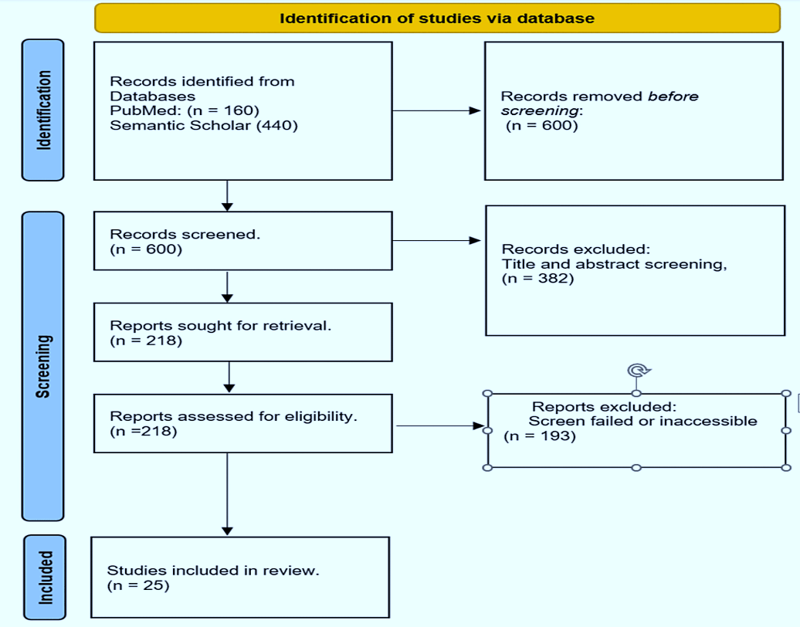

Modern methods for melanoma diagnosis Clinical Indices
The first stage in making a melanoma diagnosis is identifying atypical lesions [1-3,6-12-15]. The ABCDE approach is a straightforward acronym designed to aid the general public and medical professionals in identifying potential melanomas based on their characteristics. The letters represent for the five essential characteristics of an aberrant skin lesion: asymmetry, uneven border, colour variability/change, dimension, and progression. In situ or early-stage melanomas frequently exhibit these characteristics. Asymmetry is the term used to describe the irregularity in the lesion's shape when one half is different from the other. Border irregularity is the term used to describe the blurring, notching, or unevenness of the lesion's border. Colour variability or change refers to having a variety of colours, such as various brown or black tones, or shifting colours. They becoming more and more black or paler. The diameter of the lesion is typically greater than 6 millimetres in size. When a lesion changes over time in terms of size, form, colour, or texture, it is said to be evolving or evolving [1,6-8,14,15]. If a lesion is thought to be possibly malignant, a biopsy is performed, and the tissue is examined under a microscope to confirm the diagnosis [1-8]. Dermoscopy can improve the accuracy of tissue sampling [1-3,6,8,12-16].
Imaging
In addition to using clinical signs, imaging techniques such as CT scans, MRIs, and ultrasonography can aid in the diagnosis of melanoma. Ultrasonography is useful for measuring the thickness of melanomas, but MRI and CT scans can provide detailed views of the inner structures of the skin and surrounding tissue and help rule out metastasis to other organs [1,3-8, 16-23]. It is suggested against performing baseline tests on patients with cutaneous melanoma that is stage 0-II according to the AAD and stage 0 to IIIB according to the NCCN. The ESMO and NCCN advise whole-body PET and brain magnetic resonance imaging (MRI) for individuals with stage III and higher illness. The ESMO recommends PET for people with malignancies that are pT3b and higher. They as well as brain MRIs. Patients who have early-stage disease, symptoms of metastatic disease, or high-risk disease, such as those who present with a positive sentinel lymph node, microscopic satellite or in-transit metastatic lesions on pathology or clinically palpable lymph nodes, should also be given consideration for PET and MRI brain scans, according to NCCN [24]. The CCA does not recommend imaging for those who have positive sentinel lymph nodes (Grade B), but suggests PET and MRI brain imaging for those with palpable lymph nodes (Grade B) [24].
Histopathological Examination
The most accurate way to diagnose melanoma is by a histological analysis. A pathologist looks at the biopsy sample under a microscope to determine whether the tumour is malignant [1–8]. A typical melanoma can be described in various ways under a tissue microscope. When analysing a melanoma under a microscope, a pathologist will frequently look for a variety of unique characteristics of the cancer. For instance, whether or not perineural invasions exist, the arrangement of melanocytic cells in sheets and nests, etc. One of the lesion's additional characteristics is the number of lymphocytes, or TILs (tumour-infiltrating lymphocytes), that are present there. TILs could indicate that the immune system is actively battling melanoma cells as a result of its determination that they are abnormal [25-32]. The TILs may be referred to as "brisk," "non-brisk," or other words by the pathologist. Additionally, they might use the words "mild" or "moderate," or they might just state "absent" [1,3,5-6,8,]. Additional characteristics that define melanoma under a tissue microscope include the kind of melanoma, the depth of invasion, the presence or absence of ulceration, the mitotic count, the presence or lack of regression, and the presence or absence of satellite lesions. The pathologist may also take into account the kind of material, the technique used to remove the lesion, the place on the body where it was, the side of the body it was on, the subtype of melanoma, the edge of the excision, the size of the tumour, and whether it is in situ or invasive [4-6].
Biomarkers for the diagnosis of melanoma
Early melanoma is characterised by genetic and cellular structural changes, such as abnormalities in collagen-like sequences or structural proteins, oncogenic BRAFV600E mutations, UV-induced DNA mutations, molecular signalling pathways, or UV-induced DNA mutations. The creation of chemokines, cytokines, endopeptidases, phaeomelanin precursors, melanin-associated antigens, dimeric proteins like S100-B, RNA/DNA microarray products, and other tumorigenic effects may be caused by these complex early or late molecular modifications and events in a cell. The survival and prognosis of patients are still improved by early melanoma detection and therapy [1-3,6-9,15]. The existence or progression of a disease can be determined by biomarkers, which are molecules that can be identified in blood, tissue, or other biological samples [6–12]. Melanoma-associated antigens (MAAs), MicroRNAs (miRNAs), A number of putative biomarkers for 100B, CRP, LDH, and circulating tumour cells (CTCs) are some of the tests used to diagnose melanoma [4,6–12]. Other potential melanoma biomarkers have also been found and extensively investigated in written works. Melanoma-inhibitory antigens are among them.(MIAs), cell-free DNA, Melan-A, and circulating tumour DNA [5-14,18-25]. Because no single biomarker currently satisfies the requirements for a minimum useable test (ctDNA), the current status of biomarkers for melanoma detection is still in its infancy [6-14,18-25]. We'll discuss these distinguishing traits (see the conceptual illustration in Figure 2 below).
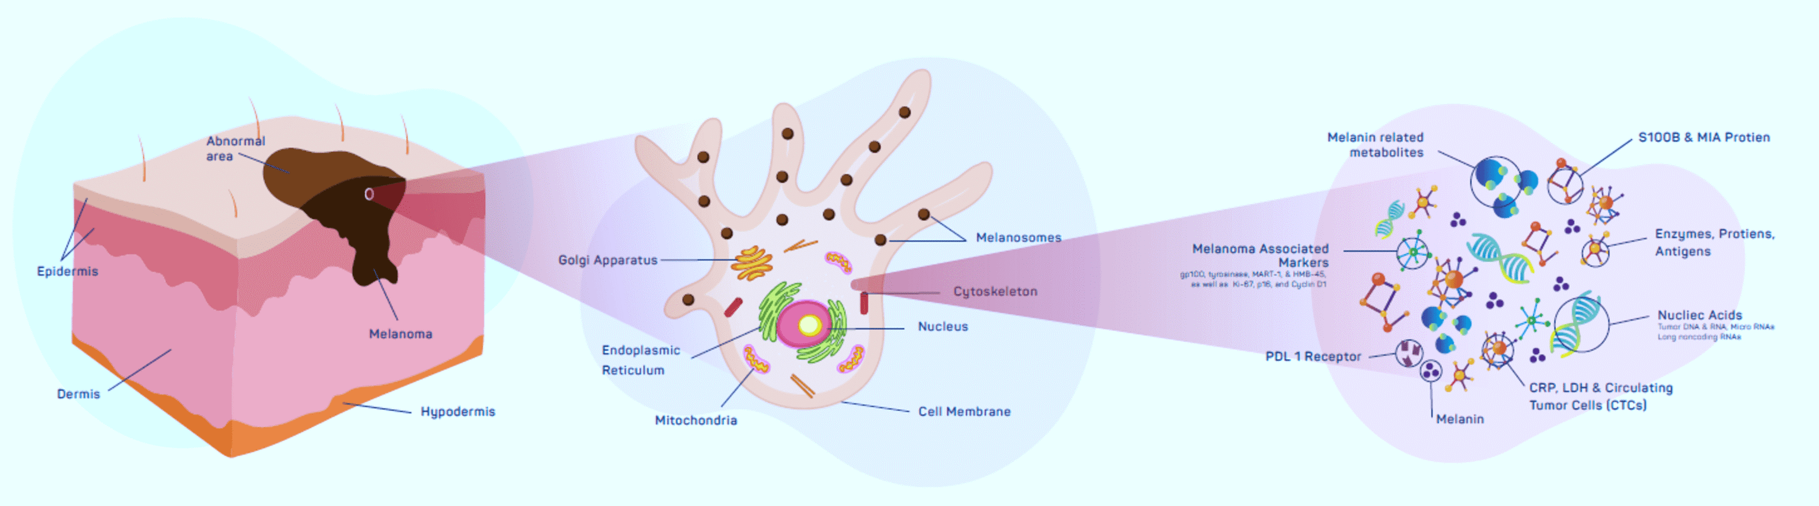

An outline for determining the qualities of the least cumbersome biomarker tests
The methodology for determining the minimally significant biomarker test characteristics includes evaluations of the sensitivity, specificity, positive predictive value (PPV), negative predictive value (NPV), and area under the receiver operating characteristic curve (AUC-ROC) [17,18].Pmel-17/gp100 and MART-1/Melan-A, two proteins referred to as MAAs, are only expressed by melanoma cells and not by healthy cells. They have been the subject of extensive research as potential melanoma biomarkers because of their ability to elicit an immunological response and their selectivity for melanoma cells. It has been shown that the expression of MAAs in melanoma patients corresponds with the course of the disease and the prognosis [5-8]. Other studies [9] looked at the expression of different MAAs in melanoma patients and found that one MAA, MAGE-A3, was significantly correlated with the illness. with poor survivability statistics [4-11-14]. The prognosis showed that patients with high levels of MAA (CYT-MAA) had an 81% greater risk of recurrence than those with undetectable levels. In a study to evaluate the prognostic significance of MAA in 117 patients, Irene et al. came to the conclusion that MAA is a significant predictive biomarker, particularly in patients who have had their tumours removed [31]. Studies on the role of Melan-A have yielded conflicting results during the past ten years. Melan-A, a unique membrane protein identified by T lymphocytes, has a high specificity of 99% for differentiating non-melanocytic cells from melanoma, according to multiple studies. especially for early tumours. On the other hand, due to its staining powers, other writers demonstrated reduced sensitivity (about 86%) and expressed concerns about its specificity. Leydig, adrenocortical, ovarian, and theca cells, as well as other pigmented epithelium, like the retina, are examples of non-pigmented epithelium or its offspring [26]. In rare cases, it has also been demonstrated that a subgroup of lesions without MAA or HLA expression has rapid remission. However, the exact mechanism of the particular association is still not fully understood [32–34]. To regulate gene expression, small non-coding RNA molecules called miRNAs focus on certain mRNA molecules. They have been acknowledged as potential melanoma and other cancer biomarkers. Numerous studies have looked into the expression of miRNAs in melanoma and their potential use as prognostic and diagnostic biomarkers.
For instance, some studies have discovered that there are several miRNAs whose expression is different between melanoma patients and healthy individuals, suggesting that these miRNAs may be employed as diagnostic biomarkers [6-15,33]. Some review studies [26–33] have discussed the potential application of other biomarkers, such as microRNAs and exosomes, for the diagnosis of melanoma. According to the authors' theories [4–15], these indicators might improve the accuracy of melanoma diagnosis and forecast disease progression and therapy response. In a research project that looked at 126 samples of human blood similar to melanoma, miRNA levels dramatically changed at more advanced stages of cancer [34]. Other research suggests that miRNA holds some promise as a prognosticating molecule for progression. For example, Shanthi and co. despite equivocal results, came to similar conclusions in a pooled meta-analysis of 2669 patients, with an overall effect size of 1.043 (95% CI 0.921-1.181; p = 0.506) and a 4.3% death rate for those with this marker. Initial tumour cells known as CTCs are shed and enter the bloodstream. They have been researched as prospective biomarkers for a variety of cancers, including melanoma, due to their ability to give information about tumour metastasis and treatment response. Numerous subsequent studies that examined CTCs in melanoma patients found a link between them and a poor prognosis and disease progression [4–15]. Other research have connected CTC to a bad prognosis as well. For instance, Morcelin et al. [36] discovered that positive rates for progression-free survival and overall survival were better in early-stage melanoma than late-stage, at 2.45 and 2.42, respectively. Based on a meta-analysis of 5433 melanoma patients from 53 trials, this conclusion was made.
Biomarkers, such as cell-free DNA (cfDNA) and circulating tumour DNA (ctDNA), have emerged as promising melanoma diagnostic aids. The potential of ctDNA as a biomarker for melanoma detection has been demonstrated in studies [6–10]. 57% of the 135 individuals in a study with advanced melanoma had ctDNA discovered [13]. The research team found a correlation between ctDNA and tumour load, disease stage, and overall survival. Furthermore, ctDNA was discovered in individuals with smaller tumours and earlier disease stages, suggesting that ctDNA may be useful for identifying melanoma at an earlier stage [13–15]. The results of the study suggest that ctDNA may be a useful diagnostic tool for melanoma, especially when traditional diagnostic methods like biopsy are not an option. Overexpression of the secreted protein MIA in melanoma Prognostic and diagnostic uses for cells have been demonstrated [4-15,37-39]. However, it is not very helpful as a sole biomarker because of its weak sensitivity and specificity. Using stage I or stage II cutaneous melanoma patients who were being observed, a study examined the diagnostic utility of the blood marker for melanoma inhibitory activity (MIA). The study contained 5,334 MIA serum levels from 1,079 consecutive stage I and stage II melanoma patients. These data were gathered at predefined intervals during standard follow-ups. Somers' Dxy rank correlation, the sensitivity and specificity of MIA, and the area under the receiver-operating characteristics curve were all calculated. The study found that metastases were present in 137 individuals with a sensitivity of. testing of MIA tests for stage II and stage I patients, respectively, of 65.6% and 67.6%. The specificity was 76.9% and 66.7% for patients in phases I and II, respectively. Compared to 8.8 and 15.0 ng/ml, 12.0 ng/ml was shown to be the most reliable normal upper limit for MIA in that study.
Furthermore, multivariate analysis revealed that false-positive readings were considerably higher in elderly men and women with an increased Breslow thickness. The results of the study also showed that MIA levels increased in 5.6% of people with early-stage melanoma and as high as 89.5% of patients with late-stage melanoma [25]. ctDNA has been identified as a promising biomarker in the blood of melanoma patients [4-6,8-15,20-25]. More clinical trials are required to prove it because its diagnostic performance is currently uncertain. HMb-45 has also been researched as a potentialimmunohistochemical marker over the previous century. The sensitivity of this monoclonal antibody ranges from 66 to 97%, with a lower sensitivity for the metastatic form of the disease. Glycoproteins (gp100, Pmel17) are stained in the space between junctional nevus cells and melanoma. Numerous peer-reviewed articles have also demonstrated that it has a melanoma specificity that ranges from 91 to 100%, but regrettably, it performs poorly at detecting its desmoplastic variant [26]. Researchers have studied the relationship between high lactate dehydrogenase (LDH) levels and melanoma survival indicators over time. Although it hasn't been quantitively defined, the effectiveness of the degree of LDH change from baseline in predicting overall survival (OS) has been investigated over the years. The significance of this marker has been substantiated by numerous studies and recommendations. In a 10-year retrospective investigation to assess the predictive value of circulating blood biomarkers in 48 patients, Arana et al. identified the change from baseline as a predictor of OS [38]. When Henry et al. looked at the diagnostic and predictive utility of a mixture of comparative biomarkers in 121 people, they discovered substantial correlation values between the serum biomarkers S100B, LDH, MIA, and proteasome. These IDs and the OS [39]. The 7th AJCC recommended using elevated LDH to categorise metastatic lesions. The anatomic sites for the M1C metastatic category were added in the 8th edition of this proposal, but [37]. Recently, non-invasive methods have been used with great success to look at the expression of melanotic genes in skin lesions. Numerous studies evaluating the existence of gene expression have shown substantial success with the non-invasive biopatch collecting technique. For instance, a noninvasive method like this raised biopsy sensitivity from 95.0% to 98.6% and specificity from 32.1% to 56.9%, according to studies by Gerami and his team. Adopting these non-invasive methods of gathering and assessing melanotic gene expression has been shown to boost sensitivity and specificity, respectively, by 91% and 69%, according to some additional studies [27-29]. Although the method appears non-invasive, it has a number of limitations, including the inability to detect melanotic lesions that are present on the mucosa, nails, soles of the feet, or other areas that are difficult to see. hands. as the lack of a thorough understanding of its predictive value [29].
Future advancements in melanoma detection
Most skin cancers, including melanoma, are currently found through visual inspection [1-3]. A number of imaging techniques, including as dermoscopy, reflectance confocal microscopy (RCM), and optical coherence tomography (OCT), are well suited to this. The development of more accurate non-invasive diagnostic techniques should be the main goal of future melanoma diagnosis research. One area of research is the use of artificial intelligence (AI) to examine clinical and histological images to aid in diagnosis and prognosis [1-3,28-34]. A growing number of researchers are also interested in developing liquid biopsies to detect cell-free DNA and circulating cancer cells, which could help with early diagnosis and the monitoring of therapeutic response [1-3,17-26]. Most of these chemicals were more prevalent in more advanced melanoma stages. These symptoms are rarely used for early diagnosis because of the level of these markers in serum [33]. Therefore, even though a few other markers have shown encouraging results as potential prognostic indicators for the early diagnosis of disease development or the prognosis of therapeutic outcomes, study designs focused on choosing more sensitive and specific markers for early diagnosis may benefit this population of patients at risk for melanoma. By enabling the early detection and tracking of treatment response, these scientific advancements may enhance the outcomes for patients. limits on study selection bias may have played a role in this investigation due to the arbitrary selection of a small number of significant biomarkers and the absence of all readily available markers.
Conclusions
In conclusion, melanoma is a type of skin cancer caused by an overgrowth of skin cells called melanocytes. Early melanoma detection and diagnosis are crucial for a successful course of therapy and better patient outcomes. The different biomarkers that have been identified as prospective melanoma diagnostic tools can be found using a wide range of methods and technology. A number of intriguing biomarkers are currently being researched for use in the diagnosis of melanoma, a research topic that is currently active. Overall, research into potential biomarkers for the diagnosis of melanoma is currently ongoing, albeit more has to be done to determine the clinical use of these biomarkers. Their diagnostic performance must be verified in comprehensive clinical trials before being used in clinical practise. The process for determining the bare minimum attributes by offering a consistent technique for assessing the diagnostic accuracy of biomarkers, of biomarker testsensures that only biomarkers with high diagnostic accuracy are exploited in clinical usage.
References:-
- Saginala K, Barsouk A, Aluru JS, Rawla P, Barsouk A: Epidemiology of melanoma. Med Sci (Basel). 2021, 9:63. 10.3390/medsci9040063
- Khushalani NI, Truong TG, Thompson JF: Current challenges in access to melanoma care: a multidisciplinary perspective. Am Soc Clin Oncol Educ Book. 2021, 41:e295-303. 10.1200/EDBK_320301
- Matthews NH, Li WQ, Qureshi AA, Weinstock MA, Cho E: Epidemiology of Melanoma. Cutaneous Melanoma. Codon Publications, Brisbane (AU); 2017. 10.15586/codon.cutaneousmelanoma.2017.ch1
- Welch HG, Mazer BL, Adamson AS: The rapid rise in cutaneous melanoma diagnoses. N Engl J Med. 2021, 384:72-9. 10.1056/NEJMsb2019760
- Pawlik L, Morgenroth S, Dummer R: Recent progress in the diagnosis and treatment of melanoma and other skin cancers. Cancers (Basel). 2023, 15:10.3390/cancers15061824
- Ward WH, Lambreton F, Goel N, Yu JQ, Farma JM: Clinical Presentation and Staging of Melanoma. Ward WH, Farma JM (ed): Codon Publications, Brisbane (AU); 2017. 10.15586/codon.cutaneousmelanoma.2017.ch6https://www.ncbi.nlm.nih.gov/books/NBK481857/.
- Deacon DC, Smith EA, Judson-Torres RL: Molecular biomarkers for melanoma screening, diagnosis, and prognosis: current state and future prospects. Front Med (Lausanne). 2021, 8:642380. 10.3389/fmed.2021.642380
- Davis LE, Shalin SC, Tackett AJ: Current state of melanoma diagnosis and treatment. Cancer Biol Ther. 2019, 20:1366-79. 10.1080/15384047.2019.1640032
- de Miranda FS, Barauna VG, Dos Santos L, Costa G, Vassallo PF, Campos LC: Properties and application of cell-free DNA as a clinical biomarker. Int J Mol Sci. 2021, 22:10.3390/ijms22179110
- Lee JH, Long GV, Boyd S, et al.: Circulating tumour DNA predicts response to anti-PD1 antibodies in metastatic melanoma. Ann Oncol. 2017, 28:1130-6. 10.1093/annonc/mdx026
- Knuever J, Weiss J, Persa OD, Kreuzer K, Mauch C, Hallek M, Schlaak M: The use of circulating cell-free tumor DNA in routine diagnostics of metastatic melanoma patients. Sci Rep. 2020, 10:4940. 10.1038/s41598-020-61818-1
- Switzer B, Puzanov I, Skitzki JJ, Hamad L, Ernstoff MS: Managing metastatic melanoma in 2022: a clinical review. JCO Oncol Pract. 2022, 18:335-51. 10.1200/OP.21.00686
- Hamid O, Robert C, Daud A, et al.: Safety and tumor responses with lambrolizumab (anti-PD-1) in melanoma. N Engl J Med. 2013, 369:134-44. 10.1056/NEJMoa1305133
- Syeda MM, Wiggins JM, Corless BC, et al.: Circulating tumour DNA in patients with advanced melanoma treated with dabrafenib or dabrafenib plus trametinib: a clinical validation study. Lancet Oncol. 2021, 22:370-80. 10.1016/S1470-2045(20)30726-9
- FDA Approves Blood Tests That Can Help Guide Cancer Treatment. (2020). Accessed: January 3, 2023: https://www.cancer.gov/news-events/cancer-currents-blog/2020/fda-guardant-360-foundation-one-cancer-liquid-biopsy.
- Vider J, Croaker A, Cox AJ, et al.: Comparison of skin biopsy sample processing and storage methods on high dimensional immune gene expression using the Nanostring nCounter system. Diagn Pathol. 2020, 15:57. 10.1186/s13000-020-00974-4
- Garcia J, Kamps-Hughes N, Geiguer F, Couraud S, Sarver B, Payen L, Ionescu-Zanetti C: Sensitivity, specificity, and accuracy of a liquid biopsy approach utilizing molecular amplification pools. Sci Rep. 2021, 11:10761. 10.1038/s41598-021-89592-8
- Ray P, Le Manach Y, Riou B, Houle TT: Statistical evaluation of a biomarker. Anesthesiology. 2010, 112:1023-40. 10.1097/ALN.0b013e3181d47604
- Nguyen LT, Saibil SD, Sotov V, et al.: Phase II clinical trial of adoptive cell therapy for patients with metastatic melanoma with autologous tumor-infiltrating lymphocytes and low-dose interleukin-2. Cancer Immunol Immunother. 2019, 68:773-85. 10.1007/s00262-019-02307-x
- Guo Y, Zhang X, Wang L, et al.: The plasma exosomal miR-1180-3p serves as a novel potential diagnostic marker for cutaneous melanoma. Cancer Cell Int. 2021, 21:487. 10.1186/s12935-021-02164-8
- Tsao H, Atkins MB, Sober AJ: Management of cutaneous melanoma. N Engl J Med. 2004, 351:998-1012. 10.1056/NEJMra041245
- Arnolds O, Zhong X, Tuo Yip K, et al.: NMR-based drug development and improvement against malignant melanoma - implications for the MIA protein family. Curr Med Chem. 2017, 24:1788-96. 10.2174/0929867324666170608104347
- Guba M, Bosserhoff AK, Steinbauer M, Abels C, Anthuber M, Buettner R, Jauch KW: Overexpression of melanoma inhibitory activity (MIA) enhances extravasation and metastasis of A-mel 3 melanoma cells in vivo. Br J Cancer. 2000, 83:1216-22. 10.1054/bjoc.2000.1424
- El Fitori J, Kleeff J, Giese NA, Guweidhi A, Bosserhoff AK, Büchler MW, Friess H: Melanoma Inhibitory Activity (MIA) increases the invasiveness of pancreatic cancer cells. Cancer Cell Int. 2005, 5:3. 10.1186/1475-2867-5-3
- Hofmann MA, Gussmann F, Fritsche A, et al.: Diagnostic value of melanoma inhibitory activity serum marker in the follow-up of patients with stage I or II cutaneous melanoma. Melanoma Res. 2009, 19:17-23. 10.1097/CMR.0b013e32831bc78c
- Weinstein D, Leininger J, Hamby C, Safai B: Diagnostic and prognostic biomarkers in melanoma. J Clin Aesthet Dermatol. 2014, 7:13-24.
- Ferris LK, Jansen B, Ho J, et al.: Utility of a noninvasive 2-gene molecular assay for cutaneous melanoma and effect on the decision to biopsy. JAMA Dermatol. 2017, 153:675-80. 10.1001/jamadermatol.2017.0473
- Cullison SRJ, Jansen B, Yao Z, Ferris LK: Risk stratification of severely dysplastic nevi by non-invasively obtained gene expression and mutation analyses. SKIN. 2020, 4:124-129. 10.25251/skin.4.2.5
- Gerami P, Yao Z, Polsky D, et al.: Development and validation of a noninvasive 2-gene molecular assay for cutaneous melanoma. J Am Acad Dermatol. 2017, 76:114-120.e2. 10.1016/j.jaad.2016.07.038
- Mocellin S, Zavagno G, Nitti D: The prognostic value of serum S100B in patients with cutaneous melanoma: a meta-analysis. Int J Cancer. 2008, 123:2370-6. 10.1002/ijc.23794
- Vergilis IJ, Szarek M, Ferrone S, Reynolds S: Presence and prognostic significance of melanoma-associated antigens CYT-MAA and HMW-MAA in serum of patients with melanoma. The Journal of investigative dermatology. 2005, 125:526-31.
- Cormier J, Hijazi Y, Abati A, et al.: Heterogeneous expression of melanoma‐associated antigens and HLA‐A2 in metastatic melanoma in vivo. Int J Cancer. 1998, 75:
- Brochez L, Naeyaert JM: Serological markers for melanoma. Br J Dermatol. 2000, 143:256-68. 10.1046/j.1365-2133.2000.03649.x
- Margue C, Reinsbach S, Philippidou D, et al.: Comparison of a healthy miRNome with melanoma patient miRNomes: are microRNAs suitable serum biomarkers for cancer?. Oncotarget. 2015, 6:12110-12127.
- Sabarimurugan S, Madurantakam Royam M, Das A, Das S, K M G, Jayaraj R: Systematic review and meta-analysis of the prognostic significance of miRNAs in melanoma patients. Mol Diagn Ther. 2018, 22:653-69. 10.1007/s40291-018-0357-5
- Mocellin S, Hoon D, Ambrosi A, Nitti D, Rossi C: The prognostic value of circulating tumor cells in patients with melanoma: a systematic review and meta-analysis. Clinical Cancer Research. 2006, 12:4605-4613.
- Gershenwald JE, Scolyer RA, Hess KR, et al.: Melanoma staging: Evidence-based changes in the American Joint Committee on Cancer eighth edition cancer staging manual. CA Cancer J Clin. 2017, 67:472-92. 10.3322/caac.21409
- Irurzun-Arana I, Asín-Prieto E, Martín-Algarra S, Trocóniz IF: Predicting circulating biomarker response and its impact on the survival of advanced melanoma patients treated with adjuvant therapy. Sci Rep. 2020, 10:7478. 10.1038/s41598-020-63441-6
- Henry L, Fabre C, Guiraud I, et al.: Clinical use of p-proteasome in discriminating metastatic melanoma patients: comparative study with LDH, MIA and S100B protein. Int J Cancer. 2013, 133:142-8. 10.1002/ijc.27991

