Molecular Mechanism of Bioactive Compounds

Corresponding Author-
1. Dr. Upendra Galgatte.
Assistant Professor
P.E.S Modern College of Pharmacy
Yammunagar,NigdiPune-411044
Email Id: ucgpharm@rediffmail.com
Mobile No. +91-9890755938

Authors
2. Mr.Parth Gharat
R.A (Pharma)
CARI Kolkata CCRAS Ministry of Ayush
Mob: -9607038237

3. Dr.Yugandhar Pulichera
R.A. (Gardern )
RARI ItanagarCCRAS Ministry of Ayush

4.Dr.M.Kalyan Kumar Raju
A.R.O (Pharmacology)
CARI Kolkata CCRAS Ministry of Ayush

Abstract
Herbal compounds are secondary metabolites that are derived from various plant parts. These herbal compounds hold an upper hand in terms of chemical as well as pharmacological diversity which isbeyond the limits of current synthetic chemistry. Till now, more than a thousand small molecules have been approved, of which 60% are drug substances and most of the approved drugs are either coming from nature or inspired from herbal compounds. Moreover, nature will still dominate to be a vital resource of molecular complexity-diversity, for the development of new chemical entities. Many investigations have evidenced that plants of ethnomedicinal value were rich in naturally occurring medicinal compounds includingalkaloids, flavonoids, terpenoids, glycosides, etc, and were clinically demonstrated to manage many lifestylediseases and associated pathological conditions. The Molecular mechanism of action of these drugs rangesfrom effects on Receptors, ion channels, and enzymes to influences on cell signalling pathways. These drugs have a critical role in enhancing people’s health and quality of life, and hence in societal progress. However,the creation of synthetic pharmaceuticals is becoming increasingly challenging due to rising developmentcosts, cycle lengthening, a steep fall in success rates, increased environmental degradation, and variousadverse drug reactions on humans. As a result, large pharmaceutical firms see the quest for lead chemicalsto create innovative medications as a lifeline. Mainly these medications comprise compounds extracted fromdifferent parts of the plant and purified by various techniques. Natural secondary metabolites with newstructures have been generated in organisms throughout their lengthy evolutionary history. These may exert many biological activities in humans, including metabolic profiling, key targeted cellular signallingpathways, and critical mechanistic insights into specific biological functions of plant-derived bioactivecompounds. Based on the physicochemical characteristics, hydrophilicity, or hydrophobicity of the targetphytochemical are employed in a certain delivery form. Due to their weak bioavailability, low watersolubility, stability, and high volatile properties delivery systems of phytochemicals are restricted. Differenttechniques like dendrimers, mesopores, nanostructured lipid carriers (NLC), nano emulsions, liposomes, andnoisome as novel nanocarriers for phytochemical bioactive compounds to deal with these problems can be addressed. It is delivered. The co-crystals of palmatine chloride, due to its hygroscopicity issues, using gallic acid as a conformer are developed. The anti-inflammatory activity of sanguinarine is reported by preparing solid lipid nanoparticles. The solubilityof ellagic acid is improved by using a supersaturatable self-micro emulsifying drug delivery system. A noveldelivery system for ellagic acid is by formulating layer-by-layer (Lb-L) electrostatic deposition ofbiopolymers onto soybean lecithin liposomes. The novel formulation of nobiletin (NOB, a citruspolymethoxylated flavone) by nano-crystalline solid dispersion (nCSD) approach for improving dissolutionbehaviour and oral absorption. Also, Lipid-based delivery systems, such as self-nano-emulsifying drugdelivery systems used for hydrophobic compounds like nobiletin. Based on the physicochemicalcharacteristics, hydrophilicity, or hydrophobicity of the target phytochemical or natural product, the type ofnanoparticles employed in a certain delivery application can be chosen. In this aspect, the liposomal aqueouscompartment created by the phospholipid& hydrophilic head groups may be ideal for containing one or morehydrophilic medications. Although liposomes have also been employed in situations where the lipophilicdrug dissolves within the liposomal bilayer, a lipophilic medication is better suited for administration with amicelle, in which the lipophilic tails that contain phospholipids serve as the drug-containing compartment.Due to lipophilicity and substantial first-pass metabolism, the phyto-cannabinoid cannabidiol has a low oralbioavailability. To overcome these problems, a novel self-emulsifying drug delivery system (SEDDS) is introduced. Amphiphilic drug-lipid complexes can increase the therapeutic effectiveness of pharmaceuticalsby increasing their solubility, prolonged or controlled release, and oral bioavailability.
The futuristic approach for the drug delivery of the phytochemicals could be in nanostructure form usingdifferent forms of nanoparticles like nanocarrier, nanocrystalline solid dispersion, nanocrystals, and also theliposomes for the hydrophilic compounds and self-emulsifying drug delivery system.

Plant Bioactive Compounds' Molecular Mechanism
Introduction
Understanding the molecular mechanisms of bioactive compounds in plants is crucial for advancements in domains like pharmacy, biology, and the health sciences. Bioactive compounds are plant-derived substances with biological activity. These substances play critical roles in the metabolic processes of these plants, and they have potential benefits for the organisms that consume them, including protective mechanisms against illnesses and pollution. Plants produce a wide range of compounds, many of which have beneficial effects on the human body. These bioactive molecules can include alkaloids, glycosides, terpenoids, flavonoids, and tannins, among other things. They not only defend plants against infections, insects, and herbivores, but they also contribute to plant growth and development, including cell division, flowering, fruiting, and root growth.
Molecular Mechanism of Bioactive Compounds
The biological reactions of bioactive compounds are facilitated by their peculiar molecular structures. Each bioactive molecule is made up of an exclusive combination of atoms that determines its particular characteristics. When a bioactive molecule enters a system that is biological, its molecular structure determines which enzymes or receptors it may interact with and therefore particular physiological or biochemical reactions it can induce.
Alkaloids
The alkaloids, substances derived from natural sources, exhibit promising pharmacological activity, including pharmacological activities for the treatment of neurodegenerative illnesses such as Alzheimer's disease, which is currently treated with a variety of medicines. These Alkaloids, for example, frequently contain a nitrogen atom in a heterocyclic ring that can bind to a variety of enzymes and receptors present in the nervous system of mammals, resulting in a variety of effects ranging from analgesia to drowsiness, euphoria, or even hallucinations. Anticholinesterase, Antioxidant, Anxiolytic, Anti-inflammatory and antidepressant properties in the treatment of symptoms and progression of certain diseases such as Alzheimer's disease. Alkaloids are important in both human medicine and an organism's natural defense. Alkaloids account for roughly 20% of all known secondary metabolites found in plants¹ Alkaloids are well known therapeutically as anaesthetics, cardioprotective agents, and anti-inflammatory drugs. Morphine, strychnine, quinine, ephedrine, and nicotine are examples of well-known alkaloids used in clinical settings².There has recently been a renaissance of interest in bioactive natural compounds, spurred by both a proactive development in the field of traditional treatments (Ethnopharmacology) and their potential in drug discovery.³ As of October 25, 2020, there were 27,683 alkaloids in the Dictionary of Natural Products (DNP), with 990 hits of newly reported or re investigated alkaloids.⁴
Flavonoids
Flavonoids are an example of phytochemical that is found in many plants.
Vegetables and fruits have undoubtedly health-promoting properties. Despite the fact that clinical, epidemiological, and experimental evidence have demonstrated this drug's promise,The underlying potential mechanisms of chemicals for the prevention or treatment of many diseases, including CVD, are numerous, complicated, and contentious.
Despite this, there is a clear anticipation that a greater knowledge of these fascinating compounds' modes of action will lead their future intelligent use from a nutritional and/or pharmaceutical standpoint. Biflavonoids are secondary metabolites that have a relatively limited occurrence in plants and serve as chemotaxonomic indicators for various species. Plant biflavonoids and biflavonoid-enriched preparations have been shown to have a wide range of biological actions, many of which overlap with those of flavonoids. Among them are the presence of antioxidant, antiproliferative, or anti-inflammatory properties indicates that there is potential for pharmaceutical application in the prevention or treatment of atherosclerosis and related vascular disorders⁵.
Biflavonoids are polyphenol compounds composed of two identical or non-identical flavonflavonoid units connected in a symmetrical or unsymmetrical fashion by a varied length alkyl or alkoxy-based linker. Because of their chemical and biological relevance, various bioprospective phytochemical research and chemical techniques employing coupling and molecular rearrangement strategies to find and synthesize novel bioactive biflavonoids have been created^{6.}Flavonoids are structurally variable natural plant metabolites found in tropical medicinal plants, green leafy vegetables, and thick-coloured fruits. Flavonoids come under the polyphenolic group of compounds, which are majorly categorized into non-flavonoids and flavonoids. The compounds like simple phenols, phenyl alcohols, stilbenes, chalcones, and lignans were classified under the non-flavonoid compounds. Whereas flavones, flavonols, flavanones, flavanols, dihydroflavonols, anthocyanins, proanthocyanidins, and isoflavones were classified under the flavonoid group. The compounds classified in these categories have significant clinical, epidemiological, and experimental evidence that have promising effects on the prevention and treatment of many diseases. Biflavonoids are a type of flavonoids which consists two flavonoids units linked together by dimerization, this dimerization may form between two identical or non-identical flavonoid units joined in a symmetrical or asymmetrical manner. Mostly this dimerization may form between flavone-flavone, flavone-flavonone, flavonone-flavonone subunits and in rare cases dimers of chalcones and isoflavones may possible. Mostly these types of compounds are found in Ginkgo biloba, Panax ginseng, and Taxus brevifolia (Samec et al., 2022). The health benefits of biflavonoids are not as well-studied. However, some research reports on biflavonoids reported some pharmacological activities including, Antibacterial, Antibiotic, Anticancer, Antifungal, Anti-inflammatory, Antimicrobial, Antimitotic, Antioxidant, Anti-Type 2 Diabetes Mellitus, Anti-tyrosinase, Antiviral, Astringent, Cytotoxic and Toxoplasmocidal activities.
S. No. | Name of the plant | Part | Name of the isolated Biflavonoid | Molecular formula | Molecular weight ( g/mol) | Structure of compound | Biological activity
 | Sarcophyte piriei | Rhizome | Diinsininol | C₃₆H₃₂O₁₆ | 720.6 | 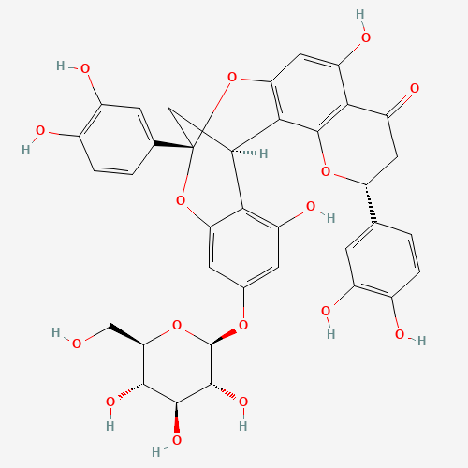 | Anti-inflammatory (Ogundaini et al., 1996)
 | Sarcophyte piriei | Rhizome | Diinsinin | C₃₆H₃₂O₁₅ | 704.6 | 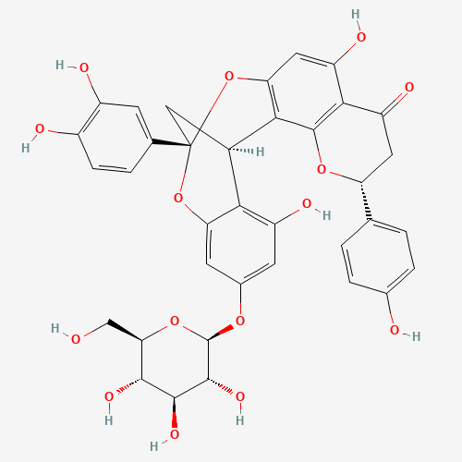 | Anti-inflammatory (Ogundaini et al., 1996)
 | Stellera chamaejasme | roots | Chamaejasmenin A | C₃₂H₂₆O₁₀ | 570.5 | 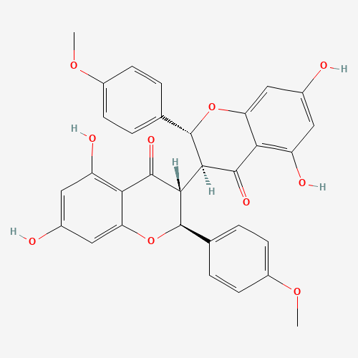 | antimitotic and antifungal activities (Yang et al., 2005).
 | Stellera chamaejasme L | roots | Chamaejasmenin B | C₃₂H₂₆O₁₀ | 570.5 | 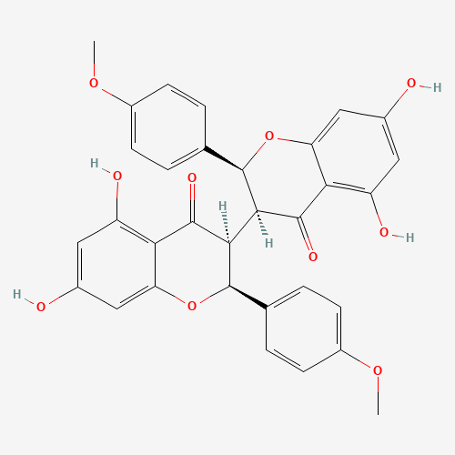 | Anti-cancer activity (Zhang et al., 2013)
 | Stellera chamaejasme L | roots | Neochamaejasmin C |  |  |  | Anti-cancer activity (Zhang et al., 2013)
 | Anacardium occidentale L. | Leaves | Agathisflavone | C₃₀H₁₈O₁₀ | 538.5 | 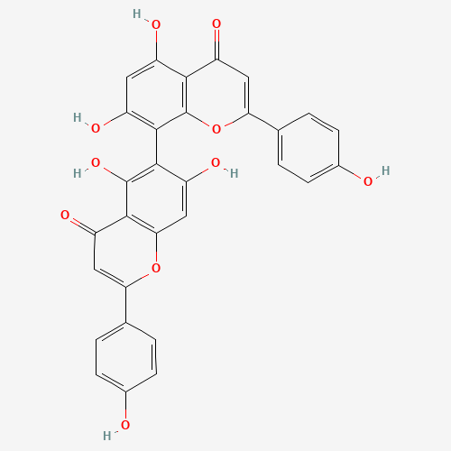 | Antibiotic (Ajileye et al., 2015)
 | Parapiptadenia rigida | Stem bark | (4α→8)-bis-4'-O-methylgallocatechin | C₃₂H₃₀O₁₄ | 638.5 |  | Astringent.  contracts the body tissues and commonly used to stop bleeding from minor abrasions (Schmidt et al., 2011).
 | Podocarpus macrophyllus var. macrophyllus | leaves | 2,3-dihydro-4',4'''-di-O-methylamentoflavone | C₃₂H₂₄O₁₀ | 568.5 | 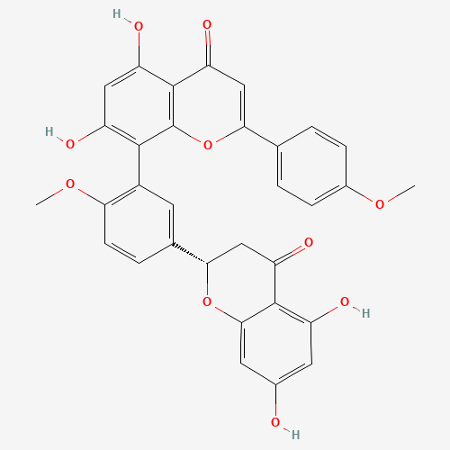 | anti-tyrosinase activity (Cheng et al., 2007)
 | Rheedia edulis | Rinds and seeds | (+)-volkensiflavone | C₃₀H₂₀O₁₀ | 540.5 | 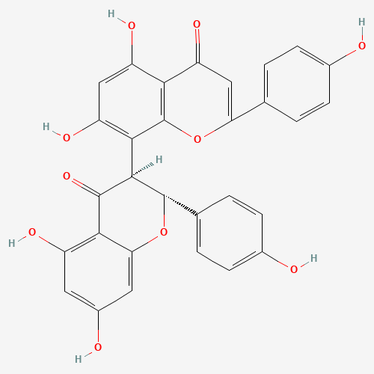 | antioxidant activity (Acuna et al., 2010)
 | Garcinia livingstonei | Fruit | (+)-morelloflavone | C₃₀H₂₀O₁₁ | 556.5 | 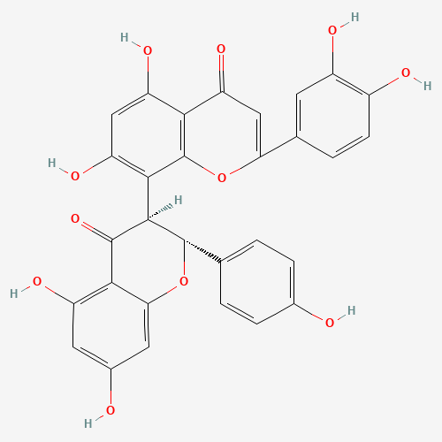 | Anticancer activity (Yang et al., 2010)
 | Selaginella tamariscina | aerial part | Hinokiflavone (H) and 7′-O-methyl hinokiflavone (mH) | C₃₀H₁₈O₁₀ | 538.5 | 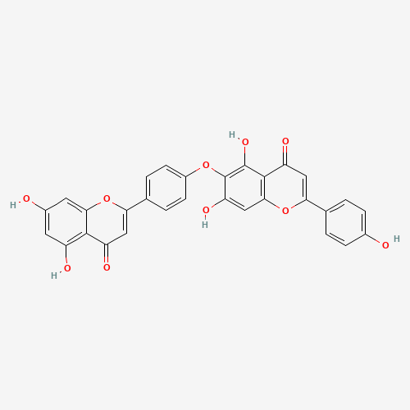 | Anti-Inflammatory activity (Shim et al., 2018)
 | Rhus natalensis | Root bark | Rhuschromone |  |  |  | Antimicrobial activity (Mwangi etal., 2013)
 | Garcinia macrophylla | stem bark | Macrophylloflavone |  |  |  | Antibacterial, Antioxidant, and Anti-Type 2 Diabetes Mellitus Activities (Cane etal., 2020)
 | Araucaria hunsteinii | Leaves | 4',7,7''-tri-O-methylcupressuflavone and  4''',7,7''-tri-O-methylagathisflavone |  |  |  | Anticancer and Antiviral activities (Agusta et al., 2022)
 | Cycas rumphii | Leaves | 4' , 4''' biapigenin di-C-glucoside |  |  |  | Toxoplasmocidal and Cytotoxic Activities (El-Seadawy et al., 2022)
 | Cycas beddomei | Cones | 2'',3''-dihydrohinokiflavone
 | Ochna kirkii | Root bark | Kirkinone B |  |  |  | Antibacterial and Cytotoxic activity (Kalenga et al., 2021)

Understanding the molecular mechanisms of these bioactive compounds is not only for academic pursuit but also has practical implications. For instance, bioactive compounds have significant potential in the pharmaceutical industry. By knowing exactly how these compounds work at a molecular level, scientists can design more effective and less toxic drugs. In agriculture, knowledge of these compounds can be used to develop plant varieties with improved resistance to pests or diseases. Furthermore, in the food industry, they can be utilized to prepare functional foods with health benefits beyond basic nutrition.
Molecular Mechanism of Action of Bioactive Compounds:
Bioactive active compounds are basically secondary metabolites including alkaloids, flavonoids, terpenoids, glycosides etc. that are derived from various plant parts. These compounds have effects on almost every organ system of the animal and human body by interacting with various endogenous biomolecules i.e., amino acids or nucleic acids present in the domains of the Receptors, ion channels and enzymes along with influences on cell signalling pathways, and also various cell cycle events. Also effective against some of infections like common malaria and cerebral malaria as well as possesses anti-inflammatory activity against various inflammatory conditions.
A. Effect of Bioactive Active Compounds on the Cardiovascular System:
Cardiac glycosides including Digoxin, Digitoxin, Ouabain, K- Strophanthidin and Thevetin A are the drugs that are derived from various plant sources that are being clinically used for the management of congestive heart failure.
S.No | Drug / Formulation | Botanical name of plant | Plant part | Family | Effective in Diseases/ Conditions
 | Digoxin (Lanoxin 0.25mg) | Digitalis lanata | Leaf | Plantaginaceae | congestive heart failure
 | Digitoxin | Digitalis purpurea | Leaf | Plantaginaceae | congestive heart failure
 | Ouabain (Ouabain 250mcg/ml) | Strophanthus gratus | Seed | Apocynaceae | congestive heart failure
 | K- Strophanthidin | Strophanthus kombe | Seed | Apocynaceae | congestive heart failure
 | Thevetin A | Cascabela thevetia | Seed | Apocynaceae | congestive heart failure

Mechanism of Action:
All these Cardiac glycosides act by effecting the action potential of cardiac cells through the inhibition of the membrane-bound Na⁺ /K⁺ –adenosine triphosphatase (Na⁺ /K⁺ -ATPase) pump essentially performs the sodium/potassium exchange in the cardiac muscles.
Normal Physiology of cardiac muscle contraction briefly involves with influx of Na⁺ ions form extra cellular fluid into cardiac cell further triggers the influx of Ca⁺² ions that further results in the contraction of cardiac muscle and further K ⁺ ions influx and simultaneous efflux of Na⁺ ions result in restoration of resting membrane potential and relaxation of the cardiac muscle. This particular simultaneous efflux of Na⁺ ions besides K ⁺ ions influx is carried out by the above-said Na⁺ /K⁺ –adenosine triphosphatase (Na⁺ /K⁺ -ATPase) pump located in the cell membrane of cardiac muscle tissue. So, when these Cardiac glycosides inhibit the Na+ /K+ -ATPase pump, K + ions influx will be inhibited, resulting in potentiation of Ca⁺² ions activity and cardiac muscle contractility, this is considered as positive ionotropy.
B. Effect of Bioactive Active Compounds on the Cell Cycle:
Some of the bioactive active compounds and their derivatives are already in clinical use for various types of cancers. All of these drugs act by interfering with cell division and cell cycle events.
i. Taxanes (paclitaxel and Docetaxel) are obtained from bark and leaves of Taxus brevifolia and Taxus buccata respectively.
Mechanism of action:
Taxanes bind with β-tubulin and form a complex which makes the microtubules resistant to depolymerization and prone for early onset of the elongation phase of polymerization. This further leads to the inhibition of disassembly in the microtubules. This microtubule disassembly is essential for formation of mitotic spindle. Hence, taxanes inhibits the spindle formation and mitosis phase (M phase) of cell division which is highly essential for chromosomal segregation to the daughter cells and lead to causes the cell death of the cancer cells.
ii. Vinca alkaloids (Vincristine, Vinblastine and Vinorelbine) are isolated from the plant Catharanthus roseus belongs to the family Apocynaceae.
Mechanism of action:
These vinca alkaloids bind to the interface of α-tubulin and β-tubulin in the tubular lumen of the microtubules and form the crosslinks and inhibits the further polymerization in the process of mitotic spindle formation and lead to causes the cell death of the cancer cells.
iii. Podophyllotoxin and Epipodophyllotoxins (Podophyllotoxin, Etoposide and Teniposide) are derivatives from the Roots and Rhizomes of the plant Podophyllum peltatum belongs to the family Berberidaceae.
Mechanism of action:
Podophyllotoxin and Epipodophyllotoxins binds to the DNA-independent sites of the DNA Topoisomerase II enzyme which is essential for reversible breakdown of phosphodiester bonds of DNA strands and causes double strand break for the DNA replication procedure during the cell division process. This results in the formation of Drug-Enzyme-DNA complex and results in the inhibition of Resealing of DNA strands, further causes the cell death of the cancer cells.
iv. Camptothecins (Camptothecin, Topotecan and Irinotecan) are derivatives from the bark and stem of Camptotheca accuminata belongs to the family Nyssaceae.
Mechanism of action:
Camptothecins acts through inhibition of the DNA Topoisomerase I enzyme which is essential for reversible breakdown of phosphodiester bonds of DNA strands and causes single strand break for the DNA replication procedure during the cell division process. This results in inhibition the DNA duplication and which ultimately leads to the loss of survival signals and results in cell death of the cancerous cells.
S.No | Drug / Formulation | Botanical name of plant | Plant part | Family | Effective in Diseases/ Conditions
 | Paclitaxel (Taxol injection) | Taxus brevifolia | Bark | Taxaceae | Advanced Ovarian cancer and non-small cell lung carcinomas.
 | Docetaxel Injection | Taxus buccata | Leaf | Taxaceae | Breast cancer, Prostate cancer.
 | Vincristine sulfate Injection | Catharanthus roseus | Entire plant | Apocynaceae | Acute leukemia, Hodgkin’s lymphoma and non- hodgkin’s lymphomas
 | Vinblastine sulfate Injection | Catharanthus roseus | Entire plant | Apocynaceae | Advanced testicular carcinoma, Kaposi’s sarcoma
 | Vinorelbine tartrate Injection | Catharanthus roseus | Entire plant | Apocynaceae | non-small cell lung carcinoma
 | Podophyllotoxin cream | Podophyllum peltatum | Roots and Rhizomes | Berberidaceae | HPV infections and genital warts
 | Etoposide Injection  (Semi-synthetic derivative of Podophyllotoxin) | Podophyllum peltatum | Roots and Rhizomes | Berberidaceae | small cell lung carcinoma, refractory testicular cancer
 | Teniposide Injection  (Semi-synthetic derivative of Podophyllotoxin) | Podophyllum peltatum | Roots and Rhizomes | Berberidaceae | Acute lymphoblastic leukemia in children
 | Camptothecin Injection | Camptotheca accuminata | Bark and stem | Nyssaceae | Leukemia and gastrointestinal cancers
 | Topotecan Hydrochloride Injection  (Semi-synthetic derivative of Camptothecin) | Camptotheca accuminata | Bark and stem | Nyssaceae | Second line drug for ovarian and small cell lung carcinoma
 | Irinotecan Hydrochloride Injection (Semi-synthetic derivative of Camptothecin) | Camptotheca accuminata | Bark and stem | Nyssaceae | Metastatic colorectal cancer, small cell and non-small cell lung carcinoma

B. Miscellaneous Bioactive compounds:
Many other bioactive compounds have wide varieties of clinical uses that have been delineated below along with the brief mechanism of action.
S.No | Drug / Formulation | Mechanism of Action | Botanical name of plant | Plant part | Family | Effective in Diseases/ Conditions
 | Quinine Sulphate (Q-TAB-300) | Binds to the porphyrin nucleus of Hemoglobin within parasite and forms complex that prevents the release of amino acids required for replication of the malarial parasite. | Cinchona officinalis | Stem bark & root | Rubiaceae | Multidrug resistant Malaria
 | Artemisinin tablets | Endoperoxide of the drug interfere with heme within parasite and further breaks down by Iron and releases free radicals that are toxic to parasite. | Artemisia annua | Bark | Asteraceae | Cerebral malaria
 | Theophylline, Etofylline | Phosphodiesterase inhibition and increases the cyclic AMP that lead to bronchial smooth muscle relaxation | Camellia sinensis | Leaves | Theaceae | Asthma, Chronic Obstructive Pulmonary Disease (COPD).
 | Theobromine | Phosphodiesterase inhibition and increases the cyclic AMP that lead to bronchial smooth muscle relaxation | Theobroma cacao | Seed and Husk | Malvaceae | Asthma, COPD
 | Caffeine | Phosphodiesterase inhibition and increases the cyclic AMP that lead to bronchial smooth muscle relaxation | Coffea arabica | Seeds | Rubiaceae | Asthma, COPD
 | Pilocarpine Hydrochloride | M₃ Receptor agonist | Pilocarpine jaborandi | Leaves | Rutaceae | Xerostomia, Glaucoma, Sjogren’s syndrome
 | Atropine sulphate | M₃ Receptor antagonist | Atropa belladonna | Leaves | Solanaceae | Anti-secretory in anesthesia and eye examnations
 | Ipratropium bromide, Tiotropium bromide (Semi-synthetic derivatives of Atropine) | M₃ Receptor antagonist | Atropa belladonna | Leaves | Solanaceae | Asthma, COPD
 | Yohimbine hydrochloride | α₂ Receptor antagonist | Pausinystalia yohimbe | Bark | Rubiaceae | Erectile dysfunction
 | Cocaine hydrochloride topical solution | Sodium channel blockade | Erythroxylum coca | Leaves | Erythroxylaceae | Topical Anesthesia
 | Codeine phosphate | µ Receptor agonist | Papaver somniferum | Seeds | Papaveraceae | Cough
 | Colchicine tablets | Inhibits the Microtubule assembly in the inflammatory cells and prevents chemotaxis and inflammation | Colchicum autumnale | Seed | Lilicaceae | Inflammation and pain in gout.
 | D-Tubocurarine Hydrochloride | N_{M} Receptor Blockade | Chondrodendron tomentosum | Root | Loganiaceae | Muscle relaxant in anesthesia
 | Reserpine tablet 0.1mg; injection 2.5mg/ml | Blockade of vesicular monoamine transporter (VMAT) results in inhibition of monoamine uptake. | Rauwolfia serpentina | Root | Apocyanaceae | Anti-hypertensive
 | Salicylic acid (from Salicin) ointment 12% w/w | Cyclooxygenase inhibition and prevents the synthesis of prostaglandins | Salix purpurea | Bark | Salicaceae | Anti-bacterial, anti-fungal and Anti-inflammatory
 | Khellin  (Semi synthetic derivatives: Cromolyn Sodium, Nedocromil) | Inhibits the mast cell degranulation and reduces release of Histamine | Ammi visnaga | Seeds and leaves | Apiaceae | Anti-histaminic and in Vitiligo
Pharmaceutical Perspective
Pharmaceutical advancement in the delivery of the bio-active compounds is the near future for these compounds that deliver them safe at the site of action or site of absorption into the human body with minimum or no toxicity. Purity of the bio-active compound and its potency, at the same time, determines the route of administration and the dose. The compounds having the low purity encourages its high dose to be delivered through more conventional ways of administration. On the other hand, the compounds having high purity and high potency reassures the modern and novel delivery ways with recently explored routes of administration. Hydrophilicity and lipophilicity of the bio-active compounds plays vibrant role in assortment of dosage forms and delivery systems.
Niosomes are stable lamellar constructions made up of admixture of cholesterol and non-ionic surfactants of alkyl and dialkyl polyglycerol ethers. Due to their non-ionic nature, they are less toxic. The characteristics of niosomes are controllable through surface charge, trapped volume and size and composition. Niosomes have been reported for its therapeutic potential as anti-infective targeting agents, carriers of anti-inflammatory agents and effective transdermal delivery. ²⁷
Dendrimers are well-thought-out nano architecture used to deliver variety of bioactive compounds. Protection of bioactive compounds, targeted delivery, controlled delivery are few noteworthy characteristics of dendrimers depends on the concentration, temperature, pH, size and terminal and core sections. The size varies from 2 to 10 nm depending on the generation. Resveratrol is administered for cardiovascular diseases, cancer, inflammation. It has low bioavailability due to quick metabolism and short half life of less than 15 min. Resveratrol, when conjugated with fourth generation poly (amidoamine) that is G4 PAMAM containing acetyl terminal groups dendrimer, proved 40 folds increase in solubility ²⁸.
Nanostructured lipid carriers (NLC) have higher loading capacity of bio-actives and afford more stability due to more firmly encapsulation of bio-actives. NLC is treated as alternative system to liposomes and O. santum ethanolic extract, after encapsulated as nanostructured lipid carriers highlighted the suitability of nanostructured lipid carriers for the delivery of rosmarinic acid.²⁹
Bio-actives of volatile nature are difficult to administer due to their volatility. However, this can be overcome by using mesoporous material for the delivery of such volatile compounds. In the case of entrapment of volatile oil obtained from Artemisia absinthium (wormwood). The plant has significant pharmacological activities such as anti-oxidant, hepatoprotective, anthelmintic and anti-inflammatory etc. It has been noted that high loading is possible of the volatile oil.³⁰
Sanguinarine is as an alkaloid derived from the roots of plants Sanguinaria canadensis and other poppy fumaria species. It has very low water solubility. Sanguinarine has anti-inflammatory, antioxidant and antimicrobial as well as antitumour property. To overcome the problem of solubility, there must be employable formulation strategies. Solid lipid nanoparticles essentially consist of matrix of solid lipids dispersed in aqueous surfactant solution. The particle size can have range from 1 nanometre m to 1 micrometre. Being a colloidal in size, solid lipid nanoparticles enjoy all advantages of colloidal systems. Pharmacokinetic study verified the potential of solid lipid nanoparticles for the delivery of Sanguinarine. The blood levels in Kunming mice increased significantly compared to the pure Sanguinarine and demonstrated significant inti-inflammatory effects³¹.
The solubility of ellagic acid is improved by using a supersaturatable self-micro emulsifying drug delivery system. Ellagic acid is phenolic compound. It has hepatoprotective, antitumour and anti-oxidant properties. It degrades easily in physiological environment. self-micro emulsifying drug delivery system is essentially consisting of oil, surfactant and co-surfactant. Supersaturatable self-micro emulsifying drug delivery system could improve drug loading compared to self-micro emulsifying drug delivery system. Supersaturatable self-micro emulsifying drug delivery system can protect drug degradation by metabolic enzymes and bio-active can cross epithelial membrane of gastro intestinal tract. In-vitro and in-vivo anti-oxidant ability of ellagic acid is proved significant compared to pure ellagic acid. Supersaturatable self-micro emulsifying drug delivery system is best delivery option for ellagic acid. ³²
Novel delivery system for ellagic acid has been designed through layer-by-layer electrostatic deposition of biopolymers onto soyabean lecithin liposomes. Biopolymers can form polyelectrolyte complexes with oppositely charged molecules by intermolecular electrostatic interaction. Layer by Layer self-assembly of chitosan coated liposomes has been identified as potential delivery choice for ellagic acid. So, chitosan coated liposomes, in this case, manifested increased loading of ellagic acid and further its sustained release.³³
Nobiletin is a flavonoid. It has anticancer property. However, it has poor water solubility and thereby limited bioavailability. Chemically bonded chitosan nanoparticles were generated by using formation of bond between chitosan amine groups and carbonyl group of nobiletin. Nobiletin loaded chitosan nanoparticles exhibited improved anti-proliferative activity compared to pure Nobiletin.³⁴
Liposomes provide opportunity to deliver hydrophilic and lipophilic active compounds due to their structure. Lipophilic compounds encapsulate into lipid bilayer and hydrophilic compounds encapsulate in aqueous portion. Bio-compatibility of liposomes is aggressively remarkable due to the natural component of the cell wall. The particle size of liposome vesicles varies usually from 10 nm to few micrometers. Topical as well as systemic administration of liposomes is possible owing to their biocompatibility. Additionally, liposomes are nontoxic and non-immunogenic. Lycopene is hepatoprotective, hypolipidemic, antioxidant etc. The stability of lycopene and its pharmacological activity is improved after preparing lycopene- cyclodextrin complexes and delivering through liposomes.³⁵.
Ethosomes are proved to reduce leakage, enhanced permeation and enhance retention in hyaluronic acid linked to curcumin loaded propylene glycol based ethosomes for psoriasis treatment. Ethosomes are lipid vesicles made up of phospholipids, water and ethanol³⁶.
Phytosome is novel and emerging delivery system for bioactive compounds in which herbal extracts or components thereof are surrounded by lipid in the structure of phytosome where one molecule of phytoconstituent is usually linked with at least one molecule of the lipid. Being a vesicular system having a size of 50 nm to few hundred nanometers; phytosome is supposed to use not only in oral but in the topical routes also. The delivery of the bioactive compounds in the treatment of cancer highly striking. The molar ratio (1:2) of curcumin-phospholipid complex has shown 60% greater permeability through the rat skin compared to the curcumin alone.³⁷
Nano-emulsions have great potential in enhancing solubility profile, chemical stability and pharmacological activity of many phytoconstituents. Nano-emulsions are reported to improve bioavailability of quercetin, catechins, curcumin, berberine and lycopene ³⁸.
Palmatine is a quaternary alkaloid obtained from Jateorhiza palmata of family Menispermaceae. Palmatine chloride is hygroscopic. Increased hygroscopicity leads to agglomeration of compounds which further leads to poor handling and poor dispersion. Co-crystals of palmatine chloride with gallic acid has been reported for significant higher stability against hygroscopicity and further good storage ³⁹.
The futuristic approach for the drug delivery of the phytochemicals could be in nanostructure form using different forms of nanoparticles like nanocarrier, dendrimers, nanocrystalline solid dispersion, nanocrystals, phytosomes, liposomes and self-emulsifying drug delivery system.
References
- Kaur, R.; Arora, S. Alkaloids—Important Therapeutic Secondary Metabolites of Plant Origin. J. Crit. Rev. 2015, 2, 1–8
- Kurek, J. Introductory Chapter: Alkaloids—Their Importance in Nature and for Human Life. In Alkaloids—Their Importance in Nature and Human Life; IntechOpen: London, UK, 2019
- Atanasov, A.G.; Zotchev, S.B.; Dirsch, V.M.; Supuran, C.T. Natural products in drug discovery: Advances and opportunities. Nat. Rev. Drug Discov. 2021, 28, 1–17.
- Chaves SK, Feitosa CM, da S Araújo L. Alkaloids Pharmacological Activities - Prospects for the Development of Phytopharmaceuticals for Neurodegenerative Diseases. Curr Pharm Biotechnol. 2016;17(7):629-35. doi: 10.2174/138920101707160503201541. PMID: 26718919.
- Tabares-Guevara JH, Lara-Guzmán OJ, Londoño-Londoño JA, Sierra JA, León-Varela YM, Álvarez-Quintero RM, Osorio EJ and Ramirez-Pineda JR (2017) Natural Biflavonoids Modulate Macrophage–Oxidized LDL Interaction In Vitro and Promote Atheroprotection In Vivo. Front. Immunol. 8:923.
- Gontijo VS, Dos Santos MH, Viegas C Jr. Biological and Chemical Aspects of Natural Biflavonoids from Plants: A Brief Review. Mini Rev Med Chem.2017;17(10):834-862. doi: 10.2174/1389557517666161104130026. PMID: 27823559.
- Yugandhar, P., Kumar, K.K., Neeraja, P. and Savithramma, N., 2017. Isolation, characterization and in silico docking studies of synergistic estrogen receptor α anticancer polyphenols from Syzygium alternifolium (Wt.) Walp. Journal of Intercultural Ethnopharmacology, 6(3): 296-310.
- Samec, D., Karalija, E., Dahija, S. and Hassan, S.T., 2022. Biflavonoids: Important contributions to the health benefits of Ginkgo (Ginkgo biloba L.). Plants, 11 (1381):1-20.
- Ajileye, O.O., Obuotor, E.M., Akinkunmi, E.O. and Aderogba, M.A., 2015. Isolation and characterization of antioxidant and antimicrobial compounds from Anacardium occidentale L.(Anacardiaceae) leaf extract. Journal of King Saud University-Science, 27(3), pp.244-252.
- Yang, G., Liao, Z., Xu, Z., Zhang, H. and Chen, D., 2005. Antimitotic and antifungal C-3/C-3 ″-biflavanones from Stellera chamaejasme. Chemical and pharmaceutical bulletin, 53(7), pp.776-779.
- Zhang, C., Zhou, S.S., Feng, L.Y., Zhang, D.Y., Lin, N.M., Zhang, L.H., Pan, J.P., Wang, J.B. and Li, J., 2013. In vitro anti-cancer activity of chamaejasmenin B and neochamaejasmin C isolated from the root of Stellera chamaejasme L. Acta Pharmacologica Sinica, 34(2), pp.262-270.
- Ogundaini, A., Farah, M., Perera, P., Samuelsson, G. and Bohlin, L., 1996. Isolation of two new antiinflammatory biflavanoids from Sarcophyte piriei. Journal of natural products, 59(6), pp.587-590.
- Schmidt CA, Murillo R, Heinzmann B, Laufer S, Wray V, Merfort I (2011)
Structural and conformational analysis of proanthocyanidins from Parapiptadenia rigida and their wound-healing properties. Journal of natural products 74, 1427-1436.
- Cheng, K.T., Hsu, F.L., Chen, S.H., Hsieh, P.K., Huang, H.S., Lee, C.K. and Lee, M.H., 2007. New constituent from Podocarpus macrophyllus var. macrophyllus shows anti-tyrosinase effect and regulates tyrosinase-related proteins and mRNA in human epidermal melanocytes. Chemical and pharmaceutical bulletin, 55(5), pp.757-761.
- Acuna, U.M., Figueroa, M., Kavalier, A., Jancovski, N., Basile, M.J. and Kennelly, E.J., 2010. Benzophenones and biflavonoids from Rheedia edulis. Journal of natural products, 73(11), pp.1775-1779.
- Yang, H., Figueroa, M., To, S., Baggett, S., Jiang, B., Basile, M.J., Weinstein, I.B. and Kennelly, E.J., 2010. Benzophenones and biflavonoids from Garcinia livingstonei fruits. Journal of agricultural and food chemistry, 58(8), pp.4749-4755.
- Shim, S.Y., Lee, S.G. and Lee, M., 2018. Biflavonoids isolated from Selaginella tamariscina and their anti-inflammatory activities via ERK 1/2 signaling. Molecules, 23(4), p.926.
- Mwangi, H.M., Mabusela, W.T., Abegaz, B.M. and Martin, O.O., 2013. Antimicrobial activities of a novel biflavonoid and other constituents from Rhus natalensis.
- Cane, H.P.C.A., Saidi, N., Yahya, M., Darusman, D., Erlidawati, E., Safrida, S. and Musman, M., 2020. Macrophylloflavone: a new biflavonoid from Garcinia macrophylla mart.(Clusiaceae) for antibacterial, antioxidant, and anti-type 2 diabetes mellitus activities. The Scientific World Journal, 2020.
- Agusta, D.D., Dianhar, H., Rahayu, D.U.C., Suparto, I.H. and Sugita, P., 2022. Anticancer and Antivirus Activities of two Biflavonoids from Indonesian Araucaria hunsteinii K Schum Leaves. Journal of Hunan University Natural Sciences, 49(3).
- El-Seadawy, H.M., Abo El-Seoud, K.A., El-Aasr, M., Tawfik, H.O. and Ragab, A.E., 2022. Toxoplasmocidal and Cytotoxic Activities Guided Isolation and Characterization of an Undescribed Bioflavonoid-di-C-glucoside from Cycas rumphii Miq. Cultivated in Egypt. Plants, 11(21), p.2867.
- Kalenga, T.M., Ndoile, M.M., Atilaw, Y., Munissi, J.J., Gilissen, P.J., Rudenko, A., Bourgard, C., Sunnerhagen, P., Nyandoro, S.S. and Erdelyi, M., 2021. Antibacterial and cytotoxic biflavonoids from the root bark of Ochna kirkii. Fitoterapia, 151, p.104857.
- Evans WC. Trease and Evans' pharmacognosy. Elsevier Health Sciences; 2009 May 27.
- Foye WO. Foye's principles of medicinal chemistry. Lippincott williams & wilkins; 2008.
- Katzung BG. Basic and clinical pharmacology. 2012.
- Alberts B. Molecular biology of the cell. Garland science; 2017 Aug 7.
- Aqil, Farrukh, et al. “Bioavailability of Phytochemicals and Its Enhancement by Drug Delivery Systems.” Cancer Letters, vol. 334, no. 1, June 2013, pp. 133–141, https://doi.org/10.1016/j.canlet.2013.02.032. Accessed 20 Apr. 2020.
- Yousefi, Mohammad, et al. “Dendrimers as Efficient Nanocarriers for the Protection and Delivery of Bioactive Phytochemicals.” Advances in Colloid and Interface Science, vol. 278, 1 Apr. 2020, p. 102125.
- Chaiyana, Wantida, et al. “Dermal Delivery Enhancement of Natural Anti-Ageing Compounds from Ocimum Sanctum Linn. Extract by Nanostructured Lipid Carriers.” Pharmaceutics, vol. 12, no. 4, 29 Mar. 2020.
- Purcareanu Bogdan et al., “Optimization of the Loading Process of Artemisia absinthium Volatile Oil in a Mesoporous Material as Drug Delivery System.” Biointerface research in Applied Chemistry vol. 12, no 2, 2022, pp. 450-464.
- Liu, Weifeng, et al. “Pharmacokinetic and Anti-Inflammatory Effects of Sanguinarine Solid Lipid Nanoparticles.” Inflammation, vol. 37, no. 2, 24 Nov. 2013, pp. 632–638,
- Zheng, Dandan, et al. “Preparation of a Supersaturatable Self-Microemulsion as Drug Delivery System for Ellagic Acid and Evaluation of Its Antioxidant Activities.” Journal of Drug Delivery Science and Technology, vol. 53, 1 Oct. 2019, pp. 101209–101209.
- Madrigal-Carballo, Sergio, et al. “Biopolymer Coating of Soybean Lecithin Liposomes via Layer-By-Layer Self-Assembly as Novel Delivery System for Ellagic Acid.” Journal of Functional Foods, vol. 2, no. 2, Apr. 2010, pp. 99–106.
- Jeetah, Roubeena, et al. “Nanopharmaceutics: Phytochemical-Based Controlled or Sustained Drug-Delivery Systems for Cancer Treatment.” Journal of Biomedical Nanotechnology, vol. 10, no. 9, 1 Sept. 2014, pp. 1810–1840.
- Merve Karpuz, et al. “Liposomes and Phytosomes for Phytoconstituents.” Advances in the Development of Novel Carriers for Bioactives and Biological Agents, 1 Jan. 2020, pp. 525–553.DOI: https://doi.org/10.1016/B978-0-12-819666-3.00018-3
- Khan, Ayesha, et al. “Phytoconstituents Based Nanomedicines for the Management of Psoriasis.” Journal of Drug Delivery Science and Technology, vol. 64, Aug. 2021, p. 102663.
- Bhangale Bhagyashree Dilip, Harshal Ashok Pawar. “Phytosome as a Novel Biomedicine: A Microencapsulated Drug Delivery System.” Journal of Bioanalysis & Biomedicine, vol. 07, no. 01, 2015, pp. 6-12.
- Xue, Feng, et al. “Anti-Aging Properties of Phytoconstituents and Phyto-Nanoemulsions and Their Application in Managing Aging-Related Diseases.” Advanced Drug Delivery Reviews, vol. 176, Sept. 2021, p. 113886.
- Zhang, Yunan, et al. “Improving Hygroscopic Stability of Palmatine Chloride by Forming a Pharmaceutical Salt Cocrystal of Palmatine Chloride-Gallic Acid with Neutral Molecule.” Journal of Drug Delivery Science and Technology, vol. 66, 1 Dec. 2021, pp. 102839–102839.

