“Futuristic Trends in IOT”
Anand Kumar Mishra¹, C.S.Raghuvanshi^{2,}
¹Assistant Professor, Rama University, Uttar Pradesh, Kanpur, India
mishra.anand13@gmail.com
²Professor, Rama University, Uttar Pradesh, Kanpur, India
drcsraghuvanshi@gmail.com
Abstract:
The Internet of Things (IoT) is on an exciting trajectory towards a future marked by unprecedented innovation and connectivity. In this ever-evolving landscape, several futuristic trends are poised to redefine how we perceive and utilize IoT. These trends encompass the integration of 5G networks to supercharge IoT applications, the proliferation of edge computing for real-time intelligence, the infusion of artificial intelligence into everyday objects, and the deployment of blockchain to fortify IoT security. Sustainable IoT solutions are set to tackle environmental challenges, while healthcare is undergoing a revolution through remote patient monitoring and telemedicine. Smart cities are becoming smarter, and human-machine interaction is reaching new heights. Quantum computing is on the horizon, and ethical considerations are gaining prominence. This abstract provides a snapshot of the thrilling IoT developments that will shape our digital future. The intersection of IoT with augmented reality (AR) and virtual reality (VR) is creating immersive, data-rich experiences that will revolutionize industries like gaming, education, and remote collaboration.
These futuristic trends in IoT are not merely speculative; they are actively shaping the trajectory of technology and industry, promising a future where connectivity, intelligence, and sustainability converge to redefine how we interact with our digital and physical worlds.
Keywords:
AI and Machine Learning in IoT, Edge Computing, 5G Integration, Quantum-Resistant Encryption, Digital Transformation, Blockchain for IoT Security, Sustainable IoT
- Introduction to IoT and its Evolution
  - The Birth of IoT
  - Evolution and Growth of IoT
  - The Current State of IoT
- IoT Connectivity Technologies
  - Wireless Communication Protocols
  - Cellular Networks and IoT
  - Satellite Communication for IoT
  - LPWAN (Low-Power Wide-Area Network) Technologies
  - 5G and IoT
- Edge Computing in IoT
  - What is Edge Computing?
  - Edge Devices and Sensors
  - Edge Computing vs. Cloud Computing
  - Edge Computing Applications in IoT
  - Challenges and Considerations
- AI and Machine Learning in IoT
  - The Role of AI in IoT
  - Machine Learning Algorithms for IoT
  - IoT Data Analytics
  - Predictive Maintenance in IoT
  - AI-Driven IoT Use Cases
- IoT Security and Privacy
  - Security Challenges in IoT
  - Authentication and Authorization
  - Data Encryption in IoT
  - Privacy Concerns and Compliance
  - IoT Security Best Practices
- IoT in Healthcare
  - IoT Applications in Healthcare
  - Remote Patient Monitoring
  - Healthcare Data Management
  - Telemedicine and IoT
  - Ethical and Regulatory Considerations
- Smart Cities and IoT
  - Smart City Concepts and Goals
  - IoT's Role in Smart Cities
  - Urban Infrastructure and IoT
  - Sustainability and IoT
  - Case Studies of Smart Cities
- IoT in Agriculture
  - Precision Agriculture and IoT
  - IoT Sensors in Farming
  - Crop Monitoring and Management
  - IoT in Livestock Farming
  - Future Trends in AgTech
- IoT and Industry 4.0
  - Industry 4.0 Overview
  - IoT and Industrial Automation
  - IoT in Supply Chain Management
  - Predictive Maintenance in Manufacturing
  - Challenges and Opportunities
- Environmental Monitoring with IoT
10.1 IoT for Environmental Conservation
10.2 Air Quality Monitoring
10.3 Water Quality and IoT
10.4 Wildlife Conservation and IoT
  - Climate Change Mitigation
- Future Trends and Emerging Technologies
11.1 The Future of IoT
  - Quantum Computing and IoT
  - Blockchain and IoT
  - Human-Machine Integration
  - Ethical and Societal Implications

References:

- Introduction to IoT and its Evolution

  - The Birth of IoT
The birth of the Internet of Things, often abbreviated as IoT, marks a pivotal moment in the history of technology. It can be traced back to the convergence of various fields, including telecommunications, computing, and sensor technology. In the late 20th century, as computing power grew exponentially and communication networks expanded, the concept of connecting everyday objects and devices to the internet began to take shape. The term "Internet of Things" was coined to describe this visionary idea. It envisioned a world where not only computers and smartphones were connected but also an extensive array of physical objects and sensors, ranging from household appliances to industrial machinery, all seamlessly communicating and sharing data over the internet. The birth of IoT heralded a new era of connectivity, automation, and data-driven insights, revolutionizing industries, improving efficiency, and enhancing the way we interact with the world around us.
1.2 Evolution and Growth of IoT
The evolution and growth of the Internet of Things (IoT) represent a remarkable journey from its humble beginnings to its current status as a transformative force in our connected world. This evolution can be understood in several key phases:
1.2.1 Emergence of M2M Communication: Before the term IoT gained popularity, Machine-to-Machine (M2M) communication laid the foundation for connecting devices. Initially, M2M was primarily used in industrial settings for remote monitoring and control. Early applications included telemetry systems, asset tracking, and smart metering.
1.2.2 Advances in Connectivity:IoT's growth was significantly enabled by advancements in connectivity technologies. The development of low-power wireless communication protocols, such as Zigbee, Bluetooth Low Energy (BLE), and LoRa, made it feasible to connect a wide range of devices while minimizing energy consumption.
1.2.3 Proliferation of Sensors: The miniaturization and cost reduction of sensors played a crucial role in expanding IoT's reach. Sensors became smaller, more affordable, and capable of measuring a wide range of variables, from temperature and humidity to motion and environmental data.
1.2.4 Security and Privacy Challenges: As IoT expanded, so did concerns about security and privacy. High-profile breaches and vulnerabilities highlighted the need for robust security measures and better data protection practices.
1.2.5 Edge Computing: To address latency and bandwidth constraints, edge computing emerged as a key IoT trend. Edge devices and gateways process data locally, reducing the reliance on centralized cloud servers and enabling real-time decision-making.
1.2.6 Future Possibilities: Looking ahead, IoT continues to evolve with the integration of emerging technologies like 5G, artificial intelligence (AI), and blockchain. These advancements open up new possibilities for IoT applications, including autonomous vehicles, smart infrastructure, and immersive augmented reality experiences.
the evolution and growth of IoT have been driven by technological advancements, the expansion of connectivity options, and the innovative applications across various domains. As IoT continues to evolve, it promises to shape our future in ways we can only begin to imagine.
1.3 The Current State of IoT
The current state of the Internet of Things (IoT) is a testament to its rapid and widespread adoption across a multitude of industries and everyday life. As of my last knowledge update in September 2021, IoT has matured significantly, and its presence continues to expand. Billions of devices are now connected worldwide, from smart home gadgets like thermostats and voice assistants to industrial machinery, healthcare devices, and city infrastructure.
In the consumer realm, smart homes have become increasingly popular, with IoT-enabled devices offering convenience, energy efficiency, and enhanced security. Meanwhile, in agriculture, precision farming using IoT sensors has helped optimize crop yields and reduce resource consumption. In healthcare, remote patient monitoring and wearable health devices have improved patient care and outcomes, especially during the COVID-19 pandemic. Moreover, IoT is playing a pivotal role in the development of smart cities, transforming urban planning, transportation, and energy management.
Looking forward, the current state of IoT is marked by ongoing innovation and an expanding ecosystem. As the technology landscape evolves with the integration of 5G connectivity, edge computing, and artificial intelligence, IoT is poised to further transform industries, enhance daily life, and drive solutions to some of the world's most pressing challenges.
- IoT Connectivity Technologies
  - Wireless Communication Protocols
Wireless communication protocols are the lifeblood of the Internet of Things (IoT), enabling devices to connect, communicate, and share data wirelessly. These protocols are the invisible bridges that link a diverse range of IoT devices, from sensors and actuators to smartphones and industrial machinery. The choice of wireless communication protocol is pivotal in determining the efficiency, range, and power consumption of IoT devices.
LoRaWAN and Sigfox, on the other hand, specialize in long-range, low-power IoT communication for applications like smart cities and environmental monitoring. Additionally, Narrowband-IoT (NB-IoT) has gained prominence for its energy efficiency and suitability for massive-scale IoT deployments, particularly in utilities and asset tracking.
The world of wireless communication protocols is dynamic, with ongoing developments and new entrants seeking to address the evolving needs of IoT. As IoT continues to proliferate and diversify, selecting the right wireless protocol is a crucial decision for ensuring optimal performance, reliability, and scalability in IoT ecosystems.
  - Cellular Networks and IoT
Cellular networks play a pivotal role in powering the Internet of Things (IoT) by providing reliable, wide-area connectivity to a vast array of IoT devices. These networks, including 4G LTE and the emerging 5G technology, offer several key advantages for IoT applications. Their extensive coverage enables IoT devices to stay connected across large geographic areas, making them well-suited for use cases like asset tracking, connected vehicles, and agricultural monitoring.Cellular networks provide robust security measures, including data encryption and authentication, ensuring the integrity and confidentiality of IoT data.
  - Satellite Communication for IoT
Satellite communication is emerging as a powerful enabler for the Internet of Things (IoT), offering connectivity solutions that transcend geographic boundaries and challenging terrains. With IoT devices becoming increasingly prevalent across industries such as agriculture, transportation, and environmental monitoring, satellite communication plays a vital role in ensuring ubiquitous connectivity.One of the primary advantages of satellite communication for IoT is its global coverage. Satellites can reach remote and isolated areas, making them ideal for applications like tracking shipping containers at sea, monitoring sensors in remote agricultural fields, or connecting sensors in rugged terrains where terrestrial networks are impractical. This global reach allows IoT data to be collected from virtually anywhere on Earth.
In conclusion, satellite communication is a pivotal component of the IoT landscape, bridging connectivity gaps in remote and challenging environments while ensuring resilience and global reach. As technology continues to advance, satellite IoT is poised to play an increasingly vital role in connecting the ever-expanding network of IoT devices worldwide.
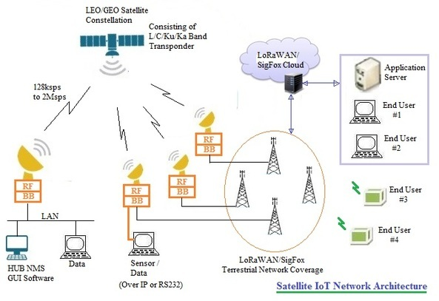

  - LPWAN (Low-Power Wide-Area Network) Technologies
Low-Power Wide-Area Network (LPWAN) technologies have emerged as a game-changing solution within the Internet of Things (IoT) ecosystem. LPWANs are specifically designed to address the unique requirements of IoT devices, offering a compelling combination of long-range connectivity, minimal power consumption, and cost-effectiveness.
One of the standout features of LPWAN technologies is their ability to transmit data over extended distances, often spanning several kilometers or more. This extended range is achieved without the need for high-power consumption, making LPWANs ideal for IoT applications that involve remote monitoring, asset tracking, or smart agriculture, where devices need to communicate over vast areas while conserving battery life.
Notable: LPWAN technologies include LoRaWAN (Long Range Wide Area Network), Sigfox, and NB-IoT (Narrowband-IoT). Each of these LPWAN options has its strengths and may be better suited to particular IoT use cases and deployment scenarios.
here are key points about Low-Power Wide-Area Network (LPWAN) technologies:
    - Long-Range Connectivity: LPWAN technologies excel in providing long-range connectivity, enabling IoT devices to communicate over distances of several kilometers or more. This extended range is ideal for applications that require data transmission over vast geographic areas, such as precision agriculture or environmental monitoring.
    - Low Power Consumption: LPWAN technologies are designed with a focus on low power consumption. IoT devices using LPWAN can operate on battery power for an extended period, often several years, before needing replacement or recharging. This energy efficiency is crucial for remote and battery-powered applications.
    - Cost-Effective: LPWAN technologies offer cost-effective solutions for IoT connectivity. Their simplicity and efficiency in terms of both hardware and infrastructure make them accessible for large-scale IoT deployments, reducing the overall cost of IoT implementation.
    - Diverse LPWAN Options: Several LPWAN technologies are available, including LoRaWAN, Sigfox, and NB-IoT, among others. Each technology has its unique characteristics, such as data rates, range, and deployment costs. The choice of LPWAN technology depends on the specific requirements of the IoT application.
    - Scalability: LPWAN networks are highly scalable, allowing organizations to add a large number of IoT devices to the network without significant infrastructure expansion. This scalability is essential as IoT deployments grow over time.
    - Use Cases: LPWAN technologies are well-suited for a wide range of IoT applications, including smart agriculture, asset tracking, smart cities, environmental monitoring, and industrial automation. Their versatility makes them adaptable to various industries and use cases.
    - Spectrum and Regulation: LPWAN technologies typically operate in unlicensed or licensed spectrum bands, depending on the specific technology and region. Regulatory considerations play a role in choosing the right LPWAN technology for a given application.
    - Interoperability: Interoperability among different LPWAN technologies can be a challenge. It's essential to select the technology that aligns with the existing infrastructure and ecosystem or ensures compatibility when integrating multiple LPWAN solutions.
LPWAN technologies offer a compelling combination of long-range connectivity, low power consumption, and cost-effectiveness, making them a critical enabler for IoT deployments across various industries and use cases. The choice of LPWAN technology should align with the specific requirements and objectives of the IoT applications

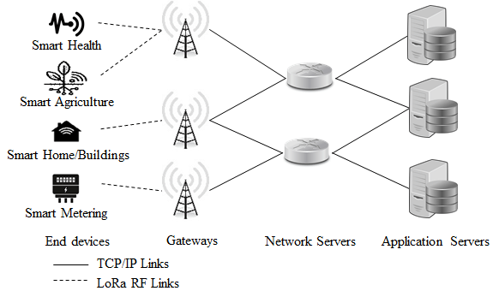

  - 5G and IoT
The convergence of 5G and the Internet of Things (IoT) has ushered in a new era of connectivity and innovation. As the world becomes increasingly connected, the synergy between 5G and IoT is reshaping industries, enhancing user experiences, and fueling a wave of transformative applications. This article explores how the marriage of 5G and IoT is revolutionizing connectivity, enabling unprecedented capabilities, and redefining the future.5G, the fifth generation of wireless technology, brings with it remarkable improvements in speed, capacity, and latency. It offers data rates up to 100 times faster than 4G LTE and significantly reduced latency, which is crucial for real-time applications. This leap in network performance is a game-changer for IoT, enabling high-bandwidth, low-latency communication between IoT devices and the cloud.One of 5G's most significant contributions to IoT is its ability to support massive device connectivity. While 4G struggled to efficiently manage the influx of IoT devices, 5G is designed to connect millions of devices simultaneously.
5G's low latency and high bandwidth make edge computing a reality. IoT devices can now process data locally at the network edge, reducing the need to send every data point to a central cloud server. This empowers IoT applications with real-time analytics, enabling faster decision-making, reduced data transmission costs, and improved privacy.The combination of 5G and IoT is propelling advancements in autonomous transportation. Vehicles equipped with IoT sensors and 5G connectivity can communicate with infrastructure and other vehicles in real time, enhancing safety, traffic management, and fuel efficiency. This data is transmitted to central hubs for analysis and action, leading to more efficient urban planning, reduced energy consumption, and improved quality of life for residents.
3. Edge Computing in IoT
3.1 What is Edge Computing?
Edge computing is a decentralized computing paradigm that brings data processing closer to the source of data generation, whether it's a sensor, a device, or a user. Unlike traditional cloud computing, where data is sent to remote data centers for processing, edge computing enables data to be analyzed and acted upon locally, at or near its point of origin. This approach reduces latency, the time it takes for data to travel to a distant server and back, leading to faster and more responsive applications. Edge computing is driven by the need for real-time data processing and decision-making, making it essential for applications such as autonomous vehicles, industrial automation, and IoT devices. By processing data at the edge, these applications can make split-second decisions without relying on a centralized data center, which may introduce unacceptable delays.
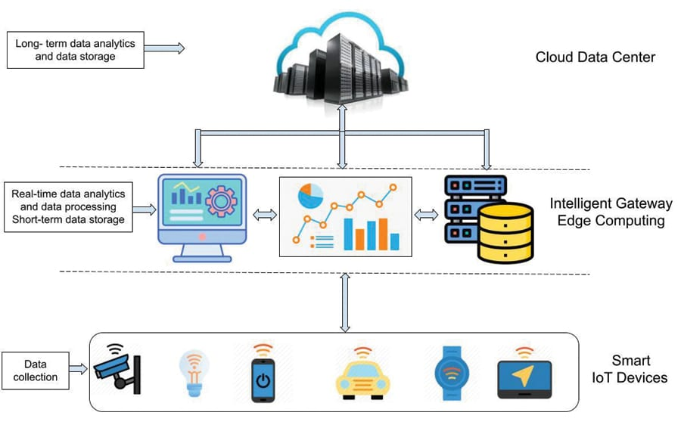

3.2 Edge Devices and Sensors
Edge devices and sensors are the unsung heroes of the Internet of Things (IoT), serving as the frontline data gatherers in the digital revolution. These compact, often unobtrusive devices are equipped with a myriad of sensors capable of collecting an array of data, ranging from temperature and humidity to motion, light, and even environmental variables. They are strategically positioned at the "edge" of networks, where data is generated, to capture real-time information from the physical world.Edge devices and sensors play a pivotal role in numerous IoT applications, including smart homes, industrial automation, agriculture, healthcare, and more. These devices represent the first step in the data journey, acting as data collection points that feed information to the cloud or local edge computing infrastructure for processing and analysis. As technology continues to evolve, edge devices and sensors will become even more sophisticated, enabling a future where our physical world is intricately connected and responsive to our needs. Their importance in the IoT ecosystem cannot be overstated, as they serve as the eyes and ears of a data-driven world.
3.3 Edge Computing vs. Cloud Computing
Edge Computing and Cloud Computing are two distinct paradigms in the field of computing, each with its own set of characteristics, advantages, and use cases. Here's a comparison table highlighting the key differences between Edge Computing and Cloud Computing:
Aspect | Edge Computing | Cloud Computing
Location | Computing resources are closer to the data source or "edge" of the network, typically at or near the device generating data. | Computing resources are centralized in remote data centers, often located far away from the end-users or data sources.
Latency | Low latency, as data processing occurs near the source, reducing the time it takes for data to travel to a remote server and back. | Higher latency due to data having to travel over the internet to remote servers and back.
Bandwidth | Reduced bandwidth requirements, as only relevant data is transmitted to the cloud, minimizing network congestion. | Higher bandwidth usage as data must be transmitted to and from the centralized cloud servers.
Reliability | Resilience in case of network failures since edge devices can continue processing data locally even when disconnected from the cloud. | Dependency on network connectivity, which can lead to service disruptions in case of network outages.
Scalability | Limited scalability compared to the cloud since edge devices have finite processing capacity. | Highly scalable, with the ability to provision resources on-demand to meet varying workloads.
Security | Enhanced security for sensitive data as it remains closer to the source and is less exposed to potential breaches during transit to the cloud. | Security measures are primarily implemented in the cloud data centers, making data potentially more vulnerable during transit.
Use Cases | Ideal for applications requiring real-time processing, such as IoT, autonomous vehicles, and industrial automation. | Well-suited for applications that can tolerate some latency, require massive storage, or need extensive computational power, like web services, big data analytics, and machine learning.
Cost | Lower bandwidth costs, as less data needs to be transmitted over the internet. However, costs may increase for deploying and maintaining edge devices. | Potentially higher operational costs, especially for large-scale applications, due to ongoing cloud service fees.
Management Complexity | Management and maintenance of edge devices can be complex, particularly in distributed deployments with a large number of devices. | Cloud providers handle much of the infrastructure management, reducing the complexity for users.
Data Privacy | Provides more control over data privacy, as data can be processed locally without leaving the edge device. | Cloud providers may have data access policies and data storage locations that impact data privacy and compliance.

It's important to note that Edge Computing and Cloud Computing are not mutually exclusive, and they can complement each other in various scenarios, forming a hybrid approach that leverages the strengths of both paradigms. The choice between the two depends on the specific requirements of a given application or use case.
3.4 Edge Computing Applications in IoT
Edge computing plays a pivotal role in Internet of Things (IoT) applications by enabling real-time data processing and decision-making at or near the data source. This technology is instrumental in scenarios where low latency is crucial, such as autonomous vehicles, industrial automation, and smart cities. By reducing the need for data to traverse long distances to centralized servers, edge computing optimizes response times, conserves bandwidth, and enhances privacy and security. In essence, it empowers IoT devices to process and analyze data locally, making it an essential component for unleashing the full potential of IoT across a diverse range of industries and use cases.
Certainly, here are key points highlighting Edge Computing applications in the Internet of Things (IoT):
    - Real-Time Data Processing: Edge Computing enables real-time data processing at or near the data source, reducing latency and allowing for instant decision-making. This is critical for applications like autonomous vehicles and industrial automation, where split-second responses are essential.
    - Reduced Bandwidth Usage: By processing data locally, Edge Computing reduces the volume of data that needs to be transmitted over networks, optimizing bandwidth usage. This is especially important for remote locations or areas with limited network connectivity.
    - IoT Devices: Edge Computing is integral to IoT, supporting a wide range of devices such as sensors, cameras, and wearables. These devices can collect and process data locally, ensuring timely and efficient data analysis.
    - Edge AI: Combining Edge Computing with Artificial Intelligence (AI) enables IoT devices to perform complex analytics locally. This is beneficial for applications like facial recognition in smart cameras and predictive maintenance in industrial settings.
    - Edge Analytics: Edge Computing facilitates local data analytics, allowing organizations to gain insights from IoT-generated data without relying solely on centralized cloud servers. This is valuable for monitoring and improving processes in various industries.
    - Improved Privacy and Security: Edge Computing enhances data privacy and security as sensitive information remains within the local network, reducing exposure to external threats. This is particularly important for applications involving personal or confidential data.
    - Scalability: Edge Computing can be scaled by adding more edge devices or servers locally to accommodate increasing data processing needs. This scalability is essential as IoT deployments grow.
    - Autonomous Systems: Autonomous vehicles, drones, and robots heavily rely on Edge Computing for real-time data analysis and decision-making. These systems require instant responses to their surroundings.
    - Healthcare: In healthcare, Edge Computing is used for remote patient monitoring, wearable health devices, and smart medical equipment. It ensures real-time data processing and timely interventions, improving patient care.
3.5 Challenges and Considerations
Challenges and Considerations in Edge Computing in IoT:
    - Resource Limitations: Edge devices often have limited computing power and storage capacity. Developing efficient algorithms and lightweight applications that can run on these resource-constrained devices is a challenge.
    - Data Management: Managing and securing data at the edge can be complex. Edge devices may generate vast amounts of data that need to be properly stored, backed up, and protected from unauthorized access.
    - Scalability: As IoT deployments grow, scaling edge infrastructure can become challenging. Ensuring that additional edge devices can seamlessly integrate into the existing architecture is crucial for maintaining performance and reliability.
    - Data Synchronization: Keeping data synchronized between edge devices and central data centers is a consideration. Inconsistent or outdated data can lead to incorrect decision-making in IoT applications.
    - Security: Edge devices are often deployed in physically vulnerable locations, making them susceptible to tampering or theft. Ensuring the security of these devices and the data they collect is a critical challenge.
    - Interoperability: Integrating diverse edge devices and systems can be complex due to differences in hardware, communication protocols, and software. Standardization efforts are ongoing but remain a consideration.
    - Latency Management: While edge computing reduces latency, managing it effectively is still a challenge, especially for applications requiring extremely low latency, like autonomous vehicles or augmented reality.
    - Cost: Implementing edge computing infrastructure can be costly, especially for large-scale IoT deployments. Balancing the cost of edge devices, maintenance, and data processing against the benefits is essential.
    - Edge-Cloud Coordination: Ensuring seamless coordination between edge devices and cloud services can be complex. Determining which data should be processed at the edge and what should be sent to the cloud requires careful planning.
    - Edge Device Diversity: Edge devices in IoT come in various forms, from sensors and gateways to smartphones and drones. Managing this diversity and ensuring compatibility with the overall edge infrastructure can be a challenge.

4. AI and Machine Learning in IoT
4.1. The Role of AI in IoT
The integration of Artificial Intelligence (AI) with the Internet of Things (IoT) is reshaping the landscape of technology and connectivity. AI plays a pivotal role in enhancing the capabilities of IoT devices and systems. By infusing intelligence into IoT networks, AI algorithms can analyze vast volumes of data generated by sensors, devices, and machines in real-time. This enables IoT systems to not only collect information but also to extract valuable insights, make autonomous decisions, and respond to dynamic situations promptly. AI-powered IoT applications are transforming industries such as healthcare, manufacturing, and smart cities, where predictive maintenance, anomaly detection, and data-driven decision-making are becoming the norm.
Moreover, AI-driven IoT solutions are driving efficiency, optimizing resource utilization, and improving user experiences. As the synergy between AI and IoT continues to evolve, it promises to unlock even greater potential for innovation, making our interconnected world smarter, more responsive, and more efficient.AI plays a pivotal role in enhancing the capabilities of IoT devices and systems by enabling them to not only collect data but also analyze, interpret, and act upon it autonomously. Through machine learning algorithms and deep neural networks, AI empowers IoT devices to make real-time decisions, detect patterns, and predict future events based on the data they collect.
4.2 Machine Learning Algorithms for IoT
Machine learning algorithms are a driving force behind the transformative potential of the Internet of Things (IoT). These algorithms empower IoT devices to not only collect data but also to learn from it, make predictions, and adapt in real-time. Whether it's smart thermostats optimizing energy consumption in homes, predictive maintenance in industrial machinery, or autonomous vehicles navigating complex environments, machine learning algorithms lie at the heart of these IoT applications.
These algorithms excel at extracting valuable insights from vast datasets generated by IoT sensors and devices. They can identify patterns, anomalies, and trends that human operators might overlook, enabling proactive decision-making and reducing the need for human intervention. In IoT, machine learning enables predictive analytics, which can prevent equipment failures, enhance resource management, and improve overall system efficiency.
Moreover, as IoT deployments grow in scale and complexity, machine learning becomes indispensable for managing and analyzing the immense volume of data generated. These algorithms can operate at the edge, on IoT devices themselves, or in the cloud, depending on the specific application requirements.
4.3 IoT Data Analytics
IoT data analytics is the cornerstone of the Internet of Things ecosystem, enabling organizations to harness the power of data generated by an ever-expanding array of interconnected devices. It involves the collection, storage, and analysis of data generated by sensors, devices, and machines, providing valuable insights that drive business efficiencies and innovation. By continuously monitoring and processing real-time data streams, IoT analytics offers the potential to optimize operational processes, predict equipment failures, and enhance customer experiences. Moreover, it enables organizations to make informed decisions, create responsive services, and even pioneer entirely new business models. Advanced techniques like machine learning and predictive analytics are often used to uncover hidden patterns within the data, making it possible to derive actionable insights from the vast and diverse data sets generated by IoT devices. While IoT data analytics promises tremendous opportunities, it also comes with challenges such as data security, privacy concerns, and the need for scalable infrastructure. Addressing these challenges is crucial to fully realize the transformative potential of IoT data analytics across industries and sectors in the digital age .
4.4 Predictive Maintenance in IoT
Predictive maintenance in IoT is a game-changing application that leverages the power of the Internet of Things to revolutionize how businesses manage their assets and equipment. It involves the use of sensors, data analytics, and machine learning algorithms to monitor the condition and performance of machinery and devices in real time. By continuously collecting and analyzing data on factors like temperature, vibration, and wear and tear, predictive maintenance can predict when equipment is likely to fail before it actually does. This proactive approach allows organizations to schedule maintenance or repairs precisely when needed, reducing downtime, minimizing disruptions, and significantly cutting operational costs.
Furthermore, predictive maintenance not only extends the lifespan of equipment but also improves overall safety and reliability. It's particularly valuable in industries with critical infrastructure, such as manufacturing, transportation, and energy, where unplanned downtime can have severe consequences. By harnessing IoT data analytics for predictive maintenance, organizations can shift from a reactive, break-fix approach to a more efficient and cost-effective strategy that enhances productivity and customer satisfaction. As technology continues to advance, predictive maintenance in IoT is poised to play an increasingly central role in modern asset management, ushering in a new era of operational excellence and resource optimization.

4.5 AI-Driven IoT Use Cases
AI-driven IoT (Internet of Things) use cases represent the convergence of two transformative technologies, offering innovative solutions across various industries. These use cases leverage AI's data analysis and decision-making capabilities with IoT's data collection and connectivity. One notable application is predictive maintenance in manufacturing, where IoT sensors continuously monitor equipment, and AI algorithms analyze data patterns to predict potential breakdowns, reducing downtime and maintenance costs. In healthcare, wearable IoT devices combined with AI can remotely monitor patients' vital signs and detect anomalies, enabling early intervention. In agriculture, AI-driven IoT helps farmers optimize crop management by analyzing data from sensors and satellites, leading to higher yields and resource efficiency. Smart cities utilize AI and IoT for traffic management, waste reduction, and energy conservation, enhancing urban living. As these technologies continue to evolve, the synergy between AI and IoT promises even more transformative use cases across industries, from autonomous vehicles to personalized marketing and beyond. AI-driven IoT (Internet of Things) applications have opened up a realm of innovative use cases across various industries. Here are some notable examples:
    - Predictive Maintenance: In manufacturing and industrial settings, AI-powered IoT can predict equipment failures by analyzing sensor data. This proactive approach reduces downtime and maintenance costs. Sensors monitor equipment conditions, and AI algorithms predict when maintenance is needed.
    - Smart Healthcare: In healthcare, wearable IoT devices can continuously collect patient data, such as heart rate and activity levels. AI can analyze this data to provide early warnings of potential health issues and enable remote monitoring of patients, improving healthcare outcomes.
    - Smart Agriculture: AI and IoT help optimize agriculture by monitoring soil conditions, weather patterns, and crop health. Farmers can make data-driven decisions regarding irrigation, fertilization, and pest control, leading to increased crop yields and resource efficiency.
    - Smart Cities: AI-driven IoT can enhance urban living by optimizing traffic flow, reducing energy consumption, and improving public safety. Smart traffic lights, waste management systems, and surveillance cameras can be integrated with AI for efficient city operations.
    - Energy Management: In buildings and factories, AI can optimize energy consumption by analyzing data from IoT sensors. This helps reduce energy costs and carbon footprints by adjusting heating, cooling, and lighting based on real-time usage patterns.
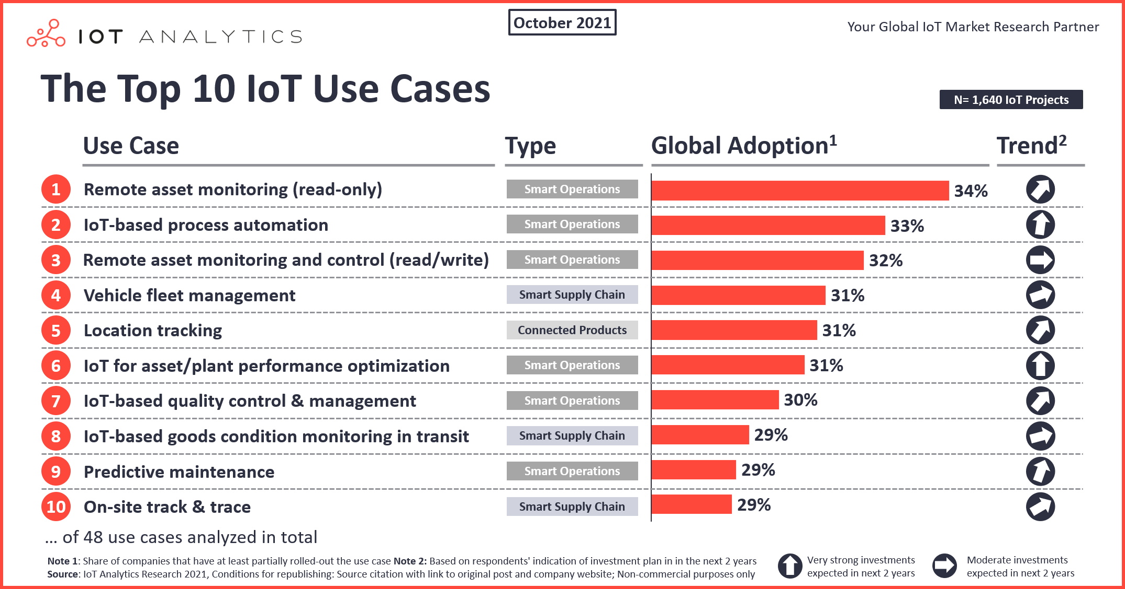

5. IoT Security and Privacy

  - Security Challenges in IoT
Security challenges in IoT (Internet of Things) represent a significant concern in the rapidly expanding landscape of interconnected devices. The inherent complexity and diversity of IoT ecosystems create several vulnerabilities that need to be addressed. First and foremost is the issue of device security. Many IoT devices lack robust security features, making them susceptible to unauthorized access and exploitation. Weak or default passwords, insufficient firmware updates, and inadequate encryption can lead to breaches. Furthermore, the sheer number of IoT devices in use increases the attack surface, making it challenging to monitor and protect every device effectively.
Data privacy is another critical concern. IoT devices collect vast amounts of personal and sensitive data, raising questions about how this data is stored, transmitted, and used. Inadequate data protection measures can lead to data leaks or breaches, potentially compromising user privacy and exposing sensitive information.Additionally, IoT networks may be vulnerable to various cyberattacks, including Distributed Denial of Service (DDoS) attacks that can disrupt services or even take down entire networks. As IoT devices often operate with limited computational resources, implementing strong security measures can be challenging, and this can be exploited by malicious actors.

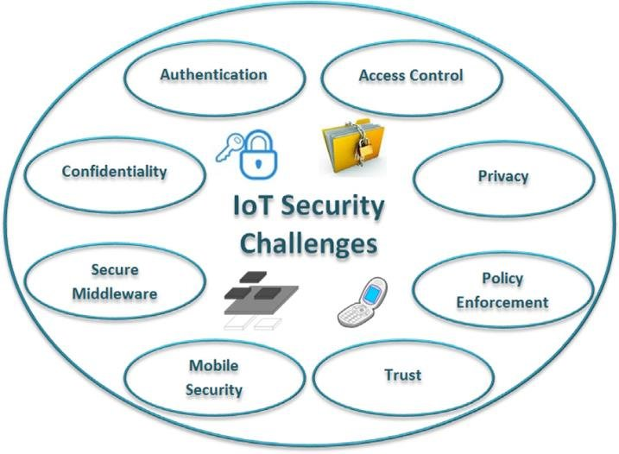

  - Authentication and Authorization
Authentication and authorization are two cornerstone concepts in the realm of information security, collectively forming a robust defense against unauthorized access to sensitive resources. Authentication serves as the initial gatekeeper, verifying the identity of users, systems, or devices seeking access. This process ensures that the requesting entity is indeed who they claim to be, employing a variety of methods such as passwords, biometrics, or security tokens. Once authenticated, the system then turns to authorization, determining the permissions and privileges granted to the authenticated entity. Authorization relies on defined roles, policies, and permissions, specifying what actions or resources an entity is allowed to access. This sequential process not only validates identity but also enforces access control, preventing unauthorized activities and safeguarding critical data. Together, authentication and authorization work harmoniously to fortify information security across a broad spectrum of applications, from web services to IoT networks, preserving data integrity and maintaining system integrity.
Authentication and authorization are fundamental aspects of IoT (Internet of Things) security and privacy, ensuring that only authorized devices and users can access and interact with IoT systems and data. Here's an overview of their roles in IoT security:

5.2.1Authentication:
Authentication is the process of verifying the identity of a device or user before granting access to IoT resources or data. In IoT, authentication ensures that devices and users are who they claim to be. Several authentication methods are commonly used in IoT:
      - Device Authentication: IoT devices are assigned unique identifiers, such as digital certificates, device keys, or unique hardware identifiers (HWIDs). During authentication, the device presents these credentials to the network or server, which then validates the device's identity.
      - User Authentication: In cases where human users interact with IoT systems (e.g., through mobile apps or web interfaces), user authentication is essential. Common methods include passwords, biometrics, and two-factor authentication (2FA).
      - Mutual Authentication: For sensitive IoT applications, both the device and the server may authenticate each other. This mutual authentication ensures a secure communication channel between them.
5.2.2 Authorization:
Authorization determines what actions or resources a device or user is permitted to access once their identity is authenticated. Authorization policies define the level of access granted based on roles, permissions, and other criteria. In IoT, authorization helps control device interactions and data access:
      - Role-Based Access Control (RBAC): RBAC assigns roles to devices or users and associates specific permissions with each role. For example, an IoT device may have a "sensor" role that grants read-only access to data but not the ability to modify configurations.
      - Attribute-Based Access Control (ABAC):ABAC uses attributes and policies to make access decisions. For instance, a device's location, time of access, or specific data attributes may influence authorization decisions.
      - Policy-Based Access Control: This approach defines access policies that govern interactions between devices and systems. Policies can be highly granular, specifying which devices or users are allowed to perform specific actions.
      - Context-Aware Access Control: Context-aware authorization considers factors such as the device's location, the user's context, and the current state of the IoT environment when making access decisions.
IoT security and privacy rely on robust authentication and authorization mechanisms to protect against unauthorized access, data breaches, and cyberattacks. When properly implemented, these measures help ensure that IoT ecosystems remain secure, data privacy is upheld, and the integrity of connected systems is maintained. As IoT continues to expand, the importance of effective authentication and authorization in safeguarding connected devices and sensitive data cannot be overstated.
  - Data Encryption in IoT
Data encryption is a critical security measure in the context of IoT (Internet of Things) to protect the confidentiality and integrity of data transmitted and stored by IoT devices. Given the vast amount of sensitive information often involved in IoT ecosystems, such as personal data, industrial process data, and more, encryption plays a pivotal role in ensuring that data remains secure throughout its lifecycle. Here are key aspects of data encryption in IoT:
    - Secure Data in Transit:IoT devices often communicate over networks, including the internet, to send and receive data. Encrypting data in transit using protocols like HTTPS, MQTT over TLS/SSL, or CoAP over DTLS ensures that data cannot be intercepted or tampered with by malicious actors during transmission.
    - End-to-End Encryption: For sensitive applications like healthcare or finance, where privacy is paramount, end-to-end encryption is essential. It means that data is encrypted on the sender's side, remains encrypted during transmission, and is only decrypted on the recipient's end, ensuring that even the network or service provider cannot access the data.
    - Data at Rest Encryption: IoT devices often store data locally or in the cloud. Encrypting data at rest ensures that if the device is physically compromised or the cloud storage is breached, the data remains unreadable without the appropriate decryption keys.
    - Device Identity and Authentication: Establishing secure communication often starts with authenticating the IoT devices themselves. Certificates, keys, or other secure methods can be used to verify the identity of devices before data transmission begins.
    - Key Management: Proper key management is essential for encryption. IoT systems need to securely store and manage encryption keys to ensure that only authorized entities can decrypt data.
    - Resource Constraints: Many IoT devices have limited computational resources, which can make implementing encryption challenging. Lightweight encryption algorithms designed for constrained environments are often used to strike a balance between security and resource efficiency.
5.4 Privacy Concerns and Compliance
Privacy concerns and compliance are paramount in today's digital landscape, where personal data is constantly collected, processed, and shared. Individuals worry about how their data is being used, while businesses and organizations grapple with the need to navigate complex and evolving regulations. These concerns are particularly pronounced in industries like healthcare, finance, and technology, where the stakes are high.
Privacy concerns center on the collection and handling of personal information, such as names, addresses, financial data, and even biometric details. With the proliferation of IoT devices, smart technologies, and online services, there is a growing awareness of the potential for data breaches, identity theft, and invasive surveillance. Individuals expect their data to be handled responsibly, with transparency about its use and robust security measures to protect it.On the regulatory front, governments worldwide have responded to these concerns by enacting stringent data protection laws. The General Data Protection Regulation (GDPR) in Europe and the California Consumer Privacy Act (CCPA) in the United States are notable examples. These laws require organizations to obtain explicit consent for data collection, provide individuals with the right to access and delete their data, and implement robust security measures to safeguard it. Failure to comply with these regulations can result in hefty fines and reputational damage.
Finally, privacy concerns and compliance are inextricably linked in the digital age. Individuals demand greater control over their data, and governments are responding with strict regulations. Organizations that prioritize data privacy, implement robust security measures, and stay abreast of evolving privacy laws are not only meeting legal requirements but also building trust with their users and customers in an era where data privacy is a top priority.

5.5 IoT Security Best Practices
Securing IoT (Internet of Things) environments requires a multifaceted approach encompassing various best practices. First and foremost, robust device authentication mechanisms must be implemented to verify the identity of devices connecting to the network. Secure boot processes and regular firmware updates are essential to ensure the integrity of IoT device software. Encryption, both for data at rest and in transit, is crucial in safeguarding sensitive information. Access control measures, including role-based access, limit what actions each device or user can perform. Network segmentation reduces the attack surface, while continuous monitoring and anomaly detection help identify potential threats. Physical security measures are necessary to prevent unauthorized physical access to IoT devices. Vendor security assessments should be conducted to select trustworthy IoT suppliers. Data minimization principles and privacy-by-design approaches help protect user privacy. User education plays a pivotal role in raising awareness of security practices, and having a well-defined incident response plan is vital for addressing security breaches effectively. Compliance with data protection regulations is non-negotiable, and security testing should be conducted regularly. Additionally, a comprehensive lifecycle management strategy ensures the secure retirement of devices. Finally, adhering to established IoT security standards and guidelines provides a solid foundation for robust security in IoT ecosystems. These best practices collectively contribute to the resilience of IoT environments against an ever-evolving landscape of security threats.
Securing IoT (Internet of Things) devices and networks is crucial to protect against cyber threats and ensure the privacy and integrity of data. Here are some best practices for IoT security and privacy:
    - Device Authentication: Implement strong device authentication mechanisms, such as digital certificates, device keys, or unique hardware identifiers. Devices should be required to prove their identity before connecting to the network.
    - User Authentication: For IoT systems with user interfaces, employ robust user authentication methods like multi-factor authentication (MFA), biometrics, or strong passwords. Ensure that default usernames and passwords are changed upon device setup.
    - Encryption: Encrypt data in transit and at rest. Use protocols like TLS/SSL for data transmission and encryption algorithms for data storage. Encryption safeguards data from eavesdropping and tampering.
    - Firmware Updates: Keep IoT device firmware and software up to date to patch security vulnerabilities. Implement a secure update process, digitally signing updates, and using secure boot mechanisms.
    - Network Segmentation: Isolate IoT devices on a separate network from critical systems. This limits the attack surface and prevents a compromise of one device from affecting the entire network.
    - Firewalls and Intrusion Detection Systems (IDS): Deploy firewalls to filter network traffic and IDS to detect and respond to suspicious activities or anomalies on the network.
    - Access Control: Implement role-based access control (RBAC) and attribute-based access control (ABAC) to restrict device and user access based on roles, permissions, and context.
    - IoT Device Lifecycle Management: Develop a comprehensive device lifecycle management strategy that covers device provisioning, decommissioning, and end-of-life considerations to prevent abandoned devices becoming security liabilities.
    - Regulatory Compliance: Stay informed about IoT security regulations and standards applicable to your industry and ensure compliance with data protection laws.
IoT security is an ongoing effort that requires proactive measures and continuous monitoring. By adhering to these best practices, organizations can significantly enhance the security and privacy of their IoT ecosystems and reduce the risk of cyber attacks and data breaches.
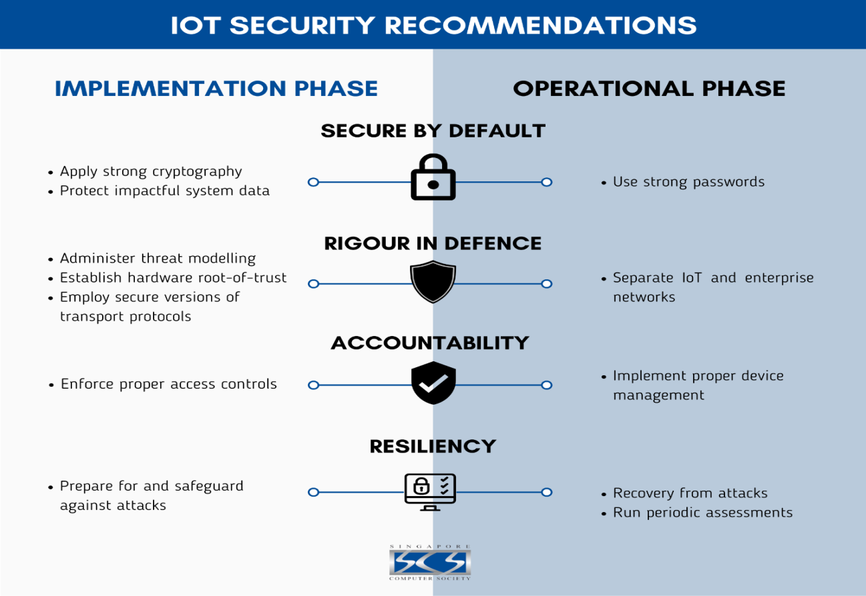

6. IoT in Healthcare
  - IoT Applications in Healthcare
IoT (Internet of Things) applications have the potential to revolutionize healthcare by enhancing patient care, improving operational efficiency, and reducing costs. Here are several key IoT applications in healthcare:
    - RemotePatient Monitoring: IoT devices, such as wearable fitness trackers and medical-grade sensors, enable continuous monitoring of patients' vital signs, including heart rate, blood pressure, and glucose levels. This data can be transmitted to healthcare providers in real-time, allowing for early intervention and better management of chronic conditions.
    - Telemedicine: IoT facilitates telemedicine by connecting patients and healthcare professionals over the internet. Video conferencing, remote consultations, and virtual health platforms enable patients to receive medical advice and treatment without the need for in-person visits, which is especially valuable in remote or underserved areas.
    - Medication Adherence: IoT-enabled smart pill dispensers and medication tracking devices help patients adhere to their medication schedules. Alerts and reminders are sent to patients and caregivers to ensure that medications are taken correctly and on time.
    - Hospital Asset Tracking: IoT technology can be used to track the location and status of medical equipment and assets within a healthcare facility. This ensures that critical equipment is readily available when needed, reducing downtime and improving efficiency.
    - Patient Safety: IoT can enhance patient safety by monitoring environmental factors such as room temperature, humidity, and air quality in healthcare settings. It can also include fall detection systems for at-risk patients and RFID-based patient identification to prevent medication errors.
    - Supply Chain Management: IoT helps streamline the healthcare supply chain by tracking the movement of pharmaceuticals, medical devices, and supplies. This ensures the integrity and safety of medical products and reduces the risk of counterfeit drugs.
    - Smart Hospitals: IoT can create smart hospital environments by integrating various systems and devices, including lighting, HVAC, and security, to optimize energy usage, improve patient comfort, and enhance security.
    - Elderly Care: IoT technologies assist in elderly care by monitoring seniors' activities and well-being in their homes. This includes fall detection, emergency response systems, and smart home automation for added convenience and safety.

6.2 Remote Patient Monitoring
Remote patient monitoring (RPM) is a transformative healthcare practice enabled by IoT technology, allowing healthcare providers to remotely track and manage patients' health conditions from a distance. This innovative approach involves the use of connected medical devices and sensors that continuously collect and transmit patient data, such as vital signs and health metrics, to healthcare professionals in real-time. RPM not only empowers patients to actively participate in their healthcare by monitoring their conditions from the comfort of their homes but also enables healthcare providers to detect health issues early and make informed decisions about treatment adjustments. Particularly beneficial for patients with chronic illnesses or those requiring post-operative care, RPM enhances patient engagement, reduces hospitalizations, and improves the overall quality of care while potentially lowering healthcare costs. However, successful implementation requires robust data security measures and user-friendly interfaces to ensure privacy and ease of use, making RPM a promising advancement in modern healthcare delivery.

6.3 Healthcare Data Management
In addition to the real-time monitoring benefits, healthcare data management is a crucial aspect of remote patient monitoring (RPM). The vast amounts of patient data generated through RPM require efficient storage, secure transmission, and effective analysis. Healthcare organizations must establish robust data management systems that adhere to strict privacy regulations, such as the Health Insurance Portability and Accountability Act (HIPAA) in the United States or the General Data Protection Regulation (GDPR) in Europe.
Data collected through RPM often includes sensitive patient information, and ensuring the confidentiality and integrity of this data is paramount. Robust encryption, access controls, and secure data storage are essential components of healthcare data management in an RPM context.
Moreover, the growing volume of data offers an opportunity for advanced analytics and machine learning algorithms to derive valuable insights from patient trends and patterns. These insights can inform treatment plans, identify potential health risks, and enhance overall patient care. However, the responsible use of data analytics in healthcare must also adhere to stringent ethical and legal guidelines to protect patient privacy and data security.
As RPM continues to evolve, healthcare data management will play an increasingly critical role in harnessing the full potential of IoT technology to improve patient outcomes, reduce healthcare costs, and transform the way healthcare is delivered.

  - Telemedicine and IoT
Telemedicine and IoT (Internet of Things) are two transformative technologies that have converged to revolutionize healthcare delivery, particularly in remote monitoring, diagnosis, and treatment. The integration of IoT into telemedicine has led to several significant benefits and innovative applications:
    - Remote Patient Monitoring (RPM): IoT sensors and devices, such as wearable fitness trackers, smartwatches, and medical-grade sensors, enable continuous monitoring of patients' vital signs, chronic conditions, and post-operative recovery. Data collected by these devices can be transmitted to healthcare providers in real-time through telemedicine platforms, allowing for timely interventions and more proactive healthcare management.
    - Enhanced Diagnostics: IoT-enabled medical devices, like connected stethoscopes, otoscopes, and even smartphone attachments, enable remote physical examinations. Physicians can examine patients and make more accurate diagnoses through telemedicine consultations, aided by high-quality visual and auditory data.
    - Medication Adherence: IoT technology is used to create smart pill dispensers and medication tracking devices that can be integrated into telemedicine platforms. These devices remind patients to take their medications, track adherence, and notify healthcare providers of missed doses, improving treatment outcomes
    - Telehealth Home Kits: IoT-based telehealth kits include a range of medical devices that patients can use at home under remote supervision. These kits often include blood pressure monitors, thermometers, and glucose meters, helping patients manage their conditions and share vital data with healthcare providers during virtual visits.
    - Elderly Care: IoT-enabled telemedicine solutions are especially valuable for elderly care. Remote monitoring and video consultations allow seniors to receive medical attention and check-ups from the comfort of their homes, reducing the need for frequent visits to healthcare facilities.
    - Data Integration and Analytics: IoT devices generate vast amounts of patient data, which can be integrated with electronic health records (EHRs) and analyzed to identify trends, patterns, and potential health risks. This data-driven approach aids in more personalized treatment plans and preventive care.
    - Cost Savings: IoT-driven telemedicine can reduce healthcare costs by lowering the frequency of hospitalizations and emergency room visits. It also decreases the need for transportation and associated expenses for patients, particularly those in remote or underserved areas.
    - Real-time Alerts: IoT sensors can provide real-time alerts to healthcare providers if specific conditions or parameters fall outside normal ranges, enabling rapid responses to critical situations.
6.5 Ethical and Regulatory Considerations
The convergence of telemedicine and IoT technologies in healthcare introduces a complex landscape of ethical and regulatory considerations. On the ethical front, safeguarding patient privacy is paramount, demanding transparent data handling practices and robust informed consent processes. Ensuring that patients fully understand the capabilities, limitations, and potential risks of these technologies is essential. Additionally, ethical responsibilities extend to data ownership, with patients often having rightful claims to their health data. Ethical concerns also encompass data security, equitable access, and transparency in the use of AI algorithms.
From a regulatory perspective, adherence to data protection regulations like HIPAA and GDPR is mandatory to govern data collection, storage, and sharing. Licensure and credentialing requirements must be met, taking into account the variations in these regulations across jurisdictions. Reimbursement policies for telemedicine services, as well as insurance coverage, add further layers of complexity. Healthcare providers must ensure that they maintain the same standard of care in telemedicine as they do in traditional in-person care, adhering to medical ethics and guidelines. Addressing regulations for telemedicine prescriptions and emergency telemedicine consultations, particularly across borders, requires careful navigation. As the telemedicine and IoT landscape continues to evolve, staying vigilant in addressing these ethical and regulatory considerations is imperative to ensure that patient care remains ethical, secure, and compliant with the law
7. Smart Cities and IoT
  - Smart City Concepts and Goals
Smart city concepts and goals revolve around leveraging technology and data-driven solutions to enhance the quality of urban life, improve sustainability, and streamline city operations. These concepts aim to address various urban challenges while making cities more efficient, livable, and resilient. Here are key smart city concepts and goals:
    - Efficient Transportation: Smart cities prioritize efficient and sustainable transportation systems. Goals include reducing traffic congestion, promoting public transit, enhancing pedestrian and cycling infrastructure, and implementing intelligent traffic management systems.
    - Environmental Sustainability: Smart cities aim to reduce their carbon footprint and mitigate environmental impacts. This includes initiatives for cleaner energy sources, waste reduction, green infrastructure, and conservation efforts.
    - Digital Connectivity: A connected city is central to smart city concepts. Goals involve widespread high-speed internet access, ubiquitous connectivity for IoT devices, and the development of a digital ecosystem that enables smart services.
    - Smart Infrastructure: Smart cities invest in intelligent infrastructure, including smart grids for energy, smart water management systems, and advanced waste management solutions. These technologies optimize resource allocation and reduce waste.
    - Public Safety: Enhanced public safety is a key goal. Smart city concepts include the use of video surveillance, real-time data analysis, and emergency response systems to improve safety and disaster management.
    - Data-Driven Decision-Making: Data analytics and sensors collect vast amounts of urban data. Smart cities leverage this data for informed decision-making, whether for urban planning, traffic management, or resource allocation.
    - Quality of Life: Improving the overall quality of life for residents is a central goal. This involves initiatives to create vibrant public spaces, enhance cultural amenities, and provide equitable access to education and healthcare.
    - Economic Development: Smart city strategies often promote economic growth and innovation. This includes supporting local startups, fostering a culture of entrepreneurship, and attracting technology companies and research institutions.
    - Efficient Governance: Smart city concepts streamline city administration through digital services, e-governance platforms, and online citizen engagement. The goal is to make government more responsive, accountable, and efficient.
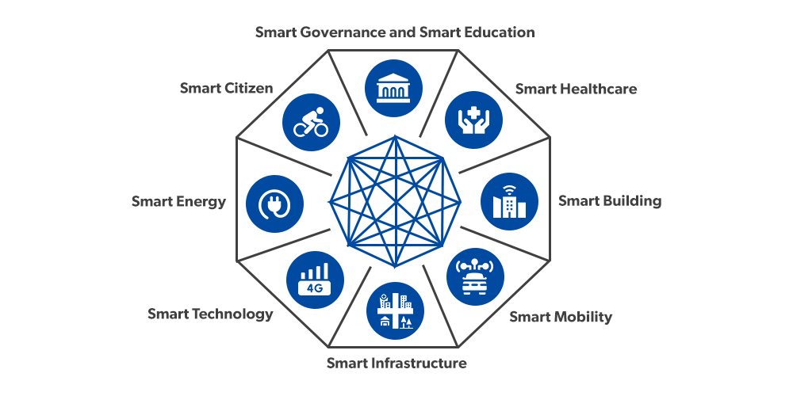

  - IoT's Role in Smart Cities
IoT (Internet of Things) plays a pivotal role in the development and functioning of smart cities, offering innovative solutions to address urban challenges and improve the overall quality of life for residents. Here's how IoT contributes to the success of smart cities:
    - Sustainable Urban Planning: IoT sensors and data analytics enable real-time monitoring of various urban parameters, such as traffic flow, air quality, energy consumption, and waste management. This data-driven approach empowers city planners to make informed decisions, optimize resource allocation, and implement sustainable urban development strategies.
    - Efficient Transportation: IoT-connected sensors on roads, vehicles, and public transit systems provide valuable traffic data. This information can be used to alleviate congestion, optimize traffic signals, and improve public transportation systems, ultimately reducing commute times and air pollution.
    - Smart Energy Management: IoT-based smart grids and meters enhance the efficiency and reliability of energy distribution. Utilities can remotely monitor and manage power grids, optimize energy consumption, and detect and respond to power outages more quickly.
    - Waste Management: IoT-enabled waste bins equipped with sensors can signal when they need emptying, optimizing waste collection routes and reducing operational costs. Smart waste management systems also contribute to cleaner and more sustainable urban environments.
    - Environmental Monitoring: IoT sensors continuously monitor environmental conditions, including air and water quality, noise levels, and weather. This data helps cities respond to pollution incidents, plan for climate change resilience, and protect public health.
    - Public Safety: IoT-connected surveillance cameras, emergency response systems, and gunshot detection sensors enhance public safety. These systems enable rapid responses to emergencies, reduce crime, and improve overall security.
  - Urban Infrastructure and IoT
The integration of IoT (Internet of Things) technology into urban infrastructure is transforming the way cities plan, manage, and optimize their essential services and resources. Here's how IoT is enhancing urban infrastructure across various domains:
    - Smart Transportation: IoT sensors and connected vehicles are used to monitor traffic flow, manage congestion, and improve road safety. Smart traffic lights, parking systems, and public transportation services help reduce traffic jams and enhance overall mobility.
    - Smart Energy Management: IoT enables the creation of smart grids and meters, allowing utilities to monitor energy consumption in real-time, detect faults, and optimize power distribution. This results in more efficient energy use, reduced costs, and improved grid reliability.
    - Water Management: IoT sensors in water distribution systems detect leaks, monitor water quality, and regulate water flow. These systems help conserve water, reduce wastage, and ensure a clean and reliable water supply.
    - Waste Management: Smart waste bins equipped with sensors alert collection services when they are full, optimizing collection routes and reducing operational costs. IoT-based waste management solutions contribute to cleaner and more sustainable cities.

    - Environmental Monitoring: IoT sensors track environmental parameters such as air quality, noise levels, and weather conditions. This data informs city planning, supports pollution control efforts, and enhances the quality of life for residents.
    - Public Safety: Surveillance cameras, gunshot detection sensors, and emergency response systems, all connected through IoT, enhance public safety and enable rapid responses to emergencies and incidents. This leads to lower crime rates and improved security.
    - Building Automation: IoT devices within buildings, including smart HVAC systems, lighting, and access controls, improve energy efficiency, occupant comfort, and security. Building automation also reduces operational costs.
    - Healthcare Services: IoT-enabled healthcare devices and remote monitoring solutions support healthcare services in urban areas. These technologies enable real-time patient monitoring, telemedicine consultations, and more responsive healthcare delivery.
  - Sustainability and IoT
Sustainability lies at the heart of IoT's role in urban infrastructure and smart cities. By harnessing the power of Internet of Things technology, cities can address pressing environmental concerns and work towards a more sustainable future. IoT sensors and data analytics enable real-time monitoring of critical factors such as energy consumption, waste production, air quality, and water usage. This data-driven approach empowers cities to make informed decisions that optimize resource allocation and reduce environmental impact. For instance, smart grids and meters help utilities manage electricity more efficiently, reducing greenhouse gas emissions, while IoT-enabled waste management systems minimize the ecological footprint of urban areas. Additionally, IoT supports sustainable transportation solutions, promoting cleaner and more accessible mobility options like electric vehicles and public transit systems. By integrating IoT into urban infrastructure, cities can not only enhance their environmental sustainability but also improve the overall well-being and resilience of their communities, ultimately contributing to a greener and more sustainable urban future.
  - Case Studies of Smart Cities
Several cities worldwide have embraced smart city concepts and technologies to enhance urban living, sustainability, and efficiency. Here are case studies of smart cities that showcase innovative approaches to urban development:
    - Singapore: Often cited as a leading smart city, Singapore employs IoT and data analytics to optimize various aspects of urban life. The city-state has deployed sensors for traffic management, smart lighting, waste management, and even an extensive network of cameras for security. Singapore's efforts include the "Smart Nation" initiative, which aims to use technology to improve citizen services, healthcare, and transportation.
    - Copenhagen, Denmark: Copenhagen focuses on sustainability and livability. The city has invested in smart traffic management to reduce congestion, implemented an extensive bicycle infrastructure, and adopted green energy solutions. The "Copenhagen Connecting" project deploys IoT technology to gather data on air quality, noise levels, and traffic, allowing for more informed urban planning decisions.
    - Barcelona, Spain: Barcelona's "Smart City" project emphasizes citizen engagement and sustainability. The city has deployed thousands of sensors for monitoring everything from parking availability to waste bin status. The data collected is used to improve services, reduce energy consumption, and enhance transportation systems. Barcelona also launched a digital platform called "Barcelona Smart City" to involve residents in decision-making and urban planning.
    - Amsterdam, Netherlands: Amsterdam focuses on becoming a "circular economy" by reducing waste and promoting sustainable practices. The city uses IoT technology to optimize waste collection, monitor energy usage, and create smart parking solutions. It has also encouraged the development of electric vehicle charging infrastructure.
    - Dubai, United Arab Emirates: Dubai has ambitious plans to become one of the smartest cities globally. The "Smart Dubai" initiative encompasses various projects, including a blockchain-based platform for government transactions, smart transportation, and IoT-driven services like smart meters for utilities and public Wi-Fi. Dubai aims to enhance the quality of life for its residents and visitors while reducing its ecological footprint.
    - Songdo, South Korea: Songdo is a planned smart city built from the ground up. It incorporates advanced technologies for waste management, energy efficiency, and transportation. The city also emphasizes sustainability, with extensive green spaces and efficient public transportation systems.
    - Toronto, Canada (Sidewalk Labs): Toronto's Quayside project, led by Sidewalk Labs (a subsidiary of Alphabet Inc.), is a smart city development that leverages technology for urban innovation. Plans include self-driving shuttles, smart building solutions, and data-driven infrastructure for enhanced urban living. While the project has faced some challenges and controversies, it highlights the potential of tech-driven urban development.
8. IoT in Agriculture
8.1 Precision Agriculture and IoT
Precision agriculture is a revolutionary approach to farming that leverages the power of the Internet of Things (IoT) to transform traditional agricultural practices. By integrating advanced technologies such as sensors, drones, GPS, and data analytics, precision agriculture aims to optimize every aspect of the farming process. IoT devices, spread throughout the farm, collect real-time data on soil conditions, weather patterns, crop health, and equipment performance. This data is then analyzed to make informed decisions, enabling farmers to apply resources like water, fertilizers, and pesticides with pinpoint accuracy. By reducing waste, increasing crop yields, and minimizing environmental impact, precision agriculture not only enhances farm productivity but also contributes to sustainable and efficient farming practices. With the ongoing advancements in IoT technology, the future of agriculture is poised for even greater innovation and efficiency, helping to address the challenges of food security and environmental sustainability on a global scale.
8.2 IoT Sensors in Farming
IoT sensors have found extensive applications in modern agriculture, revolutionizing the way farmers manage their crops and livestock. These sensors are instrumental in gathering real-time data from the field, allowing for data-driven decision-making and optimizing various aspects of farming. Here are some key areas where IoT sensors are making a significant impact in agriculture:
8.2.1 Soil Monitoring: IoT soil sensors measure crucial parameters such as moisture levels, temperature, and nutrient content. This information helps farmers determine when and how much to irrigate, as well as when to apply fertilizers, promoting efficient resource utilization and improved crop health.
8.2.2 Weather and Climate Monitoring: Weather stations equipped with IoT sensors provide accurate data on temperature, humidity, wind speed, and precipitation. This information aids in weather forecasting, allowing farmers to prepare for adverse weather conditions and make informed decisions regarding planting and harvesting schedules.
8.2.3 Crop Health Monitoring: IoT-enabled cameras and sensors can detect early signs of plant diseases, pests, and nutrient deficiencies. Farmers can respond promptly to these issues, reducing crop loss and minimizing the need for chemical interventions.
8.2.4 Livestock Management: IoT sensors can be attached to animals to monitor their health, location, and behavior. This helps farmers identify and address health concerns, optimize feeding schedules, and improve overall herd management.
8.2.5 Precision Irrigation: IoT-controlled irrigation systems adjust water delivery based on real-time data from soil and weather sensors. This reduces water waste, minimizes over-irrigation, and saves energy costs.
8.2.6 Equipment Monitoring: IoT sensors can be installed on farm machinery to track their performance and condition. Predictive maintenance alerts help prevent breakdowns, reducing downtime and repair costs.
8.2.7 Inventory Management: Sensors can be used to monitor the levels of stored crops and supplies, helping farmers manage inventory efficiently and avoid losses due to spoilage or theft.

8.3 Crop Monitoring and Management
Crop monitoring and management in agriculture have undergone a significant transformation with the advent of technology. Through the utilization of satellite imagery, drones, IoT sensors, and data analytics, farmers can now closely monitor the health and growth of their crops. Real-time data on soil conditions, weather patterns, and crop performance enables precise decision-making. Farmers can tailor irrigation, fertilization, and pest control strategies to specific field conditions, optimizing resource use and reducing environmental impact. Additionally, crop monitoring allows for early detection of issues like diseases and pests, enabling timely intervention to minimize crop losses. This data-driven approach not only enhances yields but also promotes sustainable farming practices by reducing wastage and improving overall crop quality. Crop monitoring and management have become essential components of modern agriculture, helping to meet the growing global demand for food while ensuring responsible land and resource stewardship.

8.4 IoT in Livestock Farming
IoT (Internet of Things) technology is playing a pivotal role in revolutionizing livestock farming, enhancing the efficiency and well-being of animals, and improving the overall management of farm operations. Here are some key ways IoT is employed in livestock farming:
8.4.1 Livestock Health Monitoring: IoT sensors can be attached to animals to continuously monitor vital signs, such as body temperature, heart rate, and activity levels. Any deviations from normal parameters trigger alerts to farmers or veterinarians, allowing for early disease detection and timely intervention.
8.4.2 Feed and Water Management: IoT sensors in feeders and water troughs can monitor consumption patterns. This data helps farmers optimize feeding schedules, reduce wastage, and ensure animals receive the right nutrients. It also allows for early identification of any disruptions in feed or water supply.
8.4.3 Location Tracking: GPS-enabled IoT devices can track the location of livestock, which is particularly valuable for managing grazing patterns, preventing theft, and locating animals in case of emergencies.
8.4.4 Environmental Control: IoT systems can regulate and monitor environmental conditions in livestock housing, such as temperature, humidity, and ventilation. This ensures that animals are kept in comfortable and healthy conditions, reducing stress and disease risks.
8.4.5 Reproduction and Breeding: IoT devices can track the reproductive status of animals, helping farmers optimize breeding programs and manage reproductive cycles more efficiently.
8.4.6 Animal Behavior and Welfare: Sensors can monitor animal behavior, helping farmers detect signs of distress, aggression, or illness. This enables timely intervention to improve animal welfare.
8.4.7 Data Analytics: Collecting and analyzing data from IoT sensors provides valuable insights into herd health, performance, and productivity. Farmers can make informed decisions on breeding, culling, and overall management strategies.
8.4.8 Remote Monitoring: Farmers can access real-time data from IoT sensors remotely through smartphones or computers, allowing them to monitor and manage their livestock even when off-site.
8.4.9 Inventory and Asset Management: IoT sensors can track equipment and tools, helping farmers keep better control over their assets and manage maintenance schedules efficiently.
8.4.10 Compliance and Traceability: IoT technology aids in maintaining records and ensuring compliance with regulations related to animal health and welfare. It also helps in establishing traceability for meat and dairy products.
By implementing IoT solutions in livestock farming, farmers can optimize production, reduce operational costs, enhance animal welfare, and make more sustainable choices. Additionally, IoT-driven data analytics can empower farmers with valuable insights, helping them make informed decisions to meet the ever-growing demand for high-quality animal products while ensuring the responsible management of resources.

8.5 Future Trends in AgTech
The future of AgTech (Agricultural Technology) holds exciting possibilities that promise to transform agriculture in innovative ways. Several key trends are expected to shape the industry in the coming years. Firstly, Artificial Intelligence (AI) and machine learning will continue to play a central role in precision agriculture, enabling more accurate predictions and decision-making in areas like crop management, pest control, and resource optimization. Additionally, the integration of Big Data analytics will empower farmers with valuable insights to enhance productivity and sustainability.
Next, the Internet of Things (IoT) will expand its footprint, with an increasing number of sensors and devices interconnected across farms. This will lead to more comprehensive data collection and real-time monitoring of everything from soil conditions to livestock health, enabling farmers to respond swiftly to changing circumstances. Automation and robotics will become more prevalent, streamlining labor-intensive tasks such as planting, harvesting, and weeding. Autonomous tractors, drones, and robotic arms will work alongside human labor, improving efficiency and reducing the need for manual intervention.
Vertical farming and indoor agriculture will continue to gain traction, addressing urbanization and land scarcity challenges. Blockchain technology will play a crucial role in ensuring traceability and transparency in the food supply chain, from farm to fork. Consumers will have greater access to information about the origin and quality of the products they purchase.Finally, as the world grapples with the challenges of feeding a growing global population, AgTech will continue to be a driving force in increasing agricultural productivity while addressing the sustainability and environmental concerns associated with food production. In the future, these trends will converge to create a more efficient, sustainable, and resilient agricultural sector capable of meeting the complex demands of the 21st century.
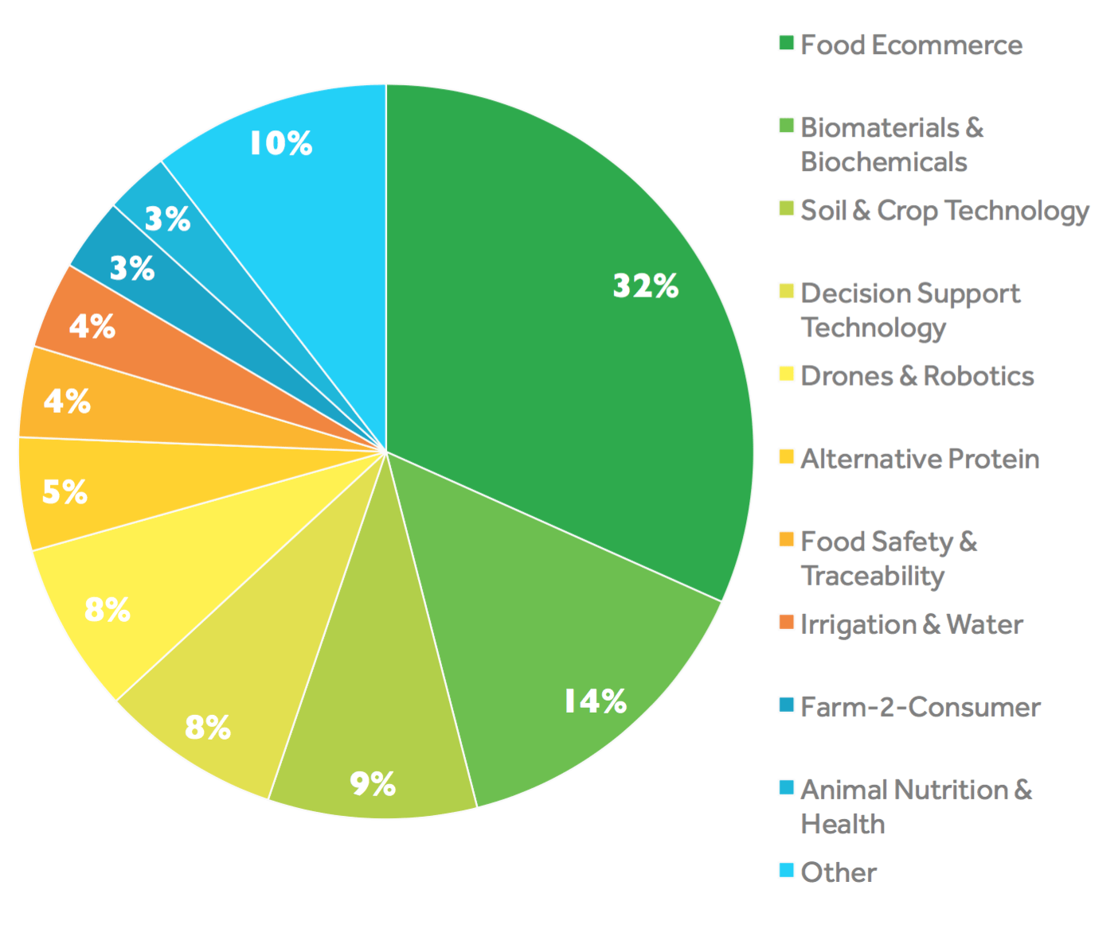

9. IoT and Industry 4.0

9.1 Industry 4.0 Overview
Industry 4.0, often referred to as the fourth industrial revolution, represents a paradigm shift in manufacturing and industry, and IoT plays a central role in its realization. This transformative concept involves the integration of IoT devices, data analytics, artificial intelligence (AI), and automation to create smart, interconnected industrial systems.In Industry 4.0, IoT devices, such as sensors and actuators, are deployed throughout manufacturing processes and supply chains to gather real-time data. These devices collect information on equipment performance, production quality, energy usage, and more. This data is then transmitted to central platforms where AI and advanced analytics tools process and analyze it, providing actionable insights.
The benefits of Industry 4.0 enabled by IoT are numerous. Manufacturers can achieve higher levels of automation and efficiency, reduce downtime through predictive maintenance, optimize production processes, and enhance product quality. This leads to cost savings and increased competitiveness. Additionally, IoT-driven insights enable more flexible and agile manufacturing, allowing companies to respond quickly to changing market demands and customize products on a larger scale.Moreover, Industry 4.0 promotes connectivity and collaboration across the supply chain. IoT devices facilitate real-time communication with suppliers, distributors, and customers, enabling better coordination and inventory management. This enhanced visibility and transparency foster more responsive and sustainable supply chains.
Overall, Industry 4.0 powered by IoT is driving a fundamental shift in how industries operate, fostering innovation, improving productivity, and ultimately reshaping the global industrial landscape. It's not just about smart factories but a broader transformation of industrial processes that holds the promise of increased efficiency, reduced environmental impact, and economic growth across various sectors.

9.2 IoT and Industrial Automation
IoT has emerged as a game-changer in the realm of industrial automation, ushering in a new era of smart manufacturing. By interconnecting machines, sensors, and systems, IoT enhances industrial automation in several ways. Industrial processes can now be monitored, controlled, and optimized in real time, leading to improved efficiency, reduced downtime, and enhanced safety.
IoT sensors embedded in machinery collect data on variables such as temperature, pressure, humidity, and equipment performance. This data is transmitted to centralized platforms where it undergoes analysis. Through machine learning algorithms and predictive analytics, patterns and anomalies are detected, enabling proactive maintenance. This predictive maintenance approach helps prevent costly breakdowns and extends the lifespan of industrial equipment.
IoT-driven industrial automation also facilitates better resource management. By optimizing energy consumption, water usage, and raw material utilization, manufacturers can reduce operational costs and minimize environmental impact. Moreover, automation leads to higher production consistency and product quality, which is critical in industries like pharmaceuticals and food manufacturing.
Furthermore, IoT contributes to improved workplace safety through the deployment of connected safety equipment and real-time monitoring of hazardous conditions. This promotes a safer working environment for employees. Finally IoT is reshaping industrial automation by enabling intelligent, data-driven decision-making and process optimization. It empowers manufacturers to be more efficient, flexible, and competitive while ensuring the well-being of workers and reducing the environmental footprint of industrial operations. As IoT technology continues to advance, its impact on industrial automation is expected to grow, paving the way for even more innovation and productivity gains in the manufacturing sector.

9.3 IoT in Supply Chain Management
IoT (Internet of Things) plays a pivotal role in revolutionizing supply chain management in the context of Industry 4.0. It brings about greater visibility, efficiency, and responsiveness across the entire supply chain, from raw material suppliers to end customers. Here's how IoT is transforming supply chain management in the Industry 4.0 era:

9.3.1 Real-time Tracking and Visibility: IoT sensors and devices are integrated into products, packaging, and transportation vehicles, allowing for real-time tracking and monitoring of goods as they move through the supply chain. This visibility enables accurate and up-to-date information on the location, condition, and status of products, reducing the risk of theft, loss, and damage.
9.3.2 Predictive Analytics: IoT sensors collect data on various environmental conditions, such as temperature, humidity, and vibration, during transportation and storage. This data is then analyzed using advanced analytics and machine learning algorithms to predict and prevent potential issues, such as spoilage or damage to sensitive products.
9.3.3 Inventory Management: IoT sensors are used to monitor inventory levels in warehouses and distribution centers. When stock levels reach predetermined thresholds, automated alerts are triggered, ensuring that inventory is replenished promptly to meet demand while avoiding overstock situations.
9.3.4 Demand Forecasting: IoT data, combined with AI and analytics, helps in generating more accurate demand forecasts. This enables companies to optimize production schedules, reduce excess inventory, and minimize supply chain disruptions.
9.3.5 Maintenance and Asset Management: IoT-enabled predictive maintenance ensures that equipment and vehicles within the supply chain are serviced or repaired before breakdowns occur. This reduces downtime and enhances the reliability of transportation and production machinery.
9.3.6 Energy and Resource Efficiency: IoT technology is used to monitor energy consumption and resource usage in facilities and transportation, helping organizations identify opportunities to reduce costs and minimize their environmental footprint.
    - Customization and Personalization: IoT enables the creation of more personalized products and services by capturing data on customer preferences and usage patterns. This leads to greater customer satisfaction and loyalty.
    - Blockchain for Transparency: IoT data can be integrated with blockchain technology to create transparent and tamper-proof records of product provenance and transaction history. This is especially valuable in ensuring the authenticity and safety of products, such as food and pharmaceuticals.
In Industry 4.0, IoT-driven supply chain management is not just about reducing costs and improving efficiency; it's also about enhancing agility, sustainability, and customer satisfaction. Companies that embrace IoT technology in their supply chains are better positioned to adapt to changing market dynamics and deliver products and services more efficiently and responsively.

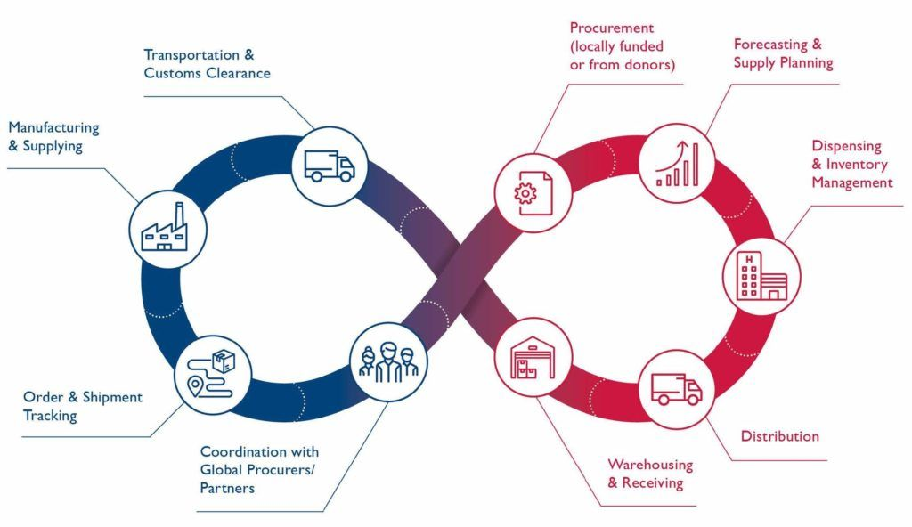

9.4 Predictive Maintenance in Manufacturing
Predictive maintenance is a key application of IoT (Internet of Things) in the manufacturing sector, particularly within the framework of Industry 4.0. It revolutionizes maintenance practices by using data analytics and IoT sensors to predict when equipment is likely to fail, allowing for timely maintenance before a breakdown occurs. Here are the key aspects of predictive maintenance in IoT and Industry 4.0:
9.4.1 IoT Sensor Integration: Manufacturing equipment is equipped with various sensors that monitor crucial parameters such as temperature, vibration, pressure, and usage patterns. These sensors continuously collect data in real-time and transmit it to centralized systems.
9.4.2 Data Analytics: The collected sensor data is analyzed using advanced analytics techniques, including machine learning algorithms. These algorithms identify patterns and anomalies, allowing for the early detection of potential equipment failures.
9.4.3 Predictive Models: Predictive maintenance models are built based on historical data and ongoing sensor data. These models predict when equipment is likely to fail, how long it can continue to operate, and what specific maintenance actions are required.
9.4.4 Condition-Based Maintenance: Instead of following a fixed maintenance schedule, manufacturers can perform maintenance only when it's necessary. This minimizes downtime and reduces the cost of unnecessary maintenance tasks.
9.4.5 Reduced Downtime: Predictive maintenance helps prevent unplanned downtime, which can be costly and disrupt production schedules. By addressing issues proactively, manufacturers can keep their operations running smoothly.
9.4.6 Optimized Maintenance Resources: Manufacturers can allocate maintenance resources more efficiently. Maintenance teams can focus on equipment that truly needs attention, rather than servicing machines that are operating within normal parameters.
9.4.7 Equipment Longevity: Predictive maintenance can extend the lifespan of manufacturing equipment by addressing issues before they cause major damage. This reduces the need for frequent equipment replacements.
9.4.8 Improved Safety: Regular maintenance helps ensure that equipment is operating safely. Predictive maintenance allows for timely repairs or replacements, reducing the risk of accidents or injuries in the manufacturing environment.
9.4.9 Cost Savings: By reducing unplanned downtime, optimizing maintenance efforts, and extending equipment life, predictive maintenance leads to significant cost savings for manufacturers.
9.4.10 Data-Driven Decision-Making: Predictive maintenance provides valuable data insights that can be used for strategic decision-making and process improvement within the manufacturing organization.
Finally, predictive maintenance in IoT and Industry 4.0 is a proactive approach that leverages data and technology to revolutionize maintenance practices in manufacturing. It enhances equipment reliability, reduces downtime, lowers maintenance costs, and contributes to overall operational efficiency and competitiveness. Manufacturers that embrace predictive maintenance are better positioned to thrive in the era of smart manufacturing and Industry 4.0.

9.5 Challenges and Opportunities
IoT and Industry 4.0 bring a mix of challenges and opportunities to the forefront of modern business and industry. The opportunities are abundant, promising increased efficiency, cost savings, enhanced product quality, and better decision-making. These technologies enable customization, sustainability, and improved supply chain management. However, the challenges are significant. Data security and privacy concerns loom large, along with interoperability issues and the complexity of integration. Bridging the skills gap and ensuring regulatory compliance are paramount, while cybersecurity risks demand constant vigilance. The initial investment can be substantial, and navigating cultural change within organizations is a considerable task. Ethical considerations surrounding job displacement and responsible AI use add further layers of complexity. To harness the full potential of IoT and Industry 4.0, organizations must carefully navigate these challenges while seizing the opportunities they present, fostering innovation, and staying agile in a rapidly evolving landscape.Here's a closer look at both the opportunities and challenges:
9.5.1 Opportunities:
9.5.1.1 Improved Efficiency: IoT and Industry 4.0 technologies enable real-time data collection, analysis, and automation, leading to more efficient and streamlined processes in manufacturing, logistics, and supply chain management.
9.5.1.2 Cost Reduction: By optimizing resource utilization, predictive maintenance, and energy efficiency, organizations can significantly reduce operational costs and improve their bottom line.
9.5.1.3 Enhanced Product Quality: IoT sensors and data analytics help monitor and control production processes, leading to higher product quality and reduced defects.
9.5.1.4 Customization and Personalization: These technologies allow for mass customization and personalized products, meeting individual customer needs and preferences more effectively.
9.5.1.5 Supply Chain Optimization: Real-time tracking, monitoring, and predictive analytics enable better supply chain visibility and management, reducing lead times and inventory costs.
9.5.1.6 Data-Driven Decision-Making: Access to vast amounts of data enables organizations to make informed decisions, optimize strategies, and identify new business opportunities.
Sustainability: IoT and Industry 4.0 can contribute to sustainability goals by optimizing resource usage, reducing waste, and minimizing environmental impact.

9.5.2 Challenges:
9.5.2.1 Data Security and Privacy: The proliferation of IoT devices generates a vast amount of data, raising concerns about data security and privacy breaches. Protecting sensitive information is paramount.
9.5.2.2 Interoperability: Ensuring that various IoT devices and systems can communicate and work together seamlessly is a significant challenge, especially in heterogeneous environments.
9.5.2.3 Complexity: The integration of IoT and Industry 4.0 technologies can be complex, requiring substantial investments in infrastructure, technology, and workforce skills.
9.5.2.4 Skill Gap: There's a shortage of skilled professionals who can design, implement, and maintain IoT and Industry 4.0 systems, which is a barrier to adoption for many organizations.
9.5.2.5 Regulatory Compliance: Different regions have varying regulations related to data handling, privacy, and cybersecurity. Companies operating in multiple jurisdictions must navigate these complexities.
9.5.2.6 Cybersecurity Risks: IoT devices are vulnerable to cyberattacks, and the consequences of a security breach can be severe. Ensuring robust cybersecurity measures is crucial.
9.5.2.7 Initial Investment: Implementing IoT and Industry 4.0 solutions requires a significant upfront investment in technology and infrastructure, which may not be feasible for all organizations.
9.5.2.8 Change Management: Cultural resistance and the need for workforce training and adaptation can hinder the successful adoption of these technologies within organizations.
9.5.2.9 Ethical Considerations: As automation and AI become more prevalent, there are ethical concerns related to job displacement and the responsible use of these technologies.
In conclusion, while IoT and Industry 4.0 offer immense potential for businesses and industries to thrive in the digital age, they also present a range of challenges that require careful consideration and proactive solutions. Success in leveraging these technologies depends on a strategic approach that addresses both the opportunities and obstacles they present.

10. Environmental Monitoring with IoT

10.1 IoT for Environmental Conservation
IoT (Internet of Things) is proving to be a valuable tool for environmental conservation efforts, offering innovative solutions to monitor, protect, and sustainably manage natural ecosystems. Here are several ways IoT is contributing to environmental conservation:
10.1.1 Wildlife Tracking and Monitoring: IoT-enabled devices like GPS collars and tags are used to track the movement and behavior of wildlife. This data helps researchers and conservationists better understand animal migration patterns, habitat preferences, and the impact of climate change on species.
10.1.2 Smart Sensors for Environmental Data: IoT sensors are deployed in various environments, such as forests, oceans, and rivers, to collect real-time data on temperature, humidity, water quality, and air pollution. This information is crucial for monitoring and responding to environmental changes.
10.1.3 Anti-Poaching and Security: IoT-based surveillance systems with cameras and sensors are employed to combat poaching and illegal logging. These systems can detect and report suspicious activities, helping authorities respond promptly to protect endangered species and forests.
10.1.4 Precision Agriculture for Sustainable Farming: IoT is used in precision agriculture to optimize resource use. Soil and weather sensors collect data to determine optimal planting times, irrigation needs, and fertilizer application, reducing waste and environmental impact.
10.1.5 Smart Forestry Management: IoT devices in forests monitor tree health, fire risk, and pest infestations. This enables timely intervention to prevent wildfires and protect valuable ecosystems.
10.1.6 Marine Conservation: IoT-equipped buoys and underwater sensors track ocean currents, temperature, and marine life, aiding in the study of coral reefs, fish populations, and the impact of climate change on oceans.
10.1.7 Air Quality Improvement: IoT networks in urban areas measure air pollution levels, helping municipalities and governments implement air quality improvement measures and reduce emissions.
10.1.8 Environmental Education: IoT-powered interactive exhibits and educational tools help raise awareness and engage the public in conservation efforts.
10.1.9 Waste Management: IoT-enabled smart bins and waste collection systems optimize waste management processes, reduce litter, and promote recycling and waste reduction.
10.1.10 Water Conservation: IoT sensors and smart irrigation systems in agriculture and urban areas reduce water wastage by ensuring precise water delivery based on real-time data.
10.1.11 Ecosystem Restoration: IoT can be used to monitor the progress of ecosystem restoration projects, such as reforestation and wetland rehabilitation, to ensure successful outcomes.
IoT for environmental conservation not only helps protect fragile ecosystems and endangered species but also supports sustainable development practices. As technology continues to advance, the integration of IoT into conservation efforts is expected to become even more sophisticated, contributing to more effective and data-driven environmental protection strategies.
10.2 Air Quality Monitoring
Environmental monitoring through IoT-driven air quality monitoring has emerged as a crucial solution for addressing the challenges posed by air pollution. By deploying networks of smart sensors and devices that continuously collect data on various air pollutants, such as particulate matter and gases, IoT empowers communities and governments to gain real-time insights into air quality. This data, transmitted to central platforms, is not only used for immediate responses to deteriorating air quality but also for informed policymaking and public awareness initiatives. IoT-based air quality monitoring not only safeguards public health by reducing exposure to harmful pollutants but also acts as a catalyst for sustainable urban planning and environmental conservation. It exemplifies how technology can play a pivotal role in promoting healthier and cleaner living environments in the face of growing environmental challenges.
Furthermore, IoT-enabled air quality monitoring systems offer the advantage of scalability and adaptability. They can be tailored to specific urban or industrial environments, allowing for a more targeted approach to pollution control and mitigation. Additionally, historical data collected over time provides a valuable resource for researchers, helping them better understand the long-term trends and effects of air pollution on communities and ecosystems.
10.3 Water Quality and IoT
Water quality monitoring with IoT in environmental monitoring is a critical application for safeguarding freshwater resources and ensuring the availability of clean, safe water for various uses, including drinking, agriculture, and industrial processes. IoT technology is instrumental in enhancing the monitoring and management of water quality in several ways:
10.3.1 Sensor Deployment: IoT-based water quality monitoring relies on the deployment of various sensors and probes in bodies of water, such as rivers, lakes, reservoirs, and groundwater sources. These sensors measure parameters like pH levels, dissolved oxygen, turbidity, temperature, and concentrations of contaminants such as heavy metals and nutrients.
10.3.2 Real-Time Data Collection: These sensors continuously collect data in real time, providing a comprehensive and up-to-date view of water quality. This data is transmitted wirelessly to central servers or cloud platforms for analysis.
10.3.3 Data Analysis and Visualization: Advanced data analytics tools process the collected information, enabling the identification of trends, patterns, and anomalies in water quality. The data is often presented through user-friendly dashboards and reports.
10.3.4 Early Warning Systems: IoT-based water quality monitoring systems can incorporate early warning mechanisms. When certain parameters exceed safe or acceptable levels, alerts can be triggered, notifying relevant authorities and the public of potential water quality issues.
10.3.5 Historical Data Storage: Data is stored for historical analysis, allowing researchers and water resource managers to track long-term trends and changes in water quality, detect pollution sources, and evaluate the impact of mitigation measures.
10..3.6 Integration with Geographic Information Systems (GIS): Combining water quality data with GIS data provides valuable spatial context, enabling more precise identification of pollution sources and the development of targeted remediation strategies.
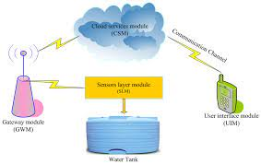

10.4 Wildlife Conservation and IoT
Wildlife conservation has greatly benefited from the integration of IoT (Internet of Things) technology. IoT offers innovative solutions for monitoring, protecting, and studying wildlife and their habitats. Through the deployment of IoT devices such as GPS collars, camera traps, acoustic sensors, and environmental sensors, researchers and conservationists can gather critical data on animal behavior, population dynamics, and ecosystem health.
These devices allow for real-time tracking and monitoring of animals, helping researchers understand migration patterns, habitat preferences, and the impact of environmental changes. Additionally, IoT sensors in remote or inaccessible areas provide valuable insights into ecosystems, including temperature, humidity, and other environmental factors, contributing to a more comprehensive understanding of wildlife habitats.
IoT technology also aids in the prevention of poaching and illegal logging. IoT-based surveillance systems equipped with cameras, motion sensors, and GPS tracking can detect and report suspicious activities in real time, enabling law enforcement agencies and conservation organizations to respond swiftly to protect endangered species and ecosystems.
Furthermore, the data collected through IoT devices fosters scientific research and evidence-based conservation efforts. Researchers can use this information to develop targeted conservation strategies, assess the effectiveness of conservation programs, and make informed decisions about wildlife management.
10.5 Climate Change Mitigation
Climate change mitigation is a global imperative, and IoT (Internet of Things) technology plays a pivotal role in monitoring and addressing its effects. IoT-based environmental monitoring systems provide valuable data and insights that support climate change mitigation efforts in several ways:
    - Greenhouse Gas Monitoring: IoT sensors measure greenhouse gas concentrations such as carbon dioxide (CO2), methane (CH4), and nitrous oxide (N2O) in the atmosphere. These measurements help track emissions, identify sources, and assess progress in reducing greenhouse gas levels.
    - Weather and Climate Data: IoT devices collect real-time weather and climate data, including temperature, humidity, wind speed, and precipitation. This information is crucial for understanding climate patterns and predicting extreme weather events, which are becoming more frequent due to climate change.
    - Renewable Energy Management: IoT supports the efficient management of renewable energy sources such as solar panels and wind turbines. It optimizes energy production and storage, reducing the reliance on fossil fuels and mitigating greenhouse gas emissions.
    - Water Resource Management: IoT-based water quality monitoring systems help manage water resources efficiently. This includes monitoring water availability, quality, and consumption, crucial for sustainable water management in a changing climate.
    - Precision Agriculture: IoT sensors in agriculture provide data on soil conditions, weather, and crop health, allowing for precise resource allocation and reducing the environmental impact of farming practices.
    - Forest and Ecosystem Monitoring: IoT sensors in forests and ecosystems monitor temperature, humidity, and carbon storage. This data helps track deforestation, assess the health of ecosystems, and identify opportunities for reforestation and conservation.
    - Urban Planning:IoT supports smart city initiatives that reduce energy consumption, improve transportation efficiency, and enhance waste management, all of which contribute to lower greenhouse gas emissions in urban areas.
    - Supply Chain Efficiency: IoT enables supply chain optimization, reducing waste and emissions associated with the transportation and distribution of goods.
    - Climate Adaptation: IoT data assists in planning and implementing climate adaptation strategies, helping communities prepare for and respond to the impacts of climate change, such as rising sea levels and extreme weather events.
    - Carbon Footprint Reduction: IoT technologies in homes and buildings optimize energy use, reduce water consumption, and promote sustainable practices, contributing to lower individual and organizational carbon footprints.
By providing real-time data and actionable insights, IoT-based environmental monitoring systems empower governments, organizations, and individuals to make informed decisions that contribute to climate change mitigation. They enable more sustainable resource management, reduced emissions, and greater resilience in the face of a changing climate, helping to combat one of the most pressing global challenges of our time.

11. Future Trends and Emerging Technologies
  - The Future of IoT
The future of the Internet of Things (IoT) holds immense promise, ushering in an era of unprecedented connectivity and automation. As we delve into the chapter on "Future Trends and Emerging Technologies," it becomes evident that IoT will play a central role in shaping the technological landscape. One key trend we anticipate is the proliferation of edge computing, where data processing occurs closer to the data source, reducing latency and enhancing real-time decision-making. Moreover, IoT will increasingly intertwine with artificial intelligence, giving rise to smarter and more autonomous systems. This synergy will enable predictive maintenance, personalized services, and enhanced energy efficiency across industries. However, as IoT grows, so does the need for robust cybersecurity measures to safeguard sensitive data and privacy. In the pages to follow, we will explore these trends and delve into the transformative potential of IoT in greater detail.
    - Edge Computing Dominance: In the future, IoT will rely heavily on edge computing, moving data processing closer to the source. This will reduce latency, enhance real-time decision-making, and alleviate the burden on centralized cloud servers.
    - AI Integration: The convergence of IoT and artificial intelligence (AI) is inevitable. AI-powered IoT devices will become smarter, enabling predictive maintenance, personalized services, and improved energy efficiency across various industries.
    - Predictive Maintenance: IoT will play a pivotal role in predictive maintenance across sectors like manufacturing and transportation, reducing downtime and maintenance costs.
    - Privacy Concerns:As IoT grows, the importance of robust cybersecurity measures will increase to protect sensitive data and user privacy.
    - Industry Transformation: IoT is set to revolutionize industries, from healthcare and agriculture to smart cities, by optimizing processes and enhancing productivity.
    - Energy Efficiency: IoT will help in creating energy-efficient systems by optimizing resource utilization and reducing waste.
    - 5G Connectivity: The deployment of 5G networks will further accelerate the growth of IoT by providing faster and more reliable connectivity.
    - Environmental Impact: IoT can be harnessed to monitor and mitigate environmental issues, such as pollution and climate change, through data collection and analysis.
    - Human-Machine Interaction: IoT will lead to more seamless and intuitive human-machine interactions, improving user experiences and accessibility.
    - Ethical and Regulatory Challenges:The widespread adoption of IoT will raise ethical and regulatory challenges related to data ownership, security, and privacy, which will need to be addressed in the future.
11.2 Quantum Computing and IoT
In the chapter, one of the most intriguing developments on the horizon is the intersection of Quantum Computing and the Internet of Things (IoT). Quantum computing, with its ability to process information exponentially faster than classical computers, holds the potential to revolutionize IoT in several ways. Firstly, quantum computers can handle the complex data analytics required by IoT applications with unprecedented speed, unlocking new possibilities for real-time decision-making and predictive analysis. Secondly, quantum cryptography promises unbreakable security protocols, addressing one of the biggest concerns in IoT - data privacy. Additionally, quantum sensors and devices can significantly enhance IoT's sensing capabilities, enabling the collection of more precise and diverse data. However, this fusion of quantum computing and IoT also brings forth challenges, such as the need for quantum-resistant encryption and the integration of quantum technology into existing IoT infrastructures. As we explore these intersections in the following sections, we'll gain insights into how this amalgamation could reshape our technological landscape.
  - Blockchain and IoT
In the chapter on "Future Trends and Emerging Technologies," the convergence of Blockchain and the Internet of Things (IoT) emerges as a captivating development with profound implications. Blockchain, renowned for its decentralized and tamper-resistant ledger capabilities, is poised to revolutionize the way IoT devices communicate, transact, and secure data. One key advantage is the enhanced trust and security it brings to IoT networks. With blockchain, data integrity and authentication can be ensured, reducing the risk of unauthorized access or data manipulation. Moreover, it facilitates seamless and efficient transactions between IoT devices, opening the door for new business models, such as device-to-device microtransactions. However, challenges remain, including scalability issues, energy consumption concerns, and the need for industry-wide standards. As we delve into the following sections, we'll explore how this fusion of blockchain and IoT technologies holds the potential to reshape industries and redefine trust in connected ecosystems.
    - Enhanced Security: Blockchain's immutable and decentralized nature can significantly enhance the security of IoT networks by preventing data tampering and unauthorized access, making IoT systems more resilient to cyberattacks.
    - Data Integrity and Provenance:Blockchain allows for the transparent tracking of data across the IoT ecosystem, ensuring data integrity and establishing a clear audit trail, which is particularly crucial in applications like supply chain management and healthcare.
    - Smart Contracts: Blockchain enables the implementation of smart contracts in IoT, automating transactions and agreements between devices without the need for intermediaries. This can streamline processes and reduce costs.
    - Challenges and Scalability: Scalability and energy consumption are ongoing challenges in integrating blockchain with IoT. Overcoming these hurdles and establishing interoperable standards will be essential for widespread adoption.
  - Human-Machine Integration
Human-Machine Integration stands at the forefront of future trends in emerging technologies, offering a glimpse into a world where humans and machines collaborate seamlessly. In this chapter, we explore the profound impact of this integration on various facets of our lives. From healthcare to education, industries are leveraging advanced technologies like brain-computer interfaces and augmented reality to enhance human capabilities and experiences. This synergy between humans and machines promises to revolutionize productivity, creativity, and accessibility. However, it also brings forth ethical and privacy concerns, raising questions about data ownership, consent, and the potential for bias in decision-making algorithms. As we delve into this topic, we will uncover the transformative potential of Human-Machine Integration while acknowledging the need for careful ethical considerations and regulations.
    - Enhanced Productivity:Human-Machine Integration can boost productivity by automating routine tasks, providing real-time data and insights, and enabling faster decision-making. This can benefit various sectors, including manufacturing, logistics, and healthcare.
    - Ethical Considerations: As humans and machines become increasingly integrated, ethical concerns arise regarding data privacy, consent, and the potential for bias in algorithms. Striking the right balance between technological advancement and ethical responsibility is crucial in this evolving landscape.

11.5 Ethical and Societal Implications
In the chapter on "Future Trends and Emerging Technologies," it becomes increasingly evident that the rapid progression of innovation and technology brings with it a myriad of ethical and societal implications that demand our attention. While these emerging technologies hold immense promise and potential for transformative change across various sectors, they also introduce complex dilemmas that must be navigated carefully. Privacy concerns loom large as we witness the unprecedented collection, analysis, and utilization of vast quantities of personal data. This raises ethical questions about the boundaries of data surveillance, user consent, and the security of sensitive information in an increasingly interconnected world. The responsible handling of data becomes paramount, as it is not only a matter of individual privacy but also a societal trust issue.The specter of bias and fairness haunts the development and deployment of artificial intelligence (AI) and machine learning systems. These technologies can perpetuate societal biases present in their training data, potentially leading to unjust outcomes in domains such as criminal justice, employment, and finance. Ethical considerations require us to address these biases systematically and develop algorithms that are not only accurate but also fair and transparent.
Automation and AI-driven advancements have the potential to transform industries and increase productivity, but they also raise concerns about job displacement and economic inequality. Ethical responses involve proactively addressing these potential disruptions by investing in workforce retraining, upskilling programs, and a comprehensive safety net to support individuals affected by these technological shifts.Ethical AI development principles are essential to ensure that AI systems align with human values. Transparency, accountability, and the prevention of harm should be at the forefront of AI deployment. This includes the responsible use of AI in decision-making processes, such as those affecting healthcare, finance, and criminal justice, where people's lives and livelihoods are often at stake.Moreover, the societal implications of digital inequality persist, as not everyone has equal access to emerging technologies. Bridging the digital divide is not just a matter of ensuring fair access but also recognizing that exclusion from the benefits of technology can exacerbate existing social and economic disparities.Security and cybersecurity challenges accompany the increasing reliance on technology, as the risk of cyberattacks and data breaches escalates. Ensuring the security and integrity of digital infrastructure is an ethical imperative, as these vulnerabilities can lead to far-reaching consequences, including the compromise of critical infrastructure and personal information.
Biotechnology and medical advancements, while offering the potential to cure diseases and enhance human health, bring forth ethical questions about the responsible use of genetic data, gene editing, and the potential for designer babies. Balancing medical progress with ethical considerations, such as informed consent and societal norms, is paramount in this evolving landscape.The environmental impact of emerging technologies also demands ethical scrutiny. While technology can provide solutions to pressing environmental challenges, it can also contribute to problems such as e-waste and increased energy consumption. As we journey into a future shaped by emerging technologies, it is imperative that we engage in thoughtful and deliberate discussions about the ethical and societal implications that accompany these advancements. Striking a balance between innovation and responsible use, while upholding human values and ensuring equitable access, is central to building a future that benefits all of humanity.

References

- Third Generation Partnership Project, Technical Report 36.888 v12.0.0, Study on Provision of Low-cost Machine-Type Communications (MTC) User Equipment (UEs) Based on LTE, 2013.
- Third Generation Partnership Project, Technical Report 45.820 v13.0.0, Cellular System Support for Ultralow Complexity and Low Throughput Internet of Things, 2016.
- Third Generation Partnership Project, Technical Specification 23.060 v14.0.0, General Packet Radio Service (GPRS); Service Description; Stage 2, 2016.
- Third Generation Partnership Project, Technical Specification 24.008 v14.0.0, Mobile Radio Interface Layer 3 Specification; Core Network Protocols; Stage 3, 2016.
- Third Generation Partnership Project, Technical Specification 36.211 v14.0.0, Evolved Universal Terrestrial Radio Access (E-UTRA); Physical Channels and Modulation, 2016.
- Third Generation Partnership Project, Technical Specification 36.306 v14.0.0, Evolved Universal Terrestrial Radio Access (E-UTRA); User Equipment (UE) Radio Access Capabilities, 2016.
- Third Generation Partnership Project, Technical Report 38.913, v14.2.0, Technical Specification Group Radio Access Network; Study on Scenarios and Requirements for Next Generation Access Technologies; (Release 14), March 2017.
- Third Generation Partnership Project, Technical Specifications 36.331 v13.3.0, Evolved Universal Terrestrial Radio Access (E-UTRA) and Evolved Universal Terrestrial Radio Access Network (E-UTRAN); Radio Resource Control (RRC); Protocol Specification, 2016.
- Cisco, The Zettabyte Era: Trends and Analysis, Cisco White Paper, 2016.
- Sigfox, About Sigfox, 2016. Available: http://makers.sigfox.com/.
- Sigfox, Sigfox Coverage, 2016. Available: http://www.sigfox.com/coverage.
- LoRa Alliance, LoRa AllianceWide Area Networks for IoT, 2016. Available: https://www.lora-alliance.org/.
- LoRa Alliance Technical Marketing Workgroup 1.0, LoRaWAN, What Is it?, A Technical Overview of LoRa and LoRaWAN, White Paper, November 2015.
- E. Dahlman, S. Parkvall, J. Sko¨ld, 4G: LTE/LTE-Advanced for Mobile Broadband, Academic Press, Oxford, 2011.
- O. Liberg, M. Sundberg, E. Wang, J. Bergman, J.Sachs, “Cellular Internet of Things: Technologies, Standards, and Performance”, Academic Press, ISBN: 978-0-12-812458-1, Oct. 2017.
- GSMA, “IoT Device Connection Efficiency Guidelines” Version 5.0, January 2018.
- S. Vitturi, C. Zunino and T. Sauter, “Industrial Communication Systems and Their Future Challenges: Next-Generation Ethernet, IIoT, and 5G,” in Proceedings of the IEEE, vol. 107, no. 6, pp. 944-961, June 2019,
- doi: 10.1109/JPROC.2019.2913443. F. John Dian, R. Vahidnia and A. Rahmati, “Wearables and the Internet of Things (IoT), Applications, Opportunities, and Challenges: A Survey,” in IEEE Access, vol. 8, pp. 69200-69211, 2020, doi: 10.1109/ACCESS.2020.2986329.
- F. J. Dian and R. Vahidnia, “LTE IoT Technology Enhancements and Case Studies,” in IEEE Consumer Electronics Magazine, doi: 10.1109/MCE.2020.2986834.
- F. J. Dian, R. Vahidnia, “Formulation of BLE Throughput Based on Node and Link Parameters,” IEEE Canadian journal of Electrical and Computer Engineering, vol. 43, no. 4, pp. 261-272, Fall 2020, doi: 10.1109/CJECE.2020.2968546.
- F. J. Dian, A. Yousefi, S. Lim, “A practical study on Bluetooth Low energy (BLE) throughput,” in IEEE IEMCON, pp. 768-771, Vancouver, Nov. 2018.
- F. J. Dian, “Low-power Synchronized Multi-channel Data Acquisition Communication System,” in IEEE CCWC, pp. 1027-1031, Las Vegas, Jan. 2019.
- F. J. Dian, A. Yousefi, K. Somaratne , “A study in accuracy of time synchronization of BLE devices using connection-based event,” in IEEE IEMCON, pp. 595 – 601, Vancouver, OCT. 2017.
- F. J. Dian, A. Yousefi, K. Somaratne, “Performance evaluation of time synchronization using current consumption pattern of BLE devices,” in IEEE CCWC, pp. 906-910, Las Vegas, Jan. 2018.
- F. J. Dian, “An analytical scheme for power consumption of battery-operated peripheral BLE nodes,” in 9th IEEE CCWC, pp. 1021-1026, Las Vegas, Jan. 2019.
- F. J. Dian, A. Yousefi, S. Lim, “Time scheduling of central BLE for connection events,” in IEEE IEMCON, pp. 763-767, Vancouver, Nov. 2018.
- A.Yousefi, F. J. Dian, K. Somaratne “Analysis of time synchronization based on current measurement for Bluetooth Low Energy (BLE),” in IEEE IEMCON, pp. 602 – 607, Vancouver, OCT. 2017.
- K. Somaratne, F. J. Dian, A. Yousefi, “Accuracy analysis of time synchronization using current consumption pattern of BLE devices,” in IEEE CCWC, pp. 841-844, Las Vegas, Jan. 2018.
- Lingala, Raghavendarraju. (2023). Futuristic Trends in IOT.
- Sanchez-Iborra, R., & Cano, M. D. (2016). State of the art in LP-WAN solutions for industrial IoT services. Sensors, 16(5), 708.
- Sun, W., Liu, J., & Yue, Y. (2019). AI-enhanced offloading in edge computing: When machine learning meets industrial IoT. IEEE Network, 33(5), 68–74.
- Breivold, H. P., & Sandström, K. (2015, December). Internet of things for industrial automation –Challenges and technical solutions. In Proceedings 8th IEEE International Conference on Internet Things (iThings) (pp. 532–539). IEEE.
- Pop, P., Zarrin, B., Barzegaran, M., Schulte, S., Punnekkat, S., Ruh, J., & Steiner, W. (2021).
- The FORA fog computing platform for industrial IoT. Information Systems, 98, 101727.
- Cerina, L., Notargiacomo, S., Paccanit, M. G., & Santambrogio, M. D. (2017, September). A fog-computing architecture for preventive healthcare and assisted living in smart ambients.
- In 2017 IEEE 3rd International Forum on Research and Technologies for Society and Industry (RTSI) (pp. 1–6). IEEE.
- Jameel, F., Javaid, U., Khan, W. U., Aman, M. N., Pervaiz, H., & Jäntti, R. (2020).
- Reinforcement learning in blockchain-enabled IIoT networks: A survey of recent advances and open challenges. Sustainability, 12(12), 5161.
- Huang, J., Kong, L., Chen, G., Wu, M. Y., Liu, X., & Zeng, P. (2019). Towards secure industrial IoT: Blockchain system with credit-based consensus mechanism. IEEE Transactions on Industrial Informatics, 15(6), 3680–3689.
- Zolanvari, M., Teixeira, M. A., Gupta, L., Khan, K. M., & Jain, R. (2019). Machine learningbased network vulnerability analysis of industrial internet of things. IEEE Internet of Things Journal, 6(4), 6822–6834.
- Varga, P., Peto, J., Franko, A., Balla, D., Haja, D., Janky, F., … Toka, L. (2020). 5G support for industrial IoT applications – Challenges, solutions, and research gaps. Sensors, 20(3), 828.
- Li, J. Q., Yu, F. R., Deng, G., Luo, C., Ming, Z., & Yan, Q. (2017). Industrial internet: A survey on the enabling technologies, applications, and challenges. IEEE Communications Surveys & Tutorials, 19(3), 1504–1526.
- Zhang, Y., Guo, Z., Lv, J., & Liu, Y. (2018). A framework for smart production-logistics systems based on CPS and industrial IoT. IEEE Transactions on Industrial Informatics, 14(9), 4019–4032.
- Hossain, M. S., & Muhammad, G. (2016). Cloud-assisted industrial internet of things (iiot) – enabled framework for health monitoring. Computer Networks, 101, 192–202.
- Civerchia, F., Bocchino, S., Salvadori, C., Rossi, E., Maggiani, L., & Petracca, M. (2017).
- Industrial internet of things monitoring solution for advanced predictive maintenance
applications. Journal of Industrial Information Integration, 7, 4–12.
- Koziolek, H., Burger, A., & Doppelhamer, J. (2018, April). Self-commissioning industrial IoTsystems in process automation: A reference architecture. In 2018 IEEE International Conference on Software Architecture (ICSA) (pp. 196–19609). IEEE.
- Li, W., Wang, B., Sheng, J., Dong, K., Li, Z., & Hu, Y. (2018). A resource service model in the
- industrial IoT system based on transparent computing. Sensors, 18(4), 981.
- Merchant, H. K., & Ahire, D. D. (2017). Industrial automation using IoT with raspberry pi. International Journal of Computer Applications, 168(1), 44–46.
- Ferrari, P., Sisinni, E., Brandão, D., & Rocha, M. (2017, September). Evaluation of
communication latency in industrial IoT applications. In 2017 IEEE International Workshop on
Measurement and Networking (M&N) (pp. 1–6). IEEE.
- Sharma, M., Pant, S., Kumar Sharma, D., Datta Gupta, K., Vashishth, V., & Chhabra, A. (2021).
- Enabling security for the industrial internet of things using deep learning, blockchain, and
coalitions. Transactions on Emerging Telecommunications Technologies, 32(7), e4137.
- Al-Marridi, A. Z., Mohamed, A., & Erbad, A. (2021). Reinforcement learning approaches for efficient and secure blockchain-powered smart health systems. Computer Networks, 197, 108279.
- Hussain, S., Ullah, I., Khattak, H., Khan, M. A., Chen, C. M., & Kumari, S. (2021). A lightweight and provable secure identity-based generalized proxy signcryption (IBGPS) scheme for industrial internet of things (IIoT). Journal of Information Security and Applications, 58, 102625.
- Yang, H., Bao, B., Li, C., Yao, Q., Yu, A., Zhang, J., & Ji, Y. (2021). Blockchain-enabled tripartite anonymous identification trusted service provisioning in industrial IoT. IEEE Internet of Things Journal, 9(3), 2419–2431.
- Latif, S., Idrees, Z., Ahmad, J., Zheng, L., & Zou, Z. (2021). A blockchain-based architecture for secure and trustworthy operations in the industrial internet of things. Journal of Industrial Information Integration, 21, 100190.
- Feng, Y., Zhang, W., Luo, X., & Zhang, B. (2021). A consortium blockchain-based access
- control framework with dynamic orderer node selection for 5G-enabled industrial IoT. IEEE Transactions on Industrial Informatics, 18(4), 2840–2848.
- Esfahani, A., Mantas, G., Matischek, R., Saghezchi, F. B., Rodriguez, J., Bicaku, A., … Bastos,J. (2017).
- A lightweight authentication mechanism for M2M communications in industrial IoT
environment. IEEE Internet of Things Journal, 6(1), 288–296.
- Katsikeas, S., Fysarakis, K., Miaoudakis, A., Van Bemten, A., Askoxylakis, I., Papaefstathiou, I., & Plemenos, A. (2017, July). Lightweight & secure industrial IoT communications via the MQ telemetry transport protocol. In 2017 IEEE Symposium on Computers and Communications(ISCC) (pp. 1193–1200). IEEE.
- Meng, Z., Wu, Z., Muvianto, C., & Gray, J. (2016). A data-oriented M2M messaging mechanism for industrial IoT applications. IEEE Internet of Things Journal, 4(1), 236–246.
- Vaidya, B., & Mouftah, H. T. (2020). IoT applications and services for connected and
autonomous electric vehicles. Arabian Journal for Science and Engineering, 45(4), 2559–2569.
- Ciancio, V., Homri, L., Dantan, J. Y., & Siadat, A. (2020). Towards prediction of machine failures: Overview and first attempt on specific automotive industry application. IFACPapersOnLine, 53(3), 289–294.
- Dashora, C., Sudhagar, P. E., & Marietta, J. (2020). IoT based framework for the detection of vehicle accident. Cluster Computing, 23(2), 1235–1250.
- Ojha, T., Misra, S., & Raghuwanshi, N. S. (2015). Wireless sensor networks for agriculture: The state-of-the-art in practice and future challenges. Computers and Electronics in Agriculture, 118, 66–84.
- Savale, O., Managave, A., Ambekar, D., & Sathe, S. (2015). Internet of things in precision agriculture using wireless sensor networks. International Journal of Advanced Engineering & Innovative Technology, 2(3), 1–5.
- Gondchawar, N., & Kawitkar, R. S. (2016). IoT based smart agriculture. International Journal of Advanced Research in Computer and Communication Engineering (IJARCCE), 5(6), 177–181.
- Suma, D. N., Samson, S. R., Saranya, S., Shanmugapriya, G., & Subhashri, R. (2017). IOT based smart agriculture monitoring system. International Journal on Recent and Innovation
Trends in Computing and Communication, 5(2), 177–181.
- Mohanraj, I., Ashokumar, K., & Naren, J. (2016). Field monitoring and automation using IOT in agriculture domain. Procedia Computer Science, 93, 931–939.
- Kansara, K., Zaveri, V., Shah, S., Delwadkar, S., & Jani, K. (2015). Sensor based automated irrigation system with IOT: A technical review. International Journal of Computer Science and Information Technologies, 6(6).
- Rukhmode, S., Vyavhare, G., Banot, S., Narad, A., & Tugnayat, R. M. (2017) IOT based
agriculture monitoring system using wemos. In International Conference on Emanations in
Modern Engineering Science and Management (ICEMESM-2017) (Vol. 5, No. 3, pp. 14–19).
Yashika publications.
- Sarkar, P. J., & Chanagala, S. (2016). A survey on iot based digital agriculture monitoring system and their impact on optimal utilization of resources. Journal of Electronics and Communication Engineering (IOSR-JECE), 1–4.
- Carrasquilla-Batista, A., Chacón-Rodríguez, A., & Solórzano-Quintana, M. (2016, November). Using IoT resources to enhance the accuracy of overdrain measurements in greenhouse horticulture. In Central American and Panama Convention (CONCAPAN XXXVI), 2016 IEEE 36th (pp. 1–5). IEEE.
- Wang, X. F., Wang, Z., Zhang, S. W., & Shi, Y. (2015, October). Monitoring and discrimination of plant disease and insect pests based on agricultural IOT. In International Conference on
- Information Technology and Management Innovation (ICITMI 2015) (p. 112–115). AtlantisPress.
- Mahajan, T. (2016). IOT based agriculture automation with intrusion detection. International Journal of Scientific and Technical Advancements, 2(4), 269–274.
- Jawad, H. M., Nordin, R., Gharghan, S. K., Jawad, A. M., & Ismail, M. (2017). Energy-Efficient wireless sensor networks for precision agriculture: A review. Sensors, 17(8), 1781.
- Liqiang, Z., Shouyi, Y., Leibo, L., Zhen, Z., & Shaojun, W. (2011). A crop monitoring system based on wireless sensor network. Procedia Environmental Sciences, 11, 558–565.
- Sun, J., Chen, D., Zhang, N., Xu, G., Tang, M., Nie, X., & Cao, M. (2021). A privacy-aware and traceable fine-grained data delivery system in cloud-assisted healthcare IIoT. IEEE Internet of Things Journal, 8(12), 10034–10046.
- Hossain, M. S., & Muhammad, G. (2016). Cloud-assisted industrial internet of things (iiot) – enabled framework for health monitoring. Computer Networks, 101, 192–202.
- Iwanicki, K. (2018, July). A distributed systems perspective on industrial IoT. In 2018 IEEE 38th International Conference on Distributed Computing Systems (ICDCS) (pp. 1164–1170). IEEE.
- Varga, P., Peto, J., Franko, A., Balla, D., Haja, D., Janky, F., … Toka, L. (2020). 5G support for industrial IoT applications – Challenges, solutions, and research gaps. Sensors, 20(3), 828.
- Sethi, R., Bhushan, B., Sharma, N., Kumar, R., & Kaushik, I. (2021). Applicability of industrial IoT in diversified sectors: Evolution, applications and challenges. In Multimedia Technologies in the Internet of Things Environment (pp. 45–67). Springer.
- Belhadi, A., Djenouri, Y., Srivastava, G., & Lin, J. C. W. (2021). SS-ITS: Secure scalable
- intelligent transportation systems. The Journal of Supercomputing, 1–17.
- Moens, P., Bracke, V., Soete, C., Vanden Hautte, S., Nieves Avendano, D., Ooijevaar, T.,
- Van Hoecke, S. (2020). Scalable fleet monitoring and visualization for smart machine
maintenance and industrial IoT applications. Sensors, 20(15), 4308.
- Petroulakis, N. E., Lakka, E., Sakic, E., Kulkarni, V., Fysarakis, K., Somarakis, I., … Waledzik, K. (2019, June).
- Semiotics architectural framework: End-to-end security, connectivity and
interoperability for industrial iot. In 2019 Global IoT Summit (GIoTS) (pp. 1–6). IEEE.
- Karaagac, A., Verbeeck, N., & Hoebeke, J. (2019, April). The integration of LwM2M and OPCUA: An interoperability approach for industrial IoT. In 2019 IEEE 5th World Forum on Internet of Things (WF-IoT) (pp. 313–318). IEEE.
- Luvisotto, M., Tramarin, F., Vangelista, L., & Vitturi, S. (2018). On the Use of LoRaWAN for Indoor Industrial IoT Applications. Wireless Communications and Mobile Computing, 2018.

