An overview of carbon dots synthesis, properties, and applications towards energy and environmental remediation

Vinoth Selvaraj^{a,}
ª Department of Chemistry,
Ben-Gurion University of the Negev,
P.O. Box 653, Beer-Sheva 84105, Israel.

Abstract
This book chapter captured the importance of existing and emerging carbon dots (CDs) based materials that are inexpensive and vigorously used towards environmental remediation-based applications. This chapter can summarize the photocatalytic degradation of organophosphates by CDs-based composites and hybrid materials synthesis, characterization, and applications towards photocatalytic degradation of organophosphates. Indeed, this chapter would bounce the future insights for the researchers working on the photocatalytic degradation of organophosphates. This survey could scrutinize the fascinating photocatalytic features of CDs that can aid in investigating their interaction with other environmental pollutants. This chapter has benefited materials scientists, chemists, biologists, and clinicians.

Keywords:
Carbon dots; synthesis and properties; photocatalytic degradation; atmospheric pollutants; environmental remediation.

1. Introduction
Environmental protection is anticipated to benefit considerably from nanotechnology [1]. Multitudinous nanomaterials have been systematically analyzed over the last twenty years for environmental remediations due to their potential characteristics of properties [2]. Nanomaterials with diverse uses in environmental decontamination, pollutant monitoring, and energy invention include transition metal oxides, sulfides, nitrides, phosphide, carbon-based 2D materials, and metal-organic frameworks [3-6]. Researchers and scientists are fascinated by carbon nanostructures [8-9]. Carbon-based nanomaterials, such as fullerene, pristine graphene, graphene oxide (GO), carbon nanotubes (CNT), and reduced graphene oxide (RGO) exhibit exceptional water stability, high specific surface areas, and substantial pore volumes. As a result, they are frequently employed in various environmental applications, including sensing, adsorptive contamination removal, photo-catalytic degradation, energy storage and conversion [10-13]. The carbon nanostructures come in a variety of shapes, from zero-dimensional "Carbon Dots" (CDs), 1D CNT and nanowires, 2D graphene, and other materials [14]. In a study published in 2004, two significant impurities like, "short tubular carbon fragments" and "fluorescent carbon," were identified and examined while single-walled carbon nanotubes (SWCNTs) were being purified. This study is where the first reports of CDs appeared [15]. Further work in 2006 discovered that the surface functionalization of the fluorescent carbon impurities further improved their intriguing size-dependent emissive capabilities [16]. The CDs are spherical-shaped nanoparticles under 10 nm that frequently have surface-functionalized carbon cores with sp² and sp³ hybridized carbon entities [17]. An example of a low-dimensional system like this would exhibit quantum confinement and unique qualities like a more significant band gap, photostability, biocompatibility, better water solubility, and non-toxicity [18]. This book chapter explains the potential utilization of CDs in environmental remediation and pollution control technologies (Figure 1).

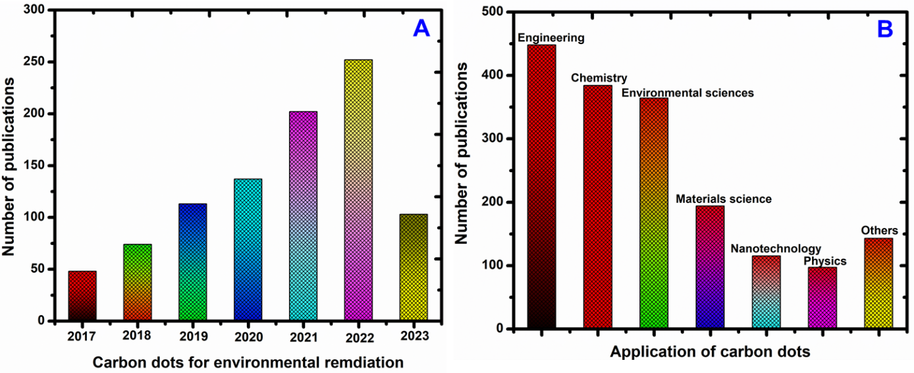
Figure 1. (A) Number of articles reported on “Carbon Dots for Environmental Remediation” from 2017 to 2023, (B) Number of articles reported on different fields for “Carbon Dots for Environmental Remediation” according to a Web of Science database search up to August-2023.

2. Carbon dots synthesis
Since Xu, et al, discovered CDs in 2004 [19], several techniques have been created to produce CDs. Top-down and bottom-up methods have both been used to manufacture carbon dots. CDs are formed when larger precursor molecules are broken down top-down. This strategy uses arc discharge, electrochemical processes, and laser ablation as techniques [20]. Contrarily, bottom-up strategies use simpler molecular precursors that are polymerized into CDs [21].
Some examples of bottom-up techniques are microwave and solvothermal synthesis, high thermal breakdown, and hydrothermal carbonization. Continuous and microfluidics-based techniques, such as low-temperature ceramic microreactors and continuous hydrothermal flow synthesis, have gained popularity recently because of improved heat transfer and reaction mixture homogenous distribution, which significantly cuts down on the amount of time needed, boosts yield, and makes them more suitable for industrial use [22-25].

2.1. Top-down synthesis
With the top-down method, more considerable carbon structure fragments like graphene, graphite, carbon nanotubes, and activated carbon are broken down using arc discharge, laser ablation, and electrochemical oxidation processes. Due to the simplicity of morphological control during this process, arc discharge has been widely employed for CD preparation.
Another popular method for producing CDs is electrochemical oxidation, which has the benefits of being inexpensive, high-purity, high-yield, simple to adjust size, and repeatable [26]. The first report on an electrochemical method for CD production was made in 2007 by Zhou's group [27].
Ming and colleagues recently developed a one-step electrochemical process that produced high-quality and pure CDs using only water as the electrolyte [28]. The CD synthesis process is cost-effective and ecologically benign thanks to this technique's excellent manufacturing efficiency. Chen et al. prepared CDs using easily accessible and inexpensive sucrose as a carbon source, which allowed them to considerably lower initial materials costs and increase the scale of CD production [29].
Additionally, Sun et al. invented the process of creating CDs via graphite powder for laser ablation while employing argon as a carrier gas and water vapor as a shield [30]. These synthesis techniques have significantly aided in the production of CDs.

2.2. Bottom-up approach
As an alternative to the above procedure, CDs can be produced by carbonizing the small molecules using hydrothermal techniques, microwave synthesis, calcination, or annealing [31]. Hydrothermal is a widely used because of the readily available, straightforward synthesis, ecologically friendly procedure, independence from high-cost instruments, and nontoxic route. The carbon sources can come from discarded peels, organic acids, sugars, or juice.
Natural carbon sources are utilized in creating CDs more frequently than conventional sources due to their affordability, ecological friendliness, and recent growth in availability [32–34]. Most hydrothermal techniques for CDs often call for a hydrothermal reactor to seal and react with the organic precursor under high pressures, for extended times, and at high temperatures.
Electromagnetic waves from 300 MHz to 300 GHz are defined as microwaves, and they have the power to disrupt the chemical bonds of the raw materials. The microwave approach can deliver uniform heating and efficiently shorten reaction times, resulting in uniform CD particle size distribution [35-36]. Recent research has shown that short external heat pulses can help to chemically oxidize and carbonize organic materials, converting them into CDs [37].
Because they utilize low-cost precursors, facile operation, rapid reaction times, and solvent-free processes, the hydrothermal and microwave synthesis methods are most frequently utilized in CD environmental applications. Usually, CDs synthesis can be considered via “top-down” and “bottom-up” approaches (Figure 2).

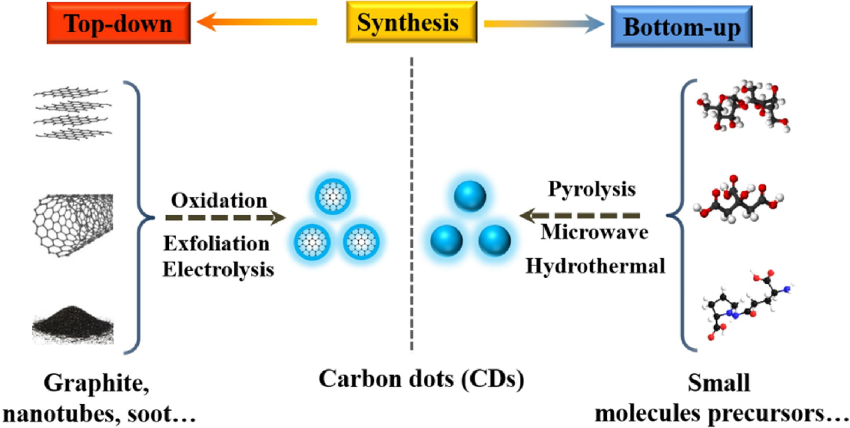

Figure 2. Carbon dots synthesis methods (adapted from Ref. 7)

3. Carbon dot properties
CDs possess a broad range of physical and chemical characteristics attributed to the diversity of precursors and synthetic approaches. Similar characteristics shared by several CDs include their solubility in water, environmental friendliness, lack of toxicity, tunable fluorescence, and excellent stability [38-39]. This section discusses CDs' physical, chemical, and optical properties in greater detail.

3.1. Physicochemical properties
An intriguing class of carbon nanoparticles through a typical size of 10 nm is known as CDs [38,40]. CDs demonstrate the quantum confinement effect due to the oxygenated functional groups on their surfaces changing surface constructions and the size of the particles [41-42].
Additionally, CDs are better at moving charges (excellent at trapping and moving electrons), which can effectively prevent charge recombination created by light [43-44]. The increased charge transport is partly due to the size-dependent visual properties of CDs, where the distance among small charge carriers and typically fewer than the diffusion carrier length [45].
Since photocatalysis occurs at edges more frequently than at basal planes, CDs' edge-rich properties benefit this reaction. Therefore, destroying organic contaminants using photocatalysis is a fantastic alternative for CDs. Additionally, CDs' particular chemical inertness and exceptional water stability make them suitable for application in nanotechnology and sensor production.

3.2. Optical properties
Overall, CDs demonstrate solid optical absorption in the UV region, with a tail that reaches into the visible region and absorption that concentrates between 260 and 320 nm [46]. The chemical groups found on CDs may influence the UV-visible regions' absorption. The observed variations in the absorption spectra data imply that diverse hybrid derivatives have different compositions or structures, at least in part.
The fluorescence emission properties of excitation-dependent are present in the bulk of previously characterized CDs, and CDs get redder as the excitation wavelength increases [47]. On the other hand, some research has covered the excitation-independent CDs emission spectrum. As an illustration, Liu et al. reported creating fresh CDs using potassium persulfate and acrylamide as a precursor.
Intriguingly, the independence of CDs from excitation was demonstrated by the fact that the fluorescence emission peak at 434 nm barely changed when the excitation wavelength was changed within the 280-390 nm range. CDs' quantum size impact was thought to be related to this phenomenon [48].
Understanding the mechanics underlying the fluorescence of CDs is essential for controlling their fluorescence and other physicochemical properties and expanding their range of applications. The fluorescence mechanism has thus been the focus of in-depth study.

3.3. Upconversion Photoluminescence
CDs' characteristic upconversion photoluminescence (UCPL) has been extensively applied for bioimaging and photocatalysis. The UCPL process, which concurrently absorbs several photons and generates fluorescence through a smaller wavelength over the excitation basis, produces the anti-stokes emission [49-50].
Cao et al. found the significant two-photon fluorescence from near-infrared stimulation by laser ablation [51]. It recommended NIR photoluminescent built of dopamine and o-phenylenediamine that displayed two-photon emission utilizing an 800 nm femtosecond pulse laser [52].
Since they can be combined with widespread band semiconductors to increase the absorption range of CDs and to be used as spectral converters in photocatalysis.

3.4. Photoinduced Charge Migration
The distribution of graphitized-conjugated areas in CDs guarantees good electrical conductivity. Consequently, CDs have emerged as a growing star emphasizing charge transfer capability, such as in photocatalysis or optoelectronics [53-54].
Steady-state of time-resolved spectroscopy showed that this fluorescence quenching was caused by charge transportation in the excited state. Furthermore, CDs act as supramolecular frameworks by their building blocks with customized electronic properties to further investigate charge movement performance as electron-donor or acceptor [55-56].
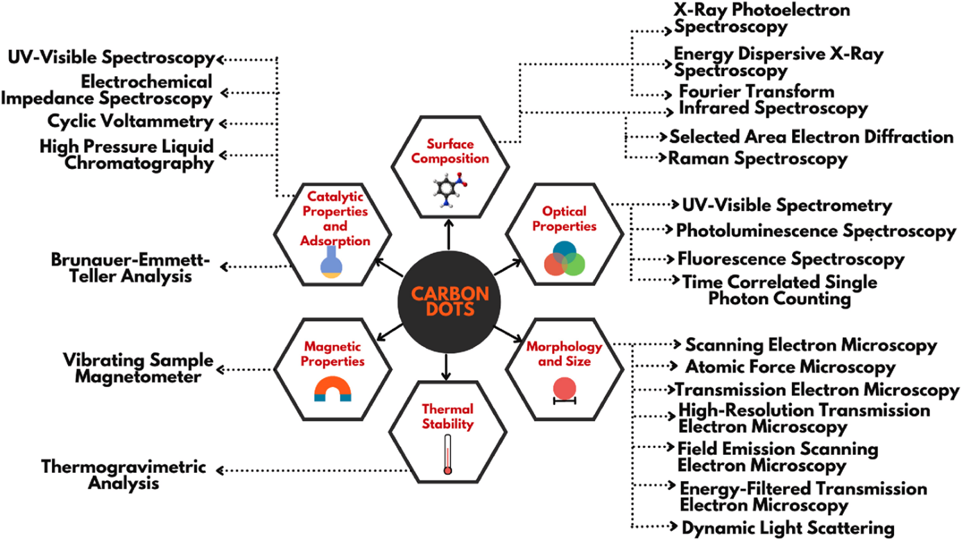

Figure 3. A flow chart on numerous properties of carbon dots (adapted from Ref. 8)

4. CDs for environmental remediation
Although membrane separation and adsorption can eliminate inorganic or organic contaminants from water, they cannot entirely decompose the contaminants; this could necessitate additional disposal. Environmental contaminants may completely degrade or become mineralized with photocatalytic treatment.
The degradation by photocatalysis has emerged in appealing method for treating wastewater treatment [57-58]. Due to the following characteristics, CDs have a great deal of potential for use in the photocatalytic destruction of environmental pollutants:
(i) CDs outperform conventional photocatalytic semiconductor materials (such as TiO₂, ZnO, and CdS) in terms of chemical stability, water solubility, affordability, and environmental friendliness;
(ii) CDs have outstanding and adjustable optoelectronic and photoluminescent capabilities. In particular, wide bandgap semiconductors' sunlight absorption into the visible and near-infrared regions can be significantly increased by CDs' up-conversion photoluminescence;
(iii) CDs can effectively distinguish electrons from holes and outstanding electron donors and acceptors. As a result, CDs can be utilized in the design of electron mediator, spectrum converter, solitary photocatalyst, photosensitizers, and catalytic centers [31, 38].
Table 1 provides an overview of current developments in bare CDs and CDs-based hybrid photocatalysts for the degradation of environmental pollutants.

Table 1. Recapitulation CDs-based photocatalysts for environmental pollutant degradation.
Photocatalysts | Synthesis | Degraded pollutants | Ref.
CDs | Reflux | Methylene blue | [59]
N-CDs | Hydrothermal | 2, 4-dichlorophenol | [60]
N-CDs | Ultrasonic | Rhodamine B | [61]
Au/CDs | Electro-chemical | Cyclohexane | [62]
Cu–N-CDs | Pyrolysis | 1, 4-dihydro-2, 6-dimethylpyridine-3, 5-dicarboxylate | [63]
TiO₂/CDs | Calcination | Ciprofloxacin | [64]
TiO₂/CDs | Hydrothermal | Paraoxon pesticide | [65]
ZnO/CDs | Electrochemical Hydrothermal | Gas-phase benzene | [66]
Fe₂O₃/CDs | Electrochemical and Hydrothermal | Benzene and methanol | [67]
g-C₃N₄/S, N: CDs | Hydrothermal | Rhodamine B | [68]

4.1. Photodegradation of dyes
Large-scale dye discharges into the aquatic environment, ubiquitous components in industrial effluent, may increase oxygen ingestion during natural humiliation and result in the widespread anoxic demise of organisms.
There has been much research done so far on the degradation of usual organic dyes like Methylene Blue (MB), Rhodamine B (RhB), and Methyl Orange (MO) using various CDs situated photocatalysts. Additionally, CDs can serve as an electron transfer conduit in a photocatalytic system between two photosensitive parts, allowing for an improved separation of photo-excited holes and electrons.
The plasmonic photocatalyst comprises CPDs/Ag/Ag₂O to improve photostability and electron-hole separation [69]. This ternary photocatalyst displays exceptional degrading efficiency across the spectrum, following the larger electron transfer capacity and upconversion characteristic of CPDs (Figure 4A).
Photodegradation of dyes can be evaluated by Feng et al. through CdS/CPDs/g-C₃N₄ (CSCCN) composites with Z-scheme transfer and vis-NIR light response (Figure 4B) [70].
Using the electron chemical impedance spectroscopy (EIS), photoluminescence (PL) spectra, and the transient photocurrent responses, CdS/g-C₃N₄ and CPDs/g-C₃N₄ indicating that carriers had longer lifetimes.
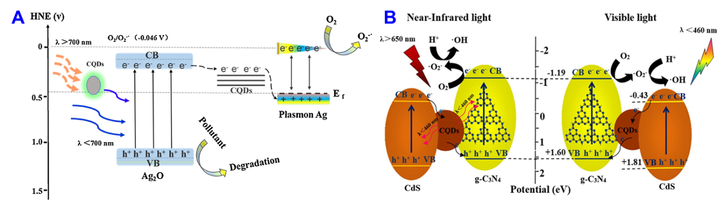
Figure 4. (A) A projected reaction mechanism for pollutant degradation on the nanocomposites of CQDs/Ag/Ag₂O and (B) Energy band diagram of CdS/CQDs/g-C₃N₄ through Z-scheme electron transfer (Adapted from Ref. 69 and 70)

4.2. Photodegradation of plastics
Along with pollutants in the water, a significant issue in the realm of eco-sustainability is the conversion or degradation of hard plastic trash. The annual production of plastic worldwide has remained constant in recent years at thousands of countless tons [71].
Most plastics, however, cannot break down naturally, and their combustion or disposal in landfills may release large amounts of plastic particles and flue gas into the atmosphere, harming nearby wildlife [72]. Han et al. realized photocatalytic recycling of polyethylene terephthalate (PET) and polylactic acid (PLA) along with simultaneous H₂ generation [73].
Graphitic carbon nitride (GCN) powders are added to CPD solutions before hydrothermal processing to create this composite catalyst. During the above-mentioned process, photo-excited holes were continually disbursed, and the residual electrons powered the conversion of H₂O to H₂.
It has been demonstrated that adding CPDs to GCN can significantly increase the charge carrier lifetime and assist carrier partition by reducing fluorescence lifetime and PL intensity. A correct CPD doping ratio in GCN enables a decreased resistance and more extraordinary charge transfer capability, as shown by i-t plots and EIS analysis.
This research offers a revolutionary method for recycling plastic and photo-catalytically converting optical energy into H₂ fuels.

4.3. Photocatalytic CO₂ reduction
The world's population growth and rapid industrial development have led to an enormous rise in energy demand. As the primary direct energy source at this time, fossil fuels as a significant growth in the atmospheric concentration of greenhouse gases, of which CO₂ is the most well-known.
The global ecological system is seriously threatened due to the greenhouse effect, global warming, and rising sea levels by the rapidly rising atmospheric CO₂ level [74]. To achieve CO₂ capture, it is required to investigate practical, effective, and environmentally beneficial solutions. An appealing and likely possibility is the photocatalytic conversion of CO₂ into valuable hydrocarbon fuels [75].
Theoretically, compared to the water reduction reaction, the multielectron and multi-proton reduction of CO₂ is often more advantageous because of its comparatively low thermodynamic barriers [76]. The crucial problem today is to attain highly peculiar target products due to the identical thermodynamical potentials for the reduction products CO₂ and H₂O [77].
Currently, CO₂ has been reported to be converted by CDs-based photocatalysts into CO, CH₃OH, CH_{4,} and -COOH acids. The first publication on photocatalytic CO₂ conversion using CDs-based catalysts mainly concentrated on processes that produced carboxylic acid. For photocatalytic CO₂ conversion, Sun, et al, reported the PEG functionalized CDs on the metal coating on the surface [78].
K. Wang and workers reported the CDs conscripted Cu/TiO₂ (Cu/TiO₂-C), a photo-thermal linked device was created [79]. Under UV light illumination at higher temperatures (>150 °C), CH₄ synthesis shows dramatic promotion but mediocre photo-promotion at ambient temperatures.
On the Cu/TiO₂ sample lacking CDs, the synergy effect of UV light and temperature does not exist. Here, Cu (II) is primarily abridged to Cu (0), but a weak Cu(I)/Cu(II) cycle by H₂ pretreatment was visible after UV exposure. This study demonstrates that adding UV light makes it possible to construct the non-spontaneous processes to spontaneous reaction (Figure 5).

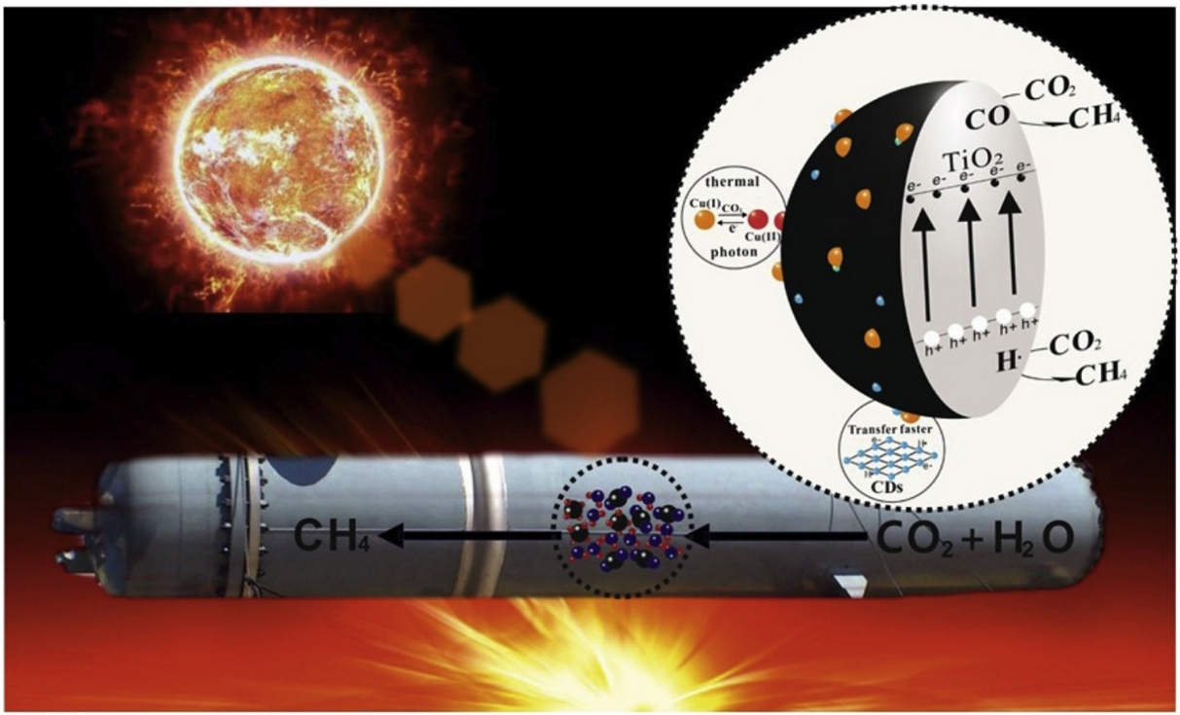
Figure 5. CO₂ methanation by H₂O over CDs drafted Cu/TiO₂ catalyst (Adapted from ref. 79)

4.4. Photocatalytic N₂ fixation
Despite making up to 78% of the atmosphere, nitrogen has a very high N-N bond energy, making it difficult to convert and utilize properly [80]. By combining atmospheric nitrogen with hydrogen at high pressure and temperature, while iron is present, Haber developed a way to make ammonia, and the Haber-Bosch process is still employed in the commercial strategy for nitrogen fixation today [81].
Regrettably, the extreme situation will utilize many fossil fuels, and emissions of thousand tons of greenhouse annually. Moderate artificial nitrogen fixation techniques, including photocatalysis, are desperately needed for the environment’s sake and long-term energy sustainability. Metallic semiconductors dominate the list of catalysts used in photocatalytic nitrogen fixation.
The nitrogen atom’s antibonding orbitals and cation sites of metals are likely to interact due to nitrogen atoms' positive electron affinities, N-N bonds activating and speeding up nitrogen fixation [82].
Through a microwave-assisted technique, Khalilabad et al. added CPDs to g-C₃N₄ nanosheets (CN-NS) that were embellished with CdS NPs [83]. CPDs' upconversion photoluminescence assisted in converting long-wavelength light into short-wavelength light that CN-NS could directly absorb.

5. Summary
The bottom-up, top-down, continuous preparation and characterization analytical methods utilized to ascertain the chemical, physical, and optical characteristics of CDs were all thoroughly described in this book chapter.
CDs have outstanding optical and photoelectric capabilities because of their distinct nanoscale structure and internal integration of graphitized sp² domains. Diverse fabrication techniques also provided several implements for CDs synthesis and subsequent modification.
The characteristics of UCPL and the capacity for photoinduced charge movement make CDs an effective wide-response photocatalyst. Additionally, photoinduced processes such as pollutant degradation, CO₂ conversion, and N₂ fixation on CDs-based hybrids or composites were thoroughly examined by concentrating on their activity, selectivity, and stability.
For instance, structural natures can be changed to increase the stability of CDs, such as by raising the carbon cores of the degree of graphitization. A high molecular state concentration in CDs makes it susceptible to photobleaching under photoexcitation, deactivating the CDs-based catalyst.
Additionally, greater graphitization gives better charge movement capabilities for CDs. In contrast, several functional groups incorporated on the surface of CDs can interact with specific substrates, lowering the energy barrier and making it easier for CDs to operate as a photocatalyst in catalytic reactions.
Notably, these functional groups are advantageous for CDs when combined with other semiconductors as cocatalysts. Even if the development path is fraught with obstacles, it is hoped that CDs will open up more intriguing possibilities for environmental applications. As it develops and is integrated with other nanotechnology, future environmental science and engineering will be increasingly impacted by nanotechnology.

6. References
[1] Q. Zhang, E. Uchaker, S.L. Candelaria, G. Cao, “Nanomaterials for energy conversion and storage”, Chem. Soc. Rev. 2013, 42, 3127–3171.
[2] W. Yang, K.R. Ratinac, S.P. Ringer, P. Thordarson, J.J. Gooding, F. Braet, “Carbon nanomaterials in biosensors: should you use nanotubes or graphene?” Angew. Chem. Int. Ed. 2010, 49, 2114–2138.
[3] F. Perreault, A.F. De Faria, M. Elimelech, “Environmental applications of graphene-based nanomaterials”, Chem. Soc. Rev. 2015, 44, 5861–5896.
[4] Y. Fu, G. Zeng, C. Lai, D. Huang, L. Qin, H. Yi, L. Li, “Hybrid architectures based on noble metals and carbon-based dots nanomaterials: a review of recent progress in synthesis and applications”, Chem. Eng. J. 2020, 399, 125743.
[5] B.E. Meteku, J. Huang, J. Zeng, F. Subhan, F. Feng, Y. Zhang, Z. Yan, “Magnetic metal–organic framework composites for environmental monitoring and remediation”, Coordin. Chem. Rev. 2020, 413, 213261.
[6] T. Wu, M. Jing, Y. Tian, L. Yang, J. Hu, X. Cao, X. Ji, “Surface-driven energy storage behavior of dual-heteroatoms functionalized carbon material”, Adv. Funct. Mater. 2019, 29, 1900941.
[7] Caicheng Long, Zixin Jiang, Jingfang Shangguan, Taiping Qing, Peng Zhang, Bo Feng, “Applications of carbon dots in environmental pollution control: A review” Chem. Eng. J. 2021, 406, 126848.
[8] Akshatha Hebbar, Raja Selvaraj, Ramesh Vinayagam, Thivaharan Varadavenkatesan, Ponnusamy Senthil Kumar, Pham Anh Duc, Gayathri Rangasamy, Chemosphere 2023, 313, 137308.
[9] F. Li, X. Jiang, J. Zhao, S. Zhang, “Graphene oxide: a promising nanomaterial for energy and environmental applications”, Nano energy 2015, 16, 488–515.
[10] B. Song, P. Xu, G. Zeng, J. Gong, P. Zhang, H. Feng, X. Ren, “Carbon nanotube-based environmental technologies: the adopted properties, primary mechanisms, and challenges”, Rev. Environ. Sci. Bio. 17 (2018) 571–590.
[11] H.K.H. Lee, A.M. Telford, J.A. Röhr, M.F. Wyatt, B. Rice, J. Wu, J.R. Searle, “The role of fullerenes in the environmental stability of polymer: fullerene solar cells”, Energy Environ. Sci. 2018, 11, 417–428.
[12] W. Hong, Y. Zhang, L. Yang, Y. Tian, P. Ge, J. Hu, X. Ji, “Carbon quantum dot micelles tailored hollow carbon anode for fast potassium and sodium storage”, Nano Energy 2019, 65, 104038.
[13] Y. Zhu, J. Li, X. Yun, G. Zhao, P. Ge, G. Zou, X. Ji, “Graphitic carbon quantum dots modified nickel cobalt sulfide as cathode materials for alkaline aqueous batteries”, Nano-Micro Lett. 2020, 12, 1–18.
[14] Yue Yu, Qingsen Zeng, Songyuan Tao, Chunlei Xia, Chongming Liu, Pengyuan Liu, and Bai Yang, “Carbon Dots Based Photoinduced Reactions: Advances and Perspective” Adv. Sci. 2023, 2207621.
[15] Xiaoyou Xu, Robert Ray, Yunlong Gu, Harry J. Ploehn, Latha Gearheart, Kyle Raker, and Walter A. Scrivens, “Electrophoretic analysis and purification of fluorescent single-walled carbon nanotube fragments”, J. Am. Chem. Soc. 2004, 126 (40), 12736–12737.
[16] Ya-Ping Sun, Bing Zhou, Yi Lin, Wei Wang, K. A. Shiral Fernando, Pankaj Pathak, Mohammed Jaouad Meziani, Barbara A. Harruff, Xin Wang, Haifang Wang, Pengju G. Luo, Hua Yang, Muhammet Erkan Kose, Bailin Chen, L. Monica Veca, and Su-Yuan Xie, “Quantum-sized carbon dots for bright and colorful photoluminescence”. J. Am. Chem. Soc. 2006, 128 (24), 7756–7757.
[17] Jagpreet Singh, Sukhmeen Kaur, Jechan Lee, Akansha Mehta, Sanjeev Kumar, Ki-Hyun Kim, Soumen Basu, Mohit Rawat, “Highly fluorescent carbon dots derived from Mangifera indica leaves for selective detection of metal ions”, Sci. Total Environ. 2020, 720, 137604.
[18] Giacomo Filippini, Francesco Amato, Cristian Rosso, Giulio Ragazzon, Alberto Vega-Pen aloza, Xavier Companyo, Luca Dell’Amico, Marcella Bonchio, and Maurizio Prato, “Mapping the surface groups of amine-rich carbon dots enables covalent catalysis in aqueous media”, Chem 2020, 6 (11), 3022–3037.
[19] X. Xu, R. Ray, Y. Gu, H.J. Ploehn, L. Gearheart, K. Raker, W.A. Scrivens, “Electrophoretic analysis and purification of fluorescent single-walled carbon nanotube fragments”, J. Am. Chem. Soc. 2004, 126, 12736–12737.
[20] N. Dhenadhayalan, K.C. Lin, T.A. Saleh, Recent advances in functionalized carbon dots toward the design of efficient materials for sensing and catalysis applications, Small, 2020, 16, 1905767.
[21] F. Arcudi, L. Dordevic, M, Prato, Design, Synthesis, and Functionalization Strategies of Tailored Carbon Nanodots, Acc. Chem. Res. 2019, 52, 8, 2070–2079
[22] S. Kellici, J. Acord, K. E. Moore, N. P. Power, V. Middelkoop, D. J. Morgan, T. Heil, P. Coppo, I. A. Baragau, C. L. Raston, “Continuous hydrothermal flow synthesis of graphene quantum dots” React Chem Eng, 2018, 3, 949-958.
[23] I. A. Baragau, Z. Lu, N. P. Power, D. J. Morgan, J. Bowen, P. Diaz, S. Kellici, “Continuous hydrothermal flow synthesis of S-functionalized carbon quantum dots for enhanced oil recovery,” Chem. Eng. J. 405, 126631.
[24] M. B. Alonso, I. O. Gomez, B. Fernández, P. Couceiro, J. A. Chamarro, L. F. C. Vallvey, A. S. Castillo, M. Puyol, “An LTCC monolithic microreactor for the synthesis of carbon dots with photoluminescence imaging of the reaction progress”, Sensor. Actuator. B Chem. 296, 2019, 126613.
[25] S. B. Peh, D. Zhao, “Synthesis and development of metal–organic frameworks in Nanoporous Materials for Molecule Separation and Conversion” Micro and Nano Technologies 2020, 3-43.
[26] G.A. Hutton, B.C. Martindale, E. Reisner, “Carbon dots as photosensitizers for solar-driven catalysis”, Chem. Soc. Rev. 2017, 46, 6111–6123.
[27] J. Zhou, C. Booker, R. Li, X. Zhou, T.K. Sham, X. Sun, Z. Ding, “An electrochemical avenue to blue luminescent nanocrystals from multiwalled carbon nanotubes,” J. Am. Chem. Soc. 129 (2007) 744–745.
[28] H. Ming, Z. Ma, Y. Liu, K. Pan, H. Yu, F. Wang, Z. Kang, “Large-scale electrochemical synthesis of high-quality carbon nanodots and their photocatalytic property,” Dalton Trans. 2012, 41, 9526–9531.
[29] B. Chen, F. Li, S. Li, W. Weng, H. Guo, T. Guo, S. You, “Large scale synthesis of photoluminescent carbon nanodots and their application for bioimaging,” Nanoscale, 2013, 5, 1967–1971.
[30] Y.P. Sun, B. Zhou, Y. Lin, W. Wang, K.S. Fernando, P. Pathak, P.G. Luo, Quantum-sized carbon dots for bright and colorful photoluminescence, J. Am. Chem. Soc. 2006, 128, 7756–7757.
[31] R. Wang, K.Q. Lu, Z.R. Tang, Y.J. Xu, “Recent progress in carbon quantum dots: synthesis, properties, and applications in photocatalysis,” J. Mater. Chem. A 2017, 5, 3717–3734.
[32] J. Yue, L. Li, L. Cao, M. Zan, D. Yang, Z. Wang, W.F. Dong, “Two-step hydrothermal preparation of carbon dots for calcium ion detection”, ACS Appl. Mater. Inter. 2019, 11, 44566–44572.
[33] B.C. Martindale, G.A. Hutton, C.A. Caputo, E. Reisner, “Solar hydrogen production using carbon quantum dots and a molecular nickel catalyst”, J. Am. Chem. Soc. 2015, 137, 6018–6025.
[34] J. Zhou, Z. Sheng, H. Han, M. Zou, C. Li, Facile synthesis of fluorescent carbon dots using watermelon peel as a carbon source, Mater. Lett. 2012, 66, 222–224.
[35] X. Zhai, P. Zhang, C. Liu, T. Bai, W. Li, L. Dai, W. Liu, “Highly luminescent carbon nanodots by microwave-assisted pyrolysis,” Chem. Commun. 2012, 48, 7955–7957.
[36] Y. Liu, N. Xiao, N. Gong, H. Wang, X. Shi, W. Gu, L. Ye, “One-step microwave-assisted polyol synthesis of green luminescent carbon dots as optical nanoprobes,” Carbon 2014, 68, 258–264.
[37] C. Long, T. Qing, Q. Fu, Z. Jiang, J. Xu, P. Zhang, B. Feng, “Low-temperature rapid synthesis of high-stable carbon dots and its application in biochemical sensing”, Dyes and Pigments, 2020, 175, 108184.
[38] Y. Wang, A. Hu, “Carbon quantum dots: synthesis, properties and applications,” J. Mater. Chem. C 2014, 2, 6921–6939.
[39] M. Han, S. Zhu, S. Lu, Y. Song, T. Feng, S. Tao, B. Yang, “Recent progress on the photocatalysis of carbon dots: classification, mechanism and applications”, Nano Today, 2018, 19, 201–218.
[40] M.J. Molaei, “Principles, mechanisms, and application of carbon quantum dots in sensors: a review,” Anal. Methods, 2020, 12, 1266–1287.
[41] L. Xiao, H. Sun, “Novel properties and applications of carbon nanodots,” Nanoscale Horiz. 2018, 3, 565–597.
[42] X. Shi, H. Meng, Y. Sun, L. Qu, Y. Lin, Z. Li, D. Du, Far-red to near-infrared carbon dots: preparation and applications in biotechnology, Small, 2019, 5, 1901507.
[43] L. Xu, X. Bai, L. Guo, S. Yang, P. Jin, L. Yang, “Facial fabrication of carbon quantum dots (CDs)-modified N-TiO_{2-x} nanocomposite for the efficient photoreduction of Cr (VI) under visible light,” Chem. Eng. J. 2019, 357, 473–486.
[44] Y. Zhang, M. Xu, H. Li, H. Ge, Z. Bian, “The enhanced photoreduction of Cr (VI) to Cr (III) using carbon dots coupled TiO₂ mesocrystals,” Appl. Catal. B-Environ. 2018, 226, 213–219.
[45] Y. Guo, P. Yao, D. Zhu, C. Gu, A novel method for the development of a carbon quantum dot/carbon nitride hybrid photocatalyst that responds to infrared light irradiation, J. Mater. Chem. A 2015, 3, 13189–13192.
[46] S. Zhu, Y. Song, X. Zhao, J. Shao, J. Zhang, B. Yang, “The photoluminescence mechanism in carbon dots (graphene quantum dots, carbon nanodots, and polymer dots): current state and future perspective,” Nano Res. 2015, 8, 355–381.
[47] L. Pan, S. Sun, A. Zhang, K. Jiang, L. Zhang, C. Dong, H. Lin, “Truly fluorescent excitation-dependent carbon dots and their applications in multicolor cellular imaging and multidimensional sensing,” Adv. Mater. 2015, 27, 7782–7787.
[48] Y. Liu, Q. Zhou, Y. Yuan, Y. Wu, “Hydrothermal synthesis of fluorescent carbon dots from sodium citrate and polyacrylamide and their highly selective detection of lead and pyrophosphate,” Carbon, 2017, 115, 550–560.
[49] B. Wang, S. Lu, “The light of carbon dots: From mechanism to applications,” Matter 2022, 5, 110-149.
[50] S. Li, L. Li, H. Tu, H. Zhang, D. S. Silvester, C. E. Banks, G. Zou, H. Hou, X. Ji, “The development of carbon dots: From the perspective of materials chemistry” Mater. Today 2021, 51, 188.
[51] L. Cao, X. Wang, M. J. Meziani, F. Lu, H. Wang, P. G. Luo, Y. Lin, B. A. Harruff, L. M. Veca, D. Murray, S.-Y. Xie, Y.-P. Sun, “Carbon Dots for Multiphoton Bioimaging” J. Am. Chem. Soc. 2007, 129, 11318.
[52] S. Lu, L. Sui, J. Liu, S. Zhu, A. Chen, M. Jin, B. Yang, “Near‐infrared photoluminescent polymer–carbon nanodots with two‐photon fluorescence” Adv. Mater. 2017, 29, 1603443.
[53] T. Feng, S. Tao, D. Yue, Q. Zeng, W. Chen, B. Yang, “Recent advances in energy conversion applications of carbon dots: from optoelectronic devices to electrocatalysis” Small 2020, 16, 2001295.
[54] C. Hu, M. Li, J. Qiu, Y. P. Sun, “Design and fabrication of carbon dots for energy conversion and storage” Chem. Soc. Rev. 2019, 48, 2315.
[55] F. Arcudi, V. Strauss, L. Dordevic, A. Cadranel, D. M. Guldi, M. Prato, “Porphyrin antennas on carbon nanodots: excited state energy and electron transduction” Angew. Chem., Int. Ed. 2017, 56, 12097.
[56] A. Cadranel, J. T. Margraf, V. Strauss, T. Clark, D. M. Guldi, “Carbon nanodots for charge-transfer processes” Acc. Chem. Res. 2019, 52, 955.
[57] M.N. Chong, B. Jin, C.W. Chow, C. Saint, Recent developments in photocatalytic water treatment technology: a review, Water Res. 2010, 44, 2997–3027.
[58] H. Yu, R. Shi, Y. Zhao, G.I. Waterhouse, L.Z. Wu, C.H. Tung, T. Zhang, Smart utilization of carbon dots in semiconductor photocatalysis, Adv. Mater. 2016, 28, 9454–9477.
[59] S. Hu, R. Tian, Y. Dong, J. Yang, J. Liu, Q. Chang, Modulation and effects of surface groups on photoluminescence and photocatalytic activity of carbon dots, Nanoscale 2013, 5, 11665–11671.
[60] M.C. Ortega-Liébana, J.L. Hueso, S. Ferdousi, K.L. Yeung, J. Santamaria, Nitrogen-doped luminescent carbon nanodots for optimal photo-generation of hydroxyl radicals and visible-light expanded photo-catalysis, Diam. Relat. Mater. 2016, 65, 176–182.
[61] P. Yang, J. Zhao, L. Zhang, L. Li, Z. Zhu, Intramolecular hydrogen bonds quench photoluminescence and enhance photocatalytic activity of carbon nanodots, Chem. A Eur. J. 2015, 21, 8561–8568.
[62] R. Liu, H. Huang, H. Li, Y. Liu, J. Zhong, Y. Li, Z. Kang, Metal nanoparticle/carbon quantum dot composite as a photocatalyst for high-efficiency cyclohexane oxidation, ACS Catal. 2014, 4, 328-336.
[63] W. Wu, L. Zhan, W. Fan, J. Song, X. Li, Z. Li, H. Zeng, Cu–N dopants boost electron transfer and photooxidation reactions of carbon dots, Angew. Chem. Int. Ed. 2015, 54, 6540–6544.
[64] Y. Zeng, D. Chen, T. Chen, M. Cai, Q. Zhang, Z. Xie, W. Lv, Study on heterogeneous photocatalytic ozonation degradation of ciprofloxacin by TiO₂/carbon dots: kinetic, mechanism and pathway investigation, Chemosphere 2019, 227, 198–206.
[65] D. Hazarika, N. Karak, Photocatalytic degradation of organic contaminants under solar light using carbon dot/titanium dioxide nanohybrid, obtained through a facile approach, Appl. Surf. Sci. 2016, 376, 276–285.
[66] H. Yu, H. Zhang, H. Huang, Y. Liu, H. Li, H. Ming, Z. Kang, ZnO/carbon quantum dots nanocomposites: one-step fabrication and superior photocatalytic ability for toxic gas degradation under visible light at room temperature, New J. Chem. 2012, 36, 1031–1035.
[67] H. Zhang, H. Ming, S. Lian, H. Huang, H. Li, L. Zhang, S.T. Lee, Fe₂O₃/carbon quantum dots complex photocatalysts and their enhanced photocatalytic activity under visible light, Dalton Trans. 2011, 40, 10822–10825.
[68] A. Cai, Q. Wang, Y. Chang, X. Wang, Graphitic carbon nitride decorated with S, N co-doped graphene quantum dots for enhanced visible-light-driven photocatalysis, J. Alloy. Compd. 2017, 692, 183–189.
[69] J. Chen, H. Che, K. Huang, C. Liu, W. Shi, “Fabrication of a ternary plasmonic photocatalyst CQDs/Ag/Ag₂O to harness charge flow for photocatalytic elimination of pollutants” Appl. Catal., B 2016, 192, 134.
[70] S. Feng, T. Chen, Z. Liu, J. Shi, X. Yue, Y. Li, “Z-scheme CdS/CQDs/g-C₃N₄ composites with visible-near-infrared light response for efficient photocatalytic organic pollutant degradation” Sci. Total Environ. 2020,704, 135404.
[71] C. M. Rochman, T. Hoellein, “The global odyssey of plastic pollution” Science 2020, 368, 1184.
[72] C. M. Rochman, “Microplastics research—from sink to source” Science 2018, 360, 28.
[73] M. Han, S. Zhu, C. Xia, B. Yang, “Photocatalytic upcycling of poly(ethylene terephthalate) plastic to high-value chemicals” Appl. Catal., B 2022, 316, 121662.
[74] J. P. Smol, ”Climate Change: A planet in flux” Nature 2012, 483, S12-S15.
[75] G. A. Olah, G. K. S. Prakash, A. Goeppert, “Anthropogenic Chemical Carbon Cycle for a Sustainable Future” J. Am. Chem. Soc. 2011, 133, 12881-12898.
[76] X. Li, J. Yu, M. Jaroniec, X. “Cocatalysts for Selective Photoreduction of CO₂ into Solar Fuels” Chen, Chem. Rev. 2019, 119, 3962.
[77] S. Navarro-Jaén, M. Virginie, J. Bonin, M. Robert, R. Wojcieszak, A. Y. Khodakov, “Highlights and challenges in the selective reduction of carbon dioxide to methanol” Nat. Rev. Chem. 2021, 5, 564.
[78] L. Cao, S. Sahu, P. Anilkumar, C. E. Bunker, J. Xu, K. A. Fernando, P. Wang, E. A. Guliants, K. N. Tackett 2nd, Y. P. Sun, “Carbon Nanoparticles as Visible-Light Photocatalysts for Efficient CO₂ Conversion and Beyond” J. Am. Chem. Soc. 2011, 133, 4754.
[79] Ke Wang, Ruimin Jiang, Ting Peng, Xu Chen, Wenxin Dai, Xianzhi Fu, “Modeling the effect of Cu-doped TiO₂ with carbon dots on CO₂ methanation by H₂O in a photo-thermal system” Appl. Catal., B 2019, 256, 117780.
[80] M. Kitano, S. Kanbara, Y. Inoue, N. Kuganathan, P. V. Sushko, T. Yokoyama, M. Hara, H. Hosono, “Electride support boosts nitrogen dissociation over ruthenium catalyst and shifts the bottleneck in ammonia synthesis” Nat. Commun. 2015, 6, 6731.
[81] J. W. Erisman, M. A. Sutton, J. Galloway, Z. Klimont, W. Winiwarter, “How a century of ammonia synthesis changed the world” Nat. Geosci. 2008, 1, 636.
[82] G. Liao, C. Li, S. Y. Liu, B. Fang, H. Yang, “Emerging frontiers of Z-scheme photocatalytic systems” Trends Chem. 2022, 4, 111.
[83] H. Khalilabad, A. Yangjeh, D. Seifzadeh, S. Khaneghah, E. Kermani, “g-C₃N₄ nanosheets decorated with carbon dots and CdS nanoparticles: Novel nanocomposites with excellent nitrogen photofixation ability under simulated solar irradiation” Ceram. Int. 2019, 45, 2542.

