Plasticulture: How much beneficial
Dr. Indu
indu.mehta@ggdsd.ac.in
GGDSD College, Sector-32,
Chandigarh

Abstract
The use of various forms of plastic in the agriculture is becoming popular for the improved crop production. Plastic in the agriculture heats up and acts like a warming blanket above the ground. So the use of plastic above the ground increases the amount of carbon dioxide that the plants take. This carbon dioxide is then used in the process of photosynthesis to make food. The plastic in the field also prevents the growth of weeds in the field. Furthermore, plasticuture requires less of herbicides, pesticides as well as water. Thus, beneficial from environment safety point of view also.

Keywords: Plasticulture, crops, agriculture, plastic material

- Introduction

A. Plasticulture
The term plasticulture means the practice of using the plastic materials for the various agricultural applications. Where Agriculture is the science and art of cultivating plants and crops etc.
B. Why Plasticulture
Plasticulture is getting popular day by day and is being practiced worldwide. Plasticulture has many benefits like it eliminates garden pests. Before the plantation, the ground temperature needs to be warm enough for the plants to grow. The plastic layer heats up and deter pests. It also heats up and will act like a warming blanket above the ground. Another benefit of using plastic is the increased amount of carbon dioxide that plants take. This carbon dioxide is then used in the process of photosynthesis to make food. When the soil gets warmed under the plastic, the carbon dioxide evaporates and is funneled to the leaves, where it is taken in for the process of photosynthesis. This funneling of carbon dioxide is called the ‘chimney effect’.
So Plasticulture It is important to control weeds specifically around the base of the plant to prevent disease and all the nutrients are accessible to the plant, thus we get healthy plant in less time.

- Various Types of plastic based products used in plasticulture
There is large variety of plastic based products which are being used these days in agriculture to improve the quality and yield of crops.
It includes all kinds of plant or soil coverings, ranging from mulch films, row coverings, poly-tunnels greenhouses, micro-irrigation (drips and sprinklers), walk-in tunnel covers, Plastic mulch etc.
Not only this, the plastic lining is used at the base of pond so that the mud doesn’t mix with the water to make water turbid and dirty, as shown in Fig: 1, the lining of farm ponds. It has many more other benefits like it reduces water seepage to great extent. Furthermore, it gives sustainable pond for fish farming for longer time.

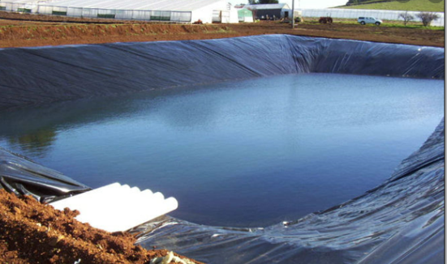(Adapted)
Fig: 1 - Lining of farm ponds

- Plastic films in agriculture:
The first use of plastic film in agriculture was to make an effort to make a cheaper version of a glasshouse. Now it has become an essential part of modern and responsible agriculture. Plastic products / films are being used in agriculture for better results ^{[2]}. The climate change is another issue which is affecting the crop production and its quality ^{[1], [10]}. It is quite obvious that the climate change has its influence on the sustainable development and finally on the economy of that country ^{[11]}.

- Various forms of plastic films which are used by the farmers worldwide:

Modern drip irrigation: It is considered to be the world's most valued innovation in agriculture. Drip irrigation is most preferred type, it is a type of micro-irrigation system which has the great potential to save water as well as nutrients, wherein, water drip slowly to the roots of plants, either from buried below the surface or is above the soil surface. The aim is to place water directly onto the root zone thus resulting in minimum evaporation. It also saves a lot of water. In the Drip irrigation systems, a network of many valves, pipes or tubing is used.
Polyethylene (PE) Plastic film: It is the plastic film used by the majority of growers as a substitute of greenhouse, because of its affordability, flexibility and easy manufacturing ^{[3]}. The polythene can be recycled and reused in the field ^{[6]}. The plastic material in its various forms has been used in European agriculture since long ^{[7]}. It comes in a variety of thicknesses, such as a low density form (LDPE) as well as a linear low density form (LLDPE). It’s composition can be modified by the addition of certain elements to the plastic that give properties which are beneficial to plant growth such as reduced water loss, UV stabilization to cool soil and prevent insects and the elimination of photosynthetically active radiation to prevent weed growth.
Greenhouses and walk-in tunnel covers: A greenhouse is a large structure in which it is possible to stand and work with automated ventilation. It has a life span between 6–45 months, used as Small tunnel covers. They are about 1m wide and 1m high, and have a thinner polyethylene film than the large tunnel covers, it is usually below 80μm.
Plastic mulch: Mulching is when a thin plastic film is placed over the ground, poking holes at regular intervals for seeds to be planted in Fig:2 –
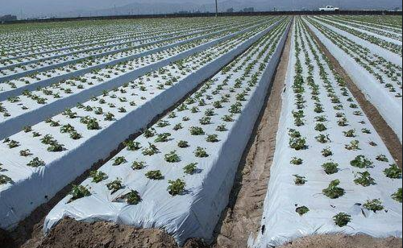(Adapted)
Fig: 2 - Plastic film

So in nut shell; plastic films have revolutionized this agriculture sector with huge benefits in terms of quality and quantity of crops. In the last two decades, agricultural films gained not only a great deal of interest and attention but also a big market more and more extended in any countries within Europe, America, and Asia, with a constant positive trend.

- Benefits of plasticulture
- Improves quality and quantity of the crop: The plastic films in the field remain in place for the duration of the cultivation. The major functions of plastic mulch are to maintain a consistent temperature and humidity of the soil thus act as insulate. These films prevent the evaporation of moisture from the soil, minimization of seedtime and harvest, prevent weed growth, and also prevent erosion
- Environmental aspects: Plasticulture not only improves crop production, Increase quantity and quality, it requires less of pesticides, use less of fertilizers, use less of water, thus helpful in Environment Protection as well.
- Recycling: One significant importance of plastic in agriculture is its reusage. Technologies exist which allow for many agri-plastics to be recycled into viable plastic resins for reuse in the plastics manufacturing industry.

- Some Drawbacks of plastic in agriculture and its alternatives
The plasticulture has many benefits, many advantages as it leads to sustainable agriculture. Everything has its pros and cones. The use of plastic in the agriculture has surely increased the yield, but the problems associated with the disposal of this plastic are yet to be solved fully ^{[8], [9]}. Some of the problems which are associated with plasticulture are recycling of plastic mulch, as the mulch is often wet or dirty. Furthermore, when lifting and removing plastic at the end of the year it is nearly impossible to remove it in its entirety. The plastic can easily rip thus causing pollution and trash in the field.
An alternative of plastic in agriculture is bioplastics. Bioplastic are the plastic like materials produced from renewable biomass sources, such as vegetable fats & oils, com starch or recycled food waste can be used instead of plastic. The biodegradable mulches are being used quite effectively in pumpkin farming and other crops, which are better than plastics in the field ^{[4], [5]}.

Conclusion
Plasticulture is latest and is scientifically proven methodology, being used worldwide. As it not only leads to increased crop production (around 20%) but also save water (around 30%), control weeds around the plants, cutting down labor and increasing the overall health of the plant itself. Furthermore, it saves agro-chemicals and fertilizers as well. Plasticulture has been very well imbibed in the mainframe today’s agriculture. Bioplastic seems to be a healthy alternative, although it is very expensive and beyond the reach of common farmer but its low-cost version can also be explored gradually to fit in the pocket of every farmer. Since it is made from bio source, it gets degraded automatically in the soil after certain interval of time.
In country like India, with increasing population and limited area of irrigation, this seems quite viable option for increased and healthy crop production.

- References
[1] Nex, Sally How to garden the low carbon way: the steps you can take to help combat climate change (First American ed.). New York. ISBN 978-0-7440-2928-4. OCLC 1241100709, 2021.
[2] Espí E, Salmerón A, Fontecha A, García Y, and Real A.I. Plastic Films for Agricultural Applications Journal of Plastic Filming and Sheeting, 22(85):e85-102, 2006.
[3] Adam A, Kouider S.A., Hamou A, Saiter J.A. Studies of polyethylene multi layer films used as greenhouse covers under Saharan climatic conditions Polymer Testing, 24(7):e834–838, 2005.
[4] Wszelaki, A., J. Moore, S. Ghimire, and C. Miles. 2016. Adhesion of biodegradable mulches to pie pumpkins: a production and quality consideration. ASHS National Conference, Atlanta, GA Aug 8-11 2016.
[5] Ghimire, S., E. Scheenstra, J. Cowan, H.Y. Sintim, M. Flury, D. Inglis and C. Miles. 2016.Deterioration of biodegradable plastic mulch in pumpkin production in Northwest Washington. American Society of Horticultural Science (ASHS) Annual Conference, ASHS National Conference, Atlanta, GA, Aug 8-11 2016.
[6] MCEWAN I., ARRIGHI V., COWIE J.M.G,Structure and properties of commonly recycled polymers, Handbook of Plastic Recycling, ed. Francesco La Mantia Rapra Technology, Shawbury, UK., 1-22, 2002
[7] SCARASCIA MUGNOZZA, G., SICA, C., & RUSSO, G. Plastic materials in European agriculture: actual use and perspectives., Journal of Agricultural Engineering, Vol. 42(3), p. 15-28, 2012.
[8] SRINIDHI, A., NAZARETH, D., Use of plastic in agriculture is improving yield, but here’s what else it’s doing, YKA Environment, 2018.
[9] TITA, V., MOCUTA, D.N., TUREK-RAHOVEANU, A., POPESCU, A.D., Bold, N., Integrated plastic management system within an agricultural enterprise, analysis of actual context, system model and simulation, Revista de materiale plastice, vol. 56., no. 2., p. 346-350, 2019.
[10] MOCUTA, D.N., CRISTEA, S., TUREK-RAHOVEANU, A., HOSSU, A.M., Applying risk management to mitigate the consequnces of climate change, Rev. Chim. (Bucharest), 69, no. 2, p.415-418, 2018.
[11] MOCUTA, D.N., The influence of climate change on sustainable development, Economic and Social Development: Book of Proceedings, Varazdin Development and Entrepreneurship Agency (VADEA), pp. 316-321, 2018
---

