Internet of Things (IoT) Vs. Green Internet of Things
Monika Ratnakar
Faculty of Information Technology, Gopal Narayan Singh University, Jamuhar, Bihar, India, 821305
Email Id: monicaranjan99@gmail.com
Sumit Kumar
Faculty of Information Technology, Gopal Narayan Singh University, Jamuhar, Bihar, India, 821305
Email Id: sumit170787@gmail.com
Abstract
The Internet of Things (IoT) is the combination of a network of physical devices, vehicles, home appliances, and healthcare & agriculture equipments. It is also used to connect other gadgets, which are embedded with sensors, actuators and Bluetooth. The all connected devices are allowed to exchange data and perform automated tasks without human intervention. Another aspect of technology is, Green IoT (Internet of Things) refers to the application of IoT technology to promote sustainability and eco-friendliness in various industries. The latest development in Green IoT is the growing concentrate on using Internet of Things devices and systems to reduce carbon emissions, minimize waste and promote energy efficiency. This paper discusses Internet of Things and Green Internet of Things structural design and current emerging utility domains such as Healthcare & Agriculture. Certainly, it would help the research scholar to understand the latest trends of technology in healthcare and agriculture and its utility to the global world.
Keywords: Internet of Things, Green IoT, Healthcare and Agriculture.
Introduction:
Internet of Things (IoT) is flourishing up-coming conception, which main objective to connect millions of devices with each other [1]. The Internet of Things devices sensors are receive, accumulate, and spread important information from their surrounds. Internet of thing is thing that can communicate to each other without human involvement. The IoT communicates directly to each other can save the communication energy with user [2]. The world is becoming “Smart” with the rapid development of science and technology [3]. Living in such a smart world people will be mechanically and collaboratively served by the smart devices (e.g., watches, mobile phones, computers), smart transportation (e.g., cars, buses, metro), smart environments (e.g., homes, offices, schools, factories) [4, 43].
Internet of Things is a new model that has changed the traditional way of living into a high tech life style. Due to Internet of Things transformations like smart world, smart city, stylish homes, and toxic waste control, power saving, smart transport, smart industries can be possible [5]. There is group of essential research studies and important investigation has continuous in order to improve the technology through Internet of Things [6].

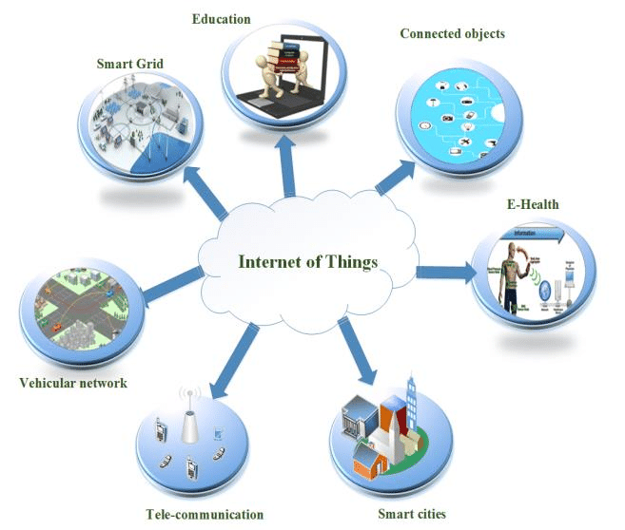
Figure 1: Internet of Things [39]

The IoT is transforming industries such as manufacturing, healthcare, agriculture and transportation by providing instantaneous data and insights, enabling predictive protection and optimizing operations [7]. In healthcare, IoT devices are being used to monitor patient health remotely, improving patient outcomes and reducing healthcare costs. In manufacturing, IoT sensors are being used to monitor equipment performance, reducing time dependency and increasing efficiency [7].
Another important aspect of IoT devices is being used in Agriculture. Crop growing is a main sector which plays important role in the Indian economy [8]. It is the backbone of our country8.70% of the Indian population depends on agriculture for food and money. In agriculture, an IoT device is being used to improve the crop production, regulate the irrigation efficiency and enhances the earnings of farmers [9]. The smart agriculture requires the integration of many of the heterogeneous objects such as the humidity sensors, wearable sensing devices, temperature sensors, mobile phones, communication technologies, etc. that offer specific services to make it successful The Internet of Things a based device is being used in smart crop monitoring systems can help to increase the yield of farming [10].
IoT sensors can monitor various environmental parameters like temperature, humidity, moisture, soil nutrient content, and sunlight, which affect crop growth [11].Farmers can make better-informed decisions by accurately tracking these parameters, on crop management practices and optimize crop growth [12].
IoT-based irrigation systems can monitor soil moisture content, weather forecasts, and crop water requirements to optimize irrigation time schedule. This ensures that crops get the appropriate quantity of water, reducing water waste and improving crop health [13]. IoT sensors can collect data on growth of crop, weather conditions, and quality of soil, which can be used to predict crop yields completely [14]. This helps farmers to easily arrange the harvest and maximum use of their resources according to requirement [15]. IoT-based crop monitoring systems can be remotely monitored and controlled, allowing farmers to manage their crops from anywhere. This technology enabling farmers to save time and reduce labor costs and to focus on other aspects of their business. Farmers can make more informed decisions about crop management practices by providing real-time insights into crop health and growth rates for higher yields. Farmers can optimize the use of water fertilizer by using precision farming practices and other resources, reducing waste and improving efficiency [16].
These devices are often equipped with sensors that collect data, such as temperature, humidity, and location, and transmit this data to other devices or cloud-based systems [17]. IoT devices can be controlled remotely and can also interact with other devices and systems, making them an integral part of the emerging "smart" ecosystem [18].
A great transformation can be observed in our daily routine life along with the increasing involvement of IoT devices and technology [19]. One such development of IoT is the concept of Smart Home Systems (SHS) and appliances that consist of internet-based devices, automation system for homes and reliable energy management system [19]. Besides, another important achievement of IoT is Smart Health Sensing system (SHSS). SHSS incorporates small intelligent equipment and devices to support the health of the human being [20]. These devices can be used both indoors and outdoors to check and monitor the different health issues and fitness level or the amount of calories burned in the fitness center etc[20]. Also, it is being used to monitor the critical health conditions in the hospitals and trauma centers as well. Hence, it has changed the entire scenario of the medical domain by facilitating it with high technology and smart devices [21]. Moreover, IoT developers and researchers are actively involved to uplift the life style of the disabled and senior age group people. IoT has shown a drastic performance in this area and has provided a new direction for the normal life of such people [22]. As these devices and equipment are very cost effective in terms of development cost and easily available within a normal price range, hence most of the people are availing them [23]. Therefore, IoT based framework is able to solve this problem and can provide high accuracy in analysis and prediction. IoT devices and sensors with the help of internet can assist health monitoring of patients. They also proposed a framework and protocol to achieve their objective [24].
IoT Architecture and Technologies:
The IoT architecture consists of five important layers that define all the functionalities of IoT systems.IoT offers a framework for interconnecting devices to permit the communication seamlessly. Most of the IoT applications are highly focused on the middleware layer of IoT structural design for information processing [28,43].
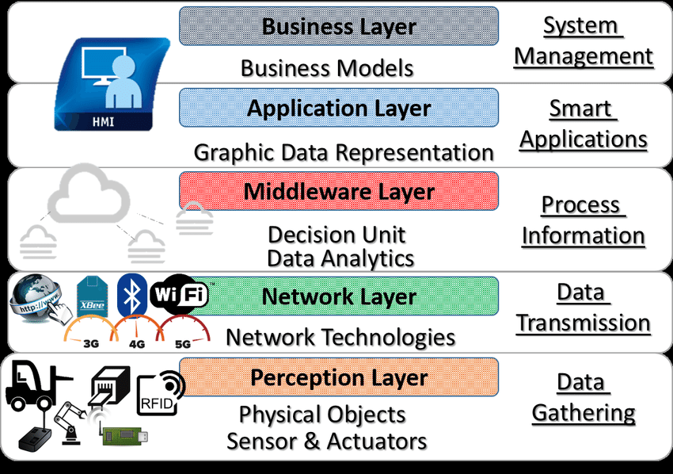
Figure 2: Five-layered IoT Architecture [40]
The five-layered IoT architecture is shown in Fig.2 which includes perception, network, middleware, application, and business layer [28].
1. Perception layer: The perception layer also known as device layer consists of different physical objects and sensor devices. The sensor devices can be the 2D barcode, RFID, or infrared sensor depends on object identification method. Such sensor device in this layer identifies the object, senses the environment, and collects information about the identified object [29].
2. Network layer: The network layer is also called as “transmission layer.” The main functionality of this layer is to interconnect different network devices, IoT architecture smart objects, and servers. It transmits and processes the data which is gathered already from sensor devices. The transmission medium can be either wired or wireless, and the technology can be infrared, Wi-Fi, Bluetooth, ZigBee, 3G, etc. Further, the information is transmitted to the processing layer [30-31].
3. Middleware layer: It is the also called as “processing layer.” The middleware layer stores, analyzes, and processes a large amount of data which is received from the network layer. The responsibility of this layer also lies in the service management and sustaining the connection with the database. It may be interlinked with various technologies like big data, cloud computing, and databases for processing the huge volume of information [32].
4. Application layer: The main responsibility of the application layer is to deliver application-oriented services to the IoT end users. This layer directly communicates with the end-user application with its application layer protocols [33].
5. Business layer: Finally, the business layer has a control over the entire IoT system including business models, user’s privacy, and applications. Based on the information received from the previous layer, it deals with the formation of different business models, graphs, flowcharts [34].
Moreover, for IoT technology the real achievement lies in well-constructed business models. After analyzing data, the business layer helps in decision making about upcoming activities and business strategies [35].
Green Internet of Things:
Green IoT can be applied to various industries, including transportation, energy, and manufacturing. Green IoT can also be applied to agriculture and healthcare. In agriculture, Green IoT can be used to optimize crop production, reduce water usage, and minimize the use of harmful chemicals, promoting sustainable and eco-friendly farming practices [35]. In healthcare, Green IoT can be used to promote healthier living environments, reduce waste, and improve patient outcomes. Overall, the latest development in Green IoT is an increasing focus on using IoT technology to promote sustainability and decrease environmental impact in various industries [36]. By promoting energy efficiency, reducing waste, and minimizing carbon emissions, Green IoT has the potential to help create a more sustainable and eco-friendly upcoming opportunity [37].
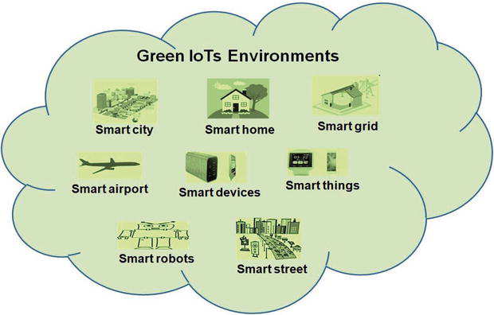
Figure 3: Green IoT [41]
Green IoT Architecture:
Green IoT focuses on the three main concepts, namely design, leverage, and enabling technologies. In the design phase, the technologies such as energy-efficient devices, network architectures, communication protocols, and interconnection are considered [36]. In the leveraging phase, it refers to how to enhance the energy efficiency and minimize carbon emissions. By enabling green ICT technologies, Green IoT preserves natural resources by reducing hazardous emissions, energy, pollution, and resource consumption [37]. Hence, Green IoT focuses on green design, green construction, green operation and maintenance, and green disposal. To effectively notify the environmental impact of IoT, a holistic approach that addresses all issues must be formulated. In general, with the moving pace of technology and adaptation to the latest improvements in the field of ICT, the number of connected devices increases gradually. Nevertheless, energy consumption needs to be reduced for the reliability of Green IoT. By focusing on the above principles, total environmental sustainability can be achieved. Figure 4 shows the lifecycle of Green IoT, which has four phases green design, green construction, green operation and Application of IoT in Green Computing [38].
- Green design: Component design should focus on the use of environment-friendly materials to be implemented in design. Hardware and software characteristics of the key components of an IoT system such as RFIDS, devices, sensors, and actuators that are the key role players of an IoT system should be designed to minimize resource utilization and produce less heat without reducing the performance. Hardware components could be reduced in size while the software characteristics ensure environment sustainability.
- Green production: IoT devices and sensors that are manufactured should be environment-friendly and the components must be made of biodegradable materials. As the number of devices grows rapidly, the construction sector ensures the compliance of green products. Standards and policies have to be framed for assessing the durability and quality of the components. All manufacturing firms should use only biodegradable materials and follow the efficient design.
- Green utilization: Energy consumption of all devices should be reduced. Devices can be programmed to automatically power down, when they are not being used. Moreover, power saving mode can be established as the default mode must be enabled to reduce the emission of greenhouse gases. Utilization of IoT components can be significantly enhanced by making simple changes in the way it is used. Sensors can work on the principle of “awake and sleep” to prolong its lifetime. Moreover, energy consumption of the devices has to be reduced to minimize the impact of hazardous gases in the environment. The energy cost savings as per component may not seem much, whereas the cost of collective components within an enterprise would not be considered in determining the cost [30].
- Green disposal: Recycling is the method of applying some technology to the existing devices or materials in order to remake the same device or some other devices. Old devices and equipment should be recycled and refurbished to reduce the amount of electronic wastes. In China, the rate of recycling of mobile phones is very less, since most of the devices are reused in the secondhand market which does not affect the environment. Around 15% of mobile phones are recycled in industrialized countries. Green recycling refers to the use of recyclable materials in the manufacture of IoT devices [35]. For instance, let us consider a mobile phone which is a commonly used device, and it contains copper, plastic, and some non-biodegradable elements.
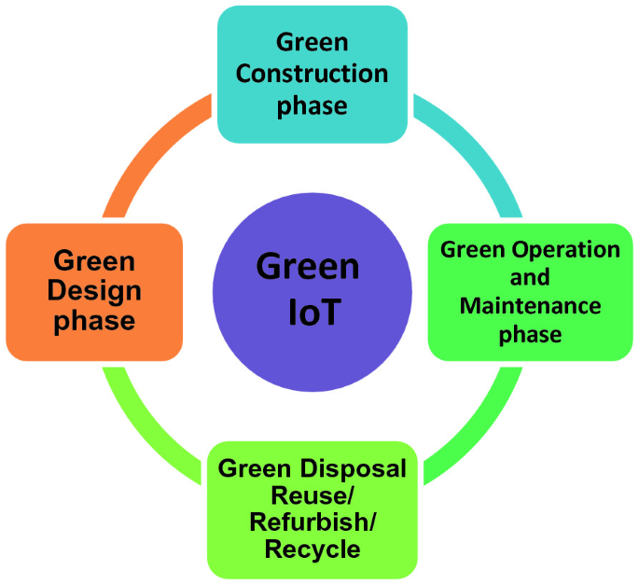
Figure 4: Green IoT Architecture [42]
Comparison Table 1
Focus Technology | Type | Energy Saving Mechanism | Practical | Trade Offs
Data Centre[10] | Software Based | Context Aware Allocation of Servers | Practical | Extra Resources for QoS.
Sensors[22] | Software Based | Selective Sensing Highly | Practical | Practical Privacy, Energy Overheads for Context Aware Sensing
Sensors [19] | Software Based | Sleep Scheduling | Highly Practical | Extra Resources for QoS
Data Centre  [16] | Software Based | Workload Distribution Among Geographically Dispersed DCs | Not Practical | Too Much Complexity
Smart Buildings  [20] | Policy Based | Policies and Strategies to Minimize Energy Consumption. | Highly  Practical | User Dependency (User needs to participate actively for efficient policies.
Processor  [5] | Hardware Based | Assigning Different Tasks to Different cores by scheduling | Practical | High cost and complexity for large scale Network.
Sensors [25] | Software Based | Compressed Sensing | Practical | Quality of Service .
Cloud [26] Computing | Software Based | Reducing Data Path | Practical | Quality of service might fall.
RFID [14] | Hardware Based | Use of Passive Sensors | Practical | Communication Delays
Integrated Circuits[17] | Hardware Based | Reducing Network Traffic using Sensor on Chip. | Practical | High Cost
Mobile Phones/ Sensors [31] | Recycling Based | Recycling the unused elements to make them productive again. | Highly Practical | Chance of wastage of recyclable material.
Virtualization  [6] | Software Based | Separating Network and IoT Devies using MILP | Practical | Performance issues in Large scale Network.
Smart Phones  [38] | Software Based | Prediction of energy consumption for different application of smart phones | Practical | Privacy and Security of Data.
Conclusion
As per the survey conducted in Australia, it is found that 23 million mobile phones are no longer usable. Moreover, 90% of materials used in the manufacture of mobile phones are recyclable. The need for recycling increases and automatically reduces the energy consumption and the effect of greenhouse gases34. Electric and Electronic Equipment (EEE) recently introduced the recovery and collection of metals that come under EEE-type. Furthermore, the use of solar energy for charging has been proposed by authors in that around 20% of the consumed energy is reduced.
Reference:
1. Gadre Chinmay & Prof. Gadre Monika, ISSN : 2278-0181, “Green Internet of Things (IoT): Go Green with IoT”, International Journal of Engineering Research & Technology , 2016
2. Chunsheng Zhu, Victor C. M. Leungi, Lei Shu, AND Edith C.-H.Ngai, : “Green internet of things for smart world”, 2015.
3. J. Suckling, J. J. Lee, C. Energy, P. Advocacy, P. Report, C. Fy, Q. Song, J. Li, C. Lee, J. J. Lee, A. Zhou, N. Carolina, E. Report, J. Lane, and IEA, “Low medium high”, 2015.
4. M. R. Helal and A. Elmougy, “An Energy-Efficient Service Discovery Protocol for the IoT based on a Multi-Tier WSN Architecture”, 2015.
5. A. Caragliu, C. Del bo, and P. Nijkamp, “smart cities in europe.”, J. Urban technology., Vol.18, 2011.
6. Z. T. Al-azez, A. Q. Lawey, T. E. H. El-gorashi, and J. M. H. Elmirghani, “virtualization framework for energy efficient iotnetworks”, 2015.
7. Rana, S. U. A. & Raju, V. Factors influencing glass ceiling focus on women administration in higher education in Malaysia. Int J Eng Adv Technol8, 461–468 (2019).
8. Younus, A. M. & Raju, V. Resilient Features of Organizational Culture in Implementation of Smart Contract Technology Blockchain in Iraqi Gas and Oil Companies. International Journal for Quality Research, 435–450 (2021).
9.D. Kelaidonis, G. Poulios, and P. Vlacheas, “Cognitive Management for the Internet of Things: A Framework for Enabling Autonomous Applications”, 2013.
10. C. Peoples, G. Parr, S.Mcclean,B. Scotney, and P.Morrow, “performance evaluation of green data centre management supporting sustainable growth of the internet of things.” , 2013.
11. Saigopal, V. V. R. G. & Raju, V. IIoT Digital Forensics and Major Security issues. 2020 International Conference on Computational Intelligence, ICCI 2020 233–236 (2020) doi:10.1109/ICCI51257.2020.9247685.
12. Farooq, M. & Raju, V. Want to Stay the Market Leader in the Era of Transformative Marketing? Keep the Customers Satisfied! Global Journal of Flexible Systems Management, 257–266 (2019).
13. D. Boll, J. De Vos, F. Botman, G. De Streel, S. Bernard, D. Flandre,and J. D. Legat, “Green SoCs for a sustainable Internet-of-Things”, 2013.
14. C. Occhiuzzi, S. Caizzone, and G. Marrocco, “passive UHF RFID antennas for sensing applications : principles, methods, and classifications.”, 2018.
15. Raju, V. Implementing Flexible Systems in Doctoral Viva Defense Through Virtual Mechanism. Global Journal of Flexible Systems Management, 127–139 (2021).
16. M. Ghamkhari and H. Mohsenian-rad, “optimal integration of renewable energy resources in data centers with behind-the-meter renewable generator.”, 2012.
17. D. Boll, J. De Vos, F. Botman, G. De Streel, S. Bernard, D. Flandre, and J. D. Legat, “Green SoCs for a sustainable Internet-of-Things”, 2013.
18. Raju, V. Theory of Lim law: Leadership style. Eurasian Journal of Analytical Chemistry, 125–136 (2018).
19. M. Etelapera, M. Vecchio, and R. Giaffreda, “improving energy efficiency in IoT with re-configurable virtual objects.” , 2014.
20. M. V. Moreno, B. Úbeda, A. F. Skarmeta, and M. A. Zamora, “how can we tackle energy efficiency in iot based smart buildings?”, 2014.
21. Dutta, P., Mandal, R., Bhattacharyya, S., Dey, R. & Dhar, R. S. Fabrication and characterization of copper based semiconducting materials for optoelectronic applications. Microsystem Technologies, 3475–3482 (2021).
22. S. F. Abedin, M. G. R. Alam, R. Haw, and C. S. Hong, “A systemmodel for energy efficient green-iot network”, 2015.
23. Hungyo, S. et al. Estimation and analysis for modelling of stand-alone graphene/AlGaAs/GaAs schottky solar photovoltaic cell module for power conversion efficiency. Microsystem Technologies, 3693–3701 (2021).
24. Kumar, K., Dhar, R. S., Bhattacharya, S. & Dey, R. Performance analysis and development of strain induced quantum well based nano-system device technology. Microsystem Technologies, 3703–3710 (2021).
25. K. Sun, “A study on medium access control scheme for energy efficiency in wireless smart sensor networks”, 2015.
26. S. A. Alvi, G. A. Shah, and W. Mahmood, “energy efficient green routing protocol for internet of multimedia things”, 2015.
27. Ahmed, A., Khan, M. M., Dey, R. & Nanda, I. Smart Helmet with Rear View and Accident Detection System for Increased Safety. 2022 IEEE 12th Annual Computing and Communication Workshop and Conference, CCWC 2022 673–678 (2022) doi:10.1109/CCWC54503.2022.9720833.
28. Siddique, M. S. U. Z., Mohammad, S., Bhowmick, T., Khan, M. M. & Dey, R. Development of Low-cost GPS Tracker System for Coastal Area of Bangladesh. Proceedings - 6th International Conference on Computing Methodologies and Communication, ICCMC 2022 1534–1539 (2022) doi:10.1109/ICCMC53470.2022.9754036.
29. Datta, B., Das, A., Dey, R. & Das, A. Design of a Second Order System with Additional Actuating Signal for Desired Output. Lecture Notes in Networks and Systems, 495–506 (2022).
30. Huiwu, Y. &Hongmei, Y. The Influencing Factors of Turnover Intention of Post-90s Employees —Evidence from small and medium-sized graphic design enterprises in Chongqing. Journal of Reproducible Research, 109–122 (2022).
31. D. Kelaidonis, G. Poulios, and P. Vlacheas, “Cognitive Management for the Internet of Things: A Framework for Enabling Autonomous Applications”, 2013.
32. Akyildiz, I. F., Su, W., Sankarasubramaniam, Y., and Cayirci, E. Wireless sensor networks: a
survey. Computer networks 38, 4 (2012), 393-422.
33. Amazon web services. http://aws.amazon.com/, Accessed: 14.05.2017. Anderson, J. C.,
Lehnardt, J., and Slater,N. CouchDB: The Denitive Guide: Time to Relax. O’Reilly Media,
2018.
34. SulaimanAlfawzan, L. The effect of firm size, profitability, liquidity and industry type on firm value. Journal of Reproducible Research, 94–102 (2022).
35.Journal of Information Communication Technology and Digital Convergence Vol. 6, No. 2,
December 2021, pp. 94-100 100
36. Gao, H. & Raju, V. Entrepreneur Ability And Firm Growth. Journal of Reproducible Research, 61–66 (2022).
37. Rasadurai, M. & Raju, V. Entrepreneurship and Innovation – A Review. Journal of Reproducible Research, 83–89 (2022).
38. P. Sathyamoorthy and E. Ngai, “energy efficiency as a orchestration service for the internet of things”, 2015.
39. https://www.researchgate.net/figure/Overall-IoT-scenario_fig2_311394404.
40. https://www.researchgate.net/figure/Five-Layer-IoT-Architecture_fig1_324797771.
41. https://www.intechopen.com/chapters/65203.
42. https://link.springer.com/chapter/10.1007/978-981-15-4246-6_19.
43. Sumit Kumar, Zahid Raza, “Internet of Things: Possibilities and Challenges”, International Journal of Systems and Service-Oriented Engineering (IJSSOE), IGI Global, pp 32-52 Volume 7, Issues 3, July-September 2017, ISSN 1947-3052, DOI: 10.4018/IJSSOE.2017070103.

