Enhancing First Pass Yield in Multi-Cylinder Fuel Injection Pumps
N V Nanjundaradhya | Nischit U R
Department of Mechanical Engineering | Department of Mechanical Engineering
RV College of Engineering | RV College of Engineering
Bangalore, India | Bangalore, India

Pradeep K Sahoo | S K Harisha
Structural Technological Division | Department of Mechanical Engineering
CSIR-National Aerospace Laboratories | RV College of Engineering
Bangalore, India | Bangalore, India

ABSTRACT

The international automobile industry, valued at around $200 billion, relies heavily on mass production and considers product quality crucial for success and customer satisfaction. The main component in Diesel Engines, the multi-cylinder fuel injection pump, significantly influences the company's outcome, with First Pass Yield being a critical factor. To enhance the First Pass Yield and address the governor cover joint leak, the Shainin approach is utilized to identify and control the root cause. Governor cover joint leakage is the leakage found between the governor cover and Governor housing Interface which was single-side glued and soaked with oil for best seating and to obtain leakproof. The asbestos-free paper gasket is used at the interface, and six screws with 8nm torque are used for perfect attachment. Even after this arrangement, small leakage occurs at the interface. The root cause is found to be Gasket Swelling time. The reason for the cause is analyzed with respect to different experimentation. The solution is found and optimized with respect to the physics of the problem. An optimized solution is validated for a particular batch over a particular period of time. Initial FPY is 97.8%. Root cause analysis is done for GCJL. The optimized solution is validated for a particular batch over a particular period of time. FPY of the FIP increased as the Swelling time of the gasket decreases. Four hundred samples are tested for swelling time, for 3 minutes, it is 100 %, and for 10 minutes, it is 99%.

` | INTRODUCTION
Various methods are used in workshops and service centers to identify and fix vehicle faults, including visual inspection, ear tests, and black box techniques [1]. In complex vehicle systems, both software and hardware tools are used to identify faults. Lubricating oil leakage from the governor cover is a major issue, and quality tools are employed to ensure good performance and customer satisfaction [2][3]. Human errors and subcomponent errors are challenges in mass production that require root cause analysis tools. The use of various techniques and tools, such as DOE and the Shainin Approach, for identifying and solving problems in mass production industries [9]. These methods aim to save time and resources while improving processes. The paper proposes a hybrid framework that integrates Taguchi methods, Shainin System, and Six Sigma DMAIC for process improvement [10]. Governor cover joint leakage is a major challenge faced by mass production industries, and various analyses and comparisons are conducted to find the best method for identifying root causes [4][5]. Overall, the use of these techniques helps achieve good quality and efficient problem-solving in mass production, though adoption can be hindered by complexity and lack of guidance [6]-[8].
The literature survey indicates that various research has been conducted using different quality and root cause analysis tools in mass production systems. However, these approaches, such as Six Sigma and Taguchi principles, are time-consuming and not suitable for quick adoption in mass production industries. On the other hand, research shows that adopting the Shainin methodology for complex and multi-parameter experiments leads to efficient outcomes [11]. The Shainin approach is found to be effective in overcoming quality-related issues in a short period of time, making it beneficial for large-scale industries. Traditional quality tools are considered time-consuming and less effective in comparison. The aim of this work is to address the literature gap in the mass production system, specifically focusing on the governor cover joint leakage issue, which currently accounts for approximately 50% of the problem. The main objective is to identify and eliminate the root cause of this leakage, as it directly impacts the first pass yield of the fuel injection pump.

II | METHODOLOGY
The project methodology, commences with a literature study to understand the significance of the study and comprehend leakage issues, gasket failures, and root cause identification methodologies in fuel injection pumps. The entire project is conducted using the Shainin methodology, represented by the standard Shainin method chart, which consists of seven steps moving from macro to micro levels. Analysis is performed by selecting good (BOB) and bad (WOW) samples to evaluate the problem. In this project, the Green Y parameter represents the Governor Cover Joint Leakage, and the Red X parameter signifies the root cause of the leakage. The methodology flow involves collecting industry data, identifying rejection types, studying their nature, and then applying the Shainin methodology to pinpoint the root cause. The behavior of gasket swelling time and its effect on sealing is also experimentally explored.

III | GOVERNOR COVER PREPARATION AND EQUIPMENT
- ASSEMBLY PROCESS OF FUEL INJECTION PUMP AND GOVERNOR COVER:
The assembly process consists of three distinct stages: main assembly, subassembly, and Governor Cover preparation. Subassembly involves assembling the inner elements of the Governor Cover. Main assembly is responsible for assembling various components of the pump housing and governor housing. Lastly, Governor Cover preparation focuses on attaching the gasket and other components to the Governor Cover.

- GOVERNOR COVER PREPARATION
Governor Cover preparation is a subassembly process conducted at various assembly stations. It involves several steps aimed at achieving improved sealing between the governor cover and governor housing.

B.1 GOVERNOR COVER PLACING AND END PLATE ASSEMBLY
The process involves the placement of Governor Covers and the assembly of End Plates. The covers are transported by trolley from the supermarket and positioned upside down in the preparation area. The End Plate is fitted with an O-Ring in its slot and assembled using a screw and screwing gun. Once this assembly is complete, the Cover is then inverted from its initial position.

B.2 GOVERNOR COVER WIPING AND EXTENSION SPRING ASSEMBLY
The Governor Cover is cleaned thoroughly with a clean cotton cloth to eliminate any oil residue from its surface. It is essential to ensure that no oil remains on the cover to maintain the sticking property of the dendrite. Once the wiping is done, the extension spring is assembled, and specific types of extension springs are used based on the requirements.

B.3 DENDRITE APPLICATION AND GASKET FIXING
After the Governor Cover is wiped clean, the application of dendrite aids in ensuring proper gasket sticking to the fixture. Additionally, the use of glue helps prevent Gasket fold during the assembly process of the Cover to the Fuel Injection Pump (FIP). Once the dendrite is applied, the Cover is allowed to dry for a few minutes. When the glue reaches a semi-dried state, the Cover is pressed against the Gasket carrier fixture. Due to the presence of glue in the Cover, one of the gaskets attaches to the Cover from the fixture. To ensure proper alignment, the fixture consists of six pins that guide the gasket to sit in the correct position.

B.4 GASKET SOAKING AND GASKET SWELLING
After the gasket is attached to the Governor Cover, it undergoes an oil soaking process for absorption. This is achieved by pressing the Cover with the Gasket against a pre-oil soaked tray containing a sponge. The tray must be filled with 75% oil, and the soaking time should be a minimum of 5 seconds. This manual pressing method ensures even distribution of the oil on the Gasket's surface through the application of equal force. Subsequently, the Gasket is allowed to swell after the oil soaking process. The procedure of allowing the cover to swell the Gasket, which enhances the smoothness of the gasket. As per instructions, a minimum of 30 seconds is required for swelling.

B.5 COVER FIXING AND ASSEMBLY
The extension spring is secured to the end fixture using a nose player, and the control rod link is connected to the rod end. The Governor Cover is then assembled to the Fuel Injection Pump (FIP) with the assistance of a screwing gun and screws.

- GASKET AND ITS PROPERTIES
An asbestos-free paper gasket is utilized at the interface between the Governor Cover and Governor Housing. Before assembly, each gasket is soaked in oil. The paper gasket is composed of cellulose fibers, which possess the unique property of absorbing liquid upon contact, enhancing its surface smoothness. If the gasket's surface becomes dry, it regains its original properties. As both sides of the gasket used in the interface are made of cellulose fiber, they exhibit similar properties. The gasket's molecules become loose upon contact with lubricating oil, resulting in increased smoothness and accurate sealing at the interface.

- EQUIPMENT USED
D.1 LEAK TESTING:
The testing chamber comprises Control Valve, Oil Tank, Pressure Gauges, Timer, and Connecting Hoses, as depicted in Fig. 1. This wet-type test unit involves immersing the Fuel Injection Pump (FIP) in an oil-filled tank by connecting it with hoses. Accuracy and repeatability are crucial factors for any testing process, and the chosen testing chamber ensures high precision and easy, quick assembly of the pump. This submersible testing unit utilizes testing oil to detect leaks, which are indicated by the appearance of bubbles when 1.5 bar air is passed into the inlet valve. The testing process is maintained for 75 seconds. Fig. 2 illustrates the connected hoses and the submersed FIP during testing, with any leakage being detected in the form of bubbles.
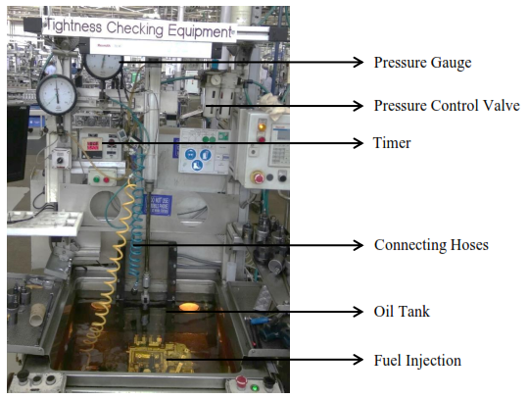
Fig.1: Tightness Chamber
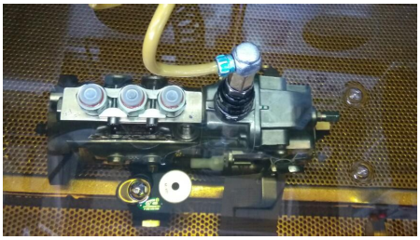
Fig.2: FIP Immersed in oil and connected hoses

D.2 SURFACE CONTACT ANALYSIS:
A Stereo zoom microscope is employed to analyze the surface contact between the gasket and governor cover. Specifically, the SZX16 capable of 900-line pair/mm microscope with 72X zoom is used for testing, After assembling the cover and housing following industry instructions, testing is conducted by zooming in on the contact area until a clear image is captured. The captured images can be exported for further analysis. A selected set of samples are tested, and their images are exported for observation. The fuel injection pump, with its complete assembly, undergoes testing to ensure perfect alignment.

IV | ANALYSIS AND EXPERIMENTATION
The experimentation is conducted to identify the root cause of the defined problem in the fuel injection pump (FIP) production. The standard format of the Shainin process is followed, and experimentation is carried out using BOB and WOW samples. The focus is on the tightness defect, which is the main cause of rejection in the FIP. Various strategies are employed for analysis, including Point to Point, Region to Region, Cover to Cover, Supplier to Supplier, etc.
Focus: The initial step is to analyze all requirements related to the problem and study their contributions. The problem definition tree is used to identify different types of defects and their contribution percentages. Tightness is found to be the major defect, and it is further divided into more than forty other defects.
Approach: Strategy diagrams (Design family and Process family) are used to identify the root cause. Design family focuses on product dimensional parameters, while Process family focuses on assembly variations.
Design Family: Different strategies are used, such as Point to Point, Region to Region, Cover to Cover, etc., to identify dimensional defects in the governor cover and housing.
Process Family: Various strategies are used to analyze assembly variations, including Line to Line, Day to Day, Group to Group, etc. The tightness defect is studied extensively, and the testing process for identifying leakage is explained.
Group Comparison: The working procedures for assembly are compared within employee groups to understand variations.
Solution Tree: The solution tree is used to converge the analysis and identify the root cause. It is revealed that the root cause lies in the gasket soaking time. Overall, the experimentation and analysis aim to identify the specific root cause of governor cover joint leakage in the fuel injection pump production, contributing to improving the first pass yield.

V | RESULTS & DISCUSSION
- COMPONENT SEARCH
The purpose of Component Search is to ensure the accuracy and precision of the leakage testing unit. This process consists of two stages with five steps. The measurements (Measurement 1, Measurement 2, and Measurement 3) are repeated to assess the repeatability of the measurement unit. The results consistently show that "WOW is WOW" and "BOB is BOB," indicating the measurement unit's perfection.
To visually represent the results and their behavior, a linear graph is plotted. The graph exhibits no variations in the results, with numerical zero representing the leakage pump and numerical one indicating the good pump. This stage is referred to as "Stage 0" in the process and is generated using the Shainin tool to gain a better understanding of the behavior of the BOB and WOW groups.
The graph displays the behavior of both the WOW pump (indicated by the red line) and the BOB pump (indicated by the blue line). The x-axis represents leakage, while the y-axis represents the process. The plotted data, which includes five experimentation steps, shows that the behavior remains consistent with no changes.
In Fig. 3, the component search is depicted, and "Stage Zero" represents the verification of tightness measurements. "Measurement One" represents the original rejected pump and the first-time good pump. These pumps undergo three leakage tests, referred to as Measurement One, Measurement Two, and Measurement Three. The fact that these three measurements consistently show WOW to WOW and BOB to BOB indicates the measurement's perfect repeatability.
"Stage 1" is focused on understanding process variation. During this stage, the components between the WOW and BOB pumps are swapped. The observation reveals that WOW changed to BOB with no leakage, indicating that there is some variation in the process.

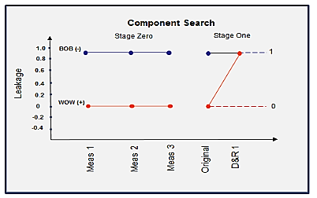
Fig.3: Component Search
- MATING SURFACE CONTACT TEST
The stereo zoom microscope is utilized to identify the surface contact between mating surfaces. In Fig. 4, two different pump groups, BOB and WOW, are shown. The first-time leak pump and the first-time good pump are used to discern the differences. The captured picture is taken between the two mating surfaces. It is observed that a small portion of the gasket is misaligned with the Governor surface, resulting in sufficient gap for leakage. The comparison is conducted at 72X zoom, and the red dotted line in the figure represents the two different assemblies. The picture clearly indicates that the quality of the gasket assembly needs to be improved to prevent leakage.
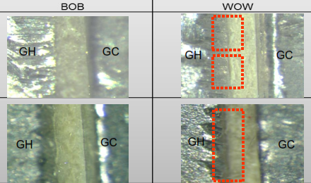
Fig.4: Stereo Zoom Microscopic images of WOW and BOB parts.

- DIMENSIONAL VERIFICATION
The Coordinate Measuring Machine (CMM) is employed to determine the dimensions of various functional features. These test results are crucial for understanding tolerance limits and their impact on the assembled unit's functionality. The FIP (Fuel Injection Pump) comprises different types of Governor Covers, each serving specific features and functions of the pumps. To differentiate and identify WOW and BOB samples of the same type, a strategy called "Cover to Cover with same type" is used. Every sample, specifically the F002A21305 type, is subjected to dimensional verification, including measurements of Parallelism, mounting hole distances, Flatness, Mounting hole true position, and Surface finish. Five samples of WOW and BOB for F002A21305 are selected and dimensionally verified.
The F002A21305 type is frequently used in most pumps. For the verification process, a rejected pump with Governor Cover joint leakage of the same 305 type is disassembled and considered as WOW. Similarly, five good pumps are disassembled to separate the assembled components and consider them as BOB. After cleaning all the covers with pressure air, dimensional verification is conducted, revealing no dimensional differences between WOW and BOB parts. Thus, the selected strategy is deemed to have no contrast between the two.

- PRESSURE STABILIZATION TEST
Tightness checking is a process that utilizes pneumatic air to identify leakage. Point to Point analysis is conducted to discern the differences between WOW and BOB parts. The process involves a low-pressure chamber with a pressure distribution of only 1.5 bars. Two FIP's, WOW and BOB, are tested for pressure stabilization in the leakage testing unit. The results are plotted in Fig. 5, where the red and blue lines represent the WOW and BOB pumps, respectively. It is evident that both WOW and BOB pumps coincide with each other up to 20 seconds of time, which indicates the stabilization and filling time. After this, the stabilized pressure inside the FIP falls suddenly in the case of leakage, while a gradual fall occurs in the case of good pumps.

Table 1: Pressure distribution and Time taken in WOW and BOB pumps
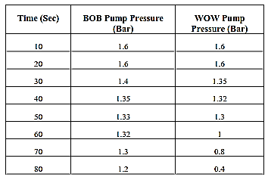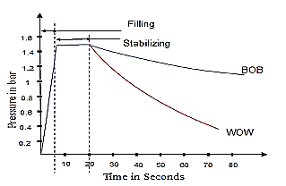
Fig.5: Pressure variation with respect to time
This test is conducted to understand the behavior of BOB and WOW pumps during testing. It helps in comprehending how leakage occurs over time and provides insights into the factors affecting the tightness of the components.

- ASSEMBLY LINE WISE EXPERIMENTATION
In January and February, a series of experiments were conducted on the six assembly lines of Ban P to analyze rejection rates and identify potential areas for improvement. Pin-to-pin analysis was performed for each assembly line, and the data collected for rejection rates was presented in Table 2. This analysis was part of the Line-to-Line strategy aimed at enhancing efficiency. Among the six assembly lines, four operated as regular working lines. The results revealed that Assembly Lines L1 and L6 had the highest rejection rates compared to the other lines. Despite similar equipment and equal workforce in each assembly line, variations in the procedures followed were observed. These findings played a crucial role in selecting specific assembly lines for further experimentation and improvement measures.

Table 2: Rejection percentage for the month of Jan and Feb.
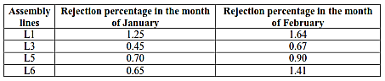

- GROUP WISE EXPERIMENTATION
This experimentation focuses on the group of workers responsible for assembling FIP (Fuel Injection Pump) in various assembly lines. The data collected for the months of January and February is presented in Table 3, where L1, L3, L5, and L6 represent different assembly lines, and G1, G2, and G3 indicate the groups of workers operating in shifts on specific days. Each assembly line consists of three different groups, each comprising fourteen employees. These groups have distinct approaches to their work based on experience, workload, and interest, resulting in varying first pass yield (FPY) rates. The collected data reveals the number of rejections for each group with respect to their respective assembly lines. Notably, Group 2 in Line 1 and Group 3 in Line 6 show the highest contrast in rejections, while Group 1 in Lines 3 and 5 exhibits the least rejections. This analysis designates G2L1 and G3L6 as the "WOW" groups, while G1L3 is identified as the "BOB" group.

Table 3: Group wise rejections for the month of January and February
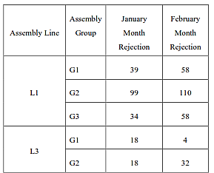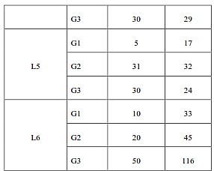

- GROUP COMPARISON
Table 4 presents the results of the WOW and BOB groups for various assembly parameters, comparing them with the standard instruction. The comparison is focused on understanding the delta "P" process variation between different assembly processes. It involves comparing a group of people following the work instruction (WOW) with a group not following the work instruction (BOB) for different parameters, including Dendrite drying, soaking time, and swelling time.

Table 4: Group Comparison
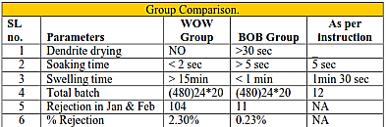

- GASKET SWELLING AND ITS EFFECT ON LEAK ARRESTING
Gasket swelling time refers to the duration after the assembly of the FIP (Fuel Injection Pump) using a gasket at the interface of the Governor Cover and Housing. During this process, oil is applied to the gasket, causing it to swell. The test is conducted using sixteen samples of the leak pump, labeled alphabetically from A to P. Each sample undergoes testing at two-hour intervals. Remarkably, within twelve hours, all initially bad samples turn into good samples without any external intervention. This test provides clear evidence that the gasket will expand and fill the leakage gap within a specific period of time. The swelling of the gasket leads to significant improvements in the FIP performance, eliminating leaks effectively.

- GASKET SWELLING TIME AND ITS EFFECT ON LEAKAGE
Table 5 presents the results of an experimentation involving 400 samples conducted at the Governor covers preparation station. The purpose of this experiment is to understand the behavior of the gasket. The samples are assembled and observed for different intervals of time, with 40 samples grouped together for testing at various time intervals ranging from 30 minutes to 10 hours. The data collected from this experiment is plotted in Fig. 6.

Table 5: Swelling time and Rejection
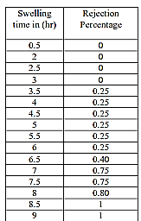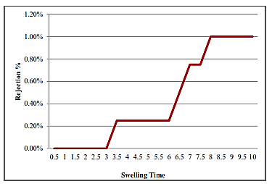
Fig. 6: Gasket Swelling time and Rejection Percentage.
The graph in Figure 6 demonstrates that as the swelling time increases, the rejection percentage also increases. This indicates that a longer swelling time leads to higher rejection rates. The experiment aims to identify the optimal swelling time of the gasket before assembly. The results of the test confirm that when the swelling time increases, the oil on the gasket surface dries off, causing the gasket to regain its original properties and hardness. As the gasket used in the interface is made of cellulose fiber, this property contributes to the gasket's behavior. The hardened surface of the gasket leads to uneven sealing of the mating parts, resulting in the rejection of FIPs (Fuel Injection Pumps). Based on the findings, it is determined that the optimal swelling time must be within 3 minutes after soaking the cover in oil to achieve the desired sealing and avoid rejections in the FIPs.

- SIX PACK TEST
The Shainin approach uses conformation tests to validate predictions of the root cause. One experiment revealed that an increase in idle time at the cover assembly station leads to a higher rejection percentage. To confirm this prediction, the Shainin approach employs a test called the "Six Pack test." This test involves selecting six samples for testing, with three representing the "WOW" process and three representing the "BOB" process. The project in question involves studying the Gasket swelling process. The Six Pack test utilizes two types of orders for testing: Run order and Rank order. Table 6.9 shows the Run order table.

J.1 RUN ORDER
In the Shainin approach, the Run order involves a random selection of BOB and WOW processes, followed by the operators. The experiment includes practicing three sets of samples using the correct WOW process and three sets using the incorrect procedure. The results are tabulated in Table 6, with each set consisting of four hundred samples. The WOW process takes more than 20 minutes for swelling, while the BOB process involves assembling within 3 minutes after soaking. The experiment is conducted for four hundred sets of samples, and the leakage percentage is calculated for both the WOW and BOB samples.
Table 6: Run Order of Red X and Green Y
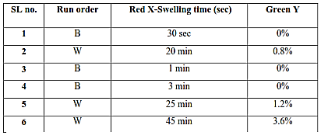

J.2 RANK ORDER
In the Shainin approach, after the Run Order process, the Rank Order is carried out. In Rank Order, all the data from the Run Order is plotted in ascending order. The objective is to ensure that all the BOB samples must come in the top three places. If this condition is met, the Six Pack tests are considered successful; otherwise, they are deemed to fail. From the data presented in Table 7, it is evident that the Six Pack tests are successful. This success indicates that the approach can be applied in the production plant. Notably, when the assembling process is conducted within 3 minutes after oil soaking, it leads to zero rejections. Thus, it is recommended to carry out the cover assembly within 3 minutes after oil soaking to achieve optimal results and minimize rejections.

Table 7: Rank Order of Red X and Green Y
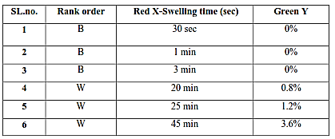

- IMPLEMENTATION AND TESTING
According to the results of the six-pack test, it is evident that there is a need to increase the gasket soaking time and time to swelling. This step has been incorporated into the assembly process to determine the optimal idle time after soaking the cover. The experimentation involved 400 samples for each time interval, and Table 8 presents the details of the time intervals, test samples, and their respective results.

Table 8: Percentage Rejection and First Pass Yield
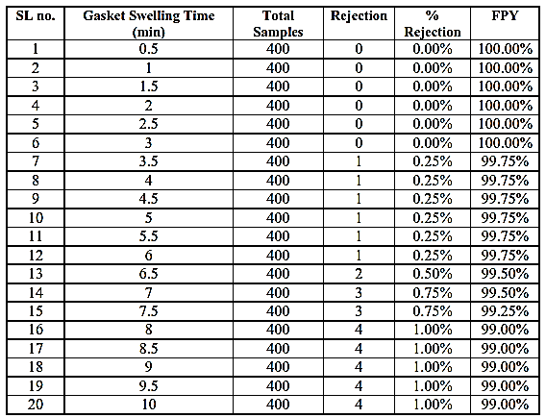
Assembly personnel are advised to adhere to these instructions. Additionally, a graph was plotted based on the data in Table 8 to better comprehend the relationship between different swelling times and their impact on the First Pass Yield (FPY). Fig. 7 provides a clear understanding of how FPY fluctuates with varying swelling times, as each of the 400 Fuel Injection Pumps (FIP) was tested for different time intervals, and the results were plotted in terms of First Pass Yield.
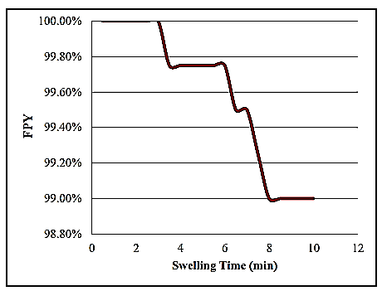
Fig.7: Gasket swelling time v/s FPY
The analysis of Figure 5.5 indicates that increasing swelling time leads to a decrease in First Pass Yield. Swelling time and FPY exhibit a universal proportional relationship. The highest rejection rates occur with maximum swelling time because while the gasket is allowed to swell, the oil within the gasket dries up, resulting in leakage.
Based on the conducted experiments, it is evident that the ideal swelling time is within 15 minutes after soaking the gasket in oil. The minimum recommended idle time after oil soaking is 1 minute. These findings mark the completion of the study, and the experimentation is considered successful.

VI | CONCLUSIONS
Several experimentations were conducted and tabulated, revealing that the major factor affecting the First Pass Yield (FPY) was the governor cover leakage resulting from the gasket soaking time before assembling the cover to the pump. The gasket plays a crucial role in preparing the seal-proof component, and it is soaked in oil to ensure a smooth surface and proper alignment with the opposite walls during assembly. The smoothness of the gasket significantly influences the leakage; hence, the soaking process is essential for reducing leaks. Through experimentation, it was observed that if the idle time exceeded 15 minutes, the oil from the gasket would dry up, leading to a hardened surface that affects the even contact between mating surfaces. To achieve optimal results, it is recommended to assemble the Governor Cover with the gasket within 15 minutes after soaking in oil. Continual analysis and experimentation on the gasket's swelling time further confirmed that it should be kept within 15 minutes to ensure efficient assembly and reduce leakage in the Fuel Injection Pump.

REFERENCE
- Ping Yangab, Yao-hui Liua, Shu-wen Gaoa, Zhi-cheng Li. Experiment on sealing efficiency of carbon fiber composite grout under flowing conditions. International Journal of Vehicle Noise and Vibration. 2018; 1(2): 43-51.
- Guoqing, LiQian, Zhang Zhijun, LeiEnliang, HuangHongwei, WuGang Xu. Leakage performance of labyrinth seal for oil sealing of aero-engine, Propulsion and Power Research 2019; 52(04): 13-22
- Carmen MataVicente, Rojas-ReinosoJosé, A. Soriano, Experimental determination and modelling of fuel rate of injection: A review, Fuel, February 2023
- Zongyan LvJianfei PengHongjun Mao, Particulate emissions from gasoline vehicles using three different fuel injection technologies, Journal of Cleaner Production, July 2023
- Alessandro Ferrari, Carlo Novara, Tantan Zhang, A novel fuel injected mass feedback-control for single and multiple injections in direct injection systems for CI engines, Fuel, November 2022
- Pankaj, Sumeet Kumar, Deepak. Root cause analysis of inlet connector leakage problem in fuel injection pump by Shainin methodology. International journal of quality science and industries. 2014; 23(01): 816-820.
- Guoqing, LiQian, Zhang Zhijun, LeiEnliang, HuangHongwei, WuGang Xu. Leakage performance of labyrinth seal for oil sealing of aero-engine, Propulsion and Power Research 2019; 52(04): 13-22
- Stephan Reckers, Pere Drinovac, Josef Mönch, Rolf W.Steinbrech, Hans Peter Buchkremer, DetlevStöver Deformation behavior and leakage tests of alternate sealing materials for SOFC stacks, Journal of Power Source, 2004; 32 (2):111119.
- Stefan H. Steiner, R. Jock MacKay and John S. Ramberg. An Overview of the Shainin System for Quality Improvement. Quality Engineering, 2008; 20(1): 6–19.
- Stephen B. Kritchevsky Nagaraja Reddy K M, Dr. Y S Varadarajan, Raghuveer Prasad. Quality Improvement during Camshaft Keyway Tightening Using Shainin Approach. International Journal of Scientific and Research Publications, 2004; 4(7):2250-3153.
- Anand K. Bewoor, Maruti S. Pawar. Use of Shainin Tools for simplifying Six Sigma implementation in QMS/ISO Certified environment– An Indian SME Case Study. Journal of Engineering Research and Studies, 2010; 1(2):177-194.

