Benefits of using Eco-Based Materials
Savvy Jain
School of Art and Architecture,
Sushant University
Gurgaon, India
savvyjain08@gmail.com

ABSTRACT
Eco materials in the construction industry has become an integral part. With the rise in the use of eco materials it is being possible to make more sustainable buildings. This chapter explores the concept of eco materials, focusing on recycled materials, waste-derived materials, and bio-based materials. It discusses the importance of sustainable materials in mitigating environmental impacts and reducing resource consumption, hence promoting a greener future. The chapter provides an overview of the characteristics, production processes, and applications of these eco materials, highlighting their potential to contribute to a circular economy and a greener future. This chapter would focus on three main types of eco materials namely- recycled, waste based materials and bio based materials. It encourages further research, technological advancements, and policy support to facilitate the transition towards a more sustainable and environmentally conscious built environment.
INTRODUCTION
The construction industry plays a significant role in shaping the built environment and has a considerable impact on the environment, resource consumption, and greenhouse gas emissions. As global awareness about sustainability and the need for eco-friendly practices increases, there is a growing demand for construction materials that minimize environmental impact while maintaining structural integrity and functionality.
Eco materials in construction refer to sustainable building materials that are designed, sourced, produced, and utilized in a manner that reduces environmental harm and promotes long-term sustainability. These materials are specifically chosen for their ability to minimize resource depletion, decrease energy consumption, mitigate pollution, and enhance overall building performance.
The use of eco materials in construction offers numerous advantages. Firstly, they contribute to the conservation of natural resources by reducing the extraction of raw materials and promoting the reuse and recycling of materials. Secondly, eco materials often possess improved energy efficiency properties, which can lead to reduced energy consumption during the lifecycle of a building. Additionally, these materials help minimize waste generation and promote the principles of a circular economy, where materials are kept in use for as long as possible through recycling and repurposing.
Eco materials, including recycled materials, waste-derived materials, and bio-based materials, offer innovative solutions to minimize the industry's environmental footprint and promote long-term sustainability. Recycled materials are derived from processed waste materials, such as recycled concrete aggregates or recycled steel, which are used to replace conventional virgin materials. Waste-derived materials are produced from various waste streams, such as agricultural residues or industrial by-products, and can be transformed into construction materials, such as fibreboards or insulation materials. Bio-based materials, on the other hand, are derived from renewable resources like plants and offer an alternative to traditional materials by reducing carbon emissions and promoting sustainable land use practices.
Incorporating eco materials in construction projects is not only beneficial for the environment but also offers economic and social advantages. These materials can often lead to cost savings through reduced energy consumption, lower maintenance costs, and improved waste management practices. Furthermore, the utilization of eco materials aligns with the increasing demand for green buildings and sustainable construction practices, enhancing a project's marketability and reputation.
This chapter explores the various eco-based materials used in construction, their characteristics, production processes, and applications. It discusses the benefits, challenges, and considerations associated with incorporating these materials into construction projects. Moreover, the chapter highlights the importance of a holistic approach to construct a sustainable building, considering not only the materials but also design, construction techniques, and building operation.
By understanding and utilizing eco materials in construction, we can strive towards a more sustainable and resilient built environment, reducing environmental impact, conserving resources, and providing a better tomorrow.

Eco Based Materials
The eco based materials are divided into three categories
- Recycled Waste Materials
One key category of eco materials in construction is recycled materials. By utilizing processed waste materials like recycled concrete aggregates, recycled metals, and recycled plastics, the industry reduces the demand for virgin resources while diverting waste from landfills. Recycling materials not only conserves natural resources but also significantly reduces energy consumption and greenhouse gas emissions associated with the extraction and production of new materials. Moreover, using recycled materials helps create a circular economy by promoting the reusability and extended lifespan of materials, thereby reducing waste generation and contributing to a more sustainable construction industry.
One of the main advantages of using recycled materials in construction is the conservation of natural resources. Instead of relying solely on the extraction of virgin resources, recycled materials repurpose materials that have already been used and discarded. For example, recycled concrete aggregates can be obtained from crushed concrete waste and used as a substitute for traditional gravel in construction applications. Similarly, recycled metals, such as steel and aluminum, can be reprocessed and used in various structural components. By reducing the demand for new raw materials, the use of recycled materials helps preserve natural resources and mitigates the environmental impacts associated with resource extraction.
In addition to resource conservation, recycled materials contribute to waste reduction and landfill diversion. Construction and demolition waste constitute a significant portion of landfill volumes. By incorporating recycled materials, construction projects can divert waste from landfills, thereby minimizing the environmental burden. Recycling materials like plastics, wood, and glass not only reduces waste generation but also helps address the challenges of waste management and promotes a more sustainable approach to construction. This helps in overcoming the biggest problem of landfills being made at corners in India.
Furthermore, using recycled materials in construction can lead to energy savings and reduced greenhouse gas emissions. The production of virgin materials often requires substantial amounts of energy and generates significant carbon emissions. In contrast, the processing and manufacturing of recycled materials typically consume less energy and result in lower carbon footprints. By substituting recycled materials for conventional materials, the construction industry can contribute to mitigating climate change and reducing its overall environmental impact.
It is worth noting that the quality and performance of recycled materials are crucial considerations in their application. To ensure their suitability for construction purposes, recycled materials undergo processing and testing to meet relevant standards and specifications. This ensures that the recycled materials maintain the required strength, durability, and safety standards necessary for construction applications.
In conclusion, recycled materials are a prime example of eco materials in the construction industry. By utilizing these materials, the construction industry can contribute to resource conservation, waste reduction, and reduced energy consumption. The adoption of recycled materials promotes a circular economy, where materials are reused and repurposed, minimizing the reliance on virgin resources and mitigating environmental impacts. Incorporating recycled materials into construction practices is a sustainable approach that aligns with the growing demand for environmentally conscious building solutions.
- Waste Derived Materials
Waste-derived materials are another category of eco materials that have significant potential in the construction industry. These materials are produced from various waste streams, such as agricultural residues, industrial by-products, or post-consumer waste, and offer sustainable alternatives to conventional construction materials.
One of the key benefits of utilizing waste-derived materials in construction is waste management and landfill diversion. Instead of being disposed of in landfills, these materials are repurposed and transformed into valuable construction products. For example, agricultural residues like straw or husks can be processed and used as a component in bio-composite panels for building construction. Similarly, industrial by-products such as fly ash from coal power plants or slag from steel production can be utilized in the manufacturing of cement and concrete, reducing the need for virgin materials. By diverting waste streams and converting them into useful construction materials, waste-derived materials contribute to reducing the environmental burden of waste disposal.
Waste-derived materials also offer environmental advantages in terms of reduced energy consumption and lower carbon emissions. The production of traditional construction materials, such as cement and concrete, often requires significant energy input and generates substantial carbon dioxide emissions. In contrast, waste-derived materials can serve as partial replacements for these materials, reducing the energy-intensive processes and associated emissions. For example, incorporating waste-derived aggregates or supplementary cementitious materials in concrete mixes can result in lower embodied energy and carbon footprint. This contributes to the overall sustainability of construction projects and helps mitigate climate change impacts.
Furthermore, the use of waste-derived materials can enhance the resource efficiency of the construction industry. Instead of solely relying on virgin resources, these materials make use of materials that would otherwise go to waste. By repurposing waste streams, the construction industry can minimize the depletion of natural resources and support the principles of a circular economy. Waste-derived materials also provide an opportunity to explore new material sources and reduce dependence on scarce or non-renewable resources.
However, it is important to note that the suitability and performance of waste-derived materials must be carefully evaluated. Factors such as material characteristics, processing techniques, and quality control need to be considered to ensure that these materials meet the required standards and performance criteria for construction applications. Adequate testing, certification, and quality assurance processes are essential to guarantee the structural integrity, durability, and safety of buildings constructed with waste-derived materials.
In conclusion, waste-derived materials represent an important category of eco materials in the construction industry. They offer opportunities for waste management, reduced energy consumption, and lower carbon emissions. By repurposing waste streams and utilizing these materials, the construction industry can contribute to a more sustainable and resource-efficient approach to building construction. Adopting waste-derived materials not only supports waste reduction and landfill diversion but also aligns with the goals of a circular economy and the pursuit of a greener future.
- Bio-based Materials
Bio-based materials are a significant category of eco materials that hold great potential in the construction industry. Derived from renewable resources such as plants, bio-based materials offer sustainable alternatives to conventional construction materials, reducing environmental impact and promoting a more environmentally friendly approach to building construction.
One of the key advantages of bio-based materials is their ability to sequester carbon dioxide during the growth phase of the source plants. By using bio-based materials in construction, the industry can contribute to carbon reduction efforts and mitigate climate change impacts. For instance, timber and bamboo are widely used bio-based materials that have a lower carbon footprint compared to energy-intensive materials like steel or concrete. Additionally, bio-based polymers and composites derived from plant-based sources can replace traditional petroleum-based materials, reducing reliance on fossil fuels and lowering carbon emissions.
Bio-based materials also offer benefits in terms of resource conservation. As renewable resources, plants can be sustainably cultivated and harvested for materials such as wood, straw, hemp, or cork. These materials can be used in various construction applications, ranging from structural elements to insulation, finishes, and bio-composite panels. By utilizing bio-based materials, the construction industry can reduce the depletion of non-renewable resources and support sustainable land use practices.
Furthermore, bio-based materials often exhibit favorable characteristics such as low toxicity and improved indoor air quality. Many traditional construction materials contain harmful chemicals and volatile organic compounds (VOCs) that can negatively impact human health and the environment. In contrast, bio-based materials, especially those with natural fiber compositions, tend to have lower VOC emissions and can contribute to healthier indoor environments. This aspect is particularly important in promoting sustainable and occupant-friendly buildings.
It is important to consider the sustainability and certification of bio-based materials. Responsible sourcing and production practices, including sustainable forestry and agricultural practices, need to be implemented to ensure the long-term viability of bio-based materials. Certification systems such as Forest Stewardship Council (FSC) for wood products or biobased certifications like USDA Certified Biobased Products Label can provide assurance of sustainability and traceability.
While bio-based materials offer numerous advantages, challenges remain, including cost, availability, and compatibility with existing construction practices. Research and development efforts are ongoing to improve the performance and durability of bio-based materials and to address these challenges. Additionally, collaboration among stakeholders, including architects, engineers, manufacturers, and policymakers, is crucial to promoting the adoption and integration of bio-based materials in the construction industry.
In conclusion, bio-based materials are a key component of eco materials in the construction industry. By utilizing these materials, the construction sector can reduce carbon emissions, promote sustainable land use, and enhance indoor air quality. The adoption of bio-based materials aligns with the goals of sustainability and resource efficiency, contributing to a more environmentally conscious built environment. Continued advancements in research, technology, and industry collaboration will further drive the integration of bio-based materials into construction practices, facilitating a transition toward a greener and more sustainable construction industry.

Benefits of using Eco-based Materials
Eco-based materials, also known as sustainable or green materials, offer numerous benefits in various industries, including construction. Here are some key advantages of using eco-based materials:
- Environmental Sustainability: Eco-based materials are sourced from renewable resources or recycled content, reducing the dependence on non-renewable resources. By utilizing these materials, we can conserve natural resources, minimize environmental degradation, and support a more sustainable future.
- Reduced Carbon Footprint: Eco-based materials often have a lower carbon footprint compared to traditional materials. They typically require less energy and produce fewer greenhouse gas emissions during extraction, production, and transportation. By using eco-based materials, we can contribute to mitigating climate change and reducing overall environmental impact.
- Waste Reduction and Recycling: Many eco-based materials are derived from recycled content or waste materials, diverting them from landfills and reducing the amount of waste generated. By promoting recycling and utilizing waste-derived materials, we can achieve a more circular economy and minimize the depletion of natural resources.
- Improved Indoor Air Quality: Eco-based materials often have lower levels of volatile organic compounds (VOCs) and other harmful chemicals compared to conventional materials. This results in improved indoor air quality, reducing the risk of health issues and enhancing the comfort and well-being of occupants in buildings.
- Energy Efficiency: Certain eco-based materials, such as insulation made from recycled materials or natural fibers, can enhance the energy efficiency of buildings. They provide better thermal insulation, reducing the need for excessive heating or cooling, and resulting in energy savings and lower utility costs.
- Enhanced Durability and Longevity: Many eco-based materials, such as bamboo or recycled steel, possess excellent durability and longevity. They can withstand harsh environmental conditions, resist degradation, and require less frequent replacement or maintenance. This contributes to reduced life cycle costs and a more sustainable approach to construction.
- Health and Well-being: Eco-based materials, particularly those derived from natural sources, can create a healthier and more harmonious living or working environment. They have been associated with benefits such as improved acoustics, better moisture regulation, and a connection to nature, promoting occupant comfort, productivity, and overall well-being.
- Market Demand and Reputation: With increasing awareness and concern for sustainability, there is a growing market demand for eco-based materials. Utilizing these materials in construction projects can enhance a company's reputation, attract environmentally conscious clients, and align with sustainability goals and regulations.
It is important to note that the benefits of eco-based materials can vary depending on factors such as sourcing, manufacturing processes, and end-of-life considerations. Selecting the appropriate eco-based materials and considering their life cycle impacts are crucial for maximizing their benefits and ensuring their overall sustainability.
Case Study 1: The Bullitt Center, Seattle, Washington
The Bullitt Center, located in Seattle, Washington, is a renowned example of sustainable design and construction, showcasing the extensive use of eco materials. Designed as a living building, the Bullitt Center demonstrates the possibilities of creating high-performance structures that minimize environmental impact. This case study explores the eco materials utilized in the construction of the Bullitt Center and highlights their contributions to sustainability.
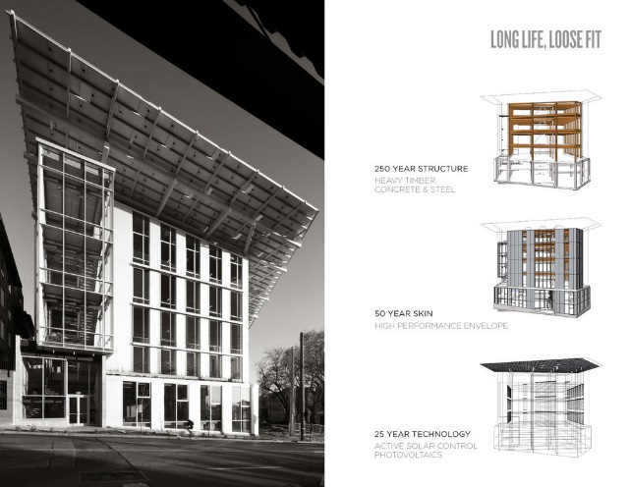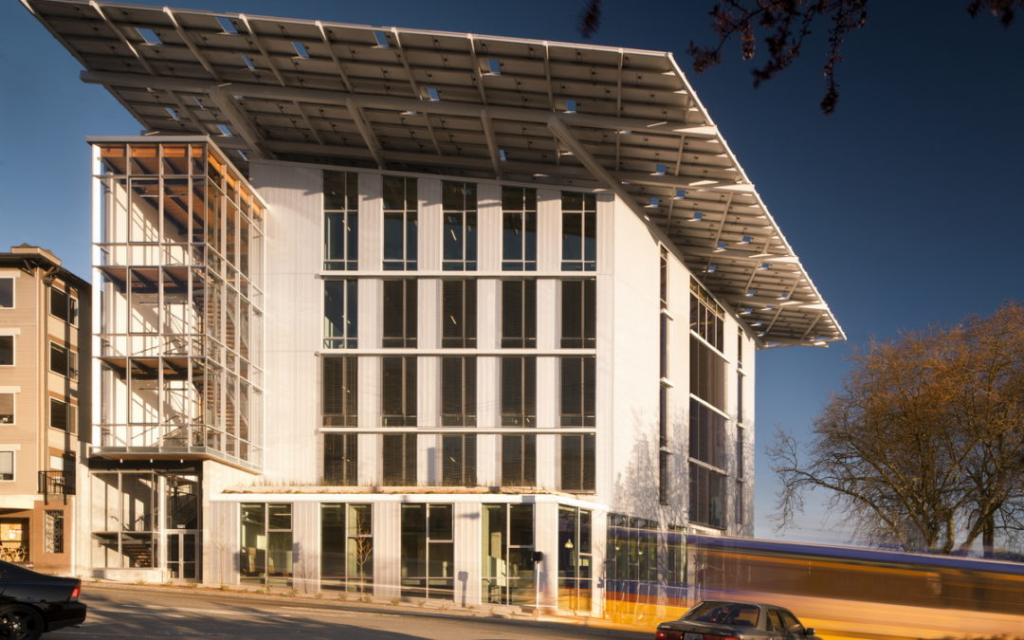
Figure 1 The Bullitt Center
Eco Materials Used:
- Mass Timber: The Bullitt Center stands as one of the largest mass timber buildings in the United States, utilizing cross-laminated timber (CLT) for its structural elements. CLT is a bio-based material made from layers of sustainably harvested wood that are laminated together. By using CLT, the building reduces embodied carbon emissions while providing structural strength and durability.
- Recycled Concrete: The construction of the Bullitt Center incorporated recycled concrete aggregates obtained from crushed concrete waste. These recycled materials replaced a significant portion of conventional virgin aggregates, reducing resource consumption and waste generation.
- Solar Panels: The Bullitt Center features an extensive photovoltaic (PV) system comprising over 575 solar panels. These panels generate clean, renewable energy to power the building's operations, significantly reducing its reliance on fossil fuels and minimizing carbon emissions.
- Rainwater Harvesting and Reuse: The Bullitt Center employs a rainwater harvesting system that collects and stores rainwater for various non-potable uses within the building. The harvested water is treated and reused for flushing toilets, irrigation, and other non-drinking purposes, reducing the strain on municipal water supply and conserving freshwater resources.
- Low-Energy Lighting and Controls: Energy-efficient LED lighting fixtures, combined with advanced lighting controls and occupancy sensors, were installed throughout the Bullitt Center. These measures help optimize energy usage by automatically adjusting lighting levels based on occupancy, daylight availability, and time of day.

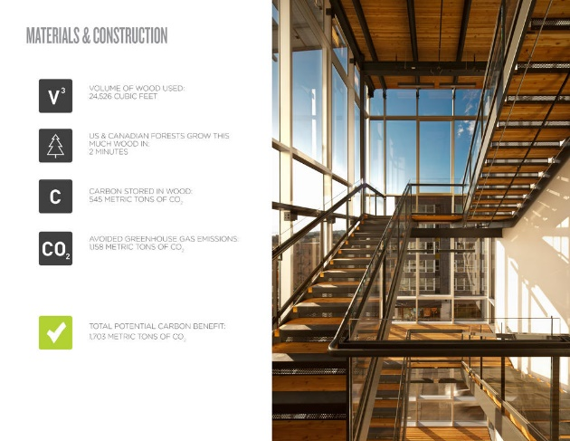
Figure 2 Material
Benefits and Achievements: The use of eco materials in the construction of the Bullitt Center has resulted in several notable benefits and achievements:
- Energy Performance: The Bullitt Center is designed to be energy-positive, meaning it generates more energy than it consumes. This is made possible by incorporating renewable energy systems like solar panels and implementing energy-efficient strategies throughout the building.
- Carbon Footprint Reduction: The utilization of eco materials, such as mass timber and recycled concrete, significantly reduced the building's embodied carbon footprint compared to conventional construction materials. This reduction in embodied carbon contributes to mitigating climate change impacts.
- Water Conservation: The rainwater harvesting system implemented in the Bullitt Center reduces the building's reliance on potable water sources, minimizing strain on local water supply and promoting water conservation.
- Indoor Environmental Quality: The selection of eco materials with low VOC emissions and the implementation of advanced ventilation systems contribute to enhanced indoor air quality, creating a healthier and more comfortable environment for occupants.
- Leadership in Energy and Environmental Design (LEED) Certification: The Bullitt Center has achieved the highest level of LEED certification, known as LEED Platinum. This certification recognizes the building's exemplary performance in areas such as energy efficiency, sustainable materials, water conservation, and indoor environmental quality.
Conclusion: The Bullitt Center serves as a compelling case study for the effective utilization of eco materials in the construction industry. Through the incorporation of mass timber, recycled concrete, solar panels, rainwater harvesting systems, and energy-efficient technologies, the Bullitt Center demonstrates the feasibility and benefits of sustainable design and construction practices. By showcasing the successful integration of eco materials, the Bullitt Center inspires and sets a benchmark for future sustainable construction projects, driving the industry toward a greener and more environmentally conscious future.

Case Study 2: The Edge, Amsterdam, Netherlands
The Edge, located in Amsterdam, is widely recognized as one of the world's most sustainable office buildings. The project prioritized the use of eco materials throughout its construction and achieved the highest sustainability certifications, including BREEAM Outstanding.
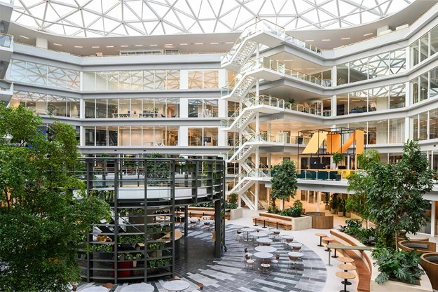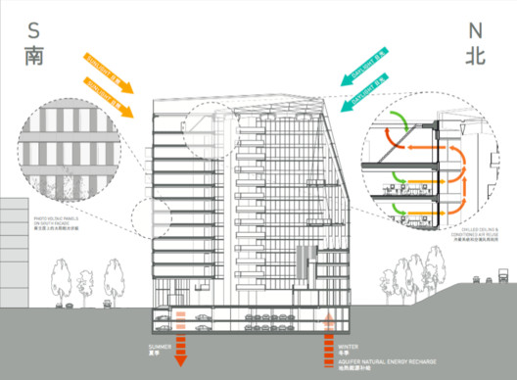
Figure 3 The Edge, Amsterdam, Netherlands
Eco Materials Used:
- Smart Facade: The Edge features a state-of-the-art smart facade that incorporates triple-glazed windows with built-in solar panels. This innovative design maximizes natural daylight while generating clean energy to power the building.
- Cradle-to-Cradle Certified Materials: The building extensively used Cradle-to-Cradle certified materials, which are designed for circularity and sustainability. Recycled materials, such as carpet tiles, ceiling panels, and furniture, were chosen to reduce resource consumption and promote a closed-loop system.
- Sustainable Concrete: The construction of The Edge utilized a high percentage of recycled concrete aggregates, minimizing the need for virgin aggregates and reducing the carbon footprint associated with concrete production.
Benefits and Achievements:
- Energy Efficiency: The Edge achieved exceptional energy efficiency, consuming 70% less energy compared to typical office buildings. The smart facade, energy-efficient lighting systems, and advanced climate control technologies contributed to significant energy savings.
- Water Conservation: The building implemented rainwater harvesting systems for toilet flushing and irrigation, reducing reliance on the municipal water supply. Additionally, efficient water fixtures and sensors were installed to optimize water usage and minimize waste.
- Indoor Environment Quality: The Edge prioritized occupant comfort and well-being. Green walls, abundant natural daylight, and a smart ventilation system that monitors CO2 levels and adjusts airflow contribute to a healthy and productive indoor environment.
- Mobility and Connectivity: The Edge encourages sustainable transportation by providing electric vehicle charging stations and ample bicycle parking. The building's location also offers excellent access to public transportation, promoting alternative modes of commuting.
Case Study 3: Parkroyal on Pickering, Singapore
Parkroyal on Pickering is an iconic hotel in Singapore known for its lush greenery and eco-friendly design. The project showcases the seamless integration of nature and architecture, incorporating various eco materials in its construction.
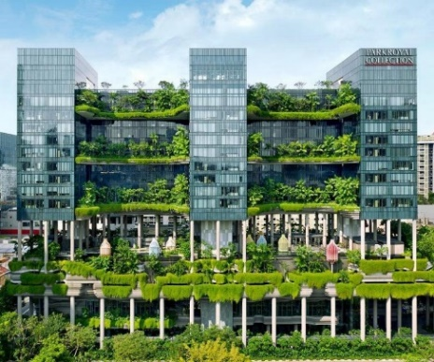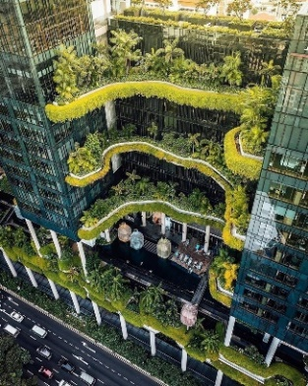
Figure 4 Parkroyal on Pickering, Singapore
Eco Materials Used:
- Greenery and Sky Gardens: The hotel features extensive greenery integrated into the building facade, with lush gardens and plantings on different levels. These green spaces provide natural insulation, improve air quality, and create a visually appealing environment.
- Recycled Materials: Parkroyal on Pickering incorporated recycled materials in its construction, including recycled timber for the interior finishes. By using recycled materials, the project reduced resource consumption and waste generation.
- Sustainable Lighting: Energy-efficient lighting fixtures and systems were installed throughout the hotel to minimize energy consumption. LED lights were used extensively, reducing electricity usage and improving energy efficiency.
Benefits and Achievements:
- Biophilic Design: The integration of extensive greenery and sky gardens enhances the hotel's visual appeal, provides a connection to nature, and contributes to improved air quality. This biophilic design creates a calming and rejuvenating atmosphere for guests.
- Energy Efficiency: Parkroyal on Pickering achieved significant energy savings through its sustainable lighting systems, efficient HVAC systems, and smart control systems. These measures resulted in reduced energy consumption and lower carbon emissions.
- Water Efficiency: The hotel implemented water-efficient fixtures, rainwater harvesting systems, and a water recycling system for landscape irrigation. These initiatives significantly reduced water consumption and supported sustainable water management.
- Green Mark Platinum Certification: Parkroyal on Pickering achieved the highest level of Green Mark certification, the Green Mark Platinum. This certification recognizes the project's commitment to sustainable design, eco materials, energy efficiency, and environmental responsibility.
Case Study 4: ITC Royal Bengal Hotel, Kolkata, India
The ITC Royal Bengal Hotel, located in Kolkata, India, is a notable example of sustainable construction and the use of eco materials in the Indian hospitality industry. The project demonstrates a commitment to environmental stewardship and resource efficiency, showcasing the integration of eco-friendly materials and sustainable design principles.
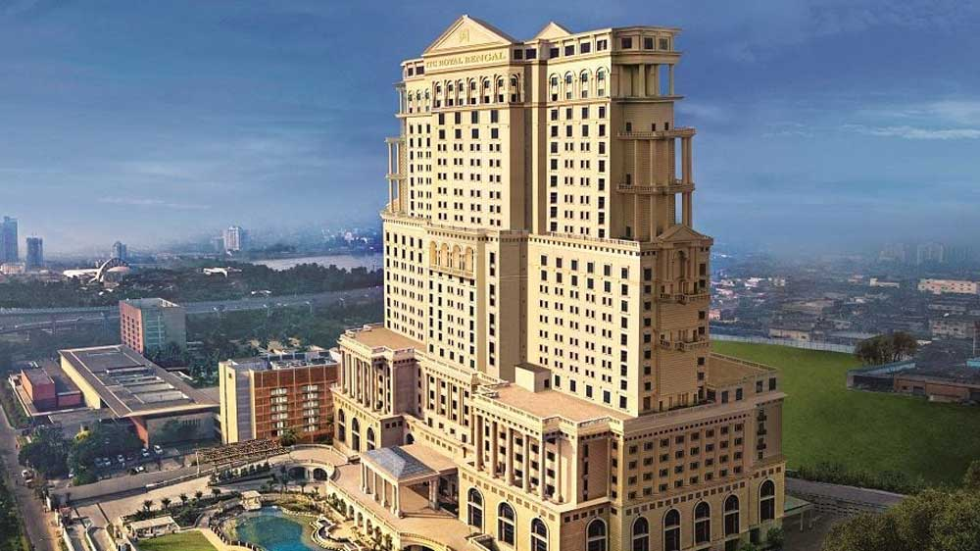
Figure 5 ITC Royal Bengal Hotel, Kolkata, India
Eco Materials Used:
- Fly Ash Bricks: Fly ash, a by-product of coal-fired power plants, was used extensively in the construction of the ITC Royal Bengal Hotel. By incorporating fly ash in the production of bricks, the project reduced the consumption of traditional clay bricks, minimized waste, and mitigated environmental pollution.
- Low VOC Paints: Low volatile organic compound (VOC) paints were chosen for interior finishes. These paints have lower emissions of harmful chemicals, improving indoor air quality and reducing the potential health risks for occupants.
- Sustainable Wood: The project utilized sustainably sourced wood for various interior and exterior elements, such as flooring, wall cladding, and furniture. By opting for certified sustainable wood, the project supported responsible forestry practices and avoided contributing to deforestation.
- Water Conservation Fixtures: Water-efficient fixtures, such as low-flow faucets, showers, and dual-flush toilets, were installed throughout the hotel. These fixtures reduce water consumption without compromising guest comfort and contribute to water conservation efforts.
Benefits and Achievements:
- Energy Efficiency: The ITC Royal Bengal Hotel achieved significant energy savings through the incorporation of energy-efficient technologies and design strategies. This includes efficient HVAC systems, LED lighting, occupancy sensors, and natural daylighting techniques. The hotel's energy-efficient measures have led to reduced energy consumption and lower operational costs.
- Sustainable Waste Management: The project implemented a comprehensive waste management system that focuses on waste segregation, recycling, and composting. By diverting waste from landfills and promoting recycling practices, the hotel contributes to a circular economy and reduces its environmental impact.
- Water Management: The ITC Royal Bengal Hotel emphasizes water conservation and management. Rainwater harvesting systems were installed to collect and reuse rainwater for irrigation and non-potable uses, reducing reliance on municipal water sources. Additionally, water-efficient fixtures and smart water management practices contribute to water savings.
- Green Building Certifications: The ITC Royal Bengal Hotel has achieved several prestigious green building certifications, including LEED Platinum and GRIHA (Green Rating for Integrated Habitat Assessment) 5-star rating. These certifications validate the project's sustainable design, eco material usage, energy efficiency, and overall environmental performance.
Case Study 5: Suzlon One Earth, Pune, India
Suzlon One Earth, located in Pune, Maharashtra, is a landmark green building and a leading example of sustainable construction in India. The project incorporates a range of eco materials and sustainable design strategies to create an environmentally friendly and energy-efficient workplace.
Figure 6 Suzlon One Earth, Pune, India
Eco Materials Used:
- Bamboo: Suzlon One Earth extensively used bamboo as a renewable and eco-friendly material. Bamboo was used for flooring, wall panels, and furniture, providing a sustainable alternative to traditional wood products.
- Recycled Materials: The construction of Suzlon One Earth incorporated various recycled materials. Recycled steel was used for structural components, recycled glass was used for windows and partitions, and recycled plastic was used in furniture and landscaping elements. By utilizing these materials, the project reduced the demand for virgin resources and diverted waste from landfills.
- Green Roof: The building features a green roof system with vegetation, which helps in insulation, reduces heat island effect, and promotes biodiversity. This eco material provides natural insulation, improves stormwater management, and enhances the overall aesthetics of the building.
Benefits and Achievements:
- Energy Efficiency: Suzlon One Earth achieved high levels of energy efficiency through the use of eco materials and sustainable design strategies. The building incorporates efficient HVAC systems, energy-saving lighting fixtures, and intelligent building automation systems. These measures have resulted in significant energy savings and reduced operational costs.
- Water Conservation: The project implemented rainwater harvesting systems to collect and store rainwater for various non-potable uses. Water-efficient fixtures and fittings, such as low-flow faucets and waterless urinals, were installed to minimize water consumption. The combined water-saving measures contribute to sustainable water management and conservation.
- Indoor Environmental Quality: Suzlon One Earth prioritized occupant health and well-being by focusing on indoor environmental quality. The use of eco materials like bamboo and low VOC paints ensures a healthier indoor environment with improved air quality. Additionally, ample natural daylighting and proper ventilation systems enhance occupant comfort and productivity.
- Green Building Certifications: Suzlon One Earth is recognized for its sustainability achievements and has received several green building certifications, including LEED Platinum and GRIHA 5-star rating. These certifications validate the project's commitment to eco materials, energy efficiency, water conservation, and overall sustainability.

Comparative Analysis of Sustainable Buildings:
- The Bullitt Center, Seattle, Washington: The Bullitt Center is a pioneering example of sustainable design and construction. It showcases features such as a net-zero energy design, extensive use of eco materials like cross-laminated timber, and rainwater harvesting systems. The building emphasizes energy efficiency, carbon footprint reduction, and overall environmental sustainability. Its innovative design and commitment to sustainable practices have earned it recognition as one of the greenest commercial buildings globally. (Figure 7)
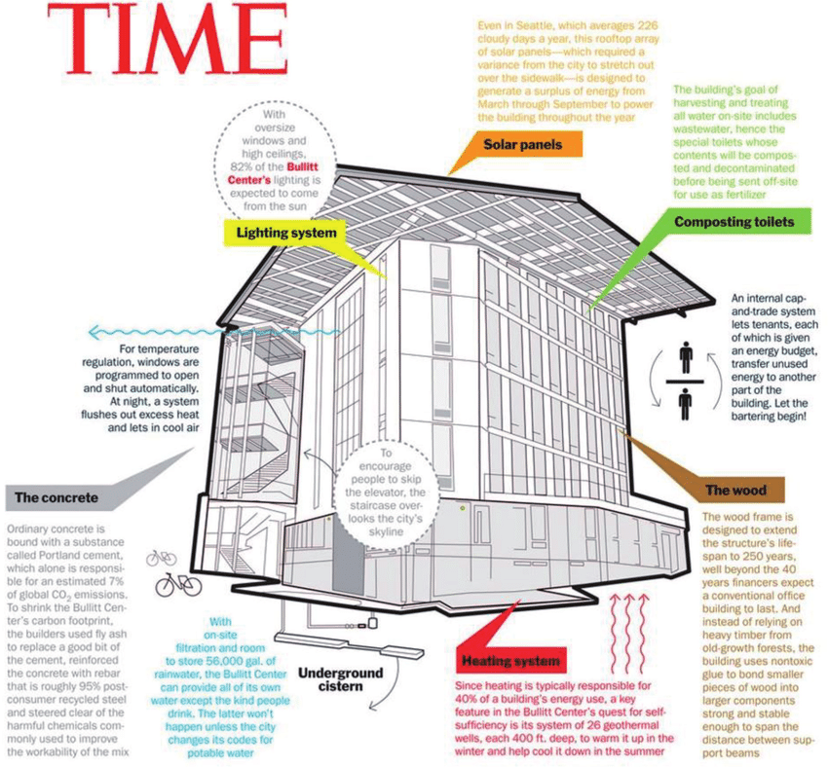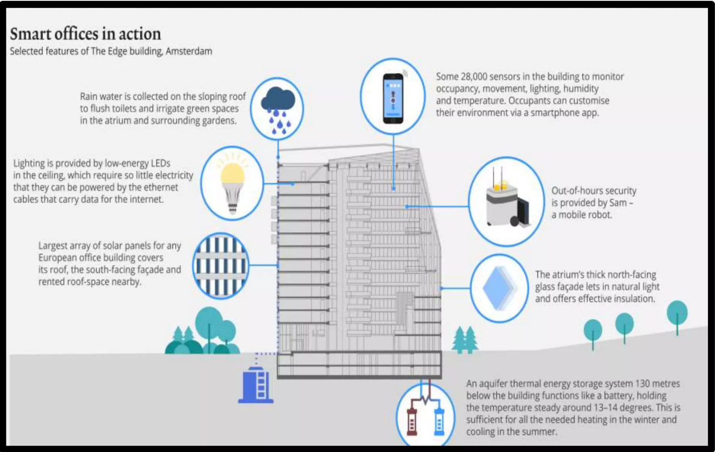
Figure 7 The Bullitt Centre Sustainability Figure 8 The Edge Smart Sustainibility
- The Edge, Amsterdam, Netherlands: The Edge is widely regarded as one of the most sustainable office buildings in the world. It incorporates advanced technologies and eco materials to achieve outstanding energy performance and occupant comfort. Notable features include a smart facade with integrated solar panels, extensive use of recycled and eco-friendly materials, and advanced lighting and climate control systems. The building has achieved BREEAM Outstanding certification, highlighting its commitment to sustainability and environmental responsibility. (Figure 8)

- Parkroyal on Pickering, Singapore: Parkroyal on Pickering is a hotel that exemplifies the integration of nature and sustainable design. The building features extensive greenery, incorporating sky gardens and lush vegetation. It utilizes eco materials, such as recycled timber and sustainable lighting fixtures, to reduce environmental impact. The hotel also emphasizes water conservation through rainwater harvesting systems and efficient water fixtures. With its unique biophilic design and sustainable practices, Parkroyal on Pickering has garnered acclaim as a green icon in Singapore.
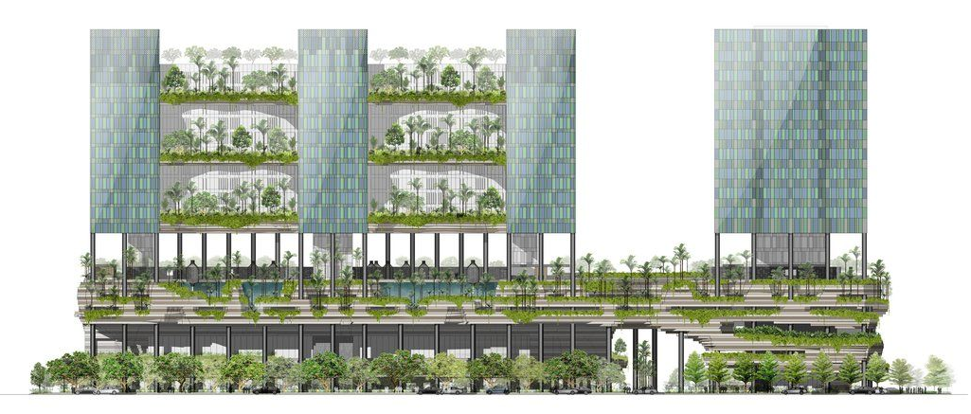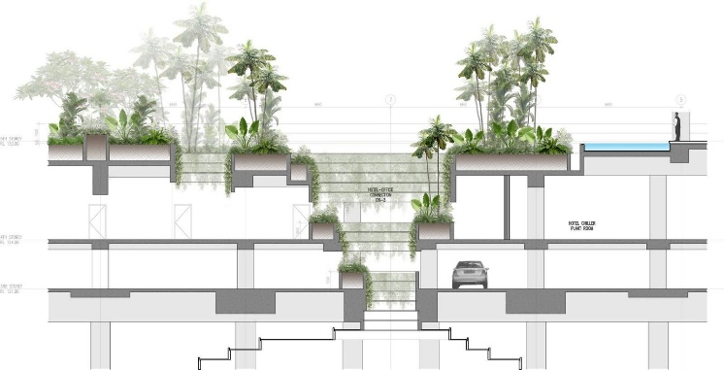
Figure 9 Parkroyal on Pickering Biophillic Design & Sustainibilty
- ITC Royal Bengal Hotel, Kolkata, India: The ITC Royal Bengal Hotel is a prominent example of sustainable construction in India. The project emphasizes eco materials, including fly ash bricks and low VOC paints, to reduce environmental impact. It prioritizes energy efficiency, waste management, and water conservation through measures like rainwater harvesting and green building certifications like LEED Platinum and GRIHA 5-star rating. The hotel showcases the integration of sustainability principles in the Indian hospitality industry.
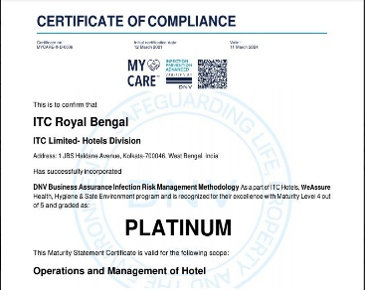
Figure 10 ITC Royal Bengal Hotel Rating

- Suzlon One Earth, Pune, India: Suzlon One Earth is a green building that combines sustainable design and eco materials. The project incorporates bamboo, recycled materials, and green roof systems to promote environmental sustainability. It focuses on energy efficiency, water management, and indoor environmental quality. The building has received LEED Platinum certification, underscoring its achievements in sustainable construction and commitment to eco-friendly practices.
Figure 11 Suzlon One Earth Site Plan
Building | Comparision
- The Bullitt Center, Seattle, Washington | The Bullitt Center stands out for its net-zero energy design and extensive use of cross-laminated timber.
- The Edge, Amsterdam, Netherlands | The Edge is notable for its smart facade, integrated solar panels, and focus on workplace comfort.
- Parkroyal on Pickering, Singapore | Parkroyal on Pickering distinguishes itself with its biophilic design and extensive greenery.
- ITC Royal Bengal Hotel, Kolkata, India | The ITC Royal Bengal Hotel showcases sustainable practices within the Indian hospitality industry.
- Suzlon One Earth, Pune, India | Suzlon One Earth emphasizes the integration of eco materials and renewable resources.
Table 1 Comparative Analysis
In conclusion, the construction industry has a significant opportunity to adopt eco materials and promote sustainable practices. By incorporating recycled materials, waste-derived materials, and bio-based materials, the industry can contribute to resource conservation, energy efficiency, waste reduction, and overall environmental sustainability. Continued research, technological advancements, and collaboration among stakeholders are crucial for accelerating the integration of eco materials into construction practices, leading to a more sustainable built environment for future generations. Challenges such as cost and compatibility remain, but the adoption of eco-based materials is crucial for creating a greener and more sustainable built environment.

References
Jones, D. (2017). 1 - Introduction to the performance of bio-based building materials. In Performance of Bio-based Building Materials (pp. 1-19). doi:https://doi.org/10.1016/B978-0-08-100982-6.00001-X
Alhazmi , H., Shah , S. A., & Mahmood , A. (2020). Sustainable Development of Innovative Green Construction Materials: A Study for Economical Eco-Friendly Recycled Aggregate Based Geopolymer Concrete. MDPI. doi: https://doi.org/10.3390/ma13214881
Bumanis, G., Vitola, L., Sinka, M., & Bajare, D. (2020). Gypsum, Geopolymers, and Starch—Alternative. MDPI. Retrieved from file:///E:/Dont%20Delete/Download/sustainability-12-05666-v2.pdf
Raja, P., Murugan, V., Ravichandran, S., Behera, L., Mensah, R. A., Mani, S., . . . Das, O. (2023). A Review of Sustainable Bio-Based Insulation Materials for. Macro Molecular Materials and Engineering, 11. doi:10.1002/mame.202300086
Shehadi, M. (2020, April). Net-Zero Energy Buildings: Principles and Applications. In Zero-energy Buildings . IntechOpen. doi:10.5772/intechopen.92285
The Constructor Building Ideas. (n.d.). Retrieved from 10 Sustainable Building Materials for Eco Friendly Construction: https://theconstructor.org/sustainability/10-sustainable-building-materials-for-eco-friendly-construction/569864/
Thirunavukkarasu, A., Nithya, R., Sivashankar, R., & Sathya, A. B. (n.d.). Bio Based Building Material for a Green & Sustainable Environment. In V. Sivasubramanian (Ed.), Bioprocess Engineering for a Green Environment (pp. 48-61). Retrieved from https://books.google.co.in/books?hl=en&lr=&id=Jy_3DwAAQBAJ&oi=fnd&pg=PA47&dq=eco+materials+recycled,+materials+from+waste,+bio-based+materials+in+construction+in+india&ots=non-DWN28q&sig=5bzU6kc5MRWGUMRKrzRWS_o2Xqc&redir_esc=y#v=onepage&q&f=false
Yadav, M., & Agarwal, M. (2021). Biobased building materials for sustainable future: An overview. In Materials Today: Proceedings, (Vol. Volume 43, pp. Pages 2895-2902). doi:https://doi.org/10.1016/j.matpr.2021.01.165.

