HASTA UTTANASANA OR RAISED ARMS POSE AS LIFESTYLE FOR KYPHOSIS AFTER CARDIO-THORACIC SURGERY
A research project
For the Degree of Bachelor of Science in YOGA
Yogic Art and Science
By
Mr. Apu Chakma
Guided by
Dr. Amaravathi Eraballi, Ph.D., M.P.T, CYEP
Co-guide
Mr. Rupesh Kumar, M.A

Department of Yogic Art & Science
Vinaya Bhavana
Visva-Bharati
(A Central University of National Importance)
Santiniketan -731235, West Bengal, India

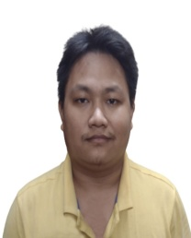
VITAE

NAME OF THE AUTHOR : Apu Chakma
DATE OF BIRTH : 19/11/1997
ADDRESS : Indirapally, Baganpara, Santiniketan, P.O.
Santiniketan, PIN- 731235, DIST- Birbhum,
STATE- West Bengal

MOBILE NO : 7384118845
E. mail :apuchakma@hotmail.com

EDUCATIONAL INSTITUTIONS ATTENDED:
• SRINANDA HIGH SCHOOL (BNGA MED) [WBBSE]
• SRINANDA HIGH SCHOOL [WBCHSE]
• DEPT. OF YOGIC ART & SCIENCE [VISVA BHARATI]

ACADEMIC ACHIEVEMENTS
• Madhyamik Examination: 2016
• Higher Secondary Examination: 2018
• Graduation(B.Sc):Appearing

OTHER ACHIEVEMENTS
• NCC BEST OBIDIENT CADET 2018
- INTRODUCTION TO PEACEBUILDING MICRO COURSE FROM UNITED STATES INSTITUTE OF PEACE 2020
- BEST PERFORMER, NCC ANNUAL TAINING CAMP 2021

ACKNOWLEDGEMENT
First and foremost I would like to thank the Almighty God for blessing, helping, and guiding me throughout my study.
I convey my deep sense of gratitude to DR. AMARAVATHI ERABALLI Madame Ph.D. (yoga and Life Sciences), M.P.T (Cardio-Respiratory conditions) CYEP (USA) for the able guidance in acquainting clinical experience and completion of the project.
I am greatly indebted to my teacher, instructor, and co-guide MR. RUPESH KUMAR qualification of MA (Yoga) for the help rendered in the completion of the study.
I express my thanks to all the other staff Members of Yogic Art and Science for providing me timely guidance for the project.
I would like to thank all the Subjects who participated in the study without whom I would not have been able to accomplish my project goals in this lockdown situation.
I would like to thank all my Colleagues at Yogic Art and Science for their insightful comments, support, and encouragement

Apu Chakma
CERTIFICATE
This is to certify that the project of “HASTA UTTANASANA OR RAISED ARMS POSE AS LIFESTYLE FOR KYPHOSIS AFTER CARDIO-THORACIC SURGERY” has been carried out by the candidate under my direct supervision and the findings have been checked thoroughly.
I am satisfied with the work of Mr. Apu Chakma, B.Sc (Hon.) in Yoga and Reg. No: VB-0593 of 2018-19 is submitted to Visva-Bharati, Santiniketan, West Bengal, INDIA.
It is further certified that Mr. Apu Chakma has undergone the prescribed course of studies leading to Bachelor of Science Degree Examinations in accordance with the university regulations.

Date: Prof. Dr. Samiran Mondal
HOD, Department of Yogic Art and Science
Guide: Dr. Amaravathi Eraballi, Ph.D., MPT, CYEP

Co-Guide: Mr. Rupesh Kumar, MA, Ass. Prof

CONTENTS
S.N.O. | TITLE | PAGE NO.
 | TITLE PAGE | 1
 | ABSTRACT | 1
 | INTRODUCTION  3.1. Anatomy of Kyphosis  3.2. The vertebral column  3.3. Vertebral joints  3.3.1. Intervertebral joints  3.3.2. Joints of the vertebral arches  3.3.3. Atlantooccipital joint and membrane  3.3.4. Movements of cervical joints  3.3.5. Proprioception for improving motor function  3.3.5.1. Testing Upper Extremities  3.3.5.2. Testing Lower Extremities  3.3.5.3. Matching Technique  3.4. Biomechanics of Kyphosis  3.4.1. Clinical features of Kyphosis  3.4.2. Complications  3.4.3. Diagnosis of Kyphosis  3.4.4 Specific Parameters  3.4.5. Treatments for Kyphosis  3.4.6. Medical Treatment for Kyphosis  3.4.7. Physiotherapy Treatment for Kyphosis  3.4.8 Ayurveda Treatment for Kyphosis  3.4.9. Yoga Treatment for Kyphosis  3.4.10. Lifestyle Modifications for Kyphosis  3.4.10.1. Sattvic diet  3.4.10.2. Yoga therapy | 2-18  3-4  5  7  7  7  8  9  9  9  10  10  11  12  12  12  13  13  13  14  14  15-18  18  18  18
 | NEED OF THE STUDY | 19
 | REVIEW OF ANCIENT LITERATURE  5.1. LANGUAGES USED  5.1.1. Sanskrit With Transliteration  5.1.2. English Alphabet  5.1.3. Bengali Barnamala  5.1.4. Hindi/ Devanagari Barnamala  5.2. SCRIPTURES  5.2.1. RAMAYANA  5.2.2. Bhagavadgita  5.3.YOGA PHILOSOPHY TEXTS  5.3.1. Pantanjali- samyama definition  5.3.2. Hatha Yoga Pradipika- Samyama  5.3.3. Prashnopanishad | 19-30  19  19  20  21  22  23  23  23  24  24-27  27-29  29-30
 | REVIEW OF MODERN LITERATURE  6.1. About Kyphosis | 31  31
 | METHODOLOGY | 31-33
 | RESULTS | 34
 | DISCUSSION  9.1. Improvements with hasthauttanasana  9.2. Neutral changes with hasthauttanasana  9.3 Adverse changes with hasthauttanasana | 35-36  35  36  36-38
 | CONCLUSION | 39
 | LIMITATIONS | 40
 | STRENGTHS AND FURTHER RESEARCH | 41
 | REFERENCES | 42-44
 | ANNEXURES  14.1. Annexure:- Institutional Ethical Clearance (IEC)  14.2. ANNEXURES:-measurement of neck movements by Physiotherapy experts | 44-45  45  46-48

1. TITLE PAGE
HASTA UTTANASANA OR RAISED ARMS POSE AS LIFESTYLE FOR KYPHOSIS AFTER CARDIO-THORACIC SURGERY.
- ABSTRACT
AIM: Kyphosis is an abnormally rounded back with a lack of muscle power distribution in post-operative heart surgery patients. With the outpatient rehabilitation facility physiotherapy exercises, yoga asana, and postural education in daily life may cure and prevent the incidence of kyphosis. Specific asana and alignment techniques are lacking in the present integrative trend.
METHODS: in the population of yoga awareness camp, 2 patients were selected with randomization method and got 1 participant for the study at Department of Yogic Art and Science, Vinaya Bhavana, Visva Bharati, Santiniketan. With the available experts and ethical clearance, a pre-post study design was planned. Hastha Uttanasana, Parvatasana, and Bhramari pranayama were prescribed and monitored online after the first consultation. Documenting the specific parameters the raw data was produced to draw the conclusions.
RESULTS: There is an increased range of motion in lower cervical movements. The range of shoulder flexion and the repetition maximum increased from pre- data. The sense of well-being was improved according to feedback. This proves the improvement from fear of movement from mid-sternal sutures.
CONCLUSIONS: Hastha Uttanasana or raised arms pose improves the strength and endurance of respiratory muscles in Kyphosis conditions after 2 years of CABG.
KEYWORDS: Hastha uttanasana, raised arms pose, Parvatasana, Mountain pose, Kyphosis, Yoga, Physiotherapy, Ayurveda, Yogic diet, Management, Review, CABG.

3. INTRODUCTION
Kyphosis is defined as an increased in normal posterior convexity of the thoracic spine and is referred to as hyperkyphosis. (1)
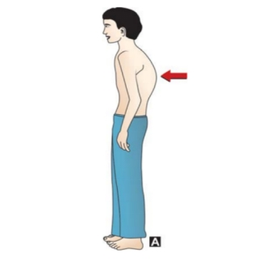
Figure-1
Kyphosis is a fairly common condition that usually affects adolescents and adults. Some types of kyphosis can occur from birth, called congenital which is rare. In the case of cardiothoracic surgery for coronary artery disease (CAD) commonly called coronary artery bypass graft (CABG) surgery patients also get kyphosis. (2)

List of normal values of parameters:
Table-1
PARAMETERS | NORMAL RANGE
Height, | NIL
Weight, | NIL
BMI, | 18.5-25
Pulse rate, | 72 beats/ min.
Respiratory rate, | 12-16
Blood pressure | 120/80
Oxygen Saturation rate, | 95-100
Body temperature | 97-99
blood glucose level. | 70-99 (Fasting)  <140 (1-2hr after meal)
.
3.1. Anatomy of Kyphosis
The cervical and thoracic junction is a very mobile part. But soon after the surgery of Coronary artery bypass graft (CABG) surgery, the fear of suture will limit the range of motion and leads to Kyphosis. Every patient with kyphosis should be treated based on her/his current state and needs. It should always be remembered that the patients with negative sagittal balance can compensate it with the hip flexion but it is far more difficult to compensate the positive sagittal balance. The main goal of surgery to treat the kyphotic patients is to correct the sagittal curve and also restore a spinal balance within an acceptable range above the hips and knees. There will be a limit of breathing in few months or a year and leads to a lack of breath-holding time, the endurance of respiratory muscles both skeletal at costal region and smooth muscles of the tracheobronchial tree.

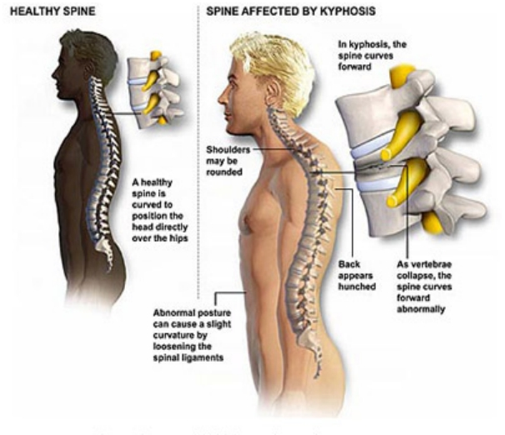
Figure-2

3.2. The vertebral column

The vertebral column, also known as the spinal column, is the central axis of the skeleton in all vertebrates. The vertebral column provides attachments to muscles, supports the trunk, protects the spinal cord and nerve roots, and serves as a site for haemopoiesis. The mammalian vertebral column consists of five morphologically differentiated groups of vertebrae: cervical, thoracic, lumbar, sacral, and coccygeal (caudal) (Fig 3). In humans, the vertebral column usually consists of 33 vertebrae, placed in series and connected by ligaments and intervertebral discs. However, the number of vertebrae can vary between 32 and 35. Usually, there are 7 cervicals, 12 thoracics, 5 lumbar, 5 sacral, and 4 caudal (coccygeal) vertebrae. In humans, the length of the vertebral column is 71 cm in males and 61 cm in females.
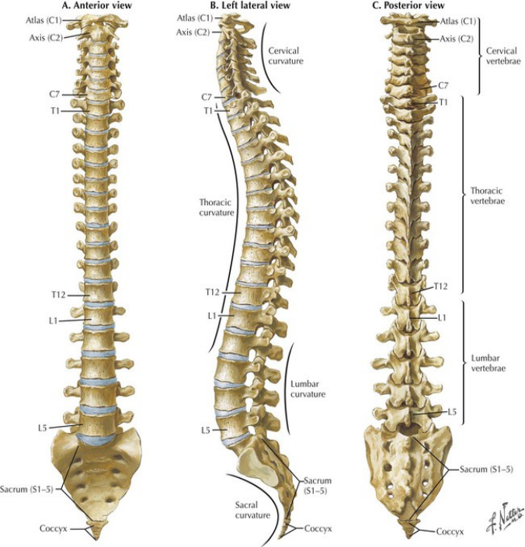
Figure-3

3.3. Vertebral joints
3.3.1. Intervertebral joints
The joints of the vertebral bodies are secondary cartilaginous joints (symphyses, singular: symphysis) designed for weight-bearing and strength. The articulating surfaces of adjacent vertebrae are connected by intervertebral (IV) discs and ligaments.
The IV discs provide a strong attachment between the vertebral bodies, uniting them into a continuous semi-rigid column and forming the inferior half of the anterior border of the IV foramen. In total, the discs (IV discs) account for 20-25% of the length (height) of the vertebral column. The IV discs also permit movement between adjacent vertebrae, and their resilient deformability allows them to serve as shock absorbers. Each IV disc consists of an annulus fibrosus (an outer fibrous part) and a nucleus pulposus (a gelatinous central mass or central core).
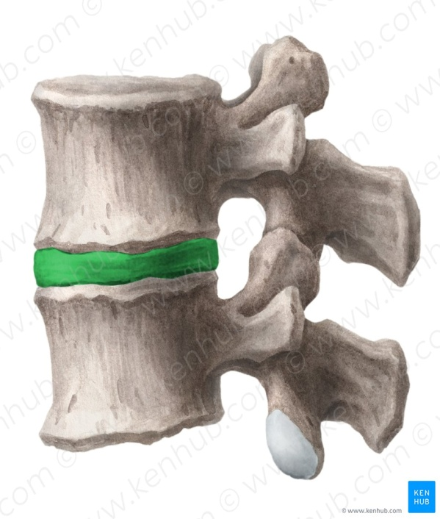
Figure-4
3.3.2. Joints of the vertebral arches
The joints of the vertebral arches are the zygapophysial joints (often called facet joints). These articulations are plane synovial joints between the superior and the inferior articular processes (zygapophyses) of adjacent vertebrae. Each facet joint is surrounded by a thin, loose joint capsule (articular capsule). Those in the cervical region are especially thin and loose, reflecting the wide range of movement.
3.3.3. Atlantooccipital joint and membrane
The articulations of the craniovertebral joints involve the occipital condyles, atlas, and axis.
Atlanto-occipital joints located between the superior articular surfaces of the atlas and the occipital condyles permit nodding of the head, such as the neck flexion and extension occurring when indicating approval (the “yes” movement). The atlantooccipital joints also permit side-ways tilting of the head. The main movement is flexion, with a little lateral bending (lateral flexion) and rotation.
The anterior and posterior atlanto-occipital membranes, which extend from the anterior and posterior arches of C1 to the anterior and posterior margins of the foramen magnum, connect the cranium and atlas. The anterior atlanto-occipital membranes are continuous with the anterior longitudinal ligament and they also function to prevent excessive movement of the atlanto-occipital joints.
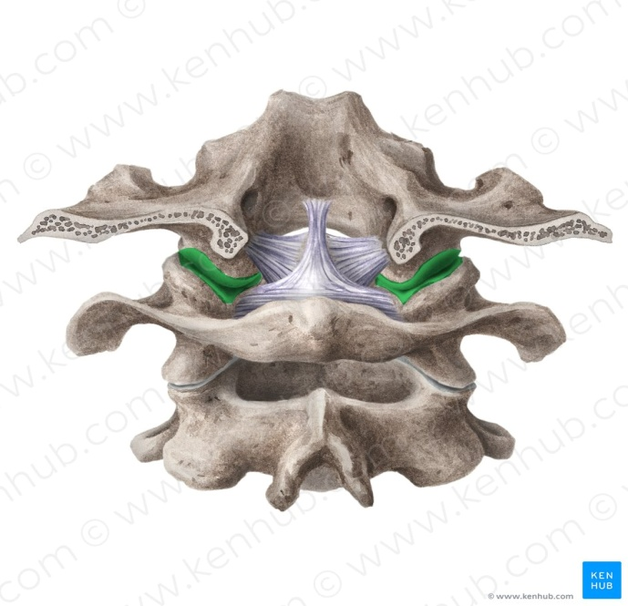
Figure-5

3.3.4. Movements of cervical joints
The cervical spine's range of motion is approximately 80° to 90° of flexion, 70° of extension, 20° to 45° of lateral flexion, and up to 90° of rotation to both sides.¹⁶ However, movement in the cervical spine is complex, because the pure uniplanar movement does not accurately portray the motion between cervical levels, and movement into any range is not the simple sum of equal motion from one vertebra to the next.¹³

3.3.5. Proprioception for improving motor function
Proprioception, also called kinesthesia, is the body's ability to sense its location, movements, and actions. It's the reason we're able to move freely without consciously thinking about our environment.
Examples of proprioception include being able to walk or kick without looking at the feet or being able to touch the nose with eyes closed.
Proprioception is a continuous loop of feedback between sensory receptors throughout the body and our nervous system.
Sensory receptors are located on our skin, joints, and muscles. When we move, our brain senses the effort, force, and heaviness of our actions and positions and responds accordingly.

3.3.5.1. Testing Upper Extremities
1) Position the patient in supine with their eyes closed.
2) Secure their hand by pinching the proximal Interphalangeal (IP) joint and the lateral aspects of their metacarpophalangeal (MCP) joints.
3) Move the digit slightly up or down ten times in an unpredictable order.
4) Test at the wrist by pinching the lateral aspects of their metacarpophalangeal (MCP) joints and the lateral aspects of their wrist.
5) Test at the elbow by pinching the lateral aspects of the wrist and elbow.
6) Test at the shoulder by maintaining the same grip as before at the elbow, but moving only the shoulder joint

3.3.5.2. Testing Lower Extremities
Test the 1st MTP joint, the ankle, the knee, and the hip.
Continue to secure the limb by pinching the lateral aspects of each joint.
3.3.5.3. Matching Technique
Proprioception can also be tested by asking the patient to match the position of the tested arm with their other arm. The joints that are being moved by the physical therapist are the ones being tested. In the following example, the proprioception of the RIGHT arm is being tested.
3.4. Biomechanics of Kyphosis:
Poor posture: posture is poor when it is inefficient, that is, when it fails to serve the purpose for which it was designed, or if an unnecessary amount of muscular effort is used to maintain it. Factors which predispose to poor posture: General causes: mental attitude, poor hygienic conditions, prolonged fatigue, etc. Local factors: localized pain, muscular weakness, occupational stresses, etc. (3)
Breathing also may change accordingly in the future because of the muscular adaptations after CABG surgery.

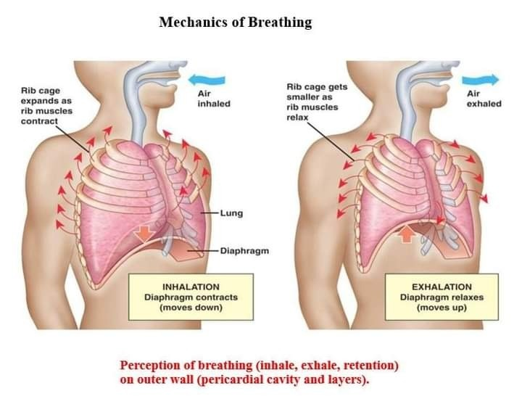
Figure-6
3.4.1. Clinical features of Kyphosis:
The primary symptom of kyphosis is an abnormal forward curve in the upper part of the spine. It causes the upper back to appear hunched over, with the shoulders rounded forward.
In mild cases, the spinal curve is not always noticeable. In other instances, a person may look as if they are bending forwards.
Kyphosis often occurs without any other symptoms. However, other symptoms can include:
- back pain
- stiffness in the upper back
- a rounded back
- tight hamstrings
3.4.2. Complications
Complications with kyphosis can occur in more severe cases. These include:
- an irreversible hunch in the back
- persistent back pain
- weakness or numbness in the arms and legs
- breathing difficulties
3.4.3. Diagnosis of Kyphosis:
- X-ray
- MRI lateral view shows anterior curvature and posterior stretch.
- General parameters
3.4.4 Specific Parameters
Table-2
S.no | Parameter | Normal Value
1. | Breath-holding time | Depends on the muscular strength of a person
2. | Bhramari Time | Depends on the muscular strength of a person
3. | Sh. flexion | 180⁰
4. | Thoracic Ex | 45⁰
5. | Repetition Maximum | Depends on the muscular strength of a person

3.4.5. Treatments for Kyphosis:
Treatment will focus on preventing the curve from worsening and restoring normal posture where possible.
3.4.6. Medical Treatment for Kyphosis:
It depends on the type and severity of the curve. In acute situations, refer to physiotherapy rehabilitation. In chronic and severe situations, surgery will be prescribed. Still, physiotherapy rehabilitation soon after one-day surgery is a must.

3.4.7. Physiotherapy Treatment for Kyphosis:
Avoiding expensive medical surgery physiotherapy uses manipulations, mobilizations, proprioceptive neuromuscular facilitation (PNF) techniques, hydrocollateral therapy, and wax therapy are successfully treat kyphosis as a rehabilitation program in outpatient departments.
3.4.8 Ayurveda Treatment for Kyphosis:
Kati Basti, massage. Refer to Chiro practitioner.
विषमादुपचाराच्चदोषासृक्स्रवणादति||15||
Wrong therapeutic management, excessive elimination of raktadhatu leads to vatadoshaprakopa
दुःखशय्यासनात्क्रोधाद्दिवास्वप्नाद्भयादपि।वेगसन्धारणादामादभिघातादभोजनात् ||16||
Sitting and lying on an uncomfortable chair or bed. Vata vitiation due to anger issues, sleeping a lot in the daytime, and fear. Suppressing urges, production of amadosha (undigested food), injury especially to vital parts, and fasting are also the contributing factors in Vata vitiation.
खाज्यपाङ्गुल्यकुब्जत्वंशोषोऽङ्गानामनिद्रता॥
Here “Kubajtavam” can be understood as kyphosis.
(Ref CharakaChikitsasthana 28/18 )
3.4.9. Yoga Treatment for Kyphosis:
Asana for physical joints of kyphosis, pranayama for physiological changes, and education of the patient about the whole treatment to carry further is the yogic counseling used as yoga therapy. (4)
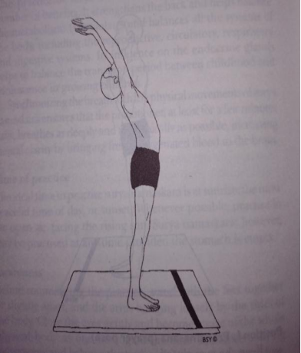 | Hastha Uttanasana or Raised Arms pose  Mechanism: the spine is gently curved with the gaze pointing upwards toward the raised hands, encouraging the heart and ribs to open up towards the ceiling, allowing for full breaths which increase oxygen flow. (https://pubmed.ncbi.nlm.nih.gov/20421831/)  Uses: Expands and Opens the Chest and Tones the Back Muscles.
Figure-7
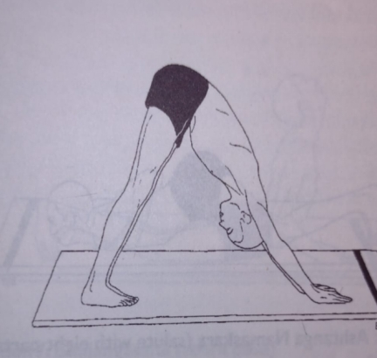 | Parvatasana or Mountain pose  Mechanism: Increases the blood circulation towards the head. strengthen the back muscles and corrects the spinal posture. (https://pubmed.ncbi.nlm.nih.gov/9043843/)  Uses: The spine and ribs are stretched. Muscles of the diaphragm develop strength.
Figure-8
Arms raised posture called as hastha uttanaasana in Sanskrit is the ancient knowledge for the shoulder girdle (TB of APMB). It involves the same muscles mentioned above to get the strength, endurance of muscles, and proper blood flow for immunization at the thymus gland. (5)
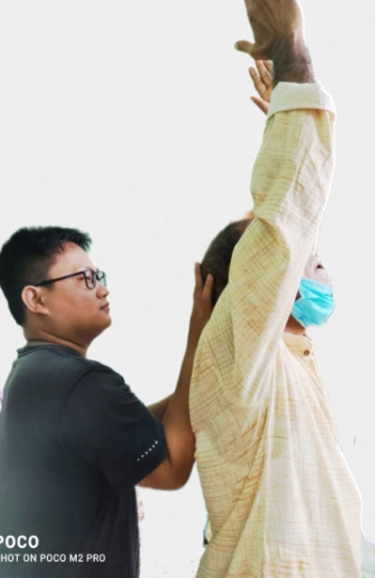
Figure-9
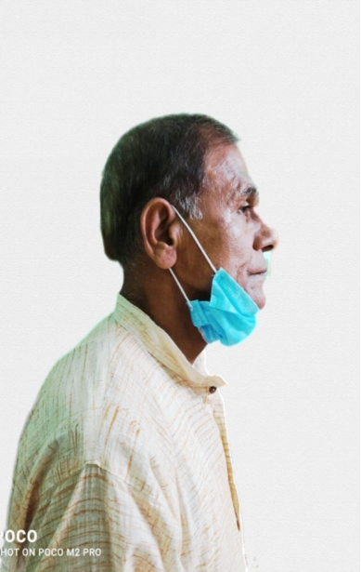
Figure-10
3.4.10. Lifestyle Modifications for Kyphosis:
3.4.10.1. Sattvic diet
Sprouts and soaked dates in the morning with an empty stomach along with own diet. Fluids are prescribed more during treatment days to show the immediate changes.
3.4.10.2. Yoga therapy:
Regular practice after discharge helps to prevent the re-occurrence of kyphosis.
4. NEED OF THE STUDY
The integration of ancient knowledge for kyphosis is mandatory to cure and prevent musculoskeletal adjustment in Kyphosis after CABG surgery.
5. REVIEW OF ANCIENT LITERATURE

5.1. LANGUAGES USED:
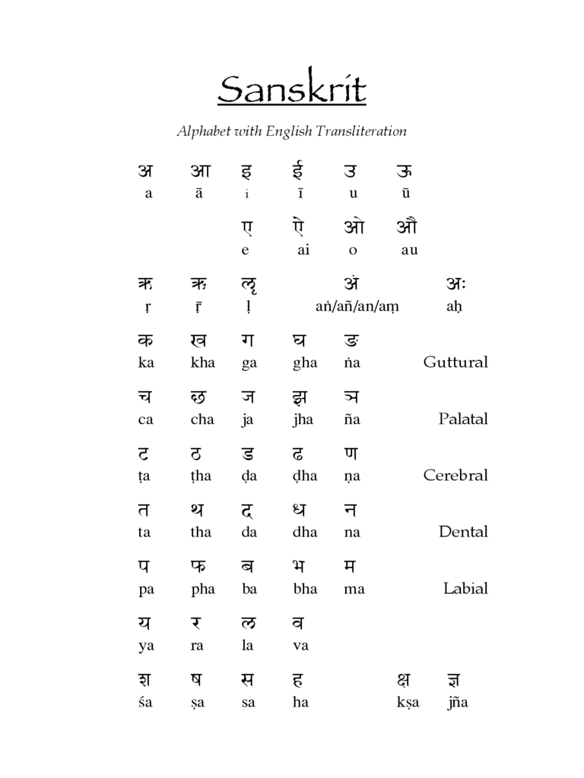
5.1.1. Sanskrit With Transliteration

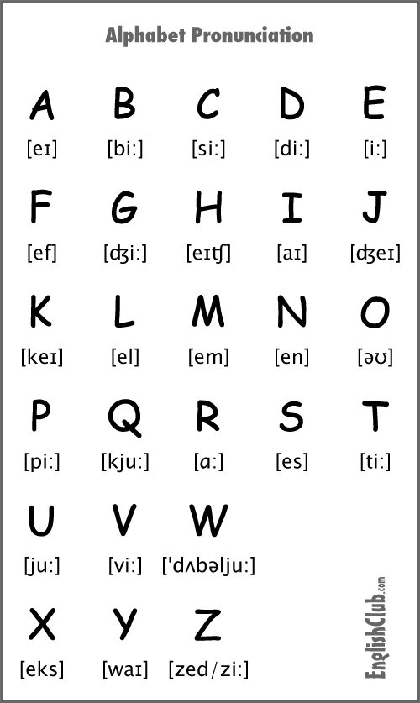
5.1.2. English Alphabet

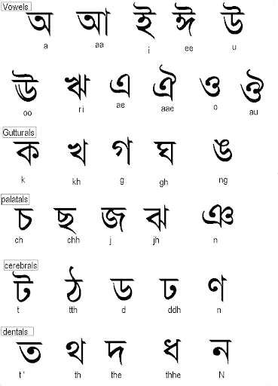
5.1.3. Bengali Barnamala

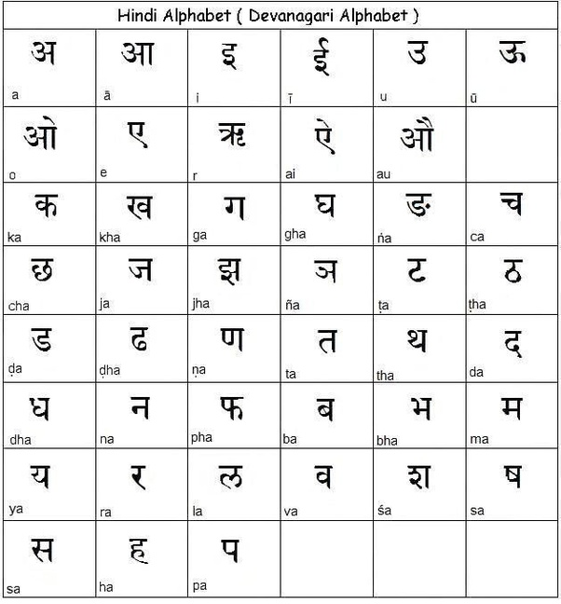
5.1.4. Hindi/ Devanagari Barnamala

5.2. SCRIPTURES
5.2.1. RAMAYANA-
Manthara (yogapedia)
Definition - What does Manthara mean?
Manthara is a hunchbacked character in the epic Hindu poem, "Ramayana." The evil servant of Queen Kaikeyi, Manthara played a key role in the exile of Lord Rama. Although mantharameans "hunchbacked" in Sanskrit, her name has also come to mean “someone who conspires.”
5.2.2. Bhagavadgita- (6)
Samam kaya shirogrivamdharayanachalamsthiraha ……
समंकायशिरोग्रीवंधारयन्नचलंस्थिरः || 13 ||
The posture of the body that is optimal for the concentration of the mind in meditation is being described in Bhagawad Gita. The word samam means straight. The back, neck, and head which is the seat of the Muladhara or sacred plexus in the top of the head must be perfectly straight while at the same time sitting with legs crossed in a lotus position or half-lotus position keeps them straight. Furthermore being firmly situated in celibacy is essential and then one is then able to properly meditate.

5.3.YOGA PHILOSOPHY TEXTS
5.3.1. Pantanjali- samyama definition-(7)
त्रयमेकत्रसंयमः॥4॥
Trayamekatrasamyamaḥ || 4 ||
ত্রয়মেকত্রসংযম।।৩/৪।।
“These three together – Dharana, dhyana, and samadhi – constitute integration or Samyama.” It is during meditation that samadhi is experienced. Samadhi is known as spiritual absorption, union with, tranquility. Samadhi is complete absorption and is experienced through dhyana or mediation. Samyama is the trinity of the three, Dharana, dhyana, samadhi. Samyama is a process, a cycle where all three parts of this trinity exist and become one experience, Samyama. The progression begins with Dharana and this concentration on something outside of ourselves brings us into ourselves and becomes concentration on ourselves, dhyana. At some point, we completely lose ourselves within dhyana and this is when we experience samadhi. At this point, Samyama or integration is occurring.
asana- definition
स्थिरसुखमासनम्॥४६॥
স্থিরসুগমাসনম্।।২/৪৬।।
sthira-sukham-āsanam ॥46॥
If we can be steady and comfortable and not ‘pulled’ by the aches and pains of the body, or distracted by restlessness due to an uncomfortable position or a whirling mind, we can sit in meditation ‘endlessly’! This, according to the Eight Limbs of Yoga, is the purpose of asana.
प्रयत्नशैथिल्यानन्तसमापत्तिभ्याम् ॥47॥
Prayatnaśaithilyānantasamapancham
“Letting go of all efforts and focusing on the infinite”
Asana becomes “sthira” through “prayatna-shaithiyla”. It becomes “sukham” through “Ananta-samapatti”.
Relaxation of effort leads to the steadiness of the asana because it is the effort that makes the mind and consequently the asana unsteady. And meditating on the infinite makes the asana joyful because the mind experiences joy when it expands into the infinite. Like when we sit in front of the sea or look at the sky we feel joy because the mind is focusing on something infinite.
Simultaneous application of these two in any posture (padmasana, ushtrasana, Shavasana, etc) brings about its siddhi – ie it makes any posture steady and joyful.
Some translators have interpreted Ananta to mean sheshanag – which isn’t correct. Yogasutra is a very secular text and nowhere in the entire text has Patanjali made any reference to any specific deity.
ततो द्वन्द्वानभिघातः ॥48 ॥
Tato dvandvānabhighātaḥ
The present sutra tells us that when the asana has been mastered, we can get over any influence from the pairs of opposites. These pairs of opposites can include heat and cold, hunger and thirst, pleasure and pain, etc. This freedom from the pairs of opposites is a direct result of the effort and concentration involved in making the asana firm and comfortable. In mastering the asana, we have been focusing either on the experience of the asana or meditating on the “Ananta” (infinite) which can free the mind from bodily sensations of heat and cold, etc., as well as any mental distractions like hunger and thirst, honor or dishonor, etc. This freedom from the dualities will also be helpful in our practices of pranayama, pratyahara (sense withdrawal), and finally meditation and samadhi. It will also help us develop strong willpower so necessary for undertaking long periods of meditation.
Pranayama- definition-(7)
तस्मिन्सतिश्वासप्रश्वास्योर्गतिविच्छेदःप्राणायामः॥४९॥
তস্মিন্সতিশ্বাসপ্রশ্বাসয়োর্গতিবিচ্ছেদঃপ্রাণায়ামঃ।।২/৪৯।।
tasmin sati śvāsa-praśvāsyor-gati-vicchedaḥprāṇāyāmaḥ॥49॥
“Having established oneself in a steady and comfortable seated posture, controlled disruption or suspension of inhalation and exhalation is defined as pranayama”. As we know, breath retention can be done after full inhalation or full exhalation or anytime during the inhalation or exhalation process. Thus, the breathing process can be considered as consisting of four segments – inhalation, exhalation, retention after inhalation, and retention after exhalation. Even though not used by Patanjali, the Sanskrit terms most commonly used for these four segments are puraka (inhalation), rechaka (exhalation), Antara-kumbhaka (internal retention), and bayha-kumbhaka (external retention). Using a variety of permutations and combinations of these four components, a large number of pranayama techniques that are practiced today have evolved over time.
dharana- definition-(7)
देशबन्धःचित्तस्यधारणा॥१॥
দেশবন্ধশ্চিত্তস্যধারনা।।৩/১।।
deśa-bandhaḥcittasyadhāraṇā॥1॥
“Dhāraṇā is the process of ‘holding onto’ the object.
Dhyānā is the process of ‘linking with’ the object.
Samādhi is the process of ‘integration into’ the object.”
Paul Harvey on Yoga Sūtra Chapter 3 verses 1-3
“To hold the Citta for connective moments is Dhāraṇā.
To be held by the Citta for connective moments is Dhyānam”
– Paul Harvey on Yoga Sūtra Chapter Three verses 1-2

5.3.2. Hatha Yoga Pradipika- Samyama- ch-1
हठविद्या परं गोप्या योगिना सिद्धिमिच्छताम् भवेद्वीर्यवती गुप्ता निर्वीर्या तु प्रकाशिता ॥11॥
haṭha-vidyā paraṃ ghopyā yoghinā siddhimichchatā |
bhavedvīryavatī ghuptā nirvīryā tu prakāśitā || 11 ||
Hatha yoga is the greatest secret of the yogis who wish to attain perfection (siddhi). Indeed, to be fruitful, it must be kept secret; revealed it becomes powerless.
This sloka is typical of any yogic shastra expounding higher knowledge, i.e. the science should be kept to oneself. Whatever a sadhaka gains or achieves during the period of sadhana should be a private affair. This may seem a little out of context as the book itself appears to be disclosing the secrets of the practices, but, when you learn under the guidance of a guru, you will find that Swatmarama has only stated the bare essentials as guidelines for the practice of asana, etc. so that the science of hatha yoga will be preserved for humanity.
Asana Definition- ch-1
हठस्य प्रथमांगत्वादासनं पूर्वमुच्यते । कुर्यात्तदासनं स्थैर्यमारोग्यं चांगलाघवम् ॥ 17 ॥
hathasya Prathama-angatvad asanam purvam uchyate |
Kuryat tadasanam sthairyam arogyam changalaghavam || 17 ||
Before everything, asana is spoken of as the first part of hatha yoga. Having done asana one gets steadiness (firmness) of body and mind; diseaselessness and lightness (flexibility) of the limbs.
Asana is the first part of hatha yoga. In raja yoga, asana refers to the sitting position, but in hatha yoga, it means something else. Asana is a specific position that opens the energy channels and psychic centers. Hatha yoga is a process through which purification and control of the body take place by restructuring the pranic flows. The Hatha yogis also found that by developing control of the body through asana, the mind is controlled. Therefore, asana practice is foremost in hatha yoga. When you practice asana, steadiness develops. Prana moves freely, and there is less chance of disease occurring. Just as stagnant water is the breeding ground for all sorts of creatures when prana stagnates anywhere in the body, conditions are perfect for bacteria to flourish; prana should move like swift-flowing water.
Pranayama- ch-2
छले वाते छलं छित्तं निश्छले निश्छलं भवेत||
योगी सथाणुत्वमाप्नोति ततो वायुं निरोधयेत || २ ||
chale vāte chalaṃ chittaṃ niśchale niśchalaṃ bhavet||
yoghī sthāṇutvamāpnoti tato vāyuṃ nirodhayet || 2 ||
The breathing process is directly connected to the brain and central nervous system and it is one of the most vital processes in the body system. It also has some connection with the hypothalamus, the brain centre which controls emotional responses. The hypothalamus is responsible for transforming perception into the cognitive experience. Erratic breathing sends erratic impulses to this centre and thus creates disturbed responses.

5.3.3. Prashnopanishad (6&7)
Nadi is an energy channel for the flow of energy of all organs to fingertips and toe tips or marma points. (8) It is not physical to see but is subtle to experience. It is the combined functionality or force from blood flow and action potentials of nerves with proper homeostasis.
हृदिह्येषआत्मा।अत्रैतदेकशतंनाडीनांतासांशतंशतमेकैकस्यांद्वासप्ततिर्द्वासप्ततिःप्रतिशाखानाडीसहस्राणिभवन्त्यासुव्यानश्चरति॥ 6 ॥
হৃদিহ্যেষআত্মাঅত্রৈতদেকশতংনাড়ীনাংতাসাংশতংশতমেকৈকস্যাংদ্বাসপ্ততির্দ্বাসপ্ততিঃপ্রতিশাখানাড়ীসহস্রণিভবন্ত্যাসুব্যানশ্চরতি।।৬।।
HridiHyeshaAatmaa; AtraitadekashatamNaadeenaamTaasaamShatamShatamekaikasyaamDvaasaptatirdvaasaptatihPratishaakhaanaadeeSahasraaniBhavantyaasuVyaanashcharati. (6)
The verse indicates what the Upaniṣads consider as Heart; it is where the nerves are connected. This according to human anatomy is the Thalamus which is described as a switchboard of information. The word Thalamus has a Greek/Latin origin and it means inner chamber. The Sanskrit word ‘hṛd’ (हृद्) also means interior chest. So, when we say Ātmā is in the Heart, we should understand the Heart as indicating the inner chest where nerves are connected, which is the Thalamus, not the heart of blood circulation. The presence of 101 nerves in the Heart is also seen mentioned in Chāndogya 8.6.6 and Kaṭha 6.16. Here it is stated that for each of these 101 nerves there are 100 branches, each of which in turn has 72000 sub-branches. The total number of nerves thus comes to 72,72,00,000 or 727.2 million. Each nerve naturally consists of many nerve cells or neurons. According to modern Neurology, the number of neurons in a human body is about 100 billion.
अथैकयोर्ध्वउदानःपुण्येनपुण्यंलोकंनयतिपापेनपापमुभाभ्यामेवमनुष्यलोकम्॥7॥
অথৈকয়োর্ধ্বউদানঃপুণ্যেনপুণ‍্যংলোকংনয়তিপাপেনপাপমুভাভ্যামেবমনুষ্যলোকম্।।৭।।
AthaikayordhvaUdaanahPunyenaPunyamLokamNayatiPaapenaPaapamubhaabhyaameraManushyalokam. (7)
The implication is that one of the main nerves going upwards is controlled by Udāna; it is through this nerve that the information, which guides beings in accordance with their deeds, passes through. Therefore, it is evident that this nerve connects the Heart with the Antaḥkaraṇa; it is a hotline between the two, presumably in addition to those maintained by Vyāna. One ancillary indication in this verse is that the human world consists of good and bad; the other two worlds, the virtuous and the evil, are included in it and we experience either of the two depending upon our deeds. Good and bad deeds are distinguished by the nature of impact they make on the existence of the world; the deed that makes a positive impact is good, otherwise bad.
Part-2: EXPERIMENT
6. REVIEW OF MODERN LITERATURE
6.1. About Kyphosis:
Kyphosis happens as a lifestyle problem for an employee of desk work, old age, and immobilization after cardio-thoracic region surgery. The skeletal muscles of the cervical and thoracic region are Trapezius, ErrectorSpinae, Lats, Sterno-cleido-Mastoid, Pectorals, intercostals, Serratus anterior, Serratus posterior, etc. The cardiac muscle-making heart is involuntary works as per the volume and pressure of blood inside and outside. The surgery involves these muscles and hence the post-operative pain, immobilization, and mental fear are the predisposing factors for kyphosis. This causes less range of motion of the shoulder, less breathing ability, and more irregular pressures on the cardiac muscle. Hence the blood pressure differences and irregular physiological functions happen over a period of time.
This study educates the patient about the symptoms, causes, and yogic treatments for kyphosis. So that the patient can prevent the problem by themselves in the future.

7. METHODOLOGY
Research Design: Experimental research
Population: Kyphosis in post-operative CABG patients
Inclusion Criteria: Post-operated cardiothoracic surgery patients with Kyphosis (>2 years).
Exclusion Criteria: lung surgery, systemic diseases
Sampling method: Convenient sampling
Sample Size: 2
Place: Research lab, Department of Yogic Art and Science, Visvabharati.
Parameters: Repetition maximum (RM), Range of motion (ROM) of shoulder flexion, and thoracic extension. Breath-holding times for proving the strength and endurance of respiratory muscles.
Intervention: HasthaUttana asana, Parvata asana with head movement practices along with yogic breathing for 3 days. After that continue with Bhramari & mindfulness 20 rounds twice a day. Diet and daily walk are common for 8 weeks.
As shown in picture-8, along with the hasthauttana asana the specialist given upward pressure to the occipital bone (skull) and the upper thoracic vertebrae (T5).
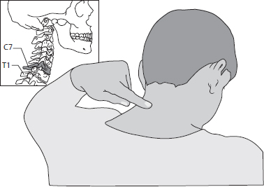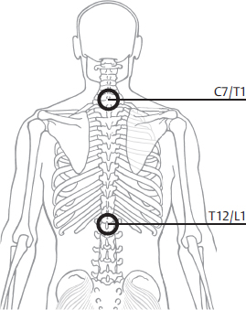
T5
Figure-11 Figure-12
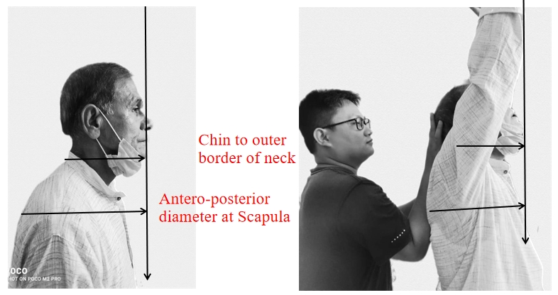
Figure-13
Parameters: Heart rate, respiratory rate, body mass index, bhramari time, breath-holding time, range of motion, repetition maximum.
One-repetition maximum determined of extension of the cervical and thoracic spine using the arm raised hastha uttanasana. One-repetition maximum determined using a leg press is a reliable measure in people with heart failure. Given its smaller limits of agreement, intra-rater testing is recommended. (9) (https://pubmed.ncbi.nlm.nih.gov/29478356/)
Study Design: Pre-post control design or Cross-sectional design.

8. RESULTS
Table-3: General parameters
Parameter | Day-3 | Week-4 | Week-8
HR | 63 | 65 | 59
RR | 4 | 8 | 8
SBP | 118 | 117 | 120
DBP | 50 | 60 | 60
BMI | 21.1 | 21.5 | 21.1
Legend: HR- Heart Rate, RR- Respiratory Rate, SBP- Systolic Blood Pressure, DBP- Diastolic Blood Pressure, BMI- Body Mass Index
The table shows the positive changes in SBP, DBP, RR. Maintained BMI and reduced HR.
Table-4: Specific parameters
Parameter | Day-3 | Week-4 | Week-8
BHT | 4 sec |  | 8 sec
BT | 2 sec |  | 8 sec
Sh. flexion | 140 |  | 180
Thoracic Ex | 20 |  | 40
RM | 2 |  | 6
Legend: BHT- Breath-holding time, BT-Bhramari Time, RM- Repetition Maximum
The table shows the positive changes in BHT, BT, Shoulder flexion, Thoracic extension, and repetition maximum.
9. DISCUSSION
9.1. Improvements with hasthauttanasana
Breath-holding means the retention of breath after inhalation improved. So the diaphragm contraction (Isometric) improved by 8 weeks in the present study. (10)
Same after exhalation means the Internal Intercostal (IICM), abdominal muscles strength, and endurance improved. (11)
Bhramari time is the prolonged exhalation with humming or pronouncing ‘M’. So the vocal cords and the abdominals endurance are improved. The antagonists like inhalation muscles are also get coordinated. As the different modulations were studied in the past, Bhramari can improve parasympathetic activation in long-term practice. High-frequency breathing practices like kapala bhati improves the strength of the respiratory muscles. (12) But the slow patterns like yogic breathing and Nadi shodhana pranayama were well studies in the various diseases.
All these muscles are attached along the cervical and thoracic vertebral column from the occipital bone to T5 (5th Thoracic vertebra) nearly mid of the scapula. The practices of yoga and Vyayama is the traditional way of life in West Bengal that also contributed to the changes. (13)
Shoulder flexion and thoracic extension improved to prove the kyphosis reduced in 8 weeks of specific integrative interventions.
Hence the repetition maximum means the availability of blood flow with oxygen and nutrition was sufficient to do more. This improved trice by 8 weeks in kyphosis patients after CABG. Supporting general change is in SBP and DBP.(14)
HasthaUttana asana is the raised arms posture where the blood flow must be against gravity to the upper limbs. So the daily practice might have improved the strength and endurance as repetition maximum. (5)
9.2. Neutral changes with hasthauttanasana
Only BMI was not changed in the person showing balanced nutrition and well-being. Proprioceptors might be the continuous internal awareness pathways that helped for these biomechanical changes. (12)
9.3 Adverse changes with hasthauttanasana
9.3.1 Reduced Heart rate means the size of the heart may increase to give sufficient cardiac output (Ejection fraction or EF). So there must be an improvement in cardiac muscle strength and endurance. This may be not possible if the patient is fear of muscle stretch and pain from the surgical suture. (15)HasthaUttana asana is a stretching practice for costal muscles, pectoral muscles which are attached to the shoulder joint. Hence this specific asana practice is beneficial for Kyphosis after CABG. Rate Pressure Product: Rate Pressure product, also known as Cardiovascular Product or Double Product, is used in cardiology and exercise physiology to determine the myocardial workload.
Rate Pressure Product (RPP) = Heart Rate (HR) * Systolic Blood Pressure (SBP)
With the units for the Heart Rate being beats per minute and for the Blood Pressure mmHg.
Rate pressure product is a measure of the stress put on the cardiac muscle based on the number of times it needs to beat per minute (HR) and the arterial blood pressure that it is pumping against (SBP). It will be a direct indication of the energy demand of the heart and thus a good measure of the energy consumption of the heart. (4)
Rate pressure product allows you to calculate the internal workload or hemodynamic response.
Table-5:
Hemodynamic Response | RPP
High | more than 30000
High Intermediate | 25000 – 29999
Intermediate | 20000 – 24999
Low Intermediate | 15000 – 19999
Low | 10000 – 14999

Cardiac Rehabilitation Intervention followed the ACSM’s guidelines for frequency, intensity, time, and type. Hence it the worldwide knowledge as a need for a better lifestyle. (16)
F – 3 to 5 sessions per week
I – Intensity according to THR
T – 12 weeks
T – Cardiac Rehabilitation Phase III Program
Frequency: Five sessions per week.
Intensity: The exercise intensity was tracked via heart rate monitor and it was determined by the heart rate reserve (HRR) method. The training intensity throughout the program ranged from 40-80% of the HRR.
Time: Aerobic training time ranges from 10-30 minutes. Initially, the exercise bouts lasted 10 minutes with the eventual progression to 30 minutes.
Type: The training session was completed on a treadmill, stationary bicycle & by walking.
Proprioception may be the other convincing change that might have brought such positive results in the present study. (17)

10. CONCLUSION
There is improvement in cervicothoracic posture and mobility in Kyphosis patients after CABG with 8 weeks of specific integrative HasthaUttanasana (raised arm pose) and Parvatasana (Mountain pose).

11. LIMITATIONS
- Small sample size
- Lack of frequent physical interaction because of lockdown
- Lack of frequent x-ray diagnosis in the lockdown

12. STRENGTHS AND FUTURE DIRECTIONS
The patient has shown great cooperation towards the techniques of yoga and physiotherapy
The examination or special tests used in the present study can be repeated for long-term and large sample sizes.

13. REFERENCES
1. Matheus GB, Dragosavac D, Trevisan P, Costa CE da, Lopes MM, Ribeiro GC de A. Inspiratory muscle training improves tidal volume and vital capacity after CABG surgery. Rev Bras Cir Cardiovasc órgão Of da Soc Bras Cir Cardiovasc. 27(3):362–9.
2. Davidson SS. Davidson’s Medicine. Davidson’s principles and practice of medicine. 2010. 498–499 p.
3. McArdle WD, Katch FI, Katch VL, McArdle WD, Katch FI, McArdle WD. Essentials of exercise physiology. 2000. xviii, 753 p.
4. Eraballi A, Raghuram N, Ramarao NH, Pradhan B, Rao P V. Yoga-based lifestyle program in improving quality of life after coronary artery bypass graft surgery: A randomised controlled trial. J Clin Diagnostic Res. 2018;12(3): YC05–9.
5. Bali HK. Yoga-an ancient solution to a modern epidemic. Ready for prime time? Indian Heart J. 2013;65(2):132–6.
6. Sivananda SRIS. Bhagavad gita. World. 1972. 23–24 p.
7. Vivekananda S. Patanjali Yoga Sutras. 0–142 p.
8. Swami S. Taittiriya Upanishad. 1921;136.
9. Shoesmith E, Smith G. Statistical Reasoning. Stat. 1989;38(2):140.
10. Madanmohan. Effect of Yogic Practices on Different Systems of Human Body. 2008;1– 14
11. Leitzmann MF, Rimm EB, Stampfer MJ, Hu FB. Exercise Type and Intensity in Relation to Coronary Heart Disease in Men. JAMA. 2002;288(16):1994–2000.
12. Mondal J, Balakrishnan R, Krishnamurthy MN. Regulation of autonomic functions following two high-frequency yogic breathing techniques. TANG [HUMANITAS Med. 2015 Feb;5(1):4.1-4.4.
13. Roy B, Chatterjee S, Mondal S. Yoga and Vyayama: Traditional mind-body technique of ancient India. Int J Yoga, Physiother Phys Educ. 2018;3(2):208–11.
14. Mehrotra R. Yoga and the heart. J Clin Prev Cardiol. 2016;5(4):138.
15. Shoemaker JK, Hogeman CS, Khan M, Kimmerly DS, Sinoway LI. Gender affects the sympathetic and hemodynamic response to postural stress. Am J Physiol - Heart Circ Physiol. 2001;281(5 50-5):2028–35.
16. Eraballi A, Pradhan B. Quality of life improvement with rehabilitation according to constitution of the World Health Organization for coronary artery bypass graft surgery patients: A descriptive review. AYU (An Int Q J Res Ayurveda). 2017;38(2):102.
17. Jerath R, Edry JW, Barnes VA, Jerath V. Physiology of long pranayamic breathing: Neural respiratory elements may provide a mechanism that explains how slow deep breathing shifts the autonomic nervous system. Med Hypotheses. 2006 Jan;67(3):566–71.
18. Swartz EE, Floyd RT, Cendoma M. Cervical Spine Functional Anatomy and the Biomechanics of Injury Due to Compressive Loading. J Athl Train [Internet]. 2005 Jul [cited 2021 Aug 23];40(3):155. Available from: /pmc/articles/PMC1250253/

19. The Vertebral Column - Joints - Vertebrae - Vertebral Structure [Internet]. [cited 2021 Aug 2
20. Aman JE, Elangovan N, Yeh I-L, Konczak J. The effectiveness of proprioceptive training for improving motor function: a systematic review. Front Hum Neurosci [Internet]. 2014 Jan 29 [cited 2021 Aug 23];8(JAN). Available from: /pmc/articles/PMC4309156/

14. ANNEXURES
14.1. Annexure:- Institutional Ethical Clearance (IEC)
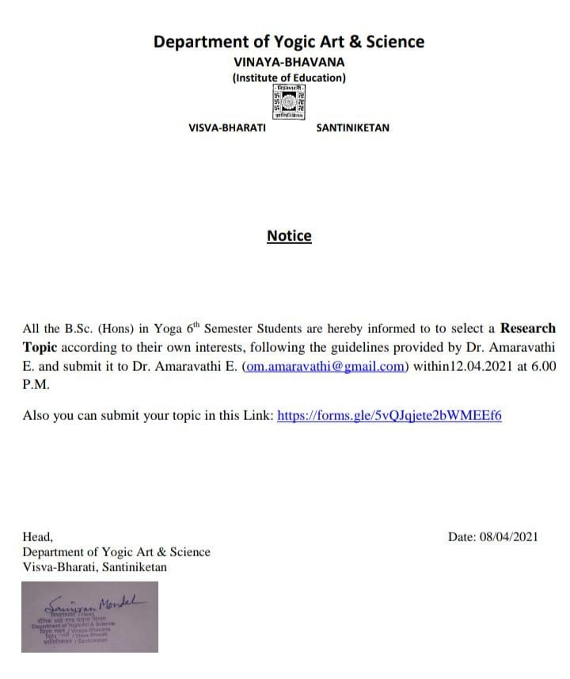

14.2. ANNEXURES:- measurement of neck movements by Physiotherapy experts

Flexion And Extension
Measurement of the distance from the chin to the sternal notch.
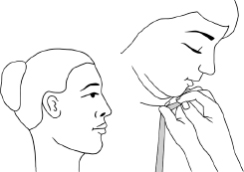
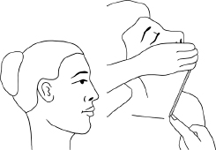

Lateral Flexion
Measurement of the distance from the mastoid process to the acromion process.

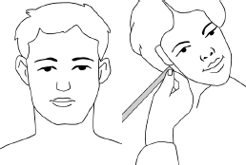

Rotation
Place a mark on the subject’s acromion process. Measure the distance from the tip of the chin to the acromion process (on the side to which the subject rotates). (Neck Assessment | Musculoskeletal Key)
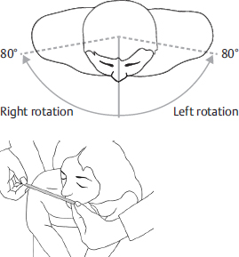

Neck Assessment | Musculoskeletal Key
