Improving geotechnical properties of soil using glass powder and fly ash
Nigitha. D
Assistant Professor, Department of Civil Engineering, SR University-Warangal
Madhavan. D
Junior Engineer, SRC Private Limited, Salem.
Abstract:
The soil's highly expansive clay minerals cause swelling and shrinkage due to moisture variations. Due to these volume changes, different problems will develop in the structure that is resting on this type of soil. The most common method to enrich the index and mechanical characteristics of problematic soil is stabilization. The goal of the current investigation was to determine whether the geotechnical characteristics of problematic soil might be improved by varying the amounts of glass powder and fly ash. The optimum dosage of glass powder and fly ash was determined. For raw soil, the Maximum Dry Density (MDD) value is 7.43 kg/cc and the optimum moisture content (OMC) is 18%. The Maximum Dry Density of the glass powder percentages of 1.89mg/m³ was obtained at 8% of glass powder with an optimum moisture content of 10%. When we added the fly ash (10%,20%,30%,40%) we got maximum dry density values at 1.93 kg/cc at 30% of fly ash. After a 7-day curing period, the treated soil with the mixture of 8% GP and 30% fly ash was able to withstand a load of 281 at a strain value of 5.1% during the compression test.
Introduction:
The soil-related issues pose formidable barriers to the construction purpose. The weak soil is unable to support the superstructure and also it causes erosion complications when it rains especially in urban areas where the land scarcity is greater. To overcome these challenges, geotechnical engineers recommend soil stabilization, which is a method to help improve the index and engineer soil characteristics. The stabilization methods vary from mechanical to chemical modification and also electrical process which is chosen based on the characteristics of the soil and the methodology condition of the planned project. Considering the environmental benefits, nowadays various waste products are added to the soil as admixture. In this approach, soil strength is increased as well as the effective usage of disposal waste. In this investigation, the waste glass powder (GP) and fly ash (FA) were utilized as additives to enrich the soil strength. Chemical stabilization particularly with glass waste emerges as practical which is a hard material. It has a more chemical composition of silicate and alkaline. And it won't harm the environment but it is non-biodegradable so it should be reused in some other way in the form of disposal. The physical characteristics of the powdered crushed glass include good soil permeability, great resistivity, and low strain stiffness, which improve soil's ability to transport loads and durability (Ikara et al, 2015). FA originates as an outcome of coal combustion from power plants. Furthermore, it is from the several industries where they are burning the waste materials that exhibit the fly ash composition or fly ash properties. As a consequence, the generation of waste and coal combustion becomes extremely problematic to dispose of in a safe manner, particularly in India, where the waste generated from the thermal plan is 130 MT per year (Rajput & Yadav, 2015). Incorporating glass powder, and extending to include fly ash, offers a systematic approach, fortifying weak soil for enduring infrastructure stability in construction ventures.
Background Study:
Several studies have focused on developing the stability of problematic black cotton soil (BCS) by using materials such as glass waste powder (Canakci et al., 2016) (Ibrahim et al., 2021) (Zamin et al., 2021) and FA (Bharambe, 2013) (Brooks et al., 2011) (Rajput & Yadav, 2015). However, there has been limited research on the effectiveness of using a combination of these two materials (GP and FA) (Singh & Gahir, 2020). Glass waste is difficult to dispose of in the environment as it takes almost 450 years to biodegrade. Only 40% of glass waste is recovered for recycling, with the rest being dumped in landfills. Despite this, it can be used for soil stabilization due to its favourable physical properties (Javed & Chakraborty, 2020). Various index and engineering characteristics were tested to measure the effectiveness of GP presents in black cotton soil. The addition of a gradually increasing amount of GP reduces the soil consistency limit and soil plasticity index nature (Zamin et al., 2021) (Siyab Khan et al., 2018) (Javed & Chakraborty, 2020). Varying percentages of GP were used in the compaction tests, and an increment in the MDD as the amount of GP increased was observed (Canakci et al., 2016) (Javed & Chakraborty, 2020). Eventually, the density reached a constant level (Siyab Khan et al., 2018). Meanwhile, the observed OMC getting decreased owing to less immersion characteristics of GP (Canakci et al., 2016) (Ibrahim et al., 2021). The soil compressive strength was examined following the accumulation of GP, and the results revealed the observed strength increased with the addition of GP up to an optimal value, after which the strength diminished. (Javed & Chakraborty, 2020) (Ibrahim et al., 2021). The use of GP improved the soil's penetration value, as evidenced by the results of the CBR test conducted in both soaked and unsoaked conditions. The observed CBR value increased with an increasing admixtures (Javed & Chakraborty, 2020). The 1D swelling test was conducted, and it was discovered that soil's tendency to swell decreased as the amount of glass powder grew, perhaps as a result of the substance's inert properties (Ibrahim et al., 2021). Then the efficiency of fly ash was studied by conducting various laboratory test such as consistency limit, Compaction test, Compression test and penetration test. The consistency limit, swelling nature decreased with increasing percentage of glass powder (Cokca, 2001) (Rajput & Yadav, 2015) . The soil dry unit weight and the soil compression strength after mixing with fly ash was increased at optimum percentage (Phani Kumar & Sharma, 2004). Finally, combined admixture of GP and FA on soil was investigated and found that the strength increment was higher (Singh & Gahir, 2020).
Past studies on the GP and FA shows the efficiency to use for the stabilization process. Based on the soil properties, both plays an important role in their possibilities. But very limited research was done on the glass powder and fly ash combination. So, still investigation is needed to understand the efficiency of this combination. The experimental work has been performed in the present work to understand the efficiency of the combination of GP and FA on the soil index and engineering characteristics.
Materials:
Three distinct types of materials were used: Soil, glass powder and fly ash were employed in this investigation. The present investigation used Black cotton soil, which is capable of attracting higher water content. The soil has a volume changing characteristic, such as swelling when wet and shrinking when dry. These actions will result in an issue with the superstructure. The soil sample was collected from Hasanparthy Village in Warangal at a depth of 2m below the surface of the land. As an admixture to stabilize the soil, there are two additives were used such as Glass Powder (GP) and Fly Ash (FA). The glass powder has a more silica content while fly ash has good cementitious properties. The broken glasses were collected and pulverized into a powder in the laboratory using a crushing machine. Then, the broken glasses were then collected and sieved in a 425µ sieve, with the passing powder were used as an admixture in this investigation. The fly ash, which is a commonly available fine powder, was then used as an activator in this investigation.
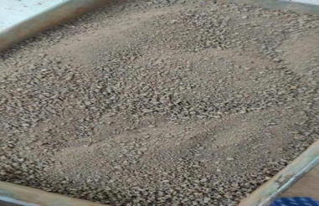 | 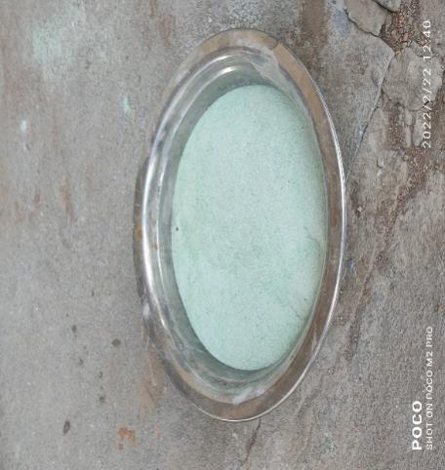 | 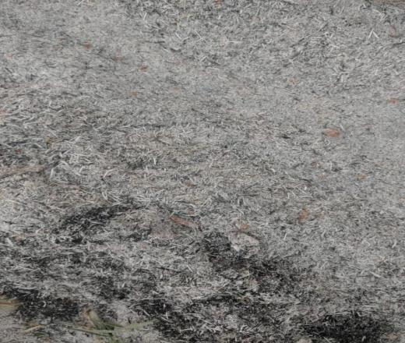
Soil | Glass Powder | Fly Ash
Figure: Collected materials for this study
Research Methodology:
The geotechnical features of soil with and without mixing admixtures were examined in the laboratory tests. Variable ratios of glass powder and fly ash were mixed with the soil sample. Fly ash proportions were 10%, 20%, 30%, and 40%, while the glass powder proportions were 2%, 4%, 6%, and 8%. Different tests were conducted for the various glass powder to soil ratios to discover how the soil qualities improved. Using standard compaction test, the optimal proportion of GP and FA were found. The compression strength of the soil was calculated using this ideal percentage for the various curing days.
Methodology Chart:
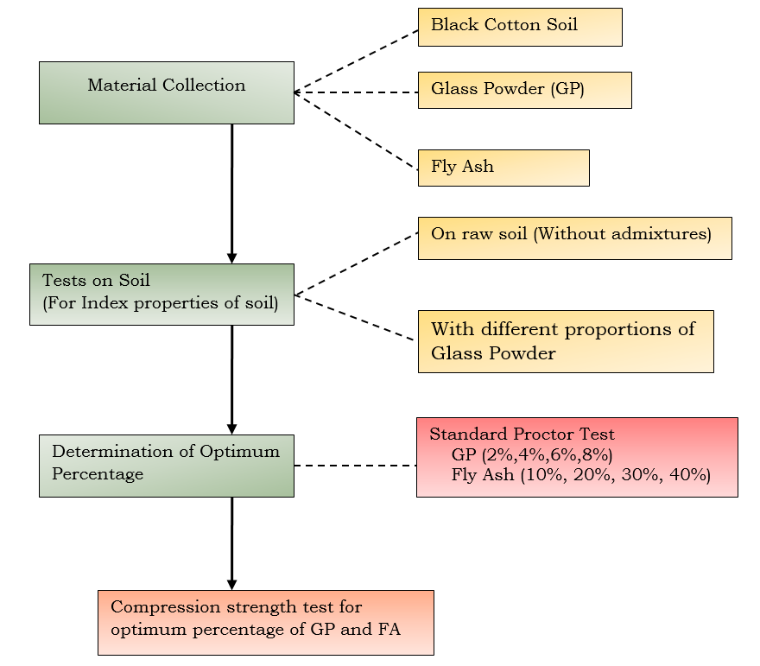
Figure: Details of Experimental program
Results and Discussions:
Characteristics of Black Cotton soil:
The primary tests were performed to ascertain the fundamental qualities of soil without the addition of any admixtures to understand the basic behavior of soil. Table 1 includes the features of Black Cotton Soil. From the free swell test, the observed swelling percentage is 50% and it shows that the soil will exhibits high expansive behavior. The soil liquid limit value is 45% and the plastic limit value is 28.5%. From this, it is observed that the soil behaves almost high plasticity. Then, from the A-line chart, its lies above A-line, hence the soil is classified as the Intermediate compressible clay. From the standard proctor test, the MDD and OMC were determined as 1.73 g/cc and 18%.
Table: Features of collected soil
S.No | Properties | Values
 | Free Swell Index | 50%
1 | Specific Gravity | 2.62
2 | Liquid Limit | 45%
3 | Plastic Limit | 28.5%
4 | Plasticity Index | 16.5%
5 | Optimum Moisture Content | 18%
6 | Maximum Dry Density | 1.73 kg/cc
The OMC and the MDD were determined by conducting the standard compaction test. The figure illustrates the correlation between the OMC and the MDD content of the soil tested.

Figure: Proctor Test for Raw Soil
Effect of glass powder on Free Swell Test:
To determine the efficacy of admixture on black cotton soil, a free swell index experiments were carried out with varied proportion of GP. The graph shows how the test turned out. The graph shows that the expansiveness of the soil diminishes as the percentage of glass powder rises. With the maximum amount of glass powder set at 8%, the free swell potential was lowered from 50% to nearly 20%. The expansive soil will have the more montmorillonite minerals which causes high swell behavior. When some of the soil is replaced with glass powder, the presence of montmorillonite minerals decreases and is replaced by silica minerals because glass powder contains more silica. These are the reason, the expansion capacity of soil got reduced by adding glass powders.

Figure: Variation in swelling behavior with varied percentages of glass powder
Effect of glass powder on consistency limit:
The value of Atterberg limits is an important property of fine-grained soil which give the consistency of the soil under varying moisture content. If the soil has higher liquid limit, the swelling potential of soil will be higher. In this study, the soil comes under the high expansive nature so undergone the stabilization process using the admixtures of glass powder. Figure shows that the consistency of the soil ranges from soft to hard, and that the addition of glass powder decreases the LL and PL values. This proves that adding a higher percentage of glass powder increases the stability of the soil getting. This actions of soil revels that the glass powder which contains high silica content having high effect on the soil consistency. In the Table, it is shown how the consistency limit changes as the percentage of GP changes.

Table. Impact of Glass Powder on Liquid Limit and Plastic Limit
Glass Powder (%) | Liquid Limit(Ll) | Plastic Limit (Pl) | Plasticity Index(Pi)
0% | 45% | 30% | 15%
2% | 40% | 27% | 13%
4% | 37% | 24% | 13%
6% | 35% | 23% | 12%
8% | 33% | 20% | 13%

Proctor Compaction test:
To evaluate the soil dry density with respect to the ideal soil moisture level, the standard compaction test is carried out. The individual test was conducted for the sample treated with each proportion of GP and FA. From the optimum percentage of both the admixtures were determined and it taken as the reference value to make the sample for the UCS test. The soil's compressive strength will be ascertained via the UCS test. The figures show the MDD and the OMC for various percentage of GP and FA. The unit weight of soil rises as the water content rises until it attains the OMC, at which point it begins to decrease due to the increased water content. Because the lubricant between the solid particles increases, particle replication increases, resulting in a reduction in soil density. The OMC and MDD for the treated and untreated soil samples are represented as the peak points of each curve at that time. The graph demonstrates that when the percentage of GP rises, soil's dry density rises as well. This is due to the presence of silica minerals. The figure also demonstrates that, up to 30% fly ash, the dry density increases as the percentage of fly ash increases. Because more soil is replaced by fly ash after the addition of 40% fly ash, the density of the soil drops.

Figure: Maximum dry density Vs Optimum moisture content for different percentage of GP

Figure: Maximum dry density Vs Optimum moisture content for different percentage of FA
Effect of glass powder on Maximum Dry Density
The maximum dry density of soil increases with increasing percentage of glass powder. The increment is due to the specific gravity of glass powder is more, due to that soil density also increased when the replacement of soil will be more by glass powder. The figure shows the increase in the dry density of soil with increasing percentage of powder.

Figure: Dry Density Vs Glass Powder

Optimum Moisture Content Vs Glass Powder:
The observed optimum water content for different percentage of glass powder was decreased. With the increase of glass powder, the replacement of soil will be more, due to that the absorption of water will be reduced. This indicated the better performance of soil with glass powder. Also, the Glass powder increases the surface area of the soil particles by the formation of calcium silicate which increases the strength of the soil and decrease the absorption of water (Ikara et al., 2015).

Figure: Optimum moisture content Vs Glass Powder
Proctor Compaction Test for Glass Powder and Fly ash:
To define the optimum moisture content for Unconfined Compression test, first, Soil compaction test was carried out for combination of admixtures (Fly Ash and Glass Powder. From the tests, it is observed that 8% of glass powder and 30% of fly ash given the good improvement. The results of optimum moisture content were established from the graph and plotted curve are shown in Figure.

Figure: Maximum dry density Vs water content for GP +FA
Unconfined compression strength
The strength of untreated and treated Black cotton soil with the combined admixture percentage of 8% Glass powder with 30% fly ash was determined by conducting the unconfined compression strength (UCS) test. The result in the form of graph was displayed in the figure. The compression strength value of sample was increased from 178 kPa to 213 kPa after adding the optimum percentage of admixtures. The optimum percentage of admixtures such GP and FA was determined from Standard compaction test. The increase in compression strength is due to the addition of glass powder that induce the cementitious nature when water is added. This will create the strong bond between the solid particles which increases the cohesion and also increases the strength. Then, the fly ash is a pozzolanic material which induces the chemical reaction between the soil and lime and it forms calcium silicate. That increases the cohesion nature of the soil which increases the strength. The improvement in the UCS tests, may be due to reduction in plasticity when adding glass powder and Fly ash till a specific limit.

Figure: Stress-strain behavior of soil with 8%GP +30%FA
Effect of curing days on compression strength of soil
The compression strength test was carried out on sample after the sample was in curing time. They are three different curing days was used for this study. The sample was mixed with the optimum percentage of Admixtures such as Glass Powder 8% and fly ash 30% and then the UCS samples were prepared at maximum dry density and optimum moisture which were determined from the Standard compaction test. The figure shows the stress-strain graph for different curing days such as 1,3 and 7 days. From the graph, it is observed that the strength of the soil was increased with increasing the curing days. The test results also showed that curing time has a positive effect in compressive strength. The largest load was recorded as 281 kPa after the 7 days of curing. When the sample kept for curing days, the sample undergoes some chemical reaction such as pozzolanic reaction because the addition of fly ash and also the cementation sprocess due to the addition of glass powder.

Figure: Stress-strain behavior of soil with 8%GP +30%FA for different curing days
Conclusion:
Glass that is not biodegradable is used in large quantities throughout the world and uses fly ash to increase soil stability. Black cotton soil (BCS) must frequently be stabilised before it can be used because BCS are typically considered to have poor engineering qualities. In this study, an experimental investigation was conducted to evaluate the effect of adding glass powder and fly ash in terms of its engineering properties. By performing the free swell test, specific gravity test, liquid limit and plastic limit tests as well as the proctor compaction test and unconfined compression test, the properties of soil were determined. Then, by conducting the strength soil, the improvement in the soil after adding admixtures were determined. The following are the conclusion drawn from the experiments outcomes:
- The percentage of soil expansive nature value got decreased with increasing the percentage of glass powder. The value of expansion reduced from 50% to 23% at 8% of GP.
- From consistency limit, it is observed that the value of LL and PL was decreasing with increasing the percentage of Glass powder.
- From proctor test, the optimum percentage of Glass powder (GP) and Fly ash (FA) was determined as 8% and 30%, respectively.
- The compression strength of the soil was increased form 178kPa to 213kPa as the addition of additives such as Glass powder (GP) and Fly ash (FA). Then after the 7 days of curing days, the strength was increased to 281 kPa at strain of 5.1%.
References
- Bharambe, R. (2013). A Study on Stabilzation of Black Cotton Soil Using Ferric Chloride. IOSR Journal of Mechanical and Civil Engineering, 10(1), 26–30. https://doi.org/10.9790/1684-1012630
- Brooks, R., Udoeyo, F. F., & Takkalapelli, K. V. (2011). Geotechnical Properties of Problem Soils Stabilized with Fly Ash and Limestone Dust in Philadelphia. Journal of Materials in Civil Engineering, 23(5), 711–716. https://doi.org/10.1061/(asce)mt.1943-5533.0000214
- Canakci, H., Al-Kaki, A., & Celik, F. (2016). Stabilization of Clay with Waste Soda Lime Glass Powder. Procedia Engineering, 161, 600–605. https://doi.org/10.1016/j.proeng.2016.08.705
- Cokca, E. (2001). Use of Class C Fly ashes for the Stabilization of an Expansive Soil. Journal of Geotechnical and Geoenvironmental Engineering, 127(7)(July), 568–573.
- Ibrahim, H. H., Mawlood, Y. I., & Alshkane, Y. M. (2021). Using waste glass powder for stabilizing high-plasticity clay in Erbil city-Iraq. International Journal of Geotechnical Engineering, 15(4), 496–503. https://doi.org/10.1080/19386362.2019.1647644
- Javed, S., & Chakraborty, S. (2020). Effects of Waste Glass Powder on Subgrade Soil Improvement. World Scientific News, An International Scientific Journal, 144(March), 30–42. www.worldscientificnews.com
- Phani Kumar, B. R., & Sharma, R. S. (2004). Effect of Fly Ash on Engineering Properties of Expansive Soils. Journal of Geotechnical and Geoenvironmental Engineering, 130(7), 764–767. https://doi.org/10.1061/(asce)1090-0241(2004)130:7(764)
- Rajput, satyendra singh, & Yadav, R. K. (2015). Effect of Fly-Ash on Geotechnical Characteristics of Black Cotton Soil. 2(03), 9–13.
- Singh, G., & Gahir, J. S. (2020). Soil stabilization with fly-ash and glass powder. Journal of Green Engineering, 10(9), 6029–6038.
- Siyab Khan, M., Tufail, M., & Mateeullah, M. (2018). Effects of Waste Glass Powder on the Geotechnical Properties of Loose Subsoils. Civil Engineering Journal, 4(9), 2044. https://doi.org/10.28991/cej-03091137
- Zamin, B., Nasir, H., Khan, B. J., & Farooq, A. (2021). Effect of Waste Glass Powder on the Swelling and Strength Characteristic of District Karak Expansive Clay. Sir Syed University Research Journal of Engineering & Technology, 11(2), 1–8. https://doi.org/10.33317/ssurj.362.
- Gurmeet Singh ,Jagdeep Singh Gahir(2020). ‘Soil Stabilization with Fly-Ash and Glass Powder’,Journal of Green Engineering(JGE)’,10(9),pp.6029-6038
- Gandhi N.S.V.V.S.J, Kumar B.R, Kumar J.V.P, “Some engineering characteristics of fly ash-treated expansive soils”, Proceedings of IGC2001, pp. 157-161,2001.
- Pandian N.S, Krishna K.C, Bb. Leelavatamma, “Effect of fly ash on the C.B.R. behavior of soils”, Proceedings of IGC-2002, pp. 183-186,2002.
- Pandian N.S, Sridharan A, SRINIVAS S, “Use of fly ash to improve the C.B.R. of soils”, Proceedings of IGC-98, pp. 261-264,1998.
- Ramakrishnan A.K, Natarajan K, Chandran R. K, “Stabilization of Annamalai Nagar clay with lime-fly ash”, Proceedings of IGC-2001, pp.251-254, 2001.
- [6]Sikdar P.K, Guruvittal U.K, “Economics of using fly ash in road construction”, journal of Indian High ways, pp. 37-45, 2004.
- Ikara, I.A., Kundiri, A.M. and Mohammed, A (2015)” Effects of Waste Glass (WG) on the Strength Characteristics ofCement Stabilized Expansive Soil” American Journal of Engineering Research (AJER)Vol. 4, Issue-11, pp. 33-41.

