CRISPR-CAS 9: AN EVOLVING TECHNOLOGY OF GENE EDITING
Vasavi K, Hema M, Reshma Anjum M, Padma K.R, Sankari M*
Sri Padmavathi Mahila Visvavidyalayam, Tirupati.
Abstract:
Gene editing is a type of genetic engineering technique. It involves modification of genomic DNA. There are many gen editing techniques discovered till now. Out of which, CRISPR/Cas9 technology has gained most popularity, CRISPR stands for Clustered Regularly Interspaced Short Palindromic Repeats. CRISPR/Cas9 technology has become the most examined gene technology in recent years due to its simple design, low cost, high efficiency and simple operation. CRISPR/CAS 9 technology is a unique technology that is catching the eyes of all researchers in today’s world. This article focusses on the structure, mechanism of gene editing and to spotlight its applications as one of the most important discoveries of the 21st century.
Key words:
Gene editing, CRISPR, ZFN, TALEN, Cas9, Guide RNA, Non-homology end joining (NHEJ), Homology directed repair (HDR), Off-target effect, Bioethical issues.
Introduction
Genetic engineering is a technology in which a target sequence of DNA present in genome is modified using numerous approaches [20]. Gene editing is a type of genetic engineering technique. Gene editing, a new origin in the field of life sciences, is a technique that is used to explore all biological events. This technique involves modification of DNA through host cellular machinery that causes explicit breaks in the gene at target sites.[16]. It involves the modification of genomic DNA at a specific target site to achieve knock-in and knock-out of DNA. Nucleases are convincing genomic tools that are used to accurately edit genes with high efficiency. Gene editing tool became apparent in the 1990s. Since then, various methods have been developed for gene editing. In broad, three systems have been developed for gene editing. These include (Zinc Finger Nucleases) ZFN's, (Transcription-Activator Like Effector Nucleases) TALEN’s, (Clustered Regularly Interspaced Short Palindromic Repeats (CRISPR). [12]
Zinc Finger Nucleases (ZFN's)
Zinc Finger Nucleases (ZFN's) are nucleases, consisting of two functional active domains namely DNA-Cleavage domain and DNA binding domain which is further composed of cysteine and histidine zinc fingers that targets three base pairs and a non-specific catalytic domain of the nuclease. The difficulty in the interaction between zinc fingers and DNA, substantiation of such proteins for particular sequence of DNA. led to the origin of other gene editing techniques.[16]
Transcription-Activator Like Effector Nucleases (TALEN's)
Like ZFN's, TALEN's are also composed of transcriptional activator like effectors (TALE) repeats built from arrays of 33-35 amino acid modules and restriction enzyme originated from plant pathogen Xanthomonas [16]. Comparative to ZFN's, TALEN's are cost-effective, precise, faster. TALEN's consist of Double stranded breaks (DSB's) in target gene which has potential to repair. The main problem associated with using TALEN's is synthesis, design, reduced efficiency, complexity, lack of specificity.[12]
CRISPR/Cas 9 System
With the advent of CRISPR-Cas 9 technology in the 21st century, it emerged as a powerful tool because of its advantages over ZFN's, TALEN's. CRISPR/Cas9 can be abbreviated as Clustered Regularly Interspaced Short Palindromic Repeats. It adapted a bacterial defence mechanism which forms the basis of CRISPR-cas9 gene editing technology. The two essential components of CRISPR/Cas9 system are cas9 enzyme and guide RNA. The complex of cas9 enzyme and guide RNA which facilitates the modification of gene [7]. CRISPR-Cas 9 technology is widely used in comparison to other two techniques because it is easy to perform while other techniques are complex in nature [4]. Constant studies in CRISPR-Cas system lines up the applications of CRISPR in various other fields too. CRISPR-Cas 9 is a flexible, simple, effective and affordable system. These advantages made CRISPR -Cas 9 system better over other two techniques.
History
Before the discovery of CRISPR/Cas9, there were many gene editing techniques being in use such as ZFN, TALEN. These two techniques were difficult to execute and even time consuming. So, CRISPR/Cas9 technology has become rapidly popular due to its simple design, low cost , high efficiency and simple operation[7]. Later, the discovery of CRISPR technology has made the process of gene editing way easier. In 1987, a Japan scientist Ishino accidentally discovered unusual series of repeated palindromic sequences that are interrupted by spacers in E.coli ,but its function was not known by then. Later in 1990, Francisco Mojica identified similar sequences in prokaryotes. In 2012, Doudna.J and Charpentier.E discovered the use of CRISPR/Cas 9 as an efficient gene editing tool. [7]. In 2020, they were given Nobel prize in chemistry for the development of gene editing tool [2]. The discovery of CRISPR technology has paved the way to gene editing.
Structure of CRISPR/Cas9
Depending upon structural and functional characteristics of cas proteins, CRISPR/Cas systems divided into two classes namely Type 1 and Type 2. Compared to type 1, type 2 is relatively simple. So, it is widely used. Cas9 protein is most commonly used in CRISPR technology. It is a large multidomain CRISPR associated DNA endonuclease. The main function of cas-9 protein is to cleave the target DNA sequence to form double-stranded break. So they are usually called as molecular scissors/genetic scissors. Cas-9 consists of two regions namely recognition (REC) lobe and the nuclease (NUC)lobe. REC lobe consists of REC1 and REC2 domain which are useful for binding guide RNA(SgRNA). NUC lobe consists of RuVC, HNH and Protospacer Adjacent Motif (PAM) interacting domain. RuVC, HNH domains together used to cut each ssDNA while PAM interacting domain confers PAM specificity and is responsible for initiating binding to target DNA sequence. Guide RNA is a combination of two parts namely CRISPR RNA (Cr RNA) and Transactivating CRISPR RNA (tracr RNA). CrRNA specifies the target DNA by pairing with the target sequence while tracrRNA is a big stretch of loops and senses and acts as functional RNA for cas 9 enzyme [4]. Cr RNA further contains two main parts, the spacer sequence that directs the complex to the target DNA and a region that binds to tracrRNA.
Mechanism of CRISPR/Cas9 based gene editing
The mechanism of CRISPR/cas9 gene editing mainly involves three main steps namely recognition, cleavage, repair.[4].
Step 1: Recognition – The PAM sequences of NUC lobe of cas9 helps in the identification of cas9 protein which is also responsible for initiating binding to target DNA. It allows sgRNA linked to tracrRNA to recognize target site.
Step 2: Cleavage – The recognition makes sure that the cas9 protein activates the cleavage of the target site. This usually occurs at -3 and -4 upstream of the PAM. This cleavage further causes production of DNA double-strand breaks (DSB). The HNH domain and RuVC domain of NUC lobe of cas9 helps in the cleavage of complementary strand and non-complementary strand of target sequence respectively which further leads to the production of blunt-ended double stranded breaks (DSB's][4].
Step 3: Repair- The double stranded breaks (DSBs) are repaired by two mechanisms namely, non-homologous end joining (NHEJ) and homologous direct repair (HDR).Cas9 protein in association with guide RNA target respective gene causes cleavage of DNA and creates double-stranded breaks.This cut is repaired by either NHEJ mechanism or Homology direct repair.

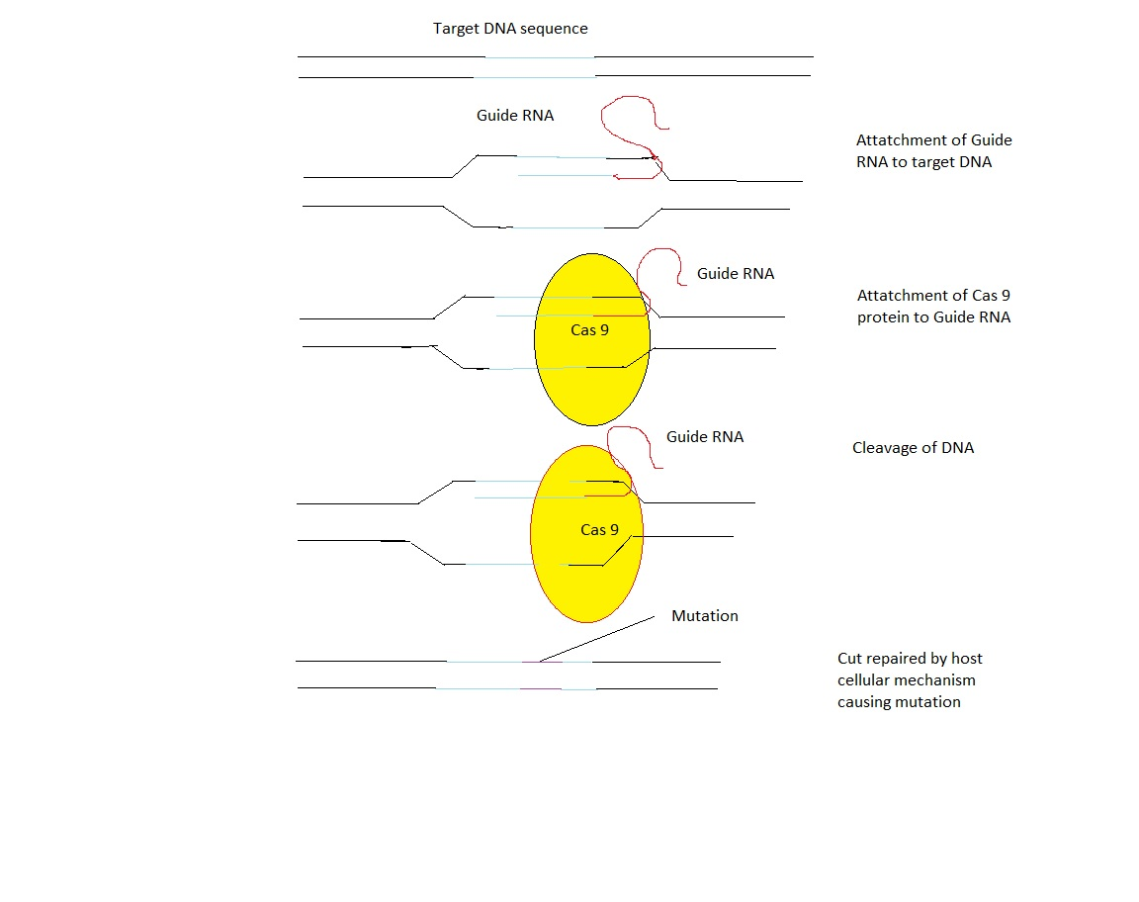
Fig1: Mechanism of CRISPR/Cas9gene editing [9]

- Non-homologous end joining (NHEJ): It is the foremost and able repair mechanism. This type of DNA repair involves the closing of space directly by joining two non-homologous strands which are opposite to each other. It is active in all phases of cell cycle [7]. The main disadvantage of non-homologous end joining is loss of required pieces of genetic information during the process [5].This is an error prone mechanism as this could lead to loss of necessary pieces in the process, which may be lost in further sequences too, causing mutation in the gene[7].
Fig 2: DNA damage repair by Non-homologous End Joining method and Homologous Direct Repair method.
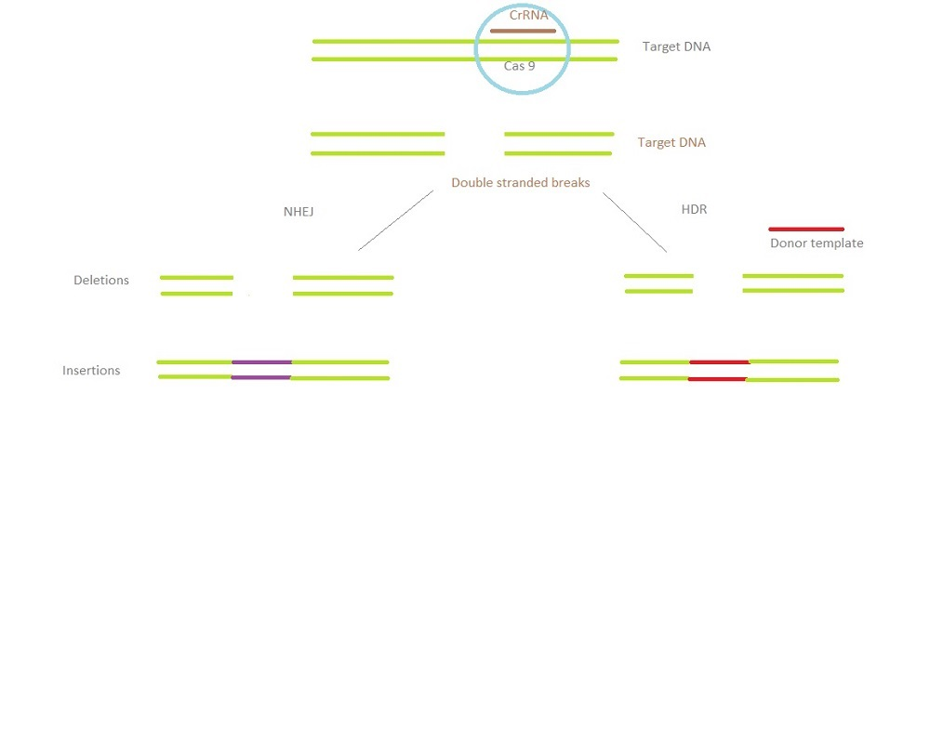
Homologous direct repair (HDR): Homologous direct repair (HDR) mechanism is highly accurate and it involves the use of DNA template. The gaps are not directly closed. Homologous direct repair adopted the mechanism of recombination [5]. In this method, the nucleotides are inserted in the space depending upon the data from previous replication. It is active in late and G2 phases of cell cycle [7].
Methods of CRISPR-Cas delivery
CRISPR technology has originated as one of the efficient tool of genetic engineering. The greatest challenge in using the CRISPR-Cas technology is the successful delivery of CRISPR components to the target cell. For CRISPR system in order to work efficiently, it should be delivered successfully to the target cell [13]. Countless techniques have been adapted till now for the delivery of CRISPR components to the target cell. The techniques developed for the delivery of CRISPR-Cas components are broadly classified into three classes namely viral vectors mediated delivery methods, physical delivery methods and non-viral vector mediated delivery methods.
Viral Vector Methods
Viral vector methods include adeno-associated virus (AAV),adenovirus(AdV),lentivirus(LV) etc. Out of all these techniques, AAV has become more popular. It is extensively used delivery vector. The minimal immunogenicity property of AAV vector method has made it popular. However, it still lags in gene packaging capacity, which is a big problem for CRISPR-Cas system with large molecules. LV and AdV vectors can also be used in CRISPR-Cas delivery system which offers better gene packaging capacity in comparison to AAV. The foremost advantage of using LV and AdV vector is its high efficiency in delivery of CRISPR components to the target cell. But the main limitation in using these vectors is they tend to increase the off-target effects causing gene transfer. So, more precautions must be taken in order to use LV and AdV vectors.[13]
Physical Methods
Physical delivery methods comprise of techniques such as electroporation, microinjection, hydrodynamic injection. These methods involves the use of physical forces for the delivery of CRISPR components. It causes penetration of cell membrane, thus facilitating the entry of CRISPR components into the target cell. Amidst this electroporation is the extensively used technique. Electroporation technique involves the use of high-voltage electric shock in order to stimulate the opening of pores in cell membrane for the entry of CRISPR-Cas components. It is widely accepted technique for in vivo and invitro applications. The main drawback of using this technique is it requires skilled personals and high-voltage shock applied during the process can lead to permanent permeabilization of target cells. Microinjection is one of the prominent technique used for the delivery of CRISPR-Cas components into cells. This technique involves the use of a micro needle for efficient delivery of CRISPR/Cas components into cells. In this method, the CRISPR components are delivered directly to target cell irrespective of biological carriers. It is used for both in vitro and in vivo applications. The main problem of this method is it’s a technically challenging process and so it requires skilled candidates to perform. Hydrodynamic injection method employs injection for the delivery of solution comprising of CRISPR/Cas components to the target cell. The sudden increase in the pressure helps in improving the permeability of cells partially thus allowing the entry of CRISPR-Cas components into the cells. It is highly suitable for in vivo applications because it is not site specific and it may cause trauma to tissues. In comparison to other techniques, hydrodynamic injection method is technically simple to perform. [11]
Non-viral vector methods
To bypass the side effects of using viral vector mediated delivery methods, non-viral vector delivery methods are employed. It involves the use of different types of materials such as polymers, nanoparticles etc., as vectors for the delivery of CRISPR-Cas components. Out of all materials available, solid lipid nanoparticles is highly used. With the exception of solid lipid nanoparticles, so many other materials such as silica, polymers, dendrimers, chitosan, nanoclusters and lipid particles are being explored for the delivery of CRISPR-Cas components. Non-viral vectors show promising applications in in vivo and in vitro applications. Despite of its advantages such as high efficacy, high loading capacity, lack of immune response and mutagenesis, it still has some limitations. Complex design requirement, toxicity of compounds and gene transfer efficacy are the main limitations of non-viral vector mediated delivery methods [14]. Over the last few years many strategies are explores to overcome these problems.
To summarize, all the methods has both Pros and Cons. The success of CRISPR does not rely on the method, it depends upon the selection of suitable carriers for delivering CRISPR components. [13]

Ethical concerns of using CRISPR/Cas 9
Despite the fact that CRISPR-CAS9 technology has drawn much attention since its advent in the 21st century, this technology also rises many new bioethical, social and legal concerns [10]. There are debates going on whether the gene editing should advance or stop doing further research on it as it crosses ethical border. Germline gene editing is forbidden in may countries. In humans, CRISPR focusses on modifying DNA sequences in germ cells. This may lead to changes in human DNA and causes establishment of new generations which would cross the border of bioethics. Gene editing has been challenged by ethics. Gene editing has triggered a heated argument around the world. There are still some security issues in CRISPR/Cas9 because of the insufficient work in it and anything wrong would lead to unnecessary consequences in the future. A regulatory system is highly needed to make sure that gene editing is moving ahead safely, ethically to balance risks and benefits, to create regulations for consumers [8]. Regardless of its challenges, CRISPR technology is a striking improvement creating buzz in the 21st century.
Applications
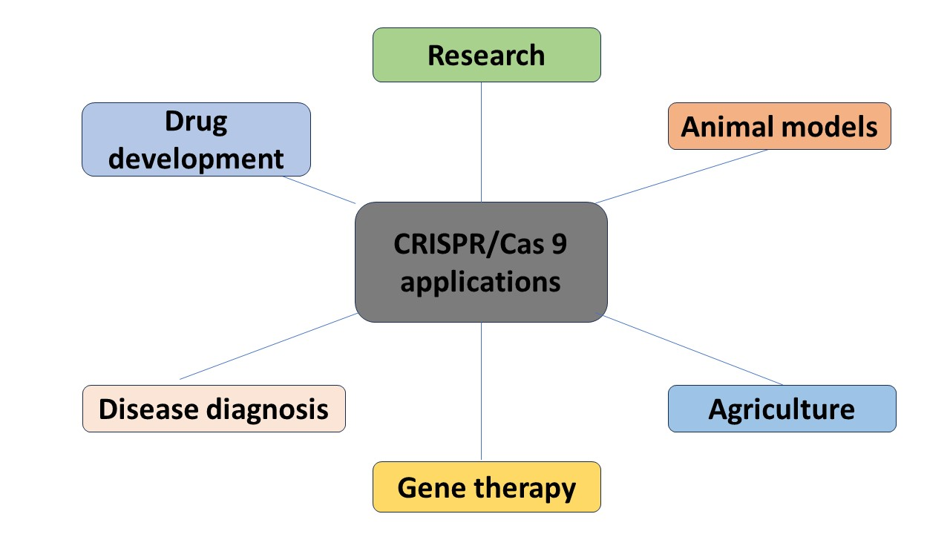
Fig 3: Applications of CRISPR/Cas9 in various fields
CRISPR-Cas9 technology has a variety of applications in various fields such as research, creating animal models, agriculture, gene therapy, disease diagnosis, drug development.
Role in research
CRISPR/Cas 9 technology is an efficient tool of genetic engineering for basic research. It allows basic research such as studying the functions of genes, analysing the cause of diseases, development of new treatments for diseases, test new drugs or medicines and vaccines on diseased animal models [10]. Researchers are mining CRISPR/Cas 9 technology to investigate more on its potential applications in the field of research.
Role in Creation of animal models
Animal models of human diseases are ideal models for drug discovery. Animal models are required to test the efficiency, toxicity and safety of drugs. Anyhow, many of the disease models that are existing now are far away from real. Animal models helps us to know further information about the disease and test developed drugs on these animals [19]. CRISPR/Cas 9 technology has hindered scientists to generate animal disease models more precisely, speedily and cost-effectively.
Role in Agriculture
Since its advent in 2012, CRISPR based gene editing technology has created new opportunities in various domains. CRISPR-Cas technology has huge array of applications in agricultural domain. CRISPR/Cas 9 system has number of advantages over traditional agricultural methods. CRISPR/Cas technology can be used to develop crops that are pest resistant, insect resistant, disease resistant [10]. It helps in increasing the yield and nutritional value of crops. CRISPR crops that had already hit the market include CRISPR rice, CRISPR mushroom, CRISPR wheat which has several benefits over traditionally crops [11]. Deep research is still being conducted to develop more such crops.
Role in Therapeutics
CRISPR technology has drastically changed the gene editing and it opened the doors for applications in various domains. CRISPR offers therapeutic treatments for various types of diseases such as genetic disorders, neurological disorders, cancer, blood disorders. Scientists are discovering new ways of using this technology to treat diseases. It is used to treat diseases by knocking out the disease-causing genes. It involves treatment of disease by transferring genetic information into cells. CRISPR technology is used to treat various curable and incurable diseases such as sickle cell disease, cancer, cardiovascular disease etc [10]. There is huge scope for CRISPR in the field of gene therapy in the near future.
Role in Disease diagnosis
Apart from gene editing, scientists are analyzing the use of CRISPR in various other fields also. CRISPR caused radical improvements in the field of diagnosis. CRISPR gives better approach to diagnose several diseases. CRISPR has become a life renewing tool. CRISPR based molecular diagnostic methods have several advantages over normal molecular diagnostic methods. In order to treat a disease, it should be detected early and precisely. Nevertheless, traditional molecular diagnostics are costly and requires skilled individual. So, CRISPR based diagnostics have several advantages over traditional molecular diagnostic techniques. CRISPR/Cas 9 technology is precise, affordable, rapid. NASBA (Nucleic Acid Sequence-Based Amplification CRISPR cleavage) was the first CRISPR based diagnostic tool developed, that is used to detect zika virus. CRISPR based diagnostics used for diagnosis of diseases such as cancers, cardiovascular diseases etc., The non-rigidity, safety and accuracy of CRISPR system has led to its rapid development mainly in the field of medicine. [18]
Role in Drug development
Drug discovery is usually a lengthy process. It takes so many years for drug discovery from the identification of target molecule to the production of drug. CRISPR-Cas 9 technology can be applied in the field of drug discovery. In drug discovery, CRISPR-Cas 9 technology helps in bringing down the timeline for drug discovery. It is used to mimic the effects of drug molecules in disease models. CRISPR-Cas technology will transform the field of drug discovery. [15]
Challenges
The key challenges of CRISPR technology include: regulation, safety, cost etc., Gene editing is currently banned in some countries. Current regulations for gene editing will regulate CRISPR based therapies also. The CRISPR technology should be studied well before because anything wrong could lead to unnecessary consequences. CRISPR based technology provides effective treatment for various incurable diseases at a high development cost[3]. Despite of these challenges, CRISPR technology will continue to grow and evolve as a greatest invention of the 21st century.
Limitations
Though CRISPR/cas9 is an efficient technique, it still has some limitations existing., which need to be solved first to improve CRISPR technology further. The key limitations of CRISPR technology are off-target effects, immune responses, DNA repair, ethical issues [6]. Most of the people doubt CRISPR only due to its off-target effect, which presents several issues. Reducing the off-target effect of CRISPR/cas9 is one of the main priorities. Much research is focussing on reducing off-target effect. Finding out the reason for the off-target effect is the key way to reduce this. Cas9, which can cut a ssDNA is noticed to reduce the off-target effect[9]. CRISPR/cas9 system specificity is highly dependent on guide RNA. Many bioinformatics related techniques are being developed to reduce the off-target effect [6]. In addition, replacing protein with plasmid and selecting the appropriate cell type could tremendously reduce the Off-target effect.
Future prospects
The huge response from researchers and public proves that it definitely has a very bright future ahead. It has a great potential to overcome the hurdles and prove it as a versatile invention of the 21st century. Currently, CRISPR-Cas 9 is used to diagnose various diseases, treat various diseases, develop new drugs. Further studies in CRISPR-Cas 9 technology has potential to extend its applications in various other fields too. Further studies in CRISPR technology would make it a safe and efficient invention for sure.
Conclusion
Due to wide variety of applications in various fields as a gene editing tool, CRISPR-Cas 9 has brought revolution in the era of gene editing since it's origin. The potential of CRISPR-Cas 9 as a gene editing tool has great developmental opportunities in the near future. It is well known gene editing tool as it is faster & cost-effective. It still has to overcome many challenges to prove it as a potential gene editing tool. Further research should be conducted to assess their safety and effectiveness. Despite of challenges and bioethical concerns, CRISPR-Cas 9 has become an extremely powerful booster station of gene editing.
REFERENCES

1. Thomson B.(2016). Gene Editing-Challenges and future of CRISPR in clinical development[Powerpoint slides].SlideShare. http://www.slideshare.net/medpace/gene-editing-challenges-and-future-of-crispr-in-clinical-development?from_m_app=android
2. Gostimskaya I. CRISPR-Cas9: A History of Its Discovery and Ethical Considerations of Its Use in Gene Editing. Biochemistry (Mosc). 2022 Aug;87(8):777-788. doi: 10.1134/S0006297922080090. PMID: 36171658; PMCID: PMC9377665.
3. Tariq,H. CRISPR-CAS 9 [Powerpoint slides] .Slideshare. Retrieved from
https://www.slideshare.net/hazz12/crispr-cas9-87803136
[4] Asmamaw M, Zawdie B. Mechanism and Applications of CRISPR/Cas-9-Mediated Gene Editing. Biologics. 2021 Aug 21;15:353-361. doi: 10.2147/BTT.S326422. PMID: 34456559; PMCID: PMC8388126.
[5] CRISPR-Cas9 Gene Editing-Definition,Mechanism,Application.(2022,Sep 30).MN Editors.Retrieved from https://microbiologynote.com/crispr-cas9-gene-editing/
[6] Rasul MF, Hussen BM, Salihi A, Ismael BS, Jalal PJ, Zanichelli A, Jamali E, Baniahmad A, Ghafouri-Fard S, Basiri A, Taheri M. Strategies to overcome the main challenges of the use of CRISPR/Cas9 as a replacement for cancer therapy. Mol Cancer. 2022 Mar 3;21(1):64. doi: 10.1186/s12943-021-01487-4. PMID: 35241090; PMCID: PMC8892709.
[7] Rodríguez-Rodríguez DR, Ramírez-Solís R, Garza-Elizondo MA, Garza-Rodríguez ML, Barrera-Saldaña HA. Gene editing: A perspective on the application of CRISPR/Cas9 to study human diseases (Review). Int J Mol Med. 2019 Apr;43(4):1559-1574. doi: 10.3892/ijmm.2019.4112. Epub 2019 Feb 26. PMID: 30816503; PMCID: PMC6414166.
[8] Yue Mei, Yan Wang, Huiqian Chen, Zhong Sheng Sun, Xing-Da Ju,Recent Progress in CRISPR/Cas9 Technology, Journal of Genetics and Genomics,Volume 43, Issue 2,2016,Pages 63-75,ISSN 1673-8527,https://doi.org/10.1016/j.jgg.2016.01.001.
(https://www.sciencedirect.com/science/article/pii/S1673852716000047)
[9] What is CRISPR-Cas 9. (2022, Feb 28). Retrieved from
https://www.yourgene.org/facts/what-is-crispr-cas9/
[10] Xu Y, Li Z. CRISPR-Cas systems: Overview, innovations and applications in human disease research and gene therapy. Comput Struct Biotechnol J. 2020 Sep 8;18:2401-2415. doi: 10.1016/j.csbj.2020.08.031. PMID: 33005303; PMCID: PMC7508700.
[11] Sinclair, F., Begum, A.A., Dai, C.C. et al. Recent advances in the delivery and applications of nonviral CRISPR/Cas9 gene editing. Drug Deliv. and Transl. Res. 13, 1500–1519 (2023). https://doi.org/10.1007/s13346-023-01320-z
[12] Tavakoli K, Pour-Aboughadareh A, Kianersi F, Poczai P, Etminan A, Shooshtari L. Applications of CRISPR-Cas9 as an Advanced Gene Editing System in Life Sciences. BioTech (Basel). 2021 Jul 6;10(3):14. doi: 10.3390/biotech10030014. PMID: 35822768; PMCID: PMC9245484.
[13] Liu W, Li L, Jiang J, Wu M, Lin P. Applications and challenges of CRISPR-Cas gene-editing to disease treatment in clinics. Precis Clin Med. 2021 Jul 10;4(3):179-191. doi: 10.1093/pcmedi/pbab014. PMID: 34541453; PMCID: PMC8444435.
[14] Ramamoorth M, Narvekar A. Non viral vectors in gene therapy- an overview. J Clin Diagn Res. 2015 Jan;9(1):GE01-6. doi: 10.7860/JCDR/2015/10443.5394. Epub 2015 Jan 1. PMID: 25738007; PMCID: PMC4347098.
[15] Scott A. How CRISPR is transforming drug discovery. Nature. 2018 Mar 8;555(7695):S10-S11. doi: 10.1038/d41586-018-02477-1. PMID: 29517026.
[16] Tussipkan D, Manabayeva SA. Employing CRISPR/Cas Technology for the Improvement of Potato and Other Tuber Crops. Front Plant Sci. 2021 Oct 26;12:747476. doi: 10.3389/fpls.2021.747476. PMID: 34764969; PMCID: PMC8576567.
[17] Tang XD, Gao F, Liu MJ, Fan QL, Chen DK, Ma WT. Methods for Enhancing Clustered Regularly Interspaced Short Palindromic Repeats/Cas9-Mediated Homology-Directed Repair Efficiency. Front Genet. 2019 Jun 17;10:551. doi: 10.3389/fgene.2019.00551. PMID: 31263478; PMCID: PMC6590329.
[18] “Applications of CRISPR in Medicine”. (Jan 12,2023). Retrieved from https://www.biocompare.com/Editorial-Articles/593658-Applications-of-CRISPR-in-Medicine/.
[19] Meenakshi P. CRISPR Applications: Agriculture, Medicine, Bioenergy, & the Future. (May 8,2019). Retrieved from https://www.synthego.com/blog/crispr-applications
[20] Lanigan TM, Kopera HC, Saunders TL. Principles of Genetic Engineering. Genes (Basel). 2020 Mar 10;11(3):291. doi: 10.3390/genes11030291. PMID: 32164255; PMCID: PMC7140808.

