Title for Book Chapter:
Driving Workforce to Sustainable Organization: An era of Inclusive Engagement Strategies

Authors
Dr. Richa Tiwari¹
Prof. Baisakhi Debnath²
Dr. Sahana B.S.³

Designation: Assistant Professor^{1,2,3}
Affiliation: Centre for Management Studies, Jain Deemed-to-be University, Bengaluru (KA), India^{1,2,3}

Abstract
Employee engagement is defined as the psychological and behavioural consequences that lead to improved business performance. It is considered to be a critical predictor of the desirable organisational outcomes over the years like productivity, profits, performance, employee retention, psychological safety, well-being and customer satisfaction to name a few. Employee engagement emphasizes on the psychological experiences of employment and work context that determines the process of individuals being present or absent from performing the task. The present chapter focuses on the factors which influences employee behaviour towards employee engagement and sustainable employability practices which is critical for the engagement and organisation’s subsistence. A highly competitive and dynamic workforce possess diverse skills and competencies, adaptable to changing work demands and contingencies, thereby exhibiting high performance. Employers have appraised the potential benefits of sustainable employability and are consistently working towards providing the workforce with improved resources, challenging work environment and cultural constructs that promotes and nurtures this type of employability structures.
The chapter discusses on the criticality of employee engagement by implementing sustainable employability practices in various work settings namely- physical, virtual and hybrid. It emphasizes on the diversity, equity and inclusion (DEI) initiatives primarily during and post pandemic scenarios to further enhance the engagement levels. It enlists the strategies to foster the engagement experience by practicing design thinking, flexible work arrangements and highlighting the well-being of employees thereby creating a culture of sustainable high performance and growth.

Keywords: Employee Engagement, Sustainability, Sustainable Employability, Career, DEI, Wellbeing

1. Introduction

1.1 The Concept of Employee Engagement
Employee engagement refers to the level of emotional commitment and involvement that employees have towards their work and their organization. It is a measure of the extent to which employees are motivated, dedicated, and invested in their job roles and organizational goals. The concept of employee engagement has evolved over time, and its genesis can be traced back to the early 1990s when researchers and organizations recognized the need to move beyond traditional employee satisfaction measurements (May, 2004). Kahn emphasized the importance of employees' psychological well-being and the role of meaningful work, autonomy, and supportive relationships in fostering engagement (Kahn, 1990).

Engaged employees feel valued, supported, and recognized for their contributions. They have a sense of belonging and alignment with the organization's values, mission, and goals. Engaged employees understand the value of teamwork and collaboration. They willingly collaborate with colleagues, share knowledge, and support others in achieving shared objectives. Engaged employees have a desire for personal and professional growth. They seek out learning opportunities, are open to feedback, and are motivated to enhance their skills and knowledge.

The Gallup Organization's Q12 survey, developed in the late 1990s, identified twelve key elements that drive employee engagement, including having clear expectations, receiving recognition, and opportunities for growth and development.

1.2 The Concept of Sustainable Organizations:
Sustainable organizations contribute positively to the called triple bottom line (Hart, 2003) known as economic, social and environmental benefits. Sustainable organizations promote awareness and educate employees about sustainability issues (Singh et. al., 2013), such as climate change, resource conservation, and social impact. Employees may be involved in sustainability committees, task forces, or employee-led green teams. Organisations provide resources, guidelines, and decision-making frameworks that promote environmentally and socially responsible actions. The recognition can take the form of awards, incentives, or public acknowledgment, creating a positive feedback loop and motivating employees to continue their sustainability efforts (Spiliakos, 2018). Sustainable organizations integrate sustainability into their core values, mission, and operational strategies. Organizations provide regular updates, solicit feedback, and encourage dialogue to foster a sense of transparency and inclusiveness. They provide training programs, workshops, and resources to enhance employees' knowledge and skills related to sustainability.

1.3 Inclusion at Workplace:
Inclusion of employee engagement in the workplace of sustainable organizations is crucial for creating a positive and productive work environment. The organization should encourage open and transparent communication between management and employees by providing regular updates on organizational goals, changes, and progress. The organization should provide employees with a sense of autonomy and empowerment in their work (Allan Lee, 2018). Organizations support employees in enhancing their skills, knowledge, and abilities through training, workshops, mentorship programs and career development initiatives. Promoting work-life balance by offering flexible work arrangements, remote work options, flexible hours and compressed workweeks. Creation of a diverse and inclusive workplace where employees feel safe, respected, and valued for their unique backgrounds, experiences, and perspectives. Recognizing and celebrating employee accomplishments through awards programs, public recognition, or simply taking the time to thank employees for their hard work.

1.2 Theoretical Underpinning
1.2.1 Classical Theories of Employee Engagement
- Two-Factor Theory of Needs by Clayton Alderfer: This theory is similar to Herzberg's Motivation-Hygiene Theory, but it divides employee needs into three categories: existence, relatedness, and growth. Existence needs are the basic physiological and safety needs. Relatedness needs are the needs for social interaction and belonging. Growth needs are the needs for self-actualization and personal development.
- Job Characteristics Model (JCM): The Job Characteristics Model, developed by Hackman and Oldham in the 1970s, suggests that certain job characteristics lead to higher levels of employee engagement. The model identifies five core job characteristics: skill variety, task identity, task significance, autonomy, and feedback. According to the JCM, when employees experience these characteristics in their work, they are more likely to be engaged, experience job satisfaction, and perform at a higher level.
- Social Exchange Theory: Social Exchange Theory, developed by Blau in the 1960s, focuses on the exchange relationship between employees and organizations. The theory posits that engagement is influenced by the perceived balance between the efforts employees invest in their work and the rewards they receive in return. When employees believe they are receiving fair treatment and adequate rewards (such as salary, recognition, career development opportunities), they are more likely to be engaged and committed to the organization.

1.2.2 Modern Theories of Employee Engagement
- Self-Determination Theory (SDT): Self-Determination Theory, developed by Deci and Ryan, focuses on intrinsic motivation and the fulfilment of psychological needs as drivers of employee engagement. According to SDT, employees are more likely to be engaged when their work satisfies their need for autonomy (feeling in control), competence (feeling capable), and relatedness (feeling connected to others). Organizations can foster engagement by supporting employees' autonomy, providing opportunities for skill development, and promoting positive relationships.
- Strengths-Based Approaches: Strengths-Based Approaches to employee engagement emphasize identifying and leveraging employees' strengths and positive attributes. These approaches, influenced by positive psychology, suggest that when employees have the opportunity to use their strengths and talents in their work, they experience higher levels of engagement, satisfaction, and performance. Strengths-based approaches involve focusing on individuals' strengths, providing opportunities for skill development and growth, and aligning job roles with employees' strengths.
- The Deloitte Model by Deloitte: This model defines employee engagement as "the degree to which employees are emotionally connected to their work and their organization." Deloitte's model identifies four key drivers of employee engagement:
- Meaningful work: Employees find their work to be meaningful and worthwhile.
- Autonomy: Employees have a sense of control over their work.
- Continuous learning: Employees have opportunities to learn and grow in their careers.
- Transparency: Employees feel that they are informed about the organization's goals and progress.

1.3 The Evolving Concepts in Employee Engagement
- Well-being and Work-Life Balance:
Organizations are increasingly recognizing the importance of employee well-being and work-life balance in fostering engagement. Well-being initiatives focus on supporting employees' physical, mental, and emotional health through programs such as wellness activities, stress management, and flexible work arrangements. Creating a positive work-life balance helps employees feel supported and allows them to effectively manage their personal and professional responsibilities, leading to higher levels of engagement.
- Meaningful Work and Purpose:
Employees are seeking meaning and purpose in their work. They want to understand how their contributions align with the organization's mission and values. Organizations that emphasize the purpose and significance of employees' roles and provide opportunities for meaningful work tend to have more engaged employees. Connecting employees' work to a larger purpose helps foster a sense of fulfillment and motivation.
- Employee Voice and Inclusion:
Engaged employees feel valued and included in decision-making processes. Organizations are recognizing the importance of employee voice, which involves actively seeking and valuing employees' opinions, ideas, and feedback. Cultivating an inclusive environment where employees feel heard, respected, and empowered leads to higher levels of engagement. Inclusive practices include diverse representation, equitable policies, and open communication channels.
- Technology and Remote Work:
The rapid advancement of technology has greatly impacted employee engagement. With the rise of remote and flexible work arrangements, organizations are leveraging technology to facilitate communication, collaboration, and connection among virtual teams. Tools such as video conferencing, collaboration platforms, and employee engagement apps enable employees to stay connected, engaged, and informed, regardless of their location.

1.4 Frameworks of Employee Engagement
Gallup, a renowned research and consulting company, developed the Q12 survey, which comprises 12 questions designed to measure employee engagement. The questions focus on aspects such as clarity of expectations, opportunities for growth, recognition, and the presence of a supportive supervisor.
- William Kahn's work emphasizes the concept of "personal engagement." According to Kahn, engagement is a state where employees invest their "physical, cognitive, and emotional selves" into their work roles.

- Christina Maslach's research on burnout led to the development of the "Job Burnout Model." This model highlights the role of emotional exhaustion, depersonalization, and reduced personal accomplishment in employee well-being and engagement.

- Allan Saks proposed a model that explores the antecedents (factors that lead to engagement) and consequences (outcomes of engagement). He identified factors such as job resources, job demands, leadership, and personal characteristics as influencers of engagement.

- Jim Harter's model combines well-being and engagement, suggesting that engaged employees experience higher well-being.

- Aon Hewitt model measures the following three behaviours that are indicators of employee engagement.
- Say – speaking positively about the organization to colleagues, potential future colleagues and customers.
- Stay – having an intense sense of belonging and desire to be part of an organization.
- Strive – being motivated and exerting effort toward success in the job and for the company.
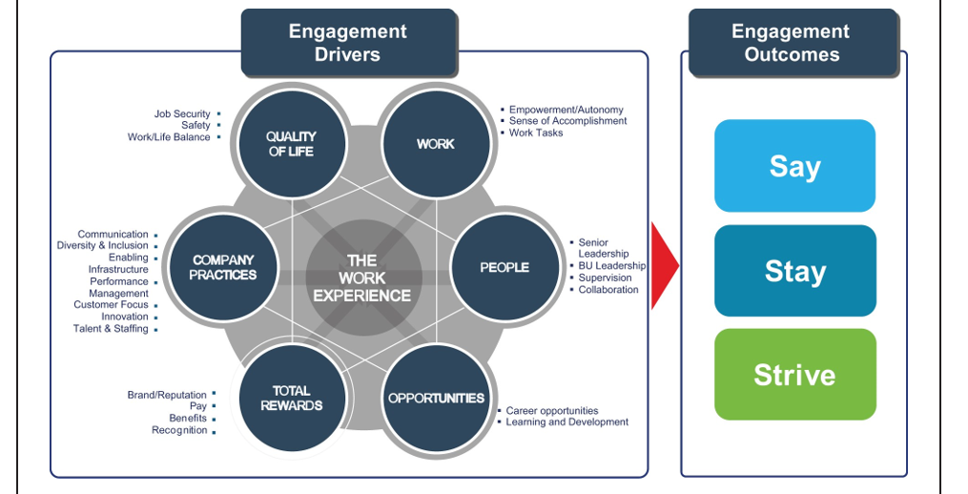
Figure 1: Aon Hewitt Engagement Model (Source: Aon Hewitt)
1.4 Scope of Employee Engagement & Sustainable Organizations

1.4.1 Engagement & its Significance:
Engaged employees tend to be more focused, motivated, and committed to their work. Engaged employees are more likely to stay with the organization for a longer duration (Subramanian, 2011). When employees find their work meaningful and are recognized for their contributions, they are more content with their jobs, leading to a positive work environment. Engaged employees feel more connected to the organization's mission and values. When employees feel supported, valued, and engaged, they experience lower levels of stress and burnout, leading to overall improved well-being. . Engaged employees contribute to increased revenue, lower costs associated with turnover, and enhanced profitability.

1.4.2 Engagement in Manufacturing Industries:
Toyota, a renowned automotive manufacturer, practices the "Kaizen" philosophy, which encourages continuous improvement. Employees at all levels are empowered to identify and suggest improvements to manufacturing processes. Harley-Davidson, a motorcycle manufacturer, offers a variety of skill development programs for its employees. For example, they have a program called "Bar & Shield University" that provides training and development opportunities for employees across different roles and departments. General Electric (GE) utilizes cross-functional teams to solve complex manufacturing challenges. For instance, GE Aviation assembled a cross-functional team consisting of engineers, production workers, and quality experts to redesign a jet engine bracket. 3M, a diversified technology company, allows its employees to spend up to 15% of their work time on projects outside of their main responsibilities. This encourages innovation and creativity. Siemens, a global manufacturing and technology company, has a comprehensive recognition and reward system. Employees are encouraged to nominate their colleagues for various awards, including those related to innovation and teamwork. Ford Motor Company implemented an "Employee Suggestion Program" that rewards employees for submitting valuable ideas for process improvements.

1.4.3 Engagement in Service Industries:
Zappos, an online shoe and clothing retailer, is known for its strong emphasis on company culture and employee engagement. They have a unique approach to hiring where cultural fit is considered as important as skills. Ritz-Carlton, a luxury hotel chain, invests heavily in employee training to ensure exceptional guest experiences. They have a comprehensive training program called "The Ritz-Carlton Gold Standards," which focuses on service excellence and empowers employees to go above and beyond to meet guest needs. Google allows its employees to dedicate 20% of their work time to pursue innovative projects of their choice. Southwest Airlines is known for its unique and fun-loving company culture. Employees are encouraged to bring their personalities to work and engage with passengers in a friendly and humorous manner. Starbucks views its employees as "partners." Hilton, a global hotel chain, places a strong emphasis on recognizing and rewarding employees' contributions. They have programs like "Catch Me at My Best," where employees can recognize their colleagues for outstanding work.
Figure 2: Determinants of Employee Engagement

2. Employee Engagement and Human Psychology

2.1 Psychology of Work in Sustainable Organizations
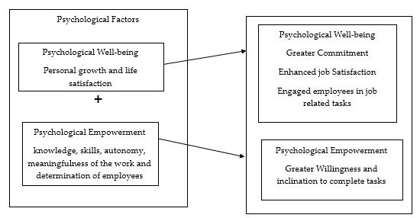
Employee engagement is considered to be a critical factor in sustainable employee engagement over the past years since it is a significant construct in enhancing the organisation performance (Hai et al., 2020). The economic integration has substantially changed the dynamics of the market and has shifted the organisational competition from organisation performance oriented to human capital oriented (Bhattacharya and Sharma, 2019; Dahlan et al., 2019). Hence, considering the factors which influences employee behaviour towards employee engagement and sustainable employability practices is critical for an organisation’s subsistence. Employee engagement is considered to be the characteristics pertaining to commitment, psychological conformity and inclination towards work, vigour and resilience at the workplace (Bakker Arnold and Demerouti, 2008); Also, sustainable employability is considered to the practices and a situation where employees continue their job till, they retire (Fleuren et al., 2018). Robertson and Cooper (2010) have outlined the psychological dimensions namely psychological well-being and psychological empowerment and its influence on employee behaviour towards work engagement and sustainable employability practices. Psychological well-being implicates the individual experiences and functions that replicate one’s personal growth and life satisfaction (Guest, 2017) and psychological empowerment is characterised knowledge, skills, autonomy, meaningfulness of the work and determination of employees toward the managerial practices (Jena et al., 2018; Pathak and Srivastava, 2020).Studies have shown the psychological factors to have a lasting influence on employee behaviour and loyalty towards the organisation (Pathak and Srivastava, 2020). These factors have also been found to be critical to job satisfaction and creativity and innovation at workplace (Grant et al., 2007). Psychological well-being has been found to be instrumental in improving the work environment (Grant et al., 2007); and employees with higher levels of psychological well-being has displayed greater commitment in achieving the organisational goals (Grant et al., 2007; Guest, 2017). Hence, psychological well-being has been considered to be contributory in enhancing job satisfaction among employees and engaging the employees effectively in job -related tasks. Again, employees with stronger psychological empowerment exhibits greater willingness and inclination to complete the tasks (Pathak and Srivastava, 2020; Salehi et al., 2020).
Figure 3: Factors driving Employee Engagement

2.2 The Perceived Work Behavior for Sustainability:
- Job Crafting
The contemporary technology driven work environment with rapidly changing work techniques and structures is the result of organisation’s endeavour for innovation and creativity, superior quality and hence the job design approaches designed by the organisations are deemed to be insufficient and ineffective in addressing and mitigating the emerging work challenges (Le Blanc et al., 2017). These characteristic work arrangements call for proactive, participatory and collaborative response the employees to shape the job design (Demeroutiet al., 2017; Grant and Parker, 2009) in order to create the pertinent-fit for the jobs. These circumstances have embarked the criticality of employee drive practical and positive job design approaches namely job crafting. Job crafting is an evolving job redesign technique that leads to sustainable advantages for the organisations and the workforce (Le Blanc et al., 2017). It enables employees to be accountable for their own job design, performance and productivity, meaningfulness of the work and well-being (Tims et al., 2016). It also allows employees to develop a conformity with their work environment either by altering job boundaries (Wrzesniewski and Dutton, 2001) or by augmenting and optimizing the job demands and resources (Tims et al., 2016).

- Sustainable Employability
Sustainable Employability, a critical construct in knowledge and service organisations (Le Blanc et al., 2017; Van Harten et al., 2016), attempts to retain, manage and maintain the employees to remain competitive (Le Blanc et al., 2017). Sustainable employability denotes the probability of an employee to work (Vanhercke et al., 2014). It is defined as the “the extent to which an employee is able and motivated to continue working productively now and, in the future” (Irfan and Qadeer, 2020, p. 127). There exist two schools of thought on sustainable employability:

Figure 4: Concepts of Sustainable Employability

“Motivation” and “ability” both are considered to be fundamental components to continue the work (Pak et al., 2019; Van der Heijden, 2012). Both of these factors are critical components of continuing to work (Pak et al., 2019; Van der Heijden, 2012). A functional workforce possesses diverse skills and competencies and are flexible to the changing work conditions and hence performs effectively at work (De Cuyper and De Witte, 2011). Hence, these potential benefits encourage employers to improve the sustainable employability to the employees by providing them with ingenious and challenging jobs (Irfan and Qadeer, 2020).

- Managerial Support
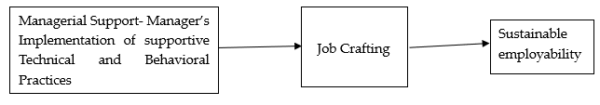
Studies have shown that managerial support accentuates the work engagement of employees, enhances their chances of individual growth and development both professionally and personally and augments their decision-making competencies which triggers the job crafting (Bakker and Demerouti, 2018). Studies have referred that the social job resources exhibited through the manager’s implementation of supportive technical and behavioural practices to be the key trigger for job crafting and sustainable employability. The key perspectives focus on the professional development pf employees, development of their knowledge, skills abilities and competencies (KSACs), optimal functioning and employee well-being. Consistent managerial support has been found to motivate employees and encourage them to continue work. The emotional support encourages the development of employees by providing effective feedback, being concerned about their challenges thereby facilitating effective functioning (Knies et al., 2017). This emotional and social job resources assist employees to cope with the demands and stressors of job (Bakker and Demerouti, 2007) and leads to improved job engagement (Xanthopoulou et al., 2007). It also empowers employees to maintain their employability and add to the employment opportunities (Van Harten et al., 2016).
Figure 5: Conceptual Model of Managerial Support

2.3 Sustainable Career Management and Employee
Contemporary careers are less predictable and less stable and does not conform to a mere amalgamation and series of related jobs arranged in a consistent hierarchy through which individuals can move through an ordered sequence. The current career scripts exhibit lesser clarity thereby providing individuals with diverse career choices over their career lifespan (Van der Heijden and De Vos, 2015). This result of this change can be attributed to the changing contexts of career evolution. The contemporary careers are represented by several changes over the period of time involving multiple career structures and settings along with its independence from the organisation itself. This has increasingly empowered employees to shape one’s own career by judiciously exploiting the various agencies (Arthur, 2014; Bidwell and Briscoe, 2010); these interventions have resulted in significant implications in the ways an individual manages and develop their career. Sustainable career management has become significant area of research (Bozionelos et al., 2020; Heslin et al., 2020; Richardson and McKenna, 2020). Studies have distinguished 3 dimensions to explain what makes the career sustainable. They are as follows:

Figure 6: Dimensions by De Vos et al. (2020)

De Vos et al. (2020), has explained career sustainability to be the interplay of the individual career actor, or the person, the multiple settings and backgrounds that impact and are influenced by careers and how this entire process develops and evolves over time. The dimension “Person” refers to the individual who functions as the fundamental career actor and hence their actions influence the sustainability of their careers, making agency a pertinent construct; Agency refers to the ways an individual’s career progresses over the time and includes the choices made by the individuals and does not merely include the outcomes of external influences and the contingencies arising from this social space (Van der Heijden and De Vos, 2015). The second significant dimension is “Context. Varied contexts influence the evolution of career; an individual’s career is unified with, influenced by and has an impact on multiple stakeholders and contexts. Along with the work context the contexts which plays significant role in an individual’s career are personal contexts, labour market contexts, the different sectoral contexts and the cultural contexts which influences the way an individual manage their careers (Hirschi et al., 2020; Kelly et al., 2020).
Figure 7:Contexts Influencing Culture (Source:Hirschi et al., 2020; Kelly et al., 2020)

The third dimension -time is significant as careers are dynamic in nature and evolve and metamorphose over time in interaction with different layers of context. Sustainable career management involves a recurring self-regulatory process (Lord and Maher, 1990) where individuals learn and acclimatize to varying context over time. Individuals define and redefine the person – career fit as their and the context evolves over the period of time (Parasuraman et al., 2000). Studies have suggested that this dynamic interplay between person, context and evolution over the time period creates a foundation sustainable or unsustainable career.

3. Recent Trends in Employee Engagements of Sustainable Organizations

3.1 Strategic Human Resource Management & its Dimensions
Human Resources is dynamic in the context of technological advancements since it enhances productivity, flexibility and employee efficiency. In the modern age, employees look for quality culture and healthy organizational climate along with a decent pay check. HR leaders, henceforth need to look out for frameworks that encourage positivity in workforce, making flexible and disruptive changes that support employees.
Sustainable organizations offer products and services along with methods that enhance employee experiences as well. Employee management is henceforth having to have elements of engagement that support not just external sustainability but internal as well.

3.1.1 Employer Relations & Positive Engagements
Hybrid workplaces have increased the complexity of HRs in terms of employer relations as scrutinizing the employee’s engagements becomes difficult. Personal interaction is the pillar to bind employees since it largely influences organizational productivity. Positive work culture benefits are endless be it boosting the innovation and creativity, lesser turnover, and increased productivity. However, productivity heavily relies over the employee wellbeing, strong communication, promoting diversity, and informal events hosted in the organization for group cohesiveness.

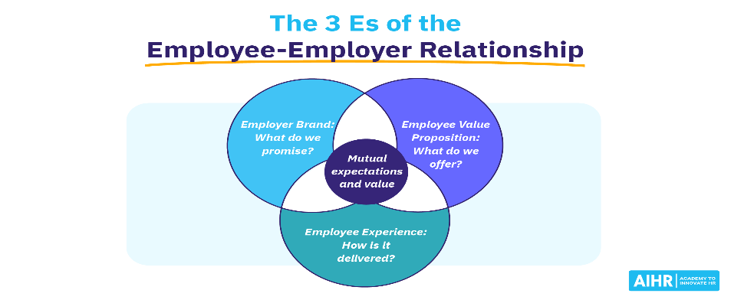
Figure 8: 3 E's Employer Relations (Source: AIHR)
Pandemic was an overnight shift for Human Resources from the classic ideas of managing work culture. Since, remote working gained relevance in multiple industries but Human Resources still face challenge in holistically disrupting the policies that accommodate for complete work from home setup. Flexi-working hours, cutting travel expenses, timing has been a few benefits but still the reports are no less in terms of work pressure, burn-out and breaking the glass for employees for socializing and sharing creative thoughts and ideas. In such a situation, global virtual teams (GVTs) and virtual engagement was the only ray for ensuring to enhance the overall employee experience in new cultural norms.

3.1.2 Sustainable Relations & SHRM
Diversity, equity, and inclusion (DEI) initiatives are at the top of chief human resource officer (CHRO) agendas during these challenging times, as well as the great resignation that has left many industries in need of workers; and, not to mention a global pandemic which forced some to work at home, while others faced challenging infection risks on the frontline. Even with all that is going on, the human resources department in many organizations is seen as the ultimate check-box function; the "R" may just as easily stand for resistance. A climate of psychological diversity is consistently accompanying positive employee attitudes, such as engagement. Various antecedents likely play a role in climate development at psychological, group and organizational levels (Kuenzi & Schminke, 2009). In addition to aligning the organization's purpose in a way that brings all employees along, leading CHROs know that their role goes far beyond DEI. Employees say they want more opportunities to find meaning in their work, according to a McKinsey survey of employee sentiment. Creating programs that connect employee purpose with the company's overall goals is what HR professionals can do to support employee purpose. A climate learning program is being launched by Deloitte in August to reach its 330,000 employees. Through the program, which was developed in partnership with the World Wildlife Fund, employees learn about climate change and how they can make climate-responsible choices at home, at work, and while advising clients.
3.1.3 Driving forces of Productive Culture
In today's business environment, culture is a key concern. The culture of an organization influences employee behavior, for example, when it comes to speaking up in meetings if they disagree or remaining quiet, polite, and agreeable. Survey results show that more than half of executives’ rate organizational culture as "very important" to success, according to Deloitte Human Capital Trends. It is revealed in this survey that organizations are most challenged by culture and engagement. Attracting and retaining top talent also depends on organizational culture. Employees and customers alike recognize the appeal of employer brands created by Southwest Airlines, Google, and Zappos. Your organization's performance and growth can be significantly impacted by cultivating a strong and constructive workplace culture.

3.2 Mapping Employee Experience through DEI strategies

3.2.1 DEI envisioned SHRM
According to a 2022 McKinsey and Co. report, "As ERGs discover more opportunities to engage employees and support companies' DE&I programs, they will want to be judicious about choosing where to dedicate time and energy—in part, to make sure that their activities are promoting a sense of inclusion among ERG members." One of the utmost important ways to show workforces that you respect their backgrounds and traditions is to invite them to share those characteristics of their values in the workplace. Although it is clear that diversity in the workplace and on teams leads to better decision-making, greater novelty and in due course higher revenues. However, it is the inclusion that links people to the business, and we believe it’s one of the core reasons they stay-because they have been able to find their place where they belong. Belonging goes beyond DEI; it is essential in optimizing employee engagement and assurance. Disengaged employees are discontented and disloyal because their workplace needs are going unmet. These employees cause 60% more errors and defects in work performance, and 73% of actively disengaged employees are on the lookout for new jobs or opportunities.

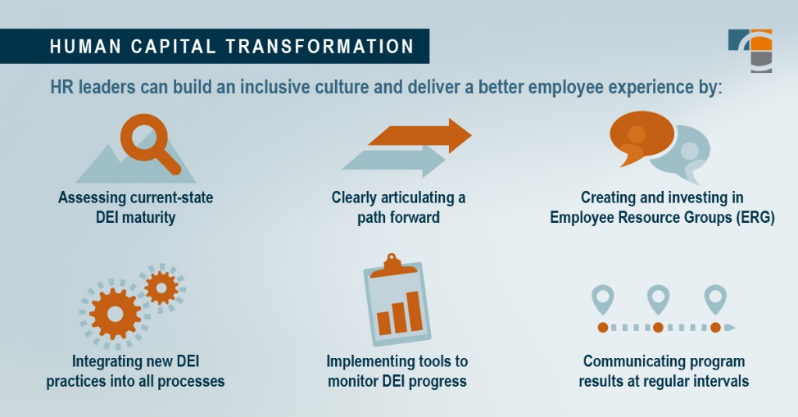
Figure 9: Source: Cross-country Consulting
3.2.2 Mapping Competencies and Experiences
With digital transformations in organizations, HR operations have improvised and employee experience ( EX) is being strengthened with it. Engagement (EE) in the workplace is gaining position (Bersin et al., 2017; IBM & Globoforce, 2016) as employees are drawn to cultural factors that promote better wages, benefits, employee sovereignty, and work-life balance. Competency mapping also serves as the basis for creating well-defined careers within an organization. Even, career self-management serves as the new tool for career progressions and urge HRs to develop framework that personalizes identifying the competencies specific to skills of employees in their different roles and career stages.

3.2.4 Productivity, Culture, and Employee Experience
Employee experience is defined as the total interaction and perceptions employees have of their work, relationships, and opportunities for growth within the organization . In an employer survey conducted by Deloitte, approximately 80% of executives rated employee experience as very important or important. An IBM study found that positive employee experiences are associated with better job performance and increased employee volunteerism. A positive employee experience is twice as likely to volunteer than an employee with a negative employee experience. A Gallup study found that employees at higher risk of burnout were less likely to discuss their goals with their boss and were 63% more likely to take sick leave than she was. Burnout is a major concern for businesses today and they want to mitigate it to prevent problems like lost productivity and absenteeism.

3.3 Hybrid Engagement Strategies

3.3.1 Improving Employee Experience for Flexible Work Cultures
In today's fast-paced and demanding world, balancing work and personal life is more difficult than ever. The pressure to meet deadlines, keep up with technological advances, and maintain a healthy lifestyle can be overwhelming for most people and only relief is a flexible way of working in all dimensions.

3.3.2 Virtual Teams and Engagement Strategies
Clearly, remote work is here to stay for most organizations. According to the Harvard Business Review, 62% of employees believe remote work will have a positive impact on engagement, but its longevity is not clear. This gap provides an opportunity for organizations to be proactive and step up their engagement efforts that serves hybrid mode. Onboarding remote workers requires a strategic approach and long-term commitment to workforce. When companies invest in the long-term success and engagement of remote workers, they end up with happier, more productive, and long-term employees.

3.3.3 Design thinking-based Engagements Activities
Identifying what enables engagement behavior is almost as difficult as identifying one specific definition of employee engagement. This is largely due to the fact that the counseling literature, and to some extent the scientific literature, suggests a variety of factors. Design thinking is now seen as a way to integrate business and technology requirements to create products that meet people's needs. This concept has a natural influence on how companies think about designing people-centric HR processes and practices. Is it all too obvious that people are at the center? is set up. Organizations uses gamifications like hackathons to gather employee ideas and develop diversified approaches that boost performance management, innovate workplace design and also benefits compensation. These uncluttered and collaborative approaches involve employees directly in creating the "perfect" employee experience. Design thinking fundamentally changes the way companies transform by creating highly engaged workplaces that lead to higher levels of novelty and organizational productivity.
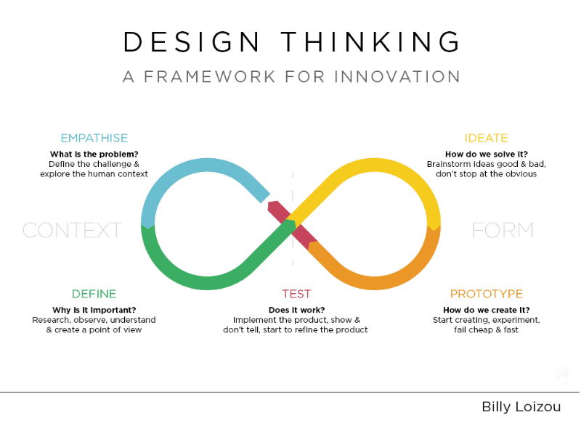
Figure 10: A Concept of Billy Loizou (Source: AIHR)

3.3.4 Well-being and Engaging High Performance
A benefits culture means that employees perform equally and understand the factors that positively or negatively impact employee benefits. is a culture well understood by employers. It can be health, spiritual, social or ecological. side. In a high-performance culture, there is no room for superficially pleasing programs. In particular, it is important to measure performance outcomes and well-being to identify possible associations. Some scholars argue that HPWS will have a positive impact on how workers manage their work and family responsibilities. Indeed, compared with traditional organizations, organizations with HPWS characteristics are more likely to have more family-friendly practices (e.g., flexible working hours and career breaks, e.g., Berg et al., 2003; Wang & Verma, 2012). ) tend to adopt To increase employee engagement numbers. Empirical studies show that working in an environment that uses HPWS helps employees to effectively manage between their passion of professional excellence and compassion towards family.

References:

Bibliography

- Bakker, A. B., & Demerouti, E. (2007). The job demands‐resources model: State of the art. Journal of managerial psychology, 22(3), 309-328.
- Bakker, A. B., & Demerouti, E. (2014). Job demands–resources theory. Wellbeing: A complete reference guide, 1-28.
- Bakker, A. B., & Demerouti, E. (2018). Multiple levels in job demands-resources theory: Implications for employee well-being and performance. In Handbook of well-being. Noba Scholar.
- Boccoli, G., Gastaldi, L., & Corso, M. (2023). The evolution of employee engagement: Towards a social and contextual construct for balancing individual performance and wellbeing dynamically. International Journal of Management Reviews, 25(1), 75-98.
- Chmiel, N., Fraccaroli, F., & Sverke, M. (Eds.). (2017). An introduction to work and organizational psychology: An international perspective. John Wiley & Sons.
- De Vos, A., & Van der Heijden, B. I. (2017). Current thinking on contemporary careers: the key roles of sustainable HRM and sustainability of careers. Current opinion in environmental sustainability, 28, 41-50.
- De Vos, A., Van der Heijden, B. I., & Akkermans, J. (2020). Sustainable careers: Towards a conceptual model. Journal of vocational behavior, 117, 103196.
- Demerouti, E., Xanthopoulou, D., Petrou, P., & Karagkounis, C. (2017). Does job crafting assist dealing with organizational changes due to austerity measures? Two studies among Greek employees. European Journal of Work and Organizational Psychology, 26(4), 574-589.
- Fleuren, B. P., de Grip, A., Jansen, N. W., Kant, I., & Zijlstra, F. R. (2016). Critical reflections on the currently leading definition of sustainable employability. Scandinavian journal of work, environment & health, 42(6), 557-560.
- Florea, L., Cheung, Y. H., & Herndon, N. C. (2013). For all good reasons: Role of values in organizational sustainability. Journal of business ethics, 114, 393-408.
- Glavas, A. (2012). Employee engagement and sustainability: A model for implementing meaningfulness at and in work. Journal of Corporate Citizenship, (46), 13-29.
- Grant, A. M., & Parker, S. K. (2009). 7 redesigning work design theories: the rise of relational and proactive perspectives. The Academy of Management Annals, 3(1), 317-375.
- Gupta, N., & Sharma, V. (2016). Exploring employee engagement—A way to better business performance. Global Business Review, 17(3_suppl), 45S-63S.
- Hart, S. L., & Milstein, M. B. (2003). Creating sustainable value. Acad. Manag. Perspect. 17, 56e67.
- Kahn, W. A. (1990). Psychological conditions of personal engagement and disengagement at work. Academy of management journal, 33(4), 692-724.
- Kim, W., Khan, G. F., Wood, J., & Mahmood, M. T. (2016). Employee engagement for sustainable organizations: Keyword analysis using social network analysis and burst detection approach. Sustainability, 8(7), 631.
- Le Blanc, P. M., Demerouti, E., Bakker, A. B., Fraccaroli, F., & Sverke, M. (2017). How can I shape my job to suit me better? Job crafting for sustainable employees and organizations. An introduction to work and organizational psychology: An international perspective, 3, 48-63.
- Lee, A. J. R., Willis, S., & Tian, A. (2018). When empowering employees works, and when it doesn’t. Harvard Business Review,
- Malik, A., Budhwar, P., Mohan, H., & NR, S. (2023). Employee experience–the missing link for engaging employees: Insights from an MNE's AI‐based HR ecosystem. Human Resource Management, 62(1), 97-115.
- Marino, P. J. (2011). Harley-Davidson Values, the Experience.
- May, D. R., Gilson, R. L., & Harter, L. M. (2004). The psychological conditions of meaningfulness, safety and availability and the engagement of the human spirit at work. Journal of occupational and organizational psychology, 77(1), 11-37.
- Pandey, A., & Gupta, S. (2020). Defining Employee Experience as an Antecedent Indicator for Employee Productivity. International Journal of Research in Engineering, Science and Management, 3, 3.
- Peeters, M. C., De Jonge, J., & Taris, T. W. (Eds.). (2013). An introduction to contemporary work psychology. John Wiley & Sons.
- Sarajoti, P., Chatjuthamard, P., Treepongkaruna, S., & Papangkorn, S. (2022). Sustainability and Corporate Innovation. In Corporate Social Responsibility. IntechOpen.
- Tims, M., Derks, D., & Bakker, A. B. (2016). Job crafting and its relationships with person–job fit and meaningfulness: A three-wave study. Journal of Vocational Behavior, 92, 44-53.
- Tran, Q. (2018). Employee Engagement: How does the organization increase engagement?–From the viewpoint of HR representatives in Finland.
- Yadav, P., & Singh, A. K. (2013). A study on understanding of employee engagement practices: comparison between banks and higher education institutions. International Journal of Management & Information Technology, 4(2), 295-308.

Webliography:

- https://blog.uwcped.org/culture-the-driving-force-behind-your-business-strategy/
- https://www.greenbiz.com/article/hr-ups-its-sustainability-game
- https://www.businessinsider.in/international/news/5-ways-to-build-a-sustainability-focused-work-culture-that-aligns-with-employee-values/articleshow/88742808.cms
- https://www.shrm.org/resourcesandtools/tools-and-samples/exreq/pages/details.aspx?erid=204
- https://talentedge.com/articles/top-20-hr-and-employee-engagement-trends/
- https://talentedge.com/articles/dimensions-human-resource-management/
- https://www.shrm.org/resourcesandtools/tools-and-samples/toolkits/pages/sustainingemployeeengagement.aspx
- https://www.hrexchangenetwork.com/dei/articles/recognize-the-link-between-employee-engagement-and-dei
- https://www.paragonone.com/post/dei-employee-engagement
- https://www.shrm.org/resourcesandtools/hr-topics/behavioral-competencies/global-and-cultural-effectiveness/pages/employee-led-dei-programs-can-keep-workers-active-engaged.aspx
- https://www.hrexchangenetwork.com/dei/articles/recognize-the-link-between-employee-engagement-and-dei
- https://www.cabem.com/alignment-in-the-workplace-with-competency-mapping/
- https://engageforsuccess.org/culture-and-working-environment/7-ways-to-elevate-employee-experiences/
- https://www.quantumworkplace.com/future-of-work/how-to-engage-remote-employees
- https://www.linkedin.com/pulse/can-you-have-employee-well-being-high-performance-culture-lardner/?trk=public_post
- https://www.crosscountry-consulting.com/insights/blog/diversity-equity-and-inclusion-in-workplace-culture/
- https://www.aihr.com/blog/employee-employer-relationship/

