PATHOGENESIS AND CONVENTIONAL REMEDIATION FOR T2DM

- *Dr. Vanitha G Ramesh

Professor in Genetics, Indian Academy Degree College Autonomous

Bengaluru, Karnataka, India.

vanitha.genetics@iadc.ac.in

- Haridev,

Scholar in M.Sc. Applied Genetics

Indian Academy Degree College Autonomous

Bengaluru, Karnataka, India.

Abstract:

Diabetes is a chronic metabolic disorder affecting greater than 400million people across the world. Type 2 Diabetes Mellitus (T2DM) is caused by two important factors such as defective insulin secretion by pancreatic β-cells of islets of Langerhans and the development of insulin resistance. Insulin resistance refers to when cells of the body including the muscle, liver and fat cells fail to respond to insulin eventhough adequate amount of insulin is secreted by β-cells. In fat cells, triglycerides are broken down to produce free fatty acids for energy; muscle cells are deprived of an energy source and liver cells fail to build up glycogen stores. To maintain glucose homeostasis, it is important to regulate the mechanism of insulin synthesis and release. Defects in the mechanisms results in metabolic imbalance which leads to the development of T2DM. It is characterized by chronic hyperglycaemia with disturbances of carbohydrate, fat and protein metabolism with its characteristic symptoms like thirst, polyuria, blurring of vision, weight loss and polyphagia. Present day survey states that there are 77 million people in India have Diabetes mellitus. Researchers disclosed that this statistical data will increase to 134 million by end of 2045 due to heredity and life style of the people. Ayurveda is a Science of life. Presently there is an ever-increasing demand for robust research work on traditional medicine to enhance the core competency of Ayurveda without compromising its fundamental principles. Since thousands of year’s traditional Ayurvedic medicine has been used to treat various human diseases including diabetes. Many medicinal plants, natural products and food additives are potential treatments for diabetic control. Hence, this chapter is intended to observe the antidiabetic effects of food additives such as Cinnamomum cassia, Ocimum tenuiflorum. Syzygium cumini, Abroma augusta L, Emblica officinalis, Moringa oleifera, Azadirachta indica.

Keywords: T2DM. Pathogenesis, Ayurvedic medicine, Cinnamomum cassia, Ocimum tenuiflorum. Syzygium cumini, Abroma augusta L, Emblica officinalis, Moringa oleifera, Azadirachta indica.

Introduction:

Type 2 Diabetes mellitus (T2DM) is a chronic metabolic disorder characterized by hyperglycaemia which may be caused due to inadequate secretion of insulin and /or resistance to insulin utilization by the cells. There are 90–95% of all diabetic patients belong to type II Diabetes (T2D). Several studies have revealed that T2DM results from hereditary component influenced by environmental and epigenetic factors. The disease has a substantial effect on social, psychological as well as physical quality of life. Progression of T2DM results in hyperglycaemia as unable to maintain glucose homeostasis and characterized by obese, higher body fat in the abdominal region. Furthermore, adipose tissue promotes insulin resistance through various inflammatory mechanisms, including increased free fatty acid (FFA) release and adipokine deregulation. The main causes for T2DM are the global rise in obesity, sedentary lifestyles and high caloric diets (Chatterjee et al., 2017). The cell like β and α-cells of the pancreas and the organs such as liver, skeletal muscle, kidneys, brain, small intestine, and adipose tissue are involved in the development of T2DM. The activity of adipokine dysregulation, inflammation, and abnormalities in gut microbiota, immune dysregulation are important pathophysiological factors. The organs involved in T2DM development include the pancreas (β-cells and α-cells), liver, skeletal muscle, kidneys, brain, small intestine, and adipose tissue (Defronzo et al., 2009). Evolving data suggest a role for adipokine dysregulation, inflammation, and abnormalities in gut microbiota, immune dysregulation, and inflammation have emerged as important pathophysiological factors (Schwartz et al., 2016). There are several studies revealed that 100s of genes (TCF7L2, SLC30A8, HHEX, ADAMTS9, CDC123/CAMK1D, CDKAL1, CDKN2A/B, IGF2BP2, JAZF1, NOTCH2, RBMS1, THADA, TSPAN8/LGR5, PPARG, etc.) have been associated with T2DM risk. The candidate gene approach and linkage-based studies have identified a small number of susceptibility genes as HNF4A and TCF7L2 which have been also replicated later (Silander 2004 & Grant et.al 2006). T2DM is caused both by genetics and the environment. Genetic factors exert their effect following exposure to an environment characterized by sedentary behaviour and high-calorie intake. Common hyperglycaemic genetic variants for T2DM have been identified by genome-wide association studies, but these only account for 10% of total trait variance, suggesting that rare variants are important (Grarup etal., 2014). People of different ethnic origins may have different specific phenotypes that increase predisposition to clusters of CVD risk factors, including hypertension, insulin resistance and dyslipidemia (Wong, N.D et al., 2016). T2DM cannot be cured but can be managed by non-pharmacological and pharmacological strategies, where improvements in glycemic control are important factors in delaying the onset and progression of diabetes-related complications (UKPDS Group, 1998). Managing T2DM can be achieved by diet, exercise and insulin replacement therapy (Pankaj Modi B. Et al., 2007 & Sean F Dinneen et al., 2007).Managing T2DM without side effects using modern medicine is still a challenge whereas in Indian system of folk medicine, more than 100 medicinal plants are mentioned for managing diabetes in which more than one plant in combined way are used for correcting the health disorders and this composite plant extract either in the form of tonic or mixture exhibits a better results than single plant extract treatment (Mallick et al., 2007 & Eshrat Halim et al., 2002). Various dietary ingredients possessing anti-diabetic characteristics can act in synergism leading to wider range of control in diabetic patients and their use is particularly important in rural Indian context in reducing the incidence of diabetes related complications. Different herbal medicines are traditionally used in India in treating diabetes and other diseases. Ayurveda practices recommend Tulsi (Ocimum sanctum), Amla (Emblica officinalis), Bitter Gourd (Momordica charantia), and Jamun (Syzygium cumini) etc. for diabetic patients (Marles et al.,1995 and Prajapati et al., 2003). Therefore, investigations from traditionally known plants might be useful in clinic or might have novel effects, such as stimulation of β cell proliferation. Hence it is possible that novel drugs with novel mechanisms of action may be discovered.

Pathophysiology of Diabetes Mellitus:

The aetiology of diabetes is complex including genetic, environmental, and metabolic predispositions. However, a sedentary lifestyle, unhealthy diet, age, obesity, and family history are strongly associated with the development of diabetes.
T2DM is also known as non-insulin-dependent diabetes mellitus (NIDDM), which constitutes most diabetes cases. Insulin plays an important role in glucose homeostasis. Generally, increased secretion of insulin promotes glucose uptake, glycolysis, as well as the uptake and synthesis of amino acids, proteins, and fats. Low insulin level is associated with gluconeogenesis, glycogenolysis, lipolysis, and free fatty acid (FFA) liberation and proteolysis. Imbalance secretion and function of insulin from islets of Langerhans causes diabetes, which eventually leads to abnormally high glucose levels in the blood and consequent complications (Stumvoll et al.,2005). It is characterized by an Inefficiency of β-cells to produce inadequate insulin coupled with peripheral insulin resistance. In the early stages of disease development, due to insulin resistance, blood sugar level remains high even in the presence of high blood insulin levels, and the peripheral tissues like muscle, liver, and adipose tissue fail to respond to persisting hyperinsulinemia. Reduced insulin sensitivity induces a compensatory increase in the β-cell function to produce more insulin to maintain normoglycemia. Despite that, the gradual failure of β-cells to compensate for the reduced insulin sensitivity leads to degeneration. Accumulation of glycogen and sorbitol within the β-cell due to sustained hyperglycaemia and no enzymatic glycation of β-cell proteins are attributed to dysfunction (Galicia-Garcia et.al., 2020). Pharmacological agents used in diabetes treatment act through different mechanisms and may be synergistic in their activity. Oral antihyperglycemic drugs which are mostly used for diabetic treatment either enhance the pancreatic insulin secretion (sulfonylureas such as glyburide, glipizide, glimepiride, and meglitinide) or reduce the insulin resistance of peripheral tissues (thiazolidinediones such as pioglitazone and rosiglitazone) (Chaudhury et al., 2017 & Sood et al., 2000). Biguanides like metformin reduce hepatic glucose production via gluconeogenesis and glycogenosis. Furthermore, Biguanides lower lipid levels, in addition to this, it also decreases gastrointestinal nutrient absorption and also increases beta cell sensitivity to circulating glucose (Rojas et al., 2013), Certain drugs namely glucagon-like peptide-1 (GLP-1) and glucose-dependent insulin tropic polypeptide/gastric inhibitory peptide (GIP) regulate incretions. These are acting on both β- and α-cells to enhance insulin production and suppress glucagon secretion, respectively. GLP-1 receptor agonists (GLP-1 RAs) (exenatide, an incretin hormone), lixisenatide, liraglutide, dulaglutide, albiglutide, and semaglutide) bind and activate the GLP-1 receptor, enhancing insulin secretion. The use of GLP-1 RAs is a well-established approach in the treatment of T2DM (Brunton et al.,2020). Dipeptidyl peptidase-4 (DPP-4) degrades the incretion hormones, mainly GLP-1 and GIP. DPP-4 inhibitors increase the levels of both GLP-1 and GIP, which in turn increase β-cell insulin secretion in the pancreas and decrease glucagon secretion, respectively, thereby maintaining glucose homeostasis by reducing postprandial and fasting hyperglycemia. For the management of T2DM, DPP-4 inhibitors (e.g., alogliptin, linagliptin, saxagliptin, sitagliptin) are a class of oral antihyperglycemic FDA-approved medications are used (Ahrén et al., 2019). Inhibitors of the sodium-glucose cotransporter-2, SGLT2 (eg. canagliflozin, dapagliflozin, empagliflozin, ertugliflozin) are FDA-approved for use with diet and exercise to lower blood sugar in adults with type 2 diabetes. SGLT2 inhibitors act on the SGLT-2 proteins expressed in the renal proximal convoluted tubules reducing the renal reabsorption of glucose while increasing urinary glucose excretion (Wright et al., 2021). Some other medications act on the central nervous system and reduce food intake and body weight. Dopamine agonists like bromocriptine reduce glycohemoglobin via an unknown mechanism (Lopez Vicchi et al., 2016).

Unhealthy Lifestyle
Physical Inactivity
Dyslipidemia
Family History

Figure 1: The Major risk factors of T2DM

Jamun (Syzygium cumini) seed powder in regulating glycaemic condition in T2DM:

The chronic disorder Diabetes mellitus with increased blood glucose level is one of the major causative agents of mortality in the world. T2DM is one of the causative agents for cardiovascular diseases, particularly coronary heart disease (Ryden et al., 2013). Plant based diet including fruits, vegetables, herbs and spices are a major source of phytonutrients to remain healthy. In this context, to substantiate that fruits and seeds of jamun have intense therapeutic applications, Ahmed Raza et al., 2017 carried out studies on the effect of Jamun fruits and seeds and stated that three doses of jamun seed extracts were given to rats at 50, 100 and 200 mg/kg per day. Rats were treated for a period of three weeks. Significant reductions in blood glucose in diabetic rats were observed when treated with jamun extract.

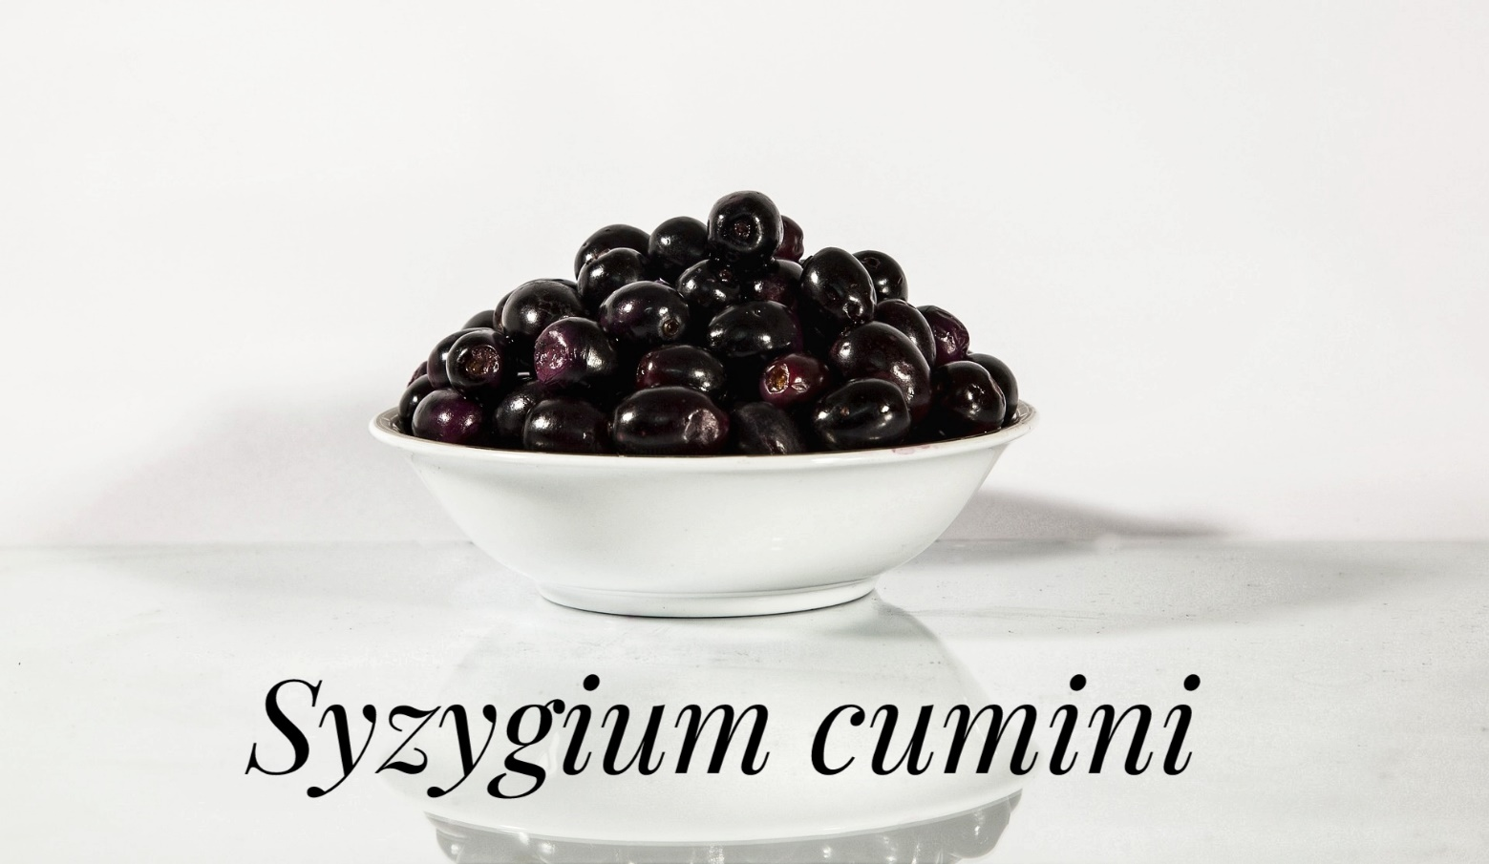

Figure 2: SYZYGIUM CUMINI

Methods:

Male Sprague Dawley rats were used to evaluate the hypoglycaemic potential of jamun extracts by Ahmed Raza et al. The normal and high sucrose diet-induced hyperglycaemic /diabetic rats were provided jamun fruit and seed's ethanolic extracts based diets for sixty days. To evaluate the hypoglycaemic effect of jamun extracts the serum glucose and insulin levels were monitored at monthly intervals.

Results:

The results revealed that both seed and fruit extracts reduce the blood glucose level significantly and also resulted in regulation in the insulin levels of hyperglycaemic rats. It was noted that jamun fruit extract attenuated serum glucose levels to 5.35% and 12.29% in normal and hyperglycaemic rats, respectively; while insulin levels were improved by 2.82% and 6.19%, correspondingly. Whereas, jamun seed extract reduced glucose to 7.04% & 14.36% and showed 3.56% & 7.24% higher insulin levels in normal & hyperglycaemic rats, respectively stated by Ahmed Raza.

Conclusions:

The result of this experiment concluded that both jamun fruit and seeds have potential prophylactic role against hyperglycaemia. In this regard, diet diet-based regimen may be tailored using extracts of jamun fruit/see to alleviate hyperglycaemia.

Impact of Ocimum santum (Tulsi) powder on Hyperglycaemic T2DM:

T2DM is characterized with the symptoms of thirst, polyuria, blurring of vision, weight loss and polyphagia. Ocimum Sanctum leaves help in lowering blood glucose levels and antioxidant property appears to be predominantly responsible for the hypoglycaemic effect (Sethi et al., 2004). S.M.Patel et al., 2016 carried out an experiment to analyse the efficacy of Ocimum santum leaves in regulating glycaemic conditions

.
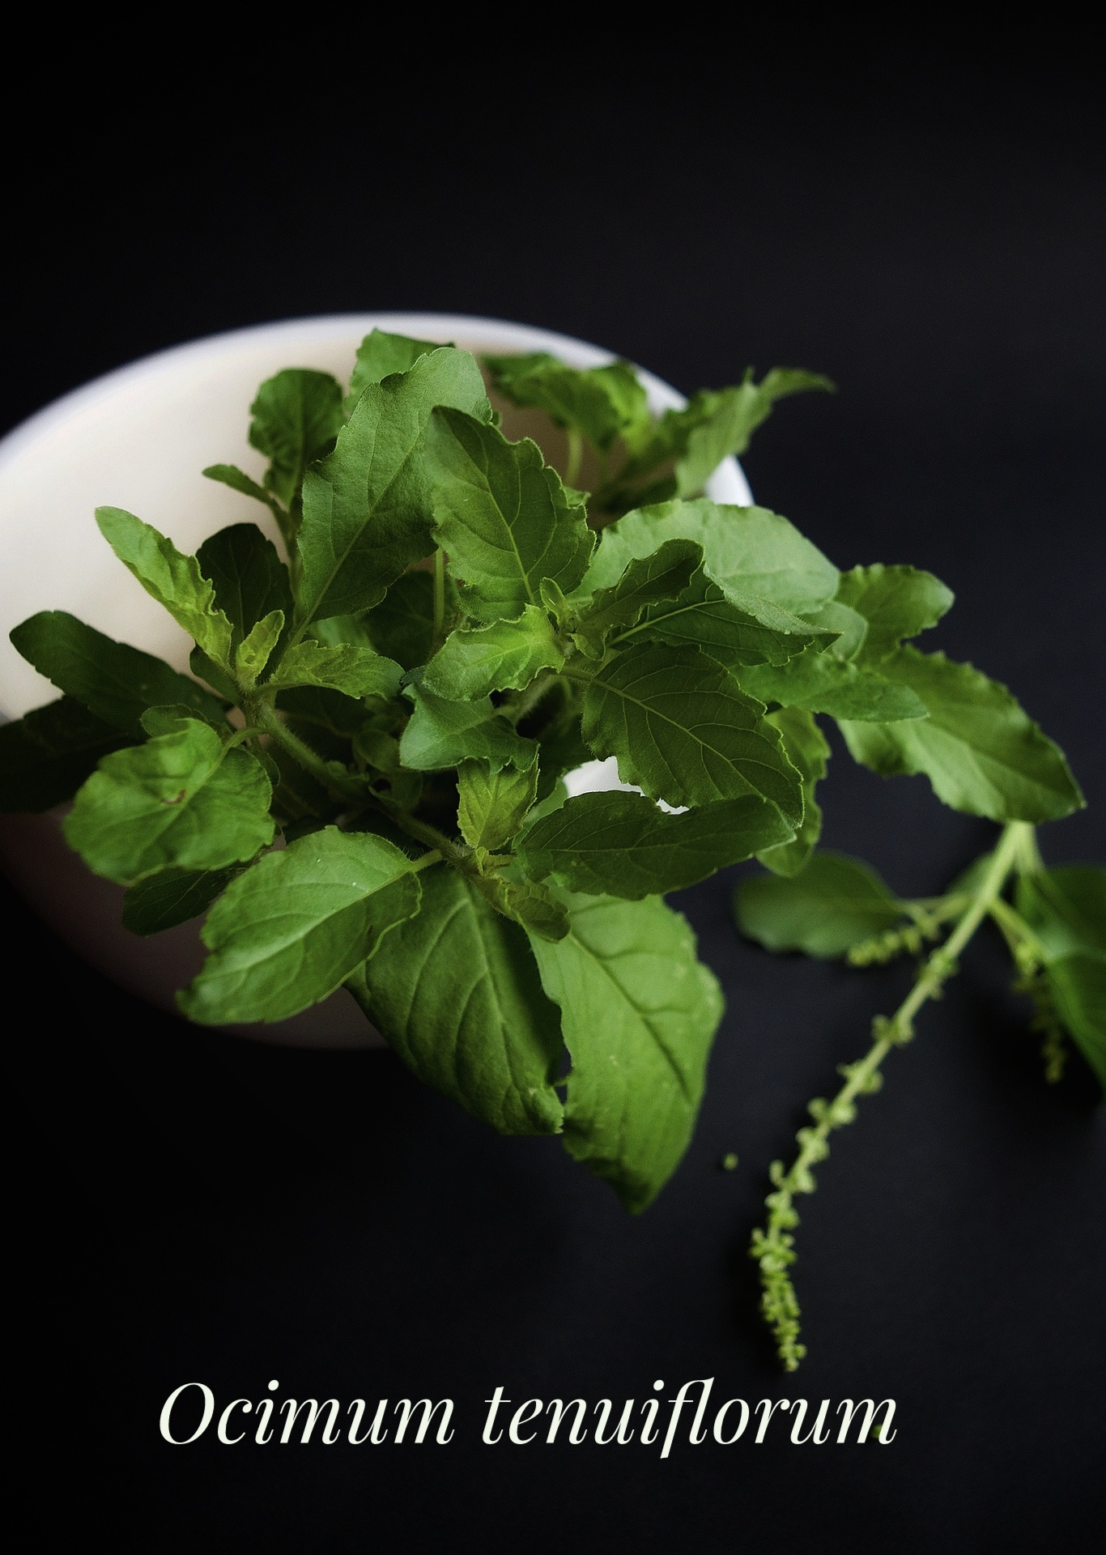

Figure 3: Ocimum tenuiflorum

Materials and Methods:
Study Population: The patients who visited “MANAN” clinic were included in the study by S.M Patil et al., 2016. A total of 40 patients belonging to the age group of 45 to 55 years were selected for the study. A Randomised control trial was conducted in the “MANAN” clinic, Vadodara.20 males and 20 females with Type 2 diabetic mellitus were included in this study.

Ethical Clearance: The study was carried out under the supervision of the Physicians. The patients were informed of the procedure involved in the study in their mother tongue. After obtaining their consent the subjects were enrolled and interviewed at their convenient time to fill a questionnaire which is prepared for research.

Preparation and Feeding of Tulsi Leaf powder: From the local market Good quality Tulsi leaves were purchased and washed thoroughly with distilled water. Leaves are pressed between folds of tissue paper and dried at room temperature for 3-5 days. The dried leaves were ground to a very fine powder in a mixer which gives Sap green colour powder. These Sap green color powders were weighed in 3 gm each and filled in a capsule. These capsules were packed in a dry small plastic bag of 42 capsules and sealed. The biochemical profiles like FBS, PP2bS, and HbA1C were estimated at the beginning and end of the intervention study. The significance of the mean difference between the preliminary and final values of biochemical parameters was tested using t and z tests.

Feeding of the Subjects: Every day the selected subjects were given Tulsi powder capsules in an empty stomach, after 30 minutes they were allowed to have their breakfast. Subjects consumed this capsule for 45 days besides taking their all regular medicines that are prescribed by the doctor and did not change their regular dietary pattern

Initial Assessment: The patients with T2DM were subjected to physical examination. The physical examination consisted of an assessment of parameters like Height, weight, Body mass Index, Waist circumference, Hip circumference, and blood pressure of extremities. As an assessment information related to pharmacological treatment, pre-existing health or diabetic complications, smoking status well as demographic information was recorded.

Laboratory investigations: 3-5 ml of Blood samples were drawn from each patient by venipuncture through disposable syringes. The blood samples were collected in clean oven-dried glass bottles. All the laboratory investigations were conducted using the set protocol and procedures established by the hospital. For FBS and PP2BS they use GOD & POD (glucose oxidase- peroxidase) method & for HBA1C the use enzymatic assay method.

Results
- The Effect of Ocimum Sanctum on fasting Blood Glucose Level for the female experimental group: The FBS in the female experimental group slightly changed from 374.3 ± 9.7 to 372.5 ± 9.7 and it was insignificant.
- Effect of Ocimum Sanctum on fasting Blood Glucose Level for male experimental group: The FBS in the male experimental group improved from the value of 388.67 ± 13.4 to 368.5 ± 17.9 and it was significant at <0.05, and <0.01 levels respectively.

Cinnamon:
Across the world, the incidence of occurrence of type 2 diabetes mellitus is increasing rapidly. Changing the diet and following medications will help to prevent the development of T2DM and to control blood glucose concentrations. Traditional herbs and spices also can be used to control blood glucose concentrations. All spices such as cinnamon, bay leaf, cloves, nutmeg, witch hazel, oregano, and black and green tea have an insulin-like biological activity. Of these spices, cinnamon has been shown to have the highest bioactivity. There is certain research evidence that reveals that a water-soluble polyphenol type-A polymer of cinnamon possesses an antioxidant effect as well as insulin-like activity. Cinnamon has been shown to reduce fasting serum glucose in patients with T2DM when it is added to the diet for 40 doses of 1- 6 g. The same study showed that, after the consumption of cinnamon for 40 days, the serum concentrations of glucose and triacylglycerol remained lower.

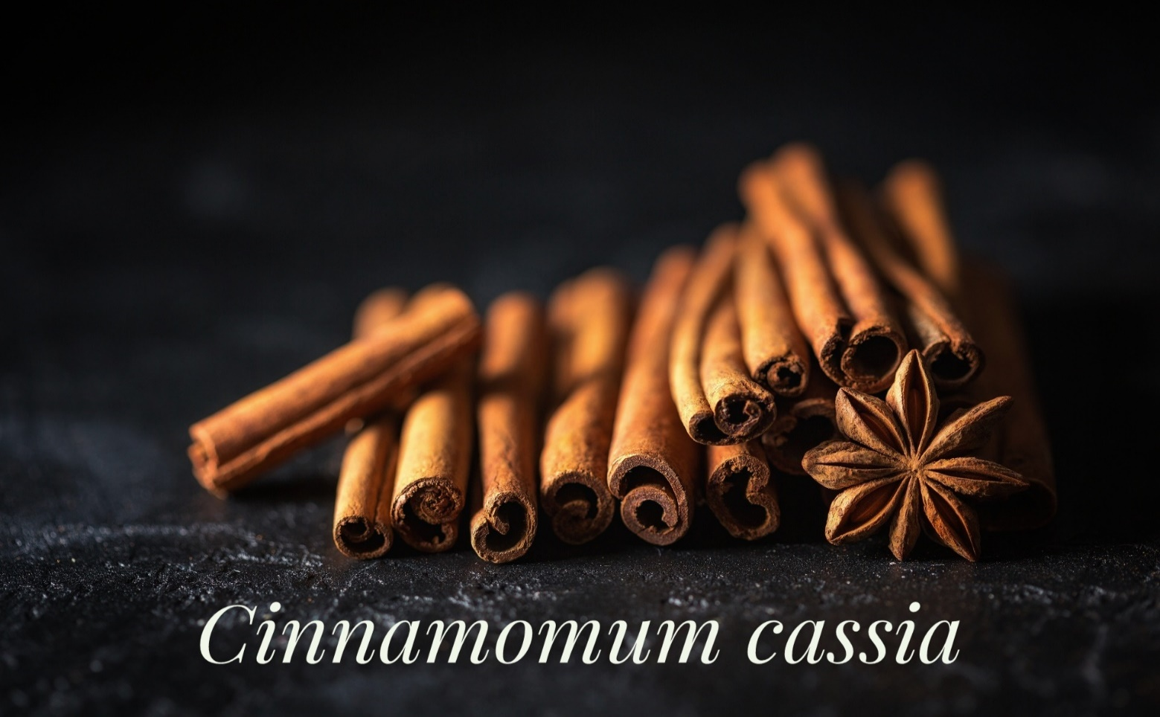
Figure 4: CINNAMOMUM CASSIA
OBJECTIVE: To determine whether cinnamon improves blood glucose, triglyceride, total cholesterol, HDL cholesterol, and LDL cholesterol levels in people with T2DM.

METHODS: A total of 60 people with T2DM were selected of which 30 men and 30 women of age groups of 52.2 ± 6.32 years, were divided randomly into six groups. Groups 1, 2, and 3 consumed 1, 3, or 6 g of cinnamon daily, respectively, and groups 4, 5, and 6 were given placebo capsules corresponding to the number of capsules consumed for the three levels of cinnamon. The cinnamon was consumed for 40 days followed by a 20-day washout period.
RESULTS: After 40 days, all three levels of cinnamon reduced the mean fasting serum glucose (18–29%), triglyceride (23–30%), LDL cholesterol (7–27%), and total cholesterol (12–26%) levels; no significant changes were noted in the placebo groups. Changes in HDL cholesterol were not significant.
CONCLUSION: The results demonstrated that intake of 1, 3, or 6 g of cinnamon per day reduces serum glucose, triglyceride, LDL cholesterol, and total cholesterol in people with T2DM and suggest that the inclusion of cinnamon in the diet of people with T2DMwill reduce risk factors associated with diabetes and cardiovascular diseases.

Abroma augusta L. (Malvaceae) leaf extract in treating T2DM:

Introduction:

In India and Southern Asia Abroma augusta L. (Malvaceae) leaf is traditionally used to treat diabetes. Hence Ritu Khanra et al., 2015 performed an experiment to evaluate the protective effect of defatted methanol extract of A.augustaleaves (AA) against type 2 diabetes mellitus (T2DM) and its associated nephropathy and cardiomyopathy in experimental rats.

Methods: Antidiabetic activity of Abroma Augusta leaves extracts (100 and 200 mg/kg) was measured in streptozotocin-nicotinamide induced T2DM rat by Ritu Khanra et al., Fasting blood glucose level was measured at a specific interval and serum biochemical markers were measured after sacrificing the experimental rats, Status of Redox, transcription levels of signal proteins (NF-κB and PKCs), mitochondria dependent apoptotic pathway (Bad, Bcl-2, caspase cascade) and histological studies were performed in kidneys and hearts of controls and A.augusta treated diabetic rats by Ritu Khanra et al.

Results: Phytochemical screening of extracts revealed the presence of taraxerol, flavonoids, and phenolic compounds in the A.augusta. significantly (p < 0.01) elevated fasting blood glucose level was observed in T2DM rats. Alteration in serum lipid profile and release of membrane-bound enzymes like lactate dehydrogenase and creatine kinase, which ensured the participation of hyperlipidemia and cell membrane disintegration in diabetic pathophysiology. Furthermore, alteration in the serum biochemical markers related to diabetic complications. T2DM altered the redox status and decreased the intracellular NAD and ATP concentrations in the renal and myocardial tissues of experimental rats.

Investigating the molecular mechanism was carried out by Ritu Khanra et al., and activation PKC isoforms were observed in the selected tissues. T2DM rats have exhibited an up-regulation of NF-κB and an increase in the concentrations of pro-inflammatory cytokines (IL-1β, IL-6, and TNF-α) in the renal and cardiac tissues. The activation of mitochondria-dependent apoptotic pathways was observed in the renal and myocardial tissues of the T2D rats. However, the oral administration of A.augusta at doses of 100 and 200 mg/kg body weight per day could reduce hyperglycaemia, hyperlipidaemia, membrane disintegration, oxidative stress, and vascular inflammation and prevent the activation of oxidative stress-induced signalling cascades leading to cell death confirmed by the experimental results.

Conclusions:

Ritu Khanra et al.'s experimental findings revealed that A.augusta could offer a prophylactic role against T2DM and its associated Reno and cardio-toxicity.

Anti-diabetic properties of E. officinalis:

The fruits of Emblica officinalis (EOF) is known as Indian gooseberry in English and amla or amalaki in most Indian languages. It is an important medicinal plant in the traditional Indian systems of medicine (Pandey et al., 2013 and Saini et al., 2022). It has been traditionally used for the treatment of various chronic diseases, like cerebral, diabetes mellitus, coronary heart diseases, and cancers (Saini et al., 2022). Yadav et al., 2017 stated that EOF is a potent rejuvenator and immune modulator with beneficial effects on digestion, cough, asthma, heart diseases, hair growth, eye health, and overall body and intellect. The etiology of diabetes is complex including genetic, environmental and metabolic predispositions. However, a sedentary lifestyle, unhealthy diet, age, obesity, and family history are strongly associated with the development of diabetes. Epidemiological evidence suggests that T2DM can be prevented or controlled by improving the status of some modifiable risk factors, such as obesity, physical activity, and diet. Manish Kumar Singh et al., 2019 revealed in their experiment that a major bioactive component of the EOF is hydrolysable tannin β-glucogallin which has anti-diabetic effects.
E. officinalis is well-known for its anti-diabetic activities. There are various evidences show that EOF can alleviate the symptoms of diabetes with obvious hypoglycaemic and hypolipidemic effects. Furthermore, EOF is efficacious in managing the course of diabetic complications that are mostly unresponsive to anti-diabetic drugs (D’souza et al., 2014). The anti-diabetic activities of EOF appear to be achieved by alleviation of mitochondrial dysfunction, inhibition of polyol pathway, inhibition of advanced glycation end products (AGEs) formation, and regeneration and rejuvenation of β cells.

Mechanism of Anti-Diabetic Action:

EOF Regulates Carbohydrate Metabolizing Enzymes:

Wu et al., 2018 stated that inhibition of carbohydrate-digesting enzymes like α-amylase and α-glucosidase enzymes is used as a therapeutic measure in diabetic patients to slow down the digestion of dietary carbohydrates into glucose and subsequent absorption in the gut. The methanol extract of E. officinalis exhibited anti-diabetic activity by reducing α-amylase, α-glucosidase, and antiglycation activity (Nampoothiri., 2011). Similarly, Majeed et al. showed that standardized EOF extract inhibited the activities of α-amylase from porcine pancreas and human saliva in a concentration-dependent manner with IC50 values of 135.7 µg/mL and 106.7 µg/mL, respectively. In addition, it also inhibited the enzyme activities of α-glucosidase (IC50 = 562.9 µg/mL) and DPP-4 (IC50 = 3770 µg/mL). Recently, ethyl acetate extract of E.fficinalis also has been found to have inhibitory effects on α-amylase and α-glucosidase in vitro.

E.officinalis against Diabetes-Induced Complications:

Prolonged diabetes induces damage to many types of tissues which includes nerves, skin, retina, kidney, heart, and brain. Complications associated with Diabetes are divisible into two groups: those affecting large blood vessels (macrovascular diseases) and those affecting small blood vessels (microvascular diseases). The most prevalent microvascular complications in diabetes include patients with retinopathy, nephropathy, and neuropathy, whereas macrovascular complications are an increased risk of cardiovascular disease, leading to myocardial infarction and cerebrovascular disease manifesting as stroke. Besides, impaired lipid metabolism and myocardial dysfunction are also associated with diabetes. There is a number of experimental evidence that have shown that EOF is highly effective in managing diabetic complications and helps to ameliorate the adverse side effects of synthetic pharmaceutical drugs.

E. officinalis Induces the Regeneration and Rejuvenation of Pancreatic β-Cells

T2DM is generally characterized by insulin resistance and reduced production of insulin by pancreatic cells. Optimal pancreatic function is essential for the regulation of glucose homeostasis, and its impairment leads to the development of diabetes. Glucolipotoxicity reduces the functional cell mass of pancreatic cells and renders them less efficient in insulin production. Prentki et al., 2002 stated that Glucose intolerance in association with hyperinsulinemia and insulin resistance are early hallmarks of the prediabetes phase. Cell dysfunction leads to insufficient insulin production, resulting in hyperglycaemia. Sri et al., 2014 revealed that the species Phyllanthus was found to be involved in the regeneration and rejuvenation of insulin-secreting cells which results in increased insulin production.

In vitro studies with RINm5F cells have shown that an active constituent of EOF Gallic acid, in its natural abundance, dose-dependently increased insulin secretion and prevented glucose and palmitate-induced apoptosis. Furthermore, Latha et al., 2011) found that Gallic acid enhanced insulin levels and stimulated the regeneration of cells of islets in STZ-induced diabetic rats when supplemented at a dosage of 20 mg/kg bw for 28 consecutive days. Similar effects were also observed by Singh et al., 2020 in other studies. Similarly, EOF treatment significantly increased serum insulin and c-peptide protein by 57% and 31% in arsenic-treated mice compared to those treated with arsenic alone.

Conclusions
Since ancient times, Emblica officinalis has been used in the management of various diseases. These fruits are well known for their antioxidant, immunomodulatory, antipyretic, analgesic, cytoprotective, antitussive, and gastroprotective agents. It is believed that regular consumption of EOF rejuvenates our bodies and provides longevity. The bioactive phytoconstituents of EOF are glucogallin, tannins, polyphenols, fibres, minerals, proteins, and amino acids, which are responsible for its beneficiary effects in humans. There are several in vitro and in vivo, studies have confirmed the efficacy of EOF in managing diabetes and its complications by controlling various biological activities. Diabetes is a chronic condition requiring life-long medications, many of which are toxic over a longer duration of time, however, reduction of drug dosage with alternative medicines needs to be explored to reduce side effects. It is increasingly recognized that gut microbiota dysbiosis is an important factor for diabetes, and more research is required to understand how EOF modulates gut microbial population. Since mono-galloyl esters are recognized as important structural features for controlling PARP/PARG activation, EOF offers several galloyl esters for further research. EOF also offers a powerful candidate for screening microvascular complications.

Hypoglycaemic effect of Moringa oleifera and Azadirachta indica in T2DM

MATERIALS AND METHODS

Jalajakumari, 2010 carried out an experiment to find the efficacy of Moringa oleifera in T2DM. Jalajakumari has chosen 55 non-insulin dependent Diabetics (36 men and 19 women) in the age group of 30-60 years from the Hospital of Acharya Nagarjuna University and Diabetic Care Hospital, Guntur and divided them into two Experimental (n=46) and control groups (n=9). The first two experimental groups were administered Moringa oleifera leaves powder (8g) and Azadirachta indica seeds powder (6g) per day respectively in three divided doses for 40 days. The third group of nine subjects did not receive any treatment and was designated as the control group. To elicit information regarding diabetic patients, a detailed interview schedule was formulated. The selected samples were interviewed and information regarding their age, sex, socioeconomic status, dietary habits, and food and nutrient intake of the selected subjects were assessed using a 24-hour recall survey for three consecutive days. Body Mass Index (BMI) and biochemical indices such as blood glucose and blood lipid levels were estimated before and after the administration of the herbal powders into the patients.

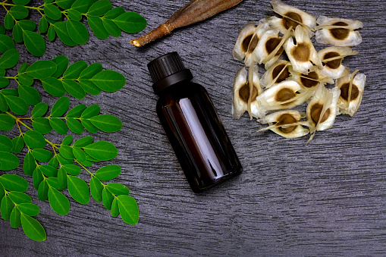
Moringa Oleifera

Figure 5: MORINGA OLEIFERA

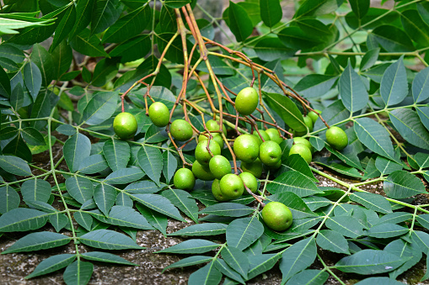
Azadirachta indica

Figure 6:Azadirachta indica

Inclusion criteria
1. T2DM patients with fasting plasma glucose levels equal to or greater than 140 mg/dL of blood without any detectable/visible complications.
2. T2DM patients taking oral hypoglycaemic agents with a history of inadequate control of blood glucose with these agents.
3. Normal healthy subjects with no family history of diabetes mellitus.

Exclusion criteria
1. Pregnant or nursing patients.
2. Smokers.
3. Patients with G.I.T., hepatic, Cardiovascular, Renal, or Endocrine disorders (other than diabetes mellitus) which can interfere with the absorption, metabolism, and excretion of the study plant.
4. Patients with any complications of diabetes mellitus. Patients suffering from type I (IDDM) diabetes mellitus.

Results:
The results of the study derived the results that the majority of the selected diabetic patients belonged to the age of 41-60 years i.e., after the age of 40 when the incidence of diabetes is precipitated. T2DM usually occurs in people over 40 years, old because pancreatic insulin-producing cells progressively lose their function with age (Whitney and Rolfes, 1997). Among the 55 patients, 10.5 percent of females belong to grade II obesity, 19.4% of males, and 26.3% of females belonged to grade I obesity. About 38% of patients were at risk of obesity in both sexes and 36.3% of the subjects were normal. According to Chan and Bridges (1998), higher rate of NIDDM may be etiologically linked to morbid obesity as the metabolic gateway to the disorders of the elderly like T2DM, atherosclerosis, hypertension, and osteoarthritis (Sadhukhan, 1997). Besides age and obesity, genetics play an important role in predicting the onset of type II diabetes (Waltson et al., 1995).

REFERENCES:
+

________________________________________________________________

