Business Ecosystem Model

Introduction

A business can be described as an organization or enterprising entity that engages in professional, commercial or industrial activities.An enterprising entity or organization that carries out professional activities. They can be commercial, industrial, or others. For-profit business entities do business to earn a profit, while non-profit ones do it for a charitable mission.

Business ownership includes partnerships, sole proprietorships, corporations, etc. Businesses can be small-scale or large-scale. Some of the biggest businesses in the world are Amazon and Walmart.

Types of Businesses

Various businesses are organized per some type of hierarchy or bureaucracy. In these businesses, the positions have a customary role and responsibility. As per business definition, we see that different types of businesses are:

Sole Proprietorship: In this kind of business, a single person owns and operates the business. There isn’t any kind of legal separation between the owner and business.

Partnership: As the name suggests, it is a business where two or more people run it together. The partners bring in resources and money, and then the shares in the profit or loss are divided amongst them.
Corporation: In this business, a group of individuals act together as a single entity. The owners in this business are called shareholders. They discuss their views on the common stock of the corporation.

Limited Liability Company (LLC): It merges a partnership’s pass-through taxation benefits and a corporation’s limited liability benefits.

Different Sizes of Business Small Business:

Small businesses are companies where small owners (an individual or a small group) operate. For instance, family restaurants, clothing companies, home-based companies, and publishing companies. In this type of business, the profits are not that high but just enough to continue the business operations.

Mid-sized Business: Mid sized business are established better than a small business. The employee base of these businesses ranges from 100 to 999 people. For instance, Colorbar Cosmetics is a mid-sized business.

Large Business: This kind of business usually operates as a corporation. Usually, these businesses issue corporate stock to finance their operations. Thus, it is publicly traded. As a result, it must report on certain things and operate restrictions. This is the opposite of a small business, where operations are independent of regulators. Amazon and Walmart are examples of large businesses.
Business Industries
There are different industries in which businesses operate. A certain company can define its business by the particular industry. For instance, there are industries of real estate, agriculture, advertising, banking, and more in which businesses exist.
It is because often, the term ‘business’ interchanges with the daily operations and the total formation of the company. We often use this term for indicating transactions concerning an underlying service or product.
Examples of Businesses
Different businesses in the world offer a variety of services and products.

The most successful ones include:
Amazon: The largest online retailer, Amazon sells a wide variety of products on its ecommerce platform. It began as an online bookseller and captured almost every category of retail. It also offers cloud computing services, movie and show streaming platforms and subscription products.
Apple: It is a renowned company famous for its innovative electronic products. They sell personal computers, smartphones, earphones, watches, and laptops. Similarly, they also provide various services like music and video streaming and production services.
Walmart: Being of the most successful retailers globally, Walmart is a multinational corporation that runs a chain of hypermarkets offering a huge variety of products ranging from family apparel to housewares. It is present in 24+ countries and has millions of employees worldwide.

Before starting a business: One needs to take various steps before starting a business. One must conduct market research first and then develop a business plan. The next step must be to seek capital or other funding and select a location and business structure. It is also important to pick the right name, complete the registration process, and get the tax documents and essential permits. A bank account is a must before starting a business.

Start an online business: An online business is different from a traditional business. You need to design your website after your market research, business plan development, and paperwork formalities. After that, start finding ways to build up your target market and engage your audience with social media platforms.

Business plan: Business plans help run your business and secure the fund needed to start the operations. There are two ways- traditional business plan or lean business plan. The former is full of details like the company’s summary, plan for success, product information, sales projections, etc. The latter one is not that detailed but has necessary information like details of the partnership, cost structure, revenue stream, and more.

Business Development

Simply we can say that, business development can be summarized as the ideas, initiatives, and activities that help make a business better. This includes increasing revenues, growth in terms of business expansion, increasing profitability by building strategic partnerships, and making strategic business decisions.

Business development encompasses a wide scope of ideas, activities, and initiatives that a business owner and management implement with the goal of making the business better.

Business development can include many objectives, such as sales growth, business expansion, the formation of strategic partnerships, and increased profitability.

Successful business development impacts every department within a company, including sales, marketing, manufacturing, human resources, accounting, finance, product development, and vendor management.

Business developers should be aware of new market opportunities, possibilities for expansion, competitor developments, and the current sources of the company's revenue.

Basics of Business Development

Business development refers to the initiatives done to expand business prospects and improve an organization's overall performance. Building and sustaining connections with clients and partners, seeking new business opportunities, and putting plans in place to boost profits and market share are all part of the duties.

The primary goal of business development is to increase the organization's capabilities and reach. Finding new trends, undiscovered markets, and client demands, frequently entails undertaking market research and analysis. Businesses may create focused plans to take advantage of opportunities to outperform the competition.

In general, business development is essential for promoting achievement and growth inside organizations. Businesses may adapt to a shifting market landscape, optimize income potential, and achieve long-term sustainability by proactively recognizing and pursuing opportunities. This is done by cultivating relationships and putting strategic plans into action.

Elements of Business Marketing

Sales: Sales personnel focus on a particular market or a particular (set of) client(s), often for a targeted revenue number. With such set goals, the sales department targets the customer base in the new market with their sales strategies.

Marketing: Marketing involves promotion and advertising aimed toward the successful sale of products to end customers. Marketing plays a complementary role in achieving sales targets. Initiatives may allocate an estimated marketing budget. Higher budgets allow aggressive marketing strategies like personal visits, roadshows, and free sample distribution. Lower budgets tend to result in passive marketing strategies, such as limited online ads, print ads and social media ads.

Strategic Initiatives or Partnerships: To enter a new market, is it better to go it alone and complete all the necessary paperwork, or is it wiser to build a strategic alliance or collaboration with local businesses who are already active in the area? The business development team, with the aid of the legal and financial departments, examines all of the advantages and disadvantages of the potential choices and decides on the one that will benefit the company the most.

Project Management: Is a new facility in the target market necessary for the business expansion, or will all the goods be produced in the home nation before being imported? Will the latter choice necessitate a second facility in the base nation? The business development team makes these decisions and bases them on their estimations of time and cost. The project management/implementation team then gets to work to move toward the intended objective.

Product Management: The activities of the manufacturing and product management departments, as determined by the company strategy. Each of these factors is evaluated as part of the development strategy, including cost consideration, legal approvals, and regulatory compliance.

Vendor Management: Does the new company require outside suppliers? Will a dedicated courier service be required, for instance, for the distribution of a product? In order to increase retail sales, will the company collaborate with any recognized retail chains? How much are these engagements going to cost? Working through these issues is the business development team.

Negotiations, Networking, and Lobbying: A few business initiatives may need expertise in soft skills. For example, lobbying is legal in some locales and may become necessary for penetrating the market. Other soft skills like networking and negotiating may be needed with different third parties, such as vendors, agencies, government authorities, and regulators. All such initiatives are part of business development.

Cost Savings: Management can implement similar cost-saving initiatives by outsourcing non-core work, such as billing, accounting, financials, technology operations, and customer service. Strategic partnerships needed for these initiatives are included in the development plan.

Business Ecosystem

A business ecosystem is the network of organizations—including suppliers, distributors, customers, competitors, government agencies, and so on—involved in the delivery of a specific product or service through both competition and cooperation. The idea is that each entity in the ecosystem affects and is affected by the others, creating a constantly evolving relationship in which each entity must be flexible and adaptable in order to survive as in a biological ecosystem.

Ecosystems create strong barriers to entry for new competition as the ecosystem already consists of the players that allow it to function.

The theory of business ecosystems was developed by business strategist James Moore in 1993.

In the 1930s, British botanist Arthur Tansley introduced the term ecosystem to describe a community of organisms interacting with each other and their environments: air, water, earth, etc. In order to thrive, these organisms compete and collaborate with each other on available resources, co-evolve, and jointly adapt to external disruptions.

Business strategist James Moore adopted this biological concept in his 1993 Harvard Business Review article "Predators and Prey: A New Ecology of Competition", in which he paralleled companies operating in the increasingly interconnected world of commerce to a community of organisms adapting and evolving to survive. Moore suggested that a company be viewed not as a single firm in an industry, but as a member of a business ecosystem with participants spanning across multiple industries.

Advances in technology and increasing globalization have changed ideas about the best ways to do business, and the idea of a business ecosystem is thought to help companies understand how to thrive in this rapidly changing environment.

Moore defined the business ecosystem as follows: An economic community supported by a foundation of interacting organizations and individuals—the organisms of the business world.

The economic community produces goods and services of value to customers, who are themselves members of the ecosystem. The member organisms also include suppliers, lead producers, competitors, and other stakeholders. Over time, they co-evolve their capabilities and roles and tend to align themselves with the directions set by one or more central companies. Those companies holding leadership roles may change over time, but the function of ecosystem leader is valued by the community because it enables members to move toward shared visions to align their investments and to find mutually supportive roles.

In effect, the business ecosystem consists of a network of interlinked companies that dynamically interact with each other through competition and cooperation to grow sales and survive. An ecosystem includes suppliers, distributors, consumers, government, processes, products, and competitors. When an ecosystem thrives, it means that the participants have developed patterns of behavior that streamline the flow of ideas, talent, and capital throughout the system.

Ecosystems and Competition

Ecosystems create strong barriers to entry for new competition, as potential entrants not only have to duplicate or better the core product, but they must also compete against the entire system of independent complementing businesses and suppliers that form the network.

Being a part of a business ecosystem provides mechanisms to leverage technology, achieve excellence in research and business competence, and compete effectively against other companies. Some other goals of a business ecosystem include:

Driving new collaborations to address rising social and environmental challenges

Harnessing creativity and innovation to lower the cost of production or allow members to reach new customers

Accelerating the learning process to effectively collaborate and share insights, skills, expertise, and knowledge

Creating new ways to address fundamental human needs and desires

It is for these reasons that in today's rapidly changing business world, a company creates its own ecosystem or comes up with a way to join an existing ecosystem by providing an advantage that is currently lacking in that ecosystem.

Business Ecosystem Model

A business ecosystem is an ecosystem where the main players facilitate an economic community by utilizing the resources in the habitat. The prime resources are raw materials and technology. The main players are producers, suppliers, consumers, competitors, and government agencies. These organisms in the ecosystem interact, producing goods and services.

A Business Ecosystem is a network of different entities that are dynamic and interact with each other to create and exchange sustainable value. Productivity, robustness, and the ability to develop niches and opportunities for new firms are key success factors for ecosystem models.

In the ecosystem model, different participants, like organizations, create value for each other compared to the traditional business model, with one participant delivering value for the customer. Furthermore, the survival and flourishing of the organization or other ecosystem participants are considered the biggest challenge.

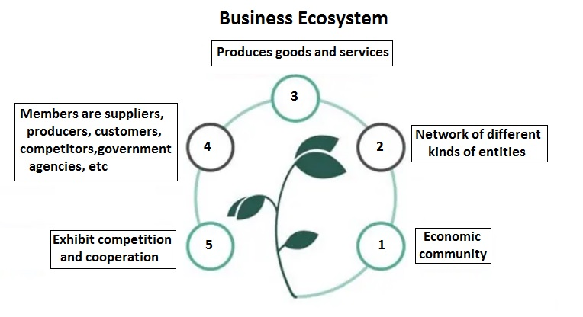

Figure: Business Ecosystem

Similar to a biological ecosystem, the participants and the processes in this business environment continually evolve to increase and maintain efficiency. Therefore, the system is dynamic, constantly remaking since it reacts to forces like innovations, technological advancements, and competitions.

Let us consider subscription streaming services like Netflix, Disney+, etc., for interpreting the business ecosystem example.

In the online economy, an ecosystem with participants that rely on each other to exist and prosper, along with their competitors and authorities who set the regulations for streaming services, has grown in size and importance. They are the potential source of significant revenues. Streaming service providers benefit economically from their interactions with other ecosystem participants. Consumers, investors, and competitors are examples of various actors in a streaming service ecosystem.

The value proposition by the streaming service company is the entertainment content. They provide a huge content library, on-demand video streaming, and personalized recommendations, cater to customers from a plethora of taste communities. To be ahead of the competition, they have to understand the competitors like other streaming service providers, cinemas, and cable TV networks. Streaming services interact with many different entities like studios, content producers, cloud service providers for storing content, Internet Service Providers (ISPs) for streaming, and banks for payments. These different entities participate in the ecosystem to develop, provide, and collect value for one another, including the consumer since doing so helps them survive and thrive.

Types of Business Ecosystem

There are different types of business ecosystem models. The categorization can be based on the structure, purpose, success factors, value creation mechanisms, etc.

Furthermore, the business environment might be local or operates in a small community, or global, focusing on the worldwide market. They are further divided into macro and micro business ecosystems. The former is credited to the ecosystem established by gathering entities with similar interests. On the other hand, the latter represents a company-wide picture of the entire system.

Let’s look into the brief description of categorization as a solution, transaction, and hybrid ecosystem model.

Solution Ecosystem: The ecosystem that generates and distributes an output, such as a product or service. Furthermore, the involvement of other ecosystem participants is important in the value generation process.

Transaction ecosystem: A digital platform integrates players in a two-sided market to establish an ecosystem.

Hybrid system: The environment that combines features of a solution ecosystem with a transaction ecosystem.

Digital Business Ecosystem

Another significant type is the digital business ecosystem. The digital environment enables the digital species such as APIs and cloud infrastructure to behave like species in the natural world where they interact and evolve. The digital environment consists of factors that are related to applied knowledge and have an impact on the business model of an organization. It include internal parties to an organization like functions and external entities like suppliers, third-party providers, customers, developers, regulators, and competitors. Examples of network manifesting customers are retailers making developers build apps and services that support business strategies and logistics companies making location and shipping applications available to others across the supply chain.

Benefit from an ecosystem business model:

Faster time to market: Integrations and relationships are faster to build than software.

Reduced development costs: Faster build time means fewer dev hours in order to offer the same functionality.

Access to new markets: Expand your total addressable market by targeting partners’ customers.

Customer tenacity: Customers that use integrations are less likely to leave.

Traditional selling vs ecosystem selling

An ecosystem business model help sales and marketing. At the risk of oversimplifying it, the traditional sales method comes down to cold outreach, inbound strategy, and advertising. Although generally successful, this is a 1:1 approach. Your sales and marketing teams run campaigns and see linear results from them.

1 effort = 1 prospect. Repeat the process.

This traditional sales model shows the linear path:

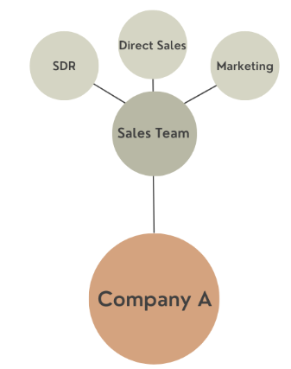

Figure : Traditional selling

The ecosystem business model, on the other hand, can drive scaled growth through your network of partners – these partners are generally solutions providers.

By partnering with service providers, you actually create an outsourced sales and marketing team to promote your products and services. And you only pay them once the deal is in the books.

It’s important to note here that tech partners can also act as channel partners. Their sales teams will drive leads and act as an outsourced sales team for you as well.

Your effort is in building and maintaining relationships with your partners.

That’s result is Low Cost Per Acquisition leads that are proven to close quicker.

The ecosystem business model still includes the direct sales model, but also involves a network of partners working together to promote and sell your products and services.
In an ecosystem led sales model your sales team is expanded through the use of your partners' sales teams.

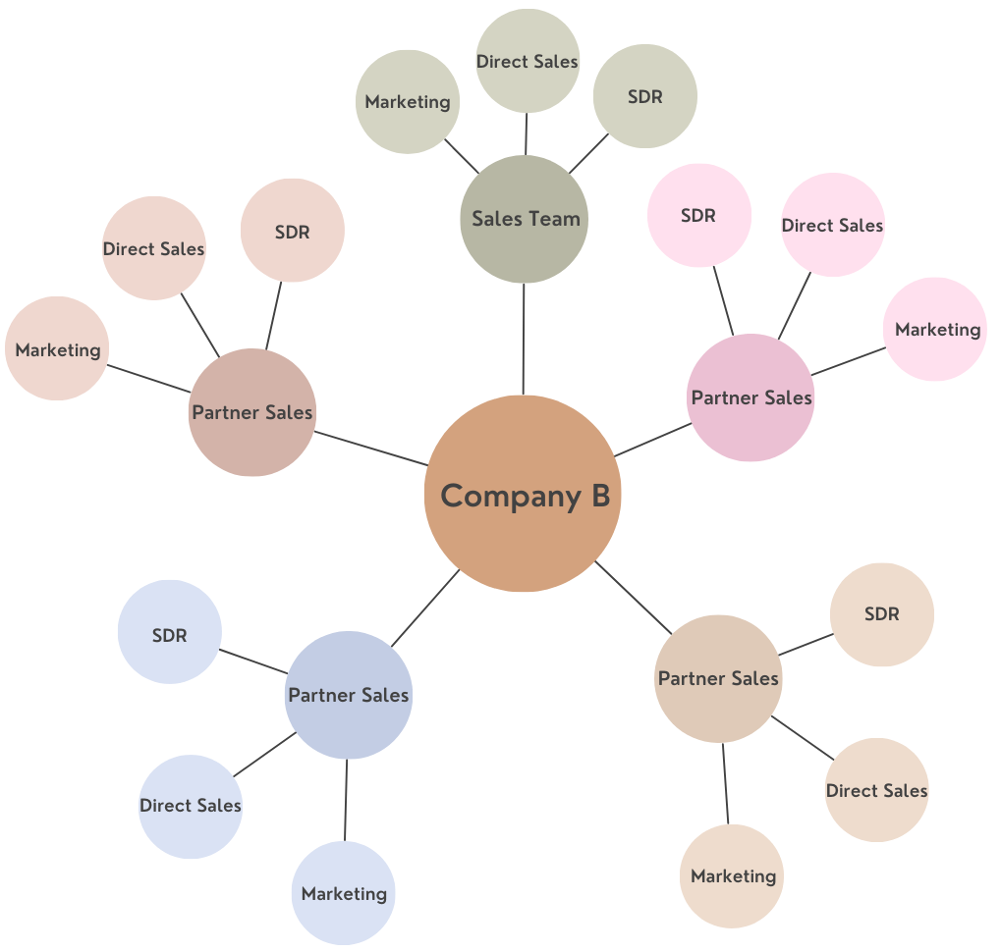

Figure : Ecosystem selling

Additional sales benefits from an ecosystem business model:

Increased reach: You can drive more awareness with less resources.

Credibility. Your partners back up your claims with a respected “seal of approval.”

Faster sales cycles. 50% faster, according to Freshworks.

Higher close rate. Twice higher rate.

Examples of ecosystem

Some real life examples of ecosystem business models that exist in the market today. These are the shining lights of ecosystems in the world.

Microsoft: 95% of Microsoft’s commercial revenue flows directly through their partner ecosystem. Microsoft has a MASSIVE partner network with over 400,000 partners. These partners include hardware manufacturers, software developers, and service providers.

Microsoft relies on partners for solution offerings, but they also ensure that people make a lot of money through partnering.

This is an ecosystem business model at its finest, where businesses have been created with the specific purpose of helping customers with Microsoft products.

HubSpot : You can't talk about ecosystems without talking about HubSpot.

HubSpot is one of the market leading CRM platforms. And, over the years, it has built one of the most successful ecosystem business models.

The main ways HubSpot drives their ecosystem business strategy is through integrations and solutions partners.

Build an ecosystem business model

Ecosystem business models are not created overnight. It takes time and care to build a truly effective ecosystem-lead business strategy.

To get your business moving in the right direction, the first thing you need to do is to gain consensus from the executive team at your organization.
As previously said, moving away from doing everything yourself (such as building features) and toward enlisting partners is necessary for a truly ecosystem-led business strategy to succeed.

Once your executives are on board, formulate a strategy to attack the lowest hanging fruit: product, sales, or support.

Normally, integrations are the easiest first step. Customers never stop requesting new features and product teams are always looking for ways to ship features with menial development time.

Once you build an integration that drives upside value for mutual customers, your partners sales & CS teams will have a meaningful incentive to refer business to you, extending the value of an integration from product to sales.

Identify and build partnerships with relevant companies that offer services your customers are asking for. (Actually, it’s likely that your customers are actually asking for the integration itself – which makes these early decisions even easier).

It is also important to provide ongoing support and resources to your partners , including training and enablement programs, and partner managers to provide further support. This will help to ensure that your ecosystem is being used effectively and that your partners are happy and successful.

Changing to an ecosystem business model may sound intimidating, but now is the time. It’s the decade of ecosystems so it’s time to get on board.

Take a look at small ways you can start using partnerships to solve business problems and you’ll likely open up the floodgates of new ideas. Those, in turn, will lead to overall strategic initiatives.

Although they take time to grow and to be successful, ecosystem led businesses such as Microsoft and HubSpot have shown the power of this approach in creating long-term sustainable growth and a loyal customer base.

