Natural mucilage based engineered micron sized particles: A novel carrier system for drug delivery
Subhranshu Panda¹, Umesh Jirole¹*, Vipul Sansare²
¹School of Pharmaceutical Sciences, Jaipur National University, Jagatpura, Jaipur, India- 302017.
²Department of Pharmaceutics, Dnyandeep College of Pharmacy, Boraj, Khed, Maharashtra, India, 415709.

Address for correspondence: umeshjirole69@gmail.com

Abstract
Novel drug delivery is growing area of drug delivery nowadays. Novel drug delivery systems offers many advantages such as controlled, site specific drug delivery at desired predetermined rate. Gastroretentive drug delivery improve gastric residence time of drug and deliver drug in gastric region and upper part of small intestine. Many scientific experts have utilized various approaches for retention of drug delivery system in stomach region of gastro intestinal tract. The mucoadhesive gastroretentive drug delivery is best suitable approach for prolonging gastric residence time of drug. The use of natural mucilage for mucoadhesive potential is recently explored area. Thus present book chapter highlights the outcomes of mucilage based microspheres in effective drug delivery.
Keywords: Natural mucilage, Microspheres, Novel drug delivery, Gastroretentive drug delivery
1.1 Controlled drug delivery systems
The oral route is most common, safe and convenient route of drug administration. The solid oral dosage form like tablet is most popular oral dosage form because of ease of handling, large scale production and stability [1]. About 80% oral dosage forms are available in the form of tablet. However, these dosage forms suffer with number of limitations like:
- The daily administration of dosage form is required which is difficult to monitor and greater chance of missing dose.
- The dosage form like tablet is available with fixed strength thus careful calculation is required to prevent overdosing. It is difficult to calculate exact dose of drug required for a child and geriatric patients.
- After oral administration the drug absorbs in systemic circulation and undergoes non-specific distribution in target site as well as off target site. Thus, majority of administered drug undergoes wastage and more amount of drug need to be administered to produce desired pharmacological effect which may precipitates dose dependent side effects.
After oral administration of a drug, the drug is absorbed in systemic circulation and concentration of drug in blood plasma increases gradually with time as represented in figure. This phase is known as absorption phase where rate of drug absorption is more than rate of elimination. The therapeutic action of drug starts when concentration of drug in blood plasma reaches in therapeutic window. Once the concentration reaches up to peak level, the descending phase begin. In this phase, the concentration declined due to metabolism and excretion thus generally known as elimination phase. During this phase the rate drug elimination is more than its rate of absorption. The therapeutic action of drug is observed until the concentration remains in therapeutic window. The time period during which concentration of drug remains above the MEC is known as duration of action. Once concentration of drug fall below the MEC, the second dose of drug need to be administered to produce desired pharmacological effect. Thus, fluctuations in plasma drug concentration are observed with conventional drug delivery systems. Extensive researches have been conducted to minimize the limitations associated with conventional drug delivery systems. The fruitful outcome of these researches is developed modified drug release systems.
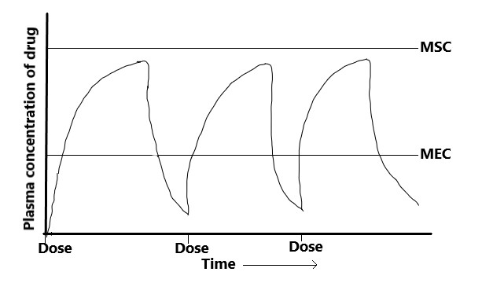
Figure 1.1: Typical plasma level time profile of conventional oral drug delivery system.
1.1.1 Rationale
As mentioned earlier, controlled release drug delivery system was investigated to minimize limitations associated with conventional systems [2]. The controlled release system is defined as the system which releases an encapsulated drug at a predetermined rate so that a constant plasma drug concentration is maintained for extended period of time with minimum side effects. The basic concept behind formulation of controlled release formulations is to alter pharmacokinetics and pharmacodynamics of drugs either by modifying molecular structure or using novel drug delivery principles and physiological parameters. Thus, in depth understanding of pharmacokinetics and pharmacodynamics parameters of drugs is necessary before designing of system. The desirable characteristic of such system is the duration of drug action. The controlled release system should provide therapeutic drug concentration for prolonged period of time. This can be achieved by controlled release of drug from system. The controlled release is possibly achieved by combining drug with the release modifying polymer. The polymer is used to control release of drug from system. This could possibly prolong the duration of drug action. The objective behind formulation of such system is to improve patient compliance by ensuring safety and enhanced efficacy of drug. This could be ensured by controlling plasma drug concentration and reducing dosing frequency.
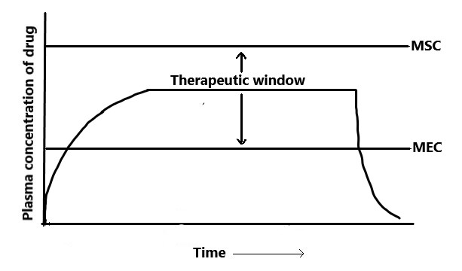
Figure 1.2: Typical plasma level - time profile of controlled release system.
The rationales of controlled release system are highlighted below:
- To provide controlled release of medicament for prolonged duration of drug action.
- To increase the bioavailability of drug.
- To provide a location-specific action of drug within the GIT.
- To reduce dosing frequency and to improve patient compliance.
1.1.2 Advantages
The desirable therapeutic advantages can be achieved by prescribing controlled release formulation [2]:
- The controlled release dosage form releases the drug in controlled manner, thus frequency of drug administration can be reduced which improve patient compliance and convenience.
- The concentration of drug in blood plasma is maintained in therapeutic window for prolonged period of time and fluctuations in plasma drug concentration due to repeated administration can be minimized.
- The total amount of drug administration can be reduced by utilizing controlled release concept thus availability of drug can be maximizing with a minimum dose.
- The release of drug from dosage form is controlled which eventually control absorption of drug in systemic circulation.
- As fluctuations in plasma drug concentration is minimize, the safety margin of highly potent drugs can be increased, and the incidence of both local and systemic adverse effects can be reduced.
1.1.3 Disadvantages [2]
- Administration of sustained/controlled release formulation does not permit prompt termination of therapy. Immediate changes in dose strength during therapy are not possible.
- Unpredictable in vitro-in vivo correlation is observed with controlled release formulations.
- In controlled release systems, the polymers are included to control the drug release. Thus, accidental release of drug (dose dumping) may be observed; specially with reservoir system, where defects/rupture in polymeric coat is responsible for dose dumping.
- The cost of these systems is high due to use of expensive equipment and processes are involved in manufacturing of such systems.
- The controlled release approach is not applicable to all drug candidates. The characteristics of drugs need to be study while selection of suitable drug candidate.
1.1.4 Approaches to design controlled release system
Basically, controlled release of drug from system is achieved by either modification of drug molecule or by modification of dosage form or by utilizing novel nanocarriers [2]. The various approaches were investigated for controlled release of drug. The modification of existing conventional oral dosage with drug release retarding polymer is widely investigated technique for controlled delivery of drug [3]. The use of nanocarriers involves encapsulation of drug in nanocarriers like liposomes [4], nanoparticles [5], niosomes [6] and solid lipid nanoparticles [7], nanostructured lipid carriers [8]. The encapsulated drug in nanocarriers releases in controlled manner. The use of nanocarriers for controlled delivery of through various routes have been investigated widely for effective management of various disease conditions [9].

Figure 1.3: Classification of modified release system
Based on the mechanism of drug release control the controlled release system can be classified into following;
- Diffusion controlled systems
- Dissolution controlled systems
- Diffusion controlled systems
In these systems, the drug release rate from drug delivery systems has been preprogrammed at specific rate. As name suggests, the drug release rate is controlled by diffusion of drug from system. The controlled diffusion of drug from system has been accomplished by system design i.e. by effective use of polymeric drug releasing barrier. These systems have divided into three types: reservoir system, matrix system and matrix reservoir hybrid system.
- Reservoir system
In this type of controlled drug delivery systems, a drug formulation/drug is totally/partially encapsulated with thin polymeric membrane. The encapsulated drug is released in surrounding environment by diffusion through polymeric membrane. The diffusion of drug through polymeric membrane is rate controlling/slow step. The drug reservoir consists of either solid drug, suspension of drug in viscous polymer or concentrated drug solution. The polymeric membrane may be porous, nonporous or microporous designed for specific release rate of drug. The encapsulation of drug in polymeric membrane is accomplished by spray coating, air suspension, microencapsulation, capsulation or injection molding. This system can be fabricated in different shape or size i.e. for suitability of administration. Since, the thickness of polymeric coating is uniform, the rate of drug diffusion is constant throughout the lifetime of product. The drug release rate from this system is controlled by controlling partition coefficient and diffusivity of drug and thickness of polymeric membrane.
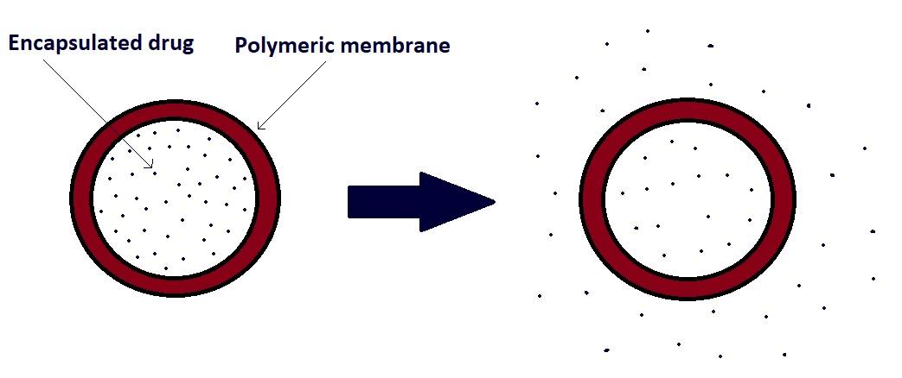
Figure 1.4: Reservoir type controlled drug delivery system
- Matrix system
The drug reservoir in this system consists of homogeneous dispersion of drug in polymer matrix. The polymer matrix is formed by crosslinking of either lipophilic or hydrophilic polymer. The dispersion of drug of drug in polymer matrix is accomplished by two methods:
- Mixing of therapeutic dose of fine drug particles with liquid/viscous polymer, followed by crosslinking of polymer chains.
- Mixing of powdered drug particles with rubbery polymer at elevated temperature.
The resulting medicated polymer matrix is then molded/ extruded to desired shape device for specific application. Another simple technique for fabrication of this system is dissolution of drug and polymer in common volatile organic solvent, followed by evaporation of organic solvent [10].
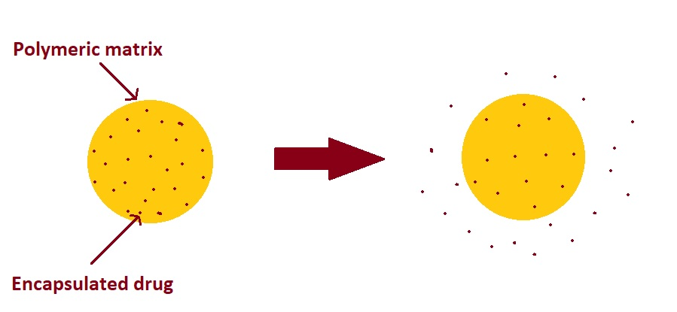
Figure 1.5: Matrix type controlled drug delivery system
- Dissolution controlled systems
This system releases the drug in controlled manner where dissolution is rate limiting step in drug release. When drug dissolution rate is high, it is mixed with a carrier having a slow dissolution rate. According to diffusion layer theory, the dissolution process is diffusion layer controlled. In such case, rate of diffusion of drug from solid surface to bulk medium thorough stagnant layer is rate limiting step.
There are two ways to fabricate dissolution-controlled system i.e. reservoir system and matrix system.
- Reservoir system
In this approach, the drug particles or granules are coated with slowly dissolving polymeric material. The coated particles are then compressed into a tablet or filled in capsules for oral administration.
- Matrix system
In this approach, the solid drug is encapsulated in polymer matrix. The drug solid is homogeneously mixed with polymer and compressed into desired shape for administration. The rate of availability of drug is controlled by permeation of dissolution medium into the polymer matrix. The permeation of medium is controlled by porosity of the matrix, the wettability of the tablet and surface area.
1.2 Gastro-retentive drug delivery systems
Oral route of drug administration is the most preferred convenient and safer route of systemic drug delivery. However, drugs which have short half-lives are eliminated quickly from the systemic circulation, thus frequent dosing of these drugs is required to maintain its concentration within therapeutic window [11]. To avoid these drawbacks, oral sustained-controlled release formulations has been investigated to release the drug slowly into the gastrointestinal tract (GIT) and maintain an effective drug concentration in the systemic circulation for a long time. These modified release oral drug delivery have recently gained interest in pharmaceutical field to achieve improved therapeutic advantages, such as ease of dosing administration, patient compliance. After oral administration, such a drug delivery systems releases the drug in a controlled manner, so that the drug could be supplied continuously to its absorption sites in the GIT. These drug delivery systems suffer from mainly two limitations: the short gastric retention time (GRT) and unpredictable short gastric emptying time (GET), which can result in incomplete drug release at absorption zone (stomach or upper part of small intestine) leading to incomplete drug absorption.
The design of oral modified release dosage form with prolonged gastric retention can possibly overcome these limitations. These dosage forms can possibly retain in stomach for prolonged period of time and releases the drug in sustained manner. Prolonged gastric retention improves bioavailability, increases the duration of drug release, and reduces drug waste [12].
Gastro-retentive drug delivery system is a novel approach to prolong gastric residence time, these dosage forms can retain in the gastric region for long periods and hence significantly prolong the gastric retention time (GRT) of drugs [13].
Drug targeting to the stomach can also be attractive for several other reasons:
- To produce a prolonged local action on to the gastroduodenal wall for e.g., drugs used in treatment of H. pylori infection e.g., Amoxicillin, Misoprostol.
- For drugs which have poor stability in the colon e.g., Ranitidine, Metformin HCl.
- For drugs which have a narrow absorption window e.g., Cyclosporine, Methotrexate, Levodopa.
- For the drugs which have primarily absorption site is the stomach e.g., Amoxicillin.
1.2.1 Gastrointestinal tract physiology
The stomach is situated in the left upper part of the abdominal cavity. Anatomically stomach is divided into three parts: fundus, body and antrum (or pylorus). The proximal stomach, made up of fundus and body regions, which serves as a reservoir for the ingested materials, while the distal region (antrum) is the major site of mixing motions. Antrum also acts as a pump to force the content from stomach to intestine [14].
Gastric emptying is process, where content in the stomach transfer into small intestine. Gastric emptying occurs in both fasted as well as fed state. The pattern of gastrointestinal motility is different in fasted and fed states. The bioavailability of orally administered drugs will depend on the state of feeding. In the fasted state, a series of electrical events occurs in both stomach and small intestine after every 2–3h. This cyclic event is called the interdigestive myoelectric cycle or Migrating motor complex (MMC). MMC is often divided into four phases: basal (Phase I), pre-burst (Phase II), burst (Phase III), and Phase IV intervals.
- Phase I (basal phase): lasts from 40–60 min with rare contractions of gastroduodenal walls.
- Phase II (pre-burst phase) lasts for 40–60 min with intermittent contraction action potential. As the phase progresses the intensity and frequency of contraction also increases gradually.
- Phase III (burst phase): lasts for 4–6 min. It includes intense and regular contractions for short periods. Due to this contraction all the undigested material pass from the stomach to the small intestine.
- Phase IV: lasts for 0–5 min and occurs between phases III and I for two consecutive cycles.
In feed state, the gastric emptying rate is slow than in fasting state since the onset of MMC is delayed. To achieve prolonged gastric retention, the dosage form must resist gastric emptying. For this, the dosage form must be able to withstand in the stomach against the force caused by peristaltic waves. Thus, it is necessary to understand the factors affecting gastric retention of dosage form.
1.2.2 Mucoadhesive or bioadhesive gastroretentive systems
Another important approach to prolonged gastric residence time of drug delivery system is the use of bioadhesive/mucoadhesive polymers [15].
The surface epithelium of stomach constantly exposes to gastric fluid which contains highly concentrated hydrochloric acid (approximately 0.16 N) and protein digesting enzyme, pepsin. Thus, in order to maintain integrity, the surface epithelium has self-protective mechanism i.e. mucus. Mucus contains mucin i.e. oligosaccharides with sialic acid (pKa=2.6) and glycoproteins which are capable to neutralize HCl thus protects the epithelium.
The adhesive properties of mucus layer have been recognized and used for development of gastroretentive system. The drug delivery system consists of drug core coated with mucoadhesive polymer as shown in figure 1.6 Thus after ingestion of such system, the mucoadhesive polymer hydrates and bind/adhere to mucin molecules in mucus lining of stomach. This enables the device to retain in stomach for extended period of time by resisting gastric emptying. The drug molecules contained in core are constantly released in stomach for absorption. A bio/mucoadhesive polymer is a natural or synthetic polymer capable of adhere to biological membrane, which is then called a bioadhesive polymer or with the mucus lining of the GIT, which is then called a mucoadhesive polymer.
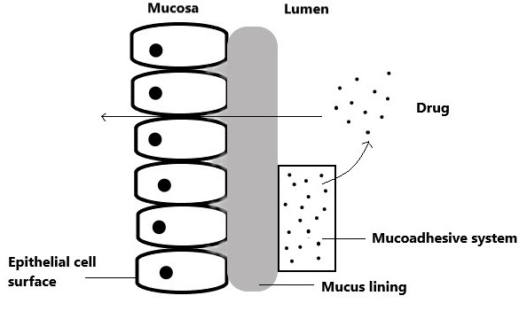
Figure 1.6 Mucoadhesive system: Interaction of system with mucus lining of stomach
Several approaches have been utilized for incorporation of drug in mucoadhesive polymer for preparation of gastroretentive system. For water soluble polymer it is possible to use polymer to coat the surface of microsized capsule shape drug core. The duration of gastric retention of such system is controlled by dissolution of mucoadhesive polymer.
1.3 Natural polysaccharides: A promising carrier for oral drug delivery
The use of natural excipients as carriers in drug delivery systems is recent trend of oral drug delivery. At present, socio-economic condition of the modern world has elevated the interest of natural polymers. Environmental concerns are also playing considerable role and contributing to the growing interest in natural polymers due to their biocompatibility, biodegradability and low processing cost [16].
Naturally obtaining polymers are diverse class of macromolecules with a wide range of pharmaceutical applications. Various natural polymers can be classified as proteins-based natural polymers like collagen [17], gelatin, silk fibroin, fibrin and natural polysaccharides like chitosan, starch, alginate, gellan gum, pectin, gum acacia, gum tragacanth, guar gum. These polysaccharides have some excellent water solubility as well as swelling potential, which eventually are useful for oral controlled drug delivery.
1.3.1 Natural gums
Natural gums are obtained from different parts of the plant. Chemically, these are polysaccharides containing monosaccharides blocks joined in linear as well as branched fashion. Thus, hydrolysis of gums results in formation of various sugar units. Gum acacia and tragacanth are most common gums used in pharmaceutical formulations since long period of time. These gums are produced by the plant as part of protection mechanisms on injury to the plant. The process of formation of gum is termed as gummosis, which indicates breakdown of cell walls [16].
Many scientific experts have investigated use of natural gums in various drug delivery systems. The gums are commonly used as suspending agent, thickening agent, emulsifying agent, binder, drug release retardant, mucoadhesive agent, gelling agent etc. The commonly used gums and their pharmaceutical applications are represented in below mentioned table.

Table 1.1: Common natural polysaccharides and their use in drug delivery
Name of gum | Botanical name | Constituent | Applications in drug delivery | Reference
Gum acacia | Cyamopsis tetragonoloba (Fabaceae) | Galactose,  Mannose | Suspending agent, emulsifier, tablet binder, demulcent and emollient | [18]
Gum tragacanth | Astragalus brachycalyx  (Fabaceae) | Arabino galactans,  Pectinaceous | Suspending agent, emulsifier, demulcent and emollient | [19]
Almond Gum | Prunus dulcis  (Rosaceae) | L-arabinose,  L-galactose | Adhesive and suspending agent | [20]
Tamarind gum | Tamarindus indica (Fabaceae) | Glucosyl: Xylosyl: Galactosyl | Drug release retardant | [21]
Grewia gum | Grewia mollis  (Malvaceae) | Galacturonic acid,  Rhamnose | Drug release retardant | [22]
Khaya gum | Khaya grandifoliola  (Meliaceae) | L-arabinose,  L-galactose | Drug release retardant | [23]
Terminalia  catappa gum | Terminalia catappa (Combretaceae) | Cyanidin 3-glucoside, Gallic acid | Drug release retardant | [24]
Okra gum | Abelmoschus esculentus  (Malvaceae) | Rhamnose,  Glucose | Suspending agent, drug release retardant | [25]
Albizia gum | Albizia zygia  (Fabaceae) | Mannose, Arabinose | Emulsifier | [26]
Cashew gum | Anacardium occidentale (Anacardiaceae) | Galactose, Rhamnose | Suspending agent, drug release retardant | [27]
Bhara gum | Terminalia bellirica  (Combretaceae) | Gallic acid,  Ellagic acid | Drug release retardant | [28]
Cordia gum | Cordia myxa  (Boraginaceae) | Galactose,  Mannose,  Rhamnose | Drug release retardant | [29]
Honey Locust Gum | Gleditsia triacanthos (Fabaceae) | Carbohydrates, Fats, Fibers | Drug release retardant | [30]
Tara Gum | Caesalpinia spinosa  (Fabaceae) | Galactomannans | Drug release retardant | [31]
Neem Gum Azadirachta indica | Azadirachta indica (Meliaceae) | Galactose, Fucose | Binder | [32]
Moringa oleifera Gum | Moringa oleifera (Moringaceae) | Glucuronic acid, Galactose | Binder, gelling agent | [33]
Gum Damar | Shorea javanica (Dipterocarpaceae) | Resins | Drug release retardant | [34]
Hakea Gum | Hakea gibbose (Proteaceae) | Arabinose, Galactose | Binder, drug release retardant | [35]
Olibanum Gum | Boswellia serrata (Burseraceae) | Resins, Carbohydrates | Binder, drug release retardant | [36]
Alginate | Laminaria species  (Laminariaceae) | Alginic acid | Stabilizer, suspending agent, emulsifier, gelling agent, tablet coating, tablet binder, matrix in controlled release, bioadhesive enhancer | [37]
Xanthan gum | Xanthomonas campestris | D-mannosyl, D-glucosyl, as well as D-glucosyluronic acid | Stabilizer, suspending agent, emulsifier, gelling agent, tablet binder, matrix in controlled release, bioadhesive enhancer | [38]
Guar gum | Cyamopsis tetragonoloba  (Leguminosae) | Galactomannans | Suspending agent, emulsifier, gelling agent, thickener, tablet binder, matrix in controlled release, bioadhesive enhancer | [39]
Karaya gum | Firmiana simplex (Malvaceae) | α-d-galacturonic | Suspending agent, emulsifier, sustained release agent, bioadhesive enhancer | [40]
Gum ghatti | Anogeissus latifolia  (Combretaceae) |  | Binder and emulsifier | [41]
Gellan gum | Sphingomonas elodea | Rhamnose, glucuronic acid and glucose | Stabilizer, suspending agent, emulsifier, matrix in controlled release | [42]
Locust bean gum | Ceratonia siliqua (Fabaceae) | Galacto-mannopyranosyl amine units | Mucoadhesive, colon targeting of drugs | [43]
Konjac | Amorphophallus konjac (Araceae) | Galactose, Mannose | Gelling agent, drug release retardant | [44]

1.3.2 Plant derived gums in nanomedicine
The biodegradability, non-toxicity, non-reactivity, adequate availability are few characteristics of natural gums. These characteristics play key role in use of natural gums as excipient in novel drug delivery systems. The study of physical and chemical properties of the gums are essential in selection of suitable gum in development of drug delivery systems. The structural modification of natural gum can result in formation of new class of polymers [16].
Gums act as stabilizer in many nanocarrier based systems. The nanoparticles like gold and silver nanoparticles can be stabilized using gum. Gums can prevent aggregation of nanoparticles, thus aids in stabilization of nanoparticles. Gums can adsorb over the surface of nanoparticles and forms protective layer around the nanoparticle surface which can possibly prevent aggregation of nanoparticles and enhance stability of nanosystem. Gum can also increase viscosity of dispersion medium which can minimize Brownian motion of nanoparticles.
1.3.3 Plant derived mucilage
The term mucilage indicates substances which have high water absorbing and swelling capability on contact with water. Several species of mucilaginous species of plants have been used in traditional system of medicine in the world since last 4000 year. Mucilage is metabolic product of the plant formed by various cells. It plays key role in food storage, germination of seeds as well as serve as important component of water storage in plants. Mucilage found in seed endosperms, roots and rhizomes may act primarily as energy reserves [16].
Chemically these are high molecular weight (approx. 200,000 Da) compounds consisting of sugar and uronic acid units. These are generally sulphuric acid esters and have a complex structure of polysaccharide. The high-water absorbing capability of mucilage is due to presence of hydroxyl groups in sugar structure of mucilages. However, upon addition of alcohol, mucilages are precipitated in the form of amorphous or granular mass [45].
Some important plants and their parts yielding mucilages are presented below:
- Intra cell mucilages: Rhizome of Agropyrum repens L., Bulb of Urginea maritime L. (squill); Bulb of Allium sp. (onion, garlic), Flower stalks of Hagenia abyssinica, Pulp of Musa paradisiacal, etc.
- Cell-membrane mucilages (secondary wall mucilages): Bark of Cinnamomum species, Bark of Rhamnus frangula L., Root bark of Sassafras variifolium (Salisbury), Inner bark of Ulmus fulva, Seed-coat of Linium usitatissimum L., Seed-coat of Cydonia vulgaris L., etc.
- Metamorphosis of cell-wall: Pith and medullary ray cells: Gum Tragacanth. Parenchyma cells of wood and bark: Cherry gum. Various cells of the bark: Gum Arabic. Primary wall as intercellular substances: Thallus of Chondrus cripus.
- Secreting hairs (Driizenzotten): Leaves of Viola tricolor L. and Coffea arabica L.
Table 1.2: Botanical sources, constituents and pharmaceutical applications of common mucilages.
Common name | Botanical name | Constituent | Applications in drug delivery | Reference
Mimosa mucilage | Mimosa pudica (Fabaceae) | D-glucuronic acid,  D-xylose | Drug release retardant | [46]
Hibiscus  rosa-sinensis | Hibiscus rosa-sinensis (Malvaceae) | D-glucuronic acid,  Rhamnose | Binder and drug release retardant | [47]
Asario Mucilage | Lepidium sativum (Brassicaceae) | Galactose, Mannose | Emulsifier and suspending agent | [47]
Fenugreek Mucilage | Trigonella foenum-graecum (Fabaceae) | Galactose, Mannose | Drug release retardant | [47]
Aloe Mucilage | Aloe vera (Xanthorrhoeaceae) | Galactan, Arabinan,  D-glucuronic acid | Drug release retardant | [47]
Phoenix Mucilage | Phoenix dactylifera (Arecaceae) | Cellulose, Mannose, Pectin | Binder | [47]
Cassia tora Mucilage | Senna tora (Fabaceae) | Tannins, Cinnamaldehyde | Binder and suspending agent | [47]
Cocculus Mucilage | Cocculus hirsutus (Menispermaceae) | Carbohydrates | Gelling agent | [47]
Cordia Mucilage | Cordia dichotoma (Boraginaceae) | Carbohydrates | Binder and emulsifier | [47]
Ocimum Mucilage | Ocimum americanum (Lamiaceae) | Galacturonic acids, Rhamnose | Disintegrating agent | [47]

1.3.4 Plant derived mucilage in nanomedicine
Some mucilages have been reported to show antihypertensive, antibacterial, antioxidant, antiasthmatic and hypoglycemic activities. The promising application of mucilage is drug delivery. Mucilages are widely investigated for development of drug delivery systems. The less toxicity, biocompatibility and biodegradability are ideal properties of mucilage which are useful in development of drug delivery systems. Many scientific investigators have utilized plant derived mucilage for development of nano and microcarrier based systems.
Mucilage obtained from Quince seeds mainly contains glucuronic acid [48]. The mucilage act as an emulsifier as well as foaming agent [49]. It also acts as thickening agent because of its high molecular weight. Akram et al. 2022 [50] formulated cefixime loaded Quince seeds mucilage- sodium alginate microspheres for sustained oral drug delivery. Formulated microcarrier based systems showed sustained drug release behavior with non-Fickian type of drug release pattern. In addition to this, the formulated microspheres showed enhanced antibacterial potential with minimum toxicity. The slow drug release is due to controlled release of cefixime across gum-alginate matrix.
Kurra et al. 2022 [51] formulated jackfruit and Okra mucilage based oral controlled drug delivery system for colon targeted drug delivery of curcumin. Jack Fruit Mucilage obtained from fruit pulp of Artocarpus heterophyllus (Moraceae) fruits. Okra Mucilage obtained from the pods of Abelmoschus esculentus (Malvaceae). The formulated drug delivery system, showed mucoadhesive behavior of system as well as controlled delivery of curcumin at colon region of gastrointestinal tract.
Ghumman et al. 2019 utilized [52] Taro corn mucilage for fabrication of alginate beads. Taro corn is Colocasia esculenta, which is normally cultivated in Asia. Taro corn contains rich percentage of mucilage which is generally used as binder in tablets and emulsifier. In addition to this, it has good swelling ability in aqueous medium and mucoadhesive potential. The pregabalin loaded Taro corn-alginate microspheres were formulated using ionic gelation technique. The formulated microspheres showed acceptable particle size and surface characteristics. The drug release pattern was sustained following Korsmeyer-Peppas model. In addition to this, the microspheres showed better bioavailability of drug compared to free drug. Thus, natural mucilages are viable mucoadhesive agent for sustained delivery of drug.
Nayak et al. 2013 [53] utilized Plantago ovata mucilage for controlled delivery of glibenclamide. The ionotropic gelation technique was successfully utilized for formulation of glibenclamide loaded mucilage-alginate beads. The formulated beads showed good mucoadhesive property as well as controlled drug release behavior.
1.4 Gum-alginate based microspheres for controlled drug delivery
Microspheres are spherical, micron sized biocompatible carriers utilize for controlled delivery of encapsulated drugs. The drug loaded in matrix of microspheres is released in controlled manner. Microspheres can be prepared using polymers, proteins and lipids. Recently, natural gum and alginate combination has been explored for fabrication of biocompatible matrix of microspheres. Numerous scientific experts working in pharmaceutical field have investigated various natural gums for formulation of biocompatible microspheres.
Noureen et al. 2022 [54] utilized Prunus armeniaca gum-alginate combination to enhance bioavailability of tramadol. The tramadol loaded microspheres containing Prunus armeniaca gum-alginate was fabricated using ionic gelation method. Infrared spectroscopy was used to confirm drug and excipient compatibility. The microspheres showed sustained delivery of drug following Korsmeyer-Peppas model. In addition to this, formulated microspheres were found to be non-toxic in mice model.
Sharma et al. 2022 [55] fabricated Acacia nilotica gum-alginate microspheres for sustained delivery of naringin. The microspheres showed slow drug delivery up to 6 hours.
Das et al. 2022 [56] used gellan gum and alginate combination for entrapment of metronidazole. The gellan gum-alginate microspheres were crosslinked in present investigation using maleic anhydride. The formulated microsphere released the loaded drug in controlled manner.
Mady et al. 2021 [42] successfully utilized two gums i.e., Okra and gellan gums for formulation of metformin hydrochloride loaded microspheres. The drug loaded microspheres containing gums and alginate were fabricated using ionic gelation technique. Fabricated microspheres showed enhanced mucoadhesive potential tested using goat intestinal mucosa. The formulated microcarrier showed acceptable encapsulation efficiency of metformin and sustained drug release behavior for 10 hours. The mucoadhesive potential of natural gums was investigated in present investigation. Thus, natural gums could be viable alternative to synthetic mucoadhesive for sustained gastrointestinal drug delivery.
Reddy et al. 2021 [57] formulated Karaya gum-alginate microbeads for sustained release of D-penicillamine. The drug loaded microbeads showed better swelling index and sustained drug release up to 35 hours.
Abrar et al. 2020 [58] formulated famotidine loaded Acacia nilotica gum microspheres for controlled gastrointestinal drug delivery. The formulated microspheres showed acceptable physicochemical properties and controlled famotidine delivery in simulated gastric fluid.
Ozoude et al. 2020 [23] utilized Khaya gum extracted from Khaya senegalensis for sustained delivery of metformin. The Khaya gum-alginate microspheres formulated using ionic gelation technique. The formulated metformin loaded microspheres showed sustained drug release behavior following Korsmeyer-Peppas model.
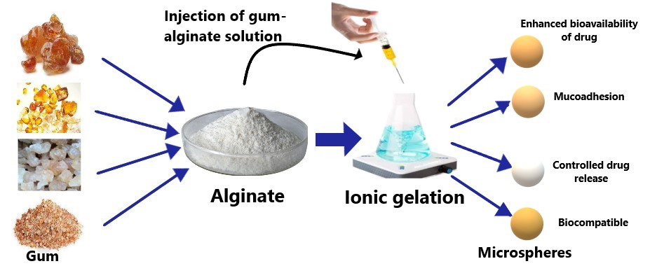
Figure 1.7: Overview of preparation and outcomes of natural gum-based microspheres
Mohamed et al. 2017 [59] successfully utilized gum Arabic-alginate microbeads for controlled delivery of protein. The ion induced gelation of calcium alginate was used as technique for encapsulation of bovine serum albumin in Arabic gum microbeads. The formulated microbeads showed acceptable encapsulation efficiency, particle diameter and surface characteristics. In addition to this, the swelling index of microbeads was also better. The protein release followed controlled release behavior.
Shwetha et al. 2018 [60] utilized Okra gum and alginate combination for controlled delivery of metformin. The microspheres showed acceptable particle size, entrapment efficiency and better swelling index.
Kahima et al. 2017 [61] successfully used acacia gum for controlled oral delivery of diclofenac sodium through acacia-alginate beads. Gum acacia-alginate beads were formulated using ionic gelation technique by addition of calcium chloride solution. The formulated beads showed pH dependent swelling ability. The swelling of beads was more at intestinal pH compared to stomach pH because of presence of carboxylic functional groups in gum. The formulated beads showed controlled release of diclofenac sodium by following Hixson‐Crowell pattern.
Jana et al. 2015 [62] used locust bean gum for formulation for aceclofenac loaded microspheres. The gum-alginate microspheres were formulated using ionic gelation method. The microspheres showed acceptable physicochemical properties and surface characteristics. The drug release pattern followed Korsmeyer–Peppas model. In addition to this, the microspheres showed better reduction of rat hind pow edema induced by carrageenan compared to free drug. Thus gum-alginate could be viable combination for encapsulation of anti-inflammatory drug.
Mamun et al. 2014 [63] used guar gum and xanthan gum for sustained delivery of glipizide. Microspheres containing guar gum and xanthan gum were formulated in combination with alginate using ionic gelation technique. Microspheres showed acceptable particle diameter and good mucoadhesive potential.
Mazumder et al. 2010 [64] fabricated metronidazole loaded microspheres using guar gum and alginate. Metronidazole is anti-amoebic drug with low solubility in aqueous medium, which limits is use for oral drug delivery. The drug loaded microspheres were prepared using ionic gelation technique. The gum-alginate microspheres showed high encapsulation efficiency of drug. In addition to this, the encapsulate drug release from polymer matrix in sustained manner for 12 hours. Thus gum-alginate microspheres could be vital formulation strategy for delivery of minimum water soluble drug.
Table 1.3: Overview of natural gum-based microspheres
Gum | Drug | Microcarrier | Outcome
Prunus armeniaca | Tramadol | Microspheres | Sustained drug release and non-toxicity in animal model
Acacia nilotica | Naringin | Microspheres | Sustained drug release
Gellan gum | Metronidazole | Microspheres | Controlled drug release
Okra and gellan gums | Metformin | Microspheres | Better mucoadhesive potential to goat intestinal mucosa
Karaya gum | Penicillamine | Microbeads | Better swelling index and sustained drug release
Acacia nilotica | Famotidine | Microspheres | Controlled drug release
Khaya gum | Metformin | Microspheres | Sustained drug release
Gum Arabic | Bovine serum albumin | Microbeads | Better swelling index
Okra gum | Metformin | Microspheres | Better swelling index
Acacia gum | Diclofenac sodium | Microbeads | Controlled drug release
Locust bean gum | Aceclofenac | Microspheres | Controlled drug release and better reduction of rat hind pow edema induced by carrageenan
Guar gum and xanthan gum | Glipizide | Microspheres | Good mucoadhesive potential
Guar gum | Metronidazole | Microspheres | Sustained drug release

References
[1] Natarajan V, Krithica N, Madhan B, Sehgal PK. Formulation and Evaluation of Quercetin Polycaprolactone Microspheres for the Treatment of Rheumatoid Arthritis. J Pharm Sci 2011;100:195–205. https://doi.org/10.1002/jps.22266.
[2] Musthaba SM, Baboota S, Ahmed S, Ahuja A, Ali J. Status of novel drug delivery technology for phytotherapeutics. Expert Opin Drug Deliv 2009;6:625–38.
[3] Bisht S, Feldmann G, Soni S, Ravi R, Karikar C, Maitra A, et al. Polymeric nanoparticle-encapsulated curcumin (“nanocurcumin”): a novel strategy for human cancer therapy. J Nanobiotechnology 2007;18:3. https://doi.org/10.1186/1477-3155-5-3.
[4] González-ortega R, Luka Š, Skrt M, Daniela C, Mattia D, Pittia P. Liposomal Encapsulation of Oleuropein and an Olive Leaf Extract : Molecular Interactions , Antioxidant Effects and Applications in Model Food Systems. Food Biophys 2020. https://doi.org/https://doi.org/10.1007/s11483-020-09650-y.
[5] Zhang YN, Poon W, Tavares A, McGilvray I, Chan W. Nanoparticle–liver interactions: Cellular uptake and hepatobiliary elimination. J Control Release 2016;240:332–48. https://doi.org/10.1016/j.jconrel.2016.01.020.
[6] Khan R, Irchhaiya R. Niosomes : a potential tool for novel drug delivery. J Pharm Investig 2016;46:195–204. https://doi.org/10.1007/s40005-016-0249-9.
[7] Bhatt Himanshu. Development of Curcumin-Loaded Solid Lipid Nanoparticles Utilizing Glyceryl Monostearate as Single Lipid Using QbD Approach: Characterization and Evaluation of Anticancer Activity Against Human Breast Cancer Cell Line. Curr Drug Deliv 2018;15:1271–83. https://doi.org/10.2174/1567201815666180503120113.
[8] Seyfoddin A, Al-kassas R. Development of solid lipid nanoparticles and nanostructured lipid carriers for improving ocular delivery of acyclovir. Drug Dev Ind Pharm 2013;39:508–19. https://doi.org/10.3109/03639045.2012.665460.
[9] Sansare V, Gupta MK, Shrivastava B, Jadhav S, Gurav P. Comprehensive review on use of phospholipid based vesicles for phytoactive delivery. J Liposome Res 2021. https://doi.org/10.1080/08982104.2021.1968430.
[10] Dokoumetzidis A, Macheras P. IVIVC of controlled release formulations: Physiological–dynamical reasons for their failure. J Control Release 2008;129:76–8. https://doi.org/10.1016/J.JCONREL.2008.04.005.
[11] Khatri S, Awasthi R. Piperine containing floating microspheres : an approach for drug targeting to the upper gastrointestinal tract 2016. https://doi.org/10.1007/s13346-016-0285-z.
[12] Garg R, Gupta G. Gastroretentive Floating Microspheres of Silymarin : Preparation and In Vitro Evaluation. Trop J Pharm Res 2010;9:59–66.
[13] Boddupalli BM, Ramani R, Subramaniam B, Anisetti RN. In vitro and invivo evaluation of hepato protection and anti ulcer activities of piperine gastro retentive micropspheres. Asian Pac J Trop Biomed 2012;2:S1237–40. https://doi.org/10.1016/S2221-1691(12)60392-X.
[14] J PT, M HS, Zimei W. Advances in Rectal Drug Delivery Systems. Pharm Dev Technol 2018;23:942–52. https://doi.org/10.1080/10837450.2018.1484766.
[15] Trickler WJ, Nagvekar AA, Dash AK. A Novel Nanoparticle Formulation for Sustained Paclitaxel Delivery. AAPS PharmSciTech 2008;9:486–93. https://doi.org/10.1208/s12249-008-9063-7.
[16] Amiri MS, Mohammadzadeh V, Ehsan M. Plant-Based Gums and Mucilages Applications in. Molecules 2021;26:1770.
[17] Jiménez RA, Millán D, Suesca E, Sosnik A, Fontanilla MR. Controlled release of an extract of Calendula officinalis flowers from a system based on the incorporation of gelatin-collagen microparticles into collagen I scaffolds : design and in vitro performance. Drug Deliv Transl Res 2015;5:209–18. https://doi.org/10.1007/s13346-015-0217-3.
[18] Sharma N. Novel gum acacia based macroparticles for colon delivery of Mesalazine: Development and gammascintigraphy study. J Drug Deliv Sci Technol 2019;24:101224.
[19] Verma C. Smart designing of tragacanth gum by graft functionalization for advanced materials. Macromol Mater Eng 2020;305:1900762.
[20] Mahfoudhi N. Assessment of emulsifying ability of almond gum in comparison with gum arabic using response surface methodology. Food Hydrocoll 2014;37:49–59.
[21] Pal D, Nayak AK. Tamarind seed polysaccharide-alginate mucoadhesive microspheres for oral gliclazide delivery : in vitro – in vivo evaluation. Drug Deliv 2012;19:123–31. https://doi.org/10.3109/10717544.2012.657717.
[22] Ogaji I. Potential of Grewia gum as film coating agent: Some physicochemical properties of coated praziquantel tablets. Int J Pharm Res 2011;3:13–6.
[23] Ozoude C. Formulation and development of metformin-loaded microspheres using Khaya senegalensis ( Meliaceae ) gum as co-polymer. Futur J Pharm Sci 2020;6:120.
[24] Kumar S. Rheological characterization and drug release studies of gum exudates of Terminalia catappa Linn. AAPS Pharm Sci Tech 2008;9:885–890.
[25] Bai L. The influence of extraction pH on the chemical compositions, macromolecular characteristics, and rheological properties of polysaccharide: The case of okra polysaccharide. Food HydrocollThe Influ Extr PH Chem Compos Macromol Charact Rheol Prop Polysacch Case Okra Polysacch 2020;102:105586.
[26] Odeku A. In-vitro evaluation of khaya and albizia gums as compression coatings for drug targeting to the colon. J Pharm Pharmacol 2005;57:163–168.
[27] Kumar R. Evaluation of Anacardium occidentale gum as gelling agent in aceclofenac gel. Int J PharmTech Res 2009;1:695–704.
[28] Shankar N. Design and evaluation of controlled release bhara gum microcapsules of famotidine for oral use. Res J Pharm Technol 2008;1:433–437.
[29] Goswami S. Natural gums and its pharmaceutical application. . J Sci Innov Res 2014;3:112–121.
[30] Rajamma A. Natural gums as sustained release carriers: Development of gastroretentive drug delivery system of ziprasidone HCl. DARU J Pharm Sci 2012;20:1–9.
[31] Santos M. Carboxymethyl tara gum-lactoferrin complex coacervates as carriers for vitamin D3: Encapsulation and controlled release. Food Hydrocoll 2021;112:106347.
[32] Gangurde A. Preliminary evaluation of neem gum as tablet binder. Indian J Pharm Educ Res 2008;42:344–347.
[33] Panda D. Studies on gum of Moringa oleifera for its emulsifying properties. J Pharm Bioallied Sci 2014;6:92.
[34] thombare N. Formulation Development and Evaluation of Gum Damar Based Sustained Release Matrix Tablet of Metoprolol Succinate. Asian J Pharm Res Dev 2020;8:81–6.
[35] Bahadur S. Review on natural gums and mucilage and their application as excipient. J Appl Pharm Res 2017;5:13–21.
[36] Pasha B. Evaluation of some natural gums as sustained release carriers in the manufacturing of tablets. Indian J Res Pharm Biotechnol 2017;5:224–228.
[37] Iliescu RI, Andronescu E, Ghitulica CD, Voicu G, Ficai A, Hoteteu M. Montmorillonite-alginate nanocomposite as a drug delivery system - Incorporation and in vitro release of irinotecan. Int J Pharm 2014;463:184–92. https://doi.org/10.1016/j.ijpharm.2013.08.043.
[38] Bhupathyraaj M, Pole S. Study on effect of combination of sodium alginate and xanthan gum on drug release from Tacrolimus microbeads. Eur J Mol Clin Med 2020;7:4584–96.
[39] Iqbal D. Novel chitosan/guar gum/PVA hydrogel: Preparation, characterization and antimicrobial activity evaluation. Int J Biol Macromol 2020;164:499–509.
[40] Kumar S. Natural polymers, gums and mucilages as excipients in drug delivery. Polim Med 2012;42:191–197.
[41] Lett J. The fabrication of porous hydroxyapatite scaffold using gaur gum as a natural binder. Dig J Nanomater Biostruct 2018;13:235–243.
[42] Mady FM, Ibrahim SRM, Abourehab MAS. Development and Evaluation of Alginate-gum Blend Mucoadhesive Microspheres for Controlled Release of Metformin Hydrochloride. J Adv Biomed Pharm Sci 2021;4:111–8.
[43] Malik K. Locust bean gum as superdisintegrant—Formulation and evaluation of nimesulide orodispersible tablets. Polim Med 2011;41:17–28.
[44] Jiang M. Depolymerized konjac glucomannan: Preparation and application in health care. J Zhejiang Univ Sci 2018;19:505–514.
[45] Afghah F, Altunbek M, Dikyol C, Koc B. Preparation and characterization of nanoclay-hydrogel composite support-bath for bioprinting of complex structures. Sci Rep 2020;10:1–13. https://doi.org/10.1038/s41598-020-61606-x.
[46] Joseph B. Pharmacology and traditional uses of Mimosa pudica. Int J Pharm Sci Drug Res 2013;5:41–4.
[47] Beikzadeh S. Seed mucilages as the functional ingredients for biodegradable films and edible coatings in the food industry. Adv Coll Interf Sci 2020;280:102164.
[48] Hopur H, M. Asrorov A, Qingling M, Yili A, Ayupbek A, Nannan P, et al. HPLC Analysis of Polysaccharides in Quince (Cydonia Oblonga Mill. var. maliformis) Fruit and PTP1B Inhibitory Activity. Nat Prod Journale 2012;1:146–50. https://doi.org/10.2174/2210315511101020146.
[49] Rezagholi F, Hashemi SMB, Gholamhosseinpour A, Sherahi MH, Hesarinejad MA, Ale MT. Characterizations and rheological study of the purified polysaccharide extracted from quince seeds. J Sci Food Agric 2019;99:143–51. https://doi.org/10.1002/JSFA.9155.
[50] Akram S, Mahmood A, Noreen S, Rana M, Hameed H, Ijaz B, et al. Formulation and evaluation of quince seeds mucilage – sodium alginate microspheres for sustained delivery of cefixime and its toxicological studies. Arab J Chem 2022;15:103811. https://doi.org/10.1016/j.arabjc.2022.103811.
[51] Kurra P. Studies on Jackfruit-Okra Mucilage-Based Curcumin Mucoadhesive Tablet for Colon Targeted Delivery. Front Pharmacol 2022;13:902207.
[52] Ghumman SA, Bashir S, Noreen S, Khan AM, Malik MZ. Taro-corms mucilage-alginate microspheres for the sustained release of pregabalin: In vitro & in vivo evaluation. Int J Biol Macromol 2019;139:1191–202. https://doi.org/10.1016/J.IJBIOMAC.2019.08.100.
[53] Nayak AK, Pal D, Santra K. Plantago ovata F. Mucilage-Alginate Mucoadhesive Beads for Controlled Release of Glibenclamide: Development, Optimization, and In Vitro-In Vivo Evaluation . J Pharm 2013;2013:1–11. https://doi.org/10.1155/2013/151035.
[54] Noureen S, Noreen S, Ghumman SA, Batool F, Hameed H, Hasan S, et al. Prunus armeniaca Gum-Alginate Polymeric Microspheres to Enhance the Bioavailability of Tramadol Hydrochloride : Formulation and Evaluation. Pharmaceutics 2022;14:916.
[55] Of C, Loaded N, Using M, Nilotica A. Formulation , Evaluation And Characterization Of Narinign Loaded Microparticles Using Acacia Nilotica. World J Pharm Res 2022;11:1222–30. https://doi.org/10.20959/wjpr202213-25527.
[56] Das S, Pan R, Dey R, Ghosh M. Development and in vitro study of Metronidazole loaded cross linked sodium alginate and gellan gum microspheres. J Drug Deliv Ther Open 2022;12:60–3.
[57] Reddy OS, Subha MCS, Jithendra T, Madhavi C. Fabrication and characterization of smart karaya gum / sodium alginate semi-IPN microbeads for controlled release of D-penicillamine drug. Polym Polym Compos 2021;29:163–75. https://doi.org/10.1177/0967391120904477.
[58] Abrar A. Formulation and evaluation of microsphere of antiulcer drug using Acacia nilotica gum. Int J Health Sci (Qassim) 2020;14:10–7.
[59] Mohamed HN, Mustafa S, Fitrianto A, Manap YA. Development of Alginate – Gum Arabic Beads for Targeted Delivery of Protein. J Biomol Res Ther 2017;6:1000155. https://doi.org/10.4172/2167-7956.1000155.
[60] Swetha M, Shireesha B, Shruthi G, Islam A, Rahman H, Sushma P. In vitro Characterization of Metformin Okra Alginate Microspheres: CRDDS. Int Res J Pharm Med Sci 2018;1:66–72.
[61] Kahina B. Formulation characterization and in vitro evaluation of acacia gum–calcium alginate beads for oral drug delivery systems. Polym Adv Technol 2018;29:884–95.
[62] Jana S, Gandhi A, Sheet S, Sen KK. International Journal of Biological Macromolecules Metal ion-induced alginate – locust bean gum IPN microspheres for sustained oral delivery of aceclofenac. Int J Biol Macromol 2015;72:47–53. https://doi.org/10.1016/j.ijbiomac.2014.07.054.
[63] Mamun AR, Bagchi M, Amin L, Sutradhar KB, Huda NH. Development of natural gum based glipizide mucoadhesive microsphere. J Appl Pharm Sci 2014;4:66–9. https://doi.org/10.7324/JAPS.2014.40111.
[64] Mazumder ranaana. Formulation and in vitro evaluation of natural polymers based microspheres. Int J Pharm Pharm Sci 2010;2:211–9.

