ANALYSING DEPLETION OF GROUND WATER IN AGRICULTURE THROUGH EFFECTIVE POLICIES AND SUSTAINABLE OPTIONS- AN ECONOMIC CASE STUDY

S.Vamsi krishna
Research Scholar, Department of Agricultural Economics
&

Ravi Raj
Research Scholar ,Department of Agribusiness Management

ABSTRACT
Natural resources are the cornerstone for fulfilling the needs of life in earth perpetuating generations since times immemorial. They have been utilised by various life forms ever since its inception and particularly mankind has found the most use. With the passage of time and the enhancement of knowledge and experience, the resources usage are proliferating which can lead to problems like overexploitation, after effects such as pollution and environmental degradation, etc. It also poses a threat to the future generations who might have to compete with the increasing global population for the resources. In the case of agricultural sector, the most widely used natural resourceis groundwater resource which is a predominant source of irrigation. In most of the countries, groundwaterexploitationhadbecomeveryrampantandhencelegislationswerebroughttoregulateits usage and conserve it for generations to come. India is the largest consumer of groundwater in the world and it faces challenges ahead. Hence this paper outlines the scenario of the existing groundwater resources in the global and Indian context and stresses upon the policy options to conserve and sustain the water resources ahead of changing climate situations.
Keywords: Groundwater,Naturalresource,Depletion,Conservation

INTRODUCTION
Natural resources are the key to the sustainment of life in earth which supports and fulfils the ecological, social and economic demands of the mankind thus making itself distinct. They are derived from the nature and find major use in domestic, industrial, commercial, scientific and cultural value systems. Natural resources come in various forms such as air, water, energy (wind, light, etc), useful flora (Shrubs, Trees and Medicinal Plants), minerals and fuels, etc. They function as a source of raw material, acting as a sink and assimilating the waste which emanates out of production and consumption and render life supporting and recreational services.These natural resources can be classified into renewable and non-renewable resources.

ECONOMICIMPORTANCEOFNATURALRESOURCES
Natural resources and ecosystem services are a part of the real wealth of countries. They contribute towards improving the social and economic indicators of a nation such as income,economic growth, development, social security and poverty reduction. Sectors related to natural resources use provide jobs and are the source for sustenance of livelihoods in poorer communities (OECD, 2011). The value of the ecosystem services provided by the functioning of the natural resource systems such as wetland has an immense potential in the improvement of standard of living of the people who are residing in the vicinity of those systems.

NATURAL RESOURCE DEPLETION IN AGRICULTURE
Resource depletion is the consumption of a resource faster beyond their rate of replacement. The value of a resource is dependent on its availability in nature and the cost of extracting the resource increases as the resource extraction increases. Agriculture, which is dependent on natural resources for its operations and production, is facing the threat in its production and sustenance due to the depletion of resources especially water resources. In this scenario changing climatic conditions pose a great challenge in the protection and preservation of these resources.

WATER’S ROLE IN AGRICULTURE
Water is a critical input for agricultural production and plays an important role in food security. Irrigated agriculture represents 20 per cent of the total cultivated land and contributes 40 per cent of the global food production (World Bank, 2022). Irrigated agriculture is comparatively twice as productive per unit of land as rainfed agriculture, thereby allowing for more production intensification and crop diversification. The flow of water in agriculture is by both physical and virtual means which implies the utilisation of water by the crops on the basis of its requirements. The food-water-energy resources forma nexus thereby balancing the supply and demand become essential for production.
Due to population growth, urbanization, and climate change, competition for water resources is expected to increase which will impact agriculture. Population is expected to increase to over 10 billion by 2050, and irrespective of either urban or rural, this population will need food and fiber to meet its basic needs. However, future demand on water by all sectors will require as much as 25 to 40 per cent of water to be re-allocated from lower to higher productivity and employment activities, particularly in water stressed regions. In most cases, such reallocation is expected to come from agriculture as it occupies highest share in water utilisation. As of now, agriculture accounts (on average) for 70 per cent of global freshwater withdrawals and an even higher share of “consumptive water use” due to the evapo transpiration of crops (World Bank, 2022) (UNESCO, 2022).

GROUND WATER RESOURCES
Groundwateris a vital water resource located on the saturated zones underground wherein the upper surface of the saturated zone is called the water table. Groundwater is held in the pores and fractures of underground materials like sand, gravel and other rock, these rock materials are called aquifers (US Gov Science dept) and they remain for a long period of time from days to millennia. Groundwater can either flow naturally out of rock materials or can be pumped out (Figure-1). Groundwater supplies wells and aquifers for private, agricultural, and public use and is used by more than a third of the world's population every day for their drinking water. The global share of groundwater consumption by sectors is represented in the figure-3 as follows:

Figure1-WATER TABLE AND THE GROUND WATER AQUIFERS
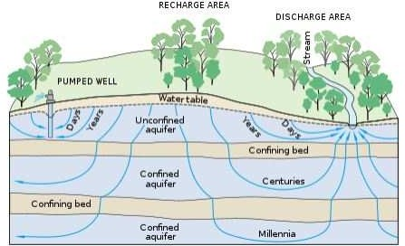

Figure-2FACTS ON GROUNDWATER USAGE

16 to 33 Per cent groundwater for AgricultureisNon renewable (Wada et.al, 2010)
30percentofglobal freshwater is groundwater
(Source: IAEA) About0.76percent of total water
volumeinEarth(US Geo Survey,2019)

GROUNDWATER
M

World'smost extractedresource(980 trillionlitresper year)

Figure3-SHAREINGLOBALGROUNDWATER
CONSU PTION(Source:UNWaterreport,2022)

INDUSTRIAL 9%
DOMESTIC 22%
AGRICULTURE 69%

Figure-4GROUND WATER USAGE-INDIAN SCENARIO
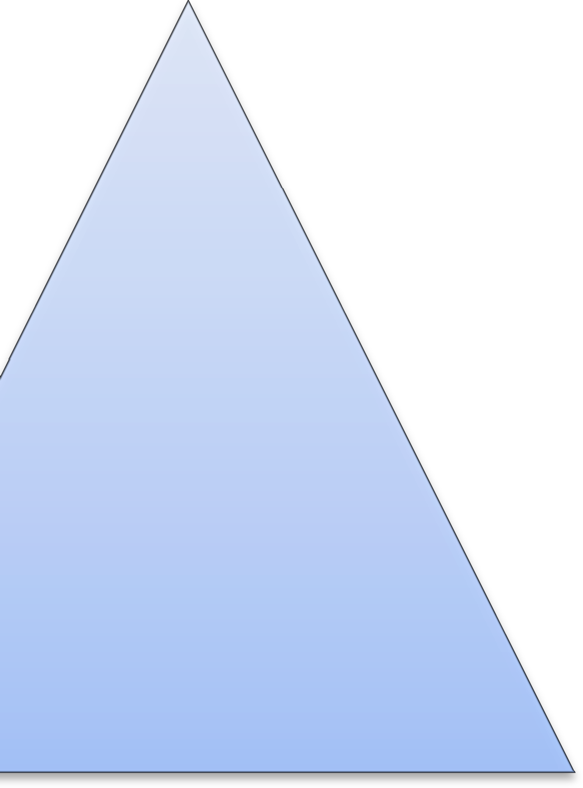

80percentdependent on Groundwater for Drinking
60 per cent of IrrigationisbyTube Wells-Twothirdsof groundwater used
60percentofIndian districts- faces overexploitation

We can observe in the figure-2 that agriculture is occupying the top position in the consumption of groundwater followed by domestic (22 per cent) and industrial sectors (9 percent).The figure-4 reveals the over dependence of India on groundwater for its various sectoral water needs which stressesthe need to optimize the use of groundwater resources.
Groundwater is considered to be a renewable resource but reaching the non-renewable state because less than six percent of the water around the world is replenished (Emily Chung, 2015). It is estimated that since 1960’s groundwater extraction has more than doubled, which has increased groundwater depletion (Wada et.al, 2010). Due to this increase in depletion, in some of the most depleted areas the use of groundwater for irrigation has become impossible or cost prohibitive (Konikow et.al, 2005). Overusing groundwater, old or young, can lower subsurface water levels and dry up streams, which could have a huge effect on ecosystems on the surface (Emily Chung, 2015).The depletion also causes a mismatch between the recharge of the groundwater table and the extraction. When the most easily recoverable fresh groundwater is removed, this leaves a residualwith inferior water quality. This is in part from induced leakage from the land surface, confininglayers or adjacent aquifers that contain saline or contaminated water (Konikow et.al, 2005). In many places, sea water intrusion into the coastal aquifers is becoming a common phenomenon which is accelerated by over exploitation of groundwater use thereby rendering it unfit for usage.
Thus, there is a need to balance the demand and supply of the groundwater resources for its longtermusage. The balance can be maintained byadoptingthe followinginterventions: Augmenting the supply by strengthening the recharge sources and reducing the demand pressure by improving the water use efficiency are the focal points to be addressed like promotion of rain water harvesting, creating more water storage structures and most importantly the conjunctive use of water. In agriculture, the associated reduction in electricity subsidies in areas with significant groundwater depletion can help offset the problem but overcoming the political obstacle is a key to these changes (Naresh et. al, 2022).

CONJUNCTIVEUSEOF WATER
Conjunctive use is the combined use of ground water and surface water sources in a given irrigation command area which would increase the economic and environmental effects of each and also to optimize the water demand and supply balance. A more planned conjunctive use and management of groundwater and surface water resources offers great potential for increasing water- supply security and water use efficiency for both irrigated agriculture and urban water supplies. Conjunctive water use management can be termed as a crucial intervention in the areas which are affected by the changing climate scenarios and especially in drought affected areas; it provides the source of water for those people residing there. Rain water harvesting and recharge irrigation structures like check dams, percolation ponds are commonly linked with the surface and groundwater irrigation structures per se and hence they play a major role in the recharging the water sources.

POTENTIAL BENEFITS OFCONJUNCTIVE USE OFGROUNDWATER AND SURFACE WATER RESOURCES
Conjunctive usage of water has the benefits which are listed below:
- Enhances Water security.
- The irrigated portion of the command area can be increased.
- More precise water delivery.
- Provides opportunity to cultivate crops which offer high commercial value and may require precision irrigation.
- Reduction of water logging and salinity issues in soil
- Helps to reduce the salinity problem in the shallow aquifers to a particular extent.

- Helps to increase the buffer space in the subsoil.
- Better capacity to buffer heavy rainfall and reduce flood runoff.
- Increased Agricultural Production followed by Productivity.(Jain,R.C,2016) SUPPLY AUGMENTATION OF GROUNDWATER RESOURCES
Some of the surface water resources which can be used to complement groundwater resources are tanks, canal systems and small water reservoirs such as lakes, ponds, etc.

TANK IRRIGATION
Tank irrigation systems capture monsoon runoff in the arid and semi arid areas where they face the problem of water shortage. Apart from serving as a main source of irrigation, it also supports other sources by its supplementary and complementary role through the synergistic relationship of hydro-economic interactions.
In India, the largest number of tanks is found in the three southern states of Andhra Pradesh, Karnataka and Tamil Nadu and the union territory of Pondicherry, which account for nearly 60 per cent of India’s tank-irrigated area (Sivasubramaniyan K, 2006). Thus tank systems provide ancillary support to the groundwater sources as it can take advantage of the local topography by the means of storing the surface water in a catchment area. They are also the storehouses of multi functional ecological systems. Nowadays the tanks are declining due to various factors such as urbanisation, encroachment of catchment areas, lack of proactive management and neglect. So the policy makers should understand the various use values that these water resources offer and formulate effective measures to rationalize the resource allocation among the stakeholders who are competing for the usage of these common property water resources.

DEMANDOFFSETOFGROUNDWATER
Offsetting the demand to groundwater resources is as important as recharging since it can bring efficiency in water usage and optimises production. Innovations in irrigation by the means of Drip and Sprinklers have reduced the wastage of water and proved to be effective in increasing the productivity of the crops. Changes in cropping pattern by cultivating less water dependent crops and farmingmethodslikedryfarmingwhichinvolvesverylessutilisationofwatercanalsobefollowedto reduce the dependency of groundwater.

CONCLUSION:
The changing scenario of climate change poses a great deal of challenges ahead in the conservation of natural resources and especially in the case of water where the balance between the extraction and the recharge had became very wide due to the erratic shifts in the pattern of rainfall followed by sudden occurrences of droughts, etc. Policy makers and stake holders across the globe must realise this alarming situation of the increase in scarcity of groundwater resources and without blaming each other for putting in this dire situation must work together and escalate the steps to preserve these water resources thereby to maintain the balance in their demand and supply as they comprise a valuable part of the common property natural resources. Need based strategies must be formulated to optimize the production of the basic needs without affecting these natural resources in the long run.

REFERENCES:
- "What is groundwater?" (https://www.usgs.gov/faqs/what-groundwater?qt-news_science_products=0#qt-news_science_products).
- Chung,Emily(2015)."MostGroundwateriseffectivelyaNon-renewableResource,Study Finds" (http://www.cbc.ca/news/technology/groundwater-study-1.3318137)
- Devineni,N.,Perveen,S.,&Lall,U.(2022).SolvinggroundwaterdepletioninIndiawhile achieving food security. Nature Communications, 13(1), 3374.
- GeographicalSurveyofwaterresources-USA(2019)
- IAEAarticleonGroundwaterresourceManagement
- Jain,R.C.(2016)Conjunctive use of Ground water and Surface water NationalWater Mission, Ministry of Jal Shakti and Water Resources, Govt. Of India
- Konikow,L.F.,Kendy,E.Groundwater depletion: Aglobal problem.Hydrogeol J 13,317–320 (2005). https://doi.org/10.1007/s10040-004-0411-8
- OECD Report on the Economic significance of natural resources: Key points for reformers inEastern Europe, Caucasus and Central Asia (2011)
- Sivasubramaniyan, K. (2006). Sustainable development of small water bodies in Tamil Nadu.Economic and political weekly, 2854-2863.
- UNWaterDevelopmentReport(2022)
- Wada, Yoshihide; Beek, Ludovicus P. H. van; Kempen, Cheryl M. van; Reckman, Josef W. T. M.; Vasak, Slavek; Bierkens, Marc F. P. (2010). "Global depletion of groundwater resources". (https://dspace.library.uu.nl/bitstream/1874/209122/1/2010GL044571.pdf).
- World Bank Report onWater in Agriculture(2022)

