**Concept of fermentation process**

Devanshi Trivedi1 and Hiral Shah2

Department of microbiology1, Ananya Institute of Science, KIRC campus, Kalol-382721

Department of microbiology2, Ananya Institute of Science, KIRC campus, Kalol-382721

**An introduction to fermentation**

Fermentation is a technology that has been around for as long as human history. The word “fermentation” comes from the Latin word “fervere” which means “boiling.” Fermentation occurs when certain substances are broken down into simpler compounds with the help of microorganism. The French chemist Louis Pasteur discovered term fermentation technology and it is known as zymology. Initially, humans developed fermentation technology as a means of preserving food materials like fruit, vegetables, and meat during shortage of food. Over time, humans have empirically demonstrated that fermentation is not only a way to preserve food but also a way to transform food into food and beverages with sensory characteristics. Furthermore, researcher also find this technique has leads to industrial level which produced bioactive compounds like antibiotics, pigments, antioxidants, antitumor agent, bio-surfactants, bioactive peptides etc. Some chemical product like acetic acid, citric acid, and ethanol are also made by fermentation. The main process of fermentation depends on the concentration of microorganisms, cells, cellular components, enzymes as well as temperature, pH and oxygen for aerobic fermentation. Almost all commercially available different enzymes, such as lipase, invertase and rennet, are also made by fermentation with genetically modified microorganism.

**Chronological development of fermentation technology**

The history of fermentation technology in India dates back more than 3,000 years, according to the literary texts. In India, Soma juice is the first product of fermentation made by Vedic Aryans**.** There is also another drink known as Sura (wine/beer) prepared by fermentation. So, it is believed that fermentation was known to India since the early times. In Rigveda, mention that Curd is another popular product of fermentation.In the beginning, fermentation was mainly associated with the preparation of spiritual drinks, but later on it was used for other purposes also.

Louis Pasteur showed that fermentation is introduced by living organisms in a series of experiments during the 1850s and 1860s. In 1857, He find out living organisms plays vital role for formation of lactic acid fermentation. He also discovered bacteria cause souring in milk, and identifying the role of microorganisms in food spoilage led to the process of pasteurization in 1860. He also working in brewing industry and published his paper “Studies on fermentation” in 1879. Pasture perform different types of experiments and noticed that particular microorganisms cause specific end-products in fermentation process.

Microbiology and fermentation technology have constantly research in different field. In 1970s, discovered microorganisms that could be mutated with physical and chemical treatments to be higher-yielding, faster-growing, tolerant of less oxygen, and able to use and increase concentration in medium. Selection of bacterial strain is useful for food fermentation. However, advance research in fermentation industry has been done by biotechnology company name as BioTork which develops technique to improve fermentation processes with the help of microorganisms.

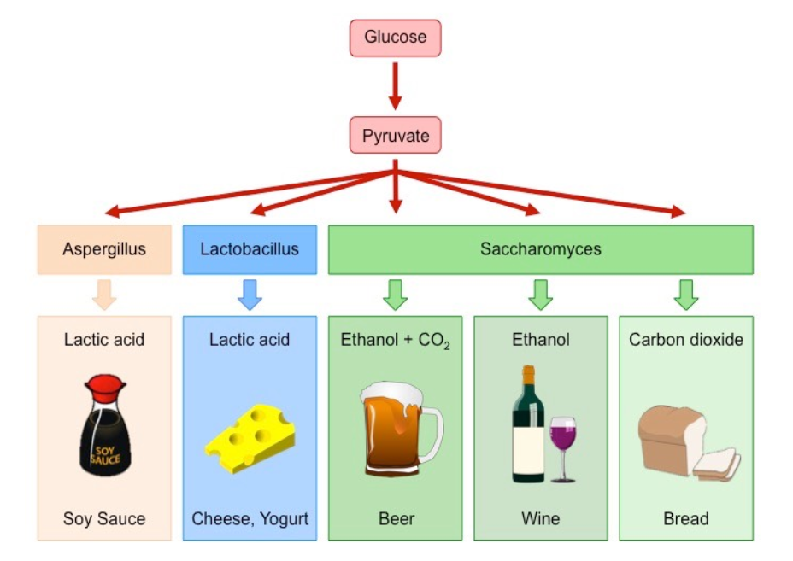

**Figure: 1.1** Production of Fermented Foods by Bacteria and Yeast (*Saccharomyces*)

(yeast fermentation – Bioninja)http://ib.bioninja.com.au

**Screening of Industrially important Microbes:**

Screening is a highly selective procedure for detection and isolation of microorganisms producing metabolite from a large microbial population.

**Primary Screening:**

Detection and Isolation of industrial important microorganism is known as Primary screening. Primary screening is followed by secondary screening which can be qualitative or quantitative in its approach. Secondary screening perform in flask, agar plate, or small fermenters including liquid media, or as a combination of these approaches. However, the qualitative analysis done by the capability of microorganisms which are sensitive to a newly discovered antibiotic whereas quantitative said that yields of antibiotic which can be expected when the microorganism is grown in various media.

**Secondary Screening:**

Secondary screening should provide the information necessary to assess the true potential for industrial use of a microorganism. It should establish whether the microbes are really generating novel chemical substances that haven't been identified before. Secondary screening should provide information as to whether a particular microorganism possesses pH, aeration, or other critical requirements for both microbial growth and chemical product formation. Secondary screening should reveal whether the product resulting from microbial fermentation occurs in multiple chemical forms in the culture broth and whether it is an optically or biologically active substance. We also need to find out whether microorganisms can chemically alter or destroy their own fermentation products.

**Design of Industrial Fermenters (Bioreactors)**

A bioreactor or fermenter is basically a large vessel, generally made of thick stainless-steel body for the culture of microorganisms. The main function of a fermenter is to provide a controlled environment for growth of a microorganism, to obtain a desired product. An Ideal characteristic of bioreactors have the provisions and control over various operations like temperature, pH, aeration and agitation system, less evaporation rate, minimum power consumption, proper sampling facilities, use of cheapest material, operated aseptically or restricted by the containment for a long period throughout the operation, small and larger vessels, vessel with a minimum use of labour in maintenance, cleaning, operating and harvesting operations etc.

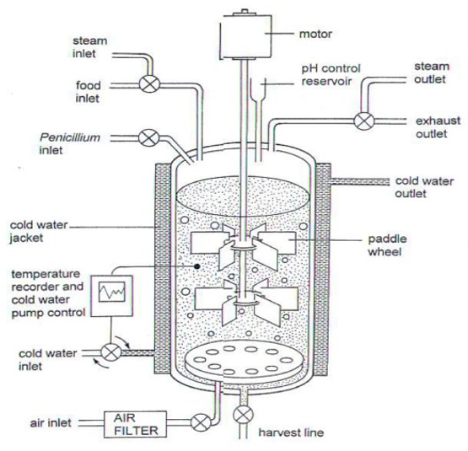

**Fig. 1.2: A typical bioreactor** **(https://wiki2.org/en/Bioreactor)**

Figure 1.2 A show the different part of Bioreactor. A bioreactor basically a large vessel, generally made of thick stainless-steel body to hold large volumes of culture broth and pressure that could be generated at times due to gas production. During fermentation process, the fermentation medium, air, and equipment are sterilized to avoid biological contamination. Design of bioreactor should be completely free from leakages; otherwise long-term operations will be difficult and contaminations will occur. Anti-foam agents are also added during the procedure to control of foam. It also facilitated monitoring or control of dissolved oxygen. Bioreactor provide adequate aeration and agitation system of the fermenting broth for the microbial metabolism to proceed at the optimum level. Recently developed fermenters are usually joined with computers for efficient process of monitoring, data acquisition etc

**Fermentation Process:**

**Downstream processing**

**Upstream processing**

Fermentation Process

Fermentation Raw Material

Production microorganism

Fermentation

Product

Product purification

Effluent wastes

**Figure 1.3: Schematic diagram of fermentation process (www.kaliganjgovtcollege.ac.in)**

**Fermentation process can be divided in three stages.**

**Stage I:** Stage 1 is called Upstream process in which preparation of liquid medium, separation of particulate and inhibitory chemicals from the medium, sterilization, air purification etc.,

**Stage II:** Fermentation which involves the conversion of substrates to desired product with the help of microorganisms.

**Stage III:** In stage three, Downstream process is occur. separation of cells from the fermentation broth or media, purification and concentration of desired product and waste disposal or recycle.

A fermentation process requires a fermenter for successful production because it provide the organism growing within it with optimal pH, temperature, oxygen, and other environmental conditions which is necessary.

**Fermentation and its types**

Fermentation is the chemical transformation of organic substances into simplex compounds by the action of microorganism such as yeast, molds or bacteria. fermentation process defines in two ways. One is aerobic and another is anaerobic. Aerobic fermentation indicates that air is mixed with intentionally in medium; microaerobic means the air is initially present, but is then used up or displaced as microbial growth occurs; while anaerobic fermentation show that an oxygen is removed and intentionally excluded from the fermentation media since it is toxic to the cells. A wide variety of microorganisms have the characteristic of producing some specific compounds in the medium and Synthesis of metabolite in the culture medium as a consequence of oxidation of monosaccharides, predominantly glucose under both aerobic and anaerobic conditions.

**Two broad fermentation techniques have emerged as a result of this rapid**

**development:**

Fermentation is classified into two types based on the substrate used as follows

Solid State Fermentation (SSF).

Submerged Fermentation (SmF).

**Solid State Fermentation (SSF).**

Solid-state fermentation (SSF) is a Fermentation technique in which substrate as a solid material or the inert support of microorganisms growing on it. SSF technique was established for the manufacturing of traditional foods and alcoholic beverages, its application has been developed to the pharmaceutical and biochemical industries.

The primary raw materials like cereal grains, wheat bran, saw dust, wood shavings and several other plant and animal materials used solid substrates for SSF. Fungi and actinomycetes are best raw material for SSF, due to the fact that it produced larger biomass and reach by means of hyphae. Later, many bacterial species and yeasts were used to carry out such fermentation also.

More recently, this approach has been used for the production of extracellular enzymes, certain valuable chemicals, fungal toxins, and fungal spores. In solid substrate fermentation, the microbial distribution occurs on the solid surface, and microbial growth and product formation also occur mainly on the surface. The microbiological components of SSF can occur as single pure cultures, mixed identifiable cultures or totally mixed indigenous microorganisms. In Solid state fermentation solid or gas interface should be good for faster development of specific cultures of molds, yeasts or bacteria, either in pure or mixed cultures. The main important characteristic of the solid matrix requires small granular or fibrous particles, which do not tend to break or stick to each other.

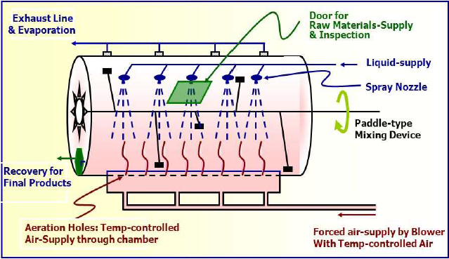

**Figure 1.4: Design of Solid-state fermentation** **(www.mlsu.ac.in)**

The SSF is multistep process involving the following steps:

* Pretreatment of raw materials done with different technique like mechanical, chemical or biochemical to enhance the availability of the bound nutrients and also to reduce the size of the components
* Hydrolysis of primarily polymeric substrates,
* Utilization (fermentation) of hydrolysis products.
* Separation and purification of end products.
* However, serious problems arise with respect to mixing, heat exchange, oxygen transfer, moisture control and gradients of pH, nutrient and product as a consequence of the heterogeneity of the culture.
* The latter characteristic of SSF renders the measurement and control of the above-mentioned parameters difficult, laborious and often inaccurate, thereby limiting the industrial potential of this technology.
* Due to these problems, the micro-organisms that have been selected for SSF are more tolerant to a wide range of cultivation conditions.

The bioreactors used in SSF are tray fermentors without any agitation, drum fermentors with continuous or staggered slow agitation, and column fermentors with forced aeration. The tray type fermentors consists of wooden, metallic, or plastic trays with perforated bottom. First step of tray fermenter is trays are sterilized and filled with a substrate mixed with inoculum and prepare slime layer of surface. The trays are stacked one above the other to a convenient height. Inside the chamber humid atmosphere is created for better growth and the temperature is controlled by cool or warm air. After the process are completed the trays are removed and the fermented mash is collective for downstream processing for product recovery. The column fermentor is a glass or plastic column, with a jacket for water circulation and usually aerated through forced air and it is more expensive.

**Submerged fermentation**

**Batch fermentation:**

In a batch culture, the fermenting organism grows in a closed system. A bacterium continues to thrive in the medium until either the nutrients are depleted or the poisonous by products it secretes reach an inhibiting threshold. The bacteria use significant resources supplied to them for growth and the build-up of metabolic products. As a result, continually changing conditions in the culture in which the composition of the cell wall and the concentrations of a number of cytoplasmic components are vary as growth of the microorganisms proceed.

When bacteria are inoculating in fresh medium under the best physiological condition, they show characteristic pattern of growth.



**Figure 1.5: Bacterial Growth curve (Christine case, Biology 230)**

Following inoculation, culture enter in a lag phase, there is no visible increase in cell number. During this period, bacteria leading up to active growth that means it is the period of adaptation to new environment and go through initially log phase. In this phase culture are active and start diving and logarithmic increase in cell number. Under the favourable condition bacteria will show maximum rate of growth and minimum generation time. When bacteria are continuously grow in same medium for prolong time, condition in medium become more and more unfavourable for growth in stationary phase due to depletion of nutrients from the medium due to utilization in log phase. It also increase the cell density can cause limiting space available for the organisms and increased viscosity. In the last phase of growth curve is death phase or decline phase. here, bacteria still continued grow in same medium and condition are more and more unfavourable due to excess amount of reduced of nutrients in medium and accumulation of toxic waste metabolite. So, bacteria are stop growing. Their death rate exceeds growth rate and number of living cell decreased in the medium.

**Fed-batch fermentation :**

Fed-batch culture system is modifying version of batch culture system. It is also called as semi-closed system of cultivation. Fresh growth medium added to continuously during fermentation without removing the growing microbial culture at the end of the process. The continuous addition of fresh medium in prolongs both log phase and stationary phase there by increase in biomass and the amount of metabolite. A fed batch fermentation increases the yield compared to batch fermentation. Fed-batch fermentation is mainly employed in Production of Thiostrepton by *Streptomyces laurentii*, Production of industrial enzymes, histidine, glutathione (*Brevibacterium flavum*), Lysine (*Corynebacterium glutamicum*) Production of baker’s yeast, Production of antibiotic like Penicillin

**Continuous fermentation**

Continuous fermentation is an open system, run for indefinite period. It is used for production of some primary metabolites like ethanol and organic acids, fermented foods and the production of monoclonal antibodies and recombinant proteins by animal cell cultures. In this technique, fresh nutrient medium is added continuously or intermittently to the fermenter and equivalent amount of used medium with microorganisms is withdrawn continuously or intermittently for the recovery of cells or fermentation products. As a result of that, volume of the medium and concentration of nutrients at optimum level are being maintained. This system been operated in an automatic manner. The continuous fermenter has its maximum use that take long time to reach high productivity, reduces down time and lowers the operating costs.

The different types of bioreactors employed in continuous fermentation

include chemostat bioreactors, turbidostat bioreactors and plug flow bioreactors

**Chemostat Method:**

In this technique growth rate is controlled by the availability of a single component of the medium. Here, nutrient feed rate and harvest culture withdrawal rate are maintained at constant value. Controlling the growth rate of the microorganism by adjusting the concentration of any one of the chemicals of the medium, like carbon source, nitrogen source, salts, O2 etc. which acts as a growth limiting factor. This method is employed more often than turbidostat method because of fewer mechanical problems and presence of less amount of unused medium in the harvested culture.

**Tubidostat** :

In the turbidostat technique, total cell population is kept constant by measuring the culture turbidity at a regular interval of fermentation process. By turbidity measurement, it is possible to the fermenter to regulate and manage both the nutrient feed rate and the culture withdrawal rate. Fermentation, in which this method is employed, must be carried out at a low maximum cell population which leads to the usage of less amount of substrate and wastage of greater amount of substrate as unused and residual medium, which is removed from the fermenter along with the harvested culture.

**References:**

1. E.M.T. El-Mansi , C.F.A. Bryce , B. Dahhou, S. Sanchez , A.L. Demain , A.R. Allman (2012). Fermentation Microbiology and Biotechnology: An Historical Perspective Taylor & Francis Group, LLC 3rd edition, pp .1-519

2. M.J.Waites, N.L.Morgon, J.S. Rokky (2001). Industrial Microbiology: An Introduction, Wiley, pp.1-304

3. P.B. Kishor., A. M. Rao., I. S. Kumar (2011). Pharmaceutical biotechnology, Himalaya Publishing House Pvt. Ltd. Girgaon, Mumbai, pp. 1-48.

4. P.Stanbury, A. Whittaker, S. Hall (1999). Principle Fermentation technology 2nd edition ,pp.1-351

**Sources/ Url link**

1. http://ib.bioninja.com.au (yeast fermentation – Bioninja)

2. (<https://wiki2.org/en/Bioreactor>)

3.[**www.kaliganjgovtcollege.ac.in**](http://www.kaliganjgovtcollege.ac.in)

4.[**www.mlsu.ac.in**](http://www.mlsu.ac.in)

5.Christine L case, Biology 230. Determination of a Bacterial Growth Curve, skyline college