DEVELOPMENT OF CARDIC BIOENGINEERING
Manisha Majji¹, Praveen Kumar Nagedesi^{2*}
¹Department of Botany, Karkarapati Bhavanarayana College ( Autonomous) Kothapeta, Vijayawada -520001, Andhra Pradesh, India
²Department of Botany, School of Life Sciences, St. Joseph's University, 36, Lalbagh Road, Bengaluru , Karnataka, India
Email: nagadesipraveenkumar@yahoo.com
Abstract:
Cardiovascular diseases are responsible for approximately one-third of deaths around the world which may happens by ischemic heart disease. It shows an adverse effects on flow of the blood to the heart by constriction of the coronary arteries and eventually leads to the death of the patient. to overcome this stem cells therapy is used which have excellent therapeutic solution by regenerating the new cells by it can help the heart to prevent the disease impact also help to prevent from either death or increase the life span of the person based on their condition .in this concept damage cells are repaired and regenerated the new cells which are derived from the cardiomyocytes of the stem cells. These cells help to replace the lost cells in myocardial infartion. Besides this other techniques are also used for the cardiac problems to develop the treatment.
INTRODUCTION :
Heart failure is the one of major problem which leads sudden death of a person and in some cases it show high risk for survival. Though heart have capable for its own function in some conditions its leads dysfunction and effected by various cardiac diseases. to cure such improper functioning of heart we need heart transplantation where the donor heart is placed into the patient. But in recent years instead of heart transplantation we can regenerate the cells in the affected area of heart or we can also take help of computational techniques. Cardiovascular engineering encompasses a wide range of biomedical and engineering projects targeted at understanding the mechanisms, treatments and detection of cardiovascular health, disease, and regeneration. This includes the following
- Cardiovascular regeneration or repair using up-to-date technologies to treat various cardiac problems which involves in gene, drug, and cellular therapies and their delivery technologies, biomaterials, bio 3D printing, and nanotechnologies
Advanced computational techniques have been introduced for the treatment from small molecules to organ levels
CELLULAR CARDIOMYOPLASTY:
This is one of the procedure in which the cells are collected from the healthy tissue and introduced into the damaged tissue of the heart. This helps in the regeneration of cells in effected area of heart and increases the function of heart as normal. The injected cell should be taken from different origin and directly into heart.
An ideal source of cells should have the following features
a) expand in vitro on a large scale
b) Integrate with damaged tissue, and
c) Differentiate into new cardiomyocytes electromechanically coupled with the host tissue
Cell type | Advantages | Disadvantages
Skeletal myoblasts | Easily isolated High rate of proliferation Hypoxia-resistant Autologous | High incidence of arrhythmias
Bone marrow-derived stem cells Endothelial progenitor cells Hematopoietic stem cells Mesenchymal stem cells | Autologous Easily isolated Multipotent Low immune response | Limited availability Cases of bone or cartilage formation in the myocardium
Adipose tissue-derived stem cells | Easily isolated High availability Multipotent Low immune response | Low survival
Cardiac stem cells | Multipotent Autologous | Limited availability
Embryonic stem cells | Pluripotent Easy to expand | Teratogenic Limited availability Host immune response Ethical problems
iPSC | Pluripotent Easy to expand Good availability Autologous | Potentially teratogenic Possible oncogenic potential
Fetal cardiomyocytes | Cardiomyocyte phenotype | Limited availability Low survival

Mammal hearts lacking self-regenerating capacity by which the heart losing self-replicating and capable of generating cardiomyocytes, endothelial cells and cardiac fibroblasts which leads to several heart problems
As an alternative, embryonic stem cells pluripotent stem cells have been developed from somatic human tissue have been introduced to increase the cells capacity for expansion and differentiation into cardiomyocytes, endothelial cells and cardiac fibroblasts. But both have limited replication and ample capacity for differentiation.
Different techniques are used is to heal the damaged infected tissue by the implantation of cells into or onto the pathologic myocardium. Various strategies, different methods are involved to recover the injured tissues which are combined with bioactive molecules depending on the condition of damage part of heart. There is a compututational technique which provides 3D organization that guides us the growth of cells and functions at the site of interest. Besides this various materials are also helpful whereas some are inject able in the form of gels at the infected site and other are ex-vivo patches or scaffolds gives additional support and improve the quality of life of cardiac patients
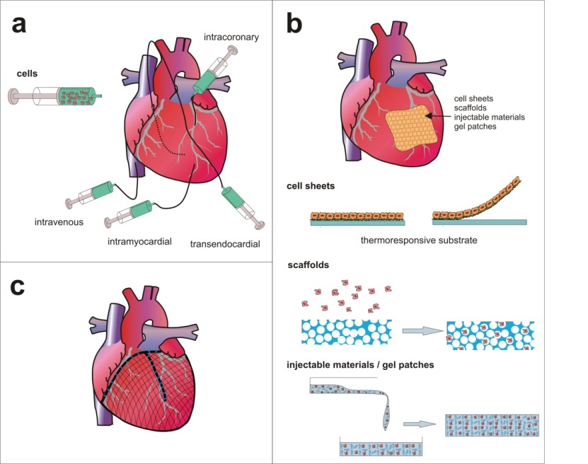
Limitations :
Though it is useful in animal models it also have some disadvantages in some cases. Only few cells involves in cell differentiation and form new cardiomyocytes in the patient body because the cells show poor survival due to lack of mechanical properties. in some condition it leads to the formation uncontrolled proliferation and shows oncogenic activity.
CARDIAC IMPLANTABLE ELECTRONIC DEVICES
In recent years by the development of compututation devices some electronics and smart devices are came into use. This is one of the advanced method in which different types of gadgets are used for the treatment. These gadgets are helpful for additional support to the heart. The devices are implantated into the heart and can be operated / useful for monitoring the activity of the heart. Various types of gadgets which are useful for in plantation are cardiac pacemakers, cardiac defibrillators (ICDs) and cardiac resynchronization therapy devices (CRT-Ds).
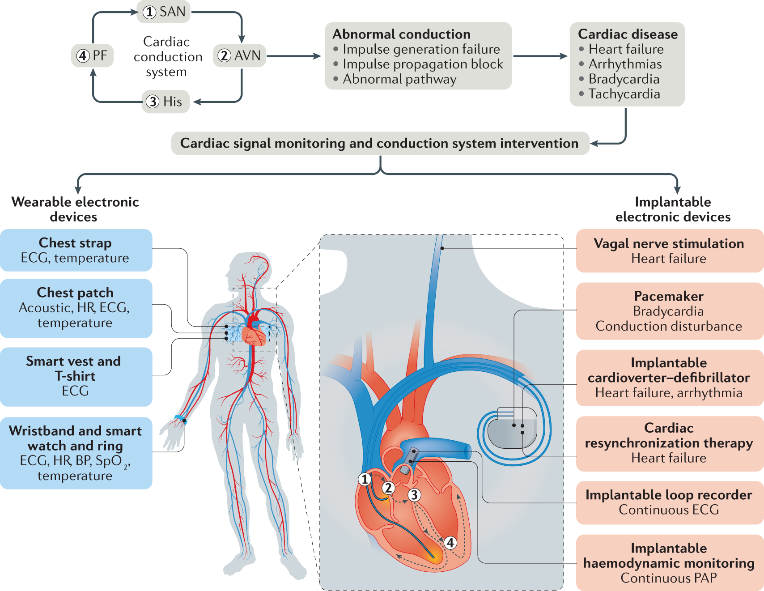
Implantable Cardioverter-Defibrillator
ICD stands for Implantable cardiovascular-defibrillator which is surgically placed under the skin below the left collar bone of a person and it is connected near to the heart through wires. It helps to tracks the heartbeat and delivers major and minor shocks to bring the heart to the normal heart rate during abnormal functioning of the heart. It works on the battery which release the shocks based on the heart rate of the affected patient.
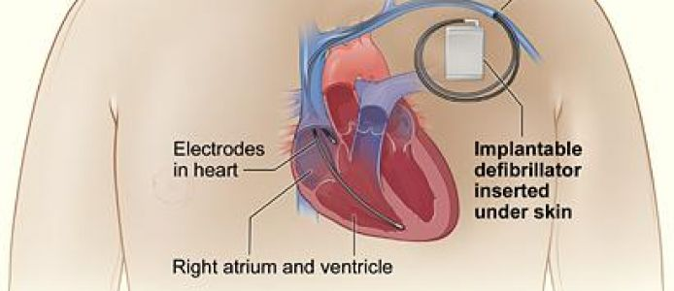
- It can deliver a low energy shock during less heart rate known as “Cardioversion”
- It can deliver a high energy shock during cardiac arrest known as “Defibrillation”
Working of ICDS :
When patient heart rate is rapid or abnormal heartbeat the wires than the signal passes through these wires which connected to the heart and generates the normal beats. This is useful to monitor the patient condition regularly and to treatment them accordingly.
Vascular grafts
Vascular grafts have the capability to grow itself and repair in vivo condition. In this method damaged artery is replaced with the graft to redirect the blood flow also withstand with the pressures during blood flow. Different types of grafts ae used depending on the patient's condition.
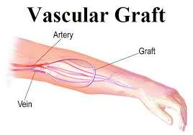
Cardiac scaffolds
Scaffolds have the potential to maintain the cellular micro environment, support cellular differentiation and organization. Cardiac scaffolds re biomaterials helps to attaches the cells during tissue development. The scaffolds and growth factors together helps to produce myocardiac tissue. The mxcardial and endothelial cells which have regenerative capacity are collected and placed in bioreactors which further other yield entire heart. Cells are collected from the donor and construct cell sheet based myocardial tissue by layering 2d with the 3d culture along with ECM.They provides the shape and mechanical support to the defected tissue and gives rigidity and stifffness to the new cells.
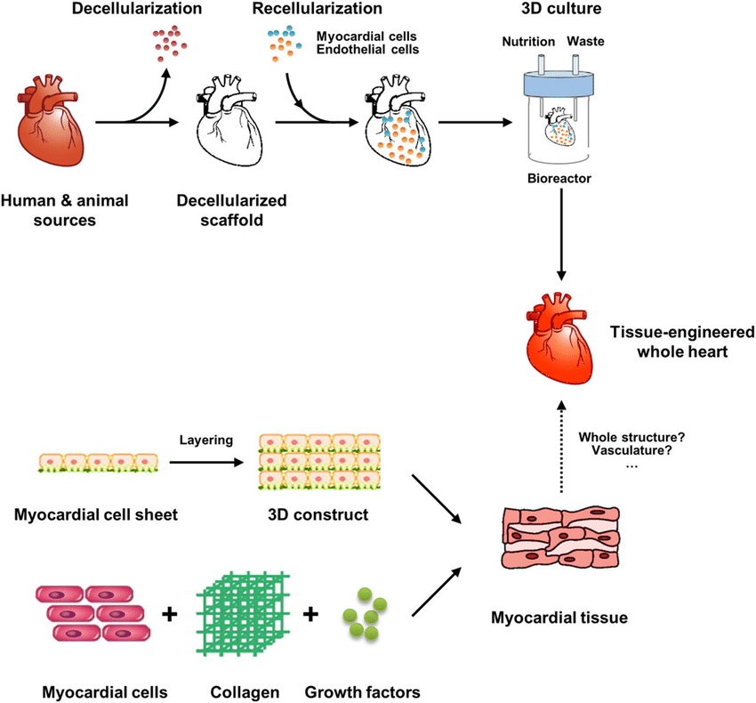

ii) Bioactive scaffolds
These are helpful for cell growth, migration of cells, adhesion of th cells and differentiation which leads the cells interaction and modifications. It takes place either on surface or bulk modification which has various purposes in treatment. These are functional group attached t polymer chains also used to modify the polymer into thin films for layering the scaffolds.
Injectable hydrogels
These most commonly used as cellular scaffolds which are formed between the different functional groups present on the base polymers like a network through molecules interactions. The networks are cross linked polymers composed of natural and/or synthetic polymers and are water swollen. There are classified based on physical and chemical cross-linking. They have excellent biocompatibility, biodegradability and have been extensively studied in bone, cartilage, skin, nerve and cardiac regeneration. These polymer are either used independently or combined with other polymers.
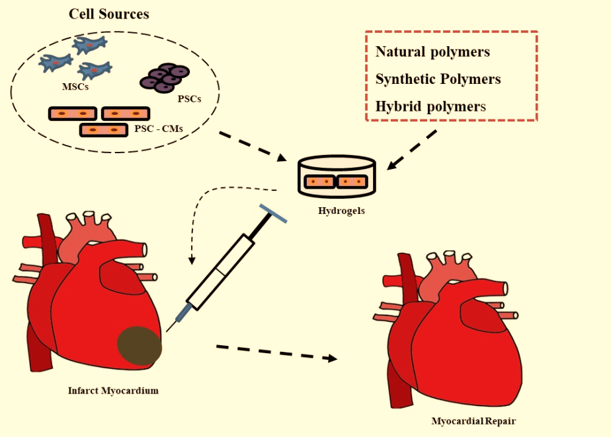

CONCULSION:
Cardiac Bioengineering has the power to improve cardiac health globally by engineering diagnostic, treatment and disease monitoring platforms that function in diverse settings and to enhance the chances to save patient health upto some time .
REFERENCES:
- https://canberraheartrhythm.com.au/services/procedures/cardiac-devices/233-implantable-cardiac-defibrillator-icd.html
- (Asghari et al., 2017; Boni et al., 2018; Brovold et al., 2018; Fakoya et al., 2018; LogithKumar et al., 2016; Malafaya et al., 2007; Van Vlierberghe et al., 2011).
- (Hasan et al., 2015; Peña et al., 2018).
- https://www.melbourneheartrhythm.com.au/learn/procedures/62-implantable-cardioverting-defibrillator-icd?showall=1
- https://www.revespcardiol.org/en-cardiac-tissue-engineering-bioartificial-heart-articulo-S1885585713000248
- https://www.intechopen.com/chapters/44656
- https://www.sciencedirect.com/science/article/pii/S1369702104002330

