Extrusion Cooking and Effect of Process Variables on Product Qualities
Chandrahas Sahu^{1*}, S. Patel², A.K. Agrawal¹
¹Department of Dairy Engineering, College of Dairy Science and Food Tehnology, DSVCKV, Raipur (CG)-492 012
²Department of Agricultural Processing and Food Engineering, IGKV, Raipur (CG)-492 012
* ercsahu2003@yahoo.com

1. Introduction
Extrusion is a high temperature short time process wherein moistened, expansive, starchy and/or proteinacious food materials are plasticized and cooked in a tube by a combination of moisture, pressure, temperature, mechanical shear, resulting in molecular transformation and chemical reactions. Extrusion cooking combines number of unit operations such as mixing, cooking, kneading, shearing, shaping and forming together. It includes fundamental operations such as instantaneous pressure and thermal treatment beside mechanical shearing, ensuring in changes like gelatinization of starch, protein denaturation, inactivation of enzymes, anti-nutritional factors and enhancement in digestibility to obtain ready-to-eat snacks. The cooking process takes place within the extruder where the product produces its own system and heat due to pressure generation. The process can include protein denaturation and starch gelatinization, homogenization, texturization, texture alteration, enzyme in-activation, pasteurization and sterilization of food spoilage and pathogenic microorganism, thermal cooking, shaping product, expansion, puffing, agglomerating ingredients, dehydration, etc. depending upon input and operational parameters. The extrusion process variables are key parameters which affect the size, shape and quality of extruded products. There can be several factors which affect the extrusion process and resulting product characteristics such as physical, textural, functional and sensory qualities. Some of the quality parameters are expansion ratio, bulk density, hardness, crispness, water absorption index (WAI), water solubility index (WSI), product moisture content, etc. The most prominent factors as evident from the literature are feed rate, feed moisture content, screw speed, barrel temperature, feed composition and die profile which affect on the process of extrusion cooking and quality of the product.

2. Extrusion Cooking

Extrusion cooking is a well-established industrial food process technique used in the food industries to produce wide range of snack and breakfast products, typical vegetable protein, animal feed, etc. Extrusion cooking has many advantages such as time saving, energy efficient, less of effluent generation, uniformity, etc. It also lowers the anti-nutritional factors in cereals and improves the digestibility. Extrusion cooking of foods may be defined as a operation in which raw food ingredients forces to pass, in one or multiple varieties of situation of mixing, heating and shearing, through a die of specially designed to shape and puff dry the ingredients (Adekola, 2016).
The extrusion cooking is one of the important tools to introduce the thermal and mechanical energy into food ingredients, forcing the basic ingredients, like starch and protein to undergo chemical and physical changes. The cooking process takes place within the extruder where the product produces its own system and heat due to pressure generation. The process can include protein denaturation and starch gelatinization, homogenization, texturization, texture alteration, enzyme in-activation, pasteurization and sterilization of food spoilage and pathogenic microorganism, thermal cooking, shaping product, expansion, puffing, agglomerating ingredients, dehydration, etc. depending upon input and operational parameters.
Thermo-mechanical and shearing action during extrusion cooks raw mixture so that physico-chemical changes of the materials occur to carry out starch gelatinization, protein denaturation and enzyme inactivation, microorganisms and many other factors against to nutrition; all these occur in a shear situation, producing a plasticized continuous mass (Navale et al., 2015).

2.1 Advantages of extrusion cooking

In recent years the extrusion cooking technology has gained popularity in the preparation of different types of food products. Researchers (Riaz, 2000; Riaz et al., 2007; Belwal and Deshpande, 2017) have analysed the process of extrusion cooking of different food products and indicated its superiority over the other traditional methods of product development. The superiority of extrusion cooking for the preparation of food products over the other traditional food/feed processing methods could be briefly narrated as follows:
- Versatility: Extrusion technology can be used easily to prepare number of products by combining varying levels of different ingredients which may be difficult otherwise with other processing methods.
- Low Cost: The requirement of labour and work place is comparatively less for extrusion processing and the method also utilizes raw materials effectively for processing and forming which in turn reduces the overall processing cost and finally the product cost.
- Productivity: The unit can be operated continuously to its maximum capacity with a set of operating conditions thereby enhances the productivity.
- Product quality: The method of extrusion uses very high temperature for short time which helps in maintaining the heat sensitive components in the product with minimum degradation of nutritional quality. Moreover, it also helps in destroying some of the anti-nutritional undesired factors such as enzymes, micro-organisms etc.
- Environmentally-friendly: This method of food processing do not require excessive water in the whole processing operation due to which excessive waste water as effluent and other pollutants are not produced which is a major problem in other methods of processing.
- Energy efficient: It works on optimum moisture content of the input ingredients which is comparatively lower than any other method of processing due to which the product do not require much of energy for final drying and finishing of the product.
- Less space: The entire system of extrusion processing can be installed and operated efficiently in a smaller space.
- Automated control: The extruder systems are such that all the controls can be fixed together and made automatic which not only helps in maintaining the product quality uniform but also reduces the manpower requirement.

2.2 Extruders and Food Extrusion

The single screw extruders are in use since as early as 1870 in the field of development of rubber products and sausage. In 1881 continuous twin-screw was used for colouring and shaping chewing gums. Subsequently with the advancement of technology extruders have been used in the food industries in the year 1930 to produce pasta using mix semolina flour with water. The simulation and modelling work of twin screw extruder was reported first time in 1984 (Yacu, 1984). The development of extruded plastics in the industries is closely linked with the extrusion process. A single screw was used in a cylindrical open channel as a conveying device to pump water uphill by Geek philosopher Archimedes (Ramachandra Rao and Thejaswini, 2015). Application of single screw extruder in the food industry was done first time in the history for the production of breakfast cereals, ready-to-eat snacks and other textured foods in the year of mid 1930s (Hazarika et al., 2013). Directly expanded corn curls were developed during 1930s and 1940s, by using extruder, which were characterized by extremely high shear rates. The single screw extruder was used commercially for the extrusion cooking and expansion of corn snacks in 1946. The first patent on an application of twin-screw extruder was filed in the mid 1950s. The success of technology was appreciated and its application spread and grown dramatically in the manufacturing of different type of food products. Later during the mid seventies the twin-screw extruders were used commercially for the combined process of cooking and forming of food products and now-a-days it is one of the most commonly used technology in the food processing industries (Ramachandra Rao and Thejaswini, 2015; Adekola, 2016).
Extruder was primarily a screw pump and capable of performing mixing, shearing, cooking and shaping. Feed ingredients during the movement inside the screw were transformed to continuous plastic dough. The barrel was externally heated either by steam or electricity. Application of working and heating operation during the process of extrusion, macromolecules in raw material looses their pre-arranged tertiary structure and forms continuous sticky dough. The laminar flow within the channels on the screw and the die aligns the large molecules in the direction of flow, exposing bonding sites which leads to cross-linking and formed expandable structures that create the crunchy texture in fabricated foods. Quality of product was observed to be varied with the variation in length to diameter (L/D) ratio of the die. Most of the mechanical energy was dissipated in a relatively short section of the screw, resulting in rapid increase in temperature of material and converting the ingredients from a course condition to continuous plasticized mass. The use of twin-screw extruders for food processing initiated as early as since 1970s which expanded largely in 1980s.
The twin-screw extruders are comparatively more expensive than single screw-extruders for the same capacity (Lusas and Riaz, 1994). Twin-screw extruder is self wiping type of extruder and produces a more uniform flow of the product through the barrel due to positive pumping action of the screw flights. The product cannot turn within the screw as its revolution was impeded by the escape of other screw. Co-rotated twin screw extruder has better transmission function, reduced residence time and readily transport sticky food ingredients compared to single screw extruder.
According to the method of construction, extruders are of two types, namely single screw and twin screw extruder used in food based industry (Ramachandra Rao and Thejaswini, 2015). They reviewed that twin screw extruder is more advantageous than single screw and also reviewed the physico-chemical changes of materials occurs during extrusion.
The most commonly used extruders in food industry are: single screw (wet and dry) and twin-screw extruders. Wet extruders require steam or water injection into the barrel (Rokey, 2000); while in dry extruders heating was accomplished by mechanical friction during processing (Said, 2000). Increased demand for development of new product with different shapes and sizes by twin-screw extruder which provide more flexibility and better control was realised with the time and product range. It was further classified into counter-rotating and co-rotating twin screw extruders with either intermeshing or non-intermeshing actions. The extruder of co-rotating self wiping type is most widely used in food processing industries which require frequent product change over, uniform size and shape, product made with low density powders and the products ranges from noodles, pet treats, cereals and corn flakes, high fat aquatic feeds, corn chips tortillas, chocolate filled snacks etc. (Riaz, 2000).
Extrusion technology is used to produce several types of snacks like formed dough products from potato, maize flours etc., half-products or pellet snacks also called ‘third generation snacks’ which further need hot air, microwave or frying to attain the crispy nature. The directly expanded snack also called ‘second generation’ snack are produced by direct steam expansion of the extrudates where water in the melt is superheated which flashes as steam when pressure falls in the die. Moisture loss and cooling causes the material to solidify in the expanded state (Tiwari and Jha, 2017). The basic structure in this snack is formed by starch continuum and other materials are dispersed within the starch. Thus this kind of snack is considered to be healthier than that of deep fried snacks available in the market and also requires less resources, time and labour.

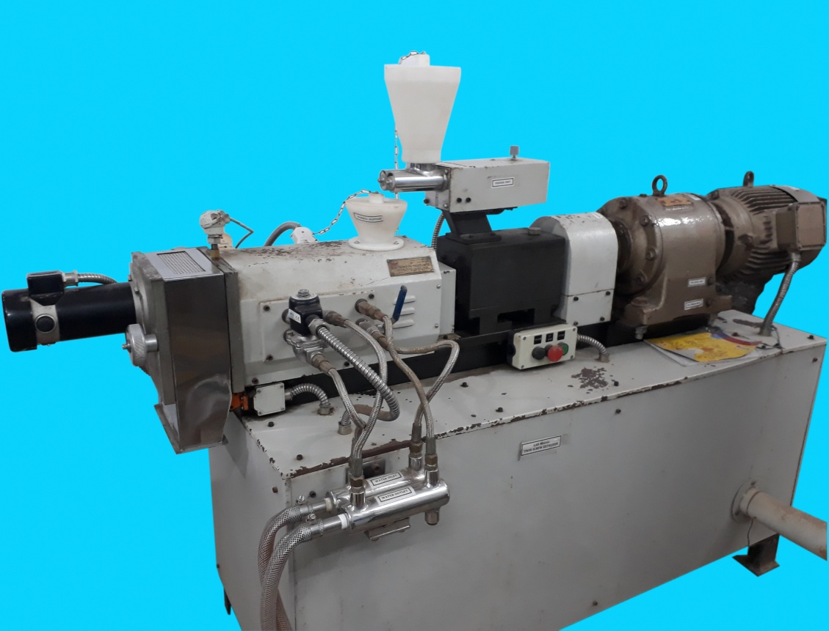
AC Induction Motor
Gear Box
Clutch
Duplex Gear
Heater-II
Solenoid Valve
Water Outlet
Water Inlet
Product Outlet
Cutter
Valve
Barrel
Heater-I
Feeder
Feed Hopper
Barrel Hopper

Fig. 1 BTPL lab model (EB-10) - twin screw extruder

Fig. 2 Control panel
3. Quality of Extruded Products

Quality of any food product is a measure for its acceptability and uniformity, and considered as the most important factor. The quality of any product depends on many factors and may change with a small variation in the process parameters (independent variables). The quality attributes in respect of the extruded product considered for evaluation were expansion ratio (ER), bulk density (BD), hardness (H), crispness (Cr), water absorption index (WAI) and water solubility index (WSI).

3.1 Expansion ratio

The ratio of cross-sectional diameter of extruded product and the diameter of die is expressed as ER. ER was calculated using Eqn. below.

$ER=\frac{Extrudate Diameter}{Die Diameter}$

3.2 Bulk density

Bulk density (BD) was determined by measuring the actual dimension of the extruded products and calculated as the ratio of mass of the product to volume and expressed in g cm⁻³. BD was calculated using the following formula.

$BD=\frac{(4 x m)}{(π x d^{2} x L)}$
Where,
L = Length of the extrudate, cm
d = Diameter of the extrudate, cm
m = Mass of the sample, g

3.3 Hardness

The textural characteristics of extruded products was measured using a Stable Micro System TA-HD plus Texture Analyzer (Texture Technology Corp., UK) with a specified attachment provided for similar products, crisp fracture rig fixture and P/0.25 probe (Fig. 3). During the test, the setting of the analyzer adopted was set to: Load cell of 50 kg, Pre-test speed of 1.0 mm s⁻¹, Test speed of 1.0 mm s⁻¹, Post-test speed of 10 mm s⁻¹, Distance of travel 5 mm. While subjecting the sample for fracture test, the value of highest peak is considered as the force required for hardness expressed in Newton (N), this represents the initial penetration or the first rupture.
3.4 Crispness

Crispness or the crunchiness is the number of positive peaks during rupture of the product. It was determined using the Textural Analyzer. To count the number of positive peaks or determine the crispness the software Exponent Lite was used. To measure the crispness, a macro region was specified which helped in making the count of number of positive peaks during the fracture test through the force-time deformation curve.

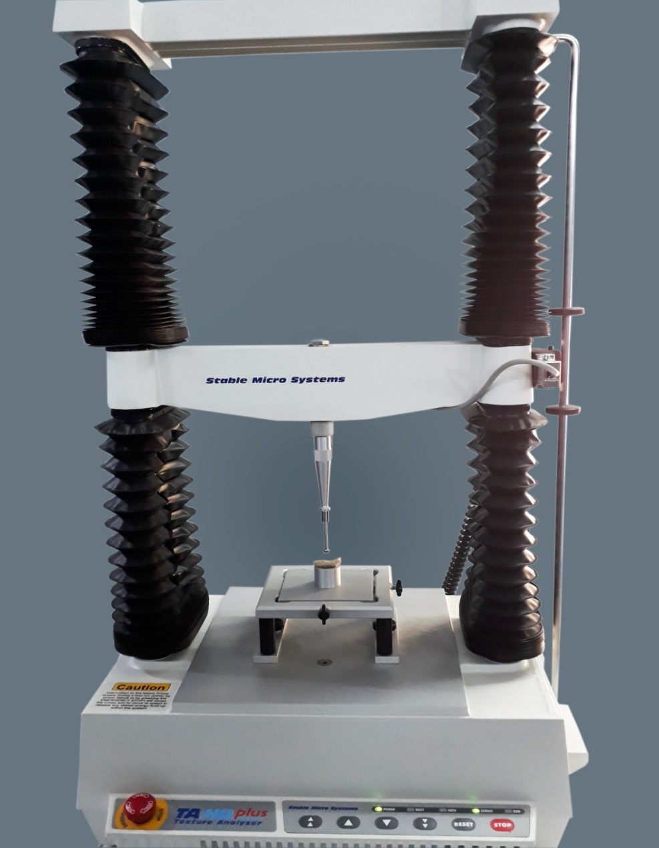

Fig. 3.3 Stable Micro System TA-HD plus Texture Analyzer

3.5 Water absorption index and water solubility index

Determination of water absorption index (WAI) and water solubility index (WSI) of extruded products was done following the procedure described by Ding et al. (2006). The following relationships were used to calculate the values of WAI and WSI.

$WAI (g/g)=\frac{Weight of sediment}{Weight of dry solids}$

$WSI \left(\%\right)=\frac{Weight of dissolved solids in supernatant}{Weight of dry solids}$ ×100

4. Extrusion Process Variables
The extrusion process variables that influence the products qualities are systematically discussed below.
4.1 Barrel temperature

The extruder barrel is provided with set of two electric band heaters for heating and cooking of the feed, one at the feed section and another at the die section. Heating is controlled with the help of temperature sensors provided at each of the sections. The temperature of the two sections can be pre-set and controlled precisely. The control knobs and digital output displays are provided on control panel. Barrel temperature is an important parameter for expansion of the extrudate, it greatly influences the visco-elastic behaviour of melted starch and gelatinization of starch which is responsible for expansion of the extruded products. Expansion does not take place if the temperature remains below 100°C. On the contrary, Singh et al. (2006) have reported successful preparation of extruded product with 20% blending of soybean (15% feed moisture content) at 85°C barrel temperature. However, it is necessary to bring the starch into completely molten state otherwise product expansion reduces greatly or in some cases it does not expand at all. Expansion of extruded products increases with the increase in extruder temperatures up to a certain limit beyond which it adversely decreases, at very higher temperatures dextrinization takes place which is responsible for weakening of the starch structure (Ramachandra Rao and Thejaswini, 2015). Barrel or the extrusion temperature also affects the bulk density, hardness, crispness, etc. of extruded products.
Studies on wheat based expanded snacks using twin screw extruder done by Ding et al. (2006) indicated that physical and functional qualities of the product significantly depends on process variables and found that the product properties were mostly dependent on barrel temperature and feed moisture. The decrease in density, water absorption index and hardness occurred with the increase in barrel temperature but it had a positive effect on expansion, water solubility index and puncture energy. A varying range of barrel temperature from 100°C to 160°C for the development of extruded products had significantly affected the water absorption index, water solubility index, expansion ratio, bulk density, total colour change, pasting and starch digestibility of extrudates.
Degree of superheating of water increases with the increase in barrel temperature during extrusion, which improves the bubble formation and decreases melt viscosity causing reduced bulk density and increased expansion of products (Lawton et al., 1985; Omohimi et al., 2013; Seth et al., 2015). The increase in barrel temperature to certain level also decreases the hardness of the product appreciably. Water absorption index (WAI) is an indication of degree of gelatinization of starch and increases with temperature. At higher temperature, more disruption of starch molecule occurs and more water is bounded to it, which causes increased WAI (Kumar et al., 2010; Seth et al., 2015). WSI increased with the increase in barrel temperature. This may be due to degradation of starch molecules with the exposure of product inside the barrel at higher temperature (Sobukola et al., 2013).

4.2 Feed moisture content

Feed moisture content is an important parameter directly affects the physical, textural, functional and sensory qualities of extruded snacks. The level of feed moisture content has been varied largely in the range of 12% to 24% depending on the type of mixture of ingredients for extrusion cooking (Ding et al., 2006; Pansawat et al., 2008; Chakraborty et al., 2014; Seth et al., 2015). Several studies have concluded that bulk density, hardness, water solubility index and water absorption index of the extruded products increased with the increase in moisture content of the blends, whereas expansion ratio and crispness have been reported to be decreased with increasing feed moisture (Chiu et al., 2012; Oke et al., 2012). During extrusion process, increased feed moisture may lead to reduce the dough elasticity through plasticization of the melt, resulting in reduced specific mechanical energy causing decrease in the expansion and increase in extrudate density due to improper or incomplete gelatinization (Ding et al., 2006). On the contrary, according to Lawton and Handerson (1972), during extrusion process higher moisture content of the feed reduces the viscosity of starch, allowing the free movement of the starch molecules and thereby enhancing the penetration of heat resulting in complete gelatinization. At lower moisture content of feed, increased shearing action inside the barrel takes place which causes more mechanical damage to starch, resulting into low WAI (Sobukola et al., 2013). At lower feed moisture content the drag force at the die increased which increases starch molecules to gelatinize and hence increased water absorption index. An increase in moisture content up to 18% decreases degradation of starch molecules and further increase in moisture content beyond 18% causes easy dissolution of polysaccharides to the food matrix, resulting in increased WSI (Seth et al., 2015). Higher expansion ratio, low bulk density and hardness properties of extruded product was obtained from the blend prepared with 16% to18% feed moisture content (Meng et al., 2010). It is explicitly indicated that the increasing moisture content in the range of 21% to 23% significantly decreased specific volume and increased hardness of the extrudate (Li et al., 2005).

4.3 Screw speed

Speed of screw is an important parameter of the extrusion process, affects specific mechanical energy requirement, torque and feed rate of the machine. Development of shear rate and residence time of feed depends largely on screw speed. With the input of mechanical energy to dough, the production of heat dissipation depends on screw speed, which in turn influences dough viscosity. With the increase in screw speed percent torque decreases but specific mechanical energy increases. Its effect on the extrudate attributes like, expansion ratio, bulk density and hardness is less prominent compared to other parameters. The increase in screw speed improves the expansion and decrease the bulk density, which may be due to lower melt viscosity of mix and increased elasticity of dough (Ding et al., 2006; Sahu et al., 2022). Colour value of product had markedly affected by screw speed of extruder while WAI and WSI of products were lesser affected by screw speed (Balasubramanian et al., 2012). Screw speed did not bring appreciable change as compared to barrel temperature and feed moisture content. Further, the specific mechanical energy was observed to be mainly affected by screw speed of the extruder and increases with the increase in screw speed. Torque required to rotate the screw is very much related with degree of fill in the extruder barrel (Jin et al., 1994).

4.4 Feed rate
A twin screw type feeder (co-rotating) attached with the hopper assembly is provided on top of the machine to charge the feed to the barrel through a hopper provided at the inlet of the barrel assembly. The rate of feeding to the barrel is controlled by a frequency controller. The feed rate is regulated with the help of a knob fitted on feeder unit and connected through control panel which displays rpm of the feeder. The feed rate is linked with the rpm of the feeder screw which can easily be calibrated and fixed at desired rate in kg h⁻¹. Feed rate is essentially influence the quality of extruded products in addition to smooth functioning of the machine. The screw element types, screw speed, feeding element and feed moisture influence the rate of feed in the extruder. The pressure development in the barrel, residence time, torque and dough temperature depends on the rate of feeding. The expansion index and sectional expansion index increases with the increase in feed rate up to certain limit and the further increase in feed rate adversely affects these important attributes. On the other hand, the specific length of the product increases with the increase in feed rate. The feed rate or throughput directly affects the capacity of the machine. However, like other similar machines, its operation is trouble free if operated within the range of rated capacity. Few of the observations made by researchers are; expansion ratio of extrudates depends on its degree of gelatinization which was found to be decreased with the increase of feed rate. WAI and WSI of the products have also been observed to be influenced with the feed rate, lower the feed rate, these indices were lower (Chinnaswamy and Bhattacharya, 1983). There are combined effects of feed rate with the feed moisture level on quality of products (Ding et al., 2006). Increased feed rate with lower feed moisture increased the hardness of the product significantly and its magnitude was comparatively less with higher feed moisture levels. Feed rate and screw speed invariably affected the firmness of the product during preparation of millet and soy blended extrudates (Balasubramanian et al., 2012). The feed rate did affect the hardness of extrudates which increased with the increase in feed rate and the corresponding density was also noted to be higher.

4.5 Die configuration

The die of an extruder is a major component of the machine. The die is a steel disk with an opening the size and shape of the intended cross-section of the final product cut through it. Dies are classified in to three types namely, solid (flat) dies, which produce solid shapes, hollow dies, which produce hollow shapes and semi hollow dies produce semi hollow shapes. The shape of the die is determines the shape of the product to be prepared. The die shapes the molten plastic existing an extruder into the desired cross section depending on the product being made. It gives a passage between the circular exit of the extruder and more complex and often much thinner and wider die exit. The die allows rapid expansion puffing of the dough into different shapes and sizes depending on the die configuration. The die section is an important section which is directly related with the performance of the extruder as well as quality of the end product. The pressure drop at the entrance of die is greater for visco-elastic fluid than that of Newtonian fluids of similar viscosity. The pressure drop at the entrance of die increases with the decrease in the ratio of length to diameter of die. This also affects the flow within the die and shear stress during the operation. Therefore, it is important to select a properly designed and developed die (Adekola, 2014). The back pressure is directly proportional to the length to diameter ratio of die. The die diameter directly affects the radial expansion of the extrudate but it is not true for axial and overall expansion of extruded products.

5. References
Adekola, K.A. 2014. Analytical engineering designs for twin screw food extruder dies. International Journal of Engineering Innovation and Research, 3(5): 713-717.
Adekola, K.A. 2016. Engineering review food extrusion technology and its applications. Journal of Food Science and Engineering, 6: 149-168.
Balasubramanian, S., Singh, K.K., Patil, R.T. and Onkar, K.K. 2012. Quality evaluation of millet-soy blended extrudates formulated through linear programming. Journal of Food Science and Technology, 49(4): 450-458.
Belwal, M. and Deshpande, H.W. 2017. Extrusion technology and effect of extrusion process on food quality parameters involving fortification process. Trends in Biosciences, 10(1): 73-81.
Chakraborty, S.K., Singh, D.S. and Kumbhar, B.K. 2014. Influence of extrusion conditions on the colour of millet-legume extrudates using digital imagery. Irish Journal of Agricultural and Food Research, 53(1): 65-74.
Chinnaswamy, R. and Bhattacharya, K.R. 1983. Studies on expanded rice. Physicochemical basis of varietal differences. Journal of Food Science, 48 (6): 1600-1604.
Chiu, H.W., Peng, J.C. and Tsai, S.J. 2012. Process optimization by response surface methodology and characteristics investigation of corn extrudate fortified with yam (Dioscorea alata L.). Food and Bioprocess Technology, 6(6): 1494-1504.
Deshpande, H.W. and Poshadri, A. 2011. Physical and sensory characteristics of extruded snacks prepared from Foxtail millet based composite flours. International Food Research Journal, 18(2): 751-756.
Ding, Q.B., Ainsworth, P., Plunkett, A., Tucker, G. and Marson, H. 2006. The Effect of extrusion conditions on the functional and physical properties of wheat-based expanded snacks. Journal of Food Engineering, 73(2):142-148.
Filli, K.B., Nkama, I., Jideani, V.A. and Abubakar, U.M. 2012. The Effect of extrusion conditions on the physicochemical properties and sensory characteristics of millet-cowpea based Fura. European Journal of Food Research and Review, 2(1): 1-23.
Hazarika, E.B., Borah, A. and Mahanta, C.L. 2013. Optimization of extrusion cooking conditions and characterization of rice (Oryza sativa) - sweet potato (Ipomoea batatas) and rice-yam (Dioscorea alata) based RTE products. Agricultural Sciences, 4(9B): 12-22.
Jin, Z., Hsieh, F. and Huff, H.E. 1994. Extrusion cooking of corn meal with soy fiber, salt and sugar. Cereal Chemistry, 71(3): 227-234.
Kumar, N., Sarkar, B.C. and Sharma, H.K. 2010. Development and characterization of extruded product of carrot pomace, rice flour and pulse powder. African Journal of Food Science, 4(11): 703-717.
Lawton, J.W., Davis, A.B., and Behnke, K.C. 1985. High-temperature short-time extrusion of wheat gluten and bran-like fraction. Cereal Chemistry, 62(4), 267–269.
Lawton, B.T. and Handerson, B.A. 1972. The effects of extruder variables on the gelatinization of corn starch. The Canadian Journal of Chemical Engineering, 50(2): 168-172.
Li, S., Zhang, H.Q., Jin, Z.T. and Hsieh, F. 2005. Textural modification of soya bean/corn extrudates as affected by moisture content, screw speed and soya bean concentration. International Journal of Food Science and Technology, 40(7): 731-741.
Lusas, E.W. and Riaz, M.N. 1994. An introduction to extruders and extrusion principles. Extrusion Communique, 7(4): 9-25.
Meng, X., Threinen, D., Hansen, M. and Driedger, D. 2010. Effects of extrusion conditions on system parameters and physical properties of a chickpea flour based snack. Food Research International, 43(2): 650-658.
Navale, S.A., Swami, B.S. and Thakor, N.J. 2015. Extrusion cooking technology for foods: A review. Journal of Ready to Eat Food, 2(3): 66-80.
Oke, M.O., Awonorin, S.O., Sanni, L.O., Asiedu, R. and Aiyedun, P.O. 2012. Effect of extrusion variables on extrudates Properties of water yam flour- a response surface analysis. Journal of Food Processing and Preservation, 37(5): 456-473.
Omohimi, C.I., Sobukola, O.P., Sarafadeen, K.O. and Sanni, L.O. 2013. Effect of process parameters on the proximate composition, functional and sensory properties. International Scholarly and Scientific Research and Innovation, 7(4): 540-549.
Pansawat, N., Jangchud, K., Jangchud, A., Wuttijumnong, P., Saalia, F.K., Eitenmiller, R.R. and Phillips, R.D. 2008. Effects of extrusion conditions on secondary extrusion variables and physical properties of fish, rice-based snacks. LWT- Food Science and Technology, 41(4): 632-641.
Ramachandra Rao, H.G. and Thejaswini, M.L. 2015. Extrusion technology: A novel method of food processing. International Journal of Innovative Science, Engineering and Technology, 2(4): 358-369.
Riaz, M.N. 2000. Extruders in Food Applications. CRC Press, Technomic Publishing Co., Boca Raton, Florida, p. 240.
Riaz, M.N., Anjum, F.M. and Khan, M.I. 2007. Latest trends in food processing using extrusion technology. Proceedings of International Symposium on Emerging Trends in Food Science and Technology, Pakistan Journal of Food Science, 17(1): 53-59.
Rokey, 2000. Single-screw extruders. In: Riaz, M.N. (Ed) Extruders in Food application, CRC Press, Technomic Publihing Co., Boca Raton, Florida, : 25-50.
Sahu, C., Patel, S. and Tripathi, A.K. 2022. Effect of extrusion parameters on physical and functional quality of soy protein enriched maize based extruded snack. Applied Food Research, 2(2022): 1-8, 100072. https://doi.org/10.1016/j.afres.2022.100072.
Said, W.N. 2000. Dry extruders In: Riaz, M.N. (Ed) Extruders in Food Application, CRC Press, Technomic Publishing Co., Boca Raton, Florida, : 51-62.
Seth, D., Badwaik, L.S. and Ganapathy, V. 2015. Effect of feed composition, moisture content and extrusion temperature on extrudate characteristics of yam-corn-rice based snack food. Journal of Food Science and Technology, 52(3): 1830-1838.
Singh, D.S., Garg S.K., Singh, M. and Goyal, N. 2006. Effect of major processing parameters on the quality of extrudates made out of soy-kodo blends. Journal of Food Science and Technology, 43(4): 434-437.
Sobukola, O.P., Babajide, J.M. and Ogunsade, O. 2013. Effect of brewers spent grain addition and extrusion parameters on some properties of extruded yam starch-based pasta. Journal of Food Processing and Preservation, 37(5): 734-743.
Tiwari, A. and Jha, S.K. 2017. Extrusion cooking technology: Principal mechanism and effect on direct expanded snacks- An overview. International Journal of Food Studies, 6(1): 113-128.
Yacu, W.A. 1984. Modeling of a twin screw extruder. In: Conference on Thermal Processing and Quality of Foods, Athen, Greece: 55-60.

*****

