Bioengineering strategies that bridge medicine and technology

Ms. Cynthia Irene kasi Dr Sharangouda J Patil
Department of lifesciences-genetics Department of Zoology
Indian Academy Degree College NMKRV College
Bengaluru,India Bengaluru,India

ABSTRACT

Biomedical engineering is emerging as a unifying bridge between two evolving fields, medicine and engineering. It has been instrumental in combatting diseases and ailments by advancing tools like biosensors, biomaterials, computational imaging, and artificial intelligence. These technologies empower medical professionals in their research, diagnosis, and treatment efforts. This chapter highlights the pivotal role that technological advancements in medicine have played in shaping the modern healthcare system and underscores the contributions of biomedical engineers within the healthcare delivery system.
Keywords- bioengineering, bionanotechnology,Biomimetic nanomaterials, bioprinting

- A HISTORICAL PERSPECTIVE
In ancient times, diseases were perceived as "visits," believed to be arbitrary actions of displeased gods or spirits. This belief eventually led to the emergence of witch doctors, medicine men, and women, who relied on their natural instincts and accumulated knowledge to develop a primitive form of science based on empirical observations. These early practitioners, such as herb doctors, bone setters, surgeons, and midwives, refined their skills by gathering and systematizing reliable practices. Healing practitioners and shamans carefully observed the characteristics of specific illnesses and passed down their experiences to future generations, much like prehistoric humans learned from observing which plants and grains were safe to consume and cultivate.
In reality, the twentieth century marked the beginning of modern medicine. The fundamental sciences, including chemistry, physiology, pharmacology, and others, underwent rapid advancements during this era. Interdisciplinary collaboration played a significant role in these developments. Progress in the physical sciences greatly facilitated medical research. For instance, in 1903, William Einthoven pioneered the creation of the first electrocardiograph, which enabled the recording of electrical changes occurring during heartbeats. This breakthrough ushered in a new era for both electrical measurement techniques and the field of cardiovascular medicine [1]. 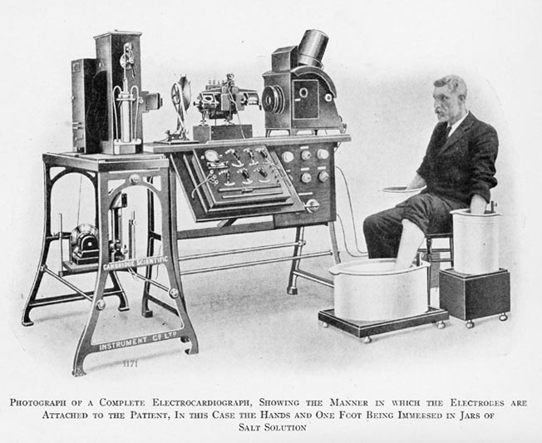
An early ECG machine (circa. 1911)
FIGURE 1: Photograph depicting an early electrocardiograph machine

The main risk of hospitalization—cross infection among patients—was greatly diminished by the introduction of sulfanilamide in the middle of the 1930s and penicillin in the early 1940s. With these new medications at their disposal, surgeons could perform their procedures without having to worry about infection-related morbidity and mortality being too high.
The use of the technology that was accessible aided in the development of sophisticated surgical techniques. The Drinker respirator and the first heart-lung bypass were both introduced in 1927 and 1939, accordingly Cardiovascular catheterization and angiography were created in the 1940s. Using a cannula inserted into the heart through an arm vein and radiopaque dye, these procedures allow for the visualization of the heart's vessels and valves on x-rays. Accurate congenital and acquired heart disease diagnoses (primarily rheumatic fever-related valve disorders) also became possible, ushering in a new era of cardiac and vascular surgery.
Throughout recorded history, technological and scientific developments have continually advanced.
Our society is now completely dominated by computers, much like the ones that managed the Apollo capsules' flight plans. These electronic brains have been used by medical researchers since the 1970s to carry out intricate calculations, maintain records (using artificial intelligence), and even command the very machinery that supports life. A constantly improving computer technology was completely necessary for the development of new medical imaging procedures like computerized tomography (CT) and magnetic resonance imaging (MRI).
In recent years, technology has made a profound impact on the field of medicine. The Human Genome Project, undertaken in the 1990s, is widely considered one of the most significant technological and scientific endeavors of that decade. It relied on engineering innovations such as robotic liquid handlers, automatic sequencers, and software for databasing and sequence assembly. This transformative project marked a notable shift in the focus of biomedical engineering, moving from the organ system level to the cellular and molecular level.
The success of the genome project has opened up new frontiers in medicine, including the ability to develop personalized medications based on an individual's DNA. These advancements, coupled with developments in tissue engineering, nanotechnology, and artificial organs, demonstrate how what was once considered science fiction is steadily becoming a reality [2].
These are merely a few of the scenarios that show how technology has the potential to develop a system of medical services that will be available, of the highest caliber, and affordable to all.

II. BIOENGINEERING

Bioengineering is commonly characterized as a research-oriented field closely associated with biotechnology and genetic engineering. Typical endeavors undertaken by biomedical engineers encompass.
- Development of novel medical diagnostic tests for diseases and the production of synthetic vaccines using cloned cells.
- Bioenvironmental engineering aimed at safeguarding human, animal, and plant life from toxic substances and pollutants.
- Investigation into protein-surface interactions and modeling the growth kinetics of hybridoma cells.
- Research in the field of immobilized enzyme technology and the creation of therapeutic proteins and monoclonal antibodies.
The term "biomedical engineering" seems to have the most expansive scope. Biomedical engineers employ principles from various engineering disciplines such as electrical, chemical, optical, mechanical, and others to understand, modify, or control biological systems, including those found in humans and animals.
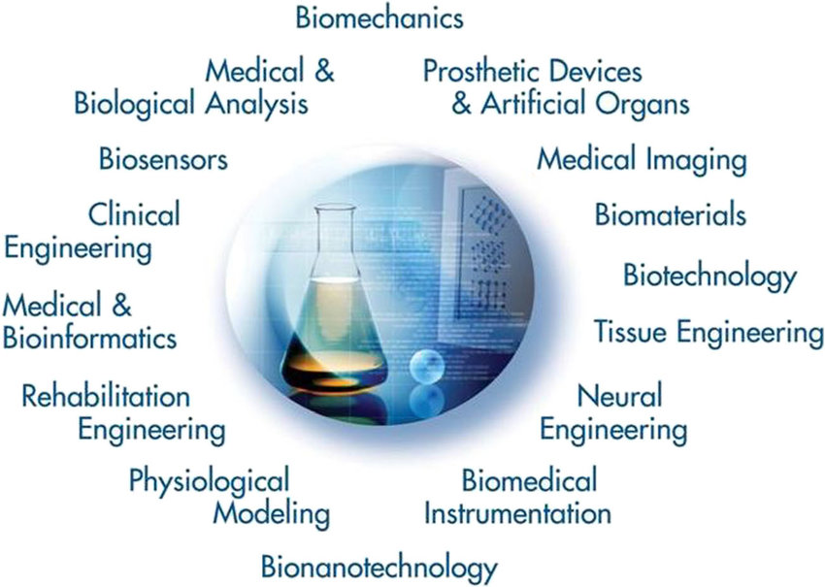
FIGURE 2: The world of biomedical engineering

As depicted in Figure 2, the field of biomedical engineering has expanded to encompass several emerging career domains. These domains encompass:
- Utilization of engineering system analysis methods, such as physiologic modeling, simulation, and control, to address biological issues.
- Detection, measurement, and monitoring of physiologic signals, including biosensors and biomedical instrumentation.
- Interpretation of diagnostic information through signal-processing techniques applied to bioelectric data.
- Development of therapeutic and rehabilitation procedures and devices.
- Design and construction of devices for either replacing or enhancing bodily functions.
Computer-based analysis of patient-related data and clinical decision-making, involving medical informatics and artificial intelligence.
- Medical imaging, which involves the visual representation of anatomical structures or physiological functions.
- Advancements in biotechnology and tissue engineering to create new biological products.
Consequently, biomedical engineering is an interdisciplinary field that spans various academic domains and draws significant influence from both engineering and the life sciences. It encompasses a wide spectrum of endeavors, ranging from theoretical, non-experimental undertakings to cutting-edge applications. It may encompass all four aspects: research, development, application, and operation. Therefore, it's improbable for any individual to attain expertise that comprehensively covers the entire field, much like the multifaceted nature of medical practice itself [3].
Identifying the challenges and demands within our existing healthcare delivery system that can be effectively addressed through contemporary engineering technology and systems methodology holds significant promise in the realm of biomedical engineering. Consequently, there is optimism in the field of biomedical engineering regarding the ongoing endeavor to deliver high-quality healthcare that remains accessible in terms of cost. By appropriately directing their efforts toward addressing concerns related to ambulatory care services, ambulatory medical methods, and related matters, biomedical engineers can provide the tools and methodologies needed to enhance the efficiency and effectiveness of our healthcare system.
III. ADVANCEMENTS IN BIONANOTECHNOLOGY

The feasibility of utilizing synthetic polymers as biomaterials for crafting biomedical devices and artificial organs capable of emulating the functionality of real organs has been investigated. However, many polymers are unsuitable for prolonged implantation due to their inability to effectively prevent the initiation of thrombosis when they interact with flowing blood or internal organs. Therefore, the development of materials that consistently exhibit enduring biocompatibility is a sought-after objective in the advancement of medical devices.
The application of nanotechnology in the life sciences offers the potential to investigate biological systems with unparalleled nanoscale precision and address medical challenges affecting millions of patients globally. Remarkable advancements have been achieved in the last two to three decades, leading, among other achievements, to the endorsement of nanotechnologies for targeted drug delivery to tumors and various afflicted areas[4]. In addition to therapeutic nanoparticles designed for drug conveyance, notable areas of focus encompass:
- For tissue engineering and regenerative medical applications, there are biomimetic nano- or micro-structured materials.
- Specifically, lab-on-chip-based systems for disease diagnosis at the point of care using nanobiosensors.
- Nano-probes for tracking cells, disease pathogenesis, and therapy monitoring in vivo.
- Nanotechnology-based instruments that hasten scientific discovery and clarify basic biology

Biomimetic micro/nano structures:

The extracellular matrix (ECM), composed of various micro/nanostructures, plays a pivotal role in the dynamic microenvironment enveloping cells, influencing their behavior. Numerous micro/nanostructures have been engineered to mimic the ECM's structure, yet these designs primarily remain static and do not fully replicate the ECM's dynamic attributes and in vivo functionality. Of particular note, certain micro/nanostructures founded on shape-memory polymers (SMPs), including patterns, fibers, porous scaffolds, and microspheres, have garnered increasing attention due to their distinct spatiotemporal variations. These biomimetic micro/nano-structures exhibit dynamic shifts owing to the shape-memory effect, conferring unique capabilities such as the regulation of cell behavior and the promotion of tissue growth. 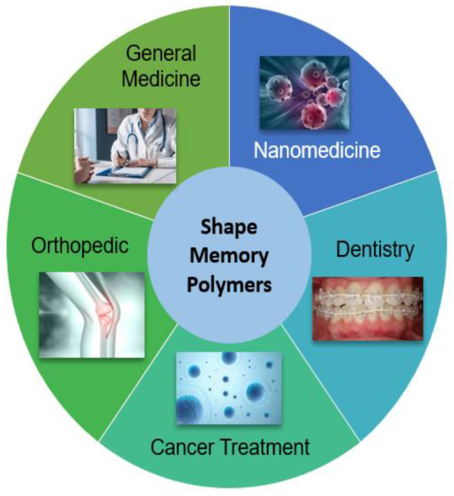
Figure 3: Application of Biomimetic nanomaterials in medicine

Biomimetic nanomaterials (BNMs) are functional materials that incorporate nanoscale components, closely mirroring the structural and technological characteristics of natural (biogenic) counterparts. These BNMs encompass organic and ceramic structural elements infused with magnetic, metallic, or metal oxide properties, along with various combinations thereof. The potential applications for these BNMs encompass diverse areas, including bioimaging, magnetic and infrared hyperthermia, chemo- and immunotherapy, the development of specialized pharmaceuticals, antibacterial and anti-inflammatory treatments, as well as tooth and bone reconstruction.
BNMs can be broadly classified based on their intended applications, defined as materials featuring biomimetic structural elements. Examples include liposomes containing cell wall proteins, materials produced through biomimetic methods, such as nanoparticles grown with magnetosome-associated proteins, and materials incorporating biogenic components, termed nanobio hydrides, such as polymeric nanoparticles coated with erythrocyte cell membranes.

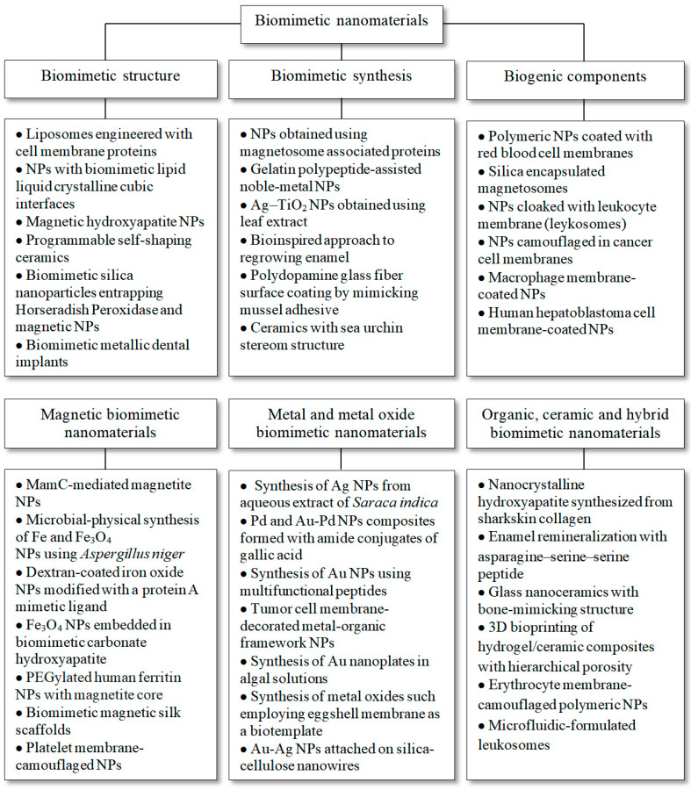
Figure 4: Classification of Biomimetic nanomaterials based on its structure,synthesis and biogenic components.[5]

Cutting-Edge Methods for Non-Invasive Disease Diagnosis Using Biomimetic Nanomaterials:

A. Dentistry:

Recent advancements have introduced various techniques to modify the topographical or chemical characteristics of conventional implant surfaces. These modifications aim to improve the adhesion of implant materials to bone cells. By altering the surface of a titanium implant, it becomes possible to stimulate bone tissue, expedite the process of osseointegration, and ensure effective transmission of occlusal mechanical loads between the implant and bone. For instance, in dentistry, a titanium base with a nanostructured calcium phosphate coating can be created by introducing hydroxyapatite (HAP) ceramic particles into a plasma jet directed at the treated titanium surface. This innovation offers enhanced performance in denture applications.

B. Bioimaging for Diagnosis:
- Surface-enhanced Raman scattering nanoparticles, known for generating unique "fingerprint" spectra, have found applications as contrast agents for precise localization of targeted cells in the body, particularly in cancer diagnosis. In a related study using a mouse model for brain tumors, researchers employed a combination of surface-enhanced spatially offset resonance Raman spectroscopy (SERRS) and spatially offset Raman spectroscopy (SORS) to image deep-seated glioblastoma multiforme tumors. This innovative optical imaging (OI) method is founded on the creation of SERRS nanostars from gold nanoparticles (AuNPs). These nanostars were functionalized with cyclic RGDyK peptide, which binds to integrin receptors on tumor cell surfaces, enabling the detection and targeting of glioblastoma. Importantly, this imaging technique overcomes the limitations of conventional Raman spectroscopy-based imaging, which is restricted to tissues within a few millimeters of depth.
- Glycine-superparamagnetic iron oxide nanoparticles (GSPIONs) were synthesized by mixing glycine with superparamagnetic iron oxide nanoparticles (SPIONs), with the aim of enabling non-invasive imaging and targeting of lung immune cells. Specifically, neutrophils and alveolar macrophages demonstrated uptake of GSPIONs. To assess the distribution of GSPIONs within the lung for disease identification, three-dimensional ultrashort echo time MRI was employed. Notably, these GSPIONs possess a hydrodynamic diameter of 84.19 ± 18 nm, a particle size measuring 12.5 nm, and offer a straightforward synthesis process. These GSPIONs hold significant potential as a precise diagnostic tool for lung cancer.

- To achieve the targeted and non-invasive diagnosis of prostate cancer through the recognition of the Prostate-specific membrane antigen (PSMA) receptor using MRI, a reversed-phase microemulsion approach is employed. This technique involves incorporating gadopentetic acid into silicon. The surfaces of silica nanotubes are modified with amino and carboxyl groups, and then a monoclonal antibody specific to PSMA is conjugated using the carbodiimide method.
- Hybrid metal oxide-peptide amphiphile micelles (HMO-Ms) are created through a self-assembly process, aiming to enhance MRI detection of thrombosis in atherosclerotic plaques. These micelles combine an inorganic core made of magnetized iron oxide or manganese oxide with an organic amphiphilic peptide that specifically targets fibrin. The innovative HMO-Ms have the capability to identify vulnerable plaques. To evaluate their targeting effectiveness in detecting blood clots, the CREKA peptide-functionalized hybrid nanoparticles were compared to non-targeted HMO-Ms (NT-Fe-Ms and NT-Mn-Ms) using MR signal enhancement and signal brightness intensities.
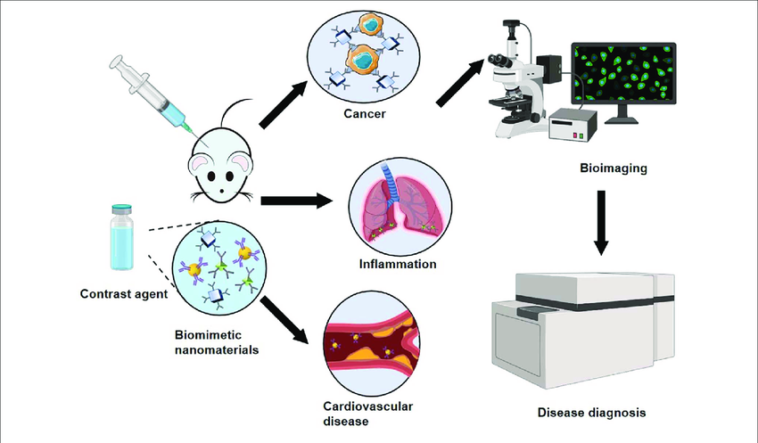

Figure 5: Schematic diagram of biomimetic nanomaterials applied to bioimaging
C. Biosensors:

- Malondialdehyde (MDA) serves as a biomarker for tissue damage. Therefore, the electrochemical polymerization of dopamine can be achieved by electrodepositing chitosan (CS) onto the dopamine (DA) polymer on the surface of a glassy carbon electrode. Silver nanoparticles (AgNPs) that are covalently attached to POLY(DA-CS) membranes effectively capture MDA biomarkers. The presence of AgNPs enhances the electrochemical signal, and the remarkable biocompatibility and stability of CS contribute to the durability of the electrode. The electrochemical sensor exhibits a dynamic range of 1.45–7.9 μm, with a lower limit of quantification at 1.45 μm. This sensor demonstrates rapid and sensitive detection of MDA in samples of exhaled breath condensate (EBC). This innovative platform holds the potential for diagnosing lung diseases.
- Lipopolysaccharide (LPS) is a substantial constituent of the outer membrane in Gram-negative bacteria. Consequently, biomarkers like LPS can be utilized for detecting conditions such as sepsis and urinary tract infections that are caused by Gram-negative bacteria. [14]
- Dopamine, a significant neurotransmitter in the human body, is closely associated with Parkinson's disease. Therefore, accurately measuring dopamine levels is essential for diagnosing Parkinson's disease. A novel approach based on surface-enhanced resonance Raman spectroscopy (SERRS) has been developed for detecting dopamine levels. With this method, biomarkers at extremely low concentrations, in the femtomolar range, can be identified. The technique involves the functionalization of AgNPs with iron-nitrilotriacetic acid, a common organic chelate that forms complexes with Fe, to capture dopamine, which is subsequently detected using SERRS.[15]
- High cholesterol levels are linked to increased morbidity from cardiovascular diseases. Consequently, non-invasive methods for cholesterol measurement are crucial for early detection and management of cardiovascular conditions. An enzyme-based electrochemical biosensor has been developed using platinum nanoclusters to immobilize an optimal amount of cholesterol oxidase for detecting low cholesterol levels in saliva. The cholesterol level was quantified using chronoamperometry. This biosensor exhibited a linear range of 2-486 m, a detection limit of approximately 2 m, and a sensitivity of 132 A mm-1cm-2.[16]
- Top of Form
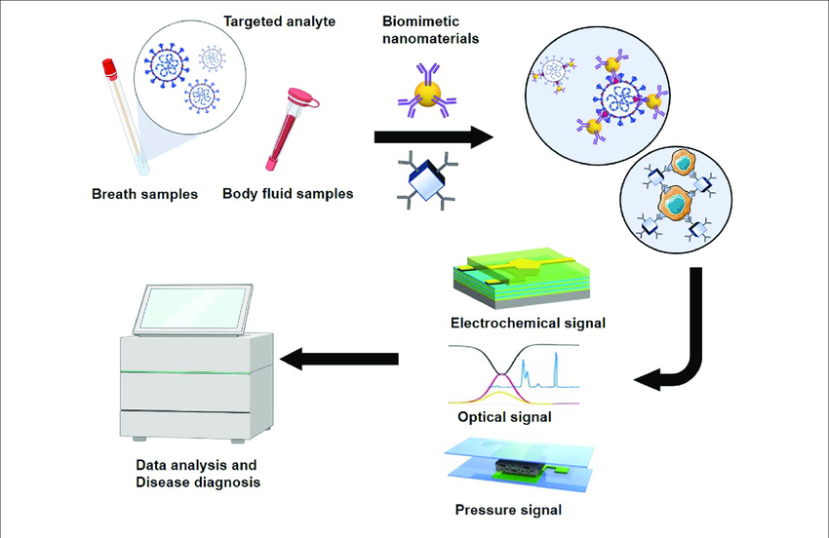
Figure 6: Schematic diagram of biomimetic nanomaterials applied to biosensors

D. Nanovaccines Using Biomimetic Immunomodulatory Materials

Biomimetic nanovaccines are created through the integration of synthetic nanoparticles with biologically derived materials. The synergy of both synthetic and biological properties is a crucial factor in enhancing the therapeutic effectiveness of these vaccines. Biomimetic nanovaccines come in various forms, including liposomes, proteins, cell-membrane-coated nanoparticles, and virus-like particles (VLPs) that have been modified with antigens and adjuvants, as illustrated in the figure, to stimulate immune responses in the body. Thanks to the presence of various cell membrane proteins and antibodies on the nanovaccine surface, they can effectively evade the immune system. Biomimetic surface engineering represents an innovative approach to advancing current therapeutic interventions.
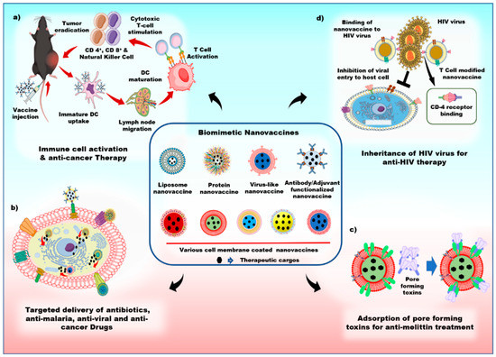
Figure 7: Schematics of the various applications of biomimetic nanovaccines

a) Biomimetic nanovaccines containing adjuvants, antigens, and antibodies have the ability to initiate dendritic cell maturation, thus promoting the activation of cytotoxic T-cells and triggering a robust immune response against tumors.

b) Biomimetic nanovaccines are proficient in actively targeting cancer cells and efficiently delivering therapeutic drugs to them.

c) Biomimetic nanovaccines serve as a natural substrate for the adsorption of pore-forming toxins.

d) Biomimetic nanovaccines possess the capacity to bind to human immunodeficiency virus (HIV) viruses via CD-4 receptors, thereby preventing host cell infection by the HIV virus.
1. Antibacterial Treatment: The innate and adaptive immune responses in the human body are activated by the presence of immunogenic adjuvants and antigens that display various pathogen-associated molecular patterns (PAMPs) on bacterial membranes. Nanoparticles coated with bacterial membranes are thus considered as promising candidates for antibacterial therapy. For instance, they have shown promise in developing a successful immune response against pathogens, as exemplified by a Neisseria meningitis vaccine. [18] 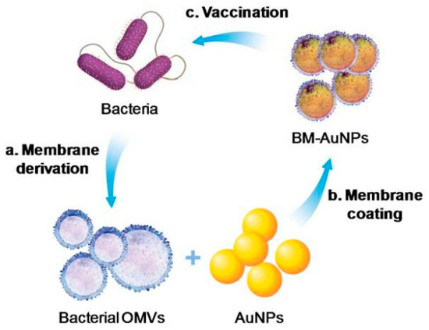
Figure 8: Schematic of antibacterial modulation via bacterial membrane-coated nanoparticles (NPs)[18]
2. Anti-Tumor Immune Response: The liposomes containing antigens triggered immunogenicity, resulting in altered T-cell responses, and the activation of CD4+ and CD8+ T-cells to combat the tumor. These phosphatidylserine-conjugated liposomes are efficiently taken up by antigen-presenting cells and promote Th-cell proliferation, contributing to effective vaccines. Another approach involved using Cytosine-phosphorothioate-guanine (CpG) oligodeoxynucleotide-loaded Poly Lactic-co-Glycolic Acid (PLGA NP) coated with the membrane of melanoma cancer cells as an antigen/adjuvant vaccination. This biomimetic nanovaccine harnessed the cancer cell membrane's function as a tumor antigen to enhance the immune response. By modulating immune reactions towards cancer cells, this nanovaccine stimulated the maturation of antigen-presenting cells and the production of proinflammatory cytokines, including interleukin-6 and interleukin-12 (IL-12). [19]

IV. ADVANCES IN REGENERATIVE MEDICINE AND TISSUE ENGINEERING:

The scarcity of organs and tissues for transplantation is a significant public health concern, limiting the access of numerous deserving patients to life-saving procedures. Regenerative medicine offers a promising solution, as it has the potential to repair and replace damaged organs and tissues. It has demonstrated considerable potential in addressing various medical issues, including the regeneration and replacement of tissues and organs such as skin, heart, kidney, and liver. This innovative approach contrasts with the conventional reliance on donated tissues and organs for transplantation, which faces challenges related to donor shortages and the risk of immune system rejection of transplanted organs.
In recent years, 3D printing has emerged as one of the most remarkable technological advancements. A crucial application within this field is the direct printing of biological materials onto scaffolds that have been seeded with cells, a process commonly referred to as 3D bioprinting. This cutting-edge discipline involves the integration of expertise from various fields, including tissue engineering, cell biology, and material science. Successful bioprinting relies on the precise placement of biological components such as cells and biomolecules like growth factors. To accurately mimic human tissue, 3D bioprinting must capture the intricate details of the extracellular matrix (ECM) and the diverse cells present in different tissues. Moreover, bioprinting must also recreate the blood vessels and nervous systems specific to each target tissue.
- 3D Bioprinting:

3D bioprinting has brought about a transformative shift in the blending of scaffolds and cells, enabling precise control over the arrangement of materials and cells within grafts and constructs. At present, the field of 3D bioprinting employs various techniques, including inkjet printing, microextrusion, and laser-assisted printing [20].
To replicate the intricate composition and spatial arrangement of tissue and organs accurately, it is essential to utilize noninvasive imaging technologies such as MRI, CAD, and CT for gathering crucial information. Computed tomography, for instance, offers insights into the actual volume and structure of the tissue being studied by presenting cross-sectional slices. Magnetic resonance imaging (MRI) relies on nuclear magnetic resonance and excels at providing enhanced contrast resolution. Leveraging mathematical modeling and computer-aided design and manufacturing (CAM-CAD), three-dimensional models of tissues and organs can be created. These computer-based models also have the capability to predict crucial properties like mechanical and biochemical characteristics. In contemporary medicine, it is even feasible to simulate and design a patient's unique organ. The fabrication of materials derived from biological sources is facilitated by three primary technologies: inkjet printing (also known as drop-on-demand printing), microextrusion printing (where a robotic system employs a microextrusion head to print onto scaffolds), and laser-assisted printing (involving the generation of bubbles under pressure through laser pulses, followed by their deposition onto scaffolds) [21].
Top of Form

1.Inkjet Bioprinting:
Inkjet printers, also known as drop-on-demand printers, have uses in both biological and nonbiological fields and have so far been utilized to regenerate healthy skin and cartilage.
Process: Liquid biological material is sprayed in large volumes with increased resolution, accuracy, and speed onto defined surfaces. Thermal or acoustic forces are used to eject liquids from the printer onto a scaffold or substrate, which is typically a component of the graft that will be implanted onto the tissue.
Types:
- Thermal inkjet printers release biological material onto the scaffold through heated print heads.[22]
- Acoustic waves are produced by piezoelectric crystals in acoustic printers. By changing the wave's amplitude and duration in the printer head, the size of the biological material droplet can be altered.
Advantages: Among the three bioprinting methods, thermal inkjet printers are the most cost-effective and enjoy widespread utilization. These printers are highly compatible with various biological materials. The control over the size of biological material droplets and their ejection direction is notably straightforward when employing acoustic inkjet printers.
Disadvantages: Using inkjet printers comes with a drawback related to the necessity of maintaining a precise viscosity for the biological material being printed. When the viscosity exceeds a certain threshold, it can lead to clogging of the printer head. To mitigate this issue, it is common practice to reduce the overall number of included and printed cells in order to maintain the biological materials in a liquid state. This adjustment is made to minimize the risk of printer head clogging and to ensure the proper formation of droplets.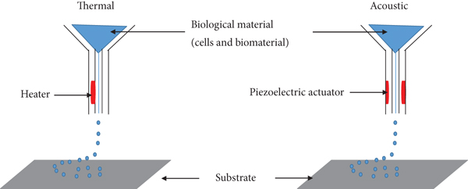
Figure 9 : Components for inkjet bioprinting. [22]

2.Microextrusion Bioprinting
A robot utilizes a microextrusion head to extrude biological material onto a scaffold or substrate. In this process, CAM-CAD software guides the continuous deposition of biological material onto the scaffold in the form of small beads. Microextrusion printing can make use of various biological materials, with hydrogels and cellular spheroids being examples. This technique has been employed to create a variety of tissues, including heart valves, vascular networks, and tumor models.
The extrusion-based 3D bioprinting process employs two mechanisms to achieve its goals: semi-solid extrusion (SSE) and fused deposition modeling (FDM). These mechanisms are instrumental in achieving the desired outcomes of the bioprinting process.
In SSE-based 3D bioprinting, a continuous flow of semi-solid materials is extruded through a nozzle using pressurized air or rotating screw gears. These materials are deposited layer by layer to construct a 3D structure. On the other hand, the FDM 3D bioprinting technique involves melting thermoplastic filaments at elevated temperatures and subsequently extruding them through a nozzle in a layer-by-layer fashion to produce a 3D structure.
Types:
- In the pneumatic system, the biological material is forced out of a nozzle by compressed air at a rate predetermined.
- In the mechanical system, biological material is dispensed using a screw or piston.[24]
Advantages: Microextrusion bioprinters, as opposed to inkjet bioprinters, can successfully print complex polymers, cell spheroids, and substrates made of clay.The capability to print extremely high cell densities for tissue formation is another significant benefit of this method.
Disadvantages: The distortion of cellular structure and loss of cellular viability that result from the pressure used to expel the bioink are two of the main drawbacks of microextrusion bioprinting.

. 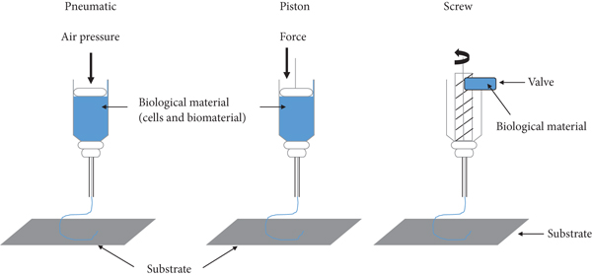
Figure 10: Pneumatic and mechanical (piston and screw) systems are used in microextrusion printers[25]
3.Laser-Assisted Bioprinting:
The process of depositing biomaterials onto a surface while using a laser as an energy source is known as laser-assisted bioprinting.A layer of biological material prepared in a liquid solution with a receiving substrate facing the projector, along with a ribbon with donor transport support, make up a laser-assisted bioprinter.The bioprinters move at a medium speed, and about 95% of the cells are still viable after the process.Laser-assisted bioprinting can be used to create human dermal fibroblasts, pulmonary artery endothelial cells, and breast cancer cells.
Process: The underlying concept behind laser-assisted bioprinting is to use a laser to force biomaterials forward onto a solid surface. The ribbon is exposed to laser light from the printer, which causes the liquid biomaterial to evaporate and droplets of it to travel to the receiving substrate. Biopolymers or a cell culture medium make up the receiving substrate, which promotes cellular adhesion and long-term growth of the biomaterial.[26]
Advantages: With its high level of accuracy and resolution, LAB is able to print bioinks with high viscosities (10-100 m) and densities up to 108 cells per milliliter without subjecting the cells to mechanical stress.
Disadvantages: A significant drawback of the method is the generation of metallic residues during printing that are present in the final bioprinted material. In addition, this approach is very expensive, though it is hoped that over time these costs will decline.[24]

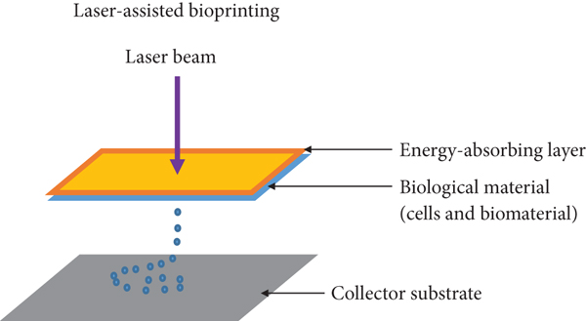
Figure 11: Laser-assisted printers are made up of a pulse laser beam which is focused on an absorbing substrate resulting in the generation of a pressure bubble that forces biological material onto the collector substrate.[26]

4.Stereolithography
The photopolymerization technique is used in the stereolithography (SLA) method of bioprinting. During this process, a UV light or laser is directed over a path of photopolymerizable liquid polymeric material, cross-linking the polymers to form a layer that is hardened.
Process:The foundation of stereolithography technology is the liquid photosensitive polymer's solidification in response to illumination.Light-sensitive polymer materials are polymerized using the technology, which regulates the light intensity using digital micromirror arrays. Layers are created as a result of the photochemical solidification of biopolymers, and these layers combine to create a 3D object.
Advantages:The most accurate fabrication method is stereolithography, which also allows for a wide range of material choices.This technique has a very quick speed (around 40,000 mm/s) and a cell viability of more than 90%.
Disadvantages: Instead of creating a smooth surface, layers sometimes create stair stepping. Moisture, heat, and chemicals all have an impact on tissue components and are finally limited to photosensitive resin.

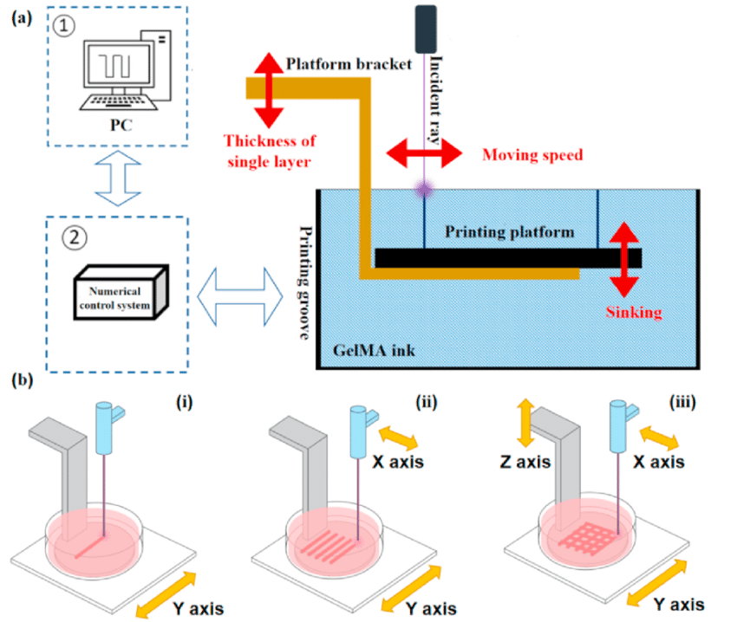

Figure 12: Design of the stereolithography bioprinting system.

(a) Diagram of the stereolithography bioprinting system. The photocrosslinkable hydrogel structure is formed by controlling the motion of the visible laser emitter and the printing platform;

(b) Fabrication of the stereolithography bioprinting system: (i) line forming, (ii) surface forming, and (iii) 3D structure forming[27].

Since its inception, 3D bioprinting has come a long way towards the objective of printing functional tissues. Despite obstacles, it has become abundantly clear from this early stage of research that bioprinting merits further study. The clinical potential of this technology will require more time, work, and multidisciplinary expertise, but the future is promising. The field of personalized regenerative medicine is poised to benefit greatly from bioprinting.

REFERENCES
- John D. Enderle,Susan M. Blanchard,Susan M. Blanchard,Joseph D. Bronzino(2005) “Introduction to biomedical engineering” 2nd ed.,Vol 1. Trinity College—Hartford, Connecticut,ISBN 0-12-238662-0.
- Frederik Nebeker,(2002)”Golden accomplishments in biomedical engineering”3rd ed.,doi: 10.1109/memb.2002.1016851.
- Bronzino, J.D.”,(2005) Biomedical Engineering Handbook”, 2nd Ed., CRC Press, Boca Raton, FL.
- Hobson D.W. Intracellular Delivery III,”The commercialization of medical nanotechnology for medical applications”pp. 405–449, 2016,Springer; Berlin/Heidelberg, Germany.
- Kamil G. Gareev, Denis S. Grouzdev,Veronika V. Koziaeva,Nikita O. Sitkov,Huile Gao,Tatiana M. Zimina,and Maxim Shevtsov(2022),”Biomimetic Nanomaterials: Diversity, Technology, and Biomedical Application”, Jul 20. doi: 10.3390/nano12142485.
- Sushnitha, M.Evangelopoulos, M.Tasciotti, E, Taraballi, F (2020). “Cell Membrane-Based Biomimetic Nanoparticles and the Immune System: Immunomodulatory Interactions to Therapeutic Applications'' Front. Bioeng. Biotechnol., 8, 627.
- Jin, K.; Luo, Z.; Zhang, B.; Pang, Z (2018).”Biomimetic nanoparticles for inflammation targeting”, Acta Pharm. Sin. B, 8, 23–33
- Le Guéhennec, L.; Soueidan, A.; Layrolle, P.; Amouriq, Y(2007)” Surface treatments of titanium dental implants for rapid osseointegration”, Dent. Mater., 23, 844–854.
- Nicolson, F., Andreiuk, B., Andreou, C., Hsu, H. T., Rudder, S., and Kircher, M. F. (2019 “ Non-invasive in vivo imaging of cancer using surface-enhanced spatially offset Raman spectroscopy (SESORS)” Theranostics 9, 5899–5913. doi: 10.7150/thno.36321
- Chakraborty, A., Royce, S. G., Selomulya, C., and Plebanski, M. (2020). “A novel approach for non-invasive lung imaging and targeting lung immune cells”. Int. J. Mol. Sci. 21:1613. doi: 10.3390/ijms21051613.
- Jiang, W., He, X., Fang, H., Zhou, X., Ran, H., and Guo, D. (2018) “Novel gadopentetic acid-doped silica nanoparticles conjugated with YPSMA-1 targeting prostate cancer for MR imaging: an in vitro study”. Biochem. Biophys. Res. Commun. 499, 202–208. doi: 10.1016/j.bbrc.2018.03.124.
- Poon, C., Gallo, J., Joo, J., Chang, T., Bañobre-López, M., and Chung, E. J. (2018). “Hybrid, metal oxide-peptide amphiphile micelles for molecular magnetic resonance imaging of atherosclerosis”. J. Nanobiotechnol. 16:92. doi: 10.1186/s12951-018-0420-8
- Hasanzadeh, M., Nahar, A. S., Hassanpour, S., Shadjou, N., Mokhtarzadeh, A., and Mohammadi, J. (2017). “Proline dehydrogenase-entrapped mesoporous magnetic silica nanomaterial for electrochemical biosensing of L-proline in biological fluids” Enzyme Microb. Technol. 105, 64–76. doi: 10.1016/j.enzmictec.2017.05.007
- Liu, T., Gao, L., Zhao, J., Cao, Y., Tang, Y., and Miao, P. (2018).” A polymyxin B-silver nanoparticle colloidal system and the application of lipopolysaccharide analysis”. Analyst 143, 1053–1058. doi: 10.1039/c7an01788j.
- Kaya, M., and Volkan, M. (2012). “New approach for the surface enhanced resonance Raman scattering (SERRS) detection of dopamine at picomolar (pM) levels in the presence of ascorbic acid”. Anal. Chem. 84, 7729–7735. doi: 10.1021/ac3010428.
- Eom, K. S., Lee, Y. J., Seo, H. W., Kang, J. Y., Shim, J. S., and Lee, S. H. (2020). Sensitive and non-invasive cholesterol determination in saliva via optimization of enzyme loading and platinum nano-cluster composition. Analyst 145, 908–916. doi: 10.1039/c9an01679a
- Veena vijayan,adithyanarayan mohanpatra,saji uthaman, In-kyu park(2019), “Recent Advances in Nanovaccines Using Biomimetic Immunomodulatory Materials”Pharmaceutics, 11(10), 534; https://doi.org/10.3390/pharmaceutics11100534
- Gao, W.; Fang, R.H.; Thamphiwatana, S.; Luk, B.T.; Li, J.; Angsantikul, P.; Zhang, Q.; Hu, C.M.J.; Zhang, L(2015) “Modulating antibacterial immunity via bacterial membrane-coated nanoparticles” Nano Lett., 15, 1403–1409.
- Kroll, A.V.; Fang, R.H.; Jiang, Y.; Zhou, J.; Wei, X.; Yu, C.L.; Gao, J.; Luk, B.T.; Dehaini, D.; Gao, W (2017) “Nanoparticulate delivery of cancer cell membrane elicits multiantigenic antitumor immunity.” Adv. Mater., 29, 1703969.
- Fan LiU,Xiaohong Wang,(2020) ”Synthetic Polymers for Organ 3D Printing“ Aug; 12(8): 1765, doi: 10.3390/polym12081765.
- Dey, Madhuri, and Ibrahim T Ozbolat.(2020) “3D bioprinting of cells, tissues and organs.” Scientific reports vol. 10,1 14023. 18 Aug. 2020, doi:10.1038/s41598-020-70086-y
- X. Cui, G. Gao, T. Yonezawa, and G. Dai,(2014) “Human cartilage tissue fabrication using three-dimensional inkjet printing technology,”Journal of Visualized Experiments, no. 88, article e51294,
- R. Jeurissen, A. van der Bos, H. Reinten et al.(2009), “Acoustic measurement of bubble size in an inkjet printhead,”The Journal of the Acoustical Society of America, vol. 126, no. 5,pp. 2184–2190,
- S. V. Murphy and A. Atala,(2014) “3D bioprinting of tissues and organs,”Nature Biotechnology, vol. 32, no. 8, pp. 773–785,.
- N. Hong, G. H. Yang, J. Lee, and G. Kim,(2018) “3D bioprinting and its in vivo applications,”Journal of Biomedical Materials Research Part B: Applied Biomaterials, vol. 106, no. 1,pp. 444–459,
- B. Hopp, T. Smausz, N. Kresz et al.(2005), “Survival and proliferative ability of various living cell types after laser-induced forward transfer,”Tissue Engineering, vol. 11, no. 11-12,pp. 1817–1823,
- Peng Zhang,Haoxuan Wang,Peng Wang,Yating Zheng,(2021) ”Lightweight 3D bioprinting with point by point photocuring”May 2021 Bioactive Materials 6(5):1402-1412,DOI:10.1016/j.bioactmat.2020.10.023

