ANTI-DIARRHEAL ACTIVITY OF WHOLE PLANT

OF ANNONA SQUMOSA
Dr. K. Hemamalini*, ¹Dr. Sadanandam palle A. Pavithra², P. Pallavi², Navadeep², E.Harshavardan²,
*Professor and Principal, Department of Pharmacology, Swami Vivekananda Institute of Pharmaceutical Sciences, Vangapally (V), Yadagirigutta (M), Yadadiri-Bhongiri (D), 508286, rkhemamalini@gmail.com, 9553601248
¹Professor, Chemistry department , Malla reddy Engineering college , Hyderabad ²Final year B.Pharm students of Department of Pharmacology, Swami Vivekananda Institute of Pharmaceutical Sciences, Vangapally.

ABSTRACT
The plant Annona squamosa belong to Annonaceae family was taken for the study. The methanolic extact of the whole plant extract was extracted and by continous hot percolation process and the Phytochemical test was evaluated and then the extract was taken for the Antidiarrheal study with 400mg /kg as a dose after literature study and a trial for LD₅₀ and Antidiarrheal activity was carried over by using castor oil induced diarrhea model which was compared with that of the standard loperamide with 5mg/kg body weight as dose. A significant decrease in the diarrhea was monitored and the same was compared with that of the standard drug loperamide. Finally the percentage protection was calculated and the results were found that the methanolic extract of Annona squamosa showed Antidiarrheal effect by reducing the stool weight.

KEY WORDS: Annona squamosa, Castor oil induced Diarrhea model, Methanolic extract.

INTRODUCTION
Herbal plants and its active constituents from single plant or combination of two or more plants are extracted at room temperature or by applying heat after they collected shade dried and crushed and powdered and extracted with various polarity of solvents. The final extract or the marc will contains various active compounds which may produce a synergistic or antagonistic effect for particular activity when compared to that of the standard drug or marketed drug. They may have an individual compound or a multiple compounds as an active ingredient. [1]. Nature serves different medicinal values plants which can be used to treat many diseases from ancient period. So plants and its value is very useful and very important for the communities[2]. Now a days the world at the pandemic situation to practiced herbal based or natural medicine obtained from plant sources where it helps to fight against foreign invading microbes with less side effects[3]. WHO has documented that plants practiced by tribal from different parts of the world has many medicinal values[4]. India is very rich in medicinal plants and have a practice of using herbal plants since ancient times. The modern isolation techniques and pharmacological testing procedure helps the plant products to find its own way as medicine[5].
Diarrhea not a disease but symptoms of various diseases like cancer. It is also called loose motions and defined as frequent passage of semisolid or liquid fecal and loss of electrolytes of Na⁺ and water with an increase in the motility of the gastrointestinal tract along with increased secretions and a decrease in the absorption of the fluid. Over eating of wrong food in untiming and overloading of foods or sometime consumption of laxatives may cause diarrhea. The main aim of present research work was to determine Antidiarrheal activity of methanolic extract of the whole plant of Annona squamosa by castor oil induced diarrhea model.

MATERIALS AND METHODS:
PLANT MATERIALS: Annona squamosa belongs to the family Annonaceae grows I different zones of the world. It has 44 species out of 40 are native of Americas 3 are to asia and 1 species grow in Africa. They have properties like soil binders, sand stabilizers. They exist in mannar regions for a long period.

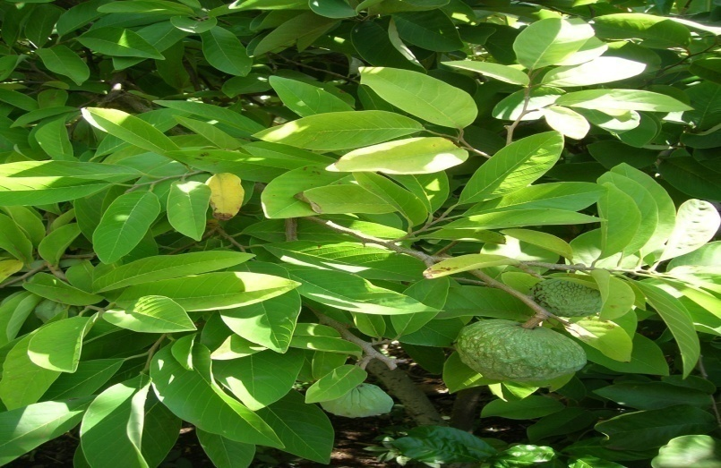
Fig.No.1: Plant of Annona squamosa

The various chemical agents that are present are flavonoids and phenolic compounds. Even Terpenes are used as insecticides and their pharmacological properties include antibacterial, antifungal, anthelmintic, antimalarial and molluscicidal [6]. Several pharmacological properties have been reported in the seed and leaves extract of Annona squamosa and the properties highlighted are anti-bacterial, anti-fungal and anti-inflammatory properties [7].
Preparation of Plant Extract: The plant Annona squamosa was collected in the month of july and shade dried and made in to coarse powder, taken for extraction process through hot continuous extraction method by using Soxhlet apparatus. The use of commercially available Soxhlet apparatus is a convenient way to prepare crude plant extract. Further the extraction was distilled to remove the solvent and the percentage yield of was calculated 9.52%. The extract was stored in refrigerator until further studies[8].
Drugs: Loperamide, castor oil, acetic acid (ASES Chemical Works, Jodhpur), and Sodium chloride (ASES Chemical Works).
Procurement of Animals: Male Wistar rats weighing (100–150 g) were obtained. They were housed and fed with a normal pellet diet and water ad libitum[9]. All experiments was performed according to ethical guidelines in conscious animal. Research protocol was approved by the Institutional Animal Ethics Committee.
Anti-diarrheal activity
In vivo anti-diarrheal activity was evaluated by using Castor oil-induced which was used from ancient times10]. 24hours fasted animals which was free access to water were taken for the study. The Rats were divided into following groups (n=10): Group 1 served as control and received distilled water (10 ml/kg), Group II served as reference drug, i.e loperamide at a dose of 5.26 mg/kg, Groups III served with MEAS at the respective doses of 400 mg/kg. All drugs were administered orally by using gastric gavage as a single bolus. The animals where left for one hour. After one hour 10 ml/kg of castor oil were administered orally to all groups. All animals were placed in separate metabolic cages with transparent plastic container beneath the cage and lined with Whatman paper to collect faces. The observation like latency time, frequency of defecation, total surface of impregnation and fresh total stools weight were measured for an 8 h period and compared with that of the control. Fresh stools were then dry in an oven to remove the water content.
RESULTS AND DISCUSSION
Table 1: Effects of the aqueous extract of Annona squamosa (MEAS) on castor oil-induced diarrhea:
Treatment | Dose  (mg/kg) | Latency time  (min) | Frequency of  defecation  (stools/8h) | Inhibition of  defecation  (%) | Total surface of  impregnation  (cm²) | Totalweight  expense of  deposit (g)
Water | 10ml/kg | 70.62 ± 5.63 | 4.00 ± 0.50 | 0.00 | 98.11 ± 25.39 | 6.12 ± 0.68
Loperamide | 5.26 | 147.62 ± 5.28 | 1.37 ± 0.46 | 65.62 | 27.85 ± 12.38 | 2.07 ± 0.49
MEAS | 400 | 296.00 ± 21.50 | 1.50 ± 0.50 | 62.50 | 18.69 ± 6.89 | 2.48 ± 0.43
Each value represents the mean ± SEM of 10 animals; ap < 0.05, bp < 0.01,cp < 0.001, significantly different compared to negative control group (distilled water); Loperamide.
DISCUSSION
Castor oil releases ricinoleic acid, a metabolite that causes diarrhea, upon metabolism in the gut. Ricinoleic acid initiates diarrhea through irritation of GI mucosa, which helps to release the prostaglandin which stimulates gastrointestinal motility and electrolyte secretion by reducing electrolyte absorption from the intestine and colon which leads to diarrhea.
CONCLUSION: The plant extract contains active component which shows an Antidiarrheal properties. This Antidiarrheal activity probably results from spasmolytic or may be due to antisecretory effect in intestinal smooth muscle. From the obtained data the plant extract is safe and can be used as an Antidiarrheal agent.

REFERENCES
- Chopra. R.N., Nayar. S.L., Chopra. I.C., “In Glossary of Indian medicinal plants”, CSIR, New Delhi, 1st ed, 1956, 197.
- The Ayurvedic Pharmacoepiea of India, “Ministry of health and family welfare Department and Indian system of medicine and homeopathy”, New Delhi, 11, (1), 1999, 137-140.
- Mukeshwar Pandey, Mousumi Debnath, Shobit Gupta, Surender K, Chikara, Phytomedicine: An Ancient approach turning into future potential source of therapeutics, J, Pharmacog. Phytotherapy, 3(3), 2011, 27-37.
- Kaido. T.L., Veale. D.J.H., Havlik. I., and Rama. D.B.K., J. Ethnopharm. 55, 1997, 185-191.
- Trease. G.E., and Evans. W.C., Pharmacognosy., 13th ed., 1992, 3-4.
- J. D. Snyder and M. H. Merson, “The magnitude of the global problem of acute diarrhoeal disease: a review of active surveillance data,” Bulletin of the World Health Organization, vol. 60, no. 4, pp. 605–613, 1982.
- S. Alam and S. Bhatnagar, “Current status of anti-diarrheal and anti-secretory drugs in the management of acute childhood diarrhea,” The Indian Journal of Pediatrics, vol. 73, no. 8, pp. 693–696, 2006.
- D. R. Diniz-Santos, L. R. Silva, and N. Silva, “Antibiotics for the empirical treatment of acute infectious diarrhea in children,” The Brazilian Journal of Infectious Diseases, vol. 10, no. 3, pp. 217–227, 2006.
- Ryu. S.D., Park. C.S., Baek. H.M., Baek. S.H., Hwang. S.Y., Chung. W.G.. “Anti diarrheal and spasmolytic activities and acute toxicity studies of Soonkijangquebo, a herbal anti diarrheal formula”, J. Ethnopharmacol. 91, 2004, 75-80.
- Shiferie F, shibeshi W. In vivo Antidiarrheal and ex-vivo spasmolytic activities of the aqueous extracts of the roots of Echinops kebericho in rodents and isolated guinea pig ileum. Int. J.Pharm. pharmacol. 2013, 2, 110-6.

