ROLE OF INTRA AORTIC BALLON PUMP IN CPB
SURIYAMOORTHI V
LECTURER
DEPARTMENT OF PERFUSION TECHNOLOGY
SCHOOL OF ALLIED HEALTH SCIENCES
VINAYAKA MISSIONS RESEARCH FOUNDATION
(DEEMED TO BE UNIVERSITY)
PUDUCHERRY

ABSTRACT
The protection of the heart throughout the procedure is one of the main issues with cardiac surgery. Due to their poor energy stores, diseased hearts are particularly vulnerable to further ischemia harm. In patients with persistent cardiac failure following cardiopulmonary bypass, in the peri-infarct period, or while treating complications of coronary artery angioplasty, intra-aortic balloon pump therapy is frequently life-saving. The majority of IABP patients are under the direct care of an anaesthesiologist, who must have a complete awareness of the apparatus, its physiological effects, and any potential issues. The current CPB circuit enables complete circulatory support, regulation of gas exchange, and temperature management through the use of a network of tubing, pumps, oxygenators, heat exchangers, and numerous safety and electrical components. The principles of cardiopulmonary bypass, related physiological abnormalities, and the use of intra-aortic balloon pumps in cardiac surgery patients are covered in this chapter.
Keywords: Cardiopulmonary bypass, Intra-aortic balloon pump, Bypass circuit, Perfusion
INTRODUCTION
Intra-Aortic Balloon Pump: This device reduces myocardial oxygen demand by reducing the workload on the left ventricle by reducing aortic end diastolic pressure (Afterload) via the abrupt decrease in pressure in the aorta after balloon deflation. It increases myocardial oxygen delivery by mechanically redirecting cardiac blood flow to the vital organs (Coronary & carotid circulation) during balloon inflation. The intra-aortic balloon catheter, which is placed into the aorta, and a machine outside the body make up the two primary components of the intra-aortic balloon pump device. The helium-controlled inflation and deflation of the balloon are controlled by a console that is attached to the balloon. Since helium dissolves readily in blood, using it reduces the possibility of air emboli if the catheter ruptures ^{[1]}.
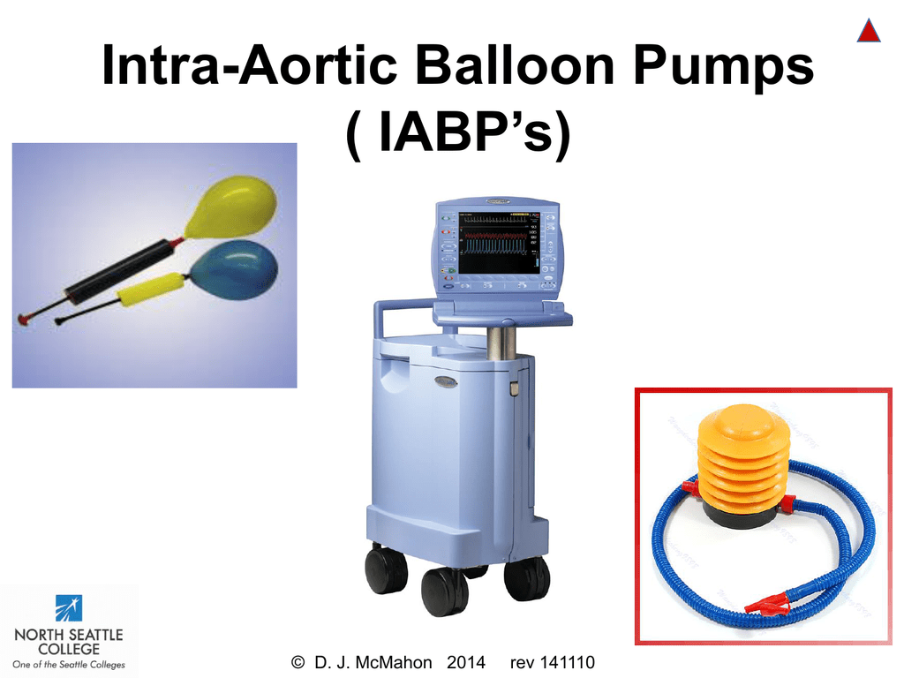
Fig 1: Intra-aortic balloon pump
PRIMARY EFFECTS OF IABP:
Increasing diastolic pressure will result in increased coronary perfusion, which can increase the amount of oxygen delivered to the heart tissue. Reduce the need for myocardial oxygen: By lowering the end diastolic pressure (Afterload), which lowers systolic pressure (APSP), the left ventricle will have to work less hard to pump blood into the aorta. (Sudden deflation creating a space in the aorta helps shift the volume from the left ventricle, which decreases the Afterload. This will completely empty the volume from the left ventricle (improving cardiac output) and so will decrease the wall tension inside the ventricle, and reduce the load on the heart, resulting in less oxygen being required ^{[3]}.
SECONDARY EFFECTS OF IABP:
- Decrease heart rate.
- Increase in cardiac output.
- Decreasing systemic vascular resistant.
- Decreasing the left ventricle end diastolic pressure.
- Increasing mean arterial pressure, that will lead to an improvement of the perfusion to all organ.
- Reduces mitral valve regurgitation.
- Increases LV ejection.

IMPACTS ON FURTHER SYSTEMS:
- Renal: increasing urine production and renal perfusion.
- Neuro: improving the brain perfusion and the mental condition.
- Respiratory: improving respiratory performance by lowering the pressure on the pulmonary capillary wedge and the pulmonary diastolic pressure in an artery.
- Vascular: lowering vascular resistance throughout the body and boosting the perfusion of the periphery.
INDICATIONS:
Cardiogenic shock, Pre-shock syndrome, Threatening extension of myocardial infarction, Unstable angina, Intractable ventricular arrhythmias, Septic shock syndrome, Cardiac contusion, Prophylactic support for: Coronary angiography, Coronary angioplasty, Thrombolysis, High risk interventional procedures such as stents.
COMPLICATIONS:
- Aortic wall:
- Dissection
- Rupture
- Local vascular injury
- Emboli:
- Thrombus
- Plague
- Air
- IAB rupture:
- Helium embolus
- Catheter entrapment
- Infection:
- Obstruction:
- Malposition
- Compromised circulation due to catheter causing ischaemia or compartment syndrome ^{[5]}.
BALLOON STRUCTURE AND POSITION
A thin polyurethane balloon attached on a catheter makes up the intra-aortic balloon catheter. Either surgically or percutaneously, the balloon catheter is introduced into the patient's aorta by passing it up through the femoral artery and into the descending aorta. The descending thoracic aorta, directly distal to the left subclavin artery, is the best location for the balloon. The balloon is perfectly positioned so that the intersection of the descending aorta and the aortic arch is where its tip should be. This reduces the chance that the balloon will occlude the renal artery and encourages the evacuation of blood from the proximal aorta. The balloon catheter is then attached to a console that inflates and deflates the balloon by transferring helium in and out of the balloon ^{[1]}.
The balloon helps the heart in two different ways:
1. To improve coronary perfusion, it raises aortic pressure during diastole.
2. To reduce the strain on the heart, it lowers aortic pressure during systole. ventricular left.
The balloon's inflation and deflation are used to achieve this. The helium will systole and diastole, respectively, and be inflated. Inflating the intra-aortic balloon has the following main effects: myocardial oxygen demand while increasing oxygen supply.
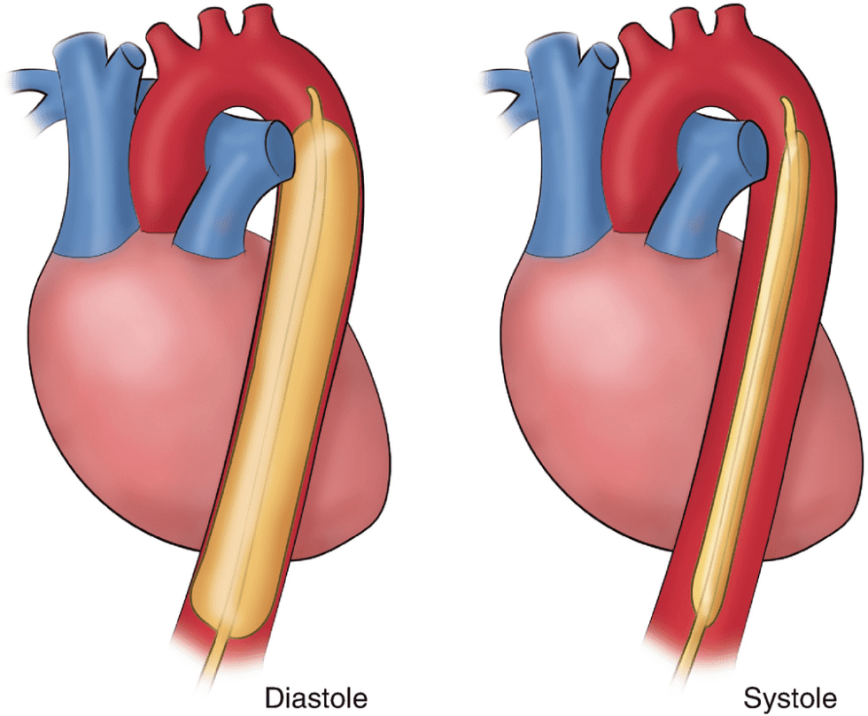
Fig 2: Balloon inflation and deflation.
ASSESSMENT OF TIMING
To provide the patient the full advantage, the balloon pump needs to be timed precisely. The diastole phase is used to fill the balloon. When the left ventricle relaxes and the aortic valve closes, diastole starts. During this phase of the cardiac cycle, the heart is not pumping blood forward. The balloon's inflation at this moment won't prevent blood from flowing forward. The dicrotic notch on the arterial pressure tracing indicates that the aortic valve is closed. The balloon's inflation is timed to happen at the arterial pressure trace's dicrotic notch. Diastolic pressure is increased as the balloon expands, improving coronary artery blood flow and myocardial oxygenation. Aortic valve opening requires deflation of the balloon ^{[8]}.
TIMING PRINCIPLES FOR INFLATION AND DEFLATION
The IABP is scheduled to expand after the aortic valve closes, during the diastolic part of the cardiac cycle. Inflation should precisely take place at the position of the dicrotic notch when a central aortic root arterial line is employed. To account for delayed waveform transmission when using a peripheral artery line, time must be significantly modified (see the operation handbook for details).is the pressure at the end of the aorta. The pressure inside the proximal descending and ascending aorta suddenly rises during inflation. Additionally, as the balloon is inflated, the distal blood flow is increased ^{[4]}. This typical physiological occurrence takes place when the blood bolus discharged from the left ventricle enters the aorta and causes aortic wall distension. The elastic walls of the aorta rebound, compressing the volume of the aortic blood before the subsequent systolic ejection. This encourages blood to move forward, leading to continuous diastolic blood flow. IAB inflation causes the aorta wall to stretch and distend more, which results in more elastic recoil when the balloon deflates and improved forward blood flow.
The end result of IAB inflation is elevated diastolic perfusion pressure and enhanced circulatory flow in an omni-directional pattern, benefiting both coronary artery and systemic perfusion.
The IABP is timed to deflate just before and throughout the systolic period of the cardiac cycle in order to prevent impedance of blood flow from the left ventricle and reduce afterload. Right before systolic ejection from the left ventricle, the IAB deflates. The abrupt drop in aortic pressure creates a vacuum-like effect that lowers systemic vascular resistance (SVR) and improves blood flow. The afterload or isovolumetric contractile force of the left ventricle is also decreased as a result of this impact. As a result, the myocardial oxygen consumption and IABP-assisted peak systolic pressure are decreased. Both the impacts of inflation and deflation boost cardiac output. Myocardial performance is improved by increased coronary artery perfusion, while afterload reduction reduces performance ^{[7]}.

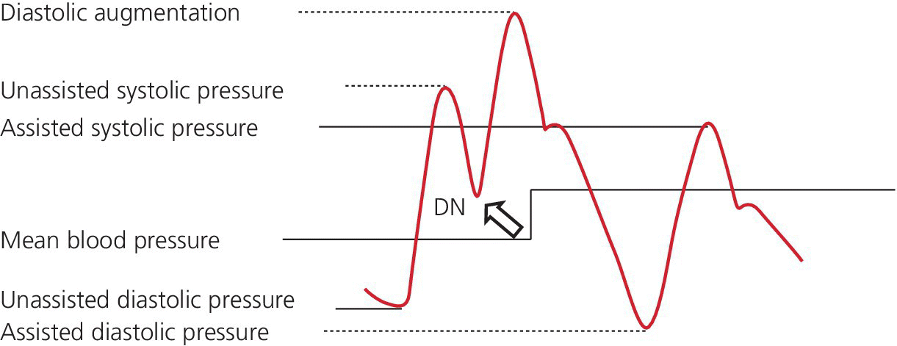
Fig 3: Dicrotic notch.
CONCLUTION
In patients with persistent cardiac failure following cardiopulmonary bypass, in the peri-infarct period, or while treating complications of coronary artery angioplasty, intra-aortic balloon pump therapy is frequently life-saving. The majority of IABP patients are under the direct supervision of an anaesthesiologist, who must have a complete awareness of the apparatus, its physiological effects, and any potential consequences, directly asses cardiac output.
REFERENCES
1. American Heart Association Heart Facts, 1981. Dallas American Heart Association, 1986
2. Bregman D: Intra-aortic balloon counterpulsation, in Iunescu M (ed): Techniques of Extracorporeal Circulation London, Butterworths, 1982, p 521
3. Moulopoulous SD, Topaz S, Kolff WJ: Diastolic ballluon pumping (with carbon dioxide) in the aorta-a mechanical assist to the failing circulation. Am Heart J 631699, 1962
4. Kantrowitz A, Tjonneland S, Freed PS, et al: Initial clinical experience with intra-aorta balloon pumping in cardiogenic shock. JAMA 203:135,1968
5. Bolooki H: Clinical Application of Intra-Aortic Balloon Pump (ed 2). Mount Kisco, NY, Futura Publishing, 1984
6. Murphy DA, Craver JM, Jones EL, et al: Surgical management of acute myocardial ischemia following percutaneous transluminal coronary angioplasty. Role of the intrapaortic balloon pump. J Thorac Cardiovasc Surg 87:332- 339, 1984
7. Park SB, Liebler GH, Bunkholder JA, et al: Mechanical support of the failing heart. Ann Thorac Surg 42:627-631, 1986
8. McGee MC, Zillgitt SL, Trono R, et al: Retrospective analysis of the need for mechanical circulatory support (intra-aortic balloon pump/abdominal left ventricular assist device or partial artificial heart) after cardiopulmonary bypass. A 44 month study of 14,168 patients. Am J Car&o1 46:135-142, 1980

