Artificial Intelligence for Sustainability: Opportunities and Challenges in Urban Solid Waste Management
Jithendra S¹, Jagdish H Godihal² Arpita C Patil³
¹Research Scholar, Civil Engineering Department, Presidency University, Bengaluru
²Professor, Civil Engineering Department, Presidency University, Bengaluru
3Assistant Professor, Architecture Department, Acharya Institute of Technlogy, Bengaluru

Abstract: Artificial intelligence (AI) can address some of our time's most urgent social and environmental issues. This article investigates the benefits and constraints of employing artificial intelligence for social good and sustainable development. We examine current literature and case studies to demonstrate the potential uses of AI for social and environmental effects, such as resource allocation optimization, disaster response improvement, and public health system enhancement. We also identify major problems, such as privacy and bias concerns, and emphasize the importance of responsible AI practices and ethical frameworks. Finally, we argue that while AI has immense potential to promote social good and sustainability, its success will be dependent on a careful and ethical approach to its development and implementation. We look at how artificial intelligence is being used in Garbage can be detected and sorted with precision from 72 to 99% using AI. By combining machine learning and physicochemical analysis, Garbage burning, carbon emission estimate, and recreation of energy are all improved. By combining artificial intelligence and chemical analysis, waste pyrolysis, carbon emission estimate, and energy conversion are all improved. And Talk about how AI may improve productivity and lower costs in waste management systems for smart cities.
Keywords: Artificial intelligence (AI), Garbage, waste management.
- Introduction
Providing uniform access to affordable sanitation services is a challenge for most of the administrations today. Artificial intelligence (AI) has risen to prominence in recent years due to its potential to alter sectors ranging from healthcare to banking to retail. One of the most fascinating areas of AI study, however, is its potential for social good and sustainability. AI can transform the way we address some of our most critical social and environmental issues. It may, for example, assist governments and non-profits in optimizing resource allocation, improving disaster response, and improving public health systems. However, there are worries about AI's potential misuse, notably in terms of privacy and prejudice. We examine the benefits and difficulties of applying AI for social good and sustainability in this article. Waste management is one industry that is increasingly embracing artificial intelligence, which is a fast-developing technology. Automation and artificial intelligence in urban waste handling plant design and operation have the potential to transform the way SW is treated, resulting in more effective operating processes and ecologically friendly waste management strategies. Several developed countries, including Austria, Germany, New Zealand, the United States, the UK, Japan, the city of Singapore, Switzerland, South Korea, and Canada, have already begun to implement artificial intelligence technologies to maximize resource utilization, efficiency, and reusing chances spread across the SWM cycle.
In summary, this paper examines prospective applications of AI in garbage management and provides a summary of the numerous waste types, their formation, and related issues. Automated dustbin mechanisms, garbage-sorting robots, sensor-based trash monitoring, and waste-generation forecast models are examples of these applications. The article additionally addresses how AI may be utilized to recognize and minimize illicit disposal and waste treatment practices, optimize the planning and delivery of recycled material, track and identify recyclables throughout the process of recycling, and examine the waste's chemical composition. One of the paper's standout achievements is the application of machine learning and waste chemical analysis to enhance the conversion process of rubbish into energy. The core concepts of AI in the handling of garbage are illustrated.in Figure 1.

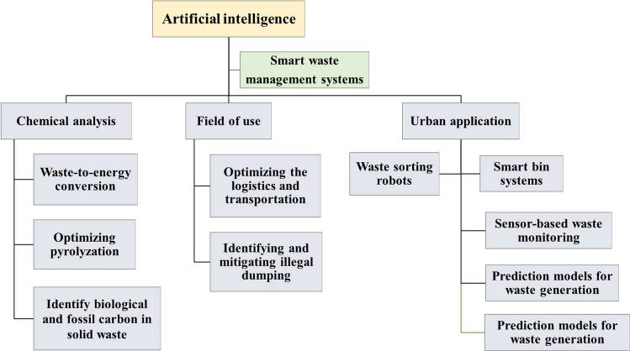
Fig.1: Fundamental ideas of AI in SWM
AI use in garbage management. The above flowchart highlights 5 essential concepts: type of Garbage, artificial intelligence's use in waste management, AI-based waste transportation optimization, the use of AI to detect and reduce unlawful disposal and waste treatment procedures, as well as the application of AI to evaluate physicochemical analyses of garbage are all examples of AI applications. This optimized portrayal summarizes the key principles discussed in this research simply and quickly, as well as highlights how AI possesses the potential to change existing SWM practices.
- Types of waste production in rural areas
Garbage is a serious environmental concern due to its proclivity to damage the water air, and land. The majority of its sources are due to human activities such as industrious output, construction, farming, emission of pollutants, consumption, and waste disposal. This might lead to resource depletion, health risks, economic losses, environmental damage, and higher Garbage management costs. To point out these problems, Governments and businesses have adopted waste management strategies like composting, recycling, and reusing, utilizing sources of clean energy, and deploying green technology. Community education and awareness programs may also help to reduce waste output and motivate individuals to make more environmentally friendly decisions. The classification of waste is as follows.
- Household Hazardous Waste (HHW)
- Construction and Demolition Debris.
- Industrial/Commercial Waste.
- Hazardous Waste Lamps.
- Regulated Medical Waste.
- Used Electronic Equipment.
- Used Oil.

Solid trash, hazardous waste, liquid waste, organic waste, and recyclable waste are the different categories of garbage, according to the waste states. Recycling, incineration, and landfilling are the three treatment options for solid waste, which is mostly produced by human activities including industry, agriculture, and mining. Construction, residential, industrial, hazardous, electronic, medical, and agricultural waste are all examples of solid waste. Hazardous waste is made up mostly of electronic and biomedical waste, which is poisonous, flammable, combustible, radioactive, and corrosive waste. Examples of liquid waste include trash containing hexavalent chromium, mercury, cyanide, corrosive and alkaline liquids, and heavy metals. Corrosive and alkaline liquid waste accounts for 12.4% of the total, followed by organic liquid waste at 32.2% and heavy metal liquid waste at 47.9%. The majority of liquid waste becomes hazardous industrial waste if the proper controls are not implemented, which may have a substantial detrimental impact on the environment and public health. Waste that can be separated from the garbage stream and utilized as a source material to make new items like paper, glass bottles, and ceramics is referred to as recyclable waste.
- Smart bin systems
Traditional garbage cans only collect rubbish, and sanitation employees must do manual checks to determine the volume of trash in the cans. This method is ineffective for normal trash disposal inspections. Furthermore, because the containers are often filled, disease-causing germs and insects proliferate on them. As a result, building intelligent waste bin tracking systems to manage trash is critical in the development of smart cities.
Several investigations on smart garbage cans have concentrated on 2 important things: autonomous waste sorting and observing. These researches provide a possible alternative for cities seeking an efficient rubbish-collecting system. A bot bin may be developed by using the Espressif systems module's system on a chip, which automatically detects things and sets limits within the bin. The collected data can then be sent to another node for additional processing and analysis. Consider the design of a garbage can, which has two primary points: the trigger pin, which is connected to the sensor, and the echo pin. The front and back of the cover each include an ultrasonic sensor. Created a trash robot bin with two sensors installed at the bottom, which moves along a straight line.
The study on garbage Cans focuses primarily on automatically tracking the degree of garbage filling and updating customers in real-time. Data is largely collected by sensors and delivered over the network. Intelligent bin systems can improve waste collection efficiency, prevent disease transmission, and improve the city's general ecology. Yet, the prices of integrating smart garbage cans are rather high, making widespread promotion difficult. To solve this problem, the government might explore sponsoring programs that would lower the price of intelligent trash cans, making them more affordable to the general people. Moreover, external elements like humidity and temperature might have an impact on the normal operation of these bins.

- Waste-sorting robots
Rubbish categorization is a top priority for municipal garbage management, and deploying robots may significantly improve rubbish classification efficiency. To perform in extremely varied, complicated, and unpredictable industrial contexts for rubbish categorization, robots require superior visual and operational abilities. New research has concentrated on enhancing the precision and effectiveness of trash-categorized robots, which necessitates the invention of good sensors and cameras to recognize various forms of garbage, as well as enhanced AI algorithms for waste categorization. A possible technique is to use hyper spectral pictures to find the targeted region of interest. According to earlier research, robots can handle difficult field situations by using simultaneous mapping and localization technologies as well as instance segmentation approaches.
Researchers are now looking for ways to incorporate garbage-sorting robotics into current systems for handling waste, such as using bots to differentiate rubbish before it is disposed of at sites. In this respect, studies have proposed an alternative robot model, with the main concept centered on a grasping device that fully integrates into a 4-degree freedom-like bot framework. Researchers are also investigating the use of optical sensors to enhance the effectiveness of waste-sorting bots. An example, a garbage-sorting bot that can reliably recognize and classify different sorts of rubbish has been constructed utilizing deep learning algorithms and optical sensors.
Finally, Garbage sorting machines have the potential to considerably improve SWM efficiency, reduce labor costs, and improve refuse categorization precision. Some contend, nevertheless, that garbage sorting bots are unfeasible because of their high setup and upkeep costs when compared with conventional garbage sorting techniques. Nonetheless, researchers are investigating more cost-effective methods of developing waste-sorting machines, like using cheaper components or building bots that can operate in a variety of environments. Efforts are also being made to enhance the bot's structure, sensors, garbage categorization computations, and robotic arms to render it more successful and efficient. Waste-sorting devices are still going to be of considerable interest and will play an important role in real-world applications going forward.
- Artificial intelligence in Garbage management
As increasing the efficiency of garbage collection, processing, and categorization, the use of AI has the potential to usher in an overthrow in SWM. Intelligent garbage cans, categorization bots, predictive models, and wireless detection are examples of artificial intelligence-based technologies that make it possible to monitor waste bins, forecast waste collection, and improve the efficiency of waste processing facilities. Municipalities may cut costs, increase safety, and lessen the environmental effects of trash management by utilizing artificial intelligence.
The use of artificial intelligence in trash management, automated trashcans, trash-sorting machines, and prediction models are some of the most prevalent uses of AI in waste management. Sort and compare the total of essential data to determine the conclusions reached.
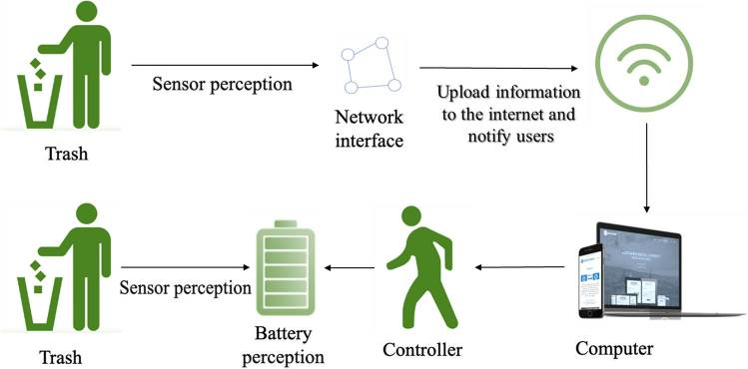
Fig.2: An ordinary wireless sensor network structure for a SWM
In the above fig 2 is a structure of a typical network of wireless sensors for a SWM system. On the garbage can, a sensor has been attached. At the time garbage enters, the sensor may collect data such as smell, weight, and humidity to categorize it. At the same time, it can detect the surroundings of waste bins and monitor garbage bin filling levels. Users may view the status of the rubbish bin on the platform in real-time as data is posted across the world.
The effect of the 2019 coronavirus illness (COVID-19) on the handling of waste. The pandemic of COVID-19 has had a substantial impact on the type, time of day, and prevalence of trash discarding. It has also raised the public's danger of infection owing to the creation of masks and surgical instruments that require physical handling. These variations in trash quantities have complicated and interconnected consequences for urban garbage management. The rapidly expanding volume of medical waste has created more substantial obstacles to various areas' discarding infrastructure and management skills since the onset of the new coronavirus (COVID-19) pandemic. Medical waste has elements of geographical contamination, acute illness, and latent infection, all of which can damage human health. It can also have serious repercussions for soil, lakes and rivers, and the environment. As seen in Fig. 3, coronavirus disease 2019 (COVID-19) alters waste composition and disposal efficiency while increasing the risk of infection in the community. Modern smart garbage management methods, such as AI-powered picture categorization and accurate item recognition, can minimize human interaction in solid waste management.
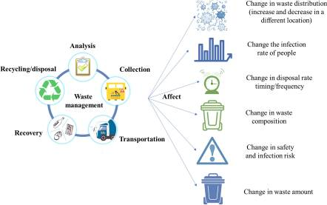

Fig.3: Waste composition and disposal efficiency for a SWM

- Field of Study:

The Geo-code or village code for Billur village is 623930, as per data from the 2011 Census. The village of Billur is situated in India's Karnataka state's Bagepalli Taluk in the Chikkaballapur district. It is located 76km from the district headquarters in Chikkaballapur and 34km from the tehsildar office in Bagepalli, the sub-district headquarters. According to data from 2009, Billur village also has a gram panchayat. The village has a total area of 419.58 hectares. 1,532 people are living in Billur, 785 of whom are men and 747 of whom are women. The community of Billur contains roughly 383 homes. Bagepalli, which is 34 kilometers away and the closest town to Billur for all significant economic activity, is listed in the following table by demographics.

Fig.4. District Map (Circle showing the location of Billuru)

Climate: The rainy season in Chikkaballapur is warm, muggy, and cloudy, while the dry season is hot and partially cloudy. The average annual temperature ranges from 59 to 94 degrees Fahrenheit, rarely falling below 53 or rising over 100. From March 10 to May 22, the hot season, with an average daily high temperature exceeding 91°F, lasts for 2.4 months. At Chikkaballapura, April is the hottest month of the year, with an average high of 94°F and a low of 72°F. From October 7 and January 11, which is the length of the cool season, the daily high temperature typically falls below 82°F.

Groundwater level: From field level observation and surveys it was found out that borewell depth in the village was around 400 – 500 feet below ground level. Below is a map of the groundwater levels across Karnataka (Source: KSNDMC, June 2020). The average depth of groundwater in the district is found to be less than 60 mg.

Soil type: Soil type in this region is a mixture of red loamy and sandy soil.

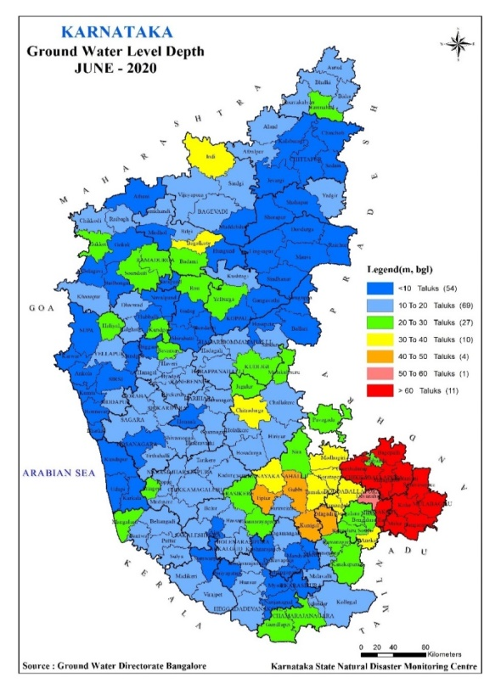

Fig.5: Karnataka groundwater level Map (Circle showing the location of Billuru)

- PROPOSED SYSTEM
The IoT, Android, web, and cloud concepts are the foundation of the technology
Structure of the System
Smart Bins: The bins will be equipped with a few sensors so that the garbage collector can get updates on their state. On the admin side, the bins' data will be gathered and stored in a cloud database, which can then be accessed
GPRS Vehicle Tracking- Garbage collection vehicles may be monitored using a GPS module and RFID tags. Once the vehicle arrives at the location of the dustbins, the RFID tags attached to the vehicle and the dustbins read and send an indication of their position to the cloud. The user's application and the administrator's dashboard will both get data from the cloud.
Android Application- The application for Android will serve as a conduit between consumers and others involved in municipal cooperation. The user may be given access to services like garbage truck tracking, daily social cleaning activities, and the ability to communicate with residents. Users may also speak out against problems they are experiencing in their area. People can even provide the administration recommendations for improved ways to combat the struggle for waste management. Additionally, the customer now has the option to reserve the garbage truck to pick up rubbish from their location on a user-pay basis.
Hardware Units

    - GPS- GPS stands for Global Positioning System a satellite-based guidance system that tells you where you are and guides you there. The three parts of GPS are the space, control, and user sections. The three parts of GPS are as follows. GPS devices are used to both monitor the location and map the route to a certain spot. To follow the car's location and trajectory, we have installed a GPS module and tracker. In this project, a global positioning system will be permanently installed in the car.
    - IOT- The term "Internet of Things" (IOT) describes a system where an object is linked to a network and can transport data and gather data with the assistance of the web without the involvement of people. Our solution uses IOT to gather data from the source and send it to the intended location. These devices will be installed in the trash cans to gather data about the trash can and tell the end users, such as whether the trash can is full or overloaded or if vehicles are required to arrive or not.
    - RFID TAGS and RFID READER- RFID is a technology that uses radio frequency waves to read, gather, and send data. It is made up of a tag and a reader, with the tag tied to the specific item. Additionally, the reader can read radio-frequency waves and gather data via an antenna. Here, the reader is also referred to as a data receiver and the tag is also referred to as a data transmitter. Due to its wireless nature, it can read and gather data at distances ranging from 12 meters to 100 meters, depending on the active and passive RFID tags used. In our project, we have utilized this technology to detect the truck and note whether it was there to collect the rubbish or not.
Software Unit-
    - The working version is being built in sections, such as the web application for the admin panel, which is being built with the newest tools like ReactJS, NodeJS, and AWS. Additionally, there will be two distinct applications, one for regular society users and the other for waste collectors. Additionally, the Flutter programming platform and Node js were used to construct the Android application.
    - REACTJS - The finest tool for creating web apps is ReactJS.
NODEJS - Utilizing to create the backend code.
FLUTTER - Flutter for the consumer experience of app development.
GOOGLE MAPS - The purpose of Google Maps is to provide users with the ability to track and virtually view the status of their vehicles.
AWS CLOUD SERVICE - AWS for the cloud service for database management.

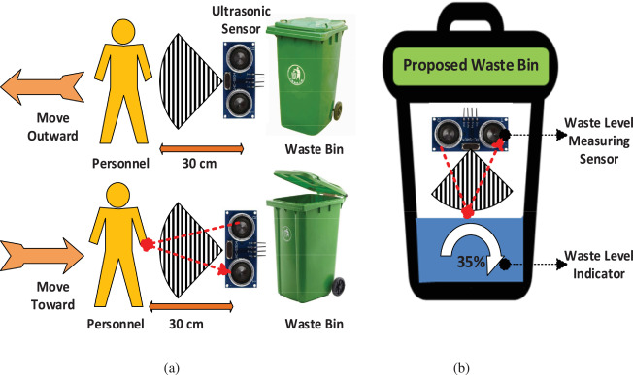
Fig.6: Sensor and indicators working Flow chart

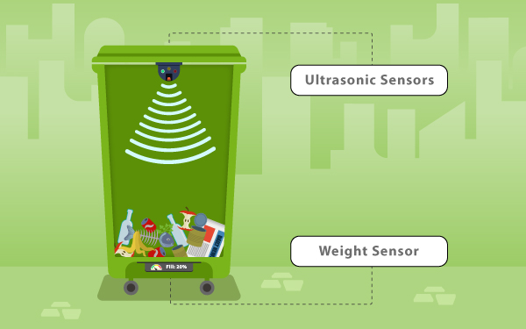
Fig.7: Use of smart bin sensors
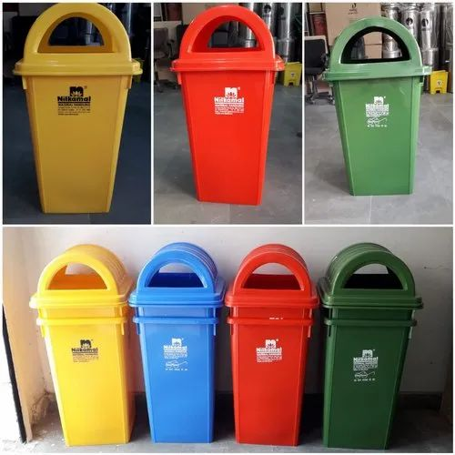
Fig.8: Dustbins distributed at Billuru GP

Functional Prerequisites-
      - Reports (login, dashboard) - The initial screen of the average user's app will have a login and register page, and upon successful login or registration, the user will be forwarded to the app's dashboard, where he or she can take advantage of features like tracking the garbage vehicle, the booking feature and reporting specific issues via the application
      - Garbage collector app - A different application is for the person who collects garbage, who may use it to accept bookings for rubbish collection from anywhere and keep track of the amount of trash in the bins
      - Admin Panel - The administration area will be created and built in such a way that the admin can quickly follow the information about the workers in one place. fundamental features such as bins waste collection level tracking, garbage collector truck tracking, and complaints for any concerns brought by the public using an application

- Discussion:
The potential for AI to make a significant contribution to social good and sustainability is widely acknowledged. However, the technology poses important challenges that need to be addressed. There are aspects of AI development that must be addressed to enable and enhance its potential as a social good and sustainability agent. One potential solution is to develop responsible AI practices that focus on the ethical and accountable deployment of AI tools. This could involve ensuring that AI systems are transparent, explainable, and less biased. It could also involve creating frameworks to address the social and ethical implications of AI applications, such as the potential for job displacement. The European Commission sets guidelines and recommendations for AI that contribute to a trustworthy and ethical AI. Another important solution is to prioritize the development of AI for social good and sustainability as a key area of research. This could involve investing in research and development to develop AI solutions that are tailored to the unique needs and challenges of social and environmental initiatives. It could also involve building partnerships between governments, non-profits, and the private sector to promote the development of innovative solutions that leverage AI for social good.
Artificial intelligence technologies can assist in minimizing the consumption of natural resources without lowering living standards by improving sustainable waste management. This ensures a reduction in the generation and disposal of solid waste, hence lowering the negative impacts on both people and the environment. Around the world, recyclable materials are being created at a far lower pace than solid garbage, and this trend is expected to continue. By merging artificial intelligence technology for intelligent recycling, garbage classification, and disposal in developed as well as developing nations, municipal solid waste management may be enhanced, leading to more ecologically friendly recycling practices.
A crucial step in developing and implementing a strategy roadmap is managing the creation of solid waste. Artificial intelligence (AI) may be used to properly anticipate the age of solid waste, which is essential for effective municipal solid waste management. Automated, intelligent devices that can multitask and sort a lot of solid trash are replacing traditional waste-sorting methods. These gadgets are extremely independent in computer vision programs, have artificial intelligence, and can distinguish between different types of solid waste. Rural garbage is sometimes referred to as "municipal waste," and some waste kinds falling under this heading need particular care and management because they are flammable, poisonous, or polluting, endangering the health of the people and the quality of life. Waste that is dangerous, poisonous, or harmful to human health or the environment at the municipal level needs to be handled carefully. This includes waste generated by operational processes like burning ash, untreated wastewater, hazardous enzyme oil, garbage, metal scrap, concrete waste, ceramics trash, ash, dirt, animal manure, livestock, cereals dust, manufactured garbage, content utilized for urban waste management, menstrual waste, and menstrual waste production. Each of these wastes possesses to causes harm, is harmful to the surroundings, or harbors infectious pathogens that might cause harm to humans. Sensor-based trash monitoring is a strategy that uses sensors to monitor the amount of rubbish created, identify waste sources, and evaluate how effectively waste management techniques are functioning in a specific site. A wireless sensor array is an arrangement composed of multiple autonomous wireless detectors that are put in the network to monitor the physical or environmental properties of the system. A typical wireless sensor network design for solid waste treatment systems is shown in Fig. 2, and it consists of a variety of sensors, including ones for temperature, humidity, odors, infrared, gas, and sound. Increase the effectiveness of trash management

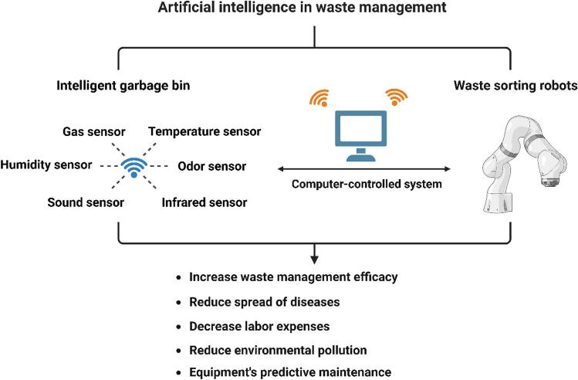
Fig.9: Network of wireless sensors designed for solid waste treatment systems
- Process efficiency
It is reasonable to conclude that incorporating artificial intelligence into the handling of waste can reduce costs while increasing efficiency. However, there are still drawbacks, such as issues with the black box, insufficient data, or a lack of specialized AI SWM models. Figure 3 displays three potential barriers to using AI in waste management.

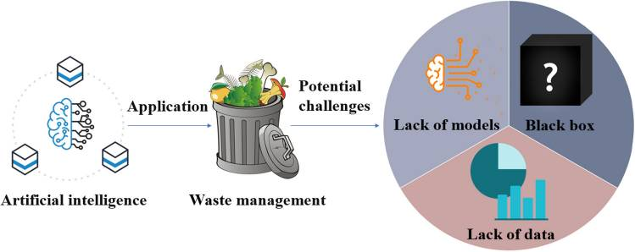

Fig.10: Depicts three possible impediments to the use of AI

Three challenges with AI in SWM. The difficulties associated with employing AI in the disposal of waste may be summed up as black box concerns, an absence of information, and a paucity of appropriate models. The complexities of AI models, known as black boxes, render it difficult for researchers to fathom their functions. The term "Facts shortage" refers to a lack and inadequacy of data in the SWM sector, which makes training AI models challenging. Finally, due to a scarcity of appropriate models, the majority of current AI applications related to garbage disposal rely on earlier models rather than unique models specifically designed for SWM

- Conclusion:

AI has enormous potential to make a positive contribution to social good and sustainability, but its success will depend on a thoughtful and responsible approach to its development and deployment. Governments, non-profits, and businesses must work together to develop responsible AI practices and ethical frameworks that focus on the social and environmental impact of AI. By doing so, we can unlock the full future of AI to address some of the most pressing social and environmental challenges of our time.
Inefficient garbage disposal causes significant ecological pollution, exorbitant prices, and an absence of management in the procedure for disposing of waste. SWM is a problem that both developed and emerging nations encounter. In contrast, AI has the potential to improve treatment efficiency, lower ecological impact, and provide arithmetic solutions for improved garbage management. The nine components of this research include terminologies and the use of AI in trash management. Through real-world applications including intelligent bin design, garbage sorting technology, and forecasted waste monitoring models, it pinnacle of the future influence of AI on waste management. The management of hazardous trash, the reduction of illegal dumping, and the recovery of valuable things from the waste stream may all benefit from the use of AI.
Despite the limitations of some algorithms, AI has the potential to improve SWM processes such as composting, recycling, landfilling, and pyrolysis. Data mining, AI, and deep learning approaches can simulate garbage-burning processes, forecast the levels of heavy metals in compost, and enhance trash categorization. Temperature, humidity, and light all have the potential to influence the handling of waste AI systems, resulting in oscillations. Despite these challenges, AI has the future to revolutionize how humans handle trash, leading to an environmentally friendly future with effective, financial, ecological, and cognitive waste management systems.

References
- Abbasi M, El Hanandeh A. Forecasting municipal solid waste generation using artificial intelligence modeling approaches. Waste Manag. 2016;56:13–22. doi: 10.1016/j.wasman.2016.05.018. [PubMed] [CrossRef] [Google Scholar]
- Abdallah M, Abu Talib M, Feroz S, Nasir Q, Abdalla H, Mahfood B. Artificial intelligence applications in solid waste management: a systematic research review. Waste Manag. 2020;109:231–246. doi: 10.1016/j.wasman.2020.04.057. [PubMed] [CrossRef] [Google Scholar]
- Abou Baker N, Szabo-Müller P, Handmann U. Transfer learning-based method for automated e-waste recycling in smart cities. EAI Endorsed Trans Smart Cities. 2021;5:e1–e1. doi: 10.4108/eai.16-4-2021.169337. [CrossRef] [Google Scholar]
- Abunama T, Othman F, Ansari M, El-Shafie A. Leachate generation rate modeling using artificial intelligence algorithms aided by input optimization method for an MSW landfill. Environ Sci Pollut Res. 2019;26:3368–3381. doi: 10.1007/s11356-018-3749-5. [PubMed] [CrossRef] [Google Scholar]
- Adnan RM, Yuan X, Kisi O, Yuan Y. Streamflow forecasting using artificial neural network and support vector machine models. Am Sci Res J Eng, Technol, Sci (ASRJETS) 2017;29:286–294. [Google Scholar]
- Ahmad I, Khan MI, Khan H, Ishaq M, Tariq R, Gul K, Ahmad W. Pyrolysis study of polypropylene and polyethylene into premium oil products. Int J Green Energy. 2015;12:663–671. doi: 10.1080/15435075.2014.880146. [CrossRef] [Google Scholar]
- Akdaş HŞ, Ö D, Doğan B, Bas A, Uslu BÇ (2021) Vehicle route optimization for solid waste management: a case study of Maltepe, Istanbul. In: 2021 13th International Conference on Electronics, Computers and Artificial Intelligence (ECAI): 1–6. 10.1109/ECAI52376.2021.9515129
- Akhtar M, Hannan MA, Begum RA, Basri H, Scavino E. Backtracking search algorithm in crop models for efficient solid waste collection and route optimization. Waste Manag. 2017;61:117–128. doi: 10.1016/j.wasman.2017.01.022. [PubMed] [CrossRef] [Google Scholar]
- Akpan VE, Olukanni DO. Hazardous waste management: an African overview. Recycling. 2020;5:15. doi: 10.3390/recycling5030015. [CrossRef] [Google Scholar]
- Alqahtani F, Al-Makhadmeh Z, Tolba A, Said W. Internet of things-based urban waste management system for smart cities using a cuckoo search algorithm. Clust Comput. 2020;23:1769–1780. doi: 10.1007/s10586-020-03126-x. [CrossRef] [Google Scholar]

