MACHINE LEARNING, DEEP LEARNING ALGORITHMS AND THEIR USES
ABSTRACT
Deep Learning has become a rapidly growing area of research and several promising research areas are expected to drive future advancements. This paper presents an overview of the algorithms, architecture, training techniques, and applications in deep learning. Deep Learning algorithms are categorized into two groups such as supervised learning and unsupervised learning. Deep understanding needs different learning algorithms for various network architectures. This paper will explore the basic concepts of deep learning and provide an overview of deep learning algorithms and their associated advantages and disadvantages. Then, it will explore recent state-of-the-art deep learning algorithms and their outstanding performance on various tasks. Finally, this paper provides a prominent standpoint on Deep Learning algorithms and future directions and opportunities for further research in deep learning.
Keywords:
Convolutional Neural Network, Recurrent Neural Network, Long Short-Term Memory, Evolved Gradient Direction Optimizer, Deep Belief Network.
INTRODUCTION
Machine learning algorithms are created to learn and acquire knowledge from data and improve their performance. The architecture of machine learning and deep learning is shown in Fig 1.1 and Fig 1.2
Fig. 1.2. Deep learning architecture
Deep learning is a subfield of machine learning, that has gained significant attention over the last decade. In Deep learning, the development of deep neural networks with more than three layers can learn hierarchical representations of data. Deep Learning involves the training of artificial neural networks with many layers of interconnected nodes, allowing them to automatically learn features and representations from large amounts of data.
The concept of deep learning is not new, but its recent popularity and success are due to a few factors. One factor is the growth of big data and the need for more advanced techniques to analyse it. Another factor is the development of more powerful hardware, particularly graphical processing units (GPUs), which can perform parallel computations needed for deep learning algorithms. In the application area, deep learning is often used for computer vision, speech recognition, and natural language processing.
Deep learning is often used for analyzing and processing large amounts of data for business intelligence, predictive analytics, and other data-driven applications. Deep learning algorithms are used in edge computing, and they can be trained on huge datasets and can learn to make accurate predictions from complex data. Deep learning is also used in cybersecurity and fraud detection. This paper aims to present a comprehensive overview of the existing algorithms and state-of-the-art algorithms in Deep Learning. We analyze the challenges and limitations of existing approaches and provide insights into future directions for Deep learning research.
OVERVIEW OF THE DEEP LEARNING ALGORITHMS
Convolutional Neural Network (CNN) is a feed-forward artificial neural network that uses convolutional layers to extract lower-level features from input images. In general, a CNN contains layers for convolution, pooling, and full connection. Recurrent Neural Network (RNN) is a type of neural network that can handle sequential input data, such as time-series data or natural language text and it comprises a recurrent layer, activation function, and fully connected layers. Particularly CNNs and Long Short-Term Memory (LSTM) have highly effective for image classification tasks, Outperforming other traditional techniques. CNN, RNN, and Deep Belief Networks (DBNs) have shown hopeful results not only in computer vision and speech recognition but also in various other fields including agriculture.
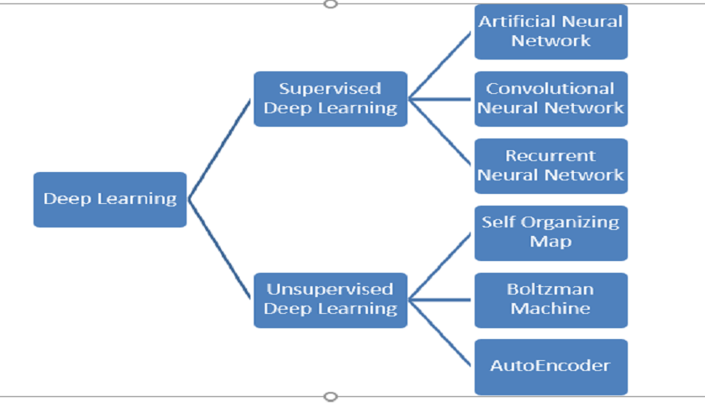
Fig. Deep Learning Algorithms
A CNN is used in agriculture for seed identification, pest detection, and identification of contaminants, and a Recurrent neural network is used for crop yield prediction and time series analysis. Though it is important to carefully design and train these models to avoid overfitting and ensure good generalization performance on new, unseen data. The prominence of having an appropriate dataset for increasing system performance. Combining CNN and LSTM networks performed better than using them alone and using multiple networks also increased performance. LSTM was able to learn long- term dependencies and the Bidirectional Encoder Representations from Transformers (BERT) model predicts the words from the undescribed text.
Multinomial naïve bayes algorithm used to classify the data. By hyper-parameter tuning, we can improve this classifier and it gives high accuracy on the same dataset after hyper-parameter tuning. Support Vector Machine (SVM) is a mathematical classification technique concentrating on increasing the edge between the instances and the separation hyper-plane. SVM, LSTM, BERT, and multinomial naïve bayes are classifiers to perform sentiment classification, though particularly LSTM and BERT deep learning techniques give high accuracy than machine learning techniques such as SVM, multinomial naïve bayes.
The prominent part of Deep Learning is the training algorithm for neural networks. Deep Learning has a higher number of layers, and each layer can be focused to extract particular features from data through training. In deep learning, multiple layers use to learn features and predict the label from the last hidden layer and fine-tune the feature detectors using back propagation without using label information.
Deep learning applications are trained to recognize patterns in a given dataset. Once the learning is complete, the model can then be used to make predictions on new instances of the same kind of data. The model uses the patterns it has learned during training to make these predictions. Researchers are facing a major challenge due to the extended duration required to train deep learning models.
The optimization algorithms are used to enhance the deep neural network by training and improving the performance of the network. A novel hyperplane evolving gradient direction optimizer is used to solve a vanishing gradient problem. Though there are some challenges in large-scale optimization.
COMPARISON OF PERFORMANCE AND LIMITATIONS OF DEEP LEARNING ALGORITHMS
The following table 1 shows the associated advantages and disadvantages of deep learning algorithms.
Deep Learning Algorithms Comparison Algorithm | Advantage | Disadvantage
Convolutional Neural Network | Outstanding performance on image and video data | High computational cost, and needs huge amounts of training data
Recurrent Neural Network | Can work well with sequential data | explosion gradient problems, slow to train
BERT | State-of-the-art performance in language understanding | High computational cost, and requires huge amounts of training data
Autoencoder | Useful for feature mining and | Overfitting Problem, needs huge

STATE-OF-THE-ART DEEP LEARNING ALGORITHMS
Following state-of-the-art deep learning algorithms that have reached outstanding performance on a variety of tasks.
- GPT 3 is a language model algorithm developed by OpenAI, it can achieve state-of-the-art performance in such as language translation, question answering, and summarization.
- AlphaZero is developed by DeepMind, it is a reinforcement learning algorithm, that can learn to play chess and shogi.
- ViT is a transformer-based CNN developed by Google, it has achieved performance in image classification and object detection.
- DeBERT a is a language model developed by Microsoft, it achieves a variety of NLP tasks.
- EfficientNet is a family of the convolutional neural network developed by google, it achieves image recognition tasks.
APPLICATIONS OF DEEP LEARNING
Machine learning is a buzzword in today's technology, and it is expanding at a rapid pace. We use machine learning in our daily lives without even realizing it, such as Google Maps, Google Assistant, Alexa, and so on.
Deep Learning is a component of machine learning that helps provide intelligent answers to complex issues. The structure and operation of the human brain serve as the foundation for Deep Learning. Artificial neural networks are used by deep learning to examine data and create predictions. It has applications in practically every business industry.
Chatbots:
Chatbots can quickly fix consumer issues. A chatbot is a text- or text-to-speech-based AI application for online communication. It can communicate with people and perform actions that would be performed by a human. Customer support, social media marketing, and instant messaging clients all often use chatbots. Automated responses are given in response to user input. It uses machine learning and deep learning techniques to generate several types of reactions.
Finance:
Deep learning has the potential to significantly transform the financial sector, with a variety of applications that can enhance customer experience, risk management, decision-making, and fraud detection. Fraud detection is one of the main uses of deep learning in the financial sector. To recognize fraudulent transactions, lower false positives, and increase accuracy, deep learning models can be developed. Financial companies may reduce losses by millions of dollars and increase client happiness and trust by using deep learning algorithms.
As was previously noted, risk management is one of the financial applications of deep learning. Large datasets can be analysed using deep learning models to find patterns and connections that help predict future hazards and spot potential opportunities.
Financial institutions may be able to lower their risk exposure and make better judgments as a result of this. Deep learning may also enhance customer happiness by increasing the precision and effectiveness of customer data analysis and behaviour pattern identification. Deep learning models, for instance, can be used to forecast customer attrition and deliver personalized offers and promotions to keep clients. Financial institutions' operations and client interactions may change as a result of deep learning, which is positioned to play an increasingly significant role in the industry.
Healthcare:
Deep Learning has found use in the healthcare industry. Deep Learning has enabled computer-aided disease identification and computer-aided diagnosis. Through the process of medical imaging, it is widely utilized for research in medicine, drug development, and the identification of life-threatening conditions including as cancer and diabetic retinopathy.
Entertainment
Companies like Netflix, Amazon, YouTube, and Spotify provide relevant movie, song, and video suggestions to its customers to improve their experience. Deep Learning has been accountable for all of this. Online streaming firms make product and service recommendations based on a person's browsing history, interests, and activity. Deep learning algorithms are also used to automatically generate subtitles and add sound to silent films.
News Aggregation and Fake News Detection
Deep Learning enables you to tailor news to the personas of your readers. You may collect and filter news material based on social, geographical, and economic characteristics, as well as a reader's personal preferences. Neural networks aid in the development of classifiers capable of detecting fraudulent and biased news and removing it from your feed. They also notify you about potential privacy violations.
Computer Vision:
Object Recognition: Identifying and classifying objects within images or videos, used in autonomous vehicles, security systems, and quality control in manufacturing.
Facial Recognition: Identifying and verifying individuals' faces, commonly used in security systems and authentication.

Image Captioning:
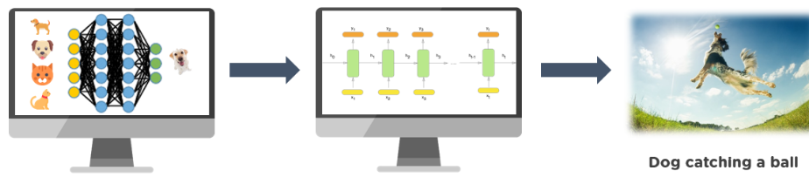
Image captioning is a technique for creating a textual description of an image. It employs computer vision to comprehend the image's content and a language model to convert the comprehension of the image into words in the correct order. To convert the labels into a comprehensible sentence, a recurrent neural network like an LSTM is used. Microsoft has created a caption bot in which you can upload an image or the URL of any image and it will display the image's textual description. description AI is another tool that offers a good description and hashtags for a photo.
Self-Driving Cars
Deep Learning is the driving force behind the concept of self-driving, autonomous autos. Deep Learning technologies are "learning machines" that use millions of data sets and training to figure out how to act and respond. To diversify its business infrastructure, Uber Artificial Intelligence laboratories are powering additional autonomous cars and creating self-driving cars for on-demand food delivery. Amazon, on the other hand, has used drones to deliver goods in certain parts of the world. The confusing issue with self-driving vehicles that the majority of its designers are addressing is putting self-driving cars through a range of scenarios to ensure safe driving. They have operating sensors that calculate the proximity of objects. They also navigate traffic using data from its camera, sensors, geo-mapping, and sophisticated models. Tesla is one popular example.
Virtual Personal Assistant:
We have several virtual personal assistants, including Google Assistant, Alexa, Cortana, and Siri. They assist us in discovering information using our voice commands, as the name implies. These assistants can aid us in a variety of ways simply by listening to our vocal commands, such as playing music, calling someone, opening an email, scheduling an appointment, and so on. Machine learning algorithms play a key role in these virtual assistants. These assistants capture our voice commands, transmit them via a cloud server, decode them using ML algorithms, and then respond as necessary
Human Resources:
- Resume Screening: Automatically screening and shortlisting job applicants based on qualifications and skills.
- Employee Engagement: Analysing employee data to improve workplace satisfaction and productivity.

Natural Language Processing
NLP, or Natural Language Processing, is another key subject in which Deep Learning is showing promising results. It is the process of teaching robots to study and interpret human language. However, keep in mind that human language is extremely difficult for machines to understand. Machines are inhibited from correctly grasping or generating human language not simply because of the alphabet and words, but also because of context, accents, handwriting, and other characteristics. Many of the difficulties associated with understanding human language are being solved by Deep Learning-based NLP by teaching computers (Autoencoders and Distributed Representation) to produce appropriate responses to linguistic inputs.
Detecting Developmental Delay in Children
Early detection of developmental disabilities in children is crucial since early intervention improves children's prognoses. Meanwhile, a growing body of research reveals a relationship between developmental impairment and motor competence, therefore motor skill is included in the early diagnosis of developmental disability. The diagnosis of a developmental issue, however, is often made through informal questionnaires or surveys to parents due to a lack of expertise and time constraints. Deep learning technology are making this possible. Researchers at MIT's Computer Science and Artificial Intelligence Laboratory and the Institute of Health Professions at Massachusetts General Hospital have developed a computer system that can detect language and speech deficits even before kindergarten
Automatic Machine Translation
In recent years, deep learning has transformed various disciplines. In response to these developments, the field of machine translation has moved away from previous techniques like rule-based systems or statistical phrase-based methods and toward the usage of deep-learning neural-based methods. Because of vast amounts of training data and unequaled processing capacity, neural MT (NMT) models can now access the entire information accessible anywhere in the source phrase and automatically comprehend which element is significant at which step of synthesising the resulting text. The major cause of the considerable improvement in translation quality is the deletion of traditional independence assumptions. As a result, neural translation was able to close the quality gap between human and neural translation.
Automatic Handwriting Generation
This Deep Learning program generates a fresh set of handwriting for a supplied corpus of a word or phrase. The handwriting is effectively given as a collection of coordinates that a pen used to create the samples. The connection between pen movement and letter formation is discovered, and additional examples are created.
Language Translations
Machine translation is gaining popularity among technological companies. This investment, combined with recent developments in deep learning, has led to major improvements in translation quality. Google claims that switching to deep learning resulted in a 60% increase in translation accuracy over the previous phrase-based technique used in Google Translate. Google and Microsoft can currently translate over 100 different languages with near-human accuracy in several of them.
Deep Dreaming
Deep Dream is a visualisation of neural network taught patterns. Deep Dream, like a kid studying clouds and striving to decipher random shapes, exaggerates and magnifies the patterns it discovers in an image. It does so by passing an image across the network and then computing the gradient of the image in relation to the activations of a specific layer. The image is then changed to magnify these activations, which improves the patterns recognized by the network and results in a dream-like visual. This strategy was dubbed "Inceptionism" (after Inception Net and the film Inception).
Fraud Detection
Another appealing use for deep learning is fraud detection and prevention; significant organizations in the payment system sector are currently experimenting with it. PayPal, for example, use predictive analytics technology to detect and prevent fraudulent conduct. The company claimed that evaluating user action sequences using neural networks' extended short-term memory architecture boosted anomaly detection by up to 10%. Sustainable fraud detection methods are critical for every fintech company, banking app, or insurance platform, as well as any organization that collects and uses sensitive data. Deep learning can make fraud more predictable and hence prevented.
Space Exploration:
Astronomy: Analysing vast amounts of astronomical data to discover new celestial objects and phenomena.
Planetary Exploration: Autonomous navigation and analysis for robotic missions.
Environmental Monitoring:
Climate Prediction: Modelling and predicting climate changes and their impacts.
Wildlife Conservation: Tracking and protecting endangered species through image analysis and sensor data.
CONCLUSION
In this chapter, we have covered the basic concepts of machine learning and deep learning, applications, and common architectures such as CNN, RNN and also discussed the advantages and disadvantages of different deep learning algorithms. We have highlighted the challenges that are still essential to be overcome. Further new ways need to help farmers in the agriculture sector because combining two tasks such as image classification and object localization in object detection still need improvement. Optimizer deep learning algorithms still have challenges and require improvement in large-scale optimization. So, in future deep learning research, a new way can be uncovered to solve problems and enhance performance to minimize human tasks in all domains.

