Understanding Indigeneity: People, Life, Culture, and Literature.
Prepared by:
Dr. Ancy Eapen
Supervisor / Researcher
Dept. of English
Jain deemed-to-be University
Bangalore
Ph: 7025234403
Email: ancyeapen2012@gmail.com

Introduction
The term 'indigenous’ implies belonging or originating in a particular place; with reference to populations, it categorizes people living in their original habitat as compared to settlers or nomads who come to settle in the same place later.
The three indigenous characteristics that make a group Indigenous:
-- a close attachment to ancestral territories and to the natural resources in these areas;
-- self-identification and identification by others as members of a distinct cultural group;
-- an indigenous language, often different from the national language;
Population can be indigenous, their culture, art and writings, cuisine, myths and belief system, rituals, physical appearance, and race. In most countries of the world, the indigenous population is marginalized from mainstream society. Yet they choose to survive in their natural habitat within the country of their origin. One of the reasons being the social cohesion: by virtue of their language, traditions, belief systems and race. Most tribal groups are formed on ethno-linguistics.
Most countries in the world have indigenous populations existing alongside the settler community. India has many such communities living in different states of the country. So also does, New Zealand, Australia, America, Iceland, and some countries in Europe. The nomenclature used for these indigenous people differ from place to place. They are referred to as Adivasi, Natives, Aboriginal people, First Nation, Janajati, hunter-gatherers or hill tribes.
In central India, the Scheduled Tribes are usually referred to as Adivasis, which literally means Indigenous People as the word adi in Sanskrit means ‘beginning’; vasi means ‘inhabitant.’ Therefore they are the original inhabitants of that land. The term ‘Adivasi’ is used to refer to ethno-linguistic minorities of the East, Central, West and South India. The term is a Sanskrit word coined in the 1930s by political activists to give the tribal people an indigenous identity by claiming an indigenous origin. In the 2011 census, it is estimated that India has a population of 10.4 crores of such tribes spread over different parts of the country. They comprise 8.6% of the total population.
The term is also used for ethnic minorities, such as the Chakmas of Bangladesh, Adivasi Janjati of Nepal, and Vedda of Sri Lanka. The Constitution of India, does not use the word Adivasi. Instead it refers to the category as Scheduled Tribes and Janjati. Though claimed to be one of the original inhabitants of India, many present-day Adivasi communities formed after the decline of the Indus Valley Civilization, carry various degrees of ancestry from ancient hunter-gatherers, Indo-Aryans, Indus Valley Civilization, Austroasiatic and Tibet-Burma language speakers. Ancestors of Munda people in India were migrants from South East Asia around 4000-3500 years ago.
Indigenous population- demography, life, and culture.
India is home to about 706 tribal groups and they constitute the second largest indigenous population in the world, after Africa According to research conducted on the development of India’s tribal-indigenous populations it has been discovered that this category has been historically excluded from mainstream society, culture and civilization. Social exclusion, as the case of these tribes clearly exemplifies, is not simply about poor material living conditions; it regularly draws pejorative moral judgments about those marginalised that work against a favourable reception of their problems, making it more difficult to find appropriate solutions for them.

As industries took away their lands, many communities were displaced and some continued to protest and struggle to protect their homes or demand a fair compensation. Inhabiting the remote hills and forests of India are isolated communities of people who have survived the ever increasing influence of urbanization. Recognizing their rights to forest areas and forest management practices is critical to understand their struggle for survival. Loss of forest cover, mining and the expansion of hybrid crops remain direct threats to food security of these people who count on forest resources and wild food. Their fight is over the natural resources of coal, oil, and forests. These tribal communities have traditionally controlled vast tracts of land and its resources, such as forests and coal, through well-established community institutions
The most commonly known tribes of India are Gonds, Bhils (or Bheels), Santhal, Munda, Khasi, Garo, Angami, Bhutia, Chenchu, Kodaba, and the Great Andamanese Tribes. Of all these tribes, the Bhil tribal group, as per the 2011 census, is the largest tribe in India.
Bhills are considered as one of the oldest tribe in India. Once they were the ruler in parts of Rajasthan, Gujarat, Malwa, Madhya Pradesh and Bihar. They are a cross section of great Munda race and a wild tribe of India. Bhil are one of the largest tribal groups, living in Chhattisgarh, Gujarat, Karnataka, Madhya Pradesh, Maharashtra, Andhra Pradesh and Rajasthan. The name is derived from the word 'billu', which means bow.
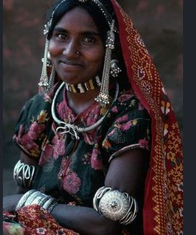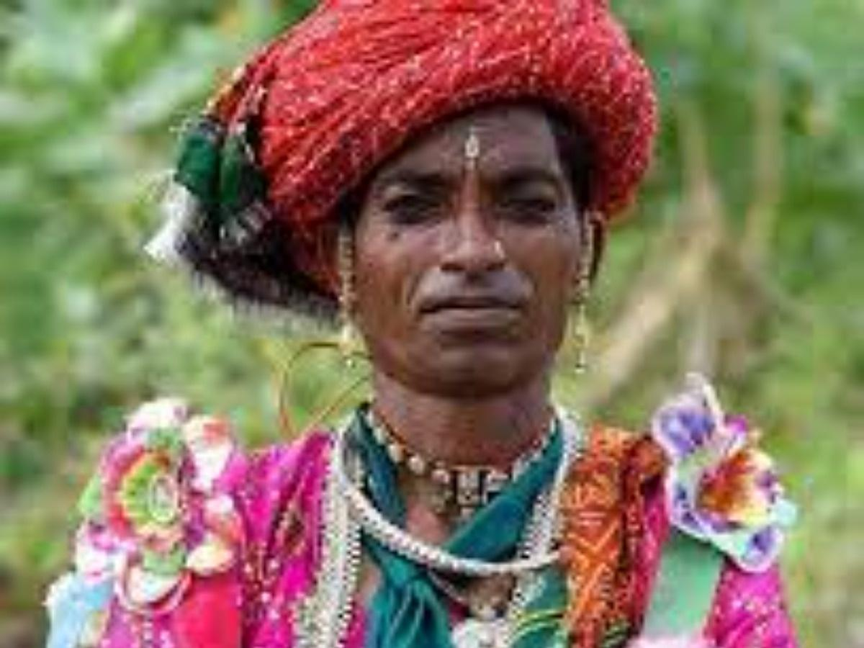
Bhills could be identified as one of the Dravidian racial tribe of Western India and belong to Austroloid group of tribes. They speak a language of Dravidian origin.
In Tripura total Bhill population is 3,105 as per 2011 Census. This tribe has migrated to Tripura from central India mainly from Bihar and Madhya Pradesh. Their economy is centralized with Tea garden, Brickfield and Agriculture. Their major concentrations in Tripura are mainly in Akinpur of Belonia, Bagan Bazar of Khowai Sub-Division. They are also found in North Tripura working in Tea gardens.
Bhills are Hindus by religion. They appease deities of forest and evil spirits beside pujas of Lord Shiva and Durga. Small percentages among them follow Christianity. They cremate their dead followed series of rites as per their traditional customs and believe.
Bhills are also fond of dance and music with traditional tune of Flute and Drum. In all family and community ceremonies they enjoy whole night by drinking and dancing. Bhills in other part of the country are well literate and enjoy modern weave of life.
Halakki Vokkaligas living in the foot of Western Ghats are known as the "Aboriginals of Uttara Kannada". Their way of living is still ancient. The women adorn themselves with beads and necklaces, heavy nose rings and distinctive attire. Halakki speak a different dialect of Kannada called as Achchagannada.
The word “Halakki” literally means milk (Haalu) and rice (Akki) in Kannada. The population of the Halakki tribe is 1.50 and they live in the four taluks of Uttara Karnataka.
The indigenous tribe of Karnataka are the Kudiya tribe. They belong to the State of Karnataka, and 2,169 individuals of this tribe live in the State, mostly in Kodagu district. The Kuruba inhabit the thickly forested slopes and foothills of the Nilgiri plateau in Kodagu district of Karnataka and Tamil Nadu States.
The Halakkis of Ankola, Karnataka.
Women in Shirkuli, a village in Ankola district, love glass bangles which they wear in their left hand. As they work they sing folk songs called janapada unaccompanied by instruments as they go about their daily chores. With no formal knowledge of music, these women sing to the same tune, mostly out of habit, to express their sadness, joy, anxiety or contentment. These women of the Konkan coast always carry chenche – a bag that holds their favourite pastime of betel leaves and areca nuts, chewed bwtween their hours of work. The bag is also used to hide money or precious objects like a small piece of gold.

The Soligas are a prime example of the exploitation and consequent misery of the indigenous population everywhere in the world. Soligas are an indigenous tribe of Karnataka, inhabiting the peripheral forest areas near Biligiri Rangana Hills and Male Mahadeshwara in Chamarajnagar district. Traditionally they have been dependent on the forests for their livelihood. The Soligas are also called the children of bamboo because the word is believed to mean that they originated from bamboo. The Soligas were dependent on hunting and shifting agriculture traditionally. The children learnt about forests and animals that their tribe worshipped. “We could easily identify over 50 different plant varieties in just one square foot of land,” said Achugegowda. Therefore they created history by becoming the first tribal community living in the core area of a tiger reserve in India to get their forest rights recognised.
Even today the Soligas are known for their intimate knowledge of the forests and judicious use of medicinal plants and non-timber forest produce like honey, gooseberry, lichen, tubers, etc. They are extremely good at identifying animals through pug marks and smells. But the Soligas were evicted and relocated, after the forests near BR Hills, as the Biligiri Rangana Hills are known, were declared a wildlife sanctuary under the Wildlife Protection Act of 1972.

Co-existing with big cats:
In 1974, the government declared BR Hills including the Biligiri Ranganatha Swami Temple area as BRT Wildlife Sanctuary. The government evicted many Soligas from the forests and relocated them in nearby plains.In 2011, the sanctuary was declared a tiger reserve. Almost every member of the Soliga tribe believes that it was a hasty announcement, without proper consultation and approval of the tribe that has ancestral rights over the region.
As far as 55-year-old Shivmallu can remember, there were hardly any incidents of conflict involving Soligas and tigers. The tribes worship the tiger as Huliverappa.“Over hundreds of years, we have successfully mastered the art of co-existing with tigers,” Shivmallu said. “It is we who first tend to sick animals, inform the forest guards of tiger and elephant deaths.”
Fight for forest rights: “Various forest laws had already put an end to our traditional practices such as hunting – for our own consumption – and taragu benki or low-intensity fires lit to control the reckless growth of invasive species such as lantana,” said Achugegowda. “In 2006, the forest officials restricted our access and collection of non-timber forest produce.”
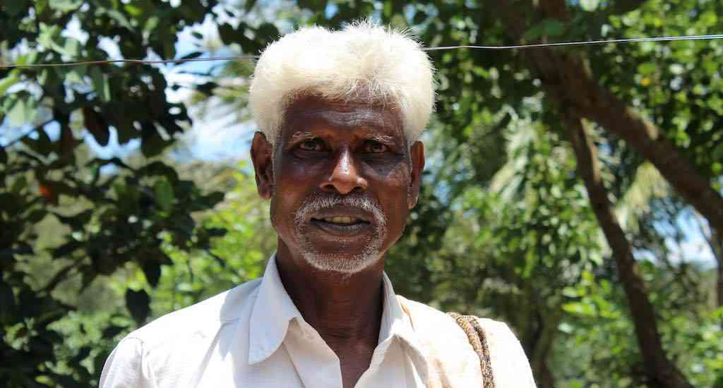Achugegowda, who has been at the forefront of the Soligas’ legal battle, says the tribe should be integrated into conservation efforts than be alienated. Photo Credit: Amoolya Rajappa
In 2008, the Soligas took the issue to court. The Forest Rights Act helped them in their legal battle. With the court ruling in their favour, in August 2010, about 1,200 families received pattas that established their rights over the land.In January 2011, when the government declared the sanctuary a tiger reserve, collection of forest produce was banned. The tribes banded together to form collectives called Soliga Abhivrudhi Sanghas, to voice their concerns. Developmental organisations such as Vivekananda Girijana Kalyana Kendra and Ashoka Trust for Research in Ecology and the Environment supported the Soligas in their demand for their rights.“We campaigned rigorously and informed the entire tribe of our traditional rights,” said Shivmallu, recalling their advocacy efforts to gain community forest rights. “We distributed pamphlets in Soliga dialect to every household in every settlement.”

Victory for the Community: “The legal proceedings were taxing and time consuming,” said C Made Gowda, secretary of the Zilla Budakattu Girijana Abhivrudhi Sangha, and the first Soliga to get a doctorate. In October 2011, when the court ruled in favour of the Soligas, and secured their rights to habitat and non-timber forest produce collection, it was a huge win for the community, especially for those dependent on the forests for livelihood.The court ruling granted community forest rights including the right of access and ownership of non-timber forest produce, fishing, grazing and cultural practice rights, besides the right to conserve and manage the forest. About 25 village panchayats were granted community rights, including collection of non-timber forest produce and maintenance of lakes within the reserve.With the authorities mulling over relocation plans, the fate of a few settlements in core and buffer zones still hang in balance. Hence, a few like 36-year-old Nanjamma, a Soliga single mother, are worried about displacement. “I am not sure we can live in the plains away from forests,” said Nanjamma. “We are too accustomed to the weather and water here.”

Community efforts to save tigers: The number of tigers doubled between 2011 and 2015 and this proves that indigenous tribes like Soligas can co-exist peacefully with wildlife. In consultation with various organizations, the Soligas chalked out detailed area-specific plans for tiger conservation in BR Hills. It is an ecologically important area of over 500 sq. km that acts as a crucial link between the Eastern Ghats and the Western Ghats. The community conservation plan suggests practical measures for both the forest officials and Soligas to jointly work on issues such as spread of lantana, forest fires, poaching, quarrying and timber smuggling.
Living with Nature: A system unique to Soligas is that they offer the first yield from their farms to animals and birds. Vivekananda Girijana Kalyana Kendra helps the tribes market their harvest from the forests, after processing or value addition. The products are sold primarily in Bengaluru and Mysore, with honey topping the sales. Made Gowda who works as a programme associate of Ashoka’s Tree has done research that proves that harvest of amla and honey from various Soliga community is sustainable for their economy.
According to Achugegowda, they value the forests more than anybody else and they are the first to respond in case of emergencies such as forest fires. “If the argument is about us looting forest produce, we should all be living in houses built of timber,” said Achugegowda, who was at the forefront of the movement and has demanded that they be integrated in conservation efforts instead of being displaced. Some Soligas like Nanjamma are worried since authorities are considering relocation even after her tribe was granted forest rights.Tribals in Kerala
Tribals in Kerala (known in Malayalam as the Adivasis) are the tribal population found in the Indian state of Kerala. Most of the tribals of Kerala live in the forests and mountains of Western Ghats, bordering Karnataka and Tamil Nadu. (.^{[2]}
Tribals in Kerala are officially designated as "Scheduled Tribes" for affirmative action purposes.^{[1]} Kerala Public Service Commission, Government of Kerala, lists thirty-six of Scheduled Tribes in Kerala.^{[1]} Tribals in Kerala are classified by Scheduled Tribes Development Department, Government of Kerala into three sub-sets (Particularly Vulnerable, Marginalised and Minorities).^{[2]}
According to the 2011 Census of India, the Scheduled Tribe population in Kerala is 4,84,839 (1.5 % of the total population).^{[2]} Wayanad district has the highest number of tribals (1,51,443) in Kerala, followed by Idukki (55,815), Palakkad (48,972) and Kasaragod (48,857) and Kannur districts (41,371).^{[2]} Paniyan, Irula, Kattunaikan, and Adiyan are some of the major "communities" among Kerala tribals.
The economic and social condition of tribal communities is desperate. For instance, the average landholding has declined more rapidly among tribes than among any other social group in India. This reflects the alienation of tribes from their traditional lands largely due to displacement over infrastructure projects or fraudulent transactions (Panda, 2016). Numerous official reports identify tribes as the most excluded section of Indian society: their levels of literacy are lower than those affecting Scheduled Castes; and the same can be said of the former’s poverty rates and health indicators. Shah (2014) points out that in contemporary India, tribes’ living standards are adversely impacted by a series of factors such as money lending, land alienation, deforestation and agricultural displacement. All of these factors combine to produce high poverty rates among tribes. Further, tribes show the highest levels of victimization concerning the incidence of atrocious crimes (Ministry of Home Affairs, 2016; Ministry of Tribal Affairs, 2016; Planning Commission, 2016; Ministry of Social Justice and Empowerment, 2016).

The Indian central state and local governments have implemented a number of schemes and programmes aimed at improving the living conditions of tribal populations. Despite all these measures the socio-economic condition of the tribals in India remain backward even in the twenty-first century..
Tribal population of Kerala: Kerala houses 484,839 tribal people in 119,788 family units that constitute 1.43 per cent of the total population of the state. Wayanad and the Attappady region of Palakkad are the most populated tribal districts in Kerala. Wayanad has the highest concentration of tribal population (31.2%), followed by Idukki (11.5%) and Palakkad (10 %). The tribes show a very low literacy rate (75.81%) compared to the general population in Kerala. With respect to employment, only 10 per cent of the total tribal population in Kerala cultivate their own land, while about 40 per cent are agricultural wage labourers (Scheduled Tribes Development Department STDD, 2013).
The Paniyan (inhabitants of Pudur) represent 22.5 per cent of the total tribal population, followed by the Kurichian (9%) and the Malayarayan (8.9 %). The Malayarayan show an exemplary literacy rate of 94.5 per cent that is comparable to that of the general population of the state. However, the Kattunaikan and Muthuvan show very low literacy rates, 40.2 and 41.5 per cent respectively. The Paniyan is the poorest group among the tribes: only 1.7 per cent of members are cultivators, whereas 65.7 per cent are agricultural wage labourers. Communities like the Kurichian, the Malayarayan and the Muthuvan include a greater number of cultivators, whilst the majority of the Adiyan and Kattunaikan are agricultural wage labourers.
Kerala’s tribal population dwell mostly in the dense forests of the Western Ghats and are thereby cut off from mainstream society. They eke out a living either through rudimentary agrarian set ups or through the open access to forest resources which they exploit making use of traditional skills; they know the ins and outs of the forest and its biodiversity, and the importance of its resources for sustainable livelihood. Nonetheless, tribes usually face the dangers posed by infrastructural projects, wild animals and the harsh climatic conditions of the forest.
A major setback to the self-sustained tribal economy has occurred as the result of Kerala’s proliferated large-scale migration of non-tribes into the prime abodes of the tribal population, seeking to exploit the rich natural resources of the forest. The expansion of the tourist industry in the Western Ghats represents one more factor contributing to the plunder of the forest. Such expansion keeps forest dwellers tied to inhumane forms of exploitation and reinforces the exclusion of most of the 450.000 aborigines of the state (CSSEIP, 2009; Rajasenan, 2010; Rajasenan, Bijith & Rajeev B, 2013).
Over time policy-makers have implemented several schemes and programmes seeking to uplift the tribal population from their present condition. During the 1970s the Indian government introduced the Integrated Tribal Development Project (ITDP). In Kerala, seven ITDP district offices were created to bring all of the geographically scattered tribes into the development process. The ITDP has the supervisory authority over all the tribal development activities of the state. With the aim of promoting decentralization, the ITDP proceeded to allocate 50 per cent of all tribal development funds directly to local self-governments (Kjosavik & Shanmugaratnam, 2006).
The launching of the ambitious Tribal Sub-Plan (TSP)³ in 1974, the Decentralization of Tribal Development Schemes of 1996 and the passing of the Forest Rights Act (FRA)⁴ of 2006 represent further key signposts in the history of tribal development in Kerala (Chemmencheri, 2013). Nevertheless, in spite of a plethora of central and state schemes and special allocations made the through the TSP, the distress of the tribal communities continues unabated (Rajasenan & Rajeev, 2013; Devika, 2016).
Research has revealed that unequal levels of economic growth and development among distinct social groups in Kerala, is a consequence of marked imbalances in the ownership and control of productive assets such as land. Added to this is the existence of high levels of illiteracy, lack of occupational mobility and poor health indicators. Given these facts it is no surprise tribal populations comprise an extremely deprived and vulnerable social group, prompting indelible dark spots in the glorified development experience of the state, widely known as the Kerala Model of Development (Veron, 2001; Govindan & Sreekumar, 2003; Thresia; 2014).
Sociological studies have shown the existence of a culture of poverty among tribes that influences all aspects of their life. According to Lewis (1975), the culture of poverty expresses as an established pattern of adaptive mechanisms which is socially constructed by the poor, from elements of their everyday lives allows them to survive in very adverse material and social conditions. The concept does not imply, as is usually contended (Valentine 1968), that it is more important to abolish these adaptive cultural patterns, than to do away with poverty itself. On the contrary, as Harvey and Reed (1996) contend, the concept suggests that under favourable political conditions the poor hold within themselves the abilities necessary to forge their own destiny. In other words, if given access to and control of productive resources such as land, assets and expertise, the poor would be able to build and sustain their own communities.
Unfortunately, there are strong countering forces to the social progress of tribal populations in Kerala such as discrimination and the intergenerational transmission of poverty that tend to reinforce one another. There is an urgent need for the implementation and proper management of policies that will succeed in tribal population’s degree of progress at a par with the social progress achieved by other social groups in Kerala. (Rajeev & Rajasenan, 2015; Rajasenan, 2016; Rajasenan & Rajeev, 2016).
The exclusion of Indian tribal populations is well beyond the mere experience of being poor. Whereas poverty refers to lack of disposable income, exclusion entails a relative loss of social rights and limited access to essential services such as education, proper housing and health care. Moreover, these indigenous groups often find themselves disempowered and oppressed. Hence, the urgent need to evaluate and monitor tribal development schemes by looking at their tangible impacts. Nevertheless, there is also a requirement to examine a number of additional factors that may contribute to the outcome of development plans: The level of commitment of policy makers, the implementing agencies’ mode of governance and the extent of stakeholders’ level of participation in development plans.
Unfortunately, there are strong countering forces to the social progress of tribal populations in Kerala such as discrimination and the intergenerational transmission of poverty that tend to reinforce one another. In our view, there is an urgent need for the implementation and proper management of policies that are able to place the tribal population’s degree of progress at a par with the social progress achieved by other social groups in Kerala.
Kanjars of Chambal Rajasthan: Originally a community of valorous Rajputs, the Bhatus were pushed to the margins of society by multiple invasions in the Indian Subcontinent. Of the many Bhati Rajputs that fled into the jungles, some became rebels or baghis who operated out of the ravines around the Chambal river. They came to be known as Kanjars.
The Kurumbas of the Nilgiris, Tamil Nadu: Descendents of the Pallava dynasty of Southern India. The forest-dwelling Kurumbas are regarded as sons of the oldest inhabitants of the Indian subcontinent. Scattered in the hills around the Nilgiris, the Kurumbas are believed to possess extraordinary spiritual and supernatural powers. Most Kurumbas survive by selling forest produce.
In the global scenario, India has 104 million indigenous people (8.6 percent of the population), while around 15 million live in the Philippines (15 percent), 14 million in Vietnam (15 percent), 13 million in Kenya (25 percent) and almost 12 million in Mexico (10 percent).
Indigenous Writings/Literature
Indigenous literature is meant as a term to indicate literature written by Indigenous authors and should not be thought of as being stylistically homogenous. Indigenous communities are culturally unique and have their own literary practices The Importance of Indigenous literature: Literature should be a space where we can read and learn about the diversity of human experiences, so it is important to have Indigenous representation to more fully understand and appreciate the culture, history, and humanity of native peoples.
Adivasi Studies is a new scholarly field that draws upon archaeology, anthropology, agrarian history, environmental history, subaltern studies, and developmental economics to produce some insightful findings about this demographic category. Adivasi Literature is the literature written by the tribals of the Indian subcontinent. It is composed in more than 100 languages. The literary tradition of tribal literature includes oral literature and written literature: written in tribal languages. The significant aspect of this literature is the presence of tribal philosophy. Well-known tribal writers include Nirmala Putul, Vahru Sonawane, Temsula Ao, Mamang Dai, Narayan, Rose Kerketta, Ram Dayal Munda and Vandana Tete among others.
The Adivasis have their own religious beliefs, traditions, and rituals which are different from that which is practiced in the rest of India. White as Milk and Rice: Stories of India’s Isolated Tribes, by Nidhi Dugar Kundalia, (2020) takes us away from the metropolitan cities into the private world of these tribal people who are still practicing age old traditions and customs. It deals with six tribes of India and is written by a tribal woman herself. It weaves together, prose and oral tradition of the different Adivasi communities. The Adivasi Will Not Dance is another work, written by Hansde Sowendra Shekar. This book won the Sahitya Akademi Yuva Puruskar in 2015. The original inhabitants of India, Adivasis, still live in forests and hills, with religious beliefs, traditions and rituals. They are far removed from the rest of the country and hence they represent an anthropological wealth of our heritage. This book weaves together prose, oral narratives and Adivasi history to tell the stories of six remarkable tribes of India-reckoning with radical changes over the last century. They were pulled apart and thrown together in ways none of them fathomed.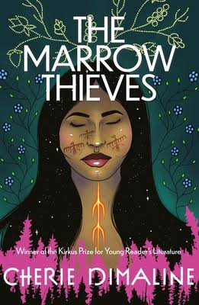
The Marrow Thieves (2017) is a survival story set in a Canada where “recruiters” harvest the bone marrow of Indigenous people. They do so to serve a non-Indigenous clientele that has lost the ability to dream. The Canadian government has deployed “Recruiters” aka “marrow thieves” to search and capture the indigenous people in order to extract their bone marrow and use it to find cure or treatment for people who can no longer dream.. The Indigenous people of North America are being hunted and harvested for their bone marrow, which carries the key to recovering something the rest of the population has lost: the ability to dream. The book was released on September 17, 2019, by Penguin Random House Canada.
Cherie Dimaline is a writer of indigenous stories. Her newest novel, Empire of Wild, focuses on a community of displaced Métis descendants who ended up in Arcand, Canada, determined to make a living.
Cherie Dimaline is an Indigenous Canadian writer from the Georgian Bay Métis Nation, a part of Métis Nation of Ontario. She has written a variety of award-winning novels and other acclaimed stories and articles.

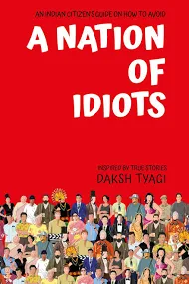
"A Nation of Idiots" is written by a Red Indian writer named Karl E Thelen. Published in January,2003. It exposes unqualified teachers, weak administrators, poor parenting, and lays bare the sinister side of corporate America and the media.

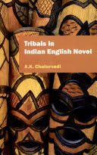
Although rural life has been dealt with in a number of Indian English novels, tribals as such have rarely been depicted in them. This fact testifies to the conspiracy of silence against a large chunk of society that is doomed to remain marginalized and lead life in its periphery. The reasons for this silence are not far to seek in view of the urban and westernized background of Indian English writers and their preoccupation with urban life and its problems. However, the references to tribal life are sporadically mentioned in Arun Joshi’s The Strange Case of Billy Biswas, Kamala Markandaya’s The Coffer Dam, Manohar Malgaonkar’s The Princes...

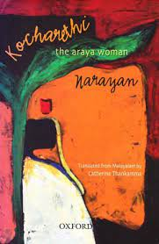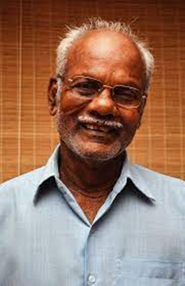

Kocharethi: The Araya Woman by Narayan (1998).
Translated by Catherine Thankamma
This is the first novel by Narayan, the first tribal novelist from South India. It has been written in the Malayalam language and translated into English by a well-known translator, Catherine Thankamma. The story, based on the Malayarayar tribe in Kerala, follows an Adivasi couple through the different phases in their lives and records a vivid account of their daily traditions, which allows the reader to learn about and experience the tribe’s cultural traditions
Khasi Folk Songs and Tales
Documented and translated by Desmond L. Kharmawphlang
“Khasi” refers to all the tribes and sub-tribes of the Khasi and Jaintia hills, located in the Northeastern state of Meghalaya. The Khasi language was purely oral until the arrival of the members of the Welsh Methodist Mission, who began to write the language in Roman script. These unique folktales and songs were compiled based on various themes.
Out of the Earth
by Felix Padel and Samarendra Das
Out of this Earth is a penetrating anthropological study that uncovers the hidden history behind mining projects in tribal areas of south Odisha. Capping its largest mountains are some of the world’s best bauxite deposits, promising prosperity to one of India’s poorest states. Entrenched capitalist notions of development collide with the locals’ perception of metal factories as a new colonial invasion. Tribal people, who have lived around them since history began, do not see these mountains as a resource to be exploited, but a source of life itself. Meticulously researched, this seminal book brings to light the displacement and cultural genocide of Adivasis, alongside hideous scams and pollution. It lays bare the complicated and bloody history of the aluminum industry, at the heart of the military-industrial complex.
The Burning Forest: India’s war in Bastar
by Nandini Sundar
It brings alive the issues through real-life human stories of tribal villagers, Maoists and security forces. This book is based on extensive field visits, court testimonies, government documents and an active participant role in the events Sundar writes about. It vividly tracks the shocking failures of Indian democracy through the responses of political parties, the media, human rights activists andthe judiciary to the ongoing crisis. This book chronicles how the armed conflict between the government and the Maoists has devastated the lives of some of India’s poorest, most vulnerable citizens. The fact that Bastar has some of India s biggest mineral reserves has made the conflict even more intense and also destroyed the ecology and culture of Bastar.

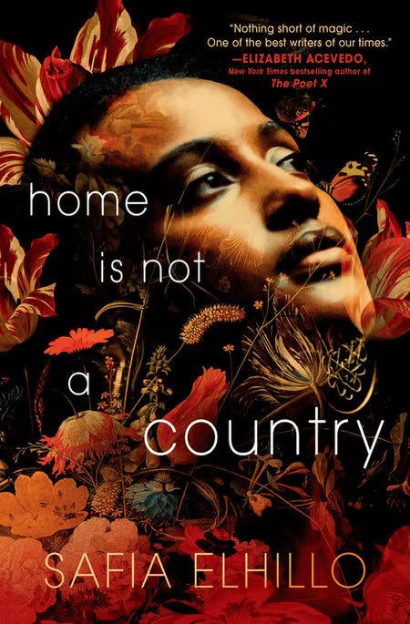2022.

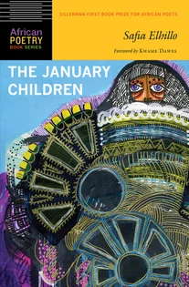 this powerful novel-in-verse captures one girl, caught between cultures, on an unexpected journey to face the ephemeral girl she might have been. Woven through with moments of lyrical beauty, this is a tender meditation on family, belonging, and home.
Nima wishes she were someone else. She doesn’t feel understood by her mother, who grew up in a different land. She doesn’t feel accepted in her suburban town; yet somehow, she isn’t different enough to belong elsewhere. Her best friend, Haitham, is the only person with whom she can truly be herself. Until she can’t, and suddenly her only refuge is gone.
As the ground is pulled out from under her, Nima must grapple with the phantom of a life not chosen—the name her parents meant to give her at birth—Yasmeen. But that other name, that other girl, might be more real than Nima knows. And the life Nima wishes were someone else’s. . . is one she will need to fight for with a fierceness she never knew she possessed.
Safia Elhillo is the author of The January Children (University of Nebraska Press, 2017), recipient of the 2016 Sillerman First Book Prize for African Poets and a 2018 Arab American Book Award.
Sudanese by way of Washington, DC, she holds a BA from NYU’s Gallatin School of Individualized Study and an MFA in poetry from the New School. Safia is a Pushcart Prize nominee, receiving a special mention for the 2016 Pushcart Prize; co-winner of the 2015 Brunel International African Poetry Prize, and listed in Forbes Africa’s 2018 “30 Under 30.” Her fellowships and residencies include Cave Canem, The Conversation, and SPACE on Ryder Farm.
Apo Maria “Whang-Od” Oggay symbolizes the strength and beauty of the Filipino spirit. She is heralded as the last ‘mambabatok’ of her generation Imprinted on her body are the symbols of the Kalinga tribe—signifying strength, bravery, and beauty This is done on the skin of thousands of people who have made the pilgrimage to Buscalan. “When visitors come from far away,” Whang-Od says in the Butbut language, “I will give them the tatak Buscalan, tatak Kalinga for as long as my eyes can see.”
Read more about Vogue Philippines’ April 2023 cover story by https://www.instagram.com/p/CqZa5JOvXXo/.
References:
CSSEIP (Centre for the Study of Social Exclusion and Inclusive Policy). (2009). Human. Development Report of Tribal Communities in Kerala. Cochin: CUSAT
Harvey, D., & Reed, M. (1996). The Culture of Poverty: An Ideological Analysis. Sociological Perspectives, 39(4), 465-495.
Lewis, O. (1975). Five families: Mexican case studies in the culture of poverty. New York: Basic Books
Rajasenan, D. (2010). The Perception-Reality Gap in the Health Status of the Disadvantaged: Evidence from Tribal Communities in Wayanad, Kerala. In D Rajasenan (Ed), Inclusion of the excluded: Dynamics and challenges (pp.10-26). Cochin: Directorate of Publications and Public Relations CUSAT
Rajasenan, D. (2016). Residential segregation and social exclusion among the scheduled castes and scheduled tribes of Kerala. Cochin: Directorate of Publications and Public Relations CUSAT
Rajasenan, D., & Rajeev, B. (2013). Development Dynamics Involved in Tribal Sub Plan. CSSEIP Working Paper, 3(1), 1-30
Rajasenan, D., Bijith, G. A. & Rajeev, B. (2013). Health, Education and Employment in a Forward-Backward Dichotomy Based on Standard of Living Index for the Tribes in Kerala. Journal of Economics and Sustainable Development, 4(7), 100-107
Thresia, C.U. (2014). Social Inequalities and Exclusions in Kerala’s “Egalitarian” Development. Monthly Review (February), 28-38
Valentine, C. (1968). Culture and poverty: Critique and counter-proposals. Chicago: University of Chicago Press.
Veron, R. (2001). The "new" Kerala model: lessons for sustainable development. World Development, 29 (4), 601-617.

