Understanding qRT PCR:
Basic principles and applications

INTRODUCTION

The discovery of the enzyme RNA dependent DNA polymerase, renamed as reverse transcriptase led to the conceptualization “reverse transcription coupled polymerase chain reaction technique” also known as RT PCR. The classical PCR technique, extensively used for enzymatic amplification of DNA, cannot be performed directly on RNA. The incorporation of reverse transcription step, wherein, the reverse transcriptase catalyses the conversion of input RNA to complementary DNA (cDNA) followed by the use of this cDNA in a PCR has enabled quantitative analysis of RNA and paved way for understanding RNA biology at diverse levels. This technique is not only sensitive (i.e. it is able to detect trace quantities of RNA present in a living cell) but also very specific (i.e., it detects the target RNA of interest in a sequence specific manner), thus making RT PCR a widely used molecular biology laboratory technique.
After the discovery of DNA as genetic material (in the 18th century), DNA was recognised as the unit of heredity and the master blueprint of life, it was widely accepted that genetic information within most biological systems (prokaryotes and eukaryotes) flows unidirectionally, that is: DNA to RNA to Protein, classically known as the Central Dogma of Molecular Biology, wherein the RNA is merely an intermediate carrying information during protein synthesis. The discovery of RT in RNA tumor viruses (viruses which are able to synthesize DNA from an RNA template) by David Baltimore (MIT, Cambridge, USA) and Howard Temin (UW, Madison, USA) simultaneously in the year 1976⁽¹⁾ and the worldwide recognition of the reverse transcriptase although contradicted the theory of Central Dogma of Molecular Biology became the major driving force behind the identification and characterization of group of RNA viruses and reteroviruses.

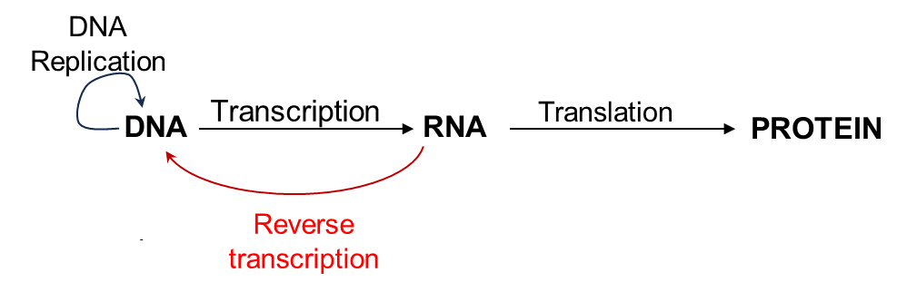

BASIC PRINCIPLES ALONG WITH THE WORKFLOW
The development of quantitative (q)RT PCR not only led to the identification of cancer-causing retroviruses (including human immunodeficiency virus (HIV) and human T cell leukemia viruses (HTLVs)) but also accelerated scientific research involving expression analysis of disease-specific mRNA biomarkers, profiling several types of RNAs (including ribosomal RNA (rRNA), transfer RNA (tRNA), messenger RNA (mRNA), non-coding RNAs, etc), detection of pathogens (especially RNA viruses) from biological and environmental samples. A typical work flow of the RT PCR set up is described in Fig.2, and basic principles underlining the methodology are described thereafter. A recently developed variation of this technique referred to as digital droplet PCR will also be discussed.
To begin with, extraction of RNA from living cells is the first step and prerequisite to carry out an RT PCR assay for gene expression analysis or pathogen identification. In contrast to conventional RNA extraction methods which were labour intensive and prone to contamination at various steps, the method of RNA extraction using the acid guanidinium thiocyanate-phenol-chloroform triphasic separation method described by Chomczynski and Sachhi in the 1987 (Ref) is most popularly used worldwide. This method is described in the research article entitled, “Single-step method of RNA isolation by acid guanidinium thiocyanate-phenol-chloroform extraction” in the journal Analytical Biochemistry, 1987. Since then, several commercially available ready to use reagents (such as TRIzol (Invitrogen), Qiazol (Qiagen) or Tri reagent (SIGMA), etc) and kits have been commercially developed.
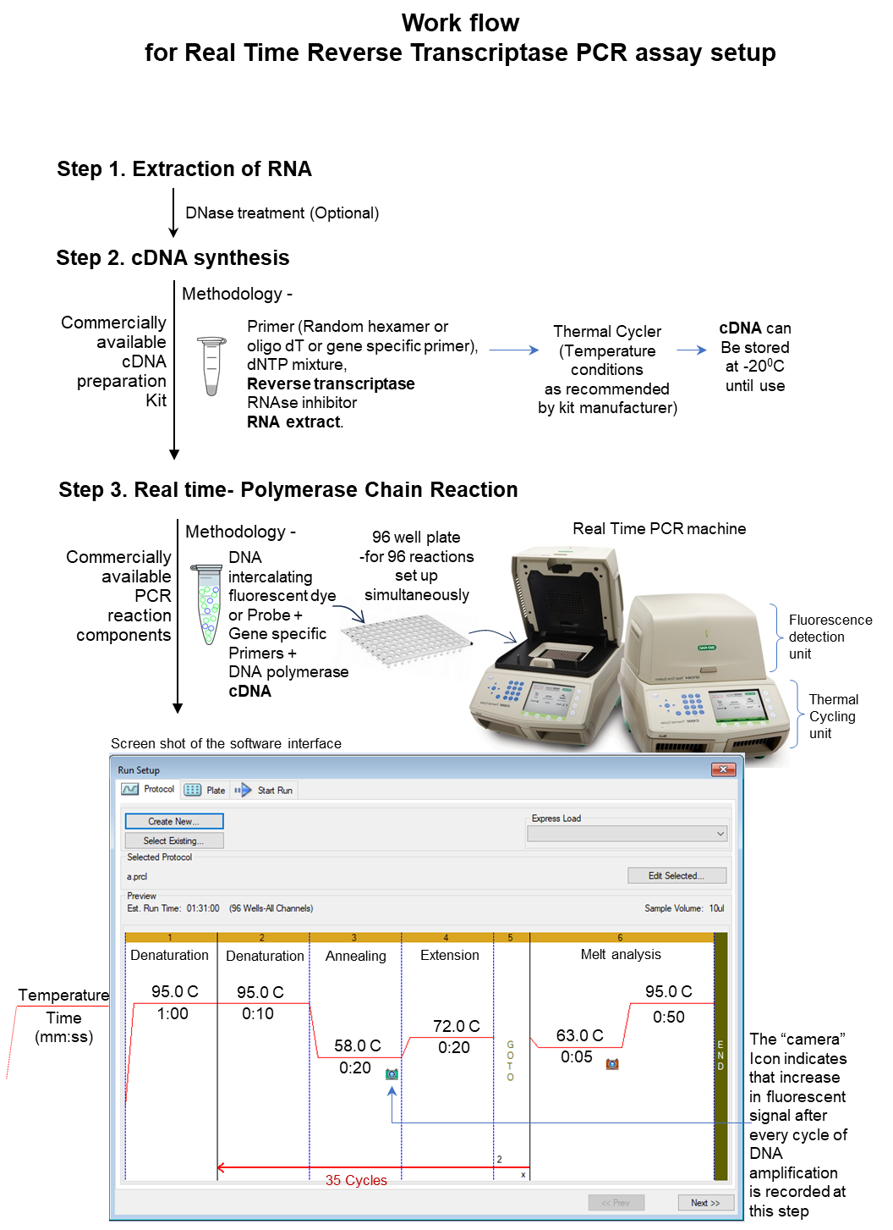

Figure 2: A typical work flow demonstrating setting up of quantitative RT PCR assay.
The cDNA synthesis involves the enzymatic conversion of RNA to complementary DNA (cDNA). These components of commercially available cDNA synthesis kits include the RT enzyme, its reaction buffer (comprising of Tris-HCL pH 8.4 for maintenance of optimal pH, and enzyme cofactors: KCl, MgCl2), dNTP mixture (comprising of ATP, TTP, GTP, CTP), primers used for reverse transcription (Oligo dT primer or Random hexamer primer), dithiothreitol (DTT), RNase Inhibitor and nuclease free water.
One example of RT used in commercially available cDNA synthesis kits is the RT isolated from molomy murine leukemia viruses (M-MuLV) which are retroviruses belonging to the gammaretroviral genus of the Retroviridae family. The enzyme possesses RNA-dependent and DNA dependent polymerase activity, but lacks RNase H activity due to a point mutation in the RNase H domain. As a consequence of the point mutation, this enzyme does not degrade the RNA in RNA-DNA hybrids during synthesis of the first strand cDNA and therefore high yields of full-length cDNA from long templates can be synthesised. The enzyme activity is stable over a wide temperature range (42-55°C) and is capable of synthesizing full-length cDNA up to 13 kb. Several genetically modified RTs are being developed which are capable of synthesizing cDNA up to 20 kb.
During cDNA synthesis, primers such as Oligo dT primer, random hexamer or gene specific primers can be used. The Oligo dT primer, as the name suggests are oligonucleotides (short stretched of nucleic acid residues or polymers) that contain a segment of repeating deoxythymidines (dT). The dT anneal (or bind) to the polyadenosine (polyA) tails of messenger RNA (mRNA), guiding the synthesis specific cDNA. Therefore, the Oligo dT primers are used during amplification of RNA fraction having a unique polyA tail. The random hexamer primers are composed of mixture of single-stranded random six-nucleotides (or hexanucleotides) which potentially anneal to random sites in RNA (or DNA) without distinguishing between mRNA or any other species of RNA (like ribosomal RNA or RNA originating from virus or bacteria) in the sample and provide a cDNA pool of wide coverage. Gene specific primers are used for reverse transcription of RNA (corresponding to particular gene of interest) which requires enrichment (as it might be present in low quantity) and specific detection from a mixed pool of RNA.
The cDNA is subjected to quantitative PCR amplification using a real time PCR machine. The real time PCR machine comprises of a standard “PCR thermal cycling block” coupled with an “excitation source” (such as a laser or tungsten lamp), “camera” for detection of fluorescence, a computer and software for data analysis. The thermal cycling block elevates and lowers the temperature of the block in cycles (Fig 3a) in predefined fashion (1 complete PCR run in set up for nearly 35-45 cycles) which allows cDNA to be copied exponentially (similar to replication of DNA) as shown in Fig 3b. The camera (or optical detection unit) records the increase in fluorescent signals after each cycle of the DNA amplification. Here, the increase in fluorescent signal is recorded along with each amplification cycle (not at the end of the entire PCR run) hence the acronym “real time”. The fluorescent signal is related to the amount of amplified product present in each cycle, the fluorescence increases as the number of DNA copies (or amplicons) increase. The real time PCR machine is able to measure and quantitate the amplified product as well as assess the number of DNA copies present in the input specimen without post PCR processing.

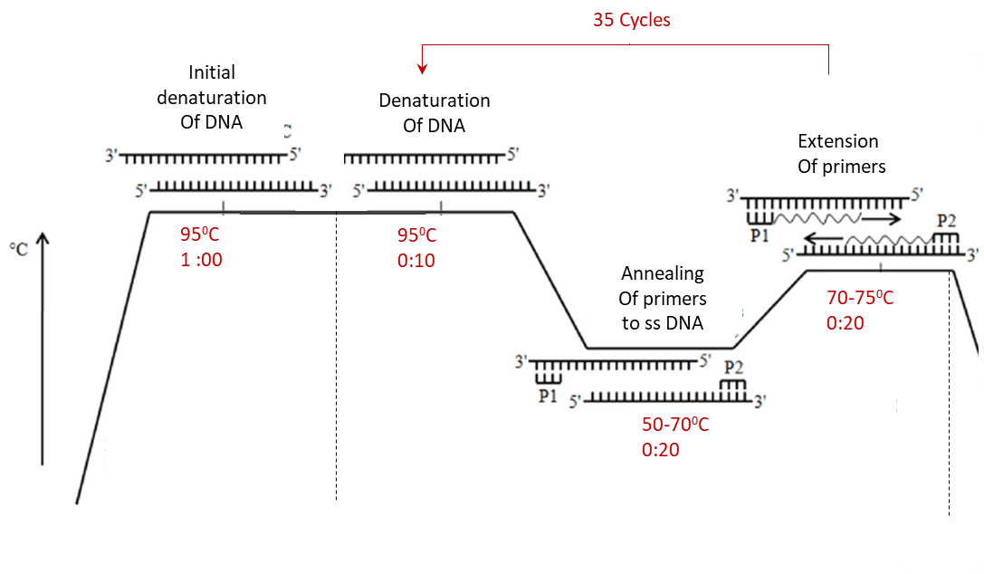

Figure 3a: Typical steps in a PCR cycle: denaturation, annealing and extension.
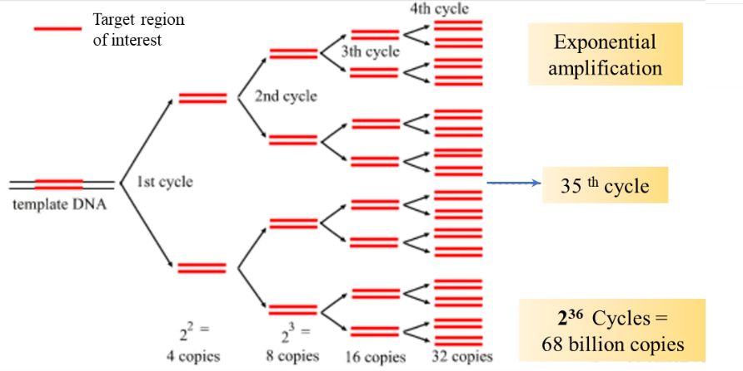

Figure 3b: Exponential amplification of DNA

The PCR is designed to perform amplification of input DNA (genomic DNA, plasmid DNA or cDNA). The PCR thermal block comprises of slots into which the micro-tube or 96 well PCR reaction plate is inserted.
The idea of “real-time PCR” which involved the inclusion of a fluorescent reporter system (fluorescent DNA intercalating dye or fluorescent probe) was first described by Higuchi and coworkers in 1992.
The continuous monitoring of the accumulation of PCR amplicons in “real-time” alongside the amplification led to certain advantages such as detection of fluorescent signal allowed the PCR reaction to proceed in a single closed tube and minimised the risk of carryover contamination. It also significantly reduced the time required to complete the PCR assay as it eliminated post-PCR processing in comparison to conventional PCR assays.
The fluorescent reporter system employed in real time PCR will be discussed in this section. The PCR reaction mixture if incorporated with (a) fluorescent DNA-intercalating dyes (such as SyBr Green, Eva Green, etc) or (b) target-specific fluorescently labelled primers or probes. The working principles of both the fluorescent reporter systems are described below:

Figure 4: Working principles of the fluorescent reporter systems used in real time PCR reaction
DATA ANALYSIS
The kinetics of the PCR amplification are visualized with help of the software. The software allows the visualization of fluorescence generated/cycle (which is directly proportional to increase in DNA amount per cycle) in the form of an amplification curve. The fluorescence is plotted along the Y axis, whereas the number of PCR cycles is represented on the X axis.

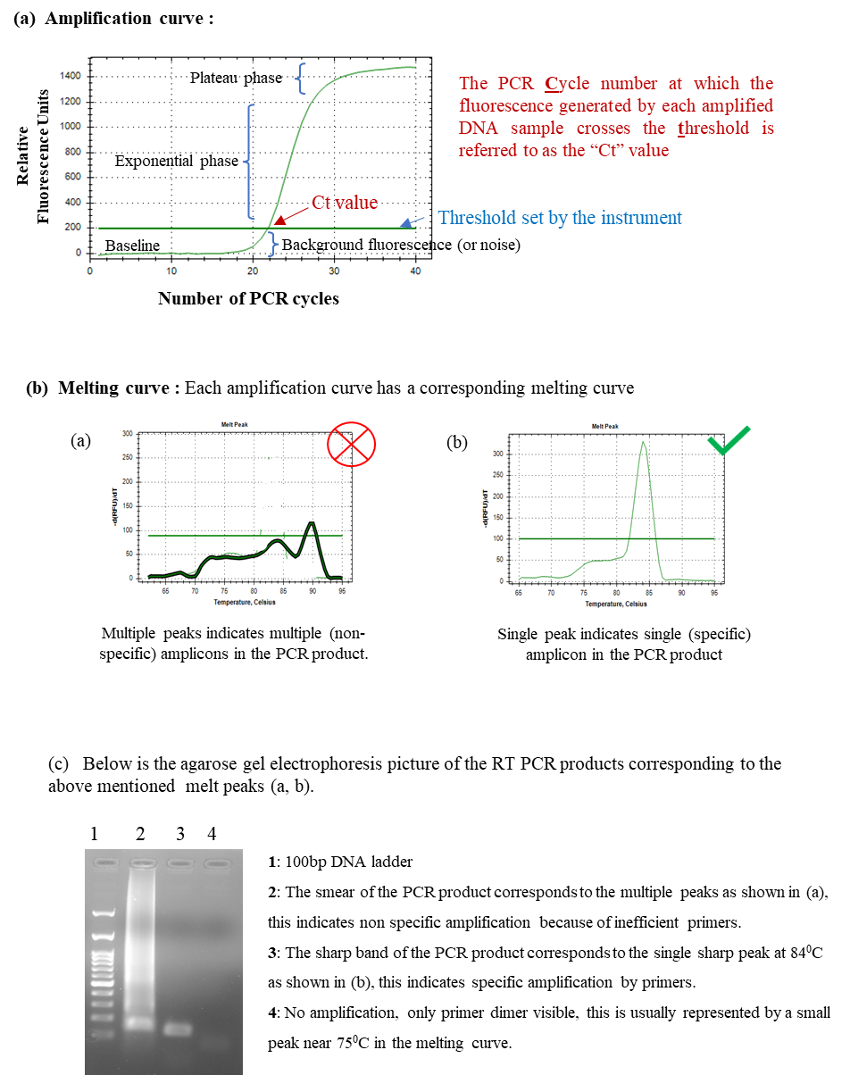

Figure 5: Visualization of the real time PCR kinetics with help of the software
The amplification curve:
The increase in fluorescence per cycle is demonstrated by the green line and resembles a sigmoidal pattern of amplification. The amplification curve can be divided in three phases as shown in the fig 5a:
- Background (or baseline): At the beginning of the run (usually between cycles 0 and 15), when the amount of PCR product is low, little fluorescence is emitted and this fluorescence is indistinguishable from the background signals. This section of cycles is known as the background signal or noise. The background fluoresce is determined by the instrument as “threshold”.
- Exponential phase: Once the amount of amplified PCR product and the corresponding fluorescence exceeds the background fluorescence level, the reaction enters the exponential phase. Here, the amount of PCR product doubles for every PCR cycle. This can be seen in cycles 15 and 30.
- Plateau: Once all of the reaction components (including nucleotides) have been used up in the PCR reaction, the amplification will slow and ultimately plateau. This is the region where no more PCR products cannot be produced. This can be seen in cycles 30 to 40 in the above amplification plot.
Ct Value: The Ct value also known as “Cycle threshold” is defined as the number of cycles after which the fluorescence of the PCR products crosses the threshold background signals. It is also referred to as the Cq or quantification cycle.
The Ct value and the amount of DNA present in the PCR are inversely correlated. This means that a PCR assay starting with abundant amount of input DNA tends to demonstrate an early Ct value and a PCR assay starting with low amount of input DNA tends to demonstrate late Ct value.
The real time PCR data can present using several methods. Two widely employed methods of presenting the real time PCR data include:
- Absolute quantitation using standard curve
- Relative quantitation (Fold change: 2^{-ΔΔCt})

Absolute quantitation using standard curve: Absolute quantitation provides the exact gene (or genome) copy number derived from transformation of data with help of a standard curve prepared using serially diluted copies of known concentration. The results are presented in terms of gene copies per cell. The absolute quantification is performed when the precise quantity of amplicon is desired, for example, calculation of viral load. It also provides an idea about efficiency of the PCR. The disadvantage of absolute quantification includes the increased effort to generate standard curves.
Relative quantitation: It is also called as comparative quantitation. Here the change in levels of mRNA (or gene) of interest relative to another gene usually referred to as an internal control or calibrator is measured. The choice of internal control (gene which is abundantly as well as constitutively expressed with stable mRNA levels) is of utmost importance.

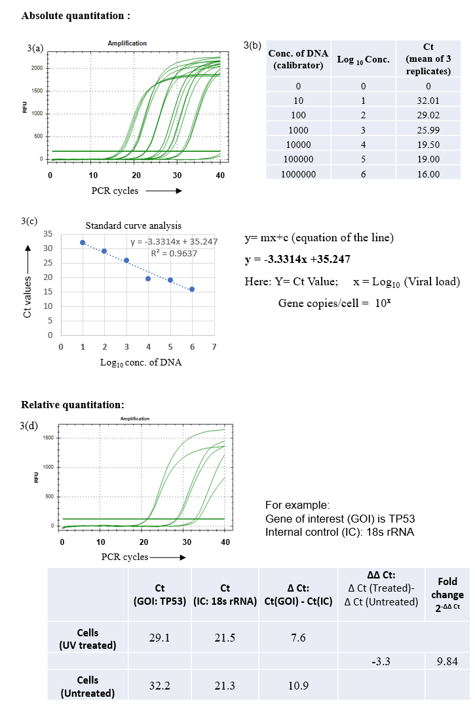
Inference: The expression of TP53 is 9.8 ford higher in UV treated cells compared to untreated cells.

Figure 6: Calculations for analysis of data using absolute and relative quantification method

- Applications

- Quantitative reverse transcriptase PCR (qRT-PCR) is now being recognised as an important diagnostic tool for detection of pathogens especially RNA viruses. Until now, this technique has been successfully employed for detection of clinically prevalent RNA viruses including enteroviruses, West Nile virus, dengue virus, human metapneumovirus, hantavirus, and more recently SARS CoV-2. Among the few changes forced by the recent SARS CoV-2 pandemic (2020-22) the installation of real time PCR machines in molecular diagnostic facilities across the world has led the medical fraternity to turn to RT-PCR based diagnosis of infectious disease above culture-based assays.
- This method is extensively used in basic biological sciences research such as:
- To study the difference in expression of a gene in the diseased state compared to the normal state.
- Experimental validation of the extent of transcription of a gene.
- Change in expression for cells that are exposed to a chemical substance (e.g., drug, toxin, hormone or cytokine).
- Change in gene expression during cell differentiation or development.
- To validate the effectiveness of small interfering RNA or antisense oligonucleotides.
- Quantification of expression of noncoding RNA.

- qRT-PCR assays are also frequently used for the detection of viral load for monitoring the response of the individual patient to therapy. For example, after appropriate antiretroviral therapy, the HIV positive patient must demonstrate an elevated CD4 count and a reduced in HIV viral load.
- This method may also be used for detection of live versus dead microorganisms such as bacteria, fungi and parasites by targeting their RNA, as ratio of RNA to DNA of any microorganism in any kind of sample indicates the presence of viable organisms.
- qRT PCR is increasingly being used in environmental microbial ecology research as a tool for detection and quantification of microbes enriched in wastewater microbial ecosystem. Development of qRT PCR based evaluation of biomarkers of fecal contamination (including enteric RNA viruses and bacteriophages) in treated wastewater before reuse is an area of active research.

References:
- Annu Rev Virol. 2016 Sep 29;3(1):29-51. doi: 10.1146/annurev-virology-110615-035556. Epub 2016 Jul 22. PMID: 27482900
- Verma, I.M., Reverse transcriptase, The Enzymes (Boyer, P.D., ed), Academic Press Inc., vol. 14, 87-103, 1981.
- Gerard, G.F. and D'Alessio, J.M., Methods in Molecular Biology, 16, Humana Press, Totowa, N.J., 73-93, 1993.
- Schmittgen TD, Livak KJ. Analyzing real-time PCR data by the comparative C(T) method. Nat Protoc. 2008;3(6):1101-8. doi: 10.1038/nprot.2008.73. PMID: 18546601.

