Experiment and Numerical Analysis of Plate Heat Exchanger Using TiO2+MWCNT Nanofluid
Manojkumar Udgire,
¹Assistant Professor, Department of Mechanical Engineering, CSMU, Panvel, Navi Mumbai.
*Corresponding Author Email:udgiremanojkumar@gmail.com

Abstract
In this, experimental and numerical investigations have been done in the plate heat exchanger using TiO2+MWCNT/water at different volume concentration (0% to 1.50%) to inspect its effect on heat transfer and pressure drop characteristics. Discrete phase model has been worked for the inspection by using CFD software (Fluent 14.0) and consequence have been differentiate with the experimental result as well as for the consistent model. The consequence of the experimental investigation of plate heat exchanger is closely matched with the CFD results. CFD results has been validated by the experimental results and found closely matched.
Keywords: CFD Analysis; Hybrid Nanofluid; Thermal Conductivity;

Introduction
Plate heat exchanger is generally constructed of thin plates. The plates are either smooth either has formed of corrugated; they are connected the heat exchanger. Flow arrangement is feasible for PHE, depending on the heat exchanger arrangement, which contains the number of channels, pass alignment, kind of channel flow and at the location of the inlet and outlet relations on the frame. The plate heat exchanger is a tool that transports thermal energy by two or many fluids by the convection property of fluids. Lozano et al. [1] had investigated the large number of possible arrangements and the infinite dissimilar of industrial plates. The colloidal suspension of nanoparticles (1-100 nm) in base fluid is called nanofluid, which is new creation of heat transfer fluid for different heat transfer approaches where heat carry feature is consider appreciable than the base fluid. Tiwari et al.[2] illustrated about the different nanofluid at the various temperature and concentration of the nanofluid CeO₂, Al₂O₃, TiO₂, and SiO₂ with water based the thermal conductivity examined 35.9%, 26.3%, 24.1% and 13.9%, specifically at perfect volume concentrations. Kwon et al. [3] had organized an experiment for the analysis of heat transfer feature of Al₂O₃ with base fluid water nanofluids for PHE and there volume concentration domain 0-6%. The outcomes showed that the OHTC occurred 3% enhanced. Wu et al. [4] had done investigation for double pipe helical heat exchanger utilize nanoparticles Al₂O₃ with base fluid water in the nanofluid, the volume concentration 0.78-7.4% used in experimentation. In the investigation, they have observed the overall effect of nanoparticles on the heat in presented qualities of nanoparticles. Ghozatloo et al. [5] concluded the result in shell and tube heat exchanger by using graphene with base fluid water, volume concentration range 0.05-0.1%. The result is found HTC enhanced in 13.1% in
~0.1% A. Joker et al. [6] organized a numerical inspection into Al₂O₃ with base fluid water nanofluid in a three-channel corrugated PHE using, CFD with concentrations domain from 1-
4.0 vol. % in the control of laminar flow. The result of their investigation accepted that the heat flow rate reduced by increasing the volume concentration of the nanofluid. They concluded about the complex flow controls of nanofluids in the three-dimensional structure of PHEs, which are slightly dissimilar from the simple geometries, such as, the circular pipes.

Experimentation
Preparation of nanofluids is the basis operation in the use of nanoparticles for applications heat transfer. In this process enhancement in the thermal conductivity, viscosity with the various volume concentration and temperature.

2.1 Measurement of Nanofluid Thermal Conductivity
For measuring thermal conductivity of hybrid nanofluid finding we are use KD2 Pro thermal properties analyzer. Instrument KD2 Pro include of a hand-hold controller and sensor which will be installed in the medium. For inspection KS1 unit-needle sensor or bi-needle there diameter -1.3 mm, length - 60mm attached to micro-processor is applied to identify or evaluate thermal conductivity of hybrid nanofluids. The accurateness of the gadget is identified thermal conductivity 0.2–2.0 W/m K of nanofluid by the constructor claiming ±5%. Study the result of TiO2-CNT/water on the thermal conductivity; nanofluids were produced in volume concentrations thermal conductivity is noted at unlike concentrations.
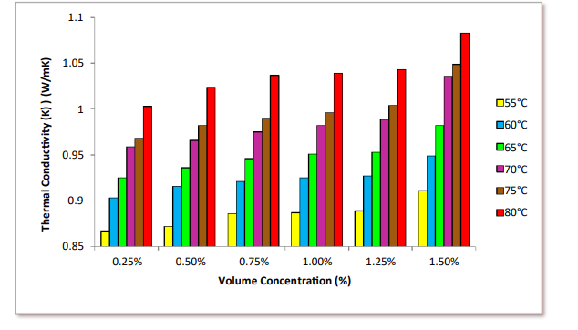
Figure 1 Variation of thermal conductivity K_{nf} for TiO2 - MWCNT nanofluid with different volume concentration

The thermal conductivity measure 0.25%, 0.50%, 0.75%, 1.0%, 1.25% and 1.50% of volume concentrations of nanofluid were determines for temperature range 55ºC, 60ºC, 65ºC, 70ºC, 75ºC and 80ºC. The thermal conductivity measured at 1.50% hybrid nanofluid is found conductivity 1.083 W/m K at a temperature of 80°C, which is 60.85% higher compared to thermal conductivity of base fluid (0.659 W/m K).

Measurement of Nanofluid Viscosity
Measurement of viscosity we used led utilizing the LVDV - II + Pro Brookfield digital viscometer. This viscometer is adopted by operating the immersed part that is termed a spindle, through beryllium copper spring attached. In the LVDV – II + pro type viscometer spring torque 673.7 (dyne - cm) and accuracy ± 1%full scale range are established.

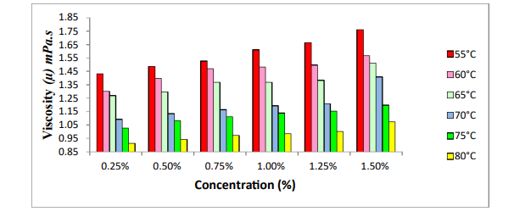

Figure 2 The variation viscosity (µ) mPas for TiO2-MWCNT hybrid nanofluid with different concentration

The viscosity of hybrid nanofluid has been calculated at different temperatures (55ºC, 60ºC, 65ºC, 70ºC, 75ºC, and 80°C) and concentration of nanoparticles (0.25%, 0.50%, 0.75%, 1.0%, 1.25%, and 1.50 %.) present operating of plate heat exchanger. The hybrid nanofluid viscosity obeys the base fluid tendency where it reduces exponentially with variation of temperature. However, as the nanoparticle bound with the base fluid expansion, the viscosity value is also increased. This is verity that enhance in nanoparticle concentration in the hybrid nanofluid enhance the fluid inner shear stress, hence the viscosity is enhance. To study the conclusion of TiO2- CNT on the viscosity, nanofluid were produced in increase volume concentration 0.25%, 0.50%, 0.75%, 1.0%, 1.25% and 1.50%. In the graph increase volume concentration then the viscosity are enhance at temperature of 55ºC hybrid nanofluid was obtained viscosity as 1.762 mPas at the volume concentration of 1.50% Graph. So we write that if increase the volume concentration then the viscosity is also increases.

3. CFD Simulation of Plate Heat Exchanger
The CFD area comprises of administering equations, meshing generation details and boundary conditions associated with the numerical examination. The leading calculations is explained with commercial CFD package (Fluent 14.0) is used.

3.1 Solution Methodology
A business CFD package (ANSYS/Fluent 14.0) has been utilized for solving the administering equations with the accompanying simplifies supposition:
- The PHE works under unfaltering state conditions.
- Heat exchange surface has been thought to be free from fouling.
- There is no mal-circulation of stream and the stream is similarly isolated into every one of the channels.
- The fluent stay in single phase along the channels.
- The external walls of the PHE have been insulation protected.
- κ– ε show has been utilized in the CFD simulation since a few numerical simulations of PHE with water have utilized this model as it has an ability to determine optional stream.
Initially the whole of the heat exchanger was modeled with both the hot and cold fluid zones to predict the exact flow and heat transfer process. But the domain was too large to solve and it reached the computational limitation to generate the mesh.

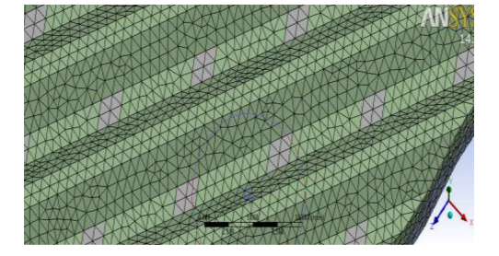
Figure 3 Mesh of the domain with maximum size of 1mm
The corrugated plate that was modeled with some approximations in the distribution area of the corrugated plate and the whole plate heat exchanger initially designed for the analysis. There were 5 layers for the cold fluid and the 4 layers for the hot fluid in the real model heat exchanger so the fluid zones were made accordingly for the heat exchanger as well as for the computational domain used for analysis

Mesh Generation
To solve the problem, the three zones were initially connected in the Design modeler so that the connected mesh is generated. Initially mesh generated for the geometry was highly skewed with skewness of 0.99 which made the simulation to diverge. Initial mesh generation was done in the Ansys ICEM CFD with options as follows:
    - Physical reference: CFD
    - Solver Preference: Fluent
    - Relevance: 10
    - Advanced Size Function: Curvature on
    - Relevance Center: fine
    - Smoothing: high
    - Transition: slow
    - Span Angle Center: fine
    - Growth Rate: 1.2
To generate a ‘good’ mesh the minimum size and the maximum size of the element is changed and the table below shows the number of nodes and elements generated at different maximum size.
Table 1
Maximum size (mm) | Number of nodes | Number of elements
1mm | 2,76,031 | 13,74,893
0.8 mm | 5,08,727 | 26,10,609
0.6 mm | 10,97,741 | 57,72,746
0.5 mm | 17,62,153 | 94,57,683

The mesh details are given below:
Cells – 14, 37,429
Faces – 61, 80,719
Nodes – 37, 62,686

Boundary Conditions
The inlet, outlet, walls and the surfaces are named selected during the mesh generation so as to apply the boundary conditions accordingly. The boundary conditions for inlet are kept as velocity inlet, for outlet it is kept as pressure outlet. For the thermal conditions of the walls of the fluid zone which are exposed to the atmosphere the adiabatic conditions are used and for that of in contact with the corrugated plate the coupled boundary conditions are used.
The values of different boundary conditions for the water-water heat exchange are as follows:
    - Cold fluid inlet velocity: 0.0176 m/sec (as accordance to 220 kg/hr)
    - Hot fluid inlet velocity: 0.01 m/sec (as accordance to 100 kg/hr)
    - Cold Inlet temperature: 293 K
    - Hot Inlet Temperature: 348 K
    - Turbulence Intensity: 6%
    - Hydraulic Diameter: 30 mm
    - Back Flow Temperature: 320 K

Analysis and Solution
The governing equations were solved using the commercial CFD package FLUENT 14.0 with the following simplifying assumptions; The figure below shows the graph of residual vs. number of iterations to obtain the converged solution for water-water combination.
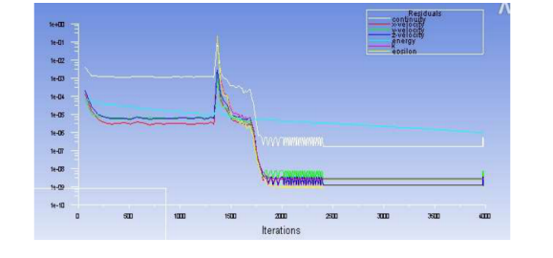
Figure 4 Graph of residual with respect to the Iterations

Time taken to obtain the converged solution for one combination is about 16 hours and it takes 3978 iterations in Intel i5 2nd generation processor, since the heat exchange takes place in the lateral direction so double precision is taken into consideration, parallel processing is done with all 8 processors in working mode so as to obtain 100% usage.

Results and Discussion
The computational fluid dynamics results for the domain with the water-water combination and the water-nanofluid combination is shown and discussed in this section. As discussed earlier, the need of corrugation in the plates is for increasing the turbulence in the flow and also to avoid recirculation in of the fluid between the plates otherwise formation of hot spots will form irregular heat exchange.
The velocity profile of the cold fluid zone and the hot fluid zone is shown in the figure.

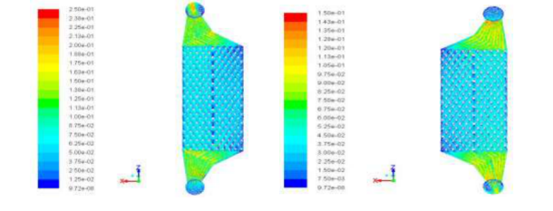

Figure 5 The velocity profile of the cold fluid and the hot fluid

The temperature distribution of the fluid zone clearly shows that there is no change in the temperature at the distribution area initially and then the heat exchange between the fluid zones takes place. The temperature distribution of the water-water combination of cold fluid zone and hot fluid zone is shown in the following figures respectively.

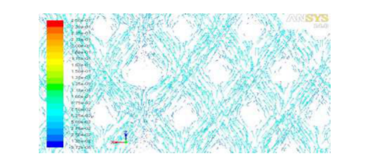

Figure 6 The velocity vector of the cold fluid showing the turbulence generated

After getting converged solution for water-water flow, data was compared with the theoretical analysis of heat exchanger for same inlet temperatures and flow rate. Outlet temperature and pressure drop are as follows for both the cases:
 | Theoretical analysis | CFD analysis
Hot water mass flow rate | 100 kg/hr | 100 kg/hr
Cold water mass flow rate | 220 kg/hr | 220 kg/hr
Hot water inlet temperature | 348 K | 348 K
Cold water inlet temperature | 293 K | 293 K
Hot water outlet temperature | 316.2 K | 318.21 K
Cold water outlet temperature | 315.1 K | 312.34 K
Hot water side pressure drop | 145.87 Pa | 140.929 Pa
Cold water side pressure drop | 415.2 Pa | 297.211 Pa

The corrugated plate three different surfaces were created to obtain the temperature distribution of the plate at different regions shown in figure. Figure

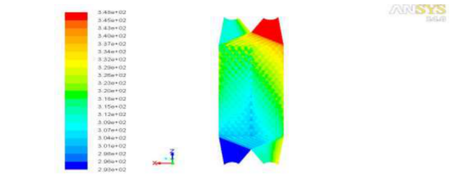
Figure 8 Distribution of temperature of the corrugated plate

Conclusions
The significant conclusions are obtained from experimental & CFD simulation by using (fluent 14.0) and geometry generated in Ansys 14.0 work are characteristics below.
- Hybrid nanofluid has optimal volume concentrations in which the heat transport individuality shows the extremity augmentation.
- The Experimental results is strictly matched by the CFD results, which is confirm that uniform mixture of hybrid nanofluid (TiO2-MWCNT) simulation can be successfully utilized to forecast the application of plate heat exchanger.
- Hybrid nanofluid is favorable rider enhance performance of PHE despite the inconvenient result of enhancement in the viscosity.
- The largest temperature arises about in the hot fluid top port as the smallest temperature arise in cold fluid flow throughout bottom port, the temperature slope is bigger, and result of heat transport is supplementary acceptable.

REFERENCES
- A. Louzano, F. Barreras, N. Fueyo, S. Santodomingo. The flow in an oil/water plate heat exchanger for automotive industry. Applied Thermal Engineering 2008.28 (10).1109
- A.K. Tiwari et.al. Performance comparison of the plate heat exchanger using different nanofluids. Exp Therm Fluid Sci. 49 (2013) 141–51
- Kwon YH, et.al. Heat transfer and pressure drop characteristics of nanofluids in a plate heat exchanger. J Nanosci Nanotechnol 2011; 11:5769–74
- Wu Z, et.al. Pressure drop and convective heat transfer of water and nanofluids in a double-pipe helical heat exchanger. Appl Therm Eng 2013; 60:266–74
- A. Ghozatloo, A. Rashidi, M. Shariaty-Niassar. Convective heat transfer enhancement of graphene nanofluids in shell and tube heat exchanger. Exp Therm Fluid Sci. 53 (2014) 136-41.
- A. Jokar and S.P. O’Halloran. Heat transfer and fluid flow analysis of nanofluids in corrugated plate heat exchangers using computational fluid dynamics simulation. J Therm Sci and Engg Applications. 5 (2013) 011002-1.
- [7] Choi S., Enhancing thermal conductivity of fluids with nanoparticles, ASME FED 231/MD 66, 1995, pp. 99-103.
- Gupta M., Singh V., Kumar R., Said Z., A review on thermophysical properties of nanofluids and heat transfer applications, Renewable and Sustainale Energy Reviews 74: 638-670, 2017
- Keblinski P., Eastman J. A., Cahill D. G., Nanofluids for thermal transport, Materials Today 8:36-44, 2005
- Kabeel A. E., Maaty A. E., Samadony E. Y., The effect of using nanoparticles on corrugated plate heat exchanger having different surface profiles, Applied Thermal Eng. 52:221-229, 2009
- Khairul M. A., Alim M. A., Mahbubul I. M., Saidur R., Hepbasli A., Hossain A., Heat transfer performance and exergy analysis of a corrugated plate heat exchanger using metal oxide nanofluids, International Communications in Heat and Mass Transfer 50:8-14, 2014
- Maré T., Halefadl S., Sow O., Estelle P., Duret S., Bazantay F., Comparison of the thermal performances of two nanofluids at low temperature in a plate heat exchanger, Experimental Thermal and Fluid Science 35:1535-1543, 2011
- Huang D., Wu Z., Sunden B., Pressure drop and convective heat transfer of Al2O3/water and MWCNT/water nanofluids in a chevron plate heat exchanger, International Journal of Heat and Mass Transfer 89:620-626, 2015.
- Sun B., Peng C., Zuo R., Yang D., Li H., Investigation on the flow and convective heat transfer characteristics of nanofluids in the plate heat exchanger, Experimental Thermal and Fluid Science 76:75-86, 2016
- Xing M., Yu J., Wang R., Experimental study on the thermal conductivity enhancement of water based nanofluids using different types of carbon nanotubes, International Journal of Heat and Mass Transfer 88:609-616, 2015
- Zamzamian A., Oskouie S. N., Doosthoseini A., Joneidi A., Pazouki M., Experimental investigation of forced convective heat transfer coefficient in nanofluids of Al2O3/EG and CuO/EG in a double pipe and plate heat exchanger under turbulent flow, Experimental Thermal and Fluid Science 35:495-502, 2011
- Kwon Y. H., Kim D., Li C., Lee J., Hong D., Heat transfer and pressure drop characteristics of nanofluids in a plate heat exchanger, Journal of Nanoscience and Nanotechnology 11:5769- 5774, 2011
- Fard M. H., Talaie M. R., Nasr S., Numerical and experimental investigation of ZnO/water nanofluid in the concentric tube and plate heat exchangers, Thermal Science 5:183-194, 2011
- Majdi H., Abed A. M., Effect of nanofluids on the performance of corrugated channel within out-of-phase arrangement, International Journal of Thermal Science 92:230-238, 2015
- Gherasim I., Galanis N., Nguyen C., Numerical study of nanofluid flow and heat transfer in a plate heat exchanger, Computational Thermal Sciences: An Int. Journal 5:317-332, 2013
- Khoshwaght–Aliabadi M., Hormozi F., Zamzamian A., Effects of geometrical parameters on performance of plate-fin heat exchanger: vortex generator as core surface and nanofluid as working media, Applied Thermal Engineering 70:565-579, 2011.

