Environmental effects of Air Pollution and their Threats to Humans in the world

S.Rajesh Khanna, A. Omprakash and A.Sivaprakasam

Abstract

Air pollution is the greatest threat to public health on a worldwide basis, causing approximately 7 million premature deaths every year WHO Reports. The term "air pollution" refers to the process through which the atmosphere becomes contaminated with particles and substances that are either poisonous or polluting. It contributes to global warming, as well as environmental problems such as pollution and acid rain, as well as health problems such as cancer and respiratory disorders. Both air pollution and global warming have been accelerated by human activities like transportation, electricity generation, industry emissions, and agricultural burning. Individuals' and politicians' concerns about the quality of the air they breathe are frequently a driving force behind their efforts to address the climate issue. When we have a desire for clean air, we speed up the process of addressing climate change.
In this age of industrialization, it is not possible to completely get rid of air pollution, but it is possible to cut back on it using a variety of methods. As part of an effort to cut down on the amount of pollution that is allowed to be discharged into the atmosphere, the government has established an air quality guideline and is continuing to work on laws to restrict emissions.
Guidelines for reducing emissions of pollutants like sulphur dioxide-[S02], particulates [PM2.5, PM10], nitrogen oxides-[NOx], carbon monoxide-[CO], ozone-[O3], and lead-[Pb] have been established by the Environmental Protection Agency [EPA].

Key words: World Health Organization [WHO], National Ambient Air Quality Standard [NAAQS]. Air Quality Index [AQI], Particulate Matter [PM2.5 microns/PM10microns]
______________________

1.1 INTRODUCTION:
Air toxics are a subset of air pollutants that are often found in trace amounts in the atmosphere. Despite this, air toxics possess toxic properties that make them capable of causing adverse health consequences even at exposure levels that are quite low.
Air pollution becomes a significant hazard to human health and welfare due to the emission of smoke, grit, gases, and dust from various sources such as locomotives, ships, and residential and industrial chimneys; exhaust gases from motor vehicles; and solid and gaseous discharges from chemical plants and industrial operations. Both our physical and emotional health might suffer as a direct result of pollution. It maintains the fog, contributes to the spread of disease, and may even result in death. Flue gases that are high in sulphur are a leading cause of corrosion in structures and metals. The level of acidity in the soil rises, the growth of crops is stunted, and the health of farm animals is harmed. flyash, smoke, grit, sulphur oxides, and oxides of nitrogen [NOx] are the combustion byproducts that do the most damage to the environment. The exhaust from diesel engines and automobiles contains lead, which is known to cause brain damage in youngsters, as well as carbon monoxide and tars, both of which are known to cause cancer.
However, air pollution has been and will continue to be a major health danger during the process of economic development. Economic growth, urbanisation, energy consumption, transportation, motorization, and a rise in urban population are all factors that contribute to air pollution. The wide variety of air contaminants, the presence of negative consequences at varying degrees of pollution, and the large population at risk have made this an issue of growing concern. The effects of air pollution can sometimes be felt even when pollution levels are far below those recommended by air quality rules.

1.2 Pollutants types and its impacts
Particulate matter, sometimes known as PM, is an ideal instance of a proxy indicator that can be used to measure air pollution. The idea that this pollutant can have a detrimental impact on one's health if they are exposed to it is supported by a considerable body of evidence. Water, sulphates, nitrates, ammonia, black carbon, mineral dust, and sodium chloride are the most commonly encountered elements of particulate matter [PM].
Carbon monoxide is an odourless and colourless gas produced by the partial combustion of carbonaceous fuels which includes [wood, gasoline, coal, natural gas, and kerosene] in appliances such as simple stoves, open flames, wick lights, furnaces, and fireplaces.
Carbon monoxide is a carcinogen, which means it can cause cancer and other serious health problems. The odour or taste of carbon monoxide cannot be detected under any circumstances.
Carbon monoxide-[CO] concentrations in the atmosphere are primarily caused by the emissions produced by motor vehicles. Human Cells of the body have greater difficulty binding to oxygen when carbon monoxide is present because it is able to go through the lung tissues and into the bloodstream. This oxygen deficiency causes harm to the body's tissues and cells. Carbon monoxide exposure can result in a variety of flulike symptoms, including difficulty breathing, tiredness, disorientation, and headaches. It is possible to die from being exposed to high doses of carbon monoxide.
Ozone smog is predominantly composed of ozone at ground level, which is commonly denoted as O3. The aforementioned molecule is produced as the outcome of photochemical reactions involving pollutants from automobiles and industrial processes, specifically carbon monoxide, nitrogen oxides-[NOx], and volatile organic compounds. Due to their photochemical characteristics, ozone concentrations in the atmosphere are greatest during periods of bright, sunny weather. It is imperative to emphasise that ordinary household appliances, including portable air purifiers, possess the capacity to generate ozone.
Nitrogen dioxide, also known as NO2, is a potent oxidant that appears reddish brown in colour and is soluble in water. Background sources of nitrogen dioxide-[NO2] include processes involving the high temperature combustion of fuels, including those utilised in transportation, power generation, heating, and industry. Domestic appliances that consume fuels, including furnaces, gas stoves, fireplaces and ovens, and even fireplace logs are capable of producing nitrogen oxides-[NOx]. Exposure to nitrogen dioxide has the potential to exacerbate preexisting respiratory conditions and cause irritation of the airways.NO2 plays a crucial role in the synthesis of ozone, a pollutant that has a significant correlation with asthma and various respiratory ailments.
Sulphur dioxide-[SO2] is a gas that dissolves easily in water despite its inert appearance. Most of it comes from burning fossil fuels for things like home heating and commercial production of electricity. Hospitalisations and ER visits related to asthma have been linked to exposure to SO2.
Lead-[Pb] and lead particulate compounds are detectable in household dust generated by various appliances including cosmetics, paints, ceramics, pipelines and plumbing materials, solders, gasoline, batteries and ammunition. These products have the potential to introduce lead-[Pb] and lead particulate compounds into the household atmosphere. Additionally, lead emissions from vehicles powered by petroleum containing lead can contribute to the concentration of lead in the atmosphere.
Pregnant women and children are especially susceptible to the detrimental health effects that lead can induce. A low IQ and hyperactivity, difficulties with learning and behaviour, stunted growth, hearing impairments, and anaemia are some of the adverse health effects that can result from lead exposure in children. Under exceedingly rare conditions, lead ingestion may cause convulsions, coma, or fatality. Pregnant women are susceptible to various health complications, such as preterm birth and impaired foetal development. Adults who are exposed to lead are more susceptible to developing hypertension, elevated blood pressure, and impaired renal function; furthermore, there is an increased risk of reproductive complications in both males and females.
Compounds found in the environment include polycyclic aromatic hydrocarbons-[PAH], which exist in particulate form. Incomplete combustion of organic matter [like when cooking meat] and incomplete combustion of fossil fuels in appliances like coke ovens, diesel engines, and woodburning stoves produce this class of chemicals. Tobacco smoke also contributes to their creation. After even a short period of exposure, the eyes and airways can become irritated. Prolonged exposure to PAH has been associated with an increased risk of developing lung cancer.
Despite being odourless, formaldehyde is a gas with an abhorrent flavour. This substance is among the most commonly detected volatile organic compounds [VOCs] within indoor environments. An assortment of substances, including construction materials [particleboard, adhesive, plywood, and paint] and personal care and household items [carpets, draperies, cleaning solutions, and hair sprays], are capable of emitting formaldehyde into the atmosphere. Further contributors to indoor pollution include combustion processes, including smoking, heating, cooking, and the utilisation of candles or incense. Even a transient exposure to formaldehyde may cause irritation of the nose, throat, and eyes, in addition to an increased sensitivity of the body to allergens. Nasopharyngeal cancer, conversely, has been associated with extended exposure to formaldehyde.
Radon is a radioactive gas that can be found in natural environments. It is formed as a result of the natural radioactive decay of uranium that's present in rocks and soil, and it does not have a smell, colour, or taste. Radon can also be present in the environment's water supply. Radon undergoes decay, which results in the production of more radioactive particles. The inhalation of these particles results in their deposition on the cells lining the airways, where they have the possibility to induce DNA damage that could eventually turn into lung cancer. Radon can be responsible for anywhere from 3% to 14% of all instances of lung cancer. The association between the prevalence of smoking and the average radon levels in any one nation is subject to variation. People who smoke have a significantly increased chance of developing lung cancer due to radon exposure; in fact, the risk is 25 times higher for smokers than it is for nonsmokers.
1.3 Air Quality guidelines and standards
The daily average PM2.5 recommendation of the World Health Organisation [WHO] was established to indicate the level of concentration at which a 24hour exposure could result in health risks of similar severity to those linked to chronic exposure to levels exceeding the WHO annual average PM2.5 guideline. Quantitatively increased hazards to human health result from acute exposure to PM2.5 concentrations exceeding the daily average guideline for more than three to four days in a given year for individuals residing in environments that otherwise meet the annual PM2.5 guideline level.
Particulate Matter [PM], commonly referred to by the term particle pollution, denotes an airborne composition consisting of solid particles and liquid droplets. Certain particulates, including smoke, dust, dirt, and soot, are dark enough or large enough to be perceived with the unaided human eye. Certain characteristics can solely be identified by employing specialised apparatus, such as an electron microscope.PM10 denotes particulate matter that is airborne and typically has a diameter of 10 micrometres or less, whereas PM2.5 denotes particulate matter that is microscopic and has a diameter of 2.5 micrometres or less. An exceedingly minute unit, exactly one fourth of a millimetre! Considering that the diameter of a typical human hair is around 70 micrometres, it is roughly thirty times greater in diameter than the largest fine particulate.
PM10 has a higher propensity to adhere to the inner surfaces of the larger airways situated in the upper lung, whereas PM2.5 is more inclined to traverse and accumulate in the deeper lung regions. Particulates that impede clearance from the pulmonary surface possess the capacity to induce inflammation and injury to adjacent tissues.
The biggest danger to people's health is posed by fine particles [PM2.5]. These minute particles are able to travel to the deeper parts of the lungs, and some of them may even enter the circulation. The lungs and the heart of a person can be negatively impacted by exposure to these particles. Even though coarse particles [PM102.5] provide less of a health risk, they nonetheless have the potential to aggravate a person's eyes, nose, and throat.
A global context can be obtained by weighting the results of calculating the annual average concentration of PM2.5 based on an area using PM2.5 data at the city level and city populations. The formula is [μg/m³ of city mean PM2.5 x city population] divided by the total regional population covered by the data from the available cities.
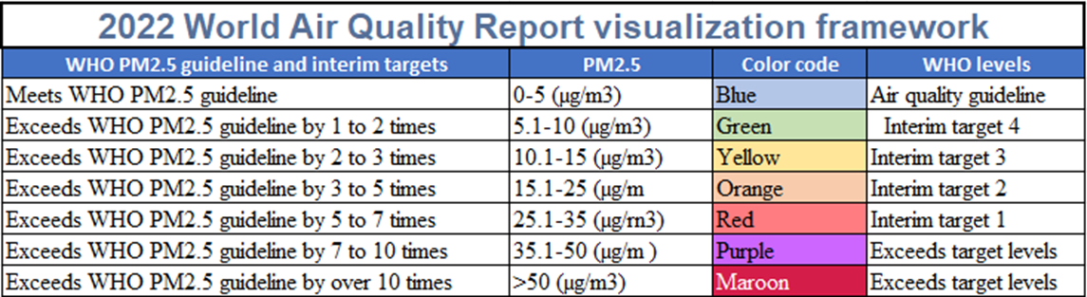

  - Air Pollution impact in India
National Air Quality Monitoring Programme [NAMP] is a nationwide ambient air quality monitoring campaign that is carried out under the guidance of the Central Pollution Control Board. The network comprises 804 operational stations distributed among 344 cities and villages spanning 28 states and 6 union territories. Its purpose is to monitor the abundance of three distinct air pollutants, namely NO2, SO2 and PM10.
Indicators such as PM2.5, ammonia-[NH3], carbon monoxide-[CO], lead-[Pb], ozone- [O3], benzene [C6H6], benzo(a)pyrene-[BaP], arsenic-[AS], and nickel-[Ni] are progressively incorporated into the NAMP monitoring network and monitored at strategic locations.
Over fifty percent of this pollution is caused by industry, followed by twenty seven percent caused by automobiles, seventeen percent caused by the burning of crops, and seven percent caused by cooking in the home. Over two million people in India lose their lives each year to conditions that can be related to air pollution.
In winter, the air quality in Delhi consistently deteriorates to the "severe" classification. This is consistent from year to year. This phenomenon is primarily caused by the practise of burning stubble after harvest to clear the land in preparation for establishing the following season's crop. According to reports, this particular factor is accountable for 32% of the PM2.5 particulate matter that is present in Delhi. The measured quantity of 292 micrograms per cubic metre exceeds the World Health Organization's recommended safe limit by a factor of five. The manner in which airborne particles disperse, be it via precipitation or wind, is profoundly affected by the prevailing weather conditions.
The concentrations of the pollutant PM 2.5 often exceed the threshold for exposure set by the World Health Organisation, with some cases exceeding five times the established limit. Individuals who are exposed to such levels frequently encounter severe respiratory complications. This is a result of air pollution both within the residence and in the surrounding environment.
In 2019, excessive levels of air pollution were potentially responsible for more than 1.6 million fatalities, according to the official data. Fatalities were attributed to the following diseases: strokes, diabetes, lung cancer, and myocardial infarctions. Furthermore, among all categories of pollution, air pollution presently represents the highest threat to mortality, according to the "State of Global Air 2020" report published this year.
As a result of the minute size of PM 2.5 particles, inadequate air quality significantly affects the respiratory system of humans. These particles attain the alveoli by penetrating the lung tissue to a considerable depth. It is then capable of traversing the body's tissues and potentially launching an assault on the heart. Respiratory exposure to polluted air is commonly associated with migraines, fatigue, coughing, sore throats, and lung cancer.
Collaboration between the Ministry of Earth Sciences, the National Centre for Medium Range Weather Forecasting, the Indian Institute of Tropical Meteorology [IITM], and the India Meteorological Department, the Air Quality Early Warning System has just been launched. The Indian Institute of Tropical Meteorology [IITM] has been equipped with the "PRATYUSH" High Power Computing [HPC] system, which the government has inaugurated as the world's first and quickest Multi Petaflop supercomputer. The government has also established the System of Air Quality and Weather Forecasting Research [SAFAR] to provide near real time, location specific data on air quality for major urban areas in India.
India’s Smart Cities Mission represents a substantial stride towards the realisation of a more forward thinking urban landscape. There are numerous smart city applications that aim to mitigate air pollution.
  - Air Pollution Statistics India Cities [2022]
The average annual PM2.5 concentration in India was 53.3 g/m3 in 2022, representing a marginal decrease from the previous year's average of 58.1 g/m3. In 2022, the mean PM2.5 concentration in Delhi was 92.6 μg/m3, which was marginally lower than the mean of 96.4 μg/m3 recorded in 2021.The report differentiates between New Delhi and Delhi, noting that New Delhi exhibits a yearly mean PM2.5 concentration of 89.1 μg/m3.A government station was allocated to both Darbhanga and Asopur in 2022, despite the fact that both cities are ranked among the 15 most polluting in the region. An excess of sixty percent of the cities in India incorporated in this analysis exhibited yearly PM2.5 concentrations that surpassed the WHO threshold by a minimum of seven times. With an annual PM2.5 concentration of 92.7 g/m3, Bhiwadi is the most contaminated city in India.
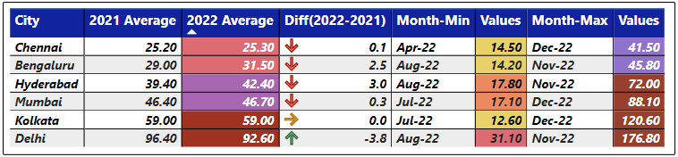
Data extracted from 5th Annual World Air Quality Report

The burning of crop stubble is another significant problem in the region; however, this is a sporadic occurrence that is restricted to a select number of places, including Delhi and North India. In 2022, environmental compliance regulations were relaxed for Indian coal mines, allowing for increased output. This action was taken in response to power outages exacerbated by the exceptionally high temperatures.46 In November, steam and thermal coal imports peaked at their lowest level in a decade, whereas the total quantity of coal produced increased by 11.7 percent to 75.9 million tonnes.
The bio decomposition method, also known as "Pusa decomposers," was developed by scientists as an alternative to the practise of burning stubble. This method turns agricultural residue into compost. This new information comes at a time when pollution is an issue in Delhi and many other regions of Northern India. Stubble burning causes the air to be filled with smoke during the winter months, making it difficult to see or breathe in certain areas.
Air pollution is a silent killer on a global scale. India's air pollution levels are among the most severe in the world, endangering the economy and health of the nation. From a variety of sources, all 1.4 billion people of India are exposed to hazardous levels of ambient PM 2.5, the most harmful pollutant. Particulates measuring less than 2.5 microns in diameter are approximately one thirtieth the width of a human hair. Deadly illnesses that may result from PM 2.5 exposure include lung cancer, stroke, and cardiovascular disease. It is estimated that indoor and outdoor air pollution contributed to 1.7 million untimely fatalities in India in 2019. The adverse health effects of pollution impose a significant financial burden on the economy. In 2017, lost labour income due to fatal illnesses caused by PM 2.5 pollution ranged from $30 to $78 billion, or approximately 0.3% to 0.9% of the nation's gross domestic product.

  - Paris Agreement's most polluted countries and PM2.5 data by region
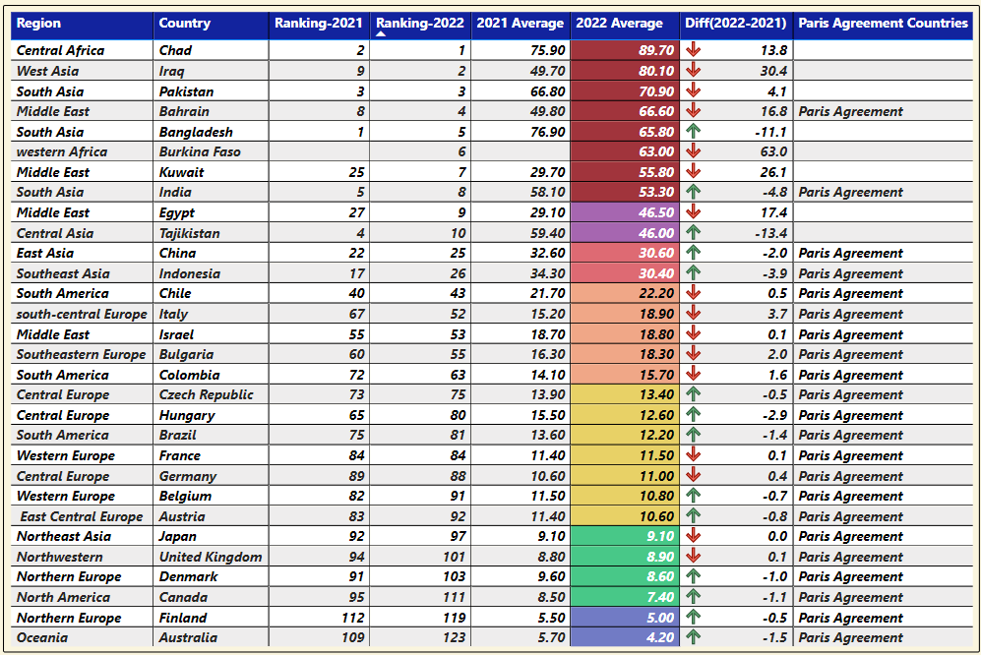
Data extracted from 5th Annual World Air Quality Report
The 5th Annual World Air Quality Report reveals concerning information regarding the regions, countries, and territories with the most severe air pollution levels in 2022. The IQAir World Air Quality Report 2022 indicates that a mere five percent of nations comply with the WHO PM2.5 Air Pollution Guideline.
Air quality scientists from IQAir analysed data from more than 30,000 monitoring stations situated in 7,323 locations across 131 countries, territories, and regions for the purpose of compiling this year's report. From Antarctica to the United States, the settings varied.
Out of a total of 131 countries and regions, 118 [or 90%] exceeded the WHO established annual PM2.5 guideline value of 5 g/m3. Conversely, the WHO PM2.5 recommendation was met by a mere six nations [Australia, Estonia, Finland, Grenada, Iceland, and New Zealand] with an annual average PM2.5 concentration of 5 g/m3 or lower.
Africa continues to be the continent with the fewest inhabitants. Merely 19 of the 54 countries in total possess sufficient data pertaining to air quality.
The municipality in the United States with the most pollution levels was Coffeyville, Kansas. Largest in the United States, Columbus, Ohio, was the most polluted municipality.
California was home to ten of the fifteen most polluted cities in the United States, whereas Las Vegas held the distinction of being the cleanest major city in the country.
The 5th Annual World Air Quality Report provides alarming data pertaining to the areas, nations, and territories that will experience the most severe levels of air pollution in 2022. According to the IQAir World Air Quality Report 2022, adherence to the WHO PM2.5 Air Pollution Guideline is observed in a mere five percent of countries.
For the compilation of this year's report, air quality scientists affiliated with IQAir conducted an analysis of data gathered from over 30,000 monitoring stations distributed across 7,323 locations spanning 131 countries, territories, and regions. Setting varied from Antarctica to the United States. 118 [or 90%] of the 131 countries and regions surveyed exceeded the annual PM2.5 guideline value of 5 g/m3 established by the World Health Organisation.
In contrast, only six countries [Australia, Estonia, Finland, Grenada, Iceland, and New Zealand] achieved the WHO PM2.5 recommendation by maintaining an annual average PM2.5 concentration of 5 g/m3 or less. Africa maintains its status as the continent with the smallest population. A mere 19 out of the total 54 countries have adequate data available regarding air quality.
Coffeyville, Kansas, was the municipality in the United States characterised by the highest levels of pollution. The most polluted municipality was Columbus, Ohio, the largest in the United States. Ten of the fifteen most polluted cities in the United States were situated in California, while Las Vegas maintained the distinction of being the most pristine major city in the country.

  - Initiatives taken by the Government of India to Combat Air Pollution
National Clean Air Programme [NCAP] implementation commenced in early 2019 under the administration of the Indian government. They have set a goal to reduce air pollution by 20 to 30 percent in 122 of the most polluted cities by 2024. Several measures are presently being executed in Ahmedabad, New Delhi, and Pune, respectively: implementation of health risk communications plans; expansion of monitoring station infrastructure; and enhanced regulation of industrial emissions.
NCAP typically conducts monitoring activities for the following four significant air pollutants: sulphur dioxide-[SO2], oxides of nitrogen- [NO2 and NO], PM10 particles, and suspended particulate matter [SMP]. These will be monitored at 308 stations dispersed across 115 municipalities and cities in twenty-five states and four territories. During this procedure, meteorological data including temperature, relative humidity, wind speed and direction, and wind speed and direction are also collected. Measurements are routinely collected of both the gaseous and particulate contaminants that are present. Due to the weekly collection of these readings, a total of 104 observations are produced throughout the course of a year.
In Delhi, the prevalence of liquid petroleum gas [LPG or NPG] for meal preparation has replaced the use of kerosene as a fuel, which has been virtually eliminated. For the remaining 10% of the global population, wood, coal, and dried animal manure continue to be their principal energy sources. One of the potential courses of action under consideration is the creation of a "green" corridor from Gujarat to Delhi that would be 1,600 kilometres long and five metres wide. Within the following decade and a half, 1.35 billion indigenous trees would be grafted in order to establish this corridor.
By 2075, carbon dioxide-[CO2] emissions are anticipated to have been reduced to zero, representing a twenty percent reduction in emissions by 2030.
Over a thousand buses will be converted to electric propulsion, and fossil fuel powered engines will be upgraded, in an effort to meet the stringent BS6 standards and accomplish the air pollution reduction objectives that India has established for the coming years. With an additional objective of transitioning to renewable energy sources for power plants, the aim is to have 25 percent of privately owned vehicles operating on Indian roads be Electric Vehicles [EVs] by 2023. For vehicles older than 15 years or failing to comply with BS6 emission standards, access to municipal roads will be strictly prohibited.

The principal policies governing the prevention of air pollution and the transition to clean air are as follows: Legislation of 1981 Concerning the Prevention and Control of Air Pollution
a] The National Air Quality Monitoring Programme is abbreviated as NAMP.
b] NAAQS: National Ambient Air Quality Standards.
c] National Air Quality Index [AQI].
d] In 2018: Develop a Comprehensive Action Plan [CAP] to establish timeframes and implementing agencies for identified actions aimed at preventing, controlling, and mitigating air pollution in Delhi and the National Capital Region [NCR],Graded Response Action Plan[GRAP] to address the aforementioned concerns.
e] The Environment Pollution [Prevention and Control] Authority [EPCA] and the Jawaharlal Nehru National Solar Mission [JNNSM] collaborate to establish the National Clean Air Programme [NCAP].
f] Yajna Pradhan Mantri Ujjwala.

Conclusion:
Determine the causes of air pollution and keep an eye on the air quality. Adopt, update, and put into practise national air quality standards in accordance with the most recent set of WHO Air Quality Guidelines. Encourage the shift towards the sole use of clean household energy for all domestic cooking, heating, and lighting needs. Establish more stringent regulations for the emissions and efficiency of automobiles, as well as obligatory inspection and maintenance requirements. Invest in power generation and homes that are more energy efficient. Develop transportation networks that are friendly to walkers and cyclists, as well as public transportation systems that are secure and cost-effective and more push the government transportation to Electric Vehicle [EV’s]. Efforts should be made to improve industry and municipal waste management. Reduce the burning of agricultural waste, forest fires, and some agroforestry operations [such as the manufacturing of charcoal, for example]. Include education on air pollution in the training of health professionals and provide the health sector with the tools it needs to get involved. In order to prevent stubble burning, the Indian Agriculture Research Institute developed a bio enzyme that is known as PUSA. This enzyme begins to break down the stubble between 20 and 25 days after it has been applied, changing it into manure that further enhances the soil's fertility. The government of Delhi has started using the Pusa decomposer, and it is also urging the governments of other states to follow it
The first four months of 2023 [Jan April] have the highest proportion of Good to Moderate Air Quality days in Delhi compared to the equivalent period over the past seven years, starting in 2016.Delhi had 108 days of 'Poor to Severe' air quality in 2016, and it's expected to have 68 in 2023.In 2023, the average daily concentration of PM10 and PM2.5 was at its lowest, and the Daily Average AQI was also at its lowest. In the short, medium, and long term, Air Quality is predicted to improve thanks to persistent field level efforts and targeted governmental initiatives.
Construction using Prefabricated Concrete Units Rapidly expanding cities have higher levels of air pollution due in large part to building dust. Niti Aayog has suggested using readymade concrete as a means of addressing this issue and lowering the environmental impact of construction projects.
To achieve the NCAP's goal of a 40 percent decrease in particle concentrations by 2026, it is essential to have access to a complete national emission database. Emissions reduction efforts can be tracked more effectively if their source emissions can be identified.

References:

https://www.ncbi.nlm.nih.gov/pmc/articles/PMC7805008/
https://loksabhadocs.nic.in/Refinput/New_Reference_Notes/English/15072022_173626_102120463.pdf
https://pib.gov.in/PressReleasePage.aspx?PRID=1593056
https://thewire.in/environment/indiahadeightworstairpollutionin2022report
https://www.greenpeace.org/india/en/press/15431/indiasairqualityisseventimesworsethanwhoguidelineiqairworldairqualityreport2022/
Fundamentals of Air Pollution Daniel A. Vallero Google Books
https://www.who.int/newsroom/factsheets/detail/ambient[outdoor]airqualityandhealth?gclid=Cj0KCQjw_O2lBhCFARIsAB0E8B6JBOJL0XN9C9iap_2SMQSpi69iubNZbcfME0Jgu6LtlO6AZWJnnIaAjZ3EALw_wcB
https://environhealthprevmed.biomedcentral.com/articles/10.1007/s1219900700185
https://www.thelancet.com/journals/lanplh/article/PIIS25425196[20]302989/fulltext
India Air Quality Data Analysis. A report by Health Effects Institute on… | by Shubhankar Rawat | Towards Data Science
NAAQS Table | US EPA
India Air Quality Index [AQI] and Air Pollution information | IQAir
Air Pollution Note – Data you need to know [unep.org]
Climate and Clean Air Conference 2023 [unep.org]
pib.gov.in/PressReleaseIframePage.aspx?PRID=1920957
AQI Ranking: RealTime Most Polluted Cities in The World

Ph.D Research Scholar (Part-Time), PG and Research Department of Economics, The New College (autonomous), Chennai-14. E.Mail: srajeshkanna@gmail.com
Ph.D Research Scholar (Part-Time), PG and Research Department of Economics, The New College (Autonomous), Chennai-14. omaprakash@gmail.com
Ph.D Research Scholar (Part-Time), PG and Research Department of Economics, The New College (Autonomous), Chennai-14. asivaprakasam@gmail.com

