HYDROGELS: A review
Anuradha Derashri¹*, Rani Vimal Pandey¹, Vibhavesh Sanjay Palav¹, Divya Dhawal Bhandari² and Ram Babu Sharma³
¹Gahlot Institute of Pharmacy, Navi Mumbai, India
²University Institute of Pharmaceutical Sciences, Panjab University, Chandigarh, India
³Himalayan Institute of Pharmacy, Kala Amb, Himachal Pradesh

Corresponding author
Dr. Anuradha Derashri
Assistant Professor
Gahlot Institute of Pharmacy, Navi Mumbai
Email Id: anuradhaderashri@gmail.com
INTRODUCTION
The most popular drug-delivery nowadays is Nano science and in that hydrogels are are being in high demand due to their exceptional wide range of applications in Therapeutics [2–4]. In recent years, thorough research has been done on hydrogels with about 5000 papers published in 2010 indicating a promising area in the scientific community (Lee et al., 2013). Hydrogels characteristics are still in research and can be define in different ways like it is a matrixwhich forms polymeric network and swell by absorbing water with one or more monomers having the ability to hold and retain a higher amount of water within its structure, but insoluble in water. This water absorption capacity is due to hydrophilic functional groups attached to the polymeric backbone. The cross-links between network chains provides resistance against dissolution. Hydrogels are smart systems and respond according to environmental stimuli like temperature and pH changes resulting in the release of entrapped drugs in a controlled and sustained manner [7-9].
FEATURES OF HYDROGELS
- Water holding capacity
Hydrogels are soft, porous, three-dimensional molecules entangled in web of natural or synthetic polymers possessing the capacity to hold large amounts of water or biological fluids and able to simulate natural living tissue in comparison to any other class of synthetic biomaterials. The swelling ratio of a hydrogel is determined gravimetrically by the volume of aqueous medium absorbed by hydrogel.
Swelling Ratio =Ws-Wd/Wd
where Ws is weight of hydrogel in swollen state and Wd is weight of hydrogel in dry state
Hydrogels containing various functional groups which respond to the variation in the pH of external environment, changes in osmotic pressure. The swelling profile is indicated by the degree of ionization of functional groups.
- Mechanical strength
This property makes use of hydrogels as
- Regeneration of ligaments and tendons
- Surgical dressing material
- Carrier for therapeutic drug
- tissue engineering
- cartilage substitutive material.
The main characteristics of hydrogel is delivery of therapeutic drug without changing its physical texture for predetermined period of time. For stronger hydrogel, the desired mechanical strength can be achieved by changing the degree of cross-linking
Biocompatibility
Biocompatibility and nontoxic nature is mandatory in biomedical tissue engineering field. To solve the purpose, polymers must pass cytotoxicity and in-vivo toxicity tests. It consists of two parameters: (a) Biosafety- require to protect from cell toxicity like neoplastic cell formation and gene mutation, (b) Bio-functionality.
BENEFITS OF HYDROGELS
- Possess great degree of flexibility same as that of human tissues due to their significant water content.
- Timely release of medicines or nutrients.
- Biocompatible, biodegradable and injectable.
- Detection of changes in physiochemical stimuli like pH, temperature and metabolite concentration.
- Easy to portable and Modifiable.
DRAWBACKS OF HYDROGELS
- Exorbitant.
- Rigorous handling.
- Less robust.
- Non -adhering.
- Difficult to loading drugs.
CATEGORIZATION OF HYDROGEL
For effective drug delivery hydrogels must exhibit nontoxicity, biocompatibility, and biodegradability. Synthesis of hydrogel can be achieved by natural or synthetic method. So they can be classified based on source, composition, appearance, type of cross links, type of charge etc.
- Characterization according to its origin
- Characterization by composition of polymeric content
- According to the biodegradability
- Characterization based on configuration
- Characterization based on type of cross-linking
Characterization based on emergence of hydrogel
- Characterization based on type of electrostatics networks
- Characterization according to mechanism of action.
- Classification according to Source
- Natural hydrogels- Natural hydrogels have unique features like abundance, nontoxicity, biocompatibility, and biodegradability with adhesion to cell. Types of natural polymers are used in production of natural hydrogels i.e. Polysaccharides such as hyaluronic acid, alginate, chitosan and proteins such as collagen, gelatin, and lysosome as given in Table 1.
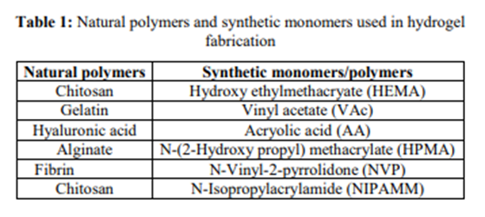
b. Synthetic hydrogels- Synthetic hydrogels are advanced version as their physical and chemical properties can be altered according to need. As hydrogels are safe, compatible and having low immunogenicity hence they are widely used in biomedical application.
c. Hybrid hydrogels- These are the blend of natural and synthetic polymer hydrogels like biopolymers such as dextran collagen chitosan and synthetic polymers like polyvinyl alcohol and poly (N-isopropyl acrylamide).

II. Classification according to polymeric composition
- Homo-polymeric hydrogels- Homo-polymers are cross-linked skeletal structure derived from a single species of monomer. Combination of monomer like poly (2-hydroxyethyl methacrylate) (poly HEMA) and cross linker polyethylene glycol di-methacrylate with polymerization technique. This film can be used for contact lenses, artificial skin manufacturing, burn dressings and also for the rejuvenation of bone marrow and spinal cord cells.
- Co-polymeric hydrogels- These are combination of two or more different monomer species with at least one hydrophilic component, arranged in block or alternating configuration. The synthesis involves polymerization of BLG N-carboxy anhydride and which is initiated by diamine groups located at the ends of poly (ethylene oxide) chains of the poly-oxamer and this poly-oxamer can be formed by thermoplastic co-polymeric hydrogel which is based on γ-benzyl L-glutamate (BLG). These hydrogels have drug delivery application because of its sensitivity towards pH and temperature.
- Multi-polymer interpenetrating polymeric hydrogel (IPN)- When natural and synthetic polymers are arranged in cross-linked and Non-cross linked network system are called Multi-polymer interpenetrating polymeric hydrogel (IPN). This system is used to confirm stability of bulk products as well as to ensure morphology of surfaces. Thermodynamic incompatibility can be overcome and limited phase separation can be obtained by IPN method.
III. According to the biodegradability
- Biodegradable hydrogels- Hydrogels are naturally biodegradable such as Chitosan, fibrin and agar. Some synthetic biodegradable polymers are Poly (aldehyde gluco-uronate), Poly-anhydrides and poly (N-isopropyl acrylamide).
- Non-biodegradable hydrogels- 2- hydroxyl ethyl methacrylate methoxyl poly ethylene glycol , 2- hydroxypropyl methacrylate and acryl amide .
IV. Characterizations based on configuration- Based on configuration, hydrogels are classified as Semi crystalline, crystalline and amorphous (non-crystalline).
V. Classification based on type of cross-linking: Chemically cross-linked networksand Physical networks of polymer interlinkage or physical interactions as hydrogen bonds, or hydrophobic interactions and having permanent and transient junctions respectively
VI. Based on emergence of hydrogel- Hydrogels appear as matrix, film, or microsphere.
VII. According to type of charge on network-
  - Neutral
  - Ionic.
  - Ampholytic
  - Polybetaines
Vlll Characterization based on mechanism of action
a. Diffusion controlled release systems
b. Swelling controlled release systems
c. Chemically controlled release systems
d. Environment responsive systems
SYNTHESIS OF HYDROGELS
Reaction of hydrophilic monomers with multifunctional cross-linkers produces hydrogels. Monomer initiator and cross linkers are fundamentals of hydrogel preparation
There are some ‘‘classical’’ chemical ways such as:
    - Generation of main chain free radicle by using ionization radiation.
    - Polymer chai linking.
    - Physical interactions such as electrostatics.
Bulk polymerization
For preparation of rods, particles, films, membranes and emulsions bulk polymerization is suitable. Vinyl monomers and cross-linking agents are composition of hydrogel . The initiation of polymerization reaction is carried out by radiation, UV source and chemical catalysts. The initiator is chosen which depends upon the type of monomers and solvents .(Fig. 1).
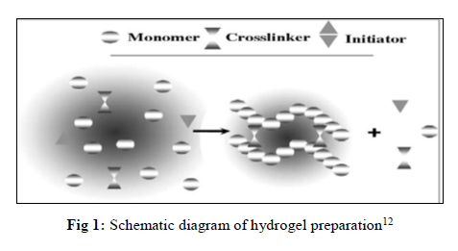
Free radical polymerization
The steps involved in polymerization include initiation, propagation, chain transfer and termination. The polymer is converted to active form by reaction between radicles and monomers. The monomers used are amide, acrylates and vinyl lactum.
Solution polymerization/cross-linking
This method is better than bulk polymerization because in it solvent like water, ethanol or both of its mixture and benzyl alcohol is used as heat sink so fast and economic also. The multifunctional crosslinking agent can be used for both ionic or neutral monomers. UV radiation or redox initiator system can be used for polymerization. The initiator, oligomer, soluble monomer, crosslinking agent and other impurities are removed from hydrogels by washing with distilled water. (Fig. 2 and 3).
Fig. 2: Hydrogel preparation block diagram Fig. 3: Solution Polymerization with recycle loop
Suspension polymerization or inverse-suspension polymerization
The homogeneous mixture consists of monomer and initiator. The polymerization is referred to as “ inverse suspension “ as it is water in oil process. Grinding is not required as hydrogel is obtained as microspheres or powders. In this technique, the continuous agitation and addition of low hydrophilic and lipophilic balance agent is required as this dispersion is thermodynamically unstable .
Grafting
In this technique free radicles on strong support surface are generated and the converted to monomers. Hydrogels can be grafted on surface coated support to improve its mechanical properties.
BIOMEDICAL APPLICATIONS
Hydrogels have soft surface and porous structure similar to living tissue. The demand of hydrogels in the field of pharmaceutical and biomedical engineering is increasing day by day. For in situ delivery of hydrogels new therapeutics are discovered by the use of medical science.
Genetically engineered pharmaceuticals can be delivered with the use of hydrogels. Hydrogels can be homo-polymeric, co-polymeric, semi and penetrating networks. Self-application hydrogels are commonly used. Thermoplastic biodegradable hydrogels have also been designed with high optical mechanical strength as they are easy to synthesize. Some of the application are given in the Fig. 4 [4-16].

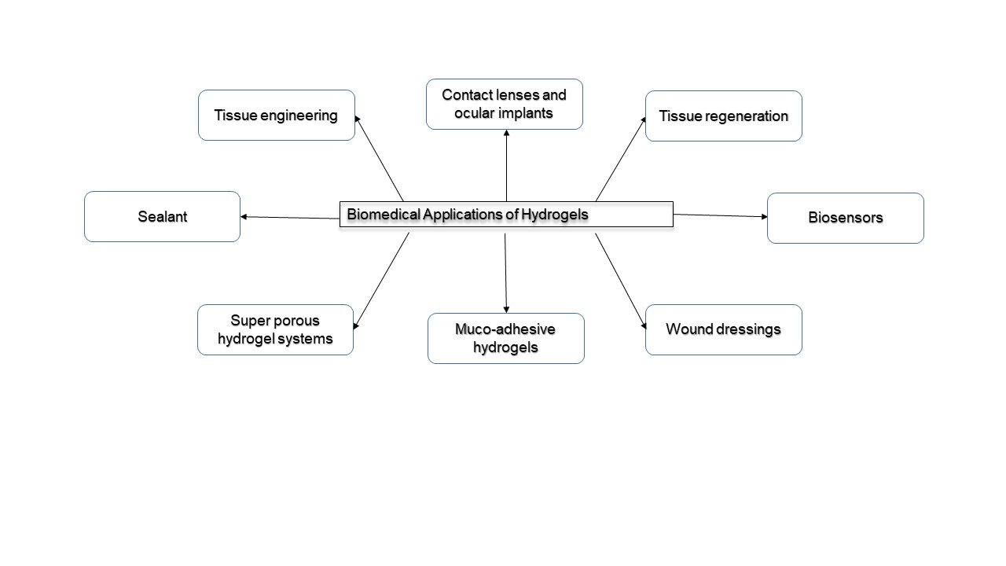
Fig. 4: Biomedical Applications of Hydrogels

CONCLUSION
Hydrogels are widely used in medical industries for dressing and tissue regeneration due to its capability of retaining large amount of water. However further research for improving the applicability of hydrogels is being carried out.

References
- Shetye SP, Dr. Godbole A, Dr. Bhilegaokar S, Gajare P. Hydrogels: Introduction, Preparation, Characterization and Applications, International Journal of Research of Research Methodology. 2015; 1(1):47-71.
- Singh. S, Dhyani. A, Juyal.D. Hydrogels: Introduction, Preparation, Characterization and Applications, The Pharma Innovation Journal 2017; 6(6): 25-35.
- Das N., Preparation methods and properties of hydrogels: a review, International Journal of Pharmacy and Pharmaceutical Sciences, Vol 5, Issue 3, 2013 :112-117.
- Hoare T.R., Kohane D.S., Hydrogels in drug delivery: Progress and challenges, Polymer, Volume 49, Issue 8,15April 2008:1993–2007.
- Ahmed E.M., Hydrogel: Preparation, characterization and applications, Journal of advanced research, Volume 6, Issue 2, March 2015:105–121.
- Caló E., Khutoryanskiy V.V., Biomedical applications of hydrogels: A review of patents and commercial products, Volume 65, April 2015: 252-267.
- Phadke A, Zhang C, Arman B, Cheng-Chih Hsu, Mashelkar R., Lele A., Tauber M., Arya G., and Varghese S.,Rapid self-healing hydrogels:4383-4388.
- Swarbrick J., Encyclopedia of Pharmaceutics, 4thedition, Vol III, F-O, 6000 Broken Sound Parkway NW, Suite300, Boca Raton, FL 33487-2742, Taylor & Francis Group, 2013.
- Das N. Preparation Methods and Properties of Hydrogel: A Review, International Journal of Pharmacy and Pharmaceutical Sciences. 2013; 5(3):1-2.
- Flowerlet M, Arya S, Mini A, Nayir SS, Joseph J, Vineetha VC et al. Hydrogel - A Drug Delivery Device, International Journal of Universal Pharmacy and Bio Sciences. 2014; 3(2):2-4.
- Devi A, Nautiyal U, Kaur SK. Hydrogels: a smart drug delivery device, Asian Pacific Journal of Health Sciences. 2014; 1(4S):93-94.
- Zaman M, Siddique W, Waheed S, Muhammad SS, Mahmood A, Qureshi J et al. International Journal of Biology, Pharmacy and Allied Sciences. 2015; 4(12):6581-6603.
- Rana P, Ganarajan G, Kothiyal P. Review on Preparation and Properties Hydrogel Formulation, World Journal of Pharmacy and Pharmaceutical Sciences. 2015; 4(12):1069-1080.
- Aulton M., Aulton’s pharmaceutics, The Design and Manufacture of Medicines, Third Edition, Elsevier’s Health Sciences Rights Department, 1600 John F. Kennedy Boulevard, Suite 1800, Philadelphia, PA 19103-2899, Harcourt Publishers Limited 2001
- Tan H, Marra KG. Injectable, biodegradable hydrogels for tissue engineering applications. Materials. 2010; 3:1746-1767.
- Susana S, Figueiras A, Veiga F. Modular Hydrogels for Drug Delivery, Journal of Biomaterials and Nanobiotechnology. 2012; 3:185-199
- . Enas MA. Hydrogel: Preparation, characterization, and applications: A review. Journal of Advanced Research. 2015; 6:105-121.
- Yang L, Chu JS, Fix JA. Colon-specific drug delivery: new approaches and in vitro/in vivo evaluation. International Journal of Pharmacy. 2002; 235:1-15.
- Abdelhalim SMI. Preparation and characterization and In-vitro evaluation of chitosan based smart hydrogels for controlled drug release, Massey University, North New Zealand, 2006, 5-6.

