Nano-diagnostics in Oral Squamous Cell Carcinoma

Dr. Rahul Mohandas, Dr. Subhashree Mohapatra, Dr. Supriya Kheur
Department of Oral and Maxillofacial Pathology and Oral Microbiology, Department of Public Health Dentistry
Dr. D.Y. Patil Dental College and Hospital, Dr. D.Y. Patil Vidapeeth
Pune, India

ABSTRACT
Oral squamous cell carcinoma (OSCC) is the most common type, accounting to more than 90% of oral cancers. The development of OSCC is a multifactorial and multistage process. Often, OSCC is preceded by the development of oral potentially malignant disorders (OPMDs) that may undergo a malignant transformation if left unaddressed. Thus, early identification of OPMDs and OSCC is extremely crucial for disease prognosis and patient survival. The invasive nature of biopsy makes it extremely uncomfortable and anxious for the patient. The diagnostic imaging techniques can provide cancer diagnosis in real-time, but their sensitivity for detecting small, early intraepithelial lesions is questionable. Nanotechnology has numerous potential applications in OSCC diagnosis and monitoring. Several nanoparticles like quantum dots, magnetic nanoparticles, metallic nanoparticles, up-conversion nanoparticles, carbon nanotubes, nanospheres, nanorods, nanosheets, nanoprisms, and nanostars have been employed for the early and accurate detection of OSCCs. In this chapter, we will discuss the nanoparticles, and the various imaging and biochemical detection modalities that have been used for the diagnosis of OSCC.

Keywords— quantum dots, nanoparticles, nano-diagnostics, carbon nanotubes, oral cancer

INTRODUCTION

Oral cancer is the sixth most prevalent cancer worldwide, with 377,713 new cases and 177,757 deaths reported in 2020 alone (1). The average 5-year survival rate is 83.7%, which varies by stage of the tumor. Approximately 70% of cases are diagnosed later, lowering the 5-year survival rate to 64.2% (2). Oral squamous cell carcinoma (OSCC) is the most common type, accounting for more than 90% of oral cancers. OSCC is a malignancy of oral epithelial cells, can penetrate the oral mucosal and hard tissues, and can show regional and distant metastases. The tongue is the most commonly affected site, having a poor prognosis (3).
The development of OSCC is a multifactorial and multistage process. Often, OSCC is preceded by the development of oral potentially malignant disorders (OPMDs) like leukoplakia, erythroplakia, oral lichen planus (OLP), oral submucous fibrosis (OSMF), and actinic keratosis that may undergo a malignant transformation if left unaddressed (4). Thus, early identification of OPMDs and OSCC is extremely crucial for disease prognosis and patient survival.
Currently, tissue biopsy and histopathological examination remain the gold standard diagnostic procedure to ascertain OPMDs and OSCC (5). However, the invasive nature of biopsy makes it extremely uncomfortable and anxious for the patient (6). Imaging techniques like computed tomography (CT), magnetic resonance imaging (MRI), positron emission tomography (PET), and cone-beam computed tomography (CBCT) are routinely employed as adjective diagnostic aids to histopathology as they are non-invasive (7). Although these modalities can provide cancer diagnosis in real-time, their sensitivity for detecting small, early intraepithelial lesions is questionable (8).
Several painless diagnostic strategies like vital staining, chemiluminescence, and autofluorescence have been employed for imaging OMPDs and OSCCs (9). However, these non-invasive imaging modalities are subjective and highly dependent on the investigator’s experience (10). Thus, novel detection methods ought to be explored to precisely forecast the malignant transformation potential of OPMDs, specifically identify OSCC based on molecular targeting, provide nano-scale ultrasensitive diagnostics, extent of intraoperative surgical resection margins, and monitor the survival and prognosis after OSCC management.
Nanotechnology is the manipulation of matter on the molecular and atomic level, with a length of less than 100 nanometers. The word 'nano' is a Greek prefix that means 'dwarf' or ‘very little' and represents one thousand millionths of a meter. Dr. Richard P Feynman introduced the concept of nanotechnology in 1959, but it was later popularized by Dr. K. Eric Drexler (11). The term nanotechnology was first defined by Norio Taniguchi of the Tokyo Science University in 1974 as - the processing, separation, consolidation, and deformation of materials by one atom or molecule (12). Nanomedicine is a widely researched topic of nanotechnology that enhances the prospect of specifically tailored cancer therapy. Nanotechnology also has potential applications in OSCC diagnosis and monitoring (13). In this chapter, we will discuss the nanoparticles, and the various imaging and biochemical detection modalities that have been used for the diagnosis of OSCC.

NANOPARTICLES EMPLOYED IN OSCC DIAGNOSIS
The various nanoparticles that have been employed for the diagnosis of OSCC have been summarized in figure 1.

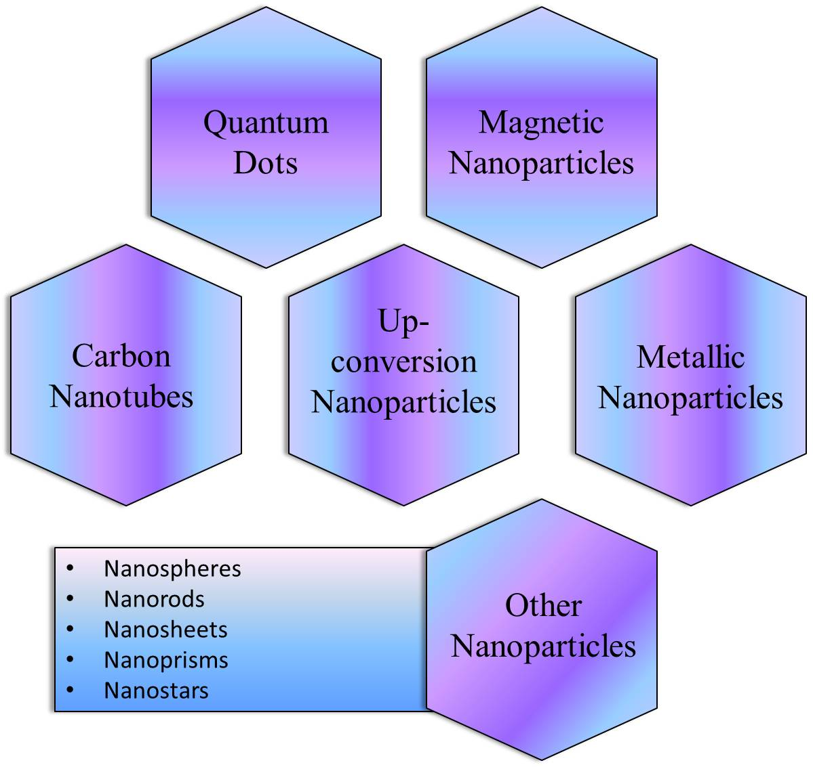
Figure 1: Nanoparticles used in diagnosis of OSCC

Quantum Dots
Quantum Dots (QDs) are zero-dimensional fluorescent nanoparticles with all dimensions less than 100 nm. They are made up of a semiconductor core covered by a shell. They have diverse electro-optical properties like increased quantum yield, enhanced fluorescence lifespan, good coefficient of absorption, increased brightness, outstanding stability, and a narrow band of emission ranging from visible to infrared. Owing to these features, numerous, highly sensitive and specific modern-day diagnostic probes have been developed using ODs (14). Figure 2 illustrates the structure and function of QDs in OSCC diagnosis.

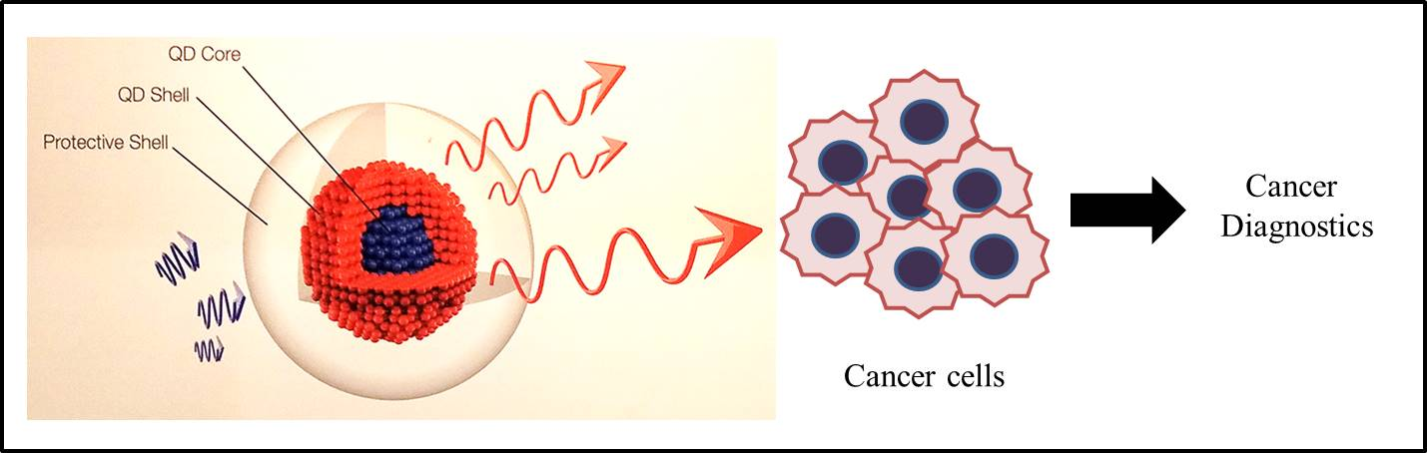
Figure 2: Structure and function of QDs in OSCC diagnosis

Magnetic Nanoparticles
Magnetic nanoparticles (MNPs) consist of a magnetic core covered by shell. Under saturation conditions, when an external magnetic field is applied, all MNPs align along the direction of the applied field. They exhibit paramagnetic and ferromagnetic behaviour, which can be altered by changing their structure or composition. They also demonstrate increased cellular attachment, excellent hematological stability, and multiplexed attachment to a single cancer cell without aggregation, making them extremely effective for the detection of circulating tumor cells (CTCs) in blood (15). The structure of MNPs has been illustrated in figure 3.

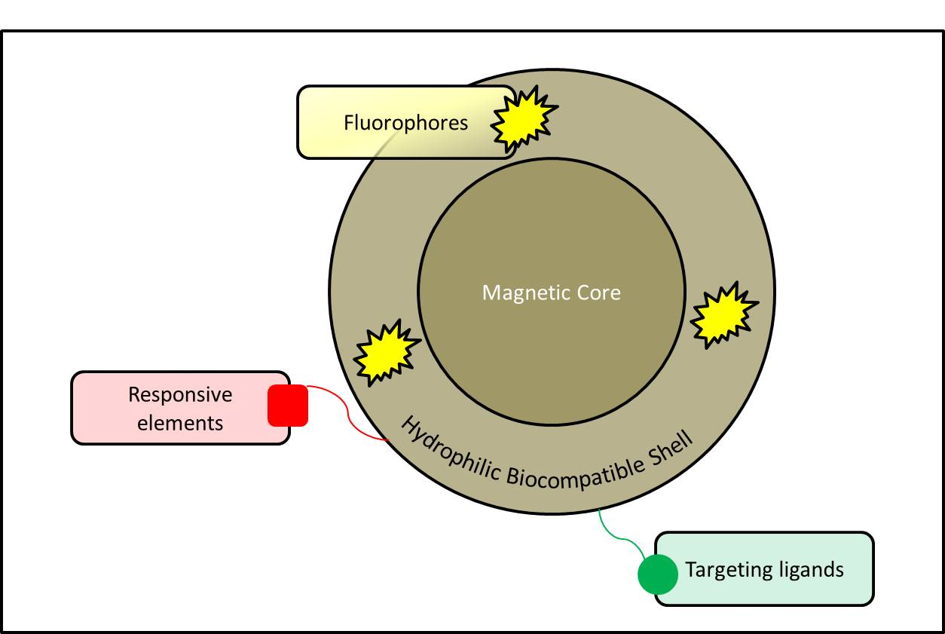
Figure 3: Structure of Magnetic Nanoparticle

Carbon Nanotubes
Carbon nanotubes (CNTs) are uni-dimensional nanoparticles because electrons only propagate down the nanotube's axis. They have a hollow cylindrical core made of single or several graphene sheets. Owing to their powerful carbon bonds and cylindrical structure, CNTs exhibit exceptional mechanical, chemical, and electrical properties. Since their conductivity may be modulated by changes in chemical binding and structure, CNTs are a great choice for the creation of nano-biosensors. CNTs are constructed of graphite sheets, with increased surface area and electrical conduction, enabling electronic detection of CTCs through real-time electrical impedance sensing (16). Figure 4 depicts the structure of CNTs.

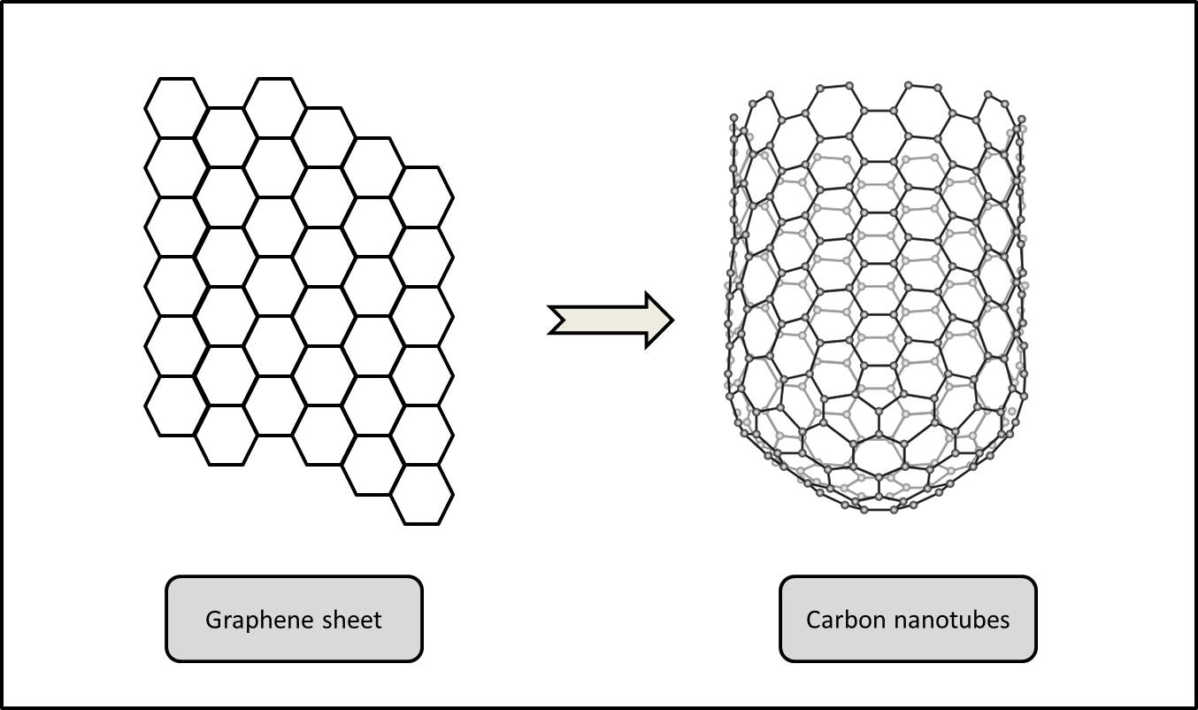
Figure 4: Structure of Carbon Nanotubes

Up-conversion Nanoparticles
Up-conversion nanoparticles (UCNPs) are composed of lanthanide ions. They convert low-energy incident photons in the near-infrared region to a single high-energy emission photon in the visible light range. They can be used for highly sensitive imaging of OSCC tissues because of their unique luminous features, significant Stokes shifts, low background signals, and less photobleaching (17). Figure 5 illustrates the working principle of UCNPs.

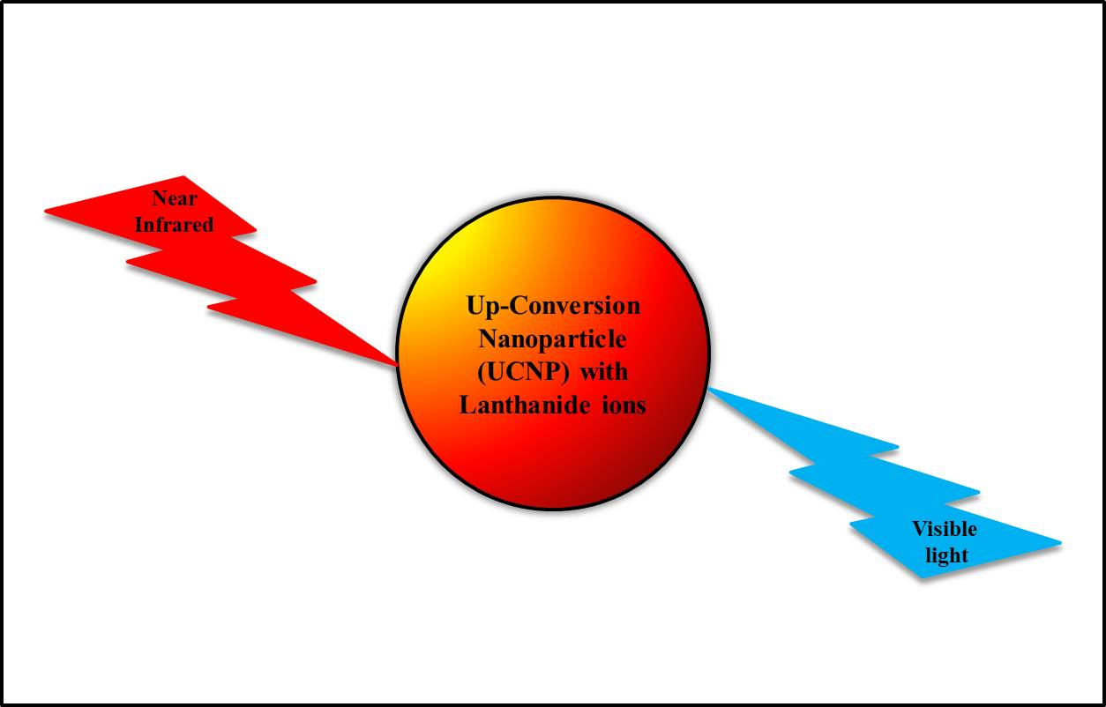
Figure 5: Working principle of Up-conversion nanoparticles

Metallic Nanoparticles
Metallic NPs contain free conduction band electrons that vibrate collectively on the application of external electromagnetic radiation. Silver and gold NPs have excellent biocompatibility and great chemical stability with low toxicity and can thus be employed for biological applications like diagnostic imaging of OSCCs (18).

Other Nanomaterials
The characteristics and sensitivity of nanostructural probes are substantially influenced by their form and size. The most commonly used nanostructure substrate shapes include nanospheres, nanorods, nanosheets, nanoprisms, and nanostars. These nanostructures have increased cell capture and binding affinity, allowing them to functionalize targeted ligands for use in detecting OSCC via ligand-antigen interaction (19).

NANO-DIAGNOSTICS IN ORAL SQUAMOUS CELL CARCINOMA

The various nanoparticle-based diagnostic modalities for early and accurate diagnosis of OSCC have been summarized in figure 6.

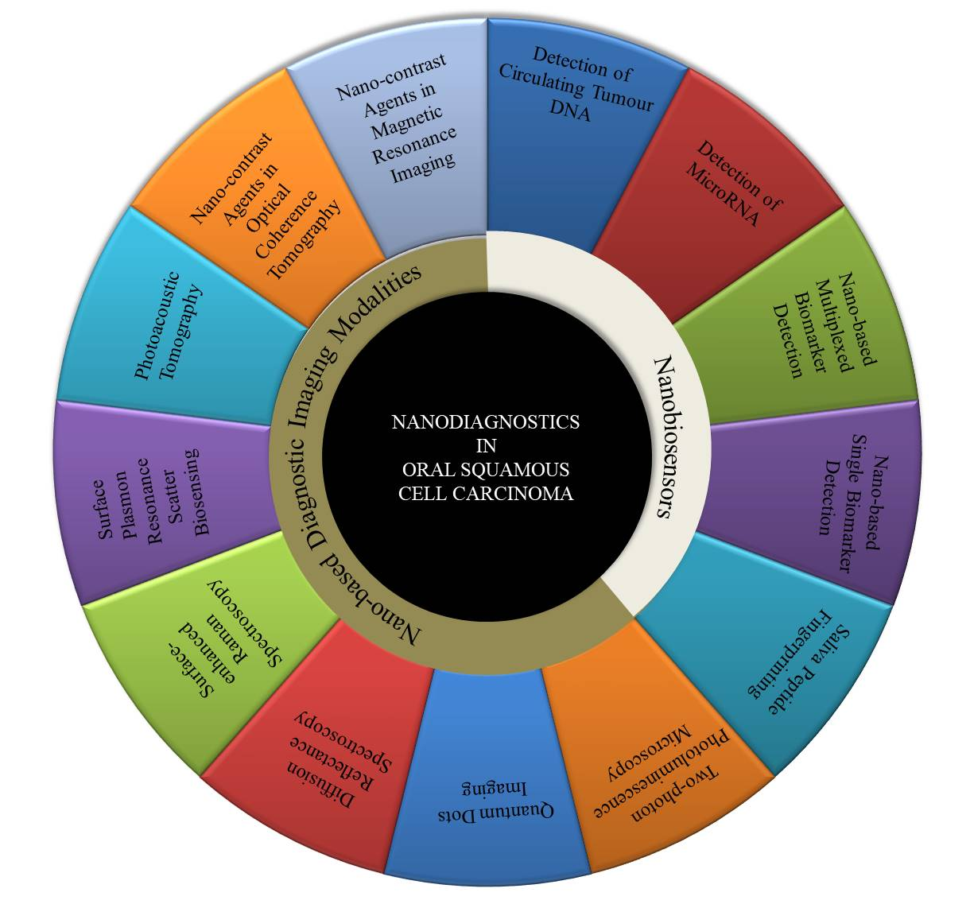
Figure 6: Nanoparticle-based diagnostic modalities for OSCC

Nano-based Diagnsotic Imaging Modalities

- Nano-contrast Agents in Magnetic Resonance Imaging
A variety of nanoparticles have been employed as MRI contrast agents for OSCC screening (20). Nano-contrast agents can identify distinct cell surface markers, resulting in improved MRI contrast qualities, and also have a longer half-life (21). A combination of folate-chitosan shell and magnetic poly-lactide-co-glycolide (PLGA) nanoparticle core have shown reduced overall T2 relaxation time, increased relaxivity, and improved imaging contrast. Meanwhile, it has also shown increased uptake and enhanced cytotoxicity in OSCC KB cell lines (22). Gadolinium-coated amorphous titanium dioxide nanoparticles have also exhibited prolonged longitudinal relaxivity, enhanced contrast along with excellent biocompatibility on OSCC cell lines (23).

- Nano-contrast Agents in Optical Coherence Tomography
Optical Coherence Tomography (OCT) uses backscattered or back-reflected light to perform high-resolution cross-sectional tomographic imaging of the internal microstructure of materials and biological systems. It generates cross-sectional images of sub-surface tissues like epithelium and basal lamina with a penetration depth of approximately 2 mm, thereby enabling early diagnosis of OMPDs and OSCCs (24). Although the resolution of OCT is better than CT, MRI, and ultrasound, the imaging contrast between healthy and neoplastic tissues remains insufficient (25). Surface plasmon resonant gold nanoparticles can improve the contrast of OCT images. To improve the poor in vivo transport of gold nanoparticles through biological barriers, a multimodal delivery system of antibody-conjugated PEGylated gold nanoparticles by microneedle and ultrasound has been developed. This multimodal delivery system can improve OCT penetration depth and increase the OCT image contrast in OSCC tissues (26).

- Photoacoustic Tomography
Photoacoustic tomography (PAT) works by conversion of absorbed optical energy into acoustic energy. PAT can generate high-resolution images because acoustic waves scatter much less than optical waves in tissues. Although various exogenous contrast agents have improved the contrast of photoacoustic imaging, gold nanoparticles exhibit enhanced bio-conjugation and produce stronger photoacoustic imaging signals (27). In metastatic mouse models of OSCC, ultrasound-guided spectroscopic photoacoustic imaging of molecularly activated plasmonic nanosensors (MAPS) have been used to detect lymph node micrometastases. It has been found that MAPS, targeted to the epidermal growth factor receptors, shift their optical absorption spectrum to the red-near-infrared region after specific interactions with nodal metastatic cells, enabling their detection by PAT. These findings offer a non-invasive alternative to sentinel lymph node biopsy analysis after resection of OSCC tissues (28).

- Surface Plasmon Resonance Scatter Biosensing
The collective oscillation of conduction electrons in noble metals creates surface plasmon waves. Surface Plasmon Resonance (SPR) scatter biosensing has evolved into one of the most potent and versatile medical diagnostic technologies. Owing to their ease of fabrication and bioconjugation, unique optical properties, and excellent stability, gold nanoparticles have been extensively used in SPR scatter biosensing (29). When SPR scattering images and SPR absorption spectra are analyzed and compared between OSCC cell lines and noncancerous cell lines, it has been found that the gold nanoparticles conjugated with anti-EGFR antibody bind homogeneously and specifically to the OSCC cell surface with 600% greater affinity than to the noncancerous cells, with a relatively sharper SPR absorption band (30). These findings imply that SPR scattering imaging or SPR absorption spectroscopy based on antibody-coated gold nanoparticles can be effective in fabricating molecular biosensing devices for the early diagnosis of OPMDs and OSCCs.

- Surface-enhanced Raman Spectroscopy
Raman spectroscopy is an imaging modality based on an inelastic interaction of light with matter. Since these vibrational transitions are associated with the respective molecular bonds, they are unique and generate distinct, fingerprint-like Raman spectra. The OMPDs and OSCC can be distinguished by inelastic scattering of light. Normal tissues have homogeneous signals, whereas malignant cells have heterogeneous signals, reflecting alterations in the chemical characterization and molecular structure of the lesions. In Surface-enhanced Raman Spectroscopy (SERS), a noble metal nanoparticle amplifies the Raman scattering intensity of molecules adsorbed on its surface (31). Small, spherical, SERS-active, and NIR-sensitive gold nanoparticles with exceptionally narrow intra-nanogap architectures have been used for imaging of OSCC cells. These NPs selectively target the cell organelles and get distributed intracellularly, thereby producing Raman images with a higher resolution (32).

- Diffusion Reflectance Spectroscopy
Diffusion reflectance spectroscopy (DRS) is a simple, safe, and economical optical diagnostic technology capable of imaging tissues using low radiation with high penetration depths (33). In DRS, a fraction of the incident white light is absorbed or transmitted by the tissue. Meanwhile, the remainder light gets reflected diffusely by multiple elastic scattering. The cytological and morphological changes during carcinogenesis have a significant impact on the reflected light, thereby enabling DRS to differentiate normal mucosa, OPMDs, and OSCCs (34). DRS can distinguish OSCC from OMPDs with a sensitivity of 98.5% and specificity of 96.0%, while it can distinguish OPMDs from healthy mucosa with a sensitivity of 95.0% and specificity of 100.0% (34).
EGFR-conjugated gold nanorods have been used to evaluate the surgical margins of OSCC specimens by DRS. The nanorods in tissues are visualized using air scanning electron microscopy, which spread to maximum of 1 mm between the healthy tissue and the tumor. DRS with a resolution of 1 mm is subsequently performed, indicating that the tumor edge is in the region of 4-5 mm. It has also been found that the reflectance intensity increases with an increase in dysplastic changes (35). Thus, DRS can be used as a potential diagnostic tool for detecting residual tumors intraoperatively in real-time, and for large-scale screening of OPMDs and OSCCs.

- Quantum Dots Imaging
QDs possess high fluorescent intensity, specific binding and are resistant to photobleaching during in-vitro imaging of OSCC cell lines (36). Near-infrared QDs with emission wavelengths ranging from 700 to 900 nm exhibit high tissue penetration and are safe for use in vivo (37). Researchers have also reported that EGFR-conjugated or arginine-glycine-aspartic acid sequence-conjugated QDs can provide high-quality images of OSCCs (38).
- Two-photon Photoluminescence Microscopy
Highly effective nanoparticles exhibiting two-photon photoluminescence (TPL) are highly attractive as contrast agents for optical imaging of OSCCs. Gold nanorods produce extremely bright TPL signals, which are several times brighter than typical fluorophores (39). Thus, TPL microscopy is an extremely appealing choice since imaging depths are sufficient to view both the epithelium and the stroma of oral mucosal tissue. Gold nanorods have found to be forty times brighter than the surrounding tissues using TPL microscopy. Intravital imaging also demonstrates 3D microvasculature and aberrant vessels using much lower incident powers in dysplastic tissues compared to healthy tissues. Thus, gold nanorods can be used as high-contrast imaging agents to visualize in vivo aspects of carcinogenesis using TPL microscopy for real-time diagnosis of OSCC (40).

Nano-Biosensors
The use of nanoparticles in biosensors and the fabrication of diagnostic devices have received a lot of attention. Owing to their nanoscale dimension, the designed nanostructured materials have an expanding surface-to-volume ratio, high mechanical strength, enhanced electrical conductivity, catalytic activity, and biocompatibility (41). Strategies for the detection and diagnosis of OSCC are greatly improved by combining biosensing and advancements in nanotechnology to help overcome limitations. Gold nanoparticles, quantum dots, dendrimers, nanocomposites, and other nanomaterials have been employed for the fabrication of nanosensors (42).

- Saliva Peptide Fingerprinting
For salivary proteomics analysis, the saliva peptide fingerprint method is a helpful tool that can forecast possible biomarkers beneficial for OSCC diagnosis. Matrix-assisted Laser-desorption Ionization–time-of-flight–Mass spectrometry is a powerful diagnostic tool that can detect and analyze salivary proteins with adequate resolution and sensitivity. One of the more promising materials for separating beads is magnetic beads made of nanoparticles. Interestingly, there have been substantial differences in expression levels of fifty proteins between OSCC patients and healthy controls in the reported studies. This provides a novel non-invasive, high-throughput method for screening of OSCC biomarkers (43).

- Nano-based Single Biomarker Detection
OSCC can also be detected using a nano-based single biomarker detection approach. Total internal reflection fluorescence microscopy (TIRFM) can be used to detect TNF-α utilizing a gold protein chip technique, thereby enabling ultra-sensitive detection of OSCC (44). Field emission scanning electron microscopy (FESEM), and atomic force microscopy (AFM) with high resolution can also be used to exhibit the substructure details of solitary human saliva exosomes, and their reversible nature of mechanical deformations in OSCC (45).

- Nano-based Multiplexed Biomarker Detection
In certain cases, a single OSCC biomarker may not suffice for reliable diagnosis. False positive and negative results arising due to single biomarker detection can be reduced by multiplexed biomarker detection. A panel of biomarkers has been evaluated using an ultrasensitive electrochemical microfluidic array in a multiplexed biomarker detection method. An abundance of nanostructured sensors and labeled magnetic beads are present in the microfluidic device. The protein panel has demonstrated a sensitivity and specificity of 89% and 98% respectively. This research offers a simple, economical tool for accurately diagnosing OSCC (46). In another study, nano-ultra-performance liquid chromatography (nano-UPLC) ion-mobility mass spectrometry has been used to analyze proteins and biomarkers in the conditioned media of OSCC cell lines. Approximately 952 proteins in total have been identified. A high-throughput method for quantifying proteins and comparing protein expression levels amongst various samples has been made available by this nano-UPLC-Q-TOF assay (47).

- Detection of Circulating Tumor DNA
Circulating tumor DNAs (ctDNAs) are tumor-derived DNA fragments that circulate in the bloodstream. ctDNA, which is secreted by primary tumors or circulating tumor cells (CTCs), can be used to identify cancer-related genetic mutations. The detection of abnormalities in ctDNA can aid in cancer diagnosis, even before the appearance of clinical signs and symptoms (48). Ultrabright SERS nanorattle-based sandwich assay has been used to detect the cytokeratin-14 (CK14) gene for head and neck SCC micrometastases in the lymph nodes. Synthetic CK14 target sequences have been identified from a negative control by creating capture probes and reporter probes that are specific to the target sequence (49). This will offer a distinctive, affordable, quick diagnostic alternative to provide a point-of-care diagnosis for OSCC and HNSCC patients with cervical lymphadenopathy.

- Detection of MicroRNA
Micro-RNAs (miRNAs) bind with mRNA and prevent its translation. These genetically encoded regulatory molecules support gene expression that controls cell proliferation, growth, and apoptosis. Dysregulation in miRNAs leads to disruption of normal cellular function, ultimately leading to cancer development (50). For the colorimetric measurement of OSCC-associated microRNA 31-5p (miRNA 31), a lateral flow strip biosensor has been fabricated using the cascade nucleic acid amplification technology. These miRNA strips can enable the formation of portable biosensor devices for real-time diagnosis of OSCC with excellent sensitivity and specificity (51).

CONCLUSION

Nanotechnology has developed novel methods for OSCC diagnosis in recent years. Nanoparticles are a promising diagnostic tool because of their performance characteristics - including function-specific size and shape, better half-life, biocompatibility, and improved cell surface targeting. Further, their properties can be modulated by altering the materials, methods, or surface chemistry used in their formation. The use of nanoparticles in the oral cavity has led to non-invasive, accurate and real-time diagnosis of OSCC and precise identification of surgical margins, thereby improving the prognosis and survival of patients with OSCC.

REFERENCES

- Tranby EP, Heaton LJ, Tomar SL, Kelly AL, Fager GL, Backley M, et al. Oral Cancer Prevalence, Mortality, and Costs in Medicaid and Commercial Insurance Claims Data. Cancer Epidemiol Biomarkers Prev. 2022 Sep 2;31(9):1849–57.
- Lingen MW, Abt E, Agrawal N, Chaturvedi AK, Cohen E, D’Souza G, et al. Evidence-based clinical practice guideline for the evaluation of potentially malignant disorders in the oral cavity: A report of the American Dental Association. J Am Dent Assoc. 2017 Oct;148(10):712–27.e10.
- Tanaka T, Ishigamori R. Understanding carcinogenesis for fighting oral cancer. J Oncol. 2011 May 12;2011:603740
- Lorini L, Bescós Atín C, Thavaraj S, Müller-Richter U, Alberola Ferranti M, Pamias Romero J, et al. Overview of Oral Potentially Malignant Disorders: From Risk Factors to Specific Therapies. Cancers. 2021 Jul 23;13(15).
- Walsh T, Macey R, Kerr AR, Lingen MW, Ogden GR, Warnakulasuriya S. Diagnostic tests for oral cancer and potentially malignant disorders in patients presenting with clinically evident lesions. Cochrane Database Syst Rev. 2021 Jul 20;7(7):CD010276
- Benergossi J, Calixto G, Fonseca-Santos B, Aida KL, de Cássia Negrini T, Duque C, et al. Highlights in peptide nanoparticle carriers intended to oral diseases. Curr Top Med Chem. 2015;15(4):345–55
- Sarrión Pérez MG, Bagán JV, Jiménez Y, Margaix M, Marzal C. Utility of imaging techniques in the diagnosis of oral cancer. J Craniomaxillofac Surg. 2015 Nov;43(9):1880–94.
- Sharma P, Brown S, Walter G, Santra S, Moudgil B. Nanoparticles for bioimaging. Adv Colloid Interface Sci. 2006 Nov 16;123-126:471–85.
- Giovannacci I, Vescovi P, Manfredi M, Meleti M. Non-invasive visual tools for diagnosis of oral cancer and dysplasia: A systematic review. Med Oral Patol Oral Cir Bucal. 2016 May 1;21(3):e305–15.
- Mercadante V, Paderni C, Campisi G. Novel non-invasive adjunctive techniques for early oral cancer diagnosis and oral lesions examination. Curr Pharm Des. 2012;18(34):5442–51.
- Bayda S, Adeel M, Tuccinardi T, Cordani M, Rizzolio F. The History of Nanoscience and Nanotechnology: From Chemical-Physical Applications to Nanomedicine. Molecules [Internet]. 2019 Dec 27;25(1). Available from: http://dx.doi.org/10.3390/molecules25010112
- Taniguchi N. On the basic concept of “nano-technology.” Proc Intl Conf Prod Eng Tokyo, Part II, 1974 [Internet]. 1974 [cited 2023 Jul 18]; Available from: https://cir.nii.ac.jp/crid/1572261550373135488
- Wang ZQ, Liu K, Huo ZJ, Li XC, Wang M, Liu P, et al. A cell-targeted chemotherapeutic nanomedicine strategy for oral squamous cell carcinoma therapy. J Nanobiotechnology. 2015 Oct 1;13:63.
- Valizadeh A, Mikaeili H, Samiei M, Farkhani SM, Zarghami N, Kouhi M, et al. Quantum dots: synthesis, bioapplications, and toxicity. Nanoscale Res Lett. 2012 Aug 28;7(1):480.
- Akbarzadeh A, Samiei M, Davaran S. Magnetic nanoparticles: preparation, physical properties, and applications in biomedicine. Nanoscale Res Lett. 2012 Feb 21;7(1):144.
- Bernholc J, Brenner D, Buongiorno Nardelli M, Meunier V, Roland C. Mechanical and Electrical Properties of Nanotubes. Annu Rev Mater Res. 2002 Aug 1;32(1):347–75.
- DaCosta MV, Doughan S, Han Y, Krull UJ. Lanthanide upconversion nanoparticles and applications in bioassays and bioimaging: a review. Anal Chim Acta. 2014 Jun 17;832:1–33
- Blanco-Formoso M, Alvarez-Puebla RA. Cancer Diagnosis through SERS and Other Related Techniques. Int J Mol Sci [Internet]. 2020 Mar 24;21(6). Available from: http://dx.doi.org/10.3390/ijms21062253
- Huang Q, Wang Y, Chen X, Wang Y, Li Z, Du S, et al. Nanotechnology-Based Strategies for Early Cancer Diagnosis Using Circulating Tumor Cells as a Liquid Biopsy. Nanotheranostics. 2018 Jan 1;2(1):21–41.
- Cheng W, Ping Y, Zhang Y, Chuang KH, Liu Y. Magnetic resonance imaging (MRI) contrast agents for tumor diagnosis. J Healthc Eng. 2013;4(1):23–45.
- Aryal S, Key J, Stigliano C, Landis MD, Lee DY, Decuzzi P. Positron emitting magnetic nanoconstructs for PET/MR imaging. Small. 2014 Jul 9;10(13):2688–96.
- Shanavas A, Sasidharan S, Bahadur D, Srivastava R. Magnetic core-shell hybrid nanoparticles for receptor targeted anti-cancer therapy and magnetic resonance imaging. J Colloid Interface Sci. 2017 Jan 15;486:112–20.
- Chandran P, Sasidharan A, Ashokan A, Menon D, Nair S, Koyakutty M. Highly biocompatible TiO₂:Gd3+ nano-contrast agent with enhanced longitudinal relaxivity for targeted cancer imaging. Nanoscale. 2011 Oct 5;3(10):4150–61.
- DeCoro M, Wilder-Smith P. Potential of optical coherence tomography for early diagnosis of oral malignancies. Expert Rev Anticancer Ther. 2010 Mar;10(3):321–9.
- Oldenburg AL, Hansen MN, Zweifel DA, Wei A, Boppart SA. Plasmon-resonant gold nanorods as low backscattering albedo contrast agents for optical coherence tomography. Opt Express. 2006 Jul 24;14(15):6724–38.
- Kim CS, Wilder-Smith P, Ahn YC, Liaw LHL, Chen Z, Kwon YJ. Enhanced detection of early-stage oral cancer in vivo by optical coherence tomography using multimodal delivery of gold nanoparticles. J Biomed Opt. 2009 May-Jun;14(3):034008.
- Jiang Y, Pu K. Advanced photoacoustic imaging applications of near-infrared absorbing organic nanoparticles. Small. 2017 Aug;13(30):1700710.
- Luke GP, Myers JN, Emelianov SY, Sokolov KV. Sentinel lymph node biopsy revisited: ultrasound-guided photoacoustic detection of micrometastases using molecularly targeted plasmonic nanosensors. Cancer Res. 2014 Oct 1;74(19):5397–408.
- Yang CT, Xu Y, Pourhassan-Moghaddam M, Tran DP, Wu L, Zhou X, et al. Surface Plasmon Enhanced Light Scattering Biosensing: Size Dependence on the Gold Nanoparticle Tag. Sensors [Internet]. 2019 Jan 15;19(2). Available from: http://dx.doi.org/10.3390/s19020323
- El-Sayed IH, Huang X, El-Sayed MA. Surface plasmon resonance scattering and absorption of anti-EGFR antibody conjugated gold nanoparticles in cancer diagnostics: applications in oral cancer. Nano Lett. 2005 May;5(5):829–34.
- Harmsen S, Wall MA, Huang R, Kircher MF. Cancer imaging using surface-enhanced resonance Raman scattering nanoparticles. Nat Protoc. 2017 Jul;12(7):1400–14.
- Kang JW, So PTC, Dasari RR, Lim DK. High resolution live cell Raman imaging using subcellular organelle-targeting SERS-sensitive gold nanoparticles with highly narrow intra-nanogap. Nano Lett. 2015 Mar 11;15(3):1766–72.
- Pang R, Zhou S, Hu X, Xie Z, Liu X, Duadi H, et al. New diffusion reflection imaging system using gold nanorods coated with poly-(3,4-ethylenedioxythiophene). Opt Mater Express, OME. 2016 Apr 1;6(4):1238–46.
- Jayanthi JL, Nisha GU, Manju S, Philip EK, Jeemon P, Baiju KV, et al. Diffuse reflectance spectroscopy: diagnostic accuracy of a non-invasive screening technique for early detection of malignant changes in the oral cavity. BMJ Open. 2011 Jun 24;1(1):e000071.
- Ankri R, Ashkenazy A, Milstein Y, Brami Y, Olshinka A, Goldenberg-Cohen N, et al. Gold Nanorods Based Air Scanning Electron Microscopy and Diffusion Reflection Imaging for Mapping Tumor Margins in Squamous Cell Carcinoma. ACS Nano. 2016 Feb 23;10(2):2349–56.
- Li Z, Wang K, Tan W, Li J, Fu Z, Ma C, et al. Immunofluorescent labeling of cancer cells with quantum dots synthesized in aqueous solution. Anal Biochem. 2006 Jul 15;354(2):169–74.
- Yang K, Cao YA, Shi C, Li ZG, Zhang FJ, Yang J, et al. Quantum dot-based visual in vivo imaging for oral squamous cell carcinoma in mice. Oral Oncol. 2010 Dec;46(12):864–8.
- Huang H, Bai YL, Yang K, Tang H, Wang YW. Optical imaging of head and neck squamous cell carcinoma in vivo using arginine-glycine-aspartic acid peptide conjugated near-infrared quantum dots. Onco Targets Ther. 2013 Dec 2;6:1779–87.
- Wang H, Huff TB, Zweifel DA, He W, Low PS, Wei A, et al. In vitro and in vivo two-photon luminescence imaging of single gold nanorods. Proc Natl Acad Sci U S A. 2005 Nov 1;102(44):15752–6.
- Motamedi S, Shilagard T, Edward K, Koong L, Qui S, Vargas G. Gold nanorods for intravital vascular imaging of preneoplastic oral mucosa. Biomed Opt Express. 2011 Apr 13;2(5):1194–203.
- Hassan RYA. Advances in Electrochemical Nano-Biosensors for Biomedical and Environmental Applications: From Current Work to Future Perspectives. Sensors [Internet]. 2022 Oct 5;22(19). Available from: http://dx.doi.org/10.3390/s22197539
- Huang X, Zhu Y, Kianfar E. Nano Biosensors: Properties, applications and electrochemical techniques. Journal of Materials Research and Technology. 2021 May 1;12:1649–72.
- Jiang WP, Wang Z, Xu LX, Peng X, Chen F. Diagnostic model of saliva peptide finger print analysis of oral squamous cell carcinoma patients using weak cation exchange magnetic beads. Biosci Rep [Internet]. 2015 May 12;35(3). Available from: http://dx.doi.org/10.1042/BSR20150023
- Weigum SE, Floriano PN, Redding SW, Yeh CK, Westbrook SD, McGuff HS, et al. Nano-bio-chip sensor platform for examination of oral exfoliative cytology. Cancer Prev Res . 2010 Apr;3(4):518–28.
- Sharma S, Rasool HI, Palanisamy V, Mathisen C, Schmidt M, Wong DT, et al. Structural-mechanical characterization of nanoparticle exosomes in human saliva, using correlative AFM, FESEM, and force spectroscopy. ACS Nano. 2010 Apr 27;4(4):1921–6.
- Malhotra R, Patel V, Chikkaveeraiah BV, Munge BS, Cheong SC, Zain RB, et al. Ultrasensitive detection of cancer biomarkers in the clinic by use of a nanostructured microfluidic array. Anal Chem. 2012 Jul 17;84(14):6249–55.
- Nassar AF, Williams BJ, Yaworksy DC, Patel V, Rusling JF. Rapid label-free profiling of oral cancer biomarker proteins using nano-UPLC-Q-TOF ion mobility mass spectrometry. Proteomics Clin Appl. 2016 Mar;10(3):280–9.
- Dessale M, Mengistu G, Mengist HM. Nanotechnology: A Promising Approach for Cancer Diagnosis, Therapeutics and Theragnosis. Int J Nanomedicine. 2022 Aug 26;17:3735–49.
- Vohra P, Ngo HT, Lee WT, Vo Dinh T. Squamous Cell Carcinoma DNA Detection Using Ultrabright SERS Nanorattles and Magnetic Beads for Head and Neck Cancer Molecular Diagnostics. Anal Methods. 2017 Oct 7;9(37):5550–6.
- Fiammengo R. Can nanotechnology improve cancer diagnosis through miRNA detection? Biomark Med. 2017 Jan;11(1):69–86.
- Li W, Peng W, Zhang Y, Liu P, Gong X, Liu H, et al. A lateral flow strip biosensor platform based on cascade nucleic acid amplification technology for ultrasensitive detection of OSCC-associated salivary MicroRNA. Anal Chim Acta. 2022 Aug 15;1221:340112.

