Title: Protease Inhibitors: Implications as key potential therapeutics for COVID19 pandemic

Prathamesh Kale
Protein Biochemistry Laboratory,
Dr. D. Y. Patil Biotechnology and
Bioinformatics Institute
Pune, India
Sujit Pawar
Protein Biochemistry Laboratory,
Dr. D. Y. Patil Biotechnology and Bioinformatics Institute
Pune, India

Divanshi Gupta
Inscribe Company
Pune, India

Ashwini Puntambekar
Protein Biochemistry Laboratory,
Dr. D. Y. Patil Biotechnology and Bioinformatics Institute
Pune, India

Vaibhavi Mohire
Dr. D. Y. Patil Biotechnology and
Bioinformatics Institute
Pune, India

Manjusha Dake*
Protein Biochemistry Laboratory,
Dr. D. Y. Patil Biotechnology and
Bioinformatics Institute
Pune, India
manjusha.dake@dpu.edu.in

Abstract
A new illness with symptoms similar to pneumonia called novel corona virus disease, or COVID-19, caused by the virus SARS-CoV-2, was sweeping Wuhan in December 2019. This disease spread at a rapid pace and was declared a pandemic by the World Health Organisation (WHO) on March 11, 2020. As of July 5, 2020, the epidemic infected more than 1.5 crore people globally, including 6.9 lakhs in India. The corona virus's quick global outbreak caused thousands of deaths and a surge in hospital admissions in numerous nations. Thus, the SARS-CoV-2 virus is often regarded as the biggest medical emergency of the 20th century. Health inequities within and between nations had been brought to light by COVID-19, which will have a long-lasting effect on world civilization. Nevertheless, during the past few decades, significant research and funding in biosciences have enabled a quick scientific response with advancements in viral characterization, testing, and sequencing. But even though there had been numerous global initiatives to address this problem effectively to date, COVID-19 still remains untreated and is not yet subject to any effective and targeted therapeutic treatment. Based on gathered knowledge since the COVID-19 pandemic started and a comprehensive list of clinical and preclinical inhibitors with anti-corona virus activity, we have presented a summary of the progress made in the development of COVID-19 drugs and preventive measures along with the basic knowledge about the structure of the corona virus, its genomic orientation, spreading mechanism, clinical approaches etc.
Keywords: COVID-19, SARS-CoV-2, Corona virus, Therapeutics, Virology, Pandemic

I. Disease Introduction
Chinese health officials discovered a novel CoV-2 epidemic in January 2020, which led to a severe acute respiratory sickness with symptoms resembling SARS. The World Health Organisation (WHO) classified the virus that caused Corona virus disease 2019 (COVID-19), a member of the corona virus family (SARS-CoV-2), and labelled it as a pandemic. At the whole-genome level, SARS-CoV-2 full-length genome sequences showed 79.6% sequence similarity to SARS-CoV and 96% sequence identity to a bat corona virus. As of April 30, 2021, COVID-19 has claimed the lives of over 3155168 persons, with over 149910744 million validated instances. Due to a dearth of knowledge on COVID-19 illness, already existing treatment methods were being tested for any type of positive outcome. One potential method for reducing the progression of sickness was found to be the use of antiviral medications, which either prevent virus entry or obstruct virus multiplication and its maturation. It has been demonstrated in vitro that antiviral medications such hydroxychloroquine, remdesivir, and lopinavir have positive effects against SARS-CoV-2. However, due to their high dosage requirements and limited therapeutic window, the aforementioned medications resulted in major adverse effects in a large number of patients. As a result, these medications need to be repurposed with an appropriate formulation with the aim to increase COVID-19 therapeutic safety and effectiveness [1].
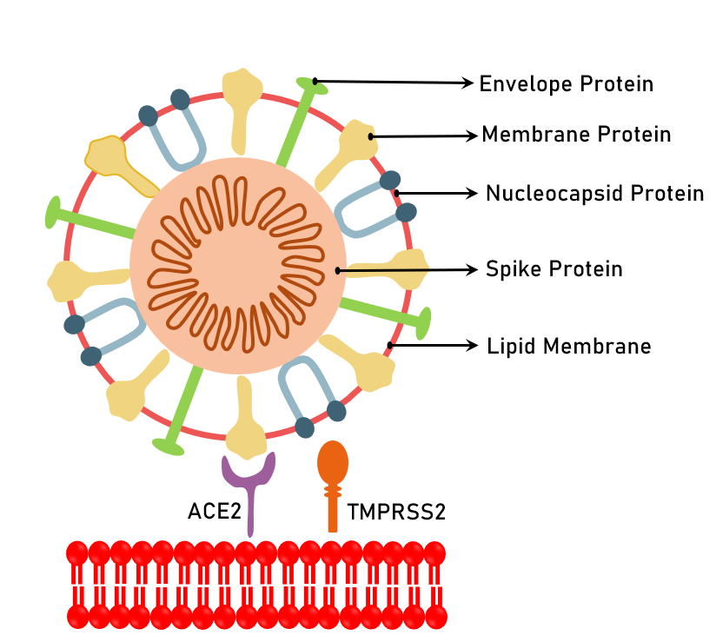
Fever, cough, sore throat, shortness of breath, tiredness, and malaise are some of the symptoms.

Figure1. Viral Proteins
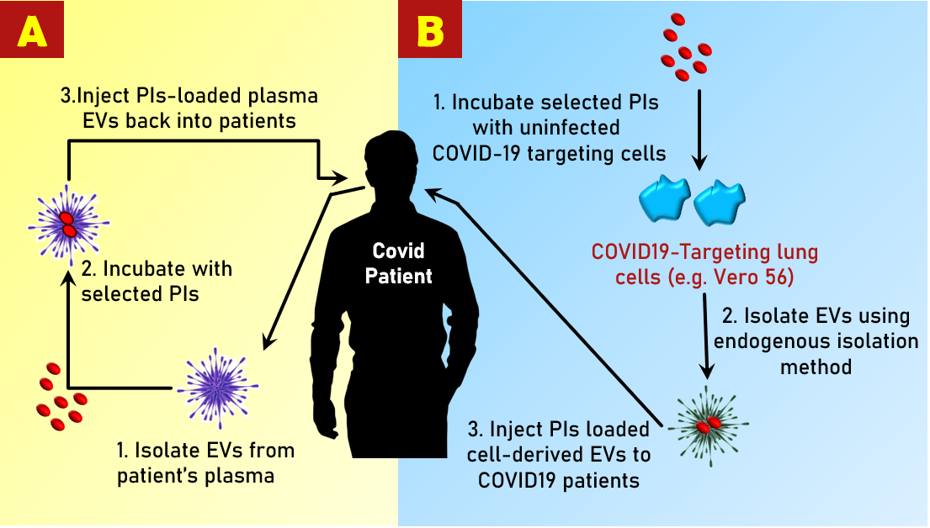

Figure 2.Personalised treatment technique: (A) EVs are extracted from a patient's plasma, loaded with specific PIs, and given to the same patient through IV. EVs are extracted from cell culture media in the endogenous loading mass production technique (B). UninfectedSARS-CoV-2 targeting cells treated with PIs. To prepare for future treatment, isolate EVs that had been encapsulated with PIs.
New human corona virus, which is connected to SARS and MERS (multiple sclerosis, or Middle East respiratory illness), has an odd strand along with positive sense RNA. It was found in the Chinese city of Wuhan at the end of December 2019. Humans who contract this 2019-nCoV likely experienced severe respiratory tract infections as well as other side effects like damage to the pulmonary system, breathing malfunctioning. Identical to SARS-CoV and MERS-CoV, which have zoonotic origins and propagated from bat and camel, respectively, the 2019-nCoV has been suggested to be transmitted from a certain species of bat to people in China and other places like the Middle East and Europe. The scaly Pangolin, which is common in China, may had been the source of the nCoV, according to another study [2]. The WHO classified the new SARS-CoV-2 virus a pandemic, indicating that the 2019 nCoV is a serious worldwide emergency. This occurred as a result of the virus's global spread to more than 100 nations [3].
The European Union's open borders allowed the virus to spread across Europe. The illness developed a pandemic due to the open borders between neighboring countries. Countries with inadequate health systems and diagnostic ability were more vulnerable to huge epidemics that met the criteria of a pandemic, while others were able to control viral spread by maintaining social distance and following a regular sanitization routine. By February 25th, 2020, China reported around 80,000 cases. Despite the fact that only 10% of cases were detected in China, the real patient number was estimated to be about 8 million. This suggested a lower rate of viral infection transmission when compared to China's population of almost 1.4 billion people, where most Chinese were uninfected and had reduced virus susceptibility. However, due to the asymptomatic nature of the viral infection, the undiscovered transmission of the 2019 nCoV throughout the country began a new pandemic chain of transmission [4].
The expansion of COVID-19 slowed economic commotion drastically. The world economy fell by around 4.9% in June 2020, according to an early prediction from the International Monetary Fund (2020a) (2020b). This contraction was of far greater magnitude as compared to the 2008-2009 Global Financial Crisis. The reasons behind the lowering of the economy include slowing down social distancing activities causing lowering the activities during lockdowns, and a steeper decline in productivity in the industrial and business sector. The lockdown also adversely affected the labour markets resulting overall effect on the production of supply chains, financial markets, and the World economy. Restrictions such as social distancing measures (e.g., lockdowns and associated rules), as well as the duration of the lockdown, were tried to mitigate the negative economic impacts. Other impacted areas experienced mental health problems as a result of the pandemic scenario and government involvement, resulting in economic inequalities and affecting various socio-demographic groups [5].
From the beginning, WHO was a major player in the global effort to combat COVID-19, who was constantly keeping an eye on the disease's progress, coordinating worldwide data exchange, and offering technical support to all the countries. Over 20 nations reported positive COVID-19 cases as of the end of January 2020; this figure swiftly rose to 54 by the end of February and to 202 by the end of March. Corona expanded to 212 countries by April 30, 2020. There were 211,028 fatalities and 3,059,642 illnesses, in accordance to the WHO. With the exception of Antarctica, where fewer places, primarily the Pacific islands, registered no COVID-19 instances, the havoc of this virus grew to all continents.
COVID-19.3 was blamed for more than 2 million fatalities in February 2021. This epidemic has presented a serious threat to human physical and mental health, and it has had a significant influence on daily life on a worldwide scale, with psychological consequences. Corona’s progress was tracked using a variety of metrics, including epidemiology, virology, pathogenesis, illness diagnostics, and the application of artificial intelligence to aid diagnosis, treatment, and vaccine development [6]. There had been a total of 286,835 COVID-19–related fatalities recorded globally as of May 12, 2020, but no thorough study of this group had provided successful results[7].
II. Spread and infection
A novel corona virus strain (SARS-CoV-2) has been found to be the source of a significant acute respiratory illness outbreak (COVID-19).Because there is no specific antiviral drug or vaccination available, quick therapeutic responses to SARS-CoV-2 have developed. Increased plasma cytokine levels and an uncontrolled inflow of inflammatory cells cause an imbalanced host immune response, which worsens the illness. When comparing data from *SIRS and MERS (Middle East Respiratory Syndrome) infections, scientific research showed that SARS-CoV-2 attacks the human body's immune system and exploits the Angiotensin-Converting Enzyme 2(ACE2) receptor to infect the host. According to further studies, proteases (TMPRSS2, cathepsins, plasmin, and others) are crucial for viral entry and immune system operation. In order to evaluate the probable role of proteases in SARS-CoV-2 viral transmission and infection, several studies provided a concise synopsis of their recent research findings. To determine the involvement of proteases in triggering an immune response, existing knowledge on how various proteases contribute to immune responses were gathered. Additionally, it advised using a combination of protease inhibitors to target proteases in a targeted manner [8].
COVID-19 corona virus illness first appeared in 2019, which had previously been referred to as "2019 novel corona virus" or "2019-nCoV." The sickness was discovered in Wuhan, the capital of China's Hubei province, around November 17, 2019. Chinese officials made the discovery of the novel corona virus public a few weeks later, in December 2019. A viral infection may be asymptomatic or show symptoms later on. Some of the symptoms include coughing, fever, and shortness of breath. Pneumonia, multiple organ failure, and death could develop in some patients as the illness worsens [9]. Coughs and sneezes are the main methods of viral transmission. The most reliable method for identifying COVID-19 infection is RT-PCR. Nasopharyngeal swabs are used to collect respiratory samples for RT-PCR analysis, which might take a few hours to two days to complete. The COVID-19 infection quickly spread to nearby countries including South Korea, Singapore, and others after the illness first appeared in China. Due to the virus's high infectivity rate, a corona virus pandemic occurred in 2019–2020 on a global scale [10].
Droplets and contact with contaminated surfaces, fomites, and aerosol formation are the most common ways for the virus to spread. Urine, faeces, and saliva all contain the virus. Asymptomatic shedding, especially in youngsters, appears to be widespread and can transmit illness [11]. The incubation time is commonly 5 to 7 days from infection to first symptom, with a range of 4-14 days. To diagnose a present infection, Virus detection assays in various bodily fluids are used. Antibody blood tests are used to confirm prior infection and infection resistance [12].
Recent studies manifested that COVID-19 transmission can occur before symptoms appear; raising concerns that otherwise healthy people may be significant carriers of the COVID-19 pandemic. Based on the percentage of transmission events that happen before symptoms develop, recent modelling found that around 44% of secondary cases were infected during presymptomatic periods of illness [13]. The quantity of infectious virus needed to transmit COVID-19 is unknown; however, case studies have found several instances of transmission before symptoms manifest. The most accurate method to calculate transmission potential is to use epidemiological research to compare the fraction of presymptomatic vs postsymptomatic spread. Since there is a lack of information on the number of asymptomatic/presymptomatic COVID-19 patients, it is challenging to estimate the ratio of pre- and post-symptom onset transmission. Modelling studies can be used to comprehend epidemiological data. On the contrary hand, COVID-19 models can be interpreted incorrectly since they rely so much on the assumptions that are made in them [14].
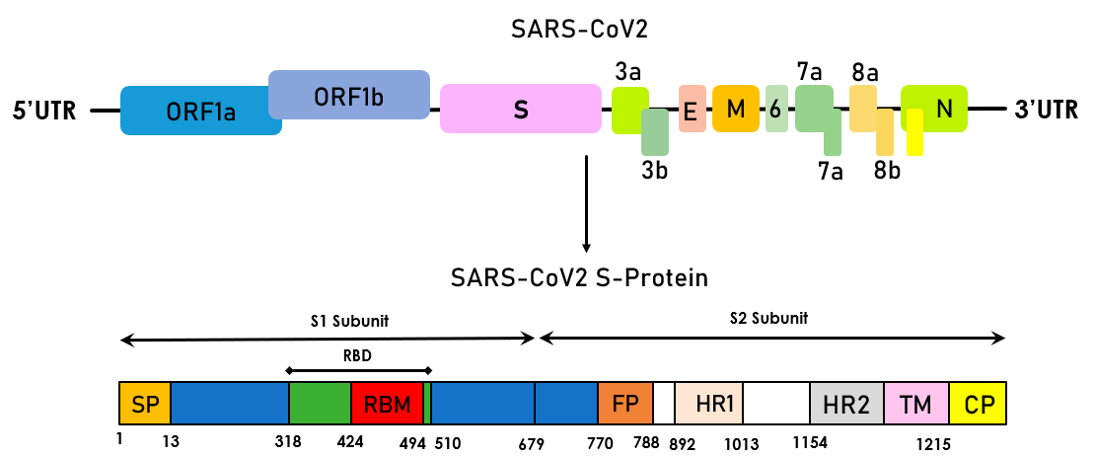

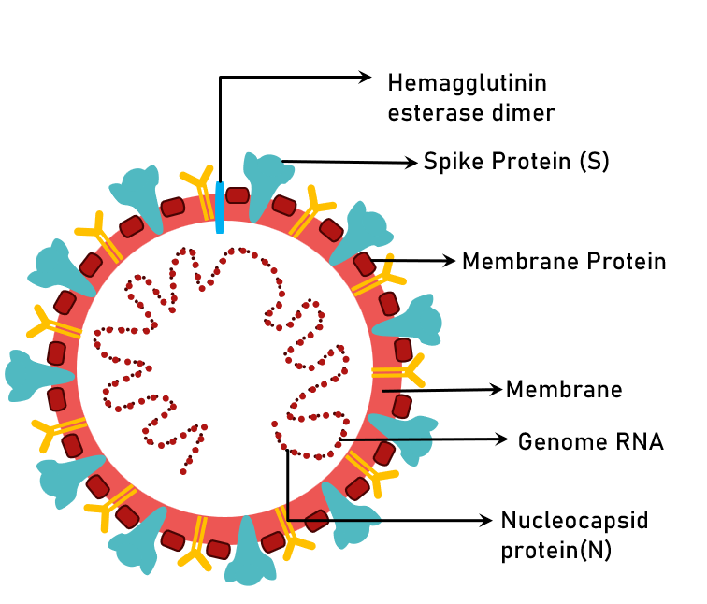

Figure 3. A schematic illustration of COVID-19 genomic structure and functional domains of the S protein.

III. Structure of virus
The single-stranded RNA genome of the COVID-19 virus encodes the ORF1a and ORF1b genes. 16 non-structural proteins are coded for by these two genes (nsp1-nsp16). Spike protein (S), envelope (E), membrane (M), and nucleocapsid (N) are all encoded by the structural genes.
The structure of S protein:
The S protein is composed of the S1 and S2 subunits. The S1/S2 cleavage sites. The cytoplasm domain (CP), fusion peptide (FP), heptad repeat (HR), receptor-binding domain (RBD), signal peptide (SP), and transmembrane domain (TM) are all components of the S-protein. The viral surface proteins spike, envelope, and membrane are encased in a lipid bilayer. The single-stranded positive-sense viral RNA along with the nucleocapsid protein are connected.

IV. Disease mechanism
The viral entry, replication, and RNA packaging mechanisms in a human cell are shown in Figure 4. A number of human cells, including the lungs, have ACE2 receptors on their surface, and the spike (S) protein binds to these receptors, allowing the virus to enter. Trypsin and furin, two host-derived proteases, split the corona virus S protein into two pieces at the S1/S2 location. In the second stage, the S2 domain (S20 site) is separated in order to release the fusion peptide. This causes the virus and its membrane fusion mechanism to become active. Finding antiviral antibodies may be a goal for the binding region of the ACE2 receptor's structural data (aa sequence). The process by which a human cell ingests the virus is known as endocytosis. After entering the cytoplasm, COVID-19 adopts a three-step process: i) Conformational changes in the Spike (S) glycoprotein; ii) cathepsin L proteolysis iii) activation of the membrane fusion mechanism. The endosome then opens, releasing the virus into the cytoplasm. Viral nucleocapsid (N) develops as a process consisting of two phases in which the virion's S1 component connects to cell surface receptor subsequently followed by the disintegration of Spike by host proteases [15] due to endogenous proteasomes digesting foreign proteins, such as the SARS nucleocapsid protein. At low pH, the S2 component facilitates the union of the viral and host target membranes. The replication/ transcription complex (RTC), which is in charge of replication and transcription (RTC), completely releases the viral RNA into the cytoplasm. The RTC complex is made up of nonstructural proteins and is encoded in the viral genome (nsp). Open reading frame 1a/b (ORF 1a/b) of the positive RNA genome is translated to produce replicase proteins. With a template genome, replicase proteins create full-length negative sense RNAs. In the cytoplasm, the viral proteins M, S, and E are made [16]. By encapsidating replicated genomes with N protein in the cytoplasm, nucleocapsids are created, and they eventually fuse to form entirely novel virions. Finally, newly produced virions generated by infected cells exocytose into nearby cells to infect them. Viral proliferation can put pressure on the endoplasmic reticulum and cause cell death [17].
According to laboratory analysis, the absolute quantities of lymphocytes in the majority of patients have dropped, indicating that 2019-nCoV, like SARS-CoV, may primarily attack lymphocytes, particularly T cells. By attacking other cells and spreading across the respiratory mucosa, virus particles modify white blood cells and lymphocytes, which set off a cytokine storm and a chain reaction of immune responses. A small number of patients with increasing acute respiratory distress syndrome (ARDS) get septic shock, which is followed by multiple organ failure. Early detection and treatment of serious cases are therefore essential.
For patients with ARDS, intravenous immunoglobulin (methylprednisolone 1–2 mg/kg per day) boosts immune power for anti-infection and steroids treat severely sick individuals. According to a few studies, the corona virus, which eats numerous immune cells and impairs the body's cellular immunological activity, caused a significant decline in the overall number of lymphocytes. T lymphocyte damage might be a contributing factor in patient 25's exacerbations. In the clinic, lymphocytes with a low absolute value might be used as a reference index for identifying new corona virus infections [18].
On chest computed tomographic (CT) imaging, the majority of COVID-19 patients appeared like ground glass, similar to SARS and MERS patients. A person diagnosed with COVID-19 displays pathological characteristics that are equivalent to those of SARS-CoV and MERS-CoV infections, based upon biopsy samples taken from the lung, liver, and heart. In addition to ARDS, COVID-19 infection can cause significant renal impairment as well as abrupt cardiac injury. Being a new SARS pandemic, the aetiology and pathology of COVID-19 are unknown. There is currently no effective vaccine or antiviral medication [19].
- Entry of virus:
Corona viruses are cytoplasmic positive-stranded RNA viruses that fuse with the host cell membrane using envelope to insert nucleocapsid. The spike glycoprotein (S), which aids viral entry, is a key factor to determine cell pathogenicity. It's a class I fusion protein that goes through a lot of conformational changes for connecting to the receptor on the host cell and for host and viral membranes fusion. The entrance mechanisms of corona virus are the subject of this topic. Corona virus causes the S protein to alter shape by a number of mechanisms, including receptor contact, low pH exposure, and proteolytic activation [20].
- Role of proteases in the entry of virus:
The enzymes cathepsin, trypsin, furin, and other proprotein-convertases, as well as transmembrane proteases (TMPRSS) and elastases, allow coronaviren (Coronaviridae) to enter the host cell. The respiratory tract is rich in the proteases TMPRSS2 and TMPRSS11a, which are found on cell surfaces and aid in SARSCoV-1 viral entry. In the instance of the TMPRSS-protease, TMPRSS11d is a trypsin-like protease that results in the spike protein's proteolytic activation. The TMPRSS2 and ACE2 receptor interact in a complex way that effectively allows the virus to enter cells. The spike protein is activated and split into the S1 and S2 subunits by TMPRSS2 and TMPRSS11D, enabling viral entry into the cell membrane without the utilisation of endosomes [21].

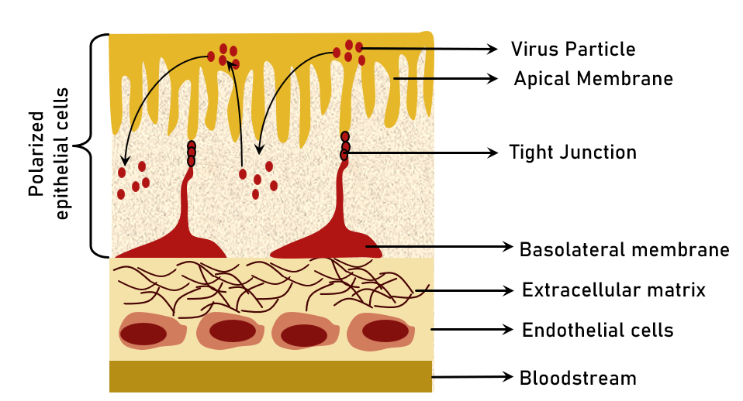

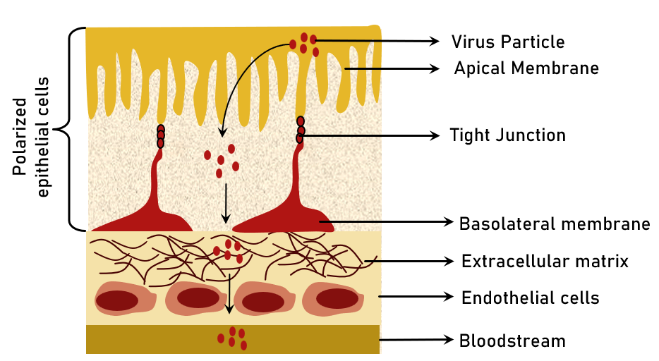

Figure 4. Entry and exit of Corona virus from polarised epithelium cells via two different routes (A) The apical membrane facilitates lateral spread by allowing entrance and release. (B) Vertical transmission is facilitated by The apical membrane is the point of entry, while the basolateral membrane is the point of exit.
Preventive methods to control the infection require knowledge of the pathogen's genesis and propagation. In the instance of SARS-CoV, researchers concentrated on identifying a crucial reservoir of infection, with civet palms serving as secondary hosts, suggesting positive viral RNA detection results. According to molecular analysis, persons from Hong Kong had a 2.5 percent frequency rate of antibodies against SARS-corona virus in 2001. As a result, circulating SARS-corona virus in human bodies was found prior to the epidemic in 2003. Antibodies to SARS-CoV were discovered in Rhinolophus, indicating that they are a source of viral replication [22]. Camels had been identified as a key host for MERS-corona virus, detected in Saudi Arabia in 2012 and linked to beta-corona virus, as well as Pipistrellus and Perimyotis bats. As a result, bats had been identified as the primary host for viral transmission, rather than humans [23]. A SARS-CoV-derived receptor binding spike glycoprotein of a new corona virus has been produced (CoVZXC21 or CoVZC45). It is critical to identify intermediate zoonotic sources that cause viral transmission to humans in order to eradicate the virus [24].
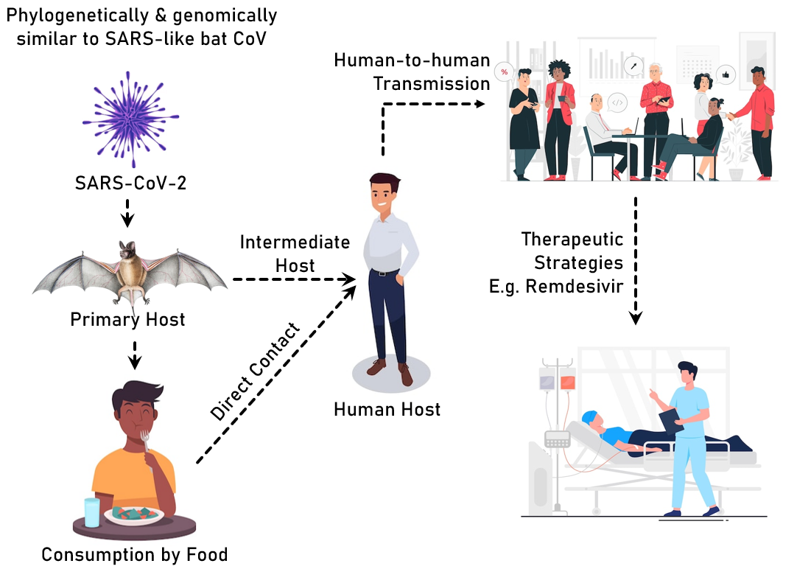

Figure 5. Transmission of COVID-19 virus
Genes in the ORF1 downstream regions of corona virus encode proteins necessary for replication of the virus, nucleocapsid development, and spike production. The corona virus's spikes glycoprotein is essential for the virus's adherence to and entrance into host cells. Due to the weak connections between viruses in the receptor-binding domain (RBD), the virus can spread to many hosts. SARS-CoV and MERS-CoV contain receptors which detect exopeptidases, however other corona viruses have receptor that sense aminopeptidases or carbohydrates. The spike protein is divided by cellular proteases like human airway trypsin-like protease (HAT), cathepsins, and transmembrane protease serine 2 (TMPRSS2), which also produce other penetrating changes necessary for corona virus entry. Dipeptidyl peptidase 4 is a key receptor for MERS-corona virus, whereas HCoV-NL63 and SARS-corona virus employ ACE2.
Spike protein, RNA polymerase, 3-chymotrypsin-like protease, papain-like protease, helicase, glycoprotein, and auxiliary proteins are only a few of the polyproteins, nucleoproteins, as well as membrane proteins that the SARS-CoV-2 can express. Van der Waals forces are maintained in the RBD region by the spike protein. The 394-glutamine residue in the RBD section of the virus is recognised by the essential lysine 31 residue of the ACE2 receptor.
To enable the fusion of the viral envelope with the cell membrane via the endosomal route, S protein interacts to the cellular receptor ACE2 and modifies it. In the host cell, the SARS-CoV-2 virus produces RNA that is translated into the viral replicase polyproteins pp1a and 1ab. A succession of subgenomic mRNAs are produced by polymerase using discontinuous transcription, and these mRNAs are then translated into viral proteins. Viral proteins and genomic RNA are created in the ER and Golgi to form virions, which are subsequently carried by vesicles and released from the cell.
Alphacorona virus, Betacorona virus, Gammacorona virus, and Deltacorona virus are members of the Coronavirinaesubfamily (Figure 1A). A single-stranded positive-sense RNA (+ssRNA) genome with a 5′ cap structure and a 3′ poly-A tail is seen in CoVs (about 30 kb) [24]
- When polyprotein 1a/1ab (pp1a/pp1ab), which codes for nonstructural proteins (nsps) (DMVs), is translated from the genomic RNA template, the replication transcription complex (RTC) is created in a double membrane vesicle.
- Following that, RTC synthesis a nested collection of subgenomic RNAs with similar′leader and 3′terminal sequences
- Transcription, termination, and subsequent acquisition of a leader RNA occur at transcription regulatory regions, which are typically situated amongst open reading frames (ORFs).
- These minus-strand sgRNAs serve as templates for the production of subgenomic mRNA.
- The two lengthy polypeptides, pp1a and pp1b, are converted into 16 nonstructural proteins.
S, E, M, and N stand for spike, envelope, membrane, and nucleocapsid, which are four structural proteins. nCoV, nCoV, nCoV, nCoV. Human corona virus is abbreviated as HCoV, infectious bronchitis virus is abbreviated as IBV, murine hepatitis virus is abbreviated as MHV and transmissible gastroenteritis virus is abbreviated as TGEV.
A ribonucleoprotein complex is created when the nucleocapsid (N) protein of the viruses interacts to the viral genomic RNA. Thus, interactions between N protein and RNA are necessary for the production of infectious virus particles. The 45 kDa recombinant nucleocapsid N protein of the corona virus infectious bronchitis virus (IBV) is particularly proteolytically sensitive. The protein core is a five-stranded anti-parallel sheet with a hairpin extension and a hydrophobic platform crucial for RNA binding, which we were able to get as a 14.7 kDa stable fragment (IBV-N29-160). As per a model for the production of the corona virus shell, dimerization of the IBV-C-terminal N's domain results in oligomerization of the IBV-nucleocapsid protein and condensation of the viral RNA.
Using in situ cryo-electron tomography and subtomogram averaging, the scientists were able to visualise the viral replication compartment and provide important new information about the virus's budding mechanics and the appearance of extracellular virions. Membrane bending and rearrangement on the envelope occur as a result of S trimer assembling in lumenal cisternae throughout virion production. The curved membrane is the site of the assembly of several cylindrical viral ribonucleoprotein complexes (vRNPs) [26].
V. Clinical approach
A new global health catastrophe emerged, frightening with the rise of COVID-19. The general public became more aware of the disease designated a public health emergency when it first appeared at a seafood market in China, in December 2019. The World Health Organization has declared an international health emergency. Several studies have identified current clinical features data to assist possible COVID-19 sufferers with diagnosis, treatment, and prevention. It's critical to keep track of fresh data on clinical features, diagnoses, treatment options, and COVID-19 results at all times. Various degrees of sickness had been reported all around the world as a result of the illness. The illness is treated with general or symptomatic treatment, antiviral medicines, oxygen therapy, and the immune system. To prevent infection from spreading to other patients and healthcare workers, it's vital to identify possible cases as soon as possible and separate suspects from confirmed COVID-19 infections.
Mpro, the primary protease of the corona virus, is a potential target for therapy in the maturation and processing of the viral polyprotein. Feline infectious peritonitis virus has previously been treated with GC376, a dipeptide-based protease inhibitor. It is now in the FIPV phase of pre-clinical testing. Both GC373 and GC376 had been shown to be effective in treating corona virus infections in animals, making them promising COVID-19 treatment options in people. GC376 is an antiviral that inhibits Mpro in a variety of viruses, including feline corona virus. However, more research on the effectiveness and safety of these broad-spectrum Mpro inhibitors in COVID-19 patients is essential. Lessons learnt from the effective use of medication candidates to treat corona virus infections in animals will help build a framework for their application in human trials.
The clinical management of COVID 19 includes screening and triage, i.e., early detection of patients, implementation of appropriate IPC measures, collection of samples for investigation, symptomatic treatment, oxygen therapy and monitoring, prevention of complications, adjunctive therapy. These medications' safety and effectiveness in COVID-19 patients have yet to be determined. Patients using Hydroxychloroquine, Chloroquine, and Azithromycin for FDA-approved applications have had trouble filling their prescriptions, apparently because the pills are used to treat COVID-19 [27].
The COVID-19 outbreak soon escalated into a worldwide health emergency. With a positive swab test, the patient might be completely asymptomatic, have a mild influenza-like sickness, or have severe symptoms requiring hospitalisation. HRCT scans of the chest had been demonstrated to be exceedingly sensitive and specific, despite the fact that there is no reliable antibody test for fast diagnosis at this time. In the absence of an effective vaccine, patients are treated with oxygen treatment, antivirals, steroids, HCQS, and antibiotics. Immunomodulatory medications and plasma exchange treatment using recovered patients' convalescent sera may be required in complicated situations and those that are resistant to normal therapy. Advances in viral genome sequencing and technology have paved the way for the development of a COVID-19 vaccine, with human trials now underway at a number of pharmaceutical firms.
Classic culture-based approaches, genetic materials-based detection and diagnostics are appropriate for high-throughput testing. They can also reveal therapeutically important information in a matter of hours, such as drug resistance, virulence factors, or strain sub-types, although at a higher cost are important in both routine clinical diagnosis and the discovery of novel bacteria, viruses, and other illnesses. The current state of nucleic acid-based technologies for COVID-19 diagnostics is discussed, as well as future improvements and the advantages and disadvantages of using these technologies [1]
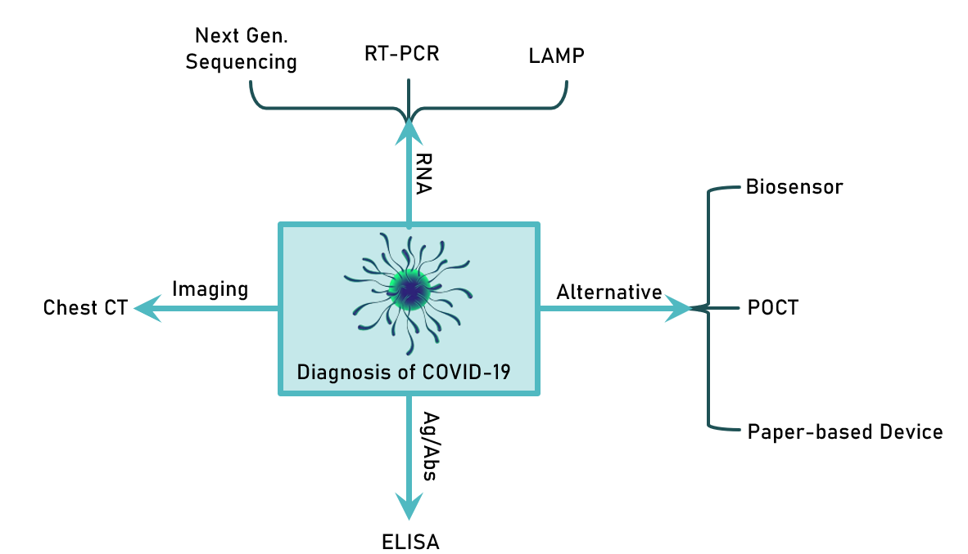

Figure 6.Diagnostic approaches for COVID-19

VI. Treatment
A. Existing drug
The World Health Organisation (WHO) received a report of a corona virus pneumonia pandemic in Wuhan, Hubei Province, China, in December 2019. It became necessary to use experimental drugs and drug repurposing to lower the severity of this unique viral infection due to the quick breakout and increasing mortality rate. Since then, a lot has changed to slow down the urgent need for a therapeutic intervention to treat SARS-CoV-2 as the epidemic spread quickly around the globe. Many effective methods and medications were found as a result of the diligent work of clinical researchers around the world.
More than 80 Clinical trials exploring corona virus treatment begun simultaneously and one of these includes pharmaceutical repositioning or repurposing. Over 20 medications, notably including human immunoglobulin, interferons, hydroxychloroquine, arbidol, remdesivir, favipiravir, lopinavir, ritonavir, oseltamivir, methylprednisolone, bevacizumab, alongside the traditional Chinese medicine (TCM), were the subject of 24 clinical studies identified by researchers. Nevertheless, there were several limitations to reusing medications. Repurposing clinical studies, however, makes it easier to identify new medication classes, and they are a desirable choice due to their lower costs and faster time to market. Pharmaceutical supply chains are additionally utilised in this situation for formulation, distribution as well as shipping [28].
Antimicrobials that could work against the corona virus are as follows:
- Remdesivir – SARS-CoV-2 infection is also being treated with antivirals that block protease inhibitors and nucleotide or nucleoside analogues that prevent viral RNA production. One of the most effective antiviral medications for battling the SARS-CoV-2 virus remdesivir. An antiviral approved by the US (FDA) has approved it for the treatment of COVID-19 in adults and children with severe disease. It is also available under an FDA Emergency Use Authorization (EUA). During the course of therapeutic interventions, the possibility of treating COVID-19 using nucleoside analogues was actively explored. The candidates for this intervention included medications like ribavirin, remdesivir, geldesivir, and favipiravir. All of these have gotten significant attention, but Remdesivir has received the most. Remdesivir, a prodrug to adenosine [29], was created initially for the treatment of hemorrhagic fever viruses such as the Ebola (EBOV) and Marburg viruses, however, it performed poorly when compared to antibody treatments for EBOV [30,31].

Remdesivir was examined in vitro at the Wuhan Virus Research Institute earlier in the SARS-CoV2 incidence [9] and was discovered to be a potent inhibitor of viral transmission in cell cultures. It was successfully used for the first time in a COVID-19 patient in January 2020. With a substantial reduction in lung viral load in animal models and a satisfactory safety record in groups of COVID-19 patients, Remdesivir offered a useful and feasible therapeutic choice for the future. Its usage in antiviral therapy combinations during the entire course of treatment is subject to a number of restrictions.

- Hydroxychloroquine & Chloroquine: Both of them were marketed as being among the most efficacious antiviral medications during the early stages of the COVID epidemic. They were applied to COVID-19 in order to prevent nuclear transport of viral proteins reduce endocytosis-mediated entry of viral proteins, and alter the glycosylation of ACE2, respectively. Testing in vitro showed that chloroquine derivatives are effective antiviral agents against SARS-CoV2 [32]. Based on this result, the drug was promptly implemented into clinical practice, and preliminary data showed that COVID-19 patients who took Hydroxychloroquine for a 10-day course had improved viral clearance and clinical outcomes [33]. A French pilot trial [34] involving 36 randomly selected COVID-19 patients found that those receiving hydroxychloroquine and azithromycin suppressed the infection more quickly.

Others, on the other hand, disagree with the results and find no benefit in viral clearance or clinical resolution [35]. Unfortunately, the largest trial to yet assessing the effects of hydroxychloroquine alone or in combination with azithromycin failed to find any benefit and instead found that those taking the medication had a greater mortality risk [36]. Due to a lack of data on their efficacy, the FDA EUA later discontinued them.

- Lopinavir; Ritonavir – Lopinavir/ritonavir is an FDA-approved HIV combo drug that was recommended as an antiviral agent against COVID-19 during the pandemic's early stages. A randomised controlled trial found no advantage with lopinavir-ritonavir treatment compared to standard care in individuals hospitalised with severe COVID-19. Thus, due to controversial opinions, Lopinavir/Ritonavir: SARS-CoV-2, a single-stranded RNA beta-corona virus, is the cause of corona virus sickness 2019, a serious respiratory disease that is rapidly spreading. Due to the lack of an effective therapeutic strategy, Chinese health officials started to investigate the use of lopinavir and ritonavir, which had previously been optimised for HIV/AIDS viral infection therapy and prevention. These two medications had been tested in clinical trials, but little is known about their potential molecular mechanisms of action. They are currently not approved for the treatment of COVID-19 due to a lack of recent preclinical data.

The C30 Endopeptidase, also known as SARS-CoV-2 main protease (Mpro), has just been crystallised and described. With this crucial structural information as a starting point, we investigated the recognition process of a ligand from its unbound to its final bound state at an atomic level using supervised molecular dynamics, a new computational method. They described the molecular mechanisms of three potential C30 Endopeptidase inhibitors—Lopinavir, Ritonavir, and Nelfnavir—the latter of which is now being studied due to its promising in vitro activity against the structurally equivalent SARS-CoV protease.

- Ivermectin –Limited clinical data and potential doses exceed those approved in humans.

- Azithromycin- Azithromycin and hydroxychloroquine shown to have synergistic effects against SARS-CoV2 in vitro, as was already mentioned, and these effects seem to have carried over into clinical practice. Fascinatingly, azithromycin has an alkalinizing action at least equal to that of hydroxychloroquine and is likewise a weak base that accumulates in endosomes. Azithromycin is sometimes utilised for its immunomodulatory effects in addition to its antibacterial ones, particularly in individuals with chronic pulmonary diseases.

- Paxloid- Paxloid is an oral protease inhibitor composed of two antiviral agents, ritonavir in combination with nirmatrelvir. It is observed to be highly effective against MPRO which is needed for viral replication [37]. Many studies as well as clinical trials proposed that Paxloid demonstrates antiviral activity against most of the forms of corona virus [38].

“There is no particular anti-COVID-19 medication for COVID-19 patients to recommend,” according to a WHO clinical care recommendation paper (as of March 13, 2020). WHO suggested guidelines of treatment based upon symptomatic therapy for moderate disease to ventilatory management for severe condition COVID 19, ARDS and only licenced, randomised, controlled trials for the treatment of viral pneumonia should employ systemic corticosteroids as experimental anti-COVID-19 therapies. In this regard, the WHO recently launched a global “mega trial” (SOLIDARITY) with a pragmatic trial design to confirm positive cases. Based on local medication availability, remdesivir, chloroquine or hydroxychloroquine, and lopinavir/ritonavir, were the active therapy arms chosen [39].
Antigen-encoding plasmid DNA or RNA, mRNA, or viral replicons are used in nucleic acid vaccinations. When a cell takes up nucleic acid to start protein synthesis, an immune response that is both humoral and cell-mediated develops in retaliation. For veterinary infectious illnesses, similar vaccines had been examined with evidence of immunogenicity. Nucleic acid vaccines for the Zika virus, influenza, and Ebola are now being tested in humans as part of phase I research.
The vaccine made on a nucleic acid platform enables for antigen alteration with increased production speed, and the method can be completely cell-free, eliminating the requirement for BSL2 labs. The main problem is that nucleic acids, because RNA, especially mRNA, is fragile, it must be transported and stored in a cold-chain environment.
SARS-CoV and MERS-CoV DNA vaccines in phase I clinical investigations, coding for the SARS-CoV N protein genome developed by the NIAID was tried in ten people. The number of people who have enrolled in Phase 2 clinical trial for a MERS-CoV DNA vaccine (GLS-5300) that codes for the whole S protein genome created by Gene One Life Science/Inovio was greater (n = 75). Both clinical studies produced positive humoral and cellular responses and had acceptable safety profiles. Sinovac Biotech's inactivated vaccine (ISCV) is another SARS vaccine that has reached Phase I testing. Human investigations in which vaccinated patients were challenged with the wild virus were not reported.

B. Protease inhibitors:
Millions of people had been infected throughout the world as a result of corona virus 2's severe acute respiratory syndrome (SARS-CoV-2). Experimental therapeutics based on repurposing current antivirals are being tried as part of the continuous hunt for an effective antiviral. This includes HIV protease inhibitors (PIs), which have received a lot of press recently. While few trials have shown lopinavir and ritonavir effectiveness in the context of SARS-CoV-2, where it is crucial to validate the drugs' mechanisms of action, more study is needed. Mahdi and colleagues [40].
SARS-CoV-2, which causes the corona virus illness of 2019 (COVID-19), poses a serious risk to public health around the world. Numerous inhibitors of the corona virus 3C-like protease (3CLpro), a crucial enzyme for viral replication, had been discovered based on their structural characteristics. The tailored inhibitory compounds were discovered to be efficacious against multiple kinds of human corona viruses, including MERS-CoV, SARS-CoV, and SARS-CoV-2, in both enzyme and cell-based examinations utilising Huh-7 and Vero E6 cell lines. A number of drugs showed antiviral activity against SARS-CoV-2 in primary human airway epithelial cells that were cultured. In a mouse animal model of MERS-CoV infection, injection of a lead compound 1 day after virus infection raised survival rates from 0 to 100% and decreased lung viral titers and histopathology. As a result, a series of lead compounds might be used as antiviral medicines against human corona viruses.
There are currently no vaccines or many antivirals for SARS-CoV-2. Therefore, it is crucial to pinpoint pharmacological targets that could result in powerful antivirals. As SARS-CoV-2 antiviral treatment targets, several viral proteins have received attention: the spike protein, the RdRp, the Mpro, and the PLpro, which stand for RNA-dependent RNA polymerase, main protease, and papain-like protease, respectively. [41]. Remdesivir, a SARS-CoV-2 RdRp inhibitor, received an emergency use authorization from the US Food and Drug Administration on May 1, 2020. Remdesivir is effective at combating SARS-CoV, SARS-CoV-2, and MERS-CoV in cell culture. The antiviral activity was verified using MERS-CoV-infected mice and rhesus macaque models. EIDD-2801, favipiravir (T-705), ribavirin, and galidesivir are among more RdRp inhibitors being studied for SARS-CoV-2. [42]
The advancement of medicine is taking a number of approaches into consideration to battle it. The replication of COVID-19 and its structural and functional resemblances to HIV were examined in many studies. Previous research had indicated that anti-retroviral medications used to treat HIV had a favourable affinity for COVID-19 and helped to treat it. Examples of these medications are lopinavir and ritonavir. Similar to the previous study, BBI (Bowman-Birk Inhibitor), a serine protease inhibitor derived from soybeans, has been found to have inhibitory effects on HIV. This may also be helpful in managing COVID-19 because of the structural resemblance between the two. The binding affinity of this inhibitor is evaluated using Hex 8.0.0 to support this notion, and the findings are interpreted accordingly. As a result, pharmacological targets for treating it can be found in structural elements of it [43].
SARS-CoV-2, a new corona virus, caused a global health and economic disaster. As of April 30, 2020, the sickness, known as corona virus disease (COVID-19), had infected 3090445 persons globally and killed around 217769 individuals. SARS-CoV-2 is currently without a specific effective medication or vaccination. Several existing and authorised medications are undergoing clinical trials to see if they may be repurposed. However, given the urgency of the issue and the necessity to save the time required for de novo drug development, medication repurposing remains the greatest option for finding effective antiviral therapy. Using a molecular docking method, the goal of this study was to see how effective 82 compounds/drugs were at blocking SARS-main CoV-2's protease (3CLPro). This protease is a key enzyme in viral replication, making it a promising therapeutic target. Among the compounds evaluated are 16 known protease inhibitors, two newly discovered -ketoamides, 24 novel potential inhibitors, and 40 phytochemicals were found. Ritonavir, Indinavir, Montelukast, Nelnavir, Candoxatril, Tigecycline, and Lopinavir are some of the most effective protease inhibitors. Several additional medications and substances, including phytochemicals, had been found as effective enzyme inhibitors or are projected to be so. Several drugs' respective efficacies in inhibiting 3CLPro are also mentioned. And therefore, these studies are critical for COVID-19 clinical intervention.
C. Antiviral drugs:
During the current global wave of corona virus disease, repurposing approved drugs was emerging as a crucial therapy option. Ganovo, a very potent inhibitor of the hepatitis C virus (HCV) protease (NS3/4A), was authorised and made available in China since 2018 for the treatment of people with chronic hepatitis C [18]. Valentina L. 2020 created a pharmacophore model of the functional domains of the protease inhibitor-binding pocket using the CoV-2 protease crystal structure as a guide.
With the help of this pharmacore model, researchers searched the conformational database of 64 FDA-approved medications for potential COVID-19 protease inhibitors. These medications' potential conformers coupled to the binding pocket of the protease during the process of docking. Carfilzomib, cyclosporine A, and azithromycin are the three pharmacological compounds that had been found that were investigated for COVID-19 treatment. It was proposed that the cited medications undergo COVID-19 therapy testing.
Numerous therapeutic strategies had been suggested as COVID-19 does not have a specific antiviral treatment. Interleukin 6 receptor inhibitors, convalescent plasma, and interferon (IFN) can all be used to lessen the cytokine storm. Nucleoside analogues are a kind of antiviral drug that inhibits reverse transcription and are one of the most effective treatments for SARS-CoV-2 infection. The goal of this study was to compile evidence from in vitro investigations, in vivo investigations, COVID-19 inpatients treated under emergency procedures, and clinical trials to present a comprehensive picture of remdesivir's potential in the treatment of COVID-1 patients [44].
Testing whether current antiviral medications are successful in treating similar viral infections is an efficient strategy to drug development. Five FAD-approved drugs were examined in vitro against a clinical strain of 2019- nCoV, includes ribavirin, penciclovir, nitazoxanide, nafamostat, chloroquine, and remdesivir (GS5734) and favipiravir (T-705), two well-known broad-spectrum antiviral medicines (2020).
A promising remedy for COVID-19 must be found because between 5% and 10% of patients can experience severe, possibly fatal symptoms. The best supportive care is still the cornerstone of treatment. Over three hundred clinical trials are now in progress, and many antivirals and immunomodulating drugs are being evaluated for COVID. Various medications are being used throughout the world on the basis of in vitro or extrapolated data or observational studies, despite the pressing need for randomised controlled research to identify a safe and suitable antiviral therapy for COVID-19. Chloroquine, hydroxychloroquine, lopinavir/ritonavir, favipiravir, and remdesivir as the most commonly used antimalarial drugs, Nitazoxanide and ivermectin, found to beeffective against the SARS-CoV-2 virus [45].
Repurposing broad range antiviral drugs may be a viable method to respond swiftly because creating a new drug takes time. The recent studies are focused on a family of wide-spectrum antivirals that specifically target the corona virus S protein, RNA-dependent RNA polymerase (RdRp), 3-chymotrypsin-like protease (3CLpro), and papain-like protease (PLpro), all of which are crucial to the pathogenesis and entire life cycle of the corona virus [46].
D. Immunomodulatory drugs
Several clinical and experimental researches had demonstrated that alterations in the immune response and, in certain individuals, the abnormal release of pro-inflammatory cytokines like interleukin-6 (IL-6), interferon-gamma, and tumour necrosis factor-alpha are significantly related to the damage caused by the virus.
Anti-inflammatory medication especially monoclonal antibodies, which had been used in rheumatology for some time to decrease the immune system reaction, are therefore employed in the COVID-19 emergency alongside being based on prior experience proven in patients with SARS. There are potential roles of anti-IL6, anti-IL-1, JAK inhibitors, corticosteroids, antimalarials, heparins, and immunoglobulins in the management of moderate to severe COVID-19.

.
VII. Prevention of infection
The easiest strategy to avoid contracting COVID-19 is to avoid coming into contact with the virus.
• The virus spreads from person to person owing to close contact with a distance of less than one metre (around 6 feet).
The virus is conveyed by respiratory droplets produced by an infected person coughing. sneezing, or talking. Such droplets penetrate surrounding people's lips or nostrils and are breathed into the lungs. People who are asymptomatic can potentially spread the disease. COVID-19. Limiting close contact with strangers, avoiding close contact with ill individuals, and maintaining a social space between ourselves and others can help prevent viral infection by maintain a space of 6 feet distance. Wearing a mask in public settings where social distance is effective is another protective technique. It is best to avoid young children under the age of two and other people who have respiratory issues. A mask can help limit viral transmission from a sick person to others. (https://www.cdc.gov/corona virus/2019-ncov/prevent-getting-sick/prevention/prevention.html)
For the management of the developing pandemic crisis, the governing bodies imposed organisational measures related to the prevention and control of the COVID-19 epidemiological crisis. The spread of the disease was halted using the following tactics at the local, state, and international levels.
- Dividing the areas into Red, Orange, and Green zones depending on the total number of patients infected with the COVID-19 virus. Putting travel restrictions in Red Zones by prohibiting people's admission and leave, especially in "red" zones where the frequency of COVID-19 infections is higher.
- Maintaining the 14-day home quarantine requirement for persons living/working in confinement zones or returning from them. Thermal scanning is used to keep track of external collaborators and visitors, and admission is restricted to prevent viral diseases from spreading.
- Setting priorities for the firm and office work by allowing employees to work from home.
- To preserve social distance standards, segregate the whole working workforce in the company/office into two or more autonomous working groups.
- People working in the health industry, such as physicians and nurses, must comply to strict PPE clothing requirements.
- The risk of SARS-CoV-2 infection spreading to individuals can be reduced by sanitising contaminated ambient surfaces, infected objects, and equipment. Minimizing immediate physical contact (such as handshakes).
- Maintaining social distance by keeping a distance of more than 2m with time restrictions of more than 15 minutes by minimising contact with infected people to avoid spreading infections via coughing and breathing, as well as the constant use of hand washing and alcohol-based disinfectants with 62 percent–71 percent alcohol to prevent the transmission
- Avoid contact with individuals for more than 15 minutes and at a distance of less than 2 metres in a closed setting (e.g., classrooms, conference rooms, hospital waiting rooms, and similar places).
- Personal protection equipment, such as hand gloves, masks, and a face shield, is worn.
- Decontamination of all used accessories with hypochlorite after coming into contact with potentially hazardous items (gloves, garments, masks, used tissues, garbage)
Recommending the use of N95 masks, which filter particles 8-12 times larger than surgical masks, which have different filtering capacities based on the particle size in an aerosol (1.3 to 6.5 m) and the model. N95 masks are N95 respirators with an exhalation valve that protects against the inhalation of airborne particles with a size comparable to germs and viruses. With no valve problem, penetration levels ranged from 0.03 per cent to 0.04 per cent [47]. Alternatively, the use of disposable Surgical Facemasks was also promoted among the people. The surgical mask reduces virus exposure by 1.1 to 55 times [48].
By adhering to the medical aid protocol provided by the medical staff, used face masks, gloves, paper tissues, and other contaminated material should be disposed of properly [49].
Global patterns of energy demand and consumption had been influenced by changes in government policy, such as the closing of international borders and placing limitations on people's movement, which eventually kept them restricted to their homes with less access to transportation. This has reduced CO2 emissions by -17% and the resulting pollution in early April 2020 when compared to the mean 2019 levels. The lockdown effect led to an average -26% reduction in CO2 emissions across all nations. Under pre-pandemic conditions, annual emissions in 2020 were estimated between -4% and -7%, which persisted assuming global restrictions upheld until the end of the year.
- Vaccination to prevent COVID-19 infection
Vaccination is a crucial tool in controlling the spread of COVID-19 and protecting individuals from severe illness and hospitalization. The ultimate goal behind vaccination is to trigger the immune mechanism which will in turn generate and keep memory of neutralizing antibodies against the virus. Throughout the world, tremendous efforts and hard work of scientists resulted in the formulation of effective novel vaccines for COVID-19 or SARS-COV2.
- BNT162b2 vaccine (mRNA-based, BioNTech/Pfizer): Based on the efficacy trials, it was reported that the patients of age 16 or above getting two dosages of BNT162b2 presented 95% protection against COVID after the definite period of 21 days. In August 2021, US FDA authorized the clinical practice of this against COVID-19.
- mRNA-1273(mRNA-based, Moderna): Trials proposed that the patient receiving two doses of mRNA-1273 showed 94.1% immunity after the period of 28 days. This was approved to be used against COVID-19 after January 2022.
- Ad26.COV2.S vaccine: It received a green flag for the COVID prevention in February 2021. Based on the randomized trials and studies, it was observed to provide 73.1% efficacy in a single dose.
- ChAdOx1 nCoV-19 vaccine: The interim analysis of randomized control trials demonstrated that ChAdOx1 nCoV-19 offers 64% efficacy in just a single dose while 70.4% clinical efficacy after two doses. Some countries have given it the approval to be used as a vaccine candidate however others are still leading research work.
Following immunisation with the ChAdOx1 nCoV-19 and Ad26.COV2 in early 2021, several patients experienced signs of a new clinical condition marked by thrombosis and thrombocytopenia. This new disease resembled heparin-induced thrombocytopenia (HIT) quite well. In circumstances devoid of preceding heparin exposure, it was referred to as vaccine-induced immune thrombotic thrombocytopenia (VITT).
Furthermore, many other vaccines which are protein-based or inactivated form were also developed and used preferably. Indigenous development of Covaxin by India, Sputnik V by Russia, and Corona Vac by China are some examples among them. These are approved or granted emergency authorization against the battle of COVID-19.
The COVAXIN (BBV152) vaccine for COVID-19 was created by the Indian company Bharat Biotech with assistance from the National Institute of Virology (NIV). On the third of November 2021, the Technical Advisory Group for Emergency usage gave their approval for immediate usage. After phase III of the Human clinical trial, it acquired the Drug Controller General of India's (DCGI) authorization. It is made up of the Vero cell platform, which is renowned both inside and outside the country for its effectiveness and safety. 14 days or more after dose 2, Covaxin exhibited a 78% efficacy against COVID-19 of any severity. The effectiveness of vaccination against serious illness was reported to be 93%. The rate of success was 79% for individuals under 60 and 68% for those over 60.

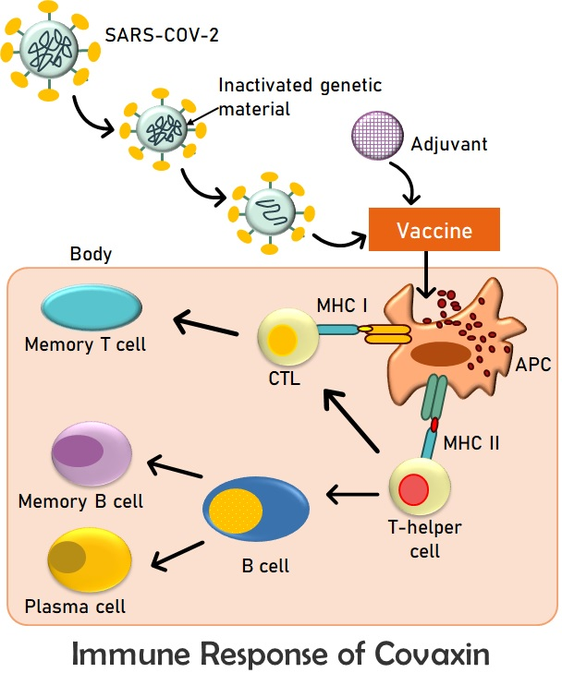

Figure 7. Diagrammatic representation of the mechanism of action of Covaxin

The next most preferred vaccine in India is Covishield. The SARS-CoV-2 Spike (S) glycoprotein is encoded by a chimpanzee adenovirus that is recombinant and replication-deficient. The third phase of the trials found that Covishield had an efficacy rating of around 90%. A third dose, often known as a booster dose, has been introduced into the vaccination schedule of many countries since studies have shown that protection starts to decrease after two doses and that a third dose gives better levels of security [50,51].

- Preexposure Prophylaxis (PrEP) to avoid SARS-CoV-2 infection
Even though vaccination is the best preventative measure against COVID-19, some people might not mount the required immune response. Due to ancestors' medical histories, the immunisation may induce unexpected reactions in just a handful of patients. In such a scenario, US FDA has proposed EUA suggesting the immediate use of Tixagevimab along with Cilgavimab for preexposure prophylaxis of COVID-19 in adults. This also validates for individuals who are taking immunosuppressive medication and because of which are unable to produce appropriate immune responses.

VIII. Will COVID-19 end?
The risk remains that COVID-19 still prevails in our society and poses problems to many people. Innate immunity protects most individuals and also reduces the risk of severity ofsymptoms along with their further transmission. Even those who have received vaccinations are at risk for COVID-19. Because the virus's structure is constantly changing, it spreads at an extremely rapid rate. This is the main cause of the relatively low subsidy in COVID-19's rate of spread. Omicron and Delta variants of COVID-19 are the several known variations. Omicron, a variant of corona virus, is more contagious than any previous variety, as it weakens the immunity that past infections and inadequate vaccinations provided. Age, demographics, and societal behaviour are all important contributors in the propagation of this virus. We don't yet know what the new Omicron variations are. Evidence indicates that over time, both naturally occurring and vaccine-induced immunity, especially against infection, declines.
Individuals with booster doses of vaccination may benefit from protection against omicron. While those who have only one or two doses may prevail and pass on the infection. The Alpha and Delta variant still reversed the shift towards end of the pandemic and immunity. Many cases of the Delta variant still have a short-term burden of disease. This is also increasing the number of hospitalizations. Delta variant is highly transmittable and thus it is difficult to achieve herd immunity. The effectiveness of vaccines in preventing the disease still raises questions. The beta and gamma variants are also recognized but these are comparatively less pathogenic. Despite the fact that the pandemic has now turned endemic, these uncertainties impart numerous issues. SARS-CoV-2 is still evolving; however the majority of these changes do not result in stable new forms and also carry a lower severity risk.

A shift from pandemic to endemicity of the disease does not ever mean that there would be no risk of infection. An “always-on” response towards immunity may quickly increase protection. Protection against the new variant forms of the virus may require herd immunity as well. Omicron spread through the community at a startlingly rapid rate as a result of these conditions, which also included pandemic-weary inhabitants' weak behavioural adaptation and the holidays, travel and gathering accelerants. An adjustment to normalcy is still achievable even without herd immunity. In order to create a herd immune system, vaccinations must be taken by everyone. The manner that settlements and people react will likely determine how the COVID-19 crisis develops in the future. There is a need for the development of fresh oral medications that could lessen the likelihood that the disease will advance. To avoid the pathogenicity and infection, one must take booster dosages. A shift in the emphasis to public health can be another step towards achieving the end goal of eradication of corona.

COVID-19 risk is not yet completely gone. The symptoms that the mutant strains pose resemble those caused by influenza. Today, the burden of this COVID-19 disease in vaccinated people is almost the same as or slightly less than that of influenza, while the risks in unvaccinated people are higher. The variants of the virus are still a concern for the threatening of the disease progression.

There are also certain risks for herd immunity: The efficacy of the vaccine in reducing transmission may not be as high as expected and could be a problem in reducing herd immunity. Hesitancy in younger populations may also be the reason. The reach for threshold immunity may be shortened because the duration of vaccine-mediated immunity may be less than expected. As a result, the variations that make vaccinations less efficient at promoting natural immunity may proliferate broadly. Additionally, the age of a person affects their immunisation. The limited length of immunity could cause a delay on the end of the journey.
Thus, achieving normality and gaining herd immunity may be the final goal for COVID-19. Aspects of social and economic life will eventually become normalised as part of this transformation. Resuming pre-pandemic activities may not be as simple as first thought. Around the world, a combination of some or all of these choices is most likely to occur over the next few years. Eradication and herd immunity don't seem to be the same thing. SARS-CoV-2 will remain active. Even when herd immunity is attained, it is still possible that additional precautions, such as self-awareness, are needed to be adopted.
IX. Conclusion:
Due to the COVID-19 pandemic all over the world, vulnerable population, such as older persons and those predisposed to cardiovascular/respiratory/renal disorders or diabetes, requires extra protection. Therefore, we conclude using clinically validated protease inhibitors, such as chloroquine, as a preventative measure. Until vaccinations and/or medications that are effective in the prevention and treatment of COVID-19 are widely available, by preventing the entry of the virus via ACE2.Transmembrane serine protease inhibitors can serve as a profound remedy to avoid the expression and advancement of COVID-19. We concluded that using clinically established PIs could treat and significantly reduce COVID-19 infection. Such measures are especially crucial in nations where positive cases are increasing and medical resources are constrained. Although there are no viable therapy options for COVID-19, the protease inhibitors mentioned in this letter can be used as prophylactics to prevent clinical symptoms and complications.

X. References
- Kumar, S., Zhi, K., Mukherji, A., &Gerth, K. Repurposing antiviral protease inhibitors using extracellular vesicles for potential therapy of COVID-19. Viruses, 12(5), 486. (2020).
- Zhang, W., Zhao, Y., Zhang, F., Wang, Q., Li, T., Liu, Z., ...& Zhang, S. The use of anti-inflammatory drugs in the treatment of people with severe corona virus disease 2019 (COVID-19): The Perspectives of clinical immunologists from China. Clinical Immunology, 214, 108393. (2020).
- Salih, M. A. H. An Overview on The Pandemic Corona virus Disease 2019 (COVID-19) Outbreak. Kurdistan Journal of Applied Research, 31-36. (2020).
- MacIntyre, C. R. Global spread of COVID-19 and pandemic potential. Global Biosecurity, 1(3). (2020).
- Brodeur, A., Gray, D. M., Islam, A., &Bhuiyan, S. A Literature Review of the Economics of COVID-19. (2020).
- Wang, C., Wang, Z., Wang, G., Lau, J. Y. N., Zhang, K., & Li, W. COVID-19 in early 2021: current status and looking forward. Signal Transduction and Targeted Therapy, 6(1), 1-14. (2021).
- Du, Y., Tu, L., Zhu, P., Mu, M., Wang, R., Yang, P., ...&Xu, G. Clinical features of 85 fatal cases of COVID-19 from Wuhan. A retrospective observational study. American journal of respiratory and critical care medicine, 201(11), 1372-1379. (2020).
- Seth, S., Batra, J., & Srinivasan, S. COVID-19: Targeting Proteases in Viral Invasion and Host Immune Response. Frontiers in molecular biosciences, 7. (2020).
- Hui DS, Hazar E, Madam DA, et.al.-nCoV epidemic threat of novel corona virus to global health-the latest 2019 novel corona virus outbreak in Wuhan. China J Infect Dis. 2020;91:264-6 2019
- Romagnani, P., Gnone, G., Guzzi, F., Negrini, S., Guastalla, A., Annunziato, F., ...& De Palma, R. The COVID-19 infection: lessons from the Italian experience. Journal of public health policy, 41, 238-244. (2020).
- Mizumoto K, Kagaya K, Zarebski A, Chowell G. Estimating the asymptomatic proportion of corona virus disease 2019 (COVID-19) cases on board the Diamond Princess cruise ship, Yokohama, Japan, Euro Surveill 2020;25:2000180. 10.2807/1560-7917.ES.2020.25.10.2000180 32183930. (2020).
- Beeching, N. J., Fletcher, T. E., & Beadsworth, M. B. Covid-19: testing times. (2020).
- He, X. et al. Temporal dynamics in viral shedding and transmissibility of COVID-19. Nat. Med. 26, 672–675 (2020)
- Slifka, M. K., &Gao, L. Is presymptomatic spread a major contributor to COVID-19 transmission?. Nature Medicine, 26(10), 1531-1533. (2020).
- Hasan, A., Paray, B. A., Hussain, A., Qadir, F. A., Attar, F., Aziz, F. M., …Falahati, M. A review on the cleavage priming of the spike protein on corona virus by angiotensin-converting enzyme-2 and furin. Journal of Biomolecular Structure and Dynamics, 1–13. (2020).
- Song, H. C., Seo, M.-Y., Stadler, K., Yoo, B. J., Choo, Q.-L., Coates, S. R., Uematsu, Y., Harada, T., Greer, C. E., Polo, J. M., Pileri, P., Eickmann, M., Rappuoli, R., Abrignani, S., Houghton, M., & Han, J. H. Synthesis and characterization of a native, oligomeric form of recombinant severe acute respiratory syndrome corona virus spike glycoprotein. Journal of Virology, 78(19), 10328–10335. (2004).
- Boopathi, S., Poma, A. B., &Kolandaivel, P. Novel 2019 corona virus structure, mechanism of action, antiviral drug promises and rule out against its treatment. Journal of Biomolecular Structure and Dynamics, 39(9), 3409-3418. (2021).
- Chen, N., Zhou, M., Dong, X., Qu, J., Gong, F., Han, Y., ...& Zhang, L. Epidemiological and clinical characteristics of 99 cases of 2019 novel corona virus pneumonia in Wuhan, China: a descriptive study. The Lancet, 395(10223), 507-513. (2020).
- Wu, F., Zhao, S., Yu, B. et al. A new corona virus associated with human respiratory disease in China. Nature 579, 265–269 (2020).
- Belouzard, S., Millet, J. K., Licitra, B. N., & Whittaker, G. R. Mechanisms of corona virus cell entry mediated by the viral spike protein. Viruses, 4(6), 1011-1033. (2012).
- Bittmann, S., Luchter, E., Weissenstein, A., Villalon, G., &Moschuring-Alieva, E. TMPRSS2-inhibitors play a role in cell entry mechanism of COVID-19: an insight into camostat and nafamostat. J RegenBiol Med, 2(2), 1-3. (2020).
- Shi Y, Yi Y, Li P, Kuang T, Li L, Dong M, et al. Diagnosis of severe acute respiratory syndrome (SARS) by detection of SARS corona virus nucleocapsid antibodies in an antigen-capturing enzyme-linked immunosorbent assay. J ClinMicrobiol;41(12):5781–2. (2003).
- Lau SK, Li KS, Tsang AK, Lam CS, Ahmed S, Chen H, et al. Genetic characterization of Betacorona virus lineage C viruses in bats reveals marked sequence divergence in the spike protein of pipistrellus bat corona virus HKU5 in Japanese pipistrelle: implications for the origin of the novel Middle East respiratory syndrome corona virus. J Virol;87(15):8638–50. (2013).
- Shereen, M. A., Khan, S., Kazmi, A., Bashir, N., &Siddique, R. COVID-19 infection: Origin, transmission, and characteristics of human corona viruses. Journal of advanced research, 24, 91-98. (2020).
- Fan, H., Ooi, A., Tan, Y. W., Wang, S., Fang, S., Liu, D. X., &Lescar, J. The nucleocapsid protein of corona virus infectious bronchitis virus: crystal structure of its N-terminal domain and multimerization properties. Structure, 13(12), 1859-1868. (2005).
- Klein, S., Cortese, M., Winter, S. L., Wachsmuth-Melm, M., Neufeldt, C. J., Cerikan, B., ...&Chlanda, P. SARS-CoV-2 structure and replication characterized by in situ cryo-electron tomography. Nature communications, 11(1), 1-10. (2020).
- Jaiswal, A., Borage, S., &Shelotkar, P. A clinical approach to COVID-19. International Journal of Research in Pharmaceutical Sciences, 11(Special Issue 1). (2020).
- Rosa, S. G. V., & Santos, W. C. Clinical trials on drug repositioning for COVID-19 treatment. RevistaPanamericana de SaludPública, 44, e40. (2020).
- D. Siegel, H.C. Hui, E. Doerffler, M.O. Clarke, K. Chun, L. Zhang, et al., Discovery and Synthesis of a Phosphoramidate Prodrug of a Pyrrolo[2,1-f][triazin-4-amino] Adenine C-Nucleoside (GS-5734) for the Treatment of Ebola and Emerging Viruses, J. Med. Chem. 60 (5) 1648–1661(2017).
- M.L. Agostini, E.L. Andres, A.C. Sims, R.L. Graham, T.P. Sheahan, X. Lu, et al., Corona virus susceptibility to the antiviral remdesivir (GS-5734) Is mediated by the viral polymerase and the proofreading exoribonuclease, mBio 9 (2) (2018).
- T.P. Sheahan, A.C. Sims, S.R. Leist, A. Schafer, J. Won, A.J. Brown, et al., Comparative therapeutic efficacy of remdesivir and combination lopinavir, ritonavir, and interferon beta against MERS-CoV, Nat. Commun. 11 (1) 222 (2020).
- M. Wang, R. Cao, L. Zhang, X. Yang, J. Liu, M. Xu, et al., Remdesivir and chloroquine effectively inhibit the recently emerged novel corona virus (2019-nCoV) in vitro, Cell Res. 30 (3) 269–271, (2020).
- J. Gao, Z. Tian, X. Yang, Breakthrough: Chloroquine phosphate has shown apparent efficacy in the treatment of COVID-19 associated pneumonia in clinical studies, Biosci Trends. 14 (1) 72–73(2020).
- P. Gautret, J.C. Lagier, P. Parola, V.T. Hoang, L. Meddeb, M. Mailhe, et al., Hydroxychloroquine and azithromycin as a treatment of COVID-19: results of an open-label non-randomized clinical trial, Int. J. Antimicrob. Agents 105949 (2020).
- J.M. Molina, C. Delaugerre, J. Le Goff, B. Mela-Lima, D. Ponscarme, L. Goldwirt, et al., No evidence of rapid antiviral clearance or clinical benefit with the combination of hydroxychloroquine and azithromycin in patients with severe COVID19 infection, Med. Mal. Infect. (2020).
- J.N. Magagnoli, F. Pereira, T. Cummings, J.W. Hardin, S.S. Sutton, J. Ambati, Outcomes of Hydroxychloroquine usage in United States veterans hospitalized with COVID-19, medRciv Server, https://doi.org/10.1101/2020.04.16. 20065920 (2020).
- Pillaiyar T, Manickam M, Namasivayam V, Hayashi Y, Jung SH. An overview of severe acute respiratory syndrome-corona virus (SARS-CoV) 3CL protease inhibitors: peptidomimetics and small molecule chemotherapy. J Med Chem. (2016).
- Owen DR, Allerton CMN, Anderson AS, et al. An oral SARS-CoV-2 MPRO inhibitor clinical candidate for the treatment of COVID-19. Pubmed/34726479. (2021).
- Sanders, J. M., Monogue, M. L., Jodlowski, T. Z., &Cutrell, J. B. Pharmacologic treatments for corona virus disease 2019 (COVID-19): a review. Jama, 323(18), 1824-1836. (2020).
- Mahdi, M., Mótyán, J. A., Szojka, Z. I., Golda, M., Miczi, M., &Tőzsér, J. Analysis of the efficacy of HIV protease inhibitors against SARS-CoV-2′ s main protease. Virology journal, 17(1), 1-8. (2020).
- Liu, S. Luo, P. Libby, G.-P. Shi, Cathepsin L-selective inhibitors: A potentially promising treatment for COVID-19 patients. Pharmacol. Ther. 213, 107587 (2020).
- Michael Dominic Sacco1, Chunlong Ma2 ,PanagiotisLagarias Structure and inhibition of the SARS-CoV-2 main protease reveal strategy for developing dual inhibitors against Mpro and cathepsin L. 020; 6: eabe075 (2020).
- Rane, T. Analyzing the Effect of Natural Protease Inhibitor (BBI) on Replication of COVID-19 in Comparison to HIV, using Protein Interaction Studies. (2002)
- Frediansyah, A., Nainu, F., Dhama, K., Mudatsir, M., &Harapan, H. Remdesivir and its antiviral activity against COVID-19: A systematic review. Clinical epidemiology and global health. (2020).
- YAVUZ, S., & Ünal, S. Antiviral treatment of COVID-19. Turkish journal of medical sciences, 50(SI-1), 611-619. (2020).
- Ghanbari, R., Teimoori, A., Sadeghi, A., Mohamadkhani, A., Rezasoltani, S., Asadi, E., ...& Sumner, S. C. Existing antiviral options against SARS-CoV-2 replication in COVID-19 patients. Future microbiology. (2020).
- Chellamani, K.P.; Veerasubramanian, D.; VigneshBalaji, R.S. Surgical Face Masks: Manufacturing Methods and Classification. J. Acad. Ind. Res., 2, 6. 2013.
- Booth, C.M.; Clayton, M.; Crook, B.; Gawn, J. Effectiveness of surgical masks against influenza bioaerosols. J. Hosp. Infect., 84, 22–26. (2013).
- Cirrincione, L., Plescia, F., Ledda, C., Rapisarda, V., Martorana, D., Moldovan, R. E., ...&Cannizzaro, E. COVID-19 pandemic: prevention and protection measures to be adopted at the workplace. Sustainability, 12(9), 3603. (2020).
- Goldberg Y, Mandel M, Bar-On YM, Bodenheimer O, Freedman L, Haas EJ, Milo R, Alroy-Preis S, Ash N, Huppert A. Waning Immunity after the BNT162b2 Vaccine in Israel. N Engl J Med. Dec 09, 2021.
- Saiag E, Goldshmidt H, Sprecher E, Ben-Ami R, Bomze D. Immunogenicity of a BNT162b2 vaccine booster in health-care workers. Lancet Microbe. Dec 2, 2021.

