Futuristic Perception of Hydrogen as Fuel

Mannam Krishna Murthy^{a,b}
ªVarsity Education Management Limited
Ayyappa Society Main Road, Madapur, Hyderabad-500 008, India.
^{b}Department of Chemistry (PG), S.V.R.Memorial College, Nagaram-522 268, India.
e-mail: mannamkm@gmail.com

ABSTRACT

Hydrogen is the simplest and most abundant element in the universe. Decades back it was recognized as one of the alternative energy resources. Year by year, the awareness of environmental disorders using fossil fuels for the energy production is increasing. The concept of ‘black to green’ is gradually strengthening. Hydrogen has highest calorific value, with biggest boom towards its fuel use. Hydrogen is the ‘forever fuel’ that we can never run out of it. Methods of hydrogen production, delivery, distribution, storage and using it as a fuel are now becoming familiar globally. The usage of hydrogen as fuel in future is gaining momentum in view of its environmental friendliness. Newer applications and perceptives of using hydrogen as future fuel are discussed in this chapter.

Key words – Alternative energy resources, trends in fuel technology, chemical reactivity of hydrogen, hydrogen fuel cell, steam reforming of methane, water electrolysis, hydrogen in transportation, future fuel perceptives.

I. Introduction

Energy is the capacity to do work. Energy is in different forms, but total energy is conserved. Industries require large amounts of energy. Most of this energy comes from the convensional fossil fuels, namely coal, petroleum and natural gas. Fossil fuels are burnt in power stations, factories, vehicles and also for domestic requirement of houses.
Fossil fuels are formed millions of years ago and are non-renewable. Once these fuels have been used up, there will be no more to replace them. Huge amounts of carbondioxide are given off into the atmosphere during the burning of fossil fuels. Carbondioxide is a green house gas and it causes global warming [1]. Small amount of sulphur associated with coal, gives of sulphur dioxide during burning, which leads to acid rain [2].
The source depletion of fossil fuels and the environmental pollution problems related to their burning [3] made to think on developing alternative energy resources.

II. Renewable energy resources

Energy that is collected from renewable resources, which are naturally replenished on human timescale, is called renewable energy as sunlight, wind, water, tides, waves and geothermal heat. Biomass is recognized not only as an alternate energy resource, but also in solid waste management. Important examples of alternative energy resources and principle of energy tapping from each of these resources are summarized in Table 1. Renewable energy consumption can be divided into four types as shown in Table 2.
Production of renewable electricity from sources such as solar power and wind power is intermittent, which results in reduced capacity factor. Such electricity production requires either base load power sources or energy storage of capacity equal to its total output.
Renewable energy technology, sometimes has been seen a costly and luxury item by critics. However, alternate energy sources are particularly suitable for developing countries producing renewable energy locally, can offer a viable alternative [4,5].
Many renewable energy devices depend on non-renewable resources such as mined metals and use of huge land areas. This dependency projects continuous need of more developments in fuel sources [6].

iii. chemical aspects of hydrogen

Hydrogen is the simplest element of the long form of the periodic table. An uncombined hydrogen atom consists of a nucleus with one proton and only one valence electron. The chemical activity of hydrogen is also very simple to understand [7]. Loss of the valence electron from hydrogen atom leads to the formation of proton. Hydrogen also has the tendency to gain one electron to form hydride ion and metal hydrides are formed with metals. Mutual sharing of hydrogen electron with other non-metal atoms forms covalent compounds.
Under normal conditions, hydrogen is chemically less reactive, but when heated it enters into many chemical reactions. The reaction of hydrogen with oxygen is exothermic and releases energy. This particular reaction is very important and makes hydrogen for its potentiality as fuel.
Hydrogen is the most abundant element in the universe. The sun as well as thousands of stars are filled with large amounts of hydrogen. Hydrogen is a component of more number of chemical compounds than any other element. Water is the most abundant liquid on our planet and methane is the most familiar gaseous hydrocarbon around us. Hydrogen is a constituent part of cellulose, starch, sugar, oils, fats, alcohols, acids, hydrocarbons, petroleum products and thousands of other substances.
Hydrogen is the ‘forever fuel’ that we can never run out of as shown in Figure 1. Water is made to split into to its constituent elements hydrogen and oxygen by applying electricity and this process is called ‘electrolysis’. Hydrogen on burning with oxygen gives water, with the release of energy and this process is called ‘combustion’.
Most of the hydrogen is now used in petroleum refining and petrochemical production. Different uses of hydrogen are listed in Table 3, along with the percentage of hydrogen under present consumption against each use. From the table, it can be noticed that the utility of hydrogen for power generation is least now. It is the thrust area and is expected to gain fast momentum in the near future [8].

iv. a primer on hydrogen safety and fuel value

All fuels known to us are hazardous, but hydrogen is comparably less [9]. Hydrogen catches fire and burns in air. The flame has no smoke. The clear flame can’t be seen, even at a smaller distance. Hydrogen is hard to make explode. It can’t explode in free air, but it burns first. During burning it rises, but doesn’t puddle.
Safety during burning is always questionable. However, history of Hindenburg myth occurred in 1937, with a record of nobody was killed in hydrogen fire.
Nuclear power uses concepts of fission and fusion. Nuclear fusion is the principle of hydrogen bomb. Though hydrogen is the main constituent of hydrogen bomb, hydrogen fuel is completely unrelated, as conditions of hydrogen bomb and hydrogen fuel are entirely different.
History of using hydrogen as fuel, event wise, is shown in Table 4. It has taken 150 years to develop the hydrogen combustion into use of hydrogen fuel in passenger cars. Since then for the last 50 years hydrogen fuel is slowly becoming popular.
The chemical reaction of hydrogen with oxygen is very exothermic and releases 286 kilojoules of energy per each mole of hydrogen burnt. Hydrogen burns, under controlled conditions, without explosion.
2H₂(g) + O₂(g) 2H₂O(l); ΔH = 572 KJ
Calorific value is a measure of the fuel value of any substance and it is the amount of energy released per one gram of the fuel burned. Calorific value of hydrogen is 143 kilo joules per gram and is the highest of all known fuels.
Burning of a substance in free supply of oxygen or air is called combustion. Because of high enthalpy of combustion of hydrogen, the hydrogen-oxygen torch can achieve temperature upto 28000°C. The hot flame of this torch is useful in the industry for cutting thick sheets of metals and alloys.

V. commercial production of hydrogen

Inspite of its highest abundance, free elemental hydrogen is hardly available. Therefore hydrogen need be produced from its compounds. There are three important sources identified for the commercial production [10,11] of hydrogen : fossil fuels, water and biomass.
Steam reforming method from coal is currently most energy efficient. Partial oxidation of liquid petroleum products or natural gas requires improvement. Electrolysis of water to produce hydrogen, at present, is not cost effective. Though thermochemical methods are known to break water, they require very high temperatures. Gassification process of biomass to produce hydrogen is becoming important in view of environmental pollution, but process requires improvements. Microbial applications of biomass to produce hydrogen are of recent origin, but are not viable due to slow reaction kinetics.
Morethan 90% of global production is presently based on steam reforming of coal and natural gas. When steam is passed over red hot coke, water gas is the product and the product gas is familiar in the industrial fuel requirements, for the past few decades.
C (s) + 2H₂O (g) 2H₂ (g) + CO₂ (g)
C (s) + H₂O (g) H₂ (g) + CO (g)
Synthesis gas (also called syngas), a mixture of hydrogen and carbon monoxide, is obtained by the steam reforming of methane as shown in Figure 2. Carbon monoxide produced in the first step of the reaction is allowed to react with steam further over a catalyst in the second step, to produce a mixture of hydrogen and carbondioxide. The first step of the process is called a high temperature shift (HTS) at 350°C and the second step a low temperature shift (LTS) at 200°C.
CH₄ (g) + H₂O (g) 3H₂ (g) + CO (g)
CO (g) + H₂O (g) H₂ (g) + CO₂ (g)
This total process is also called water gas shift reaction. Powdered nickel or powdered nickel-gold alloy is commonly used as catalyst.
Though electrolysis of water (shown in Figure 3) is not cost effective, water is a potential source to produce hydrogen commercially. Research and developments are on a positive note to reduce the expenditure of manufacture of hydrogen by splitting water [12]. Use of light, use of microorganisms and plasma state experimental methods are the newer invensions.
Splitting water is made easier and cheaper using alloys [13]. Use of such alloys performed better than commercial platinum based hydrogen evolution method. Most conventional alloy catalysts contain a primary metal constituent with high atomic percentage, such a platinum and one or two kinds of minor metal constituents with relatively low atomic percentage. The minor constituents of the alloys normally provide beneficial ligand or strain effects, which will enhance the catalytic performance of the primary metal constituent.
High-entropy alloys, however, are a relatively new concept. They usually contain five or six different elements, atmost in equiatomic proportions. Reaching far beyond five metallic elements, researchers in Japan have synthesized nanoporous ultra-high-entropy alloys containing 14 different elements, namely, aluminium, silver, gold, molybdenum, nickel, palladium, cobalt, copper, iron, platinum, rhodium, iridium, ruthenium and titanium, via a simple single step de-alloying process. Such novelty of catalysts, as well as catalytic activity is very much useful in the cost reduction of hydrogen manufacture [14].
Hydrogen can be stored as compressed gas and also as liquid hydrogen [15]. Three different liquid hydrogen tanks are shown in Figure 4. The advantages and disadvantages of storing hydrogen in different forms are compared in Table 5.

vi. hydrogen fuel cell

A fuel cell is an electrochemical cell that converts the chemical energy of a fuel and an oxidizing agent to electricity through a pair of redox reactions. Fuel cells are different from most batteries in requiring a continuous source of fuel and oxygen to sustain the chemical reaction, whereas in a battery the chemical energy usually comes from metals and their ions or oxides that are commonly already present in the battery, except in flow batteries. As long as fuel and oxygen are supplied, fuel cells can produce electricity continuously [16].
Many types of fuel cells are known. All these fuel cells consist of one anode, one cathode and an electrolyte that allows ions, often positively charged hydrogen ions (protons), to move between the two sides of the fuel cell.
At the anode a catalyst causes the fuel to undergo oxidation reactions that generate positively charged ions and electrons. The ions move from the anode to the cathode through the electrolyte. At the same time, electrons flow from the anode to the cathode through an external circuit, producing direct current electricity. At the cathode, another catalyst causes ions, electrons and oxygen to react, forming water and possibly other products.
The construction of a hydrogen-oxygen fuel cell is not very complicated, as shown in Figure 5. In its most basic constructional structure, there are two inlets. One is for hydrogen and the other is for oxygen. There are two electrodes present in the cell. The electrodes are made of porous graphite or any other similar materials. The electrodes serve as barriers, such as the barriers prevent hydrogen gas and oxygen gas to mix up. The barrier like electrode towards the hydrogen inlet is the anode. On the other hand, the electrode towards the oxygen inlet is the cathode. The space available in between the electrodes contains aqueous sodium hydroxide electrolyte.
Because of the porous nature of anode, it remains wet with electrolyte. The hydrogen gas enters through the hydrogen inlet comes in contact with the electrolyte in the porous anode. The hydrogen molecules react with OH– ions of electrolyte. This is the oxidation reaction of hydrogen. This reaction forms water molecules and free electrons.
2H₂(g) + 4OH–(g) 4H₂O(l) + 4e
The liberated free electrons travel to the cathode through the external load circuit. In the porous cathode these electrons participate in the reduction reaction, because of that, oxygen reacts with water and forms OH– ions. This half-reaction makes up the deficit of OH– ions of electrolyte occurred during oxidation reaction in the anode.
O₂(g) + 2H₂O(l) + 4e 4OH–(aq)
The overall chemical reaction is given as : 2H₂(g) + O₂(g) 2H₂O(l)
The standard electromotive force of a hydrogen-oxygen fuel cell is 0.9V.
Advantages of Hydrogen-oxygen fuel cells are: (1) Both hydrogen and oxygen are easily available and hydrogen acts as fuel; (2) The outcome of oxygen-hydrogen fuel cells is pure water. This water is so pure that we can drink it directly. Hence these cells do not create any pollution in the atmosphere; (3) The efficiency of this fuel cell is about 60-70%, which is much more than that of convectional thermal power generating plant (40-50%).
Hydrogen can be used as the primary fuel in an internal combustion engine [17] or in a fuel cell. A hydrogen internal combustion engine is similar to that of a petrol engine, where hydrogen undergoes combustion with oxygen present in the air. This process produces expanding hot gases that directly move the physical parts of an engine. The only emissions during this process are water vapor and insignificant amounts of nitrous oxides. The efficiency is small and is approximately 20%.

vii. hydrogen fuel economy

Two key developments have contributed to the growth of hydrogen in recent years: the cost of hydrogen supply from renewables has come down and continues to fall, while the urgency of greenhouse gas emission mitigation has increased. Many countries have begun to take action to decarbonise their economies, notably energy supply and demand.
Ensuring a low-carbon, clean hydrogen supply is essential. Current and future sourcing options include: fossil fuel-based hydrogen production and blue hydrogen from renewables.
Green hydrogen, produced with renewable electricity, is projected to grow rapidly in the coming two or three decades. Many ongoing and planned projects point in this direction. Hydrogen from renewable power is technically viable today and is quickly approaching economic competitiveness.
A hydrogen-based energy transition will not happen overnight. Hydrogen will likely trail other strategies such as electrification of end-use sectors and its use will target specific applications. The need for a dedicated new supply infrastructure may limit hydrogen use to certain countries that decide to follow this strategy.
While international hydrogen commodity shipping is being developed, another opportunity that deserves more attention is trade of energy-intensive commodities produced with hydrogen. Production of Ammonia, making iron and steel, use of liquids for aviation and feedstock for producing synthetic organic materials seem to be prime future markets. However, cost and efficiency barriers need to be overcome. This may offer an opportunity to accelerate global renewables deployment with economic benefits.
Hydrogen is a clean energy carrier that can play an important role in the global energy transition [18, 19]. Its sourcing is critical. Green hydrogen from renewable sources is a near-zero carbon production route. Important synergies exist between accelerated deployment of renewable energy, hydrogen production and use of hydrogen.
Around 120 million tonnes of hydrogen are produced now per annum, about 65 percent of which is pure hydrogen and the remaining 35 percent is in mixture with other gases. According to International Energy Agency statistics, this hydrogen production in total equals to 14.4 exajoules, which is nearly 4% of global final energy and non-energy use. Around 95% of all hydrogen is generated from natural gas and coal and the remaining as a by-product from chlorine production through electrolysis.
The global demand for hydrogen is shown in Figure 6. Currently there is no significant hydrogen production from renewable sources. However, this may be expected to change soon.
Hydrogen can be produced at lowest cost in locations with the best renewable energy resources and low project development costs. This hydrogen can be traded with consuming countries that lack the domestic potential for sufficiently affordable hydrogen production.

viii. hydrogen in transportation

The use of hydrogen as an energy carrier or as a fuel requires development of production, delivery, storage, conversion and end-use applications. Hydrogen in transportation was a dream in early part of the present century. Advantages and disadvantages on the use of hydrogen as a transportation fuel are compared in Table 6.
It is now established that vehicles can use energy in various forms, as shown in
Table 7. Among the four forms, hydrogen powered internal engines seems better and are superior. It is also acceptable now, that hydrogen cars will be cheaper driven based on fuel price per unit length. This is a positive note towards hydrogen driven shipping and aviation in the years to come.
Engineers have developed hydrogen trains, not only an eco-friendly alternatives, but also for unelectrified rural routes. Uses of hydrogen as fuel for trains is pollution free, as the only emissions are water vapor and warm air. The engine is also almost silent unlike the noisy diesels it will replace.
Such eco-friendly trains were made in France (Figure 7) in 2018 and started running in Germany few years back. A full tank of hydrogen allows the train to run for 800 kilometers.
Hydrogen trucks have been introduced in USA during 2019. Such trucks were designed with huge fuel cell system at the bottom of the body. Due to COVID-19 the use of such trucks has not gained momentum for some time. Now-a-days public transportation hydrogen busses are in operation in many countries. One such bus in operation on the roads of Germany is shown in Figure 8. Compressed hydrogen of about 2000 kg per day is used as a fuel for running 20 such busses back-to-back.
Eco-friendly yacht for Bill Gates is in construction, as shown in Figure 9, since 2020 with modern elements. There will be two fuel tanks, each 28 metric tonnes to store liquid hydrogen at –253°C. First tour of this pollution free cruiser is expected to take place in Mediterranean sea, from Monaco during first half of 2024.
The ambition to develop the world’s first zero-emission commercial aircraft is recently initiated by Airbus. Hydrogen propulsion will help to deliver on this ambition and results are expected by 2035. The ‘zero’ concept aircraft enable us to explore a variety of configurations and hydrogen technologies that will shape the development of our future zero-emission aircraft. Three future models of hydrogen concept aircrafts under proposal by Airbus are shown in Figure 10.
The disadvantages start with the physics and chemistry. Hydrogen has higher energy by mass than jet fuel, but it has lower energy by volume. This lower energy density is because it is a gas at typical atmospheric pressure and temperature.
The fuel tank containing 4 kilograms of hydrogen in four different forms are compared for their sizes, early this century [20], with the size of a car, as shown in Figure 11. Metal hydride fuel tank occupies lower storage volume. There were developments made on the storage forms of hydrogen for the last two decades [21]. However, the process of conversion of hydrogen to metal hydrides needs further developments in future.

ix. stratagic role of hydrogen as future fuel

Consider hydrogen as part of a larger energy transition effort. Whereas its role will be modest in the coming decade and further cost reductions are required. Hydrogen can grow thereafter to make a substantial contribution [22] by 2050. Governments and the private sector must strengthen their efforts to make this prospect a reality. Climate and energy objectives must be aligned for a hydrogen future.
Focus on green hydrogen as the long-term supply option. Hydrogen production from renewable power is today the only sustainable hydrogen supply option for the long term. Green hydrogen supply is competitive under optimal conditions and its competitiveness will spread gradually in the coming decades.
    - Enhance understanding of the energy system benefits of hydrogen production from electrolysis and of integration of high shares of renewable power.
    - Improve understanding of the cost-reduction potential for electrolysers and their potential to operate part-load based on the availability of variable power.
    - Enhance understanding of the transition issues for pipeline systems from natural gas to hydrogen.
    - Enhance understanding of the potential to reduce greenhouse gas emissions in the production of blue hydrogen.
    - Assess the potential for low-cost, large-scale production of green hydrogen in different regions and countries to make use of best-available renewable resources.
    - Explore the potential to enhance energy security and reduce environmental impacts through relocation of manufacturing activities for energy-intensive commodities based on hydrogen.

x. conclussions

Two benefits with hydrogen are: (a) Hydrogen can be produced domestically from several sources, reducing the dependence on petroleum; (b) Hydrogen produces no green house gases and air pollutants.
Three challenges with hydrogen are : (a) Hydrogen is currently expensive to produce. Hydrogen is the only available now at a handful of locations; (b) Hydrogen fuel cell vehicles currently are too expensive for most consumers to afford; (c) Hydrogen contains much less energy than diesel and gasoline on a per-volume basis and onboard hydrogen storage systems doe not yet meet requirements for commercialization.
In the near future, hydrogen could also join electricity as an important carrier, which moves and delivers energy in a usable form to consumers. Renewable energy resources like wind energy and solar energy can’t produce energy all the time. Such energies can be used to produce hydrogen which can be stored until it is needed and can also be transported to locations where it is needed.
New hydrogen commodity trade can change the narrative around energy transition. This is based on a perception that hydrogen can create an economic prospect for today’s major oil and gas-producing countries. Hope that hydrogen not only substitutes the global future energy demand, but also replace the carbon products successfully [23].

references

[1] Subhash Palekar, “Global warming and climate change, a challenge”, Aarohi Publications, 2022. ASIN : BOBG53VB7P
[2] James L. Regens, and Robert W. Rycroft, “The acid rain controversy”, University of Pittsburg Press, 1988. ISBN : 978-0-822-95404-0
[3] Frederic P. Miller, Agnes F. Vandome, and John Mc Brewster, “Fossil Fuel”, Alphascript Publishing, 2011. ISBN : 978-613-0-00338-8
[4] Evander Luther, “Fuel Starvation”, Aca Publishing, 2012. ISBN : 978-620-1-15611-1
[5] Pankaj Pathak, and Rajiv Ranjan Srivastava, “Alternative energy resources: The way to a substainable modern society”, Springer, 2021. ISBN : 978-3-030-57922-7
[6] Zhiyong Peng, “Power the 21st century with clean energy”, Scholars press, 2023. ISBN : 978-3-639-51913-6.
[7] Ady Schmitz, “Principles of General Chemistry”, Section 21.2, “The Chemistry of hydrogen”, Creative commons-licenced copies, 2012.
[8] Fouad A.S. Soliman, Hamid I.E. Mira, and Karima A. Mahmoud, “Hydrogen : The future of non-carbon fuel”, Lap Lambert Academic publishing, 2021. ISBN 978-620-4-20741-4.
[9] F. Yang, T. Wang, X. Deng, J. Dang, Z. Huang, S. Hu, Y. Li, and M. Ouyang, “Review on hydrogen safety issues”, Int. J. Hydrog. Energy, 2021, 46, 31467-31488
[10] Philip Litherland Teed, “The chemistry and manufacture of hydrogen”, 2nd ed., Franklin Classics Trade Press, 2018. ISBN : 978-0-344-89308-7
[11] R. Hren, A. Vujanovic, Y.V. Fan, J.J. Klemes, D. Krajne, and L. Cucek, “Hydrogen production, storage and transport for renewable energy and chemicals : An environmental footprint assessment”, Renewable and Sustainable Energy Reviews, 2023, 173, 113113. https://doi.org/10.1016/j.rser.2022.113113
[12] T. Smolinka, N. Wiebe, P. Sterchele, A. Palzer, F. Lehner, S. Kiemel, R. Miehe, S. Wahren, and F. Zimmermann, “Industrialisation of water electrolysis in Germany: Opportunities and challenges for sustainable hydrogen for transport, electricity and heat”, 2018. NOW-GMBH, Berlin.
[13] K.S.V. Santhanam, Roman J. Press, Massoud J. Miri, Alla V. Bailey, and Gerald A. Takacs, “Introduction to hydrogen technology”, John Wiley, 2017. ISBN : 978-1-119-26557-3
[14] Lucy Balshaw, “Water splitting electrocatalyst made from unconventional alloy containing 14 elements”, Chemistry World, Royal Society of Chemistry, 2021.
https://www.chemistryworld.com>news>4014313.article.
[15] A.T. Wijayanta, T. Oda, C.W. Purnomo, T. Kashiwagi, and M. Aziz, “Liquid hydrogen, methylcyclo hexane and ammonia as potential hydrogen storage: Comparison review”. Int. J. Hydrog. Energy, 2019, 44, 15026-15044.
https://doi.org/10.1016/j.ijhydene.2019.04.112
[16] Ulka Suryavamshi, “Future clean energy sources-Fuel cells”, Lap Lambert Academic Publishing, 2014. ISBN : 978-3-659-58465-7.
[17] I.V. Kanna, A. Vasudevan, and K. Subramani, “Internal combustion engine efficiency enhancer by using Hydrogen”, Int. J. Ambient Energy, 2020, 41(2).
https://doi.org/10.1080/01430750.1456961
[18] J.O. Abe, P. Opoola, E. Ajenifuja, and O.M. Popoola, “Hydrogen energy economy and storage: Review and recommendation”, Int. J. Hydrog. Energy, 2019, 44, 15072-15086, RG : 332841506.
[19] M. Yue, H. Lambert, E. Pahon, R. Roche, S. Jemei, D. Hissel, “Hydrogen energy systems: A critical review of technologies applications, trends and challenges”, Renewable and Sustainable Energy Reviews, 2021, 146, 111180.
https://doi.org/10.1016/j.rser.2021.111180
[20] L. Schlapbach, and A. Zuttel, “Hydrogen storage materials for mobile applications”, Nature, 2001, 414, 353-358.
[21] Y. Kojima, “Hydrogen storage materials for hydrogen and energy carriers”, Int. J. Hydrog. Energy, 2019, 44, 18179-18192.
https://doi.org/10.1016/j.ijhydene.2019.05.119
[22] J. Incer-Valverde, J. Morsdorf, T. Morosuk, and G. Tsatsaronis, “Power-to-liquid hydrogen: Exergy-based evolution of a large scale system”, Int. J. Hydrog. Energy, 2023, 48, 11612-11627.
[23] Krishna Murthy Mannam, and Uday Kiran Mannam, “Hydrogen : The eco-friendly future fuel”, Scholars Press, 2023. ISBN : 978-620-5-52208-0

Table 1: Alternate energy resources

S.No. | Source of energy | Energy tapping principle
1 | Solar energy | Radiant light and heat from the sun are used in photovoltaics, concentrated solar power and in artificial photosynthesis
2 | Hydropower | The natural flow of moving or falling water is used to generate electricity
3 | Wind power | Air flow can be used to run wind turbines and wind mills
4 | Marine energy | The energy carried by ocean tides, waves, salinity and ocean temperature difference can be harnessed to generate electricity
5 | Geothermal energy | The geothermal gradient, which is the difference in temperature between the core of the globe and its surface, derives a continuous conduction of thermal energy in the form of heat
6 | Bioenergy | Biological material derived from living organisms can be used directly to produce heat, upon combustion. It can also be used indirectly by converting into biofuel

Table 2: Four types of renewable energy consumption

S.No. | Types of energy source | Percentage consumption
1 | Traditional biomass | 9%
2 | Heat energy from geothermal, solar radiation and modern biomass | 5%
3 | Hydroelectricity | 4%
4 | Wind energy, tidal energy and other forms of renewable energies | 2%

Table 3: Present uses of hydrogen

S.No. | Present use | Percentage use
1 | Petroleum refining and petrochemicals | 93.0
2 | Metal processing | 2.7
3 | Manufacture of electronic items | 1.5
4 | Food processing | 0.7
5 | Manufacture of glass | 0.4
6 | Utility power generation | 0.3

Table 4: Yearwise history of hydrogen as energy source

S.No. | Year of event | Event description details
1 | 1820 | Hydrogen combustion in an engine like device to do mechanical work better than a steam engine as no warm-up time was needed.
2 | 1874 | Science fiction prediction that hydrogen would be the chief fuel after coal by decomposing water using electricity.
3 | 1900 | First laboratory experiments with electrolysis.
4 | 1923 | Hydrogen from wind generated electricity in England to avoid pollution from coal fired power plants. Hydrogen stored as a cryogenic liquid.
5 | 1930 | Hydrogen distributed in pipelines in Germany. Hydrogen used in mixtures with liquid fuels to markedly increase engine power.
6 | 1950 | First laboratory hydrogen/air fuel cell experiment in England
7 | 1962 | Fuel cell work in Germany in connection with splitting water using solar energy.
8 | 1962 | Proposal to use solar energy to make hydrogen for fuel cells in urban areas to generate electricity.
9 | 1970 | General Motors proposed using the fuel cell in passenger cars to replace the gasoline engine.

Table 5: Possible storage forms for hydrogen

Storage Form | Advantages | Disadvantages
Compressed Gas | Reliable  Indefinite storage time  Easy to use | Higher capital and operating costs  Heat can cause container rupture
Liquid | High density at low pressure | High cost  Low temperatures needed  Escape can cause fire  Possibility of asphyxiation
Metal hydride | High volume efficiencies  Easy recovery  Stable physical state  Very safe | Expensive materials  Heavy and big storage tanks

Table 6: Use of hydrogen as a transportation fuel

Advantages | Disadvantages
High energy yield (122 kJ/g) | Low density
Most abundant element | Not found free in nature
Produced from many primary energy sources | Low ignition energy (similar to gasoline)
Wide flammability range  (hydrogen engines operated on lean mixtures) | Currently expensive
High diffusivity | Large storage areas required
Water vapour is major oxidation product
Most versatile fuel

Table 7: Various forms of energy used in vehicles

S.No. | Type of vehicle | Form of energy used
1 | Combustion engine vehicles | Liquid petroleum products, compressed natural gas and butane
2 | Electric vehicles | Batteries and electricity
3 | Fuel cell vehicles | Hydrogen or methanol, with an on board reformer
4 | Hybrid vehicles | Two or more forms of energy

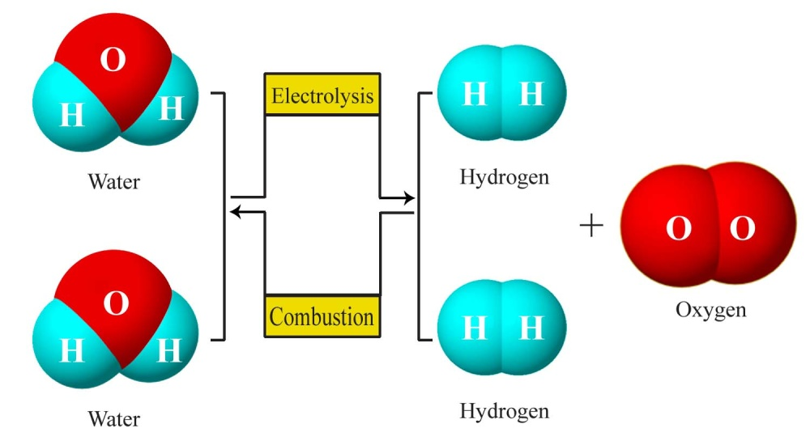

Figure 1: Hydrogen the forever fuel

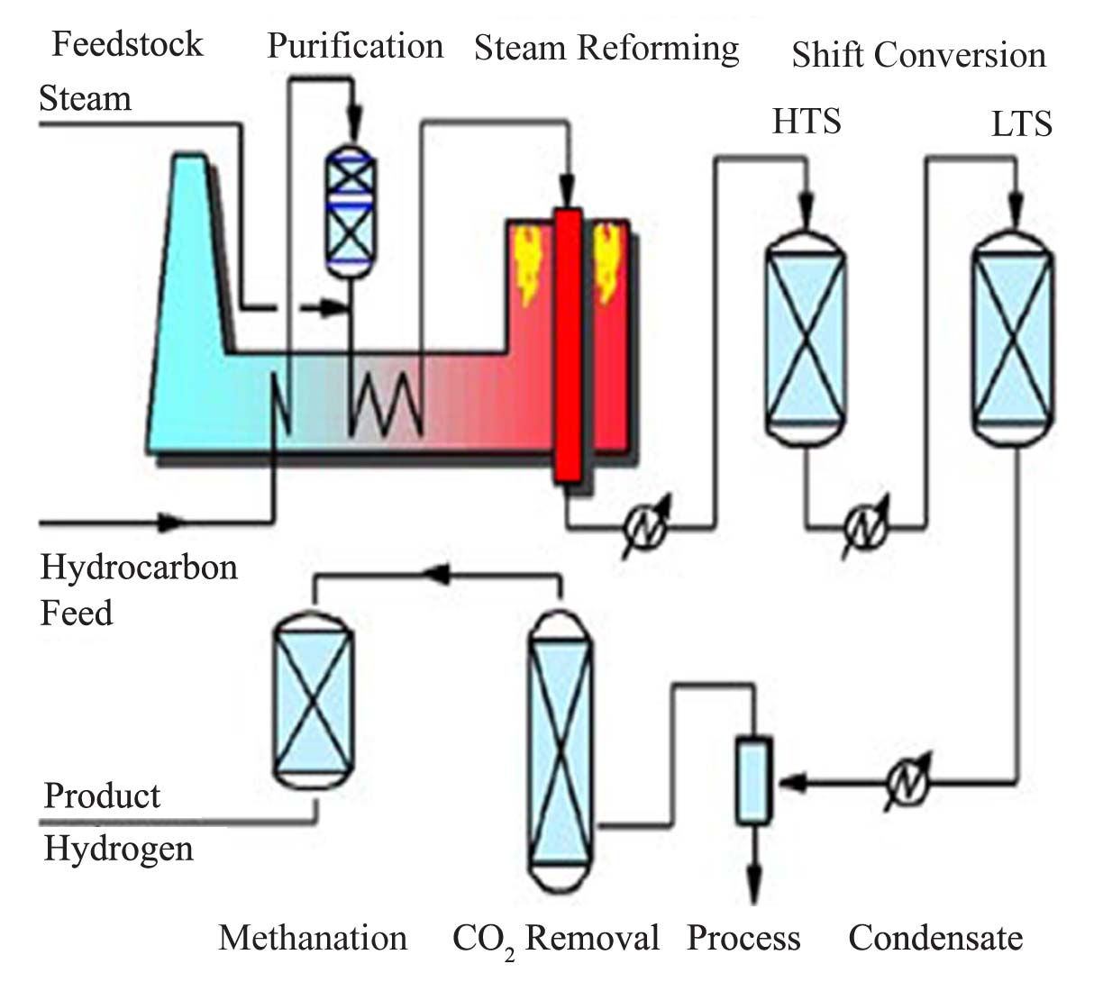

Figure 2: Steam reforming of methane

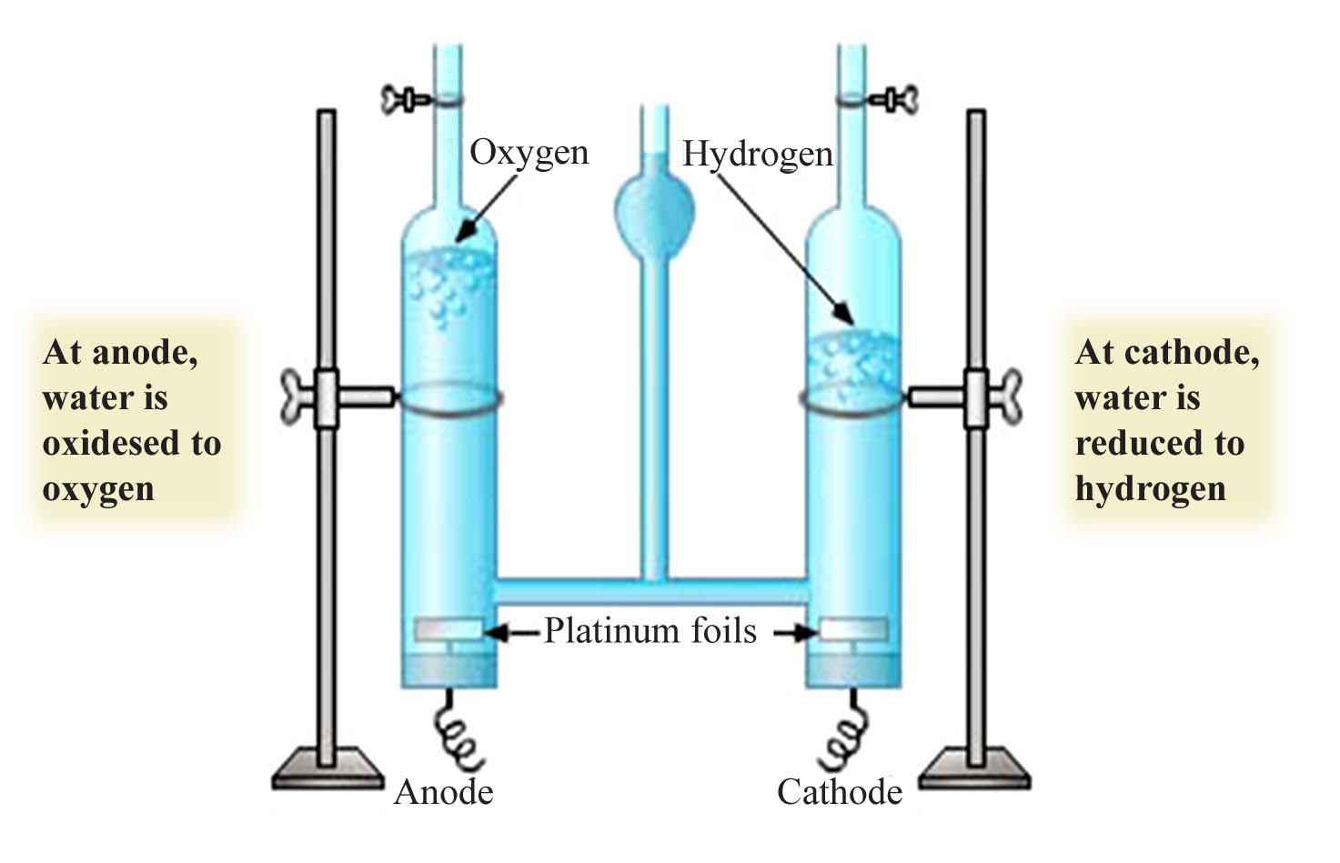

Figure 3: Water electrolysis

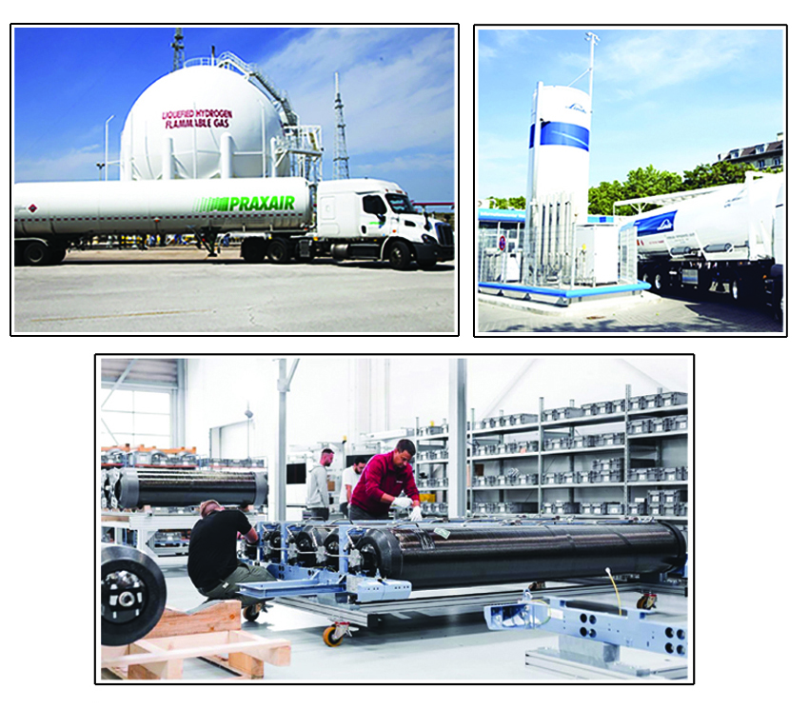

Figure 4: Three different liquified hydrogen storage tanks

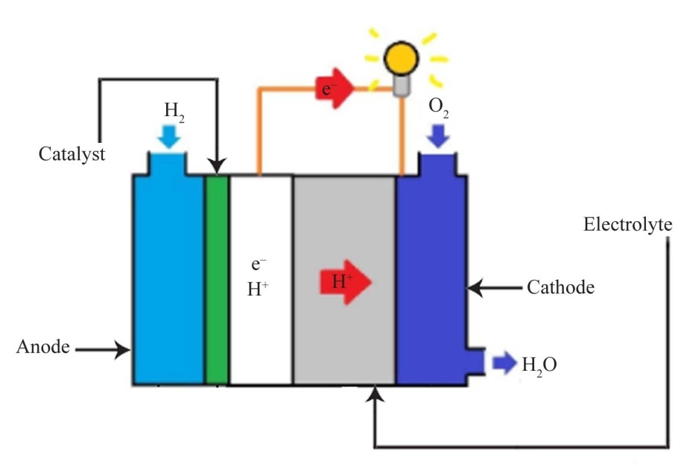

Figure 5: Hydrogen fuel cell

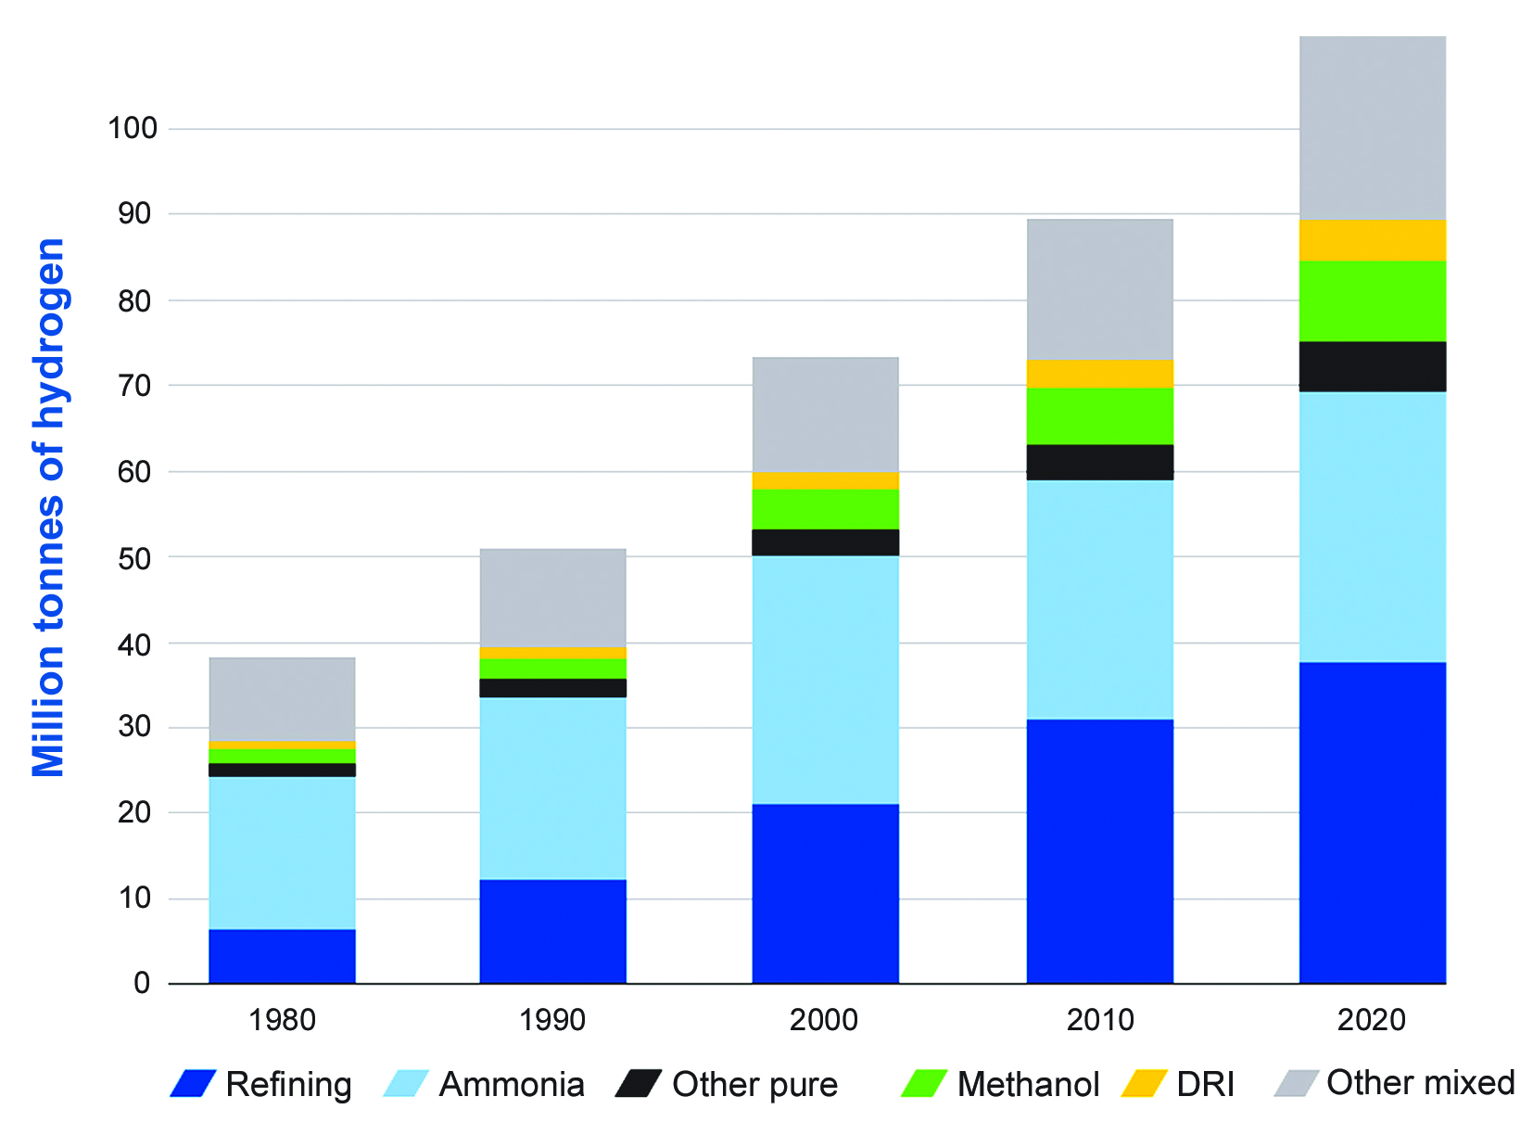

Figure 6: Global annual demand for hydrogen

Figure 7: Eco-friendly hydrogen train

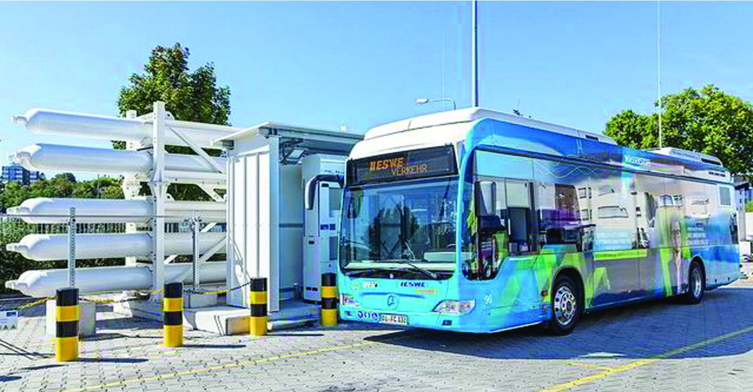
Figure 8: Bus on Germany roads with compressed hydrogen fuel

Figure 9: Eco-friendly hydrogen yacht

Figure 10: Hydrogen concept future aircrafts of Airbus

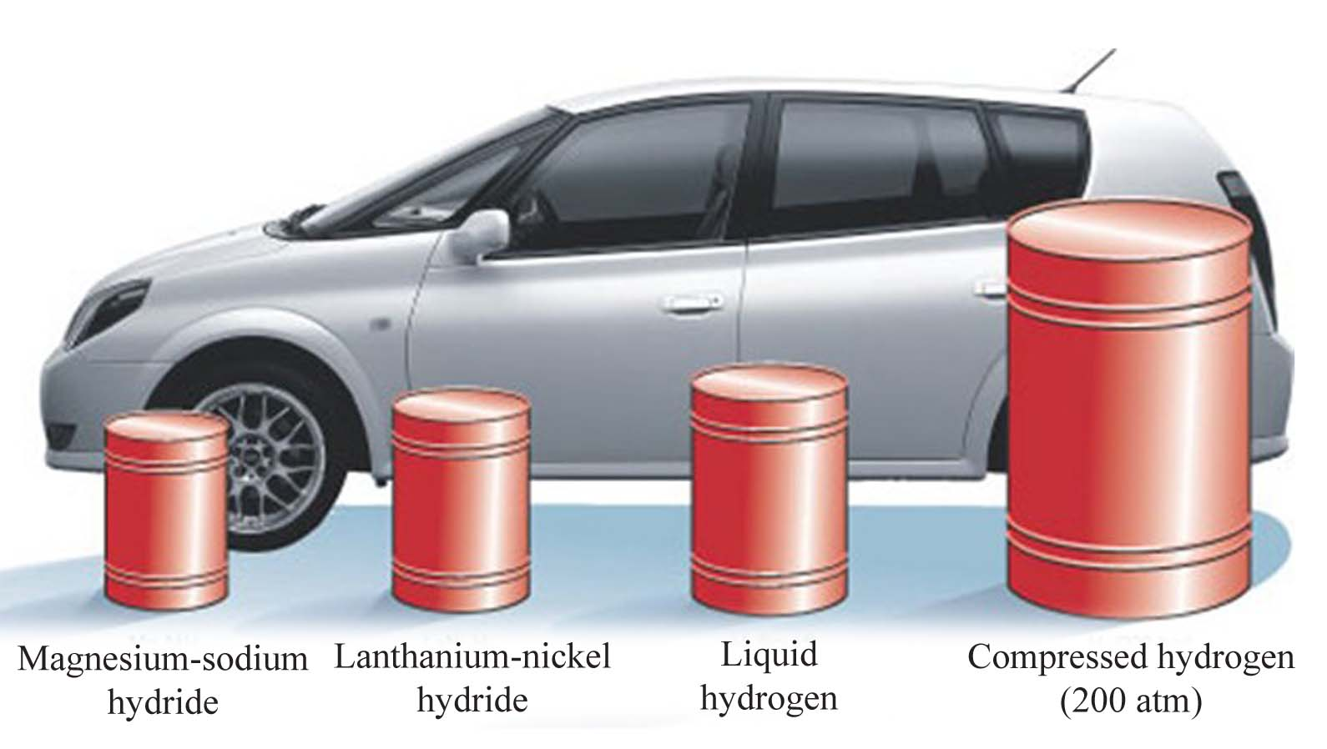

Figure 11: Hydrogen storage containers

