Applications of Computational Fluid Dynamics in the Food Industry
Abhinash P^{1*}, Dhanya Suresh², Mukul Sain³
¹Nehru Institute of Technology, Coimbatore
²Food Safety and Standards Authority of India, New-Delhi
³ ICAR-National Dairy Research Institute, Karnal

Abstract:
This book chapter presents a comprehensive overview of the burgeoning applications of Computational Fluid Dynamics (CFD) in the realm of food processing. CFD has evolved into an indispensable tool, not only for predicting diverse food processing phenomena but also for designing the equipment integral to the food industry. Recent years have witnessed remarkable growth in the development and utilization of CFD, particularly in critical domains such as drying, sterilization, mixing, and refrigeration processes. These advancements have significantly advanced our comprehension of these processes and have enabled the optimization of associated equipment designs. It is important to emphasize that while CFD simulations offer valuable insights, their results should ideally be validated through practical experimentation due to inherent approximations and assumptions. Challenges persist, including accurately simulating large-scale 3-D problems with limited computing resources, especially within complex industrial facilities. However, the trajectory strongly suggests that CFD's widespread adoption within the food processing industry will continue to flourish in the 21st century. This chapter underscores CFD as a potent tool poised to revolutionize and optimize various facets of food processing, ultimately contributing to heightened efficiency and quality within the industry.
Introduction
In the ever-evolving landscape of the food industry, the pursuit of delivering safe, high-quality products to consumers while simultaneously striving for sustainability and cost-efficiency is unceasing. It's a relentless quest that has sparked innovation and driven change across the sector. Among the arsenal of tools at the disposal of food scientists and engineers, Computational Fluid Dynamics (CFD) stands out as an indispensable computational powerhouse. CFD offers a panoramic lens through which we can peer into the intricate dynamics of fluid flow, heat transfer, and mass transfer that characterize diverse food processes. It's akin to a digital laboratory where we can meticulously analyze, optimize, and innovate in ways previously unimaginable. This chapter embarks on a journey through the multifaceted applications of CFD in the food industry, illuminating its pivotal role in enhancing product quality, safety, and production efficiency (Ahmed et al., 2019).

At its core, Computational Fluid Dynamics (CFD) harnesses the computational might of modern computers and deploys advanced mathematical models to simulate fluid flow scenarios. Its success is measured not only by its ability to replicate experimental results, when feasible, but also by its prowess in predicting intricate phenomena that elude isolation within the confines of laboratory settings . Since the advent of digital computing, CFD has risen to prominence, capturing the global imagination as a burgeoning field. It was in the late 1960s that this field began its substantial growth trajectory, permeating every facet of fluid dynamics (Moin & Kim, 1997). Consequently, CFD has woven itself into the very fabric of engineering design and analysis in myriad industries. Its exceptional capacity to anticipate the performance of nascent designs or processes even before they take physical form has elevated it to the status of an indispensable tool.

Researchers, equipment designers, and process engineers have increasingly turned to CFD to unravel the intricacies of flow patterns and performance in diverse process equipment. From optimizing the performance of baking ovens to fine-tuning refrigerated display cabinets, from understanding the dynamics of stirred tanks to enhancing the efficiency of spray dryers, CFD has made its mark. It extends its reach to the realm of heat exchangers and beyond, embracing a plethora of systems. In the realms of design and development, CFD software has evolved into a standard numerical toolkit. It goes beyond predicting fluid flow behavior to encompass the intricacies of heat and mass transfer, phase changes, chemical reactions, mechanical dynamics, and the stress and deformation of associated solid structures. It even ventures into addressing environmental and architectural challenges. Table 1 provides a glimpse into the myriad application areas where CFD has left its indelible mark, transcending the boundaries of food processing.

It is a relatively recent phenomenon that CFD has found its foothold in the arena of food processing (Szpicer et al., 2023). Driven by the escalating consumer demand for convenient, high-quality meals, the food industry has witnessed the birth of innovative food processing practices and technologies. The integration of CFD into this sector holds the promise of unraveling the intricate physical mechanisms governing the thermal, physical, and rheological properties of food materials. The food processing industry is witnessing a swift evolution in its embrace of CFD, recognizing its potential to catalyze substantial advancements. As such, this chapter serves as an overview of the recent strides made in the utilization of CFD within the food processing sector.
Advantages of using CFD
FD has transcended its origins as a mathematical curiosity to emerge as an indispensable tool across the spectrum of fluid dynamics disciplines. Its prowess lies in its ability to delve deep into the nuances of fluid mechanics, offering profound insights into local effects within a wide array of equipment. The utilization of CFD often yields a multitude of benefits, including enhanced performance, heightened reliability, increased confidence in scaling up processes, improved product uniformity, and heightened plant productivity (Bournet and Rojano, 2022). In some instances, design engineers employ CFD as a strategic precursor to assess new systems, aiding in the determination of which and how many validation tests are warranted.

The advantages conferred by CFD are multifaceted and can be classified as follows:

- In-Depth Understanding: CFD provides a comprehensive comprehension of various parameters such as flow distribution, weight losses, mass and heat transfer, and particulate separation. This enhanced understanding equips plant managers with profound insights into the inner workings of specific processes or systems.
- Cost-Effective Geometric Evaluations: CFD enables the evaluation of geometric alterations with significantly reduced time and cost compared to traditional laboratory testing.
- Rapid 'What If' Analysis: It swiftly responds to numerous 'what if' scenarios, offering valuable insights in a short timeframe.
- Scale Independence: CFD models, rooted in fundamental physics, transcend scale-dependent limitations, thereby mitigating scale-up challenges.
- Simulation of Challenging Environments: CFD excels in simulating conditions that are impractical or dangerous for detailed measurements, such as high-temperature environments within ovens.
- Proactive Problem Solving: As a proactive analysis and design tool, CFD not only identifies effects but also pinpoints root causes when assessing plant issues.

In the context of the food industry, where fluid flow plays a pivotal role in numerous operations such as chilling, drying, baking, mixing, freezing, cooking, pasteurization, and sterilization, the integration of CFD has ushered in a new era. Food engineers now benefit from enhanced insights and predictive capabilities during the equipment design phase, bolstering confidence in the quality and safety of food products (FRPERC, 1995). Equipment ranging from ovens and heat exchangers to refrigerated display cabinets and spray dryers has undergone significant improvements through the application of CFD techniques. CFD has emerged as a potent tool in the development, troubleshooting, and optimization of food processing operations, breathing new life into the industry's quest for innovation and efficiency.

Performing a CFD analysis
The process of conducting a CFD analysis involves several key steps. Initially, the analyst formulates the problem and translates it into a mathematical representation based on scientific principles. Subsequently, specialized CFD software is employed to encapsulate this problem mathematically, converting it into a scientifically defined framework. Finally, the computer executes the calculations specified by the CFD software, generating results that are subsequently reviewed and interpreted by the analyst. In essence, the execution of a CFD simulation entails the completion of three fundamental tasks (Tu et al., 2023a).

Pre-processing
The tasks that precede the actual numerical solution process collectively fall under the umbrella of "pre-processing." This essential phase encompasses problem formulation, mesh generation, and the creation of a computational model.

Problem Formulation: The initial stage in utilizing CFD is problem formulation. Before delving into practical implementation, it's imperative to deeply contemplate the underlying physics of the problem at hand. During this phase, the analyst immerses themselves in understanding the intricacies of the flow problem, striving to gain comprehensive insights.

Mesh Generation: The subsequent step is mesh generation. Here, the analyst shapes the problem domain that requires analysis. Often, this can be accomplished with the assistance of a standard Computer-Aided Design (CAD) program. It's common practice to import data generated by such a program into a CFD package. The problem domain is then subdivided into numerous cells, often referred to as volumes or elements. Many CFD packages offer integrated meshing tools, simplifying the process. An example of this is illustrated in Figure 1, depicting the mesh structure of a double tube heat exchanger.

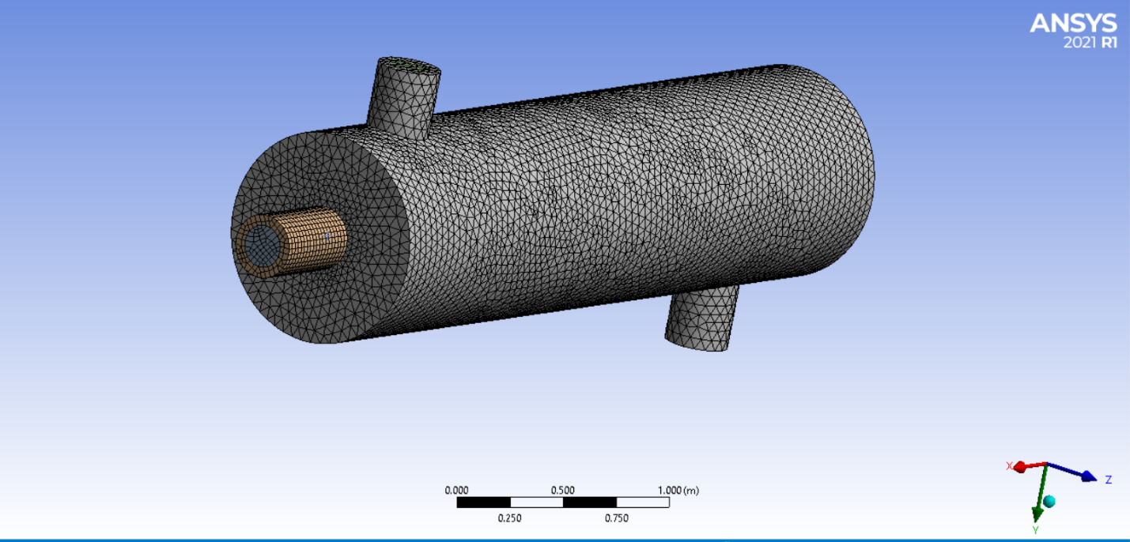

Fig 1 : Mesh structure of a double tube heat exchanger.

Once the meshing process is complete, the boundaries of the problem domain are identified, and the initial boundary conditions, determined in the initial stage, are applied. These conditions, coupled with specific fluid parameters and physical properties, define the precise flow problem to be solved. Advanced CFD software packages often feature tools for performing the following operations: defining a grid of points, volumes, or elements; delineating the geometry's boundaries; implementing boundary conditions; specifying initial conditions; setting fluid properties; and configuring numerical control parameters. However, it's important to note that generating a complex mesh can be challenging. Despite the increasing computational power of modern computers, discretizing the solution domain for 3-D turbulent problems with a grid fine enough for complete independence remains a formidable task (Mirade, 1995).

Processing
The processing phase entails utilizing a computer in which the software tackles the equations of state for every cell until a satisfactory level of convergence is attained. This is an incredibly resource-intensive procedure, often necessitating the computer to solve numerous equations, often numbering in the thousands. In each instance, the equations are integrated, and boundary conditions are imposed. This process, termed equation discretization, is applied to each individual cell within the mesh. The sequence is reiterated in an iterative fashion until the desired level of accuracy is reached. While this stage is fundamental to any CFD software package, it is inherently opaque, occurring behind the scenes and consuming a significant amount of time and computational resources.

Post Processing
Post-processing plays a pivotal role in evaluating the data produced through CFD analysis. Once the model has been successfully solved, the results can undergo both numerical and graphical scrutiny. The post-processing capabilities of advanced CFD software encompass a spectrum of visualization options, ranging from straightforward 2-D graphs to intricate 3-D representations.
Typical post-processing visualizations may include segments of the mesh alongside vector plots illustrating the velocity field or contour plots depicting scalar variables like pressure. These graphs employ a color scheme to distinguish between various value magnitudes. As illustrated in Figure 2, velocity streamlines within the double tube heat exchanger (depicted in Figure 1) provide a visual example, while Figure 3 presents the corresponding temperature distribution of the heating medium in the heat exchanger. Once results have been obtained, they undergo analysis, initially to verify the solution's adequacy and subsequently to extract the precise flow data required from the simulation.

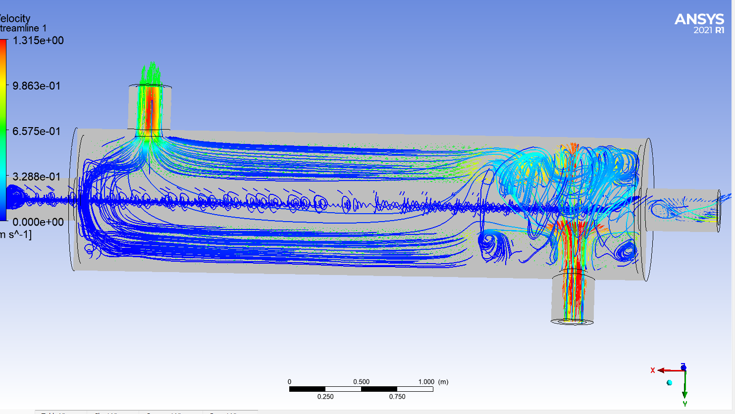

Fig 2: Velocity streamlines within the double tube heat exchanger

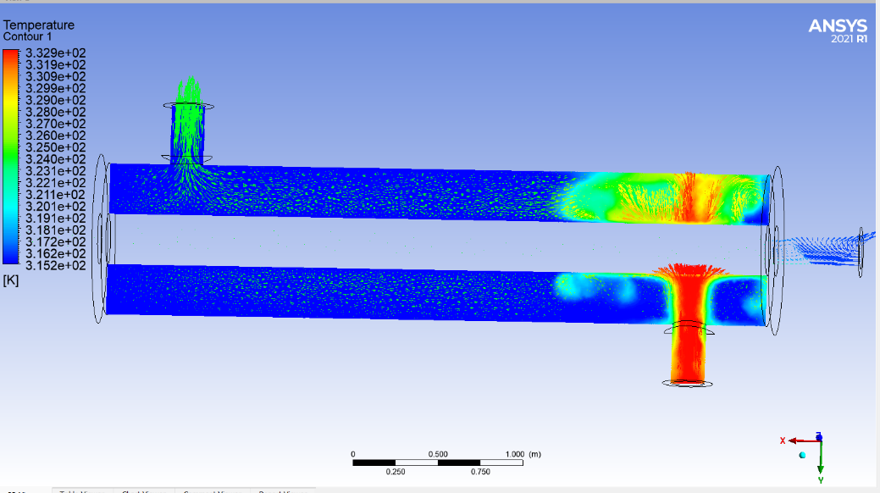

Fig 3: Temperature distribution of the heating medium in the double tube heat exchanger
Commercial CFD codes
In recent years, there has been consistent advancement in the development of CFD (Computational Fluid Dynamics) software. These codes have evolved to handle a high degree of complexity across various research domains, rendering them appealing for a wide range of applications. However, it's important to note that CFD codes used within the food processing industry have yet to attain a level of maturity. They demand further enhancement in terms of accuracy, user-friendliness, robustness, and computational efficiency (BK et al., 2023).

Within the realm of commercial CFD software, there exists a spectrum of codes, catering to general purposes as well as specific applications like non-Newtonian flow. Most of these commercial CFD codes are compatible with platforms such as UNIX workstations, as well as Windows or LINUX operating systems on high-performance Intel Pentium PCs.
CFX
CFX Engineering Software, a division of AEA Technology, offers a diverse range of software solutions, including CFX-4, CFX-5 (a general-purpose tool), CFX-TASCFLOW (aimed at mechanical engineering design and analysis), and CFX-PROMIXUS (tailored for mixer design). The CFX software suite has gained significant traction in the field of food processing. For instance, in a study by Verboven et al. (1997), CFX was utilized to analyze local surface heat transfer coefficients in thermal food processes. Similarly, Brandão et al. (2020) employed CFX software to investigate Cooling and freezing of cashew apple using various models.

CFX-4 software stands out with its robust features, offering direct CAD access, automatic geometry generation tools, and advanced models for predicting complex flows encountered in the process and chemical industries, including turbulence, radiation, and multiphase flows. On the other hand, CFX-5 combines CAD input, automatic mesh generation, and a speedy solution algorithm, providing two-phase modeling capabilities and coupled-multigrid implementation. Notably, CFX-5 concurrently solves pressure and momentum conservation equations, reducing the typical iterative process and CPU time. Users can create geometries within CFX-5's pre-processor or import them from CAD packages in their native formats, with mesh generation being automatic and customizable.
FLUENT
Fluent, a major player in the commercial CFD software arena, offers FLUENT, FIDAP, and POLYFLOW (for polymer processes) codes, catering to a wide spectrum of industrial applications. Researchers have widely adopted Fluent software, exemplified by Arsenoaia et al. (2023) Drying process modeling and quality assessments regarding an innovative seed dryer and Kondjoyan and Daudin (1997) optimization of air-flow conditions during the chilling and storage of carcasses and meat products. FLUENT 5 distinguishes itself as a fully unstructured, mesh-based technology with parallel computing capabilities, an intuitive interface, and user-defined functions. The pre-processing phase involves two tools: GAMBIT and TGRID. Fluent offers a plethora of advanced physical models for turbulence, combustion, and multiphase applications. In contrast, FIDAP, based on the finite element method, provides versatile meshing options and efficient calculations, bolstered by a rich array of physical models.
PHOENICS
PHOENICS, a versatile general-purpose CFD software package, accommodates various hardware platforms, from PCs and UNIX systems to single- or multi-processor supercomputers, running on DOS, WINDOWS, or LINUX operating systems for PCs. PHOENICS has found applications in research and development efforts at numerous institutions and companies. Notably, Mathioulakis et al. (1998) employed PHOENICS to simulate air movement in a dryer, and Moureh and Derens (2000) studied the temperature increase in frozen food packaged in pallets using PHOENICS. PHOENICS effectively solves finite-domain equations related to mass, momentum, energy conservation, among others, for steady or unsteady flow in 1, 2, or 3-D geometries. The software also boasts specialized tools like HOTBOX for electronic cooling, FLAIR for heating and ventilation, and PHOENICS-CVD for chemical vapor deposition. PHOENICS stands out with features like the parabolic option, simultaneous solid-stress analysis, multi-fluid turbulence modeling, domain decomposition for CFD parallel processing, and remote computing via the internet.
STAR-CD
STAR-CD, a commercial CFD code, excels in handling the intricacies of industrial geometries through fully-unstructured hybrid meshes and efficient finite-volume solution methods. Much like CFX, FLUENT, and PHOENICS, STAR-CD has found extensive use in the food industry. For instance, Sorensen et al. (2001) examined local heat transfer and flow distribution in a three-pass industrial heat exchanger using STAR-CD, while Zhang et al. (2000) employed STAR-CD to model the influence of process parameters on particle heating and acceleration during plasma spraying. STAR-CD's capabilities encompass complex geometries, supported by advanced meshing flexibility and solver technology that ensures accurate solutions across a wide range of mesh types. STAR-HPC, a specialized tool for parallel computing, harnesses scalable message-passing technology with fully automated domain decomposition.

Applications
Computational Fluid Dynamics (CFD) is a valuable research tool for improving the design process and gaining insights into the fundamental principles of fluid dynamics (Teimouri et al., 2022). Its potential benefits extend to various facets of the food processing industry, including drying, sterilization, mixing, refrigeration, and other related applications. Recent years have witnessed significant advancements in these domains.
Drying
Drying is a fundamental process in food manufacturing, and the rate of drying is highly dependent on-air flow and velocity within the drying chamber. Understanding these airflow dynamics is crucial for achieving efficient and uniform drying. However, measuring air flow and velocity during operation can be challenging, requiring multiple sensors placed in various directions and locations.

In this context, Computational Fluid Dynamics (CFD) emerges as a powerful tool to predict and analyze the drying process. Researchers have utilized CFD to simulate air flow and velocity during drying operations. For example, Tu et al. (2023b) employed CFD to simulate wet particle drying process in a fluidized bed dryer. Their results were validated with the experimental results. CFD simulations further demonstrated that the heat and mass transfer primarily occur in the lower section of the dryer and at the interface between the bubbles and the solid phase.
Mirade and Daudin (2000) used CFD to study velocity fields in a modern sausage dryer, shedding light on air circulation patterns within the dryer. While CFD showed promise in predicting the effects of filling levels on air flow patterns, there were some discrepancies between simulated and measured air velocities. This emphasizes the need for continued research in fine-tuning CFD models for better accuracy.

Additionally, CFD has found applications in investigating the performance and design of spray dryers widely used in the food industry for producing products like milk and coffee powder. The intricate interplay between air and spray flow patterns complicates the design of these dryers. Therefore, CFD simulations hold significant potential for optimizing spray dryer designs and addressing operational challenges, such as wall deposition (Langrish and Fletcher, 2001).

Recent research endeavors, such as those focused on modeling air flow patterns in pilot plant spray dryers and analyzing the impact of air inlet geometry and spray cone angles on wall deposition rates and highlight the versatility of CFD in addressing various aspects of dryer design and performance (Maryamnegari et al., 2023). For instance, CFD can simulate two-dimensional airflow in a spray dryer and calculate particle trajectories, aiding in understanding the drying process (Straatsma et al., 1999).

As dryers in the food industry continue to evolve in complexity, the role of CFD simulations becomes increasingly vital. They provide quick and valuable insights into dryer performance, helping to optimize product quality and drying efficiency in this essential manufacturing process.
Sterilization
Consumer preferences in the food industry are primarily centered around three key factors: safety, product quality, and cost-effectiveness. Consequently, there is an urgent need to elevate the quality and ensure the safety of our food supply. Sterilization is a pivotal technique for preserving and storing food. The application of Computational Fluid Dynamics (CFD) in the study of temperature distribution and flow patterns during the sterilization process plays a crucial role in optimizing the quality of food products.

Thermal processing stands as the most prominent sterilization technique, effectively eliminating harmful microorganisms. However, it is also associated with the potential loss of food quality and flavor due to excessive heating. Striking the right balance is essential. CFD has emerged as a valuable tool in achieving this balance, with numerous studies focusing on optimizing the thermal sterilization of foods (Wang et al., 2023). These investigations have significantly contributed to refining the control of sterilization processes and preserving the nutritional and sensory qualities of food products.
Many of the researchers conducted extensive research on canned food sterilization using CFD simulations. Their work spanned from simulating the diffusion of bacteria and their spatial distribution during the sterilization process to modeling natural convection heating within canned liquid food. While canned food sterilization has been extensively explored, there has been limited research on sterilization in food pouches, a relatively recent market introduction. Ghani et al. (2001) applied CFD to simulate transient temperature, velocity profiles, and the shape of the slowest heating zone during the sterilization of carrot soup in pouches.

Most studies utilizing CFD in sterilization have focused on thermal sterilization within the limited scope of liquid foods. However, numerous sterilization techniques exist that have yet to be explored with CFD, such as ultraviolet, visible, and infrared light surface sterilization, plasma/corona sterilization, electron and X-ray sterilization, nascent oxygen/ozone sterilization of fruits and vegetables, and pressure sterilization of fresh fruit juices and cooked ham. The future holds immense potential for extending CFD applications to these sterilization methods within the food industry. In addition, CFD modeling often relies on simplifying assumptions, such as treating specific heat, thermal conductivity, and volume expansion coefficients as constants, even though these parameters are temperature-dependent. To enhance the accuracy of CFD predictions, future research should focus on reducing these simplifications and incorporating more realistic temperature-dependent parameters.

Furthermore, the application of CFD can be instrumental in real-time sterilization process control. Effective real-time monitoring of sterilization procedures has the potential to elevate food quality and safety standards significantly. Ultimately, the overarching goal is to optimize the sterilization process to deliver food products that excel in both quality and safety. The integration of CFD applications offers a promising avenue for achieving this objective by continuously improving the sterilization process in the food industry.
Mixing
In the food processing industry, mixing is a ubiquitous operation that involves the blending of gases, liquids, and solids. Among these mixing processes, fluid mixing stands out as a crucial unit operation. Nevertheless, achieving efficient mixing is a complex endeavor, given the challenges posed by multiphase turbulence and mixer design. Computational Fluid Dynamics (CFD) has emerged as a potent tool for modeling these intricate mixing processes, providing a natural bridge between food processing and fluid flow knowledge. With CFD's assistance, we can predict phenomena within agitated vessels, as demonstrated by Romano et al. (2023).

During mixing operations, a common strategy to enhance the process is the use of stirrers or paddles. CFD codes have found application in optimizing mixing processes to minimize energy consumption and reduce processing time. Consequently, research efforts have focused on understanding energy distribution within mixing vessels and the impact of stirrer placement on mixing quality.
The design of mixing devices is a critical facet of understanding the mixing process. Consequently, research has delved into the application of CFD in designing mixing devices, such as shallow bubble columns, as investigated by Rousseaux et al. (2001) and Ranade and Tayalia (2001). These studies yield benefits like facilitating the measurement of drop size distribution, phase velocities, mixing degree, and offering precise descriptions of turbulence, swirling, and vortices generated within mixers. The continued development of CFD applications in the food processing industry's mixing domain holds the promise of more accurate monitoring, control, and optimization of mixing processes. Simultaneously, it provides a solid foundation for ongoing improvements in the mixing processes themselves.
Refrigeration
The consumption of frozen foods has witnessed consistent growth over recent years, owing to their proven track record of offering high food quality and safety. Refrigeration plays a pivotal role in slowing bacterial growth and preserving food freshness. Consequently, researchers have increasingly turned to Computational Fluid Dynamics (CFD) to model heat and mass transfer processes during refrigeration, encompassing chilling and freezing. The application of CFD simulations for air flow analysis is progressively becoming more common in the planning of refrigeration and freezing systems within the food sector (Szpicer et al., 2023). Among the fundamental publications on Computational Fluid Dynamics (CFD) applications in the food industry, you can find reports on modeling food cooling processes. These reports often focus on traditional refrigeration equipment that relies on forced convection. This equipment is commonly used for tasks such as cooling beef carcasses or improving pre-cooling conditions through a combination of thermal and aerodynamic assessments within chamber cooling systems (Ghiloufi Z and Khir T, 2019).

The cold chain encompasses more than just energy transfer processes; it also encompasses storage considerations. Computational Fluid Dynamics (CFD) is a valuable tool, among others, for simulating the sorption behavior and storage stability of dehydrated food products during cold storage (Koc B et al., 2015). In their 2019 study, Wu et al. delved into the impact of package design, pallet placement, stacking patterns, and various cold chain scenarios on the cooling process and quality changes of individual fruits within a pallet. To achieve this, they employed a virtual cold chain approach, leveraging Computational Fluid Dynamics (CFD) simulations, to analyze large collections of fruit. They assessed three different packaging designs for citrus fruits, with the Supervent packaging emerging as the superior choice, offering the quickest and most consistent cooling performance when compared to the Standard and Opentop options.This methodology empowered the researchers to determine, within a specific cold chain context, which pallet position customers should select for maximizing shelf life or which boxes should be prioritized by retailers for sale. When considering cold chain scenarios, it was observed that forced-airflow pre-cooling exhibited the swiftest temperature reduction post-harvest. Additionally, the ambient loadingscenario, where citrus fruits are loaded at ambient temperatures into the container, demonstrated itself as a viable alternative (Wu et al, 2019).

A computational fluid dynamics (CFD) model in three dimensions was established to replicate the heat transfer process under varying air-inflow velocities. This model aimed to predict the spatial and temporal variations in temperature distribution during forced-air cooling (FAC). To enhance the traditional evaluation system, a more comprehensive multi-parameter evaluation system was introduced to determine the optimal pre-cooling strategy for different air-inflow velocities. Through an analysis of the impact of varying airflow rates on several parameters, including Surface Equivalent Cool Time (SECT), pre-cooling uniformity, moisture loss, and energy consumption, an airflow rate within the range of 1.5 - 2.5 m·s-1 was recommended as the most suitable for pre-cooling harvested peaches. It was observed that further increasing the air- inflow velocity resulted in excessive energy consumption, as the decrease in SECT and overall heterogeneity index, as well as moisture loss, offered diminishing returns (Chen et al, 2022).
CFD analysis employed three turbulence models to study a domestic refrigerator’s fresh food compartment. The aim was two-fold: to determine cooling rates and visualize airflow and temperature patterns under loaded conditions. The refrigerator features three compartments: Fresh Food Compartment (FFC), Chill Compartment (CC), and Freezer Compartment (FC). The FFC uses a thermoelectric cooler, while the others rely on vapor compression. Cooling times were measured following IEC62552:2015, with a recorded time of 146.5 minutes.The CFD model revealed airflow and temperature distribution in the FFC. Predictions for upper region packages closely matched measurements (within 10%) compared to lower region predictions, mainly due to differing convective heat transfer behaviors (Söylemez et al, 2021).

Other Applications
Computational Fluid Dynamics (CFD) finds diverse applications within the food processing industry, extending beyond the previously discussed areas. These applications encompass heat exchangers, clean room conditions, forced convection ovens, baking processes, vegetable storage, and condensation management (Szpicer et al., 2023).

Heat Exchanger: Heat exchangers are prevalent in the food processing industry, with plate exchangers being a preferred choice. CFD is instrumental in predicting and controlling food quality during the heating process. For instance, Sharifi et al. (2018) employed CFD to investigate the impact of helical wire inserts on both heat transfer rates and pressure drop characteristics within a double pipe heat exchanger. With the industry's shift toward aseptic processing and the goal of minimizing cooked flavors in heat-processed products, heat exchanger redesigns are frequent. CFD plays a pivotal role in optimizing these redesign efforts.

Clean Room Conditions: Maintaining cleanliness and proper ventilation is imperative in food processing facilities. CFD aids designers in simulating airflow within clean rooms, enabling the prediction of air and particulate matter movement. Yin et al. (2020) assessed the efficiency of dust removal by air curtains under various ventilation parameters in tunneling operations. Furthermore, leveraging CFD, designers can make informed decisions regarding ventilation equipment, air supply and extraction duct placements, and optimal work area and machine positioning, ultimately enhancing sanitation and creating an ideal working environment (Havet and Rouaud, 2000).

Other Equipment Design: CFD plays a pivotal role in the early conceptualization, detailed product development, and scale-up of new designs for food processing equipment. Recent advancements in equipment design have incorporated CFD as a powerful tool for modeling fluid flow and heat transfer. Manoharan et al. (2022) explored the use of CFD in the design of food processing equipment, demonstrating its effectiveness. Khatir et al. (2012) examined its application in bakery equipment manufacture, emphasizing its role in designing and setting up baking ovens. Consequently, CFD significantly contributes to food equipment design, enhancing safety, reliability, and the uniformity of food product quality.
Limitations
Computational Fluid Dynamics (CFD) has unquestionably proven its worth as a valuable tool within the food processing industry. The practicality and effectiveness of employing CFD simulations in this field depend on several critical factors as follows

- Specific Food Material Properties and Processes: Successful CFD simulations in food processing necessitate a deep understanding of the properties and processes unique to various food materials, such as milk, vegetables, fruit juice, and meat. These materials differ significantly in rheological flow properties, thermodynamic characteristics, physical properties, and more from conventional fluids like air and water.
- Accurate Algorithm for Equations of Motion: The accuracy of CFD simulations relies on employing precise algorithms for solving the equations of motion, which must be tailored to the particular food processing scenarios.
- Powerful CFD Packages: The availability of robust CFD software packages with comprehensive features and capabilities is essential to conducting accurate simulations in food processing.
- High-Speed Computing: CFD simulations often demand high-speed and large computing resources to handle the complex calculations involved in modeling food processes.
Despite its advantages, there are still challenges hindering the widespread adoption of CFD in the food processing industry:

- Unique Food Material Properties: Food materials exhibit distinctive properties and behaviors that conventional CFD approaches struggle to capture adequately. While conventional CFD can predict "mixture-average" properties, food quality, texture, size, and composition are intricately linked, demanding a deeper understanding that extends beyond typical CFD capabilities.
- Need for CFD Expertise: Effective utilization of CFD in the food industry requires individuals well-versed in both CFD and food processing. While some commercial CFD software vendors may claim ease of use, specialized knowledge of CFD, including physical flow modeling and numerical techniques, remains indispensable. Proper simulation setup and result interpretation must consider the nuances of food processing.
- Demand for Skilled Specialists: The primary challenge in implementing CFD within the food industry may not solely lie in mesh generation, computational power, or CFD solver capabilities. Instead, the crucial hurdle is identifying individuals who possess the necessary expertise to comprehensively handle the entire CFD process. A growing demand exists for specialists capable of applying and advancing CFD methods in the food industry
In summary, while CFD holds immense potential for enhancing food processing, it must address the unique properties of food materials, and industry professionals need to possess specialized CFD knowledge to fully harness its benefits. Meeting these challenges and fostering expertise will be key to the continued success of CFD in the food processing sector.
Future of CFD in Food Industry
The future of Computational Fluid Dynamics (CFD) in the food industry holds significant promise and potential. While CFD has already proven its value in enhancing our understanding of the dynamics and physics involved in food processing operations, there are clear requirements for the development of faster, more user-friendly, and cost-effective CFD techniques.

As we enter the new millennium, the application of CFD in the food industry stands at a critical juncture. It is increasingly evident that the future growth of CFD will be characterized by qualitative, quantitative, and effective advancements (FLUENT, 2023). Food engineers may soon find relief from non-engineering concerns, such as mesh structure and cell shapes, thanks to the emergence of fully automated mesh generation techniques for CFD.

Continued strides in computer power and ongoing advancements in CFD software development will make automatic design and optimization a reality. Additionally, the development of web-based CFD platforms will expand accessibility to this technology, allowing a broader audience to harness its capabilities. These collective developments will propel CFD into becoming a mature discipline and a potent engineering tool. Consequently, we can anticipate more widespread and rapid adoption of CFD within the food processing industry in the foreseeable future.

Conclusion
In conclusion, this chapter has provided a comprehensive overview of the applications of Computational Fluid Dynamics (CFD) within the food processing industry. CFD serves as a valuable tool not only for predicting various food processes but also for designing the equipment used in food processing. In recent years, we have witnessed substantial growth in the development and utilization of CFD, particularly in key areas such as drying, sterilization, mixing, and refrigeration processes. These advancements have significantly contributed to enhancing our understanding of these processes and optimizing the design of associated equipment. However, it is important to note that while CFD simulations offer valuable insights, they should ideally be validated through practical experiments. CFD relies on numerous approximate models and certain assumptions, which may introduce uncertainties into the results. There are still challenges to overcome, such as the limitations in accurately simulating large-scale 3-D problems on readily available computing resources, especially within complex and extensive industrial facilities. Nevertheless, the trajectory indicates that the widespread adoption of CFD within the food processing industry will persist and strengthen as we enter the 21st century. As this chapter draws to a close, it is evident that CFD stands as a powerful tool with the potential to revolutionize and optimize various aspects of food processing, ultimately contributing to improved efficiency and quality within the industry.

References

- Ahmed, S. U., Arora, R., & Parkash, O. (2019). Flow characteristics of multiphase glass beads-water slurry through horizontal pipeline using computational fluid dynamics. International Journal of Automotive and Mechanical Engineering, 16(2), 6605-6623.
- Arsenoaia, V. N., Roșca, G. R., Cârlescu, P., Băetu, M., Rațu, R., Veleșcu, I., & Țenu, I. (2023). Drying process modeling and quality assessments regarding an innovative seed dryer. Agriculture, 13(2), 328.
- BK, B., Debnath, S., & Mudliar, S. N. (2023). Advanced Computational Tools for Enhanced Food Quality and Safety. Engineering Aspects of Food Quality and Safety, 207-247.
- Bournet, P. E., & Rojano, F. (2022). Advances of Computational Fluid Dynamics (CFD) applications in agricultural building modelling: Research, applications and challenges. Computers and Electronics in Agriculture, 201, 107277.
- Brandão, V. A., Araújo de Queiroz, R., Lima Dantas, R., Santos de Lima, G., Lima Tresena, N., de Queiroga, A. M., & Barbosa de Lima, A. G. (2020). Cooling and freezing of cashew apple using computational fluid dynamics. Diffusion Foundations, 25, 114-132.
- Chen YM, Song HY, Su Q (2022) Multi-parameter analysis of air flow velocity on peach precooling efficiency using CFD. International Food Research Journal 29:456–465
- Ghani, A. A., Farid, M. M., Chen, X. D., & Richards, P. (2001). Thermal sterilization of canned food in a 3-D pouch using computational fluid dynamics. Journal of food Engineering, 48(2), 147-156.
- Ghiloufi, Z., & Khir, T. (2019). CFD modeling and optimization of pre-cooling conditions in a cold room located in the South of Tunisia and filled with dates. Journal of Food Science and Technology, 56(8), 3668-3676.
- Havet, M., & Rouaud, O. (2000, June). Numerical investigation of the airflow in a food-processing clean room. In Proceedings of the 1st International Conference on Simulation in Food and Bio-industries (pp. 48-51).
- Koc B, Isleroglu H, Turker I (2020) Sorption behavior and storage stability of microencapsulated transglutaminase by ultrasonic spray–freeze–drying. Drying Technology 40:1–15.
- Kondjoyan, A., & Daudin, J. D. (1997). Heat and mass transfer coefficients at the surface of a pork hindquarter. Journal of Food Engineering, 32(2), 225-240.
- Langrish, T. A. G., & Fletcher, D. F. (2001). Spray drying of food ingredients and applications of CFD in spray drying. Chemical Engineering and Processing: Process Intensification, 40(4), 345-354.
- Manoharan, D., & Radhakrishnan, M. (2022). Computational cold plasma dynamics and its potential application in food processing. Reviews in Chemical Engineering, 38(8), 1089-1105.
- Maryamnegari, S. M., Ashrafizadeh, A., Baake, E., & Guglielmi, M. (2023). Effects of thermal boundary conditions on the performance of spray dryers. Journal of Food Engineering, 338, 111250.
- Mathioulakis, E., Karathanos, V. T., & Belessiotis, V. G. (1998). Simulation of air movement in a dryer by computational fluid dynamics: application for the drying of fruits. Journal of Food Engineering, 36(2), 183-200.
- Mirade, P. S., & Daudin, J. D. (2000). A numerical study of the airflow patterns in a sausage dryer. Drying Technology, 18(1-2), 81-97.
- Mirade, P. S., Daudin, J. D., & Arnaud, G. (1995). Two-dimensional simulation of the airflow in two industrial meat chillers. International Journal of Refrigeration, 6(18), 403-412.
- Moin, P., & Kim, J. (1997). Tackling turbulence with supercomputers. Scientific American, 276(1), 62-68.
- Moureh, J., & Derens, E. (2000). Numerical modelling of the temperature increase in frozen food packaged in pallets in the distribution chain. International Journal of Refrigeration, 23(7), 540-552.
- Ranade, V. V., & Tayalia, Y. (2001). Modelling of fluid dynamics and mixing in shallow bubble column reactors: influence of sparger design. Chemical Engineering Science, 56(4), 1667-1675.
- Romano, M. G., Alberini, F., Liu, L., Simmons, M. J. H., & Stitt, E. H. (2023). Comparison between RANS and 3D-PTV measurements of Newtonian and non-Newtonian fluid flows in a stirred vessel in the transitional regime. Chemical Engineering Science, 267, 118294.
- Rousseaux, J. M., Vial, C., Muhr, H., & Plasari, E. (2001). CFD simulation of precipitation in the sliding-surface mixing device. Chemical Engineering Science, 56(4), 1677-1685.
- Sharifi, K., Sabeti, M., Rafiei, M., Mohammadi, A. H., & Shirazi, L. (2018). Computational fluid dynamics (CFD) technique to study the effects of helical wire inserts on heat transfer and pressure drop in a double pipe heat exchanger. Applied Thermal Engineering, 128, 898-910.
- Sørensen, D. N., Hvid, S. L., Hansen, M. B., & Meyer, K. E. (2001). Local heat transfer and flow distribution in a three-pass industrial heat exchanger. International Journal of Heat and Mass transfer, 44(16), 3179-3187.
- Söylemez, E., Alpman, E., Onat, A., & Hartomacıoğlu, S. (2021). CFD analysis for predicting cooling time of a domestic refrigerator with thermoelectric cooling system. International Journal of Refrigeration, 123, 138-149.
- Straatsma, J., Van Houwelingen, G., Steenbergen, A. E., & De Jong, P. (1999). Spray drying of food products: 2. Prediction of insolubility index. Journal of Food Engineering, 42(2), 73-77.
- Szpicer, A., Bińkowska, W., Wojtasik-Kalinowska, I., Salih, S. M., & Półtorak, A. (2023). Application of computational fluid dynamics simulations in food industry. European Food Research and Technology, 249(6), 1411-1430.
- Teimouri, Z., Borugadda, V. B., Dalai, A. K., & Abatzoglou, N. (2022). Application of computational fluid dynamics for modeling of Fischer-Tropsch synthesis as a sustainable energy resource in different reactor configurations: A review. Renewable and Sustainable Energy Reviews, 160, 112287.
- Tu, J., Yeoh, G. H., Liu, C., & Tao, Y. (2023a). Computational fluid dynamics: a practical approach. Elsevier.
- Tu, Q., Ma, Z., & Wang, H. (2023b). Investigation of wet particle drying process in a fluidized bed dryer by CFD simulation and experimental measurement. Chemical Engineering Journal, 452, 139200.
- Verboven, P., Nicolaï, B. M., Scheerlinck, N., & De Baerdemaeker, J. (1997). The local surface heat transfer coefficient in thermal food process calculations: a CFD approach. Journal of Food Engineering, 33(1-2), 15-35.
- Wang, W., Wu, J., Zheng, J., Wu, Z., Huang, J., Lu, Y., ... & Huang, L. (2023). Simulation and optimization of the thermal sterilization process of puree cans using the production of chestnut puree as an example. Frontiers in Microbiology, 14, 1135700.
- Wu W, Cronjé P, Verboven P, Defraeye T (2019) Unveiling how ventilated packaging design and cold chain scenarios affect the cooling kinetics and fruit quality for each single citrus fruit in an entire pallet. Food Packag Shelf Life 21:100369.
- Yin, S., Nie, W., Guo, L., Liu, Q., Hua, Y., Cai, X., ... & Zhou, W. (2020). CFD simulations of air curtain dust removal effect by ventilation parameters during tunneling. Advanced Powder Technology, 31(6), 2456-2468.
- Zhang, T., Gawne, D. T., & Liu, B. (2000). Computer modelling of the influence of process parameters on the heating and acceleration of particles during plasma spraying. Surface and Coatings Technology, 132(2-3), 233-243.

