The Importance Of Life Skills Training In Women’s Empowerment

Women’s empowerment refers to enabling an environment where women gain control over their own lives, are able to freely exercise their rights, and attain social, political, economic and personal equality . It is a multi faceted approach that seeks to diminish the system and historical bias and disadvantages that have over history reduced them to the status of second class citizens in a society. It seeks to give the power of decision making, earning and independent identity creation by women in society.

Women’s empowerment challenges and seeks to change the current gender norms, gender perceptions, stereotypes, and discriminatory and manipulatory practices that are hurdles in women’s progress It entails various aspects which include:

• Education:

To provide equal access to quality education for girls and women, acquirement of knowledge, skills, and the inculcation of self- belief to enable them to work for and attain their goals.

• Economic empowerment:

Promoting women’s economic participation which includes a right to decent work, right to equal pay, encourage entrepreneurship and make accessible financial resources for the same. To enable them to make economic decisions and contribute to the economic development of society

• Health and well-being:

This seeks to make available to women of all strata of society their reproductive rights, provide easily available healthcare services, to tackle and reduce maternal mortality, spread awareness about sexual and reproductive health, and enable them to stand strong against gender based violence and abuse.

• Political participation:

This is sought to encourage women’s active engagement and leadership in political and decision-making processes. To advocate and help in ensuring a fair enough women’s representation in elected positions so as to enable the creation of a gender- sensitive and responsive governance system.

• Legal rights and protection:

To facilitate the enforcement of gender equality laws, address social discriminatory practices, to promote easy access to justice for women, that along with other societal discrimination also protects them from violence, social isolation and harmful cultural practices and norms.

• Social and cultural change:

To make women capable of challenging patriarchal norms, social stereotypes, and discriminatory practices that enable gender inequality, promoting gender-responsive attitudes, behaviors, and social norms, and to foster a socially inclusive society

Women’s empowerment is important for any society that seeks gender equality and sustainable development. It recognizes that women’s rights are human rights and to do away eith structural barriers and power imbalances that prevent women from achieving their potential and participating in society on an equal footing with men.

Empowerment such that it seeks to remove gender-based barriers and empowers women to participate equally in society to create a more equitable and prosperous world.

Promoting women’s empowerment necessitates challenging and transforming negative cultural norms and practices that perpetuate gender inequality. By nullifying patriarchal structures and promoting gender-responsive attitudes, societies can create an environment that values and respects women’s rights and contributions.
Empowering women challenges traditional gender roles, fosters gender equality within families and communities, and encourages shared responsibilities. This cultural transformation leads to improved relationships, reduced violence against women, and enhanced overall well-being.

Women’s empowerment is not just a matter of justice and human rights but also a catalyst for social development. By promoting women’s empowerment in education, economics, health, politics, and culture, societies can unlock the full potential of women and achieve sustainable progress. Empowered women become agents of change, transforming their lives, families, and communities. It is our collective responsibility to dismantle the barriers that hinder women’s empowerment and work towards creating a world where women can fully participate and thrive. Only by empowering women can we realize a more equitable, inclusive, and prosperous future for all.

Life Skills and Their Role in Women’s Empowerment-

Empowering women to be able to carve their own identities is directly linked to their ability to think critically and take informed decisions. These and other such aspects that enable a woman to be a person in her own right are largely a part of life skills training .

What are life skills ?
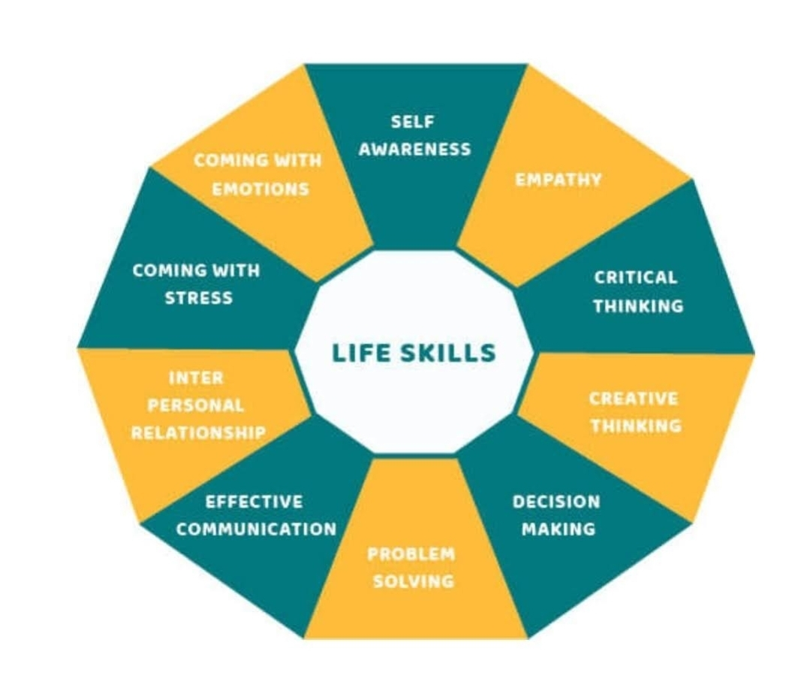
Life skills are defined as “a group of psychosocial competencies and interpersonal skills that help people make informed decisions, solve problems, think critically and creatively, communicate effectively, build healthy relationships, empathize with others, and cope with and manage their lives in a healthy and productive manner. Life skills may be directed toward personal actions or actions toward others, as well as toward actions to change the surrounding environment to make it conducive to health.” According to World Health Organization (WHO).

Bearing the WHO definition in mind, the Basic Life Skills curriculum encompasses emotional, social and intellectual tools that enable a person to lead a succesful life on a personal level and an interpersonal level, and also as members of a community and in their work life.

Considering that women constitute half of any community or society, women’s empowerment must be addressed as a crucial aspect of social progress and gender equality. Real women’s empowerment must make women capable of using the required tools and skills to exercise control over their lives and to make critically thought informed decisions. Life skills play an important role in this process by providing women with the knowledge, capabilities, and confidence needed to face challenges and be able to achieve personal growth, and contribute usefully to the communities they are part of. In this regard life skills have a major role to play in women’s empowerment.

The key life skill factors that are instrumental in women’s empowerment can be grouped under the following heads:

Build Confidence and Self-Esteem:

Life skills training inculcates the development of confidence and self-esteem, both of which are crucial for women’s empowerment. Life skills education betters their self-perception and self- belief. It enables women to overcome social barriers and get over gender biases that are big obstacles to their progress. Life skills training imparts communication skills, assertiveness, and decision-making abilities thereby enabling self-expression, the ability to negotiate effectively, and be assertive about their rights in personal and professional contexts.

An enhanced self-assurance makes women to be strong enough to challenge social stereotypes, become leaders, to participate in decision-making. Thereby bringing a change in the existing power structures.

Enhanced Critical Thinking and Problem-Solving abilities:

Life skills education makes women capable of critical thinking and endows them with problem-solving abilities, which makesthem capable of analyzing situations, making clear and informed choices, and finding solutions to problems. These skills are highly valuable in an environment where women face discrimination, gender-based violence and abuse, or restricted access to resources. The development of critical thinking skills in women empowers them to challenge traditional and feudal norms and discriminatory practices. The women become capable of recognizing and challenging gender biases in their workplaces , they become confident enough to fight for their rights and seek justice in cases of gender-based violence.

Life skills training empowers women to face problems with resilience, be creative and resourceful, enables them to overcome obstacles to achieve their goals.

Promotion of Financial and Economic Empowerment:

Economic independence is a vital component of empowering women. Life skills training bestows women with financial awareness and literacy, entrepreneurship and vocational training, thereby opening doors to economic progress. Acquirement of these skills enables women to secure gainful employment, start their own businesses, and become financially independent and self-reliant. Economic empowerment allows these women to exercise control over their financial resources, make their own financial decisions, and contribute to their families’ economic well-being. Also, financially empowered women directly play a significant role in reducing poverty, increasing economic growth, and enabling sustainable development that is of benefit for society at large.

Promotion of Health and Well-being:

Life skills education also plays a direct role in promoting awareness of the importance of women’s health and well-being. By imparting them with knowledge about reproductive health, nutrition, hygiene, and disease prevention, life skills training enables them to make informed and better choices about their bodies, health, and overall well-being

. This knowledge increases awareness in women to take control of their own health, be able to access healthcare services, and advocate for their reproductive rights.

Life skills education also includes stress management, emotional intelligence, and coping mechanisms, helping women to better handle the challenges of daily life, discharge theirresponsibilities, and attain mental and emotional well-being.

Conclusion:

Life skills are thus an invaluable tool in empowering women and bringing about gender equality. By teaching the women to be more confident, be capable of critical thinking, enabling problem-solving, imparting financial literacy, and health-related awareness, life skills education enables women to challenge societal norms, fight for their rights, and make a meaningful contribution to their communities. Women empowered through life skills will more likely lead fulfilling lives, make informed choices, and positively impact society. Therefore, it is important to train women in comprehensive life skills education programs that address the unique challenges women face and provide them with the skills necessary for them to be empowered. Thus, by providing women with the requisite life skills we can create a more equitable, just and inclusive society that benefits all its members.

