Synthesis, Characterization and Application of CdS:Pr³⁺ nano-material

Jitendra Pal Singh^{1*} Sudha Pal²
Department of Physics, School of Sciences Department of Physics,
IFTM University, Moradabad-244102, India M.B. Govt. P.G. College,
paljitendra124@gmail.com Haldwani, Uttrakhand-263139, India
palsudh2011@gmail.com

Y. K. Sharma³ Atanu Nag⁴
Department of Physics, Department of Physics, School of Sciences

Sri Dev Suman Uttarakhand University IFTM University, Moradabad-244102, India

Pt. L. M. S. Campus Rishikesh, India tnnag79@gmail.com

dryksharma@gmail.com

Richa Sexena⁵ Narender Singh⁶
Department of Physics, School of Sciences Department of Physics, School of Sciences
IFTM University, Moradabad-244102, India IFTM University, Moradabad-244102, India
saxena.rich23@gmail.com nspal_physics@rediffmail.com

Corresponding author: paljitendra124@gmail.com

Abstract
Pr³⁺ doped CdS nano-material are successfully synthesized and characterized through an easy, inexpensive simple chemical precipitation method. The obtained shape of the synthesized particles is almost spherical and their size is found to decrease with the increase in Pr³⁺ ion concentration. The chemical distinctness of the synthesized nano-particle was confirmed by the representative EDAX spectra. The absorption spectra of the prepared nano-material have been recorded at room temperature in the UV-visible an NIR-region. The structure, shape, band gap and optical behavior are also investigated. The obtained CdS:Pr³⁺ nano-material exhibit approximately sphere-like shapes of about 1μ-200nm diameter. The synthesized CdS:Pr³⁺ nano-particles can be potential for different opto-electronic applications.

Keyword: CdS:Pr³⁺, SEM, EDAX, FTIR, UV-visible spectra

1. Introduction
Generally, nano-materials have structured components with at least ID less than 100 nm. Nano-materials have definitely different physical and optical properties in different scientific and technological fields [1]. Nano-science is basically study of nano-scale materials, where their properties are remarkably different from those at a macro scale. Nano-technology, on the other hand, refers to the manufacturing and application of those structured devices and systems by managing the structure and size of these nano-materials [2]. In nano-materials, any physical property can be selectively controlled by engineering on its morphology. This is made possible by synthesizing it in the various forms of quantum confined systems [3]. The necessity for quantum confinement is to obtain nano-crystals smaller than the excitation Bohr radius of the material [4]. Group II-VI semiconductor nano-materials are a type of materials composed of group II-VI elements with a wide direct band gap and these are very crucial in many modern electronic domains, due to the tunability of their electrical and optical properties [5-7]. Cadmium sulfide (CdS) is considered to be amongst the most functional semiconductor owing to its high energy band gap value of 2.42eV. CdS structures are classified into three types viz. wurtzite, rock-salt and zinc blend phases out of which the first one is found to be the most significant due to its stability and easy to be synthesized characteristics [8, 9]. Rare earth elements exhibit remarkable optical properties [10, 11]. Praseodymium (Pr³⁺) is such a trivalent rare earth ion with a composite energy level ¹D₂, ³P₀, ³P₁, ³P₂, which provide the possibility of simultaneous emissions depending on the CdS materials. The return to the ground state is accomplished with both the radiative and non-radiatve decays. When an excited electron decays by emitting photons, which is luminescence emission, the process is then called radiative decay. Non-radiative decay is excited electron decays to the ground state by emitting phonons. General aspects of fluorescence of material as a result of radiative electronic transition in which an electron jump from a higher energy state to lower energy state with the different in energy released as light emission. Pr³⁺ ion doped CdS nano-particles (CdS:Pr³⁺) have been extensively considered in the recent year due to their describable properties and applications in different domains of interest like computing, opto-electronics, bio-medicine, structural engineering, aerospace etc [12-15]. This work will discusses the synthesis, characterization and application of CdS:Pr³⁺ nano-material.

2. Experimental Details
CdS:Pr³⁺ nano-particles were synthesized experimentally by simple chemical precipitation synthesis method (CPSM) [16]. CPSM is a single-step, easy and inexpensive method. A recent work, has been carried out by Jitendra Pal Singh et al [17], which describes elaborately the synthesis of CdS:Pr³⁺ nano-particles using the CPSM. By adopting the same methodology of experimentation, using the CPSM, different concentration (0.1, 0.2 and 0.3 mol % Pr³⁺ ion doped CdS) of CdS:Pr³⁺ nano-particles were prepared.

3. Result and Discussion
The CdS: Pr³⁺ nano-particles have been synthesized by simple CPSM and it is then characterized in terms of scanning electron microscopy (SEM) imageries, energy dispersive X-ray (EDAX) spectra, Fourier transform infrared (FTIR) spectra and absorption spectra to compute the shape, size and optical energy band gap.
3.1 SEM
The morphology of the sample was examined by SEM using FEI Quanta 200F. Representative SEM imageries (shown in Fig. 1) of CdS: Pr³⁺ nano-particles, prepared by simple CPSM, indicate approximate spherical shape of the CdS: Pr³⁺ nano-particles at 300 K. The observed particle sizes are around 1μ-200nm. It clearly demonstrates the formation of spherical shaped CdS nano-particles. The morphology of the nano-particles was found to be changed with the Pr³⁺ ions concentration.
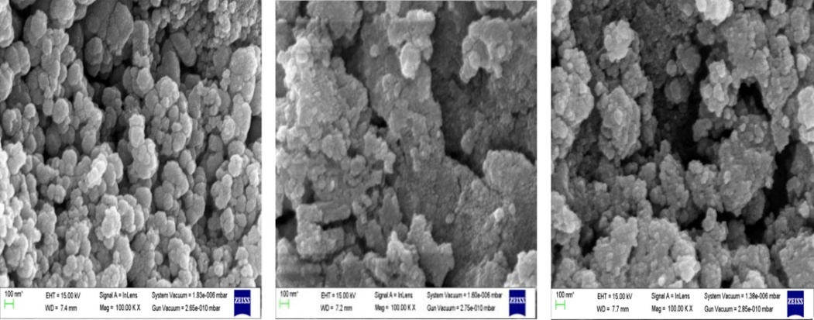
Fig. 1: SEM imageries of CdS: Pr³⁺ nano-particles
3.2. EDAX
Repersentative EDAX spectrum of CdS: Pr³⁺ nano-material specimen is shown in Fig. 2. This spectrum confirms the chemical abundances of total sample elements in the final composition which was taken initially [18].

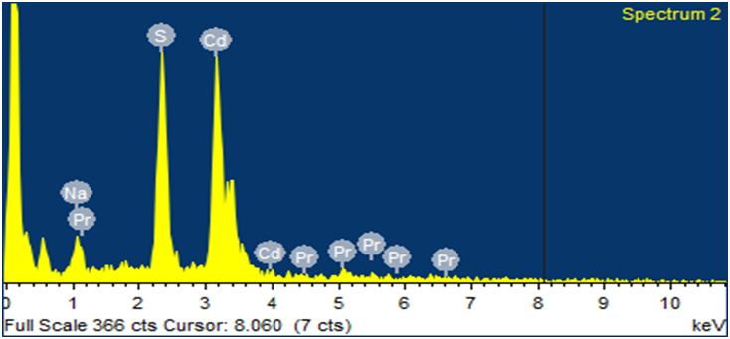
Fig. 2: Representative EDAX spectrum of CdS: Pr³⁺ nanomaterial.

3.3. FTIR Spectroscopy

In a molecule, the phenomenon of absorption spectra of the electromagnetic radiation at a specific vibration frequency with particular sets of chemical bonds can be regarded as the source of generation of FTIR spectra [19]. The FTIR spectra of CdS:Pr³⁺ nano-material observed expermentally in the 400-4000cm⁻¹ range is shown in Fig. 3. These spectra of CdS:Pr³⁺ nano-material consists of several peaks having broad and moderate in bandwidth. The peaks around 607-636 cm⁻¹ are due to metal-oxygen (Pr³⁺/CdS) bonds. The peak in the range 1613-1623 cm⁻¹ is associated with the asymmetric stretching vibrations of CdS bonds of metal-oxygen group. The broad band around 3427-3456 cm⁻¹ is due to the fundamental S-H stretching vibrations indicating the presence of H₂ groups.

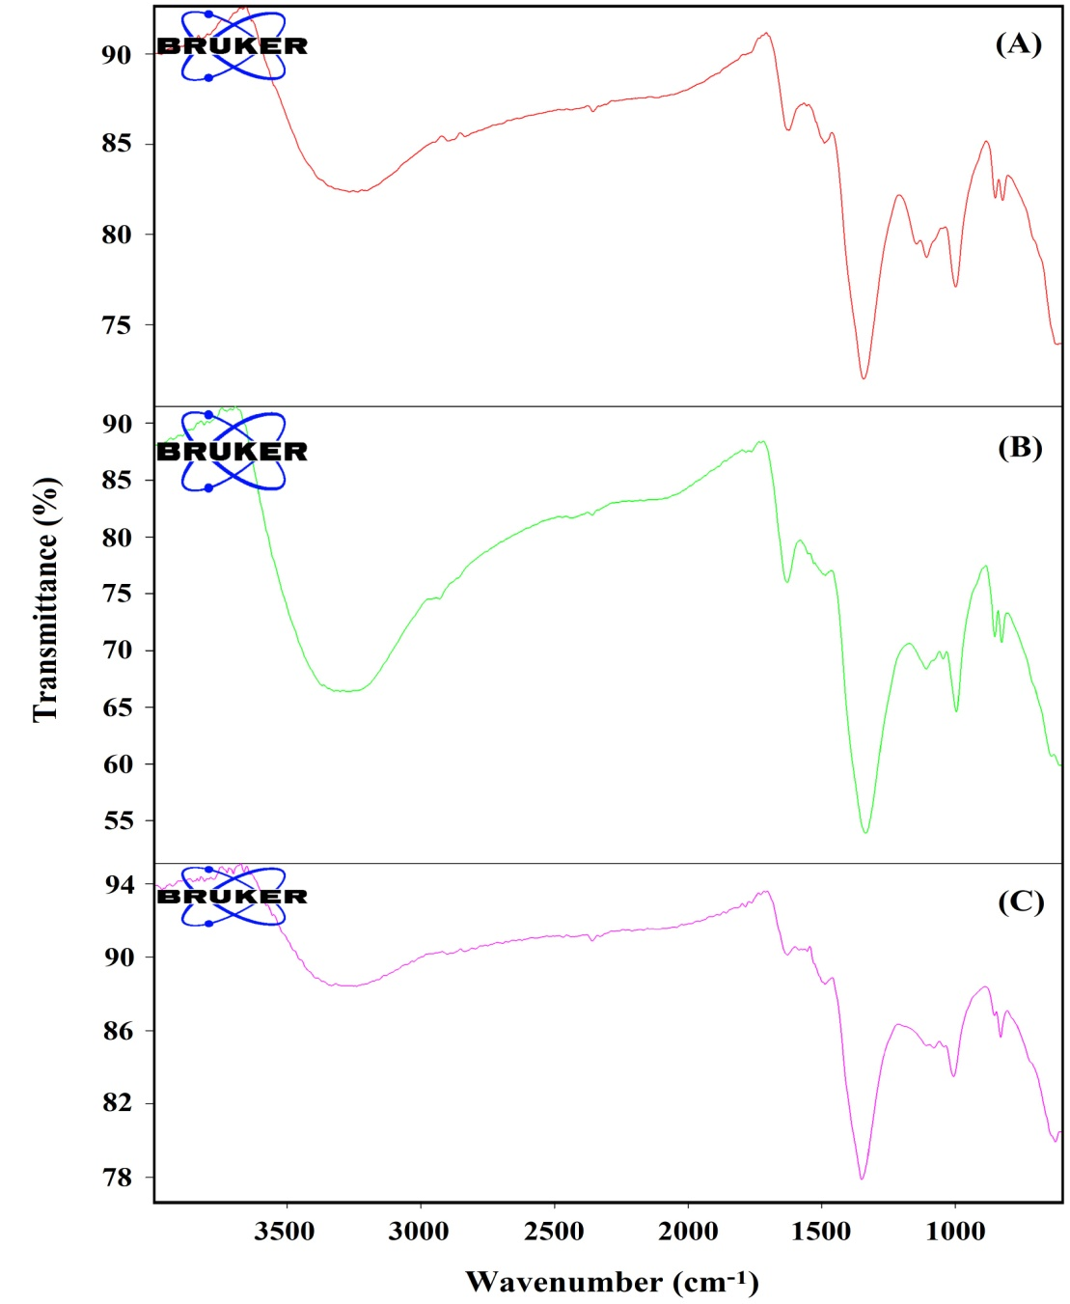
Fig. 3: FTIR spectrum of CdS with Pr³⁺ nanoparticles doping concentration of (A) 0.1 mol%, (B) 0.2 mol% and (C) 0.3 mol% of Pr³⁺ ion.

3.4 Absorption spectra

The absorption spectra of CdS: Pr³⁺ nano-particles were recorded for different concentration of Pr³⁺ ions at room temperature for with the help of 2375 Double Beam Spectrophotometer. The UV spectra of CdS:Pr³⁺ was recorded for a wavelength range of 300-1000 nm. Transitions from the ground level to different excited levels are indicated by the representative absorption spectrum in Fig. 4, with the horizontal axis representing the wavelength in nm and the vertical axis representing the absorbance in arbitrary units.
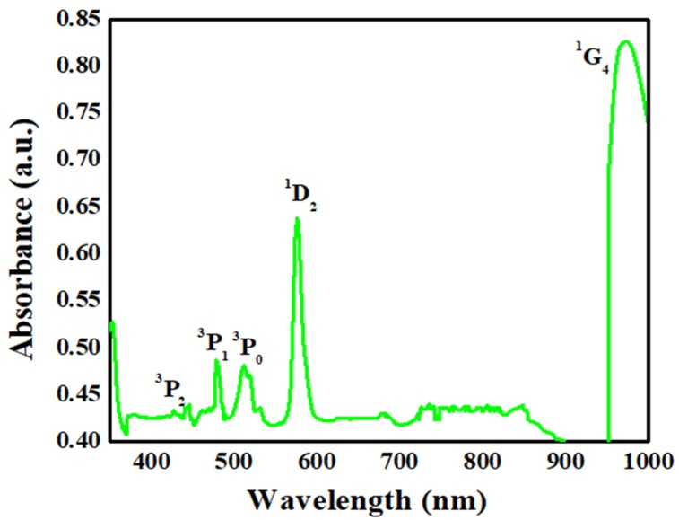
Fig. 4: Representative absorption spectrum of CdS: Pr³⁺ nano-material.

3.5 Energy band gap
Table 1 shows the optical band gap (E_{g}) energy of CdS:Pr³⁺ nano-particles, as revealed from the absorption spectrum, for different Pr³⁺ ion concentrations. The observed band gap energy variation is due to the effect of quantization. It is evident that the band gap energy value increases as the crystallite formation of nano-metric Pr³⁺ ions doped CdS nano-particles size increases. It is clear from Table-1 and Fig. 5 that, the band gap energy reduces as the concentration of Pr³⁺ ions increases.

Table.1: Absorption spectrum derived energy band gap (E_{g}) of CdS:Pr³⁺ nano-particles doped with different Pr³⁺ ion concentrations

0.1 mol% Pr³⁺ |  | 0.2mol% Pr³⁺ |  | 0.3mol% Pr³⁺
Wavelength  λ (nm) | Energy Band gap (eV) | Wavelength  λ (nm) | Energy Band gap (eV) | Wavelength  λ (nm) | Energy Band gap (eV)
446 | 2.78 | 445 | 2.78 | 448 | 2.76
480 | 2.58 | 482 | 2.57 | 481 | 2.57
513 | 2.41 | 512 | 2.42 | 513 | 2.41
576 | 2.15 | 576 | 2.15 | 577 | 2.14
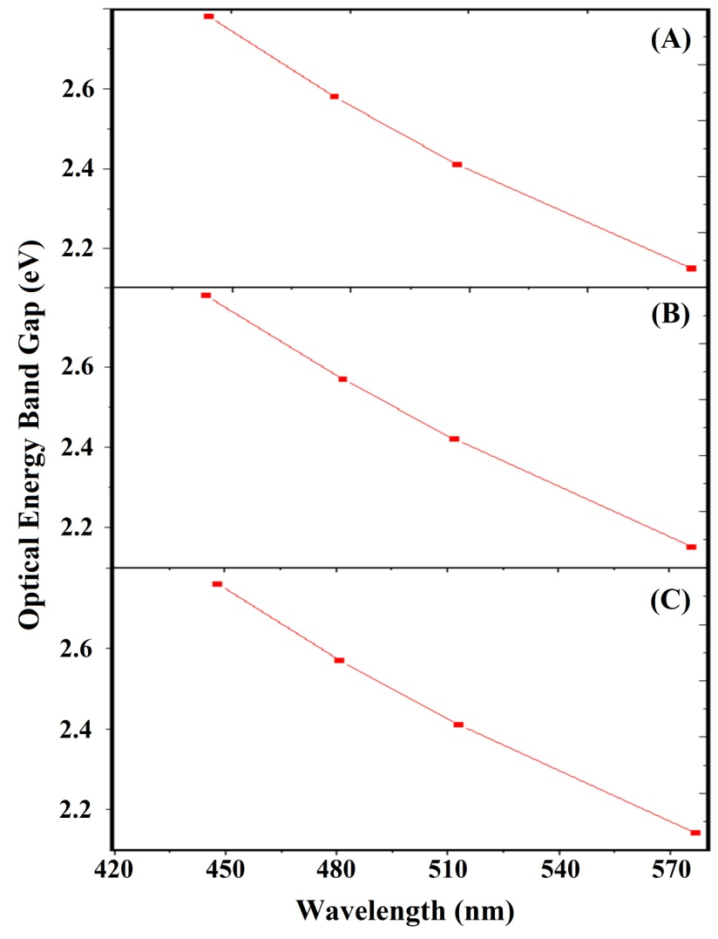
Fig. 5: Energy band gap of CdS: Pr³⁺ nanoparticles with a doping different concentration of (A) 0.1 mol%, (B) 0.2 mol% and (C) 0.3 mol% of Pr³⁺ ion.
4. Conclusion
There are size dependent physical properties such as the electrical and optical properties as exhibited by nano-materials particularly at the nano-scale regimes. Considering the fundamental and as well as the technological significance, the tunability feature of the band gap energy in certain semiconductors is very much crucial for modern electronic devices. Semiconductors, possessing such property of band gap energy tuning, are supposed to be the next generation materials of interest for display devices, photovoltaics, opto-electronic devices, lasers, photonic band gap devices etc. CdS is considered to be amongst the most utilizable semiconductor owing to its elevated band gap energy value. It is supposed to be applied potentially in opto-electronic domain [20]. We have successfully prepared Pr³⁺ doped different concentration CdS: Pr³⁺ nano-particles by simple CPSM with an objective to use this for different opto-electronic applications. The chemical distinctness of the synthesized nano-particles have identity by EDAX spectroscopic analysis and the peaks were identity by the FTIR absorption spectroscopic analysis. The SEM imageries of the synthesized CdS: Pr³⁺ nano-particles verify the morphological variation of the shape of the CdS nano-particles for Pr³⁺ ion doping with different concentrations. The band gap decreases with increasing concentration of Pr³⁺ ion. The band gap values show that it is suitable to use in solar cell fabrication as well as opto-electronic and high frequency applications. The developed CdS: Pr³⁺ nano-particles could also be useful for display devices like LEDs, and UV temperature measurement sensors [21].
ACKNOWLEDGEMENT

Authors are thankful to IIT Roorke Institute Instrumentation Centre for providing the FTIR spectroscopic measurement and the SEM imageries and Department of chemistry , IIT Roorkee for providing the absorption spectra of the sample.

REFERENCES
- Manasi Karkare ,book for “Nanotechnology fundamentals and application”,I.K.International(2008).
- Sanyasinaidu Boddu, Ph.D Thesis “Synthesis and characterization of lanthanide ions doped Nanomaterials” Bhabha Atomic Research, Centre ,(2011).
- N. Qutub, Ph.D Thesis; “Cadmium Sulphide Nanoparticles” A .M .U., India (2013) .
- Krishna Kumar Pathak, Thesis “Preparation and Characterization of Chemically Deposited rare earth doped Nanocystalline CdSe Films” India (2020).
- Peijing Tian ,Zhe Zhang, Jian Yuan,Weihong Zheng .,“Crystallization and luminescence of
Pr³⁺ doped CdS QDs silicate glass”, Functional Materials Letters, 13(2018)1-4.
- Ankit Goyal, Vinay Sharma, Abhishek Sharma; “Synthesis ,structural and Optical study
of CdS nanoparticles”, Journal of optical material ,90(2019)252- 256.
- Preeti Sahare, “Synthesis and characterization of CdS nanoparticles” International Journal of Engineering Research and technology” ,6(2018)1-4.
- V.Singh,P.Chauhan ,“Synthesis and structural properties of Wurtzite type CdS nanoparticles”
,Chalcogenide let ,6(2009)421-426
- J. P. Singh, P. Goyal, Y. K. Sharma, V. Kumar and H. O. Yadav., “Optical Energy band and Absorption spectra of CdS:Pr³⁺Nanomaterials”, International Journal of Current Advanced Research, 10 (2021) 2319-6505.
- P. Tian, Z. Zhang, J. Yuan, W. Zheng, H. Li and S. Zhu., “Crystallization and luminescence of Pr³⁺-doped CdS QDs silicate glass”, Functional Materials letters, (2018) 1-4.
- A. A. Safi and M. I. Ibrahim., “The effect or rare earth doping CdS nanostructure on structural, optical and photoconductivity properties”, 17 (2019) 108-118.
- S. Kumar and J. K. Sharma, “Stable Phase CdS nanoparticles for optoelectronics: A study on surface morphology, structural and optical characterization”, Materials Sci. Poland, 34 (2016) 368-373.
- M. N. Khan, A. Almoharmmedi, M. A. M. Khan and M. A. Shar, “Metal doped CdS quqntum dots:Structural,Optical and Photocatalytic Properties under Visible light Irratiation”, 5 (2020) 2-17.
- P. Tian, Z. Zhang, J. Yuan and W. Zheng, “Crystallization and luminescence of Pr³⁺ doped CdS QDs silicate glass”, Functional Materials Letters, 13 (2018) 1-4.
- L. Saravanan, R. Jayavel, A. Pandurangan, J. H. Liu and M. H. Yuan, “Synthesis Structural and optical properties of Sm⁺³ and Nd³⁺ doped Cadmium Sulfide nanocystals”, Materials Research Bulletin, 52 (2014) 128-133.
- L. Bokatial and S. Rai, “Optical properties and up-conversion of Pr³⁺doped CdS nanoparticles in sol-gel glasses”, Journal of Luminescence, 130 (2010) 1857-1862.
- J. P. Singh, P. Goyal, Y.K .Sharma, D. R. Prakash “Synthesis and Characterization of Pr³⁺ doped CdS Nanomaterial”. J. Emerging Technologies and Innovative Research 6(2019) 3093-3101.
- J. P. Singh, Y. K. Sharma, S. Pal and A. Nag, “Fluorescence study of Pr³⁺doped CdS Nanoparticles and its application in Sensors and detectors”, Journal of fluorescence, Published (online) July 2023. https://doi.org/10.1007/s10895-023-03325-w.
- Y. K. Sharma, P. Goyal, S. Pal and U. C. Bind, “Laser action in Praseodymium doped Borosilicate Glasses in visible region”3(2016)1031-1035.
- A. B. El-Bially, R. Seoudi, W. Eisa, A. A. Shabaka, S. I. Soliman, R. K. Abd El-Hmaid and R. A. Ramdan, “Preperation characterization and Physical properties of CdS Nanoparticles with different sizes”, Journal of Applied Science Research, 8 (2011) 676-685.
- S. Zhou, G. Jiang, X. Wei and C. K. Duan, “Pr³⁺-doped beta-NaYF4 for Temperature Sensing with Fluorescence Intensity Ratio Technique”, Journal of Nanoscience and Nanotechnology, 14 (2014) 3739-3742.

