Assessment of groundwater geochemical interactions in Mukkani and Palayakayal areas, eastern section of the Thamirabarani delta, Srivaikundam Taluk, Thoothukudi District, Southern India
Richard Abishek S^{1, 2}, Antony Ravindran A¹, Muthusamy. S¹, Christinal J¹, Moorthy G.M¹, Vinoth Kingston J¹, Antony Alosanai Promilton A¹, Abinaya R¹, Sakthi Priya. R¹
¹ PG and Research Department of Geology, V.O.Chidambaram College, Thoothukudi -628008, India
² (Reg.no19212232221046) Research scholar is affiliated with Manonmaniam Sundaranar University, Tirunelveli, India
*Corresponding author: Richard Abishek S¹
E-mail: richardabishek9710@gmail.com
Abstract
A hydrogeochemistry technique was employed in the study, which was conducted in the southern part of the Srivaikundam region, to develop quality-based groundwater applications. The research area is observed using coastal sand and river alluvium. The suitability of groundwater for drinking and irrigation was assessed by studying its physical and chemical qualities. The data was collected on 15-point groundwater samples utilising hydrochemical parameters based on Box and Whisker plots, Ternary, Piper, and Wilcox plots. The Aquachem software was used to determine the kind of atmospheric agents, and thus the impact of rocks, the response to sedimentation and evaporation, and the composition of groundwater in the area. According to the aquifer chemical facies analysis, the majority of the water samples in the cation plot are of the calcium-magnesium facies. According to the aquifer chemical facies study, the majority of the water samples in the cation plot are of the calcium-magnesium facies type, with a few falling into the calcium-sodium facies type, while the anionic section has the chloride-sulphate-bicarbonate facies type. The hydrochemical and GIS methodologies were studied, and the results were displayed as spatial distribution maps in the study area. The fresh and saline composition of groundwater in a portion of the area was measured using a hydrochemical facies evolution diagram (HFE-D). The chemical composition of groundwater is generally deteriorating as a result of agricultural and anthropogenic activities. The majority of the groundwater samples are safe to drink and use in the home.
Keywords: Hydrochemistry, Aquachem analysis, GIS analysis, HFE diagram

1. Introduction
Groundwater is the main source of water it encounters agricultural, industrial and domestic needs. During the last decade, competition for economic growth related to population growth and urbanization major changes in land use resulting in high demand water for this activity (Brindha, K., 2017). These studies show that the water is the main source of drinking water in many areas, and the main reason for the deterioration of its quality sea water infiltration, high evaporation rate, interaction with rock formations and salt plans (Raja, P., 2021). The studied groundwater samples were found be supersaturated with carbonate minerals and sub saturated with evaporated minerals (Ravindran, A. A., 2015 and Chockalingam, K., 2021). A comparison of groundwater quality in terms of drinking water standards presented that most groundwater samples were unsuitable for drinking purposes (Ayogu, C. N., 2020). The excess groundwater draft from randomly distributed pipe wells. The purpose of irrigation changed the water table, quantity and quality scenarios. Basic function control, the water quality of groundwater is a dissolved substance, commonly called salt. Salt should be small amount of dissolved solids due to dissolution or weathering of rocks. This study has shown that the rock-water interaction was the main geochemical groundwater chemistry control process in the study area (Khan, A. F., 2021). Interactions of water, soil, rocks and various water sources pollutants are the cause of groundwater inequality quality (Stanly, R., 2021). The objective of study (1) to determine hydrochemical studies on the suitability of groundwater in the study area. (2) Create geographical distribution maps for the GIS tool based on known spatial scales of water quality degradation in the study area.
2. Study Area

The study area was located between 8°3824 N of latitude and 78°0448 E of longitude and 8°4312 N of latitude and 78°0936 E of longitude in Thoothukudi District, Tamil Nadu. The part of the area covered by quaternary alluvium, Teri sands (dunes), tertiary sediment/sand, weathered zones in gneisses, and charnockite are the water-bearing formations. The main lithological units for the research area are fluvial marine deposits in coastal locations. The Thamirabarani delta is surrounded by Archean rocks that include gneisses, granites, and charnockite, and the lithological unit of research is found in the fluvial marine deposits in the coastal region. The research area comprises a variety of hydrogeological formations, from porous to fissured. Weathered and fractured hard rock formations, as well as Tertiary and recent porous sedimentary formations, make up the primary aquifer systems (Archean age). In the studied area, the surface layer is mostly covered by alluvial deposits (Fig. 1).
Fig .1 Location of water samples collection and geomorphology map of the study area
3.Materials and methods
The relevant study area was obtained by the total number of water samples out of 15 on hydrochemical processes and investigation (Satheeskumar, V.,2021). The results of the groundwater data analysis are presented in the form of shows (Table 1). The principles of cations and anion of Na⁺, Ca²⁺, Mg²⁺, K⁺,as well as the anions HCO⁻₃, Cl⁻, SO²⁻₄were examined in the lab and represented in the Aquachem programme to calculate the Box and whisker, Piper, Ternary, and Wilcox plots. The maps for water quality physico-chemical and main ions of water parameters within the study area were created using GIS-based analysis. The interpolation map for each parameter in the seasons was created using the inverse distance weighted (IDW) interpolation method (Chabuk, et al., 2020 and Antony, R.A. and Richard, A.S. 2022).
The shape file maps of the study area village in the Thoothukudi district were used to interpolate in GIS software. Another technique for the mixture of fresh and saline water in the study area to identify the evolutionary pattern of the (HFE-D) hydrochemical facies (Roy, et al., 2021). The mix of fresh and saline water in the research region is determined by the phase diagram.
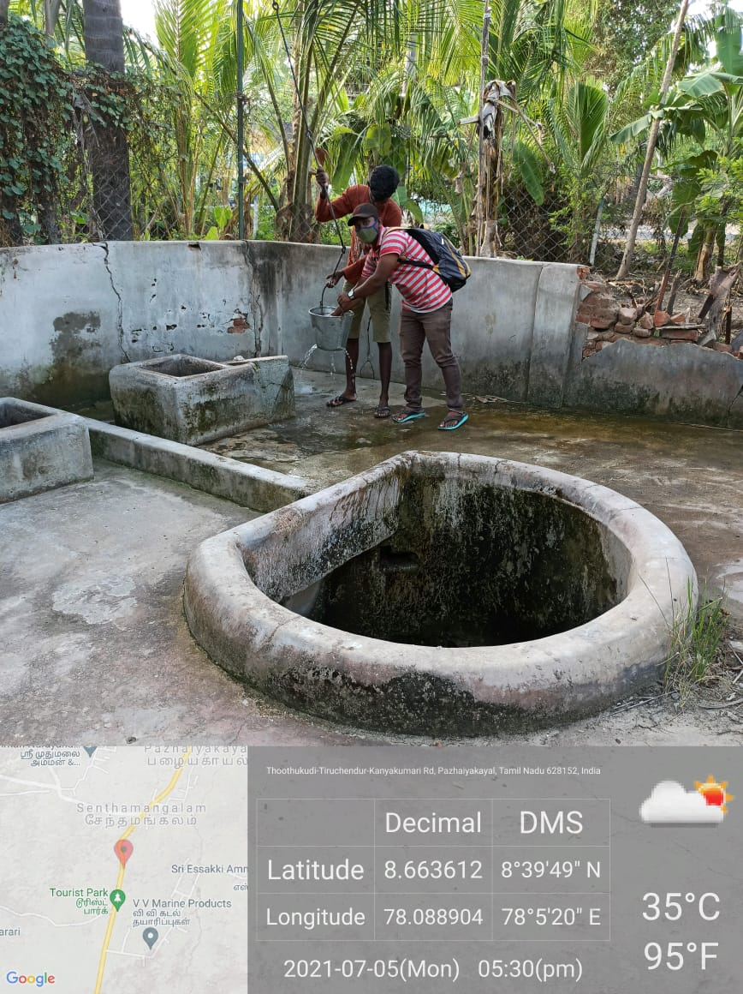
Fig 2.Water sample collection from given study area
Table 1.Samples location and given water types present in the study area
Station ID | Latitude | Longitude | Water type
WS1 | 8.696874 | 78.11184 | Ca²⁺-Mg²⁺-Cl⁻-HCO⁻₃-So₄²⁻
WS2 | 8.678306 | 78.11586 | Ca²⁺-Mg²⁺-Na⁺-Cl⁻-HCO⁻₃-So₄²⁻
WS3 | 8.682861 | 78.09909 | Ca²⁺-Mg²⁺-Cl⁻-HCO⁻₃-So₄²⁻
WS4 | 8.678375 | 78.09715 | Ca²⁺-Mg²⁺-Cl⁻
WS5 | 8.675573 | 78.09584 | Ca²⁺-Mg²⁺-So₄²⁻-Cl⁻-HCO⁻₃
WS6 | 8.678306 | 78.10293 | Ca²⁺-Mg²⁺-So₄²⁻-Cl⁻-HCO⁻₃
WS7 | 8.668056 | 78.09167 | Ca²⁺-Cl⁻-So₄²⁻
WS8 | 8.71841 | 78.10418 | Ca²⁺-Mg²⁺-Cl⁻-So₄²⁻
WS9 | 8.640338 | 78.07737 | Ca²⁺-Mg²⁺-Cl⁻-So₄²⁻
WS10 | 8.649251 | 78.08624 | Ca²⁺-Mg²⁺-Cl⁻-So₄²⁻
WS11 | 8.651954 | 78.08659 | Ca²⁺-Mg²⁺-Cl⁻-So₄²⁻
WS12 | 8.640395 | 78.07428 | Ca²⁺-Mg²⁺-Cl⁻-So₄²⁻
WS13 | 8.635921 | 78.07695 | Mg²⁺- Ca²⁺-Cl⁻
WS14 | 8.634584 | 78.07258 | Ca²⁺-Mg²⁺-Cl⁻-So₄²⁻
WS15 | 8.62906 | 78.06807 | Mg²⁺- Ca²⁺-Cl⁻

4.Result and discussion
4.1 Water chemistry
The hydro geochemical correlations between physico-chemical characteristics of groundwater were determined using graphs for Box & Whisker, Piper, Ternary and Wilcox graphs in the Aquachem programme, which was utilized to estimate the water quality for drinking and agricultural uses in the study region. The values from the lower to upper quartile are represented in the middle box (25th to 75th percentile). The median is represented by the centre line. A vertical line connects the lowest and highest numbers.
Changes in the composition of the groundwater chemical variations easily classify the mean values in the graphs. The graphical representation of the diagram box and whisker plot distribution of Na⁺, Ca²⁺, Mg²⁺, HCO⁻₃, Cl⁻, SO²⁻₄ and SO²⁻₄. Ca²⁺, Mg²⁺, Na⁺ + K⁺ vs HCO-3, SO²⁻₄, Cl⁻ in the Tri angle variation of each mineral ingredient in freshwater and seawater are shown in the following plot. Alkaline soil (Ca²⁺ + Mg²⁺) has the lowest level of HCO⁻₃ and SO²⁻₄ kinds, as seen in the graph.
The groundwater changes from a So²⁻₄ - Cl⁻ type to Ca²⁺- Mg²⁺, as can be shown (Fig 3). The breakdown of salts deposited by evapotranspiration of irrigation water followed by mixing with water might cause such a change in the chemical phase
The interaction of water with silicate minerals, as well as the return of evaporated sediments and irrigation into the water provide (Na⁺ + K⁺) and HCO⁻₃ by carbonates and silicates, and So₄²⁻ and Cl⁻ by evaporates. Through graphical approaches, the variance of Ca²⁺, Mg²⁺ and Na⁺ contained in the collected water sample is explained in Ternary plot. For example, the weathering of evaporates and silicates provides Na⁺and K⁺, whereas carbonates, silicates, and evaporates provide Ca²⁺ and Mg²⁺.
The Wilcox diagram can be used to assess the quality of water for agricultural and drinking purposes. This figure determined sodium hazard levels ranging from low to medium in this S1-low, S2-medium plot. The sodium C1-low, C2-medium, C3-high, and C4 levels will then vary. In the plot, the samples fall into the C2-S1 kind of water, which has low sodium and medium salinity.
4.2 GIS analysis
The precise local deterministic interpolation approach underpins the IDW method (Vaiphei, et al., 2020). The pH of water determines whether it is acidic or alkaline, and it is a critical characteristic in the use of drinking water and irrigation. It has a significant impact on water quality, influencing metal solubility, alkalinity, and water hardness (Chabuk, 2020). According to geographical interpolation, water samples fall into the categories of "low," "medium," "high," and "very high," indicating the quality of water in the study area.
The pH levels of water range from 7 to 8, indicating that the water samples are alkaline. The minimum and maximum TDS concentrations in a given research location range from 178 to 1134 (mg/l). TDS levels indicate that hydrolysis of potassium or sodium silicate has a significant impact on water chemistry. Furthermore, because the host rocks are alluvial sand, TDS may be increased by reduction and oxidation processes in the surface and subsurface water.
The amount of ions in the water, as well as the type of ions present, and the temperature, determine the electrical conductivity of groundwater. 376–2425 (uS/cm) was discovered to be the lowest and maximum conductivity values. It has been discovered that the concentration of dissolved solids in water is directly related to Ec values (Fig 4).
Ca²⁺ and Mg²⁺ concentrations in water samples range from 20-272 mg/l and 10-96 mg/l, respectively. The values of Na⁺ range from 6-41 mg / l. Table 2 shows the K⁺ content of the water, which ranges from 2-12 mg/l. The cations Ca²⁺ and Mg²⁺ are the most abundant in groundwater. Ca²⁺ can be obtained in the research region by dissolving carbonate minerals (Fig5).
The anion HCO₃⁻water concentration ranges from a minimum of 12-107 mg/l to a maximum of 12-107 mg/l in Table 2, with bicarbonate accounting for a large portion of the carbonate ions. So²⁻₄concentrations in water range from 19 to 468 mg/l, while Cl- concentrations range from 48 to 670 mg/l, respectively (Fig 6).
Bicarbonates, chlorides, and sulphates were measured in the research area. Irrigation, rain infiltration, and fresh water flow may have caused the carbonates in these rocks to disintegrate. Sulfate is formed in water by the decomposition of organic matter in atmospheric soils, and chloride ions are formed in water by the leaching of pollutants and saline residues into the soil, as well as by anthropogenic activities.
Table 2.Statictical summary of water chemistry data of the study area
Parameter | Min | Max | Average | St. Dev.
pH | 7 | 8 | 8 | 8
Cond (uS/cm) | 376 | 2425 | 1093 | 633
TDS (mg/l) | 178 | 1134 | 508 | 259
Ca²⁺ (mg/l) | 20 | 272 | 75 | 66
Mg²⁺ (mg/l) | 10 | 96 | 37 | 30
Na⁺ (mg/l) | 6 | 41 | 16 | 8
K⁺ (mg/l) | 2 | 12 | 6 | 3
Cl⁻ (mg/l) | 48 | 670 | 168 | 180
HCO⁻₃ (mg/l) | 12 | 107 | 57 | 36
So₄²⁻ (mg/l) | 19 | 468 | 106 | 110

Fig 3. a. Box and whisker plot, b. Piper plot c. Ternary plot and d. Wilcox plot in the study area
Fig 4.Spatial distribution map of physical parameter a.Ph b.TDS and c.Ec in th study area

Fig 5.Spatial distribution map of cation ions a.Ca²⁺ b.Mg²⁺ c.Na⁺ and d.K⁺

Fig 6.Spatial distribution map of cation ions a.HCO₃⁻ b.So₄²⁻ and c.Cl⁻
4.3 Hydrochemical Facies Evolution Diagram (HFE-D)
Hydrochemical research of all water types has characterized the hydrochemical facies evolution diagram (HFE-D) of river water or groundwater. It was created by categorizing water types, phases, and facies in order to depict significant cations and anions on HFE-D diagrams. To identify groundwater samples, the term HFE-D phase diagram indicated freshening and salinization. Four primary facies are indicated on the hydrochemical facies evolution diagram (HFE-D).
In result of freshening or salinization phase has been examined. The samples are depicted in the diagram as mix Ca²⁺ + mixCl⁻ and mix Ca²⁺ + mix So²⁻₄water types. Mg²⁺ + So²⁻₄, Mg²⁺ + So²⁻₄, Mg²⁺+ Cl⁻ and Ca²⁺ + Cl⁻ and Ca²⁺ + Cl⁻ were all found in some of the samples, as shown in the diagram.
The presence of saline intrusion in the WS-4, 7,8,9,11,14, and 15 samples indicates that they were exposed to seawater (Fig 7). Salinization along the Gulf of Mannar has been recognized as the return of irrigation water from surface or groundwater resources, which could explain the presence of a seawater intrusion within 4 km of the river mouth.
Table 3. Summary of Hydrochemical Facies Evolution Diagram (HFE-D) fresh/saline intrusion results in the study area
Station ID | Phase | Facies
WS1 | Fresh. | MixCa²⁺ | MixHCO⁻₃
WS2 | Fresh. | MixCa²⁺ | MixCl⁻
WS3 | Fresh. | MixCa²⁺ | MixCl⁻
WS4 | Intrus. | MixCa²⁺ | MixCl⁻
WS5 | Fresh. | MixCa²⁺ | MixSO₄²⁻
WS6 | Fresh. | MixCa²⁺ | MixSO₄²⁻
WS7 | Intrus. | Ca²⁺ | MixCl⁻
WS8 | Intrus. | Ca²⁺ | Cl⁻
WS9 | Intrus. | Mg²⁺ | Cl⁻
WS10 | Fresh. | Mg²⁺ | SO₄²⁻
WS11 | Intrus. | Ca²⁺ | Cl⁻
WS12 | Fresh. | MixMg²⁺ | SO₄²⁻
WS13 | Fresh. | Mg²⁺ | SO₄²⁻
WS14 | Intrus. | Mg²⁺ | Cl⁻
WS15 | Intrus. | MixCa²⁺ | Cl⁻

Fig 7.Hydrochemical face evolution diagram in the study area
5. Conclusion
The research concludes that the hydrochemistry in the study region is controlled by multiple hydrochemical processes and various natural and anthropogenic sources. Different ionic ratios refer to many mechanisms and reasons that alter the chemical composition of water, such as recharge water infiltration, mineral dissolution, secondary leaching, ion exchange, silicate weathering, reverse ion exchange, anthropogenic sources, and salt water intrusion. Various techniques have been used to determine the chemical behaviour and quality of groundwater. Rainfall, top soil thickness, lithology, weathering, precipitation, ion exchange processes, and anthropogenic inputs all play a role in groundwater quality in the studied area. A large section of the land has groundwater that is both drinkable and useful for other purposes. The major hydrogeochemical processes influencing solutes in natural water were carbonate weathering and evaporative dissolution, but cation exchange and precipitation also played a role.
Reference
Antony, R.A. and Richard, A.S. (2022). Assessment of groundwater study using geophysical and geochemistry mapping in Thamirabarani sub-basin, Karunkulamarea, Southern India. Arabian Journal of Geosciences, 15:228. https://doi.org/10.1007/s12517-021-09357-5
Ayogu, C. N., Maduka, R. I., Ayogu, N. O., Njoku, C. N., &Chinedu-Asogwa, N. C. (2020). Hydro-geochemical analysis and quality evaluation of surface water in the Mamu River basin, southeastern Nigeria. Applied Water Science, 10(7), 1-24.https://doi.org/10.1007/s13201-020-01247-7
Brindha, K., Pavelic, P., Sotoukee, T., Douangsavanh, S. and Elango, L. (2017). Geochemical characteristics and groundwater quality in the Vientiane plain, Laos. Exposure and Health, 9(2), 89-104.https://doi.org/10.1007/s12403-016-0224-8
Chabuk, A., Al-Madhlom, Q., Al-Maliki, A., Al-Ansari, N., Hussain, H. M., & Laue, J. (2020). Water quality assessment along Tigris River (Iraq) using water quality index (WQI) and GIS software. Arabian Journal of Geosciences, 13(14), 1-23.https://doi.org/10.1007/s12517-020-05575-5
Chockalingam, K., Mohan, R., &Palusamy, A. (2021). Hydro geochemical study of groundwater in eastern part of Vellar River, Chidambaram Taluk, Cuddalore District, Tamil Nadu. Arabian Journal of Geosciences, 14(12), 1-7.https://doi.org/10.1007/s12517-021-07466-9
Jeyapaul, V. K., Jebamalai, A. R. A., Selvam, R. A., Krishnaveni, A. S., & Johnson, A. A. P. A. (2020). A case study of freshwater discharge in porous calcarenite formation in coastal terrace at Manapad, South India. Carbonates and Evaporites, 35(4), 1-14.https://doi.org/10.1007/s13146-020-00641-1
Khan, A. F., Srinivasamoorthy, K., Prakash, R., &Rabina, C. (2021). Hydrochemical and statistical techniques to decode groundwater geochemical interactions and saline water intrusion along the coastal regions of Tamil Nadu and Puducherry, India. Environmental Geochemistry and Health, 43(2), 1051-1067.https://doi.org/10.1007/s10653-020-00713-0
Raja, P., Krishnaraj, S., Selvaraj, G., Kumar, S., & Francis, V. (2021). Hydrogeochemical investigations to assess groundwater and saline water interaction in coastal aquifers of the southeast coast, Tamil Nadu, India. Environmental Science and Pollution Research, 28(5), 5495-5519.
Ravindran, A. A., Mondal, N. C., Ramanujam, N. and Srinivasamoorthy, K. (2015). Aquifer assessment for agriculture through geophysical, hydrochemical and hydrogeological approaches around Perumattunallur lake, Southern India. Sustainable Water Resources Management, 1(2), 137-154https://doi.org/10.1007/s40899-015-0011-x
Ravindran, A. A., Mondal, N. C., Ramanujam, N., Srinivasamoorthy, K. and Anbazhagan, P. (2016). Appraisal of groundwater resource in Holocene soil deposits by resistivity, hydrochemical and granulomerial studies in the Gulf of Mannar Coast from Southern India. Environmental Earth Sciences, 75(2), 1-15.https://doi.org/10.1007/s12665-015-4883-8
Roy, S. K., &Zahid, A. (2021). Assessment of river water–groundwater–seawater interactions in the coastal delta of Bangladesh based on hydrochemistry and salinity distribution. SN Applied Sciences, 3(4), 1-20.https://doi.org/10.1007/s42452-021-04389-8
Satheeskumar, V., Subramani, T., Lakshumanan, C., Roy, P. D., &Karunanidhi, D. (2021). Groundwater chemistry and demarcation of seawater intrusion zones in the Thamirabarani delta of south India based on geochemical signatures. Environmental geochemistry and health, 43(2), 757-770.https://doi.org/10.1007/s10653-020-00536-z
Stanly, R., Yasala, S., Oliver, D. H., Nair, N. C., Emperumal, K., & Subash, A. (2021). Hydrochemical appraisal of groundwater quality for drinking and irrigation: a case study in parts of southwest coast of Tamil Nadu, India. Applied Water Science, 11(3), 1-20.
Vaiphei, S. P., Kurakalva, R. M., &Sahadevan, D. K. (2020). Water quality index and GIS-based technique for assessment of groundwater quality in Wanaparthy watershed, Telangana, India. Environmental Science and Pollution Research, 27(36), 45041-45062.https://doi.org/10.1007/s11356-020-10345-7
Verma, P., Singh, P. K., Sinha, R. R., & Tiwari, A. K. (2020). Assessment of groundwater quality status by using water quality index (WQI) and geographic information system (GIS) approaches: a case study of the Bokaro district, India. Applied Water Science, 10(1), 1-16.https://doi.org/10.1007/s13201-019-1088-4

