A Productive Resource Utilization-Based Strategy for Minimising and Reusing Construction Waste
Darshini S Shekhar¹ Jagdish H Godihal²
¹Research Scholar, Civil Engineering Department, Presidency University, Bengaluru -560064, Karnataka, India
²Professor-CIV and Deputy Dean-Academic Research, Presidency University, Bengaluru-560064, Karnataka, India
Abstract: Construction waste (CW) management that is both environmentally benign and cost-effective has become a significant environmental challenge in contemporary society. Rapid urbanization is transforming the management of building refuse from a low-priority, isolated concern into a pervasive social and environmental problem with public health and environmental implications. The majority of urban wastes, Construction & Demolition (C & D) Wastes, must incorporate waste reduction and recycling concepts and strive for an effective and sustainable integrated processing and disposal facility. The Indian construction activities have been growing at the rate of 10%, leading to considerable increases in construction waste. In this paper, a study has been carried out to identify the indicators for reducing construction waste. The proposed methods to decrease construction waste and reuse of construction waste materials have been discussed in the study. The study has been pertinent to policy making, labour skills, site management plan, and best design practices.
Keywords: Construction waste, TIFAC, Sustainability, Environment, Reduce, Reuse, Recycle
1.0 Introduction

The construction industry’s contribution to the development of a society is significant. Nonetheless, considering the creation and mining of basic materials, as well as the implementing initiatives, have significant environmental impacts. The origination of construction waste (CW) has been attributed to some of the most important repercussions (Solis-Guzman et. Al, 2009), wherein, Yang et al., 2017 mentions that the impacts caused as a consequence of the rapid urbanisation phenomenon. The Housing for All Mission, which was initiated in June 2015, aims to complete the building of these residential units by the year 2022. This demand give rise to myriad new constructions leading to generation of large volume of wastes. Construction demolition waste generates by means of building of infrastructure- Construction, Renovation- means a planned selective demolition and by tearing down buildings using mechanical force or explosives- Demolition. The Technology Information, Forecasting and Assessment Council (TIFAC) has developed some estimates on C & D waste generation, which recognise that specific projects generate 40-60 kg per square metre for newly built structures, 40-50 kg per square metre for structure repair, and 300-500 kg per square metre for building destruction. According to the Building Material Promotion Council (BMPTC), India generates an estimated 150 million tonnes of construction and demolition (C&D) waste every year. Among the 150 million tonnes 50% waste is from demolition, 40% from renovation and 10% from new construction. If the management of CW is inadequate, it can have considerable adverse impacts on the environment, resulting in heightened levels of air pollution characterised by elevated concentrations of particulate matter and aerosols. The scarcity of disposal sites and limited access to materials, such as aggregates (Kolaventi et al., 2017), necessitate the integration of the principles of reduce, reuse, recycle, and recovery within the building industry in India (Jain, 2021). Therefore, CW management emerges as a viable alternative for effectively managing waste generation in order to promote the worldwide trend towards environmental sustainability. Use of renewable energy on site and generation of resource from waste would satisfy certain credits prescribed by SVAGRIHA 2013 to achieve goals in terms of sustainability( Shekhar, Godihal 2021).The construction waste management is one of the vast aspects of the construction industry. Hence, the primary objective of this study is to examine the real-time reduction in the construction waste generation and to adopt strategies to reuse the waste generated at on-site. This approach is to fulfil the increasing demand of the virgin resources and to minimize the earth pollution. The main objectives the project is as follows

Objective 1: Construction management plan for productive resource utilization identifying construction waste reduction indicators

Objective 2: Construction waste management plan for productive resource utilization to reuse the construction waste generated during/at all phases of construction.

2.0 Methodology

Interviews and questionnaire are the methods used this current study. A representative sample of participants is assembled and requested to provide responses to a predetermined set of questions in an organised manner. The survey instrument employed in this research was developed through the utilisation of focus group discussions conducted with residential project managers, consultants, and other industry professionals who are actively engaged in the construction process. The methodology employed for the investigation is illustrated in Figure 1.
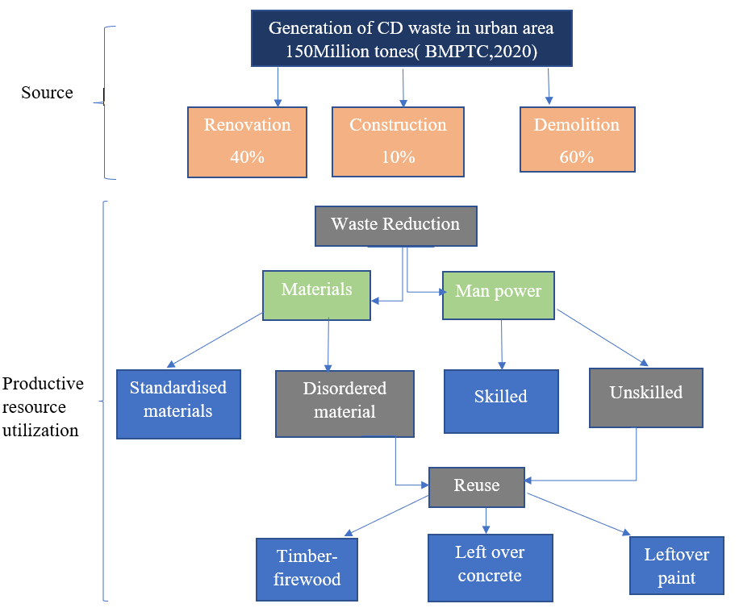

Figure 1: methodology for the study

3.0 The findings and Analysis

3.1.1 Site Management Plan
It is also thought that 13% of the raw materials that are bought are not used and are thrown away. This leaves ample of potential for reducing trash and reusing items to make buying more efficient. On a building site, it takes careful planning to keep track of and manage the different types of waste. Most waste is made on-site because of things like over-ordering, damaging materials by not handling them properly, off-cuts, poor storage of materials, and packaging building materials more than they need to be. Just-in-time delivery can help cut down on waste caused by bad storing and bad weather. To keep things from breaking down, keep the protective packaging on and make sure the storage place is safe and remains not damp.

3.1.2 Design thinking stages
Building designers play important role in construction waste minimization at prephase of construction. Builder should detail study of owner’s requirement have collaboration with with vendors and manufacturers. Materials should be selected considering its efficiency when designing architectural form, its lifetime, durability. Design for flexibility for further adjustment in future without generating waste. Design should be done as per local materials, cut fill technique and standard design techniques. among the primary difficulties encountered in the field of MEP design is on the task of identifying the most advantageous arrangement for distribution networks.

3.1.3 Labour skill

Problems with planning and managing materials aren't the only things that cause waste on building sites. Poor workmanship, theft, and pilfering of materials by workers, overestimating materials, poor supervision of workers, and wrong interpretations of drawings are also significant issues. It is evident that the five most important labor-specific factors that affect CW are labours errors that lead to redo; worker’s bad attitudes, the dearth of qualified employees; lack of experience. Inadequate documentation of required materials, lack of enthusiasm from workers, improper use of materials, damage done by workers, and vandalism and theft by workers are the least labor-specific factors that cause construction waste.

3.1.4 Policymaking

Swachh Bharat Mission (SBM): A mission started by the Ministry of Housing and Urban Affairs (MoHUA) in 2014 with the goal of making India clean. The Indian government started SBM in 2014 as a way to deal with building waste all over the country. The Ministry of Environment, Forests, and Climate Change (MoEF & CC) put out new rules on March 29, 2016 that came from the Central Pollution and Control Board (CPCB). CPCB (2017) says that construction projects that make more than 20 tonnes of trash a day or 300 tonnes a month must make a site waste-management plan (SWMP) and send it to the local government.

Ministry of Urban Development (MoUD): MoUD sent out a notice to install recycling factory in urban area with more than one million people and set up rules for how they must be operated. The organisation wants to set up short-term store facility areas in all grama panchayath and Municipalities

3.2 Reuse of waste materials at construction site

The comparison analysis of the case study from literature survey and interviews says that construction waste consists various reusable materials and its quantity order is as follows.

Bricks and blocks> concrete and aggregate> roofing materials and ceramics

Both traditional reuse, where the item is utilised a second time for the same purpose, and creative reuse, where it is used for a different purpose, fall under this category. Saving time, money, energy, and resources is made possible by reuse. In the course of building, a variety of reusable and underused components, such as lumber of various sizes, plumbing, plywood, asphalt shingles, and so forth, were discovered. Reusing goods or materials that would otherwise end up in the trash can have positive effects on society, the economy, and the environment. In rehabilitation projects including the construction of a new structure subsequent to the demolition of the previous one, it is plausible that numerous building components possess the potential for recyclability.

• Concrete - Utilised as a foundational material for roadways and pathways, it possesses the capacity to undergo fragmentation and subsequent recycling.
• Unprocessed timber is commonly utilised as a source of fuel for combustion. The re-milling of sizable portions enables their subsequent utilisation in construction projects.
• Asphalt paving - recycled into new asphalt for paved roads after being crushed
• Trees and bushes are recycled and used as mulch or compost. Direct reuse is possible for wood, big dimension lumber (defined as timber longer than 6 ft), plywood, floorboards and moulding.
• Metals: These materials can be melted down and reshaped into new metal goods. Steel, aluminium, and copper, as well as other materials, can be sold as scrap.

Guidelines for Sustainable Habitats (GSH): Regulations on the re-use of recovered C & D garbage is a report published by the central public works department (CPWD) in 2014. The recovery of valuable products that can be used again with no additional processing is guided.

Bureau of Indian Standards (BIS): BIS is in charge of setting guidelines and codes for recycled goods. Recycled aggregate substitution is advised for 25% of plain cement concrete, 20% of recycled cement concrete and 100% of lean concrete, according to the amended IS:383(2016).

Building Materials &Technology Promotion Council (BMTPC) & Ministry of Housing and Urban Affairs (MoHUA) : The BMTPC created laws on the use of building waste in government works. In a similar vein MoHUA issued an order requiring the use of building waste materials if they are found within a 100-kilometer radius of the construction location.

4. Conclusion

- Enhancing the manpower skills at foundation level by leveraging the strength of the construction industry and microplanning of the productive resources utilization leads to the reduction of construction waste generation at source considerably.

- In this paper the approach suggested with reference to the productive resource utilization such as standardized material and manpower provides impetus to skill development in construction industry.

- Products such as mild steel, doors and windows, bricks, and other similar materials possess the advantageous quality of being readily extractable and reusable with minimal processing requirements.

- The methodology adopted in this study provides insights about the concepts like., reduce and reuse potential of the construction waste in terms of a plethora of business opportunity, employment opportunity above all environmental sustainability.

Reference

- Winkler G. Recycling construction and demolition waste- A LEED based toolkit, Mcgraw Hills Green source series (2010)

- Yang, H., Xia, J., Thompson, J.R., Flower, R.J., 2017. Urban construction and demolition waste and landfill failure in Shenzhen, China. Waste Manage. 63, 393–396.

- Solís-Guzmán, J., Marrero, M., Montes-Delgado, M.V., Ramírez-de-Arellano, A., 2009. A Spanish model for quantification and management of construction waste. Waste Manage. 29 (9), 2542–2548.

- Jain, M.S., 2021. A mini review on generation, handling, and initiatives to tackle construction and demolition waste in India. Environ. Technol. Innov. 22, 101490. http://dx.doi.org/10.1016/j.eti.2021.101490.

- Kolaventi, S.S., Tezeswi, T.P., Sivakumar, M.V.N., 2017. A modeling approach to construction waste management. In: Proceedings of Urbanization Challenges in Emerging Economies. ASCE, Cham, pp. 11–20.

- Laovisutthichai, V., Lu, W., & Bao, Z. (2020). Design for construction waste minimization: Guidelines and practice. Architectural Engineering and Design Management, 1-20.

- Haruna, A. C., Usman, N. D., Oraegbune, O. M., Muhammad, U. D., & Bamidele, O. (2017). Analysis of Waste Production on Building Construction Sites: A Case Study of Public Institutional Projects in Adamawa, Nigeria. FUTY Journal of the Environment, 11(1),55-63

- Umar, U. A., Shafiq, N., & Ahmad, F. A. (2021). A case study on the effective implementation of the reuse and recycling of construction & demolition waste management practices in Malaysia. Ain Shams Engineering Journal, 12(1), 283-291.

- Darshini Shekhar, and Jagdish Godihal, Sustainability Assessment of Residential Building in Urban Area – A case study, Multi-Hazard Vulnerability and Resilience Building -Elsevier

