Stabilization of Laterite Soil Using Polypropylene Fibres

Ajay H A
Department of Civil Engineering
Presidency University
Bangalore, India
ajay@presidencyuniversity.in

Brunda B A
Department of Civil Engineering
Vijaya Vittala Institute of Technology
Bangalore, India
suryarashmi211@gmail.com

Dr. Madhavi T
Department of Civil Engineering
Presidency University
Bangalore, India
madhavit@presidencyuniversity.in

Divya Nair
Department of Civil Engineering
Presidency University
Bangalore, India
divya.nair@presidencyuniversity.in

ABSTRACT
Every civil engineering structure finds its foundation in the ground, underscoring the significance of comprehending soil behavior when encountering the loads exerted by supported structures. The diversity of soil type and properties fluctuates markedly from one location to another and through varying depths. Soil, inherently weak in bearing tension and shear forces, necessitates stabilization for specific applications such as subgrades, retaining structures, and foundations. Common stabilizing agents encompass materials like cement, lime, chemicals, fly ash, and fibers. This study is focused on the enhancement of shear strength in the plentiful laterite soil found within coastal regions. This is achieved through the integration of polypropylene fibers, aimed at reinforcing the soil and bolstering its shear strength.

Keywords—Soil stabilization; laterite soil; shear strength; polypropylene fibres

INTRODUCTION

For a Land based structure, foundation should be sufficiently strong enough to support the entire structure without causing excessive deformation and settlement. Strength of the foundation largely depends on the soil underneath it. Knowledge of various properties of soil and the factor which influences them is important to understand the behavior of soil due to loads from the superstructure. For the foundation to be strong, the soil around it plays a very critical role. Soil stabilization process helps in achieving the desired engineering properties of the soil that supports the structure without undergoing failure. Properties of soil also varies from region to region and along the depth. One of the most predominant kinds of soil available in the region close to the coast is Laterite.

Laterite Soil
Laterite is a geological material formed by the rearrangement of minerals due to chemical weathering of the parent rocks. Chemical weathering process breaks down rocks from which soluble components such as Mg, Na, Ca, Si and K tries to leach out and less soluble elements such as Fe, Ti, Al and Mn remain as insoluble residue of oxides and hydroxides that blend with certain proportion of clay minerals. The residual product exhibits variable characteristics both in terms of its physical attributes and chemical composition. This chapter delves into the physical traits of the laterites, emphasizing the direct correlation between these attributes and the chemical changes that occur during the process of laterization. The shift from the original parent rock to the eventual laterite involves a gradual and continuous transformation, rather than an abrupt change. This progression is marked by several intermediary stages, each contributing to the development of a distinctive profile. Nevertheless, there are instances of deviation, as seen in banded hematite quartzite, shales, and sandstones, where a distinct and easily identifiable boundary marks the altered zone below. The laterites display a wide range of variations in terms of color, texture, structure, morphology, and engineering properties. These variations mirror the diversity observed in their chemistry and mineralogy. A sample picture of lateritic soil available in the Mangalore region is as shown in Figure 1.
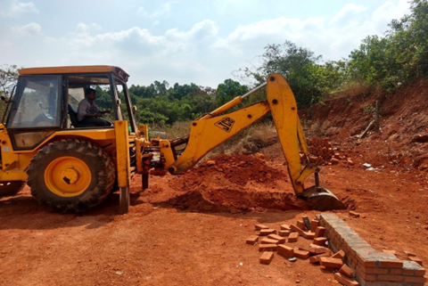
Figure 1: Laterite soil collected for experimental study

Properties of Laterite Soil
- The laterite soil samples consist primarily of Kaolinite and Illite clay minerals, accompanied by traces of quartz and feldspar. These samples exhibit significant concentrations of SiO₂ (45%), Fe₂O₃ (16%), and Al₂O₃ (10%).
- The soil demonstrated its highest strength when compacted while leaning towards the drier end of its optimum moisture content (OMC).

SOIL STABILIZATION
Soil stabilization involves modifying specific soil characteristics using various mechanical or chemical techniques. This is done with the goal of creating an enhanced soil material that possesses the desired engineering properties. The primary objectives of soil stabilization are to enhance strength and longevity of soils, as well as to mitigate erosion and the generation of dust. The prime objective is to establish a soil mass that remains stable under the anticipated usage conditions throughout the intended lifespan of the engineering project.
Soil properties exhibit considerable variation across different locations and sometimes even within a single site. The effectiveness of soil stabilization hinges on comprehensive soil testing. Diverse techniques are utilized for soil stabilization, and it is imperative to validate these methods in laboratory settings using the specific soil material before their practical implementation in the field.
Fundamentals of Soil Stabilization:
- Assessing the soil characteristics in the designated region.
- Determining the specific soil property that requires modification to achieve the desired design value, and selecting the most efficient and cost-effective stabilization technique.
- Formulating a stabilized soil mixture sample according to the design specifications, and conducting laboratory tests to ensure the desired levels of stability and durability are achieved.

Necessity and Advantages
Due to significant variations in soil properties, the construction of structures is heavily reliant on the soil's bearing capacity. Consequently, soil stabilization becomes essential for facilitating accurate prediction and enhancement of the soil's load-bearing capabilities. The soil's gradation is also a critical factor when working with soils. Ideally, a well-graded soil with fewer voids is preferred, as opposed to a uniformly graded soil which, although seemingly stable, contains more voids. Consequently, blending different soil types is advisable to enhance soil strength properties. Completely replacing substandard soil can be prohibitively costly, making soil stabilization a prudent solution in the following scenarios.
- Improve soil strength, thereby elevating the soil's load-bearing capacity.
- Presenting a more cost-effective and energy-efficient alternative to deep or raft foundations for improving bearing capacity.
- Improving the CBR (California Bearing Ratio) value of the soil, allowing for reduced pavement thickness.
- Providing improved stability to soil in slopes and similar conditions.
- Acting as a preventive measure against soil erosion and dust formation, particularly valuable in arid climates.
- Implementing soil stabilization to achieve water resistance, preventing moisture intrusion and maintaining soil strength.
- Minimizing soil volume fluctuations due to temperature and moisture changes.
- Enhancing workability and durability of the soil.

Soil stabilization methods
Soil that has been fortified with cement is termed soil cement. This cementing process is thought to arise from chemical interactions between cement and siliceous soil during the hydration reaction. Key elements influencing soil-cement performance encompass the soil's inherent composition, the mixing and compaction conditions, the curing process, and the utilization of admixtures.
Slaked lime exhibits notable efficacy in addressing highly plastic clay soils. Lime can be employed independently or alongside cement, bitumen, or fly ash, rice husk ash [7]. This approach is also suitable for enhancing the stability of sandy soils. Generally, coarse-grained soils necessitate around 2 to 8% lime content, while plastic soils may require 5 to 8% lime content. The proportion of fly ash used as an admixture can range from 8 to 20% relative to the soil's weight.
Asphalts and tars represent types of bituminous substances employed in soil stabilization, primarily for constructing pavements. The introduction of bituminous materials to soil bestows both cohesion and diminished water absorption. Based on these effects and soil characteristics, bitumen stabilization can be categorized into four distinct types: (i) Sand-bitumen stabilization, (ii) Soil-bitumen stabilization, (iii) Water-resistant mechanical stabilization, and (iv) Oiled earth stabilization.
Calcium chloride, renowned for its ability of absorbing moisture from the air and tending to dissolve in it serves as a water holding additive for mechanically stabilized soil bases and surfaces. Its presence leads to reduced vapor pressure, heightened surface tension, and decreased evaporation rate. The addition of calcium chloride also lowers the freezing point of water, thus mitigating or minimizing frost heave. By diminishing the electric double layer, the salt curbs water absorption, subsequently preventing the weakening of fine-grained soils. Furthermore, calcium chloride functions as a soil flocculent, facilitating compaction. Periodic application of calcium chloride might be essential to counteract leaching-induced chemical loss. For optimal efficacy, the atmospheric relative humidity should surpass 30%. Alternatively, sodium chloride, with stabilizing properties akin to calcium chloride, can also be employed. Additionally, sodium silicate, when combined with chemicals like CaCl₂, polymers, alkyl chlorosilanes, chrome lignin, amines, silicones, quaternary ammonium salts, sodium hexametaphosphate, phosphoric acid, and wetting agents, offers another avenue for achieving this purpose.
The grouting approach involves the injection of stabilizing agents directly into the soil. However, this method proves less effective for clayey soils due to their inherently low permeability. Implementing this technique can be financially demanding for soil stabilization purposes. It is particularly well-suited for reinforcing confined subterranean areas of relatively restricted scope. The grouting materials used are clay, chemicals, chrome lignin, polymers and bituminous.
The mechanical approach involves blending soils with varying gradations to achieve the desired soil characteristics. This mixing can take place either on-site or at a location that facilitates convenient transportation. Subsequently, the resulting blend is compacted using standard methods to attain the desired level of density.
The additive approach to stabilization involves incorporating manufactured products into the soil to improve its quality when applied in appropriate proportions. Substances like lime, cement, bitumen, and fly ash are employed as chemical additives. Occasionally, various types of fibers are introduced to bolster the soil's strength. The inclusion of these fibers is executed through two distinct methods.
- Oriented fibre Reinforcement: The fibers are organized systematically, with each fiber aligned in a uniform direction. These fibers are then deposited layer by layer in this specific alignment. This arrangement involves the strategic utilization of continuous fibers presented as sheets, strips, bars, and similar configurations.
- Random fibre Reinforcement: In this configuration, discrete fibers are dispersed haphazardly within the soil volume. The blending process continues until a relatively uniform amalgamation of the soil and reinforcement is achieved. Typically, materials employed for this type of reinforcement are sourced from substances such as nylon, paper, metals, and other materials possessing diverse physical attributes.
Randomly dispersed fibers offer certain advantages compared to systematically arranged fibers. This approach to reinforcement bears similarities to the incorporation of admixtures like cement and lime. In addition to being straightforward to introduce and blend, this method provides strength uniformity, reduces the likelihood of vulnerable planes that might arise with the alternate approach, and imparts a level of ductility to the soil.
Hongtao Jiang and Yi Cai [1] made a study on determining engineering properties of soils stabilized with short discrete polypropylene fibre. To comprehensively comprehend the engineering characteristics of soil fortified with short polypropylene fibers, a number of tests were executed to investigate the influence of fiber and aspect ratio on reinforced soil's strength. Experimental studies were conducted to enhance the soil's resistance to deformation, overall strength, and uniformity through the integration of short fibers. These experiments yielded noteworthy results. The impact of polypropylene fibers on the soil's engineering properties was thoroughly examined, revealing certain observations. Specifically, unconfined compressive strength (UCS), cohesiveness, and internal friction exceeded those of the unmodified soil. The incorporation of polypropylene fibers notably contributed to enhancing the strength and stability of parent soil.
It is also observed that the increase in aspect ratio of the flexible, flat profile resulted in an increase in both the angle of internal friction and shear strength [6].
Jeena Mathew et al. [2] have studied the effect of soil stabilization using coir fibre and polypropylene fibres. Structures bear their loads by directly transferring them to the ground. The stability of any structure depends on the soil's strength on which it's erected; in cases of soft soil, enhancing the soil's properties becomes imperative for optimal performance under load conditions. This study's principal objective is to explore and assess the impact of polypropylene and coir fibers on various soil properties. Through this experimentation, it was revealed that varying fiber content led to a decline in UC strength when fiber quantity exceeded 1.5% for coir fibers. Notably, the UC strength of clay reinforced with polypropylene exhibited over fivefold enhancement compared to unreinforced clay. By comparing the outcomes of polypropylene and coir fibers, it was evident that coir fiber could be a potent soil reinforcement, thus offering a viable alternative.
Muske Srujan Teja [3] have studied the soil stabilization using polypropylene fibre materials. This study primarily aims to explore the applicability of polypropylene fiber in geotechnical practices. It seeks to assess the influence of polypropylene fibres on the shear strength of unsaturated soil. This investigation is particularly relevant for enhancing ground conditions and serves as a promising ground improvement method, particularly valuable in engineering endeavors involving weak soil. In such cases, polypropylene fibers could potentially serve as an alternative to costly and energy-intensive deep or raft foundations, effectively lowering both expenditure and resource consumption.
Muhammad Ali et al. [4] have carried out a study on understanding properties of expansive soil that are stabilized using polypropylene fibers. This study showcases the application of polypropylene fibers to enhance the engineering attributes of a local expansive soil. The research delves into the moisture content V/s dry density relationship, UCS, elastic modulus, California bearing ratio (CBR), and the one-dimensional consolidation behavior of the soil stabilized with varying fiber content: 0%, 0.2%, 0.4%, 0.6%, and 0.8%. The investigation reveals that the dry density of the reinforced soil marginally declined by about 2.8%. This reduction stemmed from the substitution of heavier soil grains with lightweight fibers, while the optimum moisture level exhibited minimal variation due to the non-absorptive quality of the fibers.
Notably, the incorporation of 0.4% fibers led to remarkable enhancements in UCS (a substantial 279% increase), E (an impressive 113.6% increase), and CBR values (a significant 94.4% increase under unsoaked conditions and 55.6% increase under soaked conditions). This enhancement signifies the potential to establish higher-quality subgrades suitable for pavement construction on such soils. These empirical findings underscore the considerable promise of polypropylene fiber as an economical and sustainable stabilizing material for expansive soils, offering potential applications across a wide range of swelling soil scenarios.
Chaosheng Tang et al. [5] have studied the mechanical aspects of cement stabilized clayey soil with short polypropylene fibres. An experimental initiative was conducted to explore the impacts of discrete short polypropylene fibers (PP-fiber) on the mechanical properties and strength of both non-cemented and cemented clayey soil. This study involved the preparation of 12 sets of soil samples, featuring three distinct levels of PP-fiber content and two different cement content percentages. Unconfined compression and direct shear tests were executed. The outcomes of the tests unveiled that the incorporation of fiber reinforcement within non-cemented and cemented soil led to improved UC strength, shear strength, and axial strain at failure. Simultaneously, it resulted in a decrease in stiffness, reduced post peak strength loss, and transformed the brittle behavior of cemented soil into a more ductile one. SEM was performed on soil mass and this investigation revealed that the reinforcement's effectiveness appears to be mainly driven by the bond strength and friction at the interface between the fiber and soil.

EXPERIMENTAL METHODOLOGY
The investigation is carried out on laterite soil, a major type of soil occurrence in the Mangalore region. The objectives of the present work are:
- To determine the optimum amount of polypropylene fiber required for the stabilization of the locally accessible lateritic soil.
- To study the shear strength of lateritic soil for various percentage volume of polypropylene fibre such as 0.05, 0.10, 0.15, 0.20, 0.25 and 0.30 by UCC test.
- To determine the CBR value of lateritic soil by adding various percentages of polypropylene fibres.

Polypropylene Fibre
Polypropylene fibers exhibit hydrophobic characteristics, meaning they repel water and do not absorb it. Consequently, when incorporated into a concrete matrix, these fibers merely necessitate sufficient mixing time to ensure even distribution within the concrete blend. It's advised to limit the mixing duration for fibrillated or tape fibers to prevent potential fiber shredding. The favored polypropylene fiber variety recommended by manufacturers for paving applications is the collated fibrillated fiber and the sample is shown in Figure 2 and property details are indicated in Table 1.

Properties of Polypropylene Fibres:
Table 1. Properties of polypropylene fibres procured

Properties | Value
Average Length | 12mm
Average Diameter | 0.034mm
Tensile Strength | 350 MPa
Young’s Modulus | 3.5 GPa
Fibre Type | Single Fibre

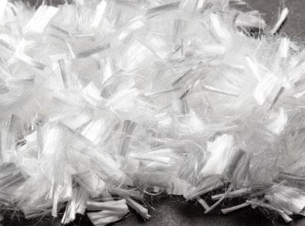
Figure 2: Polypropylene fibres procured for experimental study

Preparation of samples
The following steps are undertaken during the process of incorporating fibers in soil
- All the soil samples are first compacted to their respective maximum dry density (MDD) and optimum moisture content (OMC), as determined through standard proctor compaction tests.
- In cases where fibers are not employed, the oven-dried soil is blended with a quantity of water corresponding to the soil's OMC during sample preparation.
- For samples with fiber reinforcement, the designated amount of fibers is initially manually mixed into the oven-dried soil in incremental amounts, ensuring comprehensive distribution to achieve a relatively uniform mixture. Subsequently, the necessary amount of water is introduced.

Preliminary tests conducted on soil
Several tests were conducted in order to determine the index properties of laterite soil and the results are as below.
- Average specific gravity = 2.43
- Liquid limit ω_{L} = 33.9 % Plastic limit ω_{P} = 27 %
- Plasticity index I_{P} = ω_{L} – ω_{P} = 6.9 %
- Flow index I_{F} = (w₁-w₂)/log₁₀ (n₁/n₂) = 7.06 %
- Toughness index = I_{P}/I_{F}= 0.98

Figure 3: Graph depicting the grain size distribution curve

From the grain size distribution curve shown in Figure 3, we can deduce the following parameters to index the soil.
- Uniformity coefficient C_{u} =D₆₀/D₁₀ =16
- Coefficient of curvature C_{c} = (D₃₀)²/(D₁₀*D₆₀) = 1.17
- Due to a coefficient of curvature ranging from 1 to 3 and a uniformity coefficient exceeding 6, the soil is categorized as well-graded sandy soil.

RESULTS AND DISCUSSION

Standard Proctor Compaction Test

Table 2. Variation of Maximum dry density of soil and Optimum moisture content with addition of polypropylene fibres

Percentage of Polypropylene (%) | Maximum Dry density, g/cc | Optimum moisture content, %
0 | 1.743 | 20.29
0.05 | 1.722 | 21.10
0.1 | 1.749 | 19.56
0.15 | 1.752 | 18.31
0.2 | 1.78 | 17.70
0.25 | 1.81 | 17.18
0.3 | 1.76 | 17.92

From the results indicated in Table 1, it is observed that:
- Dry density of soil increases with increase in fibre content up to 0.25% which may be termed optimum percent of fibre and reduces beyond any further addition.
- The reason for increase of dry density of soil in addition of fibres is because the voids in the soil is filled by the fibres. Beyond the peak value of maximum dry density, the value reduces because the excess fibres replace the soil grains and fibre being less dense in nature the overall dry density reduces.

Unconfined compression test (UCC test)

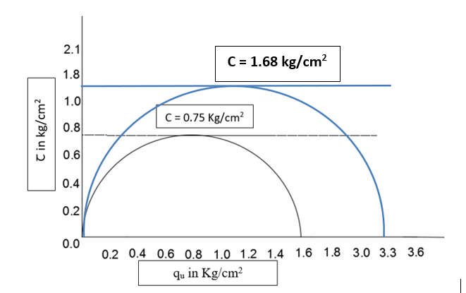

Figure 4: Shear strength of Laterite soil with 0% fibres (indicated by black Mohr’s circle) and 0.25% polypropylene fibres (indicated by blue circle).

From the UC test result graph shown in Figure 4, the cohesive value C = 0.75 Kg/cm2 for soil without addition of polypropylene fibres and C = 1.68 Kg/cm2 at 0.25 % of PP fibre. The shear strength of soil with PP fibre is increased by 2.25 times. The increase in shear strength is more due to friction between soil and fibres. The shear strength also depends on aspect ratio based on the orientation of fibre, we have used random orientation of fibres in the current study.

California Bearing Ratio Test (CBR Test)

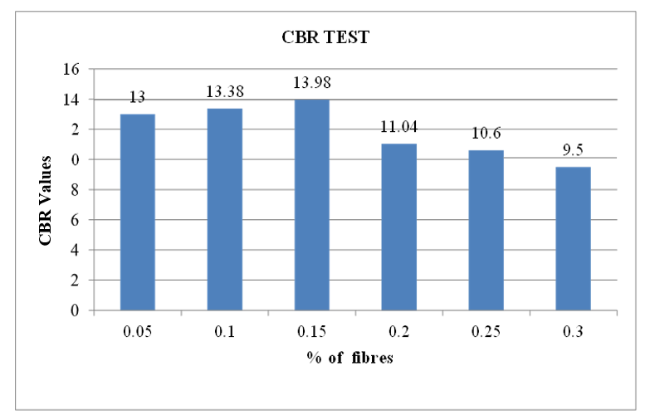
Figure 5: CBR values (in percentage for 5mm penetration) of Laterite soil with various proportions of polypropylene fibres.

From the test results as indicated in Figure 5, CBR value is high for soil stabilized with 0.15% of polypropylene fibre. Soil stabilized with 0.25% addition of polypropylene fibres is 10.6%. According to IRC 37-2012, the minimum value of CBR for road sub grade should be 8 %. Although there has been reduction in the CBR values when fibres are added, it doesn’t affect the soil for pavement applications. As the maximum dry density of the soil increases the CBR value also increases. Due to more resistance to compression. The fibre added will become resistant to compaction once it reaches its maximum value so the bearing capacity of soil increases there by CBR value also increases.

CONCLUSION
From the findings of this experimental investigation, following conclusions are drawn
- It becomes evident that the inclusion of polypropylene fibers leads to an enhancement in the maximum dry density as well as shear strength values of the laterite soil.
- Density improvement of the soil mass is not that significant as the fibres have less density, but the shear strength has improved by almost 200% with the inclusion of 0.25% polypropylene fibres.
- Overall performance of laterite soil can be improved by stabilizing with polypropylene fibres.

REFERENCES

- G. Eason, B. Noble, and I.N. Sneddon, “Engineering properties of soils reinforced by short discrete Polypropylene fiber,” Journal of Materials in Civil Engineering, vol. 22, no. 12, pp. 1315-1322, June 2010.
- Jeena Mathew and Karthika Ramesan, “Comparative study on effect of soft soil stabilization using coir fibres and polypropylene fibres,” IOSR Journal of Mechanical and Civil Engineering, International Conference on Emerging Trends in Engineering & Management, pp. 61-66, 2016.
- Muske Srujan Teja, “Soil Stabilization Using Polypropylene Fiber Materials,” International Journal of Innovative Research in Science, Engineering and Technology, vol. 5, no. 9, pp. 18906-18912, September 2016.
- Muhammad Ali, Mubashir Aziz, Muhammad Hamza and Muhammad Faizan Madni, “Engineering properties of expansive soil treated with polypropylene fibers,” Geomechanics and Engineering, vol. 22, no. 3, pp. 227-236, July 2020.
- Chaosheng Tang, Bin Shi, Wei Gao, Fengjun Chen, Yi Cai, “Strength and mechanical behavior of short polypropylene fiber reinforced and cement stabilized clayey soil,” Geotextiles and Geomembranes, vol. 25, no. 3, pp. 194-202, June 2007.
- M. Attom and A. Al-Tamimi, "Effects of polypropylene fibers on the shear strength of sandy soil," International Journal of Geosciences, vol. 1, no. 1, pp. 44-50, 2010.
- J.R. Oluremi1, S. I. Adedokun and O. M. Osuolale, “Stabilization of poor lateritic soils with coconut husk ash,” International Journal of Engineering Research & Technology, vol. 1, no. 8, pp. 1-9, October 2012.
- IS: 2720 (Part 16) -1987 Methods of test for Soil, Laboratory determination of CBR.
- IS: 2720 (Part 5) -1985, Methods of test for Soil, Determination of liquid and plastic limit.
- IS: 2720 (Part 10) -1991, Methods of test for Soil, Determination of unconfined compression strength.
- IRC 37-2012, Guidelines For The Design Of Flexible Pavements.

