Fluid Dynamics

Course Contents

Module – II
Boundary Layer Theory: Introduction: Thickness of boundary layer, Boundary layer along a long thin plate and its characteristics, Boundary layer Equations, Momentum Integral Equations of boundary layer, separation of Boundary Layer, Methods of controlling Boundary layer.
Navier-Stokes Equations of Motion: Significance of Body Force, Boundary Conditions, Viscous Force, Limiting cases of Navier – Stokes Equations, Applications of N-S Equations to Laminar flow between two straight parallel boundaries, and between concentric rotating cylinders.

Fluid Dynamics

Lecture Note 1 Boundary Layer Theory

Introduction

- The boundary layer of a flowing fluid is the thin layer close to the wall
- In a flow field, viscous stresses are very prominent within this layer.
- Although the layer is thin, it is very important to know the details of flow within it.
- The main-flow velocity within this layer tends to zero while approaching the wall (no-slip condition).
- Also the gradient of this velocity component in a direction normal to the surface is large as compared to the gradient in the streamwise direction.

Boundary Layer Equations

- In 1904, Ludwig Prandtl, the w

Fluid Dynamics

Lecture Note 2 N – S Equations

Navier-Strokes Equation

- Generalized equations of motion of a real flow named after the inventors CLMH Navier and GG Stokes are derived from the Newton's second law

Newton's second law states that the product of mass and acceleration is equal to sum of the external forces acting on a body.
- External forces are of two kinds-
  - one acts throughout the mass of the body ----- body force ( gravitational force, electromagnetic force)
  - another acts on the boundary----- surface force (pressure and frictional force).

Objective - We shall consider a differential fluid element in the flow field (Fig.1). Evaluate the surface forces acting on the boundary of the rectangular parallelepiped shown below.
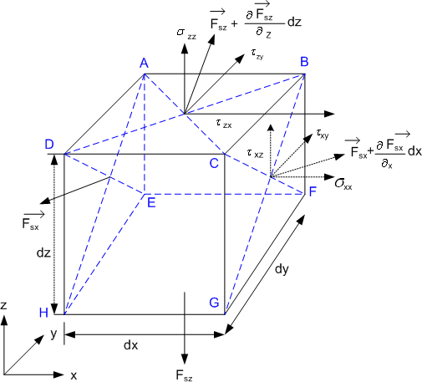

Fig.1 Definition of the components of stress and their locations in a differential fluid element

Fluid Dynamics

- Let the body force per unit mass be
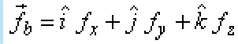
(1)

and surface force per unit volume be
(2)
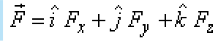

- Consider surface force on the surface AEHD, per unit area,

[Here second subscript x denotes that the surface force is evaluated for the surface whose outward normal is the x axis]

- Surface force on the surface BFGC per unit area is
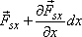

- Net force on the body due to imbalance of surface forces on the above two surfaces is
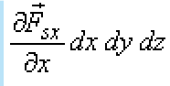

(since area of faces AEHD and BFGC is dydz)
(3)

- Total force on the body due to net surface forces on all six surfaces is
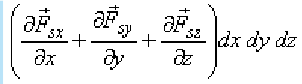

(4)

- And hence, the resultant surface force dF, per unit volume, is
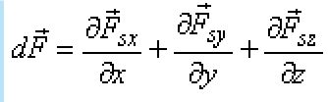

(since Volume= dx dy dz)

(5)

- The quantities , and are vectors which can be resolved into normal stresses denoted by and shearing stresses denoted by as

(6)

Fluid Dynamics

The stress system has nine scalar quantities. These nine quantities form a stress tensor. Nine Scalar Quantities of Stress System - Stress Tensor
The set of nine components of stress tensor can be described as
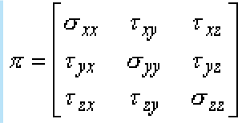

(7)

- The stress tensor is symmetric,
- This means that two shearing stresses with subscripts which differ only in their sequence are equal. For example
- Considering the equation of motion for instantaneous rotation of the fluid element (Fig. 24.1) about y axis, we can write

where =dxdydz is the volume of the element, is the angular acceleration is the moment of inertia of the element about y-axis
- Since is proportional to fifth power of the linear dimensions and is proportional to the third power of the linear dimensions, the left hand side of the above equation and the second term on the right hand side vanishes faster than the first term on the right hand side on contracting the element to a point.
- Hence, the result is

From the similar considerations about other two remaining axes, we can write

Fluid Dynamics

which has already been observed in Eqs (24.2a), (24.2b) and (24.2c) earlier.

- Invoking these conditions into Eq. (24.12), the stress tensor becomes
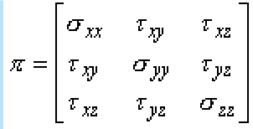

(8)

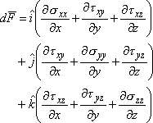
- Combining Eqs (24.10), (24.11) and (24.13), the resultant surface force per unit volume becomes

(9)

- As per the velocity field,
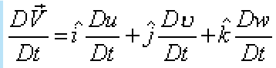
(10)

By Newton's law of motion applied to the differential element, we can write
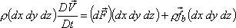

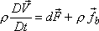
or,

Substituting Eqs (24.15), (24.14) and (24.6) into the above expression, we obtain
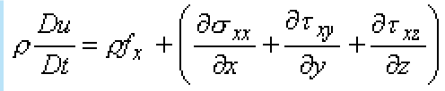

(11)

Fluid Dynamics

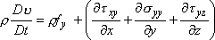 | (12)
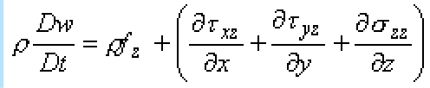 | (13)

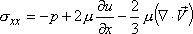
Since
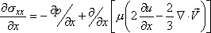

Similarly others follow.

- So we can express , and in terms of field derivatives,

- These differential equations are known as Navier-Stokes equations.
(16)
(15)
(14)
- At this juncture, discuss the equation of continuity as well, which has a general (conservative) form
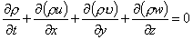
(17)

- In case of incompressible flow ρ = constant. Therefore, equation of continuity for incompressible flow becomes

Fluid Dynamics
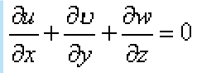
(18)

- Invoking Eq. (24.19) into Eqs (24.17a), (24.17b) and (24.17c), we get
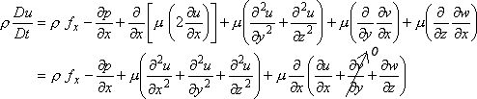

Similarly others follow Thus,

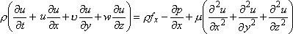
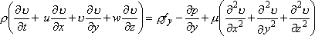
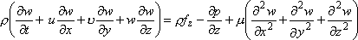
(19)

(20)

(21)

Vector Notation & derivation in Cylindrical Coordinates - Navier-Stokes equation

- Using, vector notation to write Navier-Stokes and continuity equations for incompressible flow we have

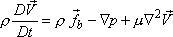 (22)
And

(23)

we have four unknown quantities, u, v, w and p ,
- we also have four equations, - equations of motion in three directions and the continuity equation.
- In principle, these equations are solvable but to date generalized solution is not available due to the complex nature of the set of these equations.

Fluid Dynamics

- The highest order terms, which come from the viscous forces, are linear and of second order
- The first order convective terms are non-linear and hence, the set is termed as quasi- linear.
- Navier-Stokes equations in cylindrical coordinate (Fig. 24.2) are useful in solving many problems. If , and denote the velocity components along the radial, cross-radial and axial directions respectively, then for the case of incompressible flow, Eqs (24.21) and (24.22) lead to the following system of equations:
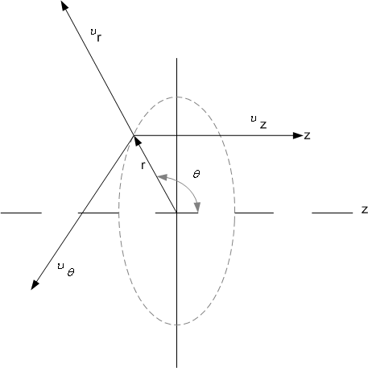

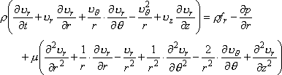
FIG 2 Cylindrical polar coordinate and the velocity components

(24)

Fluid Dynamics

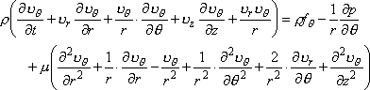
(25)

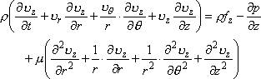
(26)

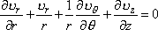
(27)

A general way of deriving the Navier-Stokes equations from the basic laws of physics.

- Consider a general flow field as represented in Fig. 25.1.
- Imagine a closed control volume, within the flow field. The control volume is fixed in space and the fluid is moving through it. The control volume occupies reasonably large finite region of the flow field.
- A control surface , A0 is defined as the surface which bounds the volume .
- According to Reynolds transport theorem, "The rate of change of momentum for a system equals the sum of the rate of change of momentum inside the control volume and the rate of efflux of momentum across the control surface".
- The rate of change of momentum for a system (in our case, the control volume boundary and the system boundary are same) is equal to the net external force acting on it.

Now, we shall transform these statements into equation by accounting for each term,
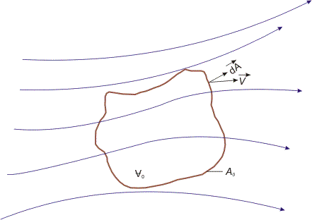

Fluid Dynamics

FIG 25.1 Finite control volume fixed in space with the fluid moving through it

- Rate of change of momentum inside the control volume
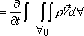

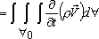  (since t is independent of space variable) | (28)

Rate of efflux of momentum through control surface

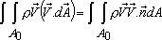

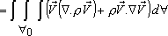 (29)

Surface force acting on the control volume

``

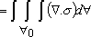
(30)

Body force acting on the control volume

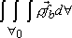 (31)
in Eq. (25.4) is the body force per unit mass.

Fluid Dynamics

Finally, we get,
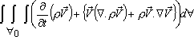
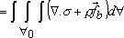

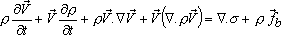
or

or,

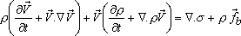  or | (32)

We know that is the general form of mass conservation equation (popularly known as the continuity equation), valid for both compressible and incompressible flows.

- Invoking this relationship in Eq. (25.5), we obtain
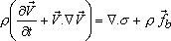

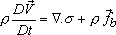  or | (33)

- Equation (25.6) is referred to as Cauchy's equation of motion . In this equation, is the stress tensor,
- After having substituted we get

 | (34)
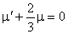  From Stokes's hypothesis we get, | (35)

Fluid Dynamics

Invoking above two relationships into Eq.( 25.6) we get

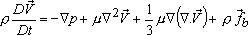 | (36)

This is the most general form of Navier-Stokes equation. Exact Solutions Of Navier-Stokes Equations
Consider a class of flow termed as parallel flow in which only one velocity term is
nontrivial and all the fluid particles move in one direction only.

We choose to be the direction along which all fluid particles travel ,
i.e. . Invoking this in continuity equation, we get

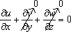

which means

- Now. Navier-Stokes equations for incompressible flow become
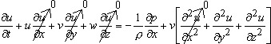
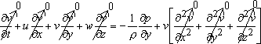
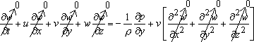

So, we obtain

which means

Fluid Dynamics

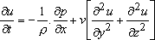  and | (37)

Parallel Flow in a Straight Channel

Consider steady flow between two infinitely broad parallel plates as shown in Fig. 25.2.

Flow is independent of any variation in z direction, hence, z dependence is gotten rid of and Eq. (25.11) becomes
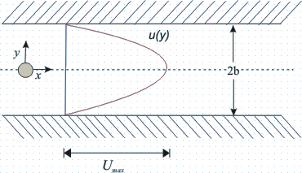

FIG 25.2 Parallel flow in a straight channel
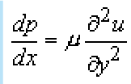

The boundary conditions are at y = b, u = 0; and y = -b, u = O.

(38)

- From Eq. (25.12), we can write

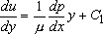
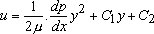
or

- Applying the boundary conditions, the constants are evaluated as
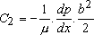
and

Fluid Dynamics

So, the solution is

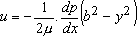 (39)

which implies that the velocity profile is parabolic.

Average Velocity and Maximum Velocity

- To establish the relationship between the maximum velocity and average velocity in the channel, we analyze as follows

At y = 0, ; this yields
(40)
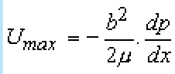

On the other hand, the average velocity,

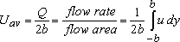
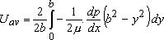
or
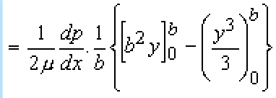

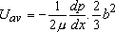  Finally, | (41)
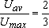  So, or |  | (42)

- The shearing stress at the wall for the parallel flow in a channel can be determined from the velocity gradient as
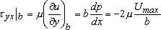

Fluid Dynamics

Since the upper plate is a "minus y surface", a negative stress acts in the positive x direction, i.e. to the right.

- The local friction coefficient, Cf is defined by
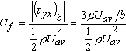

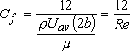
(43)

where is the Reynolds number of flow based on average velocity and the channel height (2b).

- Experiments show that Eq. (25.14d) is valid in the laminar regime of the channel flow.
- The maximum Reynolds number value corresponding to fully developed laminar flow, for which a stable motion will persist, is 2300.
- In a reasonably careful experiment, laminar flow can be observed up to even Re = 10,000.
- But the value below which the flow will always remain laminar, i.e. the critical value of Re is 2300.

Fluid Dynamics

- ell known German scientist, introduced the concept of boundary layer and derived the equations for boundary layer flow by correct reduction of Navier-Stokes equations.

He hypothesized that for fluids having relatively small viscosity, the effect of internal friction in the fluid is significant only in a narrow region surrounding solid boundaries or bodies over which the fluid flows.

- Thus, close to the body is the boundary layer where shear stresses exert an increasingly larger effect on the fluid as one moves from free stream towards the solid boundary.

However, outside the boundary layer where the effect of the shear stresses on the flow is small compared to values inside the boundary layer (since the velocity
gradient is negligible),---------

- the fluid particles experience no vorticity and therefore,
- the flow is similar to a potential flow.

  - Hence, the surface at the boundary layer interface is a rather fictitious one, that divides rotational and irrotational flow. Fig 1 shows Prandtl's model regarding boundary layer flow.

  - Hence with the exception of the immediate vicinity of the surface, the flow is frictionless (inviscid) and the velocity is U (the potential velocity).

  - In the region, very near to the surface (in the thin layer), there is friction in the flow which signifies that the fluid is retarded until it adheres to the surface (no-slip condition).

  - The transition of the mainstream velocity from zero at the surface (with respect to the surface) to full magnitude takes place across the boundary layer.

About the boundary layer

  - Boundary layer thickness is which is a function of the coordinate direction x .
  - The thickness is considered to be very small compared to the characteristic length L of the domain.
  - In the normal direction, within this thin layer, the gradient is very large compared to the gradient in the flow direction .

Now we take up the Navier-Stokes equations for : steady, two dimensional, laminar, incompressible flows.

Considering the Navier-Stokes equations together with the equation of continuity, the following dimensional form is obtained.

Fluid Dynamics

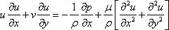
(1)

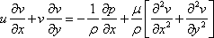 (2)
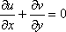
(3)

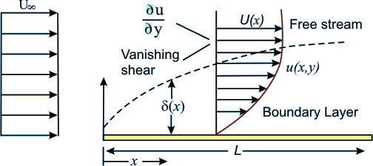

Fig 1 Boundary layer and Free Stream for Flow Over a flat plate

    - u - velocity component along x direction.
    - v - velocity component along y direction
    - p - static pressure
    - ρ - density.
    - μ - dynamic viscosity of the fluid

  - The equations are now non-dimensionalised.
  - The length and the velocity scales are chosen as L and respectively.
  - The non-dimensional variables are:
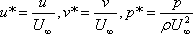

where is the dimensional free stream velocity and the pressure is non- dimensionalised by twice the dynamic pressure .
Using these non-dimensional variables, the Eqs (1) to (3) become

Fluid Dynamics
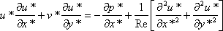
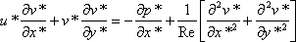
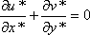
(6)
(5)
(4)

where the Reynolds number,
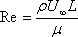

Order of Magnitude Analysis

  - Let us examine what happens to the u velocity as we go across the boundary layer. At the wall the u velocity is zero [ with respect to the wall and absolute zero for a stationary wall (which is normally implied if not stated otherwise)]. The value of u on the inviscid side, that is on the free stream side beyond the boundary layer is U. For the case of external flow over a flat plate, this U is equal to .
  - Based on the above, we can identify the following scales for the boundary layer variables:

Variable | Dimensional scale | Non-dimensional scale

The symbol describes a value much smaller than 1.
  - Now we analyse equations 4 - .6, and look at the order of magnitude of each individual term

Eq 6 - the continuity equation

One general rule of incompressible fluid mechanics is that we are not allowed to drop any term from the continuity equation.

Fluid Dynamics

- From the scales of boundary layer variables, the derivative is of the order 1.
- The second term in the continuity equation should also be of the order 1.The reason being has to be of the order because becomes at its maximum.

Eq 4 - x direction momentum equation

- Inertia terms are of the order 1.
- is of the order 1
- is of the order .

However after multiplication with 1/Re, the sum of the two second order derivatives should produce at least one term which is of the same order of magnitude as the inertia terms. This is
possible only if the Reynolds number (Re) is of the order of .

- It follows from that will not exceed the order of 1 so as to be in balance with the remaining term.

- Finally, Eqs (4), (5) and (6) can be rewritten as

(7)

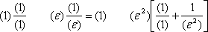

(8)

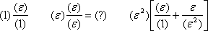

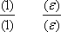

Fluid Dynamics 2016

As a consequence of the order of magnitude analysis, can be dropped from
the x direction momentum equation, because on multiplication with it assumes the smallest order of magnitude.

Eq 5 - y direction momentum equation.

- All the terms of this equation are of a smaller magnitude than those of Eq. (.4).
- This equation can only be balanced if is of the same order of magnitude as other terms.
- Thus they momentum equation reduces to

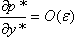 (8)
- This means that the pressure across the boundary layer does not change. The pressure is impressed on the boundary layer, and its value is determined by hydrodynamic considerations.
- This also implies that the pressure p is only a function of x. The pressure forces on a body are solely determined by the inviscid flow outside the boundary layer.
- The application of Eq. (28.4) at the outer edge of boundary layer gives

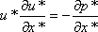 (9)
In dimensional form, this can be written as

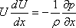
On integrating Eq ( 28.8b) the well known Bernoulli's equation is obtained

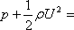
a constant
(10)

(11)

- Finally, it can be said that by the order of magnitude analysis, the Navier-Stokes equations are simplified into equations given below.

Fluid Dynamics

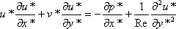
(12)

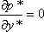 (13)

(14)

- These are known as Prandtl's boundary-layer equations.

The available boundary conditions are:

Solid surface

or (15)

Outer edge of boundary-layer
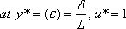

or (16)

- The unknown pressure p in the x-momentum equation can be determined from Bernoulli's Eq. (28.9), if the inviscid velocity distribution U(x) is also known.

We solve the Prandtl boundary layer equations for and with U obtained from the outer inviscid flow analysis. The equations are solved by commencing at the leading edge of the body and moving downstream to the desired location

- it allows the no-slip boundary condition to be satisfied which constitutes a significant improvement over the potential flow analysis while solving real fluid flow problems.

Fluid Dynamics

- The Prandtl boundary layer equations are thus a simplification of the Navier-Stokes equations.

Boundary Layer Coordinates

- The boundary layer equations derived are in Cartesian coordinates.
- The Velocity components u and v represent x and y direction velocities respectively.
- For objects with small curvature, these equations can be used with -
  - x coordinate : stream wise direction
  - y coordinate : normal component
- They are called Boundary Layer Coordinates.

Application of Boundary Layer Theory

- The Boundary-Layer Theory is not valid beyond the point of separation.
- At the point of separation, boundary layer thickness becomes quite large for the thin layer approximation to be valid.
- It is important to note that boundary layer theory can be used to locate the point of separation itself.
- In applying the boundary layer theory although U is the free-stream velocity at the outer edge of the boundary layer, it is interpreted as the fluid velocity at the wall calculated from inviscid flow considerations ( known as Potential Wall Velocity)
- Mathematically, application of the boundary - layer theory converts the character of governing Navier-Stroke equations from elliptic to parabolic
- This allows the marching in flow direction, as the solution at any location is independent of the conditions farther downstream.

Blasius Flow Over A Flat Plate

- The classical problem considered by H. Blasius was
- Two-dimensional, steady, incompressible flow over a flat plate at zero angle of
incidence with respect to the uniform stream of velocity .
- The fluid extends to infinity in all directions from the plate.

The physical problem is already illustrated in Fig. 1

- Blasius wanted to determine
- the velocity field solely within the boundary layer,
- the boundary layer thickness ,

Fluid Dynamics

- the shear stress distribution on the plate, and
- the drag force on the plate.
- The Prandtl boundary layer equations in the case under consideration are

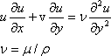 | (15)

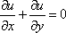

The boundary conditions are

(16)

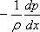
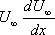
- Note that the substitution of the term in the original boundary layer momentum

equation in terms of the free stream velocity produces which is equal to zero.
- Hence the governing Eq. (15) does not contain any pressure-gradient term.
- However, the characteristic parameters of this problem are that
is,
- This relation has five variables .
- It involves two dimensions, length and time.
- Thus it can be reduced to a dimensionless relation in terms of (5-2) =3 quantities ( Buckingham Pi Theorem)
- Thus a similarity variables can be used to find the solution
- Such flow fields are called self-similar flow field .

Law of Similarity for Boundary Layer Flows

- It states that the u component of velocity with two velocity profiles of u(x,y) at different x locations differ only by scale factors in u and y .
- Therefore, the velocity profiles u(x,y) at all values of x can be made congruent if they are plotted in coordinates which have been made dimensionless with reference to the scale factors.
- The local free stream velocity U(x) at section x is an obvious scale factor for u,

Fluid Dynamics

because the dimensionless u(x) varies between zero and unity with y at all sections.
- The scale factor for y , denoted by g(x) , is proportional to the local boundary layer thickness so that y itself varies between zero and unity.
- Velocity at two arbitrary x locations, namely x1 and x2 should satisfy the equation

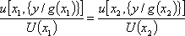 (17)
- Now, for Blasius flow, it is possible to identify g(x) with the boundary layers thickness δ we know
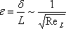

Thus in terms of x we get
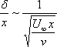
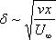

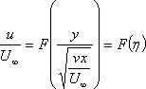
i.e.,

(18)

where
or more precisely,

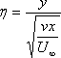
(19)

Fluid Dynamics
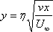
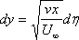

The stream function can now be obtained in terms of the velocity components as
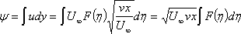

Or

(20)

where D is a constant. Also and the constant of integration is zero if the stream function at the solid surface is set equal to zero.

Now, the velocity components and their derivatives are:

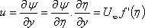
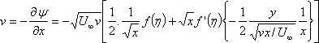

or

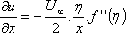
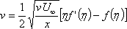 (21)
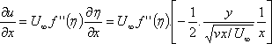
(22)
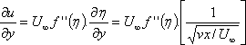

Fluid Dynamics

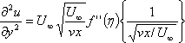

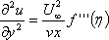

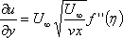
- Substituting (28.2) into (28.15), we have

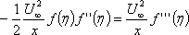

or,

where

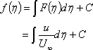

and

This is known as Blasius Equation .
(23)

(24)

(25)

- The boundary conditions as in Eg. (28.16), in combination with Eg. (28.21a) and (28.21b) become

Fluid Dynamics

at , therefore

(26)
therefore
at

Equation (22) is a third order nonlinear differential equation .

- Blasius obtained the solution of this equation in the form of series expansion through analytical techniques
- We shall not discuss this technique. However, we shall discuss a numerical technique to solve the aforesaid equation which can be understood rather easily.
- Note that the equation for does not contain .
- Boundary conditions at and merge into the
condition . This is the key feature of similarity solution.
- We can rewrite Eq. (28.22) as three first order differential equations in the following way

 | (27)
 | (28)
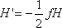 | (29)

- Let us next consider the boundary conditions.

- The condition remains valid.
- The condition means that .
- The condition gives us .

Note that the equations for f and G have initial values. However, the value for H(0) is not known. Hence, we do not have a usual initial-value problem.

Shooting Technique

We handle this problem as an initial-value problem by choosing values of and solving by numerical methods , and .

Fluid Dynamics

In general, the condition will not be satisfied for the function arising from the numerical solution.
We then choose other initial values of so that eventually we find an which results in .
This method is called the shooting technique .

- In Eq. (28.24), the primes refer to differentiation wrt. the similarity variable . The integration steps following Runge-Kutta method are given below.

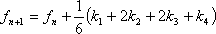 | (30)
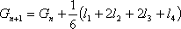 | (31)
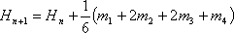 | (32)

- One moves from to . A fourth order accuracy is preserved if h is
constant along the integration path, that is, for all values of n . The values of k, l and m are as follows.
- For generality let the system of governing equations be
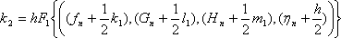
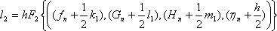
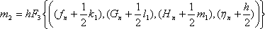

Fluid Dynamics

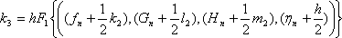
In a similar way K3, l3, m3 and k4, l4, m4 mare calculated following standard formulae for the Runge-Kutta integration. For example, K3 is given by

The functions F1, F2and F3 are G, H
, - f H / 2 respectively. Then at a distance from the wall, we have

(33)
(34)
(35)
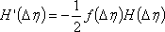
(36)

- As it has been mentioned earlier is unknown. It must be determined such that the condition is satisfied.

The condition at infinity is usually approximated at a finite value of (around ). The
process of obtaining accurately involves iteration and may be calculated using the procedure described below.

- For this purpose, consider Fig. 28.2(a) where the solutions of versus for two different values of are plotted. The values of are estimated from the curves and are plotted in Fig. 28.2(b).
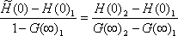
- The value of now can be calculated by finding the value at which the line 1- 2 crosses the line By using similar triangles, it can be said

that . By solving this, we get .
- Next we repeat the same calculation as above by using and the better of the two

initial values of . Thus we get another improved value . This process may
continue, that is, we use and as a pair of values to find more improved
values for , and so forth. The better guess for H (0) can also be obtained by using the Newton Raphson Method. It should be always kept in mind that for each value

Fluid Dynamics

of , the curve versus is to be examined to get the proper value of
.
- The functions and are plotted in Fig. 28.3.The velocity components, u and v inside the boundary layer can be computed from Eqs (28.21a) and (28.21b) respectively.
- A sample computer program in FORTRAN follows in order to explain the solution procedure in greater detail. The program uses Runge Kutta integration together with the Newton Raphson method

Download the program

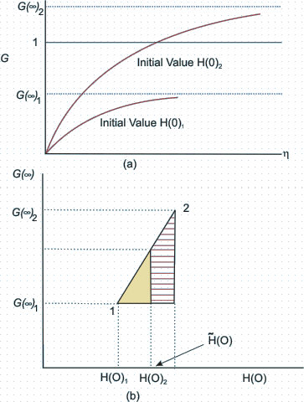
Fig 2 Correcting the initial guess for H(O)

Fluid Dynamics
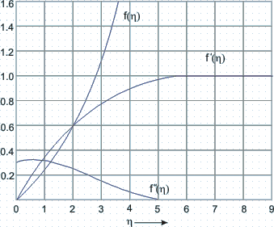
Fig 3 f, G and H distribution in the boundary layer

- Measurements to test the accuracy of theoretical results were carried out by many scientists. In his experiments, J. Nikuradse, found excellent agreement with the
theoretical results with respect to velocity distribution within the boundary layer of a stream of air on a flat plate.
- In the next slide we'll see some values of the velocity profile shape and in tabular format.

Fluid Dynamics

References

Text Book:

- Fluid Mechanics by A.K. Jain, Khanna Publishers

Reference Book:

- Fluid Mechanics and Hydraulic Machines, Modi & Seth, Standard Pulishers

- Introduction to Fluid Mechanics and Fluid Machines, S.K. Som & G. Biswas,

