Magneto Soret induced convection in couple stress nanofluid layer

Dr. Suman Sindhwani Dr. Rachana Gupta

Hindu Girls College, Sonipat Hindu Girls College, Sonipat

Haryana, India Haryana, India

[ssindhwani2001@gmail.com](mailto:ssindhwani2001@gmail.com) grachana1@gmail.com

**ABSTRACT**

In this paper, we have determined how the presence of the vertical magnetic field affects double diffusive convection in Soret induced horizontal layer of couple stress nanofluid. The effects of different parameters on stability of nanofluid has been studied analytically as well graphical analysis has been done. The comparison of results obtained has been done with the existing relevant studies.

**Keywords** Nanofluid,magnetic field, critical Rayleigh number, couple stress.

**NOMENCLATURE**

c Specific heat of nanofluid

**g** Gravitational Acceleration

 Time

 Dimensionless Time

 Nanofluid Temperature

Space coordinates

 Dimensionless space-coordinates

 Solute concentration

 Dimensionless Solute Concentration

 viscosity

Medium’s effective heat capacity

Fluid’s effective heat capacity

Effective heat capacity of the material constituting nanoparticles

 Brownian diffusion coefficient

 Thermophoretic diffusion coefficient

 Diffusion Coefficient

 Soret coefficient of salt

 Thermal Volumetric Coefficient

 Solutal Volumetric Coefficient

 Effective thermal conductivity

 Wave number

 Thermal diffusivity of the porous medium

 Relaxation time

 Heat capacity ratio

 Frequency of oscillation

 Volume fraction of Nanoparticle

 Reference value of nanoparticle volume fraction

 Porosity

 Magnetic permeability

 Electrical conductivity of nanofluid

 Permeability

1. **INTRODUCTION**

Because of increasing non-Newtonian fluid’s utilization, various problems concerned with many non-Newtonian fluids attracted interest of researchers. The couple stress fluid is one such fluid. In fluids the presence of couple stress vector and body couple were first introduced by Stokes [1].

Walicki and Walicka [2] observed that synovial fluids with very large molecules in human joints can be termed as couple stress fluids. Cosserat and Cosserat [3] modelled the equations governing couple stress vector. Important results on stability of couple stresses binary fluids with vertical temperature and concentration gradients were discussed by Rachana and Agrawal [4]. Hiremath and Patil [5] studied the oscillatory convection of couple stress fluids in a porous medium and Hayat, Mustafa, Iqbal and Alsaedi [6] studied couple stress flow over a stretching surface.

Nanofluids are recent fluids that cause significantly enhanced thermophysical properties. Couple stress nanofluids have a significant importance in MHD power generators, for the arteries blockage-removal, cancer tumour treatment, hyperthermia etc.

It is well-known that the flow field of a conducting fluid is altered on introducing a magnetic field. As far as the stability is concerned, the magnetic field, in general, is having a stabilizing effect apart from few exceptions. Thermo-solutal convection in a couple stress fluid through a porous medium having vertical magnetic field and vertical rotation was studied by Kumar [7]. Rotation was observed to have a stabilizing effect but magnetic field and couple stress were observed to give both stabilizing and destabilizing effects.

Instability of Magneto Hydrostatic stellar interiors from magnetic buoyancy were studied by Gilman [8]. Normal mode instability was observed due to magnetic buoyancy in fluids having large heat diffusivity compared with viscosity and magnetic diffusivity, as in stellar interiors. However, the magnetic buoyancy instability was found to be non-axisymmetric which is different from those in that, in a star with toroidal magnetic field. Schatzman [9] also did formal analysis on magnetic buoyancy instability but only for a special case.

The influence of magnetic field in couple stress fluids was studied by Shankar, Kumar and Shivkumara [10]. They found that the effect of magnetic field is to slow down the onset of instability while an opposite kind of behaviour is observed with increasing couple stress parameter. Sharma and Thakur [11] studied the effect of uniform magnetic field on convection in a couple stress fluid layer. The suspended particle effect in couple stress fluid layer heated from below was studied by Sharma and Sharma [12]. The magnetic field and couple stress both were found to have stabilizing and destabilizing effects in thermo-solutal convection problem for a couple stress studied by Kumar and Kumar [13].

The problem considering thermal radiation and heat generation in couple stress nanofluid in presence on magnetic field was studied by Sithole, Mondal, Goqo, Sibanda and Motsa [14]. Malashetty, Pop, Kollur and Sidram [15] studied the Soret effect on double diffusive convection in a couple stress fluid and found significant effect of couple stress and destabilizing effect of positive Soret parameter.

The literature survey indicates that no study has investigated the effect of magnetic field on double diffusive convection in a couple stress nanofluid layer with Soret factor. The present study examines the effect of vertical magnetic field on Soret induced double diffusive convection in a couple stress nanofluid horizontal layer.

1. **MATHEMATICAL FORMULATION**

We consider an infinite isotropic porous layer of incompressible Maxwellian couple stress viscoelastic fluid confined between two horizontal planes, where the temperatures at the lower and upper boundaries are and respectively,  being greater than . A uniform vertical magnetic field  acts on the system. 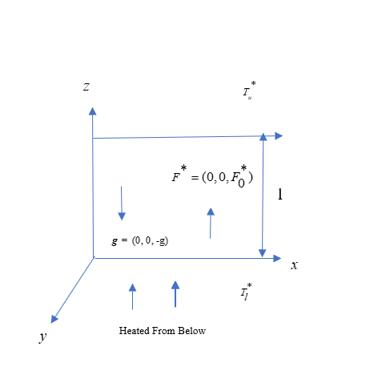

**Fig. 1: Physical configuration of the problem**

The governing equations for conservation of mass, momentum, energy and concentration of salt and nanoparticles are as follows:

 (1) 

(2)

 (3) (4)  (5)

The modified Maxwell equations are

 (6)

 ,  (7)

where is velocity.

For constant temperature and salt concentrations at the boundaries and zero nanoparticle flux, the boundary conditions are

, =,  , at  (8)

, ,  , at  (9)

Taking following non-dimensional parameters

, , , ,  where  is reference scale for volumetric fraction of nanoparticles,  is the thermal diffusivity of the porous medium and  is the heat capacity ratio parameter.

On replacing by , non-dimensional form of equations (1) to (6) together with boundary conditions (8) and (9) can be written as

 (10)

 (11)  (12)  (13) (14)

 (15)

and boundary conditions are

 , T=1, ,  at  (16)

, T=0, ,  at  (17)

Here , ,  ,are thermal, concentration, basic density and solutal Rayleigh Drcy number respectively, is couple-Stress parameter,and  are Prandtl numbers,  is Magnetic Chandrasekhar number, is Darcy number, is Soret parameter, and  are modified diffusivity ratio and modified particle density increment respectively, and are Lewis numbers for nanofluid and salt respectively.

1. **Neutral State**

Time independent neutral state of nanofluid is described as

,,, ,  ,  (18)

where the suffix “bs” refers to the basic flow. Following Chandrasekhar [16], the basic volume fraction and temperature of nanoparticles satisfy the following equations

 (19)

 (20)

 (21)

The boundary conditions are

 , , ,  at  (22)

, ,  ,  at  (23)

On solving, we get

 , , and 

1. **Perturbed State**

On the basic state, we superimpose perturbations in the form

, ,  , , 

where the primes denote infinitesimal small quantities. Ignoring the products of primed quantities and their derivatives, the following linearised perturbation equations of Couple Stress nanofluid are obtained as

 (24)

 (25)

 (26)

 (27)

with the boundary conditions

 at and  (28)

1. **LINEAR STABILITY ANALYSIS**

Following the linear stability theory by Chandrasekhar [16], the perturbations are taken of the form

 , (29)

whereand  are dimensionless wave numbers in  and directions respectively.

On substituting the above values, we get 

(30)  (31)  (32)

1.  (33)

with the boundary conditions

 , ,  at  and . (34)

**A Solution**

For employing Galerkin-type weighted residuals method to obtain an approximate solution to the system, we choose approximate functions as:

, , ,  (35)

where ,, and are unknown constants with k= 1 ,2,3….N. Using boundary conditions given by equation (34), the base functions are assumed as

, 

Taking first approximation (N=1) ,

 , ,  , 

Substituting these values in equations (30)-(33), we get



= 0

(36) where 

Taking the determinant of coefficient matrix as zero, the following Rayleigh number is obtained

 (37)

**B Analysis**

Taking s=0 in equation (37), the following Rayleigh number is obtained (38)

The above relation expresses the stationary Rayleigh number as a function of the parameters , ,,,,,  ,  and dimensionless wave number .

To obtain critical Rayleigh number putting , critical wave number is given by equation

 (39)

which shows that critical wave number depends on Couple Stress parameter, Darcy number, Porosity and Magnetic field.

**IV RESULTS AND DISCUSSION**

From equation (38), we have

which is same as obtained for a couple stress regular fluid by Bishnoi, Jawla and Kumar [17]. This shows that the effect of couple stress parameter for a nanofluid layer is to stabilize the stationary convection in same way as for a regular fluid.

Further it is also clear from equation (38) that ,  and have stabilizing effect where as

,, and  have stabilizing effect on stationary convection. Porosity has dual behaviour in stationary convection.

If ,=0, then



which is same as obtained by Shivkumara, Lee and Kumar [18].

The stationary convection curves for Rayleigh number  versus the wave number are shown in Figs. 2(a)-(g) by assigning fixed values,

= 5 , = 4,  = 0.2,  = 10,  = 4,  = 0.4,  = 800, =5, =0.1

with variations in one of these parameters.

1. (b)

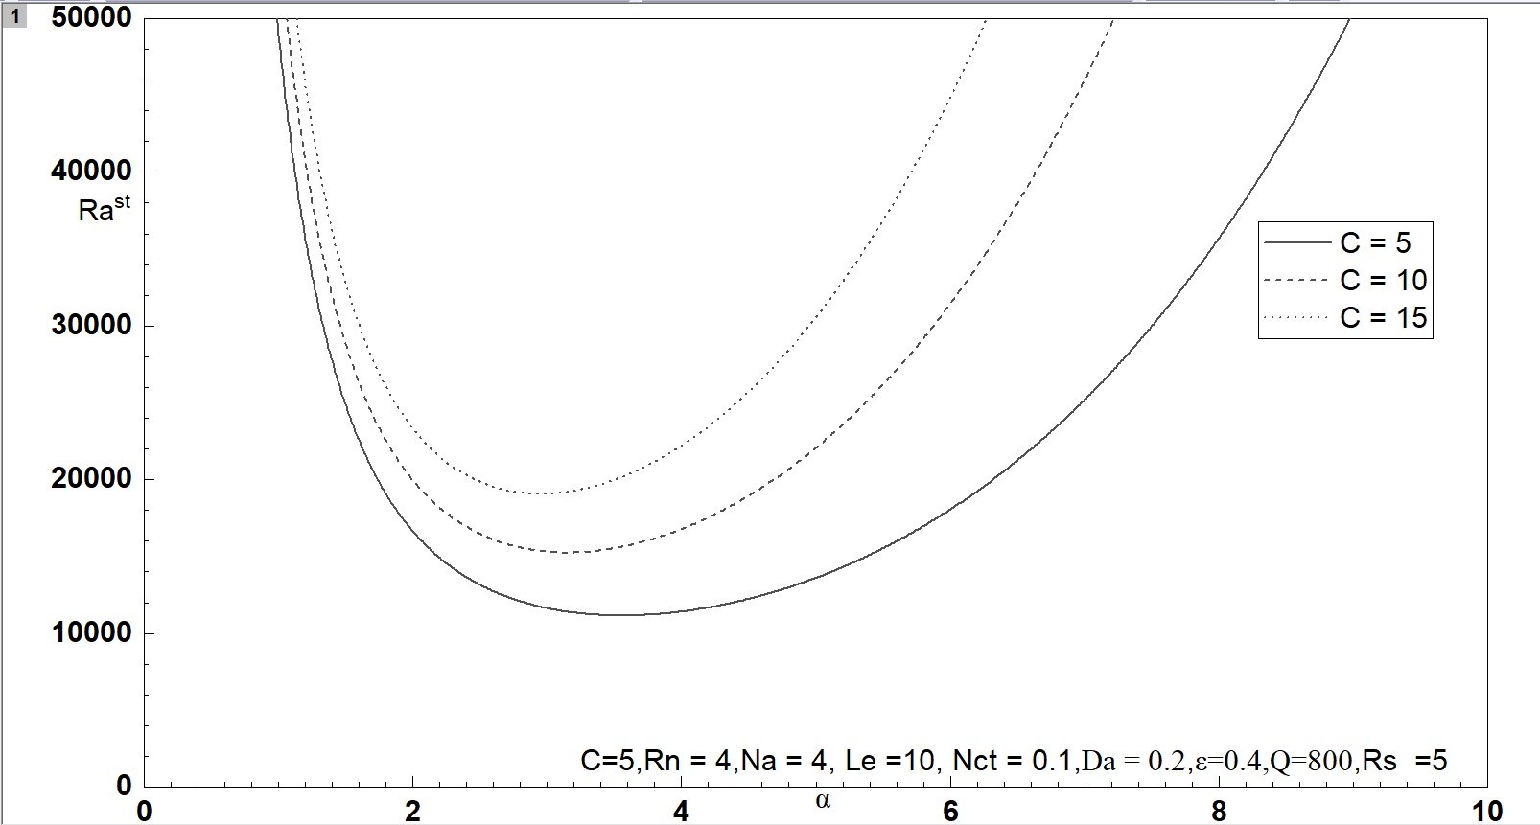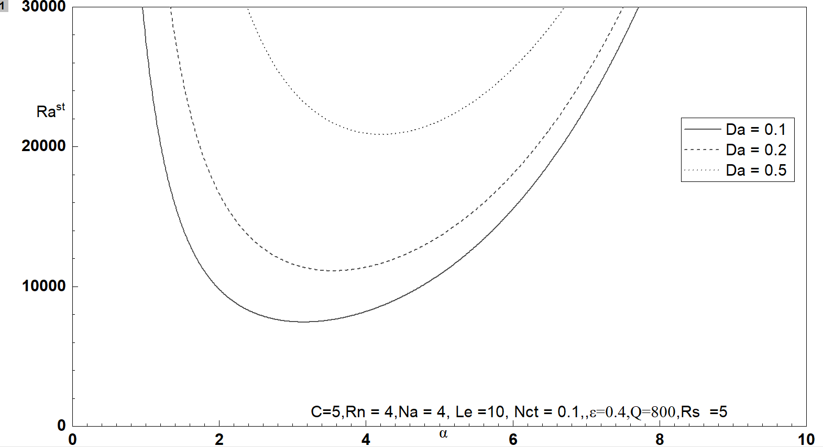

1. (d)

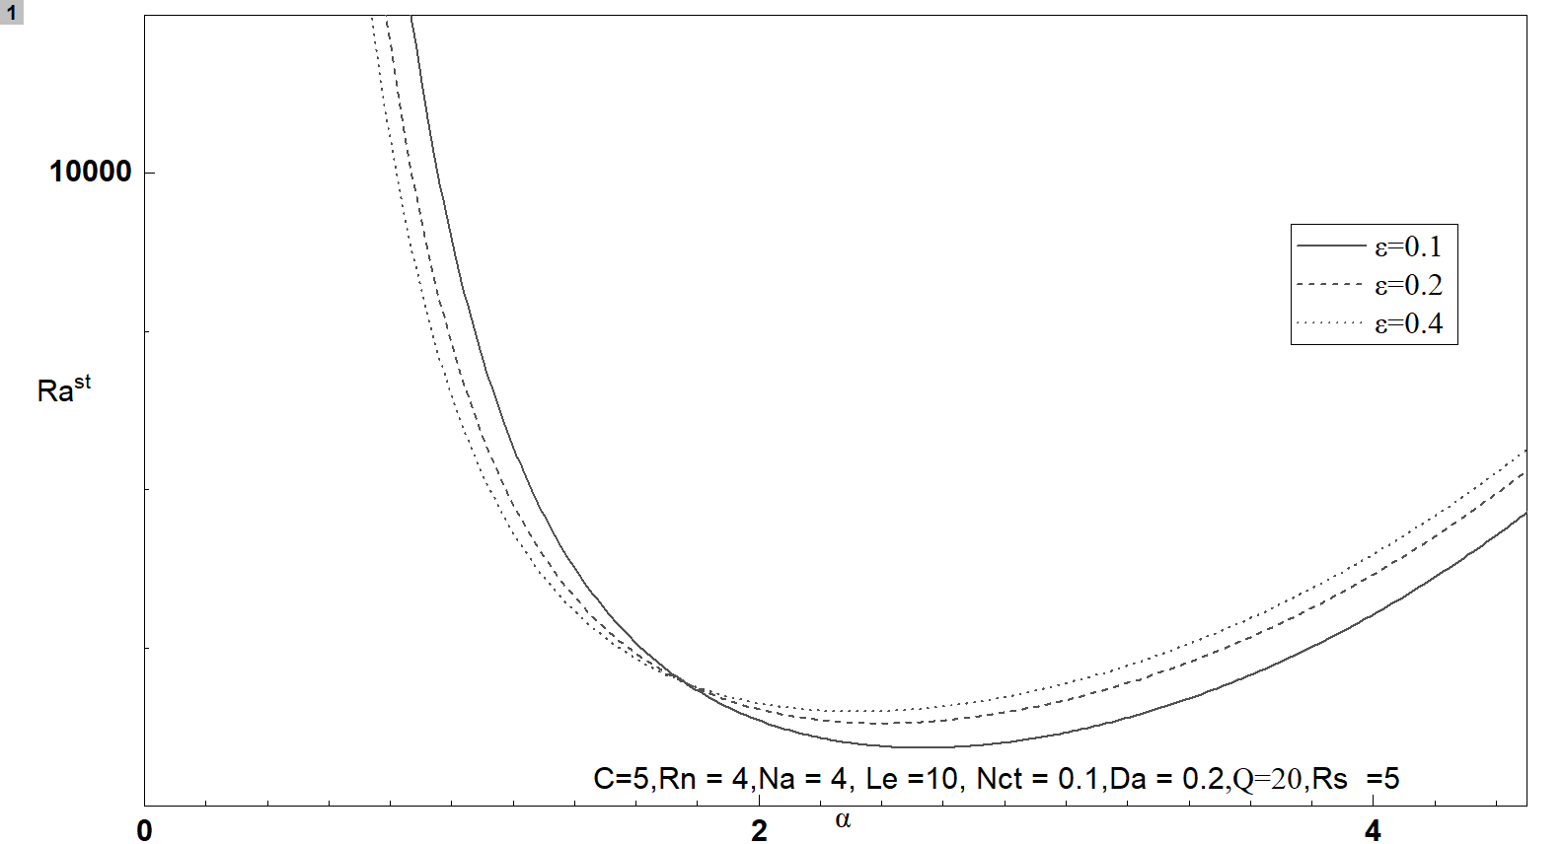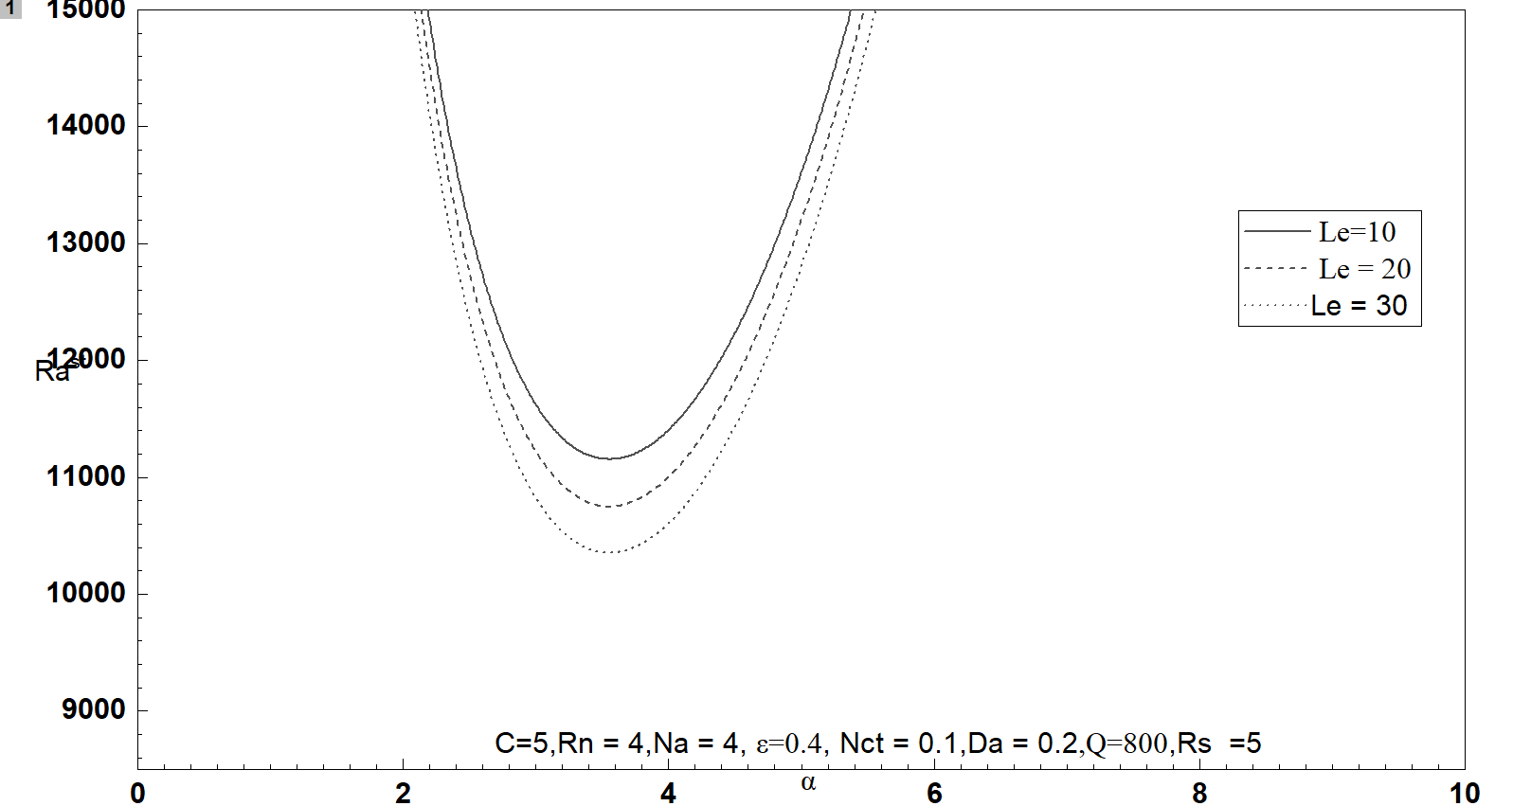

(e) (f)

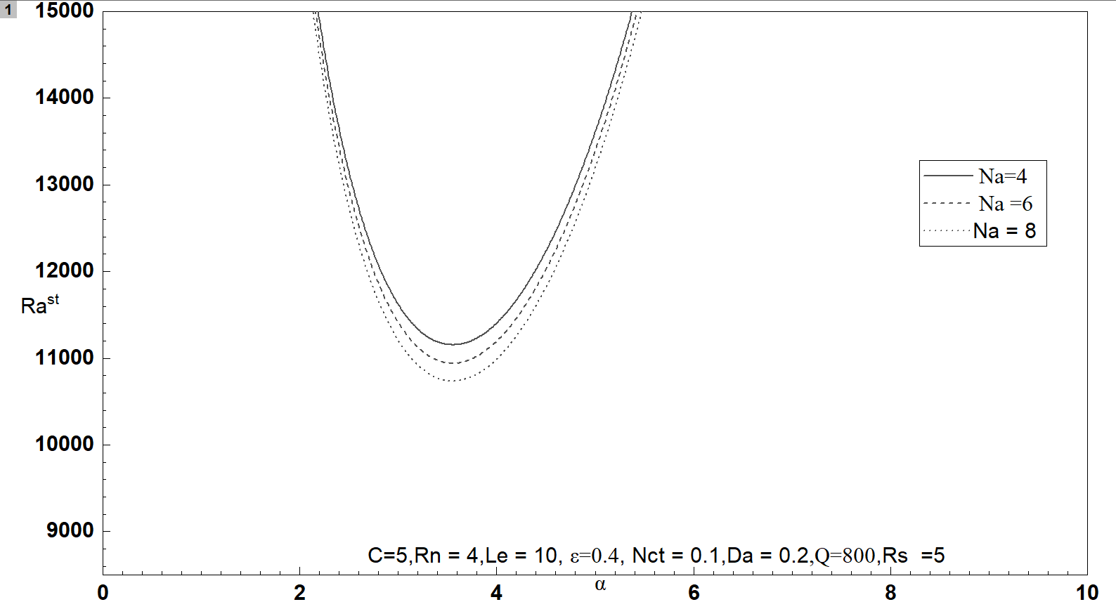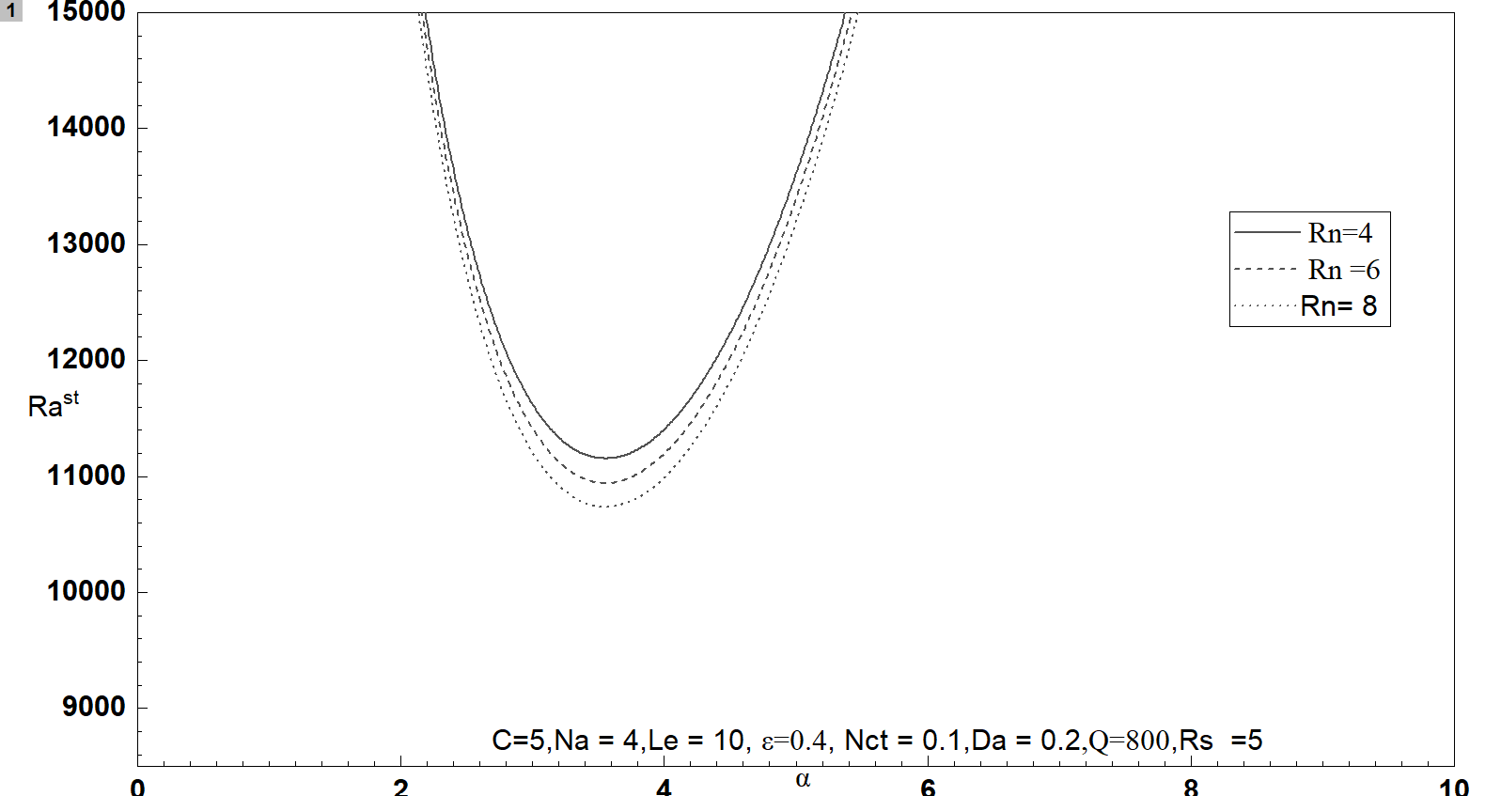

(g) (h)

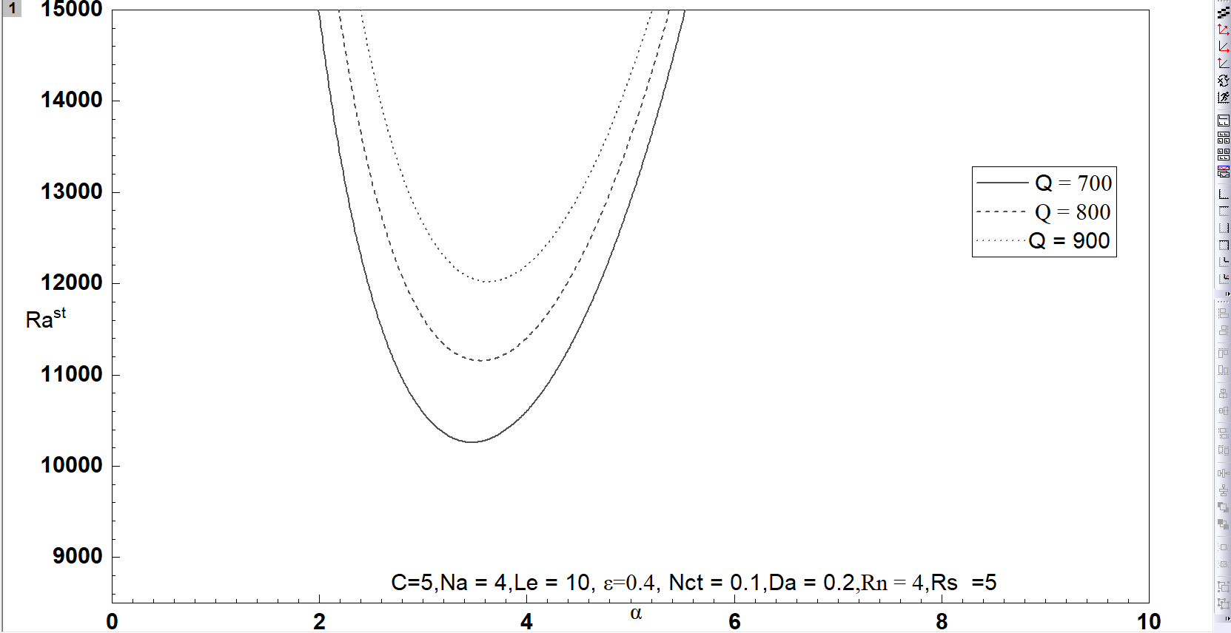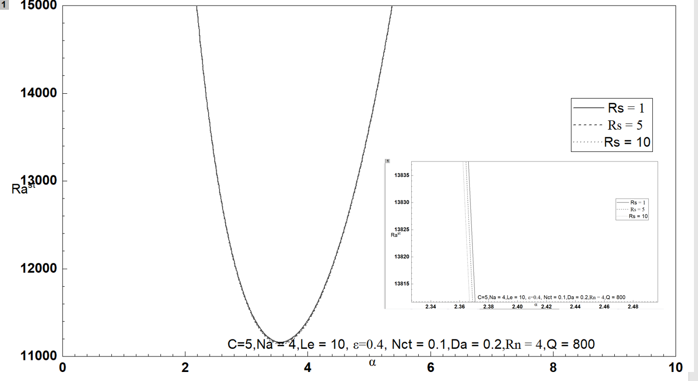

(i)

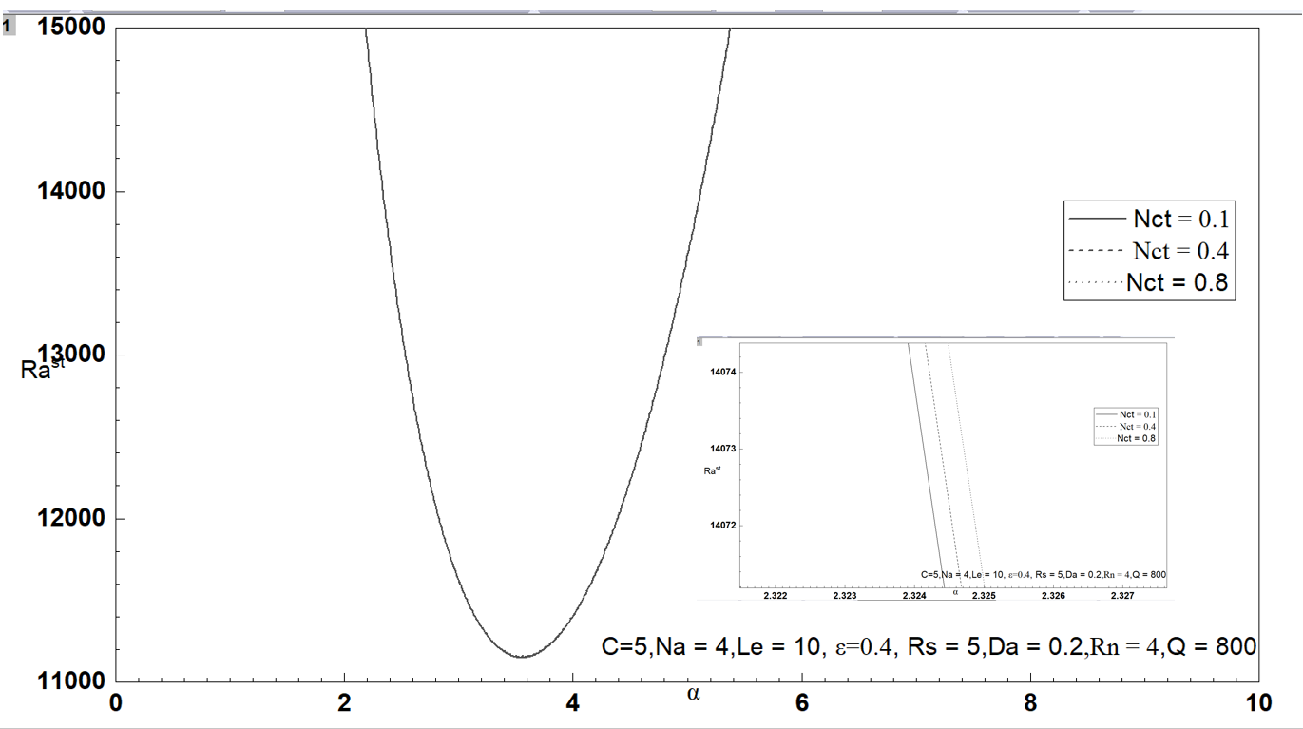

**Fig. 2: Linear stationary convection with wave number α for different values of**

(a) (b) *Da* (c)  (d) *Le* (e)  (f) *Rn* (g) *Q* (h) (i)

**V CONCLUSION**

In this paper, we have determined how the presence of the magnetic field affects double diffusive convection in Soret induced horizontal layer of couple stress nanofluid. The comparison of results obtained has been done with the existing relevant studies. The outcomes of the present analysis are summarised as follows:

* has been observed to be function of parameters , *Da* ,, *Le* , ,, *Q ,*,.
* The couple stress parameter has been found to stabilize the stationary convection as observed by Chand, Rana and Yadav [19] too while studying thermal instability in a layer of couple stress nanofluid in absence of magnetic field
* The effect of Lewis number  is to decrease Rayleigh number.
* An increase in porosity decreases  but dual effect on stationary Rayleigh number.
* A positive Soret coefficient  has stabilizing effect on convection as obtained by Gaikwad, Malashetty and Prasad [20] for a regular fluid as well as obtained by Singh, Bishnoi and Tyagi [21] for a nanofluid.
* The influence of magnetic field is to stabilise the Soret induced double diffusive convection as was found by Yadav, Changhoon, Jinho and Hyung [22] in nanofluid convection induced by internal heating.
* In this convection under magnetic field, Darcy number also comes into play and has been observed to provide stabilizing effect on stationary modes.
* An increase in Solutal Rayleigh Darcy number  was observed to cause increase in .

**REFERENCES**

[1] V. K. Stokes, “Couple-Stresses in fluids,” Phys. Fluids Vol. 9(9), 1966, pp.1709-1715.

[2] E. Walicki, A. Waika, “Inertia effect in the squeeze film of a couple stress fluid in biological bearings,” Appl. Mech. Eng. vol. 4(2), 1999, pp. 363-373.

[3] E. Cosserat, F. Cosserat, “Theorie des corps deformables,” Hermann, Paris, 1909.

[4] Rachana, S. C. Agrawal, “On the stability of a couple stress binary fluid mixture having vertical temperature and concentration gradients,” Indian National Science Academy, vol.61,1995, pp.363-370.

[5] P.S. Hiremath, P.M Patil, “Free convection effects on the oscillatory flow of a couple stress fluid through a porous medium,” Acta Mechanica, vol. 98 (1),1993, pp. 143-158.

[6] T. Hayat, M. Mustafa, Z. Iqbal, A. Alsaedi, “Stagnation point flow of couple stress fluid with melting heat transfer,” Appl. Math. Mech., vol. 34 (2), 2013, pp.167-176.

[7] P. Kumar, “Thermo-solutal magneto-rotatory convection in couple stress fluid through porous medium,” Journal of Applied Fluid Mechanics vol.5, 2012, pp. 45-52.

[8] P. Gilman, “Instability of Magneto-hydrostatic Stellar interiors from Magnetic Buoyancy,” The Astrophysical Journal, vol.162, 1970, pp.1019-1029.

[9] E. Schatzman, “The Solar Magnetic field and the Solar activity,” Astrophysics and Space Science Library book series, vol. 2, 1963, pp. 133-145.

[10] B. Shankar, J. Kumar, Shivkumara, “Stability of natural convection in a vertical non-Newtonian fluid layer with an imposed magnetic field,” Meccanica vol.53, 2018, pp.773-786.

[11] R. C. Sharma, K. D. Thakur, “On couple-stress heated from below in porous medium in hydro-magnetics,” Czechoslovak Journal of Physics, vol. 50, 2000, pp. 753-758.

[12] R. C. Sharma, M. Sharma, “Effect of suspended particles on couple-stress fluid heated from below in the presence of rotation and magnetic field,” Int. J. Pure Appl. Math. Phys., 2004, pp.973-990.

[13] V. Kumar, S. Kumar, “On a couple-stress fluid heated from below in Hydro-magnetics,” Journal of Applied Mathematics, vol. 5, 2010, pp. 432-445.

[14] H. Sithole, H. Mondal, H, S. Goqo, P. Sibanda, S. Motsa, “Numerical simulation of couple stress nanofluid flow in magneto-porous medium with thermal radiation and a chemical reaction”, Journal of Applied Mathematics and Computation, vol. 339, 2018, pp. 820-836.

[15] M. S. Malashetty, I. Pop, P. Kollur, W. Sidram, “Soret effect on double diffusive convection in a Darcy porous medium saturated with a couple stress fluid,” Int. J. Thermal Sciences, vol. 53, 2012, pp.130-140.

[16] S. Chandrasekhar, “Hydro-dynamic and Hydromagnetic Stability,” Dover Publication, New- York, 1981.

[17] J. Bishnoi, V. Jawla, V. Kumar, “Thermal convection in a couple stress fluid in the presence of horizontal magnetic field with Hall currents,” Appl. Appl. Math, vol. 8(1), 2013, pp. 161-177.

[18] I. S. Shivkumara, J. Lee, S. Kumar, “Linear and nonlinear stability of double diffusive convection in a couple stress fluid saturated porous layer,” Arch Mech., vol. 81, 2011, pp. 1697-1715.

[19] R. Chand, G. C. Rana, D. Yadav, “Thermal Instability in a layer of couple stress nanofluid saturated porous medium, Journal of Theoretical and Applied Mechanics,” Sofia, vol. 47(1), 2017, pp. 69-84.

[20] S. N. Gaikwad, M. S. Malashetty, K. R. Prasad, “An analytical study of linear and non-linear double diffusive convection in a fluid saturated anisotropic porous layer with Soret effect,” Applied Mathematical Modelling 33, 2009, pp. 3617-3635. ]

[21] R. Singh, J. Bishnoi, V. K. Tyagi, “Onset of Soret driven instability in a Darcy -Maxwell nanofluid,” SN Applied Sciences vol. 1(10), 2019, pp. 1-29.

[22] D. Yadav, Kim Changhoon, Lee Jinho, Hee Cho Hyung, “Influence of magnetic field on the onset of nanofluid convection induced by purely internal heating,” Journal of computers and fluids, vol. 121, 2015, pp. 26-36.